REFLECTIVE REPORT BASED ON THE USES OF TASKS AND SKILLS BY AN ORGANISATIONAL MANAGER

Student Name: Vanessa Popescu
Student ID: 2217243
Lecturer: Hoang Dang Nguyen
Table of Contents

Introduction 2
Discussion 2
Roles of manager from the aspect of personnel manager and store manager 2
Skills of personnel manager and store manager 2
Reflection based on Gibbs’ reflective Cycle 3
Conclusion 4
Reference List 5

Introduction
This reflective report is reffering to different tasks as well as skills, which all have conducted and also will be responsible by the organisational managers. Here, it is important to say that the selected organisation is TESCO and the total reflective essay will be illuminated by the perspective of two types of managers. These two types are based on the terms of the Personnel managers along with the store managers within the chosen, large supermarkets of the UK, recognised as TESCO. The purpose of this report is to identify the roles and skills of managers within the chosen organisation. Therefore, another purpose of this report is to mitigate all the situational hazards of TESCO by the strategic incorporation of TESCO managers. Apart from that, Gibbs Reflective cycle will also be illuminated for the better recognition of the managerial posts within TESCO, UK.

Discussion

Roles of manager from the aspect of personnel manager and store manager
According to the perspective of a report, published by Tesco (2019), it has been recognised that the salient roles of managers within TESCO, UK are based on the terms of the focusing on open and free conversation between the office colleagues for attaining high level of success. The success of TESCO, UK, can be attained by the mitigation of organisational issues with the help of the managerial people. Few other roles of manager within TESCO are based on the warm welcoming of the organisational colleagues and subordinates. It also focuses on the providence of motivation to the organisational employees for getting a sustainable organisational success (Jiang, Zhao and Ni, 2017). Some other roles of this managerial designation are based on the continuous changing of the organisational workplace. Along with this, it also focuses on the providence of motivation by the managers of TESCO. Finally, it has thereby been recognised that both the store managers and the personnel managers have almost the same roles and skills, which allows the sustainability of TESCO.

Skills of personnel manager and store manager
In addition to the previous section, it can be said that four salient skills of personnel and store managers are the Communicational skills, Leadership approach, Decision making skill as well as the team working approach within TESCO (Robert S. Kaplan, 2008).

Reflection based on Gibbs’ reflective Cycle
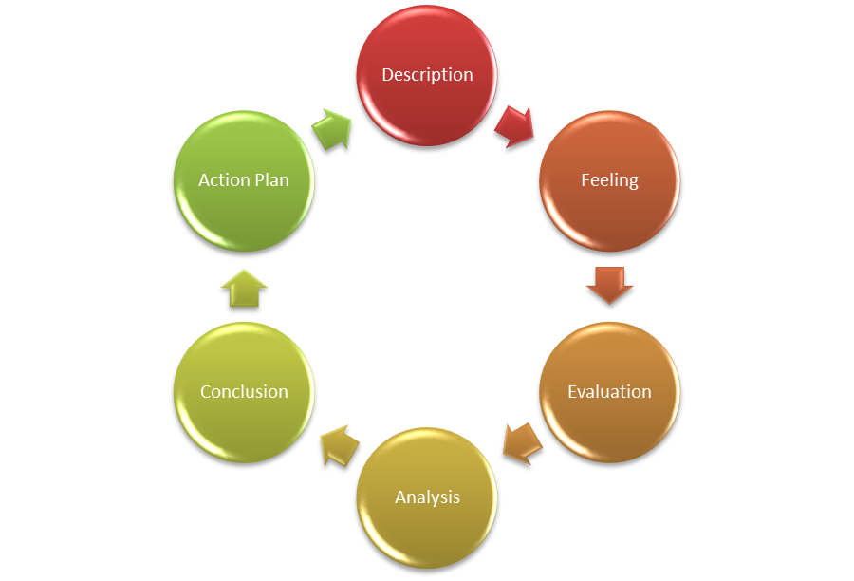
Figure 1: Gibbs Reflective Cycle
(Source: Created by Author)
This section will be based on the model of Gibbs Reflective Cycle, which is the amalgamation of six different stages (Adeani, Febriani and Syafryadin, 2020). All these six stages are based on the terms of Description, Feeling, Evaluation, Analysis, Conclusion as well as the Action Plan (According to Figure 1).
Description: On the basis of the Model of Gibbs’ Reflective Cycle, it has been recognised that the model will evaluate my journey as a manager within TESCO, UK. Both my managerial roles and skills will also be evaluated here. Some of my core roles were based on the open and free communication with my colleagues and subordinates for attaining the success of TESCO. I have also observed that my other roles and skills are providence of motivations to the other employees and mitigation of some issues related to the selected organisation.
Feeling: On the basis of the previous section, it can be said that I felt both the positive and negative aspects as a manager of TESCO, UK. From my early experience as a manager of TESCO, I have identified that my positive skills are Leadership skills, Decision making skills as well as the Communication Skills. I have also recognised that my most negative skill is the poor team working skills.
Evaluation: On the basis of the description as well as the feeling section, it has also been recognised that I had evaluated both the positive and negative aspects, from the perspectives of a manager within TESCO. From both the advantages and the disadvantages, I have recognised that I need to focus on my poor skills for further betterment of TESCO.
Analysis: I have also analysed that I need to identify all of my flaws based on my roles and skills as the manager of TESCO. Thereafter, I must say that incorporation of all my good skills and roles need to be elaborately incorporated within TESCO for the sustainable betterment of the selected organisation.
Conclusion: On the basis of the total reflective report on my managerial role and skills in TESCO, it has been concluded that incorporation of my good skills and positive roles are important for organisational success. Simultaneously, removal of the negative skill is also necessary for sustainable success of TESCO.
Action Plan: On the basis of the previous section, I have identified that my team working skill is important to improve. Moreover, it can also be recommended that I should mitigate my introvertness by interacting with more team members of TESCO. This will help me to sort out my issues and also enable the profitability of my organisation, TESCO.

Conclusion
On the basis of all description of this reflective report, it has already been recognised that the total study was based on the UK based large grocery supermarket, TESCO. This total reflective report was related to the particular designation of a manager within TESCO, UK. Furthermore, it has also been recognised that both the store managerial and personnel managerial roles and skills have been evaluated from the aspect of the large supermarket and grocery stores of the UK, TESCO. Along with this, the model of Gibbs Reflective Cycle has also been incorporated within this reflective report. Furthermore, six different cyclic stages have also been incorporated here for evaluating all the advantages and hassles of a manager within TESCO, UK. After the total evaluation and discussion of the reflective report, it can also be said that both benefits and hazards were there in terms of TESCO, UK, specifically on the basis of managerial post. Last of all, it has thereby been concluded that all the advantages need to be incorporated for the future sustainability of the selected organisation, TESCO, UK. Along with this, removal of all hassles are equally important for the organisational profitability.

Reference List
1. Adeani, I.S., Febriani, R.B. and Syafryadin, S., 2020. USING GIBBS’REFLECTIVE CYCLE IN MAKING REFLECTIONS OF LITERARY ANALYSIS. Indonesian EFL Journal, 6(2), pp.139-148.
2. Jiang, W., Zhao, X. and Ni, J., 2017. The impact of transformational leadership on employee sustainable performance: The mediating role of organizational citizenship behavior. Sustainability, 9(9), p.1567.
3. Robert S. Kaplan (2008) Tesco’s Approach to Strategy Communication: Available at: https://hbr.org/2008/09/tescos-approach-to-strategy-co [Accessed on 25th March, 2023]
4. Tesco (2019) One Stop- Store Manager: Available at: https://www.tesco-careers.com/jobdetails/390634#:~:text=You%20will%20ensure%20that%20all%20of%20your%20store%20team%20are%20fully%20trained.&text=You%20will%20promote%20and%20encourage%20teamwork%20in%20your%20store.&text=You%20will%20have%20a%20clear,in%20place%20to%20support%20performance.&text=You%20ensure%20your%20team%20are%20supported%20and%20enjoy%20their%20job. [Accessed on 25th March, 2023]

