
Learning in the digital era
BMSW4010

September 1, 2023
university of wales trinity saint David
SWANSEA BUSINESS CAMPUS

BOLAMU OTIS JEAN PAUL BASIKI
ID : 2234855

LECTURER : CHRISTIAN FELICES
- Report Template Document
The American Management Association defines report writing as the art of communicating information that has been acquired through research or investigation in a formal, structured manner and involves synthesizing information, drawing conclusions, and making recommendations based on the findings. (Harari, 1991).
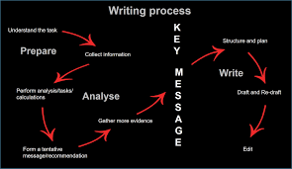

Structure of a Report:
Title Page: Summarise the main idea or ideas of the report
Executive Summary: Outline the key points of the report by restating the purpose of the report, highlighting the major points of the report, and describing any results, conclusions, or recommendations from the report.
Contents Page: This a list, usually found before the start of any writing, that outlines what is included in a piece of written work

Terms of reference: used to set out the roles and responsibilities of those involved, as well as to provide guidance on how the work will be undertaken and reported.
Procedure: This is the way of doing something or steps to be followed.
Findings: are used to answer the research questions posed in the introduction, even if the hypothesis is challenged by the findings.
Conclusion: This is the decision or judgment reached by reasoning.
Recommendations: These are often included in a report’s conclusion, although they serve different purposes. Whereas a conclusion offers the opportunity to summarise or review the report’s main ideas, recommendations suggest actions to be taken in response to the findings of a report.
Appendices: These are sections of academic writing with supplemental information about the topic that does not fit in the main text.
Acknowledgments: The acceptance of the truth or existence of something.
Reference/ Bibliography: It contains only sources that have been cited in the report while a bibliography is a list of all the sources used to generate ideas about the topic including those cited in the report or assignment as well as those which have not been cited.

- Importance of Academic Writing
Academic writing is writing that communicates information and ideas to an academic audience (Zhu, 2004). It is used as a tool, to pass knowledge to other people. It is defined as a communication skill, and for a person to communicate something, they must have a clear understanding of the particular issue. The issue should be discipline-specific, for the writing ‘to serve its purpose. There are several importance of academic writing, which have been highlighted below.
Academic writing is important because it encourages critical thinking and analysis. Before writing an academic paper, a person has to research the topic and read many other articles that may have been written (Al Fadda, 2012). They could also conduct experiments to validate a hypothesis. All this data is overwhelming and critical thinking and analysis skills are required to accurately filter out through the sets of data and use only the relevant data to write the paper. Equally, people who review the written paper, need critical thinking.
It is important because it encourages knowledge building and communication of ideas. A person can put their theories and ideas in a structured manner, through academic writing (Al Fadda, 2012). These theories can then be made public to the academic community for peer review and scrutiny. Through such avenues, new ideas and innovations can be developed, for example in fields such as medicine.
Academic writing is important because it contributes to professional development. In fields such as law and engineering, professionals are required to write academic papers in order to move from one rank to another (Kruse, 2003). Their professional development requires them to communicate ideas that they have learned over time by use of academic writing.
In conclusion, academic writing is writing that passes information and ideas to an academic audience. It is important because it encourages critical thinking and analysis, knowledge building and communication of ideas and finally, it helps in professional development.
- Critical Analysis
Critical analysis is carefully examining a piece of work to understand how different elements work (Leeuwen, 2009). In report writing, critical analysis involves looking at different documents and reports, to understand how something works and therefore write a report about it. Critical analysis involves looking at the positive aspects of a thing, looking at its negative, comparing this with other works written by different people, and finally making an informed judgement. This report looks at the ways in which critical analysis enhances the quality of work.
Critical analysis enhances the quality of work because it widens the scope of research. A person doing critical analysis is forced to investigate different research done by different people to be able to make an informed decision (Viola, 2009). The quality of work therefore improves as a person looks at various sources of information and different points of view. Secondly, critical analysis gives a person a better understanding of a topic. When a reader does critical analysis, they are forced to review more than one document, therefore getting various points of view. This removes bias which may be associated with getting knowledge from only one source. Having different points of view on a particular topic enhances understanding (Richards, 2017). Finally, critical analysis enables a person to have a stronger conclusion. A stronger conclusion is achieved from having to see both points of view on a given topic. When a person critically analyses a topic and gets both the negative and positive impacts of it, they can then be able to make a decision, from the two points of view, which one is best.
In conclusion, critical analysis is carefully examining a piece of work, and seeing how different components work. Critical analysis is important in report writing because it enhances the quality of work in the report, gives a better understanding of a topic, and helps a person have a strong conclusion.

References
Al Fadda, H. (2012). Difficulties in academic writing: From the perspective of King Saud University postgraduate students. English Language Teaching, 5(3), 123-130.
Kruse, O. (2003). Getting started: Academic writing in the first year of a university education. Teaching academic writing in European higher education, 19-28.
Zhu, W. (2004). Faculty views on the importance of writing, the nature of academic writing, and teaching and responding to writing in the disciplines. Journal of Second Language Writing, 13(1), 29-48.
Harari, O., 1991. The essence of leadership. Management Review, 80(11), pp.63-64.
Richards, I. A. (2017). Principles of literary criticism. Routledge.Van Leeuwen, T. (2009). Critical discourse analysis. Discourse, of course: An overview of research in discourse studies, 277-292.’
Viola, M. (2009). The villainisation of critical pedagogy: Widening the scope of critical educational theory. Journal for Critical Education Policy Studies (JCEPS), 7(1).

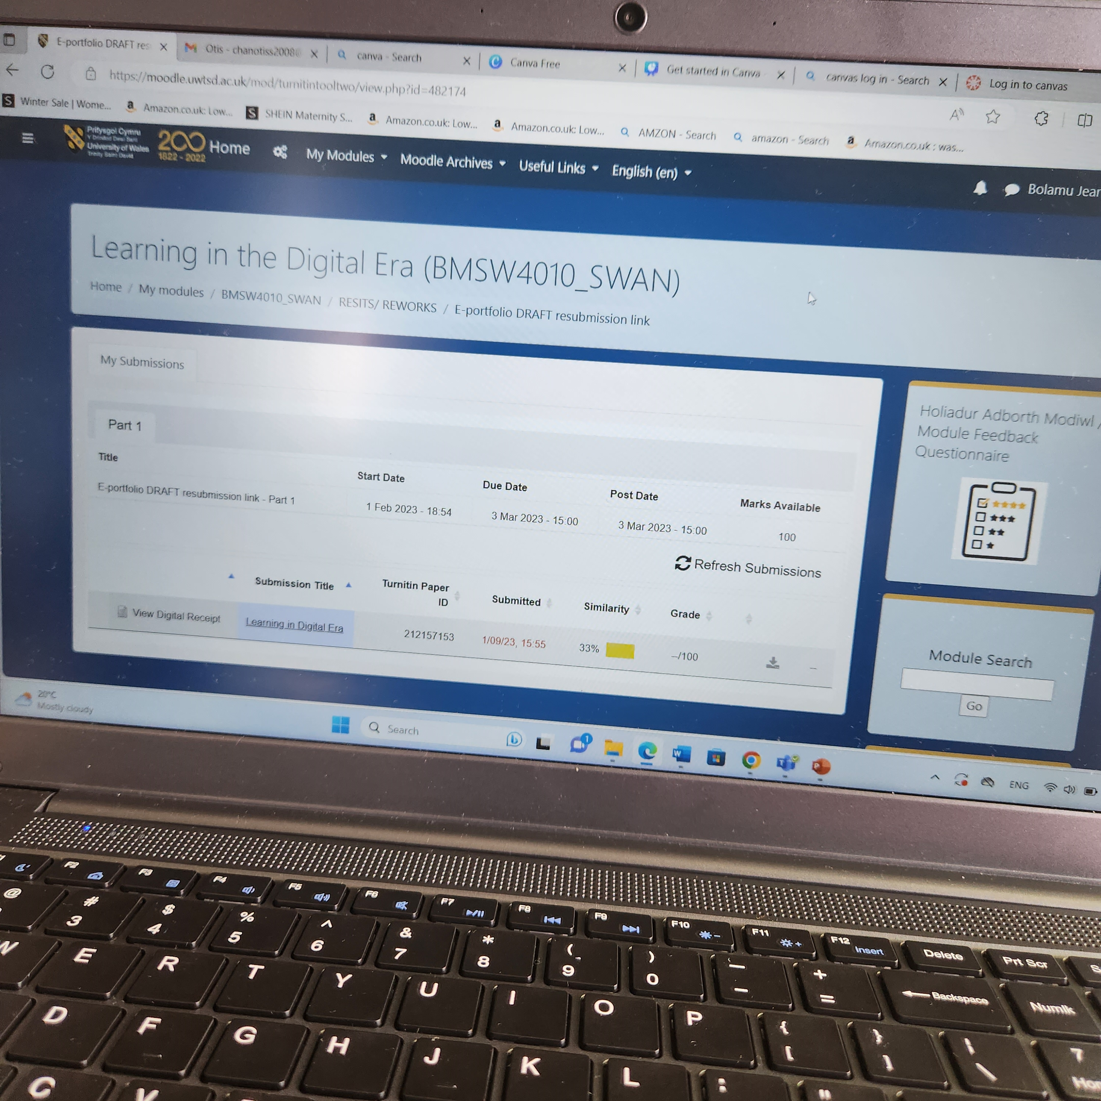

The similarity score is a percentage of the paper’s matches to other sources. It is not an assessment of whether the paper includes plagiarised material. The Similarity here is 33% according to this work that will be working to reduce for further works.

