University of Wales Trinity Saint David
Master of Business Administration
May 2024 Intake

MBA PROJECT TOPIC
A study on Hong Kong residents' preferences for staycation packages in Hong Kong and Macau
(word count: 14,397words)

Prepared by:
NG Kit Ching

Student ID number:
2337377

1

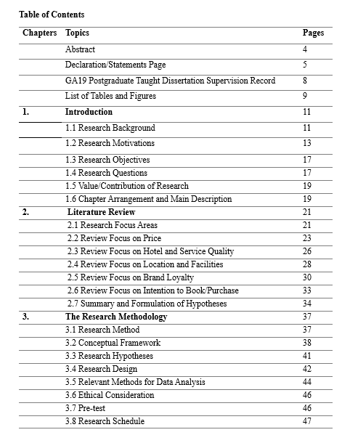

2

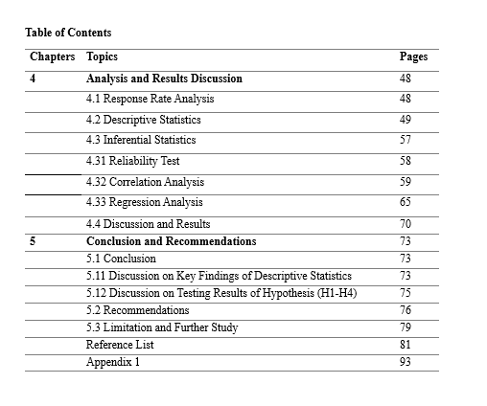

3

Abstract
This study aims to explore the key factors influencing Hong Kong residents' preferences for staycation packages in Hong Kong and Macau. The main objective is to understand how Hong Kong residents make purchasing decisions regarding staycation packages, thereby helping hotel industry players by providing practical insights for designing more attractive packages, and addressing post-pandemic recovery and regional competition. The study focuses on analyzing the relative importance of factors such as price, hotel and service quality, location and facilities, and brand loyalty.

To achieve this objective, this study employed a quantitative survey methodology targeting Hong Kong residents. The survey collected respondents' preferences, decision-making criteria, and demographic data. However, this study acknowledges limitations in generalizability due to the demographic characteristics of respondents. The sample primarily consisted of middle-aged individuals aged 45 and above and those with a bachelor's degree or higher, meaning the results may not be representative of younger populations or those with diverse educational backgrounds.

The research findings highlight key areas that hotel operators in Hong Kong and Macau need to focus on. Understanding the relative importance of different package attributes and the differences in consumer preferences is crucial for effective package offers. This research provides practical recommendations for developing staycation packages that better suit the preferences of Hong Kong residents. This can help hotels stand out in a competitive market, increase occupancy rates during off-seasons, and ultimately enhance revenue stability and competitiveness by maximizing the revenue from local market effectively.

Keywords: Staycation Package, Price, Hotel Quality, Employee Quality, Service Quality, Location, Facilities, Brand Loyalty Hong Kong and Macau tourism.

4
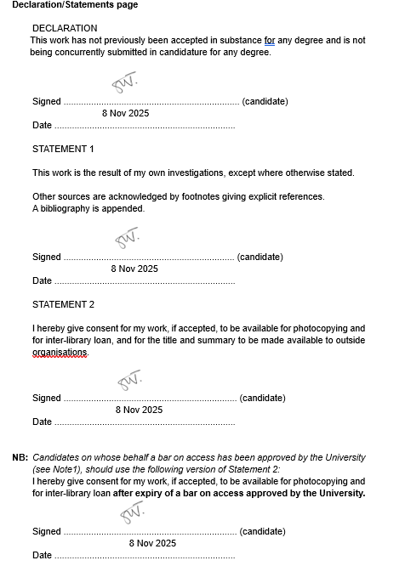

5

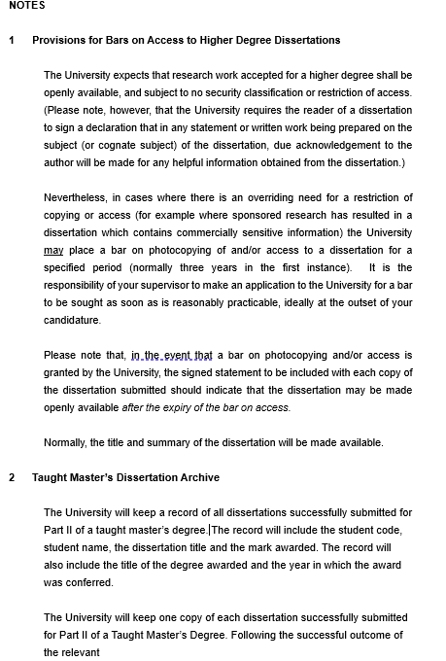

6

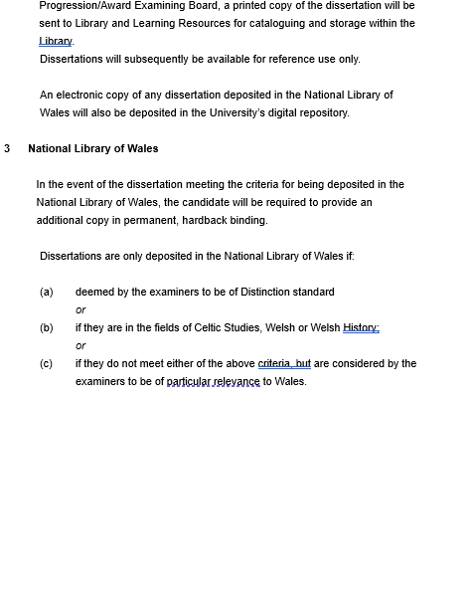

7

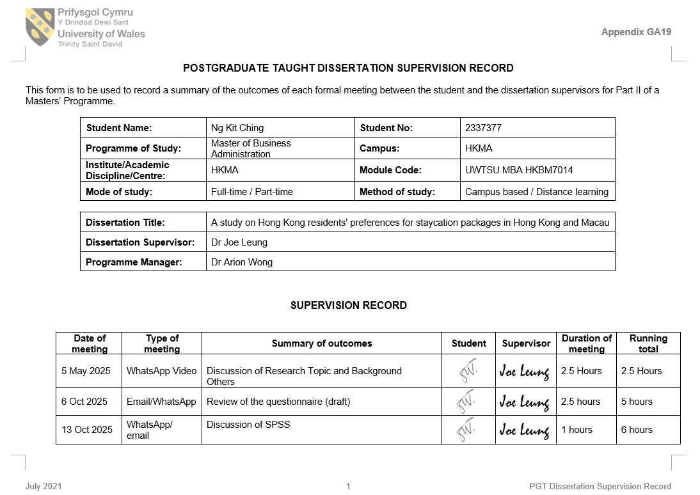
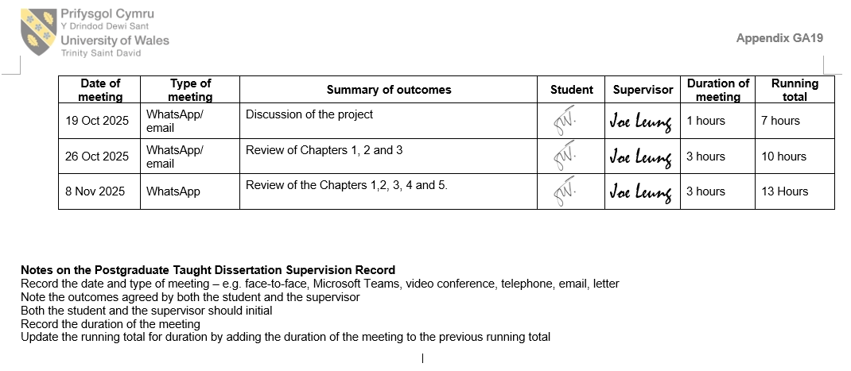
8

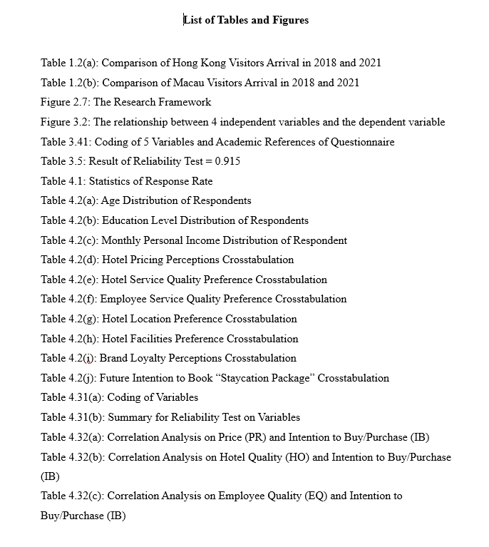

9

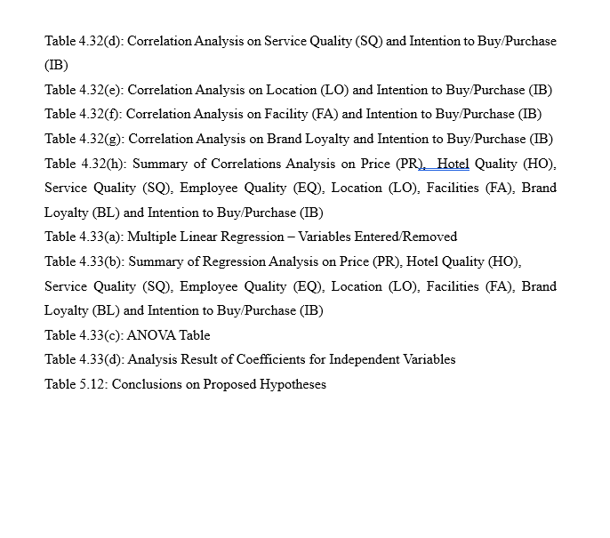

10

Chapter 1 Introduction
1.1 Research Background
The term 'staycation', formed from 'stay’ and 'vacation', dates back to at least the 1940s. It refers to staying at home during a vacation, a practice believed to be linked to the rationing of many goods during World War II, including fuel for non-essential travel. While the modern meaning of the term is like its original one, it now encompasses a broader concept of taking a holiday anywhere within one's own country (luisa, 2022).

The 2008 global financial crisis triggered a severe economic recession, leading to a sharp decline in international tourism, with the number of foreign visitors to some regions dropping by as much as 18%. At the same time, rising fuel prices and reduced discretionary spending curbed household leisure travel spending, prompting a widespread shift from international travel to domestic travel. This behavioral shift led to the mainstreaming of the term "staycation," which entered the popular lexicon through extensive media coverage during this period and subsequently became officially included in major dictionaries.

The COVID-19 pandemic has completely disrupted the global tourism industry, with international border closures and strict quarantine requirements making international travel virtually impossible. This backdrop has accelerated the previously popular "staycation" trend, making it a mainstream travel strategy worldwide. Empirical research indicates that the COVID-19 pandemic has triggered widespread travel anxiety, known as "pandemic-related travel anxiety." A nationally representative survey in the United Kingdom revealed that 68% of respondents were concerned about disruptions to international travel, while 62% cited the uncertainty of the pandemic as the primary reason for choosing a domestic "staycation" over an international vacation. Following the easing of travel restrictions, many jurisdictions strategically prioritized the restoration of domestic tourism.

11

This policy orientation has led to initial signs of recovery in tourism across several economies. Governments in countries such as Ireland, Iceland, Italy, Poland, Slovenia, Lithuania, South Korea, Macau, and Thailand have implemented formal staycation programs to stimulate local tourism demand (Muritala, Hernández-Lara and Sánchez-Rebull, 2022).

The COVID-19 pandemic significantly elevated the importance of staycation packages. In Hong Kong, where hospitality sectors historically relied on international and Mainland Chinese visitors, hotels fought for survival. Staycations emerged as a critical adaptive strategy, offering residents a safe and accessible leisure alternative amid travel constraints. In response to the COVID-19 pandemic's severe impact on inbound tourism, the Hong Kong Tourism Board (HKTB) strategically launched the "Holiday at Home" campaign in July 2020 to stimulate domestic demand and provide essential support to the local hospitality sector. Recognizing residents' pent-up desire for leisure escapes amidst travel restrictions, the initiative focused on promoting curated "staycation" packages offered by Hong Kong hotels. These packages were designed to transcend basic accommodation by incorporating value-added experiences such as themed activities, dining credits, wellness treatments, and exclusive local tours, thereby enhancing perceived value and differentiating offerings. The Hong Kong Tourism Board leveraged multi-channel marketing, including digital platforms and partnerships with travel agencies and banks, to maximize reach and offer promotional discounts. The campaign proved highly successful, with over 100 hotels participating and generating significant occupancy during periods of historically low tourism activity. This not only provided immediate financial relief to the industry but also demonstrated the viability of the domestic market. The "Holiday at Home" campaign laid the foundation for the subsequent "Hong Kong is On" phase, which aimed to sustain resident engagement by encouraging exploration of the city's diverse cultural, culinary, and natural attractions. Ultimately, the initiative successfully transformed a crisis

12

response into a catalyst for reorienting Hong Kong's tourism landscape towards greater resilience and local appreciation, establishing staycations as a permanent feature of the market (Discoverhongkong.com, 2021).

During the COVID-19 pandemic, when international travel was halted, staycation packages attracted local customers and helped the Hong Kong hotel industry survive. Hotels launched special packages including dining, spa services, and activities to generate revenue and build customer loyalty. This focus on local customers, particularly with government support and targeted marketing, maintained room occupancy rates and aided economic recovery. By tapping into the local market, staycation packages became a significant new revenue source and growth opportunities in the post-pandemic era (Knightfrank.com.hk, 2022).

  - Research Motivations
My experience working within the Sales & Marketing departments of hotels in Hong Kong and Macau provided firsthand insight into the significant threat the COVID-19 pandemic posed to these cities' hospitality sectors. Prior to the pandemic, both were leading global tourist destinations, with Hong Kong welcoming over 64 million visitors and Macau nearly 40 million in 2018. The abrupt collapse in international tourist arrivals – excluding Mainland China, which accounted for over 70% of visitors – starkly exposed critical weaknesses in market diversification. Tables 1.2a and 1.2b indicate significant evident in the loss of visitors from the second-largest feeder markets, which previously contributed over 20% of arrivals to both cities (Hktb.com, 2024) (Government of Macao Special Administrative Region Statistics and Census Service, n.d.).

13

Table 1.2(a) Comparison of Hong Kong Visitors Arrival in 2018 and 2021

Table 1.2(b) Comparison of Macau Visitors Arrival in 2018 and 2021

This crisis was compounded by the long-standing challenge of seasonal occupancy fluctuations, which significantly impacted the hotel industry. These fluctuations create distinct periods: high season characterized by peak demand and elevated room rates, and low season marked by reduced demand necessitating discounted pricing. This seasonality drives substantial revenue volatility, complicating financial planning, budgeting, and investment. Hotels heavily reliant on peak-season income become highly vulnerable to off-season downturns and external shocks, including epidemics, economic recessions, and localized events. Low season further results in underutilized facilities (restaurants, spas, meeting rooms), reduced staffing requirements, and inefficient allocation of fixed assets.

14

Moreover, an over-reliance on specific high-season segments, such as international leisure travels, mega-events, and meetings & exhibitions, heightens vulnerability to disruptions like geopolitical instability, extreme weather affecting travel, or economic shifts in key source markets.

Simultaneously, traveler behavior is evolving. Post-pandemic, travelers with heightened risk perceptions are opting for shorter trips and avoiding long-distance travel, contributing to a decline in international volume. Conversely, the widespread adoption of "staycation packages" during the pandemic bolstered confidence in local travel, fostering increased interest in nearby exploration and establishing an alternative travel model for the post-pandemic era (Miao et al., 2022).

The hotel sector also contends with intensifying competition, not only from traditional rivals but also from alternative lodging platforms (e.g., Airbnb, Vrbo) and online travel agencies (OTAs) commanding significant commissions. This competitive pressure coincides with mounting demands – regulatory, consumer, and ethical – for more sustainable operations, particularly through reducing emissions associated with long-haul travel and strengthening local community ties. Navigating this dual pressure of heightened competition, rising commission costs, and environmental imperatives makes achieving a distinct market position, especially during low-season periods, increasingly difficult.

Consequently, industry’s pivot towards the domestic market emerged as a vital survival strategy. However, as broader tourism recovers, understanding resident preferences will be crucial for sustaining stability. This study is motivated by several key gaps and challenges:

15

- Seasonal revenue fluctuations: The seasonal nature of tourism in Hong Kong and Macau leads to significant fluctuations in hotel occupancy rates. Developing targeted staycation strategies is key to boosting occupancy during traditionally low-demand periods, thereby stabilizing revenue streams and improving overall annual yield.
- Lack of Customized Products: Many current staycation packages are developed based on assumptions rather than empirical data on local preferences, potentially resulting in offerings that fail to resonate with the target market.
- Intense Competition: The dense concentration of luxury hotels and resorts in Hong Kong and Macau necessitates effective differentiation in staycation offerings to stand out.
- Changing Consumer Behavior: The pandemic has shifted consumer priorities, placing greater emphasis on health and safety, unique experiences, and value for money. Understanding these evolving priorities is critical.
- Regional Dynamics: While geographically proximate, Hong Kong and Macau offer distinct experiences – Hong Kong renowned for its urban vibrancy, shopping, and dining, versus Macau known for its casinos, integrated resorts, and cultural heritage. The impact of these differences on staycation choices remains underexplored.

Addressing these issues through focused research can provide valuable insights to help the hotel industry optimize its staycation strategies and enhance competitiveness.

16

  - Research Objectives
This study aims to address critical gaps in understanding Hong Kong residents' preferences for “Staycation Packages” in Hong Kong and Macau. By analyzing key market factors, consumer characteristics, and regional differences, this study will provide practical recommendations for hotel operators to navigate post-pandemic recovery, intense regional competition, and seasonal fluctuations. The specific objectives of this study are as follows:

- To recognize and prioritize the key factors influencing Hong Kong residents’ preferences for “Staycation Packages” in Hong Kong and Macau.
- To determine the relative importance and impact of specific attributes of “Staycation Packages” including price, hotel and service quality (also considering of staff quality), location and facilities, and brand loyalty on Hong Kong residents’ booking intentions.
- To analyze how demographic characteristics (gender, age group, education level, monthly income) influence preferences for different attributes of “Staycation Packages” and booking intentions.
- To translate the research findings into actionable guidelines for Hong Kong and Macau hotel and resort operators to optimize package design, marketing, and revenue management to boost performance. This objective focuses on the practical application of research insights. Specifically, these recommendations will guide operators on how to carefully design package content based on guest preferences, thereby directly improving key performance indicators (KPIs).

  - Research Questions
To achieve the research objectives outlined in Section 1.3, this study will address the following specific research questions through a structured survey:

17

- What key factors (such as price, hotel and service quality (also considering of staff quality), location and facilities, and brand loyalty) influence Hong Kong residents’ preferences for accommodation packages in Hong Kong and Macau, and what are their relative priorities?
- What is the relative importance and impact of specific attributes within each factor (e.g., different price ranges, specific service quality aspects, hotel location, guest room conditions, facilities and brand loyalty) on intention of booking a staycation package?
- How do demographic characteristics (such as gender, age group, education level, monthly personal income) influence:
- The perceived importance of different factors of “Staycation Packages” (price, facilities and amenities, product and service quality etc)?
- Booking intention for “Staycation Packages”?
- Based on the above findings, what specific strategies can hotels in Hong Kong and Macau implement to design more attractive staycation packages, target specific customer segments effectively, optimize pricing, and boost occupancy during low seasons?

This study systematically explores key questions to gain a deeper understanding of the drivers of Hong Kong residents' staycation choices in Hong Kong and Macau. The research will not only quantify the importance of key factors and attributes but also reveal differences in preferences across different demographic groups. The core objective of this detailed analysis is to provide direct and actionable strategic guidance for hoteliers. Ultimately, the findings will provide data-based evidence to support hotels/resorts in both Hong Kong and Macau in designing attractive packages, implementing precise segmentation and pricing strategies, mitigating seasonal revenue fluctuations, and enhancing market competitiveness. The overall research framework also lays the foundation for subsequent methodological design and data collection.

18

  - Value/Contribution of Research
This research will bring significant value to multiple stakeholders:

- Hospitality Industry: hotels, resorts and travel agencies in Hong Kong and Macau will benefit from insights into local preferences, allowing them to design more attractive and welcoming staycation packages. This will result in increased bookings, higher customer satisfaction, and enhanced loyalty.
- Tourism Boards: The Hong Kong Tourism Board (HKTB) and the Macau Government Tourism Office (MGTO) can utilize the findings to develop targeted marketing campaigns that promote staycations and thus boost domestic tourism.
- Academic Community: The study will contribute to the literature on staycation behavior, particularly in the context of Asian cities, and extend theories related to consumer preferences in hospitality and tourism industries.
- Consumers: Ultimately, Hong Kong residents will benefit from “Staycation Packages” that better suit their preferences and budget, resulting in a more satisfying leisure experience by enjoying the best valued “Staycation Package”.

  - Chapter Arrangement and Main Description
This dissertation is organized into five chapters, systematically expressing the research objectives and providing a clear analysis of staycation preferences in Hong Kong and Macao. The chapters serve as a roadmap, helping readers understand the research backgrounds and logics, critically evaluate the findings, and incorporate practical recommendations into real-world cases. The following is an overview of the key points and contributions of each chapter:

19

Chapter 1: Introduction
The purpose of this chapter is to establish the foundation of the study, including background, motivation, objectives, questions, and value/contribution as well as chapter structure and description.

Chapter 2: Literature Review
This chapter reviews and discusses the literature related to the project topic. The research questions are used to identify and examine variables and integrate the findings into a conceptual framework and testable hypotheses (H1-H5).

Chapter 3: Research Methodology
This chapter will detail the data collection and analysis methods. The conceptual framework will discuss the relationships between variables and the hypotheses developed. The research design will include questionnaire design, data collection, sampling, and data analysis methods. The entire research will be conducted with ethical considerations, and a pre-test will be conducted before the actual survey to ensure the questionnaire's guidance and reliability.
Chapter 4: Analysis and Results Discussion
This chapter will present and analyze the research findings regarding response rates, respondent profiles and preferences, reliability tests, correlation, and regression analysis. Based on the research results, identify supporting evidence for a positive or negative correlation between each variable and the hypothesis.
Chapter 5: Conclusion and Recommendations
This chapter summarizes the results of the data analysis and explains whether all hypotheses hold true. Finally, it proposes a data-driven strategy for hotel/resort accommodation packages in Hong Kong and Macau. This chapter also discusses the limitations of this project and further research directions.
20

Chapter 2 Literature Review
2.1 Research Focus Areas
The COVID-19 pandemic has dealt an unprecedented blow to Hong Kong's tourism and hospitality industries, severing vital international visitor flows and exposing deep vulnerabilities in its reliance on inbound tourism. Border closures, quarantine orders, and widespread health concerns have brought international travel to a near standstill, forcing the industry to undergo fundamental adjustments. However, a striking countertrend has emerged amidst this crisis that leads to strong growth in domestic tourism. Limited by travel restrictions and health concerns, Hong Kong residents are increasingly turning to domestic leisure and vacations. This shift is not a temporary fix, but a profound behavioral change. Domestic travel offers unique advantages, including the reassuring familiarity of the local environment, reduced complexity in regulations and healthcare systems, and the opportunity to support local businesses during a severe economic downturn, providing a critical lifeline to struggling operators and boosting the local economy (Marketing, 2023).
For Hong Kong residents, staycations have rapidly transformed from a pandemic-induced necessity to a mainstream leisure activity. While initially viewed as the only mobile alternative to international travel during the lockdown, their appeal has proven enduring even after the pandemic. Ongoing changes in work practices, particularly the widespread adoption of flexible working hours and remote working, have fundamentally altered people's leisure patterns. The logistical burden and time commitment of long-haul travel often clash with these new work realities. Consequently, staycations with their convenience, proximity, and ability to truly unwind without the need for long-haul travel have become an ideal option for time-strapped residents seeking a respite. Their core appeal often lies less in replicating the experience of an exotic vacation than in breaking away from routine in a comfortable and convenient environment, maximizing relaxation within a limited timeframe and ultimately achieving total relaxation (Gray, 2022).

21

This continued demand has prompted the hotel industry to develop a more precise and commercially focused operational definition of the term "staycation." Today, it's broadly understood to refer to a specific package offered by a hotel or resort, primarily to local residents. These packages typically bundle accommodation with value-added services such as curated dining experiences (e.g., breakfast, themed dinners, dining credits), amenities (e.g., spa treatments, pool access, minibar credits), and sometimes even local activities or experiences designed to enhance the city break experience. “Staycation Packages” have solidified their position as one of the most important and popular domestic tourism products, particularly in densely populated Asian metropolises like Hong Kong, Macau, and Singapore, which offer abundant high-end accommodation options, but the recovery of international tourists may be slower or more erratic (Richard T.R. Qiu et al., 2023).

This study is based on the high-density, highly competitive urban hotel markets, with a particular focus on Hong Kong and Macau. Understanding the drivers of "Staycation Package" success is critically important for hotels in these territories for several interconnected reasons:
- Intense competition: both cities have a high density of luxury hotels and resorts, creating a saturated market where differentiation is crucial to capturing the lucrative staycation market.
- Distinctive regional characteristics: despite their geographical proximity, the two destinations offer distinct value propositions. Hong Kong is a vibrant global hub for urban living, shopping, and fine dining, while Macau is renowned for its integrated casino resorts, vibrant entertainment scene, and unique Sino-Portuguese cultural heritage. Understanding how these inherent differences influence residents' staycation preferences is crucial.

22

- Post-pandemic market reliance: these two destinations continue to lead the recovery of international tourism. Domestic and regional markets, particularly the high-value staycation segment, remain crucial for revenue stability and operational sustainability. Furthermore, as previously mentioned, this segment offers significant potential to mitigate seasonal occupancy downturns.
- Evolving consumer expectations: post-pandemic, travelers, including those on staycations, have increasing expectations for health and safety protocols, value for money, unique experiences, and flexibility. Meeting these nuanced needs is key to gaining a competitive advantage.

In addition, this chapter synthesizes empirical research on the key factors that influence consumers' decisions on enjoying staycations in hotels/resorts. Drawing extensively from peer-reviewed hospitality, tourism, and consumer behavior literature, the analysis focuses explicitly on four key independent variables that are hypothesized to have a significant impact on the dependent variable (purchase intention). These focus independent variables are price, hotel and service quality (considering staff quality too), location and facilities and brand loyalty (lazzoni_hotel, 2024) (mytfh_lrw4mp, 2024).

Chapter 2.2 Review Focus on Price
Price is a key independent variable in hotel and tourism decision-making, acting as both a value signal and a barrier to purchase. Its impact extends beyond transaction costs to include perceived quality, risk assessment, and competitive positioning.

According to the research (Wibowo et al., n.d.), we can determine that the concept of price is closely related to the concepts of value and utility. Value measures the value provided by a good when exchanged for another good. Utility, on the other hand, is the property of a good that provides a certain level of satisfaction to the consumer. While pricing a product

23

too low may result in high sales, it can reduce the perceived value of the good, as consumers may perceive the product as a low quality one. Conversely, pricing a product too high can negatively influence purchasing decisions, causing the company to lose sales and customers.

Price is a fundamental signal in commercial competition, playing a crucial role in nearly every purchasing decision. It's more than just a number; for consumers, price is a complex stimulus loaded with multiple meanings. Crucially, many consumers interpret price as an indicator of product quality, believing that a higher price means a better product. This complexity extends to how consumers form their overall impression of product pricing, known as their price image. The formation of a price image is a multifaceted process. Consumers do not evaluate prices in isolation; they typically have limited knowledge and use subjective mechanisms to assess prices. The price image of an individual product is inherently linked to consumers' broader perception of the entire company's pricing strategy. Price image itself is a critical marketing concept that profoundly influences consumer behavior. It encompasses multiple dimensions beyond absolute price levels, including perceived price-value ratio, sense of price fairness, and the frequency or impact of sales and promotions. Essentially, it represents customers' overall perception of whether the product of the company is generally expensive, inexpensive, or offers good value for money. Crucially, consumers exhibit significant variation in how they notice and respond to prices and promotions. This heterogeneity implies that the meaning and importance of pricing as well as how price image is formed that can differ substantially across individual customers (Graciola et al., 2018).

24

According to the research (Collins and Parsa, 2006), we can determine that effective pricing incorporates a wider range of considerations. Key influences include production expenses, perceived product quality relative to competitors, substitute product costs, the nature of customer relationships, and the organization's broader pricing strategy.
Therefore, pricing combines rigorous analysis and strategic judgment, requiring both calculation and wise decision-making.

There are three primary pricing methodologies, each with distinct advantages and limitations:

Cost-Based Pricing: this approach sets prices by adding a desired profit margin to the calculated cost of producing a good or service. While it aims to secure profitability per unit, a significant drawback is the challenge of accurately determining unit costs, which often vary with production volume. This can result in prices being set too high in slow markets and too low during high demand, undermining financial performance.
Customer Value-Based Pricing: prices here are determined by the customer's perceived value and willingness to pay. This method offers pricing flexibility but faces two main issues that customers are often reluctant to disclose their true willingness to pay, and sales teams should ideally focus on demonstrating value to justify appropriate prices, not just accepting whatever price the customer initially offers.

Competition-Based Pricing: this strategy involves setting prices based on competitors, typically with the goal of achieving a specific market share target. The risk is that this strategy could trigger significant price cuts as competitors also cut prices, potentially triggering a destructive price war that erodes profitability for all companies. Basically, a more sustainable approach is to target lucrative niches where companies can set prices that generate strong profits, rather than competing on price to maximize market share.

25

Essentially, selecting and implementing a pricing strategy requires careful analysis of costs, customer perception, and competitive dynamics, balancing quantitative data with qualitative strategic insights.

Chapter 2.3 Review Focus on Hotel and Service Quality
This chapter examines hotel, employee and service quality as a critical independent variable influencing the recommendation or purchasing decisions.
According to the research (Yang, Balasubramanian and Soeiro, 2025) states that Multidimensional Service Quality (SERVQUAL) provides a structural lens for evaluating hospitality experiences through five key dimensions:
- Tangibles (physical infrastructure, equipment, and staff appearance, e.g., room aesthetics and hygiene standards)
- Reliability (consistent and accurate service delivery, e.g., adherence to package promises)
- Responsiveness (staff willingness to assist promptly, e.g., resolving queries efficiently),
- Assurance (employee competence, courtesy, and trustworthiness, e.g., safety protocol implementation),
- Empathy (personalized care and understanding of guest needs, e.g., recognizing repeat customers)

In addition, Expectancy-Disconfirmation Theory explains satisfaction formation: it posits that satisfaction arises when perceived service exceeds pre-purchase expectations. This dynamic is particularly relevant for domestic staycation markets, where residents’ familiarity with local hospitality standards may elevate baseline expectations, intensifying the need for service quality that actively surpasses anticipated outcomes.

26

Service quality is closely linked to customer satisfaction. Customers have expectations and they evaluate their actual experience against those expectations; this comparison ultimately determines their overall satisfaction with the service. Numerous studies confirm that higher service quality directly leads to higher customer satisfaction.

Based on research (Nunkoo et al., 2019), we can confirm that effectively measuring service quality of hospitality industry requires specialized frameworks to capture its unique aspects. These frameworks typically identify several core dimensions that influence guest satisfaction:
- Physical Environment: the quality and attractiveness of the hotel significantly impacts satisfaction. This includes design, decor, overall ambiance (such as lighting, acoustics, temperature), room size and condition, and most importantly, cleanliness.
- Staff Quality: the attitude and behavior of the staff are crucial. Qualities such as friendliness, helpfulness, courtesy, honesty, and genuine care during interactions significantly impact how guests perceive service quality.
- Staff Competence: staff expertise, skills and knowledge, including effective problem-solving skills, are crucial. This directly impacts the quality of guest interactions and the effectiveness of service delivery.

Essentially, achieving high customer satisfaction in the hospitality industry relies on delivering exceptional service quality in these interrelated areas: the physical environment, the behavior and skills of staff, and the overall social environment created by other guests.

27

Chapter 2.4 Review Focus on Location and Facilities
A key factor influencing traveler behavior and decision-making. Research consistently demonstrates the significant impact of hotel location on hotel choice, customer satisfaction, and the overall travel experience, and it has garnered significant attention from both academia and the hotel industry over the past two decades (Aksoy and Yetkin Ozbuk, 2017).

According to the research (Aksoy and Yetkin Ozbuk, 2017) which particularly emphasizes the strategic importance of location. They established a methodology for prioritizing and ranking hotel location criteria, identifying proximity to attractions as the most important determinant. This emphasis is justified because the tangible commercial benefits of prime locations directly contribute to increased market share and profitability, making them the cornerstone of a hotel's competitive success.

The process by which tourists choose a hotel based on location is similar to the decision-making process of ordinary consumers. Tourists evaluate various options and choose the hotel with the "best location." Their decision-making structure could be:

- Rational/Practical: Focuses on objective factors such as distance, cost, and accessibility
- Emotional/Experiential: Prioritizing ambiance, views, or perceived prestige

Despite the recognition of how location influences choice as well as its importance, research of (Aksoy and Yetkin Ozbuk, 2017) found a significant gap in that no systematic research has examined the specific rationality of tourists in choosing hotel locations or investigated how this rationality relates to their post-purchase evaluations (e.g. satisfaction, likelihood of return, word-of-mouth etc).

28

According to the research (Sinergi.or.id, 2025), we can determine that facilities are defined as "the tangible equipment provided to facilitate the activities of tourists and meet their needs during their stay at the hotel." The definition emphasizes that facilities are the tangible material resources provided by the hotel to support guests' activities and meet their basic needs during their stay.

Furthermore, amenities encompass all the physical elements that ensure comfort, convenience and overall satisfaction of guests and employees. They are an essential component of a hotel's overall product and service offerings. Beyond fulfilling functional requirements, facilities also have the following significant impacts:
- The overall ambiance and atmosphere of the hotel
- The perceived value of the hotel experience. Well-designed, well-equipped, and well-maintained facilities enhance the guest experience and directly increase the hotel's attractiveness and desirability to potential guests

The importance of facilities in influencing guest decisions can be understood through Maslow's hierarchy of needs. At the most basic level (physiological and safety needs), hotels provide essential comfort and security. High-quality amenities directly address these basic needs, providing comfortable accommodation, reliable amenities, and a safe environment. By effectively addressing these basic needs, hotels can establish foundational value to drive purchase intention.

Research shows that the impact of facilities can be measured through specific indicators, including:
- Special Planning: the thoughtful layout and functional design of spaces
- Room Design: the design, comfort, and practicality of guest rooms
- Equipment: the quality, modernity and appropriateness of the items provided (furniture, appliances etc)

29

- Lighting: the adequacy, quality and atmosphere created by the lighting system
- Color: use of color schemes that influence mood and perception of space

Most importantly, the study emphasizes that the consistency between the facilities offered and the advertised prices, as well as their suitability with the available activities, is key to stimulating tourist interest and meeting expectations.

Chapter 2.5 Review Focus on Brand Loyalty
Brand loyalty plays a strategic role as a stabilizer in the hotel industry, significantly reducing price sensitivity and creating a resilient revenue stream during market turbulence. Empirical research confirms that loyalty program members have significantly higher lifetime values ​​than non-members and exhibit a higher tolerance for service failures. Tiered programs demonstrate strong retention benefits (McCall and Voorhees, 2009). In the luxury sector, this loyalty dynamic is amplified by status-seeking behaviors, with consumers willing to pay a high premium for brands that confer social status and reinforce their identity, particularly among local customers seeking a sense of belonging (McCall and Voorhees, 2009). Additionally, culturally based rewards programs can significantly increase enrollment rates, as experiences in specific locations can foster emotional connections that transcend transactional relationships (Rather and Hollebeek, 2019). Furthermore, these mechanisms establish brand loyalty as a multidimensional competitive asset, embedding hospitality providers within consumers' social and cultural frameworks.

According to the research (Kim, Han, and Ariza-Montes, 2021) indicates that brand loyalty is a cornerstone of business success and is widely considered a key strategic asset (Lu et al., 2020). This research found that happiness and consumer attitudes are fundamental drivers of loyalty. These factors are formed through the continuous evaluation of products and services and the subjective assessment of value.

30

While customer acquisition can expand market share, however, empirical evidence confirms that customer retention leads to higher and sustained profitability. Therefore, cultivating brand loyalty remains the ultimate goal for businesses, especially in the hotel industry, where long-term and repeated customer relationships directly impact a hotel's financial performance.

Current literature has yet to fully explore how significant disruptions influence the formation of customer brand loyalty. Furthermore, the potential moderating effect of perceived happiness on the relationship between external disruptions and behavioral intentions requires further investigations.

According to the research (Ragb, Polo-Peña, & Mahrous, 2024), we can determine that brand loyalty refers to a customer's continued preference for and repeat purchases of a particular brand, even in the face of external factors that could prompt them to switch to other brands (Santos & Schlesinger, 2021). This loyalty is primarily manifested in two dimensions including attitudinal loyalty that reflects the customer's psychological attachment and commitment to the brand, behavioral loyalty that refers to observable patterns of repeated brand purchases over time (Vicente, Sampaio, & Reis, 2020).

In travel and tourism research, attitudinal loyalty is often assessed through key indicators such as repurchase intention and willingness to recommend the brand to others (word of mouth) (Ragb, Mahrous, & Ghoneim, 2020).

A well-established finding in marketing literature is that loyalty significantly increases consumers' willingness to pay (WTP) (Nguyen Thinh, 2018). Consumers with high loyalty which particularly toward attitudinal brands that emphasize emotional connection often

31

view their loyal brands as irreplaceable. Consequently, they exhibit positive behaviors, including a willingness to pay a premium or make financial sacrifices to purchase the brand, even when cheaper alternatives are available (Santos & Schlesinger, 2021). There is some empirical evidence across the other industry sectors:
- Banking: according to research (Nguyen Thinh, 2018), we found that brand loyalty directly contributes to a bank's financial performance by fostering repurchase intentions and increasing consumers' WTP a premium for its services
- Smartphones: Similarly, the research of (Teguh Soedarto and Rifan Jefri Sunarsono, 2019) demonstrated a positive relationship between brand loyalty and WTP. Loyal customers in the telecommunication sector exhibit reduced price sensitivity and are less likely to switch brands, even when faced with higher prices

According to research (Nguyen Thinh, 2018), we can determine that brand loyalty refers to a deep commitment by customers to consistently choose and support a specific brand over its competitors, even when faced with changes or alternatives. It represents a powerful connection between the consumer and the brand that goes beyond simple repeat purchasing.
Loyal customers actively seek out interactions with the brand, engage with it, and become advocates, willingly sharing their positive experiences with others. This "resonance" signifies a deep, positive relationship.

A core behavioral indicator of loyalty is a customer's resistance to switch to another brand. Loyal customers are less likely to be swayed by competitors' actions, such as price changes or feature enhancements. They exhibit a preference and stickiness towards their chosen brand.

Brand loyalty, therefore, is the powerful outcome of successfully building strong, positive relationships with customers. It manifests itself in both emotional attachments (enthusiasm,

32

advocacy) and reliable behavior (repeat purchases, resistance to switching). This dual nature makes it a valuable strategic asset. Loyal customers drive immediate financial performance (sales, profits) and provide long-term stability by protecting the brand from competitive threats and establishing a sustainable market position. Ultimately, cultivating brand loyalty is not only essential for a company's enduring success, but also a prerequisite for its success.

Chapter 2.6 Review Focus on Intention to Book/Purchase
Hotel booking intention is a key dimension of consumer purchasing behavior and is categorized as a key behavioral intention (Lin & Lu, 2011). Academic research consistently considers perceived value and the customer-brand relationship as important antecedents of purchase decisions.

There are several studies and research that have demonstrated that customer perceived Value has significant influences as well as a vital determinant on purchase intention (Nadjim Mkedder et al., 2024) (Saw, Goh and Isa, 2015).

Parallel research streams emphasize the role of customer-brand relationships in driving purchase intentions. In the foundational theoretical work of (Fournier’s,1998) stated there is strong, positive brand relationships correlate with high purchase intention. Moreover, multiple studies have also provided empirical validation that customer-brand relationship reduced consumer uncertainty, serves as a critical antecedent to purchase intention across diverse contexts and thereby increasing the probability of purchase intention (Kim and Cha, 2002) (Han, Kim and Lee, 2018) (Xie and Heung, 2012).

According to the research (Jung and Baloglu, 2025), we can determine that consumer purchase intention is an important dimension of behavioral intention due to its predictive

33

validity for actual purchase decisions. Many researchers have explored purchase intention extensively, examining the various behaviors that shape it. Studies have looked at factors influencing purchase intention in traditional offline settings and, increasingly, in online environments (Creyer, 1997) (Akram et al., 2021).

(Jung and Baloglu, 2025) has also defined one of the key drivers of purchase intention is the value a consumer perceives in an offering. Value acts as a primary motivator, directly influencing whether consumers choose or reject specific products or services proposed that consumers evaluate products based on multiple types of value simultaneously, and that their final decision is shaped by a combination of these values, rather than just one.

Chapter 2.7 Summary and Formulation of Hypotheses
Based on the motivations outlined above, this study employed a quantitative approach to investigate the factors driving Hong Kong residents' intention to book staycation packages in Hong Kong and Macau. The core research model posits that purchase intention (the dependent variable) is directly influenced by four key independent variables, drawn from the literature and industry context including price (V1), hotel and service quality (V2), location and facilities (V3), and brand loyalty (V4). Furthermore, to account for potential differences in consumer responses, the model incorporates demographic variables (e.g., gender, age, education level, and monthly personal income) as moderators, hypothesizing that these variables influence the strength or direction of the relationship between the independent variables and purchase intention.

The main relationships between V1-V4 and purchase intention are tested for significance, and the moderating effect of demographics was examined to understand for whom or under what demographic conditions these main relationships are stronger, weaker, or altered.

34

According to the theoretical framework and literature review in Chapters 2.1-2.6, the following hypotheses are proposed:

Direct Effect Hypotheses (H1-H4):
- Price (H1) has a significant influence on Hong Kong residents' purchase intention for staycation packages.
- Hotel and Service Quality (H2) has a significant positive effect on Hong Kong residents' purchase intention for staycation packages.
- Location and Facilities (H3) has a significant positive effect on Hong Kong residents' purchase intention for staycation packages.
- Brand Loyalty (H4) has a significant positive effect on Hong Kong residents' purchase intention for staycation packages.

Moderating Effect Hypothesis (H5):
- H5: The relationships between the independent variables (Price, Hotel and Service Quality, Location and Facilities, Brand Loyalty) and Purchase Intention are moderated by demographic variables (specifically gender, age, education level, and monthly personal income).

35

Figure 2.7 The Research Framework
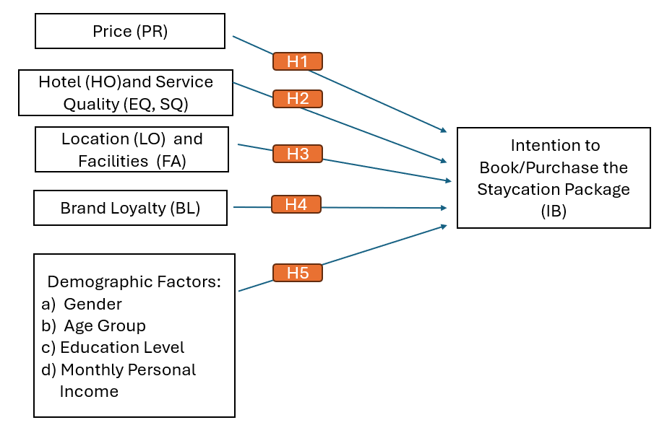

36

Chapter 3 The Research Methodology
3.1 Research Method
This study employs a deductive, quantitative research method to identify the relationships between independent and dependent variables outlined in the conceptual model.

Quantitative Research Method is chosen because it is well-suited for large sample sizes, enabling findings to be generalized to the entire population. Its key characteristics include structured data collection (often using closed-ended questions) and objective measurement. Its main advantages include efficient data analysis, feasibility of large-scale studies, higher participant response rates, reduced researcher bias due to numerical objectivity, and overall time and resource efficiency (particularly online). It is widely used in social sciences, healthcare, economics, and marketing nowadays (voicedocs.com, n.d.).

Primary data refers to first-hand information collected by researchers to achieve their research objectives (Longe, 2020). This study will collect primary data directly from the target audience (i.e. Hong Kong residents) through a structured online questionnaire.

Secondary data refers to existing information previously collected and published by other researchers, institutions, or industry organizations (Tantawi, 2024). This study's secondary data included academic journal articles analyzing tourism trends, consumer behavior theory, or hotel management strategies, as well as tourism industry reports published by organizations such as the Hong Kong Tourism Board (HKTB) and the Macao Government Tourism Office (MGTO). This data provides essential background information, theoretical frameworks, baseline statistics, and historical trends. It helps to validate the research design and identify key factors that influencing the demand of “Staycation Packages”.

37

3.2 Conceptual Framework
The conceptual framework (as described in Section 2.7) is visually represented below to
clearly state the relationship between the 4 independent variables and the dependent variable, Intention to Book/Purchase the Staycation Package.

Figure 3.2 The relationship between 4 independent variables and the dependent variable
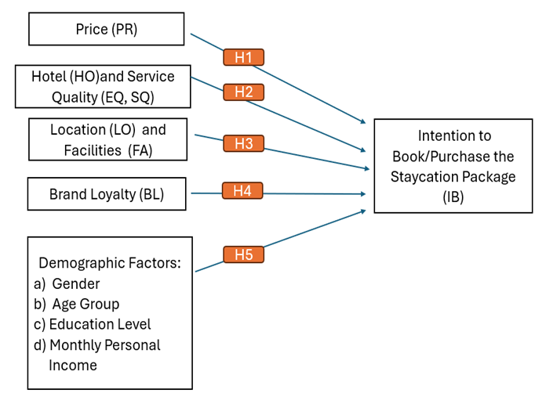

The conceptual framework of this study indicates that Hong Kong residents' preferences and choices for accommodation packages in Hong Kong and Macau are influenced by four key independent variables which are price, hotel and service quality (also considering employee quality), location and facilities, and brand loyalty. The expected impact of each variable is summarized below:

38

According to the conceptual framework, four key factors influence Hong Kong residents' staycation choices in Hong Kong and Macau are price, service quality (including employee quality), location/facilities, and brand loyalty. Their expected impacts are summarized below:
- Price:
- Impact: price is expected to have a strong influence on staycation package preferences. Higher prices typically reduce demand, but competitive pricing, discounts, or value-added inclusions (e.g. dining credits, spa/beauty treatments, sightseeing tours etc) can increase perceived value and attractiveness, particularly among budget-conscious guests or in off-peak seasons
- Rationale: Price sensitivity is fundamental to staycation decisions. As an optional purchase, consumers carefully weigh the cost against the benefits they expect. Finding the right price and value combination is vital for attracting buyers and meeting sales goals
- Hotel and Service Quality (including employee quality):
- Impact: good hotels and services quality including comfortable, luxurious accommodations and professional, responsive staff significantly boost attraction of “Staycation Packages” by enhancing perceived value and enjoyment
- Rationale: for a great staycation, the hotel is the experience. Guests want to step away from daily routines and enjoy relaxation experiences. Memorable stays are always built on excellent rooms, spotless cleanliness, inviting atmosphere, and genuinely attentive service that make people prefer a hotel and feel good about paying more. In competitive markets like Hong Kong and Macau, where top hotels abound, outstanding staff service is often what makes one hotel stand out from the rest

39

- Location and Facilities:
- Impact: selection of “Staycation Packages” is heavily influenced by location and facilities. Desirable locations (scenic views, proximity to attractions, accessibility to transportation hub) and high-quality facilities (pools, spas, dining venues) directly enhance the perceived value and attractiveness of the package
- Rationale: location determines ease of access and the kind of experience offered (urban excitement vs. resort relaxation). Facilities enhance the value by providing activities beyond just the room. Their availability and quality are crucial for satisfying different guest needs (like relaxation, family time, or romance) and gaining competitive edge
- Brand Loyalty:
- Impact: brand loyalty is likely to enhance preferences for "Staycation Packages." Familiarity, trust, and positive past experiences with a specific hotel brand may lead consumers to prioritize its offerings, diminishing their price sensitivity and reducing the perceived importance of minor attribute differences compared to competitors.
- Rationale: in competitive markets (e.g., hotels/resorts in Hong Kong and Macau), a good reputation simplifies choices for customers and reduces risk. Building trust through consistent service not only secures repeat business but also helps brands stand out.

These four independent variables (Price, Hotel and Service Quality, Location and Facilities, Brand Loyalty) interact dynamically. For instance, guests might accept a higher price if it's justified by superior quality, unique location or facilities, or strong brand loyalty.

40

Conversely, if quality or location is poor, even a lower price may deter guests. This study
will investigate the individual impact, relative importance, and how these variables interact with consumer characteristics (such as demographics and psychographics) to influence Hong Kong residents' staycation choices.

3.3 Research Hypotheses
The following hypotheses (H1-H5) are formulated to examine the factors driving Hong Kong residents' purchase intentions for staycation packages in Hong Kong and Macau:
- Price (H1) has a significant influence on Hong Kong residents' purchase intention for staycation packages
- Hotel and Service Quality (H2) have a significant positive effect on Hong Kong residents' purchase intention for staycation packages
- Location and Facilities (H3) have a significant positive effect on Hong Kong residents' purchase intention for staycation packages
- Brand Loyalty (H4) has a significant positive effect on Hong Kong residents' purchase intention for staycation packages
- Demographic variables (H5) moderate the relationships between independent and dependent variables

41

3.4 Research Design
3.41 Questionnaire Design and Coding of Variables:
The core of the questionnaire is designed to measure Hong Kong residences’ preference regarding “Staycation Packages”, directly derived from the literature and research objectives. This section utilizes a 5-point Likert Scale (1=Strongly Disagree to 6=Strongly Agree) to measure the impact of various factors including Price, Hotel and Service Quality (including employee quality too), location and facilities, brand loyalty on the choice of
“Staycation Packages” (WorkTango, 2023). Additionally, demographic information is collected including gender, age, education level and monthly personal income to enable
analysis of preference variations across population segments. The questionnaire's structure flows logically from screening through behavior and preference assessment to demographic profiling, aiming for comprehensiveness while maximizing response rates and data quality.

Each variable is coded and grouped as Independent Variable (IV) which including Price (PR), Hotel (HO) and Service Quality (EQ, SQ), Location (LO) and Facilities (FA), Brand Loyalty (BL). Dependent Variable (DV) includes Intention to Book/Purchase the Staycation Package (IB).

42

Table 3.41 Coding of 5 Variables and Academic References of Questionnaire
Variables | Category | Section in Questionnaire | Academic Reference
PR | IV | Section 1, Part 1, Q1-3 | (Graciola et al., 2018), (Low, Lee and Cheng, 2013), (Wen et al., 2021), (Collins and Parsa, 2006), (Li et al., 2023), (Xue, Jo and Bonn, 2020)
HO, EQ, SQ | IV | Section 1, Part 2, Q1-4 | (Tran et al., 2025), (Champahom et al., 2025), (Yang, Balasubramanian and Soeiro, 2025), (Nunkoo et al., 2019), (Chao, Yu and Sun, 2023),
LO, FA | IV | Section 1, Part 3, Q1-4 | (Mojoodi et al.), (Aksoy and Yetkin Ozbuk), (Sinergi.or.id, 2025)
BL | IV | Section 1, Part 4, Q1-3 | (Sun et al., 2024), (Kim, Han and Ariza-Montes, 2021), (Hussain et al., 2025), (Hany Ragb, Polo-Peña and Mahrous, 2024), (Abdullah Al Masud et al., 2024), (Dai et al., 2025), (Ju and Jang, 2022)
IB | DV | Section 1, Part 5, Q1-4 | (Martín-Gago, Camarero and Laguna-García, 2025), (Touni et al., 2022), (Wang et al., 2015), (Shen et al., 2022), (Yin, Poon and Su, 2017)

43

3.42 Population and Sampling
The target population comprises Hong Kong residents aged 18 years or older who have engaged in staycation experiences within Hong Kong or Macau during the preceding 48 months or are planning such experiences within the next 24 months. This definition ensures relevance to the study’s focus on current/preferential behaviors toward localized tourism offerings. Sampling approach will be utilizing on-line platform (e-questionnaire) and a target sample of 164 valid responses will be collected, determined through the following rationale:
Confidence Level: 80% (Z-score = 1.28)
Margin of Error: 5%
Population Proportion: 50%
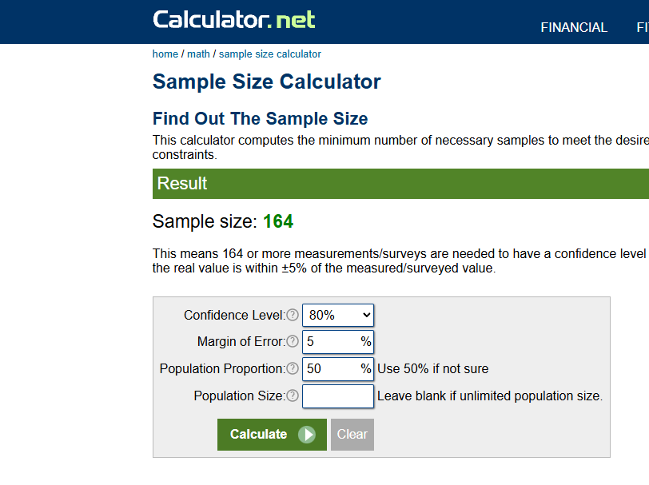

3.5 Relevant Methods for Data Analysis
This study uses quantitative methods for objective hypothesis testing and generalizable insights. Data from a structured online survey is analyzed in IBM SPSS Statistics, employing reliability test (Cronbach’s Alpha), descriptive statistics, correlation test, and multiple regression to ensure methodological rigor.

Reliability Test (Cronbach’s Alpha) is to ensure internal consistency reliability, Cronbach's Alpha (α) will be calculated in SPSS for all multi-item constructs (e.g., preferences for price, perceived hotel and service quality, location and facilities, brand loyalty.

44

Table 3.5 Result of Reliability Test = 0.915
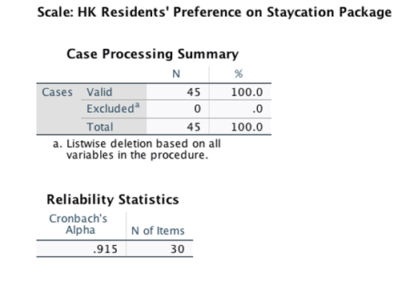
According to (Panayides, 2013), we can determine that α value of ≥ 0.70 is generally considered acceptable, ≥ 0.80 good, and ≥ 0.90 excellent.

Multiple Regression Analysis is employed to assess the relative influence of key independent variables (price, hotel and service quality, location and facilities, brand loyalty) on the dependent variable (Intention to Book/Purchase). This analysis quantifies the nature (positive or negative) and strength of the relationships between these variables and tests five specific hypotheses positing positive impacts.

The Descriptive Statistics use frequency, mean, standard deviation and other related descriptive functions to describe categorical variables provided by respondents from Part 2 of the questionnaire (i.e. gender, age group, education level and monthly personal income etc). This analysis aims to clearly characterize the respondents, identify overall trends, and quantify the variability within the dataset. This foundational understanding is crucial for setting the context and informing subsequent inferential analysis.

45

The Pearson Correlation Coefficient (denoted as r) is a parametric measure used within this study to quantify the strength and direction of a linear relationship between two continuous variables. It assesses the degree to which changes in one variable are associated with proportional changes in another. The resulting value of r ranges from -1 to +1. A value of +1 indicates a perfect positive linear relationship, -1 indicates a perfect negative linear relationship, and 0 indicates no linear association. The primary purpose of employing the Pearson Correlation Test in this research is to identify significant linear associations between key continuous variables pertinent to staycation preferences, such as the relationship between price sensitivity and facilities importance, or between income level and willingness to pay for premium packages (Nettleton, 2014).

3.6 Ethical Consideration
This research prioritizes ethical integrity through three core principles, such as informed consent that requires voluntary participation with clear disclosure of study aims, procedures, and withdrawal rights prior to survey commencement, confidentiality & anonymity which ensuring all data is anonymized by excluding unnecessary personally identifiable information, finally is data security which ensuring password-protected for all analysis files.

3.7 Pre-test
Before the main data collection process began, a pilot test (pre-test) of the questionnaire was conducted. This involved distributing a draft questionnaire to a sample of 55 potential respondents representing the target population (Hong Kong residents). The purpose of the pre-test is to identify potential ambiguities and technical issues in the survey design and procedures. Of the 55 questionnaires distributed, 45 were fully completed and returned, with a return rate of 82%. Feedback and data from these 45 completed pilot questionnaires were then analyzed to refine the final survey instrument, ensuring its clarity, validity, and reliability before launching the full-scale survey.

46

3.8 Research Schedule
The research timeline and key areas are detailed in the following Gantt Chart.

47

Chapter 4 Analysis and Results Discussion
4.1 Response Rate Analysis
- Survey Distribution and Completion
- This study used an online questionnaire as the sole data collection method. A total of 180 survey invitations were sent to eligible Hong Kong residents. Of these, 171 valid questionnaires were returned, achieving a response rate of 95.0%. The survey achieved its intended objectives and yielded a substantial number of high-quality, fully complete questionnaires. The response rate exceeded expectations, and data integrity checks confirmed that errors or missing values were extremely rare, ensuring the reliability and statistical significance of the research results.

- Data Completeness Overview
- The first part of the survey (Rating of Variables) contained 30 questions designed to measure respondents’ views on Price, Hotel and Service Quality, Location and Facilities, Brand Loyalty, and Intention to Book/Purchase "Staycation Package". Importantly, every one of the 171 respondents answered every question in this part, resulting in a complete dataset with no missing value (0% missing data).

- The second part of the survey collected basic demographic information about the respondents, covering four key areas which are gender, age group, education level, and monthly personal income. A total of 169 respondents provided complete information for all these demographic categories. However, two respondents did not complete their gender information, resulting in a very small amount of missing data for this specific variable, representing only 1.2% of the total responses.

48

Table 4.1 Statistics of Response Rate
Metric | Count | Percentage
Questionnaires Distributed | 180 | 100%
Completed Questionnaires | 171 | 95.0%
Fully Complete Datasets | 169 | 98.8%*
* Reflects complete data for both Parts 1 and 2

4.2 Descriptive Statistics
To collect descriptive statistics on demographics, the second part of the questionnaire posed four key questions to all 171 respondents concerning their Gender, Age, Education Level, and Monthly Personal Income.
Table 4.2(a) Age Distribution of Respondents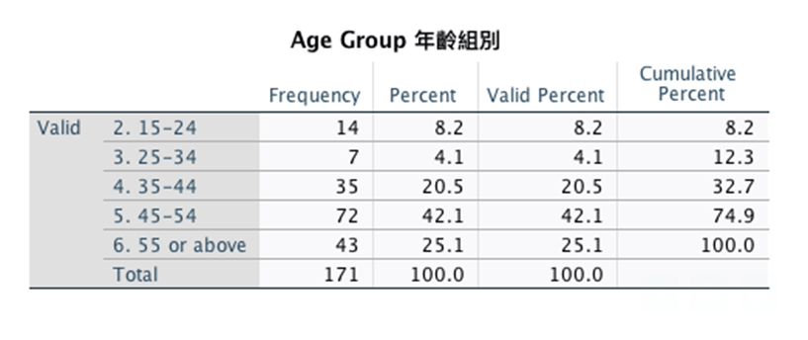
Table 4.2(a) The table provides a basic overview of the sample's demographics. The samples are highly concentrated in the 45-54 (42.1%) and 55+ (25.1%) age groups, indicating that the characteristics, preferences, or behaviors reflected in larger studies supported by this data are primarily influenced by these older groups. The sample size in the 25-34 age group is extremely small (4.1%), meaning that findings relevant to this age group require further interpretation. The percentages are identical to the valid percentages, indicating no missing values for age variations, thus enhancing the reliability of this descriptive summary for the collected sample.

49

In summary, this table effectively conveys the core age demographic information of the sample. Its clear structure allows us to immediately identify the main age groups (45-54 years and 55 years and above) and highlights the relative underrepresentation of younger adults, particularly the 25-34 age group. This distribution is crucial for understanding any subsequent analyses based on this dataset.

Table 4.2(b) Education Level Distribution of Respondents
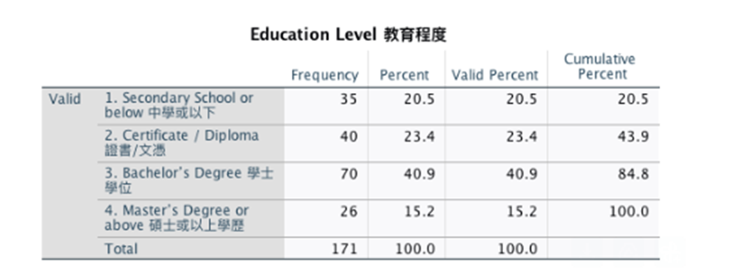

Table 4.2(b) This table clearly lists the education levels of the 171 respondents, categorizing them into four distinct levels: secondary school or below (20.5%, n=35), certificates/diplomas (23.4%, n=40), bachelor's degrees (40.9%, n=70), and master's degrees and above (15.2%, n=26). The valid percentages for each category match the actual percentages, indicating complete data with no missing values. The cumulative percentages increased from 20.5% (secondary school or below) to 43.9% (including certificates/diplomas), 84.8% (including bachelor's degrees), and finally reached 100% (including master's degree or above). In particular, the bachelor's degree is the most common education level, accounting for more than 40% of the respondents. Secondary school or below, along with certificate/diploma categories, accounted for 43.9% of the sample, while master's degree and above categories accounted for the smallest proportion, at only 15.2%. This distribution highlights the prominent position of bachelor's degrees and the relative balance between secondary education and vocational qualifications among the respondents.

50

Table 4.2(c) Monthly Personal Income Distribution of Respondents
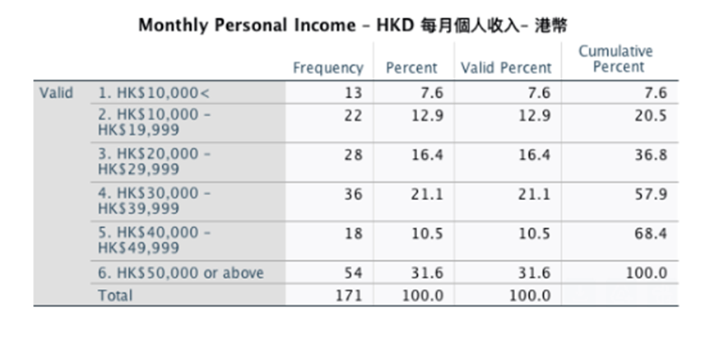
Table 4.2(c) An analysis of the monthly personal income of 171 Hong Kong respondents revealed different income distribution patterns. Especially, the highest income group (≥ HK$50,000) accounted for the largest proportion, at 31.6% (n=54), indicating a significant percentage of high-income earners. The middle-income group comprised 60.9% of respondents, but there were differences within this group: the HK$20,000-29,999 group was the most prominent (16.4%, n=28), followed by the HK$10,000-19,999 group (12.9%, n=22), the HK$30,000-39,999 group (21.1%, n=36), and the HK$40,000-49,999 group (10.5%, n=18). The lowest income group (<HKD 10,000) accounted for 7.6% (n=13). Overall, 68.4% of respondents had a monthly income below HKD 50,000, with 20.5% below HKD 20,000 and 37.0% below HKD 30,000. This income distribution is highly polarized income is concentrated in the highest and lowest income groups, while the middle-income group is relatively evenly distributed. This distribution provides valuable background information on the economic situation and potential spending power of the respondents, which is of great significance for conducting research on local holiday preferences.

51

Table 4.2(d) Hotel Pricing Perceptions Crosstabulation
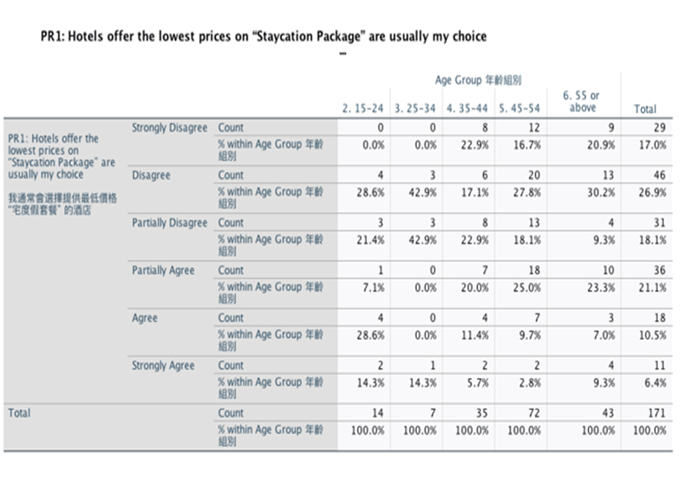
Table 4.2 (d) The crosstabulation analysis of 171 respondents revealed widespread skepticism towards hotels' price claims in Staycation Packages. Overall, 62% of respondents disagreed that the "lowest price" hotel is their top choice, with strong disagreement of 26.9% being the single largest response category. Only 38% of respondents showed agreement.

Table 4.2(e) Hotel Service Quality Preference Crosstabulation
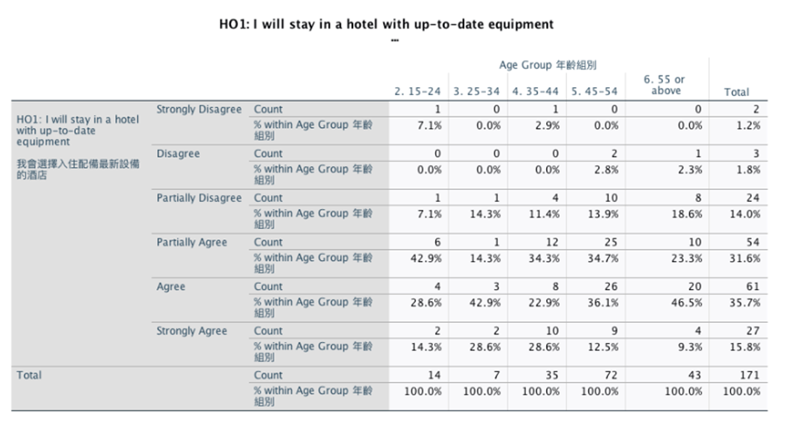

52

Table 4.2(e) The crosstabulation analysis of 171 respondents strongly supports the importance of service quality in making decision for hotel staycation. Among the 142 respondents with agreement, the vast majority showed a clear generational difference in their expectations of service quality. Those aged 45-55 and older were the most likely to agree, with 66% considering service quality as their key consideration when choosing a hotel. The 25-44 age group showed a moderate level of agreement of 25%, while the youngest group of 15-24 years old placed the lowest emphasis on service quality of only 10%. These findings underscores that hotel service quality is a primary consideration for Hong Kong residents when choosing staycation packages and suggest that service expectations increase significantly with age; older guests value personalized and attentive service experiences, while younger travelers focus more on other factors such as price or special amenities.

Table 4.2(f) Employee Service Quality Preference Crosstabulation
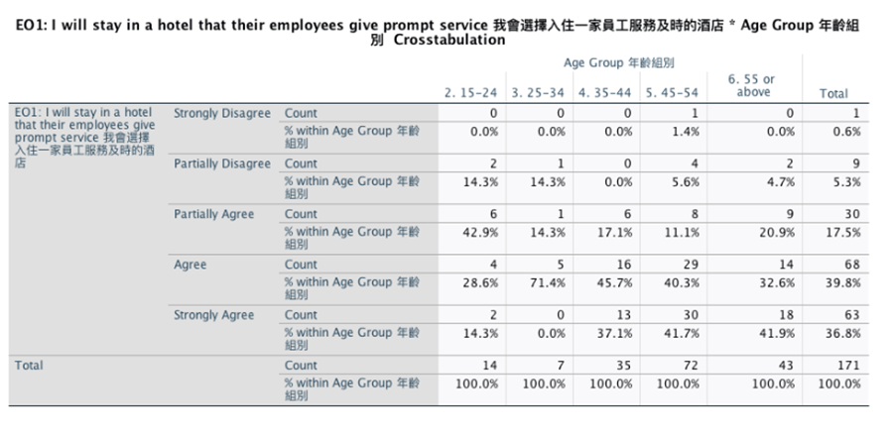
Table 4.2(f) The crosstabulation analysis findings reveal compelling insights into prompt guest services and generational differences regarding hotel service quality. An overwhelming 76.6% of respondents (131 out of 171) consider prompt service a decisive
factor in hotel selection, with only 5.8% (10 respondents) expressing disagreement, underscoring its critical role in guest retention. Significant age-based variations emerge,

53

with the 25-34 dataset illustrating the strongest preference that 71.4% agreement rate and 0% disagreement identifying non-negotiable service expectations. Older guests (55 or above) prioritize reliability, evidenced by the highest "Strongly Agree" responses of 42%, while younger guests in the range of 15-24 show more polarized views with 14.3% partially disagreeing. Obviously, prompt service transcends generational divides as one of the key competitive differentiators, driving decisions for two-thirds of guests across all age segments. These findings collectively establish service efficiency not merely as an amenity but as a fundamental determinant in hospitality choice.

Table 4.2(g) Hotel Location Preference Crosstabulation
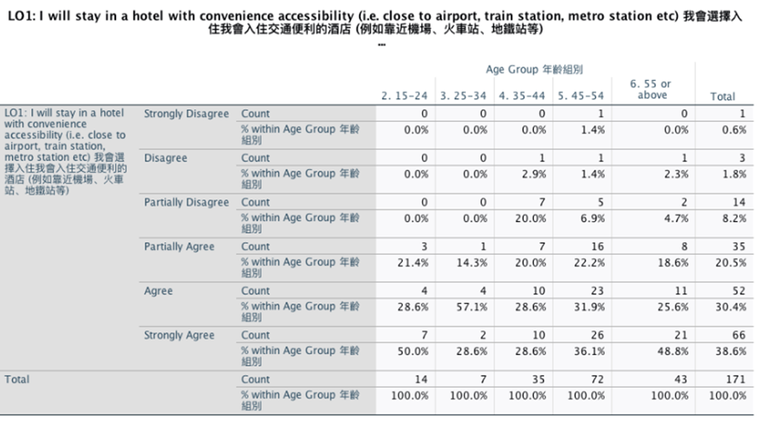
Table 4.2(g) The crosstabulation analysis the survey of 171 respondents disclosed that the vast majority (i.e. 89.5% respondents) stated that convenient location significantly influenced their choice of hotel staycation, with only 10.5% disagreeing. This finding highlights the decisive role of accessibility for nearly 90% of potential travelers when choosing staycation venues, particularly proximity to major transportation hubs such as airports, train stations, and metro stations. Convenient location's proven impact on consumer choice makes it essential for designing competitive vacation packages that fulfill expectations and secure bookings.

54

Table 4.2(h) Hotel Facilities Preference Crosstabulation
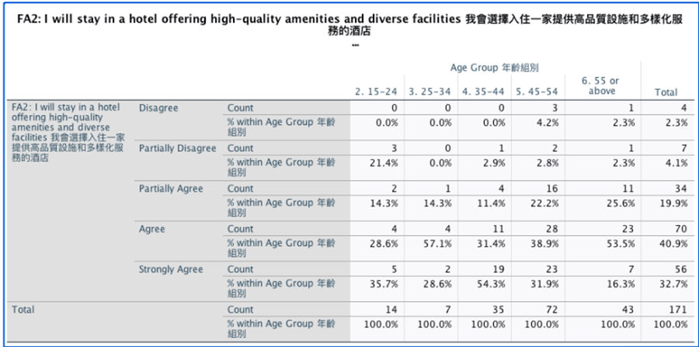

Table 4.2(h) Hotel Facilities Preference Crosstabulation analysis the survey of 171 respondents demonstrated that high-quality and diverse amenities significantly influence the choice of hotel staycation experiences. A remarkable 74% of respondents strongly agreed or agreed on the importance of high-end amenities, while only 6% disagreed. This significant result indicates that for approximately three-quarters of potential guests, well-maintained and diverse amenities are a decisive factor in their vacation accommodation choices. The extremely low dissent further confirms that amenities’ quality transcends age preferences and has become a basic requirement rather than a luxury add-on in the competitive hotel market.

55

Table 4.2(i) Brand Loyalty Perceptions Crosstabulation
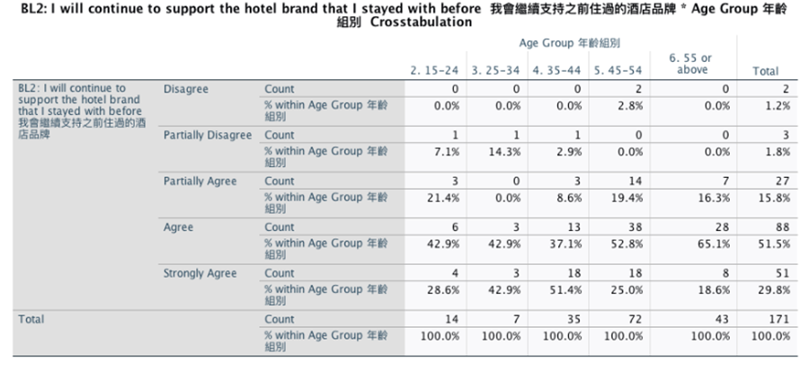
Table 4.2 (i) Brand Loyalty Perceptions Crosstabulation analysis reveals a strong correlation between brand loyalty and local holiday booking intentions among Hong Kong residents. Of the 171 respondents, nearly 97% agreed (including "partially agree," "agree," and "strongly agree") that loyalty to previous hotel brands significantly influences their decision to book local holiday packages from those brands. This overwhelming consensus highlights that positive past experiences are a major influence of the local staycation market.

Table 4.2(j) Future Intention to Book “Staycation Package” Crosstabulation
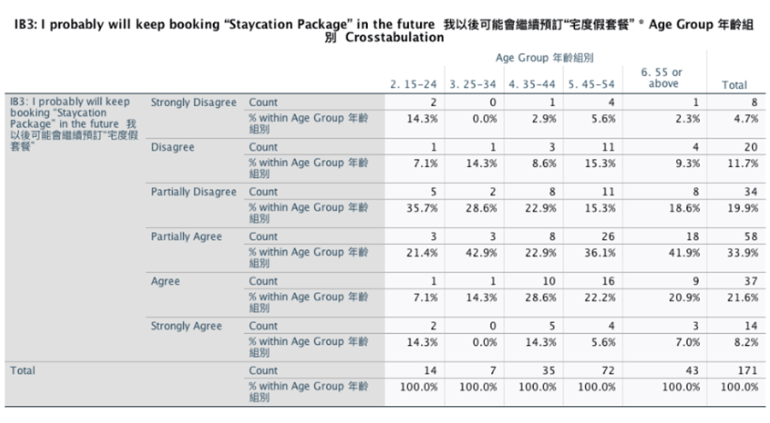

56

Table 4.2 (j) Future Intention to Book “Staycation Package” Crosstabulation analysis survey of 171 respondents, 63% of respondents agreed (including partially agree, agree, and strongly agree) with the intention to book staycation packages in the future, while 36% disagreed. The results indicate that turning disagreement into a positive outcome provides hotels with a significant opportunity to attract more customers and generate stable revenue.

4.3 Inferential Statistics
This section introduces the inferential statistical analysis based on Part 1 of the online questionnaire survey, which forms the core area of this study. The survey aimed to explore the relationships between key determinants of Hong Kong residents' decisions when choosing Hong Kong and Macau staycation packages. Specifically, the survey tool considered four independent variables include Price (PR), Hotel (HO) and Service Quality (SQ) (while also considering staff quality (EQ)), Location (LO) and Facilities (FA), and Brand Loyalty (BL). These independent variables were compared with the dependent variable of Intention to Book/Purchase Staycation Packages (IB).

To ensure the reliability of the research results, we will systematically analyze the collected data. Reliability Test (Cronbach’s Alpha) will be performed to verify the effectiveness of the measurement tools and determine the reliability of the dataset. Correlation Analysis to explore the bivariate relationships among the variables, thereby gaining a deeper understanding of their covariation followed by Regression Analysis to establish a predictive model between independent variables and dependent variables.

57

4.31 Reliability Test
To enhance readability and understandability of the research result, each variable is coded and grouped as follows:
Table 4.31(a) Coding of Variables
Variables | Code | Questions in the Survey
Price | PR | Section 1, Part 1, Q1-3
Hotel and Service Quality | HO, EQ, SQ | Section 1, Part 2, Q1-4
Location and Facilities | LO, FA | Section 1, Part 3, Q1-4
Brand Loyalty | BL | Section 1, Part 4, Q1-3
Intention to Book/Purchase | IB | Section 1, Part 5, Q1-4

We used a five-point Likert scale (1 = strongly disagree, 6 = strongly agree) to assess reliability, measuring the internal consistency of the survey items designed to evaluate these constructs. This approach ensures a reliable quantification of how each variable influences staycation booking decisions.

Table 4.31(b) Summary for Reliability Test on Variables
Variables | Code | No. of Questions | Cronbach’s Alpha
Price | PR | 3 | .727
Hotel Quality | HO | 4 | .740
Service Quality | SQ | 4 | .839
Employee Quality | EQ | 4 | .842
Location | LO | 4 | .678
Facilities | FA | 4 | .661
Brand Loyalty | BL | 3 | .771
Intention to Book/Purchase | IB | 4 | .908

58

Table 4.31(b) demonstrates all measured variables showed acceptable reliability. Cronbach's alpha scores ranged from 0.661 to 0.908, all above the standard threshold of 0.6. Booking/Purchase Intention (IB) had the highest score (α = 0.908). Location (LO) had the lowest score (α = 0.678), but it was still acceptable (Ratna Suhartini et al., 2021).

4.32 Correlation Analysis
Correlation analysis examines the strength and direction of linear relationships between two variables. The primary purpose in this study is to test whether hypothesized relationships exist between key independent variables, such as Price (PR), Hotel (HO) and Service Quality (SQ) (including Employee Quality (EQ)), Location (LO) and Facilities (FA), and Brand Loyalty (BL) and the dependent variable Intention to Book/Purchase (IB). This analysis helps identify which factors most strongly influence staycation package purchase decisions.

The Pearson Correlation Coefficient (r) is the primary indicator used in this analysis to quantify the linear relationship between variables. Its value reflects the direction and strength of the association. A positive coefficient (r > 0) indicates that the variables change in the same direction, e.g. higher perceived service quality is generally associated with higher purchase intention. Conversely, a negative coefficient (r < 0) indicates an inverse relationship, e.g. higher prices are associated with lower purchase intention. The coefficient ranges from -1.0 (perfectly negative correlation) to +1.0 (perfectly positive correlation), reflecting the strength of this linear association. The closer the coefficient is to -1.0 or +1.0, the stronger the correlation; the closer the coefficient is to zero, the weaker or negligible the linear association.

59

Determining the statistical significance of the observed correlation coefficient is crucial for assessing whether the relationship is real or due to random sampling error. This can be evaluated using the corresponding p-value (usually denoted as "Sig." in the statistical output table). A p-value less than the conventional significance level of 0.05 is sufficient to demonstrate that the observed correlation is statistically significant, meaning it is unlikely to be accidental. Conversely, a p-value greater than or equal to 0.05 indicates insufficient evidence to reject the null hypothesis at the 5% significance level, meaning that no statistically significant linear relationship between the variables was detected based on the existing sample data (Senthilnathan, 2019).

Table 4.32(a) Correlation Analysis on Price (PR) and Intention to Buy/Purchase (IB)
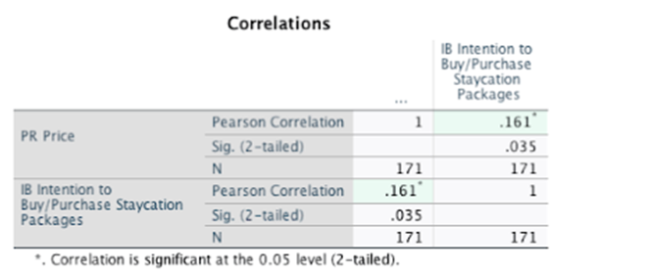
Table 4.32(a) result r = 0.161, indicates a positive weak relationship between customers' perception that Price influences Intention to Buy/Purchase “Staycation Packages”. Sig. = 0.035 is less than the standard threshold of 0.05. This means the observed positive correlation is significant.

60

Table 4.32(b) Correlation Analysis on Hotel Quality (HO) and Intention to Buy/Purchase (IB)
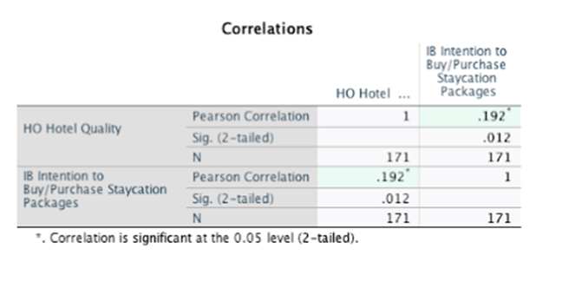
Table 4.32(b) correlation of 0.192 indicates a weak positive relationship between customers' perception that Hotel Quality influences Intention to Buy/Purchase “Staycation Packages”. Sig. = 0.012 is less than the standard threshold of 0.05, this result is considered significant.

Table 4.32(c) Correlation Analysis on Employee Quality (EQ) and Intention to Buy/Purchase (IB)
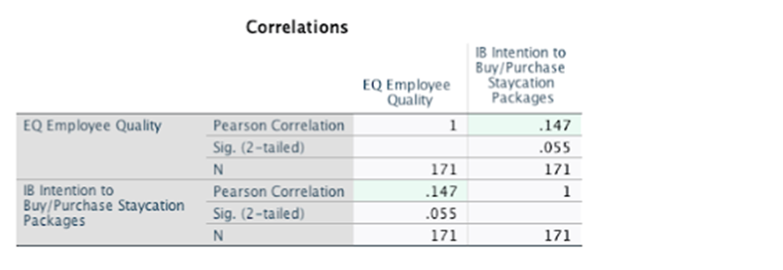
Table 4.32(c) correlation of 0.147 indicates a weak positive relationship between customers' perception that Employee Quality influences Intention to Buy/Purchase “Staycation Packages”. Sig. = 0.055 is greater than the standard threshold of 0.05, this result is considered not significant.

61

Table 4.32(d) Correlation Analysis on Service Quality (SQ) and Intention to Buy/Purchase (IB)
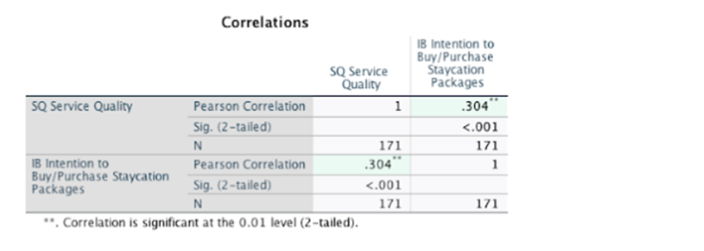
Table 4.32(d) correlation of 0.304 indicates a moderate positive relationship between customers' perception that Service Quality influences Intention to Buy/Purchase “Staycation Packages”. Sig. = 0.001 is less than the standard threshold of 0.05, this result is considered highly significant.

Table 4.32(e) Correlation Analysis on Location (LO) and Intention to Buy/Purchase (IB)
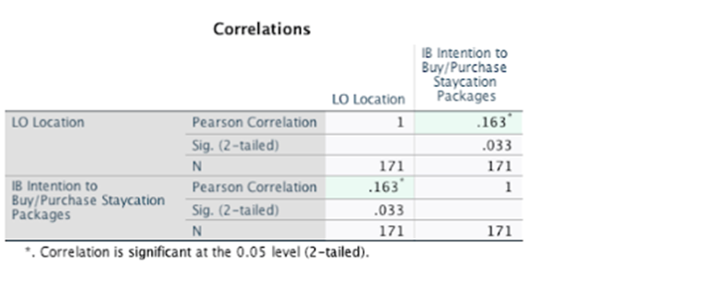
Table 4.32(e) correlation of 0.163 indicates a weak positive relationship between customers' perception that Location influences Intention to Buy/Purchase “Staycation Packages”. Sig. = 0.033 is less than the standard threshold of 0.05, this result is considered significant.

62

Table 4.32(f) Correlation Analysis on Facility (FA) and Intention to Buy/Purchase (IB)
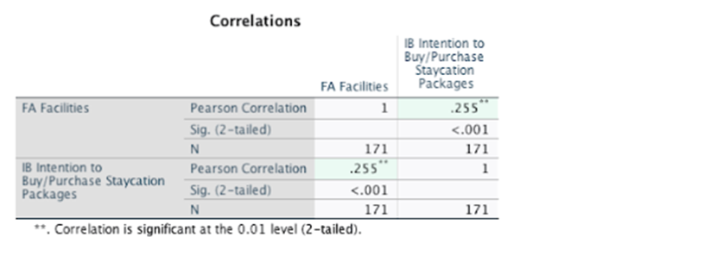
Table 4.32(f) correlation of 0.255 indicates a moderate positive relationship between customers' perception that Facility influences Intention to Buy/Purchase “Staycation Packages”. Sig. = 0.001 is less than the standard threshold of 0.05, this result is considered highly significant.

Table 4.32(g) Correlation Analysis on Brand Loyalty and Intention to Buy/Purchase (IB)
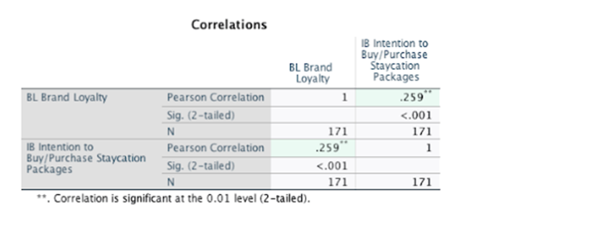
Table 4.32(g) correlation of 0.259 indicates a moderate positive relationship between Brand Loyalty and Intention to Buy/Purchase “Staycation Packages”. Sig. = 0.001 is less than the standard threshold of 0.05, this result is considered highly significant.

63

Table 4.32(h) Summary of Correlations Analysis on Price (PR), Hotel Quality (HO), Service Quality (SQ), Employee Quality (EQ), Location (LO), Facilities (FA), Brand Loyalty (BL) and Intention to Buy/Purchase (IB)
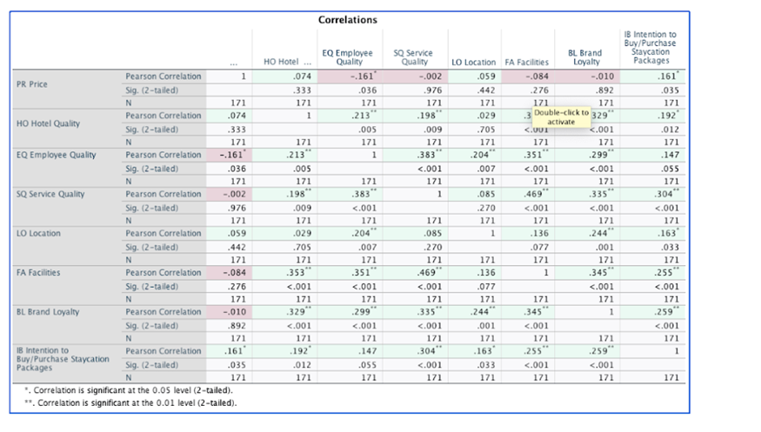
Table 4.32(h) demonstrates the results of The Pearson Correlation Coefficient (r) of the 8 variables with details as follows:

- The correlation test between Price and Intention to Buy/Purchase is 0.161 (r=0.161, p<0.05) representing a positive but weak correlation.
- The correlation test between Hotel Quality and Intention to Buy/Purchase is 0.192 (r=0.192, p<0.05) representing a positive but weak correlation.
- The correlation test between Employee Quality and Intention to Buy/Purchase is 0.147 (r=0.147, p>0.05) indicates that there is no relationship between these 2 variables.
- The correlation test between Service Quality and Intention to Buy/Purchase is 0.304 (r=0.304, p<0.05) representing a moderative positive correlation.
- The correlation test between Location and Intention to Buy/Purchase is 0.163 (r=0.163, p<0.05) representing a positive but weak correlation.

64

- The correlation test between Facilities and Intention to Buy/Purchase is 0.255 (r=0.255, p<0.05) representing a moderate positive correlation.
- The correlation test between Brand Loyalty and Intention to Buy/Purchase is 0.259 (r=0.259, p<0.05) representing a moderate positive correlation.

4.33 Regression Analysis
Regression analysis is a statistical technique used to model the relationship between a dependent variable (the predicted outcome of a study) and one or more independent variables. Its core objective is to derive a mathematical formula that can accurately predict the value of the dependent variable based on the values ​​of the independent variables. It is a primary tool in machine learning and statistics for modeling and predicting continuous outcomes, quantifying relationships between variables, and understanding how changes in the predictor variable affect the target outcome (Junaid, 2022).

This section employs regression analysis to quantify the relationships between the key variables identified in previous chapters. Specifically, it examines how independent variables such as price, hotel service quality, location and facilities, and brand loyalty collectively influence the dependent variable – Intention to Buy/Purchase “Staycation Packages”. Regression analysis also helps to simulate the net effect of each predictor variable while controlling for other variables. This approach enables data-driven package optimization by identifying the most important factors influencing staycation demand and providing hotel operators with actionable insights.

65

Table 4.33(a) Multiple Linear Regression – Variables Entered/Removed
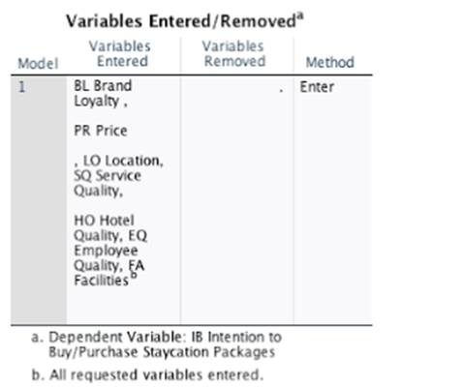

Table 4.33(b) Summary of Regression Analysis on Price (PR), Hotel Quality (HO), Service Quality (SQ), Employee Quality (EQ), Location (LO), Facilities (FA), Brand Loyalty (BL) and Intention to Buy/Purchase (IB)
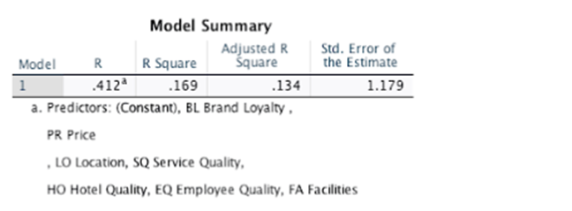

Table 4.33(b) indicates that the R (Multiple Correlation Coefficient) equals to 0.412 represents a moderate positive correlation. This means that collectively, the independent variables are associated with higher Intention to Buy, but the relationship is not exceptionally strong. There is a discernible link, but other unmeasured factors also play a

66

significant role. Additionally, R Square (Coefficient of Determination) equals to 0.169 (16.9%) and adjusted as 0.134 (13.9%) of the variation in Intention to Buy. This strongly suggests that other key factors which are not included in this model are also considered the drivers of Intention to Buy.

Table 4.33(c) ANOVA Table
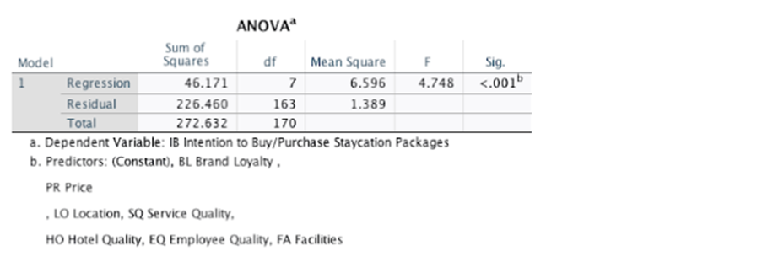
Table 4.33(c) ANOVA identified the importance of the predictors which the result of F=4.748, p < .001, explains a highly statistically significant Regression Analysis. This means that the combination of independent variables included in the study (PR Price, HO Hotel Quality, EQ Employee Quality, SQ Service Quality, LO Location, FA Facilities and BL Brand Loyalty) can significantly explain the variance observed in the dependent variable (IB Intention to Buy/Purchase).

67

Table 4.33 (d) Analysis Result of Coefficients for Independent Variables
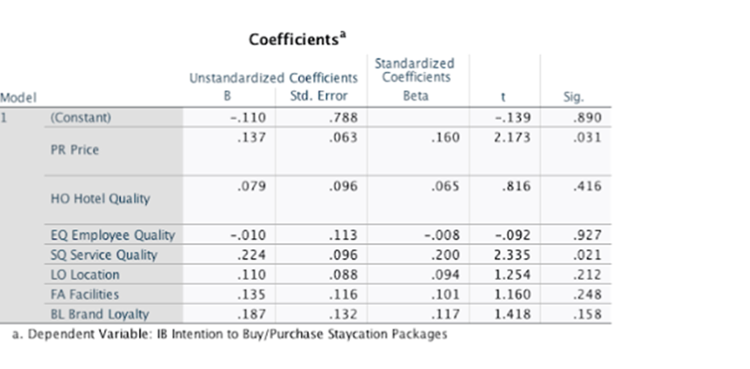
Key findings from the analysis in Table 4.33 (d) as follows:
- Price (PR) has a significant negative impact on consumers' willingness to purchase “Staycation Packages”. The Unstandardized Coefficient (B) is -0.137, indicating that the higher the price, the lower the purchase intention. This result is statistically significant (Sig. = .031, p < 0.05), confirming that price sensitivity is an important factor influencing consumer decisions. In effect, this means that price increases on “Staycation Packages” may frighten potential buyers, highlighting the necessity of strategic pricing in the market.

- The Unstandardized Coefficient for Service Quality (SQ) was positive at B = 0.224. This means that the higher the service quality, the stronger the consumer's willingness to purchase the “Staycation Package”. This positive correlation is statistically significant, with a significant value of Sig. = .021, which is less than the commonly used threshold of 0.05 (p < 0.05). The analysis shows that Service Quality (SQ) is a major driver influencing consumers' decisions to book “Staycation Packages”. Its statistically significant positive coefficient highlights the key role of service quality in differentiating products/services in the market.

68

- The analysis reveals a positive Unstandardized Coefficient (B = 0.079) for Hotel Quality (HQ), indicating that higher hotel quality correlates with a slight increase in purchase intention for “Staycation Packages”. However, this relationship lacks statistical significance with Sig. = 0.416, as the p-value exceeds the common threshold of 0.05.
- The analysis of Employee Quality (EQ) explained a negative Unstandardized Coefficient (B = -0.010), clearly indicating a negative correlation between employee quality and willingness to purchase “Staycation Packages”. Sig. = .927, p-value is significantly higher than the 0.05 threshold, result is not statistically significant. These findings indicate that employee quality is not a significant predictor of intention to purchase “Staycation Packages”.
- The analysis of Location (LO) shows a positive Unstandardized Coefficient (B = 0.110), indicating that the more advantageous the location, the higher the willingness to purchase “Staycation Packages”. However, this relationship lacked statistical significance because the p-value exceeded the conventional threshold of 0.05 (Sig. = 0.212).
- Facilities (FA) coefficient analysis showed a positive Unstandardized Value (B = 0.135), indicating that the level of amenities is associated with a higher willingness to purchase for “Staycation Packages”. However, like Location (LO), this relationship is not statistically significant (Sig. = 0.248), with the p-value exceeding the threshold of 0.05.
- The analysis results show that the Unstandardized Coefficient of Brand Loyalty (BL) is positive (B = 0.187), indicating that consumers with strong brand affinity have a higher willingness to purchase “Staycation Packages”. However, since the p-value exceeds the conventional threshold of 0.05, this relationship lacks statistical significance (Sig. = .158).

69

4.4 Discussion and Results
Based on the statistical analysis shown in Table 4.33d, we found that Price (PR) has a significant statistical impact on Hong Kong residents' intention to purchase "Staycation Packages." Its significance level (Sig. = .031) confirms that price is a key determinant of consumer decisions. The analysis also indicates that Service Quality (SQ) is another highly significant driver (Sig. = .021), suggesting that the perceived quality of service within the package is a major factor influencing purchase intention.

Conversely, the results indicate that Employee Quality (EQ) and Brand Loyalty (BL) have no significant direct impact on purchase intention in this model, as evidenced by their high significance values. This means that while these factors may have indirectly influence other variables, their direct impact on the decision to purchase the “Staycation Packages” lacks statistical support based on the current analysis. The Unstandardized Coefficients (B) and Standardized Coefficients (Beta), detailed in the table, quantify the strength and direction of these effects, providing actionable insights into prioritizing attributes in package design and marketing strategies.

Summary of Coefficient Analysis with details as follows:
Statistically Significant Drivers:
- Price (PR): Exhibited a significant negative impact on purchase intention (B = -0.137, p = 0.031). Higher prices directly reduce willingness to purchase, confirming strong price sensitivity.
- Service Quality (SQ): Demonstrated a significant positive influence (B = 0.224, p = 0.021). Superior service quality is a key differentiator that enhances purchase intention.

70

Non-Significant Factors:
- Hotel Quality (HQ) (B = 0.079, p = 0.416), Employee Quality (EQ) (B = -0.010, p = 0.927), Location (LO) (B = 0.110, p = 0.212), Facilities (FA) (B = 0.135, p = 0.248), and Brand Loyalty (BL) (B = 0.187, p = 0.158) showed no statistically significant relationship with purchase intention.

The regression analysis provides first-hand evidence of the influence of various factors on the intention to purchase “Staycation Packages”. Based on the coefficients and significance levels derived from the model, we can draw conclusions about hypothetical relationships (H1-H4). Specifically, the analysis reveals which factors have a statistically significant impact on purchase intention, allowing us to test or refute the initial hypotheses. The results highlight the key role of certain attributes while showing that some other attributes do not have a significant impact on the model. The following are the specific conclusions for each hypothesis based on statistical evidence.

Results on Hypothesis Testing (H1–H4):
- Price (H1) has a significant influence on Hong Kong residents' purchase intention for staycation packages:
- Supported. The negative coefficient (B = -0.137, p < 0.05) validates that price is a critical deterrent. Practical implication of strategic pricing is essential to avoid alienating price-sensitive consumers.
- Hotel and Service Quality (H2) have a significant positive effect on Hong Kong residents' purchase intention for staycation packages:
- Partially Supported. While Service Quality (SQ) is significant (B = 0.224, p < 0.05), Hotel Quality (HQ) is insignificant (p = 0.416). This suggests service excellence outweighs physical hotel attributes in driving purchase intention.

71

- Location and Facilities (H3) have a significant positive effect on Hong Kong residents' purchase intention for staycation packages:
- Rejected. Neither Location (LO) (p = 0.212) nor Facilities (FA) (p = 0.248) had significant effects. This implies convenience and amenities alone do not sway purchase intention.
- Brand Loyalty (H4) has a significant positive effect on Hong Kong residents' purchase intention for staycation packages:
- Rejected. Despite a positive coefficient (B = 0.187), the result is statistically insignificant (p = 0.158). Brand affinity does not reliably impact purchase intention.

72

Chapter 5 Conclusion and Recommendations

5.1 Conclusion
5.11 Discussion on Key Findings of Descriptive Statistics

The descriptive analysis of respondent demographics in Chapter 4.2 reveals the profile crucial for interpreting the study's results.

Age distribution shows in Table 4.2(a) reveals a strong skew toward middle-aged groups in the sample. Respondents aged 45–54 years form the largest segment (42.1%), followed by those aged 55+ (25.1%). Together, these two cohorts constitute over two-thirds of respondents (67.2%). Conversely, younger adults (particularly the 25–34 age group) are significantly underrepresented at just 4.1%. This distribution indicates that the study's overall findings primarily reflect the preferences and behaviors of middle-aged Hong Kong residents.

Table 4.2(b) shows the education levels of the 171 respondents show a generally high attainment, with bachelor's degrees being the most common qualification. Representing 40.9% of respondents, bachelor's degrees were held by 70 individuals. Certificates or diplomas accounted for 23.4% (n=40), while secondary school education or below made up 20.5% (n=35). Together, these two categories comprised 43.9% of the sample. Postgraduate qualifications (master's degree or above) were held by 15.2% of respondents (n=26). This distribution highlights the prominence of bachelor's degrees while also reflecting diversity through substantial representation of both vocational qualifications and secondary education levels.

73

Table 4.2(c) reveals the distribution of monthly personal income among respondents, indicating that 21.1% report earnings within the HK$30,000 – HK$39,999 bracket, while 10.5% fall into the HK$40,000 – HK$49,999 range. Notably, the largest segment of respondents, comprising 31.6%, report monthly personal incomes of HK$50,000 or above.

Analysis of Tables 4.2(d to j) identifies that Hong Kong residents have distinct priorities when choosing “Staycation Packages”. Service quality is a key factor, with 76.6% of respondents considering fast service essential, a view shared across all age groups. However, middle-aged guests aged 55 and above place greater emphasis on reliability (42% of respondents strongly agree). This generational difference is also reflected in expectations for overall service, 66% of those aged 45-55 and above prioritize service, compared to only 10% of those aged 15-24. Location is also important, with 89.5% of respondents believing that convenience, especially proximity to transportation hubs, plays significantly influenced the staycation choices. Similarly, 74% of respondents considered high-quality facilities essential.

Brand loyalty demonstrates a significant impact, with 97% of respondents stating that past positive experiences directly influence their likelihood of booking staycation packages from familiar hotel brands. This overwhelming finding highlights the value of customer retention strategies in the local vacation market. Looking ahead, 63% of respondents indicated they are interested in purchasing staycation packages in the future, while 36% of respondents remain chary. This presents hotels with a fruitful opportunity to convert unconvinced customers through precise product and service offerings. The survey results collectively indicate that while service quality, convenience location, and up to date facilities are competitive advantages for attracting customers, leveraging brand trust and meeting the needs of hesitant customers is crucial for maintaining market share. Hotels must also pay attention to the nuances of different generations of customers, particularly the high service sensitivity of middle-aged guests and the higher expectations of younger travelers for value propositions beyond price.
74

5.12 Discussion on Testing Results of Hypothesis (H1–H4)
As for the discussions and findings in Chapter 4, the final conclusions on proposed hypotheses are as follows:

Table 5.12 Conclusions on Proposed Hypotheses
Hypotheses | Conclusion
H1 Price has a significant influence on Hong Kong residents' purchase intention for staycation packages | Supported
H2 Hotel and Service Quality have a significant positive effect on Hong Kong residents' purchase intention for staycation packages | Partially Supported
H3 Location and Facilities have a significant positive effect on Hong Kong residents' purchase intention for staycation packages | Rejected
H4 Brand Loyalty has a significant positive effect on Hong Kong residents' purchase intention for staycation packages: | Rejected

The research results indicate that Hong Kong residents have different considerations when choosing “Staycation Packages”. Price sensitivity prompts hotels to adopt value-oriented strategies. Excellent service quality is the most effective way to differentiate products and enhance price reasonableness. While convenient location and comprehensive facilities are basic requirements, they are not the important factors determining purchase in a highly competitive market.

Brand loyalty plays a crucial role in customer retention and target audience positioning, but it is not the primary driver of purchase intention. Hotels must prioritize excellent service and transparent value communication, reflecting these elements in pricing and packages to effectively attract customers. Hotels should leverage brand loyalty to encourage repeat business while recognizing that facilities and location are fundamental customer needs.

75

5.2 Recommendations
This chapter translates our research findings on Hong Kong residents' staycation preferences into actionable and commercially viable strategies for hotels in Hong Kong and Macau. Our research exposed several key insights that directly influence our recommendations: (1) The middle-aged demographic (45 years and above, 67.2%) is dominant, prioritizing excellent service (over 66%); (2) They are highly price-sensitive (Hypothesis 1); (3) Service quality is more important than hotel facilities and location. Brand loyalty has a significant impact on customer retention (97%), although its influence on first-time purchase decisions is limited (Hypothesis 4); (5) The undecided customer base is large and untapped (36%).

These findings collectively demonstrate that success in the highly competitive staycation market requires tailored strategies for service delivery, value communication, and customer conversion. The following recommendations leverage these empirical insights to employ data-driven strategies to fill market gaps, optimize revenue streams, and build a sustainable competitive advantage.

- Prioritize Service Excellence as the Core Differentiator (Addressing H2 & Demographics):
  - Action: Implement "Service Tiering" with generational nuance. Train staff in anticipatory service (e.g., remembering preferences, proactive problem-solving) for guests aged 45+, while offering efficient, tech-enabled service (e.g., app-based requests, quick check-in/out) for younger segments.
  - Commercial Value: Directly targets the dominant customer segment (67.2% aged 45+) who highly value service (66%+ prioritization). Enhances perceived value, justifies premium pricing, increases positive reviews/referrals, and boosts retention (linked to brand loyalty findings). Return On Investment target set to increase repeated bookings & reduce customer acquisition costs.

76

- Adopt Value-Based Pricing & Transparency (Addressing H1 & Pricing Perceptions):
  - Action: Move away from "lowest price" claims (62% skepticism). Structure packages with clear, itemized value: e.g., "Luxury Escape: HK$3,500 includes Suite Upgrade (Value HK$1,000), Gourmet Dinner for Two (HK$900), 60-min Spa Credit (HK$900), Late Checkout." Highlight inclusions relative to published rates. Offer tiered packages (Essential, Premium, Luxury) catering to income polarization.
  - Commercial Value: Aligns with price sensitivity (H1 Supported) while countering skepticism. Targets high-income earners (31.6% ≥HK$50k) with premium offerings and price-conscious segments (<HK$30k: 37%) with value-packed essentials. Increases perceived fairness and conversion rates. Return On Investment is to drive higher ADR (Average Daily Rate) and improve RevPAR (Revenue Per Available Room).

- Leverage Brand Loyalty for Retention & Community Building (Addressing H4 & Loyalty Data):
  - Action: Transform loyalty programs beyond points. Offer "Members-Only" staycation packages with exclusive amenities (e.g., private lounge access), guaranteed room upgrades, flexible cancellation for loyal guests. Create branded staycation communities (e.g., themed events, post-stay online forums).
  - Commercial Value: Capitalizes on the overwhelming finding that 97% are influenced by past positive experiences. While H4 was rejected for initial purchase intention, loyalty is crucial for repeated business and brand positioning. Return On Investment is to increase repeated business rate and minimize the marketing expenses.

77
- Develop Targeted Conversion Campaigns for Hesitant Customers (Addressing Future Intention):
  - Action: Identify the "Hesitant 36%" and analyze demographic/psychographic data to understand their barriers (e.g., perceived value, lack of relevance). Create compelling entry-point offers, e.g. "First-Time Staycation Trial" packages focusing on core value drivers (e.g., Buy One Get One Free on "Weekend Getaway Package”). Use testimonials from similar demographics.

  - Commercial Value: Addresses a significant untapped market segment (36% not intending future bookings). Effective conversion expands the total addressable market and builds new customer relationships. Return On Investment is to drive new customer acquisition, incremental revenue growth.

- Optimize Facilities & Location as The Basic Requirement, Not Differentiators (Addressing H3 & Facility Preference):
  - Action: Ensure facilities are impeccably maintained (74% see high-quality amenities as essential). Promote location convenience (89.5% value transport links) as a baseline benefit. Integrate facilities into the core experience, e.g., "Spa & Dine Package" leveraging on-site amenities, or "Urban Explorer Package" with curated maps highlighting nearby attractions accessible via the convenient location.

  - Commercial Value: Meets fundamental customer expectations (H3 Rejected as a primary driver, but essential for consideration). Prevents dissatisfaction but focuses investment and marketing on higher-impact differentiators (Service, Value, Loyalty). Return On Investment target is to maintain competitiveness, avoids negative reviews due to poor facilities/inaccessibility.

78
- Implement Strategic Off-Peak Staycation Programs (Addressing Seasonality Opportunity):
  - Action: Design attractive packages specifically for weekdays, rainy seasons, or traditional low periods. Bundle with underutilized services (e.g., spa, F&B, discount on merchandizing products through partnership, private shopping and entertainment experience).
  - Commercial Value: Smooths demand fluctuations, increase occupancy during low periods, utilize fixed assets more efficiently, and improve annual revenue stability. Appeals to residents seeking value and convenience. Return On Investment target to increase annual occupancy rate, improved resource utilization (staff, facilities) and stabilized cash flow.

5.3 Limitation and Further Study
This study provides valuable insights on Hong Kong residents' preferences for staycation packages in Hong Kong and Macau. However, there are some essential limitations in the study design and sample characteristics should be acknowledged, which also point to helpful directions for future research.

- Sample Representativeness and Generalizability
- Age distribution: As shown in Table 4.2(a), the sample is mainly concentrated among respondents aged 45-54 (42.1%) and 55 and above (25.1%). Notably, the younger age group, especially the 25-34 age group, is significantly underrepresented (4.1%). This age distribution bias limits the general applicability of the study results to the entire adult population of Hong Kong. The preferences, priorities, and consumption behaviors found in this study mainly reflect the situation of middle-aged residents. Whether these findings are applicable to the preferences of younger adults (e.g., Millennials and Generation Z) remains uncertain and requires further study.

79
- Educational Level Weighing: Table 4.2(b) shows that the sample population is highly educated, with the vast majority holding a bachelor's degree (40.9%) or higher (15.2% holding a master's degree or higher), totaling 56.1%. While there are also individuals with certificates/diplomas (23.4%) and secondary school education or below (20.5%), the overall educational attainment of the sample population is generally high. This may influence their perception of value, interest in specific facilities, or brand awareness, and this influence may not be reflected in the broader population, especially those with lower levels of education.
- Income diversity: While Table 4.2(c) shows that respondents covered all income levels, the proportion of high-income groups is very high, i.e. 68.6% of respondents with a monthly income of HK$30,000 or above. The data for younger, potentially lower-income groups is less valuable. This suggests that findings regarding representativeness may be more applicable to low-income individuals. Furthermore, the preferences of low-income residents for staycation packages were not adequately considered.

- Impact on Research Findings
- Due to demographic limitations, the staycation packages preferences identified in this study (price, importance of service quality), the understanding of changes in consumer behavior drivers are mainly applicable to the sample population (middle-aged, higher education, with mixed income levels but leaning towards middle/upper-middle income). When generalizing these findings to a broader Hong Kong population, especially to younger groups and those with lower levels of education or income, caution is warranted. The recommendations for hotel operators based on this study are likely most applicable to the more representative population group discussed in this study.

Given the condensed six-month research period (commencing May 2025 with submission due November 2025), opportunities for more extensive exploration and in-depth analysis are necessarily limited.
80

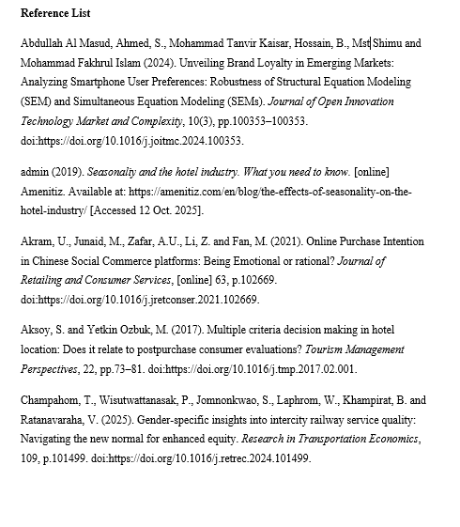

81

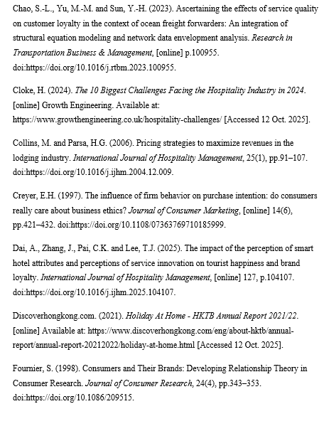

82
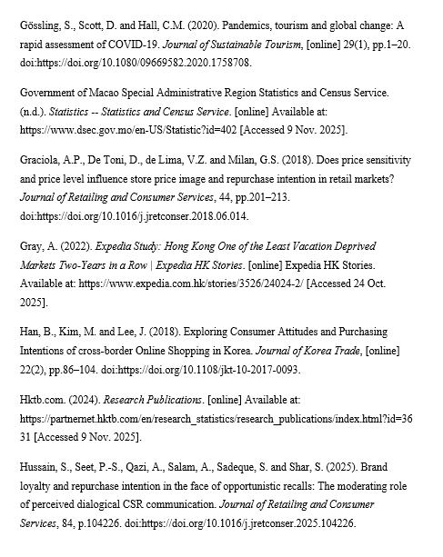

83

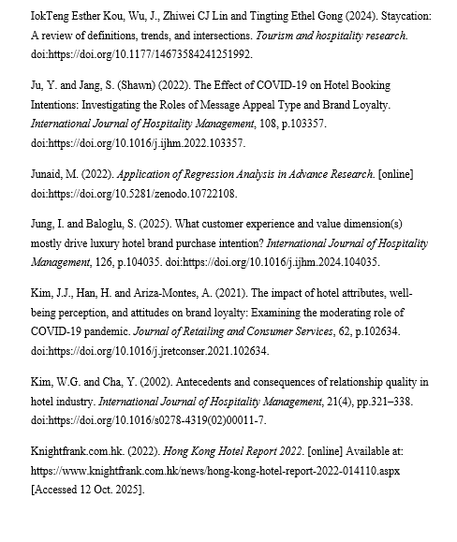

84

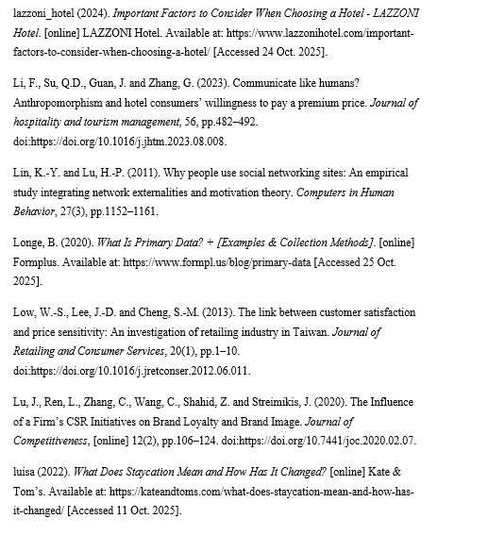

85
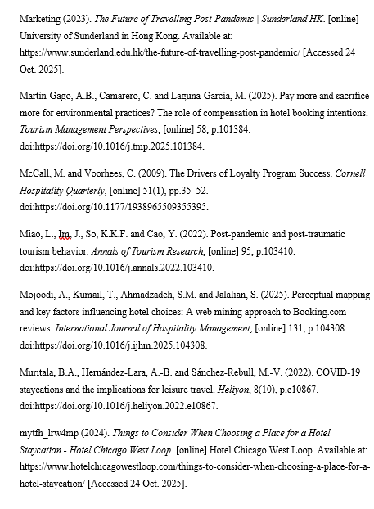

86

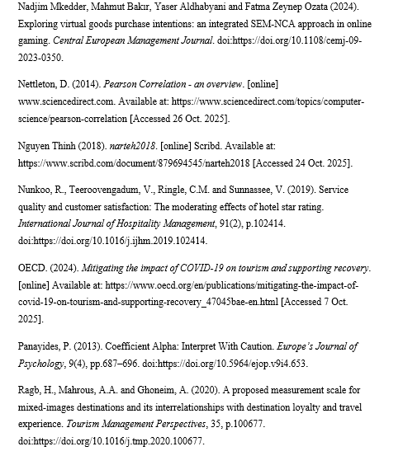

87

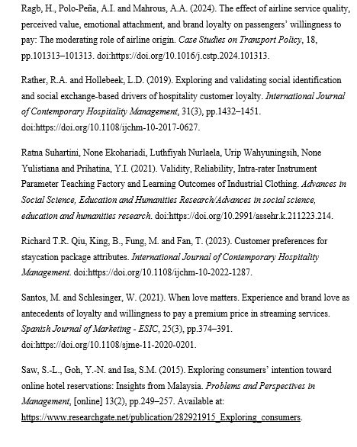

88
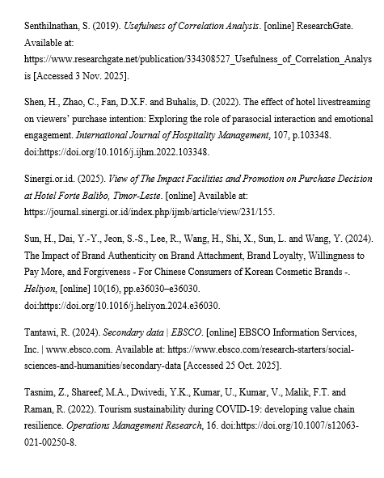

89

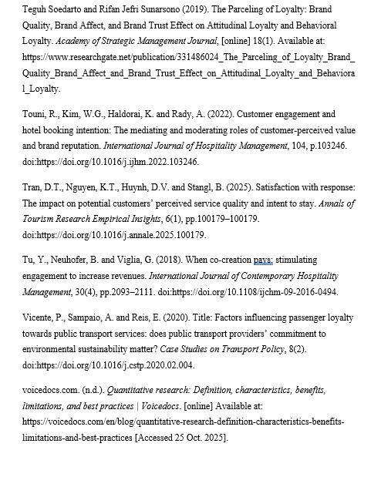

90
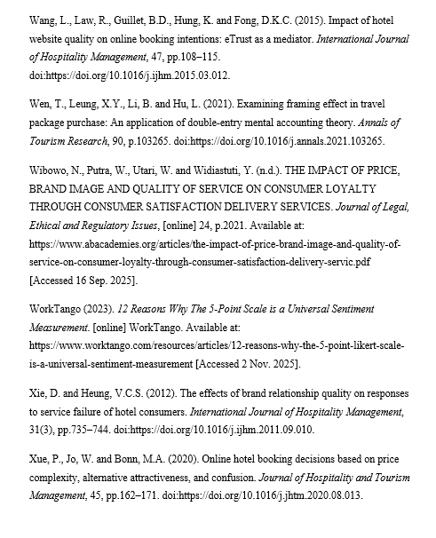

91

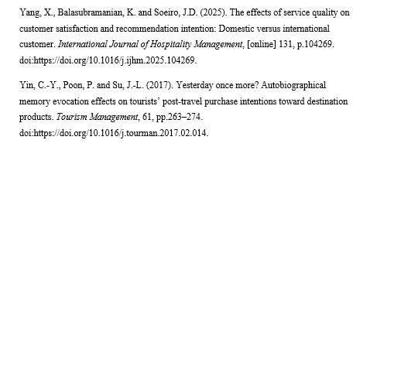

92

Appendix 1 – Questionnaire on Hong Kong Residents’ Preferences for Staycation Packages in Hong Kong and Macau
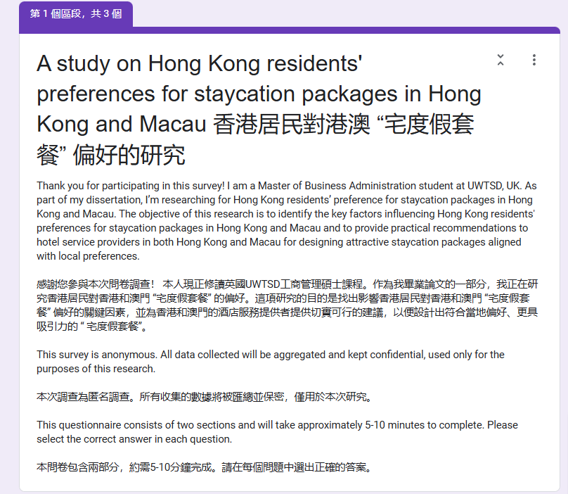
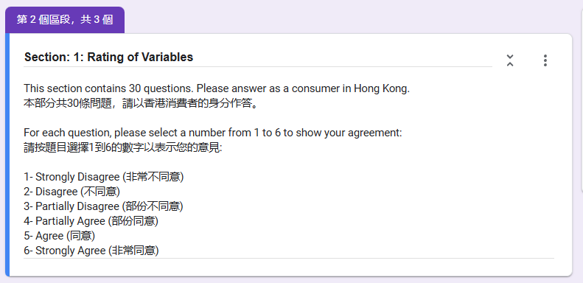

93

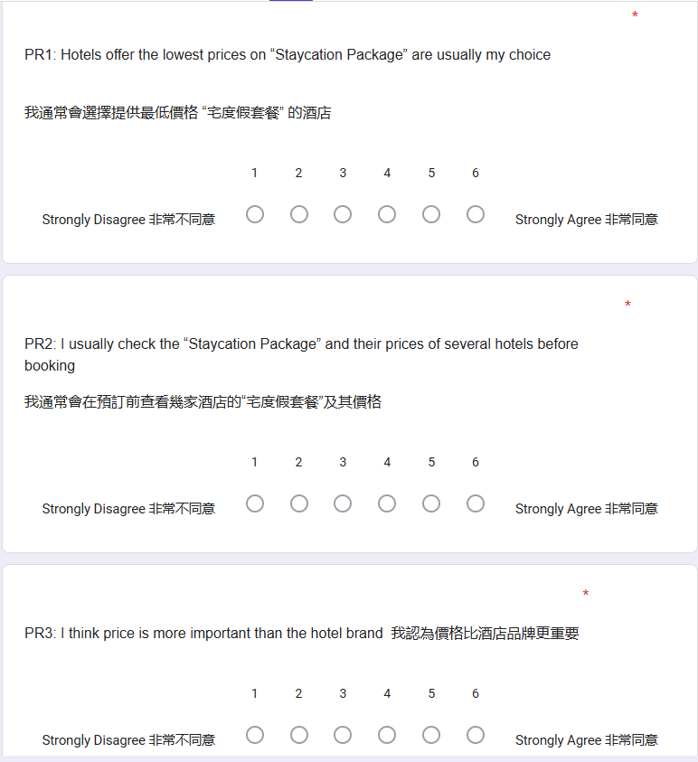

94

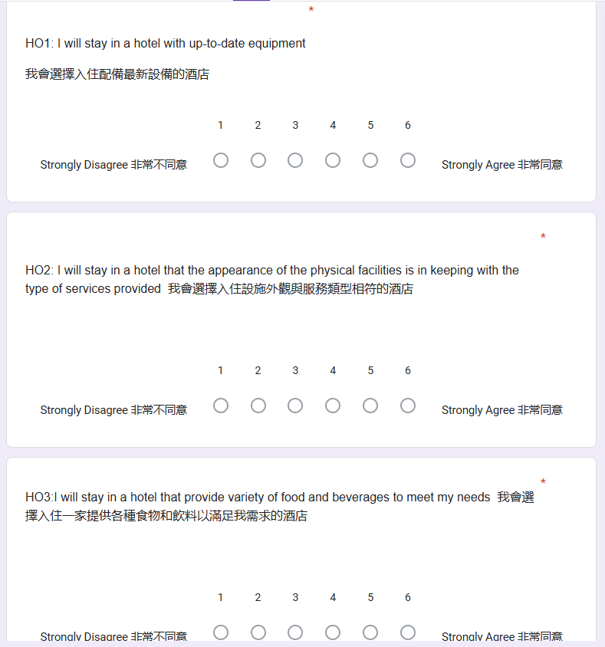

95

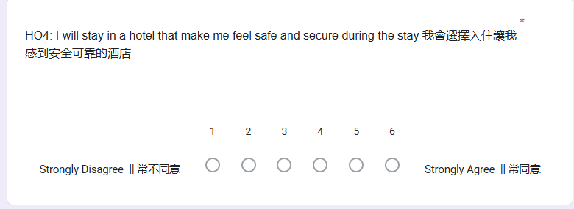
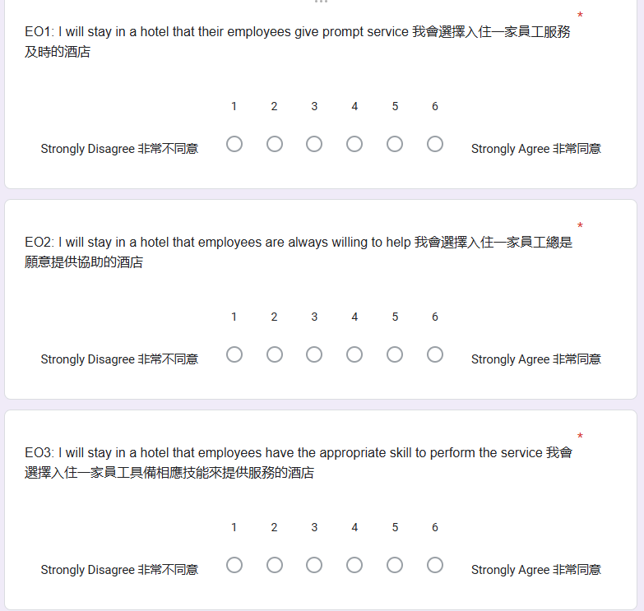

96

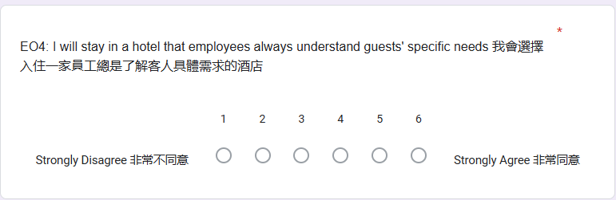
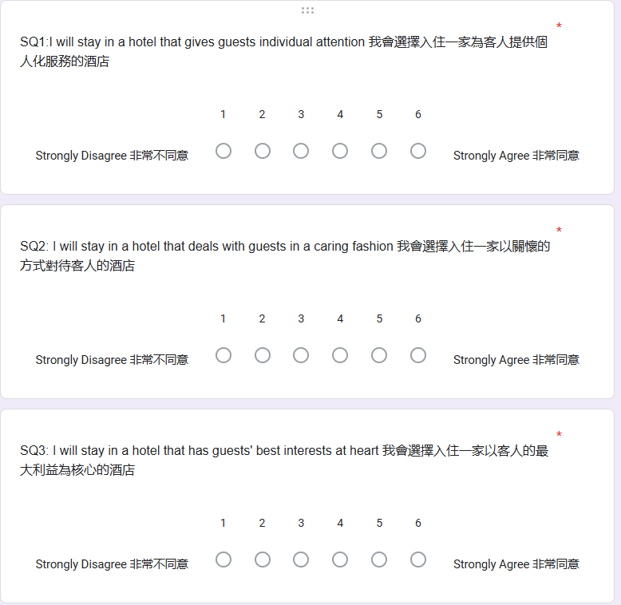

97

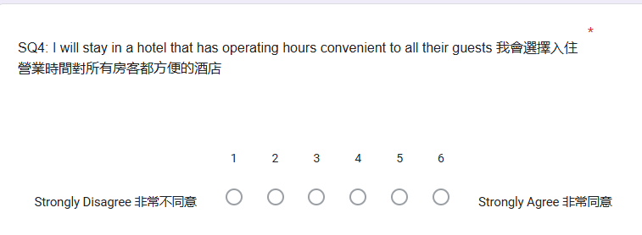
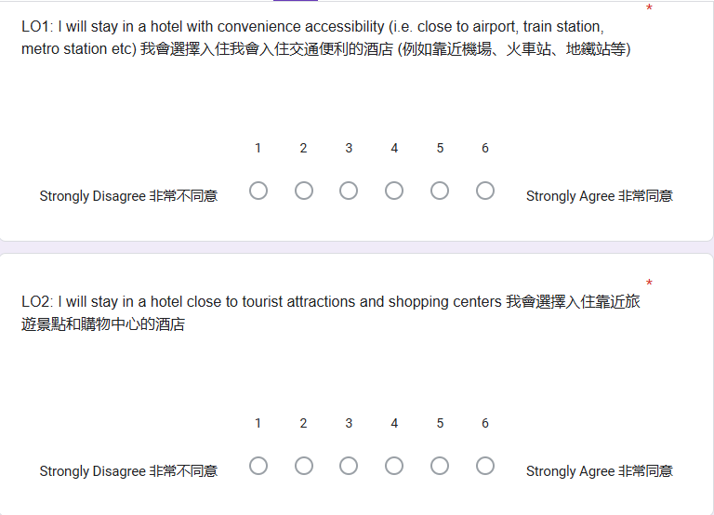

98
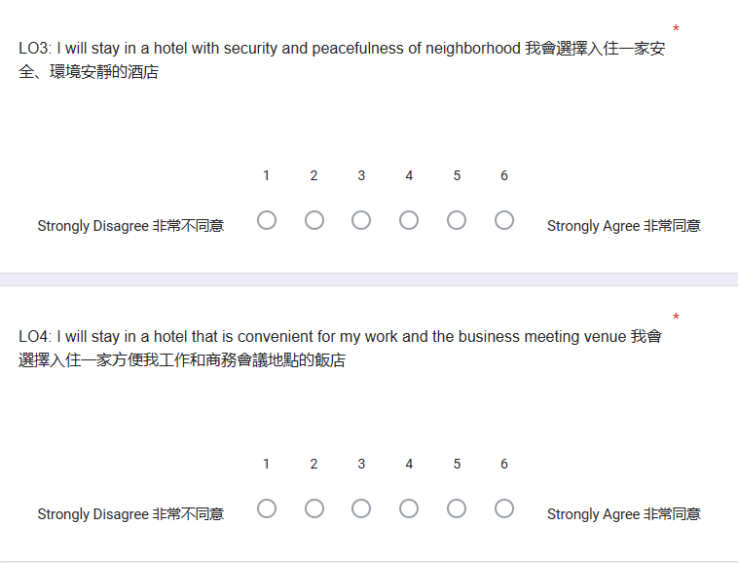
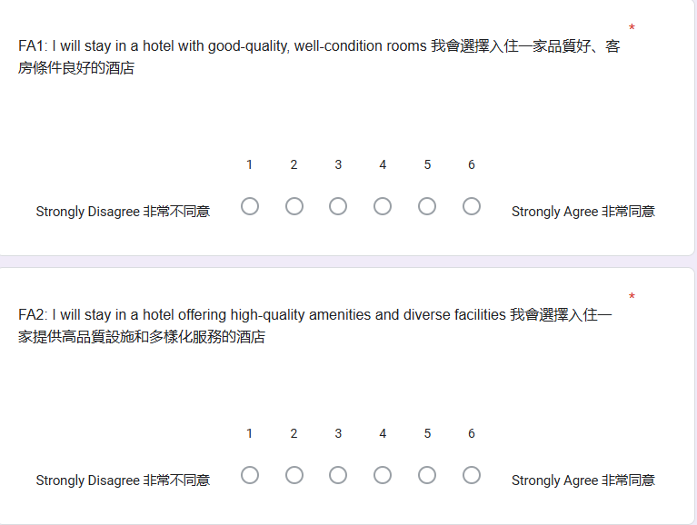

99

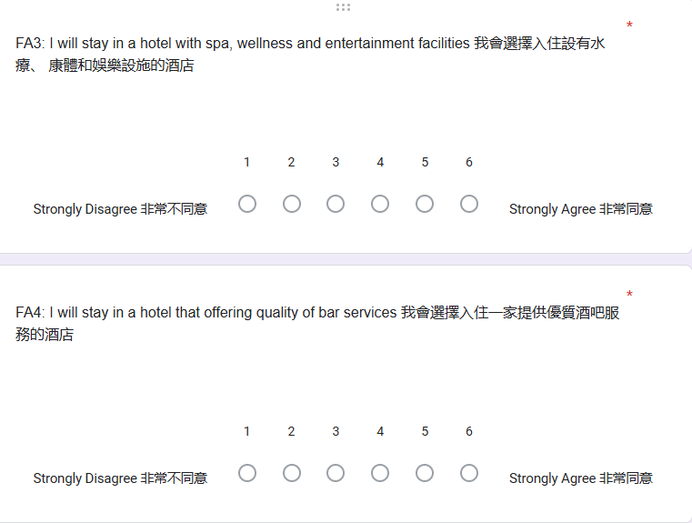
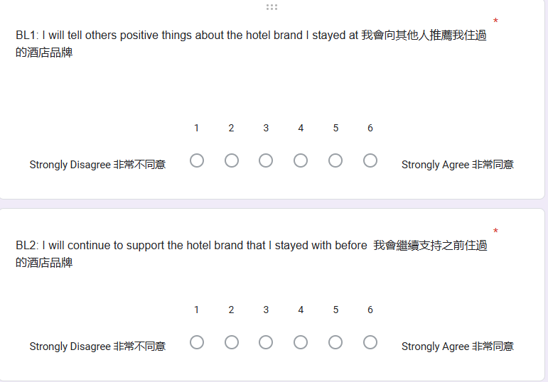

100

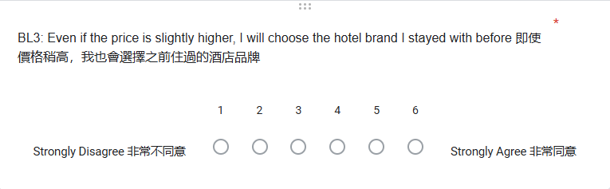
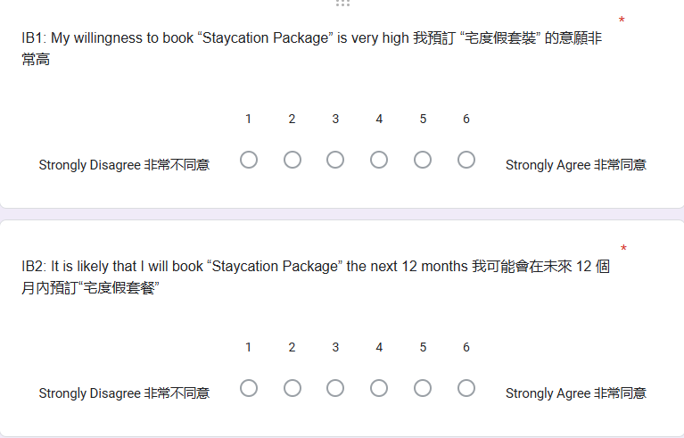

101

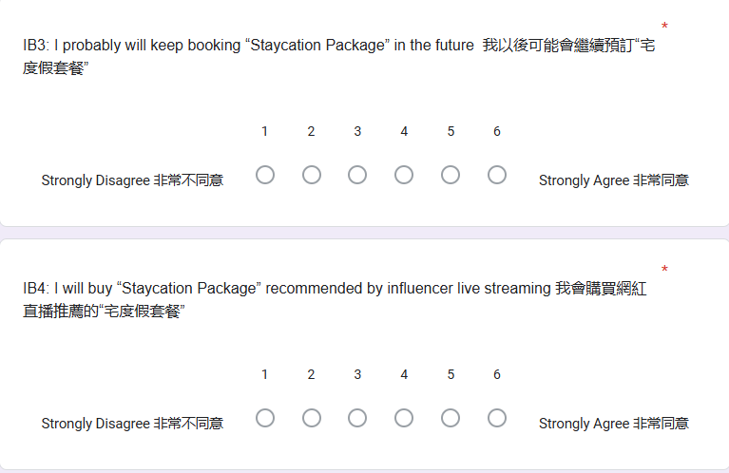
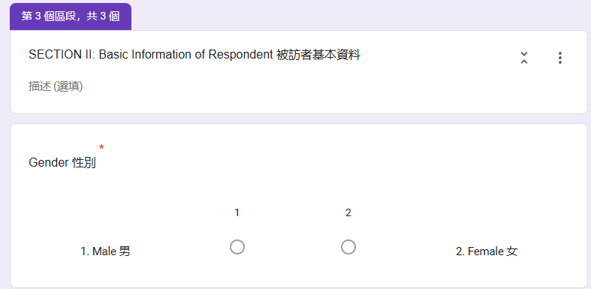

102

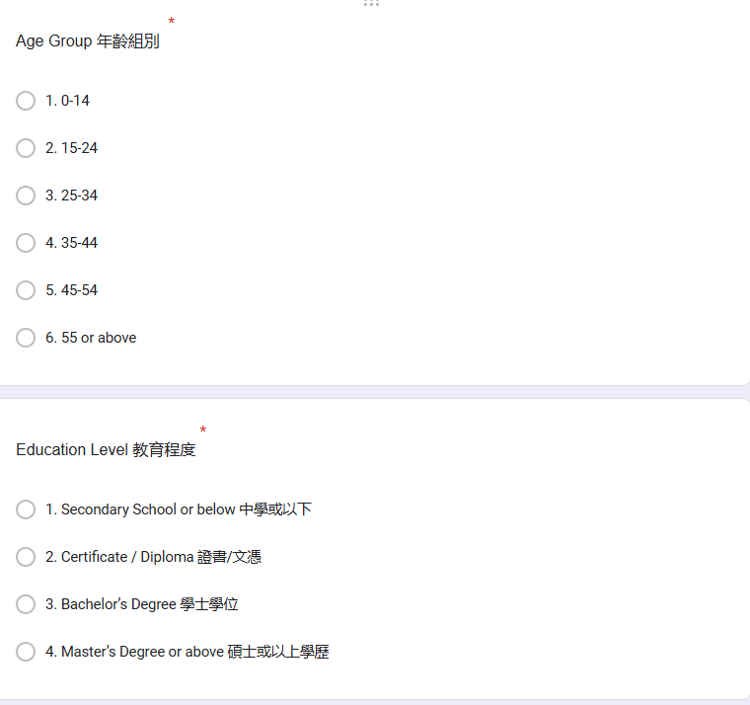

103

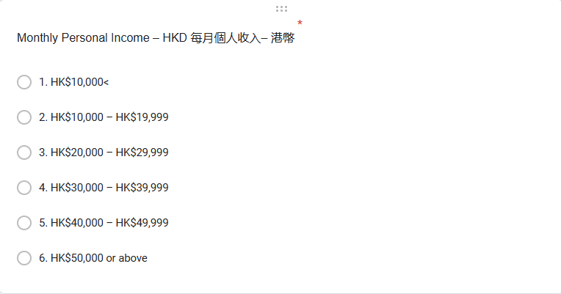

104

