Dylan Payne
Renishaw Quality Technician

Rob Goodson
Lecturer



Analysis and Simulation of a Centrifugal Clutch
STRESS ANALYSIS AND DYNAMICS (ACMA5010 - 2023)

Contents

1. Section 1 2
1.1 The Development of Centrifugal Clutches 2
1.1.1 Early Development and Design 2
1.1.2 Choice of Materials 2
1.2 How Does A Centrifugal Clutch Work? 3
1.3 Typical Applications 3
1.4 Operating Conditions and Advantages 4
1.5 Centrifugal Clutch Disadvantages 4
1.6 Modern Automation and Electromagnetic Clutches 5
1.7 Conclusion 5
Section 2 6
2.1 What Is The Diameter Of The Outer Drum? 6
2.2 The Engagement Speed Of The Centrifugal Clutch 6
2.3 The Radial Force Acting On The Clutch Face When The Driving Shaft Is Rotating At A Speed Of 550 RPM 7
2.4 At The Driving Shaft Speed Of 550 RPM, What Will Be The Value Of Torque Transmitted To The Driven Shaft 7
2.5 The Transmitted Torque At The Driven Shaft Against Driving Shaft Speed 7
2.6 The Transmitted Torque At The Driven Shaft Against Driving Shaft Speed At Various Coefficients Of Friction 8
2.7 The Angular Acceleration Of The Drum Required To Achieve The Maximum Possible Torque 9
Bibliography 10
Table of Figures 10

1. Section 1

1.1 The Development of Centrifugal Clutches

Centrifugal clutches, which provide an effective and user-friendly means of engaging and disengaging power transmission in a variety of applications, have been crucial in the development of compact motor equipment. Their design and materials have changed over the last century to accommodate various equipment and industry needs. The evolution of centrifugal friction clutches will be covered in this report, along with the selection of materials, typical uses, operating circumstances, benefits, and their applicability in the context of contemporary automation, which has witnessed the rise of electromagnetic clutches (The BLM Team, 2021).

1.1.1 Early Development and Design

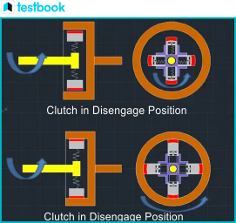
The advent of compact internal combustion engines in the late 1800s is when the idea of centrifugal clutches first emerged. These clutches were meant to activate when the engine reached a specific speed, allowing engines to start and idle without transferring power to the driven component, which is typically a wheel or a pulley (Academic Accelerator, 2023).

Originally, centrifugal clutches had a straightforward design that included a set of friction pads or shoes enclosed in a casing. When centrifugal force is applied, these shoes are meant to move radially and come into contact with the clutch drum or housing, which transfers power (Crane, 2003). This can be demonstrated in Figure 1.
Figure 1 - Centrifugal clutch Operation
(Testbook, 2023)

Figure 1 - Centrifugal clutch Operation
(Testbook, 2023)

The material that was most commonly used for these early clutches was cast iron, which was both easily obtained and strong enough to endure the forces involved.

1.1.2 Choice of Materials

Centrifugal clutch material selection has changed throughout time. Because cast iron was so durable initially, producers started looking at other materials to enhance clutch function, lower weight, and increase clutch longevity. The housing and shoes of modern centrifugal clutches are frequently constructed from lightweight, durable materials like steel or aluminium, and the friction linings are composed of composite materials that provide superior friction properties and long endurance.

Certain specialised applications use carbon composites or ceramic materials for friction linings because they operate better in high-temperature environments and have better wear resistance. The particular application, load, and operating circumstances are some elements that affect the choice of materials in centrifugal clutches (Wemp, 1925).

1.2 How Does A Centrifugal Clutch Work?

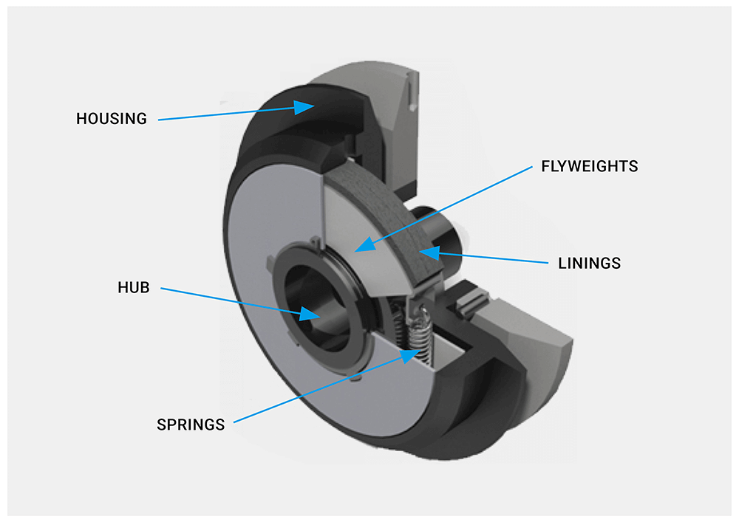
A centrifugal clutch works by utilising centrifugal force. Centrifugal clutches are made up of the hub, flyweights (sometimes called clutch shoes), springs, linings, and housing. The key idea here is that two or more flyweights work together to transmit the centrifugal force produced by the engine's rotations. Depending on how the machinery is designed, the clutch may be driven differently. Attaching the clutch to the engine's parallel or tapered crankshaft is one of the most common methods. The clutch shaft synchronises with the engine's action by rotating at the same speed as the crankshaft. The shoes or flyweights are then propelled outward by the hub's rotation until they come into contact with the clutch drum. At this point, the friction material enters the picture and transfers the torque produced by the flyweights to the drum. The drive connects as a consequence. The clutch's engagement speed is primarily determined by the interaction of the friction material, flyweights, and springs. The output of the clutch might drive a shaft, pulley, sprocket, or flange, among other parts, depending on the design of the machinery (Lancereal, 2019).
Figure 2 - Centrifugal Clutch Assembly (Lancereal, 2019)

Figure 2 - Centrifugal Clutch Assembly (Lancereal, 2019)

1.3 Typical Applications

Centrifugal clutches are frequently seen in several small motor devices, such as:
- Go-karts and minibikes: These vehicles use clutches to engage the engine automatically and smoothly with the drive wheels at a predetermined speed, facilitating smooth acceleration.
- Chainsaws: When the engine is idle, centrifugal clutches in chainsaws disconnect the cutting chain, allowing the user to wield the tool with greater safety.
- Garden Equipment: Centrifugal clutches are frequently used in lawnmowers and other small garden equipment to engage the blades only when the motor is operating at a high enough speed.
- Construction Equipment: Centrifugal clutches are used by certain construction machines, such as concrete mixers, to engage the drum when the engine achieves the necessary RPM (Testbook, 2023).

1.4 Operating Conditions and Advantages

The concepts of centrifugal force underpin the operation of centrifugal clutches. The clutch automatically engages when the engine reaches a specific speed and disengages when the engine slows down. These clutches provide several benefits such as:
- Simplicity: Centrifugal clutches don't need human input or external controls. Because they are self-acting, they are perfect for uses requiring automatic engagement.
- Energy Efficiency: The engine and drivetrain experience less shock loads when these clutches engage smoothly, which improves fuel economy and minimises wear and tear.
- Safety: By disengaging the working component when the engine is idling or stopped, centrifugal clutches improve safety in devices like chainsaws and lawnmowers.
- Durability: Centrifugal clutches are now more dependable and have a longer lifespan, which makes them appropriate for a variety of applications. This is due to advancements in design and materials.
- Virtually maintenance-free: These clutches often require little upkeep, minimising downtime, and the need for routine servicing (Lancereal, 2019).

1.5 Centrifugal Clutch Disadvantages

It's crucial to remember that not all applications have the following drawbacks, and a centrifugal clutch may or may not be appropriate depending on the demands of the particular situation. Although they have benefits including protection against engine damage and no-load starting, their limited adjustability and inability to react quickly to changes in operating circumstances may make them less appropriate for some uses (Lancereal, 2019). Some drawbacks to centrifugal clutches are:
- Restricted Adjustability: The engagement speed of centrifugal clutches is preset at the time of design and manufacture. It is difficult to modify this engagement speed without changing internal parts. This inability to be adjusted may be a drawback for applications that call for different engagement rates.
- Mechanical Complexity: Depending on the intended use, centrifugal clutches can have a variety of designs because they are mechanical devices. In comparison to some other clutch types, they may require more sophisticated and application-specific designs due to their mechanical complexity, which, although offering automated engagement, may limit their versatility.
- Unable to Adapt Quickly: Centrifugal clutches work by engaging at a set speed that is determined by centrifugal force. Rapid fluctuations in engine speed or load may cause them to react poorly, which in some circumstances might lead to delayed engagement or disengagement.

1.6 Modern Automation and Electromagnetic Clutches

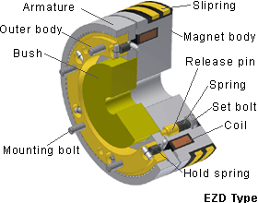
Modern machinery and equipment now tend to use electromagnetic clutches due to advancements in manufacturing and automation processes over the past few decades. Because they can be operated remotely and with fine control, electromagnetic clutches are a good fit for automated and complex processes (Gómez, 2023). The following are some important details about electromagnetic clutches in contemporary automation:
- Precise Control: Because electromagnetic clutches provide quick and exact engagement and disengagement, they are a good fit for applications like robots and CNC machines that demand precise control.
Figure 3 - Electromagnetic Clutch Assembly (MinebeaMitsumi, 2023)
- Remote Actuation: By enabling operators to engage or disengage the clutch remotely, electromagnetic clutches improve industrial processes' efficiency and safety.
- Variable Torque: Electromagnetic clutches, as opposed to centrifugal clutches, provide the ability to alter torque, enabling real-time modifications to match shifting production needs.
- Decreased Wear: Compared to friction-based clutches, electromagnetic clutches produce less heat and wear, which increases their longevity and lowers maintenance costs.
- Industrial Automation: In applications where exact control and automation are crucial, such as printing presses, packaging equipment, and conveyor systems, electromagnetic clutches are frequently utilised.
- Automotive Applications: For effective power distribution and torque management, electromagnetic clutches are also used in the automotive sector, mainly in automatic gearboxes and all-wheel drive systems (Williams, 2019).

1.7 Conclusion

In summary, over the past century, the development of centrifugal clutches has been essential to small motor equipment. The design and material choices of these clutches have changed over time, providing simplicity, longevity, energy efficiency, and safety. However, since the development of contemporary automation, electromagnetic clutches have become more well-known because of their ability to operate remotely and precisely, making them ideal for a wide range of industrial and automotive applications. The particular needs, operational circumstances, and equipment and automation processes at hand determine which type of clutch to use, whether it be electromagnetic or centrifugal.

Section 2

2.1 What Is The Diameter Of The Outer Drum?

The outer drum's diameter can be calculated using the information provided:

The radius of each shoe (from the shaft centre) is 95 mm.
The clearance distance to the outer drum is 9 mm.
The outer drum has a wall thickness of 4 mm.

Outer Diameter = 2 X (Radius of the shoes + Clearance Distance + wall thickness)
Outer Diameter = 2 X (95 mm + 9 mm + 4mm)
Outer Diameter = 2 X 108 mm
Outer Diameter = 216 mm

So, the diameter of the outer drum is 216 mm.

2.2 The Engagement Speed Of The Centrifugal Clutch

The centrifugal force on each shoe:  $$Centrifugal Force \left(F_{C}\right)=mω^{2}r$$  Where:  m = mass of one shoe (275 grams = 0.275 kg)  r = radius of the shoes (95 mm = 0.095 m) +  the clearance distance (9 mm = 0.009 m)  = (104mm = 0.104 m)  ω = angular velocity | The spring force on each shoe:  $$Spring Force \left(F_{S}\right)=kx$$  Where:  k = spring stiffness (7.5 kN/m = 7500 N/m)  x = clearance distance (9 mm = 0.009 m)
These two forces are equal at the engagement speed:  $$F_{C}=F_{S}$$  $$mω^{2}r= kx$$  $$ω^{2}= \frac{kx}{mr}$$  $$ω= \sqrt{\frac{kx}{mr}}$$ | So:  $$ω= \sqrt{\frac{7500×0.009}{0.275×0.104}}$$  $$ω= 48.58 Radians/Second$$  $$RPM= ω× \frac{60}{2π}$$  $$RPM= 48.58× \frac{60}{2π}$$  $$RPM= 463.92 RPM$$

2.3 The Radial Force Acting On The Clutch Face When The Driving Shaft Is Rotating At A Speed Of 550 RPM

$$ω=\frac{550×2π}{60}=57.6 Radians/Second$$  $$F_{C}=mω^{2}r$$  $$F_{C}=0.275×{57.6}^{2}×0.104$$  $$F_{C}=94.89 N$$ | $$F_{S}=kx$$  $$F_{S}=7500×0.009$$  $$F_{S}=67.5 N$$
$$94.89-67.5=27.39 N$$

$$27.39×4 \left(for each shoe\right)=109.56 N$$

2.4 At The Driving Shaft Speed Of 550 RPM, What Will Be The Value Of Torque Transmitted To The Driven Shaft

$$Torque (T)=F_{C}×r×μ$$

$$T=94.89×0.104×0.35$$

$$T=3.45 Nm$$

2.5 The Transmitted Torque At The Driven Shaft Against Driving Shaft Speed

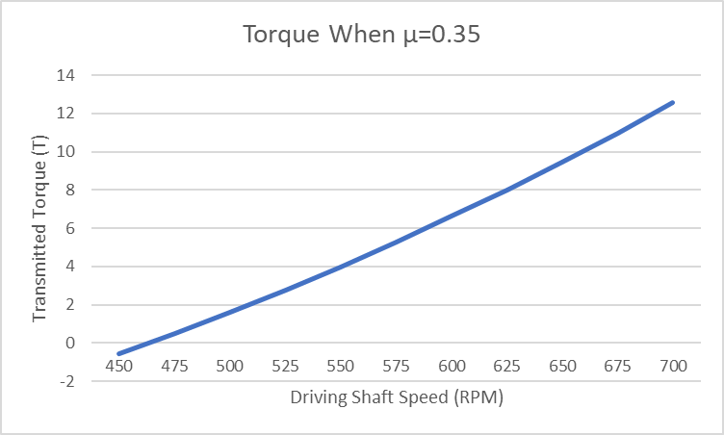

2.6 The Transmitted Torque At The Driven Shaft Against Driving Shaft Speed At Various Coefficients Of Friction

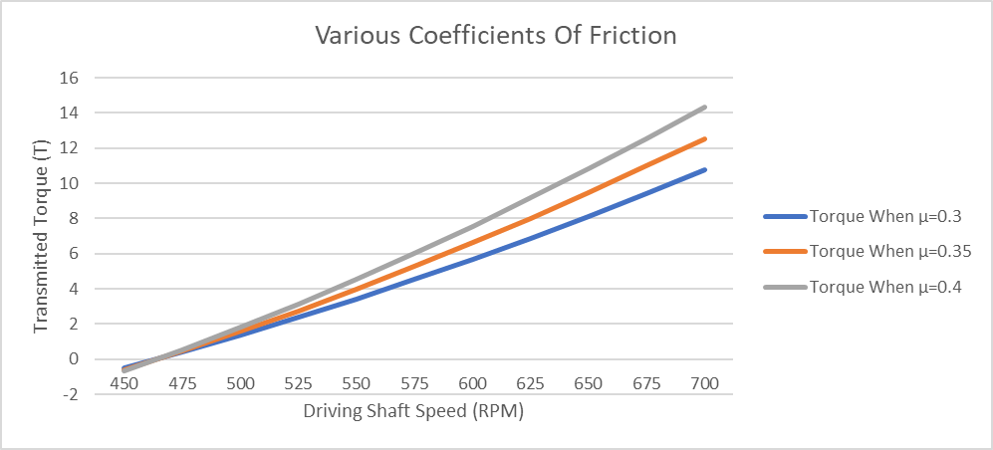

The above graph shows that a higher coefficient of friction between the shoes and the drum surface improves traction and increases the force that the shoes may apply in all directions. The torque applied to the driven shaft is directly influenced by this increased radial force. Consequently, torque transmission increases with higher coefficients of friction and decreases with decreasing coefficients of friction. A clutch's performance and its capacity to transfer torque efficiently are largely dependent on its coefficient of friction.

2.7 The Angular Acceleration Of The Drum Required To Achieve The Maximum Possible Torque

$$Angular Acceleration (α)=\frac{T}{I}$$  Where:  T = maximum transmitted torque (14.34 Nm)  I = the moment of inertia of the drum | $$The moment of inertia \left(I\right)=\frac{1}{2}mr^{2}$$  Where:  m = mass of the drum (750 g = 0.75 kg)  r = radius of the drum (108 mm = 0.108 m)
$$I=\frac{1}{2}×0.75×{0.108}^{2}$$
$$I=0.004374 Kg/m^{2}$$

$$α=\frac{14.34}{0.004374}=3278.46$$

$$α=3278.46 Radians/{Second}^{2}$$

Dylan Payne
Renishaw Quality Technician

Bibliography

Academic Accelerator, 2023. Centrifugal Clutch. [Online]
Available at: https://academic-accelerator.com/encyclopedia/centrifugal-clutch
[Accessed 29 10 2023].
Crane, N. B., 2003. Compliant Centrifugal Clutches: Design, Analysis,. 28108671 ed. Brigham: Brigham Young University ProQuest Dissertations Publishing.
Gómez, M., 2023. Electromagnetic clutches. [Online]
Available at: https://eide.net/en/electromagnetic-clutches/
[Accessed 30 10 2023].
Lancereal, 2019. Centrifugal Clutch Explained – An Engineer’s Guide to a Centrifugal Clutch. [Online]
Available at: https://www.lancereal.com/centrifugal-clutch-explained/#:~:text=The%20key%20components%20of%20a,through%20two%20or%20more%20flyweights.
[Accessed 29 10 2023].
MinebeaMitsumi, 2023. Tooth Type Electromagnetic Clutch. [Online]
Available at: https://product.minebeamitsumi.com/en/technology/rotary/clutch_brake_cat_001.html
[Accessed 30 10 2023].
Testbook, 2023. Centrifugal Clutch: Know Diagram, Construction, Working, Advantages and Applications. [Online]
Available at: https://testbook.com/mechanical-engineering/centrifugal-clutch
[Accessed 29 10 2023].
The BLM Team, 2021. The Importance of Centrifugal Clutches in Engines. [Online]
Available at: https://www.blm-cm.com/blog/centrifugal-clutches-engines/
[Accessed 29 10 2023].
Wemp, E. E., 1925. SAE Transactions. HISTORY OF AUTOMOTIVE-CLUTCH DEVELOPMENT, 20(0096736X), pp. 236-266.
Williams, B., 2019. Magnetic Particle Clutches: Advantages, Working Principles & More.. [Online]
Available at: https://www.montalvo.com/how-magnetic-particle-clutches-work/
[Accessed 30 10 2023].

Table of Figures

Figure 1 - Centrifugal clutch Operation (Testbook, 2023) 2
Figure 2 - Centrifugal Clutch Assembly (Lancereal, 2019) 3
Figure 3 - Electromagnetic Clutch Assembly (MinebeaMitsumi, 2023) 5

