Assessment 1

Module: International Financial Management

Module code: LCBB6002 Lecturer: Zainab Atta

' International Financial Management in
Pepsi Co'
(Individual Report)

Simona Filipova Vasileva
University of Wales Trinity Saint David, London Campus,
BA Business and Management, London, United Kingdom
2030587@student.uwtsd.ac.uk
Contents
Company Overview 3
Dividend Policy 4
Efficient Market Hypothesis 6
Appraisal project methods of PepsiCo. 7
Keeping it fresh for investors. 8
Conclusion 9
References 10

Company Overview
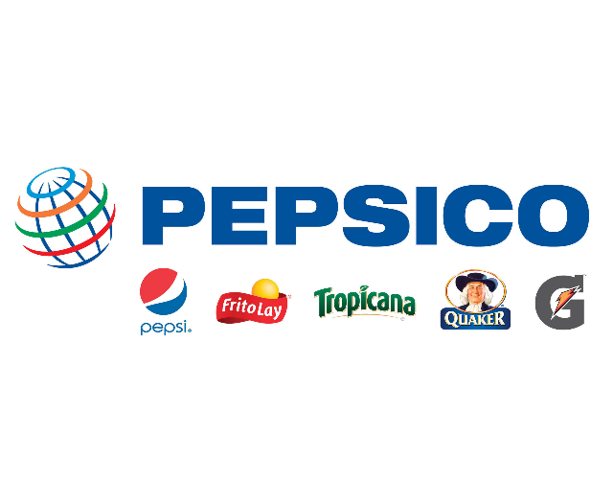
PepsiCo is a multinational food and beverage company that operates globally. It was founded in 1965 through the merger of Pepsi-Cola and Frito-Lay, two well-known companies in the beverage and snack food industries (PepsiCo, 2023). Today, PepsiCo is one of the world's leading consumer goods companies, with a diverse portfolio of brands that includes not only Pepsi and Frito-Lay but also other popular names such as Gatorade, Tropicana, Quaker, and Lay's.
Source: WordPress.com
“As of July 2023 Pepsico has a market cap of $255.69 Billion. This makes Pepsico the world's 33th most valuable company by market cap according to our data” (CompaniesMarketcap, 2023).
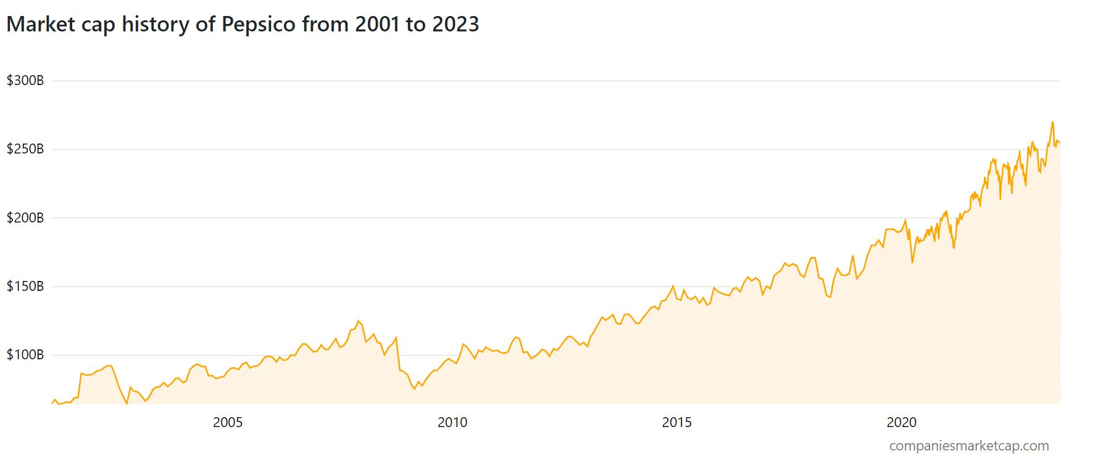
PepsiCo's product portfolio consists of a wide range of food and beverage offerings, including carbonated soft drinks, juices, sports drinks, ready-to-drink teas and coffees, snacks, and breakfast cereals. The company operates through its three main business segments:

- Frito-Lay: This segment encompasses the company's snack food operations and includes brands like Lay's, Doritos, Cheetos, Tostitos, and Ruffles. Frito-Lay is known for its strong presence in the savoury snacks market.

- Quaker Foods: This segment focuses on breakfast cereals, rice and pasta products, and other branded food products. Quaker, Aunt Jemima, Rice-A-Roni, and Cap'n Crunch.
- PepsiCo Beverages: Offering a wide range of beverages, including carbonated soft drinks, juices, ready-to-drink coffees and teas, and sports drinks. Pepsi, Mountain Dew, Gatorade, Tropicana, and Lipton are some of the popular brands in this segment.

With operations in more than 200 countries and territories. The company's international division focuses on expanding its global reach and tailoring its products to local preferences. PepsiCo is committed to sustainable growth and has set ambitious environmental and social goals. It aims to reduce its environmental impact, improve water usage efficiency, promote sustainable agriculture practices, and invest in communities through various initiatives.

Dividend Policy
PepsiCo has historically maintained a consistent and shareholder-friendly dividend policy. The company is committed to returning value to its shareholders through regular dividend payments. The specific dividend policy of PepsiCo can be summarized as follows:

- Dividend Frequency: PepsiCo pays dividends on a quarterly basis. This means that shareholders receive dividend payments four times a year (PepsiCo, 2022).

- Dividend Growth: PepsiCo has a track record of increasing its dividend payout over time. The company aims to provide consistent dividend growth to its shareholders, reflecting its commitment to delivering long-term value.

- Dividend Yield: The dividend yield is the dividend payout relative to the stock price. PepsiCo's dividend yield may vary depending on market conditions and the company's financial performance. Investors can calculate the dividend yield by dividing the annual dividend per share by the stock's current market price.

Dividend Yield for the past 12months:
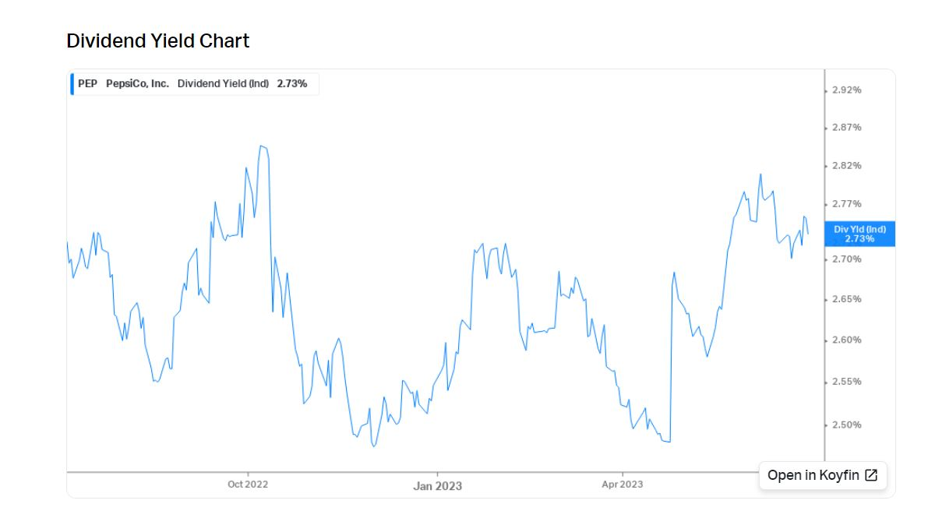

It's important to note that specific details about the dividend, such as the exact dividend amount and the dividend yield, may vary and are subject to change based on the company's financial performance, profitability, and management decisions.

Dividend Safety:
The capacity of a business to continue paying dividends to investors without disruption or diminution is referred to as dividend safety. A corporation with a high degree of dividend safety is often seen to be in good financial shape, have a track record of paying dividends, and be at minimal danger of going bankrupt.
- “Dividend payment history: PEP has a long history of paying dividends and has consistently increased its dividend payout for 51 consecutive years” (Koyfin Inc, 2023).
- “Dividend payout ratio: A low payout ratio, typically less than 60%, indicates that a company has enough earnings to pay dividends and retain earnings to reinvest in the business. PepsiCo, Inc.’s payout ratio is about 95.35%” (Koyfin Inc, 2023).

Efficient Market Hypothesis
The Efficient Market Hypothesis (EMH) is a theory in financial economics that suggests that financial markets are efficient and that asset prices fully reflect all available information (Baldridge, 2022). According to the EMH, it is not possible to consistently achieve above-average returns by using publicly available information because the market quickly and accurately incorporates that information into asset prices (DOWNEY, 2023). In the case of PepsiCo, if the Efficient Market Hypothesis holds true, it would imply that the stock price of PepsiCo accurately reflects all available information about the company, including its financial performance, earnings reports, industry trends, and other relevant factors. In an efficient market, investors would not be able to consistently outperform the market by trading PepsiCo stock based on publicly available information alone.

However, it's important to note that the Efficient Market Hypothesis has been the subject of considerable debate among economists and market participants. Critics argue that markets may not always be perfectly efficient due to factors such as investor irrationality, behavioural biases, or the existence of private or insider information that is not immediately reflected in stock prices.

In practice, investors and analysts continue to analyse companies like PepsiCo and make investment decisions based on their assessment of the company's fundamentals, industry trends, competitive positioning, and other relevant factors. While the Efficient Market Hypothesis provides a theoretical framework, it does not necessarily dictate the behaviour or outcomes of individual investors or the stock market as a whole (Thune, 2021).

Appraisal project methods of PepsiCo.
PepsiCo, like any other company, uses various methods to appraise projects and evaluate their financial viability. Here are 5 methods that PepsiCo use:

- Net Present Value (NPV): NPV is a widely used method that calculates the present value of expected cash flows generated by a project, discounted at an appropriate rate. If the NPV is positive, it suggests that the project is expected to generate more value than the initial investment and is considered financially favourable.
- Internal Rate of Return (IRR): IRR is the discount rate at which the NPV of a project becomes zero. It represents the project's rate of return, and PepsiCo compare the IRR of a project to a required rate of return or hurdle rate. If the project's IRR exceeds the hurdle rate, it may be deemed acceptable.
- Payback Period: The payback period is the time required for the project's expected cash inflows to recover the initial investment. PepsiCo have a specific payback period criteria, and projects that meet or have a shorter payback period may be considered favourable.
- Profitability Index (PI): The profitability index is the ratio of the present value of cash inflows to the initial investment. It provides a measure of the project's profitability relative to the amount invested (CHEN, 2023). A profitability index greater than 1 suggests a positive net present value and is considered financially beneficial.
- Return on Investment (ROI): ROI measures the profitability of an investment as a percentage of the initial investment (FERNANDO, 2023). PepsiCo assesses the expected return on investment for a project and compare it to other potential investments or internal benchmarks. There are various other new ROI versions that have been created for specific uses. The ROI of social media initiatives may be determined by looking at social media statistics, such as the amount of clicks or likes are produced per unit of work. The earnings related to advertising or marketing initiatives is sought after by marketing statistics ROI.
It's important to note that different appraisal methods have their strengths and limitations, and companies like PepsiCo may use a combination of these methods to evaluate projects comprehensively (BURTON & CONFINO, 2023). Additionally, qualitative factors such as strategic alignment, market potential, competitive advantage, and risk assessment may also be taken into consideration when appraising projects.

Keeping it fresh for investors.
The beverage company is producing "Pepsi Colachup," the first-ever condiment that contains genuine Pepsi. The unveiling of the special sauce reinforces the company's view that hot dogs go best with its drink and is timed to coincide with July 4, because sports and hot dogs are plentiful (Valinsky, 2023). The sauce starts with a Pepsi reduction and is then infused using a variety of ingredients, including smoked tomatoes, onions, ketchup, and a mixture of cinnamon, thyme, oregano, and paprika. Danzi told CNN that produces a "sweet, citrusy taste" of a crisp-tasting Pepsi that was designed to highlight the spicy flavour notes of a hot dog (Valinsky, 2023).

Conclusion
In conclusion, PepsiCo follows a consistent and shareholder-friendly dividend policy, paying dividends on a quarterly basis and aiming for consistent dividend growth. The company is committed to delivering long-term value to its shareholders. While the Efficient Market Hypothesis suggests that financial markets are efficient and asset prices reflect all available information, it is important to note that market efficiency remains a subject of debate. Investors and analysts continue to analyze companies like PepsiCo and make investment decisions based on their assessment of various factors beyond publicly available information.

When appraising projects, PepsiCo may employ methods such as net present value (NPV), internal rate of return (IRR), payback period, profitability index (PI), and return on investment (ROI). These methods help the company evaluate the financial viability of projects and make informed investment decisions.

Overall, PepsiCo's diverse product portfolio, global presence, commitment to sustainability, and shareholder-friendly dividend policy have contributed to its status as a prominent player in the food and beverage industry.

References
Baldridge, R., 2022. What Is the Efficient Market Hypothesis?. [Online]
Available at: https://www.forbes.com/advisor/investing/efficient-market-hypothesis/
[Accessed 18 July 2023].
BURTON, M. & CONFINO, P., 2023. Why PepsiCo hires 2,000 new grads every year regardless of economic conditions. [Online]
Available at: https://fortune.com/2023/05/08/pepsico-hiring-2000-new-graduates/
[Accessed 14 July 2023].
CHEN, J., 2023. Profitability Index (PI): Definition, Components, and Formula. [Online]
Available at: https://www.investopedia.com/terms/p/profitability.asp#:~:text=The%20profitability%20index%20(PI)%20is%20a%20measure%20of%20the%20attractiveness,investment%20amount%20in%20the%20project.
[Accessed 15 July 2023].
CompaniesMarketcap, 2023. Market capitalization of Pepsico (PEP). [Online]
Available at: https://companiesmarketcap.com/pepsico/marketcap/
[Accessed 15 July 2023].
DOWNEY, L., 2023. Efficient Market Hypothesis (EMH): Definition and Critique. [Online]
Available at: https://www.investopedia.com/terms/e/efficientmarkethypothesis.asp
[Accessed 14 July 2023].
FERNANDO, J., 2023. Return on Investment (ROI): How to Calculate It and What It Means. [Online]
Available at: https://www.investopedia.com/terms/r/returnoninvestment.asp#:~:text=Return%20on%20investment%20(ROI)%20is%20calculated%20by%20dividing%20the%20profit,when%20expressed%20as%20a%20percentage.
[Accessed 15 July 2023].
Koyfin Inc, 2023. PepsiCo, Inc. (PEP). [Online]
Available at: https://www.koyfin.com/company/pep/dividends/#:~:text=Dividend%20Data,are%20paid%20out%20as%20dividends.
[Accessed 15 July 2023].
PepsiCo, 2022. PepsiCo Declares Quarterly Dividend. [Online]
Available at: https://www.pepsico.com/our-stories/press-release/pepsico-declares-quarterly-dividend11172022
[Accessed 16 July 2023].
PepsiCo, 2023. Who We Are. [Online]
Available at: https://www.pepsico.com/who-we-are/about-pepsico
[Accessed 15 July 2023].
Thune, K., 2021. Efficient Markets Hypothesis (EMH). [Online]
Available at: https://www.thebalancemoney.com/efficient-markets-hypothesis-emh-2466619
[Accessed 19 July 2023].
Valinsky, J., 2023. Pepsi made its first-ever condiment. [Online]
Available at: https://edition.cnn.com/2023/06/27/business/pepsi-sauce-condiment/index.html
[Accessed 20 July 2023].

