Title: Secondary Research Report on Nurseries in UK and Technology in Nurseries
Module: Digital Skills and Research Methods
BMSW4003
Task 2: Research Report (2000 words)
Student Name: Violeta Cicu
Student Number: 2109660
Lecture: Terry Walcott

Abstract
The concept of a very first therm of “nursery “ came to use in the Victorian era and the very first nursery has been set in 1816 by Robert Owen.
Sens then the nurseries teachers try to keep up with the learning updates and the evolution of learning in terms, those days, of introducing technology in, as I will show in the literature review
The quantitative data was statistical analysis using charts, the qualitative data was collected by questionnaire.
Base on the about, I can confirm the pros. and cons. Opinions have been found in terms of using technology in the nursery class
Most of the participants will choose the face to face option

Table of content
Abstract………………………………………………..1
Introduction…………………………………………..2
Research Objectives………………………………..3
Methodology……………………………………….…4
Primary Data vs Secondary Data……………...5
Literature Review…………………………………..6
Secondary Data Analyse………………………….7
Conclusions……………………………………………8
Reference……………………………………………….9

Introduction
The research in this report has been collected randomly in the class on the online form over 16 people.
It is about nurseries admission and the expectation of parents in terms of nursery education also how technology has been received in this field.
Four 75% of the participants English it’s not their first language.
A bit of history will be added to the evolution of learning to be highlighted
Useful information will be added as I am looking forward to working in this field and all the data collected will be useful in the process of my development
From this questionnaire, people agree and disagree with introducing the technology in nurseries, showing more interest in face-to-face learning.

Research Objectives
The intention of this research is:
- To find out how parents accept technology in nurseries
- How do they normally get informed over a nursery and what are their expectations from the nurseries across the UK

Methodology

Data collection is defined as a set of processes by which the information on a particular studi is gathered, measured an analyzed accurately (Bhat 2019)

Primary Data vs. Secondary Data
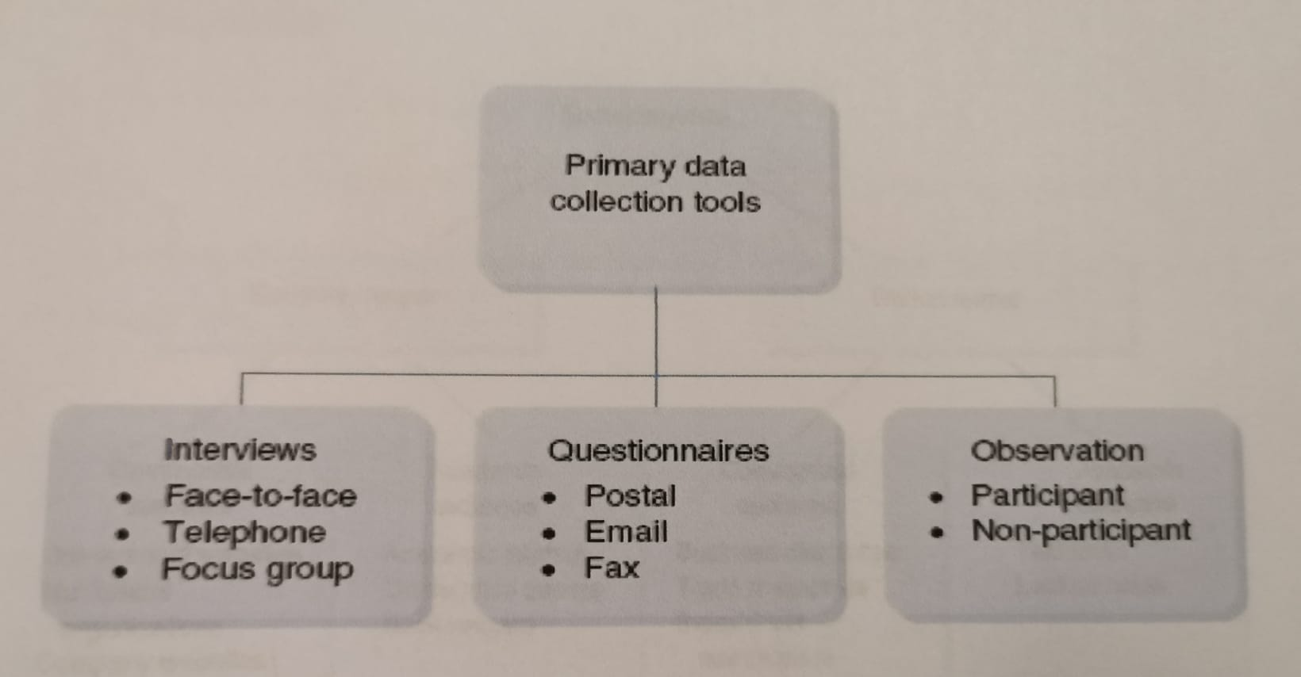

Fig. 1 Classification of primary data collection tools and survey meth.
(Wilson 2014 ,pp 152)
Primary data is to be collected yourself (Saunders et al, 2006)
The main benefits are time and cost savings when secondary data is collected
The author suggests that the key research problem is the limitation and the access to high-quality and reliable data.
The main disadvantage of the secondary data are difficulties in verifying the credibility of the source
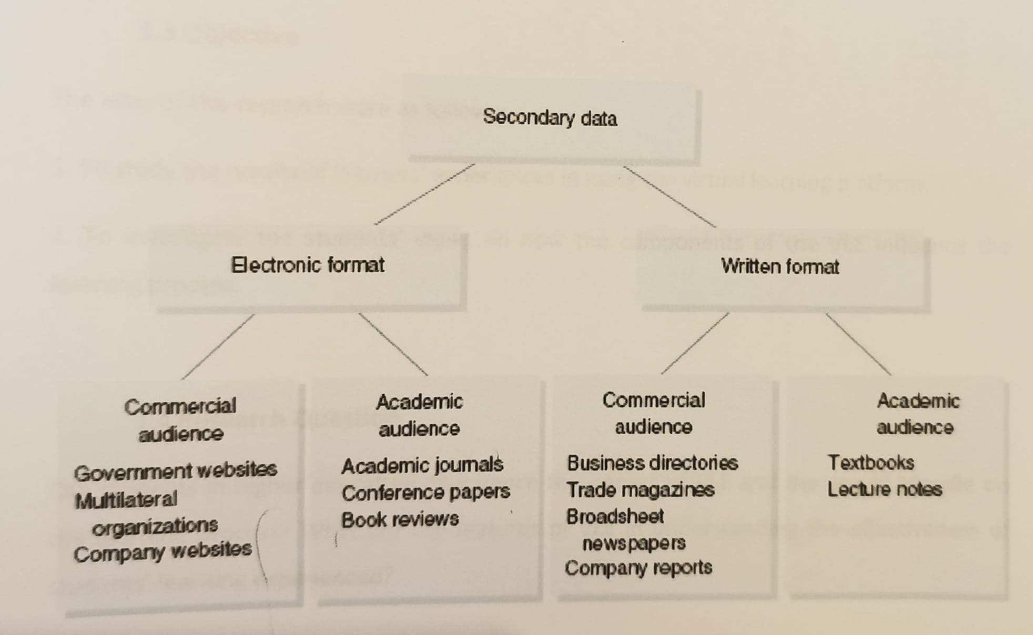
Fig 2. Classification of secondary data (Wilson 2014 pp. 192)

Literature Review
“Most expect believe computers are not developmentally appropriate for children’s at the edge of three”
(Elkid 1998 Haughland,1999; NAEYC,1996 cited in Wardle 2008)
“however these same experts believe children’s three years old and olden cam being to effectively explore and use computers” (Wardle 2008)
“The negative factor of the virtual systemin the social isolation of learning and teachers and the look of direct contact between them “ (Kamimozhi 2018)
“Today’s young children are going up in a world in which technology is so pervasive that to them it is the norm. Because of this, it is easy to deny that we have a responsibility to teach ITC to children because “ they will learn how to use it anyway “
Angela McFlare in a conference challenged this myth of the “digital native”
The origin of therm “nursery” was the actual room design for babies and young children in the Victorian Era ( we where all began. When the baby was ready to leave the brast he came in the care of a nursery maid, nurse, or any “much like Marry Poppins”
“The word nany came into use in the 1700s, meaning the same above “
In the upper-class houses “governess” came into fashion in the 19th century being a very respectful position shi have to be educated and was in charge with teaching the child to read, write and how to act in a social history French and piano
The very first nursery school was set by the extremely wealthy mill owner Robert Owen 1816 named school for children Lamark Scotland and remained open until 1968(Sarah Munson 2020)
“ The modern nurseries did their best to keep up with the time as we move on through the digital age, teaching basic us of computers is part of EYFS framework, use phones ups manage their work and the communication with parents” (Sarah Munson 2020)

Secondary Data Analyse
Questions Analyse 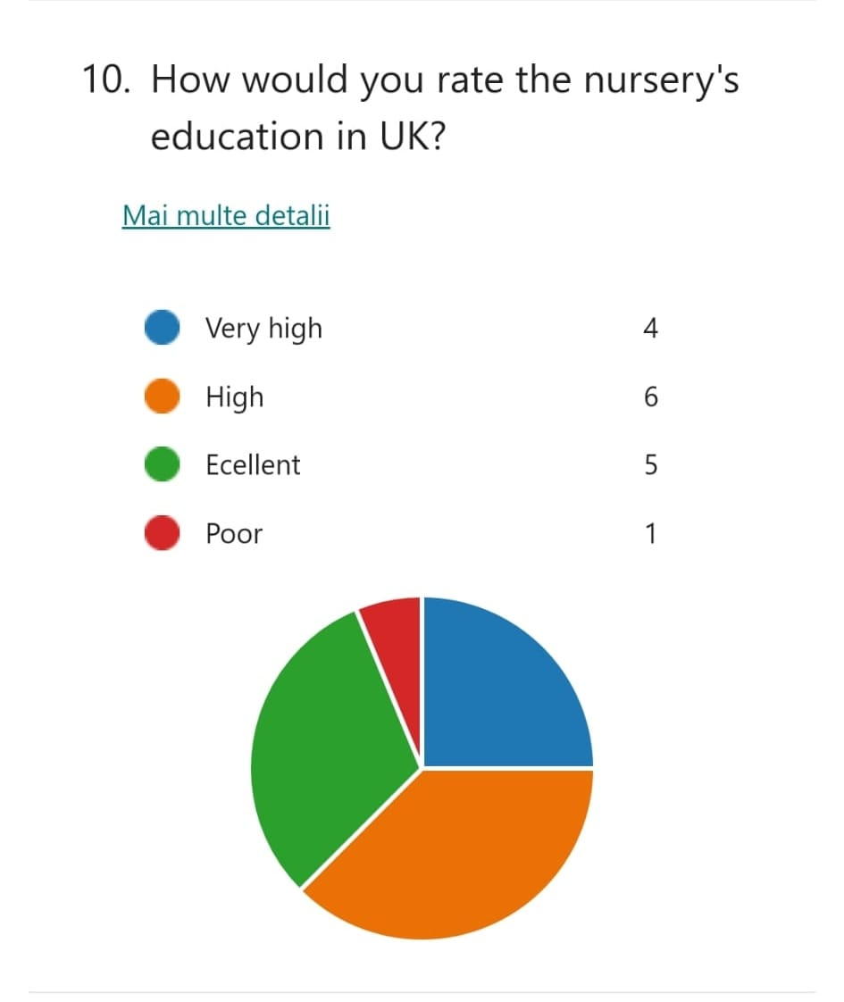
On the question above 6 out of 16 participants rates high their expectations from the nurseries in the UK and only one as poor
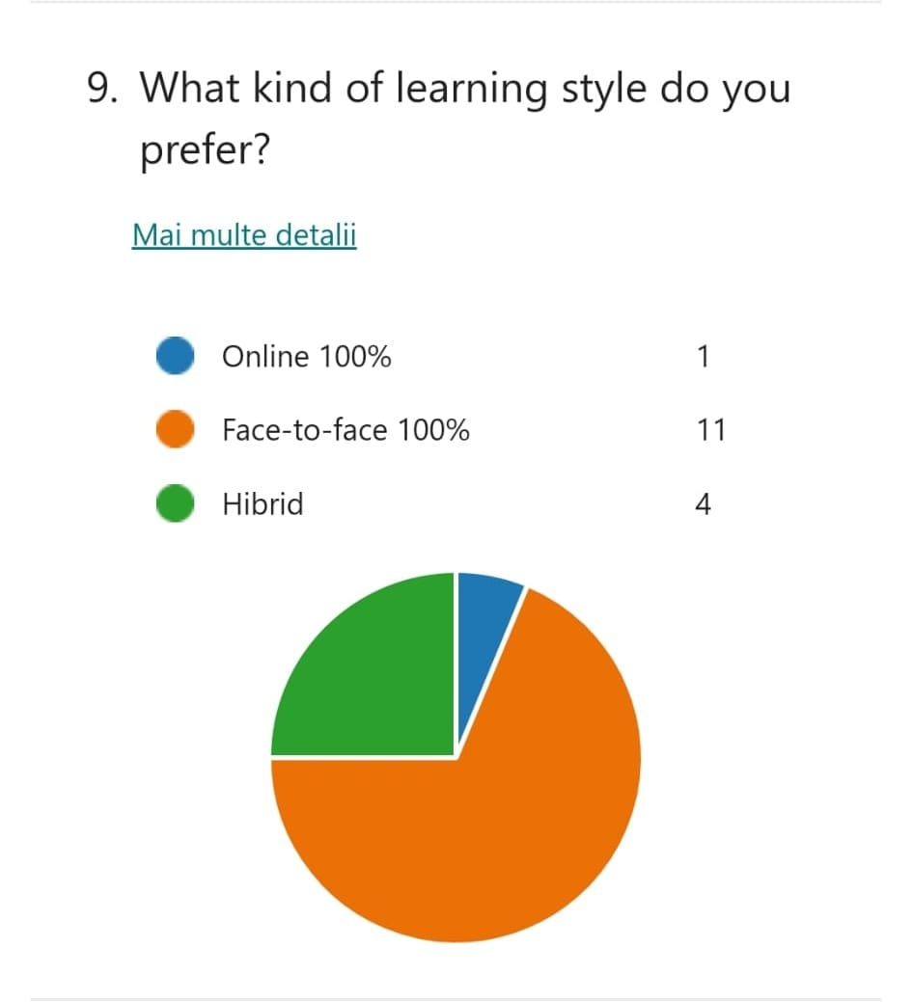
On the above, the predominate choice is face to face 100%
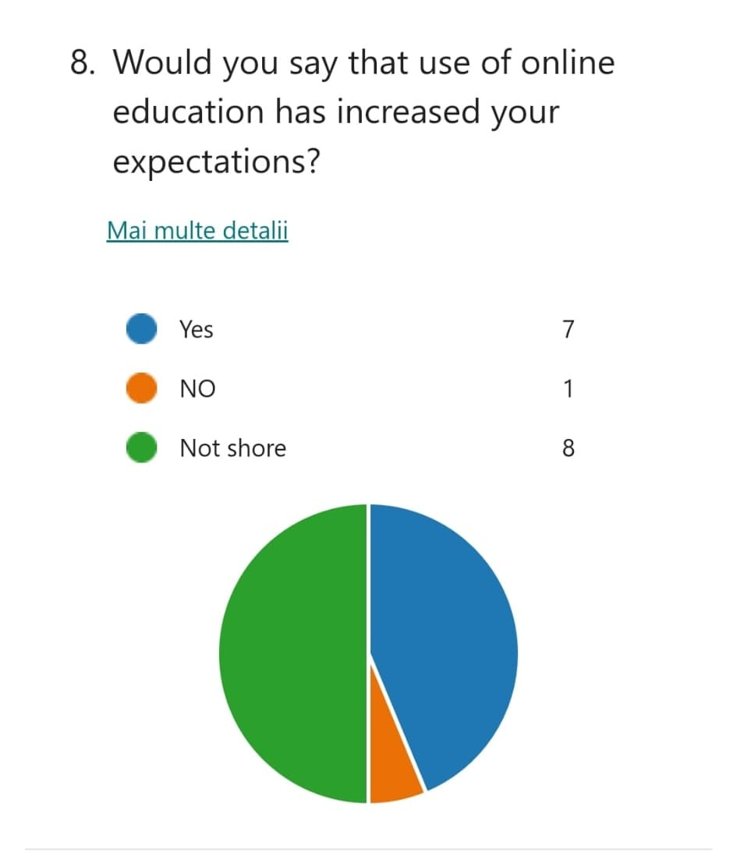
At this question, 8 participants out of 16 respond that are not sure if online education has increased their expectations
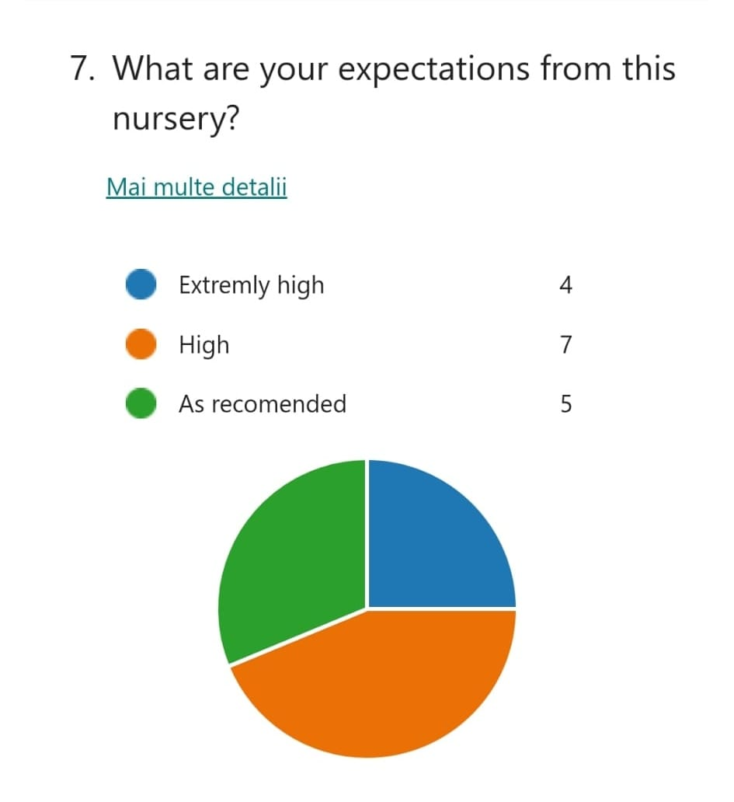 On the question above 7 participants out of 16 shows that they have high expectations from the nurseries across the UK in terms of teaching.

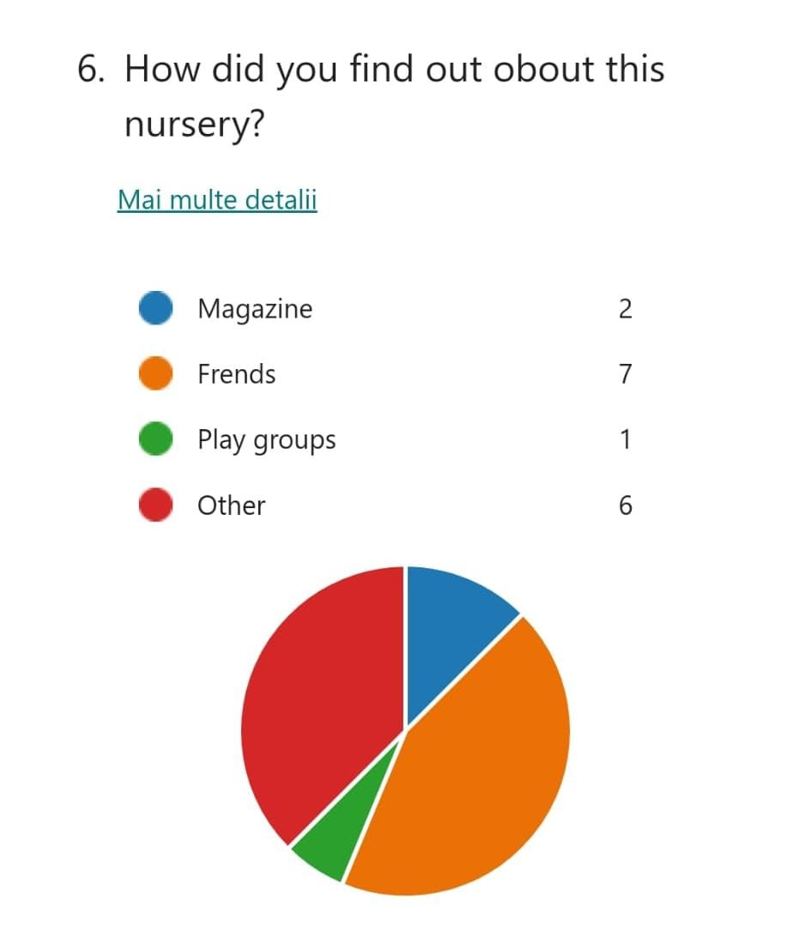
On question, no. 6 only one participant see that he/she got information about nurseries from parents at the playground and 6 of them has chosen other sources

Conclusion
The technology and the ICT have proved to be efficient in the nursery field and for the benefit of both children and teachers. However, during my research, most participants embrace the most face-to-face learning.
According to my literature research (primary data analysis), I have found out that “children are naturally curious and will explore technology on a variety of levels, not only how it works but the part of technology that plays in the word they leave”
“The technology also support in developing children’s gross, motor skills keyboard skills and hand-eye coordination” (Ms. Amies 2016)
Also during my research (secondary data analysis), 75% of participants responded that English is not their first language which proves that the UK has got a variety of cultures “due to freedom of movement within the European Union “ according to Statista research Department 2013
The way participants on my questionnaire answer the way they find out about the nursery was those other ways than magazines, friends, or playgroups meaning that without being mentioned it is via the internet
By using technology the teaching institution from around the globe has managed to continue to deliver courses despite restriction is posed by sanitary cruises being able to provide and receive education during those 2 years.

Reference:
Anderson L 2014 February 10 Kids and smart technology : How much is to much Hawkes by today (p. 10)
Bhat, I. [2019] Idea and Methods of Legal Research. India: Oxford University Press
Kanimozhi, M. [2018] Virtual Learning Environment. International Journal of Advanced Research in Computer Science, volume 9 (Special Issue 1), pp. 11-14.
Maund, A., Schriek, M., and Tinkler, P. [2017] Certificate in Higher Education: Skills for the Workplace Student Yearbook. London: Sage
Saunders, M., Lewis, P., Thornhill, A., [2006] Research Methods for Business Students. 4 th edn. Lebanon: Prentice-Hall.
Wilson, D. [2014] Essentials of Business Research: A Guide to Doing Your Research Project. 2 nd edn. London: Sage, pp. 152-192, illus.
First Discoverers. (2020). The New Age of Digital Technology and Early Years Education. [online] Available at: https://www.firstdiscoverers.co.uk/the-new-age-of-digital-technology-and-early-years-education/.
UKEssays.com. (n.d.). Benefits of ICT in Early Childhood Education. [online] Available at: https://www.ukessays.com/essays/childcare/benefits-ict-childhood-education-6369.php.
Cheeky Munkey. (2019). The importance of ICT in early years education. [online] Available at: https://cheekymunkey.co.uk/blog/the-importance-of-ict-in-early-years-education/ [Accessed 10 Jan. 2022]. Statista (2021). Statista - The Statistics Portal for Market Data, Market Research and Market Studies. [online] Statista.com. Available at: https://www.statista.com/.
Daynurseries.co.uk. (2022). [online] Available at: https://www.daynurseries.co.uk/advice/amp/a-brief-history-of-nurseries [Accessed 10 Jan. 2022]
1.
Age
Insights
 | 18-25 | 4
 | 26-35 | 5
 | 35-45 | 6
 | 45 or more | 1
2.
Gender
Insights
 | Male | 6
 | Female | 9
 | Other | 0
 | Alta | 1
3.
First language
 | English | 4
 | French | 0
 | German | 0
 | Other | 12
4.
Any alergies
 | To eggs | 0
 | To dust | 1
 | To polen | 2
 | Other | 0
 | None | 13
5.
Hobbies and passions
Insights
 | Sport | 5
 | Cooking | 6
 | Traveling | 4
 | Reading | 1
 | Other | 0
6.
How did you find out obout this nursery?
Insights
 | Magazine | 2
 | Frends | 7
 | Play groups | 1
 | Other | 6
7.
What are your expectations from this nursery?
 | Extremly high | 4
 | High | 7
 | As recomended | 5
8.
Would you say that use of online education has increased your expectations?
Insights
 | Yes | 7
 | NO | 1
 | Not shore | 8
9.
What kind of learning style do you prefer?

 | Online 100% | 1
 | Face-to-face 100% | 11
 | Hibrid | 4
10.
How would you rate the nursery's education in UK?
 | Very high | 4
 | High | 6
 | Ecellent | 5
 | Poor | 1

