

School of Sport, Health & Outdoor Education

Assessment Feedback Sheet

Student Name: Emma Louise Knight (1806654)
Module: Facilitating Learning through Experience
Module Code: SHOE7002

Assignment Title: Project Report

Design, deliver and reflect upon an experiential project or activity to facilitate learning within a specific outdoor education context. The facilitated activity must address an identifiable element of sustainability. The report should include the following:
- An abstract
- An introduction and rationale for the project (500 words)
- A literature review: critical analysis of theoretical perspectives underpinning your project / activity/ (2,000 words);
- An outline of the context of the activity and recognition of ethical concerns- “a simplified methodology” (500 words);
- A critical discussion and evaluation of the overall project in relation to the reviewed literature that leads to an appropriate conclusion (1,500 words);
- An annotated session plan (in appendix)
(4,500 words +/- 10%)

Submission Date:
3rd January 2020

Personal Evaluation – to support your academic progress please complete the section below BEFORE submitting your work.
What do you consider to be the best aspects of this work? | I have read much more in previous modules, which has led to an improved understanding. I am critical of my own and my client’s learning and how I could have improved the project.
Which aspects do you consider could have been improved in this piece of work? | Time management – ideally the reading and literature review would have been better completed before the project itself as I’m now trying to match what I did to the literature rather than building the session around what I had learnt.  The literature review has become a focus on lots of different literatures rather than having a couple of main ones to focus on. This has led to me learning a lot but I feel the critique could have been developed further.
What have you found most satisfying whilst undertaking this submission? | It was nice to be able to start connecting new learning with previous learning – I hadn’t really experienced this yet on this course.

ASSESSMENT CRITERIA | Learning  Outcomes
ASSESSMENT CRITERIA | Learning  Outcomes | Unsatisfactory  0 – 49% | Good  50 – 59% | Very Good  60 – 69% | Excellent  70% + | %
Evidence of critical discussion of relevant theoretical perspectives underpinning facilitation and experiential learning. | 1,2 |  |  |  |  | 40%
Critical analysis of the practical applications of facilitation and experiential learning in your project / activity. | 2,3 |  |  |  |  | 30%
Evaluation of the project that is both reflective and critical | 3 |  |  |  |  | 20%
Construction of a coherent argument that leads to an appropriate conclusion | 1,2,3 |  |  |  |  | 10%

Tutor comments

First Tutor’s Comments:

Second Tutor’s Comments:
Tutor 1: G. Harvey | Tutor 2:
1st Mark: % | 2nd Mark: % | Agreed Mark: %

What facilitation type can lead to improved enjoyment and learning?
(4,872 words)
Abstract
This paper explores how Heron’s (2006) different facilitation types can affect the enjoyment and learning of an outdoor, experiential learning session focused on activities to develop language skills in Primary School children. The session was designed to develop teaching staff’s abilities and confidence in the outdoors. It was led at an inner-city school with higher than average levels of needs. Prior to and following the session the participants completed questionnaires designed to find out how the different facilitation types (hierarchal, cooperative and autonomous) impacted their enjoyment and learning. Their answers showed that the facilitation types didn’t have an impact on enjoyment and learning, but the relevance of the activities to them did. Further research would need to be completed to fully conclude that facilitation types do not impact enjoyment and learning, perhaps with more focused questions. It would also be interesting to investigate whether there is a difference between children’s and adult’s perceptions of the facilitation types.
Introduction and Rationale
This project focused on using experiential learning in the outdoors to develop the education of language in a variety of ways. A range of facilitation types were used to explore their impact and effectiveness on enjoyment and overall learning. The project aims differed for the participants and for the project leader (myself), see table 1.
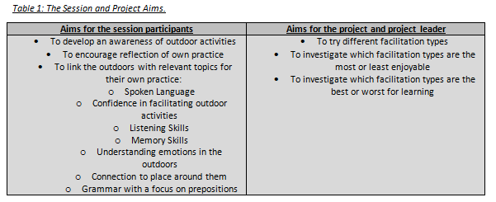
The aims were decided based on literature reviews and my own experience, as a Primary School teacher trying to increase the use of Outdoor Education throughout the curriculum. Jones (2019) and Raising.children.net (2017) both showed the importance of language in a child’s early development and therefore schools. As there is an increase of children with English as an additional language (EAL) and an increase in children being left in front of electronic devices, rather than playing/talking together or with adults, the number of children entering Primary schools with language levels at the correct level is decreasing. This is a concern as some believe the number of words that a child knows by the age of 2 correlates with their end point in education and life (Prigg, 2015; Duff et al, 2015).
The facilitation types used were based on Herons three modes: hierarchal, cooperative and autonomy and how they can be broken down into direction, negotiation and delegation (Heron, 2006). As a teacher I tend to fall into the hierarchal, direction category. Even when I try to delegate and create autonomy, a lot of modelling, support and direction still happen to create effective learning (Hill, 2017). Therefore I wanted to explore how I could deliver the different facilitation styles and what impact they would have on enjoyment and the learning created.
Enjoyment was chosen as a focus because it is believed that it has a positive impact on learning (Hermite and Jewarksike, 2018; Willis, 2017). It was also chosen as a link into Well-being and mental health which is a current issue within sustainable learning (Porter, 2019; innovatingminds, 2019).
Literature Review: Language Development
Duff et al (2015) explains that there is good evidence to show a link between infant vocabulary and later reading accuracy and comprehension in theory, but in practicality it is not a good indicator. However, two-year olds with delayed vocabulary levels and a family history of delayed vocabulary or speech problems, will have an elevated risk of developing reading difficulties in the future.
In comparison, Prigg’s (2015) research showed that children entering kindergarten/nursery with higher reading and math achievements are more likely to go to college, own homes, be married and live in good neighbourhoods as adults. It identified a growth in vocabulary as having a particularly important role with children aged two with a larger oral vocabulary being better prepared academically and behaviourally. Positives of this research were that the researchers took into account background characteristics and experiences to more fully isolate the role of vocabulary growth. A negative is that the vocabulary levels were measured by a parent survey – this could lead to errors either positively or negatively.
Proper language development in the first year leads to a secure foundation in speech and language and the next two years allow a great rate of development. Therefore, language development is a critical part of a child’s overall development and the best way to encourage the development of speech and language is to do lots of talking and listening. Most importantly, talking about things that interest the child: ensure you tune in and respond to the child by repeating and building on what they say (Raisingchildren.net, 2017). A language rich environment is about talking with children, not building displays or sticking on post-it-notes (Jones, 2019). This is something which schools are becoming increasingly aware of.
Children’s developments are often viewed in expectations known as milestones. Bainbridge (2019) explains the average expectations for development in speech and language, see table 2 below:
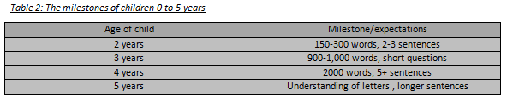
Gifted children can be identified by having advanced language abilities: e.g. they may talk earlier, have larger vocabulary or more advance vocabulary, or using larger sentences (Bainbridge, 2019). Therefore the development of early language is crucial to the future of the children.
Language development of children today is becoming ever more important, with an increasing focus on children with special educational needs and disabilities (SEND) and EAL, there is a need to consider language development throughout their child years and not just in early years. There are over 1.5 million learners with EAL in UK maintained schools, which equates to more than 15%. Some people associate this with newly arrived children with zero amounts of English but this isn’t always the case. Having an EAL status doesn’t show their English fluency or if they are born in the UK. EAL is a diverse group, they have a wide variety of ethnic, religious, political and social class backgrounds, which makes it an important topic to consider how they are taught. The best way to support students with EAL is to use a language aware pedagogy (Bell foundation, 2017; Leedham, 2015).
Language is initially taught through repetition and rote learning (Zilberman, 2018), although this can often be effective, some children will forget the learning quickly or not be able to apply it to new situations, which is crucial to effective language development (Fox, 2011; Cui et al, 2017). Williams (2013) believes that language pedagogy has come a long way since repetitive grammar-translation methods were used and regarded as the best way to learn. The use of task based approaches through communication and practical uses of language are now believed to be a better method of facilitation. Teaching the English method through communicative methods using real content and student-contributed content is a productive method (Cook, 2005/1983). Language is no longer seen as being learnt through mechanical exercises, it’s developed through students interacting and engaging. Others believe that languages should be learnt through the students being responsible for their own learning and the teacher being a guide (Williams, 2013). This idea of a guide links to: learning being the conscious effort of rote memorisation of facts in English and training being the subconscious activity of the learner in which he/she develops the skill of thinking in English and speaking it effortlessly. The ‘acquisition method’ as first described by Stephen Krashen in 1982, refers to the subconscious process that happens when learning language. They know they are using it but are unaware they are acquiring it. He discusses how simultaneous repetition can cause overload as the link between different languages can over fill the working memory (Zilberman, 2018). This idea link to the theory of cognitive overload (PsychologistWorld, N.D.). Repetition can lead to boredom which in turn leads to negative behaviours being shown, in turn leading to negative impact on learning engagements and achievements (Fox, 2011; Cui et al, 2017). This led me to wonder whether outdoor, experiential learning is currently used and whether it would be useful and effective in developing language, so I created a training session plan to support staff with delivering sessions aimed to develop a range of language skills.
Literature Review: Experiential Learning
Experiential learning can be explained in image 1 below:
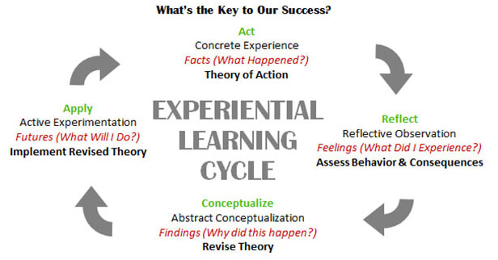
Image 1: The experiential learning cycle (FirstHand, N.D.)
It is when a learner experiences something concrete, reflects on why it has happened and what occurred (learning and feelings), before understanding it conceptually and apply it to the same or another situation. When most staff plan and teach they consider a range of research and theories such as Solo Taxonomy (see image 2) and Bloom’s Questioning (see image 3), but as lessons become outdoor sessions, they tend to turn into one activity fits all rather than the 3 to 4 way differentiation used indoors. Why is this? Surely this lowers the impact of learning through experience? Often it leads to the use of self-determination and differentiation by outcome.
Image 2: Solo Taxonomy (ThePeakPerformanceCentre, N.D.)
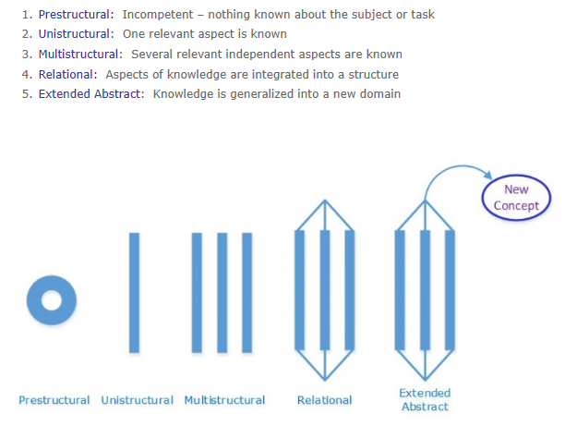
Image 3: Bloom’s Questioning (Johnston, 2012)
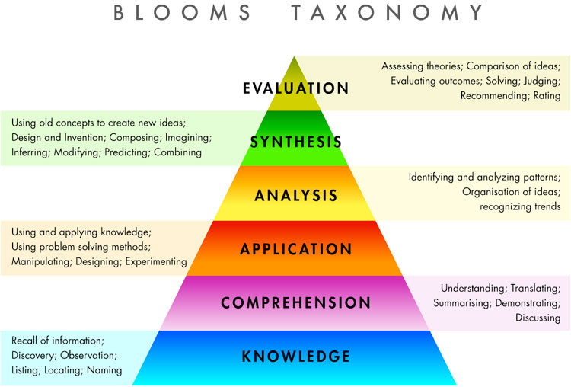
Experiential learning is viewed as: multi-stranded, active and real learning, ensuring all learners experience something relevant to them and their lives. This enhances their experience, engagement and therefore learning (Heron, 2006). It is a very student centred, subject focused way of learning which enhances the end learning goal (N.N., 2015). As rote learning and standardised tests encroach on many students joy, which can lead to distancing students from effective information processing and long term memory storage, experiential learning is an important part of a rounded education. If you remove pleasure then you can create bored, anxious children who are not engaged. Superior learning rises from enjoyment and relevant topics (Willis, 2009). There are 4 primary emotions recognised by Paul Ekman: fear, anger, sadness and enjoyment. All of these emotions can evoke engagement but not all allow deep thinking, resilience and the ability to develop new solutions and knowledge. Enjoyment is known to have a positive impact on learning, memory and social behaviour and can create a good learning community (Hernik and Jawarska, 2018).
Literature Review: Facilitation
Zilberman (2018) believes learning is when the teacher is the centre and training is where the learner is the centre, so where does facilitation come into this? According to Ahuvia (2011) a ‘felicitator’ is someone who brings happiness to others through personal creativity and respect. Ahuvia believes that the focus on creating social inclusion through their mutual respect, and aim to critique materialism and conformity, which they believe can create snobbery and prejudice. Tolerance is not the best way forward, but inclusion and enthusiastic appreciation of differences is, and this is where facilitators can best encourage imagination and creativity. Ahuvia believes happiness leads to creativity, which leads to positive evaluations by others and a perception of success, this then returns to happiness completing the circle.
Heron (2006) believes there are three modes of facilitation: hierarchal, co-operation and autonomy. Hierarchal is where the teacher or facilitator are in charge acting as a boss, whereas autonomy is the opposite, with the participants or learners being in charge of their own learning. Co-operation is a mixture of the two, where both facilitators and participants join their ideas together and learn from each other. This project was based on this as it explored whether one of the modes had a greater positive or negative impact on enjoyment or learning outcomes. E.g. Would autonomy lead to an increase in enjoyment and learning over hierarchal activities. Enjoyment, independence and autonomy are important to sustainable futures (Bourn et al 2016).
In comparison, the eight Tutelary procedures break these down further, see image 4.
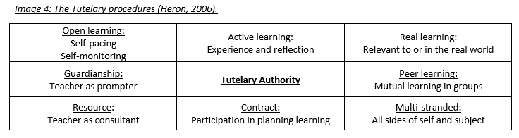
Hierarchal becomes guardianship with the teacher prompting, it also views the teacher as a consultant with a focus on resources. Autonomy becomes peer learning, where they learn in small groups; having a contract by participating in planning and open-learning through self-acing and self-monitoring. The other procedures point more towards experiential learning. An example of autonomy is shown by Hill’s (2017) discussion of the student learning community where they use specific purposes to create collaboration, discussions and reflections.
As a facilitator or teacher it is important to consider the impact you have on you learners, for example Young (N.D) discusses five ways to boost resilience. They are:
- Watch your language – praise the learning process and not achievement
- Engage in strength-based parenting/teaching – encouraging and acknowledging strengths of the children
- Don’t shield them from stress – this will reduce resilience
- Teach self-regulation skills
- Quantity line and group activities – quality time and talking

Literature Review: Sustainability and Well-Being
In 1994, Elkington introduced the Triple Bottom Line, see figure 1 below.
Figure 1: Elkingtons, 1994 Triple Bottom Line model
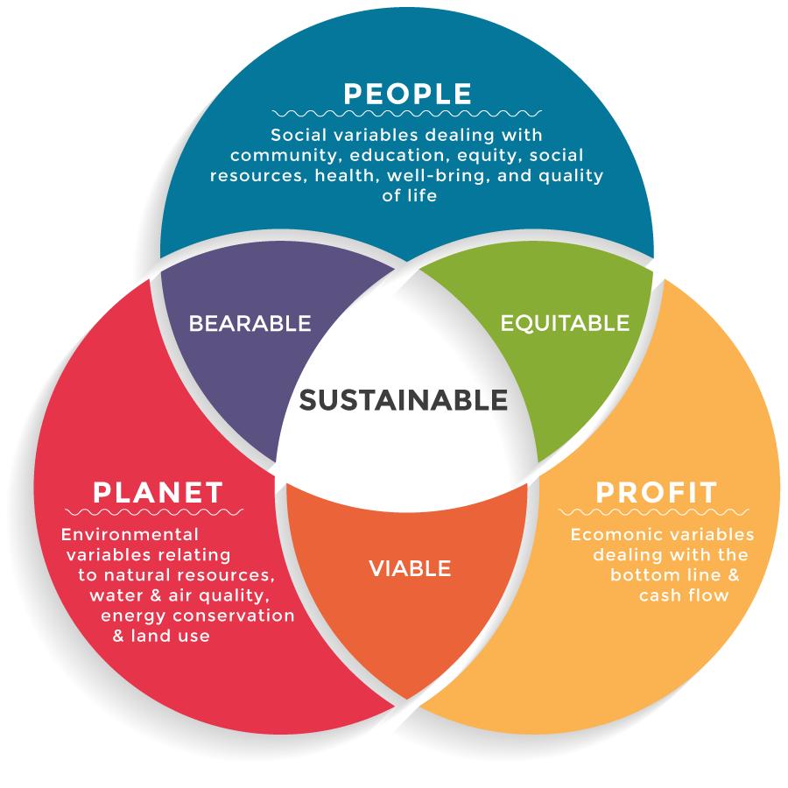
This encouraged people to consider how life and its actions worked alongside other things. They believed sustainable development could only be achieved if there was a balance between society, environment and ecology. In 2018, Mullingan adapted the model to become the social ecology model of sustainability. The main differences were: society becoming personal and economic became social ecology. This encouraged us to consider our impact on the different strands, as too much focus on one, for example society and cause a negative imbalance with the others, e.g. environment.
Well-being is important for the balance of the personal section and the society sections. In 2015, the future generations act in Wales introduce the Seven Well-Being Goals: prosperous, resilient, healthier, cohesive, communities, equal, globally responsible, vibrant culture and thriving Welsh language. Some of these ideas link with the Values based schools approach of the school I worked with (Hill Farm, 2019 and VBE, 2019).
The consideration of values links nicely to figure 4 below:
Figure 4: A change model for sustainable outdoor education (Hill, 2012).
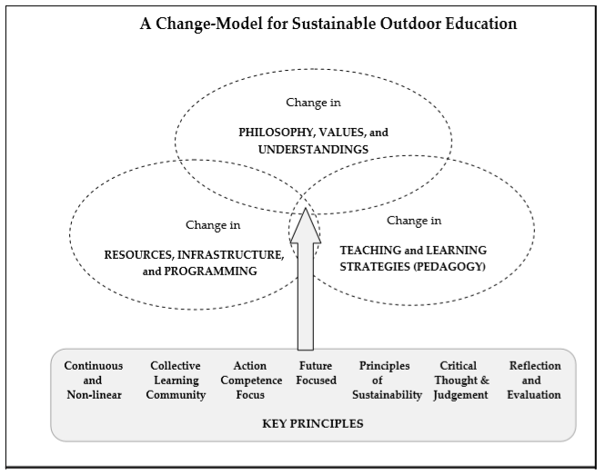
Another focus highlighted in figure 4 is the idea of place-based or environmental-based learning. This could be due to the belief o pedagogy of place engaging learners with nature and grasping information easier (sustainabilityinthecurriculum, N.D.). Teaching in the natural world is a brilliant platform for transformational learning (Gray, 2019). Another idea could be that experiential and holistic outdoor learning approaches are considered the most beneficial method for enhancing a learner’s personal and social development as well as raising awareness of environment concerns (Thorburn, 2017).
Personal development is seen as crucial for developing sustainable mental health, and as stress-related and mental health problems are an ever-growing concern due to the people being trapped in their own delirious discourse, the outdoors and Nordic philosophy of friluftsliv are a good option (Farkic and Taylor, 2019). Through the outdoors and creating increased resilience, people can handle stress easier and therefore life becomes sustainable (Gray, 2019; Prince, 2017).
As well as this, the focus on location and resources needs to be reduced. They should be viewed as objects which create opportunities and not the end point. This is shown in the capability approach, through focusing on a persons capabilities (what they are able to be and do) and their functioning’s (what they actually achieve) and using it as an evaluation space to promote individual well-being and human flourishing (Walker, 2005; Hart, 2009) and self-realisation (Smith, 1997)
Good mental health is the foundation of children achieving aspirations. Schools should create an emotional wellbeing friendly culture. Outstanding schools will having children who can make informed choices about healthy eating, fitness and their emotional and mental wellbeing (Innovating mind, 2019). As OFSTED have had a consultation with mental health charity young minds, and are moving away from data to focus on engaging and developing children using the curriculum, there is no better a time to encourage a push to sustainable, outdoor education (Porter, 2019).
Some believe that engaging with nature allows the holistic development of children, but teachers need encouragement to embrace unconventional nature-based pedagogies. Gray and Pigatt, 2018, believe wilderness promotes:
- An opportunity for friendship, peace and conservation
- A rewarding experience despite hardship
- A precious tangible memory
- A motivating factor in their current careers, recreational choices and attunement with nature
All of which are positive for the future development of secure mental health and wellbeing, figure 5 below explains how best to do this:
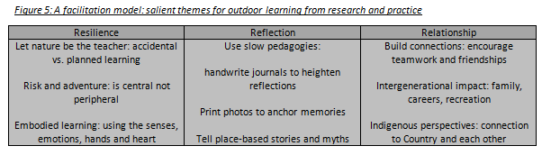
Method: The Project
Participants were invited to participate via a work email to all teaching colleagues at one Primary school in the City of Coventry. The school is a larger than average sized Primary school, with almost one third of the pupils having EAL. It has a higher than average number of disadvantaged pupils and higher than average number of children with SEND (OFSTED, 2013). Out of approximately 40 staff, 5 responded and 3 attended the session completing both questionnaires.
Due to the numbers of children classed as disadvantaged, SEND and EAL, the session was designed as an active-learning led session introducing the use of the outdoors to develop language. It was aimed to cover a range of topics suitable from the Early Years Foundation Stage to Key Stages 1 and 2 (England). The participants were aware that it was part of a Masters project into facilitation.
The project was designed to explore whether a specific facilitation style was more or less effective when delivering facilitation in the outdoors. It focused in on the following styles:
- Exploratory
- Directive through active learning and talking aloud
- Directive through active learning and games
- Delegating
- Directive through passive participants and teacher talk learning
The facilitation methods were chosen alongside the activities, trying to ensure there was a range but that it also met the needs of the participants.
Method: Ethics
The participants were aware of the research which greatly reduced ethical concerns, but potentially increased bias. Relevant forms were completed and are attached in the appendix. Consent was taken, and participants given the option of anonymising any data given through the use of a nickname/codename. Participants were debriefed following the questionnaire and allowed to remove their participation at any point before the submission date, as explained in email and person. The use of questionnaires was the main data collection tool, the questions were optional, and participants could leave a question if they felt it necessary.
Method: Data Collection
Data was collected via two questionnaires, one prior to the training session and the next the following day (included in the appendix). The questions were a mixture of open and closed styles, some requiring longer answers and others multiple choice. Questionnaires were chosen due to the hope of all 40 teaching staff participating, allowing lots of answers to be collected but minimising the need for time. They also enabled the collection of views pre- and post- session.
Some conversations throughout the session also allowed me to build a bigger picture of the participants’ previous experience: e.g. the session started with an assessment for learning question, asking when they had last led an outdoor session and what outdoor education meant to them.
There are positives and negatives to all data collection types, see figure 6 below for those that link to questionnaires:
Figure 6: The advantages and disadvantages of questionnaires being used to collect data (Debois, 2019).
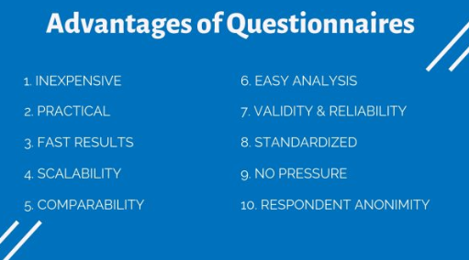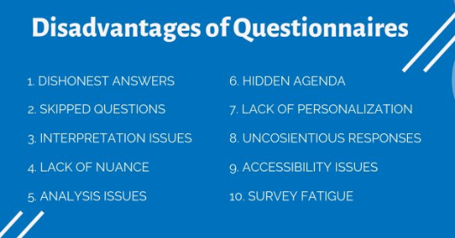
I chose questionnaires due to them being inexpensive, easy and fast. I am aware that they can collect dishonest questions and can sometimes lead to interpretation issues, but when I analyse and discuss the results, I will take these disadvantages into account.
Discussion: The Method
This project allowed the appreciation of positives and negatives of the method of a questionnaire. Questionnaires are known to be useful due to their cheap and quick results which often allow for an easy analysis of the data collected (Debois, 2019). This project supported these positives, although the data collected was difficult to analyse due to the questions asked: we will discuss this later. Another positive of the use of questionnaires in this study, was that it allowed a direct comparison of participants beliefs before and after the session through the comparison of the pre-questionnaire and post-questionnaire. In theory, this allowed us to see the impact that the session had on the beliefs of the participants, although you can still not prove that it was the session that impacted the answers, as something else may have happened to some of the participants as well, especially as the questionnaires were via the internet and allowed some delay.
Debois (2019) suggested some negatives of questionnaires as: dishonest answers, skipped questions, interpretation issues and a lack of personalisation. In light of these, I was always going to take the answers as starting points and was hoping large numbers of participants and similar answers would allow us to take the answers as correct and valid. Unfortunately, we only got three participants, one of which admitted to searching for an answer on the internet for the pre-questionnaire, as he felt like he should have known the answer and didn’t want to appear stupid and uneducated in the matter of sustainability. This proves how simple it is to give dishonest answers in questionnaires, especially when they are done away from the researcher and via the internet. Perhaps to reduce this I should have had paper questionnaires and completed at the session, but this would have reduced the time given to think about questions and introduced new negatives regarding other participants being around. The issue of skipped questions was not seen, but may have been if larger numbers of participants had taken part.
As mentioned above, the questions asked created an issue when it came to analysing and understanding what they showed. I went for mostly open questions, where participants were required to provide written answers: these are helpful in gaining a wide view of the participants understanding, but very difficult to compare. Alongside these I asked closed questions, where they had to pick a choice, these should have provided useful data, but due to the choices I provided, the usefulness of the answers was limited. I should have used a Likert style system instead: as the terms ‘best’ and ‘worst’ were poorly conceived.
The participants themselves are a crucial part of whether a study produces valid and generalisable results. Unfortunately, out of the approximately 40 staff that were invited to participate, only 3 fully participated. This leads to the results not being great enough to compare, as these 3 people are not a big enough sample size. (Faber and Fonseca, 2014).
Discussion: The outcome for the participants/clients
There were three main aims for the participants during the session, which differed greatly to the aims for the project itself. This was to ensure that the participants could gain something from the experience and not just the researcher.
The first aim was to increase an awareness of outdoor activities. Prior to the session, all three participants had led outdoor learning sessions but these had been several years ago and none could directly explain what they had done. This information was collected during the assessment for learning part of the session, it was fascinating to listen to their explanations and initial understanding of the outdoors. Participant L discussed how they did not know any of the activities that we had completed during the session previously, but that he now does and could use them at school. This shows a positive impact that the session had and would suggest the aim was met. The .other two did not comment on this, in future a direct question linked to this would give a clearer result. To support this positivity, all participants were more likely or definitely going to deliver outdoor sessions to develop language. This aim was successfully met, although an improvement would be to have more participants and to hold a questionnaire at a later date, to see whether any of them have actually put the knowledge into practice.
The second aim was to encourage reflection of own practice. This aim was only partially met and could have been developed better into the session. At the beginning of the session, the assessment for learning part allowed for them to consider their own practice and how much outdoor learning they use and have previously used. Also the questionnaires prior and following the sessions allowed for further reflection, but to have met this aim completely, there should have been reflection planned throughout the different activities. Through this reflection I could have increased the understanding and retention of the key focuses: language, sustainability, mental health and wellbeing.
The third and final aim was to link the outdoors with relevant topics for their practice. Two of the participants shared their views on this aim: Participant L explained how the touch 3 then me activity could be adapted for his role working with EAL children; and participant S discussed how the story activity linked to creativity and art as well as English. This could have been enhanced through the use of reflection as discussed above.
In conclusion, the session was strong for developing awareness of the outdoors and linking it to relevant topics for the participants, but it was weak on reflection time which could have been used to enhance their learning to ensure it was put into their practice.
Discussion: The outcome for the researcher and project aims
There were three main aims for the researcher and project, which are harder to decide whether they were met or not. All of them could have been improved and enhanced, through an improved questionnaire and more participants.
The first aim was to explore the different facilitation styles. This was partially met as there was the chance for the facilitator to plan for the different types, but due to the low numbers of participants it made it difficult to complete some of the types properly. For example, the facilitation style of delegation. When I tried to delegate an activity to them, and give them ownership over it, they completed it once and then were ready to move onto the next activity. This didn’t allow enough time to fully explore the facilitation method and the positives and negatives it brings. I also found that I personally fall back into ‘teacher mode’ and find it very difficult to step back and watch, which in turn reduces the autonomy given to the participants and increases the hierarchal feeling. This means that it is hard to be fully autonomous and see the impact that it can have. I also forgot to include well-being into the touch three then me activity, this therefore reduced the impact that it could have had on mental health and wellbeing.
The second aim was to investigate which facilitation type was the most or least enjoyable. We chose to consider enjoyment due to the impact discussed by (Hernik and Jawarska, 2018). See table 3 below for the answers referring to this:
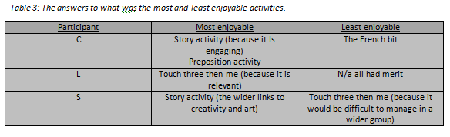
The ‘story activity’ is an example of directive facilitation through active learning and talking aloud and the ‘touch three then me activity’ is an example of directive facilitation through active learning and games, where as the preposition activity is an example of delegation. Due to the different activities mentioned in the table above and the different facilitation types they represent we can compare the enjoyment of them, see table 4 below for what it showed:
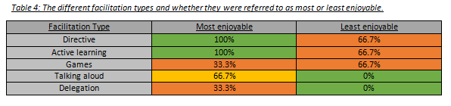
These results show that there is no real correlation between facilitation type and the amount of enjoyment. These results may have been different using more focused types (most activities link back to directive), a larger number of participants and questions which were more focused on the facilitation types rather than the activities. More research would be needed to show whether or not there is an impact on enjoyment due to facilitation types.
The final aim was to investigate whether the different facilitation types led to better or worse learning, see table 5 for the participants thoughts:
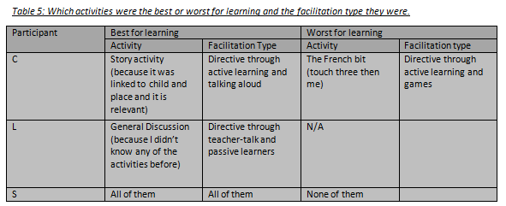
According to their comments, 66.7% believed that none of the activities were bad for learning. This suggests that no facilitation type had a negative impact on the learning created. 33.3% didn’t like the French bit, as they described it as the French bit we can presume that the dislike and lack of learning is due to it being linked to languages rather than the facilitation method and activity itself. In comparison, if we look at what they say about the most learning: Participant C preferred the directive facilitation through active learning and talking aloud; participant L preferred the directive method through passive learning and participant S had no preference. Again, there is no correlation here as they all have mentioned different teaching styles.
In order to conclude whether one of the facilitation types led to more or less learning further research would be required, ideally using a wider range of participants in numbers and backgrounds. When only considering the project, and not focusing on the results, it would have appeared that it was set up with a strength for looking at and comparing facilitation types, but following the analyse of participant comments, this does not appear to be the case. Directive facilitation takes over, although whether that is due to my bias or the session plan is unclear. It also appears that participants view relevant topics as more enjoyable and creating more learning, this meant that the relevance overshadowed the facilitation types and has led to results that cannot be applied to the aims comparing facilitation types. Potentially using children or being clearer on the comparison of facilitation types rather than activities, may reduce this and allow a direct comparison. An increase on use of reflection, but linked directly to facilitation types, may be another way of reducing this negative variable.
Discussion: Mental health, wellbeing and sustainability
This area was a weakness in the project and would need to be strengthened in future studies. The aspect could be developed through more focused discussions and questions throughout activities, encouraging the participants to focus on these and relate these to activities and facilitation types.
Conclusion
The conclusions from this research project are:
- three people are not enough to obtain results that are valid or comparable to other people;
- learning is most enjoyable or memorable when it is relevant but it doesn’t appear to matter what facilitation style you use (with adults);
- further study required, possibly seeing how children would respond, this would remove the relevance factor and allow us to focus on facilitation;
- build in more time for reflection;
- strengthen the aspect of sustainability, mental health and well-being through discussions and questions throughout the activities;
- complete a questionnaire at a later date to show whether or not the learning had been applied

References
- Ahuvia, (2001). Dr. Seuss, felicitator. International journal of wellbeing, Volume 1 (Issue 2). Pages 197-213
- Bainbridge, C. (2019). Gifted Children and Language Development, [online]. (Last updated on: August 8th 2019) Available at: https://www.verywellfamily.com/gifted-children-and-language-development-1449117 [Accessed: 20th December 2019]
- Beord and Wilson (2002), The power of Experiential learning. London: Saxon Graplings
- Boeree, C.G. (2006) Abraham Maslow [online] Available at: http://webspace.ship.edu/cgboer/maslow.html [Accessed: December 10th 2019]
- Bourn et al (2016). Primary education for global learning and sustainability. A report for the Cambridge Primary review trust. York: Cambridge Primary Review Trust
- Cook, V, (1983) What should language teaching be about? [Online] Available at: http://www.viviancook.uk/Writings/Papers/What%20should%20language%20teaching%20be%20about.htm [Accessed: 20th December 2019]
- Cui, G etc al (2017) The dampening effects of perceived teacher enthusiasm on class-related boredom: The mediating role of Perceived Autonomy support and task value. Front. Psychol. Volume 8 (Issue 400), pages not given. Accessed online at: https://www.frontiersin.org/articles/10.3389/fpsyg.2017.00400/full
- Debois, S (2019) 10 advantages and disadvantages of questionnaires. [online] Available at: https://surveyanyplace.com/questionnaire-pros-and-cons/ [Accessed: November 29th 2019]
- Duff et al. (2015). Do infant vocabulary skills predict school-age language and literacy outcomes? Journal of Child Psychology and Psychiatry and Allied Disciplines, Volume 58(Issue 8), pages 848-856.
- Farkic and Taylor, (2019). Rethinking tourist wellbeing through the concept of slow adventure
- FirstHand, (N.D.) Experiential Learning [Online] Available at: https://www.bing.com/images/search?view=detailV2&ccid=JUxnTWHS&id=14B408C190AD555A9B69AD3B268CAF6840B205C0&thid=OIP.JUxnTWHS1sqOgqahJmFQ1AHaD3&mediaurl=http%3a%2f%2fwww.firsthandstem.com%2fimages%2fabout%2f2.jpg&exph=322&expw=616&q=what+is+experiential+learning&simid=607988315598817126&selectedIndex=10&ajaxhist=0 [Accessed on: January 1st 2020]
- Freireinstitue (N.D.) Paula Freire [online] Available at: https://www.freire.org/paulo-freire/ [Accessed: December 11th 2019]
- Gray and Pigott, (2018). Lasting lessons in outdoor education: A facilitation model emerging from 30 years of reflective practice. Ecopsychology. Volume 10 (Issue 4). Pages 195-205
- Gray, T (2019). Outdoorlearning and psychological resilience: making today’s students better prepared for tomorrow’s world. Curriculum perspectives. Volume 39. Pages 67-72
- Greenaway, R, (2016). Your guide to active reviewing. [online]. Available at: http://reviewing.co.uk/ [Accessed 14th December 2019]
- Hart (2009). Quo Vadis? The capability space and new direction for the philosophy of educational research. Stud Philos Edu. Volume 28. Pages 391-402.
- Hawkes, N.J. (2018) The inner curriculum Woodbridge. John Catt Educational LTD.
- Hernik, J (2018) The effect of enjoyment on learning [online] Available at: https://www.researchgate.net/publication/323897499_THE_EFFECT_OF_ENJOYMENT_ON_LEARNING [Accessed 22nd December 2019]
- Heron, (2006). The complete facilitator handbook. London: Kogan Page
- Hill Farm, (2019). [online] Available at: https://hillfarmprimary.co.uk/ [Accessed: January 2nd 2020]
- Hill, (2012). Outdoor learning and psychological resilience, making today’s students better prepared for tomorrow’s world. Australian journal of outdoor education. Volume 16 (issue 1). Pages 15-27.
- Hill, S (2017) Flattening the Hierarcy: the role of student agency in school improvement. [Online] Available at: https://www.educ.cam.ac.uk/networks/lfl/about/inform/PDFs/InForm18-SLC-Project.pdf [Accessed: 20th December 2019]
- Innovatingminds, (N.D.) OFSTED and mental health provisions in schools [online]. Available at: https://www.innovatingmindscic.com/ofsted-and-mental-health-provisions-in-schools [Accessed: 21st December 2019]
- Johnston, G (2012). Scaffolding Math benchmarks with Blooms taxonomy. [online] Available at: https://teachingaheadofthecurve.blogspot.com/2012/12/scaffolding-math-benchmarks-with-blooms.html [Accessed: January 2nd 2020]
- Jones, G. (2019). Early reading and the education inspection framework, [online]. Available at: https://educationinspection.blog.gov.uk/2019/11/04/early-reading-and-the-education-inspection-framework/ [Accessed: 21st December 2019].
- Kristinisdottir, S (2008) Lev Vygotsky (1896-1934) [Online] Available at: http://mennta.hi.is/starfsfolk/solrunb/vygotsky.htm [Accessed: December 12th 2019]
- Leedham, D. (2015). The challenges of English as an additional language, [online] Available at: https://thekeysupport.com/insights/2015/01/08/the-challenges-of-english-as-an-additional-language/ [Accessed 20th December 2019]
- Munari, A, (1994) Jean Piaget The quarterly review of comparative education. Paris: UNESCO. Volume XXIV (Issue ½) Pages 311-327
- Porter, T (2019). Ofsted’s framework: What it means for pupil mental health. [online]. Available at: https://www.tes.com/news/ofsteds-framework-what-it-means-pupil-mental-health [Accessed: 21st December 2019]
- Prigg, M. (2015). Why your toddler’s vocabulary at age TWO can predict their success in later life, [online]. The daily mail, Pages not given. (Last updated on: August 20th 2015). Available at: https://www.dailymail.co.uk/sciencetech/article-3203970/How-does-toddler-talk-Researchers-say-vocabulary-age-TWO-predict-future-success-school.html [Accessed: 20th December 2019]
- PsychologistWorld (N.D.) Cognitive Load Theory [online] Available at: https://www.psychologistworld.com/memory/cognitive-load-theory [Accessed: December 29th 2019]
- Raisingchildren.net (2017). Language development in children:0-8 years, [Online.] (Last updated: November 27th 2019) Available at: https://raisingchildren.net.au/babies/development/language-development/language-development-0-8 [Accessed: 19 December 2019].
- Schon (1991) The reflective practictioner 2nd Ed. GB: Maurice Temple Smith
- Sherrington, (2019) Rosenshine’s principles in action. Woodbridge: John Catt Ed. LTD.
- Smith, M (1997) Maria Montessori and education. [online] Available at: https://infed.org/mobi/maria-montessori-and-education/ [Accessed: December 11th 2019]
- Smith, M (2001) John Dewey on education, experience and community. [online] Available at: http://infed.org/mobi/john-dewey-on-education-experience-and-community/ [Accessed: December 12th 2019]
- Smith, M (2001) Kurt Lewin: groups, experiential learning and action research. [online] Available at: http://infed.org/mobi/kurt-lewin-groups-experiential-learning-and-action-research/ [Accessed: December 12th 2019]
- Smith, M (2016) Jerome Bruner and the process of education. [online] Available at: https://infed.org/mobi/jerome-bruner-and-the-process-of-education/ [Accessed: December 10th 2019]
- Smith, M (2103) Chris Argyris: theories of action, double-loop learning and organization learning. I[online] Available at: https://infed.org/mobi/chris-argyris-theories-of-action-double-loop-learning-and-organizational-learning/ [Accessed December 14th 2019]
- Sustainabilityinthecurriculum, (N.D) Sustainability in the curriculum. [online] Available at: https://www.sustainabilitycurriculum.co.uk/ [Accessed: November 14th 2019]
- Taylor, et al. (2015) Educating for sustainability in primary schools: teaching for the future New Zealand: Sense Publications
- The bell foundation, (2017). EAL learners in the UK. [online]. Available at: https://ealresources.bell-foundation.org.uk/school-leaders/eal-learners-in-uk [Accessed: 21st December 2019]
- The Peak performance Centre, (N.D.) SOLO Taxonomy [online] Available at: http://thepeakperformancecenter.com/educational-learning/thinking/blooms-taxonomy/solo-taxonomy/ [Accessed: January 2nd 2020]
- The person-centred association, (N.D.) Carl Rogers. [online] Available at: https://www.the-pca.org.uk/about/carl-rogers.html [ Accessed: December 14th 2019]
- Thorburn, (2017) Moral deliberation and environmental awareness: reviewing Dewayan informed possibilities for contemporary outdoor learning. Journal of adventure education and outdoor learning. Volume 18 (Issue 1) Pages 26-35.
- Values Based Education (VBE), (2019). [online] Available at: https://www.valuesbasededucation.com/ [Accessed: January 2nd 2020]
- Walker, (2005). Amartya Sen’s capability approach and education. Educational Research. Volume 13 (Issue 1). Pages 103-109
- Williams, M. (2013). What’s the best way to teach languages? [online] The guardian, pages not given. Available at: https://www.theguardian.com/teacher-network/teacher-blog/2013/may/14/best-way-teach-language-schools [Accessed: 21st December 2019]
- Willis, J (2007) The neuroscience of joyful education [online] Available at: https://www.psychologytoday.com/files/attachments/4141/the-neuroscience-joyful-education-judy-willis-md.pdf [Accessed: 22nd December 2019]
- Ziberman, A (2018). Training Vs. Rote Memorization in learning English: What are the differences? [Online] Available at: https://elearningindustry.com/rote-memorization-in-learning-english-vs-training [Accessed 21st December 2019]

Appendix
- Ethics form
- Lesson plan
- Pre-questionnaire
- Post-questionnaire
- Raw data

- Ethics Form
APPLICATION FOR ETHICAL APPROVAL

In order for research to result in benefit and minimise risk of harm, it must be conducted ethically. A researcher may not be covered by the University’s insurance if ethical approval has not been obtained prior to commencement.

The University follows the OECD Frascati manual definition of research activity: “creative work undertaken on a systematic basis in order to increase the stock of knowledge, including knowledge of man, culture and society, and the use of this stock of knowledge to devise new applications”. As such this covers activities undertaken by members of staff, postgraduate research students, and both taught postgraduate and undergraduate students working on dissertations/projects.

The individual undertaking the research activity is known as the “principal researcher”.

Ethical approval is not required for routine audits, performance reviews, quality assurance studies, testing within normal educational requirements, and literary or artistic criticism.

Please read the notes for guidance before completing ALL sections of the form.

This form must be completed and approved prior to undertaking any research activity. Please see Checklist for details of process for different categories of application.

Delete the Guidance Notes at the end of the form BEFORE submitting your application

SECTION A: About You (Principal Researcher)
Full Name: |  | Emma Knight
Tick all boxes which apply: |  | Member of staff: | ☐ | Honorary research fellow: | ☐
Undergraduate Student | ☐ | Taught Postgraduate Student | ☒ | Postgraduate Research Student | ☐

Faculty/School/Centre: | School of sport, health and outdoor education
Campus: | Carmarthen
E-mail address: | Emmsy19@hotmail.com
Contact Telephone Number: | 07708781914
For students:
Student Number: | 1806654
Programme of Study: | Outdoor Education Masters
Director of Studies/Supervisor: | Graham Harvey

SECTION B: Approval for Research Activity
Has the research activity received approval in principle?  (please check the Guidance Notes as to the appropriate approval process for different levels of research by different categories of individual) |  | YES | ☐ | NO | ☐
 |  |  |  | Date
If Yes, please indicate source of approval (and date where known): Approval in principle must be obtained from the relevant source prior to seeking ethical approval | Research Degrees Committee |  | ☐
 | Faculty Research Committee |  | ☐
 | Other (write in) |  | ☐

SECTION C: Internal and External Ethical Guidance Materials
Please list the core ethical guidance documents that have been referred to during the completion of this form (including any discipline-specific codes of research ethics, and also any specific ethical guidance relating to the proposed methodology). Please tick to confirm that your research proposal adheres to these codes and guidelines.
UWTSD Research Ethics & Integrity Code of Practice | ☒
UWTSD Research Data Management Policy | ☒
 | ☐

SECTION D: External Collaborative Research Activity
Does the research activity involve collaborators outside of the University? |  | YES | ☐ | NO | ☐
If Yes, please provide the name of the external organisation and name and contact details for the main contact person and confirmation this person has consented to their personal data being shared.as part of this collaboration.
Institution
Contact person name
Contact person e-mail address

Has this individual consented to sharing their details on this form? |  | YES | ☐ | NO |  |  | ☐
Are you in receipt of a KESS scholarship? |  | YES | ☐ | NO |  |  | ☒
Is your research externally funded |  | YES | ☐ | NO |  |  | ☒
Are you specifically employed to undertake this research in either a paid or voluntary capacity? | Voluntary | YES | ☒ | NO |  | ☐
 | Employed | YES | ☐ | NO |  | ☒
Is the research being undertaken within an existing UWTSD Athrofa Professional Learning Partnership (APLP) | If YES then the permission question below does not need to be answered. | YES | ☐ | NO |  |  | ☒
Permission to undertake the research has been provided by the partner organisation | (If YES attach copy)  If NO the application cannot continue | YES | ☐ | NO |  |  | ☒

Where research activity is carried out in collaboration with an external organisation
Does this organisation have its own ethics approval system? | YES | ☐ | NO | ☒
If Yes, please attach a copy of any final approval (or interim approval) from the organisation

SECTION E: Details of Research Activity
Indicative title:
Proposed start date: |  | Proposed end date:
Introduction to the Research (maximum 300 words)
Ensure that you write for a Non-Specialist Audience when outlining your response to the three points below:
- Purpose of Research Activity
- Proposed Research Question
- Aims of Research Activity
- Objectives of Research Activity
Demonstrate, briefly, how Existing Research has informed the proposed activity and explain
- What the research activity will add to the body of knowledge
- How it addresses an area of importance.
Purpose of Research Activity

To investigate which facilitation style is the most suitable for teaching adults about how they can use the outdoors to support development in spoken language.

(this box should expand as you type)
Research Question

Which method of facilitation is most suited for teaching how to use the outdoors?

(this box should expand as you type)
Aims of Research Activity

- To teach some school staff how to use the outdoors effectively to develop language
- To investigate which method of facilitation is most suited to teaching about the use of the outdoors
- Which method of facilitation is the most enjoyable?
- Which method leads to the most learning?

(this box should expand as you type)
Objectives of Research Activity

As above

(this box should expand as you type)
Proposed methods (maximum 600 words)
Provide a brief summary of all the methods that may be used in the research activity, making it clear what specific techniques may be used. If methods other than those listed in this section are deemed appropriate later, additional ethical approval for those methods will be needed.
Time | Facilitation Style | Location | Description
10 minutes | Exploratory | Classroom | When have you used outdoor education? Have you ever used it to develop language?  Participants share their experiences with outdoor education. Aim – AfL  What values do we need to use to be successful in outdoor education? (SUSTAINABILITY –values)
15 minutes | Directive – active learning, talking aloud | Classroom/outdoors | People to find an object outdoors and create a back story for that object. They then need to share the object and it’s story with the group. Aim – to develop spoken language and confidence to share  SUSTAINABILITY – don’t pick an object that is living, if you do point at where it is and don’t pick it up.
10 minutes | Directive – active learning, game | Outdoors | Touch three, then me – In French  Developing listening skills.
15 minutes | Delegating | Outdoors | Give the group roles:  - Observer – Do they use the prepositions correctly?  - Director – Tell the placer where to put the object/ tell a story using prepositions  - Placer – follows the directors instructions  Aim- develop the use of prepositions
15 minutes | Directive – teacher talk, participants listen | Outdoors/classroom | Share other ideas of activities. Participants just listen to the ideas  e.g. https://www.spectrumspeech.ie/blog/outdoor-activities-to-develop-speech-and-language-skills

Questionnaire
- Have you previously used the outdoors to develop language?
- How likely are you to now use the outdoors to develop language? Not, unlikely, more, definitely
- Which part of the session did you enjoy the most? Why?
- Which part of the session did you enjoy the least? Why?
- Which part of the session did you learn the most in? Why?
- Which part of the session did you learn the least? Why?
- How could I have improved this session?

(this box should expand as you type)

Location of research activity
Identify all locations where research activity will take place.
Hill Farm Primary School, Coventry – in a classroom or on the school field

(this box should expand as you type)
Research activity outside of the UK
If research activity will take place overseas, you are responsible for ensuring that local ethical considerations are complied with and that the relevant permissions are sought. Specify any local guidelines (e.g. from local professional associations/learned societies/universities) that exist and whether these involve any ethical stipulations beyond those usual in the UK (provide details of any licenses or permissions required). Also specify whether there are any specific ethical issues raised by the local context in which the research activity is taking place, for example, particular cultural and/or legal sensitivities or vulnerabilities of participants.
N/A

(this box should expand as you type)
Use of documentation not in the public domain: Are any documents NOT publicly available? | NO | ☒
 | YES | ☐
If Yes, please provide details here of how you will gain access to specific documentation that is not in the public domain and that this is in accordance with prevailing data protection law of the country in question and England and Wales.

(this box should expand as you type)

SECTION F: Scope of Research Activity
Will the research activity include: | YES | NO
Use of a questionnaire or similar research instrument? | ☒ | ☐
Use of interviews? | ☐ | ☒
Use of diaries? | ☐ | ☒
Participant observation with their knowledge? | ☒ | ☐
Participant observation without their knowledge? | ☐ | ☒
Use of video or audio recording? | ☐ | ☒
Access to personal or confidential information without the participants’ specific consent? | ☐ | ☒
Administration of any questions, test stimuli, presentation that may be experienced as physically, mentally or emotionally harmful / offensive? | ☐ | ☒
Performance of any acts which may cause embarrassment or affect self-esteem? | ☐ | ☒
Investigation of participants involved in illegal activities? | ☐ | ☒
Use of procedures that involve deception? | ☐ | ☒
Administration of any substance, agent or placebo? | ☐ | ☒
Working with live vertebrate animals? | ☐ | ☒
Other primary data collection methods, please explain in this box  For example, ‘focus groups’. Please indicate the type of data collection method(s) in this box and tick the accompany box. | ☐ | ☒
Details of any other primary data collection method:  (this box should expand as you type) | ☐ | ☒
If NO to every question, then the research activity is (ethically) low risk and may be exempt from some of the following sections (please refer to Guidance Notes).

If YES to any question, then no research activity should be undertaken until full ethical approval has been obtained.

SECTION G: Intended Participants
Who are the intended participants: | YES | NO
Students or staff at the University? | ☐ | ☒
Adults (over the age of 18 and competent to give consent)? | ☒ | ☐
Vulnerable adults? | ☐ | ☒
Children and Young People under the age of 8? (Consent from Parent, Carer or Guardian will be required) | ☐ | ☒
Prisoners? | ☐ | ☒
Young offenders? | ☐ | ☒
Those who could be considered to have a particularly dependent relationship with the investigator or a gatekeeper? | ☐ | ☒
People engaged in illegal activities? | ☐ | ☒
Others (please identify specifically any group who may be unable to give consent) please indicate here and tick the appropriate box. | ☐ | ☒
Other – please indicate here:  (this box should expand as you type) | ☐ | ☒

Participant numbers and source
Provide an estimate of the expected number of participants. How will you identify participants and how will they be recruited?
How many participants are expected? | Unsure but approximately 5-10 people  (this box should expand as you type)
Who will the participants be? | Teachers/teaching assitants at Hill Farm Primary School  (this box should expand as you type)
How will you identify the participants? | I will send an email to staff at my school and invite them to attend my staff training session linked with my masters course. They will understand that I am looking into different ways of facilitating learners and that we are reflecting on how successful they are.  (this box should expand as you type)

Information for participants: | YES | NO | N/A
Will you describe the main research procedures to participants in advance, so that they are informed about what to expect? | ☐ | ☐ | ☒
Will you tell participants that their participation is voluntary? | ☒ | ☐ | ☐
Will you obtain written consent for participation? | ☒ | ☐ | ☐
Will you explain to participants that refusal to participate in the research will not affect their treatment or education (if relevant)? | ☐ | ☐ | ☒
If the research is observational, will you ask participants for their consent to being observed? | ☒ | ☐ | ☐
Will you tell participants that they may withdraw from the research at any time and for any reason? | ☒ | ☐ | ☐
With questionnaires, will you give participants the option of omitting questions they do not want to answer? | ☒ | ☐ | ☐
Will you tell participants that their data will be treated with full confidentiality and that, if published, it will not be identifiable as theirs? | ☒ | ☐ | ☐
Will you debrief participants at the end of their participation, in a way appropriate to the type of research undertaken? | ☐ | ☐ | ☒
If NO to any of above questions, please give an explanation
(this box should expand as you type)

Information for participants: | YES | NO | N/A
Will participants be paid? | ☐ | ☒ | ☐
Is specialist electrical or other equipment to be used with participants? | ☐ | ☒ | ☐
Are there any financial or other interests to the investigator or University arising from this study? | ☐ | ☒ | ☐
Will the research activity involve deliberately misleading participants in any way, or the partial or full concealment of the specific study aims? | ☐ | ☒ | ☐
If YES to any question, please provide full details
(this box should expand as you type)

SECTION H: Anticipated Risks

Outline any anticipated risks that may adversely affect any of the participants, the researchers and/or the University, and the steps that will be taken to address them.

If you have completed a full risk assessment (for example as required by a laboratory, or external research collaborator) you may append that to this form.
Full risk assessment completed and appended? |  | Yes | ☐
 |  | No | ☒
Risks to participants
For example: emotional distress, financial disclosure, physical harm, transfer of personal data, sensitive organisational information
Risk to Participant: potential risk of falling in the outdoors, no other risks expected  (this box should expand as you type) | How will you mitigate the Risk to Participant  Safety rules shared at the start of the session – e.g. bring attention to the rough floor outside  (this box should expand as you type)
If research activity may include sensitive, embarrassing or upsetting topics (e.g. sexual activity, drug use) or issues likely to disclose information requiring further action (e.g. criminal activity), give details of the procedures to deal with these issues, including any support/advice (e.g. helpline numbers) to be offered to participants. Note that where applicable, consent procedures should make it clear that if something potentially or actually illegal is discovered in the course of a project, it may need to be disclosed to the proper authorities
None used

(this box should expand as you type)
Risks to investigator
For example: personal safety, physical harm, emotional distress, risk of accusation of harm/impropriety, conflict of interest
Risk to Investigator:  None  (this box should expand as you type) | How will you mitigate the Risk to Investigator:  (this box should expand as you type)
University/institutional risks
For example: adverse publicity, financial loss, data protection
Risk to University:  none  (this box should expand as you type) | How will you mitigate the Risk to University:  (this box should expand as you type)

Disclosure and Barring Service
If the research activity involves children or vulnerable adults, a Disclosure and Barring Service (DBS) certificate must be obtained before any contact with such participants. | YES | NO | N/A
Does your research require you to hold a current DBS Certificate? | ☐ | ☒ | ☐

SECTION I: Feedback, Consent and Confidentiality
Feedback
What de-briefing and feedback will be provided to participants, how will this be done and when?
After questionnaires are collected, I will share the findings with the group via email. There is no real need for an immediate de-brief but I will thank all participants.

(this box should expand as you type)
Informed consent
Describe the arrangements to inform potential participants, before providing consent, of what is involved in participating. Describe the arrangements for participants to provide full consent before data collection begins. If gaining consent in this way is inappropriate, explain how consent will be obtained and recorded in accordance with prevailing data protection legislation.
I will talk them through the session in advance via email and obtain online consent. I will repeat this at the start of my session.

(this box should expand as you type)
Confidentiality / Anonymity
Set out how anonymity of participants and confidentiality will be ensured in any outputs. If anonymity is not being offered, explain why this is the case.
Anonymous responses – limited information given

(this box should expand as you type)

SECTION J: Data Protection and Storage
In completing this section refer to the University’s Research Data Management Policy and the extensive resources on the University’s Research Data Management web pages (http://uwtsd.ac.uk/library/research-data-management/).
Does the research activity involve personal data (as defined by the General Data Protection Regulation 2016 “GDPR” and the Data Protection Act 2018 “DPA”)? | YES | NO
“Personal data” means any information relating to an identified or identifiable natural person (‘data subject’). An identifiable natural person is one who can be identified, directly or indirectly, in particular by reference to an identifier such as a name, an identification number, location data, an online identifier or to one or more factors specific to the physical, physiological, genetic, mental, economic, cultural or social identity of that natural person. | ☐ | ☐
If YES, provide a description of the data and explain why this data needs to be collected:
(this box should expand as you type)
Does it involve special category data (as defined by the GDPR)? | YES | NO
“Special category data” means sensitive personal data consisting of information as to the data subjects’ –  (a) racial or ethnic origin,  (b) political opinions,  (c ) religious beliefs or other beliefs of a similar nature,  (d) membership of a trade union (within the meaning of the Trade Union and Labour Relations (Consolidation) Act 1992),  (e) physical or mental health or condition,  (f) sexual life,  (g) genetics,  (h) biometric data (as used for ID purposes), | ☐ | ☐
If YES, provide a description of the special category data and explain why this data needs to be collected:
(this box should expand as you type)
Will the research activity involve storing personal data and/or special category data on one of the following: | YES | NO
Manual files (i.e. in paper form)? | ☒ | ☐
University computers? | ☐ | ☒
Private company computers? | ☐ | ☒
Home or other personal computers? | ☐ | ☒
Laptop computers/ CDs/ Portable disk-drives/ memory sticks? | ☒ | ☐
“Cloud” storage or websites? | ☒ | ☐
Other – specify: | ☐ | ☒
For all stored data, explain the measures in place to ensure the security of the data collected, data confidentiality, including details of password protection, encryption, anonymisation and pseudonymisation:
Anonymous – no names, only their answers – using google questionnaire and printed versions too

(this box should expand as you type)
All Data Storage
Will the research activity involve any of the following activities: | YES | NO
Electronic transfer of data in any form? | ☒ | ☐
Sharing of data with others at the University? | ☒ | ☐
Sharing of data with other organisations? | ☒ | ☐
Export of data outside the European Union or importing of data from outside the UK? | ☐ | ☒
Use of personal addresses, postcodes, faxes, emails or telephone numbers? | ☐ | ☒
Publication of data that might allow identification of individuals? | ☐ | ☒
Use of data management system? | ☐ | ☒
Data archiving? | ☐ | ☒
If YES to any question, please provide full details, explaining how this will be conducted in accordance with the GDPR and DPA (and/or any international equivalent):
Information shared will only be the answers to the questions and the finding – none will be linked back to individuals

(this box should expand as you type)
List all who will have access to the data generated by the research activity:
University staff, myself and participants

(this box should expand as you type)
List who will have control of, and act as custodian(s) for, data generated by the research activity:
Emma Knight

(this box should expand as you type)
Give details of data storage arrangements, including security measures in place to protect the data, where data will be stored, how long for, and in what form. Will data be archived – if so how and if not why not.
Google drive – only accessed by myself
No personal data will be stored

(this box should expand as you type)
Please indicate if your data will be stored in the UWTSD Research Data Repository (see https://researchdata.uwtsd.ac.uk/ ). If so please explain. (Most relevant to academic staff)
No

(this box should expand as you type)
Confirm that you have read the UWTSD guidance on data management (see https://www.uwtsd.ac.uk/library/research-data-management/) | YES | ☒
 | NO | ☐
Confirm that you are aware that you need to keep all data until after your research has completed or the end of your funding | YES | ☒
 | NO | ☐

SECTION K: Declaration
The information which I have provided is correct and complete to the best of my knowledge. I have attempted to identify any risks and issues related to the research activity and acknowledge my obligations and the rights of the participants.

In submitting this application I hereby confirm that I undertake to ensure that the above named research activity will meet the University’s Research Ethics and Integrity Code of Practice
Signature of applicant: | E.Knight | Date: 21/10/19

For STUDENT Submissions:
Director of Studies/Supervisor: |  | Date:
Signature: |  | Date:

For STAFF Submissions:
Head of School/Assistant Dean: |  | Date:
Signature: |  | Date:

Checklist: Please complete the checklist below to ensure that you have completed the form according to the guidelines and attached any required documentation:
☐ | I have read the guidance notes supplied before completing the form.
☒ | I have completed ALL RELEVANT sections of the form in full.
☐ | I confirm that the research activity has received approval in principle
☐ | I have attached a copy of final/interim approval from external organisation (where appropriate)
☐ | I have attached a full risk assessment (and have NOT completed Section H of this form) (where appropriate) ONLY TICK IF YOU HAVE ATTACHED A FULL RISK ASSESSMENT
☒ | I understand that it is my responsibility to ensure that the above named research activity will meet the University’s Research Ethics and Integrity Code of Practice.
☒ | I understand that before commencing data collection all documents aimed at respondents (including information sheets, consent forms, questionnaires, interview schedules etc.) must be confirmed by the DoS/Supervisor, module tutor or Head of School.
☒ | I have deleted the guidance notes before submitting the PG2 for consideration

RESEARCH STUDENTS AND STAFF ONLY
All communications relating to this application during its processing must be in writing and emailed to pgresearch@uwtsd.ac.uk , with the title ‘Ethical Approval’ followed by your name.
You will be informed of the outcome of your claim by email; therefore it is important that you check your University and personal email accounts regularly.

STUDENTS ON UNDERGRADUATE OR TAUGHT MASTERS PROGRAMMES should submit this form (and receive the outcome) via systems explained to you by the supervisor/module leader.

This form is available electronically from the Academic Office web pages: http://www.uwtsd.ac.uk/academic-office/

Application Process

All staff research projects and all research students must submit the Ethical Approval Form to the University Ethics Committee via the Academic Office (pgresearch@uwtsd.ac.uk). Staff research directly in relation to personal study for taught undergraduate or Masters programmes should be submitted via the Faculty procedures explained below.

Taught masters and taught undergraduate research Ethical Approval Forms are considered within Faculties. Faculties will provide details of the specific processes for this. Where the Ethical issues within any single ethical application are of particular concern the Faculty will refer these to the University Ethics Committee. Any student activity that involves the collection of primary data needs to undergo Ethical approval, this includes assignment work as well as dissertations.

- Lesson plan
Facilitation Project – Training session into using the outdoors to develop language
Participants – volunteers from staff at Hill Farm, recruited through an email
Session –
Time | Facilitation Style | Location | Description | Link to sustainability, environment, or wellbeing.
10 minutes | Exploratory | Classroom | When have you used outdoor education? Have you ever used it to develop language?  Participants share their experiences with outdoor education. Aim – AfL  What values do we need to use to be successful in outdoor education? (SUSTAINABILITY –values)  Share why the outdoors is important – link to well being and mental health, link to risk taking | Wellbeing  Values – sustainability?
15 minutes | Directive – active learning, talking aloud | Classroom/outdoors | People to find an object outdoors and create a back story for that object. Ensure the story is connected to the environment around them – i.e. it can’t have come from outerspace or talk to aliens as we can’t see them. Encourage them to connect to the place around them. They then need to share the object and it’s story with the group. Aim – to develop spoken language and confidence to share  SUSTAINABILITY – don’t pick an object that is living, if you do point at where it is and don’t pick it up. | Connecting with the place/ environment around them
10 minutes | Directive – active learning, game | Outdoors | Touch three, then me – In French  Developing listening skills.  Wellbeing – link to feeling (e.g. touch something that makes you feel calm, touch something that makes you feel sad, etc.)  Discuss which feelings were harder to find – e.g. angry is probably hard to find unless there is litter around. | Wellbeing – encouraging them to consider and understand their feelings and how they change outside.
15 minutes | Delegating | Outdoors | Give the group roles:  - Observer – Do they use the prepositions correctly?  - Director – Tell the placer where to put the object/ tell a story using prepositions  - Placer – follows the directors instructions  Aim- develop the use of prepositions | Connecting to the environment – by using prepositions and describing what they can see, they begin to relate themselves to the environment
15 minutes | Directive – teacher talk, participants listen | Outdoors/classroom | Share other ideas of activities. Participants just listen to the ideas  e.g. https://www.spectrumspeech.ie/blog/outdoor-activities-to-develop-speech-and-language-skills | No direct link to sustainability here

Questionnaire
- Do you think it is important to spend time outdoors? Why?
- What impact do you think the outdoors has on mental health and wellbeing?
- What does sustainability mean to you?
- How can you ensure your lessons are keeping sustainability in mind?
- Have you previously used the outdoors to develop language?
- How likely are you to now use the outdoors to develop language? Not, unlikely, more, definitely
- Which part of the session did you enjoy the most? Why?
- Which part of the session did you enjoy the least? Why?
- Which part of the session did you learn the most in? Why?
- Which part of the session did you learn the least? Why?
- How could I have improved this session?
Questions 1-4 link to sustainability and wellbeing. – asked before and after the session to show whether learning has happened or if they still think the same.
Questions 5-11 link to facilitation styles.
Touch 3 then me: touche trois puis moi

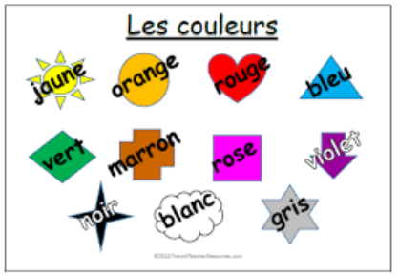

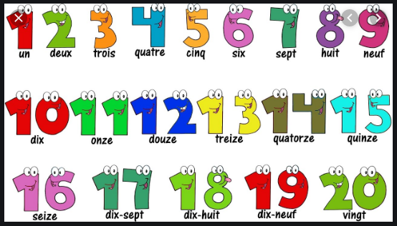

Objects - objets

- Pre-questionnaire
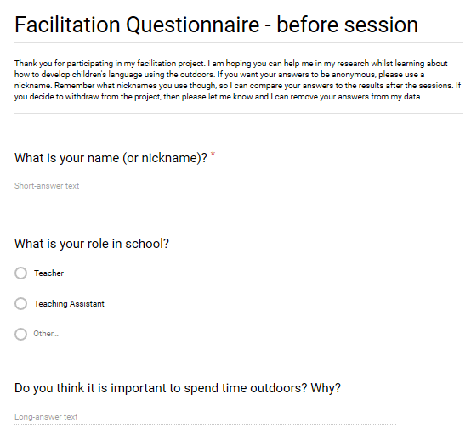
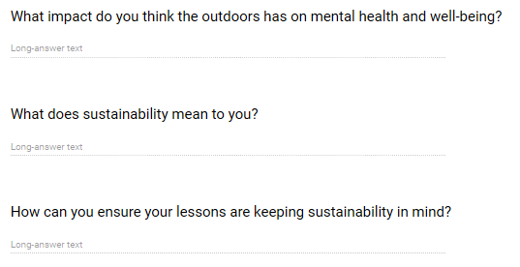

- Post-questionnaire
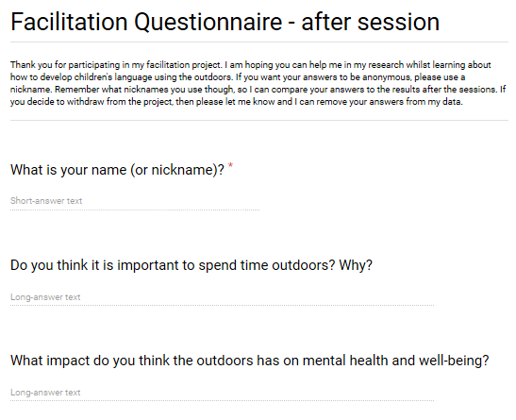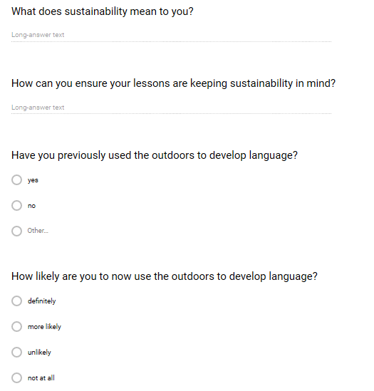

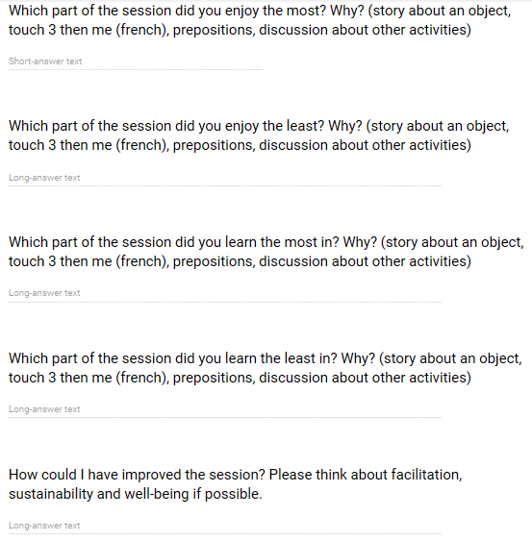

- Raw data
Participant | Pre-questionnaire | Post-questionnaire
C  Teaching Assistant | 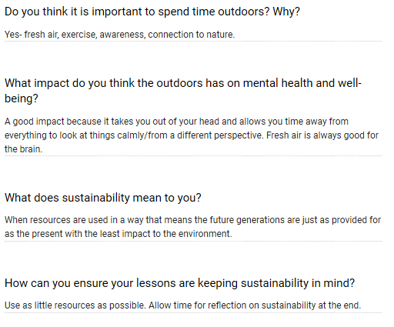 | 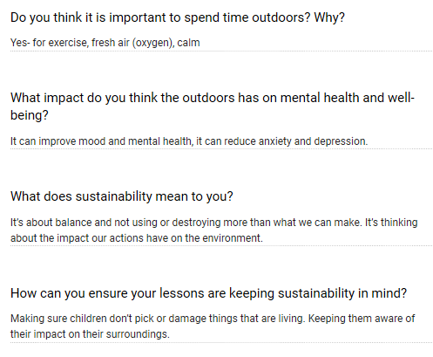  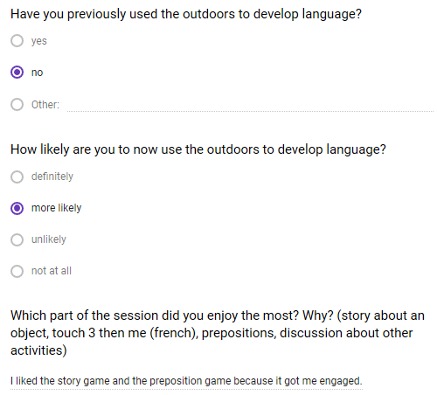  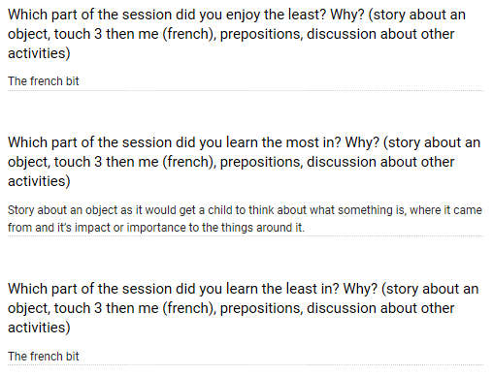  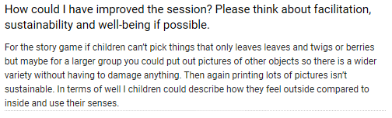
L  Teaching Assistant | 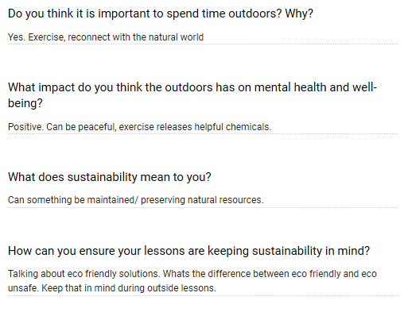 | 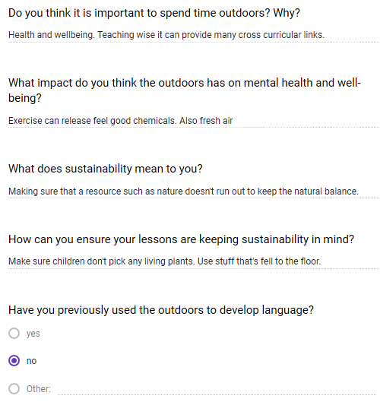  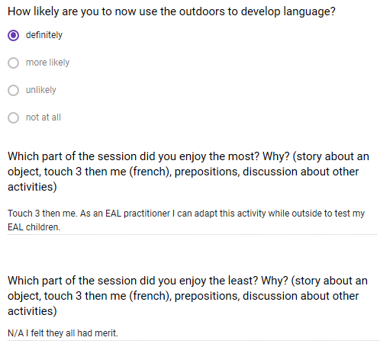  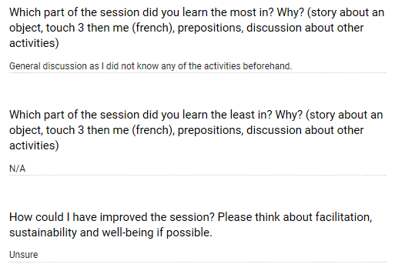
S  Teacher (UKS2) | 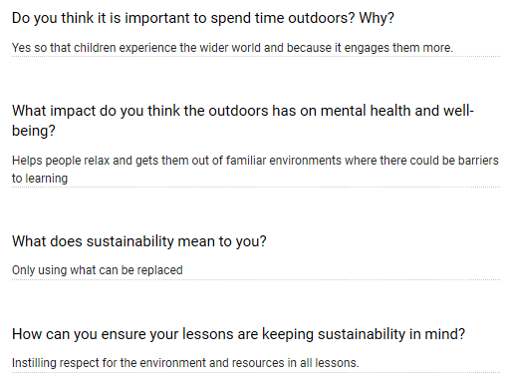 | 

