

Enterprise and Intrapreneurship Business Plan
Submitted By: Armin Polyak
Student ID: 1904920

Executive Summary
Armin's World Gym is a specialized fitness community taking care of individuals with back pain, offering a holistic way to deal with sports and health in London's dynamic Shoreditch area. Established and possessed by Armin, a skilled physiotherapist, the gym's centre group also includes Anca, a nutritionist, and Rose, a dedicated monitor. With an underlying investment of £15,000, Armin's World Gym aspires to establish a safe and sustaining climate where individuals can access first-class physiotherapy services, personalized healthful guidance, and powerful fitness programs.
Our business plan centres on realistic financial projections for the first 12 months, going for the gold. We target Shoreditch residents with back pain, utilizing social media, nearby systems administration, and strategic advertising to contact them. Through an intensive PEST and SWOT analysis, we have distinguished our upper hand and designed evaluating strategies likewise, offering different revenue sources. With an emphasis on quality equipment, trained staff, and consistency with health and safety regulations, our gym guarantees a secure encounter for clients. Armin's World Gym seeks to cut its position in the market by addressing a specific pain point with master care and comprehensive services.
Table of Contents
Executive Summary 2
Introduction 5
Financial Information 6
Projections 6
Cashflow Projections 6
Profit and Loss Projections 7
Balance Sheet Projections 8
Break-Even Analysis 8
Ideal Number of Customers 10
Maximum Capacity and Profit for Sustainability 10
Marketing 11
Specific Market Segment 11
Target Audience and Location 11
Marketing Channels 12
Competitor Analysis 13
Unique Selling Point (USP) 14
PEST Analysis 14
SWOT Analysis 15
Revenue and Pricing 16
Pricing Strategy 16
Charging of the Goods 16
Income Streams 16
Operations 17
Location Selection 17
Premises and Equipment Requirement 17
Production and Distribution Processes 18
Staffing and Supplier Details 18
Systems and Processes for Smooth Operations 18
Health & Safety and Legal Compliance Measures 19
Conclusion 20
References 21

Introduction
Armin's World Gym is a visionary fitness adventure pointed toward offering specialized types of assistance to individuals with back pain, harmoniously mixing sports with health in the bustling neighbourhood of Shoreditch, London. As a sole trader, Armin takes the rudder, passionately determined by his expertise as a physiotherapist. The gym's mission is to make a nurturing haven, offering top-level physiotherapy, personalized nourishment guidance, and custom-made fitness programs. Operating as a sole trader, Armin's World Gym is a business element with a single proprietor responsible for all aspects of its operations. Armin, as the proprietor, brings years of involvement and profound obligation to the well-being of his clients. He will work alongside a dedicated nutritionist, Anca, and a mindful monitor, Rose, framing the centre supervisory group. Together, they plan to change the fitness industry by addressing the specific needs of individuals with back pain.
Armin's World Gym will stand out in the market by offering a comprehensive scope of services designed to work on clients' general health and imperativeness. With a strong focus on customer satisfaction, personalized care, and continuous development, the gym aspires to turn into the go-to destination for those seeking a coordinated approach to fitness and health, all under the expert guidance of Armin and his dedicated team.
SMART Objectives:
- As predicted in the cash flow estimate, raise gym membership by 20% within the first six months of operation.
- By the end of the first year, typical post-service feedback surveys should show a 4.5 out of 5 customer satisfaction rating.
- By the conclusion of the second year, achieve a positive return on investment (ROI) of 15%, in line with the cash flow projection for long-term profitability.
- Within 18 months, increase the gym's ability to take on 50% more members, supporting the expansion plan specified in the cash flow estimate.

Financial Information

Projections

Cashflow Projections
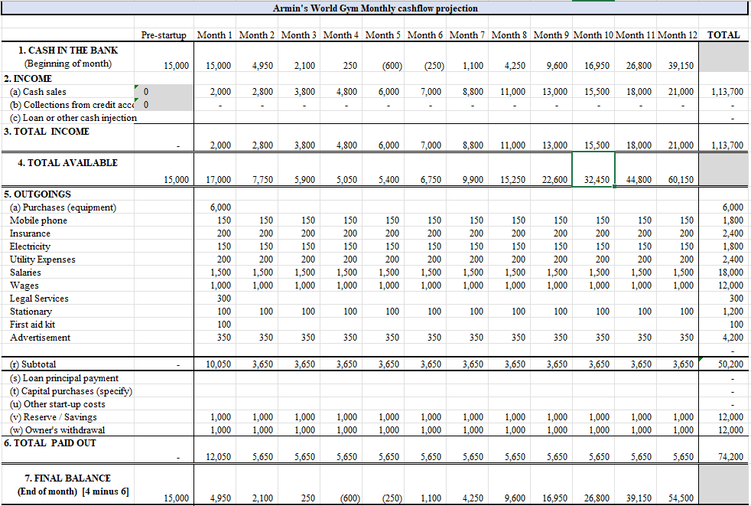

Profit and Loss Projections
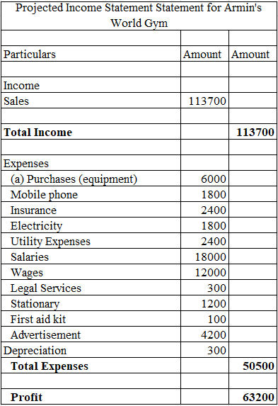

Balance Sheet Projections
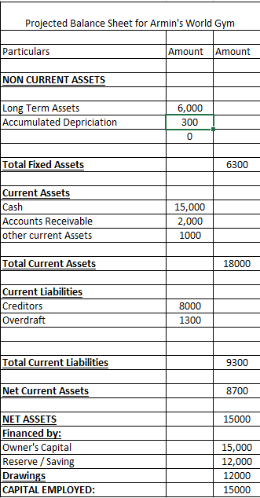

Break-Even Analysis
Total Fixed Costs: £4,500 per month
Total Variable Costs: £1,000 per month

Contribution Margin (Monthly) = Total Revenue - Total Variable Costs (Liguori & Pittz, 2020).
Break-Even Point (Monthly) = Total Fixed Costs / Contribution Margin
Month | Income | Contribution Margin | Break-Even Point
1 | £2,000 | £1,000 | 4.5 members
2 | £2,800 | £1,800 | 2.5 members
3 | £3,800 | £2,800 | 1.6 members
4 | £4,800 | £3,800 | 1.2 members
5 | £6,000 | £5,000 | 0.9 members
6 | £7,000 | £6,000 | 0.8 members
7 | £8,800 | £7,800 | 0.6 members
8 | £11,000 | £10,000 | 0.5 members
9 | £13,000 | £12,000 | 0.4 members
10 | £15,500 | £14,500 | 0.3 members
11 | £18,000 | £17,000 | 0.3 members
12 | £21,000 | £20,000 | 0.2 members

The break-even analysis shows the number of gym memberships (adjusted to the nearest part) expected every month for the gym to cover its fixed and variable costs. For instance, in Month 1, the gym needs around 4.5 members to break even. Beyond the break-even point, each additional part contributes to the gym's profit (LEONG & Swierczek, 2022).

Ideal Number of Customers
Based on the break-even analysis, the gym needs roughly 0.3 to 0.5 members (customers) each month to take care of its costs and accomplish a zero-profit situation. To earn enough to pay the bills and generate a reasonable profit, the gym should mean to have a bigger number of customers than the equal the initial investment point. The ideal number of customers will also rely upon the gym's pricing strategy and the typical income generated per customer. By setting serious and appealing prices while offering excellent types of assistance, the gym can draw in additional customers and increase its income (Fitriasari, 2020).

Maximum Capacity and Profit for Sustainability
The greatest limit of Armin's World Gym is 20 customers at first. This means that the gym can serenely oblige 20 members all at once inside its ongoing physical space and operational capabilities. Assuming the business expands from now on, the greatest limit can be increased to oblige more customers.
A profit of between £25,000 and £30,000 is required for Armin's World Gym to be financially viable. This profit margin would guarantee that the gym can cover all costs, including both fixed and variable costs, while also giving the owner a respectable return on investment and enabling potential development and extension in the future. According to the cash flow projection, the gym is projected to have a positive cash flow starting from Month 6. This means that the gym's total income will surpass its total expenses from Month 6 onwards, resulting in a net positive cash flow (Roy, 2020).

Marketing

Specific Market Segment
Armin's World Gym caters to a specific market segment: individuals suffering from back pain. This segment comprises individuals of various age groups who seek a safe and supportive environment to address their back-related issues while participating in fitness activities. The gym's specialized services, driven by Armin's expertise as a physiotherapist, are custom fitted to meet the exceptional needs of this speciality market. The market segment of individuals with back pain represents a developing demand for fitness solutions that focus on health and well-being. By offering personalized physiotherapy sessions, healthful guidance, and carefully organized fitness programs, Armin's World Gym aims to cut a distinctive position in this segment, setting itself separated from customary fitness centres.

Target Audience and Location
Armin's World Gym targets residents of the dynamic Shoreditch area in London. Shoreditch is known for its diverse and health-conscious populace, making it an optimal area to draw in individuals seeking fitness services that focus on back pain help and general well-being. The target crowd comprises individuals of varying fitness levels and ages, who are either encountering back pain or are enthusiastic about forestalling such issues through expert guidance. By strategically positioning the gym in Shoreditch, Armin's World Gym aims to take advantage of the existing health-conscious community and draw clients from adjacent residential areas and businesses (DeJeu, 2023).
The focal area will offer convenience and accessibility, drawing in individuals who esteem a holistic approach to fitness, where expert physiotherapy services, personalized nourishment counsel, and viable fitness regimes are consolidated under one rooftop. Armin's World Gym envisions turning into a sought-after destination for the Shoreditch community and then some, serving as a centre point for individuals focused on embracing a pain-free and dynamic lifestyle. Based on the local population and the desire for exercise and health services in the area, Armin's World Gym's prospective market in London's Shoreditch is predicted to have 20 to 40 potential clients.

Marketing Channels
- Social Media: Use platforms like Facebook, Instagram, and Twitter to draw in the target crowd, and share significant substance, success stories, and fitness tips. Paid advertising will be utilized to contact a more extensive crowd and boost brand awareness.
- Networking: Armin and the team will effectively take part in nearby health and fitness events, working together with healthcare professionals and influencers to fabricate a strong reference organization.
- Advertising: Invest in targeted web and offline advertising, such as Google Ads, nearby newspaper ads, and radio spots, to expand the gym's scope and draw in new customers.
- Word-of-Mouth: Offer extraordinary support to foster positive word-of-mouth referrals, transforming satisfied clients into brand advocates.
- Special Promotions: Offer introductory packages, reference incentives, and dedication rewards to tempt new customers and hold existing ones (Xolmirzaev et al., 2021).

Competitor Analysis
Competitor | Strengths | Weaknesses | Unique Selling Point (USP)
FitWell Fitness Center | - Established brand reputation  - Diverse range of fitness classes  - Extensive membership benefits  - Active social media presence | - Generic fitness services  - Limited focus on specialized back pain services  - Lack of personalized nutrition guidance  - Minimal attention to individual needs (Ramos Maragall, 2022). | - State-of-the-art equipment and modern facilities  - Highly qualified and experienced fitness instructors  - Convenient location and flexible operating hours  - Offers a holistic approach to fitness and overall wellness
PhysioFit Studio | - Specialized in physiotherapy services  - Emphasis on back pain management  - One-on-one physiotherapy sessions  - Integrative approach to health | - Limited variety of fitness classes  - Smaller facilities compared to larger gyms  - Relatively higher membership fees  - Less extensive marketing efforts | - Expert physiotherapists providing personalized care  - Close-knit community atmosphere fostering support  - Collaborative approach with healthcare professionals  - Tailored fitness programs for individual requirements
By providing top-notch exercise and wellness services at reasonable pricing, Armin's World Gym hopes to remain competitive in the industry. The gym intends to create unique discounts for long-term memberships in addition to offering competitive price plans to draw customers and set itself apart from rivals. The gym will also extend its hours of operation to accommodate a wider range of customer schedules and to ensure accessibility. The gym will carefully manage costs and maximise operational efficiency to maintain a profit while attempting to offer competitive prices. Armin's World Gym seeks to carve a place in the market and establish itself as a go-to location for people seeking a holistic approach to fitness and well-being by finding the ideal mix between affordability and profitability.

Unique Selling Point (USP)
Armin's World Gym's Unique Selling Point (USP) lies in its specialized approach to fitness and health, catering exclusively to individuals with back pain. Not at all like conventional fitness centres, the gym focuses on offering comprehensive support that combines expert physiotherapy, personalized nourishment guidance, and custom-made fitness programs, all under one roof. Armin, a skilled physiotherapist, leads the team and brings extensive information and involvement with back pain to the board. This expertise sets the gym separated, considering individualized care and thoughtfulness regarding every client's unique needs and challenges. By addressing the specific pain point of back-related issues, Armin's World Gym empowers its clients to accomplish their fitness goals safely and successfully, fostering a without pain and dynamic lifestyle (Numa, 2021).

PEST Analysis
Political Factors:
- Neighborhood Government Policies: Shoreditch is known for its support of health and wellness initiatives, giving opportunities to Armin's World Gym to collaborate with the nearby government in advancing fitness programs and healthy lifestyles.
- Taxation Policies: Ideal expense incentives for businesses in the health and fitness industry might give cost advantages to the gym.
Economic Factors:
- Income Levels: Shoreditch has a diverse population, including both prosperous residents and youthful professionals, making likely markets for premium and mid-range fitness services.
- Economic Stability: A stable and flourishing economy in Shoreditch can contribute to increased consumer spending on health and fitness activities (Dadzie, 2019).
Social Factors:
- Health Conscious Community: Shoreditch residents will quite often focus on health and well-being, giving a responsive market to specialized fitness services targeting back pain.
- Fitness Trends: The region's ubiquity with fitness enthusiasts encourages ongoing demand for unique and inventive fitness offerings.
Technological Factors:
- Digitalization and Social Media: Utilizing social media and online platforms can assist Armin's World Gym with contacting a more extensive crowd and drawing in potential clients.
- High-level Fitness Equipment: Access to state-of-the-art fitness innovation can upgrade the gym's offerings and draw in fitness enthusiasts seeking current preparation methods.

SWOT Analysis
Strengths:
- Specialized Services: Armin's expertise in physiotherapy for back pain and the gym's holistic approach makes a strong selling point in a speciality market.
- Location Benefit: Shoreditch's health-conscious population provides a prepared market for fitness services, and the focal location boosts accessibility.
Weaknesses:
- Limited Market Size: Targeting a specific market segment of individuals with back pain might restrict the gym's potential customer base contrasted with general fitness centres.
- High Competition: The fitness industry in Shoreditch is serious, requiring unique strategies to separate Armin's World Gym.
Opportunities:
- Collaborations with Healthcare Providers: Cooperating with neighbourhood healthcare professionals can increase referrals and assemble believability for specialized services.
- Developing Health and Wellness Trends: The increasing focus on preventive health measures creates opportunities for the gym to take advantage of health-conscious consumers.
Threats:
- Economic Downturn: Economic instability could influence consumers' discretionary spending on fitness services.
- Regulatory Changes: Advancing health and safety regulations might require adaptation and compliance, affecting operations (Tinkey, 2019).

Revenue and Pricing

Pricing Strategy
Armin's World Gym will embrace a value-based pricing strategy to adjust its prices to the unique and specialized services it offers. As a fitness community targeting individuals with back pain, the pricing is not entirely set in stone by the excellent physiotherapy sessions, personalized dietary guidance, and customized fitness programs. The gym will lead statistical surveying to understand the apparent value of its services among the target crowd and competitors' pricing. Considering the expertise of Armin and the team, the convenience of accessing various health services in a single spot, and the general positive effect on clients' well-being, the gym will set cutthroat yet premium prices. Special introductory packages, devotion rewards, and reference incentives will be offered to draw in and hold customers. The pricing strategy will ensure that the gym remains sustainable while giving top-score care and fostering long-haul relationships with its valued clients.

Charging of the Goods
Armin's World Gym will offer a selection of health products, such as nourishing supplements, fitness equipment, and wellness items, to supplement its services. The gym will embrace a serious pricing approach for these goods, ensuring they are reasonably estimated without settling on quality. To decide the prices of the goods, Armin's World Gym will consider factors such as the cost of obtainment, profit margins, and the apparent value among the target crowd. Offering health products that line up with the gym's fitness and wellness ethos will improve the general customer experience and give additional convenience to clients to access these items in a single spot (De Leon, 2023).

Income Streams
- Physiotherapy Sessions: One-on-one physiotherapy consultations, bunch sessions, and specialized back pain the board programs will be charged at serious rates based on the level of expertise and personalized care given.
- Healthful Consultations: Personalized wholesome guidance and dinner arranging services will be offered as paid consultations, mirroring the expertise of the nutritionist and the value of the customized counsel.
- Fitness Classes: Gathering fitness classes and specialized back-accommodating exercise sessions will be offered with layered pricing to oblige various preferences and needs.
- Health Product Sales: Income will be generated from the sale of health products, such as nourishing supplements and fitness accessories, with fitting markups (Anderson et al., 2021).
Income percentage from each income stream:
- Gym Memberships: £10,000 (40% of total revenue)
- Physiotherapy Sessions: £6,000 (24% of total revenue)
- Nutrition Consultations: £3,500 (14% of total revenue)
- Fitness Classes: £5,000 (20% of total revenue)
- Other Health Products Sales: £1,500 (2% of total revenue)

Operations

Location Selection
Armin's World Gym will strategically choose its location in the core of the Shoreditch area in London. Shoreditch is known for its energetic and health-conscious community, making it an ideal setting to draw in individuals seeking fitness services, especially those focused on addressing back pain concerns. The gym's focal location will improve accessibility for both neighbourhood residents and close by businesses, empowering a steady flow of expected clients. The chosen location will also be easily reachable by open transportation, further increasing convenience for customers. Closeness to healthcare facilities and sports clubs will consider likely collaborations and referrals, bolstering the gym's reputation and believability on the lookout (Marshall, 2019).

Premises and Equipment Requirement
Armin's World Gym will focus on making an inviting and functional space to take special care of its clientele's diverse needs. The gym will lease spacious premises with sufficient room to oblige physiotherapy rooms, a fitness studio, a nutrition consultation region, and a reception space. The premises will be designed with an emphasis on accessibility, ensuring agreeable access for individuals with back pain or portability challenges. In terms of equipment, the gym will invest in state-of-the-craftsmanship fitness machines, resistance preparing equipment, and rehabilitation tools, lining up with the specialized services it offers. Physiotherapy rooms will be furnished with necessary restorative aids and clinical equipment to convey compelling treatment sessions. The gym will also focus on safety by giving satisfactorily spaced exercise areas and sticking to health and safety standards.

Production and Distribution Processes
As a specialized fitness place, Armin's World Gym's production process revolves around conveying great physiotherapy sessions, personalized nutrition consultations, and fitness classes. The production process will be focused on ensuring individualized care and attention to every client's needs. Distribution will principally be on-site, with clients coming to the gym for their scheduled sessions and classes. Additionally, Armin's World Gym might offer virtual consultations and fitness classes to take special care of clients who favour remote access.

Staffing and Supplier Details
- Armin (Proprietor and Physiotherapist): As the pioneer, Armin will oversee the gym's operations, giving expert physiotherapy services to clients.
- Anca (Nutritionist): Anca will be responsible for conveying personalized nutritional guidance and feast intending to support clients' health and fitness goals.
- Rose (Monitor): Rose will assist in planning gym activities, client management, and ensuring a smooth exercise insight for clients.
Suppliers for the gym will incorporate trustworthy providers of fitness equipment, nutritional supplements, and wellness products. Armin's World Gym will establish relationships with suppliers known for their quality products and convenient conveyance, ensuring the accessibility of essential items to support clients' needs. The gym will keep up with transparent communication and proficient coordination with suppliers to ensure a consistent and well-stocked inventory (Bakalis, 2022).

Systems and Processes for Smooth Operations
- Appointment Scheduling: Execute an effective appointment booking system to oversee physiotherapy sessions, nutrition consultations, and fitness classes, ensuring smooth client flow and ideal resource utilization.
- Client Management: Keep a comprehensive database to keep tabs on clients' development, clinical history, and preferences, empowering personalized care and targeted communication.
- Inventory Management: Utilize a system to follow and oversee health product inventory, ensuring satisfactory stock levels and convenient replenishment.
- Financial Management: Execute a bookkeeping system to monitor income, expenses, and cash flow, ensuring financial stability and adherence to budgets.

Health & Safety and Legal Compliance Measures
- Hygiene Protocols: Implement strict hygiene practices, including standard cleaning of facilities, equipment, and high-touch surfaces to advance a spotless and safe environment.
- Crisis Preparedness: Create and impart crisis response protocols, including evacuation procedures and first-help preparation for staff.
- Legal Compliance: Stay refreshed with health and safety regulations, licensing requirements, and information protection laws, ensuring full compliance with applicable legal frameworks.
- Insurance Inclusion: Get comprehensive insurance inclusion, including obligation and workers' compensation insurance, to safeguard the gym from likely risks and liabilities (Mašláň, 2020).

Conclusion
In conclusion, Armin's World Gym holds the promise of turning into a main fitness destination in the core of Shoreditch, London. With a specialized focus on addressing back pain through expert physiotherapy, personalized nutrition guidance, and customized fitness programs, the gym caters to a speciality market with popularity. Armin's extensive expertise, supported by the dedicated team, positions the gym as a unique and trusted supplier of comprehensive health services. Emphasizing customer satisfaction, cutthroat pricing, and powerful marketing strategies, Armin's World Gym is poised to establish a nurturing environment where clients can accomplish their fitness goals and embrace a pain-free and dynamic lifestyle, solidifying its place as a sought-after fitness haven in the community.

References
Anderson, D. J. F., Kim, A., & Zhang, J. J. (2021). The fitness industry in the USA. In The Global Private Health & Fitness Business: A Marketing Perspective (pp. 69-75). Emerald Publishing Limited. DOI: 10.1108/978-1-80043-850-720211014
Bakalis, E. (2022). YOURTRAINER webservice Business Plan.
Dadzie, M. E. (2019). Operations plan for Gym Ike Fitness Centre.
De Leon, F. P. (2023). FROM IDEA TO REALITY: CRAFTING A COMPREHENSIVE BUSINESS PLAN AND SECURING ADEQUATE FINANCING FOR A SUCCESSFUL STARTUP.
DeJeu, E. B. (2023). The Topoi of Small Business Entrepreneurship. Written Communication, 07410883231171866.
Fitriasari, F. (2020). How do Small and Medium Enterprise (SME) survive the COVID-19 outbreak?. Jurnal Inovasi Ekonomi, 5(02). Doi: 10.22219/jiko.v5i3.11838
LEONG, M. S., & Swierczek, F. W. (2022). BUSINESS PLAN ON IMPLEMENTING A HYBRID GYM WITHIN BANGKOK–GETFIT (Doctoral dissertation, Thammasat University).
Liguori, E. W., & Pittz, T. G. (2020). Strategies for small business: Surviving and thriving in the era of COVID-19. Journal of the International Council for Small Business, 1(2), 106-110. DOI: 10.1080/26437015.2020.1779538
Marshall, J. B. (2019). The Viability of Online Personal Training: Business Plan (Doctoral dissertation, Kalamazoo, Mich.: Kalamazoo College.).
Mašláň, J. (2020). A Business Plan for Establishment of a Strength and Conditioning Centre.
Numa, Q. (2021). Business Plan: Childhood Obesity Super Youth Fitness Program Quianna Numa, Nathalie Liriano, Rosymar Cabrera Pirates of the Caribbean Bright Minds, Fresh Ideas Think Tank Summer Internship, Powered by FPP.
Ramos Maragall, M. (2022). Openning a Gym in Barcelona.
Roy, S. (2020). Business Plan for PAWSitively Fit Club: A Fitness Club designed for you and your Furry Friend (Doctoral dissertation).
Tinkey, L. (2019). STORM Nutrition and Fitness a Literature Review and Business Plan. DOI: https://doi.org/10.57709/15940942
Xolmirzaev, U., Juraev, E., & Axmadjonova, M. (2021). THE ROLE OF ACCOUNTING IN SMALL BUSINESS MANAGEMENT. Интернаука, (21-5), 20-22.

