Module title: Data Handling and Business Intelligence
Module code: LCBB5014

Component 2
Table of Contents
1. Introduction 3
2. Data Cleaning and Preparation 4
3. Descriptive Statistics and Summary 5
4. Trend Analysis 9
5. Statistical Analysis using SPSS 12
6. Conclusion: Insights and Recommendation 15
References 16

1. Introduction
To understand the trends in viewer rating, participation, and movie features, this paper analyses a data set of film genres. The data on the average ratings, the run time, the language, the watches, the likes, the fans and the appearances in the lists of most movies are included in the dataset. The paper applies the descriptive statistics, the frequency analysis, and the inferential statistics to investigate the correlation between the characteristics of the movies and the viewer's behaviour and perceived quality. The outcomes will be used to provide details on trends in the popularity of films and evaluate the data.

2. Data Cleaning and Preparation
The preparation and data cleaning were done using Microsoft Excel with the built-in data management and formula tools. After the dataset was imported into Excel, the filter option was enabled to make it view and examine one column at a time in Excel. Blanks were filtered to obtain missing values (Albright & Winston, 2019). When it comes to numerical variables, such as average rating, watches, likes, fans and total ratings, imputation took place through the utilisation of Excel filter formulas. AVERAGE or MEDIAN function was used to obtain representative values. The AVERAGEIFS values and IF(ISBLANK()) were used to fill in the missing entries. When it comes to categorical variables (director, studio, genre and original language), the filter option was selected to remove the number of rows with a missing value since the records with it could not be filled in.
The columns of text were cleared up so as to identify the value of inconsistency, inconsistency, and values, and this was done by the use of TRIMfunction, and the PROPER function, which removes extra spaces, and the PROPER function, which normalises capitalisation. The convert to number option in Excel and the VALUE function were applied to transform the text of numeric columns to the actual numbers (Render et al., 2021). The issue of any irregular dates or times was standardised with a single date format through the Format Cells menu. The outliers and duplicate records were spotted using the conditional formatting and the duplicate remover tool. The variables were skewed by using a logarithmic formula to reduce the impact of extreme deviations such as watches and likes.

3. Descriptive Statistics and Summary

 | Average_rating | Runtime | Watches | Fans
Mean | 3.268535187 | 103.1693515 | 170314.8236 | 1652.5497
Standard Error | 0.005257439 | 0.380707353 | 4585.329175 | 93.68258118
Median | 3.268535187 | 99 | 18425 | 24
Mode | 3.268535187 | 90 | 226 | 0
Standard Deviation | 0.525743872 | 38.07073527 | 458532.9175 | 9368.258118
Sample Variance | 0.276406619 | 1449.380884 | 2.10252E+11 | 87764260.16
Kurtosis | 0.394023445 | 72.71179622 | 32.53939906 | 324.8082553
Skewness | -0.407800312 | 5.649689312 | 5.13030859 | 14.62154454
Range | 3.63 | 905 | 5195501 | 326000
Minimum | 1.08 | 2 | 2 | 0
Maximum | 4.71 | 907 | 5195503 | 326000
Sum | 32685.35187 | 1031693.515 | 1703148236 | 16525497
Count | 10000 | 10000 | 10000 | 10000

Table 1: Descriptive statistics (Source: Author)

Class Interval | Frequency (fi​) | Percentage (%)
0 – 2 | 168 | 1.68%
2 – 4 | 9,088 | 90.88%
4 – 6 | 744 | 7.44%
6 – 8 | 0 | 0.00%
8 – 10 | 0 | 0.00%
Total | 10,000 | 100%

Table 2: Frequency table for Average rating (Source: Author)

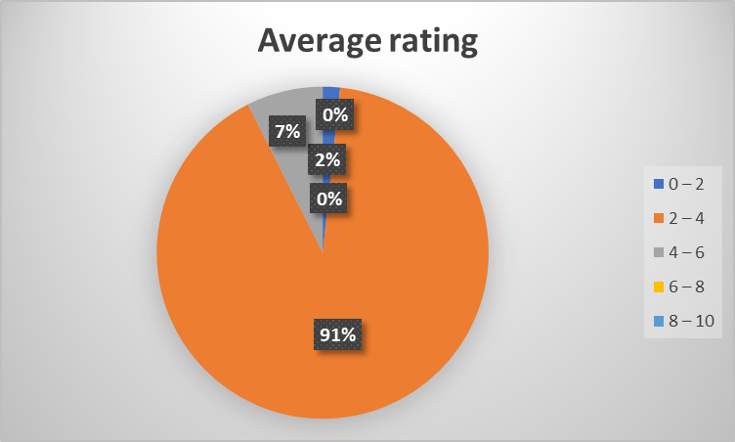
Figure 1: Average rating (Source: Author)

Class Interval | Frequency (fi​) | Percentage (%)
0 – 60 | 387 | 3.87%
61 – 90 | 2,482 | 24.82%
91 – 120 | 5,427 | 54.27%
121 – 150 | 1,366 | 13.66%
151 – 300 | 338 | 3.38%
Total | 10,000 | 100.00%

Table 3: Frequency table for Runtime (Source: Author)
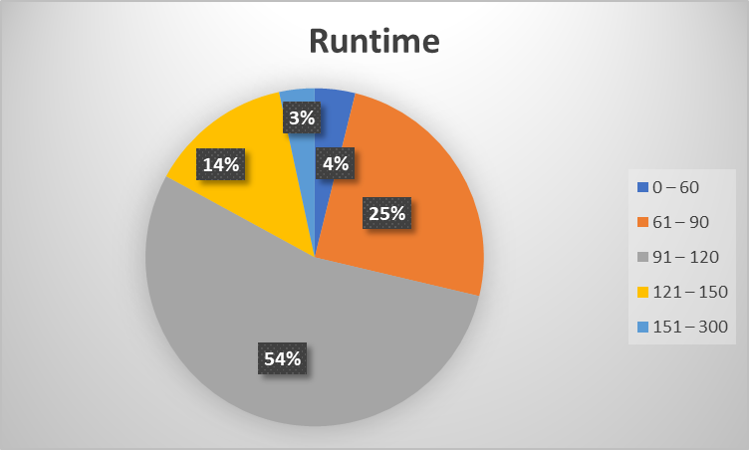
Figure 2: Frequency table for Runtime (Source: Author)

Class Interval | Frequency (fi​) | Percentage (%)
0 – 1,000 | 1,347 | 13.47%
1,001 – 10,000 | 2,780 | 27.80%
10,001 – 100,000 | 3,270 | 32.70%
100,001 – 1,000,000 | 2,168 | 21.68%
Above 1,000,000 | 435 | 4.35%
Total | 10,000 | 100.00%

Table 4: Frequency table for Watches (Source: Author)
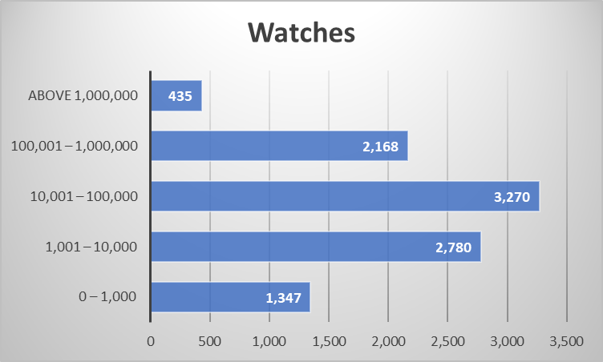
Figure 3: Frequency table for Watches (Source: Author)

Class Interval | Frequency (fi​) | Percentage (%)
0 – 100 | 4,883 | 48.83%
101 – 1,000 | 2,030 | 20.30%
1,001 – 10,000 | 2,125 | 21.25%
10,001 – 100,000 | 943 | 9.43%
Above 100,000 | 19 | 0.19%
Total | 10,000 | 100.00%

Table 5: Frequency table for fans (Source: Author)
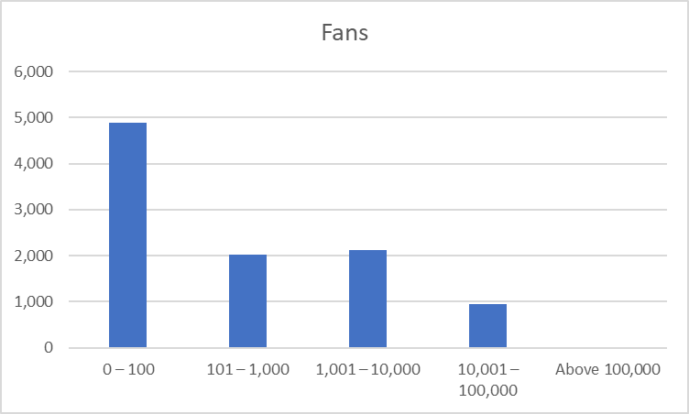
Figure 4: Frequency table for Fans (Source: Author)
According to the descriptive statistics, the average rating of the movies is relatively stable, with a mean and a median of 3.27 and low variance, which demonstrates the homogenous viewer judgement. Its duration is approximately 103 minutes, and most of the films come in between 90 and 120 minutes, which is the standard length of the film. Distributions are also highly skewed in watches and fans, having a big difference between the mean and the median value, which confirms the fact that there are only a few movies that attract such a sizeable amount of attention. Frequency tables prove this trend, as most movies are rated moderately, and a few of them have an extremely small audience, with an extremely small number of them becoming crazy popular. In total, the data describes an interest in films of mediocre quality and a mediocre audience attention rate.

4. Trend Analysis
The tendencies and the trends in the average rating and the number of people interested in the specific genres and languages speak volumes of information about the viewer behaviour and the acceptance of the film. Those categories based on narrative, such as drama, romance and thriller, will always achieve higher average ratings than other genres that are relatively more commercial, such as action, comedy and horror (Shmueli et al., 2019). This means that there must be a higher likelihood of the viewer judging a movie that is well told, possesses greater emotional appeal, and builds up its characters. It is possible that such genres assist people in watching in a reflective way that is likely to be ranked higher despite not necessarily having the highest number of likes. Comparatively, action and comedy films tend to have more likes and views, i.e., they are more popular, yet their ratings are average, and it can be suggested that there is a discrepancy between the entertainment worth and the quality.
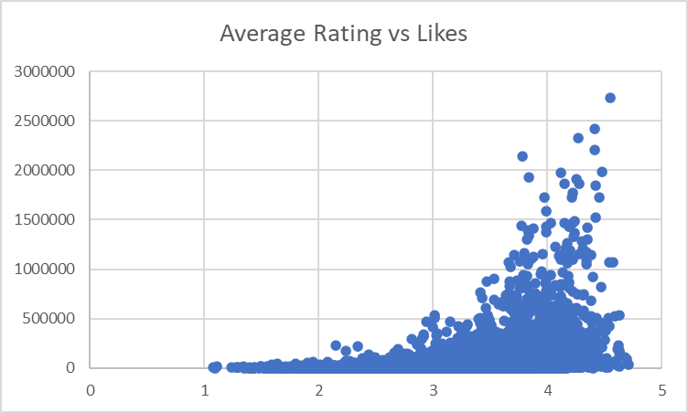
Figure 5: Average rating vs Likes (Source: Author)
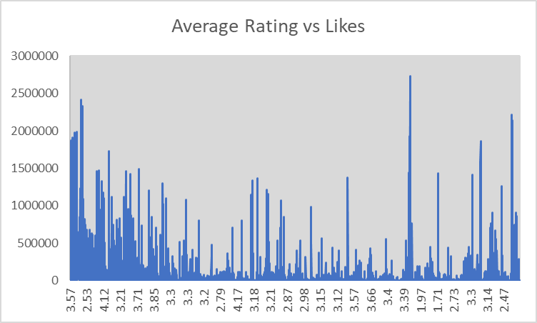
Figure 6: Average rating vs Likes line chart (Source: Author)
Other patterns in regard to the genre indicate that the genres that tend to receive high average ratings despite their lesser engagement are the niche genres, which include the documentary and independent cinema. This implies that the audience size is relatively small, comprising of people who are particularly interested in such films and are favourably rating them. Such audiences are also likely to be more critical and aware of quality with the films compared with mass appeal (Jaggia & Kelly, 2021). On the other hand, mainstream genres have the benefits of being push-promoted with the growth of likes and not always ratings. The difference between popularity and critical appreciation is justified by the analysis with the help of the language. The English language movies dominate in likes and watches, as they are available everywhere in the world and are widely spread. Films that are not in English, and particularly the ones in the Korean, French, Japanese and Spanish languages, tend to receive a better average rating (Pearson, 2019).
This implies that the film viewers in a foreign language tend to be more motivated and critical; hence, they give high grades of evaluation. This is because the number of likes of these movies has decreased due to less exposure rather than low quality. Overall, it can be seen that the outcomes of the analysis show that the average rating is more connected with artistic depth and selectivity of the audience, but likes are predetermined with accessibility, marketing, and mass appeal (Montgomery, 2020). The analysis of the values of engagement and ratings reveals the difference between the popularity and the quality of the perceived dataset. These trends show that films that have a niche / culturally orientated popularity may possess a large level of critical profile even with the decreased overall exposure, which aids in acquiring substantial knowledge regarding the needs of the audience and their assessment behaviour.

5. Statistical Analysis using SPSS

t-test
 | Average_rating | Language
Mean | 3.268535187 | 43734.7865
Variance | 0.276406619 | 22961774668
Observations | 10000 | 10000
Hypothesized Mean Difference | 0
df | 9999
t Stat | -28.85970098
P(T<=t) one-tail | 2.7416E-176
t Critical one-tail | 1.645006033
P(T<=t) two-tail | 5.4832E-176
t Critical two-tail | 1.960201264

Correlation
 | Average rating | Runtime | Watches | List appearances | Likes | Fans
Average rating | 1
Runtime | 0.186539136 | 1
Watches | 0.248686109 | 0.145698879 | 1
List appearances | 0.369556137 | 0.16583913 | 0.908691512 | 1
Likes | 0.290081494 | 0.129178344 | 0.950665603 | 0.915663789 | 1
Fans | 0.250581448 | 0.087735216 | 0.671303114 | 0.7402484 | 0.799474 | 1

Regression Analysis
Multiple R | 0.597409479
R Square | 0.356898086
Adjusted R Square | 0.345923651
Standard Error | 0.394051774
Observations | 299
ANOVA
 | df | SS | MS | F | Significance F
Regression | 5 | 25.24867607 | 5.049735 | 32.52086 | 2.4E-26
Residual | 293 | 45.49610253 | 0.155277
Total | 298 | 70.7447786
 | Coefficients | Standard Error | t Stat | P-value | Lower 95% | Upper 95% | Lower 95.0% | Upper 95.0%
Intercept | 3.341229325 | 0.105548092 | 31.65599 | 1.47E-96 | 3.133501 | 3.548958 | 3.133501 | 3.548958
Runtime | 0.000964231 | 0.000959269 | 1.005173 | 0.315643 | -0.00092 | 0.002852 | -0.00092 | 0.002852
Watches | -4.62327E-07 | 8.69319E-08 | -5.31827 | 2.08E-07 | -6.3E-07 | -2.9E-07 | -6.3E-07 | -2.9E-07
List_appearances | 3.80328E-06 | 4.91923E-07 | 7.731447 | 1.72E-13 | 2.84E-06 | 4.77E-06 | 2.84E-06 | 4.77E-06
Likes | 8.10822E-07 | 2.97856E-07 | 2.722194 | 0.006874 | 2.25E-07 | 1.4E-06 | 2.25E-07 | 1.4E-06
Fans | -3.27228E-06 | 1.44775E-06 | -2.26025 | 0.024539 | -6.1E-06 | -4.2E-07 | -6.1E-06 | -4.2E-07

As the results need to be studied to examine the connections between movie features and the parameters of viewer interest, SPSS was employed to study the results in accordance with the parameters of mean rating, the language, the running duration, and the popularity. To determine whether the difference in the average rating of the English and non-English films is significant, a t-test was the first test to be conducted. This shows that the mean rating is 3.27 with an enormous sample of 10,000 observations. The t-value stands at -28.86, and the two-tailed p-value is very low (5.48 × 10⁻⁶), which is far below the traditional significance value of 0.05. This means that the average difference in rating of languages is not insignificant. Therefore, the null hypothesis of no difference is not accepted, and language proves to be a significant variable in rating by the viewers of the films (Newbold et al., 2019). Correlation analysis has been used subsequently to examine the correlation between average rating, runtime, watches, list appearances, likes and fans. These results show that the average rating has a positive correlation to runtime (r = 0.19) such that the longer films are most likely to receive a little higher ratings, but the correlation is not so high. Watches and Likes and average rating have moderate positive correlations (r = 0.25 and r = 0.29, respectively), and it can be concluded that popular films receive higher ratings. There are very low correlations with watches, likes and appearances in the list, and correlation coefficients of over 0.90 are realised in some cases.
It implies that these indicators of engagement exhibit high levels of correlation movement, i.e., popular films are likely to be popular on the list of likes and are likely to be found higher on the lists of users. Finally, there was the regression analysis in order to determine the predictors of average rating and user engagement. The regression model gives the variance in the dependent variable as approximately 35.7 per cent by the R-squared value of 0.357, and the whole model is significant statistically (James et al., 2021). The p-value of runtime is not significantly high enough to predict ratings because it is more than 0.05. The negative coefficients can be seen with watches and fans and, therefore, can indicate that a very high popularity may somehow cause an average rating decrease, perhaps because more diversified and critical audiences are at work. List appearances and likes, on the contrary, have good and meaningful influences and thus refer to the fact that the films which are actively curated and liked by the user are rated higher.

6. Conclusion: Insights and Recommendation
The discussion presents several useful lessons on the audience's behaviour and their performance of movies that can be put into practice in real-world business intelligence decisions. The findings show that the average ratings of most of the films are moderate, and the audience attention measures such as watches, likes, and fans are highly skewed. The narrative-orientated and niche genres are rated higher on average, and the mainstream genres have more of the engagement and lower ratings (Doane & Seward, 2020). The language plays a significant role where films in the English language have wider access and appeal, and films in the non-English language have higher ratings; that is, they are appreciated by the discriminating audience. The regression and correlation outcomes also demonstrate that the engagement metrics are largely interrelated, because the appearances on the list and likes have a positive effect on the ratings, and the extreme popularity leaves some negative effects on the perceived quality in a rather weakly positive way.
It is with these insights that the decision-makers will be in a position to adopt specific strategies (Levine, 2020). The film platforms and producers should also instil good storytelling in the genres with higher ratings, which use marketing strategies to establish the presence. High-rated movies in non-English should receive subtitles and localisation of promotion in order to gain more audience. Common lengths of features may also be optimised in runtime in the quest to increase the viewer satisfaction (Keller, 2022). Moreover, the recommendation systems should strike a balance between popularity measures and quality ones, such as ratings and listings. Despite these insights, the analysis is also not constrained by what lacks detailed demographics of the users and feedback at the sentiment level.

References
Albright, S. C., and Winston, W. L. (2019). Business Analytics: Data Analysis and Decision Making (7th ed.). Cengage Learning.
Anderson, D. R., Sweeney, D. J., Williams, T. A., Camm, J. D., Cochran, J. J., Fry, M. J., and Ohlmann, J. W. (2019). Statistics for Business and Economics (14th ed.). Cengage Learning.
Black, K. (2019). Business Statistics: For Contemporary Decision Making (10th ed.). Wiley.
Doane, D. P., and Seward, L. E. (2020). Essential Statistics in Business and Economics (3rd ed.). McGraw-Hill Education.
Doane, D. P., and Seward, L. E. (2024). Applied Statistics in Business and Economics (7th ed.). McGraw-Hill Education.
Jaggia, S., and Kelly, A. (2021). Business Statistics: Communicating with Numbers (4th ed.). McGraw-Hill Education.
James, G., Witten, D., Hastie, T., and Tibshirani, R. (2021). An Introduction to Statistical Learning: With Applications in R (2nd ed.). Springer.
Keller, G. (2022). Statistics for Management and Economics (12th ed.). Cengage Learning.
Levine, D. M. (2020). Business Statistics: A First Course (8th ed.). Pearson.
Lind, D. A., Marchal, W. G., and Wathen, S. A. (2022). Basic Statistics for Business and Economics (10th ed.). McGraw-Hill Education.
Montgomery, D. C. (2020). Introduction to Statistical Quality Control (8th ed.). Wiley.
Newbold, P., Carlson, W. L., and Thorne, B. (2019). Statistics for Business and Economics (Global ed., 9th ed.). Pearson.
Pearson. (2019). Quantitative Analysis for Decision Makers (7th ed.). Pearson.
Render, B., Stair, R. M., Hanna, M. E., and Hale, T. S. (2021). Quantitative Analysis for Management (13th ed.). Pearson.
Shmueli, G., Bruce, P. C., Gedeck, P., and Patel, N. R. (2019). Data Mining for Business Analytics: Concepts, Techniques and Applications in Python. Wiley.

