

From Colonial Classification to Sectarian Governance: The Legacy of the French Mandate in Syria and Lebanon

Ali Ejaz

Supervised by: Dr Ryan Joseph O’Byrne

Submitted in partial fulfilment for the award of the degree of XXXX

University of Wales Trinity Saint David

2026

Contents
Figures
Abstract
Introduction
Context
Literature Review
Chapter 1: Colonial Institutions and the Transformation of Sectarian Governance under the French Mandate
- Introduction: From Communal Difference to Institutional Hierarchy
- Ottoman Legacies and the Preconditions of Sectarian Governance
- The French Mandate and the Institutionalisation of Differentiated Rule
- Resistance and the Limits of Colonial Ordering
- Hierarchies of Incorporation and Colonial Governance
- Conclusion
Chapter 2: Divergent State Formation in Syria and Lebanon under the French Mandate
- Introduction: Shared Colonial Logic, Divergent Outcomes
- Syria: Fragmentation, Exclusion, and Indirect Sectarianisation
- Lebanon: Institutionalising Sectarian Hierarchy
- Explaining Divergence: Why Different Outcomes?
- Conclusion
Chapter 3: Persistence and Contemporary Sectarian Governance
- Introduction: Mandate Legacies and Postcolonial Transformation
- Lebanon: Institutionalised Continuity and Confessional Governance
- Syria: Informal Sectarianism and Authoritarian Hierarchy
- Comparing Continuity and Postcolonial Transformation
Conclusion
Notes
Bibliography
- Primary Sources
- Secondary Sources

Figures

Figure 1: Ethnic and religious demographic map of Syria and Lebanon in 1935 during the French Mandate.
Figure 2: Map showing location of some French Catholic Schools in French Mandate Syria and Lebanon.
Figure 3: The urban population in the Syrian coastal region in 1935 by religious community.
Figure 4: The corpses of three members of the Syrian resistance, hanged in Marjeh Square during the Arab Revolt.
Figure 5: Except of section 4 from Article 22 from the League of Nations Covenant for the Mandate.
Figure 6: Map of The Alawite state from 1920-36, showing mixed populations on the coast.
Figure 7: Article 24 from the Lebanese constitution of 1926.
Figure 8: Map of territorial concentrations of different religions and sects in Lebanon.
Figure 9: Lebanon’s Religious Demographics map showing the increase of the Muslim population as compared to the previous Christian majority population.
Figure 10: Opening Ceremony of the Mediterranean Games, Lattakia, in 1987, depicting Hafiz al-Asad as omnipotent.

To what extent did the French Mandate for Syria and Lebanon shape contemporary sectarian governance?

Abstract

This dissertation examines the extent to which contemporary sectarian governance was shaped by the French Mandate for Syria and Lebanon. It challenges both the main academic interpretations on the subject, primordialism and reductionist colonial explanations. The former treats sectarianism as a longstanding aspect of the Levantine region while the latter explains it as being linked to French ‘divide and rule’ policies. Instead, it argues that the Mandate’s main impact was the transformation of communal distinctions that already existed and that were shaped by Ottoman rule and reforms in the nineteenth-century, into a hierarchical system of governance strategies that were embedded within state institutions.

This dissertation demonstrates how the French re-categorised and re-organised populations through the restructuring of territory and careful incorporation of certain groups for their own benefit, and it does this by drawing on historical debates and a range of primary sources including Mandate maps, constitutional documents, League of Nations texts, nationalist proclamations, demographic tables, and visual propaganda. These processes not only fragmented societies but also created a hierarchy of governance in which different people groups were given unfair and unequal access to political authority based on who the French thought had most strategic value and reliability.

This dissertation is structured in three parts. The first chapter looks at how the Mandate institutionalised differences in society into state structures and thus transformed identities that were fluid into fixed categories. The second chapter explores how state formation diverged in both Syria and Lebanon, showing how colonial strategies produced both confessionalism in Lebanon and authoritarianism in Syria. The third chapter looks at how these structures remained after independence, by showing how regimes that came after independence managed to adapt Mandate-era dynamics and policies through how the constitutional and security arrangements were set up, and by elite bargaining.

This dissertation argues that the best way to understand sectarian governance in contemporary Lebanon and Syria is by viewing it as the result of a layered historical process. The French Mandate was not the only producer of sectarianism, but it was a key moment in the institutionalisation of sectarianism, and in the process of embedding communal or sectarian identities into the architecture of modern state power. This legacy still shapes political authority, representation, and legitimacy in Syria and Lebanon today.

Introduction

The current political systems in Syria and Lebanon are often understood through the lens of sectarianism. In Lebanon, there is a confessional power-sharing system that allocated political offices and seats based on religious lines, but in Syria, sectarian dynamics function in a more indirect way through authoritarian military networks and political structures. Much historiographical debate has arisen from attempts to explain the origins of these systems. Some scholars posit that sectarian governance was mainly imposed by the colonial Mandate system, while others emphasise older historical influences of the Ottoman system. This dissertation intervenes in the debate by making the case that the French Mandate system did not produce sectarian identities themselves but rather transformed them into mechanisms of governance by institutionalising them.

This dissertation answers the question: To what extent did the French Mandate for Syria and Lebanon shape contemporary sectarian governance? Its main argument is that the most enduring legacy of the Mandate was the creation of a hierarchical system of political incorporation whereby communal identity became the main mediation mechanism to access state power or authority. So instead of simply dividing populations, the French categorised, classified, ranked and carefully integrated favoured communities into the administrative, military and political systems, based on who the French perceived as the most strategically valuable and politically reliable, in order to maintain their own power and protect their own interests. This process created what this dissertation calls as a hierarchy of governance.
The argument poses a challenge to two reductionist interpretations. Firstly, it rejects primordialism which portrays sectarianism as longstanding or inbuilt into Levantine society. It is true that communal identities existed before French rule and were shaped by Ottoman systems of governance such as the Millet structure and the Tanzimat reforms. The Tanzimat decree which promised equal rights to all people ‘of whatever religion or sect’ highlights that communal identity already existed before the Mandate period as an administrative category. However, Ottoman governance did not institutionalise sectarian identity and governance within state structures in the same way the French later developed during the Mandate period.
Secondly, the dissertation also challenges the interpretation that shows sectarian governance as completely invented by the coloniser and forced upon passive societies. The reproduction and adaption of communal political structures after independence was due to a significant number of factors including local elites, religious authorities, nationalist movements, and postcolonial regimes. As Max Weiss argues, sectarianisation emerged through a ‘dialectical relationship between attempts at divide and rule from above and clamorous demands from below for recognition and autonomy. Therefore, sectarian governance emerged through the interaction between colonial intervention and local political agency.
The dissertation argues that the French Mandate deepened and reorganised already existing communal structures through various mechanisms, including:
- territorial fragmentation,
- constitutional confessionalism,
- selective military recruitment,
- missionary education,
- differentiated political access.
Primary sources that are used throughout the dissertation highlight these processes in practice. Maps of Syria and Lebanon during the Mandate period highlight the concentration of French Catholic educational institutions regions that had a majority of certain minorities, suggesting attempts to cultivate loyal intermediaries through missionary networks. Demographics maps and census documents further highlight that French land divisions often simplified more complex social realities, especially along the Syrian coast where Sunni, Christian, and Alawite populations lived together in coexistence before the administrative separation. In addition, anti-colonial sources from the Great Syrian Revolt show that many Syrian nationalist viewed the French governance as a fragmenting force. Sultan al-Atrash condemned the French for having ‘divided the indivisible homeland’ into ‘religious sects and states.’ These kinds of sources are significant because the show how colonial governance was seen and challenged by historical actors at the time of the Mandate, even if they are not fully objective accounts.
The structure of this dissertation is split into three chapters. The first chapter examines how French Mandate institutions transformed communal differences into systems of political hierarchy by restructuring territory, new classification methods, and selectively incorporating people deemed reliable and beneficial for the French. Chapter two examines how both countries diverged in their respective paths, arguing that both were born out of the same colonial Mandate, but developed differently: confessionalism in Lebanon and authoritarian hierarchy in Syria. Finally, chapter three explores how these sectarian systems persisted after independence, showing how the regimes that came after independence adapted Mandate-era mechanisms within modern contemporary systems of governance.
In terms of methodology, this dissertation combines historiographical analysis, postcolonial lens analysis, and critical examination of primary sources, including constitutional documents, maps, speeches, League of Nations texts, revolutionary proclamations, demographic tables, and visual political imagery. Importantly, the limitations of the sources are also evaluated, recognising the potential political biases within colonial archives, nationalist rhetoric, propaganda materials, and demographic documents.
Ultimately, this dissertation argues that the French Mandate’s significance is not in having ‘created’ sectarianism outright, but in institutionalising communal identity as a mechanism of political organisation that could endure. Therefore, contemporary governance in Syria and Lebanon is best understood as the outcome of a layered historical process in which colonial rule played a major formative part, but not necessarily exclusive.
Historical Context
To understand the sectarian governance developed in Syria and Lebanon, it is necessary to place the French Mandate within the wider transformations of the late Ottoman Empire and the aftermath of the First World War. Although sectarian identities did exist before French rule, they functioned within a different political framework that did not fully organise access to power political or state power and authority through a Mandate style rigid system of hierarchy.
In Ottoman times, the millet system partly structured communal identity, and granted religious communities a certain level of autonomy in matters like personal law, marriage and education. During the nineteenth century, the Tanzimat reforms did attempt to modernise and centralise imperial governance while also promoting legal equality among subjects. The Gulhane Edict declared that reforms would apply to all Ottoman subjects of whatever religion or sect.’ On the one hand; this did reflect an attempt by the Ottomans to reduce sectarian inequality and strengthen imperial unity. However, historians disagree as to whether these reforms were a genuine attempt at liberalisation or damage control by an Empire facing internal unrest and external enemies.
Ottoman affairs during this period did increasingly come to be shaped by and responses to European influence particularly through missionary work and claims of protecting Christian minorities. French Catholic educational institutions increased in number across the Levant during the later Ottoman period and the early Mandate period. A map of missionary schools in Syria and Lebanon shows the concentration of a number of these institutions in areas dominated by minorities, particularly among Christian populations and later also within areas where Alawites were concentrated. While it is true that the map does not prove that France engaged in social and political engineering deliberately, it does however, suggest that educational networks were part of a larger system of connecting certain local communities to France.
The political landscape of the Levant was massively reshaped by the collapse of the Ottoman Empire after World War One. Under this backdrop, Article 22 of the League of Nations Covenant, was passed by the League at the time, placing Syria and Lebanon under the French Mandate authority as these territories were considered not yet ready for full independence. The document described these communities as having reached a stage where their existence as nations could be ‘provisionally recognised subject to the rendering of administrative advice and assistance by a Mandatory,’ in this case France.
The wording used which included the term ‘tutelage’ reflected a broader colonial assumption that the Middle East required political management and supervision by Europe. Edward Said’s concept of ‘Orientalism’ is relevant here because it highlights how colonial powers justified intervention through representations of the East as backward, fragmented and incapable of self-governance.
The region was reorganised through fragmentation of territory and differentiated administration. Separate political units were created for certain minorities such as the Alawites, Druze and Greater Lebanon where the Maronite Christians lived. Demographic maps depicting the Mandate period population patterns, complicate later assumptions that these territories reflected naturally homogeneous sectarian regions. Maps in Michael Kerr and Craig Larkins book. ‘The Alawis of Syria,’ show that coastal Syria contained a substantial Sunni and Christian population alongside Alawites before French territorial restructuring. Similarly, census tables from the coastal region in 1935 reveal mixed populations in the urban centres as opposed to exclusively minority dominated coastal centres.
These are significant sources because they suggest that French administrative divisions simplified demographic realities that were more complex. However, there are limitations to the maps too. One originates from a Facebook cartography page rather than a formal academic archive, which means its methodology and sourcing must be carefully observed. Nevertheless, when they are compared alongside academic demographic studies, the idea of mixed populations is credible.
At the same time, there was a great deal of nationalist resistance faced by the French. During the Great Syrian Revolt, which was one of the most fierce resistance events to take place against the French, figures such as Sultan al-Atrash accused the French of having ‘divided the indivisible homeland’ into sect based states. Such sources suggest the existence of anti-colonial actors who viewed French governance as a source of fragmentation of their lands, who usually fell into the Arab nationalist and Sunni camps.
This historical context is particularly important because it demonstrates that the French Mandate emerged within a region that was already shaped by communal diversity, Ottoman reform, and European intervention and influence. However, the Mandate transformed these already existing structures by entrenching communal identity more deeply into systems of administration of territories, political representation and state power.

Literature Review

The question of sectarianism in Syria and Lebanon produces deeply contested historiographical debates. Scholars disagree significantly on whether sectarian governance should be understood mainly as a result of colonial intervention, Ottoman administrative legacy, local elite mobilisation, or modern state formation. The dissertation engages with these debates by arguing that the French Mandate did not create sectarian identities out of thin air, but rather, transformed them into hierarchical systems of political incorporation entrenched within state structures. The literature review therefore examines four main areas of scholarly debate: colonial ‘divide and rule’ interpretations, continuity from Ottoman era arguments, studies focusing on local agency and sectarianisation, and wider theoretical approaches to colonial governance and political classification.

One of the most discussed interpretations portrays the French Mandate as a deliberate strategy of sectarian fragmentation. Philip Khoury argues that French rule in Syria functioned through a ‘policy of divide and rule,’ seeking to weaken Arab nationalism by fragmenting territory and creating alliances with minorities. Similarly, Nadine Meouchy describes French policy as contributing to the ‘territorial parcelling up of minorities’ through the creation of autonomous or semi-autonomous political entities.’ These arguments are highly important as they show that sectarian governance was not merely accidental but actually embedded within the Mandate strategy of administration.

However, these interpretations can at times risk focusing too much on colonial impact and intentionality and overstate their importance. French policy was not always based on strategy; at times it was improvised and reactionary to revolt, administrative weakness, and geographical concerns. Michael Provence’s study of the Great Syrian Revolt explains how colonial authorities often reacted defensively to nationalist resistance rather than implementing a fully consistent sectarian engineering programme. This suggests that ‘divide and rule’ alone may oversimplify the complex nuances of Mandate governance.

Another important historiographical debate emphasises Ottoman era precedents. Elizabeth Thompson posits that many forms of sectarian representation were already in existence prior to the Mandate, noting that the allocation of seats in parliament according to religious sect had already started in the Ottoman elections of 1876. Similarly, the Tanzimat reforms attempted to reorganise Ottoman imperial governance around legal equality of religious communities. The Gulhane Edict’s declaration that reforms would apply to subjects ‘of whatever religion or sect’ shows that communal identity had already become important as an administrative category before the Mandate period.
This scholarship is significant because it challenges the idea that sectarianism was a solely colonial invention. However, Ottoman continuity arguments can also downplay the transformative nature of the Mandate itself. While communal categories did exist under Ottoman rule, they were not embedded in the state structures in the same way as they became under the French Mandate. The Mandate system transformed these categories and structures into more rigid ones through constitutional engineering, separation of territory, and selective or careful incorporation into the state apparatus.
James Gelvin’s work helps connect this divide by focusing on uneven social transformation rather than simple colonial imposition. Gelvin argues that late Ottoman Syria was already experiencing the emergence of ‘distinct subcultures that articulated variant responses to socioeconomic change.’ Therefore, sectarian identities developed in the broader context of modernisation, urbanisation, and political transformation. This interpretation is helpful as it places sectarian politics within broader changes taking place rather than colonial manipulation or determinism. Furthermore, Gelvin highlights that French control redirected political participation into more controlled institutional channels and discouraged other forms of nationalist political mobilisation. This supports the argument made in this dissertation that the Mandate transformed communal identity into a more structured mechanism of political participation and incorporation.
A third debate by scholars focuses on sectarianism as a dynamic political process rather than a fixed identity structure. Max Weiss argues that sectarianism emerged through a ‘dialectical relationship between attempts at divide and rule from above and clamorous demands from below for recognition and autonomy.’ This interpretation is especially important because it shifts the debate beyond simplistic colonial determinism. It recognises that there were local actors who actively participated in the production and reproduction of sectarian governance.
Similarly, work by Carol Hakim on Lebanon highlights the role local elites played in negotiating and adapting Mandate institutions. Hakim argues that the confessional framework which was established under the French Mandate gradually resulted in acceptance of Lebanon as a sovereign entity through elite participation in state structures and institutions. This reinforces the argument that sectarian governance continued after independence as postcolonial elites found it worked to their benefit.
Since the Lebanese case represents the clearest formalisation of sectarian governance, it has produced extensive scholarship. Kamal Salibi’s ‘A House of Many Mansions’ explores how Lebanese political identity was shaped by competing historical narratives, particularly among Maronite elites who opted for French protection and claims of autonomy. Salibi’s work is significant because it highlights that communal identity was historically constructed and politically contested as opposed to being primordial or fixed. However, some Lebanese historiography risks overstating elite political negotiation while underestimating the wider structures of colonial power. Therefore, this dissertation combines elite-focused interpretations with wider analysis of the administrative hierarchy creating and restructuring of territory.
The Syrian case on the other hand, has often been examined through the lens of authoritarianism and military structures. Nikolaos Van Dam argues that sectarian dynamics became deeply embedded within the Syrian military and Ba’ath Party structures, through Alawite dominance of the security apparatus. David Lesch similarly draws attention to the importance of Alawite networks within the Asad regime.
These studies are important because they highlight how sectarian hierarchy persisted informally even under regimes that were officially anti-sectarian. However, this unintentionally risks portraying sectarian identity and Syrian politics as only based on communal affiliation. Lisa Wedeen offers a more nuanced approach by emphasising symbolic domination, obedience, and authoritarian political performance rather than explicit sectarian mobilisation. Her research suggests that Syrian governance functioned through controlled ambiguity as opposed to open constitutional sectarianism.
This dissertation also includes wider theoretical scholarship about colonial governance methods and classification. Timothy Mitchell argues that colonial rule relied on rendering societies ‘legible’ through mapping, categorisation, bureaucratic ordering. This framework is especially helpful for understanding how the Mandate transformed fluid communal identities into categories that were administratively manageable.
Edward Said’s concept of Orientalism further sheds light on the ideological aspects of colonial governance. Said posits that colonial knowledge systems constructed the Orient as naturally fragmented, irrational, and in need of external assistance. This framework helps explain how French administrators justified partitioning territory and communal governance as necessary to stabilise disoriented regions. Frantz Fanon’s analysis of colonial societies as ‘a world divided into compartments’ also contributes to this dissertation’s argument about hierarchy and differentiated incorporation. Fanon’s work is particularly useful because it highlights how colonial governance produced political stratification through institutional and spatial separation.
This dissertation therefore builds on these historiographical and theoretical debates by proposing the concept of hierarchical incorporation as a way of understanding Mandate governance. Existing scholarship has convincingly argued that the French fragmented territory, manipulated communal differences, and built minority alliances. However, less attention has been given to how colonial governance ranked communities according to their political usefulness, reliability, and strategic value.
The main argument made here is therefore that the Mandate’s most enduring legacy was not simply division on sectarian lines, but the institutionalisation of uneven and unfair political access through community identity. Lebanon and Syria represent different institutional forms of this same governing logic:
- Lebanon through formal constitutional confessionalism,
- Syria through informal authoritarian hierarchy.
The Literature shows that sectarian governances in the Levant cannot be explained through any single factor. Colonial intervention, Ottoman administrative structures, local elite dynamics, nationalist resistance, and postcolonial state formation all contributed and interacted in shaping political outcomes. Neither was the French Mandate completely deterministic or completely historically insignificant. Rather, it was a transformative moment in which communal identities were reorganised into systems of political hierarchy that could endure and whose effects still shape Syria and Lebanon today.
Chapter 1: Colonial Institutions and the Transformation of Sectarian Governance under the French Mandate

1. Introduction: From Communal Difference to Institutional Hierarchy
This chapter looks at how French Mandate institutions transformed existing communal differences In Syria and Lebanon into structured forms of political governance. It argues that sectarian governance under the Mandate did not appear solely from colonial intervention, primordial identity, or Ottoman legacy, but from the interaction between all these forces. However, while communal identities did exist before French rule and Ottoman administration had already institutionalised some aspects of communal structuring, it was under the French Mandate that these identities intensely and systematically reorganised into a hierarchy of political incorporation.
Rather than simply ‘dividing’ populations, the French Mandate ranked communities according to who the French perceived to be politically reliable and then integrated them unevenly into state structures. This chapter therefore builds on Elizabeth Thompson’s argument that colonial governance reflected both ‘past Ottoman practice and French influence,’ while also engaging Max Weiss’s view that sectarianisation emerged through a ‘dialectical relationship between attempts at divide and rule from above and clamorous demands from below for recognition and autonomy.’
This chapter therefore argues that the Mandate’s main transformation was not the production of sectarian identities on their own, but their conversion into administrative and political categories embedded within modern state institutions.

2. Ottoman Legacies and the Preconditions of Sectarian Governance

The roots of sectarian governance existed before the Mandate. Ottoman systems such as the Millet framework and the Tanzimat reforms had already entrenched communal identity within governance structures. An important example of this is the 1839 Tanzimat decree, which declared that ‘these imperial concessions shall extend to all our subjects, of whatever religion or sect they may be.’ This is a particularly salient source as it demonstrates that communal identity was already recognised before French rule as the working and declaration suggest. It also complicates arguments that sectarian governances originated entirely under colonialism. However, the source does have limitations. Although the decree promoted equality on the face of it, in practical terms, communal distinctions remained in place within Ottoman political life. This raises the questions about whether the reforms were represented genuine transformation or imperial damage control during a period of great pressure from Europe and within the Empire.

Elizabeth Thompson similarly notes that sectarian representation ‘went back further, to the Ottoman elections of 1876.’ James Gelvin corroborates this view by arguing that late Ottoman society experiences uneven modernisation, producing ‘distinct subcultures that articulated variant responses to socioeconomic change.’

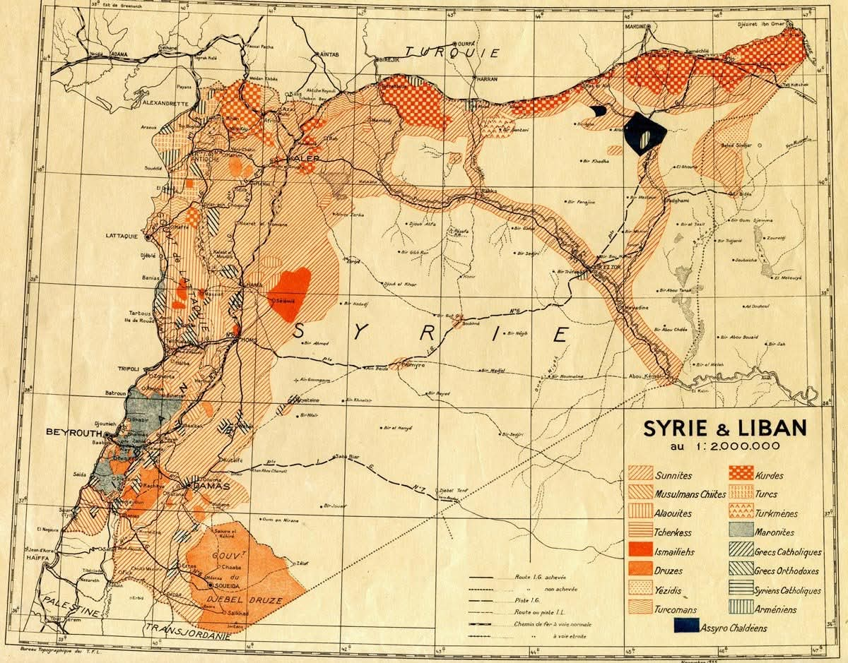

Figure 1: Ethnic and religious demographic map of Syria and Lebanon in 1935 during the French Mandate.

These developments suggest that communal categories already did exist prior to French rule, but they had not yet been transformed into the rigid territorial and political hierarchies they later became under the French. This becomes clearer through primary source demographic evidence. A map reproduced in Michael Kerr and Craig Larkin’s ‘The Alawites of Syria’ shows a mixed population of Sunni, Christian, and Alawites along the Syrian coast between 1920 and 1936. Likewise, a demographic published on a Facebook maps page, by the page ‘The Atlas Bookshelf’ which seems to produce non-political cartography and maps, depicts significant Sunni presence in regions later incorporated into minority-dominated areas.’

Although the Facebook map should be treated with caution given the nature of its unofficial source origins, its value is in the contents of the map which show that communal geography, was historically missed rather than naturally segregated. The Kerr and Larkin map source provides stronger academic support for this argument. Used together, these maps challenge deterministic assumptions that French territorial divisions merely showed pre-existing demographic realities.

3. The French Mandate and the Institutionalisation of Differentiated Rule
The French Mandate transformed inherited communal structures by embedding them into modern state institutions. As Nadine Meouchy argues, French governance relied upon the ‘territorial parcelling up of minorities’ as a strategy of rule.’ This process involved fragmenting territories and additionally cultivating carefully selected communities as political intermediaries.
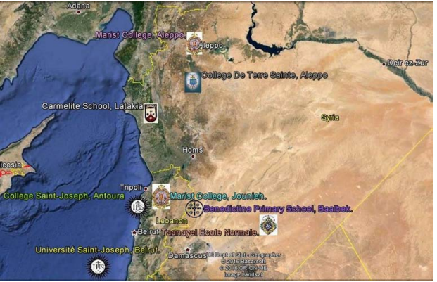
Figure 2: Map showing location of some French Catholic Schools in French Mandate Syria and Lebanon.
A useful primary source illustrating this process is the concentration of French Catholic missionary schools in Mandate Syria and Lebanon. The map shows schools heavily concentrated in Christian-majority Lebanon and minority regions of Syria, including Alawite and Druze areas. This map is incredibly useful as it visually shows the spatial relationship between French educational institutions and minority regions and communities. It suggests that missionary networks may have been used to cultivate communities that were perceived as politically reliable for the French. However, the source also has limitations. Missionary schools were not exactly political institutions and often functioned independent of state strategy, there was also perhaps the fear of opening schools in Sunni or Nationalist areas in the interior regions since they were more hostile to French interests and institutions. The map on its own therefore cannot prove that intentional sectarian engineering took place. Nevertheless, when read alongside the wider Mandate policies, it supports the argument that French governance functioned through selective incorporation rather than universal administration.
Another primary source document highlighting demographic evidence reinforces this interpretation. A table reproduced by Kerr and Larkin on the Syrian coast in 1935 shows that Sunnis maintained high population numbers in the coastal urban areas despite the creating of the Alawite state although that balance did shift later when population shifts took place. This further suggests that the French division of territory was not simply recognition of demographics but actual political restructuring.

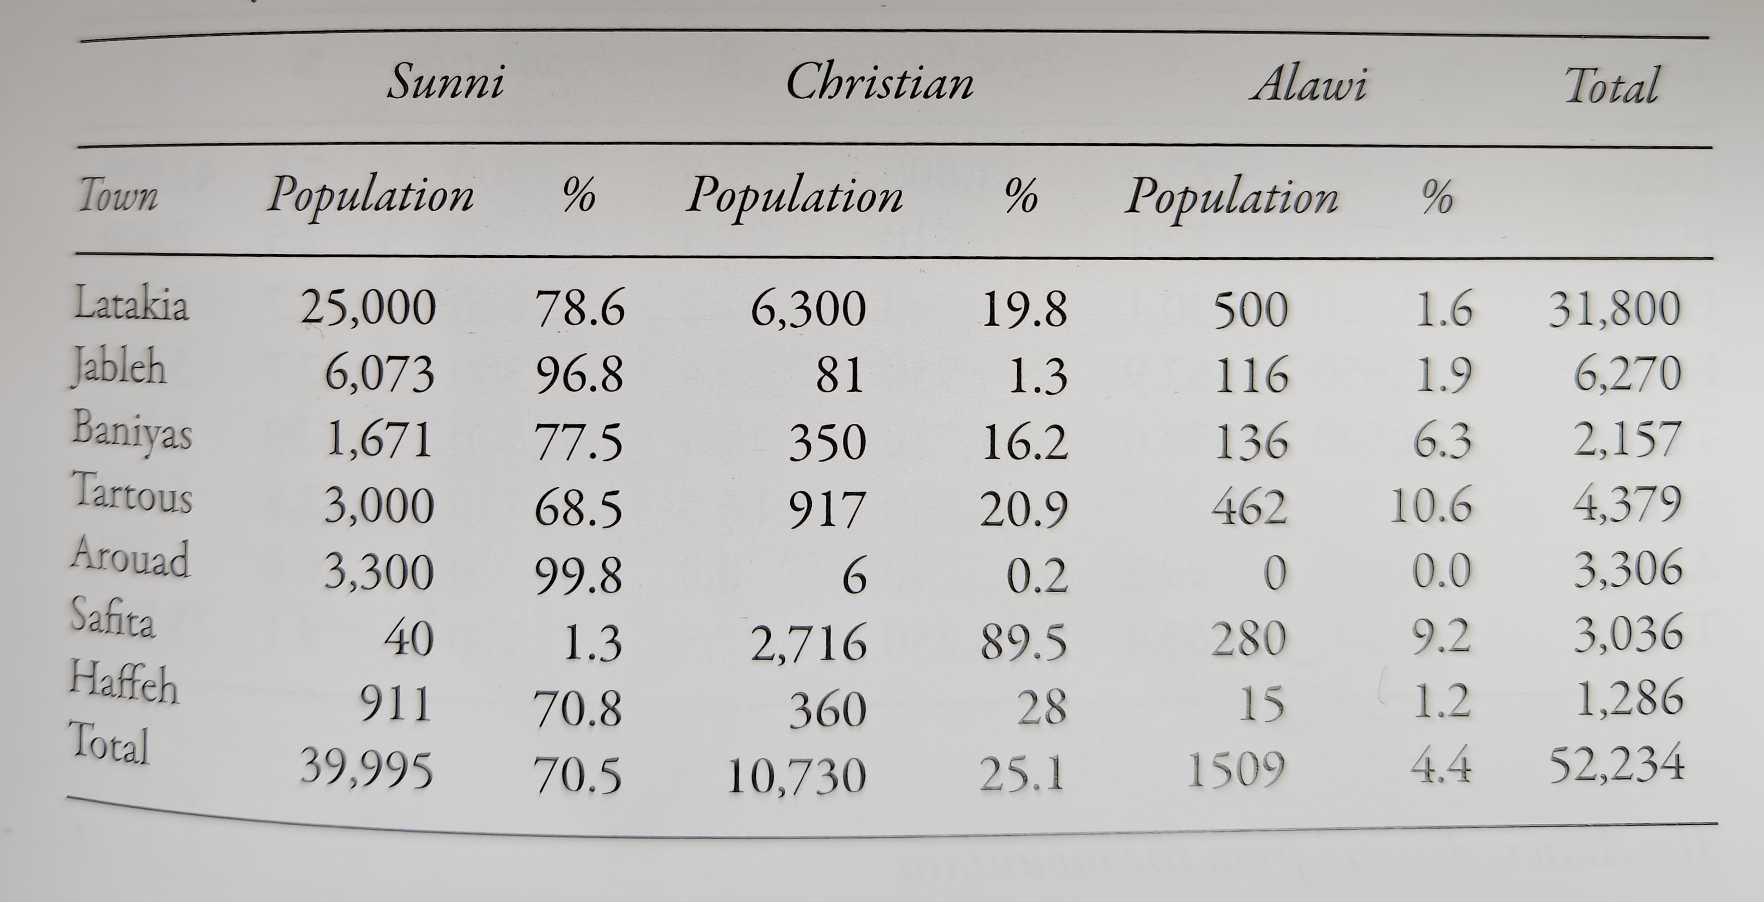
Figure 3: The urban population in the Syrian coastal region in 1935 by religious community.
Philip Khoury describes this broader policy as a strategy of ‘divide and conquer’ which aims to weaken any pan-Syrian nationalism through the nurture and cultivation of ‘potentially Francophile minorities.’ However, this dissertation argues that ‘divide and rule’ alone is not sufficient. French governance did not simply divide communities – it went further and established a hierarchy of political trustworthiness and reliability. Timothy Mitchell’s concept of colonial ‘legibility’ helps in explaining this process. He argues that colonial states aimed to make populations administratively knowable through systems of classification and simplification. Under the Mandate, sectarian identity became a tool for the classification of how populations were organised and governed.

4. Resistance and the Limits of Colonial Ordering
French actions in particular their attempts to reorganise political and social life sparked string resistance, especially during the Great Revolt. A circular distributed across Damascus in 1925 and signed by Sultan al-Atrash declared that the French had ‘separated the nation into religious sects and states. This source is valuable because it directly shows that anti-colonial nationalists understood French governance as a project of fragmentation which specifically focused on sectarian and territorial division. However, the source must also be critically evaluated. As revolutionary propaganda, its primary aim was mobilisation of the masses against French intervention and therefore may include exaggerations of national unity. The Ottoman Empire had only recently collapsed so it is difficult to believe that Syrians could have developed a nationalistic fervour to the magnitude of that mentioned in the nationalistic propaganda post. But looking at it from the other side, nationalism at that time could also have been an Islamic nationalism and not necessarily nationalism for the current Syrian borders, since within the same source there are countless references to God.
Similarly, a letter that is attributed to Hasan al-Kharrat in 1925, urged Damascenes to boycott the French High Commissioner and reject colonial rule. Provence notes that Hasan al-Kharrat was likely illiterate and probably dictated the letter, which raises questions about authorship and credibility of the source. However, this limitation is useful because it shows how nationalist discourse was collectively produced through resistance networks when there was a clear vacuum of legitimate native leadership.
French repression also revealed the extent of the coercive methods they were willing to take to quash and punish any form of resistance against the French and their Mandate. A photograph reproduced in Daniel Neep’s ‘Occupying Syria under the French Mandate’ depicts Syrian resistance fighters publicly hanged in Marjeh Square during the revolt. This image shows how colonial authorities relied on public violence and intimidation alongside colonial governance to contain and control the masses. The image illustrates how colonial authority relied not only on administration but also on public violence and intimidation to contain and control the masses.
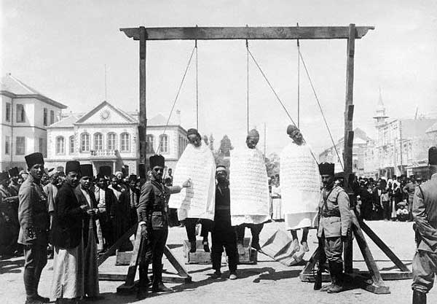
Figure 4: The corpses of three members of the Syrian resistance, hanged in Marjeh Square during the Arab Revolt.
Photographs, however, also have limitations as historical evidence. They capture moments that are emotionally powerful but do not always reveal the wider context. Nevertheless, the source remains important insofar, as it exposes coercive methods of French colonial rule. Together, these sources challenge interpretations of the Mandate as simply administrative or developmental. Instead, they highlight a system which used classification alongside repression.

5. Hierarchies of Incorporation and Colonial Governance

One of the most important transformations under the French Mandate was the emergence of differentiated political incorporation. Some communities were integrated into educational, administrative, and military structures, while others, in particular urban Sunni nationalist centres, were neglected, politically marginalised and securitised. Frantz Fanon’s observation that colonial society becomes ‘a world divided into compartments’ is useful here as it shows two different worlds; one for the French and their favoured and incorporated sects, and the rest. Under the Mandate, these compartments were not only spatial but also institutional.
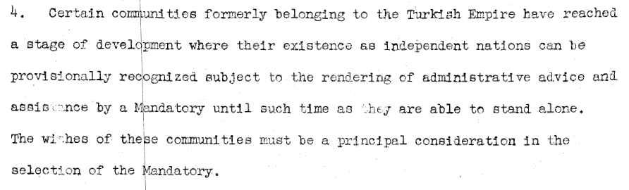
Figure 5: Excerpt of section 4 from Article 22 from the League of Nations Covenant for the Mandate.
This logic was reinforced by the League of Nations Mandate system itself in ‘Article 22’ which declared that formerly Ottoman territories had ‘reached a stage of development’ requiring ‘administrative advice and assistance by a Mandatory’ before they could govern themselves.’ This is an important source in that it exposes the paternalistic assumptions of colonial powers. French governance was framed internationally as ‘tutelage’ rather than ‘domination’ since the former is based more on the language of care and concern, but the latter is linked to control. In addition to the language of care, the language of ‘development’ hides the realities of coercive colonial rule and instead presents itself as politically neutral. Edward Said’s critique of Orientalism is relevant here. Said argues that colonial power relied upon representations of Middle Eastern societies as fragmented and incapable of self-government. The Mandate institutionalised exactly this logic by treating communal populations as administratively manageable categories requiring outside supervision. So while the League of Nations justified colonial rule through the idea of ‘guidance’ and ‘development,’ and the French then governed different communities according to their own assumptions and categorisations, some communities gained better access to power and made their way up the hierarchy with ease, while for those not favoured, it produced long term effects that endure today, especially hierarchical incorporation through Mandate governance.

6. Conclusion
This chapter has argued that the French Mandate essentially transformed communal distinctions in Syria and Lebanon into institutionalised forms of political governance. Ottoman reforms had already to a certain degree embedded sectarian identity within political life, but these structures were still quite fluid. Under the Mandate, however, communal identity became inextricable linked to territorial administration, education, political representation, and security management.
The primary sources analysed strongly support this arguments. Demographic maps show that populations were historically more mixed as opposed to completely segregated, while missionary school networks highlight selective investment in minority regions. National writings condemned French fragmentation initiatives, and League of Nations discourse exposed a paternalistic mindset that set the basis and justification for colonial governance. Combined together, these sources suggest that the French Mandate did not simply create sectarianism. But rather, it actually transformed communal identity into a hierarchy of governance which was based on differentiated political incorporation. Some communities were cultivated and selectively chosen to act as intermediaries and partners helping the French to stabilise the region and maintain control, while other groups such as the Sunni and Arab Nationalist populations were excluded, disciplined and marginalised. This institutional hierarchy would shape the divergent state trajectories of Syria and Lebanon examined in the following chapter.

Chapter 2: Divergent State Formation in Syria and Lebanon under the French Mandate

1. Introduction: Shared Colonial Logic, Divergent Outcomes
Building on the previous chapter’s argument that the French Mandate transformed communal distinctions into hierarchical systems of political incorporation, this chapter examines how that logic produced two distinctly different state trajectories in Syria and Lebanon. Instead of treating both countries as completely different cases, this chapter argues that both emerged from the same Mandate framework of communal classification and differentiated incorporation. However, this framework was not implemented evenly. In Lebanon, sectarian hierarchy became formally institutionalised through a constitutional power-sharing system. Conversely, in Syria, sectarian hierarchy was more indirect, and operated through exclusion, military recruitment, and authoritarian centralisation. As Philip Khoury argues, French authorities followed a strategy that ‘courted potentially Francophile minorities’ while damaging national cohesion and unity. This resulted in not a single sectarian model, but rather, produced different institutional expressions of the same colonial thinking: governance through differentiated communal incorporation.
2. Syria: Fragmentation, Exclusion, and Indirect Sectarianisation
In Syria, French rule depended heavily on fragmentation and the exclusion of nationalist urban elites. Michael Provence notes that French authorities viewed Damascus, Aleppo, and Hama as ‘hotbeds of anti-colonial nationalist resistance’ and therefore denied their elites any worthwhile participation in governance. This exclusion was extremely widespread within the Nationalist and Sunni communities. It represented a wider colonial strategy of reorganising political authority away from urban Sunni and Nationalist centres, and towards alternative intermediaries. Nadine Meouchy similarly argues that ‘minorities became the instrument of divide and rule.’
Analysis of primary source material, specifically, demographic evidence as observed earlier, makes the territorial dimension to this strategy visible. Kerr and Larkin’s reproduced map of coastal Syria shows that the coastal region remained religiously mixed during the Mandate period. It shows substantial Sunni and Christian populations alongside the Alawaites, visible in figure 6 below.
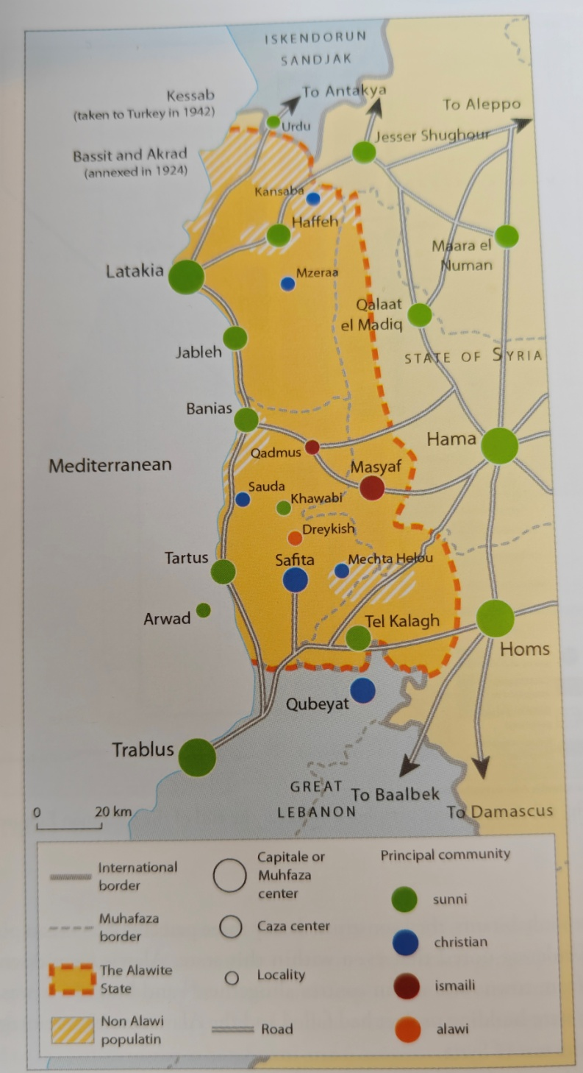
Figure 6: Map of The Alawite state from 1920-36, showing mixed populations on the coast.
This source is valuable because it challenges the assumption that French territorial divisions merely reflected demographic realities. Instead, it suggests that the Mandate politically privileged certain communal identities within strategically important and often diverse regions. However, the source also has limitations. Demographic data alone cannot prove the idea of deliberate colonial engineering, and urban statistics may not fully reflect the real rural picture. Nevertheless, when read alongside French administrative policy, this demographic source strongly supports the argument that territorial division was politically selective rather than neutral.
French Mandate governance also relied heavily on coercion. The photo from figure 2 shows three Syrian resistance fighters publicly hanged during the Great Syrian Revolt. Archival evidence like this illustrates how colonial authority depended upon public violence as well as hierarchical administrative structures and incorporation to maintain its grip on power. However, again, it is a photo source which has its limitations as it captured an isolated moment and not an entire era. Even so, the image reinforces the argument that colonial governance in Syria operated through both fragmentation and discipline. As mentioned in chapter 1, nationalist opposition sources such as the letter attributed to Hasan al-Kharrat and the revolutionary proclamation by Sultan al-Atrash, where he states they ‘separated the nation into religious sects and states,’ further reveal how Syrians felt about the French and how they viewed the fragmentation of their lands and the sectarianisation being advanced. These sources are an insightful window into the lived experiences of the lives of underprivileged and marginalised locals. Nevertheless, there may be an element of exaggeration or perhaps propaganda in both sources and therefore they need to be treated with caution.
Unlike Lebanon, Syria did not institutionalise formal confessional representation within parliament. Instead, sectarian hierarchy manifested itself through uneven recruitment within the military and key administrative positions, through selective alliances, and exclusionary governance practices. Mitchell’s concept of colonial ‘legibility’ is highly relevant here as he defines with clarity in one word how the French authorities attempted to make Syrian society governable a through categorisation, classification, and territorial simplification. However, caution again is necessary as he was writing within the context of the colonisation of Egypt. Having said that, Egypt and Syria and not too different, and have shared a similar history and where at one point under nationalist governments, became one county in the twentieth century. Thus, Syria’s trajectory reflects not the absence of sectarian governance, but its informalisation within a fragmented and increasingly authoritarian political structure.

3. Lebanon: Institutionalising Sectarian Hierarchy
In contrast to Syria, Lebanon represents the formal institutionalisation of the Mandate’s system of differentiated incorporation. Right from its inception as a modern nation-state, in 1920, Greater Lebanon was organised based around the idea that communal identity should guide, shape and structure political representation and access to state structures. A strong primary source showing this is Article 24 of the Lebanese Constitution of 1926. The article states that parliamentary representation should be distributed according to ‘equal representation between Christians and Muslims’ and proportional representation among confessional groups.
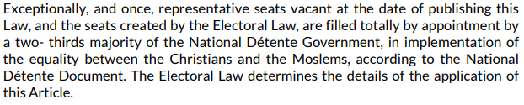
Figure 7: Article 24 from the Lebanese constitution of 1926.
This sources is central because it because clearly shows how sectarian identity was formally embedded within state institutions. Political representation became married in the most rigid way to communal affiliation, as opposed to universal citizenship. However, the source must also be analysed critically. Although it presents itself as a mechanism for balanced representation, it entrenches sectarian identity as the organising and foundational principle of governance. In a TRT World News You Tube video source, scholar Ussama Makdisi describes the situation as ‘a single identity, where one’s sect defines one’s involvement in the public sphere and one’s ability to be appointed to office, to govern, to collect taxes and to punish.’ This quote as confusing as it sounds, defines the problematic nature of the setup since he refers to it as one identity when in fact there are four major identities competing for that one identity but at the same time are competing for their own individual identities, all sect based. This highlights the flaw within the system which since is constitutional, cannot be changed. However, although Makdisi is one of the foremost scholars on this topic, he is essentially being interviewed by a Turkish news channel which may have a political motive to identify flaws within the Lebanese confessional system. On the flip side, it is the national news channel of Turkey, and is quite professional in its coverage and reporting, except of course for when the narrative does not fit its national agenda.
However, Carol Hakim argues that the 1926 constitution ‘provided for a strong presidency and a parliament in which different religious communities were represented, each according to its size.’ Therefore, this marks a decisive shift from fluid communal relations to institutionalised confessionalism.

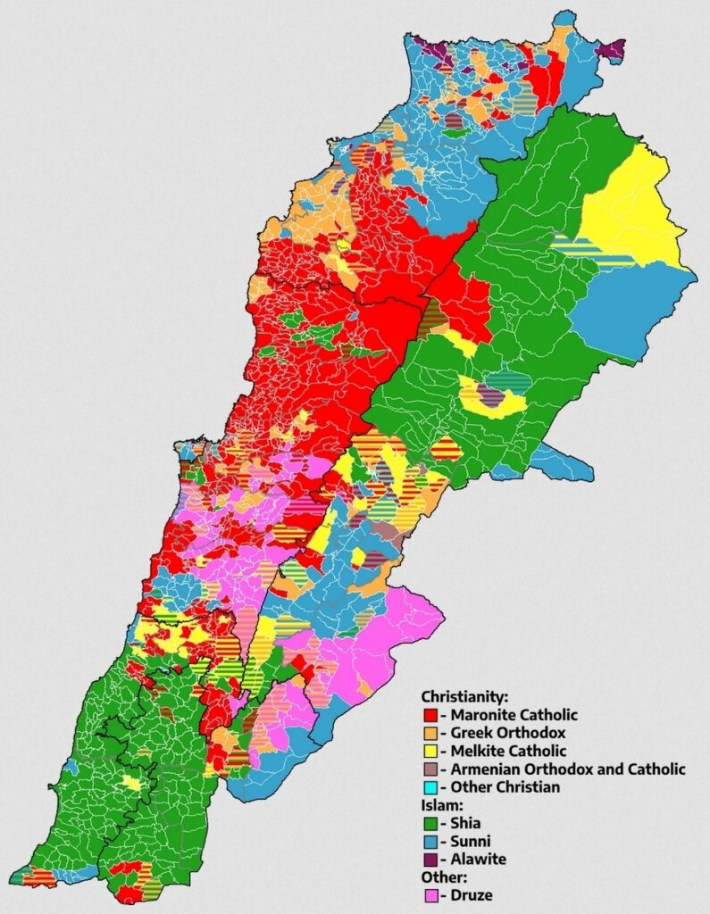
Figure 8: Map of territorial concentrations of different religions and sects in Lebanon.
The territorial or spatial logic behind this arrangement is also salient. Maps of Mandate-era Lebanon demonstrate that Christian populations were most heavily concentrated within the borders of Greater Lebanon, although large numbers of Muslims also existed within the new state. This can be viewed in two ways. The first is that the French did not create a purely Christian entity, but rather a state that was structured or built around communal representation while also maintaining and institutionalising a majority Christian population. On the flip side, there is the widely held view also that France did not want the original smaller land of the Maronite Mutassarifate which was the original district where Christians were concentrated as it would not be a nation that would be economically prosperous, and so they added extra portions of land from Sunni, Druze and Shia areas to create Greater Lebanon for economic advantage. Additionally, the source of the map is an Arab American diaspora website but when compared with election data maps, it is an accurate representation.
The map in figure 2 in chapter one, of the concentrations of French Catholic missionary schools in Mandate Syria and Lebanon in the minority areas also demonstrates how educational institution networks operated as mechanisms for cultivating and producing local intermediaries loyal to the French cause. However, missionary schools do not definitively prove deliberate political engineering but when looked at from the perspective of wider Mandate policies, it supports the view that colonial governance relied on selective incorporation.
Kamal Salibi further argues that Maronite elites promoted the idea of a unique Lebanese identity that aligned with French strategic interests. This suggests that sectarian governance was not imposed solely from above but that it was co-produced by the interactions of local elites with colonial authorities. Lebanon therefore represents the clearest institutional expression of what Nadine Meouchy describes as the ‘territorial parcelling up of minorities.’ Sectarian identity became constitutionally embedded within political representation, producing a formal style of hierarchical incorporation.

4. Explaining Divergence: Why Different Outcomes?

The divergent paths of Syria and Lebanon do not reflect completely different colonial intentions and motives, but rather differences in implementation and political intent. Firstly, geography played a large role as Lebanon’s smaller territory size made confessional institutionalisation more administratively realistic, whereas Syria’s larger and more diverse political landscape problematised formal sectarian division. Secondly, elite cooperation also differed to a large degree. In Lebanon, Maronite elites largely worked with French authorities to institutionalise political autonomy. However, in Syria, French rule was resisted by Sunni and nationalist elites, thus limiting opportunities for formal incorporation. Thirdly, colonial priorities and motives varied. France viewed Lebanon as a relatively stable and reliable coastal ally, while Syria was seen as the centre of nationalist unrest and resistance which in turn required coercive management. Despite these differences though, lay the underlying logic that remained consistent. In both states, populations were classified into communal categories that structured access to political power and authority. Fanon’s description of colonial society as ‘a world divided into compartments’ is a credible description of these divergent French governance styles. It applies not only spatially but also in terms of institutionalisation and political incorporation.

5. Conclusion

This chapter has argued that Syria and Lebanon emerged from the same colonial logic of differentiated communal incorporation, but developed starkly different institutional results under the French Mandate. In Syria, sectarian hierarchy functioned through fragmentation, exclusion, and selective coercive methods of integration. In Lebanon, sectarian, sectarian hierarchy became formally entrenched within the constitutional system. The primary sources strong anchor the arguments with evidence and support this interpretation. Demographic maps challenge ideas of primordially segregated populations, nationalist writings highlight resistance to colonial fragmentation, and constitutional documents clearly demonstrate the institutionalisation of confessionalism in Lebanon. Taken together, these sources suggest that the Mandate did not simply divide populations, but rather, it transformed communal identity into mechanisms and methods for organising political authority. They main difference between Syria and Lebanon therefore, not the actual existence of sectarian governance itself, but the way it was institutionalised. This legacy of differentiated incorporation continued to shape postcolonial governance, as is examined in the following chapter.

Chapter 3: Persistence and Contemporary Sectarian Governance

1. Introduction: Mandate Legacies and Postcolonial Transformation

The previous chapters argued that the French Mandate transformed communal difference into systems and structures of political incorporation through administrative classification, territorial division, and selective elite integration. However, the relationship between Mandate governance and contemporary sectarian politics is not one of simple continuity. Instead of reproducing colonial institutions that were unchanged, postcolonial regimes in Syria and Lebanon adapted and reshaped these already existing structures in different ways.

This chapter argues that the Mandate’s most enduring legacy was not sectarianism itself, but the institutional logic behind it that linked political authority to communal identity through differentiated incorporation into state power. In Lebanon, this persisted through the paralysis of confessional politics. In Syria though, it survived more indirectly through authoritarian structures that denied sectarianism rhetorically but reproduced it through informal hierarchies within the military-security apparatus.

At the same time, this chapter challenges deterministic interpretations that attribute contemporary governance solely to colonialism, Ottoman precedents, postcolonial nationalism, civil war, and regional intervention all played a part in shaping these systems after independence. The Mandate therefore created structures of political possibility rather than fully determining future outcomes.

2. Lebanon: Institutionalised Continuity and Confessional Governance

Lebanon represents the clearest example of continuity between mandate governance and contemporary sectarian political organisation. The French institutionalised communal representation through the 1926 Constitution, embedding sectarian identity directly into how the state was structured. As shown earlier in chapter two in figure 7, Article 24 formalised parliamentary representation according to confessional allocation quotas, establishing ‘equal representation between Christian and Muslims’ alongside proportional representation within the various confessional groups.
This source is very important as it demonstrated the constitutionalisation of communal identity as the organising basis of governance. Unlike Syria, where sectarian differentiation often functioned indirectly, Lebanon institutionalised it rigidly. Its strength is in the official legal statues, revealing how sectarian hierarchy became embedded within the state itself. However, the constitutional text reflects formal institutional design rather than the actual practical political processes.
The constitutional framework established under the Mandate persisted after independence through the National Pact of 1943. Although it was uncodified, so there is not in existence an original source document of it, it was extremely impactful and formalised the distribution of political offices according to sectarian identity and resulted in the following permanent setup:
- the President as a Maronite Christian,
- the Prime Minister as a Sunni Muslim,
- the Speaker of Parliament as a Shia Muslim
This political arrangement demonstrates continuity through adaptation. The Pact did not abolish formal confessionalism that it inherited from the Mandate, but instead, it renegotiated it between Lebanese elites after French withdrawal. As Carol Hakim argues, the French Mandate ‘provided for a strong presidency and a parliament in which different religious communities were represented, each according to its size.’ Therefore, sectarian governance survived and endured because postcolonial elites realised it was politically beneficial for them for only because it was externally imposed but because it helped maintain the status quo of power they enjoyed.
The Taif Agreement of 1989 shows this continuity ever further. Although it was designed to end the Lebanese Civil War, Taif actually maintained and preserved it with only a few adjustments made to reflect the growing Muslim population:
- Parliamentary representation shifted to Christian-Muslim parity,
- Executive authority moved away from the Maronite presidency,
- Yet sectarian office allocation remained intact (Taif Agreement source).
This source is useful as it demonstrated that even reform efforts could not move away from placing sectarian identity as the basis of political legitimacy. The agreement rhetorically called for the overturning of political sectarianism while at the same time reinforcing sectarian allocation quotas. This contradiction supports the argument that sectarian governance became self-reproducing beyond the French Mandate period.
However, the Taif also reveals the limits to explaining the crisis purely through colonial determinism. By 1989, Lebanon had experienced a whirlwind of new crisis such as civil war, war with Israel, a new militia forming and demographic change. Therefore sectarian governance cannot be explained as solely originating from the Mandate.
The Online news channel TLDR produced a report of the current state of the Lebanese political system and reported ‘Lebanon is politically deadlocked’ and ‘its Lebanon’s lack of state capacity eroded by years of political and economic crisis’ that has resulted in a ‘cruel paradox’ or a state of paralysis where due to the Taif agreement entrenching and reinforcing the confessional system along sectarian or communal lines, the state cannot make any effective changes thus finding itself in a constant state of crisis. Although this is a YouTube video analysis, it is from a reputable news source known for its fact based and neutral stance in reporting.
This demographic transformation is illustrated by the contemporary religious map of Lebanon produced by the New Lines Institute on the Brilliant Maps website. The map suggests Muslims now form roughly 64 percent of the population, despite the political system still reflecting older confessional balances rooted in the Mandate era.
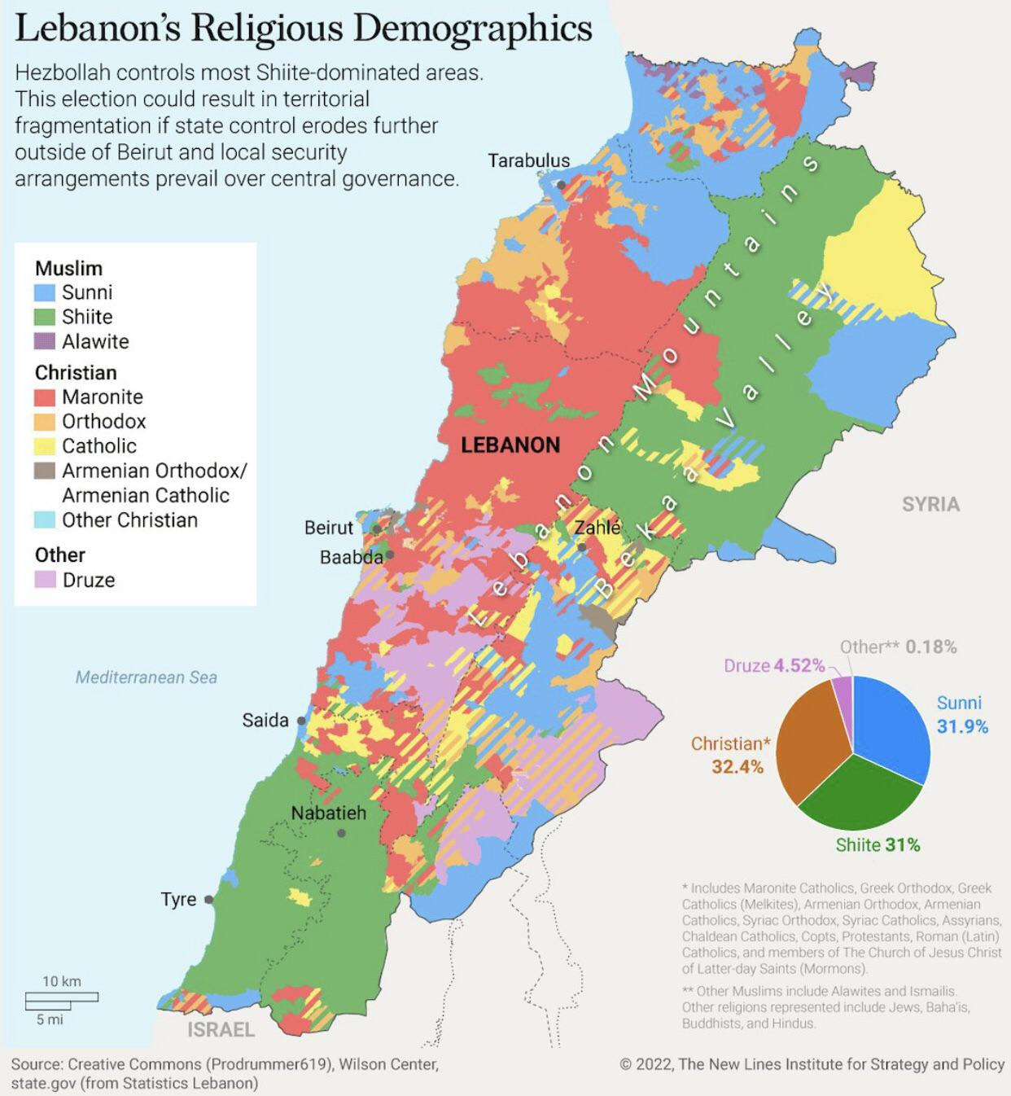
Figure 9: Lebanon’s Religious Demographics map showing the increase of the Muslim population as compared to the previous Christian majority population.
This source in figure 9 is analytically valuable because it highlights the divide between demographic realities and the enduring political structure. However, Lebanon has not conducted an official census since 1932 due to the political sensitivity of sectarian demographics, meaning the map relies on estimated rather than definitively provable data unless one looks at election results that pain a closer picture to the new reality.
Max Weiss’s argument that sectarianism emerged through ‘a dialectical relationship between attempts at divide and rule from above and clamorous demands from below’ becomes particularly relevant again here. Lebanese sectarian governance persisted not because communities were naturally divided, but differences were reproduced by the colonisers and the elites. Therefore Lebanon demonstrated strong institutional continuity of Mandate governance, which is reproduced and reinvented leading to a divided outcome as before.

3. Syria: Informal Sectarianism and Authoritarian Hierarchy
Unlike Lebanon, Syria did not institutionalise confessionalism constitutionally post independence. Officially, postcolonial Syrian regimes promoted Arab nationalism and anti-sectarian rhetoric. However, sectarian hierarchy persisted informally through military structures and recruitment processes as well as security and authoritarian networks. This system was rooted in Mandate governance. As Michael Provence argues, French authorities viewed Damascus, Aleppo, and Hama, as ‘hotbeds of anti-colonial nationalist resistance’ and systematically marginalised and excluded urban nationalist elites from governance.’ Instead, colonial authorities depended on intermediaries and minority linked governance structures.
The most significant continuity can be seen within the military-security apparatus. This is highlighted by the testimony recorded in Nikolaos van Dam’s The Struggle for Power in Syria. In the confession, First Sergeant ‘Ali Fadil describes discussions within military units about ‘the Sunni bloc and the Alawi bloc,’ warning that ‘the Alawis were forming a bloc against Islam.’ This source is valuable because it provides direct evidence of sectarian perception inside military structures. It shows that communal identity was a political reality despite the regimes stating otherwise.
However, the source also has limitations. The testimony emerged within a politically charged environment and may reflect fear, factionalism, or retrospective interpretation rather than objective truth. Van Dam’s work has also been critiqued for his often over emphasis of sectarian structures and dynamics without focusing on ideology and patronage networks. Nevertheless, the source does strongly support the idea that postcolonial Syria reproduced informal communal hierarchies which were partly rooted in French Mandate recruitment and exclusion dynamics.
This hierarchy became increasingly visible under Hafiz al-Asad. The image of Asad in figure 10 illustrates how authoritarian rule was dependent on symbolism and domination and hierarchical structures or levels of loyalty.
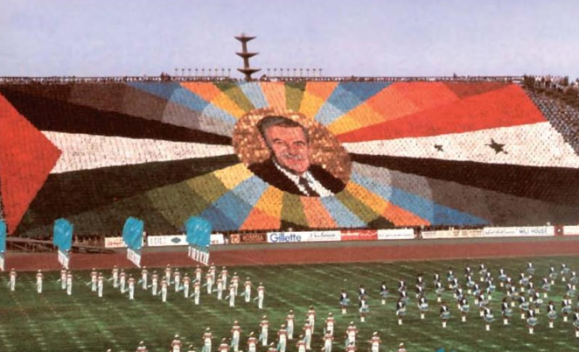
Figure 10: Opening Ceremony of the Mediterranean Games, Lattakia, in 1987, depicting Hafiz al-Asads face as omnipotent.
The source is important because it visually demonstrates the personalisation of power. Wedeen argues that such spectacles enforced obedience through rituals of public submission. However, the image does not directly prove sectarianism. Rather, it shows how authoritarian governance replaced formal sectarian representation with systems of symbolic control and managed loyalty with omnipotence displays and military parades. Thus, Syria demonstrates continuity with Mandate governance not through formal institutions, but through latent hierarchies embedded within coercive state structures.
Comparing Continuity and Postcolonial Transformation
The comparison between Syria and Lebanon has demonstrated two very divergent forms of postcolonial continuity, both of which were born out of the same Mandate era system. In Lebanon, sectarian governance remained very explicitly constitutional while elite formation and maintained and reproduced the confessional system after independence. Constitutional arrangements such as Article 24, along with the National Pact and later the Taif Agreement, all entrenched and embedded sectarian representation within the foundations of the political systems of governance. Instead of disappearing after independence, it evolved into a system that could endure.
By contrast, in Syria, formal sectarianism was publicly shunned but institutionally continuous through Arab nationalism and anti-confessional unity. However, communal hierarchy persisted indirectly through for example military networks, security networks, loyalty networks, and authoritarian patronage structures. Although the Syrian state had not institutionalised sectarianism constitutionally, political power was based on a highly sectarian basis involving differentiated incorporation informal communal structures. Evidence such as the military confessions, Hafiz al-Asad’s political rhetoric, and Lisa Wedeen’s analysis of symbolic authoritarianism, all show how sectarian dynamics survived behind the fig leaf of national unity.
This divergence supports the dissertation’s broader claims that the French Mandate created not a single institutional blueprint to follow, but rather a hierarchy of governance whose mechanisms and structures could be adopted differently after independence. Timothy Mitchell’s concept of colonial ‘legibility’ is quite salient here as both Syria and Lebanon inherited systems designed to make them administratively manageable through communal categorisation and classification. Yet, these categories were institutionalised in different ways with Lebanon following a formal confessional system and Syria through informal authoritarian and security structures.
At the same time, the comparison also highlights the limits of colonial determinism. While Mandate institutions developed important structural foundations, postcolonial developments reshaped and built on these systems significantly. The ways that communal identities operated were shaped by a variety of factors such as Ottoman administrative legacies, local elite agency, authoritarian state formation, civil war, regional geopolitics amongst other factors. Therefore, contemporary sectarian governance reflects not only the persistence of colonial institutions, but the interactions between colonial legacies and postcolonial transformations.

Conclusion

This dissertation has argued that the French Mandate for Syria and Lebanon significantly shaped contemporary sectarian governance, but not in the in the simplistic sense of either creating sectarian identities or even by employing ‘divide and rule’ tactics. Instead, the central claim is that the Mandate transformed pre-existing communal distinctions, already created in part, though to a much lighter degree, by late Ottoman governance and nineteenth-century reform, into a durable institutional logic of political organisation. This logic operated through what can be understood as and what this dissertation uniquely claims, as a system of hierarchical incorporation, whereby access to state power was mediated through communal categorisation and classification and unevenly distributed according to perceived political reliability.
Rather than producing sectarianism as a fixed structure, the French Mandate system recalibrated and reconfigured how communal identity operated politically. Communities were not solely differentiated but actually ranked, resulting in the production of a hierarchy of incorporation in which certain groups, in particular Alawite and Christian minority groups were positioned as intermediaries and political partners of colonial authority. Left out were the Arab nationalists and Sunni majority populations who were marginalised, had their territories fragmented, and were subject to coercive control. This logic was expressed through a variety of mechanisms which included territorial reorganisation, selective military recruitment, educational networks, constitutional engineering in Lebanon, and more indirect modes of administrative control in Syria. Across these areas and domains, sectarian categories operated less as expressions and manifestations of social divisions but more as carefully constructed tools for the management of political access and consolidation of authority.
This argument challenges the two main strands of historiography that dominate the scholarly space on this topic by proposing a new lens to view Mandate era machinations and rule. Primordialist interpretations wrongly treat sectarianism as a long standing and enduring feature of Levantine society, obscuring the extent to which communal identities were historically based and politically reworked. At the same time, strictly colonial ‘divide and rule’ approaches tend to overstate the intentionality of French policy, and thereby reducing a complex process of governance to a strategy of fragmentation. As the dissertation has show, the Mandate era governance was not exactly completely pre-planned but did operate at a reactionary level too, including to rebellion, administrative constraints, and local collaboration. Therefore, the emergence of sectarian governances can be seen as the meeting and interaction of a variety of forces such as local elites, missionary networks, national resistance, and colonial administrators.
The comparative analysis of Syria and Lebanon further shows that the Mandate did not produce a contiguous model of sectarian governance, even though both countries borders met, but rather two institutional versions of the same underlying logic. In Lebanon, hierarchical incorporation was formalised through constitutional confessionalism, thereby embedding communal identity directly within the architecture of the state. In Syria, by contrast, it operated more informally through marginalisation and exclusion from urban governance, selective incorporation, and the development of coercive military and security structures of an authoritarian nature. These differences reflect variations in geography, elite cooperation, and colonial priorities. But the same logic was applied in that political authority was distributed through differentiated communal categorisation as the base or foundational principle.
The postcolonial trajectories of both states highlight the durability and adaptability of this inherited logic and structure. In Lebanon, confessional governance practices persisted through elite bargaining and were reproduced as opposed to dismantled by independence and later by the Taif Agreement, even as demographic realities changed. In Syria, formal anti-sectarian ideology acted as a fig leaf of unity, masking the persistence of informal hierarchies embedded within the security apparatus and state institutions. In both cases, sectarian governance endured not as a direct institutional inheritance, but as a flexible framework through which political authority continued to be organised, justified, contested and renewed.
The main contribution of the dissertation therefore, is conceptual as much as it is historical. It proposes that the key legacy of the French Mandate was not sectarian division in itself, but the institutionalisation of differentiated incorporation into state power structures, a governing logic in which communal identity became the primary medium through which political inclusion and exclusion were decided. This framework helps to explain the divergence between Syria and Lebanon and their shared underlying patterns of governance. But it also highlights the salient role played by postcolonial elites in sustaining and reshaping these systems.
Ultimately, contemporary sectarian governance in Syria and Lebanon should be understood as a layered process of history in which precedents set by the Ottomans, colonial machinations, local agency, and postcolonial state-building all contributed to different degrees, producing the outcome we have today. The French Mandate plays a major role in this since it embedded communal identity into how institutions function even today. Its most enduring and lingering impact was the creation and embedding of hierarchical structures of governance and incorporation into governing institutions that are crisis producing machines, but that cannot be easily overturned.

Word count: 9687
Notes
- Religious Demographics of Lebanon Map’, Brilliant Maps, 18 July 2024, https://brilliantmaps.com/lebanon-religion/ [accessed 16 May 2026].
This source states a different origin but was found on the Brilliant Maps website.
- https://anayasa.gen.tr/gulhane.htm
This is the web link from where I obtained the primary source for the Tanzimat reforms
which is another word for Gulhane Edict.

Primary Sources
League of Nations, The Covenant of the League of Nations, Article 22, in The Avalon Project, Yale Law School https://avalon.law.yale.edu/20th_century/leagcov.asp#art22 [accessed 03 May 2026].
Lebanese Constitution (1926), Presidency of the Lebanese Republic https://www.presidency.gov.lb/English/LebaneseSystem/Documents/Lebanese%20Constitution.pdf [accessed 17 May 2026].
‘Gülhane Hatt-ı Şerif (Tanzimat Fermanı)’, Anayasa Gen https://www.anayasa.gen.tr/gulhane.htm [accessed 08 May 2026].
Sultan al-Atrash, revolutionary proclamation during the Great Syrian Revolt, quoted in The Great Syrian Revolt (Austin: University of Texas Press, 2005).
Hasan al-Kharrat, letter circulated during the Great Syrian Revolt, quoted in The Great Syrian Revolt (Austin: University of Texas Press, 2005).
Ussama Makdisi, interview on Lebanese confessionalism, TRT World, YouTube video https://www.youtube.com/watch?v=JQ8PpS1m7nE [accessed 16 May 2026].
‘Why Lebanon Is Politically Deadlocked’, TLDR News Global, YouTube video https://www.youtube.com/watch?v=JdX8HNOlYSE [accessed 10 May 2026].
‘Religious Demographics of Lebanon’, Brilliant Maps https://brilliantmaps.com/lebanon-religion-map/ [accessed 10 May 2026].
‘Ethnic and Religious Demographic Map of Syria and Lebanon, 1935’, The Atlas Bookshelf, Facebook cartography page https://www.facebook.com/theatlasbookshelf/ [accessed 10 May 2026].

Secondary Sources
Frantz Fanon, The Wretched of the Earth, trans. by Constance Farrington (New York: Grove Press, 1963).
James Gelvin, Divided Loyalties: Nationalism and Mass Politics in Syria at the Close of Empire (Berkeley: University of California Press, 1998).
Carol Hakim, The Origins of the Lebanese National Idea, 1840–1920 (Berkeley: University of California Press, 2013).
Michael Kerr and Craig Larkin, The Alawis of Syria: War, Faith and Politics in the Levant (London: Hurst, 2015).
Philip S. Khoury, Syria and the French Mandate: The Politics of Arab Nationalism, 1920–1945 (Princeton: Princeton University Press, 1987).
David W. Lesch, The New Lion of Damascus: Bashar al-Asad and Modern Syria (New Haven: Yale University Press, 2005).
Nadine Méouchy, ‘The British and French Mandates in Comparative Perspectives’, in The British and French Mandates in Comparative Perspectives, ed. by Nadine Méouchy and Peter Sluglett (Leiden: Brill, 2004), pp. 413–26.
Timothy Mitchell, Colonising Egypt (Berkeley: University of California Press, 1988).
Daniel Neep, Occupying Syria under the French Mandate: Insurgency, Space and State Formation (Cambridge: Cambridge University Press, 2012).
Idir Ouahes, ‘Catholic Missionary Education in Early Mandate Syria and Lebanon’, Revue des mondes musulmans et de la Méditerranée, 151 (2022), 221–42.
Michael Provence, The Great Syrian Revolt and the Rise of Arab Nationalism (Austin: University of Texas Press, 2005).
Edward Said, Orientalism (New York: Pantheon Books, 1978).
Kamal Salibi, A House of Many Mansions: The History of Lebanon Reconsidered (Berkeley: University of California Press, 1988).
Elizabeth Thompson, Colonial Citizens: Republican Rights, Paternal Privilege, and Gender in French Syria and Lebanon (New York: Columbia University Press, 2000).
Nikolaos van Dam, The Struggle for Power in Syria: Politics and Society under Asad and the Ba‘th Party (London: I.B. Tauris, 2011).
Lisa Wedeen, Ambiguities of Domination: Politics, Rhetoric, and Symbols in Contemporary Syria (Chicago: University of Chicago Press, 1999).
Max Weiss, In the Shadow of Sectarianism: Law, Shi‘ism, and the Making of Modern Lebanon (Cambridge, MA: Harvard University Press, 2010).

Gulhane Edict (Tanzimat Fermani), ‘Gulhane Edict (Tanzimat Fermani) (1839)’, Anayasa Gen Tr, https://anayasa.gen.tr/gulhane.htm (Accessed 12 May 2026).
Max Weiss, In the Shadow of Sectarianism: Law, Shi‘ism, and the Making of Modern Lebanon (Cambridge, MA: Harvard University Press, 2010), p. 77.
Idir Ouahes, ‘Catholic Missionary Education in Early Mandate Syria and Lebanon’, Social Sciences and Missions, 30.3–4 (2017), p. 234.
Michael Kerr and Craig Larkin, The Alawites of Syria: War, Faith and Politics in the Levant (London: Hurst & Company, 2015), pp. 84–85.
Michael Provence, The Great Syrian Revolt and the Rise of Arab Nationalism (Austin: University of Texas Press, 2005), p. 82.
Gulhane Edict (Tanzimat Fermani), ‘Gulhane Edict (Tanzimat Fermani) (1839)’, Anayasa Gen Tr, https://anayasa.gen.tr/gulhane.htm (Accessed 12 May 2026).
Idir Ouahes, ‘Catholic Missionary Education in Early Mandate Syria and Lebanon’, Social Sciences and Missions, 30.3–4 (2017), p. 234.
‘Article 22 of the Covenant of the League of Nations’ (1924), United Nations Digital Library, A/297 https://www.un.org/unispal/document/auto-insert-185531/ [Accessed 14 May 2026].
Edward W. Said, Orientalism (London: Routledge & Kegan Paul, 1978), p. 3.
Michael Kerr and Craig Larkin, The Alawites of Syria: War, Faith and Politics in the Levant (Oxford: Oxford University Press, 2015), pp. 84-85.
Ibid., p. 85.
Michael Provence, The Great Syrian Revolt and the Rise of Arab Nationalism (Austin: University of Texas Press, 2005), p. 82.
Philip S. Khoury, Syria and the French Mandate: The Politics of Arab Nationalism, 1920–1945 (Princeton: Princeton University Press, 1987), p. 58.
Nadine Meouchy and Peter Sluglett (eds), The British and French Mandate’s in Comparative Perspective (Leiden: Brill, 2004), p. 586.
Michael Provence, The Great Syrian Revolt and the Rise of Arab Nationalism (Austin: University of Texas Press, 2005), p. 13.
Elizabeth Thompson, Colonial Citizens: Republican Rights, Paternal Privilege, and Gender in French Syria and Lebanon (New York: Columbia University Press, 2000), p. 53.
Gulhane Edict (Tanzimat Fermani), ‘Gulhane Edict (Tanzimat Fermani) (1839)’, Anayasa Gen Tr, https://anayasa.gen.tr/gulhane.htm (Accessed 12 May 2026).
James Gelvin, Divided Loyalties: Nationalism and Mass Politics in Syria at the Close of Empire (Berkeley: University of California Press, 1998), p. 52.
Ibid., p. 292.
Max Weiss, In the Shadow of Sectarianism: Law, Shi‘ism, and the Making of Modern Lebanon (Cambridge, MA: Harvard University Press, 2010), p. 77.
Carol Hakim, The Origins of Confessional Politics in Lebanon under the French Mandate (London: I.B. Tauris, 2019), p. 1692.
Kamal Salibi, A House of Many Mansions: The History of Lebanon Reconsidered (London: I.B. Tauris, 1988), p. 22-26.
Nikolaos van Dam, The Struggle for Power in Syria (London: I.B. Tauris, 2011), p. 68.
David W. Lesch, The New Lion of Damascus: Bashar al-Asad and Modern Syria (New Haven: Yale University Press, 2005), p. 76.
Lisa Wedeen, Ambiguities of Domination: Politics, Rhetoric, and Symbols in Contemporary Syria (Chicago: University of Chicago Press, 2015), p. 6.
Timothy Mitchell, Colonising Egypt (Cambridge: Cambridge University Press, 1988), p. 33.
Edward W. Said, Orientalism (London: Routledge & Kegan Paul, 1978), p. 3.
Frantz Fanon, The Wretched of the Earth (London: Penguin, 1963), p. 37.
Elizabeth Thompson, Colonial Citizens: Republican Rights, Paternal Privilege, and Gender in French Syria and Lebanon (New York: Columbia University Press, 2000), p. 53.
Max Weiss, In the Shadow of Sectarianism: Law, Shi‘ism, and the Making of Modern Lebanon (Cambridge, MA: Harvard University Press, 2010), p. 77.
Gulhane Edict (Tanzimat Fermani), ‘Gulhane Edict (Tanzimat Fermani) (1839)’, Anayasa Gen Tr, https://anayasa.gen.tr/gulhane.htm (Accessed 12 May 2026).
Elizabeth Thompson, Colonial Citizens: Republican Rights, Paternal Privilege, and Gender in French Syria and Lebanon (New York: Columbia University Press, 2000), p. 53.
James Gelvin, Divided Loyalties: Nationalism and Mass Politics in Syria at the Close of Empire (Berkeley: University of California Press, 1998)., p. 52.
‘Religious and Ethnic Groups in Syria and Lebanon under the French Mandate’, The Atlas Bookshelf (Facebook post, 2023) https://www.facebook.com/photo/?fbid=1349685063627602&set=a.527495192513264 [accessed 15 May 2026].
Michael Kerr and Craig Larkin, The Alawites of Syria: War, Faith and Politics in the Levant (Oxford: Oxford University Press, 2015), p. 84.
‘Religious and Ethnic Groups in Syria and Lebanon under the French Mandate’, The Atlas Bookshelf (Facebook post, 2023) https://www.facebook.com/photo/?fbid=1349685063627602&set=a.527495192513264 [accessed 15 May 2026].
Nadine Meouchy and Peter Sluglett (eds), The British and French Mandate’s in Comparative Perspective (Leiden: Brill, 2004), pp. 586-587.
Idir Ouahes, ‘Catholic Missionary Education in Early Mandate Syria and Lebanon’, Social Sciences and Missions, 30.3–4 (2017), p. 234.
Ibid.
Michael Kerr and Craig Larkin, The Alawites of Syria: War, Faith and Politics in the Levant (Oxford: Oxford University Press, 2015), p. 85.
Michael Kerr and Craig Larkin, The Alawites of Syria: War, Faith and Politics in the Levant (Oxford: Oxford University Press, 2015), p. 85.
Philip S. Khoury, Syria and the French Mandate: The Politics of Arab Nationalism, 1920–1945 (Princeton: Princeton University Press, 1987), p. 58.
Timothy Mitchell, Colonising Egypt (Cambridge: Cambridge University Press, 1988), p. 33.
Michael Provence, The Great Syrian Revolt and the Rise of Arab Nationalism (Austin: University of Texas Press, 2005), p. 82.
Ibid., p. 119.
Daniel Neep, Occupying Syria under the French Mandate: Insurgency, Space and State Formation (Cambridge: Cambridge University Press, 2012), p. 56.
Daniel Neep, Occupying Syria under the French Mandate: Insurgency, Space and State Formation (Cambridge: Cambridge University Press, 2012), p. 56.
Frantz Fanon, The Wretched of the Earth (London: Penguin, 1963), p. 37.
United Nations Digital Library, Article 22 of the Covenant of the League of Nations, League of Nations, A/297 (New York: United Nations, 30 April 1947), p. 1.
Ibid.
Edward W. Said, Orientalism (London: Routledge & Kegan Paul, 1978), p. 3.
Philip S. Khoury, Syria and the French Mandate: The Politics of Arab Nationalism, 1920–1945 (Princeton: Princeton University Press, 1987), p. 58.
Michael Provence, The Great Syrian Revolt and the Rise of Arab Nationalism (Austin: University of Texas Press, 2005), p. 13.
Nadine Meouchy and Peter Sluglett (eds), The British and French Mandate’s in Comparative Perspective (Leiden: Brill, 2004), p. 583.
Michael Kerr and Craig Larkin, The Alawites of Syria: War, Faith and Politics in the Levant (Oxford: Oxford University Press, 2015), p. 84.
Michael Provence, The Great Syrian Revolt and the Rise of Arab Nationalism (Austin: University of Texas Press, 2005), p. 82.
Timothy Mitchell, Colonising Egypt (Cambridge: Cambridge University Press, 1988), p. 33.
Lebanon’s Constitution of 1926 with Amendments through 2004, translated by Fouad Fahmy Shafik and Abed Awad (Oxford University Press, prepared for distribution on Constitute Project, n.d.), art. 24, https://www.constituteproject.org/constitution/Lebanon_2004 [accessed 16 May 2026].
Ibid.
Ussama Makdisi, quoted in ‘It’s Complicated: Lebanon’s Political System’, TRT World, YouTube video, 6 November 2019, https://www.youtube.com/watch?v=4WpTHy4Qj2M [accessed 16 May 2026].
Carol Hakim, The Origins of Confessional Politics in Lebanon under the French Mandate (London: I.B. Tauris, 2019), p. 1691.
Liam Nagle, ‘Lebanon before Independence’, Arab America, 22 May 2024, https://www.arabamerica.com/lebanon-before-independence/ [accessed 18 May 2026].
Kamal Salibi, A House of Many Mansions: The History of Lebanon Reconsidered (London: I.B. Tauris, 1988), pp. 25-26.
Nadine Meouchy and Peter Sluglett (eds), The British and French Mandate’s in Comparative Perspective (Leiden: Brill, 2004), pp. 586-587.
Frantz Fanon, The Wretched of the Earth (London: Penguin, 1963), p. 37.
Lebanon’s Constitution of 1926 with Amendments through 2004, translated by Fouad Fahmy Shafik and Abed Awad (Oxford University Press, prepared for distribution on Constitute Project, n.d.), art. 24, https://www.constituteproject.org/constitution/Lebanon_2004 [accessed 16 May 2026].
Carol Hakim, The Origins of Confessional Politics in Lebanon under the French Mandate (London: I.B. Tauris, 2019), p. 1691.
‘Lebanon: Taif Agreement To End the Lebanon Civil War (1989)’, Jewish Virtual Library, https://jewishvirtuallibrary.org/taif-agreement-to-end-the-lebanon-civil-war-1989 (Accessed 19 May 2026).
‘How Lebanon Became a Failed State’, YouTube, uploaded by TLDR News Global, 28 October 2023, https://www.youtube.com/watch?v=Ggyy8V97fe0 [accessed 16 May 2026].
‘Religious Demographics of Lebanon Map’, Brilliant Maps, 18 July 2024, https://brilliantmaps.com/lebanon-religion/ [accessed 16 May 2026].
Ibid.
Max Weiss, In the Shadow of Sectarianism: Law, Shi‘ism, and the Making of Modern Lebanon (Cambridge, MA: Harvard University Press, 2010), p. 77.
Michael Provence, The Great Syrian Revolt and the Rise of Arab Nationalism (Austin: University of Texas Press, 2005), p. 13.
Nikolaos van Dam, The Struggle for Power in Syria (London: I.B. Tauris, 2011), p. 186.
Lisa Wedeen, Ambiguities of Domination: Politics, Rhetoric, and Symbols in Contemporary Syria (Chicago: University of Chicago Press, 2015), p. 23.
Lisa Wedeen, Ambiguities of Domination: Politics, Rhetoric, and Symbols in Contemporary Syria (Chicago: University of Chicago Press, 2015), p. 23.
Ibid.
Timothy Mitchell, Colonising Egypt (Cambridge: Cambridge University Press, 1988), p. 33.

