James Holmson

P150037

Mobile Application Development I
Assignment 2

iPhone for The School of Applied Computing

Gaynor Thomas

13/07/2018

Table of Contents
Introduction 1
iPhone Application Components Produced 1
Application Navigation 1
Home 2
Campus Details 6
Contact Us 13
Open Days 15
Conclusion 20

Table of Figures

Figure 1. Application layout of the finished design. .1
Figure 2. Application home-page in portrait orientation .2
Figure 2.1 Application home-page landscape orientation .3
Figure 3. UWTSD Computing Website potrait mode .4
Figure 3.1 UWTSD Computing Website landscape mode .5
Figure 4. Web page loading indicator .5
Figure 5. Campus homepage potrait mode .6
Figure 5.1 Campus homepage landscape mode .7
Figure 6. Table view of campuses potrait mode .8
Figure 6.1 Table view of campuses potrait mode .9
Figure 7. An expanded view of a specific campus .9
Figure 8. An expanded view of a specific campus .9
Figure 8. Campus map view potrait mode 10
Figure 8.1 Campus map view lanscape mode .11
Figure 9. Calculating the route to the campus from the pre-set location .12
Figure 10. The contact form on the iPhone SE .13
Figure 10.1 The contact form on the iPad .14
Figure 11. Open Days Tab Potrait Mode .15
Figure 11.1 Open Days Tab Landscape Mode .16
Figure 12. Campus Open Day Portrait Mode – (Tick Symbol) .15
Figure 12.1 Campus Open Day Portrait Mode – (Cross Symbol) .15
Figure 12.2 Campus Open Day Landscape Mode .15

Introduction
This report outlines the development process of an iPhone application created for the case-study. Moreover, there is an analysis of the methods implemented, which is used to evaluate the final application, providing suitable recommendations for future improvements.

iPhone Application Components Produced
The requirements specify using xCode to demonstrate the Table View and Auto-layout features. In addition to this, JSON would be used to return relevant information from a server to make the application dynamic. The results of using auto-layout are discussed by examining the application on different screen sizes in landscape and portrait mode for each screen.

Application Navigation
Auto-layout constraints have been applied with each item on screen, they are pinned to their nearest neighbour to maintain the location. The theme tries to be consistent throughout, using the some of the colours that are used on the Universty’s website. Primary navigation is through a Tab Bar Controller, which subdivides each section. Navigation bar controllers are then applied to any subsequent screens providing a way for users to navigate back to the home screen. These have had their colours set in the app delegate file, with white used on all navigation bar items. The layout of the finished application can be seen in Figure 1.
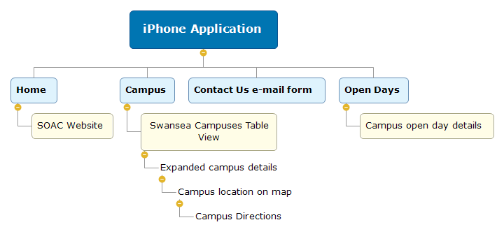
Fig 1. Application layout of the finished design.

Tab 1 – Home
The first tab is an introduction page (Figure 2) with. The button it links it to a website: www.uwtsd.ac.uk/computing.
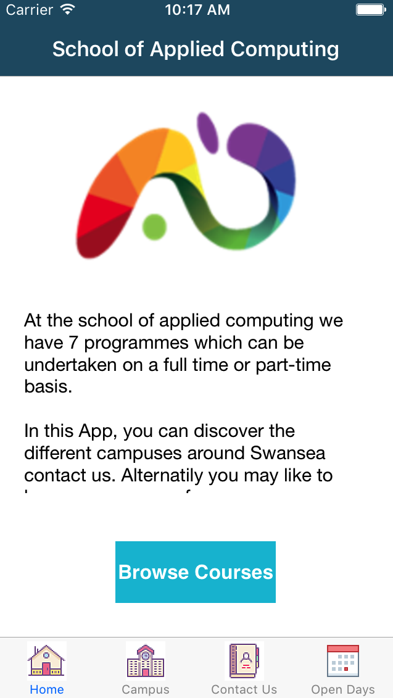
Fig 2. Application home-page in portrait orientation.

The image and text-view are set to occupy equal heights and widths, although as the image is aspect fit it scales itself as not to distort. All buttons throughout are set to keep the same size (equal heights and widths). However, perhaps it does seem somewhat large in landscape mode, but this may assist with application usability. The text field is scrollable, to retain readability.
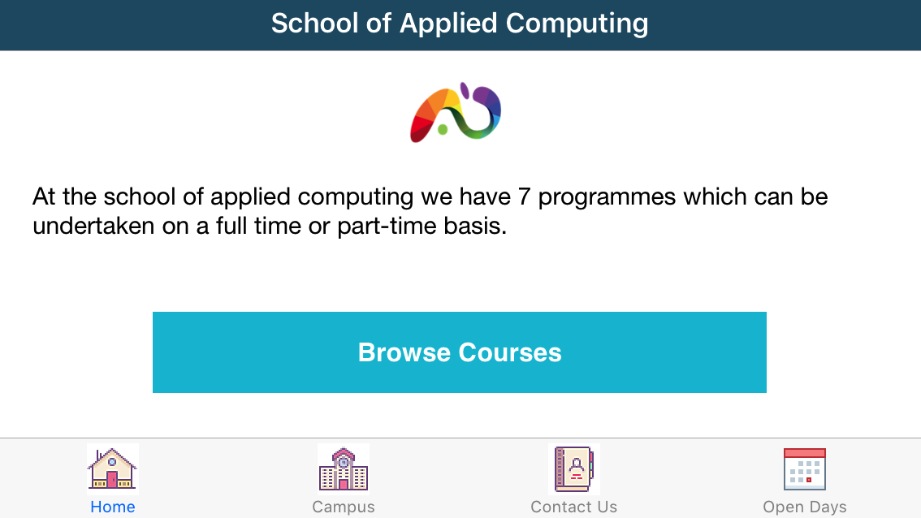
Figure 2.1. Application home-page landscape orientation.

A UI Web View (Figure 3) displays the webpage and there is a toolbar which houses additional buttons used for navigation (back, forward, stop and refresh). The UI Web is to ‘Scales to fit page’ it automatically adjusts to all screen sizes.

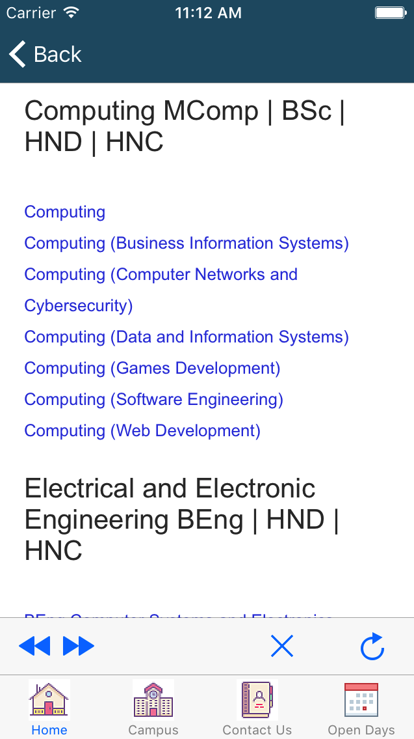
Fig 3. UWTSD Computing Website portrait mode.
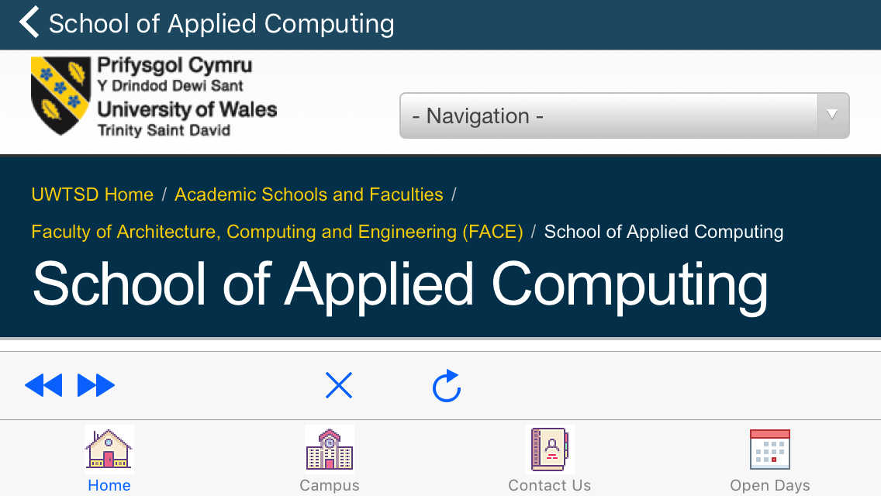
Figure 3.1 UWTSD Computing Website landscape mode.

Whenever a site loads a website indicator is displayed (figure 3), which is horizontally and vertically centred in the middle of the webpage.

Fig 4. Web page loading indicator.

Tab -2 Campus Details
All university campuses across Swansea are detailed in this tab. The first page provides information about the section figure 5.
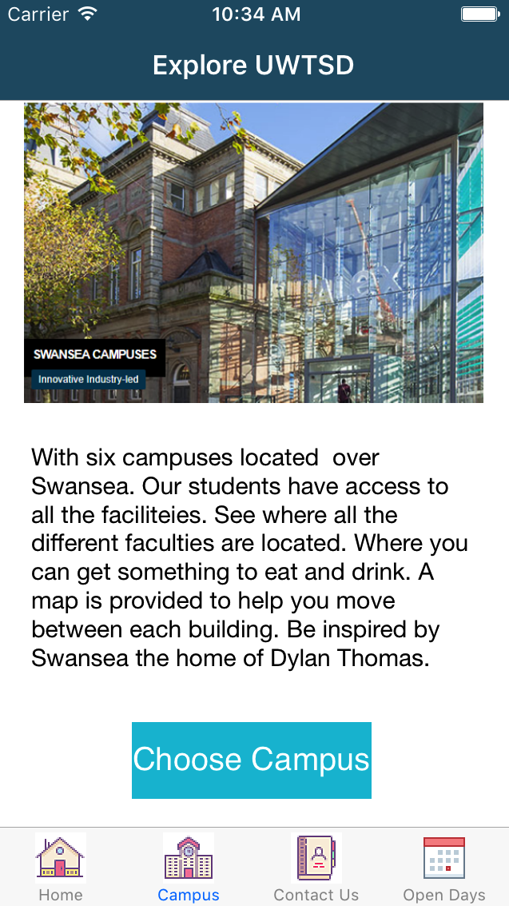
Fig 5. Campus homepage portrait mode.

Landscape mode is somewhat condensed using a scrollable text field. The same auto layout properties are used on the homepage.
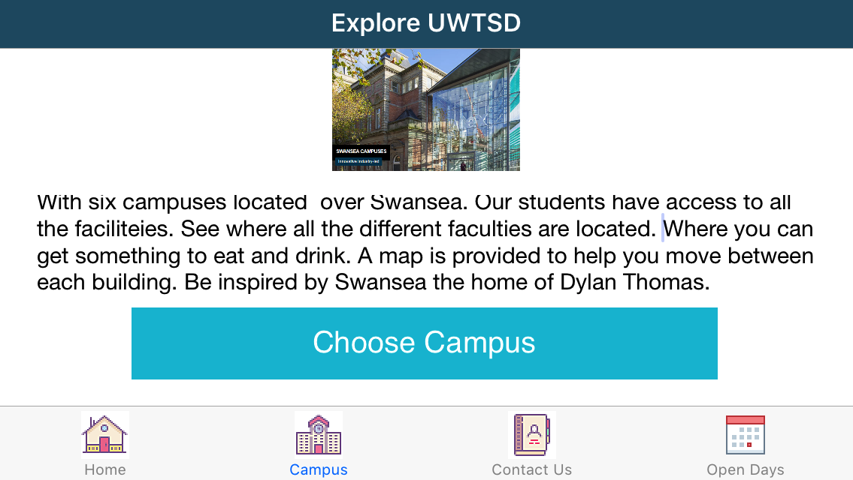
Figure 5.1. Campus homepage landscape mode

The user is presented with a Table view (Figure 6) with an image and information which includes the name, the faculty based there and the name of the library.
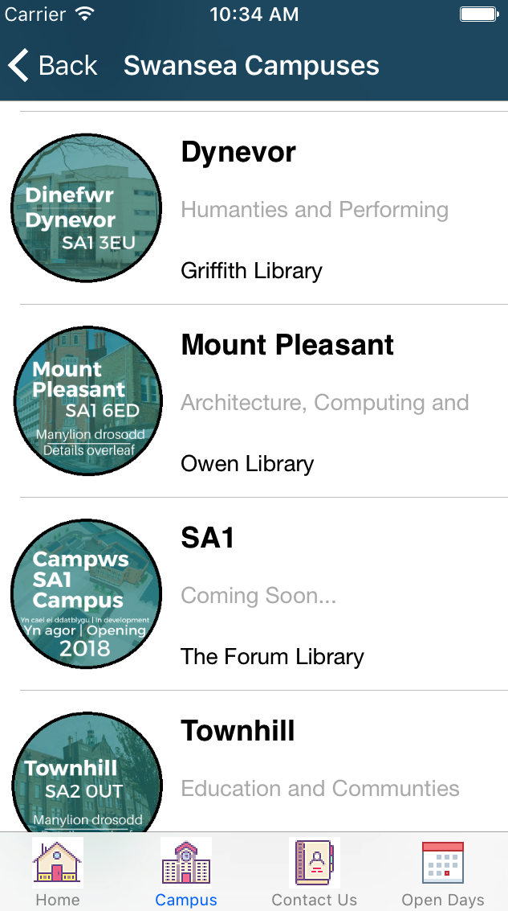
Fig 6. Table view of campuses portrait mode.
There are four arrays, for the campus names, campus images and the corresponding faculties and libraries each of which occupies the same matching array location. The array indexes are used to make the content on the three label and images outlets within the custom cell.
The image is a fixed size of 100 pixels by 100 pixels, the labels in the cells are set to be the equal width, whatever the screen size.
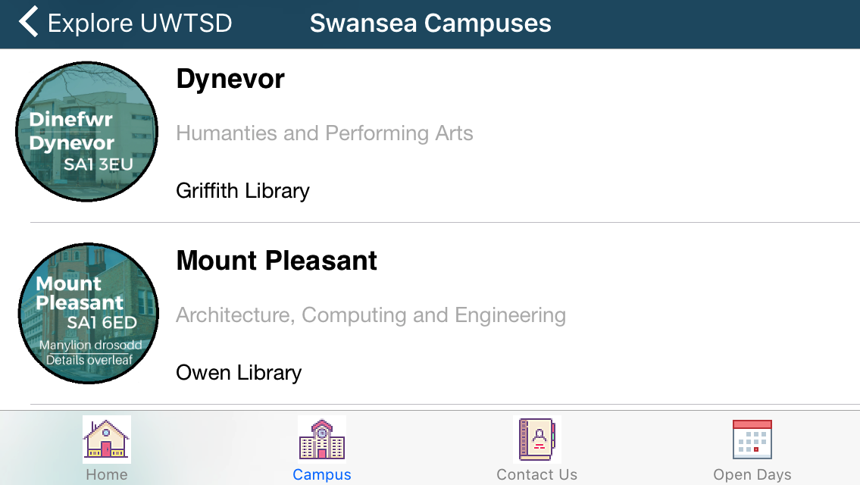
Fig 6.1 Table view of campuses landscape mode.
Upon clicking any cell, it takes the user to an additional view controller with a range of details about the specific campus the user clicked on (Figure 7). To decide which campus, it displays the previous segue stores it in a variable on push Segue. A switch statement holds the details of every campus to display the correct images and text.
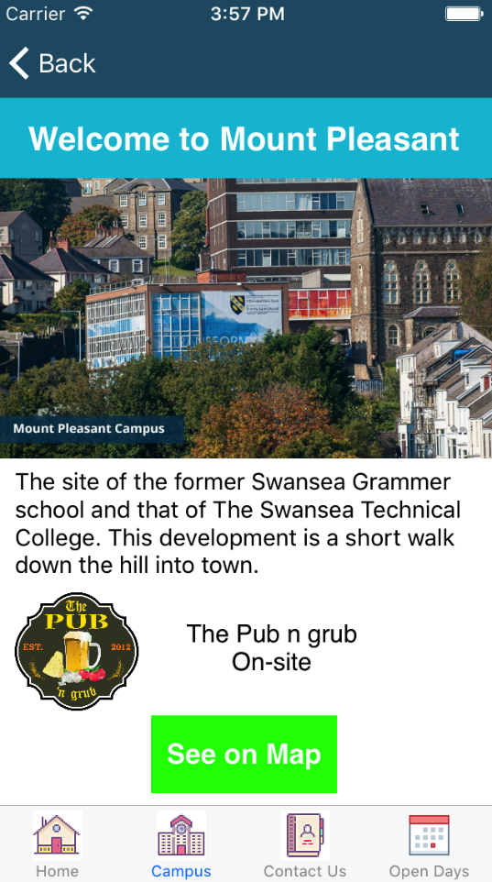
Fig 7. An expanded view of a specific campus.
With a final option to see the campus location on the map (Figure 8), the location of which is determined by a switch statement which holds the coordinates and the subtitle text. Firstly, the user sees the location of the campus they clicked on, in the map view with a pin, then they can receive directions by using the button.
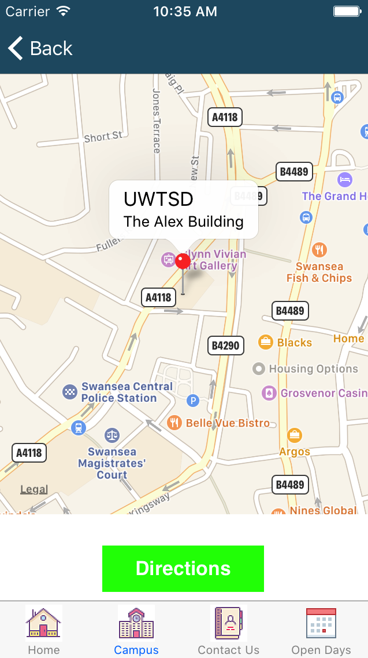
Fig 8. Campus map view portrait mode.
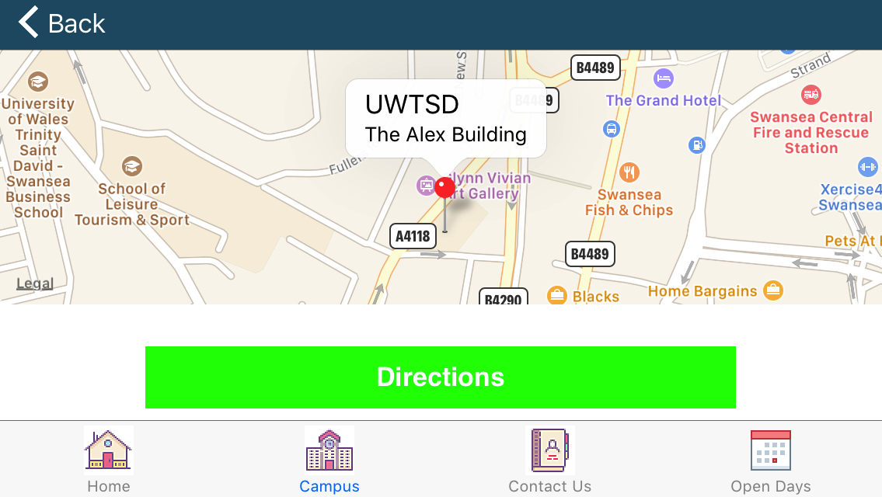
Fig 8.1. Campus map view landscape mode.

The UI Map View is pinned to each side of the view controller and set to scale to fill to automatically adjusts the content to the device.

Finally, the user can receive directions from their present location to this campus. With the simulator this is set to Swansea Castle. To do this, the coordinates are passed into the Apple Maps, which calculates and presents this to the user in the following view (Figure 9).
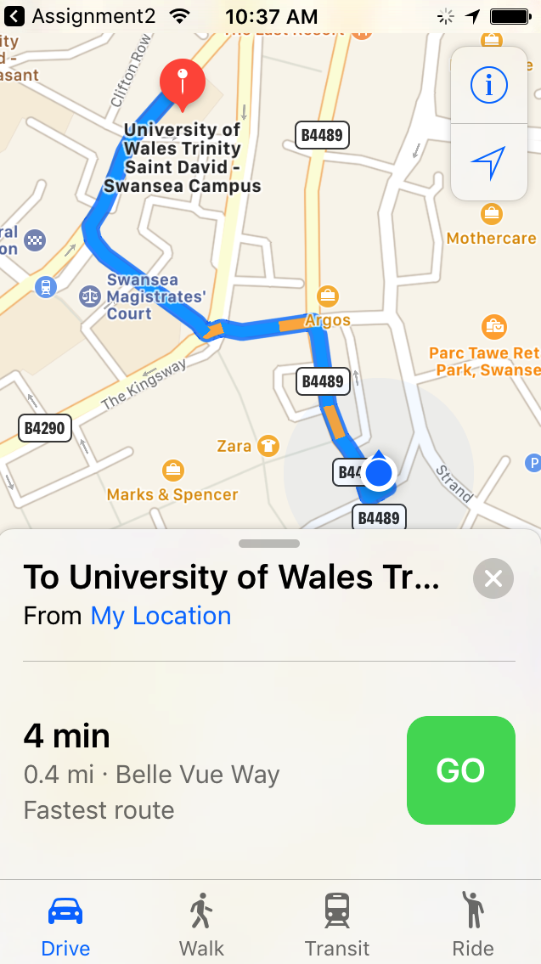
Fig 9. Calculating the route to the campus from the pre-set location
Switching between the modes of transportation is straightforward for the user as this is included with Apple Maps.

Contact Us
The form allows the user to send an email regarding one of the four-degree pathways selectable via a segmented control. When the user presses send, it will populate a new email message of their default email service provider. The format is determined in xCode with the segmented button controlling who the email is sent to.
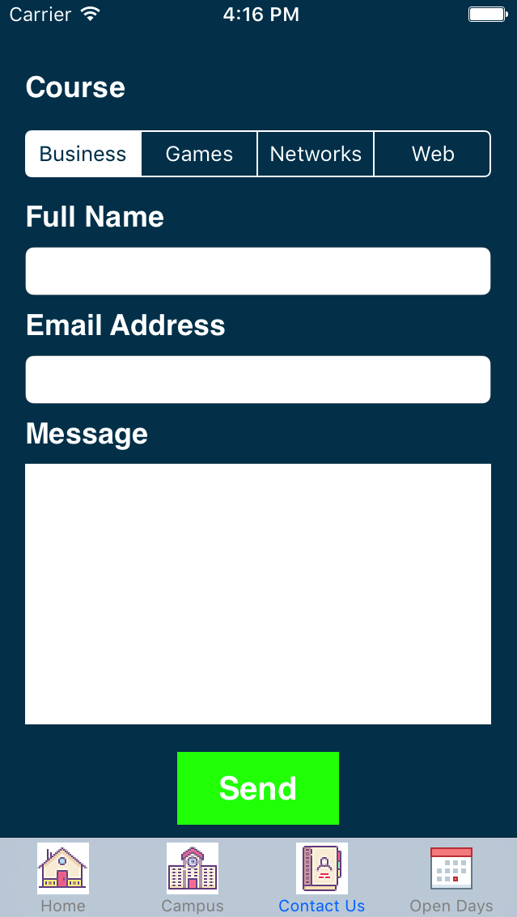
Fig 10. The contact form on the iPhone SE.
Unfortunately, setting auto-layout constraints that are acceptable in portrait and landscape mode proved challenging. Thus, an acceptable compromise was to set the text input fields to aspect ratio, which would expand these to occupy the entire screen.

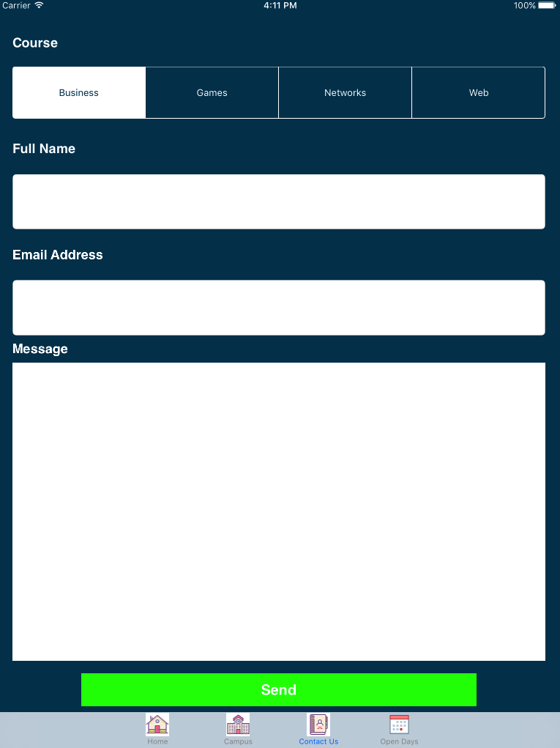
Fig 10.1. The contact form on the iPad.

Unfortunately, the iOS version on the iPad Mini used for testing can only run up-to version 9.35. Thus, no testing took place to check it opened the email application.

Open Days
This tab (Figure 11) has six buttons which will present users with details about open days at each campus. Every button on the view controller is tagged and upon clicking on it, it will be used differentiates which details the user will see using this identifier. These are saved to an integer variable in an object using a function call achieved by using ‘.tag’ to determine the exact sender.
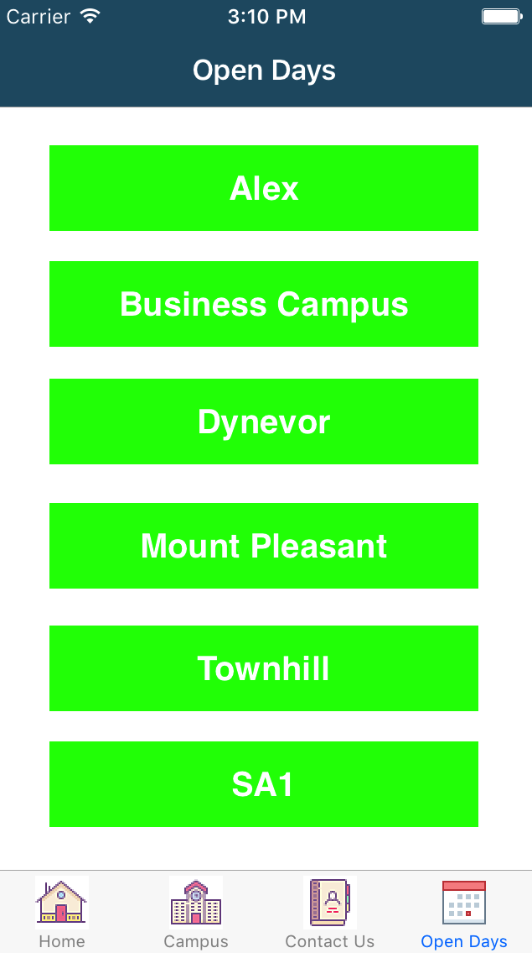
Fig 11. Open Days Tab Portrait Mode.
Auto layout is used on every button setting it to equal heights and widths to expand and shrink as necessary.
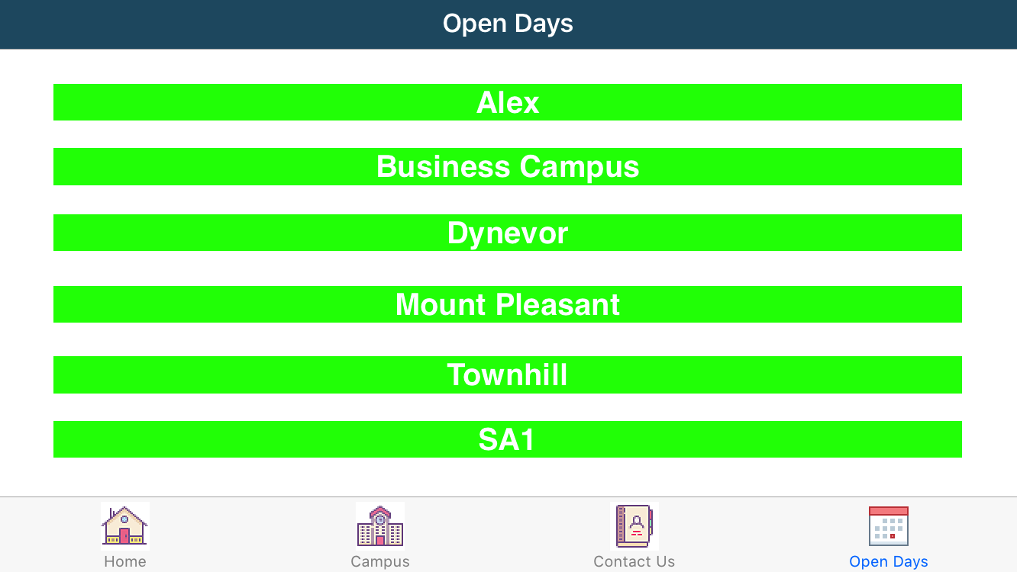
Fig 11.1 Open Days Tab Landscape Mode.

A MYSQL database holds details relevant to users such as the dates nearest parking facilities and charges. The device uses Wi-Fi to connect the server and access the PHP file it then displays the information on the view Controller via JSON. The main benefit is when records are updated in the database, it will action this in the application. It is set up to pull all the information from the database. Appending the data held in each column to associated arrays. Rather than display the word Yes or No as to whether the car park is pay and display. A conditional statement sets an additional variable to the Unicode for a tick or a cross symbol, which will be added to the label. Consequently, it uses the tag as the array index to display the details from the chosen campus on screen seen in Figure 12.
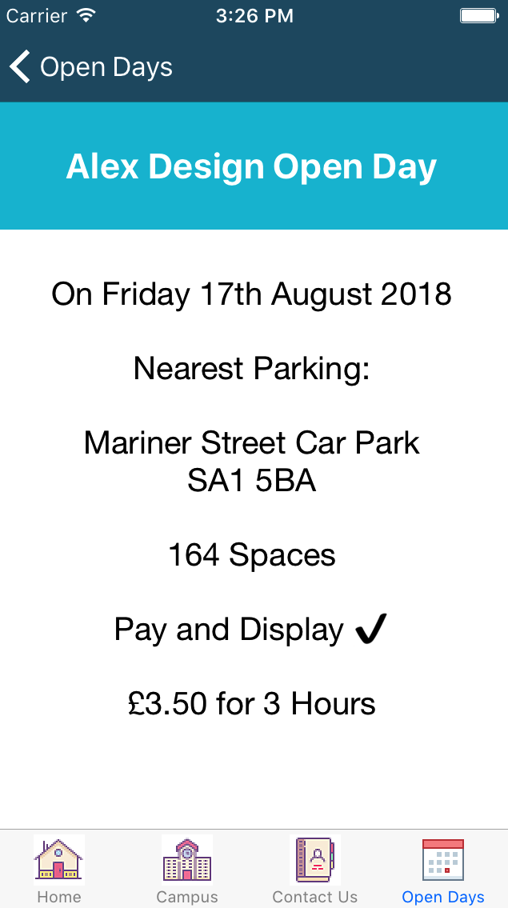
Fig 12. Campus Open Day Portrait Mode – (Tick Symbol)

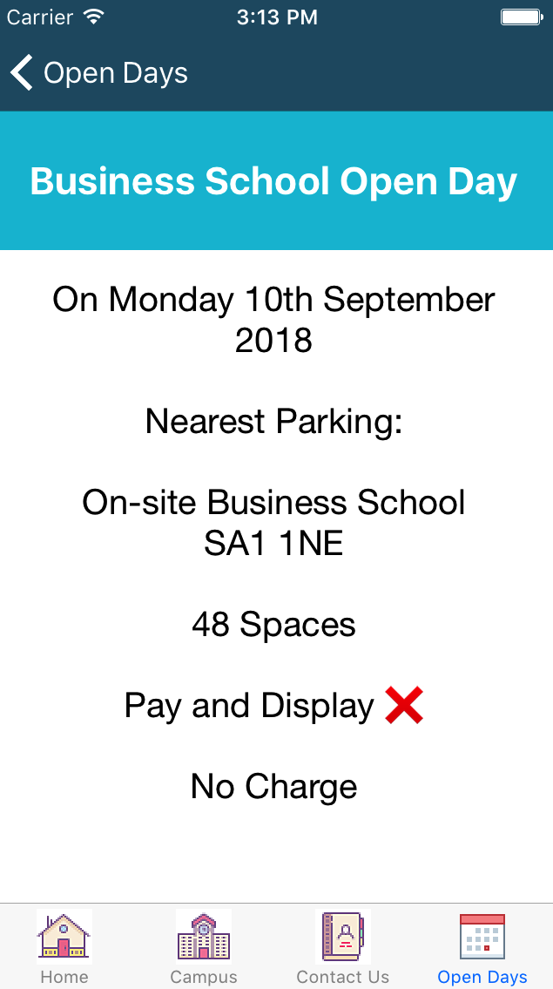
Fig 12.1 Campus Open Day Portrait Mode – (Cross Symbol)

Auto-layout uses a fixed height of 80 pixels on the title, in addition to which aspect ratio is used to fill the devices screen. However, in the code of the label line breaks are forced so at present it does miss out some of the information, although, changing this to a text field would allow users to scroll.
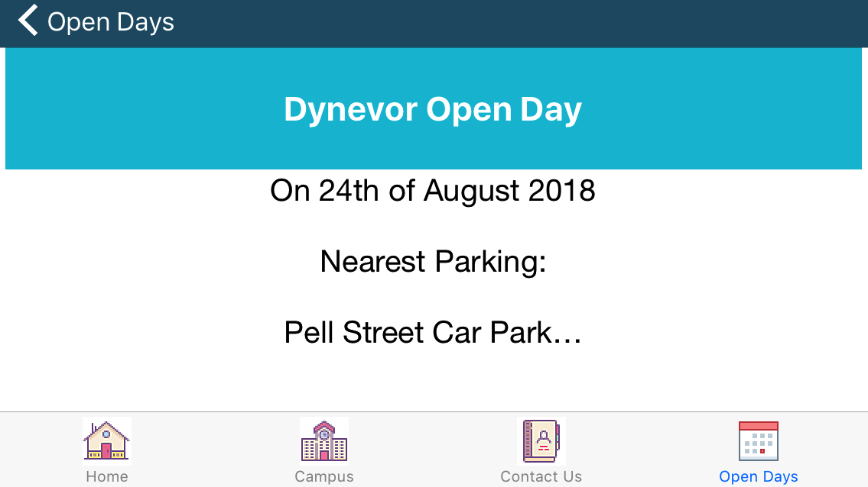
Fig 12.2 Campus Open Day Landscape Mode

Conclusion
The navigation throughout this application is one of the strong points, due to it employing the Tab Bar and Navigation Bar Controllers. Consequently, development work is reduced due to it providing the links between view controllers. A potential improvement could be to add further links to a certain section, for example, the homepage. It was noted that users will primarily use the application in portrait mode, it was also observed that due to the disparity in screen sizes on smaller screens some items can get too close together, or on the larger screens, too far apart. However, pinning items does ensure that they stay next to one another and equal height and/or widths will adjust items to fit. However, auto-layout skills can be developed over time with practice.
Making an application dynamic in this way provides many benefits. It makes updates relevantly straightforward and assists with maintenance. If developers have to alter or add code in the IDE, there is the potential to create errors at this time. However, it relies on an internet connection and hosting for database and associated files, which could stop the details of this section of application loading, or there could be issues around stability and security to address.
In summary, the application provides relevant information, to the target audience. It is dynamic in its operation, which is a positive attribute as the alternative would be to create view controllers for every campus. Thus, development and maintenance work would likely take longer and possibly be more confusing due to having many different view controller screens and swift files to manage. There are still sections that would need addressing to make sure users of all iOS devices have the same positive experience. Therefore, further work is required with the auto layout features and working through the range of different sized iPhones.

