University of Wales Trinity Saint David

16/17

Certificate of Higher Education in Skills for the Workplace:

Communication Skills - EMPL4004

Matilda Joan Trye

(1605824)

Lecturer Gregory Mcgregor

Part 1

A report on work place issue

My topic of discussion is based on the Policies,Practices,Culture to Support the Work and Family relationships and how effective it can be in the work Place.
Policies, Practices,Culture to support the work and Family relationships and how it can be in the work place.
These are put into practice to avoid discrimination at work place against the vulnerable who would not otherwise know but will suffer I silence until they can per chance find a job they can relate to regardless of pay.
Supporting work and family issues is also very crucial in our society where you have a high percentage of working parents of different background and culture. This family relationship in the work place helps families to take up jobs on part time bases and to work their hours around their families without being discriminated against. This helps families that work be part of another institution that is not family life but one that links both in these sense of supporting a business that pays to support the family unit.
Culture to support the work and family are vastly used in many firms that are beneficial to employees rather than their employers.
The issue of these Work/Life policies are programmed to have little connection to their HR policies. Therefore less attention is paid to the subject of ordinary culture issues. In these circumstances the management is therefore worried about the cost of labour, turnover,customer service,
quality of service and staff shortage. They are also worried about the differences of workers in different businesses?
And the various views from other businesses.
There are also issues that has effect on this policy such as work-group factors
The effects it has on the work place and the
employee behaviour is a major factor that has to be considered by all employers or businesses and organisations.
workplace relation has a huge effect on jobs
and it is also subject to changes.
Reasons that employers put into practice on paper these policies but do not always abide by it in the work place.
Every worker is considered according to their various skills and these policies and practice apply within.
Employees family life is incorporated in the work place, the benefits it brings to firms is always broadly considered according to the business and what it stands for and how much will they gain from these policies if it is put in place in their organisations. How well others do that have practiced similar policies and its effect on investment..
More work is implemented to meet dead lines and less time off.
Application of work methods that will work for both employers and employees is also put into practice.
Employees work better when their employers are understanding towards them.
Example of this is employees who rated work life benefits as useful were significantly more likely to make voluntary workplace improvement suggestions (Lambert, 2000).
Appreciating workers rights makes them feel valued.
Engagement at the state level with Government officials
Interactions at work between employers and employees.
Interacting with policy makers and work force groups such as unions, community and professional groups helps the work place to get more perspective of how to best put forward these policies linking it with the latest and also having an insight on how these policies have made changes in spite of its earlier doubts.
Strategies are put in place to stop these policies that affect human rights also changes are made that will blend in work and family and improve job productivity.
Research should be done on how to make best work situation for success. Employers should be approachable in bringing together workers and engaging them in researches. These researches will prove how best to put the policies forward and how to incorporate them with the company policy without ignoring them but making sure it works for them.
Workers should be involved in more than one subject for improvement. Employers should give them the opportunity to get involve in other issues that might be of help to them and that will bring good working relation within the business.
Bringing about methods such as internet and social media through which employees can communicate quicker and faster and effectively. This will help promote issues that will help in the learning process of those who would otherwise not be well informed and those who are informed to teach them how best to communicate in the right order.
Work Life Policy Business Case Exercise is an example of a case study that in learning students adopt policies making a business case in universities and are challenged in it.
Work-Life Strategy Game
Team working for students allows them to develop ways of coping in a working environment and equips them with the policies of dealing with working life and how to they can fit in with their plans to succeed at work.
Identify a work-family policy that could have an impact on business practices at your college/university
Identifying two articles on this policy as it was implemented at other workplaces and
make a business case for its implementation
Outlining the shape of the policy on
Who could be eligible and who can’t be,
Costs and implications and returns on investments.
Outline how you would go about creating the organisational change,or if a business case can not be made, your thoughts on how this issue should be addressed.
Beneficial outcome is to be considered questioning if the company needs their workers to be loyal to them and their products. Also are they choosing some over others and does that influence the outcome of how they construct their Policy. Other questions include, what kind of workers do these businesses need?
What do they do to access productivity? Are they putting time against amount and quality of product?
The types of information needed to make a business case
Which of these items are known in advance?
The policy of every group is put forward for discussion as a case reference.
The known policy is put forward and sold to the business.
This is then made possible and ready for all concerned.
Employers put into practice on paper these policies but do not always abide by it in the work place.
Every worker is considered according to their various skills and these policies and practice apply within.
Employers have to be flexible to keep their staff rather than loose important and loyal staff to other businesses and creating an unfriendly working environment. furthermore,
Applying diversity plays a very important role in the workplace. Diversity brings about different ideas to a business and has its advantages and disadvantages but the positive far outweighs the negative.
When this application is done it is often the case that good employers have more applications than those who do not apply such method.people look out for jobs that identifies to them much more than that which pays more but is bias to the requirement of these policies.
Employees work better under good caring and inclusive environment than rigid excluded ones.
Interactions at work between employers and employees makes a productive environment and also included is and of importance is
interacting with policy makers and work force groups such as unions, community, governmental and professional groups.these groups look out for the people in their policy and can help in preventing dispute or stopping misuse of power. These institutions also help these workers to know how to cope in various situations and how to work within their right in the company.
There is also of importance team working for students it gives them the upper hand and allows them to develop ways of coping in a working environment and equips them with the policies of dealing with working life and how they can fit in with their plans to succeed at work.
When it is taught in the learning environment it makes it so much easier when it is time to find a job to look for the right job in a business that caters to all the policies that will be required or that you are looking for.

Part 2

Power Points on work place issue

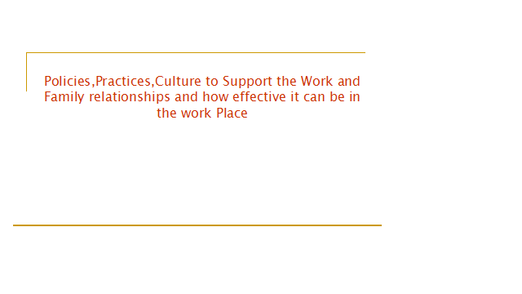
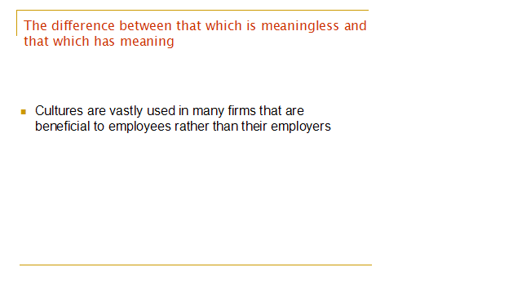

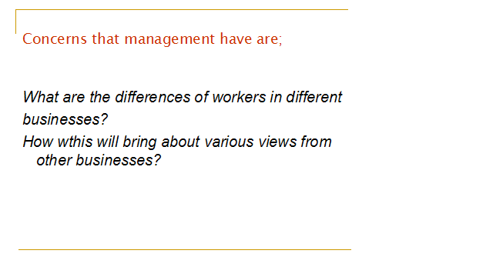
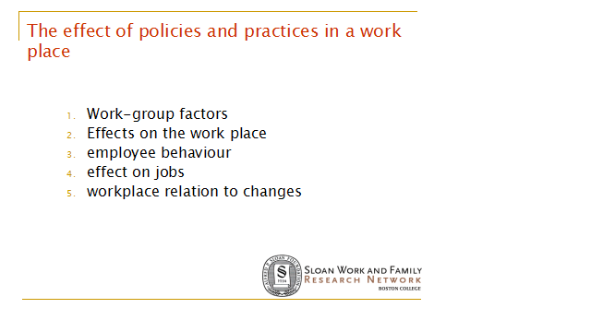
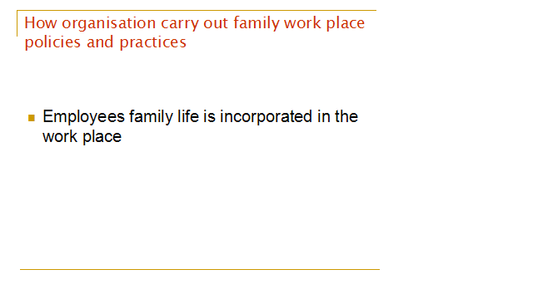
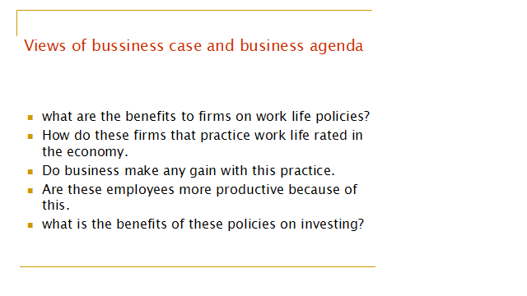

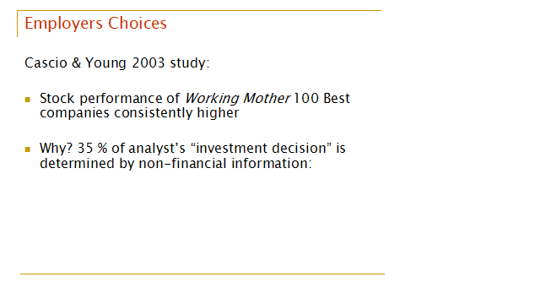
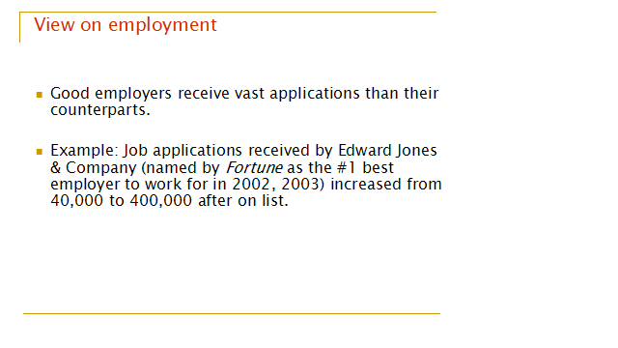
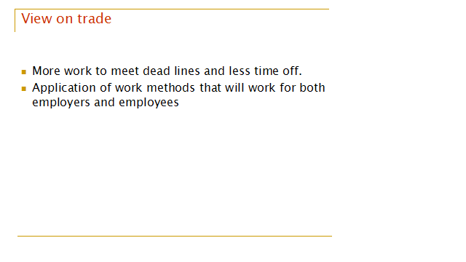
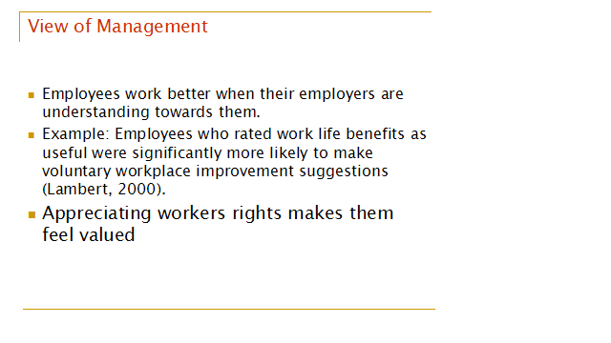

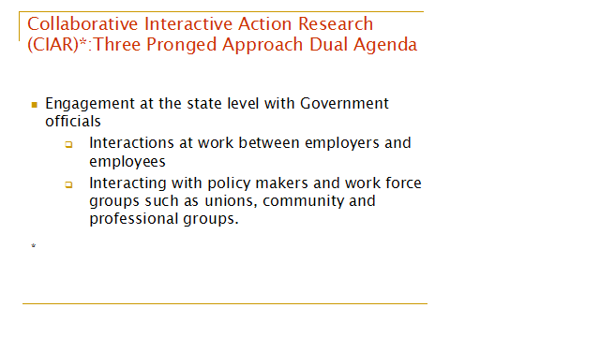
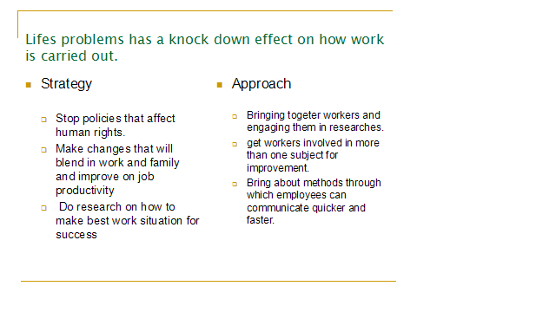
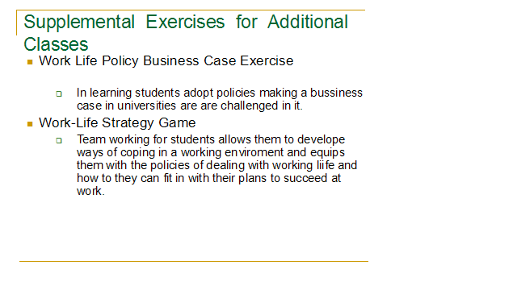
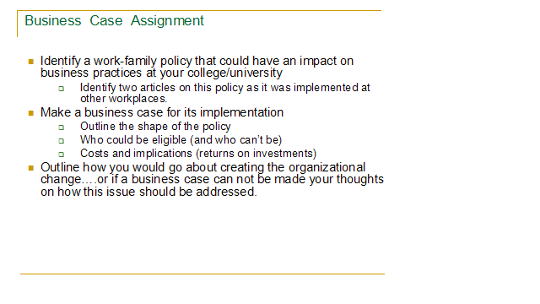
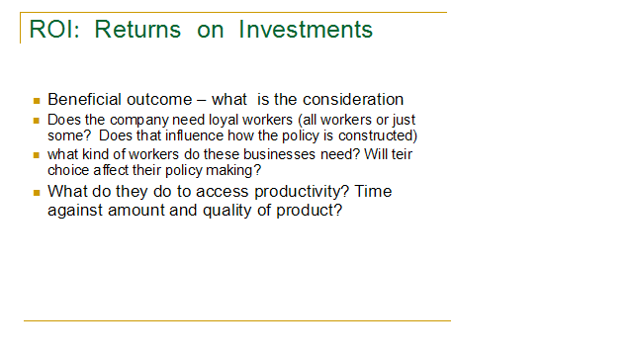

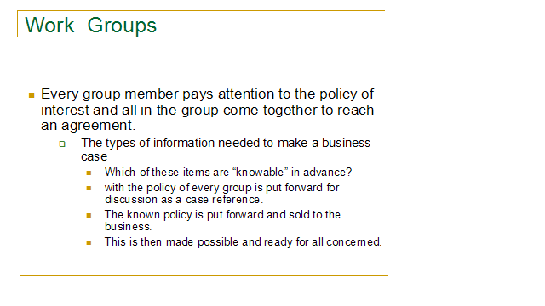

References

A Teaching Module Developed by
Ellen Ernst Kossek (Michigan State University),
Mary Secret (Virginia Commonwealth University),
Stephen Sweet (Ithaca College)
and the Curriculum Task Force of the
Sloan Work and Family Research Network

Bailyn, L., Bookman, A., Harrington, M. & Kochan, T. (2006). Work-family interventions and experiments: Workplaces, communities, and society. In M. Pitt-Catsouphes, E. E. Kossek, & S. Sweet (Eds.), The work and family handbook: Multi-disciplinary perspectives, methods and approaches (pp. 73-99). Mahwah, N.J.: Lawrence Erlbaum Associates, Publishers



https://www.free-powerpoint-templates-design.com/free-powerpoint-templates-design/accessed1August 31, 2018

