

Esports: A breath of fresh air in the 21st century or doomed to be overshadowed by more “traditional sports”?

Supervisor: Gareth Hughes

Project submitted as part of the requirements for the award of BA (Hons) Business Management

May 2022

Declaration of Originality

I, ............................................(FULL NAME)………………………………… declare that I am the sole author of this Project; that all references cited have been consulted; that I have conducted all work of which this is a record, and that the finished work lies within the prescribed word limits.

This work has not previously been accepted as part of any other degree submission.

Signed : .............................................

Date : ...............................................

FORM OF CONSENT

I ............................................(FULL NAME)………………………………… hereby consent that my Project, submitted in candidature for the B.A.(Hons) Business Management degree, if successful, may be made available for inter-library loan or photocopying (subject to the law of copyright), and that the title and abstract may be made available to outside organisations.

Signed : .............................................

Date : ...............................................

Copyright Acknowledgement

I acknowledge that the copyright of this project report, and any product developed as part of the project, belong to University of Wales Trinity Saint David, Swansea

Abstract

Acknowledgments

Contents
Chapter 1 – Introduction 7
1.1 Introduction 7
1.2 Background And Rationale 7
1.3 Aims And Objectives 7
1.3.1 Aims 7
1.3.2 Objectives 7
1,4 Research Structure 7
1.5 Conclusion 7
Chapter 2 – Literature Review 8
2.1.Introduction 8
2.1.2 Conceptual Framework 9
2.1.3 Surrounding Literature 10
Chapter 3 - Methodology 13
3.1.Selection Of Research Methods 13
3.2 Research Onion 13
3.2.1 Research Philosophy 14
3.2.2 Research Approaches 14
3.2.3 Research Strategies 15
3.2.4 Choice 15
3.2.5 Time Horizon 16
3.2.6. Data Collection Methods 16
3.2.6.1 Data Collection 16
3.2.6.2 Questionnaire Design + Why Each Question Was Chosen 16
3.2.6.3 Pilot Study 26
3.2.6.4 Analysis 26
3.3 Sample 27
3.4 Reliability and Validity 27
3.5 Limitations 27
3.6 Ethical Considerations 28
3.7 Conclusion 28
Chapter 4 – Data Analysis 29
Introduction 29
References 30

Chapter 1 – Introduction

1.1 Introduction

1.2 Background And Rationale

1.3 Aims And Objectives

1.3.1 Aims

1.3.2 Objectives

1,4 Research Structure

1.5 Conclusion

Not Completed Yet

Chapter 2 – Literature Review

2.1.Introduction
The main focus of this chapter is to analyse and evaluate the previously done literature available surrounding the main aims and objectives of this dissertation which is “To research what people think esports needs to accomplish to become recognised and accepted compared to more “traditional sports” also looking at what effects gambling and the COVID-19 Pandemic have on esports as a whole with a focus on football as the primary “traditional“ sport.

This chapter will look at the rise of esports as to where they are today as well as what goes into people’s mind when deciding on what sport to invest their time into looking into audience participation and the human relation theory. This chapter’s research will be conducted using a wide variety of up-to-date sources such as academic journals, web articles, official reported statistics as well as anything else that is found to be relevant to the topic at hand to help achieve and gain a more understand of the research already conducted surrounding the aims laid out in the previous chapter.

The literature review has been carried out using google scholar and the University of Wales Trinity Saint David’s library database with the intent on using the information found to assist the research found as a result of the primary research and will help identify the gaps that are present within the surrounding topics this will be concluded upon in Chapter 4. The main parameters that were used to find relevant literature on google scholar and using the UWTSD database was “esports”, “gambling within esports/sports,” “football” and “COVID 19 Pandemic effects on sports” intending on finding the most accurate literature toward my topic and the parallels between both.

This dissertation is intended to bridge the gap between “traditional sports” and esports as it shows no signs of stopping and could one day grow to be on the same level. This will also help researchers to understand what goes through someone’s mind when pursuing a career in esports over “traditional sports”.

2.1.2 Conceptual Framework
Regarding the aims and research question that is being tackled back in chapter 1 this section of chapter 2 is going to focus on what framework will be used when analysing the current situation esports is in the main theories that are going to be focused upon are Stuart Hall’s “Audience response theory” and Elton Mayo’s “Human Relation Theory” as it has been shown they are the most beneficial when analysis the audience’s impact on decision making also how the structures is formed as well as understand why people play the same game over and over for many years straight.

The audience response model suggests that an active audience engages, observes, and reacts to various types of media in various ways, as well as being capable of challenging the ideas expressed, as opposed to a passive observer, who is more willing to accept messages without questioning them, and thus is more likely to be directly affected by the messages. This concept may be traced all the way back to Stuart Hall's studies in the 1980s and 1990s, when he claimed that the media had the ability to affect people directly. He further argued that the audience might change the message to fit their existing social situation (Hall, S, 2001).

The human relation theory suggested that productivity and efficiency and motivation can be strengthened by strong social relationships in the workplace and recognition of the individual as a unique person, according to the human relation theory, which was initially advocated by Elton Mayo in the twentieth century. It claims that better working environment results in higher output with some aspects of the theory being traced back to as far as the 1920’s. This dissertation decided to focus on this theory because certain esports require immense teamwork and coordination and having bonds with the teammates has been proven to produce better results even under pressure. This theory also states that effective management is essential to producing better results (Mayo, E. 2003).

2.1.3 Surrounding Literature
Electronic sports or esports has been defined as “an area of sport or activities in which people train their mental or physical abilities in the use of information and communication technologies” (Wagner, M. 2007). Whilst a universal definition of esport has not been determined as the industry progressed and got bigger and bigger the bigger picture was seen and there was no doubt a connection between esports and traditional sports such as competitive leagues, live broadcasts and a global following (Funk, D. C., Pizzo, A. D., Baker, B. J., 2018) also it should be noted that esports can take place induvial or as part of a team with as many as 6 players involved including on the casual level at local tournaments.

The main viewers of esports have been found to be active gamers seeking to improve their gameplay skills and performance by watching others play and learning from their favourite players (Jang, W., Byon, K. K, 2020). With the ever-increasing popularity of streaming games to people using sites such as Twitch and YouTube enabling viewers to watch their favourite players outside of large-scale double elimination tournaments where its 2 loses and you’re out this allows them to interact with their fans whilst also showing them their gameplay explain the mechanics behind the situations they are in which is something sports players cannot do live only watching replays and analysing them.

Similar to how Sky Sports has the rights to every formula 1 race from 2019-2024 (Sky Sports ,2016). Esports has a similar distribution right as Twitch paid $90 million to purchase the rights to the overwatch league which is just one competition that takes places every year where teams compete against each other further pushing the idea that there are parallels between esports and traditional sports (Wolf, J. ,2018). The French government also officially recognises esports as a national sport and expressed heavy interest in potentially adding esports to the 2024 Olympics games which are due to be held in France. (BBC News ,2018).
Gambling is prevalent almost everywhere we go from the national lottery which is held every week in which around 70% of the UK's over 18s take part in which is close to 45 million people to being able to bet on nearing every sporting event (The National Lottery, 2022) and video games are no different just because they named differently they purpose is the same. Loot boxes are video game consumables that can be purchased with real money and offer players with a randomly selected reward of unknown value. Players have no means of knowing exactly what they'll get in exchange for their money when they pay it.
According to a review of the top 100 games from both the Google Play store And apple App stores, as well as the top 50 most-played games on Steam, loot boxes were discovered in 58.0 percent of the top Google Play games, 59.0 percent of the top iPhone games, and 36.0 % of the top Steam titles. For youngsters aged 12 and up, 93.1 % of Android games with loot boxes and 94.9 % of iPhone games with loot boxes were rated appropriate. Only 38.8 percent of desktop games with treasure boxes were made available to children, demonstrating that age ratings were slightly more cautious in determining whether loot boxes are available in games that children are allowed to play. (Zendle, D. et al, 2020).

Just like when esports moved to online as result of the Covid-19 Pandemic, Sports also had to stop for a while whilst people worked out a solution to bring them back to T.V. One example being a lot of sports leagues including rugby and footballs were paused and a lot of the athletes ceased heavy training whilst a solution was found (The Guardian, 2020). These events were later held in sports bubbles where players had to have negative covid test on the day of the match these took place without a live audience (Wetsman, N, 2020). Given the sport industry's significant position in society and its symbolic importance in relation to health, hope, and joy, the suspension of sporting events and limits on physical activity and live spectators has sparked heated debate. Simply said, people's participation in sports may have a significant impact on their well-being, which is especially vital amid a global crisis that much of the globe hasn't seen in a long time (Su, Y. et al, 2022).

When it comes to the gender of a person, In terms of women's roles in esports, research has indicated that they are with in minority, accounting for only 5% of all competitors at the top level (Hilbert, 2019) Moreover, studies have claimed that the fabrication of masculinity in esports, which is acquired from video games, does have real and significant bad repercussions for equality when it comes to women in high tiers of video games (Xue et al., 2019), putting them in a vulnerable situation in which they frequently face general and sexual discrimination from other players (Ruvalcaba et al., 2018). Despite this, women's participation in esports has surged in recent years. (Cullen, 2018). All of these unfavourable attitudes against women make them feel dissatisfied, as they perceive the esports sector to be run by and heavily for males (Rogstad, 2021). As a result, it becomes reasonable to draw a differentiation between men and women while investigating brand-related factors in order to see if gender inequalities exist in esports.

Chapter 3 - Methodology
This study is based upon the experience of the public and what people think esports needs to accomplish to become recognised and accepted compared to more “traditional sports” also looks at what effects gambling and the COVID-19 pandemic have on esports as a whole with a focus on football as the traditional sport. Primary information will be collected via online questionnaires which will be sent out and responded to by people around the world as the chosen topic at hand isn’t based in a singular area but worldwide. The rest of the information will be collected from online sources such as databases and news articles as collecting information solely based in Swansea wouldn’t provide a large enough audience to reliably draw any conclusions and make repeating it for different people rather difficult.

3.1.Selection Of Research Methods
When deciding on what method was best suited to conduct the study, various methods were considered with comparisons based on these positives and negatives and eventually decided on questionnaires as the main form of primary research due to the nature of the study and it is worldwide not based in a singular city questionnaire allowed the study to be conducted worldwide enabling participants from around the world with little to no issues other than language barriers (Johnson, B. and Christensen, L., 2000). Most information gathered can be split into 2 diverse types: “Quantitative” and “Qualitative”. Quantitative data is non-numerical information such as interviews, diaries, replies to open-ended questions, sound files, and pictures are just some examples of qualitative data (Taylor, G.R. ed., 2005). Qualitative data on the other hand is the process of gathering, analysing, and understanding non-numerical data, such as speech, which is known as qualitative research. Qualitative research may be used to learn how a person personally experiences and interprets their social environment (Gelo, O., Braakmann, D. and Benetka, G., 2008).

3.2 Research Onion
The research onion framework (see below) was created by Saunders (Saunders, M., Lewis, P., & Thornhill, A, 2007). Which outlines the several components of the research that is taking place that must be considered and addressed to arrive at a decent research methodology (Melnikovas, A., 2018).
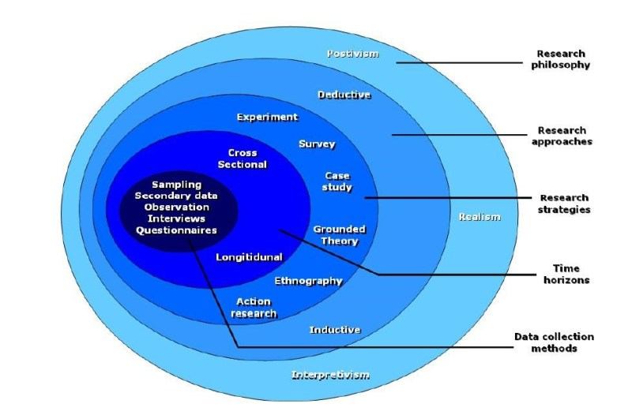

3.2.1 Research Philosophy
As described by Geoff Walsham in 1995 (Walsham, G., 1995). Interpretivism is the effect of social and cultural elements on an individual. This point of view focuses on people's thoughts and ideas in light of their social and economic context. The interpretive research theory requires the researcher to take a more active position in the investigation to get a comprehensive understanding of the participants and their behaviours, ideas, and intentions. This study falls under Interpretivism since it is based on gathering people’s answers from a questionnaire and using them to draw a conclusion based on what is found.

3.2.2 Research Approaches
This study will be using an inductive approach as according to David Thomas (Thomas, D.R., 2006). An inductive research approach is used when there is extraordinarily little information on a topic, therefore, meaning any information gathered can be transformed into theories based on what has been found as a result of the study. Another reason inductive will be used is that since Esports are still a new topic there are only limited amounts of information out there and a lot of that information is related to the video games themselves rather than the tournaments they are a part of. The answers given by the public will be analysed and a result will be determined based on the finding. Also as there is the theories will be based on the finding there will be no hypothesis during the initial stages as due to the nature of the research any deductions will need to wait until the end of the study.

3.2.3 Research Strategies
There are a lot of different methods and techniques that can be used when gathering data and all of them have their advantages and disadvantages such as interviews allow you to build up a rapport with your participants and allows more clarity on certain answers they give ensuring you receive the correct answers for what you asked them. Questionnaires on the other hand allow you to reach a wider audience enabling a lot more participants in your study but you can’t discuss any issues that arise within questions due to participants realistically being from anywhere (Granello, D.H. and Wheaton, J.E., 2004).
When conducing this study surveys and questionnaire were decided on as the best option of data collection as esports is a very worldwide based topic and having participants from round the world would make the research more dependable and valid instead of just a single area in one country. The questionnaire was created via google forms and disturbed via social media platforms such as WhatsApp, Facebook, Discord and Reddit. The questionnaires remained confidential and anonymous which enabled participants to not feel restricted by any of the answers that they provided and also allowed anyone with access to an electronic device the ability to participate in the study making the results more consistent and iron out any inconsistencies (De Leeuw, D., 2005).

3.2.4 Choice
The main approach to this study will be a mono method questionnaire and survey-based study. (Bell, J. and Waters, S., 2018) Says in their first-time guide for researchers that you should use a variety of different collection method if possible to obtain the best results as the country is still coming out of the COVID-19 pandemic and a lot of people are still wary off the virus the researcher decided that it would be best to conduct online questionnaire where there wasn’t any contact between people that could put anyone at risk. Due to the previous statement about the restrictions of the research the researcher decided on only using qualitive based data as the questionnaire that was sent out and the type of topic that was being researched lead to a lot of open-ended questions and people giving them opinions on topics and then making conclusions based upon the information given (Punch, K.F., 2013). By only using qualitive data although the research is restricting themselves by only using one type of data this allows the data to be analysed in more depth resulting in more consistent conclusion, more reliable data and more precisely related to the topic. Since there is only one data set there was limitations as you can’t verify the results being given against the participants. Another issue was that qualitive research requires a lot of thought into each question as a lot of it is based upon opinion and judgement numbers and results this also makes them quite hard to replicate (Silverman, D., 2015).

3.2.5 Time Horizon
As the period for this study is around 6 months the researcher best decided that the most useful time horizon would be cross section where a certain section in time gets analysed. According to (Munn, P. and Drever, E., 1990) Questionnaires are best used when doing research over a brief period of time which means as the study is taking place over 6 months cross sectional would be the correct time horizon.

3.2.6. Data Collection Methods

3.2.6.1 Data Collection
This study will be primary research based which means collecting data based on a pre-set question which was decided prior to the study (Rowley, J., 2014). The primary research in this study will be obtained via questionnaire and will be distributed to the general public. (Ghauri, P., Grønhaug, K. and Strange, R., 2020) states that the disadvantages of questionnaires are the fact they are time consuming and having access to the necessary resources. This research has direct access to the general public and has enough time for a cross sectional-based study.

3.2.6.2 Questionnaire Design + Why Each Question Was Chosen
A lot of consideration is needed when designing a questionairre such as how many of each type of questions are needed and what types of questions they are going to be. E.g., Closed, Open, Rating. This questionairre used closed questions with a few opened ended questions intended of giving recipients a chance to comment using their own opinion (Siniscalco, M.T. and Auriat, N., 2005). The researcher decided on using the question types as they provide the best answers in response to the question asked and allow the researcher to analyse the results. The researcher kept the closed questions to only “Yes” or “No” options as having the 3rd option of maybe would make the research not analysable due to it becoming a median (Krosnick, J.A., 2018).

Also consideration was given to questions which may make the participants uncomfortable such which is why all the question were pretested with 5 participants varying in age and gender to ensure all question would be appropriate for anyone no matter the age (Taherdoost, H., 2016).

Questionnaire
Introduction
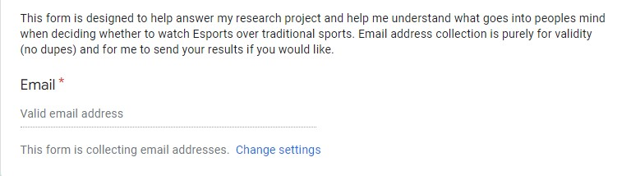
This was presented to the participants to inform them of the why the study is taking place and what the objective of the study is and also explains why the email is needed.
Question 1
This question informs the participant that all data collected from this questionnaire is confidential and anonymous and also informs that they will be happy for the data collected to be used as part of the researcher’s dissertation project.
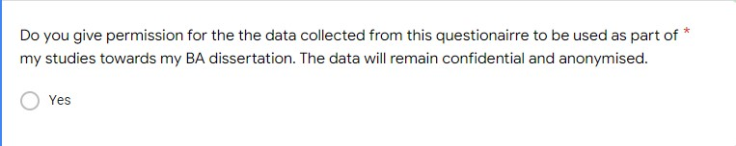

Question 2
This question is used to determine the age range of all participants and also helps with analysing the data as previously stated the main age range of Esports watchers is between the ages of 18-25. The other age brackets were determined on where the people would most likely be at in life with the middle bracket being the largest due to it being the most prominent bracket for people with families.
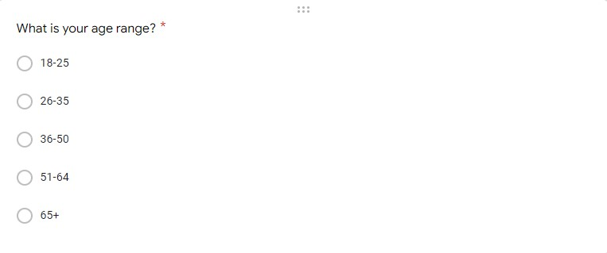
Question 3
This question is used to determine the gender of the participants and helps with the analysis sections as previously stated Esports is a heavily male dominated environment and knowing the gender of the participants allows the researcher to see what each genders answer were in relation to the topic.
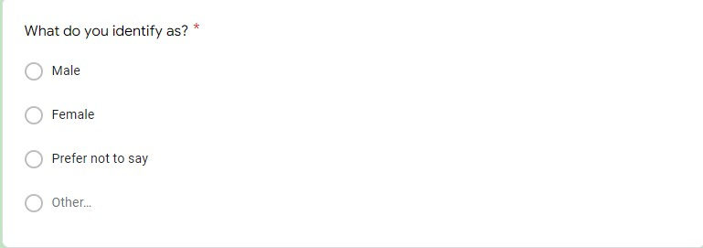

Question 4
This question is used to determine whether or not each participant has ever watched any Esports as since the primary aim is to do with gaging what people think Esports needs to do to become more like traditional sports having one of the 1st questions be about esports helps the researcher establish who actually has prior knowledge of Esports. 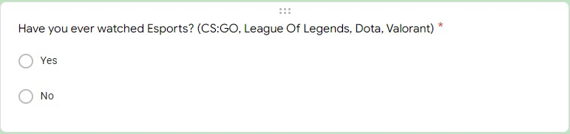
Question 5
This question is used to determine whether or not each participant has ever watched any traditional sports as since the primary aim is to do with understanding what goes through people’s minds when they decide whether or not to watch sports. This helps the researcher establish who actually has prior knowledge of traditional sports. 
Question 6
This question is used to determine how much traditional sports each participant watches and helps the researcher understand how heavy of a fan is the participant.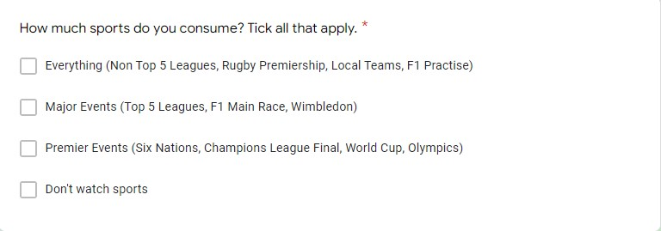

Question 7
Similar to the previous question this is used to determine how much Esports each participant watches and helps the researcher understand how heavy of a fan is the participant.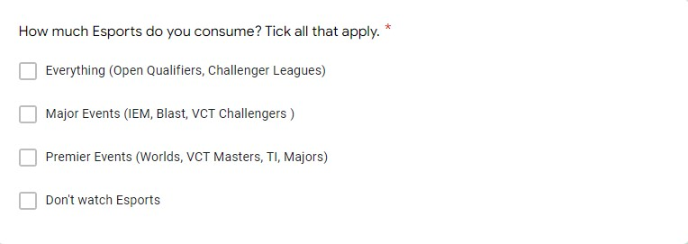
Question 8
This question is used to determine how if the participant has gambled if at all as the 2nd aim of the research project is determining how big of a presence and effect gambling has on Esports and traditional sports. 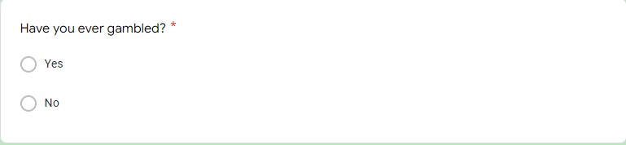

Question 9
This question is used to determine why each participant gambles if at all and as previously found out 75% of the UK’s over 18’s gamble this question helps the researcher gain and understanding of the different reason behind why people gamble.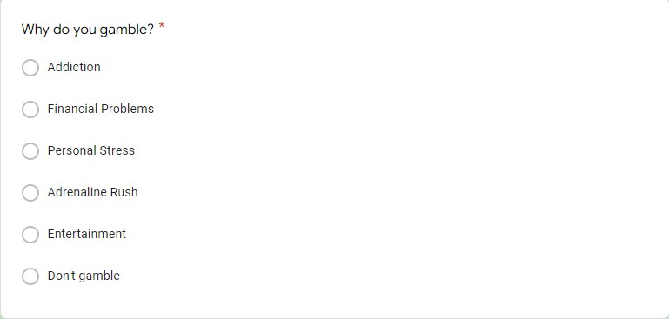
Question 10
This question helps the researcher with the 2nd aim of the study relating to gambling and helps the researcher understand different people’s perspectives on whether or not they think the gambling presence has an effect on the viewer. 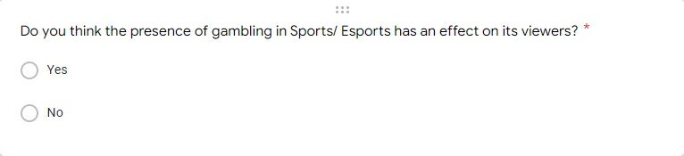

Question 11
This question helps the researcher with the 2nd aim of the study relating to gambling and helps the researcher understand how often different people gamble and is usefully during the analysis section when compared to whether or not they think gambling has an effect on the viewer. 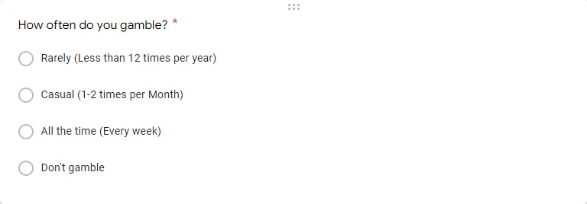
Question 12
This question helps the researcher with the 3rd aim of the study relating to the COVID-19 pandemic and helps the researcher understand different people’s perspectives on whether or not having no fans in stadiums and events effected the outcome of the match. 

Question 13
This question is used to determine whether or not anyone has been harassed online as a result of their Gender, Race or Sexuality. This question is used to answer the 2nd half of the 1st research aim which is to determine whether a lack of representation in their chosen sport/ esport in a heavily male dominated environment affects their decision to pursue a career in the Sport/ Esport.
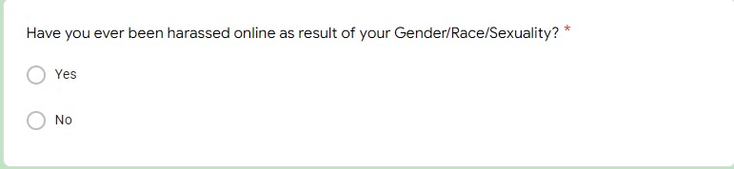

Question 14
This question is used to determine what the participants reasons are for not choosing to watch sports if they have chosen not to. This question is used to answer the main research aim which is to research what people think esports needs to accomplish to become recognised and accepted compared to more “traditional sports”.

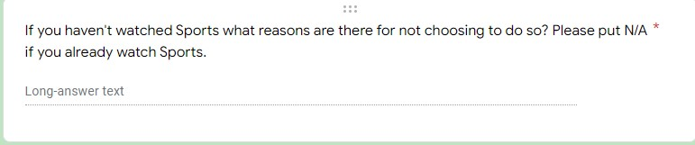

Question 15
Similar to the previous question this question is used to determine what the participants reasons are for not choosing to watch Esports if they have chosen not to. Just like the last question this question is used to answer the main research aim which is to research what people think esports needs to accomplish to become recognised and accepted compared to more “traditional sports”.
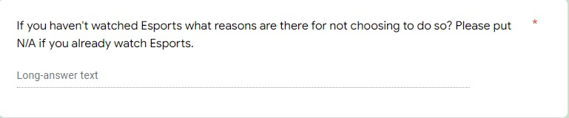

Question 16
This question is used to determine whether or not lack of representation in Sports/ Esports discourages people from pursuing a career in the sport. This question is used to answer the 2nd half of the 1st research aim which is to determine whether a lack of representation in their chosen sport/ esport in a heavily male dominated environment affects their decision to pursue a career in the Sport/ Esport.
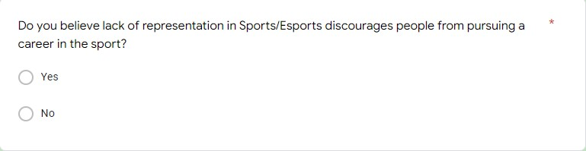

Question 17
The last question is an open-ended question giving the participant the chance to voice their own opinion as to what they believe Esports needs to accomplish to be viewed on the same level as traditional sports. This answers the main research aims of the study which is to research what people think esports needs to accomplish to become recognised and accepted compared to more “traditional sports”.
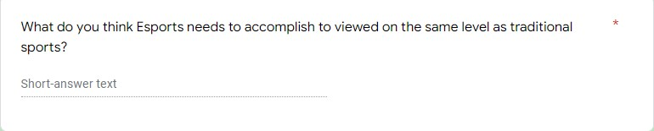

3.2.6.3 Pilot Study
The pilot study was a preliminary test of the questionnaire designed to influence the real questionnaire by highlighting any issues and changing the wording of any questions that the testers found to be hard to understand (In, J., 2017). The pilot study also shows the researcher the feasibility and the rough amount of time it would take someone to complete the questionnaire. The pilot study was conducted by 5 willing participants and a number of minor changes were made to the fluidity of the question and also to some of the answers

3.2.6.4 Analysis
The data will be analysed in section 4 using the “Human Relation theory” as well as the “audience response theory” to identify findings and complete the research aims as well as the study.

3.3 Sample
To have the entire world answer the questionnaire would be completely unreasonable and also very unrealistic. Therefore a smaller sample would be used to represent the larger population and also increase the reliability and validity of the study findings. The target population of this research is going to be the general public with a slight focus on gamers but also a large focus on the general publics. The sample population required was 100 participants in order for the research to be considered valid and reliable. (Wright, K.B., 2005) Says that the number of participants all determines on how much of a margin of error you are willing to have and for a city of 500 if you allow a 10% margin of error you realistically only need 80 people.

The participants for this study were recruited via social media. This was due to a lack of budget and the ability for social media to send the questionnaire across the world and enable the researcher to have a large study.

3.4 Reliability and Validity
Reliability is when the data that is collected is accurate. Reliability and validity are essential in research as without these the data is useless s the same person could’ve answered the questionairre 100 times but just clicked different answers therefore forging the results (Reliability & validity, 2018).

To make the questionnaire reliable and valid the questionnaire required the entering of the participants email to ensure that only 1 person was entering the questionnaire from one device (Meyer, J.P., 2010).

3.5 Limitations
The limitations of the questionnaire were the inability to control who answered the questionnaire therefore potentially leading to one sided answer if a lot of older people answered leading to an imbalance of gender and age. Another limitation of the research was the inability to determine whether the answers given by the participants are truthful especially in some of the deeper question such as the ones about gambling habits (Ochieng, P.A., 2009).

3.6 Ethical Considerations
Ethical considerations refer to the moral aspect of the research meaning is your research conducted with moral aspects taking into consideration. (Sales, B.D. and Folkman, S.E., 2000) says the importance of ethics in research with human participants is to acknowledge social responsibility and also only ask the necessary questions to obtain the information for you research aims.

This research questionairre was conducted in line with the ethical standards of The University Of Wales Trinity Saint David with prior approval from the research supervisor along with an ethics form completed prior to the start of the research study. Ethical considerations were met through the participants being anonymous, the research only being used for what was stated on the questionairre and the security of the data that was sent. The questionnaires were voluntary meaning no one was forced to complete it and all participants were over the age of 18. The data was collected and stored on the researcher’s password protected device to eliminated misuse. The ethics form was completed prior to the questionnaire and the researcher and supervisor saw no potential harm to anyone that was going to participate (Gregory, I., 2003)

3.7 Conclusion
This section successfully completes the research aspect of the main study which was “To research what people think esports needs to accomplish to become recognised and accepted compared to more “traditional sports” also looking at what effects gambling and the COVID-19 pandemic have on esports as a whole with a focus on football as the traditional sport”. This chapter successfully completed the research aspect by identifying a suitable research method in the form of a questionnaire as well as justifying every aspect of the research should anyone need to question any of it. The following chapter will analyse and discuss the data collected in this chapter.

Chapter 4 – Data Analysis

Introduction
Not completed yet

References
BBC News . (2018). Paris 2024 Olympics: Esports “in talks” to be included as demonstration sport. https://www.bbc.com/sport/olympics/43893891
Bell, J. and Waters, S., 2018. Ebook: doing your research project: a guide for first-time researchers. Mcgraw-hill education (uk).
Bruce, K. and Nyland, C. (2011) ‘Elton Mayo and the Deification of Human Relations’, Organization studies, 32(3), pp. 383–405. doi:10.1177/0170840610397478.
Bryman, A., 2006. Integrating quantitative and qualitative research: how is it done?. Qualitative research, 6(1), pp.97-113.
Core concepts in research. Reliability & validity (2018). Leicester, England: Shortcuts TV.
Cranmer, E.E. et al. (2021) ‘Esports matrix: Structuring the esports research agenda’, Computers in human behaviour, 117. doi:10.1016/j.chb.2020.106671.
Cullen, A. L. L. (2018). "I play to win!": Geguri as a (post)feminist icon in esports. In Feminist Media Studies (Vol. 18, Issue 5, pp. 948-952). Routledge. https://doi.org/10.1080/14680777.2018.1498112
De Leeuw, D., 2005. To mix or not to mix data collection modes in surveys. Journal of official statistics, 21(2), p.233.
Funk, D. C., Pizzo, A. D., Baker, B. J. (2018). Esports management: Embracing esport education and research opportunities. Sport Management Review, 21, 7–13.
Gelo, O., Braakmann, D. and Benetka, G., 2008. Quantitative and qualitative research: Beyond the debate. Integrative Psychological and behavioural science, 42(3), pp.266-290.
Ghauri, P., Grønhaug, K. and Strange, R., 2020. Research methods in business studies. Cambridge University Press.
Granello, D.H. and Wheaton, J.E., 2004. Online data collection: Strategies for research. Journal of Counseling & Development, 82(4), pp.387-393.
Gregory, I., 2003. Ethics in research. A&C Black.
Hall, S., 2001. Encoding/decoding. Media and cultural studies: Keyworks, 2, pp.163-173.
Hilbert, J. (2019). Gaming & gender: how inclusive are eSports? The Sports Integrity Initiative. https://www.sportsintegrityinitiative.com/gaming-gender-how-inclusive-are-esports/
In, J., 2017. Introduction of a pilot study. Korean journal of anesthesiology, 70(6), p.601.
J S C Amor, M Alguacil and A M Gómez-Tafalla (2022) ‘Gender influence on brand recommendation at an esports event’, Journal of Physical Education and Sport, 22(1), pp. 231–238. doi:10.7752/jpes.2022.01030.
Jang, W., Byon, K. K. (2020). Antecedents of esports gameplay intention: Genre as a moderator. Computers in Human Behaviour, 109, 106336.
Jiménez-Murcia, S. et al. (2014) ‘Video Game Addiction in Gambling Disorder: Clinical, Psychopathological, and Personality Correlates’, BioMed research international, 2014, pp. 315062–11. doi:10.1155/2014/315062.
Jin, D.Y. (2021) Global esports : transformation of cultural perceptions of competitive gaming. Edited by D.Y. Jin. New York: Bloomsbury Academic. doi:10.5040/9781501368745.
Johnson, B. and Christensen, L., 2000. Educational research: Quantitative and qualitative approaches. Allyn & Bacon.
Krosnick, J.A., 2018. Questionnaire design. In The Palgrave handbook of survey research (pp. 439-455). Palgrave Macmillan, Cham.
Laurent Michaud (2020) ESPORTS, Digiworld Yearbook. Montpellier: Institute de l’Audiovisuel et de Telecommunications en Europe (IDATE), pp. 62–63.
Mayo, E. (2003) The human problems of an industrial civilization. London: Routledge. doi:10.4324/9780203487273.
Melnikov, A., 2018. Towards an explicit research methodology: Adapting research onion model for futures studies. Journal of Futures Studies, 23(2), pp.29-44.
Meyer, J.P. (2010) Reliability. New York ;: Oxford University Press.
Munn, P. and Drever, E., 1990. Using Questionnaires in Small-Scale Research. A Teachers' Guide. Scottish Council for Research in Education, 15 St. John Street, Edinburgh, EH8 8JR, Scotland, United Kingdom.
Ochieng, P.A., 2009. An analysis of the strengths and limitation of qualitative and quantitative research paradigms. Problems of Education in the 21st Century, 13, p.13.
Punch, K.F., 2013. Introduction to social research: Quantitative and qualitative approaches. sage.
Reitman, J.G. et al. (2020) ‘Esports Research: A Literature Review’, Games and culture, 15(1), pp. 32–50. doi:10.1177/1555412019840892.
Rogstad, E. T. (2021). Gender in eSports research: a literature review. European Journal for Sport and Society. https://doi.org/10.1080/16138171.2021.1930941
Rowley, J., 2014. Designing and using research questionnaires. Management research review.
Ruvalcaba, O., Shulze, J., Kim, A., Berzenski, S. R., & Otten, M. P. (2018). Women's Experiences in eSports: Gendered Differences in Peer and Spectator Feedback During Competitive Video Game Play. Journal of Sport and Social Issues, 42(4), 295-311. https://doi.org/10.1177/0193723518773287
Sales, B.D. and Folkman, S.E., 2000. Ethics in research with human participants. American Psychological Association.
Saunders, M., Lewis, P., & Thornhill, A. (2007). Research Methods for Business Students, (6th ed.) London: Pearson.
Silverman, D., 2015. Interpreting qualitative data. Sage.
Siniscalco, M.T. and Auriat, N., 2005. Questionnaire design. Quantitative research methods in educational planning, 8.
Sky Sports. (2016). Sky Sports to show every F1 race live from 2019 until 2024. Available: https://www.skysports.com/f1/news/12433/10215419/sky-sports-to-show-every-f1-race-live-from-2019-until-2024. Last accessed 8th April 2022.
Studies, 38(6), 845-861. https://doi.org/10.1080/02614367.2019.1640778
Su, Y. et al. (2022) ‘We are in this together: sport brand involvement and fans’ well-being’, European sport management quarterly, 22(1), pp. 92–119. doi:10.1080/16184742.2021.1978519.
Taherdoost, H., 2016. Validity and reliability of the research instrument; how to test the validation of a questionnaire/survey in a research. How to test the validation of a questionnaire/survey in a research (August 10, 2016).
Taylor, G.R. ed., 2005. Integrating quantitative and qualitative methods in research. University Press of America.
The Guardian (2020). Premier League and British football shut down until April due to coronavirus. https://www.theguardian.com/football/live/2020/mar/13/premier-league-and-british-football-set-for-shutdown-due-to-coronavirus-live.
The National Lottery. (2022). About Lotto. Available: https://www.national-lottery.co.uk/games/lotto/about-lotto. Last accessed 12th April.
Thomas, D.R., 2006. A general inductive approach for analysing qualitative evaluation data. American journal of evaluation, 27(2), pp.237-246.
Volberg, R.A., 1996. Prevalence studies of problem gambling in the United States. Journal of gambling studies, 12(2), pp.111-128.
Wagner, M. (2007). Competing in metagame game space: Esport as the first professionalized computer metagames. In von Borries, F., Walz, S. P., Böttger, M. (Eds.), Space time play: Synergies between computer games, architecture and urbanism (pp. 182–185). Springer.
Walsham, G., 1995. The emergence of interpretivism in IS research. Information systems research, 6(4), pp.376-394.
Wetsman, N. (2020). WHO declares the outbreak of the new coronavirus is a pandemic? https://www.theverge.com/2020/3/11/21156325/coronavirus-pandemicwho-declares-covid-19-outbreak-global-h1n1
Wolf, J. (2018). Overwatch League to be streamed on Twitch.tv in two-year, $90 million deal. ESPN.
Wright, K.B., 2005. Researching Internet-based populations: Advantages and disadvantages of online survey research, online questionnaire authoring software packages, and web survey services. Journal of computer-mediated communication, 10(3), p.JCMC1034.
Xue, H., Newman, J. I., & Du, J. (2019). Narratives, identity and community in esports. Leisure
Zendle, D. et al. (2020) ‘The prevalence of loot boxes in mobile and desktop games’, Addiction (Abingdon, England), 115(9), pp. 1768–1772. doi:10.1111/add.14973.

