We Can Try
  - An investigation into the therapeutic benefits of art

Eleanor Studman-Badillo
1802395
Confirmative Praxis

Acknowledgments
Thanks to all my lecturers, my family, Hannah, Heidi, Ben, Nikita and my friends.

Note to reader

The work for the Confirmative Praxis module consists of practical artwork and a 5,000 word element. I have chosen to do this as an epistolary document, written in the form of diary entries and letters. While this is a first-person account of my research, it will still adhere to the academic conventions of critical analysis and discourse. The reason for choosing this format is because it links to the subject matter of therapy and therapeutic methods. Therapists often ask their clients to keep diary entries, and the act of journaling and letter writing can be therapeutic. This style of writing is inspired by the book ‘The Perks of Being a Wallflower’ by Stephen Chbosky (1999), as this is an epistolary book about two traumatic experiences and resonates with teens and young people who have ever felt like an outcast. Epistolary books are usually about a character who finds diary writing to be a way of coping with life. They are not always victims of trauma, but there is usually some form of healing involved, or something that the character can only share through diary writing. As my work centers on therapeutic methods of healing, I wanted to reflect this practice into my report.
In adherence to the course requirements, the report will cover the artists who have been inspirational to this work, the theoretical research underpinning the main themes of the work, and the practical research I have been doing throughout this project. These will all be tied together as a reflection of thoughts, ideas and research as they occurred.
The research, notes, images and reflections of this MA praxis can be viewed at: https://www.tumblr.com/confirmative-praxis-esb

Table of contents

Acknowledgments 2
Note to reader 3
Table of contents 4
Table of Figures 5
Day 1: Reflections 10
Day 14: Defining Art Therapy 10
Day 15: Developing a Graphic Novel 11
Day 26: Inspiration - Perks of Being a Wallflower 11
Day 42: Artists that influence me 15
Day 68: How is art therapeutic? 20
Day 80: My style changed 21
Day 99: Influential books 22
Day 110: Freewriting 24
Day 125: Practical idea update 26
Day 132: Developing my style 27
Day 156: Exhibition ideas 27
Day 161: Exhibition ideas update 28
Day 212: WIP Symposium 29
Day 244: Preparing the exhibition and final practical pieces 30
Day 258: Setting up the exhibition 30
Day 270: Reflection 35

Table of Figures
Figure 1: Jon Carling, Goat & Bird 7
Figure 2: Sad Ghost Club 1 8
Figure 3: Aya Takano 1 9
Figure 4: Sad Ghost Club 2 14
Figure 5: Ai Yazawa, Nana Compilation 15
Figure 6: Ai Yazawa, Nana & Hachi 16
Figure 7: Jon Carling, Rabbit 17
Figure 8: Aya Takano, Running 18
Figure 9: Jeauyce 1 19
Figure 10: My Traditional Art 21
Figure 11: My Digital Art 22
Figure 12: Ai Yazawa, Nana Manga page 23
Figure 13: Draft Comic Page 25
Figure 14, Free Writing 26
Figure 15: WIP Exhibition layout draft 28
Figure 16: My front & back comic covers 29
Figure 17: Initial exhibition layout 31
Figure 18: Initial Exhibition Layout Close up 31
Figure 19: Improved exhibition layout 32
Figure 20: Exhibition close up 1 33
Figure 21: Exhibition close up 2 33
Figure 22: Exhibition close up 3 34
Figure 23: My clay figures 34
Figure 24: Instagram comments 1 35
Figure 25: Instagram comments 2 36
Figure 26: Instagram comments 3 36

Spring 2022: Research for Praxis

As part of my Confirmative Praxis for my MA Illustration, I will embark on a journey of self-healing and therapy. I have decided to keep this diary because evidence suggests that it can help with self-understanding and can be a powerful complement to other forms of therapy (Thompson, 2011). Diary writing as therapeutic tool can help with understanding the world around you and where you fit in. It can also help to improve skills in decision-making, planning and problem-solving, which themselves can contribute towards improved wellbeing. Psychologists Pennebaker & Evans (2014) add to this by stating that writing can improve health and can be more effective than talking in some cases, especially when dealing with trauma.
I am also influenced by the book ‘Perks of Being a Wallflower’ by Stephen Chbosky (1999), which is an epistolary novel, meaning a book written in the form of letters or diary entries. The book is semi-autobiographical, drawing on the author’s own experiences. He wrote the book to respect and celebrate what teenagers and young people go through and to help people who have felt like outcasts. I find books written in this format more accessible to me, so I feel it is appropriate to follow the same format, especially as the topic involves self-healing and wellbeing. This type of book has resonated with me from a young age, starting with the ‘Diary of a Wimpy Kid’ book series by Jeffrey Patrick Kinney (from 2007) and the ‘Dear Dumb Diary’ book series by Jim Benton (2008-2016). As well as epistolary books, I have been inspired by a TV series on Netflix called ‘I am not okay with this’ (2020). The main character was told to keep a diary by her therapist as a way to help express herself and manage her feelings. The show is played out as if the viewer is reading her diary entries.
In an essay about ‘Perks of Being a Wallflower’ Ducker (2018) said that the narrator’s experiences were from an immediate perspective, as most events were written about on the day it happened. I would like to follow a similar structure with this diary report, posting my ideas and research as they happen.
As part of this diary, I will include my own images and research for the confirmative praxis module. This diary report will also log my progress with my art practice. Art is therapeutic as it can harness the healing power we have inside. Art helps us connect with others and with ourselves. Healing is a journey rather than a fixed point. I will engage in my art regularly and note down the reasons behind my artistic decisions. I will back up my practice with research as I go through this journey by including theoretical research to support my work, such as art therapy, art as therapeutic practice, wellbeing and healing.
Finally, my research will not be complete without looking at inspirational artists. This diary report will discuss the artists who inspired my work and why. I will include artists such as Jon Carling, and the Sad Ghost Club graphic novel, as well as some less-known artists who I have found on Instagram.
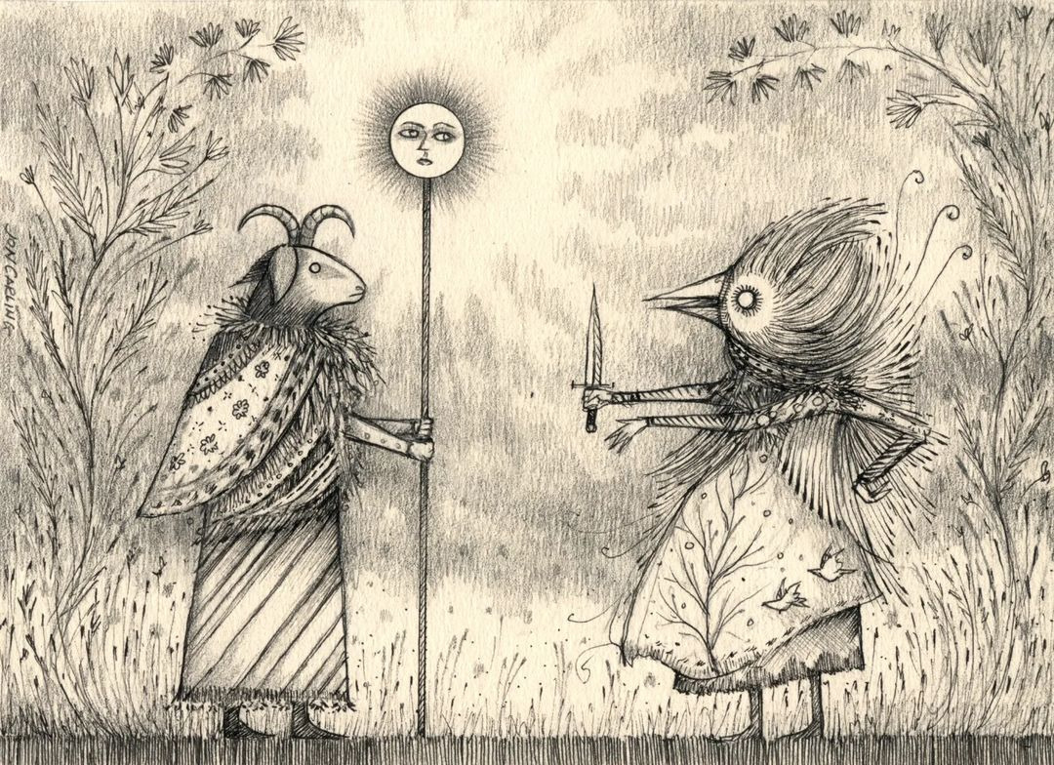
Figure 1: Jon Carling, Goat & Bird
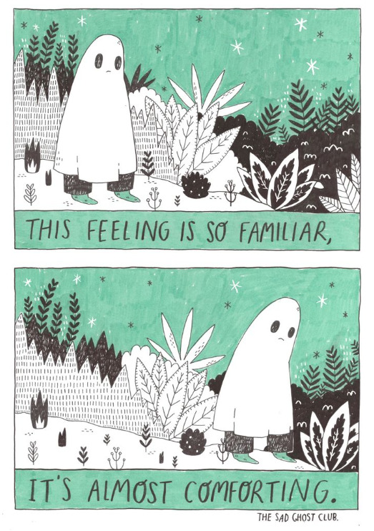
Figure 2: Sad Ghost Club 1
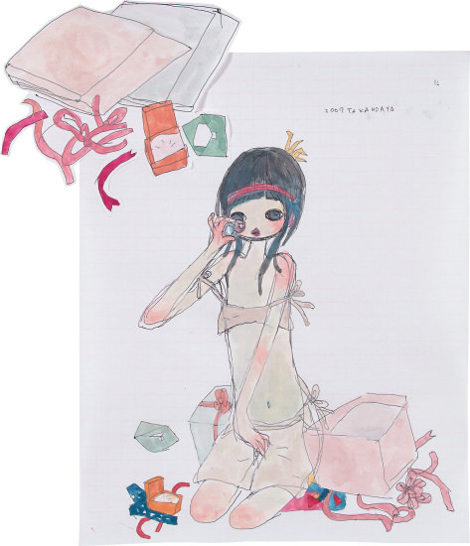
Figure 3: Aya Takano 1

Day 1: Reflections

This is day one of my Confirmative Praxis journey. I have been reflecting on my previous work and the art therapy research I had done in the past. In my previous module, I looked at games as a form of art therapy, using Off developed by Mortis Ghost, Gris and other games for inspiration. For Confirmative Praxis, I decided to move away from games and focus on creating a character that can be used as a therapeutic support character or a mental health support buddy character. I also want to create a pitch bible for a graphic novel, which will feature some of these characters I have designed.
To develop my work for Confirmative Praxis, I am going to do more research on mental health, therapy and art therapy. I touched upon these topics before, but I feel that I would like to go deeper into these as I am still very keen on the subjects and am interested in exploring career options that involve art and therapeutic methods.

Day 14: Defining Art Therapy

To begin this journey, I will need to define art therapy. Art therapy is based on the idea that "the arts have a key role to play in promoting intellectual and emotional development” (Edwards & Wilkins, 2014). The British Association of Art Therapists (BAAT) state that art therapy: “uses art media as its primary mode of communication” to achieve personal growth (2022). The definition provided by the American Art Therapy Association (AATA) is similar, but they also mention “the life-affirming pleasures of making art” (2022). The practical outcome from art therapy can be as simple as scribbles on a page, to something more complex and sophisticated. The main point is to use art as a tool to represent feelings, emotions, or thoughts that they are unable to express verbally. It is not exclusive to people with mental health conditions but can be utilized by anyone wanting an accessible method of self-exploration or self-soothing (Liebmann, 2006).
Art therapy sessions can be individual therapy sessions or group sessions. Group art therapy can enhance social factors such as awareness and appreciation of others, communication, sharing problems, and relating to others. Group therapy sessions are usually limited to groups of six to twelve to help maintain visual and verbal contact with all members and to avoid cliques from forming (Liebmann, 2006). This is important for allowing all members a chance to talk during the discussion, and it enables interaction and idea sharing between all members. Group therapy sessions usually have a recognisable theme as a starting point for participants. The theme should be open enough for participants to interpret it in their own way (Liebmann, 2006).
Individual art theory is focused on the individual, so the themes used withing these sessions will be relevant to their own circumstances (Mead, 2020). This type of therapy may be more suited to those who do not feel confident enough to produce art in a group, where they may feel judged. Some people may not get the focused attention they need if they are in a group, so individual therapy might be more appropriate (Art Therapy Resources, 2022).
Art therapy is usually guided by a therapist, but it is possible to achieve therapeutic benefits from art without attending a therapy session. Simply viewing artworks have been known to have healing effects. For instance, talking to MoMA Magazine, Christopher Baily stated that when viewing Water Lilies by Claude Monet (1899), he feels “no anxiety or dread. I simply luxuriate in the joy of color and celebrate this present moment. This to me is the healing power of art” (Baily cited in Armstrong, 2021 p. 10). The article was careful not to imply that art is a cure for illness or a substitute for necessary medical treatments, but there can be some therapeutic benefits to wellbeing when viewing art. However, most art therapists would argue that for an activity to be considered art therapy, it must be led by a professional therapist. For instance, Mead (2020) claims that participating in art practice “can certainly be helpful for many, [but] unless a licensed art therapist has designed them, they cannot be considered art therapy”. This means that an activity on a certain theme might be therapeutic, but it is not ‘art therapy’ if not led by an art therapist. To avoid confusion, therapeutic art sessions that are not led by people who are qualified art therapists, but who want to share the healing properties of art, are usually given other titles such as ‘emotional education’ (Liebmann, 2006).

Day 15: Developing a Graphic Novel

When researching art therapy and the theory behind informal therapeutic methods that use art as a healing tool, I began to design some characters that I wanted to develop as ‘healing buddies’. The main idea is to make these as 3D models that people can have and hold, but I also want to design some characters for my graphic novel, which I have decided to develop rather than a pitch bible.
Moggy Boo was an influential artist for these buddies because they are close to my own ideas for 3D models. There are a few artists that I have mentioned in my research blog, but I resonate more with this style. I like the fact there is less detail in the body shape than in the work of some of the other artists I have looked at.

Day 26: Inspiration - Perks of Being a Wallflower

Perks of being a Wallflower by Stephen Chbosky (1999) by is about a young adult who lost a friend and has traumatic experiences. As a loner, the main character writes emotionally charged letters as if he is addressing a friend, but he is writing to a stranger. The character himself remains anonymous, using ‘Charlie’ as a pseudonym. This is so he can be completely candid in his writing (Ducker, 2018). A reviewer for The Guardian said that “Chbosky intelligently explores stock YA [young adult] themes such as mental health, substance abuse and sexuality, whilst simultaneously reminding the reader about how exciting it is to be young and idealistic” (Guardian reporter Nic, 2015). The article goes on to say that the book underpins the need to understand human complexities, and that sometimes people do bad things, but that does not make them innately bad.
I find the epistolary style of writing very endearing and more personal, especially when dealing with serious themes like mental health. The author uses the letter writing format as a way to demonstrate the character's ability to understand his struggles and trauma during a critical phase of development. Ducker argues that “Charlie’s letter writing encourages his self-scrutiny. Which help in his understanding of how to become more emotionally stable” (Ducker, 2017 p. 160). This type of writing is often fragmented, so the reader has to piece the snippets together to work out the whole story, which is a good way to keep the reader thinking.
At first, I thought the book was more like a diary than a series of letters, because the letters only went one way. Letters usually have some form of exchange. However, I later felt that this one-way communication was similar to the relationship between a therapist and client, where the client is encouraged to do all the talking while the therapist listens. Letters to a stranger is also a technique used by therapists for some clients as a way pf getting them to open up, so I thought it was possible that the character was writing these letters because he was told o. He mentions in one of his letters that he is writing them to give himself an outlet to open up, but it is unclear if he came up with that idea himself. Ducker (2018) points out that diaries are private whereas letter are not. This could explain why he chose to write letter as an outlet because he wanted to express himself to an audience, even if it was anonymously.
Charlie’s letter writing helped him develop as a character, showing that it can be a valid therapeutic process. At the end of the book, he is able to come to terms with living a life shaped by traumatic experiences, and is able to understand and deal with this better than at the start of the book. This is a more realistic ending than him being ‘cured’. According to Sagara-Monaghan (2016) this makes the book a more authentic representation of mental health than some others.
The theme within this book is described as ‘narrative medicine’, as it is a text with a healing property. Sagara-Monaghan (2016) says that “Narrative medicine finds a built-in audience: teens who consume these novels because the narrative engages them, because they can relate in some way to the illness experience addressed” (p. 33).
Mental health is something I want to explore more in my project, so reading this book has helped me to find ideas. One quote from the book that explores his inner thoughts is the following:
I don’t know if you’ve ever felt like that. That you wanted to sleep for a thousand years. Or just not exist. Or just not be aware that you do exist. Or something like that. I think wanting that is very morbid, but I want it when I get like this. That’s why I’m trying not to think. I just want it all to stop spinning.
The book does not romanticise mental illness or trauma. It deals with it with respect and sensitivity, which is how I want to treat it within my project. I have also learned that the book was healing for others. When asked in an interview if he had heard from fans about them getting better, Chbosky responded that he had and that the reason for their journey in recovery was because the book helped them to understand that they are not alone (Kasperkevic, 2014). This understanding gives them courage to reach out to get help, which can lead to professional support, someone listening, or being pointed in the direction of self-help. This shows that exposure to trauma, difficulties and struggles through art and literature can be the first step in a recovery program.
The book was later turned into a film, written and directed by the author. This worked well because it meant that the original was not misinterpreted, and the focus remained where it was originally intended. As it was his own story, as a director, he treated it with care in the same way that the character was treated with care and respect in the book, not going into unnecessary details about his sexual assault, concentrating more on the impact and the trauma resulting from it.
The realism of the story inspired my own story in my graphic novel as I wanted to show normal lives with something big happening, the gradual positive instead of a ‘fix’ or a ‘cure’ for their situation. The artists who helped inspire the aesthetic of the novel have been a mixture of Sad Ghost Club and Jon Carling, along with Jeauyce for the panels in his work and Ai Yazawa for the exaggerated expressions.
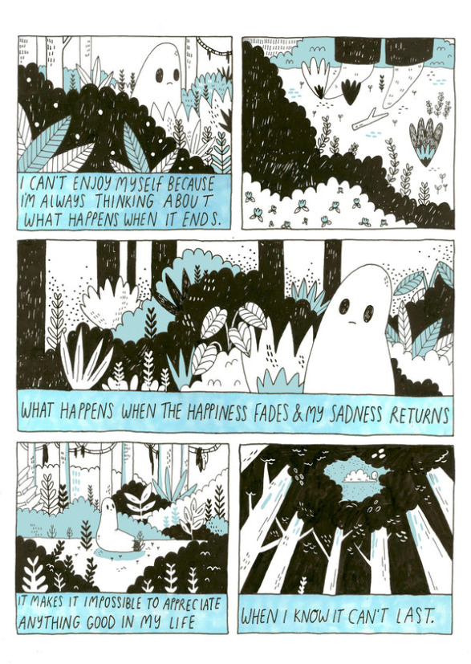
Figure 4: Sad Ghost Club 2
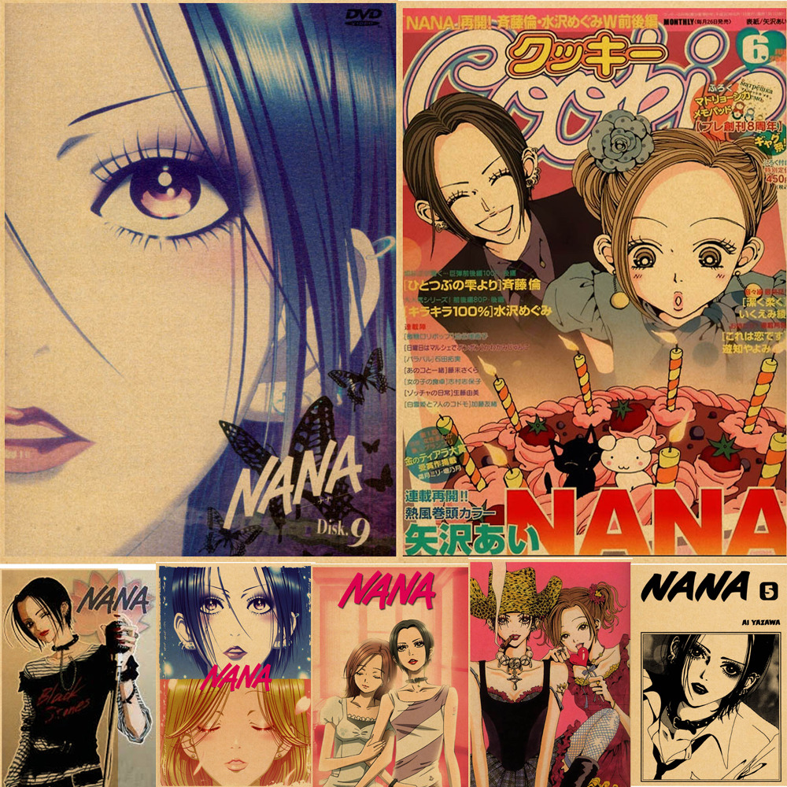
Figure 5: Ai Yazawa, Nana Compilation

Day 42: Artists that influence me
Today I wanted to look at artists that influence me. I have written about several artists in my research blog and why they are influential. Below are a few of the key artists that I have mentioned.
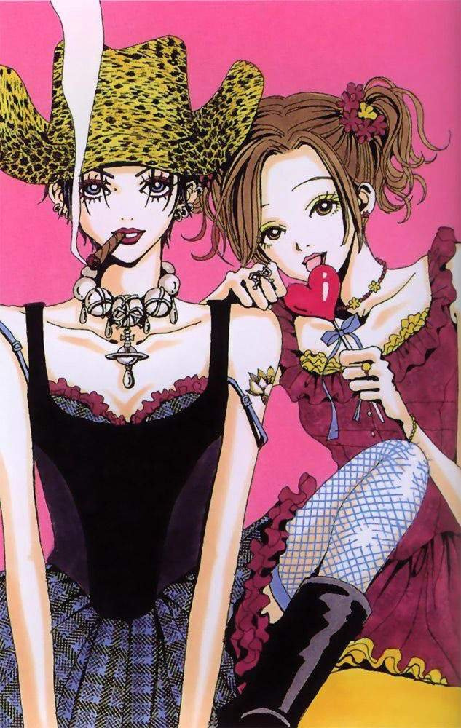
Figure 6: Ai Yazawa, Nana & Hachi
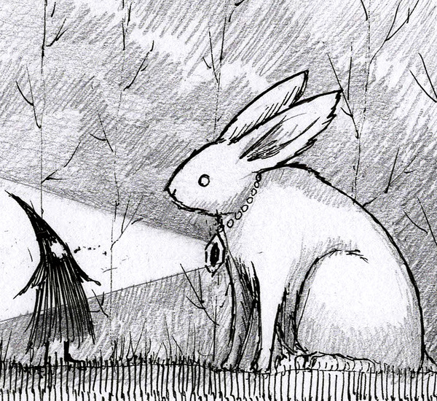
Figure 7: Jon Carling, Rabbit
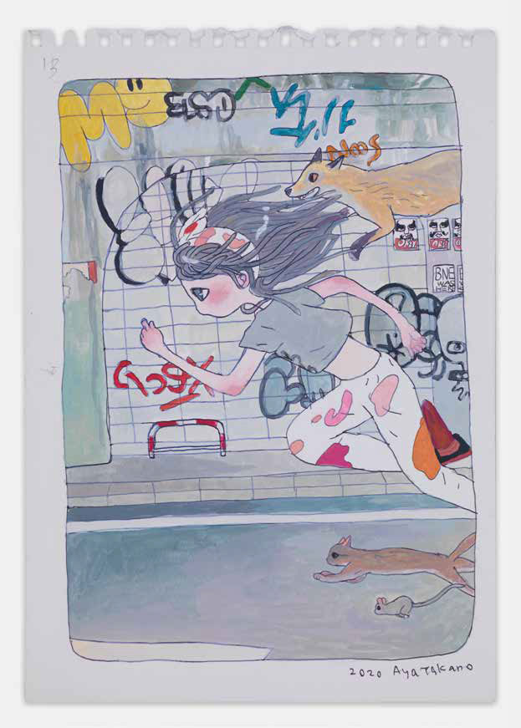
Figure 8: Aya Takano, Running
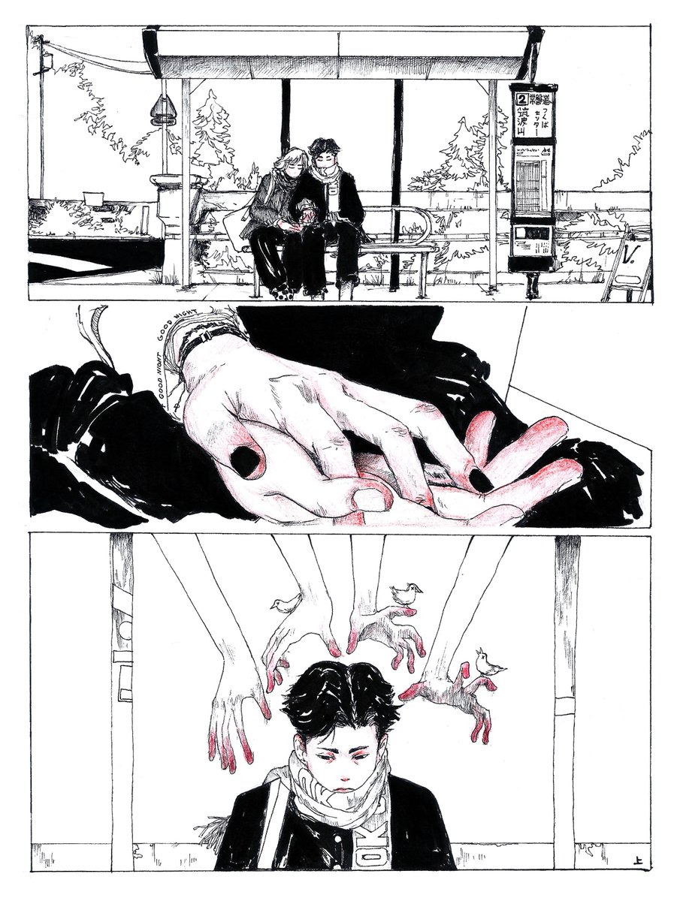
Figure 9: Jeauyce 1

Summer 2022: Practial experiments

Day 68: How is art therapeutic?

“Science has yet to solidly prove that art has helped to enhance well-being and healing in medicine. However, art appreciation has been observed to be used as an aid or among the tools used to help in human care and healing. After all, isn't this one of art's reason for being?” (World Health Organization, 2011 p. 6).
I spent a lot of time over the summer researching how art can be therapeutic to help add theoretical depth to my work. World Health Organization produced a series of videos that discussed art and mental health, so this was a good starting point. Most of the relevant points are discussed in more detail in my research blog, but one key point was how arts and crafts helped a lot of people improve their wellbeing during the Covid-19 lockdown (The Art Newspaper, 2021).
Art is also used to create a more therapeutic environment in hospitals and hospices, as being surrounded by colour and art can be calming (The Art Newspaper, 2021). This is only one way that observing art can have healing effects. Certain art works can make people feel at ease and joyful. “I feel no anxiety or dread. I simply luxuriate in the joy of color and celebrate this present moment. This to me is the healing power of art” (Christopher Baily cited in Armstrong, 2021 p. 10). Others feel a sense of belonging when they see themselves represented in art.
When engaging with art, it can be healing, aid mindfulness, or help with relaxation regardless of artistic skill. Some people might take part in an informal form of art therapy by doing art or craft projects to soothe them. Some vulnerable people in Wales were given kits during lockdown to help them be creative as a way to support their mental health (USW, 2020). As well as crafts, even simple doodles can be a good way to self soothe and relax (Sosnoski, 2020). Art therapy in a formal setting can help with creativity and spontaneity, expression, freedom, and self-awareness awareness. If participating in group art therapy, it can help with appreciation of others, communication, sharing problems, and relating to others (Liebmann, 2006). There is a lot more detail about group and individual therapy in my research blog.

Day 80: My style changed

I have posted in my research blog that my style has changed from traditional hand-drawn art to fully digital work, but I have a desire to return to hand-drawn work. My digital work feels stiff, whereas my traditional work is more delicate. I also feel more in tune with the work when drawing in a traditional format as I can feel the paper and the materials I use. My traditional style also fits in with current trends within art and fashion of a less polished, more ‘everyday’ and ‘normal’ looking style, so I want to experiment more with this style for my work moving forward.
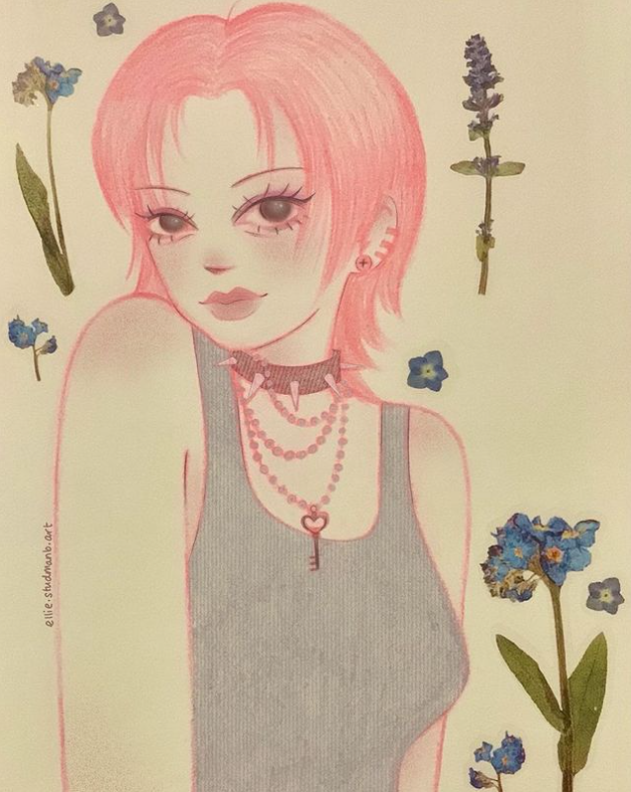
Figure 10: My Traditional Art
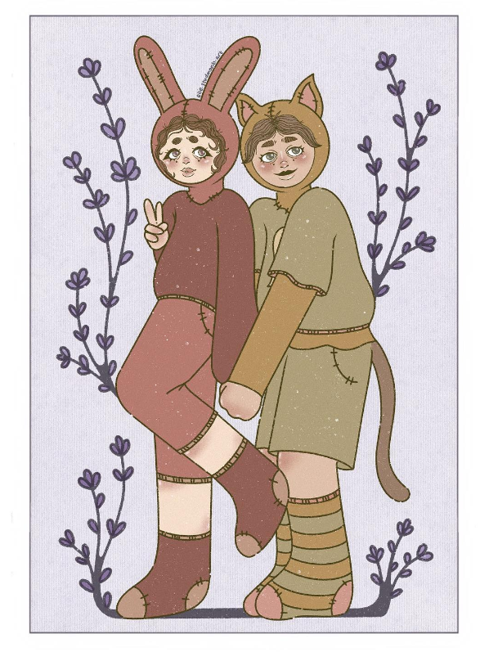
Figure 11: My Digital Art

Day 99: Influential books

To research for inspiration for my graphic novel, I have been looking at graphic novels and illustrated books that deal with similar topics to my own. The books by Steve Haines, mentioned in my research blog, deal with themes such as anxiety, trauma, pain and physical contact, but the focus is on healing, improving wellbeing, understanding yourself and being gentle with yourself. This is the tone I want in my own work.
Another influential book series was The Sad Ghost Club, also mentioned in my blog. I like the ambiguousness of the character. It has no name, age, gender, ethnicity or any other defining feature, so it could be anyone, meaning anybody can relate to it. I like the use of colour and how it looks like it is drawn in pen and ink. The work is mainly black and white, sometimes with one colour injected into it, and other times four colours. As well as the style, I love the storyline as it is an inner monologue of the character. This is something I am trying to capture in my own work.
The Manga series Nana is another inspirational book. The story is sad, but the style is one I am drawn to. The characters’ expressions are sometimes silly, and other times the work can be full of pretty details. They also refer to fashion designer Vivienne Westwood and draw actual pieces from her range. I love this unique detail in the work.
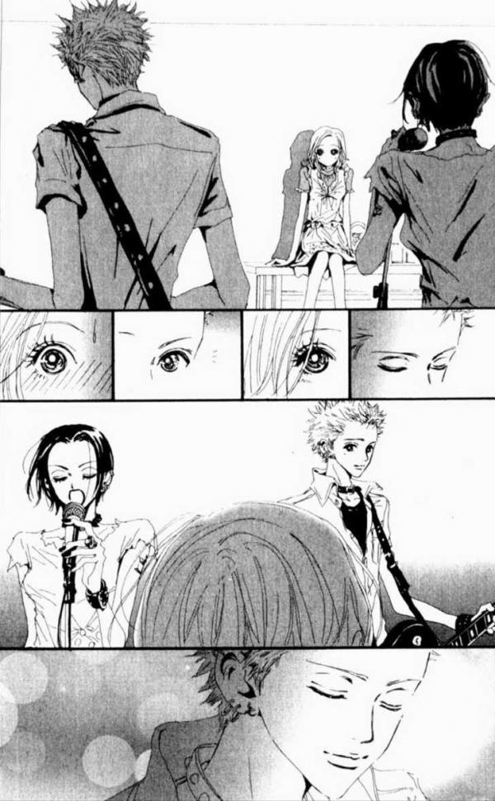
Figure 12: Ai Yazawa, Nana Manga page

Autumn 2022: Graphic Novel Writing

Day 110: Freewriting

A lot of the summer was spent drawing and developing my style. For the start of the new term, I decided to focus more on the writing side for my graphic novel. When researching writing techniques, I came across the idea of freewriting. This is where the writer clears their mind and writes non-stop for a set amount of time, with no plan or direction. Freewriting usually starts out quite vague, but can eventually lead to something meaningful, which might not have come out otherwise, as the process of freewriting helps to develop unconscious thoughts. Flannery O’Connor said that “I write to discover what I know” (O’Connor cited in Gil Teach 2016), which supports this idea.
Freewriting can be seen as writing backwards. This is because the most familiar way of writing fiction is to design an outline of the story first, and then begin writing. With freewriting, you write first, then discover new ideas from this. “...think of writing as an organic, developmental process in which you start writing at the very beginning—before you know your meaning at all—and encourage your words gradually to change and evolve. Only at the end will you know what you want to say or the words you want to say it with (Peter Elbow, cited in Hayes 2006 p. 32).
I started to do my own freewriting exercise by clearing my mind and just writing. The first one I did was to give me an idea of the process and the practice doing it. This made me more comfortable to do the process again, but this time in the character I had created for my graphic novel. I wanted it to be like the inner monologue of the character, so I put myself in their shoes and performed the freewriting exercise. I did not edit the work at all afterwards, so the written piece is the pure thoughts as they came to me whilst trying to channel my character. The writing piece formed the backbone of a page of my graphic novel.
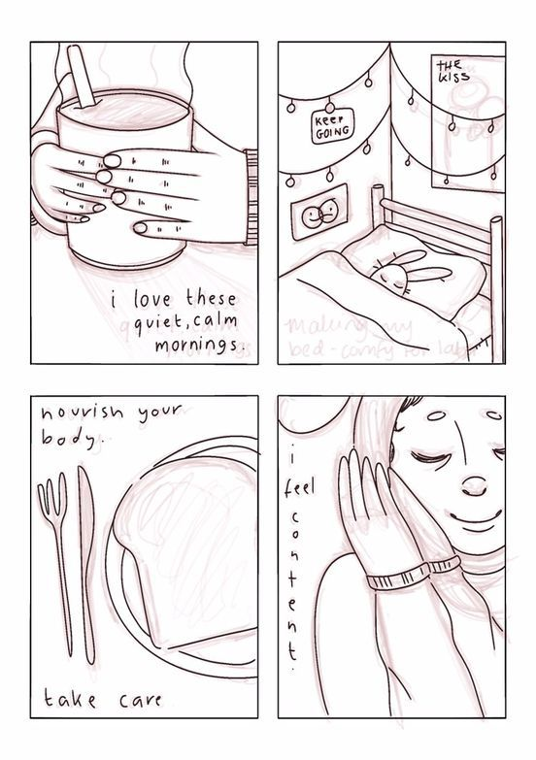
Figure 13: Draft Comic Page
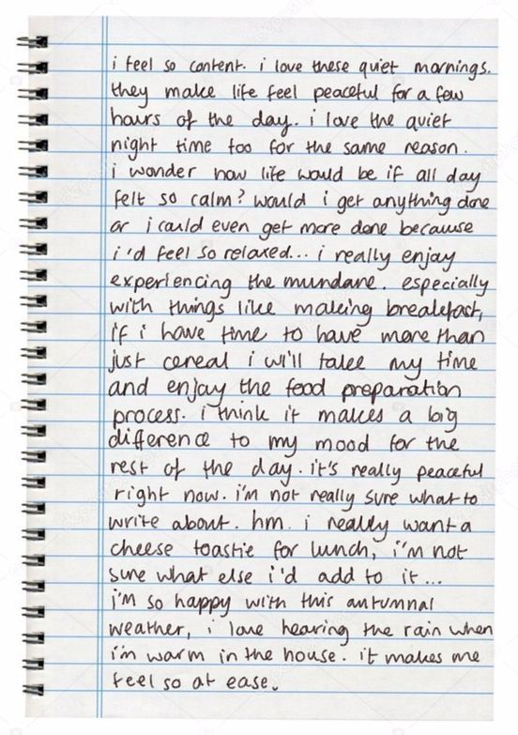
Figure 14, Free Writing

Day 125: Practical idea update

Today I had a meeting with my course tutor to discuss my ideas. I want to link my graphic novel to the main theme of my work, so I thought about whether the novel should be about a character’s mindfulness journey, or if the book itself should be therapeutic in some way for the readers. I decided to do both. The story will be about the thoughts and emotions of a character, and how they deal with them, and I would like the book itself to contain interactive elements to help with mindfulness.
One idea I have for the book is to include pages at the front and back where readers can note down what they are feeling, what they are thankful for, what activities help them to improve their mood etc. These pages can be repeated at key parts of the novel to get the reader to go back to their feelings and ways to help them improve their mood and wellbeing, so that the actions and ideas listed at the start are not then ignored. I had an idea to leave one or two pages uncoloured, so that the reader can colour them in, with a few lines to explain why colouring can be therapeutic. I would also like to include activities in the graphic novel such as dress-up paper doll.
Further linking to the project theme, I decided that the graphic novel could written as a diary from the point of view of the main character. Once I have practiced a bit more with freewriting and I have created my character for my graphic novel, I will try to place myself in the head of my character and do a freewriting exercise for them to insert into the novel.

Day 132: Developing my style

In the summer, I wrote about how my style had returned to a more traditional, hand-drawn illustration technique with some digital retouching. However, I have recently written a blog post in my research file about rethinking this decision. I feel that if I could have the same control on my iPad as I do with paper, I would go fully digital, but I still like the traditional look.
In a perfect world I would do both. However, a lot of professional artists claim that there should be a recognizable and defining style that an artist is known for (Jax, 2021). Artists like Picasso or Quentin Blake have a distinct signature style that makes their work identifiable as theirs. Furthermore, Hollowood (2019) states that marketing is easier when artists have one style. However, to contrast this, Chiu (2021) argues that having a narrow style could be detrimental to an artist’s career as they need to be adaptable to working on projects for clients.
This leads me to believe that there are advantages and disadvantages to having a distinct, signature style as an artist. My current idea is to do my character designs in the traditional way and insert them into my graphic novel using a digital style. I will spend a few weeks developing my style and preferences before making a fixed decision about my final outcome of work for this project, but my priority is being comfortable with my work, and being happy with it.

Day 156: Exhibition ideas

The planned outcome for my exhibition will be my graphic novel, along with a 3D model of one of the characters I have made. Shelves or a plinth could be used for a physical exhibition, but I have been considering a digital exhibition because a lot of my work is digital, so I want to explore the digital space. This could be achieved by putting up a QR code that links to a virtual gallery, a projector screen that shows a video of my work, or a monitor with my exhibition work pre-loaded where viewers can navigate through the various aspects of my work. Digital exhibitions can be beneficial as they are more accessible, and visitors can go back to the work again without having to travel to the physical location. They can be accessed from anywhere by anyone and can be adjusted to suit certain needs and preferences. For example, the information on the screen can be enlarged, images can include descriptive ‘alt text’, and there can be audio descriptions. Drake, (2020) notes that as digital exhibitions can be global, there may be a greater need for bilingual audio and text, but this must be authentic. I did some research on logistics of setting up a digital exhibition and found that there are not many differences with setting up a physical exhibition. Both types of exhibitions require consideration of intended audience, content, and architecture of the space. The main difference is the experience of the exhibition, as the audiovisual experience will be different to that in a physical space. A digital exhibition could change how long people view each exhibit before moving on (Drake, 2020).

Day 161: Exhibition ideas update

I have been re-thinking my exhibition and decided to design a physical space to show my work, with the digital space as a back-up plan. I would like to set up a corner of a bedroom, showing some of my designs, including my comic book, 3D models of my characters, posters of my work, and a few other small bits I will make related to the work. As the main target audience for my work is teens and young adults, a bedroom setting seemed appropriate as a bedroom is often a sanctuary for teens, and the only place that is their own (Pickhardt, 2019).
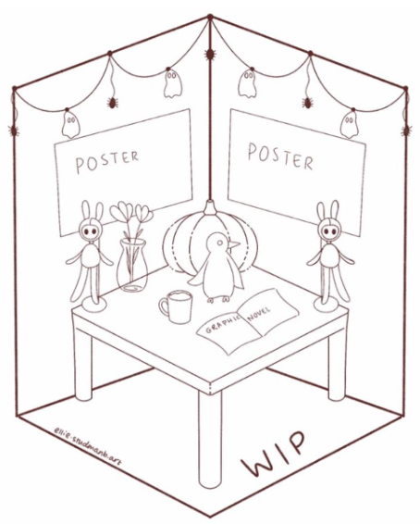
Figure 15: WIP Exhibition layout draft

Day 212: WIP Symposium

I did a ‘Work in Progress’ symposium where I showed the work I have and my ideas for where it is going. I had some good feedback and was pleased with a comment from another student who noted that I am handling a dark issue and making it softer. This is what I wanted from my work, as I want to approach a serious issue in a friendly and caring way, and I feel a graphic novel is an accessible and welcoming way into this topic.
I hope my cover design shown below will draw people into the book.
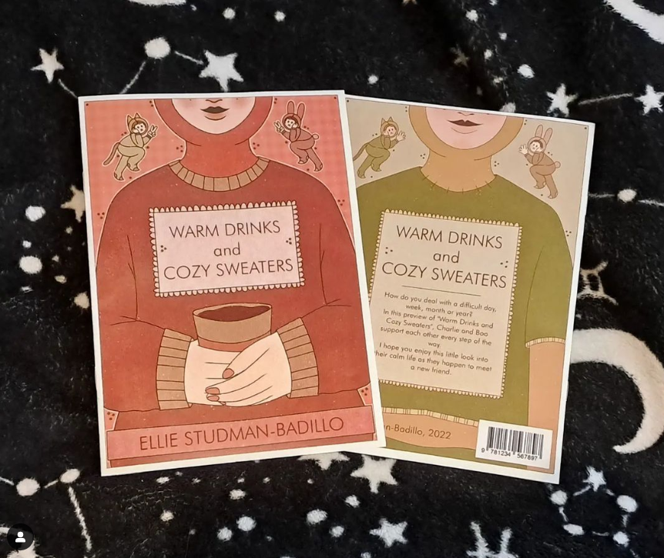
Figure 16: My front & back comic covers

Winter 2023: Exhibition preparation and reflection

Day 244: Preparing the exhibition and final practical pieces

I had a group meeting to discuss exhibition spaces. My space has now been finalised to be a section in the Dynevor foyer. This space works well for me as it is more accessible for me as it does not have stairs from the front entrance. I also like that the space is a large open space, so I can set up my installation without being limited by size, and it also makes a better visitor experience as they have room to move around the exhibits. I have found a table that I will purchase for the installation, and I will attach posters to the wall with white-tac to give it a bedroom feel. To make the table more interesting, I will buy a tablecloth that’s appropriate for a bedroom without having a distracting pattern.
For the practical work I have finished the posters and almost finished the pages of the graphic novel. I have found a company that will print the graphic novel and the poster, who also offer an eco-friendly printing option. I have also bought some airdrying modelling clay to finish some of my model designs. I have also sources a few other items to add to the bedroom feel, such as a mug and some extra details.

Day 258: Setting up the exhibition
The exhibition set up was quite stressful, but in the end went well. I went with my partner and stayed overnight in a hotel nearby (the Dragon Hotel) as it was cheaper for me to stay overnight than travel twice. It was good to go a few days beforehand as it gave me time to set up and then go back in case I needed to change anything.
Initially me and my partner set up by ourselves. I had arranged this to look like my mockup idea for the exhibition space. Looking back, it looked a bit like a marketplace stall which really wasn’t what I was going for.
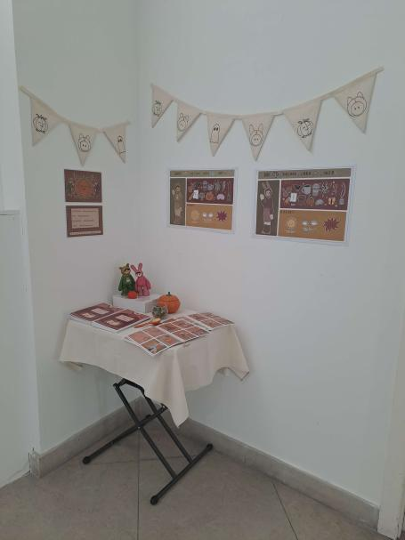
Figure 17: Initial exhibition layout
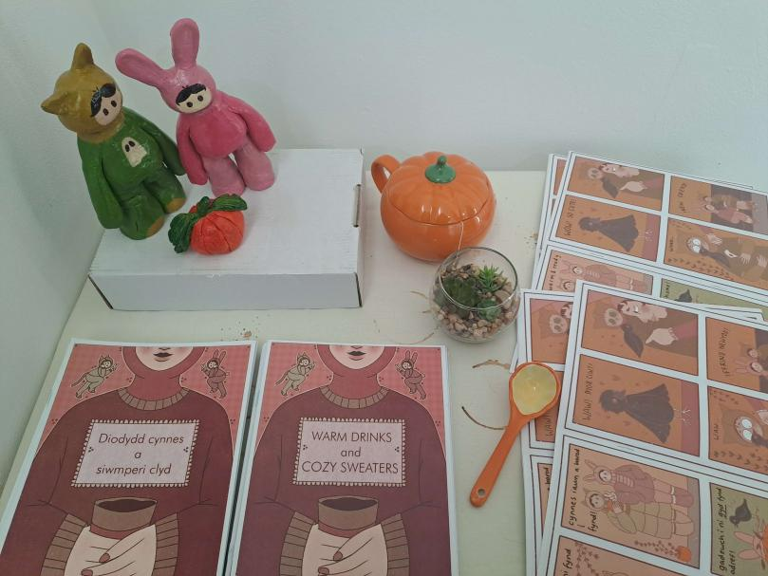
Figure 18: Initial Exhibition Layout Close up
The day of the exhibition we had gone to add finishing touches, and then went to lunch. However; I got a voicemail from Hamish to let me know that a member of staff had suggested some changes so we rushed back to talk about it. The changes were so helpful and it made my exhibition space feel a lot more open and professional! I really love how it turned out. I’m so thankful and grateful for Catherine, Lloyd and my partner for helping me set up. It made my work look more open and readily available rather than hidden away in a corner.
To adapt to the new layout, I reprinted my A3 posters and bought some little fake foliage to add to the area. Catherine helped me photocopy and manipulate images to look like a forest floor to add to the little crevices to make it more put together. We nailed my comics to the wall to display each page. I love how it ended up looking.
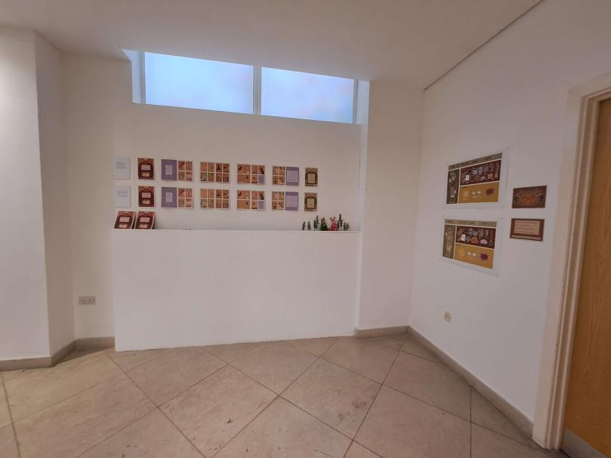
Figure 19: Improved exhibition layout
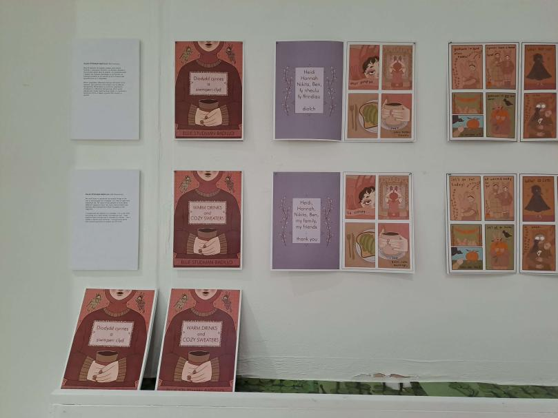
Figure 20: Exhibition close up 1
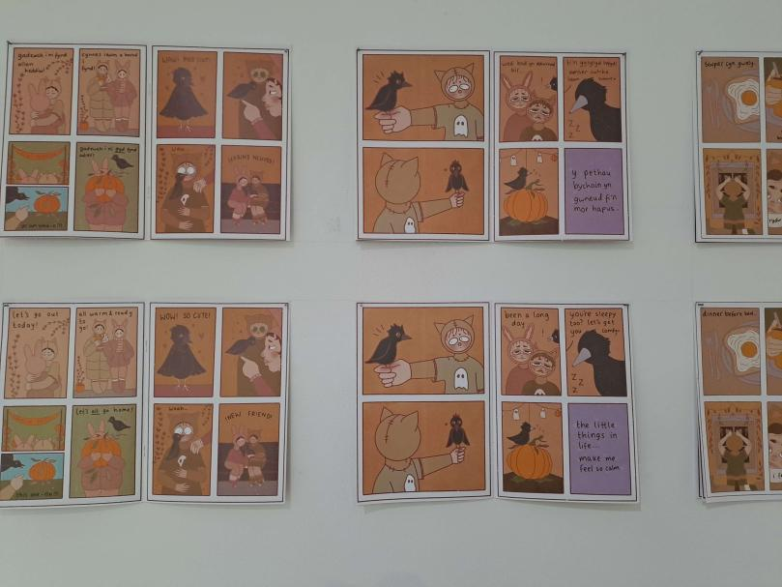
Figure 21: Exhibition close up 2
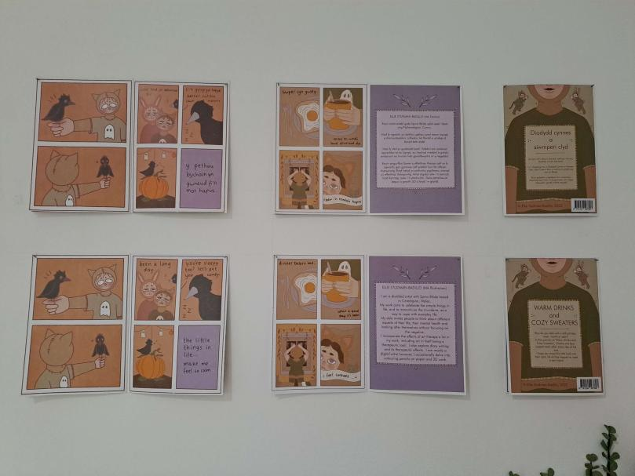
Figure 22: Exhibition close up 3
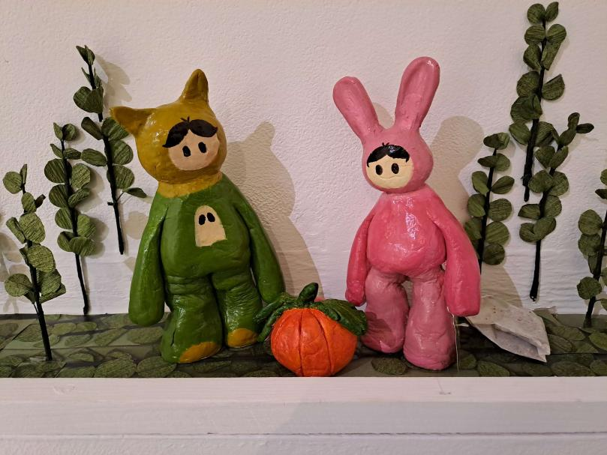
Figure 23: My clay figures

Day 270: Reflection
The exhibition was initially a bit stressful, but it felt satisfying once the setup had been completed. It went well overall. It looks so much better than I thought it would be, especially after having some help with a redone layout.
I’ve done my course online this year as I haven’t been able to come in due to my health and situation, so it was really nice to see everyone’s work and to be in that creative environment again. I think people liked my work, especially after I opened up my space more and made it more accessible for people to look at.
I talked to a few people about my work, but I was mostly looking around at other people’s work so I wasn’t by my area all the time. I mostly got compliments on my clay figures which I was surprised about but it’s motivated me to want to do more work in that medium. I was really happy with the end result. If I could redo this exhibition layout I think I would make elements of my work such as the clay figures, a lot bigger. I would also install a shelf to display more things.
My work and some things people have said about it:
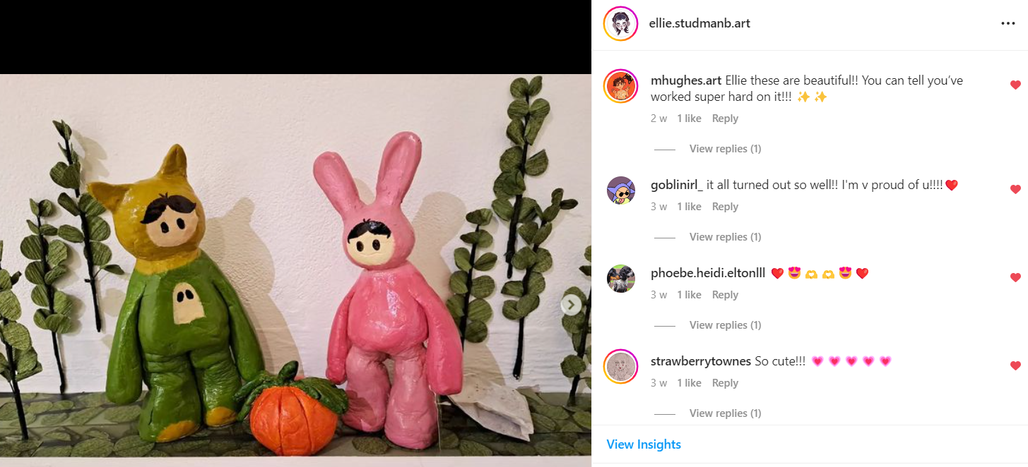
Figure 24: Instagram comments 1
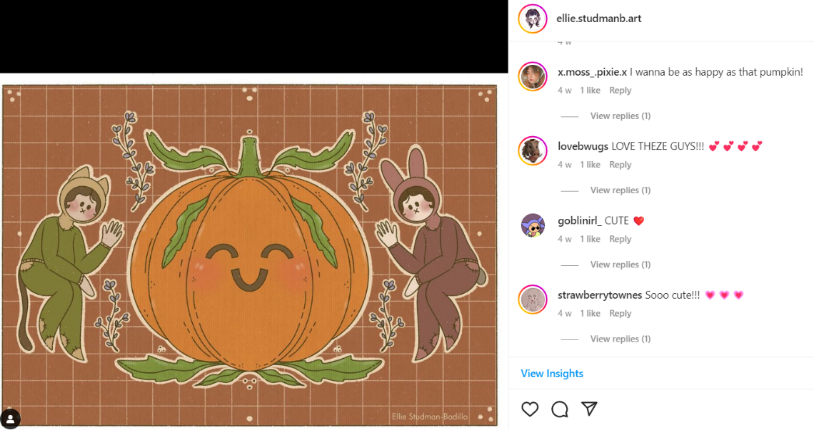
Figure 25: Instagram comments 2
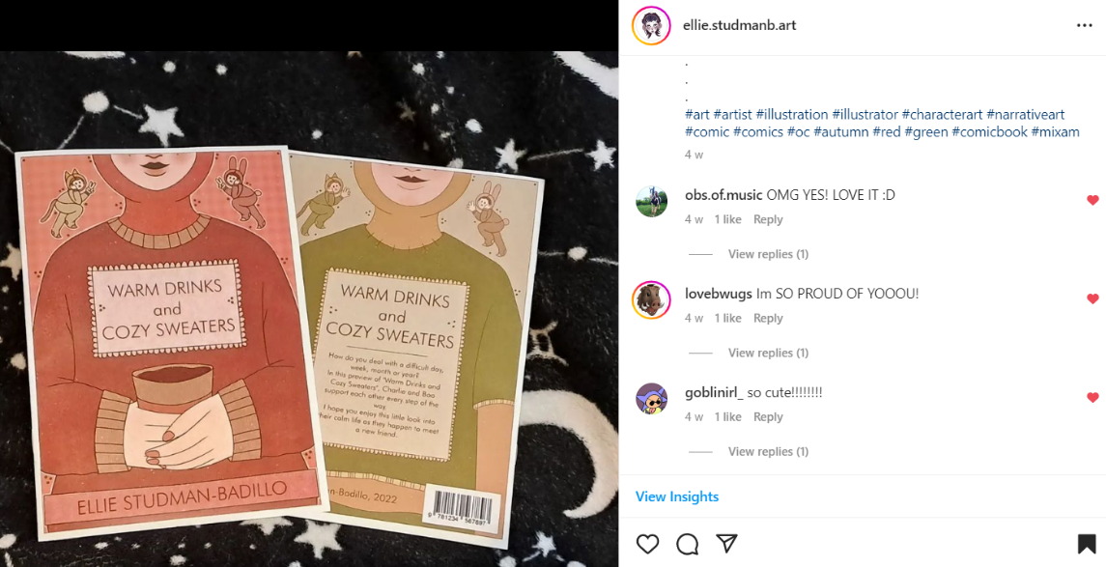
Figure 26: Instagram comments 3
In the future, I’d love to develop this comic into a full graphic novel to sell, and develop it into a book series. I feel more comfortable in my art style now, so I want to be able to do this again but dedicate a lot more time to the drawing process. I feel like the story I had for my comic was quite weak, so I want to spend more time writing and improving the story to make it more mature.
I would like to spend more time planning out and making my clay figures, so I will remake them to see improvements and develop the characters further. I want to dedicate some time into making them fully fleshed out. My initial idea for this project was a pitch bible, so I would like to revisit that and create a pitch bible for an animated series based on this story and the characters in this story.
References
Absolute Documentaries (2022) Can Art Therapy Help Traumatised Kids?: Healing Abilities of Painting [YouTube] Available at: https://www.youtube.com/watch?v=Eq3ExDHhAF8 [accessed 25.07.2022]
American Art Therapy Association (2022) About Art Therapy [online] Available at: https://arttherapy.org/about-art-therapy/ [Accessed 21.02.22]
Armstrong, J. (2021) ‘The Healing Power of Art’ in MoMA Magazine, Issue 620 pp. 11-16.
The Art Newspaper (2021) Healing Arts London: Frame of Mind—A Conversation about Art and Healing [YouTube] Available at: https://www.youtube.com/watch?v=qkyj_zA385Y [accessed 6.06.2022]
The Art Newspaper (2021) Does Art Heal? What is the Evidence? What should the Policy be? [YouTube] Available at: https://www.youtube.com/watch?v=jvDi-E3p1QM [accessed 6.06.2022]
The Art Newspaper (2021) Artists on the Frontline - A Panel on Art's Role in Community Healing [YouTube] Available at: https://www.youtube.com/watch?v=Yc77brIaVnU [accessed 6.06.2022]
Art Therapy Resources (2022) Comparing Individual and Group Art Therapy [online] available at: https://arttherapyresources.com.au/individual-and-group/ [Accessed 22nd August 2022]
Balzer, D. (2014) ‘Only Connect: What’s Wrong with “Art as Therapy”’ in Canadian Art, 27th May 2014 pp. 1-6
Benton, J. (2008) Dear Dumb Diary (book series) New York: Scholastic Paperbacks
British Association of Art Therapists (2022) What is art therapy? [online] Available at: https://www.baat.org/About-Art-Therapy [Accessed 21.02.22]
Chbosky, S. (1999) Perks of Being a Wallflower, New York: Simon & Schuster
Chiu, B. (2021) Is it Important to have a Unique and Recognizable Artistic Style? [online] available at: https://art.schoolism.com/is-is-important-have-unique-recognizable-artistic-style/ [Accessed 29.09.2022]
Creative World (2017) Huge Healing Toys Haul /Mochi Animals Stretchy Squishy Squeeze/Oddly Satisfying Stress Relief [YouTube] Available at: https://www.youtube.com/watch?v=jvDi-E3p1QM [accessed 6.06.2022]
Drake, D. (2020) ‘How I created a digital exhibition,’ British Council Voices Magazine, 29th April 2020 pp. 1-5
Ducker, M. (2018) Form and Emotion in Stephen Chbosky’s "The Perks of Being a Wallflower". In: I. Jandl, S. Knaller & S. Schönfelln, eds. Writing Emotions : Theoretical Concepts and Selected Case Studies in Literature. Berlin: Verlag, pp. 159 - 174.
Edwards, D. (2014) Art Therapy (2nd ed.) London: Sage Publications
Gil Teach (2016) Classroom Management: Why We Freewrite [online] available at: http://gilteach.com/2016/12/19/why-we-freewrite/ [accessed 3rd October 2022]
Good Therapy (2019) Self-Care [online] available at: https://www.goodtherapy.org/learn-about-therapy/issues/self-care [Accessed 22nd August 2022]
Haines, S. (2015) Pain is Really Strange, London: Jessica Kingsley Publishers
Hayes, J. (2006) ‘New Directions in Writing Theory’ in Charles A. MacArthur, Steve Graham, and Jill Fitzgerald (eds) Handbook of Writing Research, New York: Guilford Publications
Herdieckerhoff, Elena (2016) The gentle power of highly sensitive people [Tedx Talks] Available at: https://www.youtube.com/watch?v=pi4JOlMSWjo [accessed 24.06.2022]
Hofilena, F. (2001) ‘Araceli and old lace’ in Arts and Culture December 3, 2001
Hollowood, K. (2019) ‘Master one style or stay versatile? Illustrators discuss the pros and cons’ in It’s Nice That, 14th May 2019 pp. 1-9.
I am Not Okay with This. 2020. [TV Series] Directed by Jonathan Entwistle. USA: 21 Laps Entertainment, Ceremony Pictures, Raindrop Valley.
Invaluable (2022) Sold at Auction: Araceli Dans [online] Available at: https://www.invaluable.com/artist/dans-araceli-6nqtyvwawe/sold-at-auction-prices/ [accessed 27.06.2022]
Jax, J. (2021) When should an artist focus on one style? [online] Available at: https://jacquelinejax.medium.com/when-should-an-artist-focus-on-one-style-1cc859bf4052 [accessed 29.09.2022]
Jon Carling (2022) Jon Carling Art [online] available at: https://www.joncarling.com/ [accessed 3rd October, 2022]
Jon Carling (2016) Approaching a Star [YouTube] Available at: https://www.youtube.com/watch?v=LIu7ByYTMXA [accessed 7th October 2022]
Kaimal, G., Ayaz, H., Herres, J., Dieterich-Hartwell, R., Makwana, B., Kaiser, D.H. & Nasser, J.A. (2017) ‘Functional near-infrared spectroscopy assessment of reward perception based on visual self-expression: Coloring, doodling, and free drawing’ in The Arts in Psychotherapy Vol 55 pp.85-92
Kasperkevic, J. (2014) The cost of mental health: How one author advises kids with depression in The Guardian, 17th December 2014 pp. 1-8
Kelly, D.C. (2000) Arts Build Community, in ShelterForce 1st January 2000
Kinney, J.P. (2007) Diary of a Wimpy Kid (book series) New York: Amulet Books
Liebmann, M. (2006) Art Therapy for Groups: A Handbook of Themes and Exercises Abingdon-on-Thames: Taylor & Francis
Lifespan Health System, (2022) Toys and Games with a Healing Purpose [online] available at: https://www.lifespan.org/centers-services/norman-prince-neurosciences-institute/toys [accessed 20.05.2022]
Machemer, T. (2020) ‘Arts and Crafts Are Experiencing Surge in Popularity Amid COVID-19' in Smithsonian Magazine, 5th May 2020 pp. 1-4
McGivern, H. (2021) ‘World Health Organization joins art world to launch global campaign confronting mental health toll of pandemic’ in The Art Newspaper, 17th March 2021
Mead, E. (2020) 15 Art Therapy Activities, Exercises & Ideas for Children and Adults [online] Available at: https://positivepsychology.com/art-therapy/ [Accessed 5th August 2022].
Meddings, L. (2021) The Sad Ghost Club: Book 1, London: Hodder Children's Books
Nic. (2015) ‘The Perks of Being a Wallflower by Stephen Chbosky – review’ in The Guardian, 19th August 2015 pp. 1-4
Orosa Goquingco, L., Mendez Ventura, S. (2005) Araceli Limcaco Dans, Makati: Equitable PCI Bank
Pennebaker, J.W. & Evans, J.F. (2014) Expressive Writing: Words that Heal, Enumclaw: Idyll Arbor
Pickhardt, C.E. (2019) Parents and the Importance of the Adolescent Bedroom in Psychology Today April 29th 2019
Sagara Monaghan, A. (2016) Evaluating Representations of Mental Health in Young Adult Fiction: The Case of Stephen Chbosky’s The Perks of Being a Wallflower in Enthymema Vol. 16 pp. 32-42
Samuelson (2021) Disadvantages of Art Therapy: What You Should Know [online] available at: https://delightfuldesignstudio.com/disadvantages-of-art-therapy/ [accessed 25.07.2022]
Sosnoski, K. (2020) ‘The Mental Health Benefits of Doodling’ in Healthline, 13th November 2020 pp. 1-13
Thompson, K. (2011) Therapeutic Journal Writing: An Introduction for Professionals, London: Jessica Kingsley Publishers
Todd, L. (2021) Can fidget toys be useful for people with anxiety? [online] available at: https://www.medicalnewstoday.com/articles/fidget-toys-for-anxiety [accessed 13.06.2022]
Trin Lovell (2020) The Contrast of Beauty and Tragedy in ‘The Perks of Being a Wallflower’ [YouTube] Available at: https://www.youtube.com/watch?v=Rm3WCOqf9s0 [accessed 24.06.2022]
USW (2020) Using art to support mental health and wellbeing during Covid-19 pandemic [online] available at: https://www.southwales.ac.uk/news/news-2020/using-art-support-mental-health-and-wellbeing-during-covid-19-pandemic/ [accessed 22nd August 2022]
Winnicott, D. (1980) The Gift of Play, Rotherham: Walker and Co
Whelan, E. (2021) ‘Great Art is not Therapeutic- It’s better than that’ in The Telegraph 25.03.2021
World Health Organisation (2011) Art for Healing & Caring, Manila: World Health Organization
Yhara zayd (2021) Breaking the Cycle of Abuse | The Perks of Being a Wallflower [YouTube] Available at https://www.youtube.com/watch?v=FePQTncIYXc&t=119s [accessed 24.06.2022]
Zelazko, A. (2020) How has COVID-19 influenced art? [online] available at: https://beyond.britannica.com/how-has-covid-19-influenced-art [accessed 22nd August 2022]

