

Cover Page

Name: Jahida Begum
Student Number: 2316313
Programme: BSc Health and Social Care
Module: Changemakers: Building your personal brand for sustainable employment
Module Code: BMHP5015
Lecturer: Raheela Shaikh
Assignment Title: Component 1: Online Portfolio of Set Exercises

Task 1 – Personal Brand
Write about your own person brand and how you could develop this to enable you to reach your employment goals (200 words- 2 referenced sources)

A person's distinct abilities, beliefs, and professional personality that set them apart in the job market are represented by their personal brand. Creating a strong personal brand is crucial for establishing credibility, employability, and trust in the health and social care industry. Self-awareness, introspection, and a steady professional demeanour are all necessary for effective personal branding. Individuals may match their brand with industry principles like compassion and ethical care by recognising their main talents, which include empathy, communication, and problem-solving (Moudatsou et al., 2020).
Professional networking, ongoing education, and sustaining a strong online presence such as through professional portfolios or LinkedIn profiles can all help build a personal brand. Through these channels, people may interact with employers, discuss accomplishments, and exhibit their abilities. Furthermore, by emphasising transferable talents and pertinent experiences, I may customise their brand to fit desired positions by establishing clear professional goals. To be authentic, I must retain consistency in their online persona, professional conduct, and principles (Gorbatov, Khapova and Lysova, 2019).
In the end, a strong personal brand improves employability by conveying a distinct, self-assured professional identity that fits the requirements and expectations of employers in the health and social care sectors.

Task 2 - Network Map and Rationale
Create a map of your own network considering career, support, social and community dimensions. Additionally, you should provide a supporting rationale explaining and critically assessing this (200 words- 2 referenced sources).
Crucially, preserving a network that is balanced in all of these areas improves wellbeing and professional identity. According to Li et al. (2009) networks serve as "communities of practice," where learning and a sense of community are fostered by shared experiences. Similarly, NHS Leadership Academy (2011) demonstrates how productive professional relationships strengthen engagement and service excellence. Thereby, creating and maintaining networks is crucial for reaching professional objectives, fostering resilience, and making a significant contribution to the health and social care industry.

A professional network is made up of relationships that promote professional and personal growth in a variety of contexts, including social, professional, support, and community. These networks are essential for fostering job prospects, adaptability, and continuous growth in the health and social care industry.

Support Networks
Career Networks
Family, friends, and academic tutors make up support networks that provide both essential and personal support during academic and career changes.

Social Networks
Mentors, managers, professional associations (such the Nursing and Midwifery Council), and coworkers who offer direction, criticism, and chances for development are examples of career networks.

Partnership and shared learning are promoted via social networks, which include peers and online professional networks like LinkedIn groups.

Community Networks

Community networks, such as local health partnerships and volunteer groups, enhance interaction with a variety of people and advance inclusive practice.

YOU

Task 3- Blog
Write a blog exploring a current topic or issue of your choice within the health and social care sector in the UK. The purpose of this is to inform a specific target audience of your choosing (300 words)

This Photo by Unknown Author is licensed under CC BY

A&E Waiting Times' Increasing Crisis in the UK
One of the most urgent problems confronting the health and social care system in the United Kingdom is the length of time patients must wait in Accident and Emergency (A&E) departments. Long wait times can cause patients to experience more pain, worry, and in certain situations, significant dangers to their health. It causes tension, fatigue, and low morale among employees.

Approximately forty percent of A&E patients are waiting longer than the four-hour limit, and the demands increase over the winter, according to (Eatock, Cooke and Young, 2017). An increasing number of patients presenting with complicated, non-urgent problems, personnel shortages, and an ageing population are some of the reasons contributing to this issue. Delays in social care also have a significant impact; emergency rooms find it difficult to accept new patients effectively when hospital beds are taken up by patients waiting for medical packages or placement.
The future workforce is represented by early-career professionals and students studying health and social care, who are the blog's target audience. Gaining an understanding of this problem enables them to consider integrated care options seriously, including enhancing community-based services, funding primary care, and supporting advances in digital healthcare like virtual consultations and NHS 111 (Service, 2019).
Working together across sectors is necessary to address A&E waiting times. Improving patient flow and lowering needless hospitalisations can be achieved by establishing ties between hospitals, general practitioners, and social service providers. Professionals may regain efficiency and public trust in emergency services by cooperating.

Task 4- NHS Equality, Diversity and Inclusion Quiz (250 words equivalent)
- What is the primary goal of the NHS Equality, Diversity, and Inclusion Improvement Plan?
By guaranteeing equitable treatment and equal opportunity for all patients and employees, the NHS Equality, Diversity, and Inclusion Improvement Plan seeks to advance an inclusive healthcare system.

- How does the NHS EDI Improvement Plan propose to tackle the gender pay gap?
By encouraging clear pay scales, equal opportunities, and flexible work arrangements, the NHS EDI Improvement Plan seeks to close the gender pay gap and guarantee equitable remuneration and career progression for each gender.

- What is meant by the term ‘intersectionality’ as used in the NHS EDI Improvement Plan?

Understanding how multiple identities, such as race, gender, disability, and class, interact to influence people's experiences of discrimination and inequality is what the NHS EDI Improvement Plan refers to as intersectionality.

- Why is it important for the NHS to create a psychologically safe work environment?
In order for employees to feel appreciated, feel free to voice concerns, and enhance patient safety and welfare, the NHS must establish a psychologically safe workplace.

- How does the NHS EDI Improvement Plan suggest improving the experience of internationally recruited staff?

According to the NHS EDI Improvement Plan, equitable career development opportunities, mentorship, inclusion networks, cultural awareness training, and improved induction may all enhance the experiences of newly hired foreign employees.

- What role does leadership play in advancing EDI objectives according to the NHS Improvement Plan?
Leadership promotes EDI goals by fostering diversity, guaranteeing accountability, exhibiting inclusive conduct, and integrating equity principles into corporate culture and decision-making, according to the NHS EDI Improvement Plan.

- Identify one way the NHS EDI Improvement Plan aims to reduce health inequalities within the workforce.
Through the collection and analysis of staff data, the NHS EDI Improvement Plan seeks to eliminate worker health inequalities by identifying discrepancies, guiding action, and encouraging better improvements in health.

- Why does the NHS EDI Improvement Plan emphasize the importance of collecting and analyzing data on protected characteristics?
In order to detect disparities, track advancement, guarantee responsibility, and develop focused initiatives for inclusive improvement, the NHS EDI Improvement Plan places a strong emphasis on gathering and evaluating data on protected characteristics.

- Explain how flexible working policies can contribute to equality and inclusion in the NHS workforce.
By accommodating a range of requirements, enhancing work-life balance, lowering burnout, and facilitating participation from under-represented or caring workers, flexible working policies advance equity and inclusion in the NHS.

- What is one strategy mentioned in the NHS EDI Improvement Plan to combat bullying and harassment in the workplace?
The NHS EDI Improvement Plan includes measures to prevent bullying and harassment, such as improving reporting protocols, guaranteeing responsibility, and encouraging a polite, zero-tolerance work environment.

Task 5- A Letter to Yourself
Think of a time in the past when you may have been experiencing issues or difficulties, and after considering what you have learned in this module about emotional intelligence and resilience write a letter to your younger self explaining how these attributes were important at that time and perhaps how developing these areas could have been useful (250 words)

Letter to Myself,
Dear younger Jahida,

I understand how challenging it was to enter social settings when anxiety took control, causing your heart to race, your mind to race, and your dread of saying the incorrect thing to prevent you from moving forward. Despite your deep-seated need to connect and fit in, you frequently avoided social situations since it felt safer to keep silent.

If only you were aware of what I now know about resilience and emotional intelligence. Being socially flawless is not the goal of emotional intelligence; rather, it is about comprehending your feelings and realising that others frequently share them (Stoewen, 2024).

Instead of letting fear dominate you, you may take control by learning to stop, take a deep breath, and identify your emotions. Conversely, resilience is the ability to persevere in the face of discomfort. Small, regular actions of bravery, such as establishing eye contact, participating in discussions, or asking for assistance, are what build it.

Vulnerability is a pathway to empathy and connection, not a sign of weakness, as you will eventually realise. You will learn how to control your nervousness, speak confidently, and help others who share your feelings via experience and introspection. Gaining these abilities has helped you become a more sympathetic and emotionally conscious health and social care worker in addition to improving your relationships.
With dignity and compassion,
Yours Sincerely, older Jahida.
Task 6- GANTT Chart (200 words equivalent)
Compile a Gantt chart which illustrates the tasks you must complete to achieve your future employment goals
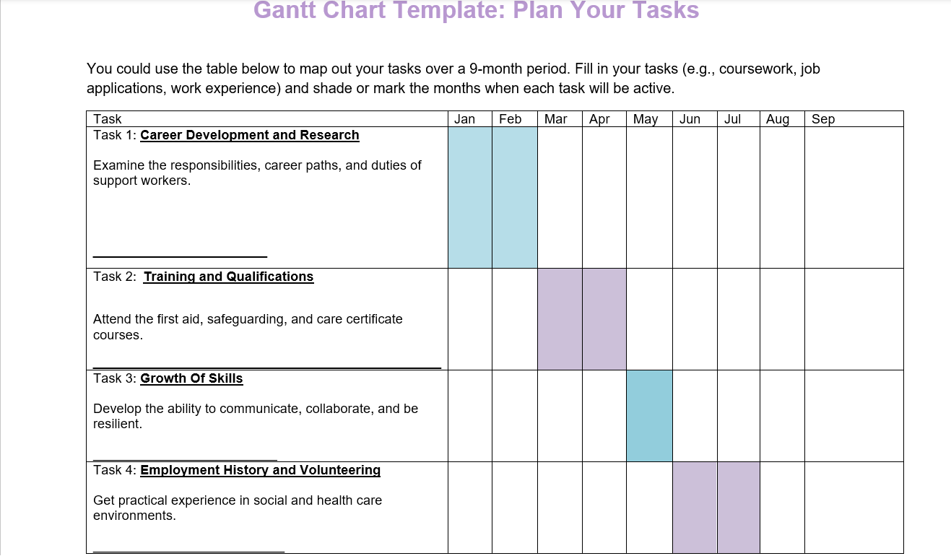

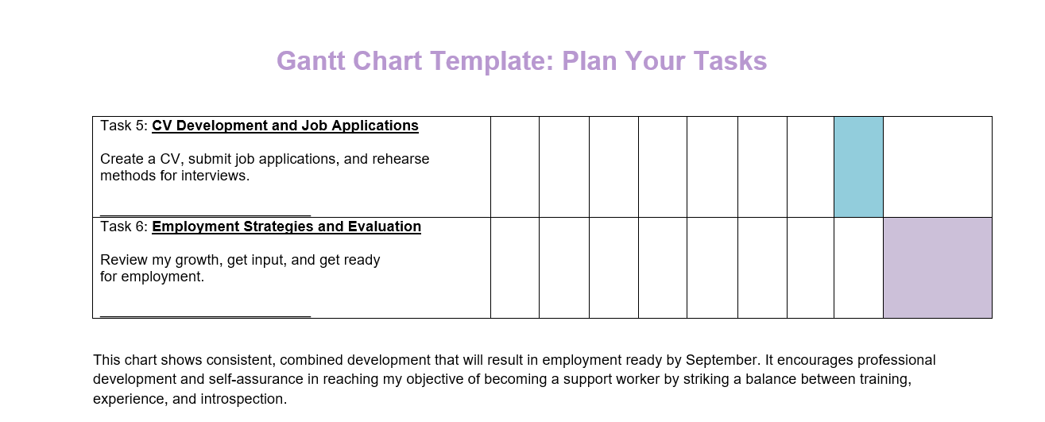

Task 7- Making Changes- Report
You are the manager of a care home and want to make changes to your workplace. Identify one specific change that you want to implement and write a brief report on how this is going to be achieved considering the necessary skills needed and addressing possible barriers to success. Relevant change models can be highlighted (250 words- 2 referenced sources).


This Photo by Unknown Author is licensed under CC BY

My goal as a care home manager is to replace paper-based records with digital care planning solutions. This modification will provide a higher standard of care for residents, increase accuracy, and improve staff communication.
In order to do this, I will apply to Stanz et al. (2021), this consists of three phases: refreezing, changing, and unfreezing. For the purpose of to raise staff knowledge and motivation throughout the unfreezing phase, I will explain to them the advantages of digital care systems, including real-time updates, fewer mistakes, and simpler audits. During the transition phase, employees will get practical training and continuous assistance to develop their digital competence and confidence. In order to sustain commitment, the refreezing step will entail incorporating digital care planning into everyday activities, revising policy, and acknowledging early achievements.
According to Tagscherer and Carbon (2023), digital literacy, leadership, and communication are essential abilities. Creating a culture of openness and support will ease employees' transition to modern technology and minimise their fear of change. Staff opposition, a lack of technical expertise, and a concern of an increased workload are examples of potential obstacles. Assistance with inclusive decision-making, and constant assurance are ways to manage this.
Given the circumstances, the use of digital care planning will modernise the service, encourage accountability, and improve the standard of care given to residents.

Task 8- Self-Reflection
Using one of the highlighted models of reflection, reflect on what you have learned about yourself during this module, as well as the knowledge you have gained, and explain how this has developed your skills and informed your future practice (250 words- you must reference the model you use)

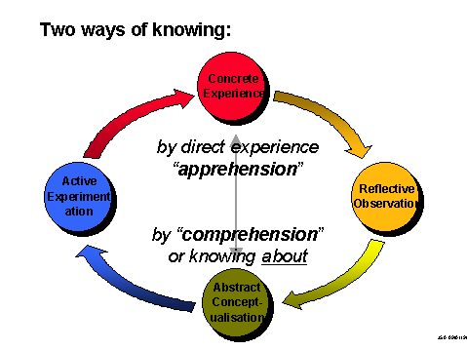
This Photo by Unknown Author is licensed under CC BY-NC-ND

Kolb's Experiential Learning Cycle: A Reflective Account
I have gained a better grasp of my professional identity, capabilities, and limitations during this program. I can consider how my education has influenced my abilities and future practice by using Kolb's Experiential Learning Cycle (1984).
Concrete Experience: Because of my social anxiety, I frequently felt overpowered during group activities in the beginning of the program. It was frightening to talk to strangers and share ideas, and I occasionally remained silent even when I had something worthwhile to offer.
Reflective Observation: I discovered that many students had similar worries by seeing how others behaved. I also understood that I was restricting my confidence and my ability to learn by keeping quiet. This prompted me to consider why communication seemed so difficult and how I may approach it in a unique way.
Abstract Conceptualisation: I was able to comprehend my responses because to the emotional intelligence and resilience module material. Understanding self-awareness, self-regulation, and empathy made it clear to me that controlling one's emotions is a skill that can be learnt rather than something that comes easily. I also discovered how crucial resilience is for handling difficult circumstances and progressively gaining self-assurance.
Active Experimentation: I started practicing little moves, such as posing queries, offering suggestions, and striking up brief discussions. Over time, these activities enhanced my cooperation and communication skills and made me feel less anxious.
My confidence, emotional intelligence, and resilience have all increased as a result of this introspective trip. My future work in health and social care will be directly impacted by these abilities, which will allow me to assist others with professionalism, patience, and compassion.

Reference list
Eatock, J., Cooke, M. and Young, T.P. (2017). Performing or not performing: what’s in a target? Future Hospital Journal, [online] 4(3), pp.167–172. Doi: HTTPs://doi.org/10.7861/futurehosp.4-3-167.
Gorbatov, S., Khapova, S.N. and Lysova, E.I. (2019). Get Noticed to Get Ahead: The Impact of Personal Branding on Career Success. Frontiers in Psychology, [online] 10(2662). Available at: https://www.frontiersin.org/articles/10.3389/fpsyg.2019.02662/full [Accessed 14 Oct. 2025].
Kolb, D.A. (1984). Experiential Learning: Experience As The Source Of Learning And Development. [online] Research Gate. Available at: https://www.researchgate.net/publication/235701029_Experiential_Learning_Experience_As_The_Source_Of_Learning_And_Development [Accessed 17 Nov. 2025].
Li, L.C., Grimshaw, J.M., Nielsen, C., Judd, M., Coyte, P.C. and Graham, I.D. (2009). Evolution of Wenger’s concept of community of practice. Implementation Science, [online] 4(1), pp.1–8. Doi: https://doi.org/10.1186/1748-5908-4-11.
Moudatsou, M., Stavropoulou, A., Philalithis, A. and Koukouli, S. (2020). The Role of Empathy in Health and Social Care Professionals. Healthcare, [online] 8(1), pp.1–9. Doi: https://doi.org/10.3390/healthcare8010026.
NHS Leadership Academy (2011). Leadership Academy Leadership Framework. [online] NHS Leadership Academy. Coventry: NHS Institute for Innovation and Improvement. Available at: https://www.leadershipacademy.nhs.uk/wp-content/uploads/2012/11/NHSLeadership-Framework-LeadershipFramework.pdf [Accessed 5 Nov. 2025].
Service, G.D. (2019). NHS 111 online live assessment. [online] GOV.UK. Available at: https://www.gov.uk/service-standard-reports/nhs-111-online-live-assessment [Accessed 17 Nov. 2025].
Stanz, L., Silverstein, S., Vo, D. and Thompson, J. (2021). Leading through rapid change management. Hospital Pharmacy, [online] 57(4), pp.422–424. Doi: https://doi.org/10.1177/00185787211046855.
Stoewen, D.L. (2024). The vital connection between emotional intelligence and well-being — Part 1: Understanding emotional intelligence and why it matters. The Canadian Veterinary Journal, [online] 65(2), p.182. Available at: https://pmc.ncbi.nlm.nih.gov/articles/PMC10783582/ [Accessed 5 Nov. 2025].
Tagscherer, F. and Carbon, C.-C. (2023). Leadership for Successful digitalization: a Literature Review on Companies’ Internal and External Aspects of Digitalization. Sustainable Technology and Entrepreneurship, [online] 2(2), pp.1–15. Available at: https://www.sciencedirect.com/science/article/pii/S2773032823000032 [Accessed 9 Nov. 2025].

