Cloud Computing Technologies

An Overview and Recommendations Based on Specified Case Study

Thomas Molner
1804565
Anupam Mazumdar

Table of Contents
Introduction 1
Background and terminology of CC 1
Benefits of cloud computing 5
Service models 6
Infrastructure-as-a-Service: 7
Platform-as-a-Service: 7
Software-as-a-Service: 7
Deployment models 7
Private Cloud Computing: 7
Public Cloud Computing: 8
Hybrid Cloud Computing: 8
Role of virtualization using cloud computing 9
Migration strategies of cloud computing 10
Security concerns 12
Implementation process of SaaS for London Bikes 13
Conclusion 14
References 15

Introduction
Cloud Computing (CC) is highly adopted technology in the most of the industry. In addition, there are many benefits of CC, which are helpful in managing different types of business functions including sales, finance, marketing, inventory, payroll, and many more. It can be more valuable for a firm to improve their performance and accuracy. It is the best way to improve the customers satisfaction as well. Besides, many companies have migrated their information system to the cloud-based services, which is a good way to enhance business in the market. It can provide competitive advantage to a firm. London Bikes (LB) is a UK based company, which is located in the London. It is a small and medium enterprise (SME), which provides bicycles for city riding as well as accept custom orders. Moreover, the company has manged their own database management system, which has provided data and information of their customers as well as other processes. This report will provide overview of CC and it will discuss benefits for the company. This report will provide solution of different potential issues and challenges of LB. in this report, service and deployment model will recommended to the LB based on their requirements. This report will suggest migration strategies of CC to the LB. it will include security and privacy of data as well. In the later section, implementation process of SaaS for LB will be discussed based on the various factors.

Background and terminology of CC
In this context, CC is a well-known concept to manage internal and external operations of a firm. In the last few decades, many firms have used Information system (IS) for managing their business processes including decision making system, database management system, transaction management system, and many more.
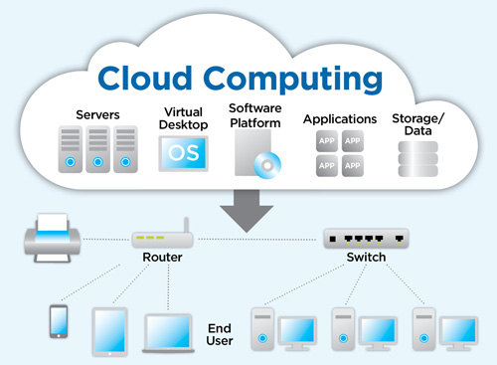
In addition, there is a strong reason of implementation of CC in the LB. it can be more beneficial for a company to improve their functionalities. In case of LB, the staff members can increase their knowledge about the CC and its various features. It can manage most of the business functions in easy way.
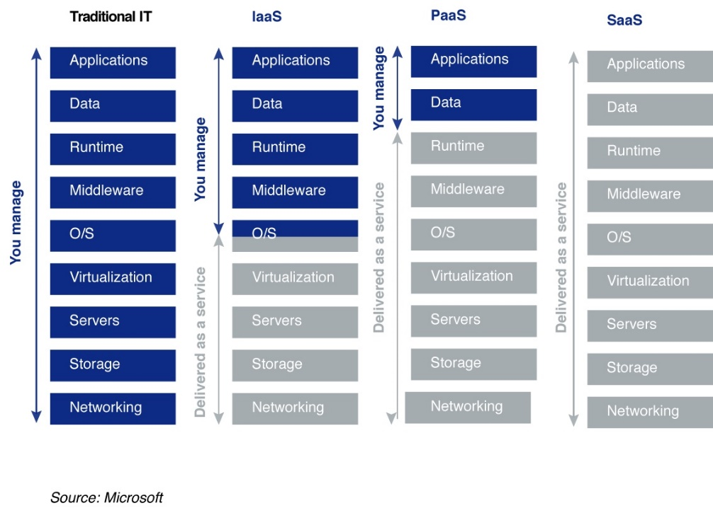
It is good to take help of technology to manage and improve the basic service of a firm. It can be more beneficial and faster. Moreover, cloud-based services can be used for managing different things in an organization, which are Platform-as-a-Service (PaaS), Infrastructure-as-a-Service (IaaS) and Service-as-a-Service (SaaS). Besides, there are mainly three types of services in the industry that are used in an organization to manage their platform, services and infrastructure. It can be beneficial for manging differ types of services. Moreover, most of the services can be managed using basic services.
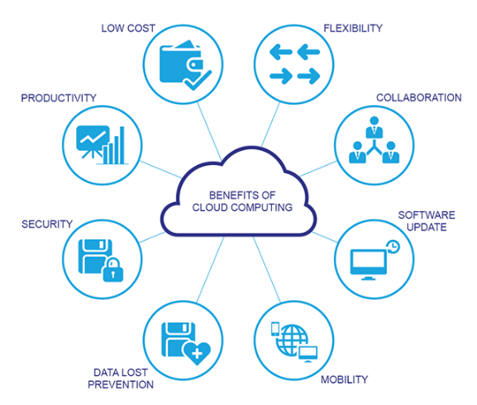

There are many benefits of CC including flexibility, mobility, security, low cost, data lost prevention, collaboration, and many more. These benefits are important from security point of view. Most of the companies have used CC for managing their business operation in more productive way.
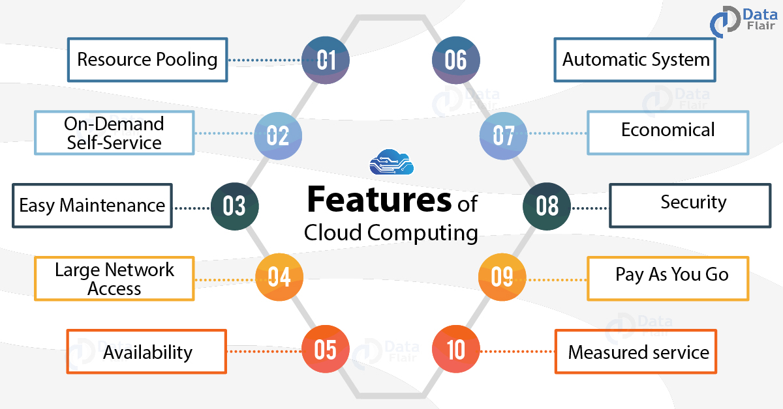
CC has included various features including resource pooling, security, automatic system, availability, pay as you go, easy maintenance, economical, large network access, and on-demand services. It makes all the things easier with the company as well.
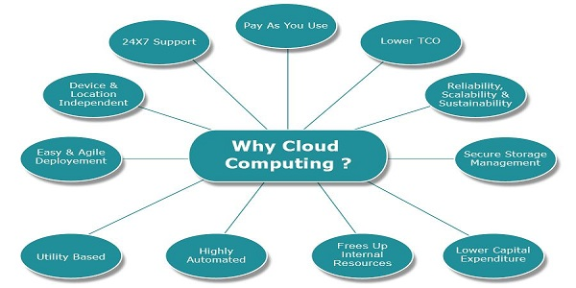
There are many reasons behind the implantation of CC in a firm. In addition, there are many changes in the company, which has based on the migration processes as well. In addition, customer support is available to each consumer, which is a good feature of this system, as most of the clients have faced issues and challenges in this type of processes, which can be reason for manging different types of services. There are many changes required in the manual processes of a company using cloud-based programs. Moreover, low cost is a huge factor of this services, as number of services are available in the cloud-based system.
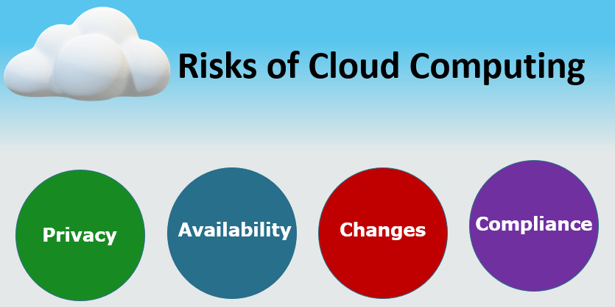
Risks should be managed by a company using different types of cyber security approaches. In addition, there are many challenges in the security of data in CC, as all the data transfer from a public network, which is not secure. Thus, it be properly managed using firewalls and IDS systems. It will be beneficial for an organization from security point of view. In this case, compliance is easy and more powerful to manage issues in the business functions.

Benefits of cloud computing
The idea of cloud commenced within the 1950s. with the aid of the start of the 1990s, cloud services had been utilized by everyone because of the IT revolution. Cloud carrier provision started best by using 2000. The advancement within the cloud grows each day. all of the corporations, no matter length use cloud services. because of the new features which include purchaser courting control, information control, delivery programs, company aid management, industries use cloud services in all forms.
CC has provided many benefits, which are suitable of most of the SME’s as well. LB can adopt the CC for managing their internal processes as well as external processes including payroll systems and marketing.
The provider supplied through the internet to the users on-call for in place of via the enterprise’s very own servers is known as cloud services. The facts are saved in pools or digital servers and is available any time via the internet. Cloud services confer with any programs, offerings or sources. The provider is controlled via the cloud provider. The company presents all the sources wanted for the application and for this reason the organisation desires no longer to fear about useful resource allocation. Cloud offerings can dynamically scale up based totally on users’ desires. we can say that the cloud is the transport of servers, garage, and backups on line. carrier carriers fee businesses for cloud usage.
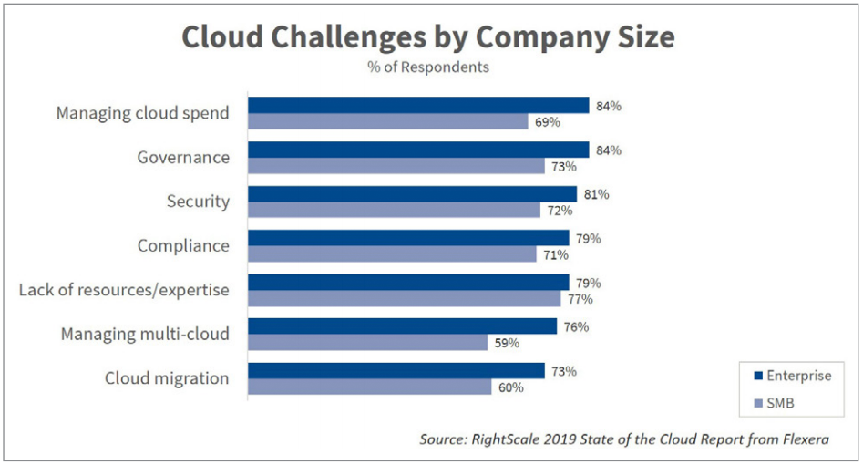
It is a basic need of a firm to manage its IT assets in a proper manner. However, Cloud-based services are available in the low cost. Moreover, governance level is high with CC.
The information may be stored on-line and also subsidized up, documents can collaborate without problems, database processing can be finished and technical guide services can be controlled. Also, new programs may be created and managed, statistics is recovered and streaming audio and video, information evaluation, and prediction are done the usage of cloud offerings. Thus, users’ interest is tracked effortlessly the usage of cloud and therefore it is made comfy.
Now the packages want not be downloaded inside the system to use. Cloud infrastructure facilitates the organizations to apply programs at their very own tempo and without a license issue. consequently, the storage and time of down load are stored. additionally, even as the usage of the utility within the cloud, the utility works faster than the local network. The advantages of cloud services are scalability, accessibility, speed, less cost, computerized update, patch updating, statistics recovery, safety, much less energy, no bodily servers in the agencies and collaboration of storage with extraordinary establishments.
Cloud computing commercial enterprise answers enable your business to leverage sources that cloud service carriers hold and reserve in mystery, comfy servers, and networks. Cloud solutions provide an obvious strategy to mobilize community sources and data.
Besides, legendary commercial enterprise applications have forever been very complicated and luxurious to keep. numerous software and hardware are required to run them that is simply daunting. Thus, except that, agencies want to have an in-house group of professionals to install, configure, check, run, relaxed, and update them.
presently, a massive number of businesses are relying on apps inside the cloud, like HR, accounting, customer relationship management, and much greater. most of the sector’s largest groups have moved their packages to the cloud after knowledge the reliability and security of its infrastructure.
In addition, there are many chances for upgradation of this system because it can manage all the data in a proper manner, which can be transferred in another system in easy way. It can be used for other systems as well.

Service models
There are three types of service models in the CC, which has used for managing different types of services in an organization, which areas:

Infrastructure-as-a-Service:
LB can use IaaS for developing their own servers, network, software, hardware, and other on the cloud storage. It is a hardware service in which vendor has provided different types of services including data centres, network, servers, data storage in this service. It is basically platform virtualization, as SME cannot spent large amount of money for infrastructure. Thus, it can be managed using cloud-based service. It will be easier to pay based on the services. It is scalable, which is a most important factor of CC.

Platform-as-a-Service:
It is an important service for an organization as it can provide services for software development including software and hardware as well. The vendor provides various components including database management systems. Besides, PaaS provides different types of languages for programming and it provides platform for editing, compilation, execution, and testing. The main advantage of PaaS is web services integration.

Software-as-a-Service:
It is a basic service that provide applications to users for managing their works. It can be added new features based on the clients demands. It can integrate with LB IT unfractured as well. It is helpful in the sales and marketing as well as inventory management. There is many software available in the CC, which can be modified based on the user’s demand. It can provide more better features as well.
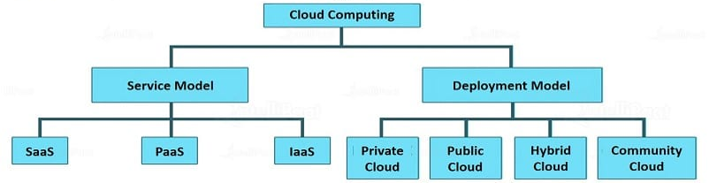
Moreover, there are some other services are also available based on the demand of clients, which are Network-as-a-Service and Function-as-a-Service.

Deployment models
Development models can be divided in three parts, which are private, public and hybrid.

Private Cloud Computing:
A private cloud ha used for confidential and sensitive data, as it provides better outcomes for a company. It offerings to corporations from a business middle to their inner customers. In different phrases, non-public clouds are operated by means of the corporations separately and offer more controlling skills over the resources.

Public Cloud Computing:
Public clouds are solely owned and operated with the aid of the corporations where a third party provides the offerings over a public community. In addition, there are many personal documents of a company, which can be secured using basic processes. This facilitates the corporations keep money and time from obtaining the resources manually.

Hybrid Cloud Computing:
Hybrid clouds are the appropriate amalgamation of public and private clouds. here, an organisation can use a non-public cloud for strolling personal and essential operations and use a public cloud for sharing the workloads and scaling the infrastructure. Besides, there are Mancy changes in the system as well. an agency can't live to tell the tale with simply the private cloud as public clouds serve a massive number of functions in a single shot. therefore, a balance among those two is fairly desirable, that's fulfilled via a hybrid cloud.
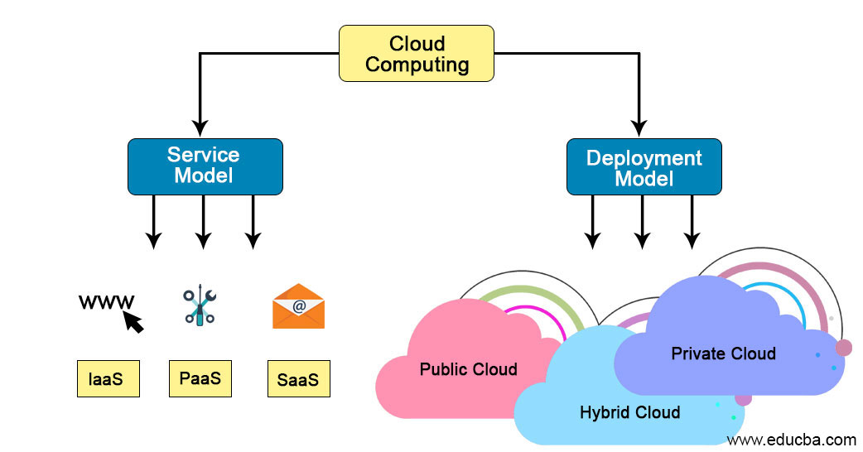
Moreover, consumers over the net use CC in which the infrastructure is primarily based at the cloud computing business enterprise. Most of the systems have used proper configuration. However, the public cloud is not relaxed and the businesses with touchy facts are not must use this cloud. The data is available for all and sundry who makes use of the cloud. In addition, it will suitable for the company as well. The cloud infrastructure is positioned in the enterprise and it isn't always shared with all. It is a personal cloud as most comfy amongst all the cloud deployments. Thus, it can be used for managing different types of processes, which are helpful in the management of other services. Customization, scaling and versatility manage is higher within the non-public cloud. hardware and software program are built best for the proprietor.
Moreover, there are many benefits of private and public cloud in a firm to improve the business functions. The combination of personal and public cloud deployments is called the hybrid cloud. Besides, LB can be used this approach to manage all the problem using this approach. Many companies have the benefit of public cloud at the same time as doing heavy workloads and the facts is at ease as non-public cloud is integrated in the same.
The deployment model furnished for a restricted number of people and agencies so that the offerings are loved best within themselves are known as network cloud. In addition, there are many good changes in the business operations using CC. Besides, this is provided both internally or externally and hosted primarily based on the requirements of the company.
Besides, different styles of cloud services assist users in all methods to absolutely use the service. service carriers use their full capacity to serve customers. The customers have to be vigilant for their information to be at ease through provider carriers offer complete protection.

Role of virtualization using cloud computing
Virtualisation is used for running programs on virtual infrastructure of CC. it is the process of running a virtual instance of a hardware in a layer abstracted from the hardware. Besides, it refers to running multiple OS on a device. Moreover, it can provide help into running large programs and multiple processing.
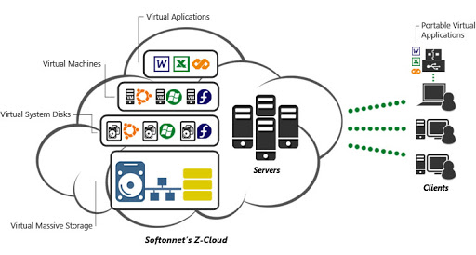
It is a new concept to provide many benefits from virtual hardware. There are many benefits of virtualization, which makes it more important. The company does not require hardware and software from different vendors, as all the software and hardware are available using CC.
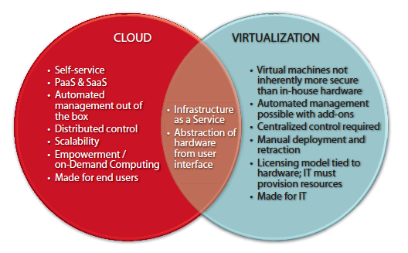
There are some issues with virtualisation, which makes less secure the hardware as compared to on-premises hardware.

Migration strategies of cloud computing
Many organizations have successfully migrated from information systems to cloud-based services because of many benefits and features. It provides easy migration process, which is suitable for SME’s as well. LB has used database management system. Thus, all the data can be migrated on the cloud in easy way. Moreover, there are many other benefits of migration process. It can be managed in easy way, as most of the processes can be used for managing different types of services of LB.
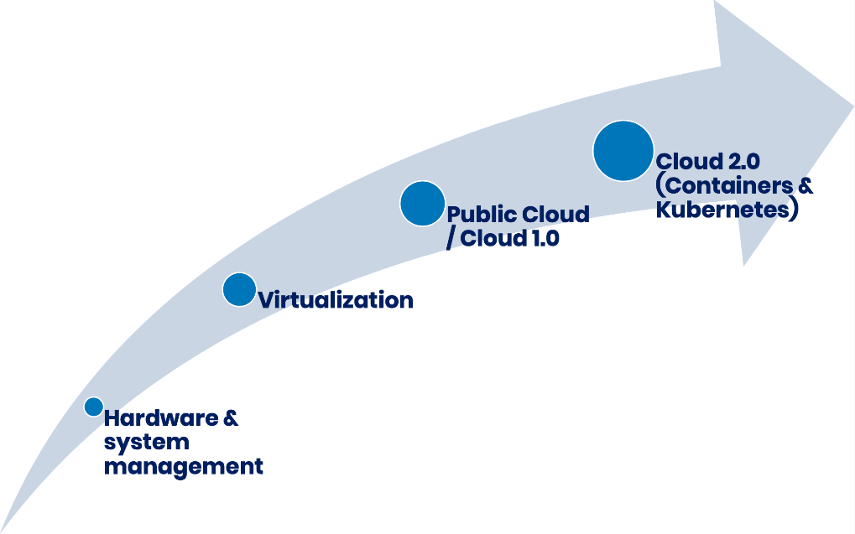
Migration is needed in many organizations as they face issues in their basic requirements, which are not suitable for a company. Moreover, data can be migrated in another system using proper format. CC has provided various options to manage all the data in a proper manner. Most of the things can be changed using migration stages.
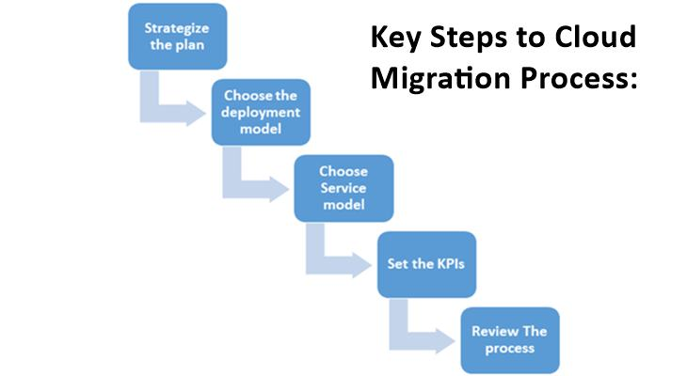
Migration has needed a plan to transfer all the business functions into CC. in addition, this plan is based on the requirement of a company, which is needed based on their requirement. Most of the data is presented in the structured manner. However, it is a tough stage to manage a plan.
Second stage is development model selection, which is a good way to improve the applications and services of a firm. It is based on the working processes, as public cloud can be used for managing external services. However, private cloud can be used for secure data of the firm. It can be used based on the requirements of a firm. Few firms have adopted hybrid cloud to manage their private and public clouds as well. Most of the services should be managed using this approach as it is necessary to develop a strong model.
The next stage is service model that is based on the services of a company. In case of LB, SaaS can be used for managing their services. It is the best way to manage number of clients in better manner. It will improve the performance of a company as well. LB must include such types of services to improve their performance. It will be more suitable for the company in the future as well.
In addition, KPI’s should de designed for manging migration process, as it is related to the business functions of the company. LB should include their roles and responsibilities of employees for their business using KPI’s.
Moreover, review process is used for understanding whole processes. It will provide a brief knowledge about the basic processes. In addition, most of the companies have used this approach for managing their issues and challenges. All of the business processes should be used for managing different types of works.

Security concerns
Cloud computing has provided secure channel for accessing data and services. However, there is some security issue and challenges. In addition, there are many reasons behind the cyber threats for a firm. LB can use CC for improving their security as well. It will secure all the data and information in encrypted form. Moreover, there are many benefits of CC in the security and privacy of data. It can be more secure in the future, as it has based on the Artificial Intelligence and Machine leaning.
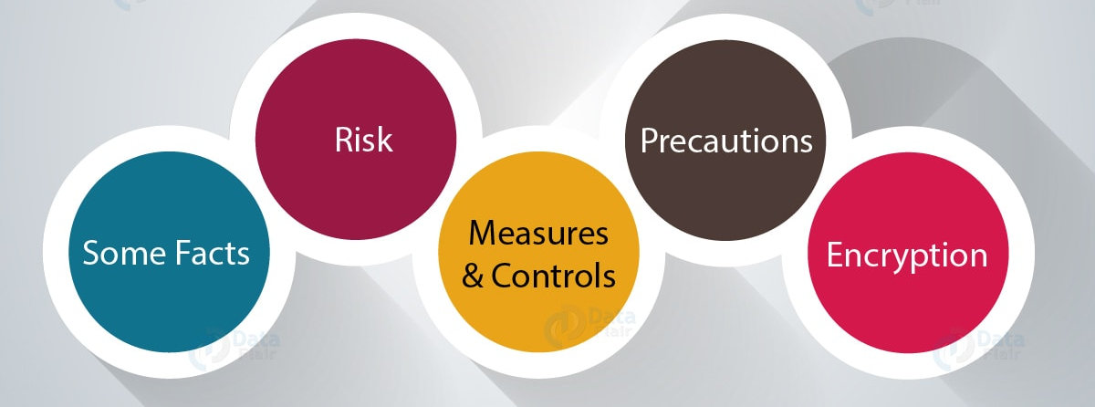
Risk assessment is easier in the cloud-based service, as all the services are centralized, which is easy to identify threats and vulnerabilities. Moreover, CC has provided precautions for managing IT assets and security policies. In addition, CC can measure risk to design security controls based on their ranking.

Implementation process of SaaS for London Bikes
There are many changes in the basic processes in the implementation of SaaS, as most of the new software will be used for managing the work. LB should transfer their data from their database management system to CC, which is managed from the cloud-based data storage as well as database system. It is the best way to use software for managing internal and external programs.
Besides, implementation plan is required for managing implementation process of SaaS. LB should create a plan to implement cloud-based services. It is based on their requirements. The company has used legacy systems, which are not suitable for the CC, as they can be a reason of cyber-threats. Thus, first thing is that update all the systems with latest antiviruses and patches to secure the data and information.
Therefore, LB should use proper implementation process in the SaaS. In addition, the company should create a backup of their data to avoid any type of risk during implementation. It can be manged using different types of work models as well. It will make huge impact on the company profit in the future as well. CC should require a basic IT infrastructure to run the whole programs.
A proper policy should be used for implantation of SaaS. It is based on the requirements of the LB. according to the company, database management system can be used for internal processes, which can be used for another works as well. In addition, the company can improve their security systems to avoid threats and risks as well.
Moreover, a high level of security system will be used for security data and network of the company as well. There are many hackers, which can access the data from a system because of lack of security. However, cloud-based services are secured but clients should be ready for handling security issues.
In addition, there are many changes in the security systems based on the requirements. SaaS has used for payroll management of the company, as it has provided different types of services. Accounting service should be managed using accounting software. In addition, LB should connect their website with the cloud-based services in this implantation processes. All the business functions should be managed using centralized system. All the manual work transferred to automatic work, which will manage by a superior person. In addition, it will more suitable for audit and other works of the company.
Furthermore. Implantation processes has required number of software, which has required for the company to manage their business processes including payroll and other systems. In addition, most of the computer system have managed their performance using new hardware and software. All the stages should be reviewed by an IT expert before starting the processes. It will help in to the management of various services of the company.

Conclusion
In concision, CC is the best approach to improve the business growth of LB, as it can provide better customer services using different types of software and applications. Moreover, there are many benefits of the CC, which are suitable for LB. Moreover, CC terminologies are suitable for long term benefits for LB. Besides, service model can be used for different types of services including platform, software, and infrastructure. This report has provided overview of CC and its terminologies. In addition, private and public cloud services can be used for separate works. This report has provided development model of CC. In addition, the security is high in the CC, which is a first need of online services. Besides, most of the processes can be managed using virtualisations, which provide hardware and software for editing, compiling and executing programs of different languages. In addition, implementation process of SaaS is easy and flexible that is a quality of CC. Finally, LB should implement SaaS for managing their business processes including sales and marketing. It will provide better support to their customers as well.

References
Alley, G., 2018. What is Cloud Migration?. [Online]
Available at: https://www.alooma.com/blog/what-is-cloud-migration
[Accessed 28 December 2019].
Balalaie, A., Heydarnoori, . A. & Jamshidi, P., 2016. Microservices architecture enables devops: Migration to a cloud-native architecture. Ieee Software, 33(3), pp. 42-52.
Bhagat, . B. C., 2012. Cloud computing governance, cyber security, risk, and compliance business rules system and method. U. S., Patent No. 13/016,999.
Bird, D. A., 2018. Information Security risk considerations for the processing of IoT sourced data in the Public Cloud.
Blakstad, K. . M. & Andreassen, M., 2016. Security in Cloud Computing: A Security Assessment of Cloud Computing Providers for an Online Receipt Storage. [Online]
Available at: https://brage.bibsys.no/xmlui/handle/11250/253189
[Accessed 21 February 2019].
Chen, D. & Zhao, H., 2012. Data security and privacy protection issues in cloud computing. International Conference on Computer Science and Electronics Engineering, 1(1), pp. 647-651.
Jansen, W. A., 2011. Cloud hooks: Security and privacy issues in cloud computing.. Hawaii, IEEE, pp. 1-10.
Kaufman, L. M., 2009. Data security in the world of cloud computing. IEEE Security & Privacy, 7(4), pp. 61-64.
King, N. J. & Raja, V. T., 2012. Protecting the privacy and security of sensitive customer data in the cloud.. Computer Law & Security Review, 28(3), pp. 308-319.
Kshetri, . N., 2013. Privacy and security issues in cloud computing: The role of institutions and institutional evolution. Telecommunications Policy, 37(4-5), pp. 372-386.
Mather, T., Kumaraswamy, S. & Latif, S., 2009. Cloud security and privacy: an enterprise perspective on risks and compliance.. Sebastopol: O'Reilly Media, Inc..
Pearson, . S., 2013. Privacy, security and trust in cloud computing. In Privacy and Security for Cloud Computing. 1 ed. London: Springer.
Peng, G. C. A. & Gala, C., 2014. Cloud ERP: a new dilemma to modern organisations?. Journal of Computer Information Systems, 54(4), pp. 22-30.
Prokopp, C., 2014. Big Data Science and Cloud Computing. [Online]
Available at: https://www.semantikoz.com/blog/big-data-as-a-service-definition-classification/
[Accessed 25 October 2019].
Publishing, P., 2018. Complex Cloud Architecture Types. [Online]
Available at: https://www.networkcomputing.com/cloud-infrastructure/complex-cloud-architecture-types
Rittinghouse, J. W. & Ransome, J. F., 2016. Cloud computing: implementation, management, and security. Florida: CRC press.
Romansky, R., 2012. Cloud Services: Challenges for Personal Data Protection. International Journal on Information Technologies and Security, pp. 67-80.
Sen, J., 2014. Security and privacy issues in cloud computing.. In: In Architectures and protocols for secure information technology infrastructures. USA: IGI Global, pp. 1-45.
Sill, A., 2016. The design and architecture of microservices. IEEE Cloud Computing, 3(5), pp. 76-80.
Svantesson, D. & Clarke, R., 2010. Privacy and consumer risks in cloud computing.. Computer law & security review, 26(4), pp. 391-397.
Takabi, H., Joshi, J. B. & Ahn, G. J., 2010. Security and privacy challenges in cloud computing environments.. IEEE Security & Privacy, 6(1), pp. 24-31.
Wu, Y., Casey, C. G., Hazen, B. T. & Hall, D. J., 2013. Cloud computing in support of supply chain information system infrastructure: understanding when to go to the cloud. Journal of Supply Chain Management, 49(3), pp. 25-41.
Zhou, J., Cao, Z., Dong, X. & Vasilakos, A. . V., 2017. Security and privacy for cloud-based IoT: challenges.. IEEE Communications Magazine, 55(1), pp. 26-33.

