A
ASsignment 2
Learning in the Digital Era

Video presentation Link: Video presentation

Module Name: Learning in the Digital Era
Module Code: ACCA 4025
Student Name: Jonathan Hernandez
Student ID: 2513126
Group: 4
Lecturer’s name: Dipo Dunsin

Table of Contents
Introduction 1
Main body 1
Slide 1: Cover page 1
Slide 2 : Contents 2
Slide 3: Gibbs Model 2
Slide 4 : Self evaluation with SWOT 3
Slide 5 : Professional development plan (PDP) with SMART objectives. 3
Slide 6: Assigned topic from Unit 4 “Becoming a lifelong learner 4
Slide 7: Conclusion 4
Slide 8 References 5
Conclusion 5
References 5

Introduction
This assignment is about to make a self-evaluation from myself based on tasks as SWOT analysis, Professional development plan(PDP) and a summary of an assigned topic from Unit 4 “becoming a lifelong learner”. This assignment will show what are my expectations and plans for the future, also getting known my personality based on experiences and learnings through life so far.

Main body
This is the main body, here are the slides of my presentation and a brief explanation of each one.
Video Link: Video presentation

Slide 1: Cover page
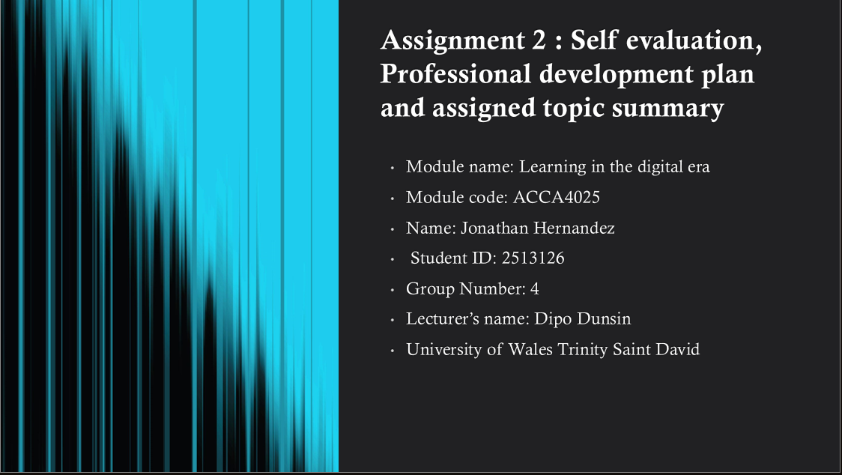

Slide 2 : Contents

Slide 3: Gibbs Model

This slide is about the Gibbs model is about how to develop a plan form six stages, this method will help met to create a plan based on my professional development plan and to make an evaluation from my experiences of what I did and did not an also analyse and reflect on what it could be better in that time [1] [2] [3].

Slide 4 : Self evaluation with SWOT

This task is about my self-reflection using SWOT method, here are some strengths and weaknesses from my personality, also it shows some opportunities and traits I have gained from self-reflection.

Slide 5 : Professional development plan (PDP) with SMART objectives.

This slide shows a professional development plan using SMART method for my future path and what I need to do to become a software developer. This is based on goals to achieve, personal, action plan or opportunities to develop with a qualification and the expected time to get them completed.
Slide 6: Assigned topic from Unit 4 “Becoming a lifelong learner”

This slide is about a specific topic from Unit 4, in my case is the section reflectivity as mindset from topic Unpacking experiences, it is about how reflection can impact on human beings and personalities and what is one of the most important ways to do this.

Slide 7: Conclusion

Slide 8 References

Conclusion
This assignment has showed my personality base on my own reflection, I have could been able to identify, analyse, reflect and know different aspects of my own self and how reflection can impact on people so they are able to create different opinions and perspectives to structure a good Professional development plan for their future paths and the reason what is so important to know how to do this

References
Gibbs model references
[1]
J. Oviawe, “Application of Graham Gibbs model of reflection to improve teaching understanding among technical education students in Ambrose Alli University Ekpoma Edo State,” vol. 3, no. 2, pp. 1201–2617, 2020.
[2]
K. S. Praveena, F. Juslin, C. M. Patil, and K. Bhargavi, “Using Gibb’s Reflective Model Approach for Enhancing Project-Based Learning Among Students Through Reflective Assessment,” pp. 148–155, 2025.
[3]
I. S. Adeani, R. B. Febriani, and S. Syafryadin, “Using GIBBS’reflective cycle in making reflections of literary analysis,” vol. 6, no. 2, pp. 139–148, 2020.
Task 1 references
[4]
T. A. Widiger, “Strengths and weaknesses,” p. 261, 2016.
[5]
F. Gander, J. Hofmann, and W. Ruch, “Character strengths: Person–environment fit and relationships with job and life satisfaction,” vol. 11, p. 1582, 2020.
[6]
W. Fleeson, Perspectives on the person: Rapid growth and opportunities for integration. Oxford University Press New York, 2012.
[7]
E. Diener and R. E. Lucas, “Personality traits,” vol. 278, p. 3, 2019.
Task 2
[8]
J. Liebenberg, M. Huisman, and E. Mentz, “Knowledge and skills requirements for software developer students,” vol. 8, no. 8, pp. 2604–2609, 2014.
[9]
D. Graziotin, X. Wang, and P. Abrahamsson, “Software developers, moods, emotions, and performance,” 2014.
[10]
M. N. A. Khan, M. Khalid, and S. ul Haq, “Review of requirements management issues in software development,” vol. 5, no. 1, pp. 21–27, 2013.
Task 3
[11]
J. Anderson, “Reflection,” vol. 74, no. 4, pp. 480–483, 2020.
[12]
K. Peck, “The Influence Of Student Self-Reflection On Academic Mindset Change,” 2019.
[13]
M. J. Butler, “Thinking Creatively About Learning–The Reflective Mindset,” p. 31, 2006.
[14]
M. Clarà, “What is reflection? Looking for clarity in an ambiguous notion,” vol. 66, no. 3, pp. 261–271, 2015.

