

Assessment 2

The Global Business Environment

Name: Georgiana Loredana Nedelcu
Student ID: 2018584

Table of Contents

Introduction 3
Impact of the pandemic on the automobile industry (Aston Martin) 4
Survival and success factors 7
Conclusion 10
References 11

Introduction
The automobile industry has been greatly affected because of the pandemic. Aston Martin has been selected as the automobile brand to focus on. The aim of this task is to assess how COVID-19 affects the automobile industry and the process in which Aston Martin can deal with it to ensure success in the market. At first, the trend in the market will be analysed to find out the impact of the pandemic. Based on that survival and success factors will be developed so that businesses in the industry can have the chance to survive.

Impact of the pandemic on the automobile industry (Aston Martin)
The automobile industry experiences the negative impact of the pandemic. Most aspect of a business in the industry has been affected because of the pandemic. Some of these impacts are:
Decreasing sales: The sales of Aston Martin products has been decreased because of the pandemic. The impact of this is different in different parts of the world. By October 2020, cars sales in Western Europe has been reduced by 3.84 million (Statista, 2021). That means the customers are not willing to buy new cars. The demand for cars has been reduced in other factors of the world as well. For example, in North America car sales reduced by 2.52 million, 1.47 million in the Chinese market and 0.54 million in the Japanese market. This is indicating that the sales in the market have been affected greatly because of the pandemic (Tamtam and Tourabi, 2021). Although the sales have been started to increase it will take time to reach the previous level. The demand for luxury vehicles has been reduced more than the demand for comfort vehicles. This was the reason for which a business like Aston Martin suffered a huge amount of loss in the market.
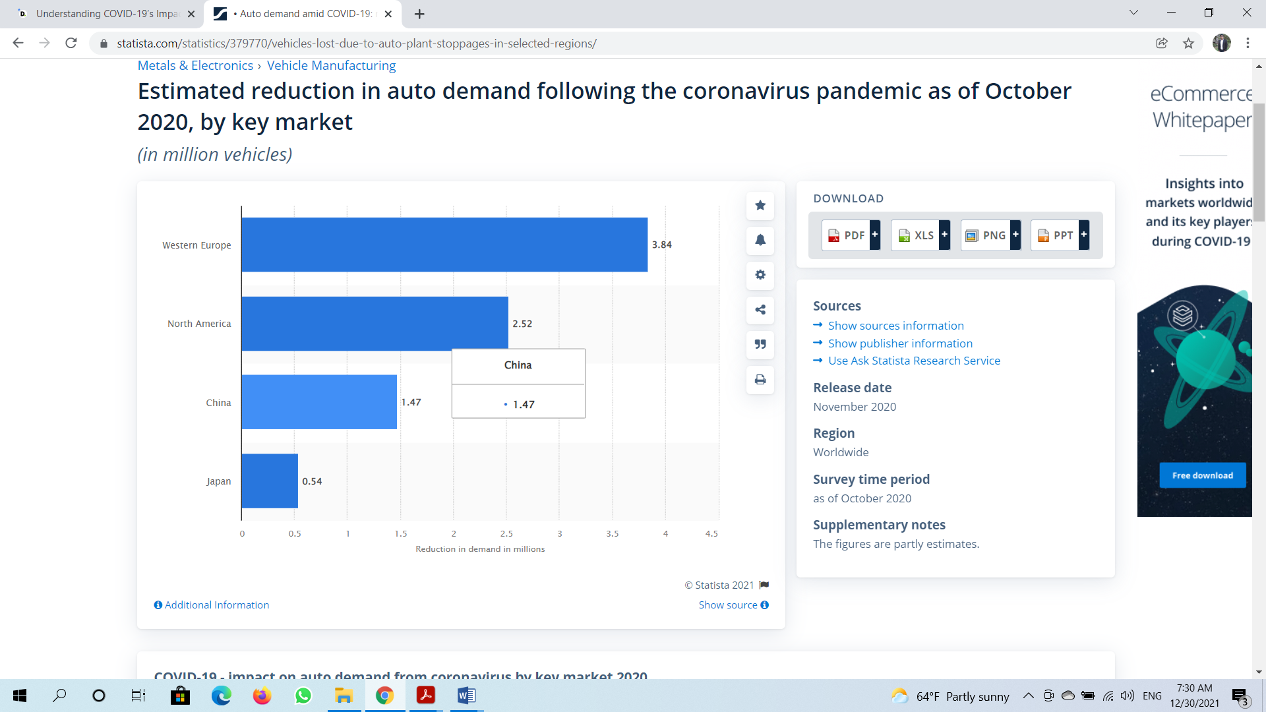
Figure: Decreasing sales
Source: (Statista, 2021)
Supply chain problem: During the pandemic, almost all countries governments initiate lockdown to reduce the spread of the pandemic. This was a necessary decision, but the problem was that it affect Aston Martin negatively (Deloitte.com, 2021). This creates problems for the supply chain of the business as the movement of raw materials and final product of the business was difficult. That means production continuity was greatly affected because of the pandemic. Automobile company like Aston martin faces problem regarding the supply chain as well.
Change in customer preference: This is one of the most important aspects on which the automobile industry companies like Aston Martin need to focus on. Because of COVID-19, the global economy has been slowed down and several countries are facing negative economic growth including the UK (Silva et al., 2021). Job cut, decreasing income base, increasing cost and trying to focus on comfort than luxury has become common trends in the market. None of these is good for the automobile industry. For example, the products which Aston Martin provides is not a daily commodity and that when people will not have enough money in hand then it will try to reduce cost in an area that is not necessary (Shiddiq, 2020). That might be a reason for which the customers are not interested to spend money for buying cars. Every company in the automobile industry has to focus on this aspect to ensure success in the market and survival. For example, using digital tools for conducting marketing has become an important trend because of the change in customer preference in the automobile industry.
Change in business structure: The ways in which a business is operating in the market has been affected because of the pandemic as well. For example, many companies in the automobile industry have to invest more in digital marketing than in traditional marketing processes which is an example of changing capital structure (Haria, 2021). The funding requirement for R&D has been increased so that innovative products can be developed. This was important to make sure that the product and service which the business is offering is based on the needs and wants of the customers. COVID-19 has a huge impact on strategic decision making and organisational structure. For example, becoming cost-effective has become a necessity for luxury car producers to stay in the market. The cost of operating a business in the automobile industry has been increased as well which is indicating a change in the capital structure and Aston Martin should focus on that.
Liquidity issues for the suppliers: In Aston Martin, suppliers play an important role because without the raw materials which have been supplied by the suppliers, a company in the industry will not be able to operate the business production. But the suppliers in the industry is facing liquidity problem (Redda and Surujlal, 2021). The financial institutions were not interested to provide loans during the pandemic and it was the reason for which the crisis has been raised. If the supplies do not have the required money to operate in the market the whole supply chain will fail and ultimately it will affect the automobile industry.
Impact on the employees: Employees in Aston Martin has been affected as well because of the pandemic. The number of employees who work in the industry has been affected by the pandemic. This has a huge impact on productivity of the employees in employees in the automobile industry (Kaitwade, 2020). For that, trends like remote working have emerged in the industry. The companies in the industry are trying to make sure that remote working opportunities will be provided to employees so that employees can have the chance to work from their comfort zone and that will have a positive impact on employee productivity. For example, the rate of employee turnover has been increased because of the pandemic in Aston Martin. Apart from that the motivation of an employee has been affected because of this as well.
Strategic preference has been changed: The strategy which a company in the automobile industry was used before and after the pandemic has been changed as well. For example, most of the companies in the automobile industry are now focused on installing advanced technology on vehicles because this has become a demand (Holmes, 2022). Social media has been started to be used as a way to promote the product in the market. The ways in which a business was distributing its final product in the market has been changed as well. From this, it can be said that the strategy concerning most of the aspects of Aston Martin has been changed because of the pandemic.
These are some of the impacts of COVID-19 on the automobile industry and on Aston Martin. A business that is operating in the market must have to make sure that these factors have been considered while running a business. The companies which will be able to deal with these will have sustainability in the automobile industry.

Figure: Impact of COVID-19 on the automobile industry (Aston Martin)
Source: Author

Survival and success factors
There are a few factors on which Aston Martin will have to focus to ensure that the business has the ability to survive in the industry and achieve success. Some of these factors include:
Ensuring employee safety: This is one of the most important survival factors on which a business in the automobile industry must have to focus on. COVID-19 endangered the safety of an employee. This disease is very continuous and for that, it spread fast. That is taking action to ensure the safety of the employees has become important (Hoeft, 2021). Although Aston Martin is not a labour-intensive company still it is important because employee safety is related to employee products which are important for success and survival.
Provide remote working opportunity: Most of the task in Aston Martin has been done automatically and for that, there are very few employees in Aston Martin who has to work in the factory. That means providing remote working opportunities in the industry is possible (Deloitte.com, 2021). Researchers found out that the employees who are working remotely are more productive than an employee which is working in the office. For that reason providing remote working opportunities can be helpful to deal with the problem which has been created because of the pandemic and ensures success.
Innovate: The demand for customers in Aston Martin has been changing rapidly because of the pandemic. In this type of situation innovation is the only way in which a business in the automobile industry can meet the needs and wants of the employees. That is why it has become an important survival and success factor (Haria, 2021). Innovation is an effective tool to offer something new to the customers so that the customers can be attracted to the business.
Cost-effectiveness: The cost of conducting a business during the pandemic has been increased. But the most important reason for which Aston Martin should focus on achieving cost-effectiveness is that the personal disposable income base of an individual has been reduced. That is why price reduction has become a necessity (Tamtam and Tourabi, 2021). In this case, ensuring cost-effectiveness is the only way to ensure profitability by reducing the price. For that aspect, a business in the automobile industry should focus on this.
Employee training: Adaptability has become an important skill to have for an employee to deal with the pandemic. There is a high chance that the employee's industry does not have much knowledge about the process in which safety can be ensured and productivity has been maintained so that the business can have the chance to ensure success. Employee training is the process that Aston Martin can use for this process.
Focus on technology: The use of technology in the production facility of Aston Martin and the products is important. Using technology in production will be helpful to increase quality and reduce cost (Silva et al., 2021). Customers will have the chance to have the best experience because of having advanced technology like self-driving in cars. A business will be able to achieve a competitive advantage in the market because of this.
Focus on customer trends: The spending trend of the customers, the preference of how to get information, what types of product which the customers want etc. has been changed. A business in the automobile industry needs to focus on those trends while offering. If a business is able to get this right then the customers will be attracted to the business and the chance of the business to achieve a competitive advantage will be improved.
Develop an effective supply chain: During the pandemic, the supply chain was the most problematic area. This has a huge impact on the ability of a business to operate effectively (Hoeft, 2021). The business in the automobile industry needs to ensure that the supply chain which has been used is effective because effectiveness in supply will ensure the ability of a business to achieve competitive ability.

Conclusion
COVID-19 has a negative impact on the automobile industry and Aston Martin. The sale industry has been decreased, the supply chain in problem, the suppliers in the industry if facing credit issues, the organisational structure has been changed because of the pandemic and the cost of operation has been increased because of COVID-19. Aston Martin needs to focus on finding out ways to deal with the pandemic. Some of the factors on which focus should be given includes ensuring employee safety, the remote working opportunity for the employees, achieving cost-effectiveness, becoming innovative and ensuring the effectiveness of the supply chain.

References
Deloitte.com (2021). Understanding COVID-19’s Impact on The Automotive Sector. [online] Deloitte United States. Available at: https://www2.deloitte.com/us/en/pages/about-deloitte/articles/covid-19/covid-19-impact-on-automotive-sector.html.
Haria, H.J. (2021). Organizational Change and Development during the COVID-19 Pandemic in Automotive Industry. SSRN Electronic Journal.
Hoeft, F. (2021). The case of sales in the automotive industry during the COVID‐19 pandemic. Strategic Change, 30(2), pp.117–125.
Holmes, J. (2022). New Trade Rules, Technological Disruption and COVID-19: Prospects for Ontario in the Cross-Border Great Lakes Automotive Industry. International Journal of Automotive Technology and Management, 22(1), p.1.
Kaitwade, N. (2020). COVID-19 shatters global automotive industry; sales of metal powder take a nosedive amid wavering demand. Metal Powder Report.
Redda, E.H. and Surujlal, J. (2021). AN IMPACT ASSESSMENT OF COVID-19 ON THE SOUTH AFRICAN AUTOMOTIVE INDUSTRY. EURASIAN JOURNAL OF BUSINESS AND MANAGEMENT, 9(3), pp.208–216.
Shiddiq, M. (2020). Case Study of Tesla, Inc. as Dynamic Organization in Automotive Industry and How It Acts Amidst COVID-19 Epidemic. SSRN Electronic Journal.
Silva, C.A.G., Faria, W., Betarelli, A. and Andrade, G. (2021). Business cycle and uncertainties: evaluating the behavior of the automotive industry in relation to the COVID-19 period in Brazil. International Journal of Automotive Technology and Management, 21(4), p.1.
Statista. (2021). Auto demand amid COVID-19: reduction by market. [online] Available at: https://www.statista.com/statistics/379770/vehicles-lost-due-to-auto-plant-stoppages-in-selected-regions/.
Tamtam, F. and Tourabi, A. (2021). Analysis of the agility of the automotive industry supply chain in times of COVID-19: a case study. EUREKA: Physics and Engineering, (6), pp.112–120.

