

UNIVERSITY of WALES TRINITY ST. DAVID
Certificate of higher education skills for the workplace

Effective teamwork and communication

Report 2000 words

Student: Andrea Pisanti (2111539)
Lecturer: Ejiro Esohwode (BMSW4002_LON)

Table of Contents
Introduction 1
Models of Communication 2
SHANNON and WEAVER 2
Schramm 4
Berlo 5
Communication skills 7
Verbal communication 7
Nonverbal communication 7
Active listening 8
Empathetic listening 8
The disadvantages of modern technology 9
Identity theft 9
Cyberbullying 10
Social interaction 10
Conclusion 10
References 11

Introduction
Communication is the action related to sharing a message between two or more people. Usually, it starts with a sender who transmits his thoughts to another person, the receiver (Evans, 2003).
However, correct communication can be affected by many factors such as linguistic, cultural, religious, etc.
The appropriate delivery of the message happens just if both parts speak a common language or with the comprehension of the same contents.
In the workplace good communication is essential for many reasons: to create a collaborative team, can determine the progression of the business, boost people to be more ingenious, and develop productivity and efficiency.
Right communication can be helpful to avoid conflict and misconception and to set up regulations of civil life.

Models of Communication

SHANNON and WEAVER
In 1948 Claude Elwood Shannon and Warren Weaver published an article called “A mathematical theory of communication”, then renamed Shannon Weaver Model of Communication. (businesstopia, 2018).
The sender composes and transmits the message to the receiver using a technological instrument. Firstly, he transforms the message into signals compatible with the instrument, and then, the message is shipped through the channel. The receiver decodes the message to make it understandable. However, in some cases, the noise acts as a source of interference and can cause issues in the delivery process.
This model was elaborated to develop technical communication and did not have feedback, which was added later, and then it was used for all kinds of communication to improve efficiency.

Example: The Manager calls his employee to let him know about a delivery to send out the next day.
Manager: the boxes need to go out tomorrow (“at 9 am” has not been received because of interference).
In this case, the message has not been delivered correctly because of the noise and the employee knows what to do, but he doesn’t know what time.

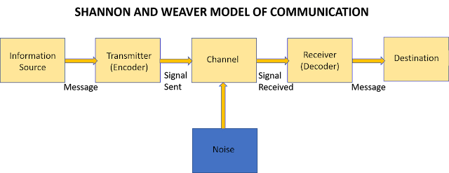
Image source

The example shows how noise can play a fundamental role in the correct delivery of the message; without it, the communication could be properly concluded.
This model works better with one-by-one communication instead of group communication. Another criticism of this model is that the collector is the static part as the composer is the main component, also the reaction by the receiver is considered less important compared to the composer part.
Shannon and Weaver do not apply to any kind of human communication because the way how we communicate with each other is not scientific but can have lots of variables.

Schramm

In 1954, Wilber Schramm introduced the model of communication.
According to his theory, coding and decoding are key components of successful communication.
The process of communication begins with the encoder by transforming the concept into the content. When the receiver gets the message, he needs to be able to clearly perceive the information, if this does not happen the communication is ineffective.
Schramm also highlighted the importance of feedback from the receiver, he retained the connection between the two parts essential (businesstopia, 2018).

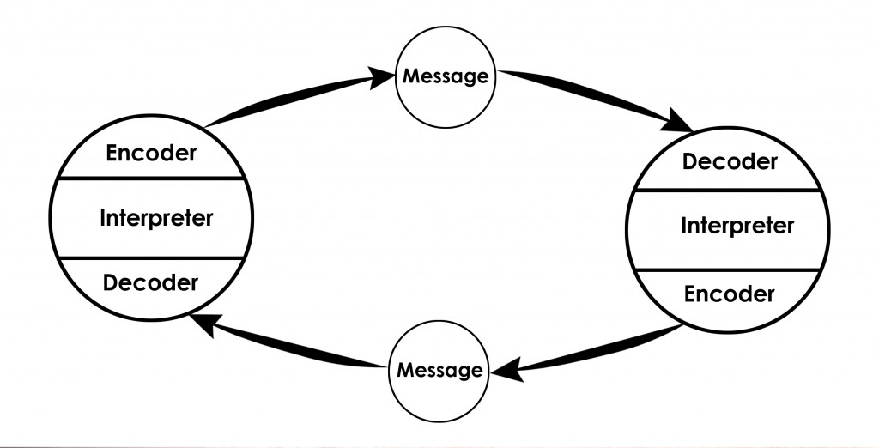
Image source

Example: Mark says to Jane: “You will come with me to the cinema?”
Until Jane replies to Mark the communication is not exhaustive.
Jane must return to Mark and gives him feedback to understand if the message has been delivered correctly and establish a connection between the parts to make the communication process completed.

Sender
M↓ ↑M
Receiver

Schramm also retained personal experience or different history and traditions as a relevant factor for the right delivery of the message.
In conclusion following the Schramm model of communication can be stated that the communication process is not complete without feedback from the receiver.

Berlo

Inspired by Shannon and Weaver’s model of communication, Berlo created his model in 1960.Sender-Message-Channel-Receiver (SMRC). He believed that any of these elements can be distressed by personal contents (businesstopia, 2018).

 image source

The Sender originates the message addressed to the recipient (the subsequent skills apply to both).
- Communication skills: is a relevant component, better communication from the origin means more chance to deliver a correct message.
- Attitude: can change the sense of the information.
- Knowledge: awareness of the destination can make the intendment clear.
- Social systems: any background can be relevant (origin, cult, social class, etc.).
- Culture: anything can be relevant and at the same time irrelevant for someone else depending on the background.
The Message is the meaning of the communication between origin and destination, and may be concerned with the following aspects:
- Content: everything regarding the message from the origin to the destination.
- Elements: nonlinguistic components.
- Treatment: how the recipient receives the message.
- Structure: how the message has been disposed of.
- Code: represents the format of the message, can be verbal, written, visual, etc.
The Channel can be the equipment used to send the message or, in global communication, the human perception that can determine the efficiency of the channel.
- Hearing
- Seeing
- Touching
- Smelling
- Tasting
The Receiver is the individual that receives the message. Berlo’s highlighted how the communication can be distorted or not depending on the similarities between the sender and the receiver.
For example, the English teacher in a small Italian village goes outside to find help because his house is on fire and says to the people:
“My house is an inferno!”, they just didn’t care about him.
The day after the teacher ask why they didn’t help him.
The answer was: “why you didn’t say help me because my house is burning?”.
This example highlights how communication can be distorted by background and linguistic differences.

Communication skills

Verbal communication
Many people believe that verbal communication is just the way how we speak to each other, this is not correct, verbal includes any way of communicating in which the words are used, it can be spoken or written.
The most important thing in oral communication is the correct choice of the words used, you need to predict how the other part can interpret your message, which means that both parts, the sender, and the receiver, have the same importance.
Written communication is used to transform your thoughts in writing, this can be helpful to create a more detailed message easy understandable to everyone (Team, 2021).

Nonverbal communication

Nonverbal communication is a significant part of how we communicate, including gestures, facial expressions, posture, tone, the pitch of voice, signals, and signs (Cherry, 2021).
A fundamental role in nonverbal communication is played by facial expression, this human characteristic gives the receiver much information about our feelings and can be a decisive factor. According to the perception of the receiver the communication can be misunderstood.
Furthermore, another characteristic of nonverbal language is that gestures, body movements, and signs can explain many things without using any words. For example, frenetic leg movements or nail biting can communicate nervousness, as well as crossed legs or arms indicate closure or a defensive attitude.
Appearance also can communicate much information about the person, the way how we wear our clothes, the haircut, and the accessories that we use can give, to the other part, an overview of our personality.

Active listening

One of the most complicated communication skills to improve is active listening, more than your response what matters is the attention you pay to the speaker, the way you listen can determine and show your interest and the importance you give to the conversation (Zay, 2022).
Using active listening will make it easier to obtain and understand useful information from any communication. Moreover, it is important to build a good relationship based on trust in the workplace and as well as in private life.
There are a few aspects to keep in mind while we are listening, be open mind to capture the perspective of the speaker, don’t be distracted from other factors like watching your phone or people around and just be focused on the conversation.
Keeping eye contact will show that we care about the conversation, also keeping calm is good to build a comfortable atmosphere. Furthermore, the most important thing is not to interrupt the speaker until he finishes his speech and only then gives feedback.

Empathetic listening

Listening with empathy means establishing a sensitive connection with the other part, trying to perceive the feelings of the speaker, this will make him more comfortable and confident (Anon., 2011).
Listen with empathy involves being tolerant, avoiding any judgments, being sensible, respecting the speaker’s personality, in a few words “trying to wear his shoes”

The disadvantages of modern technology

Nowadays is hard to think about our world without technology, imagine a life free from a smartphone, laptops, and social media is unbelievable for most of us (Ismail, 2017).
Technology gives us many benefits regarding the quality of life, as it improves many fields like medicine, helps to create new business, and makes life more comfortable.
However, technology does not give only benefits, there are many negative aspects especially because a new field is not known in total and for this reason hard to rule.

Identity theft

Stealing other people’s identities is a very old practice, with the advent of new technologies this method has increased the way how scammers can fraud people (bitdefender, 2022).
Identity theft is the act of stealing personal data such as name, surname, date of birth, bank account numbers, a social network profile, etc.
The way how criminals can steal identities are many, one of these, as well the more common is called phishing.
Phishing can be organized by email or text message where the hackers can appear as a true company and mislead people to give them personal data, thereafter scammers have the data is hard to get back even because some information is not modifiable
There are not many actions to do after data has been stolen, the only way is preventing, using an antivirus or data protection system can be helpful to avoid any trouble.

Cyberbullying

With the advent of modern technology, we are facing a new problem, cyberbullying (Anon., 2022).
This phenomenon increases a lot in the last decade, with serious consequences for the victims, the most affected are young people, research made by Pew Research Centre shows that the percentage of adults victims of cyberbullying is half compared to that of a teenager.
The victims of cyberbullies suffer dramatic consequences, usually, they start with complete alienation that can become depressed and, in some cases induce suicide.
Cyberbullies usually act on social networks, where it is easier to lure victims, but also use online gaming, email, forum, and messaging app.
The only measure to combat this phenomenon is to relate as much as possible cyberbullies to the authorities.

Social interaction
The use of social networks has brought us many benefits in relational terms, helping each other to stay in touch despite long distances, but there are also many negative aspects (Jarai, 2022).
The constant use of our devices can determine relational difficulties, by replacing human relationships, problems can be encountered both with current relationships and with the ability to build new ones in the future.
The excessive use of social media can lead to addiction associated with anxiety disorders and personality, always recommend reasonable and responsible use.

Conclusion
In conclusion, I wanted to highlight how communication is one of the most important human resources.
It helps us to improve our workplace, relation, and many other aspects of our life but we need to use it consciously as has been shown in the models of communication messages can be distorted or misunderstood by the receiver, causing consequences like mental illness, aggressive behaviour, anxiety, relational problems and sometimes induce to suicide. All the technologies have side effects and benefits; therefore, we must use them for what they were invented for, responsibly and without abuse.

References
Anon., 2011. skillsyouneed. [Online]
Available at: https://www.skillsyouneed.com/ips/verbal-communication.html
[Accessed 24 July 2022].
Anon., 2011. skillsyouneed. [Online]
Available at: https://www.skillsyouneed.com/ips/empathic-listening.html
[Accessed 25 July 2022].
Anon., 2022. social media victims law center. [Online]
Available at: https://socialmediavictims.org/cyberbullying/effects/
[Accessed 29 July 2022].
bitdefender, 2022. bitdefender. [Online]
Available at: https://www.bitdefender.com/cyberpedia/what-is-digital-identity-theft/
[Accessed 26 July 2022].
businesstopia, 2018. businesstopia. [Online]
Available at: https://www.businesstopia.net/communication/shannon-and-weaver-model-communication
[Accessed 29 June 2022].
businesstopia, 2018. businesstopia. [Online]
Available at: https://www.businesstopia.net/communication/berlo-model-communication
[Accessed 23 July 2022].
Cherry, K., 2021. verywellmind. [Online]
Available at: https://www.verywellmind.com/types-of-nonverbal-communication-2795397#:~:text=Nonverbal%20communication%20types%20include%20facial,)%2C%20appearance%2C%20and%20artifacts
[Accessed 24 July 2022].
Evans, A. C., 2003. study.com. [Online]
Available at: https://study.com/academy/lesson/what-is-communication-definition-importance.html
[Accessed 23 July 2020].
Ismail, N., 2017. informationage. [Online]
Available at: https://www.information-age.com/modern-technology-advantages-disadvantages-123465637/
[Accessed 26 July 2022].
Jarai, M., 2022. medicalnewstoday. [Online]
Available at: https://www.medicalnewstoday.com/articles/social-media-and-relationships
[Accessed 29 July 2022].
Juneja, P., 2015. Managment study guide. [Online]
Available at: https://www.managementstudyguide.com/strategies-to-improve-communication.htm
[Accessed 4 July 2022].
Team, I. E., 2021. indeed. [Online]
Available at: https://uk.indeed.com/career-advice/career-development/written-communication
[Accessed 24 July 2022].
Zambas, J., 2021. careeraddict. [Online]
Available at: https://www.careeraddict.com/the-importance-of-effective-communication-in-the-workplace
[Accessed 23 July 2022].
Zay, L., 2022. hihello.me. [Online]
Available at: https://www.hihello.me/blog/what-is-active-listening-improve-skills
[Accessed 25 July 2022].

