Oana Nicoleta Manta
2124123
The assignment title: Planning and Delivering an International Meeting/Event.
The module title: International Meetings Management BMIH6007
Module Tutors:Kathryn Flynn
Executive Summary
The report has discussed the sustainability event of Hilton which is themed sustainability. The report has applied the SMART objectives framework to develop two major objectives for the event which coincide with the aim of the event. The five phases of the event cycle have also been discussed with regard to the sustainability event of Hilton. An itinerary for the event has also been depicted which divides the event into two halves. Crowdfunding is noted to be the major source of funding.
Table of Contents
Introduction 4
The Event Cycle 4
Event Concept 5
Aim and Objectives of the Meeting / Event 6
Event Operations 7
Event Budget 8
Cultural and Situational Considerations 11
Conclusion 11
Reference List 13

Introduction
According to Makeuk (2022), the average duration for meetings and conferences in the UK was noted to be 1.6 days. Almost two-thirds of the events in the UK lasted less than a day. Hilton in this case is expected to conduct a meeting that will adhere to aspects of sustainability and will be directed towards enhancing their business practices about sustainability. While considering the scenario of the meeting to be conducted by Hilton, the report will consider the event cycle model and evaluate the current progress of the meeting. The report will also provide a brief explanation regarding the concept of the event and will develop aims and objectives that form the rationale behind the meeting to be conducted by Hilton. SMART objectives framework will be applied in this case to develop objectives for the meeting. The skills and resources that will be required for the purpose of managing and monitoring the event will also be analysed in this report. The current industry trends with regard to meetings and events will also be evaluated in this report the impact with regards to meetings conducted by Hilton. The report will also present cultural and situational considerations that have been taken into account during the planning of the meeting to be conducted by Hilton.

The Event Cycle
According to Curry et al. (2020), the event cycle is a series of phases that are required to be completed in order to ensure that an event has been conducted successfully. The event cycle consists of five phases namely, announce, presale, on sale, maintenance period and closing (Etix, 2020). The application of the model to the event of Hilton is as follows:
Announce
This stage of the event cycle is concerned with the announcement of the event. In this regard, Hilton has announced the event that will be conducted to address sustainability business practices.
Presale
Presale is concerned with the sale of tickets before the official sale is started. In this phase, tickets are provided to the prioritised audiences and stakeholders of the event. In this case, tickets will be provided to government bodies and environmental agencies.
On sale
In this stage, the tickets are availed to the general public. It is understood that the tickets will be provided through online mediums. This will ensure that an audience that is formed by the general public is available for the event increasing the reach and effectiveness of the meeting.
Maintenance Period
During this phase of the event cycle, activities are conducted to increase the awareness of the event among the general public. In this case, social media marketing will be used to market activities and the importance of the event to the general public. According to Dencheva (2023), 90 per cent of marketing experts adhere to the use of social media marketing as it allows them to reach a wide base of customers. Considering this it can be said that the use of social media to increase awareness regarding the sustainability event of Hilton can be considered to be viable.
Closing
This stage of the event is concerned with the closure of marketing activities and the sale of tickets before the event is officially held on the said date.
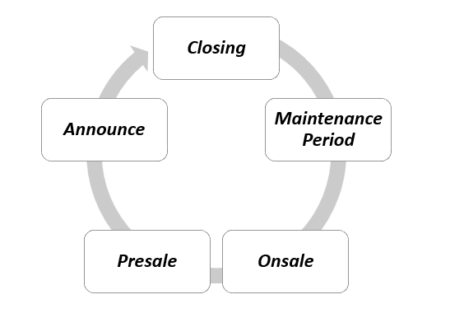
Figure 1: Event Lifecycle
(Source: Self-Developed)

Event Concept
According to Sadegh et al. (2018), the concept of the event is vital in increasing the awareness of the event is vital for attracting relevant customers. It is understood that the concept of the event that is concerned with Hilton is sustainability. The citizens in the UK have attested to the increase in awareness concerning sustainability while considering environmental protection and supporting sustainable business practices (Openaccessgovernment, 2022). In this regard, it can be said that the concept of the event is aligned with the current environment in the UK. The guests at the event will include general citizens of the UK, government bodies and NGOs that work for environmental protection causes. Customer experience is vital in ensuring the success of the event. In this regard, a clear itinerary has been devised to inform the guests about the timings of the event. The itinerary for the event of Hitlon directed towards sustainable practices is depicted in Figure 2. There is a break between events to ensure that guests do not get burned out and engagement level and interests of the guests towards the event are maintained. According to Hussain et al. (2018), the triple bottom line theory states that the success of businesses is measured in three dimensions which include, people, plants and profit. In this regard, the event conducted by Hilton can be considered to be failing under the dimension of people and planet considering that the theme is sustainability which is a vital concern for the people and the environment.
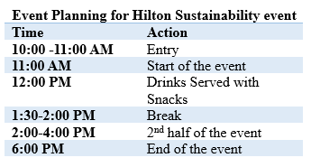
Figure 2: Itinerary of the event
(Source: Self-Developed)

Aim and Objectives of the Meeting / Event
Meetings are important as they provide a platform to share and discuss ideas mutually (Indeed, 2022). In this regard, it can be said that meetings and events can increase the understanding of the people and the audiences concerning the theme and topic of the meeting. The meeting conducted by Hilton at Crowd will discuss sustainability which concerning business practices. The objectives of the event while considering the SMART framework are as follows:
Specific | Measurable | Achievable | Relevant | Timebound
To increase awareness regarding sustainable business practices | The increase in awareness can be measured by the change in policies that will be undertaken by the business | The theme of the event is based on sustainability and hence this can be achieved | Considering that in the present environment, climate and environment are trending issues, the objectives can be considered relevant | 10 Days
To provide guests with a seamless experience of the event | This can be measured by taking feedback from the guests after the completion of the event | The event is held on Crowd Palace which avails a wide range of different facilities which can be delegated to enhance the experience of the guests | The success of the event is highly dependent on the experiences of the guests and hence the objective can be considered relevant | 30 Days
Table 1: SMART objectives for the event
(Source: Self-Developed)

Event Operations
It is understood that there is a range of resources and skills that are required for the purpose of conducting a particular event. The quality of the resources and skills are also vital in terms of ensuring that the event has been conducted successfully. The resources that will be required are staff, technical equipment, a place for the event, and online channels for increasing awareness regarding the event. Capital is another important resource that is vital for the event as it will enable the acquisition of other resources required. In this regard, crowdfunding will be adhered to. Crowdfunding is a type of fundraising in which appeals for funds are made to the general public (BDC, 2022). Considering the event is themed on sustainability which is a concern for society people are expected to contribute financially towards the event. This will enable the collection of enough funds can allow the event to induct resources required for the successful conduction of the event. According to LinkedIn (2022), managing an event is a huge task and requires successful organising, planning and managing. The skills that are required to be effective in this aspect are communication skills, negotiation skills, time management skills and planning skills.
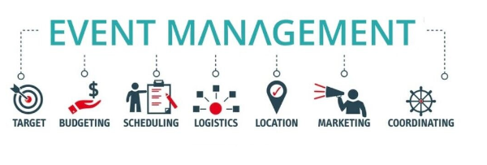
Figure 3: Aspects of event management
(Source: LinkedIn, 2022)
Communication is considered to be vital in managing any business and event. Through communication, the event manager is required to communicate the aims and objectives of the Hilton event to the team members who can devise plans and act accordingly. Communication also helps in developing relationships with clients which can effectively help in enhancing understanding towards expectations regarding the event (LinkedIn, 2022). The goal-setting theory states that team members perform better when a clear goal is provided (Locke and Latham, 2019). Hence communication allows clarity of goals to the members which facilitates the prospect of successful completion of the aims and objectives of the Hilton sustainability event. It is also important for the Hilton event to be directed towards sustainability to ensure that a consistent theme of the event is maintained. In this regard, organising skills can be considered to be vital.

Event Budget
A budget is a special spending plan that depicts the financial expenditure for a particular set of tasks (Indeed, 2023). Budget estimation is important to ensure that no shortage of funds is faced during the event planning which can affect large-scale events like those conducted by the Hilton. The breakdown of costs and expenditures for the Hilton sustainability event is depicted in the table below:
Breakdown of costs and expenditure
Required expenditure | Breakdown in costs
Decoration costs | 1000 £
Digital Invitation cards | 500 £
Misc | 5500 £
Technical backup costs | 2000 £
Salaries and wages | 2000 £
Gifts to special guests | 1000 £
Total | 12000 £
Table 2: Breakdown of costs and expenditure
(Source: Self-Developed)
From the above table it can be understood that the total spending related to the event of Hilton is expected to be 12000 British pounds [Refer to Table 2].
Funding sources and income generation
As stated above, the crowdfunding method will be used for the purpose of funding this event. The total funding that will collected for the event is 14000 British pounds [Refer to ppt]. The excess financial availability will ensure that no shortage of funds is expected. On the other hand, the main source of income for the event will be the sale of online tickets to the audience. In this regard, the predicted revenue for the event is 21000 British pounds [Refer to ppt]. The stakeholders involved with the project are expected to earn a profit of 8000 British pounds.
Industry Trends/Impacts
Latest Trends linked to the Meeting/events Industry
Sustainability trends in recent event industries all around the world in increasing use of technologies powered by renewable energy sources. These technologies include Augmented Reality, Virtual Reality, Artificial intelligence and others (Event Academy, 2024); which help improve flexibility in communication systems among stakeholders of an organisation from any place on earth. More specifically it can be stated that the rise of digital as well as hybrid events, sustainability initiatives and the use of AI provides a premium experience to stakeholders which is improving their engagement in sustainability events, an important point of business practices in meeting corporate social responsibilities. These events include the promotion of sustainability of natural resources, reducing waste conserving water and energy sources and protecting biodiversity which helps improve the sustainability of businesses in the highly competitive market (Eclipse, 2024). In this context, hotel organisations are focusing on the incorporation of renewable energy sources like wind, solar and geothermal energy which helps improve resource optimisation (Linkedin, 2023). In the case of international hospitality organisations, these events help improve the inclusion of automation technologies which leave less impact on the environment and greater satisfaction to guests. In recent times, global hospitality organisations have hired panthers of event management to choose green destinations for meetings in which potential wastes are removed (Hotello, 2024). This trend is attracting environmentally aware clients and improving brand advocacy which improves the sustainability of hotels in the highly competitive global hospitality market. In maintaining sustainable development goal 13, global hospitality organisations are taking prompt actions to combat climate change (Alvarez-Risco et al. 2020). Thus these trends are improving the corporate social responsibilities of hotel organisations which help improve their sustainability.
Determination of the impact of latest meeting trends on proposed sustainable meeting event on Hilton
According to Meredith and Mantel (2022), project management helps improve the sustainability of an organisation which improves its productivity. Hilton is one of the leading hospitality chains which has developed partnerships with many global NGOs which are working on environmental sustainability projects which is improving the productivity of the organisation. Hilton has worked with WWF for more than a decade on various initiatives, including Seafood Week and Earth Hour, a WWF initiative that unites the world around climate action (Sustainable Brands 2015). This can impact the proposed campaign which will target NGOs and government bodies. Hilton is committed to reducing waste and driving towards a circular economy. The organisation is testing "Winnow food waste technology" in three EMEA hotels to enhance the use of Artificial intelligence in developing sustainable kitchens (Sustainable Hotel News, 2023). Thus the organisation can follow the recent trend of technology in sustainability plans which can be developed in the proposed campaign. Apart from this, Hilton has set science-based carbon targets aligned with climate science and the “Paris Climate Agreement” which have been approved by the “Science Based Target Initiatives (SBTi)” (Hilton, 2024). This can help the organisation improve its focus on renewable energy sources to enhance its sustainability, an executive plan which can be undertaken in the proposed campaign. Overall, it can be stated that the organisation can significantly focus on its environmental sustainability in this proposed campaign and meet these through global events on energy, water and waste management which are improving their tendencies to arrange events in green destinations and improve the competitiveness of the organisation in the highly competitive hospitality market in the UK and globally.

Cultural and Situational Considerations
According to Hofstede cultural dimensions, it has been found that the UK is a highly individualistic country. The individualism score of the people of the UK is noted to be 76.
It is also depicted that 89% of the population of the UK is taught to think by themselves (Iulia-cristina, 2022). This can be used to understand that people in the UK are more freethinkers and are more likely to consider aspects of the environment and future in their decision-making. In this regard, it can be said that the theme of the event aligns with the cultural dynamics of the UK.
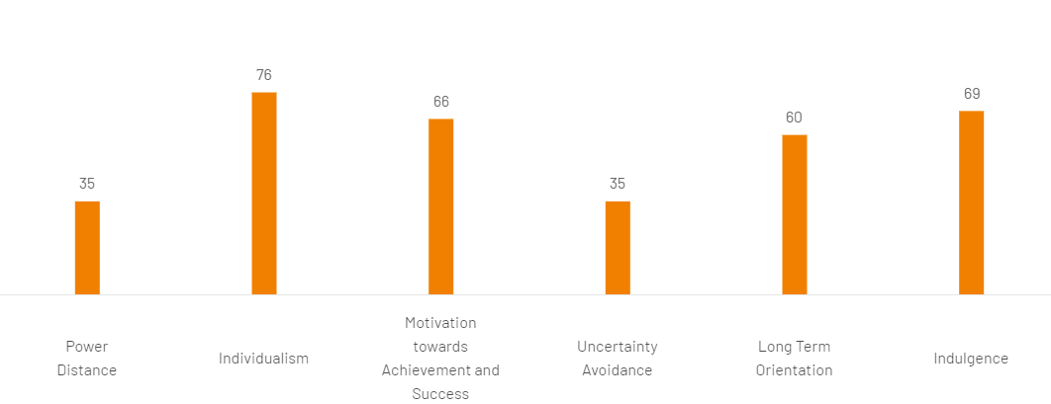
Figure 4: Hofstede Cultural Dimensions of the UK
(Source: Hofstede-insights, 2023)
On the other hand, it has been understood that prior to COVID-19 there was an enhanced emphasis on sustainability issues by the customers as well as by the businesses. The Government of the UK has also been noticed to be proactive in terms of deriving policies that are directed towards the development of sustainable practices. According to Briggs (2023), sustainability is considered to be an important aspect for 61% of UK consumers. On the other hand, 55% of UK consumers state that sustainability is important for society. Considering this, it can be said that at present UK citizens and customers are highly aware of sustainability and hence the theme of the Hilton event can be said to be aligned with the current situation in the UK.

Conclusion
The above report is concerned with the evaluation of the event that is themed sustainability by Hilton and will be hosted at the Crowd Palace. It has been found that in the UK there is an enhanced understanding of the citizens regarding sustainability which is reflected in the shopping patterns. In this regard, the theme of the event can be considered to be appropriate. On the other hand, the high score in the individualism of the UK depicts that people in the UK think freely and hence can be considered to be more entitled towards sustainability aspects. In this regard, this will help the event become more acceptable in the region.

Reference List
Alvarez-Risco, A., Estrada-Merino, A. and Perez-Luyo, R., 2020. Sustainable development goals in hospitality management. In Sustainable Hospitality Management: Designing Meaningful Encounters With Talent and Technology (pp. 159-178). Emerald Publishing Limited.
BDC, 2022. Crowdfunding. Available at: https://www.bdc.ca/en/articles-tools/entrepreneur-toolkit/templates-business-guides/glossary/crowdfunding (Accessed: 12 February 2024)
Briggs, F., 2023. Sustainability is more important to 61% of UK consumers than it was two years ago. Available at: https://retailtimes.co.uk/sustainability-is-more-important-to-61-of-uk-consumers-than-it-was-two-years-ago/ (Accessed: 16 February 2024)
Curry, E., Gao, F. and Curry, E., 2020. Quality of service-aware complex event service composition in real-time linked dataspaces. Real-time linked dataspaces: enabling data ecosystems for intelligent systems, pp.169-190.
Dencheva, V., 2023. Social media advertising and marketing worldwide - statistics & facts. Available at: https://www.statista.com/topics/1538/social-media-marketing/#topicOverview (Accessed: 14 February 2024)
Eclipse, 2024. What Are The Positive And Negative Environmental Impacts Of Events?. Available at: https://eclipse.global/positive-and-negative-environmental-impacts-of-events/#:~:text=Despite%20often%20getting%20a%20bad,raising%20awareness%20about%20environmental%20issues. (Accessed: 15 February 2024)
Etix, 2020. Marketing the Event Life Cycle. Available at: https://hello.etix.com/marketing-the-event-life-cycle/#:~:text=The%20event%20life%20cycle%20consists,engagement%20and%20ticket%20sales%20volume. (Accessed: 12 February 2024)
Event Academy, 2024. Your Guide To Event Technology. Available at: https://eventacademy.com/guide/event-technology/ (Accessed: 12 February 2024)
Hilton, 2024. Environmental Impact. Available at: https://esg.hilton.com/environment/#:~:text=Hilton%20is%20proud%20to%20have,destination%20stewardship%2C%20please%20click%20below. (Accessed: 12 February 2024)
Hofstede-insights, 2023. Country Comparison Tool. Available at: https://www.hofstede-insights.com/country-comparison-tool?countries=united+kingdom (Accessed: 15 February 2024)
Hotello, 2024. What is green marketing?. Available at: https://hotello.com/en/green-marketing-hospitality-industry/#:~:text=By%20definition%2C%20green%20marketing%2C%20also,sales%20and%20improve%20its%20image. (Accessed: 15 February 2024)
Hussain, N., Rigoni, U. and Orij, R.P., 2018. Corporate governance and sustainability performance: Analysis of triple bottom line performance. Journal of business ethics, 149, pp.411-432.
Indeed, 2022. 6 Reasons for Conducting Meetings and Why They're Important. Available at: https://www.indeed.com/career-advice/career-development/reasons-for-meetings (Accessed: 14 February 2024)
Indeed, 2023. 7 Reasons Why Budgeting Is Vital for Successful Businesses. Available at: https://www.indeed.com/career-advice/career-development/why-budget-is-important (Accessed: 13 February 2024)
Iulia-cristina, U., 2022. What is Hofstede’s cultural dimensions theory? UK vs China, a comparison. Available at: https://brandminds.com/what-is-hofstedes-cultural-dimensions-theory-uk-vs-china-a-comparison/ (Accessed: 12 February 2024)
LinkedIn, 2022. Top 10 Skills Every Event Manager Needs. Available at: https://www.linkedin.com/pulse/top-10-skills-every-event-manager-needs-/ (Accessed: 14 February 2024)
Linkedin, 2023. Sustainable Energy Practices for the Hospitality Industry. Available at: https://www.linkedin.com/pulse/sustainable-energy-practices-hospitality-industry-asif-akash#:~:text=Hospitality%20businesses%20can%20switch%20to,property%20to%20utilize%20wind%20energy. (Accessed: 15 February 2024).
Locke, E.A. and Latham, G.P., 2019. The development of goal setting theory: A half century retrospective. Motivation Science, 5(2), p.93.
Makeuk, 2022. New research reveals an evolving UK meetings market. Available at: https://www.makeuk.org/news-and-events/news/new-research-reveals-an-evolving-uk-meetings-market (Accessed: 14 February 2024)
Meredith, J.R. and Mantel, S.J., 2022. Project management: a managerial approach. John Wíley and Sons, Inc..
Openaccessgovernment, 2022. UK citizens’ interests towards sustainable practices on the rise. Available at: https://www.openaccessgovernment.org/uk-citizens-interest-sustainability-sustainable-practices/152965/ (Accessed: 13 February 2024)
Sadegh, M., Moftakhari, H., Gupta, H.V., Ragno, E., Mazdiyasni, O., Sanders, B., Matthew, R. and AghaKouchak, A., 2018. Multihazard scenarios for analysis of compound extreme events. Geophysical Research Letters, 45(11), pp.5470-5480.
Sustainable Brands, 2015. Hilton, WWF Partner to Improve Sustainability in Hospitality Industry. Available at: https://sustainablebrands.com/read/collaboration-cocreation/hilton-wwf-partner-to-improve-sustainability-in-hospitality-industry#:~:text=For%20nearly%20a%20decade%2C%20Hilton,the%20world%20around%20climate%20action. (Accessed: 12 February 2024)
Sustainable Hotel News, 2023. Hilton tests Winnow food waste technology in three EMEA hotels. Available at: https://sustainablehotelnews.com/hilton-tests-winnow-food-waste-technology-in-emea/ (Accessed: 14 February 2024)

