Methodology
- Introduction
The methodology section of this dissertation outlines and assesses the approaches and methods used to investigate whether the prison system is fit for service within England and Wales, focusing on overcrowding, corruption, rehabilitation, and alternatives to incarceration. This chapter will also explain why certain research methods were used, as well as the strengths and weaknesses they possess. Furthermore, this chapter will assess and prove how ethical considerations were always considered and adhered to throughout the process of this research.

- Research Onion
Saunders et al. (2009) stated that the research onion that he developed, illustrates the different sections necessary for the methodology chapter. It is named the research onion because when it is viewed from the outside, each layer of the onion describes a more detailed stage of the research process (UKEssays, 2018). This study will follow the research onion to make sure that all research and data are important to the study and to be able to show and produce accurate and detailed results.
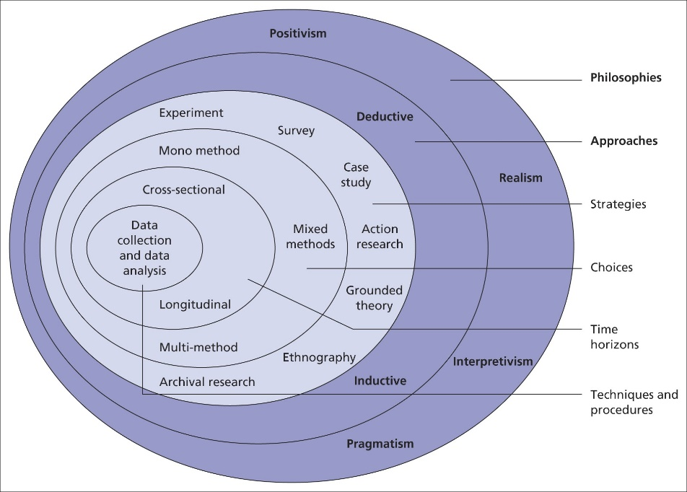

- Research philosophy
Galliers (1991), asserts that the research philosophy is a belief in the way in which data about a phenomenon should be gathered, analyzed, and used. He also mentions that there are two types of research philosophy, these being positivist and interpretivist. Ryan (2018), states that the positivist research philosophy is based on being able to prove or disprove a hypothesis and believes in the use of objectivity. On the other hand, the interpretivist research philosophy is completely different and values subjectivity instead. This research focuses on the positivist research philosophy. This research philosophy is beneficial to this research because of the subject nature of this dissertation looks closely at government-run institutes, therefore relying heavily on empirical as well as quantitative data which will be studied to draw hypotheses through patterns and correlations that will lead towards a conclusion. According to Pham (2018), the advantages of adopting a positivist approach can lead to research having high-quality standards of validity and reliability. However, positivism relies on objectivity and disregards subjectivity, this research philosophy is also based on assumptions that what happens in one social environment can be generalized to other social situations (Velez, 2008). Due to this, it will be important to compare and contrast other sources and information so that the research can be accurate and not generalized. This way of thinking will also be applied to the questionnaire survey to ensure that there is no bias in the questions and that all participant's answers are thoroughly examined and not generalized.

- Research Approach
After determining that the research philosophy will follow the positivist philosophy, therefore leads to the deduction that the inductive research approach will assist this study the most. Thomas (2003), explains that the inductive research approach establishes clear links between the research objectives and the summary findings derived from the raw data, on top of this it is apparent that the raw data can be used to develop a model or theory about the underlying structure of experiences or processes. The benefits of the inductive research approach are that through flexibility and staying accurate to content a new theory can be supported (Warwick, 2016). By allowing that flexibility and staying true and accurate to the results that will come from the questionnaire survey, alongside the positivist research philosophy and the inductive research approach, it will produce a new theory or conclusion that is insightful and well-resourced.

- Methodological Choice
Tharsika (2022), states that the methodological choice is where the researcher will choose whether to use qualitative, quantitative data, or a mixed method for their research. LeCompte (2000) explains that qualitative data can be retrieved from a variety of sources ranging from interviews, observations, and documents and can produce a vast amount of data (Pope et al. 2000). This data can be used to delve deeper into an individuals emotions and thought process, showing that qualitative research will reveal insight to a person true nature and behaviour (Sutton & Austin, 2015). On the other hand, quantitative data is represented numerically, alongside anything that can be measured, counted, or given a numerical statistic such as the gender percentages of those who submitted a survey and then analyzed statistically (National Library of Medicine, 2024). Halcomb & Hickman (2015) explain that when both quantitative and qualitative data are used within a singular research project it is referred to as mixed methods research, and allows the researcher to examine and explore their chosen topic in more detail. The advantages that mixed method research brings will be used within this research project. This is because this project will collect public opinions through questions about ongoing issues within the prison system in England and Wales, and through this will collect qualitative data but to ensure this research project is reliable it will base the questions from well research quantitative data so there is no bias.

- Research Strategy
The research strategy used within this project is a questionnaire survey. According to Jones et al. (2013) a survey is an important tool that allows a researcher to gather meaningful results from a large population with relative ease. Wright (2005), mentions that the advantages of using an online survey can include that individuals who are in very distant locations can still access the survey and give their input, alongside having the benefit of having automated data collection, reducing the time and effort a researcher needs to analyze their findings. However, Wright (2005) also says that an online survey can lead to uncertainty over the validity of data. To avoid this the questions and answers received will be carefully studied and accessed to ensure quality control and accurate data collection and analysis (Patino & Ferreira, 2018).

- Time Horizon
As shown in the research onion provided by Saunders et al. (2009), the time horizon layer is one of the innermost sections and is addressed after the other layers of the research onion have been identified. Melnikovas (2018) describes this layer as the point at which the researcher must confirm a time frame for their research. This can be done through one of two studies the cross-sectional or longitudinal. Cross-sectional studies are said by Wang & Cheng (2020) to be observational studies that focus on a singular or specific point in time and analyze the data retrieved. Whereas, Caruana et al. (2015) states that longitudinal studies engage in constant measures to follow a particular individual over an extended time frame with no external influence affecting the results. Based on these findings and time factors, this research will use a cross-sectional study to ensure that the research can be completed within the time frame given by an academic institute and not result in going over the deadline. The survey will be accessible to anyone who wishes to participate for a week-long period of time. Once this time is over the survey will be closed, no more answers will be accepted, and the results will be reviewed and analyzed.

- Techniques & procedures
8.1 Data Collection, Processes and Analysis
The primary data will be collected through a survey. This will collect qualitative and quantitative data by using open and closed questions based on the Literature Review. Open-ended questions allow those who choose to participate in the chosen survey the freedom to write or say as they wish in text form. Compared to closed-ended questions restrict the participant from choosing between a limited set of answers, such as ‘yes’ or ‘no’ (Rosala, 2024). This questionnaire survey will made through the use of Google Forms, and for the specified time period of a week will be made available at all times to anyone who wishes to share their insight and participate. When this data is collected the researcher will analyze the results through thematic analysis. Thematic analysis is described by Braun & Clarke (2012) as an accessible, flexible method of qualitative data analysis.

8.2 Sampling
Sampling is a method that allows a researcher to collect data from a group of participants, without having to investigate and question each individual of a large population as that can be impractical and allow for high-quality research to be received with less effort (Health Knowledge, 2024). Specifically this research will adopt the non-probability sampling method for this research. According to Elfil & Negida (2017), this sampling method is also known as convenient sampling due to its quick and convenient way of retrieving data, this is due to the participants having access to choose whether they want to be a participant after the researcher announces the study to a large group of individuals.

8.3 Reliability and validity
According to Roberts & Priest (2006), reliability and validity are ways researchers use to demonstrate the research processes and the trustworthiness of research findings. They also go on into more depth explaining that reliability shows how far a researcher's tools or procedures can produce similar results under different circumstances, with the assumption that nothing has changed therefore leading to the ability of repeatability. To ensure that the research is reliable it must be repeatable, this is accomplished through finding research through similar means and being clear and direct with questions in the survey so that if redone the answers will be the same. Whereas, validity refers to whether a test measures what it aims to measure. For example, if an individual is taking a driving test it shouldn’t be all theory but must require some practical driving to accurately assess the individuals skills (Cambridge, 2024). Alwin (2010) states that surveys routinely have high reliability and validity, however, a variable that can affect this is the survey being improperly designed and having possible survey errors leading to the research not being reproducible (Rickards, 2012). The researcher can avoid this to ensure the reliability and validity of their research is not harmed by making sure that all questions that are released to the public are beneficial to the research and have no errors or bias in them.

8.4 Limitations or Ethical Issues
The limitations of a research study are the impacts or influences that the chosen research could have on the researcher's findings (University of Southern California, 2023). A limitation that could be an issue during this research is in the sampling section, this is due to the fact that the survey is published and shared between individuals only the researcher knows which sets the limitation that others can not access the survey. Another limitation that could affect the researcher's results is the time limit used in the cross-sectional study, due to its shorter time frame than other studies potentially leading to fewer individuals participating in the survey, therefore there being less data to compare and analyze for the researcher.

References
15 Writers (2019). Understanding the Research Onion. Available at: https://15writers.com/research-onion/ (Accessed 18th April 2024)

Saunders, M. Lewis, P., & Thornhill, A. (2009). Research methods for business students. Pearson education.

UKEssays (2018). Research Onion – Explanation of the Concept. Available at: https://www.ukessays.com/essays/psychology/explanation-of-the-concept-of-research-onion-psychology-essay.php#citethis (Accessed 18th April 2024)

Galliers, R.D. (1991). Choosing Appropriate Information Systems Research Approaches: A Revised Taxonomy. ResearchGate. Available at: https://www.researchgate.net/publication/236143992_Choosing_Appropriate_Information_Systems_Research_Approaches_A_Revised_Taxonomy (Accessed 19th April 2024)

Ryan, G. (2018). Introduction to positivism, interpretivism and critical theory. Nurse researcher, 25(4), pp.41-49.

Pham, L.T.M. (2018). Qualitative approach to research a review of advantages and disadvantages of three paradigms: Positivism, interpretivism and critical inquiry. University of Adelaide. pp.2

Velez, A.M. (2008). Evaluating research methods: Assumptions, strengths, and weaknesses of three educational research paradigms. Academic Exchange Extra. 9, pp.1-9.

Thomas, D.R. (2003). A general inductive approach for qualitative data analysis.

Warwick (2016). Inductive or deductive approaches. Available at: https://warwick.ac.uk/fac/soc/ces/research/current/socialtheory/maps/when/#:~:text=The%20benefits%20of%20an%20inductive,on%20social%20loss%20as%20example%5D. (Accessed 19th April 2024)

Tharsika, K. (2022). A review of methodological choice: Research paradigm underpins. ResearchGate. Available at: https://www.researchgate.net/publication/361119109_A_review_of_methodological_choice_Research_paradigm_underpins (Accessed 20th April 2024)

LeCompte, M.D. (2000). Analyzing qualitative data. Theory into practice. 39(3), pp.146-154.

Pope, C. Ziebland, S., & Mays, N. (2000). Analysing qualitative data. BMJ. 320(7227), pp.114-116.

Sutton, J., & Austin, Z. (2015). Qualitative research: Data collection, analysis, and management. The Canadian journal of hospital pharmacy. 68(3), p.226.

National Library of Medicine (2024). Quantitative Data. Available at: https://www.nnlm.gov/guides/data-glossary/quantitative-data (Accessed 20th April 2024)

Halcomb, E.J., & Hickman, L. (2015). Mixed methods research.

Jones, T.L. Baxter, M.A.J., & Khanduja, V. (2013). A quick guide to survey research. The annals of the royal college of surgeons of England. 95(1), pp.5-7.

Wright, K.B. (2005). Researching Internet-based populations: Advantages and disadvantages of online survey research, online questionnaire authoring software packages, and web survey services. Journal of computer-mediated communication, 10(3).

Patino, C.M., & Ferreira, J.C. (2018). Internal and external validity: can you apply research study results to your patients?. Jornal brasileiro de pneumologia. 44, pp.183-183.

Melnikovas, A. (2018). Towards an Explicit Research Methodology: Adapting Research Onion Model for Futures Studies. Journal of futures Studies, 23(2).

Wang, X., & Cheng, Z. (2020). Cross-sectional studies: strengths, weaknesses, and recommendations. Chest. 158(1), pp.65-71.

Caruana, E.J. Roman, M. Hernández-Sánchez, J., & Solli, P. (2015). Longitudinal studies. Journal of thoracic disease. 7(11), p.537.

Rosala, M. (2024). Open-Ended vs. Closed Questions in User Research. Nielsen Norman Group. Available at: https://www.nngroup.com/articles/open-ended-questions/#:~:text=There%20are%20two%20types%20of,limited%20set%20of%20possible%20answers. (Accessed 21st April 2024)

Braun, V., & Clarke, V. (2012). Thematic analysis. American Psychological Association.

Health Knowledge (2024). Methods of sampling from a population. Available at: https://www.healthknowledge.org.uk/public-health-textbook/research-methods/1a-epidemiology/methods-of-sampling-population#:~:text=Sampling%20is%20a%20method%20that,having%20to%20investigate%20every%20individual. (Accessed 21st April 2024)

Elfil, M., & Negida, A. (2017). Sampling methods in clinical research; an educational review. Emergency, 5(1).

Roberts, P., & Priest, H. (2006). Reliability and validity in research. Nursing standard. 20(44), pp.41-46.

Cambridge (2024). What is Validity? Available at: https://www.cambridgeenglish.org/blog/what-is-validity/#:~:text=Validity%20refers%20to%20whether%20a,of%20the%20rules%20of%20driving. (Accessed 21st April 2024)

Alwin, D.F. (2010). How good is survey measurement? Assessing the reliability and validity of survey measures. Handbook of survey research., 2, pp.405-434.

Rickards, G. Magee, C., & Artino Jr, A.R. (2012). You can't fix by analysis what you've spoiled by design: developing survey instruments and collecting validity evidence. Journal of graduate medical education. 4(4), pp.407-410.

University of Southern California (2023). Research Guides: Organizing Your Social Sciences Research Paper. Available at: https://libguides.usc.edu/writingguide/limitations (Accessed 21st April 2024)

