Introduction

The introduction will begin by setting the scene, with a brief account of my childhood experience which has led me to where I am today and informed this research topic. The aims and objectives of the research will be stated, followed by a background to the area of research, its application and relevance to psychotherapeutic practice and a wider societal and public health context. Finally, a brief explanation of the research methodology, why it has been chosen, and its limitations will then lead onto a description of the chapters to come.

Personally significant pictures will be interspersed throughout this paper, to support the expression of what is an emotionally challenging process. I am finding that words can feel as though they are not always enough. Wall Kimmerer (2013), an environmental and forest biologist, ancestor and member of the Potawatomi Nation, shares a reassuring conversation with a Cheyenne elder when trying to learn her native language;

‘I spoke to him with a heavy heart, lamenting that I had no native language with which to speak to the plants and the places that I love. “They love to hear the old language” he said, “it’s true”. “But,” he said, with fingers on his lips, “You don’t have to speak it here.” “If you speak it here,” he said, patting his chest, “They will hear you.” ‘
Wall Kimmerer (2013, p.59)

It is with a hand on my chest, a gentle listening to my internal native language and a wish to express whole heartedly that I begin writing.

Before stepping fully into the body of the introduction it is important to firstly acknowledge that this dissertation has been conceived, researched, nurtured and written during the Covid-19 pandemic. Living in a period of personal and global uncertainty, with an awakening to a new sense of impermanence and change, will no doubt be reflected within this work. The grief, anxiety, longing, coming together and moving apart will be shadows within the words, analysis and meaning making. Perhaps this research is timely and as relevant as it has ever been, as the Welsh Government (2021) proposes that, although Adverse Childhood Experiences should not be seen as deterministic, it is already becoming apparent that childhood adversity has increased as a result of the pandemic. It feels important, therefore, to bear in mind the heart of hermeneutic philosophy and research when reading what is to follow. The cultural context of this research is profound and unique. As McCaffrey et al (2012, p.215) states, when reappraising the hermeneutic research approach, ‘I have become aware of the sands of history shifting under my feet – the insight of impermanence’. I too have this experience.

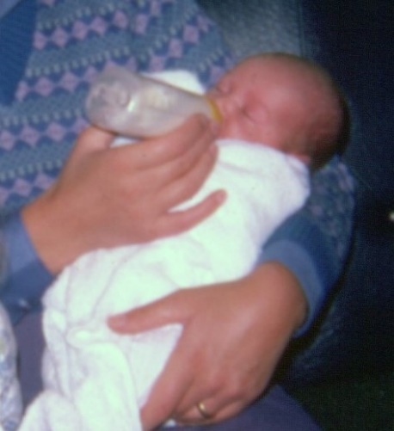
‘The Beginning.’ Helen Evans (2022)

I was born in the mid 1970’s. Growing up with my Mum, Dad and older sister, it was a time of concrete playgrounds, mud pies and lemon sherbet bought by the quarter from the corner shop. It was also a time of despair, uncertainty, fear and loss. Things were different then, but not so different!

Mum lived for many years with depression and psychosis, and as a child I don’t remember a time when this was not the case. When I was 21 a psychiatrist appeared, the saviour, dishevelled, dressed in a brown suit jacket and clutching a leather bag. Here was the possibility of light and to breath. As he left, he took Mums tormentors with him in his leather bag, the dark, shadowy visitors that had stayed far too long. He couldn’t take it all though. Their presence in my childhood left a mark, a sense of having lost my’self’. This legacy continues to exist in my adult life and it is with curiosity toward this phenomena that this research is based. How can I become my’self’?

It feels important to post a loving disclaimer for Mum here. It was never Mum’s intention to cause harm to me or my sister. In fact, I often felt as though Mum was trying to protect us from what she perceived to be threats from outside our magical group of three. She did the best she could in the situation she found herself. Mum has a kind and gentle soul, with many beautiful gifts still waiting to be realised.
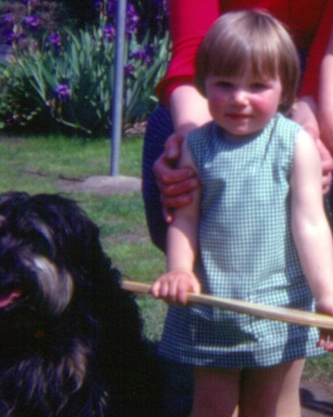
‘A Touch of Confusion.’ Helen Evans (2022)

This research aims to explore how the legacy of an adverse childhood experience in adulthood, such as parental mental illness, can cause parentification and the potential impact of this on the development of the ‘self’. Working with clay as a creative therapeutic approach to support the healing of this burden in adulthood will also be studied. It is my hope and intention that this research may add to a growing field of psychotherapeutic research which holds at its heart the aim of better understanding and easing human suffering.

To achieve the aims, the objectives are firstly to explore and review research related to adverse childhood experiences, parental mental illness, parentification and loss of ‘self’, theories on the development of the ‘self’, neuroscience and the potential therapeutic benefits of using clay as a creative, body-based, non-verbal approach to psychotherapeutic practice. Secondly, as this research is not purely a literature review, it is guided by a heuristic inquiry methodology, my living experience of the phenomena will be included, plus the data collected from my personal use of clay in a therapeutic context. In collating, analysing and synthesizing all the data, conclusions and recommendations will be drawn, relevant to psychotherapeutic practice and a current public health issue.

Adverse Childhood Experiences (ACE’s) is a term that originates from the seminal research of Felitti et al (1998). ACE’s are traumatic events that happen in childhood, such as physical and emotional abuse or neglect, plus experiences like domestic abuse, parental separation, substance misuse, parental incarceration and parental mental illness (Welsh Government, 2021).

The research conducted by Felitti et al (1998), which was undertaken in San Diego and included more than 9000 participants, found that ACE’s have a negative impact on physical and mental health outcomes in adulthood, this impact increased as the number of ACE’s increased, and that the impact can be cumulative. A diagram was produced (Figure 1) illustrating the potentiality of ACE’s over the lifespan.

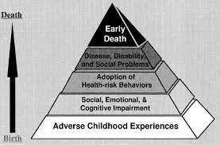
Figure 1. Felitti et al (1998)

The Welsh Government (2021) have taken this research on board and conducted their own, more recent study (Public Health Wales, 2015), which relates to the work of many others (Herzog and Schmahl, 2018; Navalta et al, 2018; Hughes et al, 2017; Mackes et al, 2020; Iob et al, 2021), finding that ACE’s can affect how a child’s brain develops, along with the hormonal, immunological and nervous system development. As a result, Felitti et al’s (1998) diagram has been updated (Figure 2) with the introduction of an extra layer, that of disrupted neurodevelopment and allostatic load.

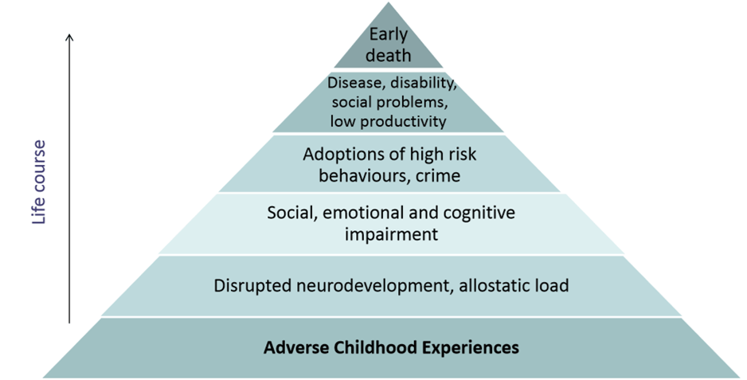
Legacy Zone
Figure 2. Centers for Disease Control and Prevention (2021a, Cited in Public Health Wales 2015)

There is an understandable acknowledgement of the need to prevent ACE’s (Welsh Government, 2021; Hughes et al, 2017, p.365; Centers for Disease Control and Prevention, 2021), with research and interventions focusing heavily on the bottom layer. There is, however, recognition of a need for more research into the upper layers, which I refer to as the legacy zone (Murphy et al, 2011, p.3430; Hooper et al, 2011, p. 1028; Murphy et al, 2016, p.668; Simpson-Adkins and Daiches, 2018, p.2706; Metz and Jungbauer, 2021, p.64). This research will sit very much within the legacy zone, particularly the layers of disrupted neurodevelopment, allostatic load and social, emotional and cognitive ‘adaptation’. I have deliberately changed the term ‘impairment’ to ‘adaptation’ as it feels less pathologizing, less likely to unhelpfully suggest abnormality within me and people with similar living experiences to me. I believe the legacies of ACE’s in adulthood, although painful and confusing, could be described as intricate, natural adaptations. Sar’s (2017, p.2) research suggests that developmental trauma, which can be caused by ACE’s, can lead to a protective internal division to save the psychological self from annihilation. Therefore, the adaptation could be seen as a means to survive, not an impairment or abnormality.

The phenomena that can occur from experiencing the ACE of growing up with a parent with mental illness is ‘parentification’. This is recognised within research, as Murphy et al (2011, p.3433) and latterly, Simpson-Adkins and Daiches (2018, p.2712) and Kallquist and Salzmann-Erikson (2019, p.2062) found in their meta-synthesis’. Parentification is a term coined by Boszormenyi-Nagy (1965 cited in Jurkovic, 1997, p.17) and can describe the overburdening of children within a family dynamic. Jurkovic (1997, p.19) suggests ‘the net result is that the childhood of destructively parentified children is lost.’ Murphy et al’s (2016, p.668) research testifies that adult children experience this sense of loss too, the ‘loss of self’. It is this deep relationship between an ACE, parentification and the loss of self that is at the core of this research, and invites the question ‘How can I become my’self’?

It is recognised that there is the need for further research into psychotherapeutic practices that may support the healing of this phenomena. Within the three meta-synthesis already mentioned (Murphy et al, 2011, p.3433; Simpson-Adkins and Daiches, 2018, p.2712; Kallquist and Salzmann-Erikson, 2019, p.2062) it was found that adult children could experience anxiety, depression and relational issues and it is proposed that a cognitive behavioural model be used, and that reduction of the stigma of mental illness by educating clinicians would be helpful. Hughes et al (2017, p.364) report from their systematic review and meta-analysis on the effects of multiple ACE’s on health, that there is a need for collaborative, trauma-informed services available across the life course, and ACE-informed practice could be developed in multiple settings. When considering the need for ACE and trauma-informed practice, and the impact ACE’s can have on our neurodevelopment and nervous systems, it seems reasonable to turn to contemporary research in the fields of trauma, neuroscience, somatic and sensorimotor psychotherapy, haptics and art therapies to explore new possibilities. This will be explored in depth within the literature review chapter, but it is apparent that there is a convergence of these theories and practices within therapeutic clay work. It is my immersion into and experiencing of the research question that I hope will offer new insights and approaches into psychotherapeutic practice when in the presence of an adult living with the experience of an ACE legacy, that of having lost them’selves’.

To guide this process heuristic inquiry has been chosen as the research methodology for this Masters dissertation. It offers a rigorous and robust qualitative research approach that explores and gives voice to a living experience, such as the feeling of losing one’self’. Emerging from a humanistic background, heuristic inquiry focuses on what it means to be human. It is autobiographical, uniquely placing me as researcher and participant, it weaves a rich tapestry through engaging with seven processes within six distinct research phases. All of which will be explored in depth within the methodology chapter. The processes and phases of the research flow between introspection and relationality, therefore inviting a connection between the personal and societal, and perhaps even universal. A profound, enlightening approach to researching human experiencing, it sits closely with the foundations of my humanistic psychotherapeutic training and practice, and with my aim of researching the possibility of healing emotional burden in adulthood and to better understanding and easing human suffering.

Curiously, there is a mutual symbiotic relationship between the chosen research methodology and the research topic. Heuristic research is an exploration of the self, and the focus of this research is on a sense of losing and becoming my’self’. Heuristic inquiry is creative and based on tacit knowledge, which begins with non-verbal, body-based experiences (Sela-Smith, 2002, p.61). This research is studying the therapeutic use of clay as a body-based, creative, non-verbal approach to becoming my’self’. This relationship between methodology and topic creates an opportunity to deepen the experience and process, inviting profound and significant meaning making.

Heuristic inquiry as a research method is not without critique and limitations. Moustakas published his original work on heuristic research in 1990. This was later reviewed by Sela-Smith (2002) who felt Moustakas had not acknowledged the possibility of resistance to experiencing ‘unbearable pain’. Therefore, the potential for the research focus to shift from the self’s experience to the idea of experiencing could result in a model of ambivalence. This became apparent when Sela-Smith (2002, p.70) reviewed 28 research papers that followed Moustakas’ research method and found only 3 had successfully used the method. In recognising the issues, Sela-Smith (2002, p.83) went on to propose a research method called Heuristic Self-Search Inquiry (HSSI). The focus of which was to clearly address ambivalence and resistance and focus on the ‘I-who-feels’. Sela-Smith (2002, p.85) drew three conclusions, firstly a need for recognition of HSSI and returning to the internal perspective. Secondly, recognition of resistance to feeling and thirdly, an acceptance of surrender to the process.

Sultan (2019) has produced a contemporary revision and revitalisation of Moustakas’ original work. The aim being to ‘more efficiently meet the needs of the 21st century researcher’ (Sultan, 2019, p.xiv). Interestingly, Sultan (2019) makes no reference to Sela-Smith’s (2002) work. But similarly discusses the experiencing of ‘roadblocks’ when refining research questions and becoming saturated and fully immersed (Sultan, 2019, p.19). This suggests a similarity to Sela-Smith, albeit implicit, in surrendering to the process and the opportunity for resistance. Sultan (2019) offers a clear, concise, thorough, vibrant and guided approach to undertaking heuristic inquiry in the present day. She acknowledges contemporary qualitative research ‘resides at the highly complex intersection of human experience, perception, memory, language, history, culture and other social systems, relational interactions, and social justice’ (Sultan, 2019, p.xiv).

With this knowledge and depth of information about the process, and the acknowledged critique and limitations, it is suggested that a hybrid approach be utilised, incorporating the work of Moustakas, Sela-Smith and Sultan. In so doing, the relevance, credibility and application of this research to the present will be significant. This is explored in depth within the methodology chapter.

Following this introduction, the structure of this dissertation will be as follows: the literature review chapter will explore the research connecting parental mental illness, parentification and the loss of the ‘Self’. The concept of the ‘Self’ will be reviewed through the lens of Bowlby and Winnicott’s foundational work in attachment and object relations theory. Contemporary neuroscientific research is introduced, and all that has been explored is synthesised to address the emerging question, ‘How can I become My’Self?’ In addressing this question, the therapeutic use of clay is considered as a possible psychotherapeutic practice. The methodology chapter follows and describes the heuristic research methodology, the methods used for data collection and the application of the six phases of thematic analysis as a means for analysing the data. The data analysis and findings chapter will share and explore the themes created from the thematic analysis process. The discussion chapter will synthesis the findings from the data with the research explored within the literature review, propose an answer to the research question, highlight limitations and recommend areas for further research. Finally, the conclusion will offer a summary of the whole research journey.

A heuristic piece of research, by its very nature, invites being written in the first person. It feels as though the heart and the impact of the work would be diminished if not. Therefore, the first person will be used throughout, with the exception of the literature review chapter. The aim of the literature review is to critically analyse existing, relevant research, to be objective and synthesis what has been discovered. In order to achieve this, and a piece of work that is of academic quality, the literature review will be written in the third person.

Literature Review

Before stepping into the body of the literature review, it feels important to firstly describe the approach that has guided this process. Sultan (2019, p.109) notes that for a heuristic research literature review it can be wise to explore the literature at different phases of the research journey; ‘Before formulating your research question’, ‘After identifying a research question’ and ‘After analysing your data and identifying themes’. An attempt to follow this guidance has been made, however, the process has had moments of challenge, overwhelm and emotional pain. Reading articles and books related to a deep, profound, personal experience has, at times, felt like scratching at a raw wound and this feels unacknowledged within Sultan’s (2019) writing on this area. Moustakas (1990, p.37) does, however, reassuringly acknowledge that, ‘Heuristic research is an extremely demanding process.’

When exploring qualitative research in art therapy, Gilroy (2006, p.104) suggests that the data gathered can be in the form of any ‘physical object that bears the traces of human activity’. This proposition sits comfortably with the theme of this research and has inspired the literature review. It also speaks to a part that is terrified of being exposed through this process and finds reassurance in imagery and non-verbal expression. The lost ’self’, letting its presence be known, as it did when discovered at the very beginning of this research journey. The calling to non-verbal communication is silent but undeniable. Not speaking enters dreams: the peace and the safety.
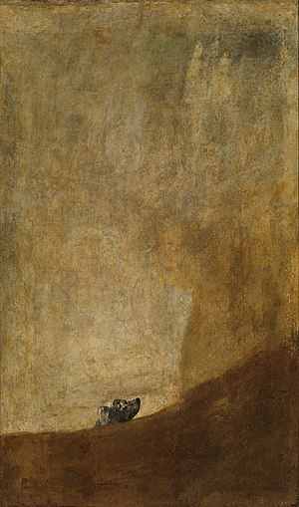
The written word will be given precedence here but, to repeat what was stated in the introduction, significant pictures will be included, to enhance what is being discovered, as well as to offer comfort to the terrified, lost ‘self’. It is hoped this literature review will offer a depth of understanding, along with a depth of feeling. To engage the reader in exploring the living experience of parentification and the almost unbearable pain of having lost one’self’. Like Goya’s ‘El Perro/The Dog’, the parentified soul can be afraid, stuck, lost and silent, looking toward a dark, shadowy place. ‘El Perro.’ Goya (1819-1823)
In order to undertake this literature review books and articles were accessed using the University of Wales Trinity Saint David library database. In particular, texts were accessed using SAGE Books, SAGE Knowledge, ProQuest Ebook Central, Taylor & Francis Group eBooks, EBSCOhost Academic Search Premier, Askews and Holts VLe Books, Taylor & Francis eBooks Complete and Elsevier ScienceDirect.

The literature review will begin by exploring the definition of parentification. Research on growing up with a parent with mental illness and the connection to parentification will then be examined followed by a review of the potential impact this can have on the development of the self. This will lead into an analysis of the concept of the self, drawing on the foundational work of Winnicott and Bowlby, whilst incorporating contemporary research in the field of neuroscience. In bringing together the old and the new, deeper insights into the ‘self’ and the phenomena of losing one’self’ is possible, and the question, ‘How can I become my’self?’, emerges. In endeavouring to explore this question the therapeutic potentiality of clay will be considered, as a body based, haptic, trauma informed approach to psychotherapeutic practice. Drawing notably on the pioneering work of Souter-Anderson and Elbrecht.

In the 1960’s, when Minuchin and colleagues were working with families living in the ghettos of New York, they noticed that some children were taking on parental responsibilities. They referred to these youngsters as ‘parental children’ (1967 cited in Jurkovic, 1997, p.16). But it was Boszormenyi-Nagy (1965 cited in Jurkovic, 1997, p.17), also a key figure in family therapy at the time, that coined the term ‘parentification’. Within psychotherapeutic research, the term parentification most often refers to children, or adult children, who have experienced an overburdening of parental responsibility, beyond what is developmentally appropriate. The parent-child relationship boundary is distorted and the family dynamic becomes confusing. The child takes on the functional and/or emotional role of the parent, sacrificing their own needs in response to what the parent needs, this is considered damagingly exploitative (Chase, 1999, p.5; Boszormenyi-Nagy and Spark, 1984, p.164). It is a heavy burden that involves invisible loyalties and symbiotic relationships between parent and child. A sense of obligation is created, an internalisation of the expectations to care for the parent.

It is alarming that parentification was being recognised in the 1960’s, with acknowledgement in the late 1990’s that ‘there is an epidemic of parentified children’ (Chase, 1999, p.143). Yet, even as research on ACE’s has been thriving over the last few years (Struck et al, 2021, p.1), research on the impact of parentification on both children and adults is still desperately needed (Chase, 1999, p26; Engelhardt, 2012, p.45; Abraham and Stein, 2013, p.600; Van Loon et al, 2017 p.142; O’Connell, 2008, p.89).

Perhaps it is the ubiquitous nature of parentification that makes it unappealing to researchers. Boszormenyi-Nagy and Spark (1984, p.151) believed that parentification is applicable to most human relationships, not always inherently damaging or problematic. They propose that a level of parentification can enable a child to prepare for and identify with responsible roles in the future. The reciprocity in the relationship being helpful to a child’s sense of belonging and usefulness. In recognising a dichotomy in parentification, two definitions are offered, ‘adaptive’ and ‘destructive’ (Byng-Hall, 2002, p.376). Jurkovic (1997, p.19) identified adaptive parentification as generally transient, the child is not captive to the role and their identity is not formed around it, whereas destructive parentification is diametrically opposite to this. Do these two definitions capture the entirety of the living experience? Chase (1999, p.144) suggests, ‘there is no one parentified child, any more than there is one form of parenting’, so maybe these two definitions are limiting. Defining parentification in a way that fits all individual experiences feels challenging, as can be the case when trying to describe a complex phenomenon. Perhaps parentification could be considered a complex, multi-dimensional, interrelated, continuum.

When using the term parentification within this research, it will refer to the overburdening, exploitative aspects, the ‘destructive’ form. It is hoped that more research will be undertaken in this area and that, in some small way, this piece of research may help in filling some of the void.

There is a growing body of research on the experience of growing up with a parent with a mental illness and the impact this can have. However, it has been acknowledged for some time that there is a need for further research and understanding in this area, particularly in relation to adult children (Foster, 2010, p.3144; Petrowski and Stein, 2016, p.2873; Murphy et al, 2018a, p.1016; Metz and Jungbauer, 2019, p.74). The division between researching the experience of the child and the experience of the adult child is apparent within the three meta-synthesis identified as key pieces of research for this literature review. One captures data from under 18’s, whilst the other two explore the adult child perspective (Simpson-Adkins and Daiches, 2018; Murphy et al, 2010; Kallquist and Salzmann-Erikson, 2019). It is prudent to include Simpson-Adkins and Daiches’ (2018) research on under 18’s, even though this piece of research is focusing on adult children, because their qualitative data, so generously and courageously shared by the young participants, is rich, heartfelt and insightful. It is also applicable, as Murphy et al (2018, p.1016) describes, ‘Whilst there is a paucity of qualitative studies with a focus on adults who experienced childhood parental mental illness, current knowledge suggests there might be similarities with study findings involving children.’

The three meta-synthesis’ described all aimed to identify and bring together the available, applicable, published, qualitative research on the experience of having a parent with a mental illness and offer new interpretations and insights within this field. They defined parental mental illness as either depression, psychosis, bipolar disorder, schizophrenia, obsessive compulsive disorder, a diagnosed personality disorder or being in contact with a psychiatrist or mental health service.

There is a feeling of discomfort with this list. What about people, families and children, that do not fit these categorisations? It also risks forgetting that there is so much more to us than a diagnosis. It is acknowledged that a diagnosis can sometimes be helpful, it was for Mum. But medicalisation and the use of generalised terms within qualitative research could lead to a sense of dehumanisation and a narrowed view. Perhaps it is a requirement for focus and robustness, but it feels a rudimentary aspect of qualitative research. Johnstone and Boyle (2018, p.43) agree, with their research exploring alternatives to functional psychiatric diagnosis and the limiting impact a diagnosis can have on research methods and outcome measurements. They suggest a diagnosis is fundamentally an assumption of human functioning. It invites the question, how much valuable information are we losing in qualitative research and, particularly, within this heuristic research inquiry when such criteria are adopted? With an awareness of this issue and a feeling of unease, for continuity and to avoid confusion, the same terminology will continue to be used throughout, to align with the existing research within this field. It is clear, however, that this is an area in need of further exploration.

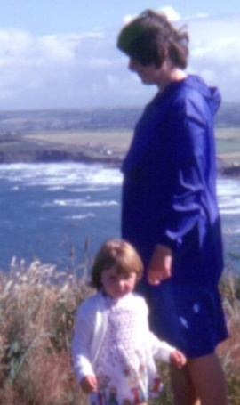
‘We’re Lost, Please Help; the diagnosis fits, but not all is better.’ Helen Evans (2022)

Within their meta-synthesis’, Simpson-Adkins and Daiches (2018, p.2707) identified 14 papers related to under 18’s, Murphy et al (2010, p.3432) included 7 articles exploring adult child experiences and, interestingly, 9 years later Kallquist and Salzmann-Erikson (2019, p.2058) identified 14 articles on adult child experiences. It is hoped that this increase in available research on adult children suggests increased attention and interest in this much needed area. Simpson-Adkins and Daiches (2018, p.2711), both holding Doctorates in Clinical Psychology from the University of Lancaster, in their recent study discovered three main themes amongst the evocative accounts of the young people. The most relevant, for this research, being that children ‘subjugate’ their own needs for the parent’s, “Sometimes it’s more like I’m the one who’s the parent”. There was a clear recognition of the changing role within the family, the sense of parentification (Simpson-Adkins and Daiches, 2018, p.2712).

Murphy, a mental health nurse and lecturer, appears to be a prolific contemporary researcher on adult experiences of growing up with a parent with a mental illness (Murphy et al, 2011; Murphy et al, 2016; Murphy et al, 2018a; Murphy et al 2018b). Interestingly, Kallquist and Salzmann-Erikson (2019, p.2061), both associated with the University of Gavle in Sweden, incorporate three of Murphy’s research papers in their recent meta-synthesis. It is perhaps not surprising, therefore, that the findings of both Kallquist and Salzmann-Erikson (2019) and Murphy et al (2011) meta-analyses are similar. They both identified that adults who grew up with a parent with mental illness experienced ‘reversed roles and responsibilities’ (Murphy et al, 2010, p.3433; Kallquist and Salzmann-Erikson, 2019, p.2062). This corroborates with Simpson-Adkins and Daiches’ (2018) findings. However, there is curiosity and concern towards the intertwined nature of the two pieces of research. Although highly significant and peer reviewed, there is the possibility of the interpretation of findings being influenced by bias when the research is repeatedly undertaken by the same group of people. Whilst honouring and respecting the work of Murphy and her colleagues, it was felt it would be wise to search for research undertaken by others, to gain a wider perspective and overall view in this area.

Three additional pieces of research were identified. Metz and Jungbauer (2021), Abraham and Stein (2013) and Reupert and Maybery (2007). Metz and Jungbauer’s (2021, p.66) very recent qualitative research in Germany included eighteen adult participants, all had grown up with at least one parent with a mental illness. They found that 72% of the participants disclosed experiencing parentification (Metz and Jungbauer, 2021, p.74). Abraham and Stein’s (2013, p.604) research, affiliated to the University of Michigan and recruiting 116 participants, specifically focused on the experiences of emerging adults who have a mother with a mental illness. From responses to an online self-report questionnaire, they claim that having a mother with mental illness resulted in experiencing higher levels of role reversal. Reupert and Maybery’s (2007, p.362) research, based on a review of literature, also found that children can assume parental responsibilities when a parent has a mental illness. It is noticed that Reupert and Maybery (2007) fail to highlight how many research articles were included, and the criteria for inclusion and exclusion. Their work is also slightly dated. Metz and Jungbauer (2021, p.74) and Abraham and Stein (2013, p.611) both state that a low number of participants is a limitation to the generalizability of their results. Both had predominantly female participants, which does bring into question the applicability to men. Abraham and Stein’s (2013) research was concentrated on having a mother with a mental illness. This fails to address the possibility that parentification may not be exclusive to the mother-child relationship. The terms ‘role reversal’ and ‘parentification’ are also used interchangeably. Both imply exclusivity in the relational dynamic between parent and child, two individuals, when parentification may have the potentiality to involve multiple familial relationships. Again, bringing our attention to the limitations of the terms used within this field and a need for further exploration into the phenomena of parentification.

When examining all the research it is reasonable to suggest that there is a clear relationship between the Adverse Childhood Experience (ACE) of growing up with a parent with a mental illness and destructive parentification. There is also strong evidence within the research that, once established in childhood, the legacy of destructive parentification can be carried into adulthood creating psychological symptoms, the consequence of which can be far reaching (O’Connell, 2008, p.96; Jurkovic, 1997, p.19; Hooper et al, 2011, p.1037; Engelhardt, 2012, p.47; Byng-Hall, 2002, p.377; DiCaccavo, 2006, p.469). This concurs with the research findings of Felitti et al (1998) and Public Health Wales (2015), that ACE’s have the potential to impact, detrimentally, throughout the lifespan.

The psychological symptoms, or legacy, of destructive parentification in adulthood can include a sense of being held emotionally captive, a loss of autonomy and freedom, isolation, confusion, grief, worry, fear, lack of trust, shame, guilt and, particularly relevant to this research, a loss of our ‘self’ (Boszormenyi-Nagy and Spark, 1984, p.160; Murphy et al, 2016, p.670; Foster, 2010, p.3146; Earley and Cushway, 2002, p.165; Engelhardt, 2012, p.47; Byng-Hall, 2002, p.377; DiCaccavo, 2006, p.469). Chase (1999, p.147) powerfully describes the almost unbearable experience of destructive parentification and the resultant phenomena of losing our true ‘self’ and, although referring to children, this is the reality for many adult children too:

“Parentified children swim in a sea of internal, drowning objects, too many to save easily, yet too precious to be abandoned. To where can the true self swim? Does the true self even deserve to stay afloat, hearing the cries for help, the distress, of the other parts who carry the burden of overwhelming experience? How can the true self justify accepting help for itself, knowing that these related parts have, at times, served to aid in its very survival, and are equally deserving of rescue? The powerful undertow of loyalty to even those desperate parts makes the prospect of individuation a terrible dilemma. Psychic life comes to resemble the interminable, hellish waiting for the drowning.”

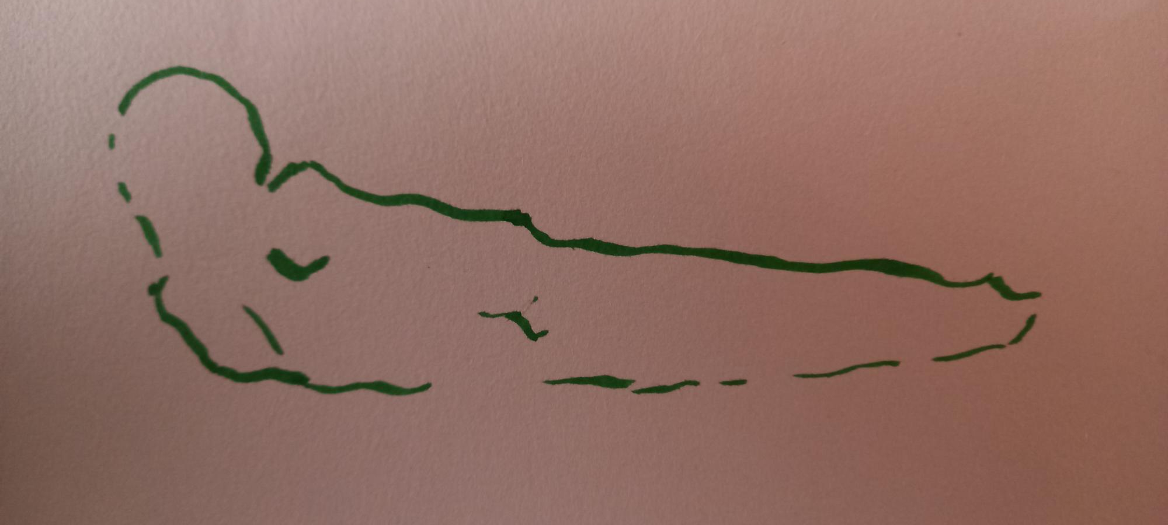
‘Moribund’. Helen Evans (2021)

Reflecting on Chase’s (1999, p.147) words and acknowledging the impact destructive parentification can have on the ‘self’, it is important to now consider the concept of the ‘self’ and how the ‘self’ develops. Through this examination comes the possibility of beginning to identify potential approaches in supporting destructively parentified adult children, particularly within the field of psychotherapeutic practice.

There are many theories written on the ‘self’ over an extensive period. Over 2000 years ago, Socrates proposed the true self to be the soul. Freud, in the late 20th Century, referred to the ‘self’ in terms of the psyche, the ego, id and superego (Lear, 2015, p.168). Kohut conceived ‘self’ psychology (Cooper and Randall, 2011, p.1), and the post-Freudian Stern considered a layered approach in the ‘four senses of self’ (Stern, 1985). It became apparent, perhaps due to the search for seminal works in this area, that psychoanalysis is woven into the fabric of many of these theories. With this heuristic research inquiry growing from the roots of humanistic psychotherapy it initially felt incongruous to explore the ‘self’ through this lens. Looking, perhaps predictably, to Rogers’ humanistic theory on the self was, therefore, considered. However, it became evident that the theories of Bowlby and Winnicott, both belonging to a British psychoanalytic splinter group and both having a keen interest in child development, were highly relevant to this piece of research. By its very nature, destructive parentification is relationship based and born in childhood. Therefore, it felt right and appropriate to turn to their respective relational based theories of attachment and object relations. Their work is also referenced repeatedly, not only within the research on parentification, but in neuroscientific research on childhood trauma as well as the two foundational theories of clay therapy (Elbrecht, 2013; Souter-Anderson, 2010; Evans and Coccoma, 2014, p.53; Schore, 2009, p.193; DiCaccavo, 2006, p.470; Murphy et al, 2010, p.3439; Reupert and Maybery, 2007, p.363; Hooper et al, 2011, p.1029; Engelhardt, 2012, p.47; Metz and Jungbauer, 2021, p.65; Byng-Hall, 2002, p.375; Strand and Rudolfsson, 2020, p.1020; O’Connell, 2008, p.89; Waldron, 2013, p.103).

As already alluded to, object relations theory places relationships at the heart of what it is to be human. Originating from Freudian ideas, it was explicated, most notably, through the work of Klein, Fairbairn and Winnicott. Interestingly, Bowlby’s work on attachment theory is also considered to have been built on a ‘modern scientific attitude and approach to object relations’ (Gomez, 1997, p.4). When considering Winnicott’s influential contribution to this field it is helpful to firstly remember his dictum, ‘there is no such thing as a baby’ (Winnicott 1952a cited in Gomez, 1997, p.86; Brodie, 2020, p.44). Here he is highlighting that a baby cannot survive alone. That an infant is completely dependent on, what is unanimously referred to in the literature as, the mother. An important critique of Winnicott’s theory is to consider if this unilateral view of the child-mother relationship is still applicable today. Many babies may experience having one or two fathers for example, and no mother. Does object relations theory apply in these situations, as the baby remains wholly reliant on another to survive? Is the theory still relevant in the current cultural climate? As this research is based on a mother-daughter relationship, it is considered applicable here. However, research is needed into the application of object relations theory to alternative baby-caregiver relationships in the present day.

Winnicott believed that on some level a baby knows that the mother is needed for survival and, therefore, separation from the mother can feel threatening. If there is, however, a ‘good enough mother’, a mother that can adapt to the needs of the baby and provide a ‘holding environment’, the feeling of threat does not occur and the baby/child can begin to learn about themselves, become, what Winnicott termed, their ‘true self’. Without a ‘good enough mother’, without the ‘holding environment’, ‘a sense of self does not emerge’ (Brodie, 2020, p.51), and a ‘false self’ begins to develop, a self that is compliant to the mother (Winnicott, 1965, p.145). Chase (1999, p.146), over thirty years later, corroborates with the lack of a ‘holding environment’ and subsequent feeling of threat in view of the destructively parentified child’s experience, stating, ‘The truly parentified child negotiates a landscape devoid of protective hands, where the edges rule, rather than what feels safe.’ When considering Winnicott’s theory in conjunction with the research on growing up with a parent with mental illness and the phenomena of parentification, it is reasonable to suggest that a destructively parentified child is without an adaptive, holding, ‘good enough’ mother. This leaves the baby/child feeling threatened and unsafe, and in attempting to quell these feelings, to gain a sense of safety and to ultimately survive, devastating adaptations occur. The false self begins to develop as the true self becomes lost, to the point of invisibility.

Bowlby’s foundational work on attachment theory also holds relationships at the heart of what it is to be human and like Winnicott, the mother-child relationship takes centre stage. There is similar critique of Bowlby’s work, in that there is an inherent overburdening placed on the mother, due to the exclusivity given to the mother-child relationship (Holmes, 2014, p.32). It is propositioned that, contrary to Bowlby’s theory, care from just a mother can lead to less not more security in the child, referring to the African proverb, ‘it takes a whole village to raise a child’, suggesting a range of people could be attachment figures (Holmes, 2014, p.32). Interestingly, Bretherton (2010, p.9) agrees that, for much of Bowlby’s work on attachment theory, more attention was given to mothers, but she notes that at a very early stage Bowlby was interested in fathers too. Perhaps the heavy focus on the mother is a reflection of the time and societal context Bowlby was researching in. This is supported when Bowlby states he found it easy to recruit mothers into his research, whereas it was difficult to find children being mainly cared for by their fathers (Bowlby, 1988, p.10). Bretherton (2010, p.19) draws the conclusion that there is a need for a family systems approach to attachment theory research going forward. It seems fair to suggest this is still needed today, as family and societal structures continue to evolve.

Bowlby believed, similarly to Winnicott, that babies and children naturally seek connection and proximity to the mother for survival. Bowlby worked closely with Mary Ainsworth, and it was from her ‘strange situation’ research that the terms secure and insecure attachment were founded. These terms are associated with the ways in which a baby/child relates to the mother. A secure attachment between child and mother was founded on a sense of safety within the relationship, and this acts as ‘a springboard for curiosity and exploration’ (Holmes, 2014, p.56; Bowlby, 1988, p.68). When there is a threat the child can return to the mother, the attachment figure, for safety. As Holmes (2014, p.56) describes, ‘we can endure rough seas if we are sure of a safe haven’. Insecure attachment is diametrically opposite to this and can be subdivided into three ‘secondary attachment’ variants: avoidant, ambivalent and disorganised. Here there is no safe haven. Comparable to Winnicott’s theory on the development of the false self, Bowlby proposes ‘secondary attachments’ are strategies developed in an attempt to gain the much needed sense of safety a baby/child needs. Bowlby suggests there is a relationship between attachment style and an internal working model, built ultimately on how the mother communicates and behaves towards the baby/child through synrythmic regulation, attunement, mirroring, being held, being touched, warmth, safety and comfort. This becomes the blueprint for how we feel about our’selves’ and how we relate to others (Bowlby, 1988, p.146). It is from this internalisation that the ‘self’ begins to develop. It is proposed, with the support of current research, that destructively parentified children experience insecure attachments and, therefore, find difficulty in developing a sense of ‘self’ (Lyons-Ruth et al, 2013, p.279; Engelhardt, 2012, p.45; Byng-Hall, 2002, p.376; Metz and Jungbauer, 2021, p.73).

The common theme in both Winnicott and Bowlby’s theories, when looking at the development of the ‘self’ in childhood, is the fundamental need for safety, achieved through an adaptive, attuned, holding, secure attachment figure: a ‘good enough’ mother. It is proposed that destructively parentified children do not receive enough of these qualities, hence the subsequent loss of the ‘self’, and it appears that contemporary neuroscientific research is now substantiating Winnicott’s and Bowlby’s theories and this proposition. Evans and Coccoma (2014, p.53) state that a child’s ability to feel safe is fundamentally connected to brain development, and that a child’s brain is dependent on external information, such as from a mother, to develop necessary ‘safety cues’. Children’s brains are vulnerable, they ‘experience the most changes in the microarchitecture of their brains as a result of experiencing trauma’ (Evans and Coccoma, 2014, p.49). Important structural connections are disrupted by a sense of threat and fear in childhood (Evans and Coccoma, 2014, p.50); ‘safety trumps everything within the brain’ (Evans and Coccoma, 2014, p.72). Evans and Coccoma (2014) do not stand alone, they are supported by a plethora of neuroscientific research findings that show childhood as a critical time for brain development, with trauma known to impact the amygdala, hippocampus and limbic system, and causing disconnection between the left and right hemispheres (Mackes et al, 2020, p.641; Sampaio and Lifter, 2014, p515; Van der Hart, Nijenhuis and Steele 2006 cited in Fisher, 2017, p.4; Van der Kolk, 2014). This also clearly supports the introduction of the layer of ‘disrupted neurodevelopment and allostatic load’ within the revised impact of ACE’s across the lifespan by Public Health Wales (2015).

The impact of the changes within the brain are highly significant for this research, and potentially catastrophic as a living experience. The amygdala and hippocampus are related to emotion, understanding trauma memory and together are ‘integral to processing information transmitted from the body’ (Rothschild, 2000, p.20). Disconnection of the left and right sides of the brain is problematic because, although both sides are intricately intertwined and work together, they both have different functions. The left brain has a voice, it uses language and reason, and helps us to have a narrow, sharply focused attention. The right brain tends not to have a voice, it is how we make connections to living things, it is intuitive, understands metaphor and gives us a broad, open alertness (McGilchrist, 2010). The living experience of disconnection of the left and right brain is a lessening of the accessibility of emotional memory to the verbal consciousness (Schore, 2003a and Schore, 2003b cited in Chong, 2015, p.120).
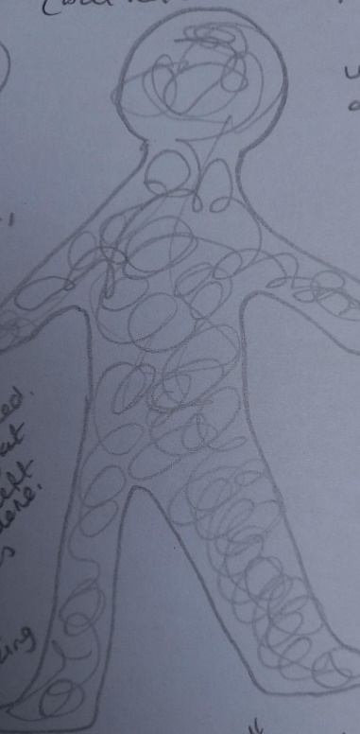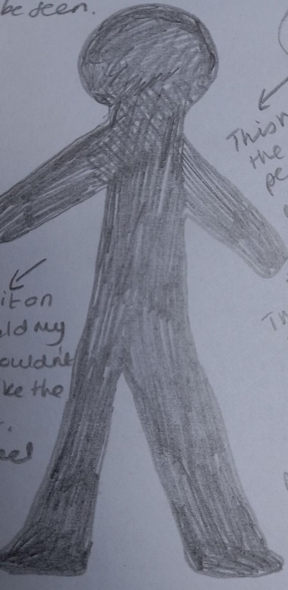 ‘Disconnected’. Helen Evans (2021)
Bessel van der Kolk (2014, p.47) describes his seminal study which involved 8 adults having brain scans as they recalled their trauma. The results showed that the left side of the brain and the prefrontal cortex go offline, as the right side is activated. This research is particularly interesting when applied to Keenan et al (2010, p.341) and D’Argembeau’s (2013, p.2) findings, as they argue that aspects of the ‘self’, or ‘bias for the processing of the self’ may sit within areas of the prefrontal cortex. This suggests that during trauma, such as when babies and children feel unsafe, the part of the brain associated with the ‘self’ goes offline. When viewing the neuroscientific research in relation to the ‘self’, it is noticed that a limitation may come from the colliding worlds of psychotherapeutic theory and scientific research. There is a sense, garnered from how the neuroscientific studies are written, of trying to force the abstract into a tangible form. D'Argembeau (2013, p.2) acknowledges ‘the self is not a single entity’, but then goes on to define the self broadly into two parts: firstly, ‘the self as the experiencing subject’, and secondly, ‘the self as object of knowledge’. This could be seen as a reflection of the differences between the hemispheres, but it feels more like a contradiction. If a single definition of the ‘self’ is seen as too constrictive, then offering a dualistic definition surely does not address this. The concepts of the ‘self’ are far from definitive within the theories of psychotherapy, and this feels positive, as it is an acknowledgment of how much is still in the realm of the unknown and still to be explored through research.

When looking through the lens of Winnicott and Bowlby’s theories and the contemporary neuroscientific research, it is proposed that the ‘self’ sits at the interface of relationship, emotion, and neurobiology. A complex combination of the living experience of the brain, the body and the external world that is impacted upon by a sense of safety and survival. With this understanding the research question emerges, how can I become my’self’? As an adult, living with the legacy of destructive parentification and the subsequent phenomenon of having lost one’self’, what psychotherapeutic practice may best support the discovery, development and integration of the ‘self’?

To address this question, it is propositioned by this author that a therapeutic approach needs to be body based, non-verbal, able to create a connection between both brain hemispheres and to hold a sense of safety at its core. It, therefore, felt prudent to turn to the world of creative therapies. It was found within art therapy research that there is an argument for it being well placed as a therapeutic and neurobiological approach to working with trauma. However, it is also noted that there is an urgent need for further research into the mind-body connection in this field, how specific strategies promote neuroplasticity and healing, and which aspects of art therapy are more effective with specific groups of traumatised adults (Schouten et al, 2015, p.226; Perryman et al, 2019, p.91). With this in awareness, a more specific exploration was undertaken, which yielded interesting results in the available research and theories on clay therapy. There is recent research showing favourable results in the therapeutic potential of clay work for people with Parkinson’s disease, women living with cancer and adolescents living under socio-political unrest (Bae and Kim, 2018, p.1; Reynolds and Lim, 2007 cited in Stuckey and Nobel, 2010, p.257; Nan and Wong, 2021, p.27). But it was the research of Sholt and Gavron (2006, p.70) that offered a light-bulb moment. Their research came a few years after Sherwood (2004, p.5) stated, ‘clay work is like the Cinderella of the art therapies. She still waits to be discovered with her magic, her beauty and her ability to transform the wells of human suffering into places of insight and celebration’. Sholt and Gavron (2006, p.71) aided in the recognition of Cinderella’s plight and possible liberation, by concluding from their much needed review that the therapeutic qualities of clay work are fundamentally about the ‘exploration of the self’, the ‘integration of primal experiences of the self’, and that for participants it can ‘widen their access to their inner selves and thus continue their journey of becoming’. It felt undeniable that there was more to explore here.

Only one other article was identified as connecting the theme of this research and therapeutic clay work. Through their examination, Elbrecht and Antcliff (2014, p.24) strongly advocate for the potential of using clay in therapy when working with the legacy of ACE’s and trauma. They highlight a connection between touch, the nervous system and the brain, and pull together theories and research in these areas to formulate their compelling argument. Unfortunately, their almost solitary work does not involve collecting data from participants, emphasising the importance and need for this piece of research.

Two contemporary clay therapy theories have been identified. Firstly, Elbrecht’s (2013) ‘Trauma Healing at the Clay Field’, and secondly Souter-Anderson’s (2010, p.51) ‘Theory of Contact: Physical, Emotional, Metaphorical’. Both theories differ in their practical approach to working with clay. Elbrecht’s (2013, p.15) ‘Clay Field’ consists of a rectangular box, 36cm by 42cm, and 3cm deep, filled with 15kg of clay, prepared and ready for the client to use. Souter-Anderson (2010), perhaps more freely, roughly prepares pieces of clay, big enough to hold in one hand, and invites the client to choose. Both are similar, however, in how they are anchored in working with the body, movement, emotion, metaphor, imagination, non-verbal expression, left and right-side cooperation and imagination. Touching the clay, or haptic perception, is acknowledged by both authors as fundamental as it creates a connection between our nervous system and our brain, allowing access to a sensorimotor, non-verbal psychological process (Souter-Anderson, 2010, p.59; Elbrecht, 2013, p.24; Elbrecht and Antcliff, 2014, p.19). Elbrecht (2013, p.42) describes the intricate evolutionary journey between the use of our hands and the development of our brains. Souter-Anderson (2010, p.60) refers to our earliest experiences of touch as babies. It could be argued that touching clay offers not only engagement with areas of our brain, perhaps where aspects of the ‘self’ are processed, but also a connection to our earliest, body-based experiences. Touching clay, or the use of clay in therapy, has the potential to aid the process of making what is invisible, visible. When discussing the challenges of therapy with the parentified child, Chase (1999, p146) says ‘our imagination is our guide to the invisible world’. Here she is implying that finding the invisible and making it visible, by using our imagination, is fundamental in the process of healing the burden of parentification. This is an attractive proposition, possible with clay, and central to this research’s aims and objectives. It feels important, however, to add a note of caution and reiterate the need for safety being at the core of any therapeutic approach with the destructively parentified child seeking to become their ‘self’. Encouraging the invisible, or the lost, to become visible could, in itself, be traumatising. ‘The hazard of visibility lies in the fear that when the precious parts of the self are revealed, the vulnerable parts will not be able to protect themselves and close the gates’ (Chase, 1999, p148). Brogan (2021, p.210) agrees, identifying that there is a sense of danger in reaching the ‘I AM’.

To conclude, the relationship between the ACE of growing up with a parent with a mental illness and destructive parentification is supported within contemporary qualitative research. What is also borne out of the research is the significant impact destructive parentification can have on a child and adult child, with one impact being the debilitating sense of having lost ones ’self’. Through examining two foundational theories on how the ‘self’ develops, in line with contemporary neuroscientific research, it is proposed that body-based, non-verbal therapeutic practices, that hold a sense of safety at their core, are best placed to ease the burden of this legacy. When exploring two contemporary theories on the therapeutic use of clay, it appears that there is a strong argument for its potential application in this context. However, this comes with a cautionary note; inviting what has been invisible to become visible, to become my’self’, the ‘I AM’, through the therapeutic use of clay, can be a powerful and overwhelming experience, even traumatic. It was with this awareness that the heuristic research methodology was planned and implemented.

Methodology

Within this methodology chapter I will begin by briefly reintroducing the research aim and question. This will be followed by an exploration of the heuristic research methodology, the rationale for choosing this research design, and an introduction to the newly proposed ‘Triadic Heuristic Inquiry’ model. The seven processes and six phases of the methodology will be described, and this will include the methods used to create and collect data. The application of thematic analysis will then be introduced as the method adopted to analyse the qualitative data, along with its limitations. To conclude, the implicit ethical issues will be considered.
The aim of this research is to examine how the legacy of an Adverse Childhood Experience in adulthood, such as destructive parentification due to parental mental illness, can result in the enduring phenomenon of having lost my‘self’. From here emerges the research question; How can I become my’self’? It is proposed that the therapeutic use of clay is well placed within the field of psychotherapeutic practice to support the exploration of this question.

A complete systematic literature review was considered as the methodology for this research, but I felt as though something would be lost if the actual living experience of the phenomenon and subsequent data was not captured. There is a clear need for more empirical, qualitative research in the fields of parentification, the loss of ‘self’ and the application of the therapeutic use of clay within psychotherapeutic practice to support this adult burden. Sultan (2019, p.46) debates how heuristic inquiry sits as an empirical process and concludes that it is ‘an empirical research approach grounded in sensory experience and inferential constructs’. I have, therefore, adopted a heuristic inquiry methodology to support this research process.

Heuristic research was developed by Moustakas through his early work titled ‘loneliness’. It is fundamentally about investigating human experiencing and what it means to be human. This methodology places me, uniquely, as both participant and researcher. It is possible to engage with other participants within heuristic research, Sultan (2019, p115) supports this in her contemporary revision of Moustakas’ methodology. However, Sela-Smith (2002, p.71), who has critiqued Moustakas work since its inception in the 1990’s, argues ‘the inclusion of coparticipants seems to create a distraction from the internal process’. Opinion is divided on whether the inclusion of participants, beyond the self, is of benefit or a distraction. The decision of whether to include co-researchers within this research was taken out of my hands, as when this research was being conceived, Covid-19 was lapping at our shores, bringing with it social distancing and isolation. Therefore, for this heuristic inquiry I am the sole participant, but I believe that the data still holds significance. As Moustakas (1990, p.15) states, ‘with virtually every question that matters personally there is also a social – and perhaps universal – significance’. This research question feels deeply personal, has significance to a current public health issue and contemporary psychotherapeutic practice.

The word heuristic originates from the Greek ‘heuriskein’ which means ‘to discover or to find’ (Moustakas, 1990, p.8). Moustakas (1990, p.38) described the process as seeking ‘to discover the nature and meaning of the phenomenon itself and to illuminate it from direct first-person accounts of individuals who have directly encountered the phenomenon in experience’. Heuristic research developed from a humanistic background, drawing most notably on the work of Polanyi (1969 cited in Moustakas, 1990, p.21), Gendlin (1978 cited in Moustakas, 1990, p.25), and Rogers (1951 cited in Moustakas, 1990, p.26). It involves engaging with seven processes, within six phases, those of which will be discussed shortly. But firstly, it is important to note the critique of Moustakas’ (1990) work. Moustakas created a unique qualitative research methodology that is autobiographical, systematic, organised, reflexive, and robust. However, since his original writing, Sela-Smith (2002, p.71) has noted that there can be a sense of ambivalence within his design, as one can easily shift from the ‘self’ experiencing, to the idea of experiencing, perhaps due to the pain and discomfort connected to experiencing the inner phenomenon. To address this, Sela-Smith (2002, p.83) proposes a research method called Heuristic Self-Search Inquiry (HSSI), which keeps the focus on the ‘I-who-feels’, returns to the internal perspective, recognises resistance to feeling and accepts surrendering to the process. Interestingly, Sultan (2019, p.xiv) offers what she feels is a desperately needed ‘revision and revitalization’ of Moustakas’ (1990) original work, acknowledging the evolution of qualitative research, and stretching heuristic research to ‘more efficiently meet the needs of the 21st century researcher’. It is in acknowledging the critique and potential limitations of Moustakas’ (1990) original heuristic research methodology that I propose a unique ‘Triadic Heuristic Inquiry’ methodology be used within this research (see figure 3). This will work by placing Moustakas’ (1990) original heuristic research methodology as the foundation, whilst interlinking with Sela-Smith’s (2002) HSSI and Sultan’s (2019) contemporary approach, to support and inform the research process. I hope that in doing so, this research will be more thorough, and its application to the present day significant and credible.

Figure 3.
The heuristic research methodology comprises of seven processes and six phases, and Sultan (2019, p.94) describes how the ‘processes and phases work in concert to support the exploratory, introspective, creative, experiential, and relational facets of heuristic research’. It feels important to acknowledge that the six phases are written sequentially, however, the participant and researcher experience has a sense of movement between the phases. This has felt unsettling at times, like swaying back and forth.
The seven processes are as follows: Identifying with the Focus of Inquiry involves actively immersing myself into the experience I am noticing to achieve an understanding of it. What Salk (1983 cited in Moustakas, 1990, p.15) called ‘the inverted perspective’. Sultan (2019, p.82) describes this as ‘you embody the phenomenon you are exploring’. Self-Dialogue asks that I enter into a dialogue with the phenomenon, the sense of having lost my’self’. Moustakas (1990, p.16) states this is ‘allowing the phenomenon to speak directly to one’s own experience, to be questioned by it’. Tacit Knowing gives ‘birth to the hunches and vague, formless insights that characterise heuristic discovery’ (Douglas and Moustakas, 1985 cited in Moustakas, 1990, p. 22). Moustakas (1990, p.20) and Sultan (2019, p.87) refer heavily to the work of Polanyi and what he considers the subsidiary and focal elements of tacit knowledge. In essence, I am drawing on implicit, tacit knowing, of an experience that I know is here, but is unknown. Interestingly, Sultan (2019, p.88) suggests this experience is ‘preverbal’ and, therefore, more likely to be understood through body sensations than thoughts. This supports my choice to explore the phenomenon through the therapeutic use of clay. Intuition is what Moustakas (1990, p.23) describes as ‘the bridge between the explicit and the tacit ..the realm of the between’. It is intuition that connects inner and outer experiences, and will guide me not only as participant, but as researcher too. As Sultan explains (2019, p.89), intuition ‘guides the heuristic researcher’s encounter with recurring patterns and themes, as well as the creation of new knowledge and meaning’. Einstein famously said ‘The intuitive mind is a sacred gift and the rational mind is a faithful servant. We have created a society that honours the servant and has forgotten he gift’ (McGilchrist, 2010). Within this research I purposefully notice the sacred gift. Indwelling will direct my gaze inwards, with an ‘unwavering attention and concentration’ on my experience of the phenomenon, so to ‘understand its constituent qualities and its wholeness’. The process is ‘conscious and deliberate’ and is ‘not lineal or logical’ (Moustakas, 1990, p.24). Focusing is derived from the therapeutic technique offered by Gendlin (Sultan, 2019, p.91; Moustakas, 1990, p.25). Gendlin (1978, p.43) breaks down the act of focusing into six movements; clearing a space, felt sense, handle, resonating, asking and receiving. He believes these aid in touching a holistic body sense of a problem. Moustakas (1990, p.25) describes focusing in heuristic research as including Gendlin’s six movements, and states it is an ‘inner attention, a staying with, a sustained process of systematically contacting the more central meanings of an experience’. Finally, the internal frame of reference is what I will rely on to understand the meaning and nature of my own internal experience. This is derived from Rogers’ (1951 cited in Moustakas, 1990, p.26) person centred theory, and the core conditions, particularly empathy. Sultan (2019, p.92) describes the challenge of maintaining a balance here, stating ‘too much focus on your inner experience can undermine other processes and phases of the research’. I keep in awareness throughout, the delicate balance between my dual role as participant and researcher.
The six phases integral to the structure of the heuristic research methodology are as follows.
Initial Engagement.
This phase asks that I look inward, explore and discover something that is ‘an intense interest, a passionate concern that calls out’ (Moustakas, 1990, p.27). I use tacit awareness and intuition to guide me, and ultimately the research question begins to form. I feel that this phase is captured beautifully within Rumi’s (Circa 13th Century) poem:
“What in your life is calling you,
When all the noise is silenced,
The meetings adjourned,
The lists laid aside,
And the wild iris blooms
By itself
In the dark forest …
What still pulls on your soul?

My experience of this phase was twofold. It felt helpful and reassuring to identify my internal experience of the phenomenon, having lost my’self’, to have found what pulls at my soul. It shone a light on an experience that has been with me forever but is, at the same time, unknown to me. However, in recognising this came a deep pain, sadness and confusion. It was my husband, an experienced personal therapist and my dissertation supervisor that have supported this research process, offering safety, trust, reflection, and comfort.
Immersion.
In this phase ‘the researcher lives the question in waking, sleeping, and even dream states’ (Moustakas, 1990, p.28). Everything in life revolves around the question, it becomes my primary focus, taking all my attention. It is the full surrendering to the process, as described by Sela-Smith (2002, p.85), that creates a depth and intensity of experience, without limitation. It was within this phase that I began to immerse myself within the literature and, importantly, started touching clay. I found walking in woodlands and by the sea called me, a sense of reassurance offered by the predictability of the changing seasons and the lapping of the tide. Very naturally, I entered the immersion phase twice. Initially for approximately five months, with therapeutic clay work fortnightly. My second immersion phase being two months later and lasting five days, as I attended an experiential clay therapy group. The research question was in my awareness throughout both immersions and it was during these phases that I created clay forms and kept notes on my emotions and body movements whilst in contact with the clay. This was inspired by the three therapeutic features of clay work that Sholt and Gavron (2006, p.67) identified in their literature review: movement, construction or deconstruction and the regressive process which aids us in understanding our inner world and needs. It is this data that will be analysed in the next chapter and, interestingly, Sultan (2019, p.134) identifies that, in heuristic research, data can be gathered from ‘artifacts’, such as artworks, stating ‘I firmly hold that certain types of artifacts have the ability to tell stories that words cannot possibly tell’. This supports the non-verbal exploration of the identified phenomenon and is supported by Gilroy’s (2006, p.104) belief that data can be in the form of any ‘physical object that bears the traces of human activity’.
Incubation.
During this phase the researcher withdraws from the intense experiencing of the immersion phase, and ‘allows the inner workings of the tacit dimension and intuition to continue to clarify and extend understanding on levels outside the immediate awareness’ (Moustakas, 1990, p.29). As Sultan (2019, p.96) describes, ‘incubation is the sleeping-on-it phase’. I ‘incubated’ twice, after each of the immersion phases, and to my surprise, it initially did not feel less intense. It was reading Moustakas’ (1990, p.29) suggestion that incubation ‘is a process in which a seed has been planted; the seed undergoes silent nourishment, support, and care that produces a creative awareness of some dimension’, that I gained a sense of what may be happening. Perhaps the destructively parentified adult child is unfamiliar with a sense of internal nourishment, support and care. It felt as though this phase was asking the phenomenon I had been immersed in to do something that felt alien. A fogginess descended. Levine (1997, p.138), in his influential writing, describes fogginess, or spaciness, as dissociation, ‘one of the most classic and subtle symptoms of trauma’. It is the mystical way in which we can endure threats to our survival. Once aware of this, I committed to keeping this in my consciousness, which was possible through weekly personal therapy. I also remained awake to the differentiation between my dual role of participant and researcher, and when I needed to be one or the other.
Illumination.
What has come into being within the incubation phase now surfaces into consciousness in this phase. This is where the core themes of my research will emerge naturally, from tacit knowledge and intuition. Moustakas (1990, p.29) describes it as ‘a clustering of qualities into themes inherent in the question.. an awakening to new constituents of the experience’. It is where knowledge can be synthesised or a new discovery made. It is within this phase that I begin to draw my data together, using the method of thematic analysis, which will be discussed later in this chapter.
Explication.
Within this phase Moustakas (1990, p.31) says, as researcher, I will utilise ‘focusing, indwelling, self-searching, and self-disclosure’, to aid me in fully examining what has been discovered and awakened in my consciousness. It is about meaning making through ‘nuances, textures and constituents of the phenomenon’ (Moustakas, 1990, p.31). Sultan (2019, p.98) describes this phase as though co-researchers were involved, however, it is possible to take from her writing that this is where core themes appear, that there is a refinement of the data in preparation for the next phase. Within this phase, I spent time with the collated data, whilst also continuing to absorb myself within the literature. As Sultan (2019, p.109) suggests, it is wise to explore the literature at different phases of the research journey, particularly ‘after analysing your data and identifying themes’.
Creative Synthesis.
In this final phase, I am familiar with all the data, its qualities, themes, and the meaning made from the whole research experience. Moustakas (1990, p.31) suggests that tacit knowing and intuition are integral to this phase. It is a personal process, that can take many forms, such as a drawing, painting, storytelling, poems, photographs, or mosaics (Sultan, 2019, p.99). My hands returned to the clay to form part my creative synthesis, and this will be shared at the end of the Data Analysis and Findings chapter.

Thematic analysis has been chosen as the method for analysing the qualitative data within this research because it offers an accessible, flexible approach that uncovers repeated patterns of meaning and has the potential to produce rich, detailed and complex findings. It can be applied across theories and is quicker and more straight forward than other methods, making it ideal for the ‘beginning’ qualitative researcher, like me. Sixteen years ago, Braun and Clarke (2006, p.77) recognised thematic analysis as being ‘poorly demarcated’. They addressed this in their highly popular paper, by presenting reflex thematic analysis with clear guidance for its application. They describe six phases within the process, all of which I have followed within the data analysis (See Figure 4).
Familiarising
Reading and re-reading data, identifying initial ideas.

Generating
Coding initial interesting features

Searching
Collating codes into potential themes

Reviewing
Checking themes, creating thematic map

Defining and Naming
Refining, naming themes

Producing
Final analysis, produce report

Figure 4.

Thematic analysis is not without its limitations, as Braun and Clarke (2021, p.44) are keen to highlight, there is no perfect analytic method for qualitative analysis. A possible limitation of using thematic analysis within a heuristic research methodology is my positioning as both participant and researcher. Negri et al (2019, p.345) discuss epistemological assumptions within trainee psychotherapists and state that ‘when an observation is made, what is known is not the object itself, but rather ideas about the object within the linguistic and cultural categories shared by the observer with their contexts’. There are no ‘extra pair of eyes’ within my data analysis, only my own observational context. This creates the possibility for introspection without extrospection, or relationality. My data gathering, analysis and findings have all occurred within the sphere of my own experiencing and understanding. With this in consideration, I believe that this research still holds potential and significance to the area in which it applies. As discussed in the introduction, the impact of Adverse Childhood Experiences (ACE’s) across the lifespan is recognised by Public Health Wales and it has become apparent that the Covid-19 pandemic has increased childhood adversity (Welsh Government, 2021). This positions this research within a contemporary public health issue that, I argue, psychotherapeutic theories and practice could be well placed to support. There is a need for more research in this area and, as an adult who experienced an ACE, I propose that this research offers an original insight into the potential of therapeutic clay use within this context.

Due to the nature of this research, I applied for and received ethical approval from the University of Wales Trinity Saint David Ethical Board. Integral to my application was the evaluation of anticipated risk. The risk of harm to myself, as both participant and researcher, was identified as potential emotional distress. This was mitigated through my commitment to attend weekly personal therapy throughout the research process. I also had regular contact and support from my dissertation supervisor. I have adhered to the Universities Research Ethics and Integral Code of Practice and Research Data Management Policy.

Data Analysis and Findings

This chapter will analyse the data collected whilst working with clay. The data consists of the clay forms I made, my feelings when making the clay form, and the movements made whilst touching the clay (See Appendix 1 and 2). The process of gathering data occurred in two phases, as discussed in the methodology, and both are synthesised here. During each phase of data collection, I held in my awareness the research question, ‘How Can I Become My’Self?

Through analysing the data using the method of Thematic Analysis, four themes have emerged (See Figure 5). The order in which the themes are presented reflects the overall therapeutic movement and development that naturally occurred. The data and analysis of each theme will form the structure of this chapter.

Figure 5.

Frozen Solid

This theme encapsulates clay forms 1a ‘Holding’, 1b ‘Stillness’ and 2a ‘Earthworks’, and is the experiencing of the frozen ‘Self’. When I was in contact with the clay during these three sessions there was minimal movement in my hands and body, along with a sense of motionlessness within the clay. The feelings of being lost, empty, blank, confused and sad were present with each of the clay forms. This was a place that felt almost entirely devoid of emotion as well as movement, everything was frozen. Through the data analysis, it is seen that these clay forms and experiences occurred at the beginning of phases 1 and 2. This indicates a freezing at initial contact with the clay, when first coming into relationship with my ‘Self. This is an interesting finding, although incredibly uncomfortable at the time of data collection. There is a sense, within the data, of overwhelm and overexposure, a wishing to remain lost or frozen, to remain where feels safest. As though my ‘Self’ would whisper, ‘Please go away. I don’t want anything to change’.

Impending Doom

Clay forms 1c ‘The Shell’, 1d ‘The Impending Wave of Psychosis’ and 2b ‘Boat Trip, Destination Unknown’ are included here. There is a considerable difference between this theme and the previous, in that there are strong movements, particularly slapping, squeezing and squashing of the clay. There are feelings of anger, terror, agitation, dread, fear, a sense of being lost and alone. It is apparent from the data that there is a release of energy, a movement from the frozen to a more energy laden expression. There is also an overall sense of a terrifying, potential free falling into the abyss.

‘The Impending Wave of Psychosis’ shows my ‘Self’ in the little boat with Mum and my sister, the three of us clinging on for dear life. Interestingly, in this piece, Mum is free from psychosis. The giant wave, waiting to crash upon us, holds a visceral sense of impending doom and is the embodiment of psychosis. The analysis of the data shows my ‘Self’ sitting somewhere between the psychotic world and the terror of waiting to be engulfed by it. I propose this to be the embodiment of what Chase (1999, p.147) describes as the ‘hellish waiting for the drowning’. ‘The Shell’, full of anger and movement, is suggestive of an attempt to protect this vulnerability, and the ‘Boat Trip, Destination Unknown’ offers the picture that, although the three of us are together, my ‘Self’ feels very much alone. What is drawn from this data, and underpins this theme, is that safety, particularly from another, is absent. There are no protective hands to catch and hold my ‘Self’.

Finding Safety

Clay forms 1e ‘The Container’, 1f ‘Grandad’s Robin’, 1h ‘The Empty Boat’, 2c ‘The Ammonite Oak Leaf Vessel’, 2d ‘The Shelter’ and 2e ‘The Nest’ are collated within this theme. The overall feelings when in contact with the clay were of calmness, warmth and comfort. The movements used were predominantly slow, smoothing and stroking, with an overall sense of reassurance present. The clay forms made within this theme are containers. There is not a sense of falling into the abyss here or impending doom, but of gentle movement, calmer feeling and of holding. ‘The Empty Boat’, with my name etched on the inside, is a symbol of my ‘Self’ no longer waiting in the shadow of the wave of psychosis, but of being somewhere else, somewhere much less terrifying, somewhere tranquil.

The one clay form within this theme that, on first inspection, does not physically appear as a vessel for holding and containing is ‘Grandad’s Robin’. It does belong, however, because it represents the remembering of a secure attachment figure, a ‘safe haven’. It was made from a memory that emerged within the immersion phase. When I was 5 or 6 years old, I sat in silent amazement as Grandad quietly held out his hand. A piece of cheese on his palm, a robin appeared and gently ate it. His patience, gentleness, love and kindness sensed by the robin, it felt safe. My ‘Self’ felt safe and held, perhaps for the first time. The data within this theme indicates the accessing to a sense of holding and safety, to a secure attachment figure, and the reassurance and calmness that emerges from that. This is ultimately embodied within the clay form ‘Grandad’s Robin’.

Gestation, Birth and Liberation of My ‘Self’

Clay form 2f, ‘Steps of Contemplation’, sits as an introduction to this theme. Made with a feeling of curiosity and anticipation, with some pressing and smoothing, this piece bridges the safety and secure attachment discovered in the previous theme with what is to come. The steps initially felt as though they were leading to something, but it was difficult to put a finger on what. It was the discovery of de Waal’s (2021) sculpture (See Figure 6) within the analysis process that helped to enlighten the true meaning. ‘Steps of Contemplation’ felt related to ‘Stone for Two Hands and Water’.

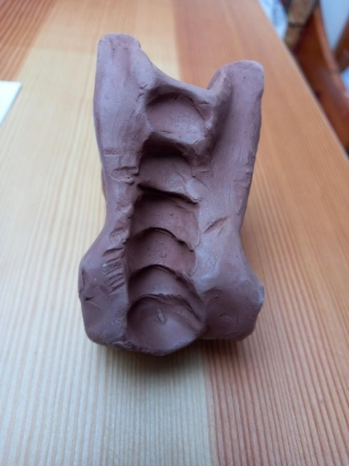
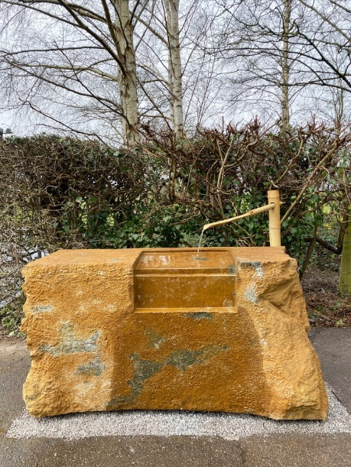

Figure 6. ‘Stone for Two Hands and Water’. Edmund de Waal (2021)

De Waal (2021) describes his creation as based on a ‘tsukubai’ a traditional Japanese washbasin found at the entrance to a holy place for visitors to purify themselves. The ‘Steps of Contemplation’ are a bridge to accessing a spiritual place, offering purification, in the sense of clarity and something new. It became apparent within the data analysis that this is also encapsulated within 1g ‘The Gem’ and 1i ‘The Feather’. Both forms holding a sense of potential and of hope. Feathers and birds have become particularly poignant throughout the research process. I remembered as a child I would often look out of my bedroom window, watching the birds fly by and wishing, so desperately, that I could be like them, that I could fly, fly away. They are a symbol of freedom. A freedom that my ‘Self’ has been longing for, for many years, and is now being realised from within this research process with clay.

The crescendo within this theme is held in clay forms 2g ‘Pregnancy’, 2h ‘The Foetus’, 2i ‘Holding the Seed’, 2j ‘The Birth of My‘Self’, 2k ‘Loving Tenderness’ and 2l ‘Liberation of My ‘Self’. When making these forms there were feelings of relief, hope, freedom, warmth, love, cherishing and nourishment. The movements were predominantly smoothing, holding, rolling, and stillness. Interestingly, the stillness in this theme had a different quality to the frozenness explored in the first theme. This stillness was warm and alive.

These clay forms capture the gestation, birth, nurturing and then liberation, or emancipation, of my ‘Self’. During the immersion phase I had a dream that I was heavily pregnant. This was two weeks prior to creating ‘Pregnancy’ and ‘Foetus’. I had forgotten the dream, until the images emerged within the clay. There is suggestion from this data that there was a period of time required for gestational development, much like with an actual pregnancy. Following the ‘Birth of My’Self’ there also seemed to be time needed for the development, nurturing and nourishment of my’self’. This can be seen in ‘Holding the Seed’ and ‘Loving Tenderness’.

Interestingly, the ‘Birth of My’Self’ was created using the soles/souls of my feet. It did not seem possible to use my hands. On analysis, this indicates a need for my hands to be free, ready to receive, hold and cradle the new ‘Self’, much like during the birth of a baby. There was a cherishing and a love for the new ‘Self’. A willing to keep her safe. It is seen within the data that the new ‘Self’ continued to grow. From a baby, being nurtured in ‘Loving Tenderness’, to emerging as an adult in ‘The Liberation of My’Self’. ‘The Liberation of My’Self’ began as a tree, the container in the middle, between the branches, a nest. A wise owl perched on one branch and a pot, like the magic porridge pot, never empty, pouring nourishment. It took time for me to see the human image, like the statue of liberty, emerging from the clay form. A woman, liberated, the true ‘Self’ now here. My ‘Self’ could not only be seen, but was free, could breathe and was relieved of the burden she had carried for so long.
This profound experience of the heuristic process has been captured within the creative synthesis below, which consists of a photograph and a pencil sketch, both of which I made.
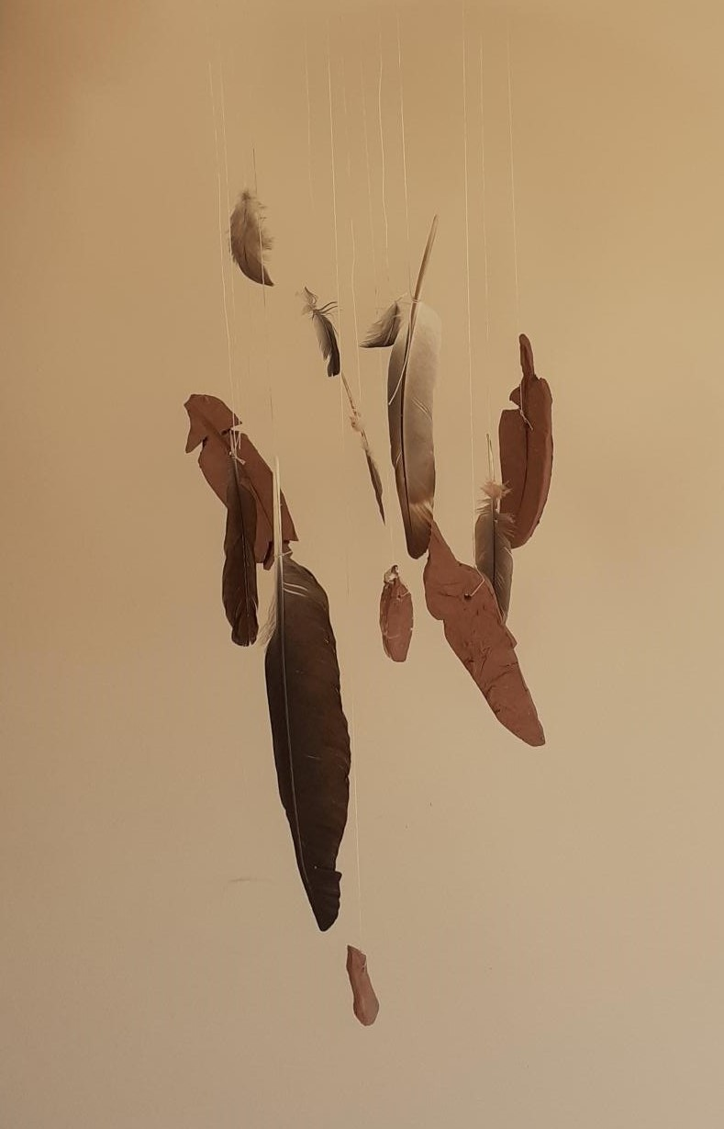

‘A Gift for the New Baby’. Helen Evans (2022)

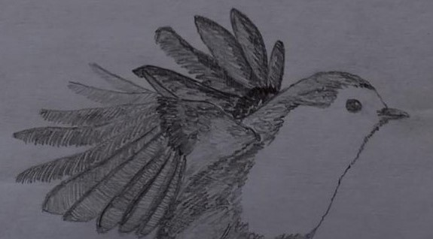
‘Freedom’. Helen Evans (2022)

Discussion
How can I become my’Self’ after experiencing the Adverse Childhood Experience (ACE) of parental mental illness, the inherent destructive parentification and the phenomenon of having lost my’Self’? This is the question that this heuristic research process has set out to explore. Following the literature review, data collection and analysis, I propose that this research shows there is a place for the therapeutic use of clay within psychotherapeutic theory and practice to support the healing of this burden in adulthood.

The data analysis indicates that I experienced a movement toward, eventual birth of and liberation of my ‘Self’, through the therapeutic use of clay: I became my ‘Self’. What is apparent is that the growing sense of safety was fundamentally linked to this process, which is evidenced through the making of containers and, ultimately, embodied within ‘Grandad’s Robin’, the symbol of a secure attachment. This supports what was discovered within the literature review, as these clay forms accounted for almost 30% of the data collected and it was through them that my ‘Self’s’ need for safety was realised, creating movement from the frozen to the liberated. This also supports Bowlby’s theory on secure attachments which is founded on a sense of safety and then acts as ‘a springboard for curiosity and exploration’ (Holmes, 2014, p.56; Bowlby, 1988, p.68). I argue that safety is the soil from which my ‘Self’ could grow and flourish. As Evans and Coccoma (2014, p.72) state, from a neuroscientific perspective, ‘safety trumps everything within the brain’. Souter-Anderson (2010, p,72) supports this idea within her clay theory by stating, ‘what emerges forms the essence of a caring and loving relationship, which is the bedrock of fertile ground for abstract ideas and concepts to begin to take root and unfold ..for a healthy sense of self to develop’.

Through working with the clay therapeutically I was able to embody, what Winnicott describes as, the ‘good enough’ mother. My’Self’ became visible within the clay, as Sholt and Gavron (2006, p.68) explain, when we see our fingerprints or marks within the clay, we realise that we exist, we are here, now. In seeing my’Self’ this way, I was able to be the mother, to be adaptive to the needs of my ‘Self’, to the clay forms, and offer a holding environment, creating safety. My ‘Self’ then had the possibility to be true, there was no need to remain compliant with the mother, there was a new mother, no need to adapt, no need to be the false self (Winnicott, 1965, p.145). From the standpoint of neuroscience in childhood development, it was discussed in the literature review that Evans and Coccoma (2014, p.53) note our brains are dependent on external information for a sense of safety. In being the ‘good enough’ mother, I could offer the external information so desperately needed for a sense of safety. The clay had offered the positioning for this to be possible. The clay forms became objects I could relate to, that I developed new relationships with. They came to represent my’Self’, outside of myself. In noticing this it offers a potentially new, contemporary revision of Winnicott’s Object Relations theory because it suggests that the sense of the ‘good enough’ mother can be accessed from within our own internal being as adults. The therapeutic use of clay can allow for an adjustment in our relationality to the internal and external worlds. The externalisation of my lost ‘Self’ within the clay, and the subsequent creation internally of the ‘good enough’ mother. An ‘Internal Object Relations’ theory, which holds the possibility of healing from within. This feels like an area for further research.

My somatic experiencing was an integral part of creating the clay forms. This is visible when looking at the variety of movements used (See Appendix 2). Both my hands were used when touching the clay and this engagement of haptic perception would have involved my nervous system and both sides of my brain (Elbrecht, 2013, p.31). From a neuroscientific perspective, and referring to the research of Bessel Van Der Kolk (2014, p.47), it could be argued that, through this physical engagement with the clay, I was able to bring the left side of my brain and prefrontal cortex back online, creating access to the parts of my brain that are connected to aspects of my ‘self’ and ‘bias for the processing of the self’ (Keenan et al, 2010, p.341; D’Argembeau, 2013, p.2). With a cautiousness, I suggest there is a place for neuroscientific research into the therapeutic use of clay as a psychotherapeutic practice, particularly within the fields of trauma, namely the legacy of ACE’s in adulthood. My cautiousness being in the potential ‘over-sciencing’ of psychotherapeutic research. As Evans and Coccoma (2014, p.73) state, ‘reason is not part of the survival system of the brain’ when it comes to trauma, and perhaps it would be beneficial for this to be the case for research in this area too. Neuroscientific research is aiding the understanding and impact of ACE’s and can support and inform psychotherapeutic practice. However, I hope that the growing body of neuroscientific research does not equate to an eroding of qualitative, particularly heuristic, research, which offers such a rich insight into the experiencing of what it is to be human. It feels important to remember and honour the sacred gift of intuition, not just the faithful servant of rationality (McGilchrist, 2010).

My therapeutic use of clay within this heuristic research process has offered a healing, body based, non-verbal, neuroscientific experience, that has led to me becoming my’Self. It has shown that the adult burden of destructive parentification and the phenomenon of having lost my’Self’ has been eased. Sherwood (2004, p.5) may be happy to know that, as far as this research goes, Cinderella shall go to the ball, and that the therapeutic use of clay within psychotherapeutic practice is now established within the contemporary foundational theories of Elbrecht (2013) and Souter-Anderson (2010). However, it feels as though the research on the therapeutic use of clay is in a fledgling stage, and it is hoped that this research may contribute to its development. The potentiality of the application of clay use to psychotherapeutic practice and theory is vast, as is the scope for further research.

I feel there is a place for further research into the therapeutic qualities of clay forms as transitional objects (Winnicott, 1971, p.1), again with a focus on adults living with the legacy of ACE’s. As Holmes (2014, p.55) states, ‘Inanimate objects such as transitional objects can also be important as comforters and alleviators of attachment distress’. Further research could also explore how contact with the clay, ‘playing’, in the presence of another, could hold a therapeutic quality. This links with Winnicott’s (1971, p.67) theorising that when a child plays in the presence of another person ‘there is a chance to introduce enrichments’. It would be interesting to explore this in research with adults who experienced ACE’s. Souter-Anderson (2010, p.64) introduces this aspect within her clay therapy theoretical anchoring, stating, ‘throughout the whole process we detect a state of flux in both the relationship with the other and the substance of the clay’.

I also recommend further research is needed in the same area as this heuristic inquiry but involving participants. I acknowledge that my dual role as participant and researcher may have impacted the results. Particularly as my exploration of the therapeutic use of clay within this context as participant may have been altered by my need to examine, analyse and synthesise the data at depth as researcher. Rothschild (2000, p.161) describes that what helps us bridge the implicit and explicit experience is within the body, but equally in the words we use to make sense of our experience. It is perhaps the depth required to make sense with words within this research that ultimately influences the findings. It would, therefore, be interesting for this research to be repeated with participants, to discover if the findings differ when the role of researcher is removed.

Bowlby’s Attachment theory and Winnicott’s Object Relations theory were chosen as foundational works to support the exploration of the development of the ‘Self’ because they are relational and built on the observations and discoveries of childhood development. ACE’s, as the name implies, begins in childhood, and in relationship. I do, however, acknowledge the age and critique of these theories. There is, therefore, a place for a contemporary revision of both theories and their applicability to parentification and current societal contexts. This would need to be an ongoing revision and review process, as our societal structures, and the world in which we live, evolves.

To Conclude, it is important to highlight that this research leans heavily on the experiences of women. From my own heuristic research journey to the review of literature on parental mental illness and parentification there is an underrepresentation of men, which is of concern. This brings into question the applicability of these research findings to men. From a neuroscientific perspective on trauma responses, Evans and Coccoma (2014, p.26) state, ‘men and women are not the same’. Research including men is desperately needed, particularly within the arena of the adult legacy of ACE’s, psychotherapeutic practice and the therapeutic use of clay. ‘There is no one size fits all approach to trauma recovery’ (Evans and Coccoma, 2014, p.10), so I encourage continuing research into ACE’s and how psychotherapeutic practice and theory can support the living legacy of them in adulthood. It is hoped that the findings of this heuristic research inquiry will go some way to highlight a psychotherapeutic approach, namely the therapeutic use of clay, as a means of supporting such adults.

Conclusion
This heuristic research inquiry set out to explore and answer the question: How can I Become My’Self’? Having grown up with a parent with a mental illness which resulted in destructive parentification and the phenomenon of having lost my’Self’, this was an extremely personal exploration, guided by a heuristic research methodology, that also had relevance to a current public health issue. Public Health Wales (2015) are acknowledging the impact ACE’s are having, not only on children, but across the lifespan. This places this research within the field of a current societal issue as well as contemporary psychotherapeutic research and practice. It explores how psychotherapy can ease this living, burdensome, legacy, and provides evidence supporting the therapeutic use of clay within this context.

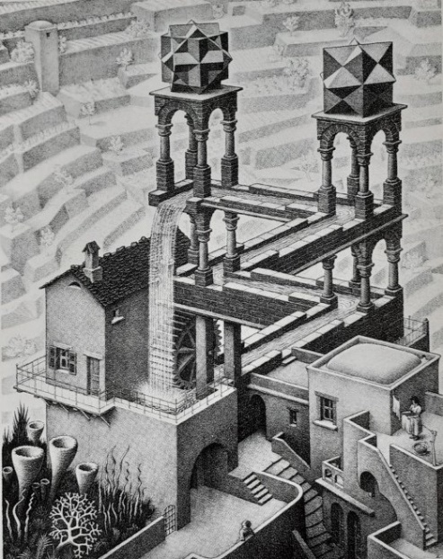
The heuristic methodology adopted for this research has offered a unique insight into a living phenomenon within myself, from the viewpoint of both participant and researcher. At times I have questioned how heuristic research fits into the academic requirements for a Masters dissertation. How can something so personal be formulated and assessed by another? Moustakas (1990, p.14) acknowledges, ‘the heuristic research process is not one that can be hurried or timed by the clock or calendar’. The exploration of the phenomenon does not come to an end as I finish this piece of work. I have come to believe the heuristic process, albeit somewhat contained here, will be a continual, lifelong journey, that will certainly continue beyond these pages. I imagine it to be like Escher’s ‘Waterfall’ (See Figure 7). A continual cycle of flow, but with a freshness each time I arrive back at the beginning, as it is not quite the same as it was when I was last there.

Figure 7.‘Waterfall’. Escher (1961)
In their research, Metz and Jungbauer (2021, p.74) state a need for longitudinal studies to investigate the living experiences of adult children that grew up with a parent with a mental illness. In bracketing my heuristic research within a time frame and word limit, this research does not meet their request. It would be interesting to consider how heuristic research could sit as a longitudinal study, and perhaps it would be insightful for me to revisit this research again in the future. To formally research the phenomenon of having lost my’Self’ once more, as it feels as though a shadow will remain.

To Conclude, I am drawn to the research findings of DiCaccavo (2002, p.469). From her investigation it was found that the experience of parentification made it more likely that people would decide to train as counselling psychologists. This highlights the potential number of parentified adult children that may be training and practicing as psychotherapists, I being one. What is the impact of this to ourselves and our clients? Perhaps a place for further research, but it leaves me considering the key messages of this research. Firstly, I wish to state that this research supports the therapeutic use of clay as a psychotherapeutic approach aimed at easing the living legacy of ACE’s in adulthood, particularly the experience of destructive parentification and the phenomenon of the loss of ‘Self’. Secondly, in view of DiCaccavo’s (2002) research, the importance of taking care, in our role as psychotherapists, but importantly of our ‘Selves’.
I finish with a sense of hope, embodied by Emily Dickinson’s poem (Circa, 1861):

“Hope is the thing with feathers
That perches in the soul,
And sings the tune without the words,
And never stops at all,

And sweetest in the gale is heard;
And sore must be the storm
That could abash the little bird
That kept so many warm.

I’ve heard it in the chilliest land,
And on the strangest sea;
Yet, never, in extremity,
It asked a crumb of me.”

