Foreign Languages and Cultural Awareness

INTERCULTURAL COMPETENCE REPORT

Module code: BMIH5003
Module Leader: Giulia Chifari

Name of the student: Ionelia Popoiu
Student ID: 2243056

Content Table:

Exclusive summary…………………………………………………………………………3
Introduction…………………………………………………………………………………4
Main Body…………………………………………………………………………………..5
Conclusion…………………………………………………………………………………..8
Recommendations…………………………………………………………………………...9
Reference List……………………………………………………………………………….10

Executive Summary
The intercultural competence report has focused on participating in the role of general manager at a multinational hotel and spa in England, to develop an understanding of the brand standards and hotels in operations visiting France which is the chosen headquarters from the GLOBE project list. The report has evaluated the key differences between France and England considering customs and business culture. It has analysed an in-depth comparison between the countries evaluating leadership study and cultural factors. The discussion on the challenges of intercultural leadership management has been analysed focusing on the functions in the hospitality industry.

Introduction
The intercultural competence report indicates the job role of a general manager at the multinational Hotel & Spa in London England aiming to visit the hotel branch headquarters to learn about brand standards and operations. Depending on Latin European cultural clusters, France is chosen as the headquarters of the multinational company. Understanding and evaluating business functions in the chosen hotel location will help to handle the cultural differences easily, as the employees from the chosen location will be joining the London hotel team in July 2024. Outlining the key differences in customs, culture and other factors will help to manage the team easily. It will further evaluate and compare countries depending on leadership and cultural factors and will critically discuss the challenges of intercultural management and leadership functions in the hospitality industry.

Main Body

Key differences between England and the chosen country
Cultural values
France, part of the Latin Europe cluster and England within the Anglo cluster exhibit different cultural norms and values. French culture focuses on collectivism with strong views on hierarchical social structure, cultural sophistication and intellectualism (Cherry, 2022). On the other hand, in London, the cultural trends promote pragmatism, and individualism and maintain equality and fairness. The differences impact professional and social behavior that are observed in France as well as England, and London.

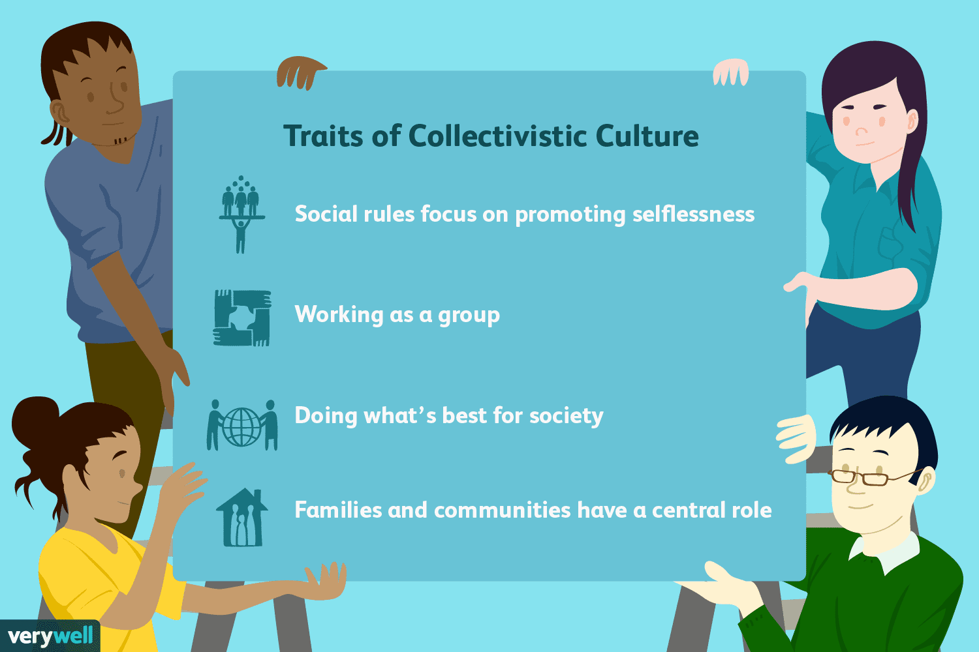
Figure 1: Collectivist culture in France
(Source: Cherry, 2022)
Communication type
The French communication style is expressive, assertive and direct compared to England. The communication style is understandable, polite, and indirect and depends on shared values and understanding in England (Commisceo Global Consulting Ltd, 2024). The French people value joining argumentative discussions maintaining their own perspectives and clarity
Work-life balance
The approach associated with work-life balance in France differs from England. People in France focus on maintaining a work-life balance that is protected by employment laws and regulations. The employees in France enjoy life after work). On the other hand, in England, the work-life balance indicates remote working systems and flexible working hours
Business Etiquette
The people in France maintain business adequately by developing personal relationships with a blend of formality and informality. On the other hand English business etiquette involves reserved norms, punctuality and formality making decisions depending on structured viewpoints and collaboration.

Analysis and comparison between the two countries
Power distance
Depending on the GLOBE Project, France holds a higher power distance that strongly focuses on individual authorities with the application of a hierarchical structure. On the other hand, England exhibits a lower power distance which indicates a smaller power gap between the subordinates and superiors (Deresky, 2017). It focuses on effective decision-making practices and a supportive leadership style in England. On the other hand, the leaders in France focus on promoting assertiveness and confidence among the people to take decisions by the higher authority.
Uncertainty avoidance
Both France and England have moderate uncertainty avoidance. In France, business organisations prefer to maintain procedures and regulations to manage uncertainty with the application of risk management approaches and structured frameworks for decision-making. On the other hand, in England, businesses focus on flexible and pragmatic approaches to avoid uncertainties where the uncertain change is introduced through proper planning and development.
Individualism Vs. collectivism
With having connective is an orientation in France the business culture promotes group cohesion and harmony. On the other hand, individualistic values are promoted by business organisations in England for personal achievements and growth (Hampden-Turner and Trompenaars, 2020). The leaders in France develop strong teams with collective goals that help maintain loyalty and collaboration among the people.
Gender egalitarianism
France and England both are committed to promoting gender egalitarianism in their business culture maintaining gender equality and diversity in leadership positions. The organisation supports offering equal opportunities to the individual gender for career development creating a supportive environment. It helps avoid gender biases specifically in career progression and leadership participation.

The challenges of intercultural leadership in the hospitality industry
Cultural norms and service expectations
The changes in cultural norms and practices both in England and France might impact service expectations and standards. It might result in conflicts and dissatisfaction among the team members (FranceTaxLaw, 2024). For example, the French employees focus on offering personalized experiences to the customers but the British employees prioritise overall service efficiency over personalization. The differences in thoughts and expectations might impact on guest satisfaction and team performance.
Leadership challenges
The differences in leadership approaches and styles, specifically decisions and leading teams, the business leaders of the multinational brand might face difficulties managing the coordination among the employees (Abramson et al., 2018). As an example, the managers guiding Anglo-cluster people might adopt a participative leadership style on the other hand managing French employees the authority of leadership style is crucial. The differences in leadership dedication mighty a lack of team performance and collaboration.
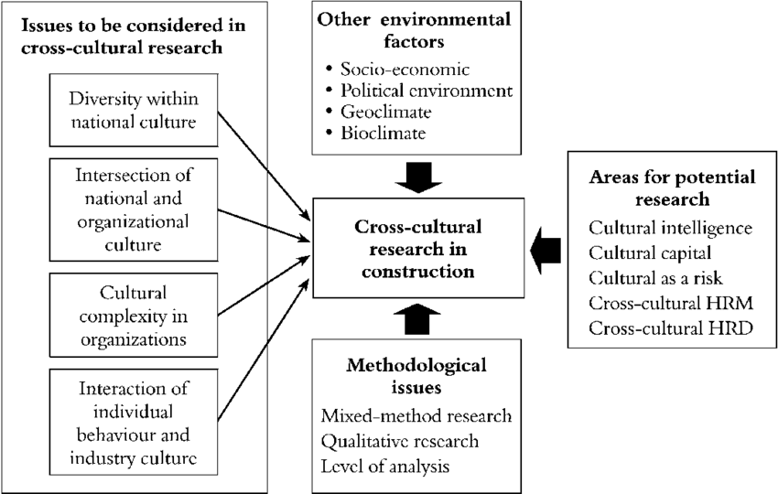
Figure 2: Issues in cross-cultural leadership
(Source: Abramson et al., 2018)
Communication challenges
Language barriers and the style of communication are the major challenges that lead to inefficiency and misunderstandings among the tea members that might impact on customer services. Depending on intercultural leadership, the business leaders of the multinational hospitality brand may face difficulties in managing French employees because of the cultural barriers specifically making them understand indirect communication (Maheshkar and Sharma, 2018). The expressive and direct communication style of the French employees might cause service disruptions and misinterpretation operating in London, England.

Conclusion
The assignment analysed the differences between England and France considering customs, culture, leadership and style that might influence the business management practices managing French employees in England. Evaluation of different functions associated with managing intercultural teams analysed in this assignment with comparison using GLOBE Project's culture and leadership study. The differences and challenges are analysed in this report.

Recommendations
Maximise the performance of the new joiners in London, England it is important to enhance open communication and provide proper training to the individual team members to promote cross-cultural collaboration (Christiansen et al., 2020). Strengthening team building is important to enhance employee engagement promoting business growth and guest satisfaction operating in the hospitality industry.

References
Abramson, N.R. and Moran, R., (2018). Managing Cultural Differences: Global Leadership for the 21st Century. 10th Ed. Abingdon: Routledge.
Cherry, K., (2022). What Is a Collectivist Culture? [online] Verywell Mind. Available at: https://www.verywellmind.com/what-are-collectivistic-cultures-2794962 [Accessed: 28 May 2024].
Christiansen, B., Branch, J.D. and Karmowska, J., (2020). Cultural Factors and Performance in 21st Century Businesses. Hershey : IGI Global.
Commisceo Global Consulting Ltd, (2024). What’s the British Communication Style? [online] Available at: https://www.commisceo-global.com/blog/what-is-the-british-communication-style#:~:text=British%20people%20use%20a%20mix [Accessed: 28 May 2024].
Deresky, H., (2017). International Management: Managing Across Borders and Cultures: Text and Cases. 9th Ed. Harlow: Pearson Education Ltd.
FranceTaxLaw, (2024). France vs England: Differences in Business Culture. [online] Available at: https://www.francetaxlaw.com/news/france-vs-england-differences-in-business-culture/#:~:text=In%20England%2C%20relationships%20between%20employees [Accessed: 28 May 2024].
Hampden-Turner, C. and Trompenaars, F., (2020). Riding the Waves of Culture. 4th Ed. London: John Murray Press.
Maheshkar, C. and Sharma, V., (2018). Handbook of Research on Cross-Cultural Business Education. Hershey: IGI Global.

