Homework sheet
- Answer the following questions in pinyin or Chinese characters and then translate your answer into English or Welsh

例如：伦敦(Lúndūn)在哪儿？
Lúndūn zài yīnggélán。
伦敦 在 英格兰。
1. 爱丁堡(Àidīnɡbǎo)在哪儿？
爱丁堡在苏格兰
Edinburgh is in Scotland
2. 利物浦(Lìwùpǔ)在哪儿？
利物浦在英格兰
Liverpool is in England

3. 成都(Chéngdū)在哪儿？
成都在中国
Chéngdū is in China

5. 斯旺西(Sīwàngxī)在哪儿？
斯旺西在威尔士
Swansea is in Wales
6. 都柏林(Dūbólín)在哪儿？
都柏林在爱尔兰
Dublin is in Ireland

7. 西安(Xī’an)在哪儿？
西安在中国
Xī’an is in China


- Listen to the audio and write down the names under the corresponding pictures


This Photo by Unknown Author is licensed under CC BY-NC
David Lucy

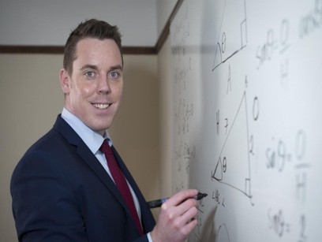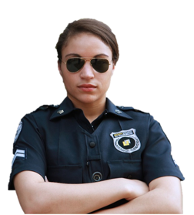

Brynmor Alison

3. Write a paragraph to introduce yourself and your family. Then recording yourself reading it afterwards. (Please feel free to look up the words you are not sure about, e.g.: jobs and adjectives that are not included in our lesson. I will give you some feedback on that afterwards.)
you can talk about:
- your name
- your nationality
- your age
- your job and location
- people in your family (What are they like? What are their jobs?)
- your pet
我叫茉莉。 我是威尔士人。我二十二岁。我是学生。我去学校。我的学校在加的夫 (Cardiff)。我家有四口人。我的爸爸是医生。他在医院工作。我的妈妈是公务员 (gōngwùyuán = civil servant)。她在家工作 (she works from home)。我有一个弟弟。他是中学生 (zhōngxuéshēng = middle school student)。我有辆只宠物。我有一只狗。我的狗叫 Lola。Lola 很聪明和Lola很漂亮。我有一只仓鼠。我的仓鼠叫Oreo。Oreo很小和Oreo很可爱。

4. Cultural study
https://youtu.be/LDPNNrzjlu4
Research questions for independent study:
1. How is the concept of Yin and Yang used in TCM and/or Chinese wellbeing?
2. What is Qi 气 and Shen 神, and how are they correlated? (Watch the videos below)
3. Is there a correlation between plant property and its location (herbs for example)? If so, what is the correlation?

The concept of Energy Qi 气 in TCM:
https://www.youtube.com/watch?v=poKwuQap8xU
The concept of Shen 神 in TCM:
https://www.youtube.com/watch?v=wHnEsdmsaLM

