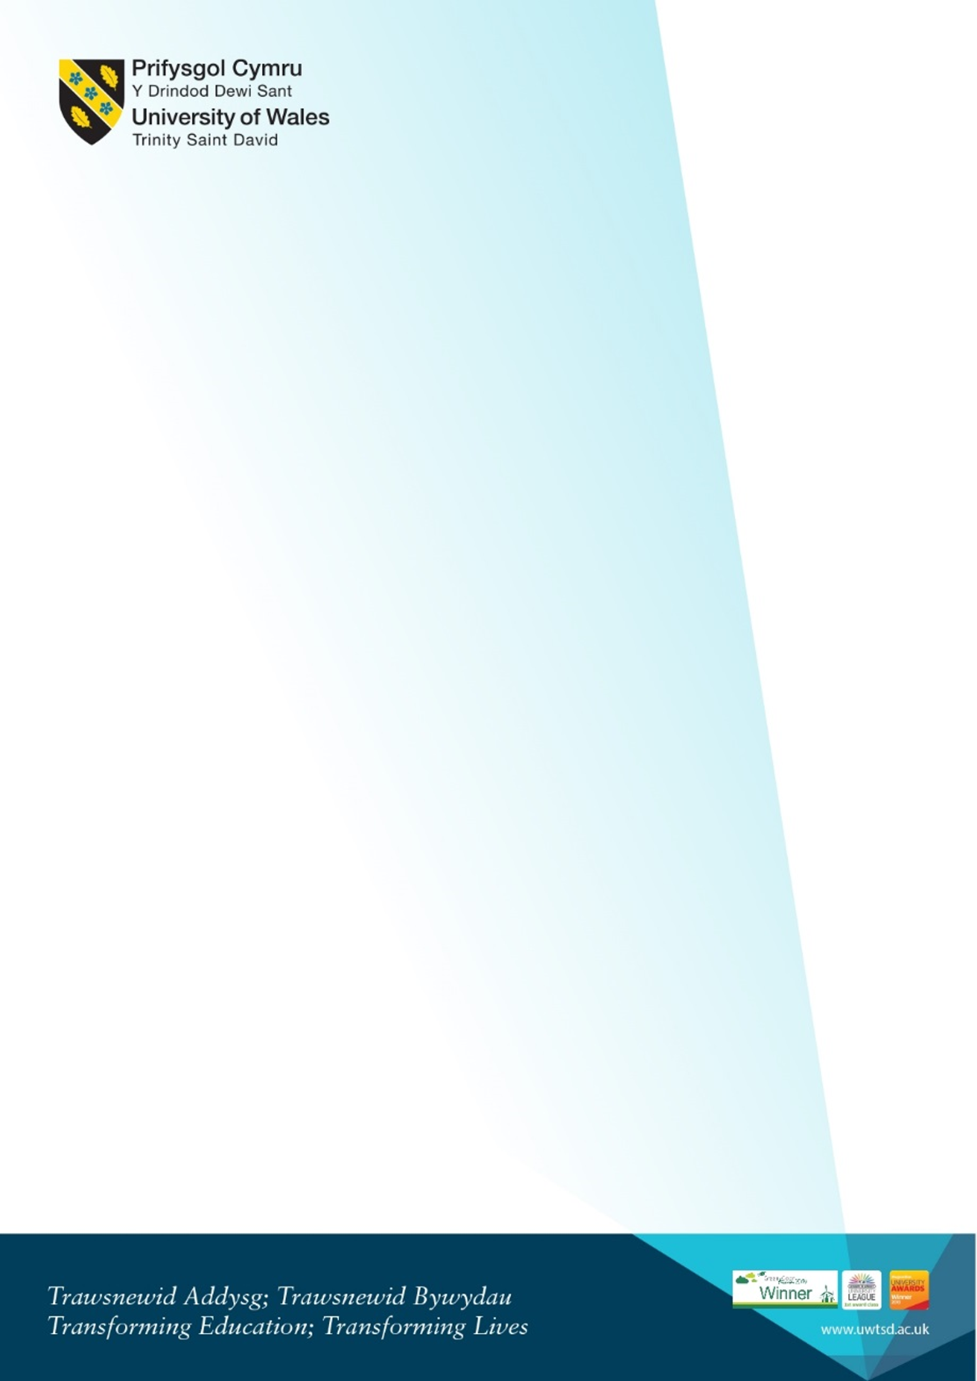
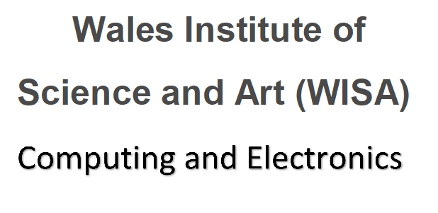
Online Welcome for new Degree Apprenticeship Computing (DDA) Students
Monday 20th September 2021
Microsoft Teams link: Click here or https://bit.ly/3C2Tf6O
1pm – 1.30 pm | Welcome from the team  Kapilan Radhakrishnan - Academic Director (App. Computing)  Beverley Holland and Gaynor Thomas - Programme Managers DDA scheme  Bridget Moseley - Head of the Apprenticeship Unit | Who we are, our roles. Who to contact.
1.30pm – 2 pm | Introduction to the Liaison officer team. | Brief introduction from each member of the team.
2pm – 3pm | Beverley and Gaynor Course overview | - Introduction to the course structure and overview of the modules.  - Moodle and where to find information on Moodle.  - Information on student services and procedures to follow.  - Logging on and remote access  - Accessing Mail
3pm – 4pm | Team Q and A session | - Opportunity to ask any question about enrolment.  - ID Cards  - IT requirements where to find software
4pm | Self-guided:  University-wide videos and Campus safety presentations link.  Please take some time to look at the available videos. If you  have any questions please email a member of the team. | Including  - Welcome from the VC  - Welcome from Provost  - Your Campus: Safety on Campus  - Campus Virtual Tour  - Parking  - Enrolment  Link to resources on Hwb:  https://hwb.uwtsd.ac.uk/pages/student/resources_welcomeandinduction

