Project Management

Managing a Hardware/Software Project for Disaster Recovery

Sue Maw

Scott Howells
Student P Number - 1701604

Table of Contents
Introduction Page 2
PID Table Page 3
Section 1 – What is the Project all About? Page 4
Section 2 – Why should this Project go Ahead? Page 7
Section 3 – Who will Work on the Project? Page 9
Section 4 – How and When will the Project be Delivered? Page 11
References Page 13

Introduction
The following document is a Project Initiation Document with the purpose of providing the foundation of the project that will be entailed. The purpose of a Project Initiation Document (PID) is that it can provide the foundation of a project along with providing a reference point for the project and highlight many integral procedures such as project goals, risks, constraints, stakeholders and a summary.
The project that will be conducted is based on working within a small group to plan either a software or hardware resource aimed at the scenario of HALO Emergency Logistical Provisions (H.E.L.P) to provide help in the event of a disaster. H.E.L.P is a mobile networking product for governments and aid agencies that are located around the world and is designed to provide a communications system to areas where traditional methods of communications are no longer functioning due to the potential damage of communications towers.
This Project Initiation Document will contain the plan of the proposed system that the team has identified as the method to use in the result of disaster recovery.

PID Table
PID: | Check When Complete:
Section 1: What is the Project About
The Proposed System
Purpose
Objectives
Scope
Constraints
Assumptions
Resources
Potential Stakeholder Risks
Section 2: Why Should This Project go Ahead?
Business Case:
- Project Benefits
- Options
- Cost and Timescale
- Cost/Benefit Analysis

Risk Analysis:
- Risk Identification
- Risk Prevention
- Risk Management
- Risk Monitoring
Section 3: Who Will Work on the Project?
Roles and Responsibilities
Names of:
- Project Sponsor
- Project Management
- Project Team
Project Organization Diagram
Section 4: How and When Will the Project be Delivered?
Assignments/Milestones
Schedule (Gantt Chart)
Human Resource
Project Control
Quality Control

Section 1 – What is the Project all About?
The Proposed System
The Proposed System that as a group have decided to create is a website that provides all the suitable information that is required when accessing a lost and found database. The website will contain lost and found persons that have been registered through the website, people will be able to view these reports as well as comment on them. To access a website the internet is required, unfortunetly due to the fact that this website is in immediate response to the potential event of a natural disaster, the likelihood of communications through the use of the com’s towers are likely to be disrupted. This solution comes hand in hand with the Halo Emergency Logistical Provisions (H.E.L.P). The H.E.L.P product will be utilized also during the immediate aftermath of a natural disaster. H.E.L.P provides High speed Local Area Network (LAN) and Wireless Local Area Network (WLAN) communications, in other words it allows communications such as voice, video and data to be distributed amongst personnel and citizens. High speed Wide Area Network (WAN) satellite communications such as voice, video and data to a Command and Control (C&C) center located within the UK contains professionally trained logistical coordination staff who will liaise with the government and aid agencies near to the effected area to provide. The H.E.L.P product will allow for the website to be operational and ready to use on sight during the event of a disaster. The website will allow people to search for lost ones due to the potential events that may occur.
Purpose
The reason for constructing this system is to provide knowledge and constant updates to those requiring information on lost persons. The desired outcome to this project will be a fully functioning website that allows people search for lost persons such as family and friends and view and also comment on the database that will be provided.

O.S.C.A.R
O.S.C.A.R is a strategic planning tool that can be used to give the terms-of-reference for new projects [1]. When initiating a project, it is important that everyone involved is in agreement with all aspects of the project before beginning it. It is an ideal way of delivering all necessary project information to stakeholders as they may be busy and may not have enough time to read a lengthy document. O.S.C.A.R allows for a simple and fast reading.
Objectives – The Specific Outcomes to be Achieved
- Allow users to connect through devices such as Mobile Phones, Tablets, Computers and Laptops. In order to measure these outcomes, thorough testing will be conducted to see if the site will be accessible through different web browsers and different devices.
- Allow users to comment and post for lost persons on the site. In order to measure this outcome, users will need to post on the site and others to comment on the post.
- Allow for the posts of others to be shown regarding a missing person/person. This will be measured when attempting to search for posts that have been uploaded.
- Allow for an easy to use interface that has all the appropriate features so that users can easily use the site. This can be measured by asking multiple people to use the website and comment on if it was or can be made easier to use.
Scope – What are the Boundaries
The purpose of the website is to allow people to access a lost and found database after the event of a natural disaster. People will be able to upload posts to search for missing loved ones as well as comment on other people posts in order to keep regular updates.
The website will include:
- An Account System
- Add a ‘Friend’ function
- Allow users to create posts
- Allow users to see and comment on posts
- Push Notifications
The website will not include:
- Information on the disaster itself
- Information on the news of the current rescue operations/procedures that are being undertaken
- A live feed of the disaster
- The map of the area
- Emergency service numbers for each local area

Constraints – What to take into Consideration
The constraints are issues that could occur that will influence the schedule of the project that cannot be controlled. The following are a few constraints that have been identified:
- The software not running
- Absent team member
- Data loss
Assumptions – Assumptions to make before Starting the Project
The assumptions that have been made before conducting the project are:
- Everything will be operational and functioning correctly
- All devices will be connected and will work accordingly
- Users can upload posts and comment on other posts
- The interface will be successful
- The add a ‘Friend’ function will not work correctly
Resources – Key features to aid the Project
The resources are the key personnel, equipment such as hardware and software and also the finances of the project. The key personnel are the members of the project team, the equipment that will be in use are the software that is used to create the website and the inclusion of conducting further testing on the website. Finally, the finances are how much will be spent on the project.
Potential Stakeholder Risks
Risks that the potential stakeholder may include:
- Missing information, or the misunderstanding of the project.
- Failure to recognize issues and allow for sufficient time to complete the project.
- The potential stakeholder may develop a lack of confidence in the project team as a result in concerns and opinions not being addressed adequately.

Section 2 – Why should this Project go ahead?
Project Benefits – Benefits expected to be Delivered
This project is being carried out to aid those in desperate need to find lost loved ones in the potential event of a natural disaster. The project will commence hand in hand with the H.E.L.P resource as it allows for the website that is being created to correctly function adequately. There are many benefits to this project being followed through, such as:
- Missing persons being found.
- Users being able to help others in times of need.
- Constant updates within the database to record how many are missing within the are incase emergency services are called.
Options – Other actions that were considered
At the beginning of the project there were many ideas discussed, some of the following are those ideas:
- A website that can offer essential items such as food and water
- The inclusion of emergency service numbers to each local area depending on where the location of the devices was activated from
- An app that contains up-to-date information on the disaster and the aid operation and procedures that are taking place
Cost and Timescale – Project costings and related timescale
The project has been carefully considered and all aspects where thoroughly looked at in order to complete with the minimal spending as possible. The project will be completed with no costings attached as each member within the team has agreed to complete sections of the project that align with each of the strengths on offer. The software that is being used to complete the project has also been researched and will be free to use. The timescale for the completion of this project will be done through the use of external software in order to fully plan each aspect and section of the project and when the completed tasks are required to be met. The project completion will be aimed for the deadline.
Cost/Benefit Analysis – Expected returns
The expected return of the project costings is based on the what a company or government are willing to invest. As the project is being constructed using free software and personal time, there is no budget to the project and therefore the expected return will be higher than what was initially set. Meaning if anyone were to invest, the group will be making a guarantee profit.

Risk Identification – Risks within the Project
There are multiple risks that could occur, whether it be of individual mistakes or risks out of the control of others. The following are some risks identified:
- Data Loss
- Hardware Failure
- Software Failure
- Disaster
- Absent team member
Risk Prevention – What will be done to deal with these Risks?
Based on the risks that have been identified above, the following bullet points are a brief description of how to deal with the risks previously identified:
- Multiple Backups of the Project
- Catchup Sessions on absent members
Risk Management – Plan for dealing with un-preventable Risks
Despite having risk prevention for the potential risks to this project, the unfortunate possibility of risks that can not be prevent must also be considered. Thus, a contingency plan must be constructed in order to take action when the risk occurs. Below are the bullet points that highlight these plans:
- The contingency plan consists of multiple devices to store the backups within multiple locations. External Drives such as USB devices and cloud-based storage such as Google Drive will be used to store these backups.
Risk Monitoring – Assessing the Risks
In order to assess the risks that could potentially harm the project, a risk assessment form will be constructed and filled in when the risks occur. The following is the template for the risk assessment:
Risk: | The potential damage: | Measures taken to rectify the damage: | Has the risk been rectified: | Date:

Section 3 – Who will work on the Project?
Roles and Responsibilities
The project will be managed and organized carefully and fairly, each member will be shared an even work load, and each will contribute where necessary. The roles have been handed out with careful consideration to suit which team member is better suited to what role.
Project Sponsor – Who has the ultimate authority?
- The ultimate authority lies with the manager Daniel Davies. However, the decisions that are being made are joint and discussed as if it was a joint management.
Project Manager – Project manager responsibilities
- The responsibilities of the manager is to keep the project flowing by making sure everything is being done accordingly and to sufficient standards.
Project Team – The key members
Member Name: Daniel Davies
Roles: Manager, Designer 2, Lead Programmer and Researcher 2
Job Description: Daniel Davies will manage the project and ensure everything is being done efficiently. As backup designer, he will assist with the design of the website and ensure no mistakes will be made when designing the layout of the website with appropriate HCI throughout. As lead programmer, his duty is to conduct a programming algorithm that will suit the needs of the website. Finally, as the backup researcher he will assist with the appropriate research needed to allow the project to be a success.
Phone Number: 07976 674853
Email: 1701603@student.uwtsd.ac.uk

Member Name: Scott Howells
Roles: Lead Designer, Programmer 2, Tester and Lead Researcher
Job Description: As lead designer Scott will design the website that will be constructed and make sure the correct features are being used throughout. He will help the lead programmer with aiding with the code within the programming aspect of the task. As tester he will be testing the website when completed. Finally, as lead researcher he will be conducting the appropriate research to allow the project a successful outcome.
Phone Number: 07507 297403
Email: 1701604@student.uwtsd.ac.uk

Project Organization Diagram
The following diagram has been constructed to show the lines of authority within the team:
Manager
Daniel Davies

Researcher 2
Daniel Davies
Lead Researcher
Scott Howells
Tester
Scott Howells
Programmer 2
Scott Howells
Lead Programmer
Daniel Davies
Designer 2
Daniel Davies
Lead Designer
Scott Howells

Section 4 – How and When will the Project be Delivered?
Initial Project Plan
This section of the document will provide broad information on how the project will be implemented. Timelines, resources, and management stages will be outlined as well as an overview of the control.
Assignments/Milestones – Major tasks to be completed
The following bullet points are tasks which have been highlighted as significant to the completion of the project:
- Research – The research will be conducted to establish an understanding of what features are needed on the website.
- Design – The design of the website will be based on the research and will include appropriate functions where possible for a fully functioning and successful site.
- Create – The creation of the website by using software to code the website.
- Risk Assessment – In order to make sure no risks have compromised the project, risk assessment forms will be completed to ensure the success of the project.
- Test – Test the completed website and fix any issues that have been identified.
Schedule – Summary of the Schedule
The following screenshots have been obtained by using Microsoft Project in order to create the schedule for the project. The following are screenshots of a high-level Gantt chart:
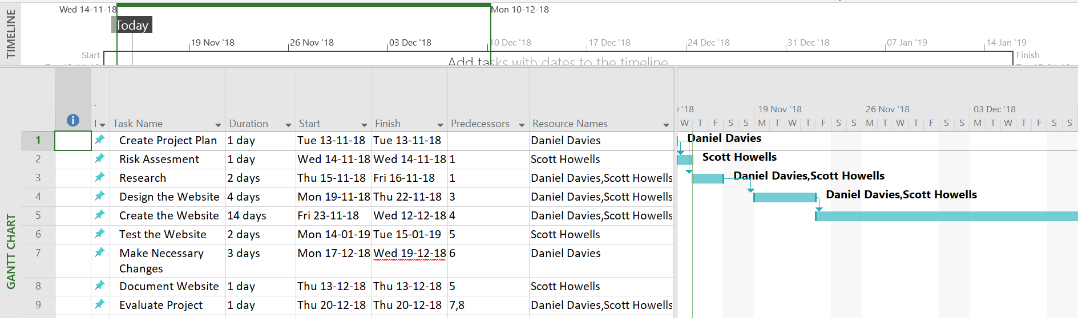
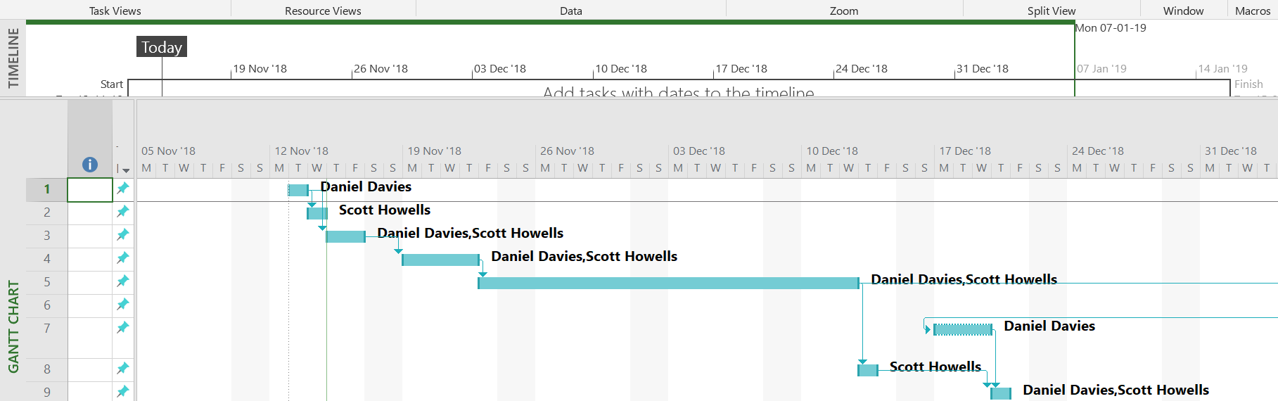
The screenshots of the above Gantt chart illustrate when and who will be completing certain tasks and the duration it will take.
The following screenshots are of the Pert Chart or Network Diagram, in order to fully illustrate the schedule:
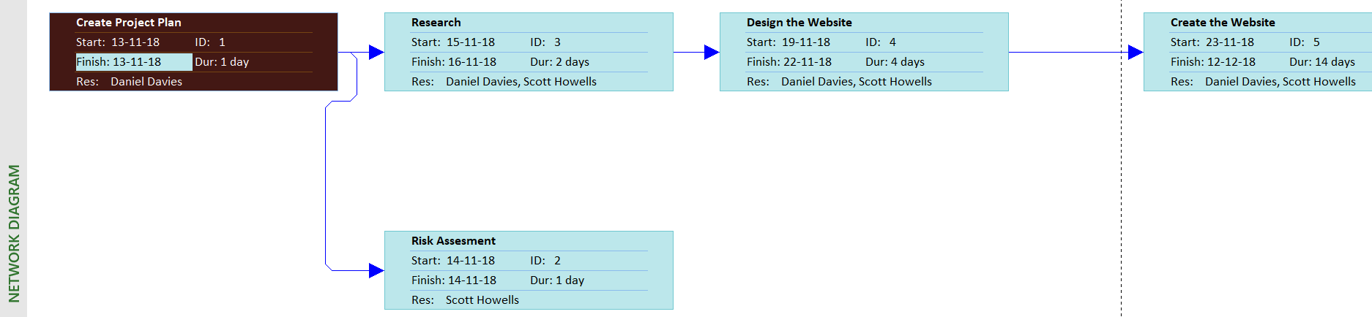

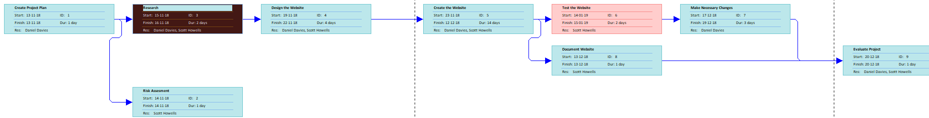
The tasks have been carefully considered and the appropriate personnel and time have been assigned to each task.
The following tasks were thought to have been simple enough to complete within a duration of 1 day. These tasks are; Create Project Plan, Risk Assessment, Document Website and Evaluate Project. These tasks have been aimed to be completed within the duration of 1 day when initially commenced (its worth noting that these will be completed on different days and not on the same day). The Research and Testing will take 2 days each to complete. The duration of these tasks are longer so that each aspect of the task has been looked at. Making changes to the website and creating the website have been issued 3 and 4 days to complete respectively. The designing aspect and making the relevant changes have been allowed longer durations as it is important to garner enough time to allow these important tasks to have enough time to be completed. Finally, Creating the Website will be allowed 14 days in order to complete as it is the fundamental part of the project. The 14 days have been issued to allow room for any mistakes and changes to the code. The 14 day deadline will allow the website to be created within sufficient time.

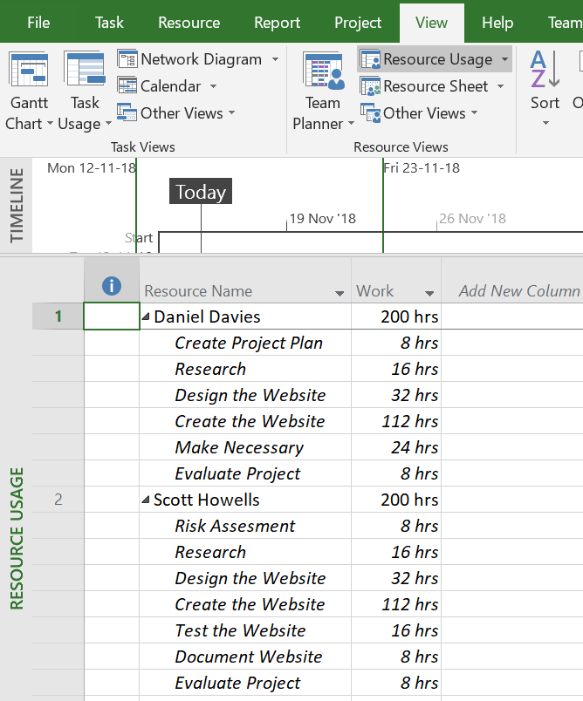
Human Resources – Staff to complete the Project
This screenshot illustrates the staff and the days/hours it will take to complete the tasks. Although there is room to include new people into the project team, it is not needed as the tasks have been evenly shared to the already existing team members.

Project Control – How will progress be Monitored and Communicated?
Progress will be monitored and communicated through the use of team meetings. On a weekly basis there will be scheduled meetings in which the team will attend and communicate the progress of the project.
Quality Control – How will the deliverables be Monitored?
The quality of deliverables will be evaluated and monitored by using constant communication in order to discuss the development process.

References

[1] | D. Haughey, “BOSCARD (Terms of Reference),” Project Smart, [Online]. Available: https://www.projectsmart.co.uk/boscard.php. [Accessed 8th November 2018].

