BMSP6002
Digital Business

  - Assignment 2 - Report
Sarah Carr
Student ID - 2107448
January 2024
Table of Contents
Introduction 1
The Sharing Economy 1
Airbnb Landscape 1
Business Model Canvas (BMC) 2
Strategic Formulation Framework (SFF) 4
Grand Strategy Matrix (GSM) 4
Tools and Systems 6
Customer Relationship Management (CRM) 6
Supply Chain Management (SCM) 7
Enterprise Resource Management (ERM) 8
Conclusion 8
References 9

Introduction
The following report will critically examine and critique the online marketplace Airbnb within the sharing economy. I will do this by first looking at the sharing economy and the landscape of AirBnB, I will then assess Airbnb’s business model canvas, before moving onto their strategic formulation framework before finally looking at other tools and systems they use will strategically analysing their business.

The Sharing Economy
The sharing economy is “an economic system in which assets and services are shared between private individuals” (Lovick, 2023), it is an umbrella term for many different services, apps, and products. The two most prominent examples within the sharing economy are Uber and Airbnb. The innovation in the technology has been the biggest driver for the sharing economy’s growth. With the technology available to businesses through sharing economy apps and digital platforms, businesses are now able to connect with consumers from all over the world. These platforms provide a variety of data that can be analysed and used in future decision making, marketing and advertisement to consumers (Washington State University, 2023).
The sharing economy services, and platform has multiplied dramatically over recent years, research shows that the trend is set to continue, with the estimated total value of the global sharing economy to increase from $113 billion in 2021 to $600 billion in 2027 (Statista, 2023).

Airbnb Landscape
AirBnB was created in San Francisco, California in 2007. Airbnb or Air Bed and Breakfast is an online community built on a sharing economy that connects people that want to rent out their home to a traveller that is looking for somewhere to stay. Airbnb do not own the properties listed on their platform, they act as an intermediary between the hosts and the guest to facilitate the transaction. The currently have more than six million listings in an estimated two hundred and twenty countries worldwide (Wallis, 2023).
Property owners create a listing which includes photographs and a written description, then guests review the listings and book where they would like to stay through the app or online platform. There are no listing fees, price, or property type restrictions for the hosts. Once the stay is complete both host and guests are asked to review each other, creating a rating for each user. This then allows potential hosts or guests to evaluate each other before making a decision to rent or stay, the system is based on trust of these evaluations. No cash is exchanged in person all transactions are completed through the platform. Airbnb takes their revenue through a commission percentage, 3% for hosts and 6-12% for guests (AirBnB, 2023).
Airbnb entered an extremely competitive market, however well-established commercial accommodation where not concerned at first. They saw Airbnb as a niche market for alternative travellers, despite their comments, the popularity for Airbnb increased leading to widespread adaptation of the booking platform worldwide (Dolnicar & von Briel, The evolution of Airbnb’s competitive landscape, 2021).

Business Model Canvas (BMC)
The business model canvas is a strategic tool used in business to provide an organisation with a visual overview of their business model. It has nine building blocks that capture the essential elements needed to create, deliver, and capture value (Ramirez, 2023).
Key Building Blocks of a Business Model Canvas
- Customer Segments
- Value Proposition
- Channels
- Customer Relationship
- Revenue Streams
- Key Activities
- Key Resources
- Key Partnerships
- Cost Structure

Using this framework for a business model canvas provides an organisation with a complete overview of how they create, deliver and capture value. With this information a business can understand where they can innovate and adapt their own business model to meet the ever-changing need of their consumers.
Below is a business model canvas of Airbnb. The data in the blue boxes has been added by myself to show what additional information could be included to the business model canvas.

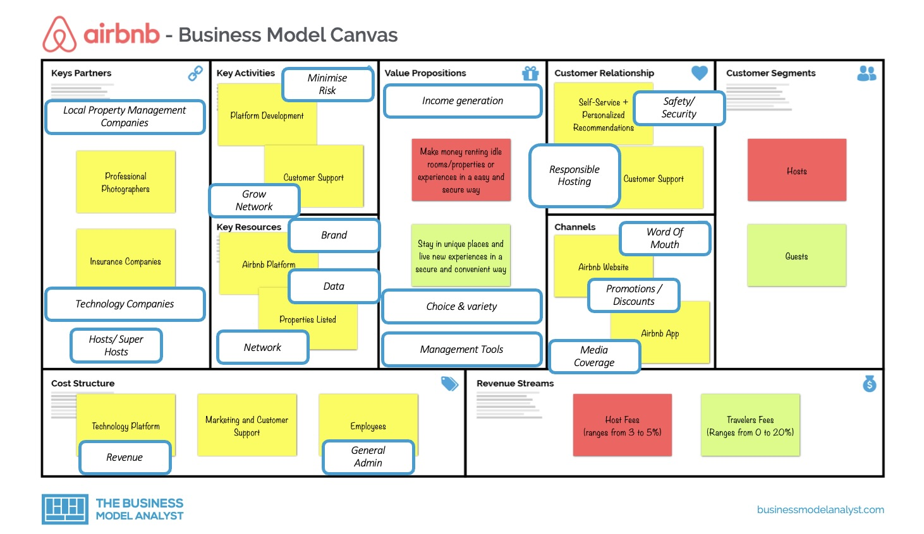
(Pereira, 2023)
The main contributions to the business model canvas are,
Key partners
- Hosts/Super Hosts – they bring their properties to the platform. Airbnb hosts are crucial they supply the ‘product’ to the consumer (guest).
- Local property management companies – partnering with local companies with a range of properties can increase the variety available to the guests.
- Technology companies – partnering with online platforms such as booking.com, can give access to guests that would traditionally book into hotels.
Key Activities
- Grow network – the more hosts that join, the more variety and offerings the guests have to choose from.
- Minimise risk – the largest risk to the hosts is damage to their properties, to lower set house rules and cover property with insurance policy, continue to use verification system and update if needed.
Value Proposition
- Income generation – increased number of hosts will in turn increase revenue.
- Management tools for hosts – management tool for hosts to access listings, availability calendar, price settings and contacting guests.
- Choice and variety - wide range of choice of places to stay unlike hotels that can all have similar interior and amenities.

Key Resources
- Brand – Brand is crucial to the key resources. Every effort to grow the brand has been on the fact that it’s an intermediary and not the provider of the guest experience.
- Network – continue to grow the network and increase number of hosts and guests.
- Data – keeping all data of hosts and guests private and confidential. Can use data to assess current climate and adjust as necessary.
Customer Relationships
- Responsible hosting – restrictions around number of days hosts are able to let their property can cause the biggest financial impact on Airbnb.
- Safety and Security – ensuring that the rental property is safety and secure for guests to stay in, keep all payments and communication through the Airbnb platform.
Cost Structure
- Revenue – includes the continued costs of things like insurance premiums, payment fees and IT costs.
- General Admin – continued costs of employees, legal fees, and professional services.

Strategic Formulation Framework (SFF)
Airbnb’s mission statement is “to create a world where anyone can belong anywhere” (Airbnb, 2019). They implement this by focusing on disrupting the hospitality industry by offering unique personalised and affordable travel experiences to customers” (Cascade, 2022). To be able to complete their mission statement AirBnB need to create a strategy. A business strategy creates a vision and direction for the entire organisation. It is a list of strategic goals and aims that a company continually works towards to “create value for the organization and its stakeholders to gain a competitive advantage in the market” (Boyles, 2022). A business strategy is crucial for any company and needs to be in place before any goods or services are sold.

There are many different types of strategic tools available to businesses. A strategic formulation framework is a tool that is used in business during a specific stage of the strategic management cycle (Wright, 2023). These frameworks allow a business to identify their weaknesses, opportunities, environmental changes and then they can adjust their focus to address the issues.

Grand Strategy Matrix (GSM)

The Grand strategy matrix is a strategic management tool that is used to formulate alternative strategies based on their competitive position and market growth. It is “broken into four quadrants by an x and y axis, each quadrant represents a combination of a company’s competitive position and growth of the market” (Smyth, 2021).
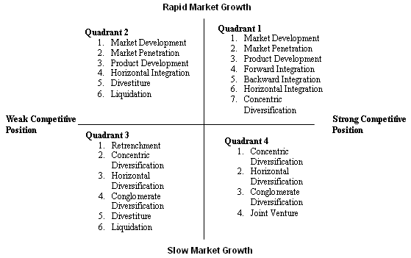
Image – Grand Strategy Matrix (Google,2024)
This strategy contains four different quadrants and each quadrants has a list of strategic options that an organisation could benefit from depending to where they fit in the matrix.
Quadrant one is for a company that has strong competitive position and rapid market growth. These companies have an excellent strategic position, are concentrating on current markets and take risks aggressively when needed.
Quadrant two is for a company that has a weak competitive position and in a rapidly growing market. These companies need to evaluate their current approach, improve their competitiveness, and require an intensive strategy to continue to the rapid growth.
Quadrant three is for a company that is in a weak competitive position and within a slow market growth. Companies that are in this quadrant need drastic changes quickly to align themselves into quadrant two to avoid the possibility of liquidation.
Quadrant four is an organisation that had a strong competitive position but are in a slow growth industry. An organisation in this quadrant would possibly need to diversify to move into a strong growth area.
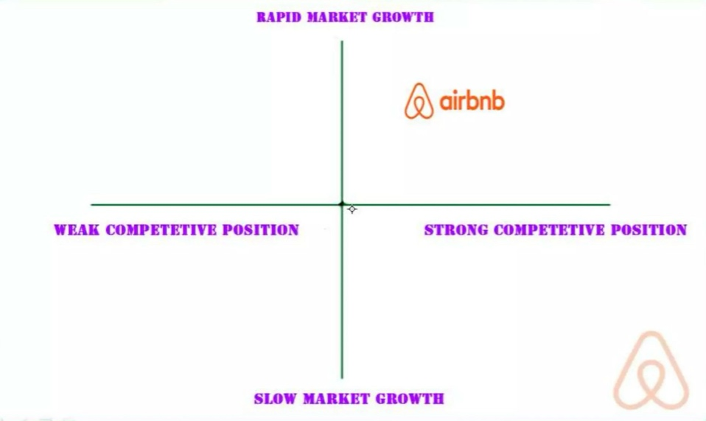
(Ismail, 2017)
With regards to Airbnb, I would place them in quadrant 1 of a grand strategy matrix. Airbnb has a very strong competitive position in a rapidly growing industry. They should continue to use their strong competitive position to increase their growth within the market and possibly diverse into other markets through strategic partnerships to grow.

Tools and Systems

Customer Relationship Management (CRM)
Customer relationship management (CRM) refers to the principles, practices, and guidelines that an organisation follows when they are interacting with customers. Customer relationship management ranges from face to face contact with a customer, website, email, social media or telephone calls it involves any interaction with a customer. The reason behind customer relationship management is to create and build a positive experience with consumers to make them happy and to keep them coming back to your company.
David Chaffey tells us that there are four classic marketing activities of customer relationship management. They are;
- customer selection
- Customer acquisition
- Customer retention
- Customer extension.
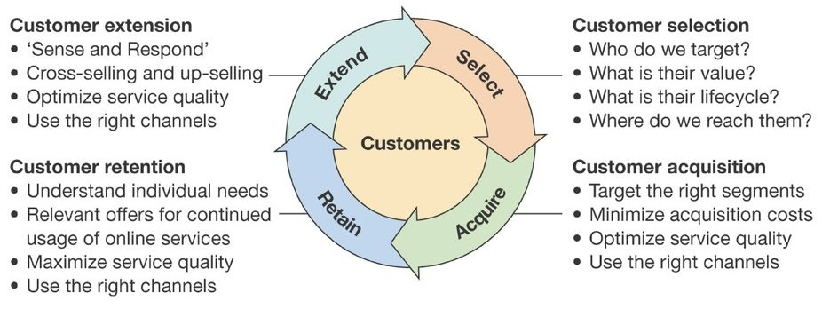
(Chaffey D. , 2009)

Supply Chain Management (SCM)
Supply chain management is the process of managing the flow of goods and services that come in and out of a business. It includes every step from raw materials and components to the final product and also the delivery and possible returns to and from the customers. The need for an effective supply chain management can streamline any business big or small to gain a competitive edge over their competitors, eliminate waste, reduce their carbon footprint, cut costs, and maximise their customer satisfaction. Improving efficiency and collaboration with suppliers and customers is extremely important in today’s hyper competitive accommodation industry.
Within a business there is usually a supply chain manager whose responsibility it is to deal with these components. They typically follow the process of the five phases of supply chain management.
- Planning
- Sourcing
- Manufacturing/ Production
- Distribution/ Delivery
- Returns
With regards to Airbnb following the five phases of supply chain management, planning would involve determining their operational strategy. How will it run, marketing, customer service and data analytics. Regarding sourcing Airbnb relies on homeowners and collaborators to provide the product to their guests. Airbnb provide a platform and the tools to screen and validate guests and hosts identity. The third phase, manufacturing/ production, would involve creating the website and apps that Airbnb uses to run their business without these they would be unable to take reservation, process payments and oversee the services. The fourth phase distribution/ delivery once the guests have chosen their location to stay, after payment come the delivery of the service. Once the service has been completed then hosts and guests are asked to provide feedback to ensure the services remains at the highest standards. The final phase, returns, if there are any issues with the service provided, Airbnb need to be able to communicate and resolve the issue to the best of their ability.

Enterprise Resource Management (ERM)
Enterprise resource planning is a type of software that company’s use to manage the day to day running of their businesses. They are a critical asset to any business especially larger businesses’ that are spread over different areas or even countries. Enterprise resource planning software helps by implementing resource planning by combining all the processes needed to run a business in one system.
Enterprise resource planning allows different departments to become self aware by connecting the information from production, finance, distribution, and human resources together. The system then analyses the data and then combine data for accounts, stock control systems and can also ‘red flag’ any duplicates, unpaid items, or specific issues for the business to deal with.
Airbnb needs to use an enterprise resource planning software as it has many benefits for an organisation of this type. Some of the benefits to Airbnb would be,
- Data Security / Centralised Data
- Increased Productivity
- Cost Savings
- Compliance
- Operational Efficiency
- Collaboration
- Better Customer Service

Conclusion

This report has set out the key facts for Airbnb within the sharing economy. Airbnb is an online marketplace that over the last fifteen years has exploded in popularity and challenged more traditional accommodation industries. As it continues, I believe that partnering with other companies is the right move for them to innovate and grow. Creating a partnership with holiday/ tour operators, Airbnb could offer services such as flights, transportation links and experiences in a package deal, similar to package holidays traditionally bought through a travel agent. Another collaboration could be with Uber. Both are users of the sharing economy, and a partnership for accessing Uber for all their transport needs while on holiday especially to users who may not have used their service before could be very finically rewarding to both companies.

References
Airbnb. (2019, January 15). Airbnb 2019 Business Update. Retrieved January 7, 2024, from Airbnb News: https://news.airbnb.com/airbnb-2019-business-update/
AirBnB. (2023, March 14). How much does Airbnb charge Hosts? Retrieved January 9, 2024, from AirBnB: https://www.airbnb.co.uk/resources/hosting-homes/a/how-much-does-airbnb-charge-hosts-288
Boyles, M. (2022, October 20). What is business strategy and why is it important? Retrieved January 4, 2024, from Harvard Business School: https://online.hbs.edu/blog/post/what-is-business-strategy
Cascade. (2022). What value can you get form AirBnB strategy? Retrieved January 10, 2024, from Cascade: https://www.cascade.app/templates/airbnb-strategy-template#:~:text=Airbnb%27s%20strategy%20focuses%20on%20disrupting,and%20differentiate%20themselves%20from%20competitors.
Chaffey, D. (2009). E-business and e-commerce management: strategy, implementation and practice (4th ed.). Financial Times Prentice Hall.
Chaffey, D. (2013, May 14). Social CRM Strategy Definition. Retrieved Janaury 12, 2024, from https://www.smartinsights.com/customer-relationship-management/social-crm/social-crm-strategy/
DigitalBizModels. (2020, May 29). AirBnB Biz Model Canvas. Retrieved January 9, 2024, from Digital Biz Models: https://www.digitalbizmodels.com/blog/airbnb-business-model-canvas#value-propositions
Dolnicar, S. (2018). Peer To Peer Accommodation Networks : Pushing The boundaries . Goodfellow Publishers .
Dolnicar, S., & von Briel, D. (2021). The evolution of Airbnb’s competitive landscape. In S. Dolnicar, & D. von Briel, Airbnb before, during and after COVID-19. The University of Queensland. Retrieved from https://uq.pressbooks.pub/airbnb-978-1-74272-321-1/chapter/the-evolution-of-airbnbs-competitive-landscape/
Fernando, J. (2023, October 20). Supply Chain Management (SCM) : How it works and why its important. Retrieved January 11, 2024, from Investopia: https://www.investopedia.com/terms/s/scm.asp
Ismail, M. (2017, February 25). Airbnb, Inc. Strategic Plan 2017-2021 MBA - strategic Management Assignment (Harvard case study June 2017 ). Retrieved January 11, 2024, from SlideShare: https://www.slideshare.net/mohieismail9/airbnb-inc-strategic-plan-20172021-mba-strategic-management-assignment-harvard-case-study-june-2017
Lovick, S. (2023, March 17). What Is The Sharing Economy? Retrieved January 5, 2024, from Business Because: https://www.businessbecause.com/news/insights/6736/what-is-the-sharing-economy
Pereira, D. (2023, June 10). AirBnB Business Model. Retrieved January 6, 2024, from The Business Model Analyst: https://businessmodelanalyst.com/airbnb-business-model/#Download_FREE
Ramirez, M. (2023, June 23). Airbnb: Business Model, SWOT Analysis, and Competitors 2023. Retrieved January 9, 2024, from Pitchgrade: https://pitchgrade.com/companies/airbnb
Smyth, D. (2021, May 25). How to Develop a Grand Strategy Matrix. Retrieved January 10, 2024, from Small Buisness Chron: https://smallbusiness.chron.com/develop-grand-strategy-matrix-37514.html
Statista. (2023, January 4). Value of the sharing economy worldwide in 2021 with a forecast for 2027. Retrieved January 5, 2024, from Statista: https://www.statista.com/statistics/830986/value-of-the-global-sharing-economy/#:~:text=Sharing%20economy%20services%20have%20exploded,growth%20(CAGR)%20of%20approximately%2032
Wallis, J. (2023, April 21). Airbnb Tech Stack Explained: What’s Driving The Airbnb App? — The Tech Behind Series. Retrieved January 9, 2024, from Intuji: https://intuji.com/airbnb-tech-stack-explained-airbnb-app/
Washington State University. (2023, November 9). Yours, Mine and Ours: How the Sharing Economy is Transforming Business. Retrieved January 5, 2024, from Washington State University: https://onlinemba.wsu.edu/blog/yours-mine-and-ours-how-the-sharing-economy-is-transforming-business#
Wright, T. (2023, September 27). 11 Best Strategic Frameworks for your organisation. Retrieved January 10, 2024, from Cascade: https://www.cascade.app/blog/best-strategy-frameworks#:~:text=A%20strategic%20framework%20is%20a,the%20best%20course%20of%20action.

