

Master of Business Administration
International Business Concepts
Module Code: LCMB7034
Costco’s Strategic Market Entry India
Assessment Title: Report
Student Name: [ Rutvik patel ]
Student ID: [2505514]
Lecturers:
Akshay Narayanan
Mansoob Murshed

Contents
Section 1: International Market Entry Analysis 4
1. Introduction 4
1.1 Company and Market Context 4
1.2 Report Purpose and Scope 4
2. Global Strategy and Configuration 4
2.1 Costco's International Strategy 4
2.2 Global Configuration and Advantage 5
3. Indian Market Strategic Appraisal 6
3.1 Political Environment 6
3.2 Economic and Retail Environment 7
3.3 Competitive Retail Landscape 9
3.4 Legal and Regulatory Environment 10
3.5 Cultural and Consumer Environment 11
3.6 Dunning's OLI Framework 12
4. Entry Strategy and Recommendation 15
4.1 Historical Entry Mode Pattern 15
4.2 Alternative Entry Mode Evaluation 16
4.3 Strategic Fit and Risk 17
4.4 Final Recommendation and Conclusion 18
Section 2: Critical Reflective Account 19
5. Gibbs Reflective Learning Account 19
5.1 Description 19
5.2 Feelings 19
5.3 Evaluation 19
5.4 Critical Analysis of Learning 20
5.5 Reflective Conclusion 21
5.6 Future Action Plan 21
Reference List 22

Section 1: International Market Entry Analysis

1. Introduction

1.1 Company and Market Context
Costco Wholesale Corporation is a retail chain with giant stores that are member-owned. The company's business model provides a limited choice of private label or branded products at low prices, with bulk purchasing and efficient distribution. As of 28 May 2026, Costco had 931 stores in various countries around the world, such as Japan, China, South Korea and Australia. The U.S. retailer, however, did not have a retail presence in India, nor did it have an e-commerce presence, as the cutoff date was 1 June 2026. India is thus a new expansion opportunity albeit with unique strategic challenges due to varying retail environment (Costco Wholesale 2025).

1.2 Report Purpose and Scope
This report assesses whether the Indian market is a good potential market for the Costco and a suitable market entry strategy. The Bartlett and Ghoshal framework is used to first evaluate Costco's international strategy. The political, economic, legal and cultural conditions of India are then evaluated. These findings are then synthesized using Dunning's OLI framework and an analysis of the history of Costco's entry patterns and other entry modes. Based on the analysis, a suitable recommendation is suggested for Costco's future entry into the Indian market based on the evidence found.

2. Global Strategy and Configuration

2.1 Costco's International Strategy
Bartlett and Ghoshal proposed a framework of international strategy based on two pressures: Global integration and Local responsiveness. The primary transnational aspect of Costco is its global strategy, with some transnational elements also present. Costco is close to the global strategy, as its core business is very uniform across markets, as illustrated in Figure 1. Costco keeps their costs low through membership warehouses, the fact that they sell a limited amount of products, they purchase in bulk quantities, and they have very simple warehouses. The company's business data shows that due to limited product selection, volume purchasing and efficient distribution, the company has a fast inventory turnover rate and has lower operating margins ( shuttle 2024).
The standardisation brings scale benefits and Kirkland Signature offers another transferable strength. Costco says that its own brands are meant to be of the same or better quality than national brands. But it's not all global because Figure 1 also demonstrates why Costco shouldn't be considered just a global company. Local responsiveness, especially in terms of product mix and consumer preferences, is driven by international retail markets. Recent studies also suggest that localisation can enhance the brand recognition of a multinational. As such, Costco can be considered as having predominantly global and selective transnational features. For India, this balance is crucial: Costco can maintain its membership-based business model, its purchasing efficiency, and its Kirkland brand, but there is a need for more adaptation at the merchandise and the consumer level. This is a dilemma between achieving global economy of scale and meeting the specific retail environment in India (Alonso 2023).
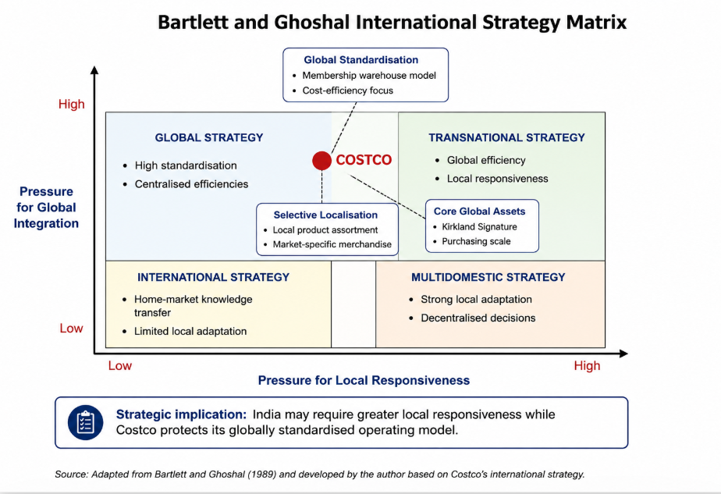
Figure 1: Costco’s Global Strategy Positioning Matrix

2.2 Global Configuration and Advantage
Costco adds value by expanding internationally, not just by opening more stores, via scale and through market learning and geographic diversification. As of 28 May 2026, Costco had 931 stores, including 37 in Japan, 20 in South Korea and 15 in Australia, 14 stores in Taiwan, and seven stores in China, along with significant operations in Canada, Mexico and Europe. This Asian presence is especially significant in the context of India, given that it reveals Costco's cross-border capabilities to run its warehouse system in non-Western markets (Kurian 2007).
Scale is an international factor that bolsters Costco's cost advantage. It is a model that benefits from the high sales volumes, volume purchasing, efficient distribution, and reduced amount of merchandise handling, which enables the company to run with relatively low gross margins. A bigger global network can assist with greater purchasing power and supplier relationship, and in the process distribute Costco's operating expertise across markets. It's also a lesson in the value of international diversification that can be seen in Costco's commercial results: Other International sales by Costco were up 11.2% in the third quarter of fiscal 2026, excluding the impact of foreign exchange and gasoline prices.
But the experience of Asia does not provide reason for confidence that India will do well. Bartlett and Ghoshal's integration-responsiveness logic acknowledges that multinational companies have to deal with various local pressures. India could have very different regulations, purchasing power, retail structure and shopping behaviour. So, Costco's global footprint offers significant opportunities for expansion in India, but it's not a matter of copying and pasting, but rather learning from the market (Liao & Le 2017).

3. Indian Market Strategic Appraisal

3.1 Political Environment
The political situation at India is mixed for Costco because retail is less liberalized than other sectors, but the government welcomes foreign investment. DPIIT's FDI policy in India is described as investor friendly, where many sectors have 100% FDI, and automatic route is available. But this transparency doesn't work for Costco, which has a membership warehouse format with multiple brands and product categories. As seen in Fig 2, the diverse nature of the retail segments in India indicates that the policy environment for Costco's multi-category approach would be more complex than that of a specialist single brand retailer (Neeraj Patharkar 2020).
The main challenge is India's policy towards multi-brand retail trading. Foreign investment is allowed up to 51% in multi-brand retail in given conditions by the government. Historically, these have involved a host of minimum foreign investments of US$100M, investment in back-end infrastructure and domestic sourcing requirements. Costco's conditions are relevant because they can affect how flexible the ownership structure is and how much investment is required prior to the involvement in large-scale expansion. Meanwhile, logistic and local procurement needs may match some of Costco's capabilities in warehousing, supply-chain management, and high volume purchasing (Kaur 2019).
Another problem is that the choice for multi-brand retail policy has been a state-level matter in implementation. This leaves them with an uncertainty as they cannot approach India as a single retail market. The concept of a feasible warehouse approach may be different in various states depending on varying political acceptance. This requires location choice and local knowledge of institutions to be a critical issue.
Thus, the political climate in India is conducive for long-term prospects and presents certain entry barriers. The overall support by the government to FDI is good, but the controls on retail is reducing the case for immediate complete and scale controlled FDI expansion. The political climate is conducive to a slow, measured and geographically limited approach for Costco, as ownership structure and regulatory compliance will be evaluated before big investments are made.
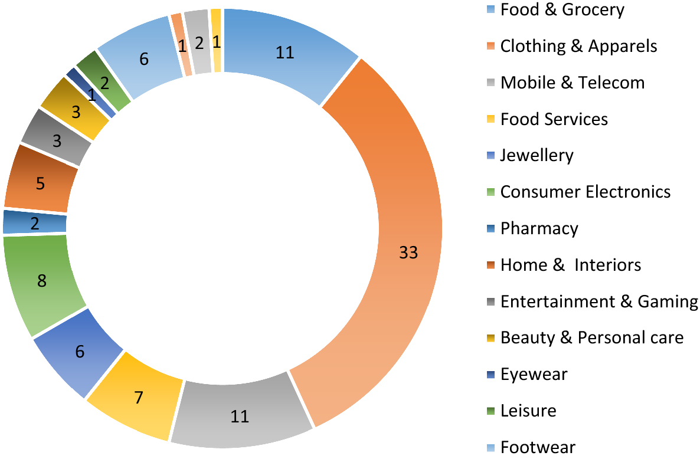
Figure 2: India’s Retail Sector Distribution Overview

3.2 Economic and Retail Environment
The economic prospects of India offer a great long-term opportunity for Costco, but that doesn't mean its warehouse concept will work here. The IMF reported real GDP growth of 6.5% in FY2024/25 and projected 6.6% for FY2025/26, while inflation was projected at 2.8% for 2025/26. These can be accompanied by strong growth, which can encourage household consumption and business investment, and lower inflation which can make purchasing more viable. But these national statistics mask significant inequalities in income and consumer power at the household level. Costco should therefore not view the Indian populace as one potential membership market (IMF 2025) but focus on the higher income urban families and small businesses (IMF 2025).
The retail opportunity is sizeable. The retail market was valued at US$1,124.2 billion in 2025 and is expected to increase to US$3,505.4 billion by 2034 with a CAGR of 12.8% for the period from 2026 to 2034, as indicated in Figure 3. Increasing incomes, urbanisation, digitalisation, infrastructure development, and the growing middle class are seen as key drivers of growth in the forecast. This provides a favorable location advantage for Costco since it must be a low-margin, high volume business, which in turn necessitates a large customer base. The increase of food, household goods, apparel and other types of merchandise in Figure 3 are in line with Costco's diverse merchandise mix.
Yet, the retail segment is driving the shift in Indian consumers' shopping habits. There is rapid growth in ecommerce, digital payments and organised retail - providing demand for convenience, as well as value. This is a challenge for Costco's traditional store model of people going to large stores in bulk to buy the products. Indian shoppers who are increasingly demanding fast delivery of digital content might not necessarily perceive enough value in paying a fee for a membership and going the extra mile for bigger packs. Costco would then have to prove substantial cost savings and perhaps combine a physical store with online ordering (Jain & al. 2025).
There is also a mixed picture when it comes to infrastructure. India improved six places to be ranked at 38th position in the World Bank's 2023 Logistics Performance Index (LPI) among 139 economies. Highways and dedicated freight corridors are also improving the links between production centres, ports and main markets. This is important for Costco as it's a critical part of their Cost Model and they need to move their inventory efficiently. However, there may be significant differences in logistics performance and commercial property conditions from one warehouse site to another, which is why it is important to consider warehouse-site selection.
In general, India's economy and retail landscape is appealing but not necessarily one that works with Costco. Scale potential is provided by growth and urbanisation, retail expansion, but purchasing-power differences, convenience expectations and infrastructure variation are limits. Costco's best prospects are probably in the more prosperous, high-density metropolitan areas where it's likely that sufficient numbers of households and businesses will derive clear benefits from membership, and bulk purchases (Rishika Sadam & Sai Ishwarbharath B 2025).
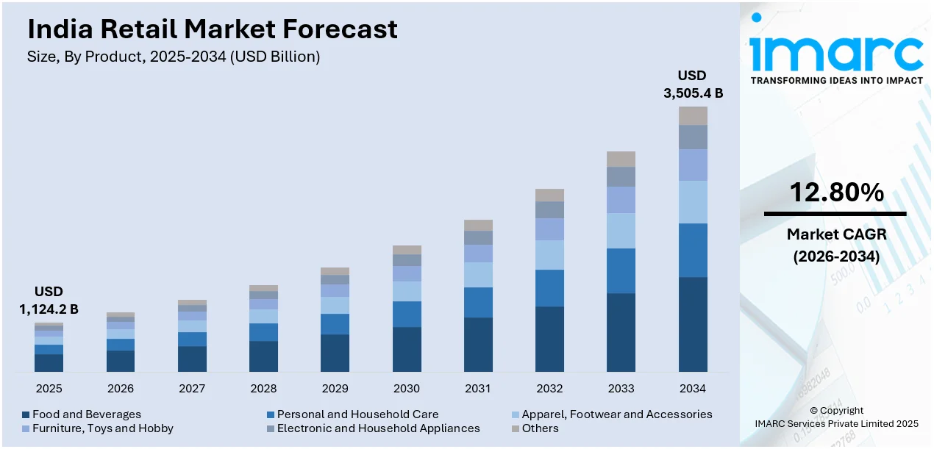
Figure 3: India Retail Market Growth Forecast

3.3 Competitive Retail Landscape
Today, India's retail segment offers a formidable challenge to Costco, as the customers have the option to buy from traditional stores, large organised retailers, e-commerce and fast-growing quick-commerce retailers. The concentration measure is also significantly higher in 2024 and the retail and wholesale market in India is also growing in activity. Import concentration, however, does not directly reflect the level of competition at the retail level, and therefore should be read as an indicator of shifting wholesale and sourcing conditions - not as a measure of the competitive position of Costco (Jain & al. 2025).
Costco would be in competition with itself as well as other retailers. While large organised retailers give customers good value for money and a large range of products, Amazon and Flipkart offer convenience and choice when it comes to their online offerings. Most important of all, however, is that quick commerce companies like Blinkit, Zepto and Swiggy Instamart have made it the norm in major cities, playing around the speed of delivery. Swiggy was set to expand big-time at Instamart by 2026 and Zepto, BigBasket, Amazon and Flipkart were also giving it a run for their money. There is other competition as well in the form of the traditional Kirana shops which offer convenience of a small purchase, familiarity and proximity.
But low prices are not enough for Costco. It may be due to a mix of membership benefits, bulk value, a well curated product selection and Kirkland Signature products. But for this to work, there has to be a belief among the members that the savings they make in the year outweigh the cost of being a member and the inconvenience of shopping at a store. (Zhao 2024)
The competition, then, favors selective adaption of the current Costco model instead of a complete copy. Costco can uphold its membership philosophy and values with the development of locally relevant pack sizes, merchandise and digital initiatives. The company would then have the option to play the value game, without directly mimicking the convenience store model in India.
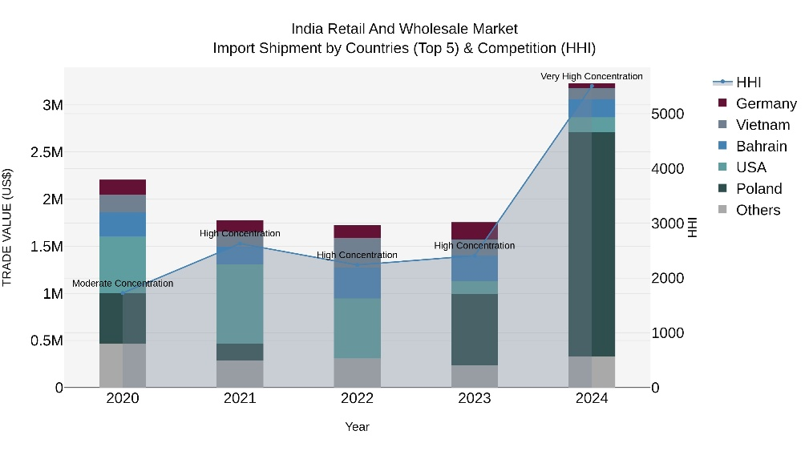
Figure 4: India Retail Import Competition Trends

3.4 Legal and Regulatory Environment
India's regulatory landscape is one of the most formidable challenges for Costco to overcome as its typical approach of running a warehouse cannot be ported over to the country automatically. The FDI framework in India allows foreign investment up to 51% in multi-brand retail trading under the Government route, under certain conditions. It's important because Costco carries numerous brands and product lines under one store design. Therefore, the legal viability needs to be tested before the commercial viability is accepted as an investment (Arnold & Narang Luthra 2000).
The regulation also impacts on Costco's supply chain. Local sourcing and investment conditions may make it more challenging initially, but can also spur Costco to develop Indian supplier relationships. This may help it continue to sustain its low-cost model in the future by limiting reliance on imports. Food has a special relevance since Costco stores carry large items of food. The Food Safety and Standards Authority of India has regulations related to business licensing, food-product standards, imports, packaging, among other food operations. A robust compliance system would thus be needed at Costco for both local and imported foods.
There is another operational consideration with taxation. GST applies to all goods and services, though different goods/services may be treated differently. Having thousands of products means more of the following for a retailer: Pricing, Accounting, and Systems. Rules for consumer protection and competition would also impact advertising, pricing, supplier relations and customer treatment (Rane 2019).
Data regulation is particularly applicable to Costco due to the fact that they have to gather and oversee client data to assist with membership. Local legal and tech expertise is crucial to India's data-protection laws, which would have to be followed by Costco's membership and digital systems. Further requirements of the location would include property approval, labour compliance and warehouse development.
India is a commercial attractiveness with a legal challenge. While the regulatory situation doesn't ensure Costco won't be able to get in, it makes it tough to just copy a well-regulated foreign-market model. A structure that gives Costco some control and introduces local regulatory knowledge may thus be more appropriate. This discovery directly reinforces the argument of comparison of partnership or joint-venture entry with wholly owned entry in the later entry-mode analysis (Delalić & al. 2025).

3.5 Cultural and Consumer Environment
The opportunity and the challenge for Costco in India is the consumer environment, as their shopping habits differ significantly based on income, location and lifestyle. This is supported by Figure 5 as newer consumer behaviour is more likely among affluent consumers and those residing in metro and Tier 1 cities compared to a number of lower income and smaller city groups. This means that Costco should not assume the Indian market as a single market segment. In fact, recent BCG research also highlights the interplay of growing affluence and a substantial middle class, as customers are torn between global wants and local needs, premiums and value, and digital and physical shopping (Rajagopal 2025).
The diversity poses an important problem for Costco's membership model. Costco is generally an annual membership that provides customers with a limited product selection and low prices. This model will only be successful with Indian consumers if they can see the savings and they feel it is worth buying the product in bulk for the price. So price sensitivity is an issue, especially with middle income families. Bulk packs could be offered at a value to the large family and small business, but may not be desirable for consumers who have limited storage capacity or who prefer to buy more often, for smaller quantities.
There's another tension that comes with convenience. The Indian Retail sector is going digital and BCG forecasts that ecommerce may account for US$280–300 billion by 2030. The speed of delivery is also becoming more ubiquitous on quick-commerce platforms, especially in the main city markets. This warehouse-only approach might then seem cumbersome to app-based buying (Viswanathan & ET Entrepreneur 2026).
Costco should consequently standardise its core value proposition but localise the customer offer. There should be no change in membership or efficiency of operations, in Kirkland Signature and value pricing. Product range, package sizes, food product lines, digital services and marketing could need adjustment to Indian preferences, such as vegetarian options and regional tastes. While national cultural models may provide general guidance, they are not able to adequately reflect the sizeable regional and socioeconomic differences in India. Hence, there is an increased possibility of initially targeting rich households in metros and small businesses, rather than the entire Indian consumer market (Ng & al. 2025).
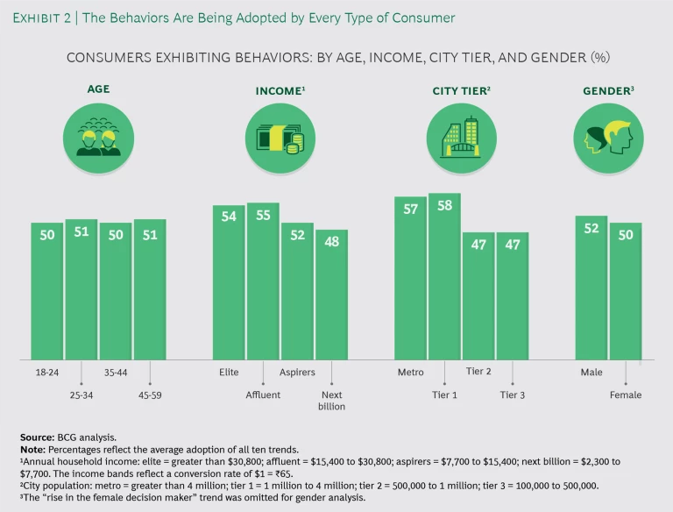
Figure 5: Indian Consumer Behaviour Adoption Patterns

3.6 Dunning's OLI Framework
3.6.1 Ownership Advantages
The Dunning's ownership dimension is whether or not Costco has firm-specific capabilities that can provide an advantage in an unfamiliar market. Figure 6 highlights three aspects of the strengths that are well transferable: membership model, Kirkland Signature, purchasing scale. Costco's business model has low prices, low product variety, high volume sales and efficient distribution, which enables it to run at relatively low gross margins. It also has a membership system that generates recurring revenue and a relationship with customers, and Kirkland Signature offers differentiated private-label products (Alonso 2023).
The benefits are enhanced by Costco's worldwide buying power, supplier relations, and warehouse expertise and cost-control knowledge. However, transferability differs. Systems, warehouse practices and brand criteria can be acquired relatively easily, and customer loyalty and acceptance of membership status must be built locally. As a result, Costco has valuable ownership advantages but this does not eliminate the liability of foreignness. They may not be very effective due to Indian regulation, shopping habits and competition. Its impact is therefore through its operating system, not its name (Roy & al. 2022).
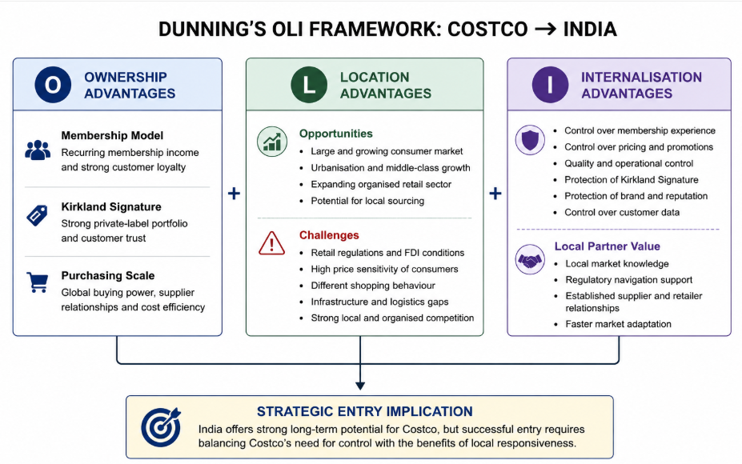
Figure 6: Costco India OLI Strategic Framework
3.6.2 Location Advantages
India does provide the location advantages in particular that are relevant to Costco, but Figure 6 accurately includes pertinent restrictions. Organised retail is growing in the country, along with urbanisation and affluent consumers, providing the scale required for a high volume warehouse business. BCG predicts that India's retail sector will be valued at about INR190 trillion by 2034, and the increase in consumer affluence and preference changes are driving the sector's growth. Local sourcing would also enable Costco to establish lower cost supply chains and provide products for Indian customers (BE Staff & ET BrandEquity 2025).
But size of the market must be weighed against disadvantages of location. This is important ownership restriction because the government route still allows 51% FDI in multi-brand retail. Kirana stores, organised retailers and fast growing digital channels are other very strong alternatives for consumers. Thus, India's location advantage is not widespread. This is because there is a greater potential than immediate pan-national expansion in major metropolitan areas that have affluent households, businesses, available logistics and purchasing power. This enables a selective, staged rollout as opposed to a blanket rollout.
3.6.3 Internalisation Advantages
The internalisation element incorporates the idea that Costco should maintain its own control over critical activities, instead of relying on external companies heavily. Figure 6 indicates that control is especially important for membership experience, pricing, product quality, the Kirkland Signature, and customer data and warehouse operations. These capabilities are related to Costco's competitive advantage, and if executed incorrectly by the external party, it can negatively affect customer trust and Costco's low-cost strategy. It uses an existing model that is based on close relationship volumes sales, efficient distribution, and less merchandise handling (Wang 2024).
But, in India, there is a trade-off with full internalisation. A local partner may be able to share with knowledge of consumer behaviour, supplier networks, property markets and regulatory processes. This is particularly the case since multi-brand retail investment is subject to government approval and has ownership limits. Therefore, Costco must maintain a high level of control over its brand, membership program, purchasing requirements, Kirkland products and operations. In general, the internalisation analysis aligns with high level of operational control and local market knowledge, to be used to inform the entry-mode comparison in Section 4 (Surana & al. 2024).

4. Entry Strategy and Recommendation

4.1 Historical Entry Mode Pattern
The Costco International expansion indicates that the company is not about to give its warehouse to others, at least on the primary basis of licensing or franchising. This strategy has resulted in operations in established markets such as Japan, South Korea and Taiwan, and Australia and several European markets, as shown in Figure 7. As of April 2026, there were 37 Costco warehouses in Japan, 20 in South Korea, 14 in Taiwan, and seven in China.As of April 2026, there were 928 Costco warehouses worldwide, including 37 in Japan, 20 in South Korea, 14 in Taiwan, and seven in China. This indicates that Costco has been able to move its membership and store between markets (Singh 2026).
But Costco was not always managed in this fashion. An example of this is Taiwan. It was a joint venture that was discontinued in 2022 when Costco bought the other 45% for US$1.05 billion and became a wholly owned subsidiary of the company. This indicates when the local conditions are appropriate, Costco may choose to share ownership and after gaining knowledge of the market, assumes more control.
The historical trend is thus one of high level of operational control and some flexibility over ownership. It makes sense strategically, as costco's competitive edge is having the membership and buying standards, pricing, warehouse efficiency set at a uniform level. But, Fig 7 is not a template for the same to work in India. Costco's typical strategy of controlled expansion will need to be adapted due to India's foreign-investment rules and retail environment (Gil & al. 2026).
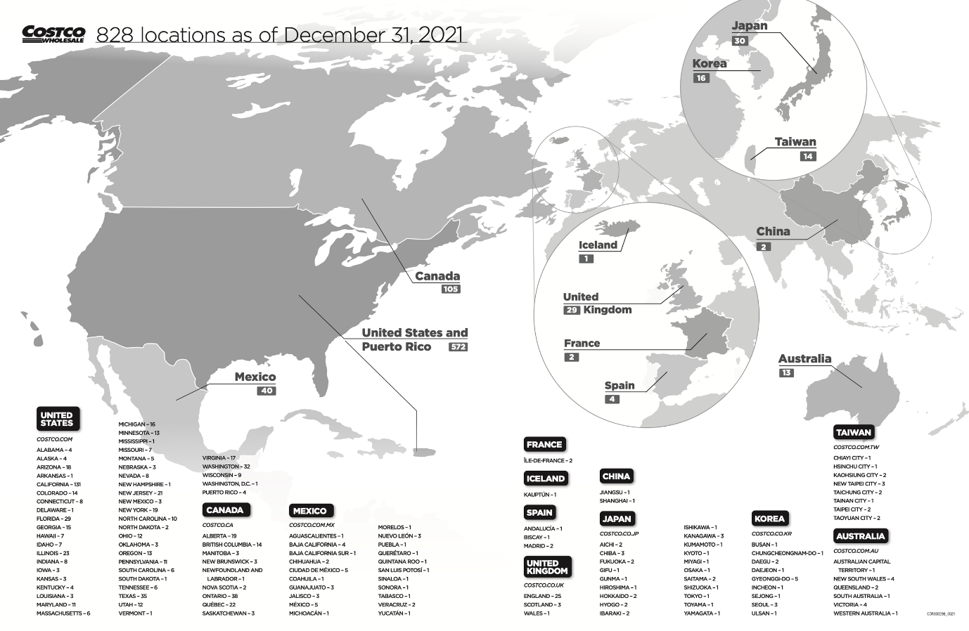
Figure 7: Costco Global Warehouse Location Network

4.2 Alternative Entry Mode Evaluation
Costco's strategy usually would work with a wholly owned greenfield subsidiary because they would have the greatest level of control over warehouse operations, membership, pricing and Kirkland Signature. It will also safeguard the advantages of ownership and internalisation identified by OLI. But this option is marred by a big legal problem in India. Under the Government route, multi-brand retail FDI can get up to 51% and is subject to restrictions, such as a minimum foreign investment of US$100 million and conditions relating to back-end infrastructure. Thus, a completely foreign-owned multi-brand retail store would not only be a high-risk option, but would be also have at least one basic regulatory limitation at present (Briefing 2012).
A good business fit, alongside a proper Indian partner, is achieved through a joint venture arrangement. Costco's brand, procurement savvy, membership program and warehouse experience could be joined with a partner's knowledge of regulation, property, suppliers and customer buying habits. There are previous examples of Costco's expansion to full ownership in the past when it was appropriate (Case of Taiwan). The weakness is the lack of control and the risk of disagreement about the pricing, sourcing, investment or expansion (Rice 2010).
A non-equity strategic partnership would be less capital-intensive and more flexible, but might result in Costco having less control over the customer experience. Exporting Kirkland products would be even less appropriate as it would test the demand for the product, but not the membership model of the Costco.
Not the lowest risk is not the strongest, then. OLI proposes to Costco the need for operational control and to India's institutional environment, the value of local knowledge. Thus, a well-managed joint venture provides the best combination of control, regulatory fit and learning and risk sharing.

4.3 Strategic Fit and Risk
In Figure 8, the key strategic compromise is summarized. Costco's long-standing focus on control is reflected in the matrix, as this also leads to the greatest resource commitment and exposure. In India, regulatory risk is linked with financial risk: The 51% multi-brand retail FDI ceiling limits ownership and the policy needs huge investment and back end infrastructure. This could lead to financial and operational risk due to the high costs of implementing membership before the supermarkets understand the demand for membership (Ammar Yasira Wahyudi & Cervantes 2024).
Consumer risk is also significant. Costco will need to drum up enough sales to compel Indian shoppers to alter their shopping behaviors. Poor product assortment, pack sizes and digital convenience will affect low membership adoption, which will have a negative impact on warehouse volumes and the economies of scale that Costco is built upon. Performance of the supply chain and local sourcing would then be linked to the same problem.
A joint venture is located between full ownership and low control partnerships, as shown in Figure 8. This is the same uncertainty that is present in India: Costco is able to get local knowledge, but maintain some influence on the brand and operations. Shared ownership introduces governance risk where partners disagree (Ozturk & Liu 2026), however.
The optimal strategic match becomes therefore not maximum control but adequate control with local capacity. India's long-term growth potential is significant enough to warrant investing in the country, but regulatory and consumer uncertainty is more suited to a gradual and staged joint-venture structure than to a big bang investment.
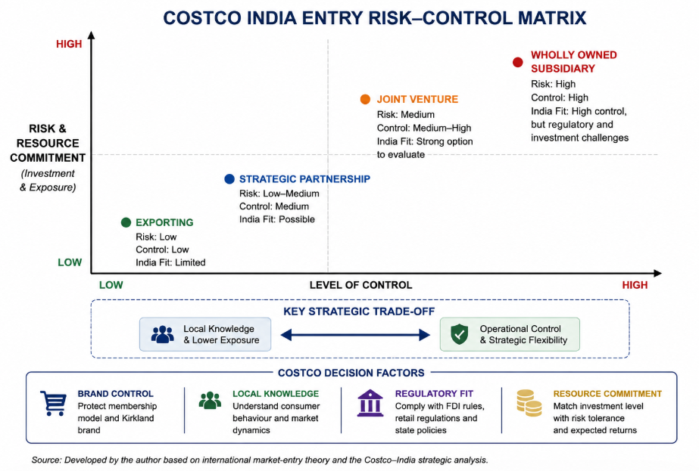
Figure 8: Costco India Entry Risk-Control Matrix

4.4 Final Recommendation and Conclusion
Costco needs to come to India, but via a gradual, joint venture with a solid local partner, not with a firm hand with a green thumb. This recommendation is based on the results of the analysis of the political, economic, legal, cultural and OLI factors. India is a good place to grow retail business in long-term, but at the start it's not a good idea to invest in a high-commitment strategy due to regulatory hurdles and varying consumer behavior, as well as the uncertain acceptance of membership.
Costco is expected to have a powerful voice in the determination of membership requirements, costs, the Kirkland Signature brand, product quality and warehouse procedures, and its partner to bring regulatory expertise, property expertise, relationship with suppliers and local consumer knowledge. The initial warehouses need to be focused in specific rich metro markets with localised goods, pack size and digital services (Mishra & al. 2025).
Growth should only happen after the first sites have proven to have a high membership renewal rate, high sales volumes, efficient supply-chains and regulatory compliance. This method is a compromise between control and flexibility, and learning. In general, India is a good potential market for Costco in terms of long-term prospects, but it will require more than just copying their global approach to localisation.

Section 2: Critical Reflective Account

5. Gibbs Reflective Learning Account

5.1 Description
I began this assessment by trying to find out what I needed to be investigating and how each section was linked to the others. I chose the Costco as it allows me to study the membership-based warehouse business model that is unique to it and therefore, an interesting case study for international business. I picked India due to the fact that Costco has not yet established a large retail footprint in India, and the market provides good growth potential but also presents a few challenges to enter the market. I developed a research strategy and segmented my research into the company strategy and business environment in India along with entry modes. I relied on Costco corporate reports to get to know about the company and government sources to study the FDI laws in India. I also relied on academic sources and more recent industry reports. As I researched, I used the framework developed by Bartlett and Ghoshal to help structure the evidence and provide a building block to help formulate my final recommendation and the Dunning model to provide the evidence (Teece 2014).

5.2 Feelings
Initially, I had a lot of initial confidence because India looked like a good market because of its population and the expansion of retail activity in India. I initially thought that Costco could simply use its successful international model in India. But, when I began to do some research on the retail regulations in India, my confidence shifted. Foreign investment in multi-brand retail was more complicated than I thought. I also wasn't sure how to relate political, economic, and cultural data and theories to international business. As I dug deeper into it I felt more confident that it wasn't just one separate topic but instead there were theories. They helped me to challenge my initial thinking and make a well-informed choice (Lim 2025).

5.3 Evaluation
One area that was successful was to incorporate a variety of evidence sources rather than utilizing general websites. The information in the Corporate section enabled me to have an understanding of Costco's membership plan, their warehouse system and international experience. Some of the most valuable sources of information when I looked at FDI rules were documents from the Indian government, rather than blogs on the same rules. I used academic literature to understand the theories and use recent industry reports to gather information about Indian retail and consumer behaviour. Dunning's OLI framework was particularly helpful as it enabled me to integrate and combine the different findings (Wang 2022).
But there were some problems I had to overcome, In some reports, India's retail market size and growth has been estimated differently. This took me a while to understand, as I wanted one exact figure. I learnt to compare the estimates in terms of publication date, how the estimate was made and how reliable the sources were rather than simply taking the biggest estimate. Another challenge lay was description avoidance. I enhanced this by questioning repeatedly what each piece of evidence was really about as far as Costco's entry decision. My analysis was thus more focused, but with some uncertainty around it since Costco hasn't officially launched in India yet.

5.4 Critical Analysis of Learning
What has been the most significant thing I learned? When I understood that an attractive market isn't necessarily a market that is appropriate for a specific company. Prior to this research, I had primarily focused on India's population, economic growth and growing retail market as drivers for Costco to enter the market. The module theories enabled me to consider these basic indicators, (Wichmann & al. 2022).
The concepts of global integration and local responsiveness, introduced by Bartlett and Ghoshal, gave me a better understanding of the subject. I figured out how Costco makes money efficiently because they had the same, relatively standard, membership structure, warehouse processes, and shopping experience. But India might need their own products, pack sizes, food options and digital products. This demonstrated to me that international expansion entails local changes and what remain consistent internationally (Muthangya Maithya 2012).
I further developed my thinking with the Dunning's OLI framework. Rather than asking the question: attractive or not, I asked myself the question: do there exist transferable ownership advantages for Costco in India? Do there exist location advantages for Costco in India that would be useful? Should activities be conducted in house? This helped me realize that the purchasing scale that Costco may have and the Kirkland Signature may have it, may be beneficial, whereas being accepted by the consumers in other countries, cannot be transferred here.
My mind about the approaches to entry shifted as well. At first I thought full ownership would have the strongest since Costco could have the most control. I've learned that a lot about regulations in India, and what the Costco has done in the past, and how it can mean higher financial and operational risk if the control is too high. It may be possible to mitigate some of the uncertainty by forming a joint venture, but they have a different governance risk.
The one constraint with my analysis was that I was using secondary data. But, actual customer response to the membership at Costco is still unknown, as the company has yet to announce its official launch in India. I came to learn that uncertainty cannot be eliminated by good strategic analysis, it is used to reach a judgment on a matter using evidence and theory (Bandi & al. 2024).

5.5 Reflective Conclusion
In the big picture, I found this assessment to be very beneficial in developing my research skills and understanding of international business decisions. In retrospect, the most important lesson I learned is that you can't consider only one positive aspect of the market, like the population or the economic development, and decide whether or not to enter. I learned to link the company's abilities to the political, legal, economic and cultural context before I was able to come to a recommendation. I also learned to ask questions of sources and to evaluate evidence from one source against another in an effort to not take everything they say as it comes. Most importantly, I shifted from talking about information to what the information means for Costco's strategy. I still need to develop my skills in assessing rival academic arguments and dealing with lots of evidence effectively. I now feel more confident however in my ability to make strategic recommendations that consider opportunities and risks rather than conclusions that are drawn one-sidedly (Bandi & al. 2024).

5.6 Future Action Plan
For future assignments, I'll start my research earlier, and also make a clear evidence plan before I begin to write. I'm going to break up this research question into smaller sections and determine what kind of evidence is needed for each. I will use peer-reviewed studies, company reports and official government sources before commercial websites. If two sources are giving conflicting statistics, I will note the date of publication, how they were obtained, and how good the source is in an evidence matrix before I make my decision about which is more valid (Jain & al. 2025).

Reference List
Alonso, T. 2023. Strategy study: How Costco’s unique business model resulted in global success. Cascade. URL: https://www.cascade.app/studies/how-costcos-business-model-resulted-in-success. Accessed: 8 August 2026.
Ammar Yasira Wahyudi & Cervantes, M. 2024. Financial risk management in global expansion: Which market entry strategy is the most effective in financial risk management? The Proceedings of the ASEAN School of Business Network International Conference, 1, pp. 345–368. URL: https://doi.org/10.64458/asbnic.v1.28. Accessed: 8 August 2026.
Arnold, S.J. & Narang Luthra, M. 2000. Market entry effects of large format retailers: A stakeholder analysis. International Journal of Retail & Distribution Management, 28, 4/5, pp. 139–154. URL: https://doi.org/10.1108/09590550010319896. Accessed: 8 August 2026.
Bandi, N., Cohen, M.C. & Ray, S. 2024. Behavioral retail operations: Tactics to win customers. Foundations and Trends® in Technology Information and Operations Management, 18, 3–4, pp. 214–420. URL: https://doi.org/10.1561/0200000111.
BE Staff & ET BrandEquity 2025. India’s retail sector set for explosive growth: BCG-RAI report. ETBrandEquity. URL: https://brandequity.economictimes.indiatimes.com/news/research/indias-retail-sector-set-for-explosive-growth-bcg-rai-report/118676690. Accessed: 8 August 2026.
Briefing, I. 2012. Foreign direct investment in India’s single and multi-brand retail. URL: https://www.india-briefing.com/news/foreign-direct-investment-indias-single-multibrand-retail-5232.html/. Accessed: 8 August 2026.
Costco Wholesale 2025. Costco Wholesale Corporation - Company profile. URL: https://investor.costco.com/company-profile/default.aspx. Accessed: 8 August 2026.
Delalić, S., van Heel Merdanović, A. & Kasumović, Z. 2025. Multinational corporations (MNCs) and global governance in the age of globalization: Challenges and opportunities – reshaping power dynamics. Društvene i humanističke studije (Online), 10, 2(28), pp. 773. URL: https://doi.org/10.51558/2490-3647.2025.10.2.773. Accessed: 8 August 2026.
Gil, M., Ots, M. & Uman, T. 2026. Current trends and future research in management control for sustainability in retail. Business Strategy and the Environment. URL: https://doi.org/10.1002/bse.70602.
IMF 2025. IMF Executive Board concludes 2025 article IV consultation with India. URL: https://www.imf.org/en/news/articles/2025/11/24/pr-25392-india-imf-executive-board-concludes-2025-article-iv-consultation. Accessed: 8 August 2026.
Jain, S., Roy, S., Singh, A., Agarwal, S. & Jain, P. 2025. The rise of Quick Commerce: Transforming India’s retail, consumer behaviors, and employment dynamics. URL: https://www.kearney.com/industry/consumer-retail/article/the-rise-of-quick-commerce-transforming-india-s-retail-consumer-behaviors-and-employment-dynamics. Accessed: 8 August 2026.
Kaur, S. 2019. Foreign direct investment in Indian single &amp; multi brand retail trading: An analysis. 3, 3, pp. 988–996. URL: https://www.researchgate.net/publication/378525443_FOREIGN_DIRECT_INVESTMENT_IN_INDIAN_SINGLE_MULTI_BRAND_RETAIL_TRADING_AN_ANALYSIS. Accessed: 8 August 2026.
Kurian, P.S.S.B. 2007. India could be Costco’s next Asian stop. Economic Times. URL: https://m.economictimes.com/industry/services/retail/india-could-be-costcos-next-asian-stop/articleshow/1188086.cms. Accessed: 8 August 2026.
Liao, T.-S. & Le, U.-M. 2017. A dynamic global integration and local responsiveness framework: Understanding strategic movements of multinational enterprises. URL: https://www.researchgate.net/publication/343513495_A_Dynamic_Global_Integration_and_Local_Responsiveness_Framework_Understanding_Strategic_Movements_of_Multinational_Enterprises. Accessed: 8 August 2026.
Lim, W.M. 2025. Theory and theory development: Guidelines for establishing theoretical gaps, foundations, contributions, and implications. Journal of Business Research, 202, pp. 115745–115745. URL: https://doi.org/10.1016/j.jbusres.2025.115745.
Mishra, S., Srivastava, S. & Jahan, T. 2025. Costco Wholesale Corporation: A comprehensive business case study. BSSS Journal of Commerce, XVII, 1. URL: https://www.researchgate.net/publication/393786331_Costco_Wholesale_Corporation_A_Comprehensive_Business_Case_Study. Accessed: 8 August 2026.
Muthangya Maithya 2012. Strategy and change management: Costco. ResearchGate, 101, Strategic management, pp. 13. URL: https://www.researchgate.net/publication/378846326_Strategy_and_Change_Management_Costco. Accessed: 8 August 2026.
Neeraj Patharkar 2020. FDI in multi-brand retail sector and its impact on Indian economy. unknown. URL: https://www.researchgate.net/publication/342881408_FDI_in_Multi-Brand_Retail_Sector_and_its_impact_on_Indian_Economy. Accessed: 8 August 2026.
Ng, S., Torelli, C.J., Zhang, Y.A. & Li, Y. 2025. Globalization unveiled: Navigating the impact of firm and consumer. Foundations and Trends® in Marketing, 19, 2, pp. 64–162. URL: https://doi.org/10.1561/1700000081.
Ozturk, A. & Liu, S.Y.H. 2026. A model for building capabilities among family-controlled multinational corporations in emerging markets. Journal of Business Research, 205, pp. 115892. URL: https://doi.org/10.1016/j.jbusres.2025.115892.
Rajagopal 2025. Contemporary marketing strategy. Springer Nature Switzerland. Cham. URL: https://doi.org/10.1007/978-3-031-95921-9.
Rane, S. 2019. Impact of goods and services tax on Indian economy. URL: https://www.academia.edu/38654485/IMPACT_OF_GOODS_AND_SERVICES_TAX_ON_INDIAN_ECONOMY. Accessed: 8 August 2026.
Rice, M. 2010. The global expansion of transnational retailers: A case study of the localization strategy of Costco in Taiwan. URL: https://www.academia.edu/2680950/THE_GLOBAL_EXPANSION_OF_TRANSNATIONAL_RETAILERS_A_CASE_STUDY_OF_THE_LOCALIZATION_STRATEGY_OF_COSTCO_IN_TAIWAN. Accessed: 8 August 2026.
Rishika Sadam & Sai Ishwarbharath B 2025. US retail giant Costco to set up global capability centre in India, to employ 1000 people, sources say. Reuters. URL: https://www.reuters.com/world/india/us-retail-giant-costco-set-up-global-capability-centre-india-employ-1000-people-2025-07-21/. Accessed: 8 August 2026.
Roy, S., Kasi, V., Singh, T. & Edibam, P. 2022. Indian retail’s journey toward a sustainable future. URL: https://www.kearney.com/industry/consumer-retail/article/indian-retail-s-journey-toward-a-sustainable-future. Accessed: 8 August 2026.
shuttle 2024. Bartlett and Ghoshal’s matrix: Mastering global dynamics. URL: https://growthshuttle.com/frameworks/bartlett-ghoshal-matrix/. Accessed: 8 August 2026.
Singh, S. 2026. Costco’s warehouse expansion strategy fuels long-term growth. URL: https://finance.yahoo.com/news/costcos-warehouse-expansion-strategy-fuels-145700713.html. Accessed: 8 August 2026.
Surana, A., Chavan, M., Kumar, V. & Chirico, F. 2024. The internationalization process: A contextual analysis of Indian ibusiness firms. International Business Review, 33, 4, pp. 102255–102255. URL: https://doi.org/10.1016/j.ibusrev.2024.102255. Accessed: 8 August 2026.
Teece, D.J. 2014. A dynamic capabilities-based entrepreneurial theory of the multinational enterprise. Journal of International Business Studies, 45, 1, pp. 8–37. URL: https://doi.org/10.1057/jibs.2013.54.
Viswanathan, S. & ET Entrepreneur 2026. Quick commerce solved delivery. It has not solved discovery. ETEntrepreneur. URL: https://entrepreneur.economictimes.indiatimes.com/news/opinion/quick-commerce-solved-delivery-it-has-not-solved-discovery/132861827. Accessed: 8 August 2026.
Wang, H. 2024. The strengths and weaknesses of Costco’s business and financial model as well as the potential risk of Costco’s international development and outlook. Highlights in Business Economics and Management, 24, pp. 75–80. URL: https://doi.org/10.54097/b7w0qv37. Accessed: 8 August 2026.
Wang, J. 2022. Financial and market performance analysis of an international chain of member-owned warehouses Costco. BCP Business & Management, 34, pp. 573–579. URL: https://doi.org/10.54691/bcpbm.v34i.3067. Accessed: 8 August 2026.
Wichmann, J.R.K., Uppal, A., Sharma, A. & Dekimpe, M.G. 2022. A global perspective on the marketing mix across time and space. International Journal of Research in Marketing, 39, 2, pp. 502–521. URL: https://doi.org/https://doi.org/10.1016/j.ijresmar.2021.09.001.
Zhao, H. 2024. A comprehensive analysis of the retail giant: An in-depth study of Costco. Highlights in Business, Economics and Management, 43, pp. 120–127. URL: https://doi.org/10.54097/9z1g2647.

