GEORGIANA-ANDREEA ENE
18131233
THE GLOBAL BUSINESS ENVIRONMENT
MODULE NUMBER: LCBB4005
LECTURER: REXON NTING

ENVIRONMENTAL ANALYSIS OF AN AUTOMOBILE INDUSTRY

Table of Contents
Introduction 3
Critical Assessment of the Manufacturing Industry 3
Major forces shaping the business environment 3
Modification of the manufacturing Industry 4
Advantages of electric vehicles 5
Assessment of global automotive industry 6
Business opportunities by selling Electric Cars 6
Discuss, how other business currently linked to global automotive industry 375 8
Advantage Disadvantages of that Industry 9
CONCLUSION 10
Reference list 11

Introduction
Electric Vehicles or EVs are majorly made up of lithium batteries which produced renewable energy sources that also maintained environmental balance. Countries like Europe, United States, and Canada are using Electric Vehicles to gearing up modern technology. As per the case study, EVs consist of the internal combustion engine (ICE); Hybrid Electric Vehicle (HEV) et al. In Europe, Volvo Company manufactured EVs which have ICE and electric motors. Case study analysis says that in 2013 Europe adopted electric mobility more than the margin of 1% of other countries. However, after 2013 EVs are the huge market value in Europe (mckinsey.com, 2019). PESTEL approach has been considered in this case study to show environmental factors in EVs manufacturing works.

Critical Assessment of the Manufacturing Industry
According to Kim and Lee (2017), EVs are influenced and adopted in some specific Manufacturing Industries in Europe which has been high costs and comparatively low awareness, certain anxiety as per the customer demand in the citied borders.

Major forces shaping the business environment
Several factors are shaping the business environment of EVs industry which is the following:
Political Conditions- In the sense of EVs production so many skilled labourers are needed. For this, sometimes they have face problems with company hierarchy. CEO of Volvo and President, Hakan Samuelsson says that the public demand for electrified cars has been increasing day by day. So, for meeting the customer demands the Volvo Company always ready to work upon current and upcoming needs.

On the other hand, Government is a stimulus for promoting EVs across Europe and ready to provide several subsidies and other benefits whichever customer’s need.
Based on Economic Conditions, electric Vehicles are more expensive cars than ICE cars without subsidies. Customers are always looking for benefit from this type of acts is drawn to EV, because they provided subsidy to the government always.

Some of the attractive ICEs are likely to toll taxes, registration taxes, VAT for national highways. As per, case study says that the number of EV model launches double in the year 2013, compared to the year 2012, and the growth rate increased by 50% in the year 2014. (Löfsten, 2016).
Industrial Development- Major countries other than Europe have now started to release modern EV models tie-up with Europe.

The case study says that the number production of EVs including hybrid engines has been increased every year since 2013 and in 2014 holds for a large number of productions, hence EVs has been developed sky-rocketed in the market in the past few years.
Based on Environmental perspectives, Governments around the world have estimated CO2 emissions for large to small EVs respectively. Analysis has shown that as per New European Driving Cycle 33% emission of CO2 is likely to cut down by the year 2020. (Data prescribed in CO2/km).

As a result of this CO2, oxides of Nitrogen’s can also be regulated. Thus, EVs produce less polluted smoke and promotes a green world. Last but not least, when the EV technology came to any country it collaborated with other neighbouring countries (Masiero et al. 2016).

Modification of the manufacturing Industry
The manufacturing industry and car makers Volvo is one of the major companies for making EVs in Europe.

Changes in Industry in the last few years- To set up achieving the goals of reduced emission rate, how much energy dissipated for this EV technology are the major issues for changing in the industry. In the next five to ten year of transport technology through EVs changing rapidly.
The report says that Jeju, which is an island in Korea, has set a goal of having 100% EVs by the year 2030. Case Study says that Germany has set to produce 1 million EVs by 2020; France has been expected to 2 million EVs by 2020; the Netherlands also targeted 2 laky EVs by 2020 and thereafter 1 million at the end of 2025. The changes in setting up this number of targets give a strong for their countries and governments also.

Overall modification and implementation of EVs- As EVs are the sources of renewable energy, so it has been high marketing value in the upcoming years. According to Tatiana et al. (2017), EVs can face any type of technical challenges and improve its electric mobility. Thus, it can be applied into different business models such as PESTLE approach, Porter’s Diamond, Value Network.

Modification of EV engines and the final result- From the case study it has been clearly seen that EVs are consist of various types of machines starting from Internal Combustion engines (ICE) to modified Fuel cell electric vehicle (FCEV). EVs can be configured with engines, by fuel consumption and exhaust emission and by the capacity of the battery.
Thus, modified EV power trains have been more productive and benefits for the Environment and which overcome any difficulty in case of marketing and gearing up for the new phase in Europe.

Advantages of electric vehicles
There are many advantages to use an electric car such as lack of carbon footprint, cost savings. Other advantages of electric vehicles have been explained below.

Carbon footprint One of the most important factors in EV is that it reduces that carbon footprint and this is helpful to reduce environmental pollution. Even there are some electric cars which emit zero carbon footprints. A study has shown that carbon emission in environment in petrol car is 2.99 t CO2e for every 10000 miles while in diesel car it is 2.88t CO2e. Average electric car emits very less carbon which is around 0.96 CO2e for the same distance (carbonfootprint.com, 2019).

Cost saving Though cost of electric car is same or a little higher than normal vehicles, there are several schemes from government which reduce the cost of electric vehicles. Government is trying to encourage people so that they buy more electric vehicle that petrol or diesel vehicle for reducing environmental pollution. Even purchase tax, road tax, registration, VAT is attractive than those more carbon emitted vehicles. Pollution control campaigning and its implication through electric vehicles has inspired government to reduce tax electric vehicles owner.

Low maintenance cost Maintenance cost EV is cheaper that tradition vehicles as there are a smaller number of moving parts in EV than conventional car (Dijk, Wells and Kemp, 2016). It reduces the friction inside the car and helps to drive some extra mile without maintenance. Several parts such as fuel injection system, radiators, exhaust system is not required which decrease the cost of vehicles maintenance. There is only battery needed in an EV and those batteries even do not require much maintenance, Battery Company provides around 7-8 years of warranty. For example, battery of Volvo EV car has 8 years of warranty. There is no need to lubricate the car’s engine as it works in electricity which is one of the main reasons for its low maintenance cost.
Environment friendly vehicles, apart from carbon footprint there are other factors which have made this EV eco-friendly car. It does not pollute air as there is almost no exhaust emission. Renewable energy such as electricity is used in this type of cars so it reduces greenhouse emission. Even it is possible to charge an EV from solar power which has zero greenhouse gas emission.
Safety improvement an electric is safer than a diesel or petrol vehicles as there are several advance technologies has been used in EV. Centre of gravity is lower in this type of vehicle which has made these vehicles more stable and does not roll over easily (Dijk, Wells and Kemp, 2016). Chance of explosions of fire is very less in EV which has a significant role for making it durable vehicles.
Reduce noise pollution Electric vehicles are not as louder as other conventional car. Smooth driving experience can be observed in electric vehicles without any noise pollution. It is reported that saving in electric vehicles can be observed more than 9 thousand dollars every year. This functionality of an electric vehicles has increased its popularity among the citizen of United Kingdom.

Assessment of global automotive industry

Business opportunities by selling Electric Cars
Not only EV manufacturing companies has improved their business, rather other associated company also has increased their profit. For example, copper, neodymium business is increasing rapid as these are the important component of electric cars (Nykvist and Nilsson, 2015). Volvo has improved their revenue by selling electric cars as they have provided best technology and advance EV. According to Volvo management their battery is so advanced that it is very easy to switch it to electric cars. Improved and quieter engine is another reason for their business improvement. By selling electric cars some other business has also developed such as navigation software, charging service, battery swapping.
Volvo is investing $A420 for their electric vehicles and expecting huge profit by 2025. They have planned to convert their all model into electric model and this process has been stated from 2019 (Nykvist and Nilsson, 2015). This is a huge project and it will force their competitor companies to convert their vehicles into electric vehicles.
Hence this growing business of selling have formulated a foundation of more sophisticated manufacturing of EV(Electric Vehicles) models of more complex models.
On this basis of analysis of the automotive industry in the European regions, the various other forms of basic moments are that based on this business has helped to grow various advancements in this field of business of EV models of cars as Navigation software and application related to charging that helps to locate the diverse whereabouts of charging stations for charging this various types of automobiles powered through electric energy.

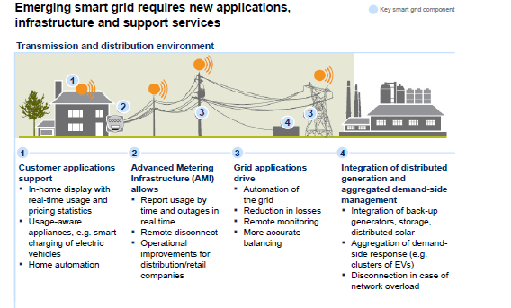
Figure 1: Various advantages parts of using electric vehicles
(Source: Giannetti et al. 2016)
This software’s and numerous applications help to locate these forms of charging stations (Giannetti et al.2016).
All these forms of charging that are done through various forms of stations of charging, so various forms of charging services are made for payments, register and gain access.
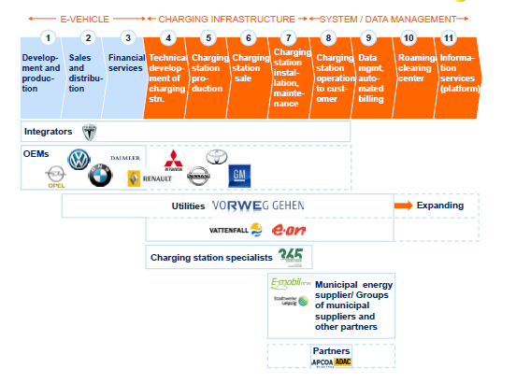
Figure 2: Types of functionality available after electric vehicles.
(Source: Musonera and Cagle,2019)
These forms of services are being for huge easy access of paying and other forms of accounts procedures in case of charging matters (Musonera and Cagle, 2019).

Discuss, how other business currently linked to global automotive industry 375
On various forms of different types of business on global industry of automation are as following different business related to this type of business are based on various European technologies and various finance funds of diverse research and innovative findings of this battery industry.

In this part of the business, the various targeting forms of investments are from private funding and with various researches based on transports and batteries and next generation of batteries for electric vehicles of Europeans country (Cavazza et al.2017).

According to the various forms of business that are related to this business of automobiles are of taxation policy tool for transportation services. So, these forms of taxation are mainly based on vehicles and automobiles transportation industry of European countries. This country must have some form of digital structures of taxation for this type of electrical vehicles. Thus, a lot of harmonica taxation formation is based on fragmentation of various businesses that are being increased on electric types of vehicles in regions of Europe (mckinsey.com, 2019).

Various forms of policies are being passed for dismantle of different old and polluting cars or vehicles in the regions of European Country. This policy is mainly based on air pollution measures in regions of European countries. This introduction of this form of policies resulted in a huge revolutionary change in the history of European automobile industry by providing an innovation or pledge that helps to change air pollution of air and this made them a global scale of innovator in respect to vehicles.

On the scene of pollution factors in level of global scale, an innovation of cleaning off old vehicles are being made in European countries. Those forms of deployments on the cities have provided various infrastructures of less polluting fuels cars that are based on production innovative for electric and fuel-efficient cars of less polluting in air. This cost of this type of cars is being associated with this transformation patterns (Zhu, 2015).

Advantage Disadvantages of that Industry
The industry that are very much related to this part of industry of automobiles are totally based on other industries such as finance industry and industry of cleaning policy and their advantages and disadvantages are based on this automobiles industry.

Advantages of this financial parts on the automation industry of electric motors of European regions are this basic finance helps to regain control of debt or loan that are being taken, this form of debt all are controlled by the users of automobile industry. All forms of decision regarding this loans or debt for these electric vehicles are based on own decisions. Hence after repair structures of money, relation between company and customer ends.
In these matters of finance, there is a huge pro in tax parts of business. This part of tax is being deductible as interest is based on effective reduction of total agreements of this control.
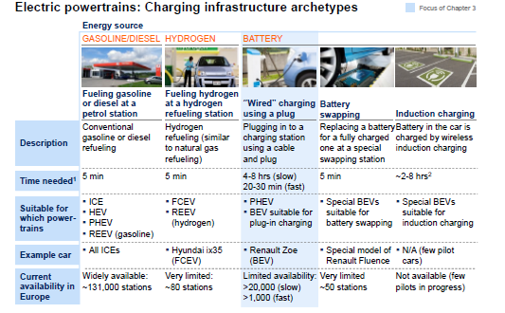
Figure 3: Types of cars available for running process.
(Source: Zhu, 2015)

On this basis of structures of buying option of electric vehicles, there is present an easier way of planning of paying of interest and principal payments on the basis of monthly analysis. This procedure helps out for making of budget and other plans of finance easier.
This includes good qualification requirements of credit balance for valuing these offers through finance in automobile industry (Hirz and Gulanová, 2017).

Other forms of cons on these parts are that discipline that gives risk in the process of investing systems and on business of automobile industry. This risk can be a potential term in excess of financing opportunity. The most treacherous parts of risk on these financial parts are based on collateral assets of finance as they can heavily risk in terms of loans and finance plans of business in automobile industry.

The advantages of industry of cleaning policy with the automobile industry are that the introduction of automobiles that are based on the types of hydrogen propulsion cars that are very much effective in vehicle combustions in air.
The invention of electric vehicles in terms of cleaning policy is a huge step for reduction of air pollution levels in the air. These forms of propulsion have zero emission effects.
The major disadvantage of this policy of cleaning in this part of the industry are the various forms of high cost infrastructures of this electric or hydrogen gas compatible vehicles are need to made and the hydrogen fuels in terms of storage capability as of forms liquid as well as solid states.

Conclusion
The opportunities of business on cars of electric types are in about diverse from as typical advancement are taken place in European continent. There are more numbers of business models that are very much related to the development of space of varieties of business models in this field of electric cars selling. This forms of selling cars of electric types have made a huge opportunity for this type of industry that are very much related to growing of foundation of various models of EV (Electric Vehicles).

Reference list
Journals
Cavazza, B.H., Gandia, R.M., Antonialli, F., Nicolaï, I., Zambalde, A.L., Sugano, J.Y. And De Miranda Neto, A., 2017, September. Management and Business of Autonomous Vehicles: A Systematic Integrative Bibliographic Review. In 12th European Conference in Innovation and Entrepreneurship Ecie 2017 (P. 141).
Dijk, M., Wells, P. and Kemp, R., 2016. Will the momentum of the electric car last? Testing a hypothesis on disruptive innovation. Technological Forecasting and Social Change, 105(15), pp.77-88.
Giannetti, R., Risso, L. And Cinquini, L., 2016. Managing Costs by Business Model: Issues Emerging from The Case Of E-Car. Measuring Business Excellence, 20(4), Pp. 28-45.
Hirz, M., Rossbacher, P. and Gulanová, J., 2017. Future Trends in Cad–From the Perspective of Automotive Industry. Computer-Aided Design and Applications, 14(6), Pp.734-741.
Kim, S., Lee, J. and Lee, C. (2017). Does driving range of electric vehicles influence electric vehicle adoption? Sustainability, 9(10), 1783.
Löfsten, H. (2016). Industrialization of hybrid electric vehicle technology: Identifying critical resource dimensions. Journal of Technology Transfer, 41(2), 349-367.
Masiero, G., Ogasavara, M. H., Jussani, A. C. and Risso, M. L. (2016). ELECTRIC VEHICLES IN CHINA: BYD STRATEGIES AND GOVERNMENT SUBSIDIES: REVISTA DE ADMINISTRAÇÃO E INOVAÇÃO REVISTA DE ADMINISTRAÇÃO E INOVAÇÃO. Rai, 13(1), 3-22.
Musonera, E. and Cagle, C., 2019. Electric Car Brand Positioning in The Automotive Industry: Recommendations for Sustainable and Innovative Marketing Strategies. Journal of Strategic Innovation and Sustainability, 14(1), Pp. 120-133.
Nykvist, B. and Nilsson, M., 2015. Rapidly falling costs of battery packs for electric vehicles. Nature climate change, 5(4), p.329.
Zhu, Y., 2015. Electric Automobile Technology Comparison Research Based on Eco-Energy: Eea Eea. Electrotehnica, Electronica, Automatica, 63(1), Pp. 23-30.
Websites
carbonfootprint.com , 2019. electric vehicles . Available from: https://www.carbonfootprint.com/electric_vehicles.html Accessed at(13/07/2019)
mckinsey.com, 2019. featured-insights . Available from https://www.mckinsey.com/featured-insights/europe/electric-vehicles-in-europe-gearing-up-for-a-new-phase Accessed at( 13/07/2019)

