BUSINESS PLAN
Ahmed Khaled Shaban Abdelgawwad Atalla 2022999
Dario Shehu 2017916
Diletta Chiara Franzone 2021160
Programme: Certificate of Higher Education in Skills for the Workplace
Module Name: Managing Enterprise in the 21st Century
Module Code: BMSW4006_LON
Lectured: Rexon Nting, Afzal Munna

TABLE OF CONTENT
Introduction ………………………………………………………………………………. 1-2
Business Description ………………………………………………………………….. 2-4
Aim and Objectives ……………………………………………………………………. 4-7
Mission and Vision …………………………………………………………………….. 7
Business Structure ……………………………………………………………………… 8
Product and Service ……………………………………………………………………. 9
Marketing Trends ……………………………………………………………………….. 10
S.W.O.T. Analysis ………………………………………………………………………… 11-12
PESTLE Analysis …………………………………………………………………………… 12-13
Technological Plan ………………………………………………………………………. 13-14
Management and Organization …………………………………………………… 15
Social Responsibility ……………………………………………………………………. 15-17
Reference List ……………………………………………………………………………… 18

For our business plan, me and my group had a business plan report about a restaurant, the restaurant name is BETTER FOR US, and we divided all our work equally.
This is the list of the CEO Dario Shehu business plan: INTRODUCTION; BUSINESS DESCRIPTOR; AIM AND OBJECTIVES; MISSION AND VISION.
This is the list of Ahmed Atalla as the COO: RESTAURANT STRUCTURE; PRODUCT SERVICE; MARKETING TRENDS; S.W.O.T. ANALYSIS and PESTLE ANALYSIS.
This is the list of the Managing Partner Diletta Franzone: TECHNOLOGICAL PLAN; MANAGEMENT AND ORGANIZATION and SOCIAL RESPONSIBILITY.

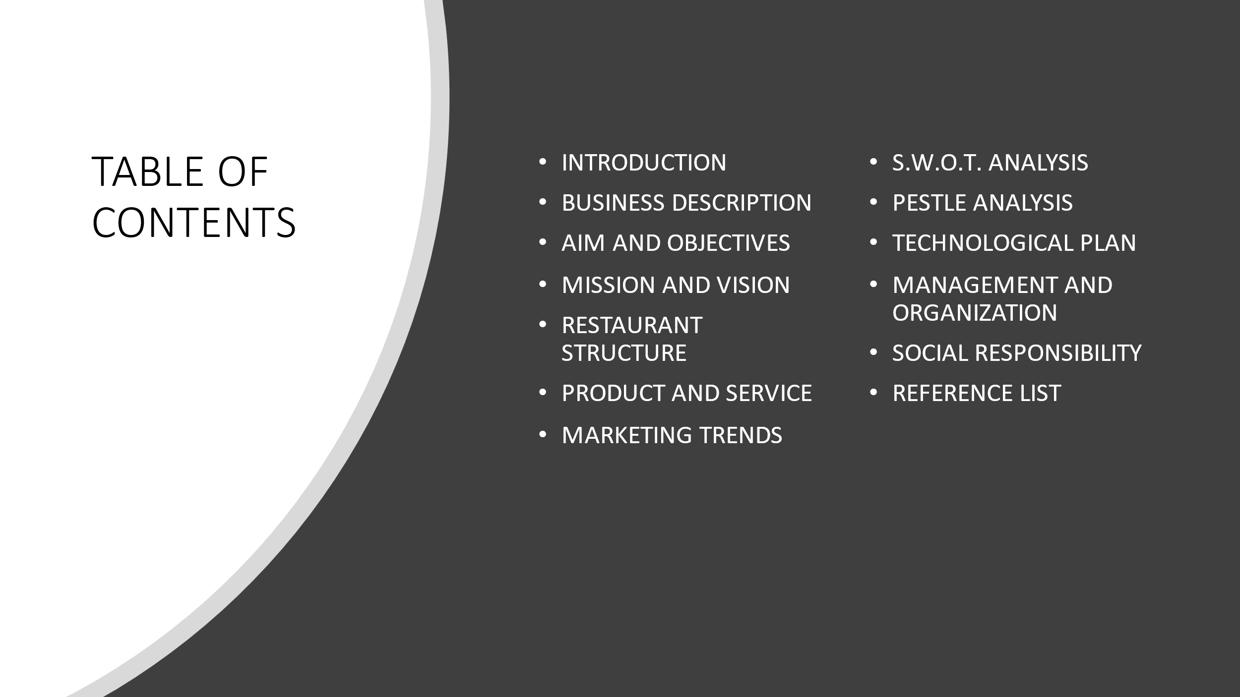

EXECUTIVE SUMMARY

This restaurant business plan is for ‘’Better for Us’’ , it is an organic food restaurant and only delivers to the final customer natural and biological goods. a new medium-sized restaurant shop located in the heart of London, Fulham. better for us procures local foods, reducing their dependency on fossil fuels used for transportation. Its particularity is that it receives goods from almost each continent of the world, such as from Asia, Africa, Europe, South America, North America, Oceania. Perfect combination of flavours and cultures as we tend to be in one of the most multi-ethnic cities in the globe.

Natural food patterns show that natural food varieties are filling in notoriety. Natural, which used to be a curiosity term, is currently significantly more standard, and customers are getting shrewd with regards to their natural food buys. One buyer review tracked down that 41% of guardians are purchasing more natural food sources than a year prior. Another huge overview takes note of that over portion of grown-ups say they'll pick natural food over regular food varieties.
In particular for entrepreneurs, organics are staying put. Current studies show that once a natural purchaser changes over, they seldom return to purchasing customary, in any event, when cash is tight. At the point when shoppers are this energetic with regards to natural food, eateries can securely jump aboard with organics also.

IT CAN BE PROFITABLE…
LET’S SEE WHY:
While buying natural food can cost a coffee more than buying traditional food, purchasers will pay that additional expense to eat in a way that is harmless to the ecosystem. Reviews show that customers will reduce expenses somewhere else to manage the cost of natural food. One green eating overview tracked down that most purchasers will pay more at eateries that serve natural and privately developed food. Altogether, 63% of buyers noticed that they would pay 11% more to feast at a green eatery. In a similar review, an entire one-fifth said they'd pay over 11% more to eat green.

IMPACT ON THE ENVIRONMENT
Developing natural food over ordinary food has many advantages for the earth we occupy. Natural agribusiness rehearses to secure the planet as well as can even assist with working on current negative ecological issues. At the point when you put resources into natural nourishment for your eatery, you assist with ensuring the climate. For instance:
- Natural cultivating fabricates sound, solid soil which can keep up with soil supplements and assist with tackling disintegration issues.
- Natural cultivating assists with moderating and securing our water supply.
- Natural cultivating can diminish our requirement for petroleum derivatives and helps battle the adverse consequences of environmental change.
- Natural cultivating energizes sound biodiversity.
- Natural cultivating brings about less air contamination than ordinary cultivating.
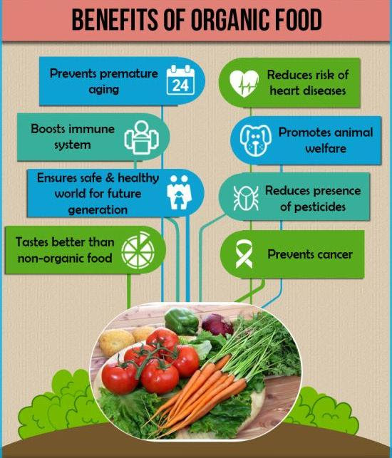

If your eatery offers regular food, natural insightful purchasers realize that they're additionally getting a feast that might contain pesticides, overabundant synthetic substances, added substances, chemicals and antimicrobials and conceivably even a stacking aiding of sewage ooze. Yum!
Ensured natural food, by law, should be liberated from all the above yuck factors, which, you need to concede, makes natural food limitlessly more mouth-watering than regular food.

AIM AND OBJECTIVES

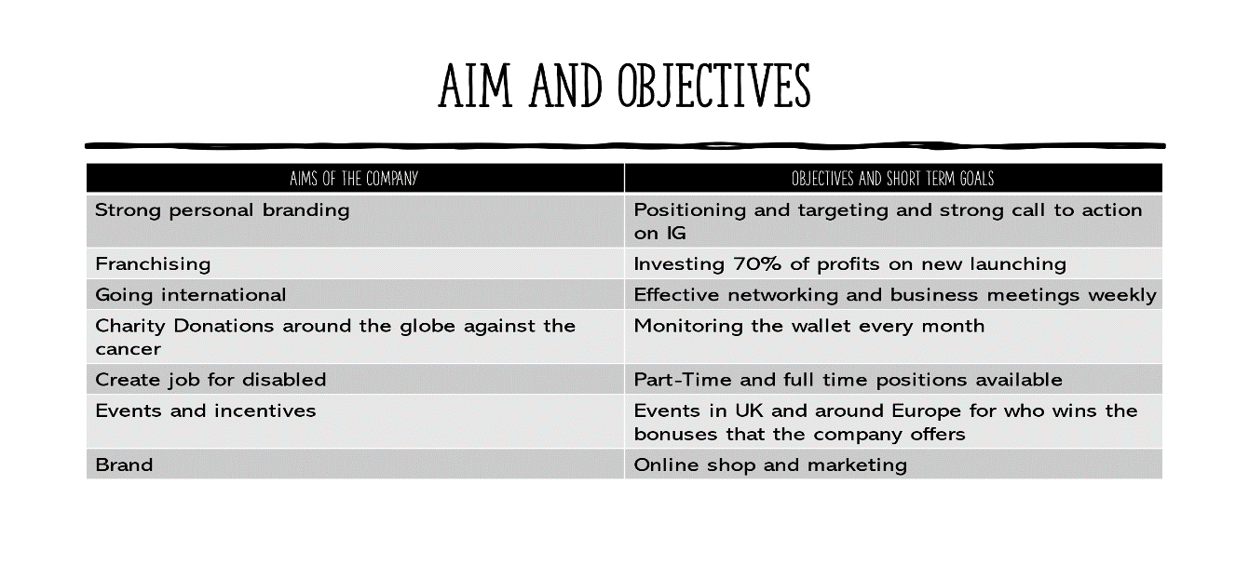
STRONG PERSONAL BRANDING IN BUSINESS AND WHY?
Personal branding is the cycle engaged with making a novel name and picture for your eatery in the client's brain to separate you from your opposition. This extraordinary personality won't just separate you from the parcel; however, building you up as an alternate substance which will procure brings about terms of client's confidence in your image and brand picture accordingly making a dependable client base. There are numerous techniques through which you can mark your business, however the most well-known approaches to make brand mindfulness for eateries are through Logo, menu plan, eatery plan, restaurant food, colours utilized in a restaurant, eatery name, eatery strength, commercials, and a web-based media presence.

FOR WHAT REASON DO YOU NEED A RESTAURANT BRANDING STRATEGY?
What is one of a kind with regards to you as a person? Maybe, your eyes, stature, appeal, or design sense? Likewise, every eatery needs a character that characterizes the manner in which it is, and café marking is the best approach to accomplish that.
BRAND IDENTITY
A brand character guarantees that you are steady with the messages that you convey to clients through your advertising efforts and any remaining correspondence channels. For example, regardless of where you go on the planet, Starbucks welcomes you with a similar logo and customer facing facade plan.
IMPROVED CREDIBILITY
In the event that you have any extension plans, having the right marking set up is worth very much. Individuals esteem generosity and don't spare a moment to wander into attempted and tried waters. Grill Nation, with its, 'live on the table barbecue' idea, had the option to make an unmistakable brand character – easy-going, fun, and exuberant. Today, it has in excess of 70 outlets across India, has opened its abroad outlet in Dubai, and plans to open 300 additional outlets by 2020.
WHAT CREATES BRAND AWARENESS IN THE RESTAURANT SPACE
A brand can't be implicit one day. Nor does it have a solitary part. It is the long stretches of building an insight in the brain of clients through an amassing of different components.
RESTAURANT NAME AND RESTAURANT LOGO
Eatery Slogan/Tagline: A decent trademark ought to convey your image guarantee. It should set the norm for how you need general society to see your image and what they can anticipate. For example, KFC's 'finger-licking' is acceptable.'
Eatery Colours: Have you at any point asked why Burger King or McDonald's uses red tone in their markings? There is a logical explanation for it. Warm shadings, for example, red is said to animate yearning. Orange is a shade of advancement and youth. Green is the shade of nature and morals. Tones can assist with mirroring the qualities you need to depict for your café.
Retail facade Design: How does your business show up as far as format, area, climate, insides, and cleanliness? Every one of these sets up an additional brand for our restaurant.
Dress and Attire: Who might want to be served by pitifully dressed staff? Or on the other hand envision where you can't separate between the clients and staff individuals. Dress and clothing of the staff improve the norm of your eatery as well as are indispensable parts of your marking.
THE MOST EFFECTIVE METHOD TO BRAND YOUR RESTAURANT
Since you know all the why's and what's of marking, how about we see how you ought to get it done.
1. Characterize Your Brand
Characterizing your image will establish your café marking procedure. The second you set up the above-examined parts, you are nearly finished with characterizing your eatery image. It's significant that you require some investment to characterize each part as they ought to resound with one another and mirror your motivation, convictions, and qualities.
2. Position Your Brand Correctly
Situating is the psychological space you need to consume in the brain of clients. It is your remarkable incentive and what you need clients to think about you. Chipotle, the mainstream American tacos and burrito eatery, has situated itself as somebody who furnishes 'food with respectability.' It features Chipotle's decision to serve normally raised hamburger and pork, liberated from anti-infection agents and chemicals.
3. Be Consistent With Your Brand
The shortfall of brand consistency can be lethal to your image and keep your clients from returning. Your marking methodology ought to reflect in each and every part of your eatery, from the logo on your entryway to the persona of the staff, from music to style, and from your menu to support. This consistency ought to likewise be kept up with across all areas and correspondence channels, for example, web-based media handles, flyers, leaflets, and so on.
4. Recount A Story – A Good One!
The popular anecdote concerning how Colonel Harland Sanders, after his retirement concocted the first chicken formula of 11 spices and flavours and proceeded to turn into the world's most well-known cook, interest’s individuals. Narrating revives your image and sets up an enthusiastic association. On the off chance that you have a story, use it to mark your café.
5. Go the extra mile
You have done everything to draw in clients, yet could you accomplish something that makes you a decent brand openly? Marking is likewise going past the self-evident and taking drives that go far in building your picture. For example, Pappadavada, a renowned eatery in Kerala, has put a fridge outside its premises. By the day's end, it places all extras in this fridge for day in and day out admittance to penniless individuals.
Marking develops as your eatery develops. It is a standing that requires a very long time to construct. Yet do recall that marking works on the off chance that you have an incredible item and phenomenal administrations.

MISSION AND VISION

LONG TERM VISION
Our company is improving in every aspect every year, people more often in the 21st Century are looking for healthy and organic food. This is because of the environmental change that the world is facing. The pandemic has increased our Delivery sales making it up to 300% on Deliveroo, Uber eats and the other apps. It literally changed the way we used to do business, now more than ever people want their goods online, just by ordering with a click. So, in our long-term vision, we see our restaurant expanding worldwide with a franchise concept. We will apply a strong call to action, with an innovative strategy of marketing using all the technologies required. It Happens that in the business environment we see conflicts or organizations who compare themselves to others and play a short-win game, meanwhile we want to stay for an infinite-game. The best investment that we will make is people. We see '’BETTER FOR US’’ giving people what they really need, doing incentive trips, helping kids all around the world with the cancer foundation, innovating the restaurant environment and hospitality, we will give people a ‘’why’’.

RESTAURANT STRUCTURE
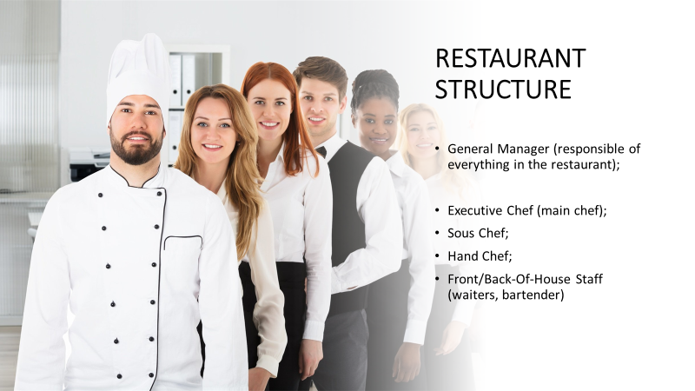
For the restaurant structure we need different types of workers and all of them are important equally to grow as a restaurant and to create a beautiful relationship between all of us. Owners are responsible for the business finances, but often hire accountants to take care of the books. They are also the ultimate decision makers and are accountable for the general direction of the business. Although they do not need to be involved in the day-to-day operation of the restaurant, owners of smaller independent establishments often take on an active role in the restaurant’s operations.
- The first one on the list is the General Manager and he is responsible of everything in the restaurant. He is responsible of hiring, training, and overseeing the staff, daily business and making sure that the restaurant is in good condition to open.
- The second one on the list is the Executive Chef and he is responsible for hiring and training kitchen staff, creating menu items, helping the General Manager to choose the best food and the price to put on the menu. The Executive Chef is the main chef of the restaurant and he need Hand Chefs to help him work better, faster, less stressed and more comfortable.
- The third one on the list is the Sous Chef and he is the second most important person in the kitchen after the Executive Chef
- The fourth one on the list are the Front or Back House Staff. The Front or Back House Staff is responsible for the restaurant’s dining area, including setting up service, waiting on customers and interacting with the kitchen staff. If the restaurant serves alcohol, they are also responsible for the beverages and bar area.

PRODUCT AND SERVICE OF A RESTAURANT

In our restaurant we want to offer a large variety and vastity of different food from different countries.
- The first thing we want to offer in our restaurant is the Organic Food (Organic foods have been grown or farmed without the use of artificial chemicals, hormones, antibiotics or genetically modified organisms). In our restaurant we want to offer organic food because we want natural food that is not modified by anything that can compromise our health or the customer health.
- The second thing we want to offer in our restaurant is the Healthy and Fresh Food (In our restaurant we will offer only fresh food and will try to not offer a large variety of junk food. We would like to offer a good meal with a large variety of veggie food and natural fruits for the dessert and for the juices).
- The third thing we want to offer in our restaurant is the Racial distinction (For me and all my group this is the most or one of the most important one) In our restaurant we do not want any type of racism for skin colour or discrimination about anyone home country of origin or religion. We want to create a sort of a big family were everyone can work together and in peace, we want for our customers and for all our staff to feel safe and at home without any type of fear.
- The fourth thing we want to offer in our restaurant is the Online Ordering (The ability to instantly order from your online menu provides easy access for your customers. It allows them to conveniently browse and then order from your menu). In our restaurant we want to offer the online ordination so the customers can watch the menu with their mobile phone through an app to install and it will show everything we have in the menu.

MARKETING TRENDS

For our restaurant we need the marketing trends to grow, because nowadays social media play a big role for everything, and it is important to use them properly to grow. There are many steps to follow to grow as a business.
- The first one is Professional Food Photos; It is important to have good photos to put on social media and on your restaurant website to attract more customers.
- The second one is N.A.P. Optimization; N.A.P. is the acronym of Name, Adress and Phone Number. It is important to put N.A.P. on the first page of your website or social media because without it the costumers will never know what the name of the restaurant is, where it is located and how to contact them.
- The third one is a Good Website; This is one of the most important ones because you need a good design for your website, it must be easy to use to find all type of information that are needed (the story of the restaurant, N.A.P. information, the menu, etc...).
- The fourth one is Partnership with Delivery Service; The partnership can be made for example with Just Eat, Uber Eats, Deliveroo, etc…
- The fifth one is Loyalty Rewards; Loyalty rewards programs might boost your marketing and sales efforts because they don’t focus solely on customers that have already been to your restaurants. If the incentives are personalized and effective, you can attract new clients.
- The sixth one is Local Ingredients; Using local ingredients and fresh produce not only supports the local community but it also attracts new customers.
- The seventh one is Online Delivery; Online food delivery is a trend and for your business to keep up with the times and the competition, your customers should be given the opportunity to order their food in various forms.

S.W.O.T. ANALYSIS
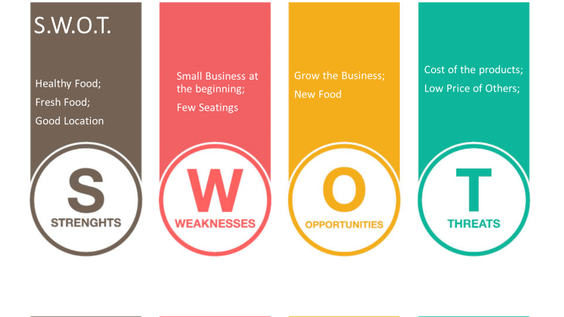
S.W.O.T. is the acronym of Strength, Weaknesses, Opportunities and Threats and any type of business have one.

For Strength we have:
- Healthy Food: In our restaurant we will offer organic food, because we want to offer natural food and we will try to offer less junk food (like hamburgers and soda drinks).
- Fresh Food: In our restaurant we will offer fresh food, we do not want to offer frozen food if it will be possible, because fresh food is better than the frozen one, for example the meat and the fish (not every type of it) will be better if it will be fresh.
- Good Location: Our restaurant will be in a good location, in Fulham, London. It is a good location because it is in the centre of London, and it will be reachable from everywhere.
For Weaknesses we have:
- Small Business at the beginning: The restaurant at the beginning will be small, because of the cost of the location and for the cost of the products (food, drinks, tools for the kitchen, tools for the dining saloon and the rent of the place).
- Few Seats: The restaurant at the beginning will have few seats because for the cost of the place and the products the budget for the restaurant left to us will allow us to have few seats at the beginning.
For Opportunities we have:
- Grow The Business: At the start the restaurant will be small, but over time, it will grow and when it grows, we will plan to open more restaurants over the UK and over the world.
- New Food: With the expansion of our restaurant, we will be able to offer new food from the world and we can have variations in the menu with new type of food (for example if we open a restaurant in Italy, we will plan to offer local food and our food menu, the same will be if we want to open one in India or Mexico for example).
For Threats we have:
- Cost of the Product: If we want to offer organic and fresh food and in a good place we need to spend more. Because of the budget at the start, we need to pay attention to the type of products that we will buy.
- Low Price of the Competitors: People tend to avoid expensive restaurants and food, they tend to buy cheap food to save money, so at the start it will be difficult to grow and get the recognition.

P.E.S.T.L.E. ANALYSIS
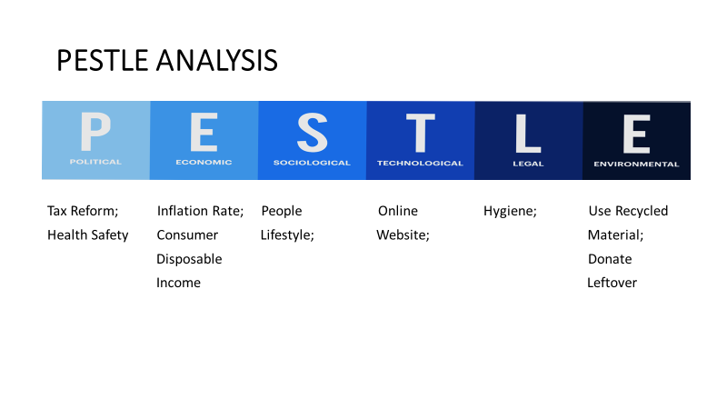P.E.S.T.L.E. is the acronym of Political Factors, Economic Factors, Social Factors, Technological Factors, Legal Factors and Environmental Factors.
Political factors are government regulations that influence business operation positively and negatively. For Political Factors we have:
- Tax Reform: Government regulations may raise the tax rate for some businesses and can lower the same for others due to specific reasons and it may impact business.
- Health Safety: Health regulation and Safety change from a country to another and it prevents work related death, injury and health.
For Economical Factors (All businesses, whether domestic or international, are affected by the dynamic economic environment conditions prevalent in the market) we have:
- Inflation Rate: If the inflation rate increases in the economy where your restaurant is operating, it will affect the prices of the ingredients. As a results menu prices will go up and most of the time people avoid ordering food from a restaurant.
- Consumer Disposable Income: Consumer disposable income can affect the food industry. If people have more disposable income, they will tend to spend more outside.
For Social Factors (There are several factors that can affect your restaurant business negatively or positively) we have:
- People Lifestyle: People are more health conscious nowadays, but for the busy life that they have they tend to order fast food because fast food or junk food (like hamburgers and soda drink like Coca-Cola) will require less time.
For Technological Factors (Technological factors are variables that are being used for evaluating available alternatives with respect to technological capabilities) we have:
- Online Website: Almost every business today has a website which helps them in making and maintaining a global presence. With social media businesses can easily communicate with their targeted audience. In addition to this, through internet technology, you can also easily communicate with your employees, clients and co-workers in other countries.

For Legal Factors (These authorities frequently visit the different areas of the restaurant like kitchen and store to check the different food items quality and expiry, staff and other hygiene conditions) we have:
- Hygiene: In our business, we want to pay attention to the hygiene of our food, tools and everything else because it is really important.
For Environmental Factors (Both the internal and external environment of your restaurant is very important to consider) we have:
- Use Recycled Material: In our business, we want to use recycled material because we do not want to pollute the world any more than it is now.
- Donate Leftover: In our business, we want to donate to poor people and in charity instead of wasting it (for example throwing it away).

TECHNOLOGICAL PLAN

Technological planning refers to the process of evaluation of the estimated time and resources for
understanding the fact what is right for the newly established business organization. For taking
significant and essential decisions in business the owners and higher management authority must
understand the key aspects of technological innovation. According to the statement of Escobar et al. (2020), technological planning will help the organization in earning and achieving significant gains within the service of the business. This process gives a proper framework for defining the scope of the technical effort which are required to develop and sustain the systems of operations within the established business. The planning of the updated technologies will help in giving critical quantitative inputs to the program planning and setting process of the entire cost for maintaining the lifecycle of the tools which ultimately helps to identify the maturity level of the installed system in the company.
There are some steps based on which the technical implementation in the business can be
successful.
● In the first step, there are requirements of defining the technological requirements in the
business. Depending on the nature of the industry that the business is going to set, the key
personalities in start-up business companies have to decide the technological needs for bettering the working process, enabling better interaction between the employees and all types of stakeholders, and for creating new products under a new technological niche (Garriga Ferrer, 2020).
After chalking out the technical requirements in the company, there are requirements of setting some strategies for achieving the goals and financial savings for software and hardware improvements before implementing the plan into action.
● In the second step, there are requirements of collecting all the possible resources and detailed calculations of timing for technological implementation. Each implementation always has a list of the estimated tasks and the equipment. The technological tools will be purchased by the higher management authority before developing the plan successfully (Krasyuk et al. 2019). This advanced plan will help them in avoiding delays in the working process and also helps to minimize barriers in the working process. Employees of the organization will also get benefits from the technological resources in case of planning their works accordingly.
● Before incorporating new technologies in business employees of the organisation are required to give appropriate training for operating the technological resources for bringing additional results of production in the business (Saleh et al. 2019). Following it, the starting process of new software will help the staff in adopting the new technological changes within the working environment.
● In the final step, there are requirements for analysing the contingencies for the betterment of the technology planning. The tech managers of the start-up business organization should take the threats into account like cyber threats, power outages, and increasing demands of stable networks (Fogarassy and Finger, 2020). There are possibilities of frequent losses of internet connectivity. The proper definition of the nature and gravity of the risks during the entire technological planning process will help them in the successful building process of the business which would give better definitions and clarity to the technological requirements and priorities in the business.

MANAGEMENT AND ORGANIZATION

It has been identified that organizational management is one of the most significant aspects in the potential marketplace of the United Kingdom. This is the reason; it is required to develop the business profit in the target marketplace is a good approach. It can be stated that with the assistance of the organizational management, the manager of the company needs to augment the overall revenue in the marketplace of the country. It can be stated that the operation of the business needs to be managed in the market to survive at the edge of high competitiveness. It is also important to gain competitive advantages in the marketplace of the United Kingdom. It is also important to increase sustainability. Furthermore, it is needed to augment the business profit in the target market to sustain the business functions. For any kind of team, the primary role is to combine resources, skills, competencies and bandwidth to accomplish organizational objectives.
Groups of employees are mainly highly focused by an organization, to support organizational success by giving major focus on the specific task (Adwiyah, 2021). Understanding the various processes that teams will carry out over time is important when considering the role of a team. A transitional procedure is carried out at the beginning of a team. The team can progress towards the completion of their goals once they have set strategic goals. An organization must need to choose different types of teams according to their work pattern or type such as cross-functional teams, common teams, virtual teams, and are project teams. Project teams are mainly focused on achieving a goal. Virtual teams comprise associates who have the capability of performing tasks in different locations. People from different departments or specialties come together in cross-functional teams.
It can be possible to explain that with the help of team management, it is needed to improve the overall performance in the target marketplace of the country. For this reason, it is required to focus on profit management in a good manner. Project teams are created to achieve a goal. Members of a project team are chosen to participate in the team based on their skills in the functional groups they belong to. Project teams are responsible for the software development project. Virtual teams are often used by academic researchers. Cross-functional teams are mainly considered different types of people from different regions, and they work together in order to achieve a common goal. In addition to this, this company mainly focuses on cross-functional teams to improve the overall revenue in a good manner. It is also helpful to deal with team management effectively.

SOCIAL RESPONSIBILITY AND SUSTAINABILITY

CSR refers to the commitment of the organizations towards the development of the societal, environmental and economic impact of the region in which the business is being operated. It also enables a company to manage the business operations responsibly by taking public expectations into account. It can be possible to explain that with the help of the CSR activities, the company can meet the needs of the stakeholders in an effective manner. As CSR is a broad concept, it is needed to identify the organizational needs in the marketplace of the country. It is also important to focus on the business functions on a collective note (Ibrahim et al. 2017). CSR is important for the community, but it is equally important for a company. CSR actions can help forge a stronger relationship between workers and corporations, boost morale and help both workers and employers feel more associated with the world around them. It can be possible to improve the business operation in the marketplace. In addition to this, it can be possible to describe that social responsibility, as well as sustainability management in the potential marketplace, helps to describe the operational activities. As for this cause, it is needed to improve the business profit. Greenhouse gas emission is one of the environmental issues in the target marketplace. Additionally, it is also needed to augment the business operation in the marketplace of the country to manage the functional activities. ISO 26000 is considered in this regard. It helps to manage the business functions on a collective note. It is also important to augment the business profit in a good manner. From the point of view of de Fraiture and Clayton (2019), it can be stated that the profit can be augmented in the market by meeting the satisfaction level of the stakeholders such as consumers, government, suppliers as well as distributors and so on. Moreover, employee needs can also be analysed through corporate social responsibilities. It can be possible to focus on the business analysis in the marketplace to manage the profitability in the potential marketplace, the company can also focus on renewable energy management. It is also required to use renewable energy to manage CSR activities. On the contrary, waste management is also needed in this regard. It can be evaluated that the movement toward CSR has had an impact. Many companies have taken steps to improve the environmental sustainability of their operations through measures such as installing renewable energy sources or purchasing carbon offsets. It can be possible to explain that with the help of sustainability management, it is needed to improve the profit in the marketplace in a good manner. CSR is considered an important part of a company’s reputation as it signifies their brand image which further attracts customers towards ethical brands. It is also an important part to be taken into consideration in terms of improving public relations (Tipu, 2019). The purpose behind the organization's CSR work needs to be nailed down. It is needed to focus on the business functions on a systematic note (O'Loughlin, 2017). It can be explained that by considering that sustainability management in the organization, it is needed to improve the profit
margin in an effective manner (Balcells, 2017).
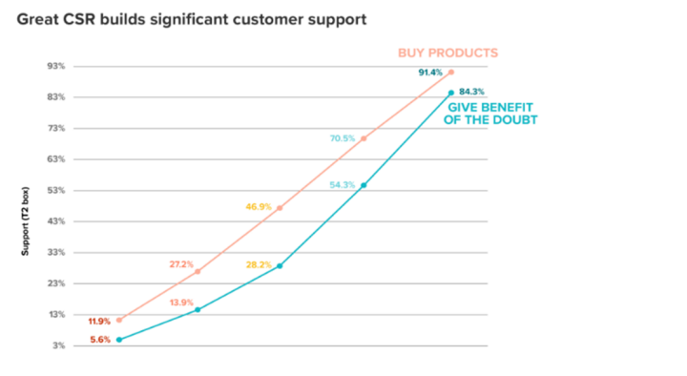
Figure 1: Support of the customers for building CSR activities

(Source: Tipu, 2019)
It is needed to focus on the operation management in the marketplace to augment the profitability in a good manner. It is helpful to focus on CSR activities to improve the business potentiality in the country. The Best for us helps to manage the business plan properly by implementing CSR activities in a good manner. The organisational team can make real change with a modern platform for running CSR initiatives. Enhancement of workplace culture is one of the benefits of CSR programs. The promise of CSR is why so many organizations try to make it happen. CSR work involves engaging local communities with humility by trying to understand the historical context and linking to existing efforts in those neighbourhoods. In managing supply chains, efforts have also been taken to eliminate reliance on unethical labour practices, such as child labour and slavery (McKenzie, 2017). Although CSR programs have generally been most common among large corporations, small businesses also participate in CSR through smaller-scale programs such as donating to local charities and sponsoring local events. In addition to this, it is needed to improve the business operation on a collective note to augment the functional activities effectively. It can be feasible to manage the operational activities in an effective manner. It can be stated that with the help of sustainability management through CSR activities, the company needs to augment the profit margin. Building a unified team within your company that works well with local leaders already engaged in social impact work is what a great CSR program is all about. CSR is an exercise in leadership and so much of it is about finding the best in people and focusing it as part of a larger effort. Discussing the nature and results of your CSR work and tracking its success is an important part of serving the broader corporate giving sector. CSR campaigns should include speeches, panel discussions, and annual reports.
REFERENCE LIST:
- Adwiyah, R., 2021. Analysis of Business Plan Using Business Model Canvas (BMC) on Modern Fish Market. MIMBAR: Jurnal Sosial dan Pembangunan, 37(1).
- Ahsan, A., Shaw; (2018); Political Factors Affect Business Environment https://www.marketingtutor.net/political-factors-affect-business/
- Balcells i Gil, M., 2018. Creation and Business Plan of the project UniRealidad.
- de Fraiture, C. and Clayton, T., 2019. Irrigation service providers–a business plan: increasing access to water for smallholders in sub-Saharan Africa. Gates Open Res, 3(1370), p.1370.
- Escobar, S., Santander, M., Useche, P., Contreras, C. and Rodríguez, J., 2020. Aligning Strategic Objectives with Research and Development Activities in a Soft Commodity Sector: A Technological Plan for Colombian Cocoa Producers. Agriculture, 10(5), p.141.
- Garriga Ferrer, M., 2020. Business plan of Nanotarg: a technological platform aiming to treat pancreatic cancer.
- Hannah, Wickford; (2019); Structure of a Restaurant https://yourbusiness.azcentral.com/organizational-structure-restaurant-2980.html
- Ibrahim, S.S., Baharuddin, F.N., Jamil, N.I. and Rosle, A.N., 2017. Modelling effective business plan in entrepreneurship education: A solution toward better learning. Advanced Science Letters, 23(11), pp.10786-10789.
- Jennifer, Chait; (2009); Reasons for Restaurants to Go Organic, Reasons for Restaurants to Go Organic; thebalancesmb.com
- Krasyuk, I., Medvedeva, Y., Baharev, V. and Chargaziya, G., 2019, March. Evolution of strategies of retail and technological systems under broad digitalization conditions. In IOP Conference Series: Materials Science and Engineering (Vol. 497, No. 1, p. 012124). IOP Publishing.
- Mano, Behera; (2021); The Digital Restaurant https://thedigitalrestaurant.com/top-20-restaurant-marketing-ideas/
- Mary, J., Brook; (2016); What Is Organic Food and Is It Better Than Non-Organic? https://www.healthline.com/nutrition/what-is-organic-food
- McKenzie, D., 2017. Identifying and spurring high-growth entrepreneurship: Experimental evidence from a business plan competition. American Economic Review, 107(8), pp.2278 2307. nufarm.com (2021), Overview, Available at: https://nufarm.com/uk/ [Accessed on 12th August, 2021]
- Saleh, N., Ibrahim, I. and Abd Rahman, F., 2019. Determine the factors of influence the technological, organizational, environmental, halal awareness towards Halalan-Toyyiban risk management plan (HTRMP). transportation, 2(09).
- The restaurant Times; https://www.posist.com/restaurant-times/restro-gyaan/restaurant-branding-create-brand-awareness-restaurant.html
- Tipu, S.A.A., 2019. Business plan competitions in developed and emerging economies: What do we still need to know? Journal of entrepreneurship in emerging economies.

- Umar, Farooq; (2019); Pestle Analysis of a Restaurant https://www.marketingtutor.net/pestle-analysis-of-a-restaurant/

- Zeynep Lokmanoglu, Restaurant Branding: the complete guide, Restaurant branding: the complete guide - 99designs

