

REPORT
Planning and Delivering an International Event
“Winter Story on the Ice Rink” in Chelmsford

Student Name: VICTORIA CHILIANU
Student ID Number: 2208500
The Module Title: International Meetings Management for the Hotel Industry (BMIH6007)
Lecturer’s Name: KATHRYN FLYNN
Word count: 2727

Executive Summary
Chelmsford's "Winter Story on the Ice Rink" event is a festive, family-friendly winter attraction from November 15, 2024, to January 5, 2025. This temporary outdoor ice rink, complemented by live performances, festive food stalls, and themed activities, aims to attract over 10,000 visitors and generate £125,000 in profit. The event is designed to boost local tourism, strengthen Chelmsford’s position as a winter destination, and foster a sense of community.
Meticulous planning is crucial to the event’s success, following a structured event cycle of Planning, Delivery, and Evaluation. During the planning phase, research identified target audiences, set objectives, and developed a marketing campaign to ensure strong attendance and financial viability. In the delivery phase, smooth coordination between vendors, staff, and performers is essential to provide a seamless experience for visitors. The evaluation phase will measure success through feedback, attendance figures, and financial performance, with critical learnings applied to future events.
The event’s objectives include securing £20,000 in sponsorship from critical stakeholders, achieving a 90% attendee satisfaction rate, and ensuring all staff are trained in customer service and first aid. These goals align with the growing trends of sustainable event practices, digital marketing, and personalized experiences. The event will feature eco-friendly initiatives such as synthetic ice and efforts to reduce single-use plastics.
To ensure future success, recommendations include enhancing operational efficiency through contingency planning for bad weather, offering VIP and accessible experiences to cater to diverse audiences, and prioritizing sustainability by partnering with local environmental groups. By implementing these strategies, "Winter Story on the Ice Rink" will become a cherished seasonal event in Chelmsford, providing economic and social benefits to the local community.

Table of Contents
Executive Summary 1
List of Figures and Tables 3
1. Introduction 4
2. The Event Cycle 5
3. Event Concept 9
4. Aim and Objectives of the Event 10
5. Event Management 11
6. Event Budget 13
7. Industry Trends, Issues and Impacts 14
8. Situational and Cultural Considerations 15
9. Conclusion 16
10. Recommendations 17
Reference List 18
Appendices 22
Appendix 1: Central Park, Chelmsford. Location position on the map 22
Appendix 2: Skate at Somerset House, London 22
Appendix 3: SMART Objectives 23
Appendix 4: Glice Christmas Ice Skating Rink 24
Appendix 5: Contingency Planning 24
Appendix 6: Expenditure (Costs) 25
Appendix 7: Income (Revenue Sources) 26
Appendix 8: SWOT Analysis 27

List of Figures and Tables
Figure 1. The 3 Phases of the Event Cycle 5
Figure 2. Gantt Chart for “Winter Story on the Ice Rink” (14 Sep 2024 – 14 Jan 2025) 8

Table 1. Operational Activities 11
Table 2. Planning Activities 11
Table 3. Marketing Activities 12
Table 4. Net Income Calculation 13
Table 5. Calculating ROI 14

Introduction
The "Winter Story on the Ice Rink" in Chelmsford is a temporary outdoor ice rink that provides residents and visitors with a festive and magical winter experience. This family-friendly event will offer ice skating for all ages and skill levels, various festive stalls, live music, and themed evenings to enhance the holiday atmosphere and highlight the event.
Chosen for its potential to attract large crowds and boost the local economy, the ice rink provides a unique winter activity that Chelmsford needs to improve. It aligns with the city's goal to become a vibrant seasonal destination, drawing attention from residents and tourists from surrounding areas.
The ice rink will be located in Chelmsford’s Central Park (see Appendix 1), a picturesque setting further enhanced with holiday lights, decorations, and festive music. The event will promote community spirit, providing a place for families, groups, and individuals to gather and enjoy the magic of the winter season. By establishing itself as a central winter attraction, "Winter Story on the Ice Rink" aims to contribute to Chelmsford’s reputation as a must-visit holiday destination.

The Event Cycle
The Event Cycle, as defined by Getz and Page (2019) in Event Studies: Theory, Research, and Policy for Planned Events, refers to the sequential phases an event goes through from conception to its conclusion. These stages provide a framework for planning, delivering, and evaluating an event. The cycle is typically divided into three phases (see Figure 1).
Figure 1. The 3 Phases of the Event Cycle

Source: Developed by Author
'Winter Story on the Ice Rink' in Chelmsford's Event Cycle involves a structured process that ensures meticulous planning, smooth execution, and thorough evaluation. This section provides a breakdown of each phase as it pertains to the event
- Planning
This phase involves all activities leading up to the event and sets the foundation for its success (Allen et al., 2022). It requires thorough research, planning, coordination, and decision-making.
Key Components:
- Market Research: Market research focuses on understanding the target audience, competitors, and demand (Aaker and Moorman, 2023). The primary audience includes families, tourists, groups, ice sports enthusiasts, and schools from Essex and nearby areas. The event stands out with its mix of ice skating, festive entertainment, and food stalls, offering a unique alternative to local Christmas markets.
- Define Goals and Objectives: The main goal is to create a festive winter experience, boost community engagement, and generate profit. Key objectives are to attract 10,000 visitors, generate £100,000 in revenue, secure three local sponsors, and achieve 90% customer satisfaction.
- Budgeting and Financing: The budget includes venue hire, staffing, marketing, and entertainment, with revenue from ticket sales, vendor fees, and sponsorships (Jones, 2020). A balanced pricing strategy ensures affordability and profitability, featuring special family packages.
- Secure Date and Venue: The “Winter Story on the Ice Rink” in Chelmsford is a temporary outdoor rink from November 15, 2024, to January 5, 2025. Offering 2-hour skating sessions daily from 10 am to 10 pm, it caters to festive family demand. Chelmsford City Council will manage licensing and safety protocols (Chelmsford City Council, 2020).
- Marketing and Promotion: Launch a comprehensive marketing campaign using social media, local press, posters, and collaborations with local businesses (Cudny, 2019). Combining digital and traditional methods will ensure strong visibility.
- Delivery
The operational phase involves executing planned activities, with success depending on smooth coordination between staff, vendors, and stakeholders to ensure a positive attendee experience (Meredith et al., 2021).
Key Components:
- Event Setup: Set up the ice rink, stages, lighting, sound equipment, and vendor stalls, ensuring all technical elements are ready and functioning.
- Vendor and Staff Coordination: Vendors, performers, and staff are well-briefed and in place, ensuring smooth coordination of food stalls, booths, and entertainment.
- Event Day Operations: Efficiently manage visitor flow, ensuring smooth ticketing and check-in. Maintain the event schedule with ice skating shows and live music as planned.
- Guest Experience and Safety: Manage crowd control, enforce rink safety, provide first aid, and maintain a family-friendly atmosphere.
- On-the-Spot Adjustments: Address unexpected technical problems, weather changes, or last-minute schedule adjustments.
- Evaluation
After the event, the team reviews its success, learns from the experience, and completes any remaining tasks (Getz and Page, 2019). It's essential for future planning and ensures improvement in the next event.
Key Components:
- Teardown and Cleanup: The team dismantles setups, cleans the venue, returns rental equipment, and manages waste disposal in line with sustainability goals.
- Final Financials: The team reconciles expenses and income, pays outstanding invoices, and compares the budget to the forecast to identify variances.
- Gather Feedback: The team conducts post-event surveys with attendees, sponsors, and staff to assess success and identify improvements (Shipway et al., 2020). This helps measure event success based on objectives and participant satisfaction.
- Event Report: A detailed report summarising attendance, revenue, costs, and feedback, highlighting successes and areas for improvement.
- Planning for Future Events: Involve adjusting the budget, revising the schedule, or finding new ways to engage sponsors and the community.
The "Winter Story on the Ice Rink" Event Cycle involves meticulous planning, flawless execution, and thorough post-event evaluation. By following these structured phases, the event can offer a memorable and festive winter experience, engage the community, and ensure profitability.

The Gantt chart for the "Winter Story" event in Chelmsford (14 Sep 2024 - 14 Jan 2025) outlines tasks across three phases - Planning, Delivery, and Evaluation - ensuring timely and organised completion (see Figure 2).
Figure 2. Gantt Chart for “Winter Story on the Ice Rink” (14 Sep 2024 – 14 Jan 2025)
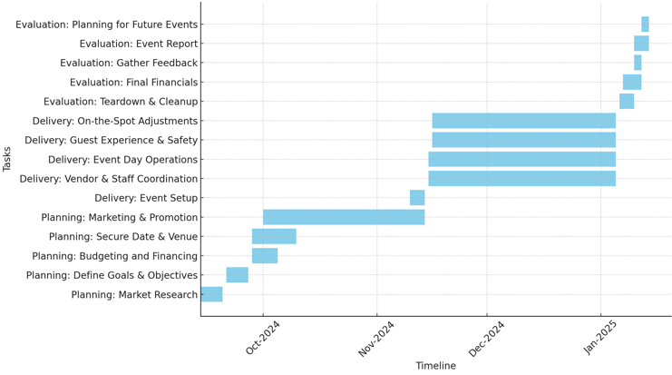
Source: Developed by Author
The structured timeline and task management ensure transparency and efficiency, supporting the event's success.

Event Concept
The event concept is a cohesive story linking all elements for participants, sponsors, and stakeholders (International Hotel and Casino, 2023). "Winter Story on the Ice Rink" is a festive, family-friendly winter event in Chelmsford centred around a temporary outdoor ice rink. Despite competitors like Riverside Leisure Centre (Chelmsford City Sports, 2024), Winter Wonderland (Hyde Park Winter Wonderland, 2024), and the Ice Rink in Braintree (Ice Tickets, 2024), it offers a unique regional experience and seasonal adventure. The event aims to unite the community for a magical winter experience filled with ice skating, holiday entertainment, food stalls, and themed activities, similar to the iconic Skate at Somerset House in London (see Appendix 2). From 15 November 2024 to 5 January 2025, the event will offer daily sessions from 10 am to 10 pm, creating a vibrant atmosphere for locals and visitors.
Key Elements:
- Ice Skating Experience:
  - The main attraction is a large outdoor rink with 2-hour sessions, skate rentals, and special sessions for families, schools, and corporate groups.
  - Festive lighting and winter-themed decorations enhance the holiday atmosphere.
- Entertainment:
  - Professional ice-skating performances, live music, carollers, and local acts will entertain the crowds.
  - Special events include themed shows, winter concerts, fireworks, Santa’s Grotto, face painting, and magician shows.
- Festive Food and Market Stalls:
  - Local vendors will offer festive treats such as hot chocolate, mulled wine, roasted chestnuts, and holiday-themed snacks.
  - Market stalls will sell holiday crafts, decorations, and gifts.

Aim and Objectives of the Event
Aims and objectives define the event’s purpose and guide its strategic direction (Visit Monmouthshire, 2024). Aims to outline the overall intent, while objectives provide specific, measurable targets for event delivery and evaluation.
The event seeks to boost local tourism, support local businesses, and foster a sense of community spirit during the festive period (Ho et al., 2022). The "Winter Story on the Ice Rink" aims to offer families, residents, and visitors fun, seasonal activities centred around ice skating.
SMART objectives enable clear planning and execution, ensuring goals are structured for measurable results. Three key objectives were set for the event planning (see Appendix 3):
- Engaging 3 key stakeholders for the event, with formal agreements in place by November 1, 2024, to secure £20,000 in sponsorship, ensuring their engagement and support throughout the event duration (November 15, 2024, to January 5, 2025). Chelmsford City Council, a local sponsor, and a media partner are key to the event's success. Securing £20,000 in sponsorship and 3 media features by November 1, 2024, ensures financial support, visibility, and local backing. A clear plan and targeted communication will engage stakeholders and help achieve holiday season goals.
- Attracting 10,000 attendees over a 2-month period (November 15, 2024, to January 5, 2025), while maintaining a 90% satisfaction rate from attendees and generating a profit of £125,000 through ticket sales, sponsorships, and concessions. Through strategic marketing, sponsorships, and organisation, the goal is to deliver a memorable, profitable event that promotes family-friendly winter activities and boosts Chelmsford’s economy. Timely execution and post-event analysis will ensure targets are met.
- Train 100% of the event staff in both First Aid and Customer Service by November 10, 2024, ensuring they are fully equipped to handle emergencies and provide exceptional service during the event. This training equips staff for medical emergencies and customer service, enhancing safety, professionalism, and visitor satisfaction. Partnering with certified providers and clear timelines ensures smooth, safe event operations.
These objectives form a comprehensive plan addressing stakeholder involvement, attendee engagement, financial success, and operational readiness, ensuring a memorable and smooth "Winter Story on the Ice Rink" event.

Event Management
Managing the "Winter Story on the Ice Rink" requires various skills and resources across Operational, Planning, and Marketing areas to ensure success. Below is a breakdown of key requirements for each (see Tables 1, 2, and 3).
Table 1. Operational Activities
Skills | Claimant company
Logistics Management: | (Glice, 2024) | Source, transport, and set up synthetic ice rink materials, protective fences, benches, skate rental equipment, dressing room, and heating area (see Appendix 4).
Vendor/Partner Coordination: | (Freemans, 2024) | Managing vendor and partner relationships, ensuring food and drink stalls.
Crisis Management: | (St. John Ambulance, 2024) | Emergency medical support ensures attendee safety during health emergencies.
Crowd Control and Safety: | (G4S, 2024) | Ensuring attendee and staff safety by managing crowds, ice rink safety, and emergency exits.
Technical Skills: | (LITE, 2024) | Managing event lighting, sound systems, and on-site technology.
Source: Author Analysis
Resources:
- Trained staff;
- Equipment;
- First Aid kits;
- Security personnel;
- Safety barriers and signage.
Table 2. Planning Activities
Skills | Claimant company/organisation
Project Management: | (Eventbrite, 2024) | Managing timelines, task assignments, and ticket sales.
Budgeting and Financial Management: | (PwC, 2024) | Controlling costs, monitoring spending, and ensuring profitability.
Stakeholder Management: | Local Government: (Chelmsford City Council, 2024)  Corporate Sponsor: (High Chelmer Chelmsford, 2024)  Media Partners: Essex Live (Davies, 2024) | Ensures regulatory compliance, community support, financial backing, branding, and cross-promotion. Expands reach through media coverage, promotions, and social media campaigns.
Source: Author Analysis
Resources:
- Event timeline and planning tools;
- Stakeholder contracts;
- Budget tracking tools;
- Contingency plan (see Appendix 5);
- Permits and insurance.
Table 3. Marketing Activities
Skills | Claimant platform/software
Digital Marketing: | (Hootsuite, 2024) | Executed digital campaigns on social media to promote the event and drive ticket sales.
Branding and Design: | (Canva, 2024) | Develop a strong event brand with logo design, promotional materials, and banners.
Public Relations: | (Essex Live, 2024) | Manages media relations, writes press releases, and secures coverage.
Data Analysis: | (Google Analytics, 2024) | Analyse marketing performance and optimise campaigns.
Source: Author Analysis
Resources:
- Marketing team;
- Design tools;
- Budget for paid ads (Google, social media, etc.);
- Media partnerships;
- Website and ticketing platform.
Successful management of "Winter Story" requires expertise in logistics, project management, finance, marketing, and stakeholder engagement. Key resources include trained staff, budget, equipment, and a marketing plan, ensuring a smooth, safe, and profitable event.

Event Budget
Event planning relies on budgeting to guide resource allocation (Allen et al., 2022). The "Winter Story" budget estimates costs and revenues based on plans and research (see Appendix 6 and 7).
The "Winter Story on the Ice Rink in Chelmsford" is expected to generate £150,000 from ticket sales, sponsorships, vendor fees, merchandise, and media partnerships, with £100,000 projected from 10,000 attendees.
The event's estimated costs total £120,000, covering ice rink setup, staffing, marketing, and entertainment to ensure a smooth, engaging experience. This budget allocation demonstrates a comprehensive approach to covering all aspects of event management, from safety to festive branding.
With a projected income of £150,000 and expenditure of £120,000, the event is expected to generate a surplus of £30,000 (see Table 4).
Table 4. Net Income Calculation
Net Income Calculation
Total Estimated Expenditure: | £120,000
Total Estimated Income: | £150,000
Total Income − Total Expenditure = £150,000 − £120,000 = £30,000
Source: Author Analysis
The surplus provides a financial cushion, highlighting profitability. A £5,000 contingency ensures preparedness for unforeseen issues, supporting the event's feasibility and return on investment for stakeholders.

Industry Trends, Issues and Impacts
The event industry's trends, issues, and impacts drive change. The main trends are digital transformation, sustainability, and hybrid events, with increasing focus on health and safety, data privacy, and environmental concerns (Getz and Page, 2019).
The "Winter Story on the Ice Rink" must adapt to key industry trends, including sustainability (synthetic Ice Rink), hybrid event format (live-streamed performances), personalised experiences (exclusive merchandise), technology integration (Mobile apps for ticketing), and stringent health and safety measures (hygiene and crowd control). Addressing industry issues like economic uncertainty (rising costs), vendor reliability (contingency plans), weather risks, shifting consumer preferences, and labour shortages (competitive wages) will be essential for smooth operations.
The event's impact will depend on its focus on Return on Investment (ROI) (see Table 5), environmental responsibility, and social contributions. Utilising digital marketing, adhering to health regulations, and offering unique experiences will help it stand out. Careful planning in these areas will boost engagement, attendance, and success.
Table 5. Calculating ROI
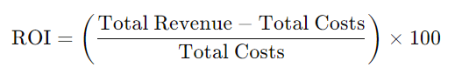
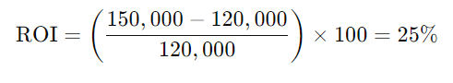
Source: Author Analysis
The ROI of 'Winter Story on the Ice Rink' includes financial returns, attendee satisfaction, sponsor value, and community impact. Improving these ensures a successful return on investment.

Situational and Cultural Considerations
Organising a leisure event requires consideration of situational and cultural factors that can affect its planning, marketing, and execution (Carlsen and Andersson, 2011). These factors help shape the event’s success, influencing audience engagement, sponsorship, and local support. A SWOT Analysis (Strengths, Weaknesses, Opportunities, and Threats) can be applied to identify internal and external factors, helping develop strategies aligning with the event’s goals.
Using the SWOT Analysis, the "Winter Story on the Ice Rink" can better understand the situational and cultural considerations that will impact the event (see Appendix 8). Strengths like community engagement and location should be leveraged, while weaknesses such as weather risks must be addressed with contingency plans. By capitalising on opportunities like sustainability and partnerships while being mindful of threats like economic uncertainty and competition, the event can be successfully positioned to attract attendees, sponsors, and media attention, ensuring long-term success.

Conclusion
The "Winter Story on the Ice Rink" event in Chelmsford aims to bring festive cheer, community engagement, and economic growth to the city through a family-friendly winter experience. The temporary outdoor ice rink, enhanced by holiday-themed entertainment, food stalls, and special events, is set to attract a diverse audience of residents, tourists, and groups. Positioned as a key seasonal attraction, the event aligns with Chelmsford's goal of becoming a vibrant winter destination.
Thorough planning, coordination, and strategic marketing will ensure the event meets its objectives. The event's focus on sustainability, inclusivity, and digital innovation fits current industry trends and community expectations. By securing sponsorships, delivering a high-quality experience, and generating a strong return on investment, "Winter Story on the Ice Rink" will leave a lasting impact, establishing itself as a hallmark event in Chelmsford's festive calendar.
Rapid planning, contingency measures, and a flexible budget have addressed challenges such as weather risks and economic uncertainty. Ultimately, the event is expected to achieve its goals of high attendance, strong financial performance, and positive community feedback, ensuring both its success this season and its growth in future years.

Recommendations
  - Strengthen Operational Efficiency:
- Weather Contingency Plan: Use tents or indoor alternatives for bad weather.
- Staff Training: Continue prioritising staff training in customer service and safety.
- Event Management Software: Implement software to streamline ticketing and logistics.
  - Enhance Visitor Experience:
- Personalised Experiences: Offer VIP passes with perks like priority skating sessions and meet-and-greet opportunities.
- Accessibility: Ensure the event is accessible to all, including those with disabilities.
- Real-Time Feedback: Use mobile apps or QR codes to gather attendee feedback during the event.
  - Focus on Sustainability:
- Sustainable Practises: Continue using synthetic ice and reduce single-use plastics by partnering with eco-friendly vendors.
- Partner with Environmental Groups: Collaborate with local environmental organisations to enhance sustainability efforts.

Reference List
Aaker, D.A. and Moorman, C. (2023) Strategic market management. 12th edn. Hoboken, NJ: Wiley.
Allen, J., Harris, R. and Jago, L. (2022) Festival & special event management. Milton: Wiley.
Bark (2024) Event Entertainment. Available at: https://www.bark.com/buyers/bark/Za769b/?blt=3235-a8dcfd4c417c92e036aa5de2b4366c5324c5ea5e&bli=3oRg11 (Accessed: 18th October 2024).
Canva (2024) What will you design today? Available at: https://www.canva.com/en_gb/ (Accessed: 17th October 2024).
Carlsen, J. and Andersson, T.D. (2011) ‘Strategic SWOT analysis of public, private and not‐for‐profit festival organisations’, International Journal of Event and Festival Management, 2(1), pp. 83-97. Available at: https://doi.org/10.1108/17582951111116632 (Accessed: 18th October 2024).
Chelmsford City Council (2020) Licensing policy | Statement of licensing policy. Effective January 2021 – January 2026. Available at: https://www.chelmsford.gov.uk/media/23wbtr2c/statement-of-licensing-policy-1.pdf?alId=63743 (Accessed: 11th October 2024).
Chelmsford City Council (2024) Temporary Event Notices. Available at: https://www.chelmsford.gov.uk/business/licensing/alcohol-licensing/temporary-event-notices/ (Accessed: 16th October 2024).
Chelmsford City Sports (2024) Ice skating. Available at: https://www.chelmsford.gov.uk/leisure-centres/what/ice-skating/ (Accessed: 18th October 2024).
Cudny, W. ed. (2019) Urban events, place branding and promotion: Place event marketing. New York: Routledge.
Davies, G. (2024) ‘A stunning new light trail is coming to Essex this winter’, Essex Live, 27 June. Available at: https://www.essexlive.news/special-features/stunning-new-light-trail-coming-9355443 (Accessed: 16th October 2024).
Essex Live (2024) Essex News. Available at: https://www.essexlive.news/news/essex-news/ (Accessed: 17th October 2024).
Eventbrite (2024) Best events in Chelmsford. Available at: https://www.eventbrite.co.uk/d/united-kingdom--chelmsford/events/ (Accessed: 16th October 2024).
Fox, D., Gouthro, M. B., Morakabati, Y., and Brackstone, J. (2014) Doing events research: From theory to practice. 1st edn. Oxford: Routledge.
Freemans (2024) Food & Beverage. Available at: https://www.freemanseventpartners.co.uk/solutions/food-beverage/ (Accessed: 16th October 2024).
G4S (2024) Event Security. Available at: https://www.g4s.com/en-gb/what-we-do/security-professionals/event-security (Accessed: 16th October 2024).
Getz, D. and Page, S.J. (2019) Event studies: Theory, research and policy for planned events. 4th edn. London: Routledge.
Glice (2022) How Much Does a Synthetic Ice Rink Cost? Available at: https://www.glicerink.com/synthetic-ice-rink-cost/ (Accessed: 18th October 2024).
Glice (2024) Synthetic Ice Christmas Rink. Available at: https://www.glicerink.com/synthetic-ice-rink-products/synthetic-ice-christmas-rink-3/ (Accessed: 16th October 2024).
Google Analytics (2024) Get essential customer insights. Available at: https://marketingplatform.google.com/intl/en_uk/about/analytics/ (Accessed: 17th October 2024).
High Chelmer Chelmsford (2024) High Chelmer Shopping Centre. Available at: https://www.highchelmer.com/ (Accessed: 16th October 2024).
Ho, J.M., Tiew, F. and Adamu, A.A. (2022) ‘The determinants of festival participants' event loyalty: a focus on millennial participants,’ International Journal of Event and Festival Management, 13(4), pp.422-439. Available at: https://doi.org/10.1108/IJEFM-01-2022-0006 (Accessed: 18th October 2024).
Hootsuite (2024) Save time and get REAL results on social media. Hootsuite makes it easy. Available at: https://www.hootsuite.com/ (Accessed: 17th October 2024).
Hyde Park Winter Wonderland (2024) The ultimate destination for festive fun 21st November - 5th January. Available at: https://hydeparkwinterwonderland.com/ (Accessed: 18th October 2024).
Ice Tickets (2024) Get your skates on. Braintree Village. Available at: https://braintree.icetickets.co.uk/sessions (Accessed: 18th October 2024).
International Hotel and Casino (2023) ‘Event Concept’, 24 August. Available at: https://www.hotelcasinointernational.com/about-us/blog/event-concept#:~:text=WHAT%20IS%20AN%20EVENT%20CONCEPT,the%20marketing%2C%20and%20the%20feedback. (Accessed: 13th October 2024).
Jones, L.J. (2020) The Event Planning Toolkit: Your Guide to Organizing Extraordinary Meetings and Events. Lanham: Rowman & Littlefield Publishers.
Kaliff (2024) Event Insurance. What We Cover. Service. Available at: https://www.kaliff.com/event-insurance?p=fairs (Accessed: 18th October 2024).
Kwiatkowski, G., Hjalager, A. M., Ossowska, L., Janiszewska, D., & Kurdyś-Kujawska, A. (2021) ‘The entrepreneurial orientation of exhibitors and vendors at food festivals’, Journal of Policy Research in Tourism, Leisure and Events, 16(2), 207–226. Available at: https://doi.org/ (Accessed: 18th October 2024).
LITE (2024) Fest Pro Chelmsford. Available at: https://liteltd.co.uk/fest_pro_Chelmsford.html (Accessed: 16th October 2024).
Meredith, J.R., Shafer, S.M. and Mantel Jr, S.J. (2021) Project management: a strategic managerial approach. 11th edn. Hoboken: John Wiley & Sons.
Monday Merch (2024) Event merch. Done. Available at: https://www.mondaymerch.com/use-cases/events-and-exhibitions?utm_source=google&utm_medium=cpc&utm_campaign=21157781687&utm_term=event%20swag&utm_content=695627461419&device=c&gad_source=1&gclid=CjwKCAjwjsi4BhB5EiwAFAL0YCrYh58kKlQ1EK0Hnmmm7oJdXO118lRSymOerqVb4JKUyM5GIMSXmBoC9yEQAvD_BwE (Accessed: 18th October 2024).
O'Toole, W. (2021) Events Feasibility and Development: From Strategy to Operations. 2nd edn. London: Routledge.
Pacer (2024) Central Park, Chelmsford. [Web mapping platform]. Available at: https://www.mypacer.com/parks/347373/central-park-chelmsford (Accessed: 9th October 2024).
PwC (2024) Annual Report 2023. Local projects for new skills in our communities. Available at: https://www.pwc.co.uk/who-we-are/annual-report/stories/2023/local-projects-for-new-skills-in-our-communities.html (Accessed: 16th October 2024).
Reynolds, L. (2024) ‘Where To Go Ice Skating In London For Christmas 2024’, Londonist, 27 September. Available at: https://londonist.com/london/christmas-in-london/where-to-go-ice-skating-in-london-at-christmas (Accessed: 13th October 2024).
Shipway, R., Jago, L. and Deery, M. (2020) Quantitative and qualitative research tools in events. In The Routledge Handbook of Events (pp. 306-327). Routledge. Available at: https://www.taylorfrancis.com/reader/read-online/f647c32a-0114-4eca-8fe2-5fd4f7b35682/chapter/pdf?context=ubx (Accessed: 13th October 2024).
St. John Ambulance (2024) Event first aid cover. Available at: https://www.sja.org.uk/what-we-do/our-first-aid-services/event-first-aid-cover/ (Accessed: 16th October 2024).
Visit Monmouthshire (2024) Event aims and objectives. Available at: https://www.visitmonmouthshire.com/information/events-management/aims (Accessed: 15th October 2024).

Appendices

Appendix 1: Central Park, Chelmsford. Location position on the map
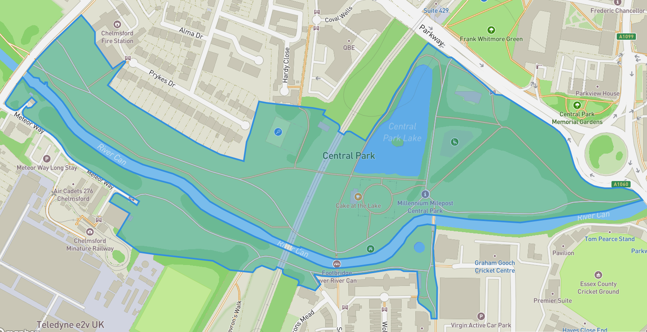
Source: Pacer, 2024

Appendix 2: Skate at Somerset House, London

Source: Reynolds (2024)

Appendix 3: SMART Objectives
Engaging 3 key stakeholders for the event, with formal agreements in place by November 1, 2024, to secure £20,000 in sponsorship, ensuring their engagement and support throughout the event duration (November 15, 2024, to January 5, 2025)
Specific | Engage the council for permissions and funding, a sponsor for financial backing, and a media partner for promotion.
Measurable | Secure £10,000 and 3 media features by December 1, 2024.
Achievable | Use personalised proposals and meetings to present the event’s value and stakeholder benefits.
Relevant | Stakeholder involvement is vital for financial backing, visibility, and local authority support.
Time-bound | Commitments must be secured by December 1, 2024, to ensure timely promotion and operations for the event.
Attracting 10,000 attendees over a 2-month period (November 15, 2024, to January 5, 2025) while maintaining a 90% satisfaction rate from attendees and generating a profit of £125,000 through ticket sales, sponsorships, and concessions
Specific | The event will feature ice skating, themed performances, and festive food and drink, targeting local families and tourists.
Measurable | The goal is to reach 10,000 attendees, achieve 90% satisfaction, and generate £125,000 in profit.
Achievable | A comprehensive marketing plan and sponsorships will ensure attendance and financial goals are met.
Relevant | The event supports Chelmsford's efforts to offer family-friendly winter activities and boost the local economy.
Time-bound | The event will run from November 15, 2024, to January 5, 2025, with analysis completed by January 15, 2025.
Engaging 3 key stakeholders for the event, with formal agreements in place by November 1, 2024, to secure £20,000 in sponsorship, ensuring their engagement and support throughout the event duration (November 15, 2024, to January 5, 2025)
Specific | Provide First Aid and Customer Service training to all event staff to ensure they are prepared to handle medical emergencies and deliver high-quality service to attendees.
Measurable | 100% of the staff (e.g., 30 employees) will complete the training and be certified in First Aid and Customer Service.
Achievable | Partner with certified training providers to conduct on-site or virtual sessions, ensuring all staff complete the courses before the event launch.
Relevant | Training is essential to guarantee safety, professionalism, and customer satisfaction during the event, enhancing visitor experience and staff confidence.
Time-bound | All staff will complete the required training by November 10, 2024, before the event’s opening on November 15, 2024.
Source: Author Analysis based on Fox et al. (2014)

Appendix 4: Glice Christmas Ice Skating Rink
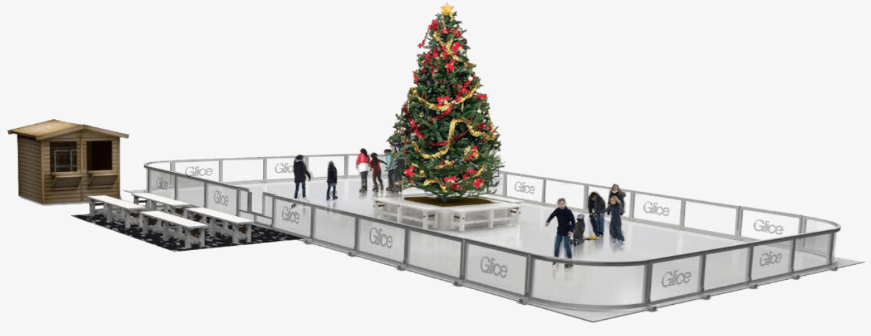
Source: Glice (2024)

Appendix 5: Contingency Planning
Key Components | Potential Risks | Action Plan
Weather-Related Contingencies | Rain, Snow, or Ice Accumulation | Ice maintenance  Shelter for guests  Session adjustments
Weather-Related Contingencies | Extreme Cold Temperatures | Heated areas for staff and guests
Health and Safety Contingencies | First Aid and Emergencies | First aid stations and emergency services  Safety guidelines
Health and Safety Contingencies | Seasonal Illnesses | Hygiene stations  Cleaning schedule  Illness protocol
Operational Contingencies | Power Outage | Backup generators  Response time
Operational Contingencies | Staff Shortages | Temporary staffing agencies  Cross-training
Financial Contingencies | Low Ticket Sales | Marketing push  Sponsorships
Financial Contingencies | Unexpected Costs | Emergency fund
Source: Author Analysis based on O'Toole (2021)

Appendix 6: Expenditure (Costs)
Expenditure Item | Estimated Cost (£) | Explanation
Ice Rink Setup and Equipment | £50,000 | Cost of renting and setting up the synthetic ice rink, including fences, skate rental equipment, and seating areas (Glice, 2022).
Marketing and Promotion | £10,000 | Costs for digital marketing, PR campaigns, printed materials, and social media ads to promote the event (Hootsuite, 2024).
Staffing and Security | £25,000 | Wages for event staff, including security personnel, customer service representatives, and technical support (G4S, 2024).
Entertainment and Performances | £10,000 | Hiring performers for live shows, musicians, and other entertainers to create a festive atmosphere (Bark, 2024).
Insurance and Permits | £5,000 | Cost of obtaining necessary permits and insurance for the event (Kaliff, 2024).
Food and Beverage Vendors | £5,000 | Providing infrastructure and utilities (e.g., electricity, water supply) for food and drink vendors (Freemans, 2024).
Decorations and Branding | £10,000 | Festive decorations, lighting, banners, and branded materials to create a themed winter atmosphere (LITE, 2024).
Contingency Fund | £5,000 | Reserved for unexpected expenses or emergencies (e.g., equipment malfunction, weather issues).
Total Estimated Expenditure | £120,000
Source: Author Analysis

Appendix 7: Income (Revenue Sources)
Income Source | Estimated Amount (£) | Explanation
Ticket Sales | £100,000 | Expected ticket sales from 10,000 attendees over the event period, with an average ticket price of £10 for adults and £5 for children (ages 5-12).
Sponsorship | £20,000 | Financial sponsorship from local businesses (e.g., Chelmsford City Council, High Chelmer Chelmsford, Barclays Bank).
Food and Beverage Vendors | £15,000 | Fees charged to food and beverage vendors for stalls at the event (Kwiatkowski et al., 2021).
Merchandise Sales | £10,000 | Income generated from branded event merchandise, such as hats, scarves, and other winter-related items (Monday Merch, 2024).
Advertising and Media | £5,000 | Income from media partnerships (e.g., Essex Live, local radio stations) for exclusive on-site promotions.
Total Estimated Income | £150,000
Source: Author Analysis

Appendix 8: SWOT Analysis

Source: Author Analysis based on Carlsen and Andersson (2011)

