University of Wales
Trinity Saint David

PROBLEM SOLVING AND DECISION MAKING(H&Sc)
BMSW4004
Communication in Healthcare
by
Olaniyi Toafeek Oladimeji
(2009509)

Course Lecturer: Barbara Chinyani

April, 2021
Table of Contents
1.0 Introduction 3
2.0 Overview……………………………………………………………………………………….3
3.0 Communication ….3
3.1 verbal communication………………………………………………………………………….4
3.2 non-verbal communication…………………………………………………………………………….4
3.3 listening communication……………………………………………………………………………….4 4.0 Causes and Effects of Lack of Communication among Health Workers 4
4.1 Poor quality collaboration…………………………………………………………………………………………………………….5
4.2 Lack of coordination………………………………………………………………………………………………………………………5
4.3 Lack of shared………………………………………………………………………………………………………………………………….5
4.4 People…………………………………………………………………………………………………………………………………………6
4.4.1 Service user……………………………………………………………………………………………………………………………….6
4.4.2 Staff……………………………………………………………………………………………………………………………………………6
4.4.2.1 Carers………………………………………………………………………………………………........................................6
4.4.2.2 Nurses……………………………………………………………………………………………………………………………………6
4.5 Family………………………………………………………………………………………………………………………………………….6
5.0 Solution 7
6.0 Opportunities for Positive Change with the Burke-Litwin Change Model 7.
7.0 The Burke-Litwin Change Model 7.
8.0 Change-Oriented Decision-Making and Problem-Solving Process..................................................8
8.1 Management………………………………………………………………………………………….8
8.2 Organisation………………………………………………………………………………………….9
8.3 Motivation……………………………………………………………………………………………9
9.0 Choosing from a List of Alternative Solutions................................................................................9 10.0 Concluding Remarks...................................................................................................................11
11.0 References ..........................................................................................................................................13

1.0 Introduction
This paper is a report what can be done to bring about positive change in a health facility bedevilled by the challenge of poor communication among the facility's workforces. Indeed, the health sector is generally bedevilled by several problems too numerous to discuss in detail in this place. The challenges include deficiency in communication between staff or management, leading to deficiency in coherent treatments accorded patients; short-staff and heavy workload, one that reduces the level of productivity of staff as a result of burdensome assignments; low pay and insufficient breaks for the staff, one that demoralises them from giving their best to the service; incompetent staff/insufficient training, one that leads to poor service delivery; lack of PPE/testing equipment, a situation that makes medical activities to be inefficient and cumbersome; and gender inequality or pay gap, one that diminishes the collective zeal of both men and women to give all they have to the service.
2.0 Overview However, as stated earlier this report is specifically focused on the problem associated with lack of communication between staff and management. The report particularly presents solutions that have been worked out to bring about positive change within the context of communication among the staff of the health facility chosen for the study. The fishbone diagram is used to examine the causes and effects of the challenge while the SWOT Analysis and the Burke-Litwin Change Model are used to examine the problem as an opportunity for positive transformation of the health facility and to work out sustainable solution that will lead to the highly desired change.

3.0 Communication
Communication has been described by Doyle (2021) as simply the act of having information transferred or transmitted from one individual, place, or group to another. Meanwhile with specific regard to communication within the workplace, Doyle (2021) explains that it is very important for an employee to possess the ability to effectively communicate with his colleagues and superiors, regardless of the industry where the employee works. He further stresses that wherever communication takes place, the process usually involves three important elements or parts, namely the sender, the message, and the recipient. The sender has the duty of encoding the message sometimes through a combination of verbal ad non-verbal skills, the message is thereafter transmitted probably in a written or spoken manner and the recipient decodes it and may eventually give feedback to the sender for the communication process to be considered complete (Coiera, 2016). Nevertheless, Harris (2002) warns that in the process of communication there may arise some barriers or hindrances that may make mutual understanding between the sender and receiver of the message impossible, adding that effective communication can only be achieved where such barriers are defeated.

Meanwhile, certain communication skills should be possessed for effective communication to be achieved. They include verbal, non-verbal and listening skills.
3.1 Verbal Communication
Also known as spoken communication skill, this type of skill can be carried out through such means as face-to-face, telephone, radio, or television, among others. It should be noted written form of communication can be include in this category since what is written are usually read out verbally (SkillsYouNeed, 2021).
3.2 Non-Verbal Communication
This category of communication skill involves communication-related actions that are not expressed orally but are rather expressed through such means as body language, gestures, or by mode of dressing, standing or even scent. Other ways of communicating that may not be intentional but are regarded as non-verbal communication skills are the tone of one's voice and the signals made with the hands, among others.
3.3 Listening Communication.
The above category of skills concerns paying attention to a message, usually oral, being transmitted by someone else. The listener can be categorized as active listener where he pays total attention to what he is being told; or empathetic where the listener pays attention and demonstrates absolute understanding to the listener (Tombs, 2018).

4.0 Causes and Effects of Lack of Communication among Health Workers
We discovered several causes and effects associated with the lack or deficiency of communication among health workers. Some of the causes include, as stated in the fishbone diagram below:
- Poor quality collaboration
- Lack of coordination
- Lack of shared mental models
- Poor leadership
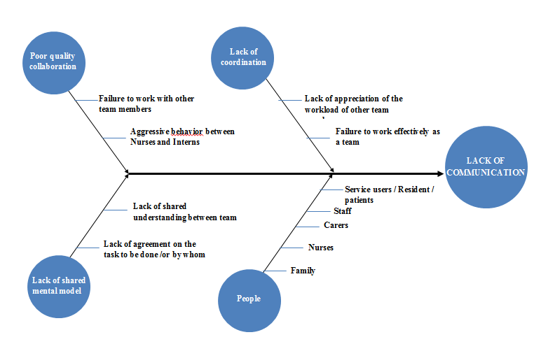
It should be added, for instance that in fishbone.
4.1 Poor-quality collaboration which is the major cause of the problem we discovered that there was lack of mutual trust and respect between team members; undermining/bullying a team member; and failure to address conflict between team members. Regarding
4.2 lack of coordination, we found among the workers lack of appreciation of the workload of other team members; team member performs a task beyond their capability; failure to work effectively as a team; and lack of willingness to help a struggling team member. As regards lack of shared mental models, the details we found out showed that team members do not have a shared knowledge of a situation.
4.3 lack of a shared understanding between team members; there was equally lack of agreement on the tasks to be done, and/or by whom.
4.4 People: In any organisation, there are people who provide leadership, stewardship, and followership. People devise methods to assist organisations in achieving their goals.
4.4.1 Service user: they communicate effectively through possible communication barrier caused by differences, relying on both verbal and nonverbal signals to direct perception.
4.4.2 Staff: they act as an advocate for service user as they carry order from senior staff.
4.4.2.1 Carers this can include practical tasks such as tiding the house, doing washing, ironing, cooking meals, giving medication, and collecting prescriptions, attending doctor’s appointment and emotional support.
4.4.2.2 Nurses giving patients-centred care per se, does not affect nurse’s mental health, but the relationship of the patient-centred care behaviours and nurse’s mental health is moderated by the nurse’s caring orientation.
4.5 Family: maintenance of patient’s communication with family and relative. support for the patient’s mental and psychological wellbeing
The decision of hospital administrations to exclude patient family members was contested, and a campaign for protection arose, with patient and relative wishes considered, resulting in a reform in visiting regulation.

The major effects of these causes are the fact that they hamper the wellbeing of the patients in the first place and put their health in jeopardy. According to Weller et al (2011) when there is minimal or lack of effective communication among the staff of a given health-related facility there is always the tendency that the patients will bear the brunt. Meanwhile, Jackson (2011) argues that the existence of such a challenge equally affects the reputation of the hospital concerned as, sooner or later, the adverse effects seen on the health of the patients will entail that the respect and patronage accorded the hospital will either wane or be completely tarnished. Johnson further posits that a major source of the soiling of the reputation of a healthcare facility comes from the facility being involved in litigations having to do with violations of the medical-related rights of patients. In such cases, the hospital in question not only destroys its reputation, but impoverishes itself during litigations. As matter of fact, in the UK, there are several legislations that promote utmost care for patients. Regulated by the Care Quality Commission (CQC), these legislations include Health and Social Care Act 2008, 2012, which stipulates the registration and regulation health and adult social care services with a view to guaranteeing the safety and quality of care for service users (McGaughey, 2019); the Duty of Candour, which is the legal duty of service providers to be open and honest to patients and their families when things go wrong (Deakin et al, 2012); Care Act 2014, which stipulates that caregivers should always take a person-centered approach when safeguarding vulnerable adults (High Speed Training, 2021); Putting People First 2007, which aims at creating a high quality and responsive care system (McGaughey, 2019); and the Equality Act 2010, which protects individuals from unfair treatment and promotes a fair and more equal society (Equality Human Rights, 2020).
.

5.0 Solution
This report has already shown that there are adverse effects of the problem of poor communication on the healthcare system in the hospital. Because the personnel are not enjoying interpersonal relationship that will enhance their job performance, the patients they are treating are bearing the brunt in terms of receiving poor medical attention and care. In addition, the morale of the workers diminishes with the passage of time leading them to be unable to deliver optimal service. All these, in turn, tell on the reputation of the health facility. According to Weller et al (2011), in every health facility, reputation is the key thing that either attracts or rebuffs customers, adding that because health is a very delicate issue, no one wants to risk the chances of getting treatment in a hospital that cannot guarantee their safety, especially if such a hospital suffers from poor public image. There is also the fact that the management structure of the health facility also has a poor way of expressing itself in terms of communication with the more junior colleagues. The management is unable to adhere to professional protocols and even ethics associated with medicine, thereby setting poor standards for their subordinates, and subjecting the hospital to disrepute. According to Gardiner (1999), in a circumstance where the leadership style is directive instead of facilitative, there is always the likelihood that the relationship between such a leadership and its workers will be cold, and the workers may experience unrelenting feeling of work-related demoralisation. At the same time, Thomas el (2004) stress that in an any workplace where members of staff communicate and collaborate in terms of carrying out their professional responsibilities, the outcomes a favourable to the company involved especially in terms of low rate of workers exiting the company, high rate of loyalty on the part of the customers, high rate of productivity and high rate of company's revenue and growth.

6.0 Opportunities for Positive Change with the Burke-Litwin Change Model
We have found out some of the underlying causes of poor communication among workers of the healthcare facility under review. To improve communication, the so-called Burke-Litwin Change Model is used. The Model is particularly helpful in identifying possible courses of action to be taken based on the reasons already discovered as being responsible for the poor state of communication among the workers and management of the healthcare facility. This line of action has to do with the disparity that exists between leaders and managers. Here it is worthy of note that while managers are concerned with regular complexities and operations of a company, leaders on the other hand work out important and effective changes (Kotter, 1990; Kouzes et al, 2007). At the same time, Colvard (2003) argues that while a manager has the possibility of seeing and hearing about events in the company, a leader can hear a sound that is not being made, and equally sees what is not being revealed by the light. So, the leadership approach is adopted while applying the Burke-Litwin Change Model.

7.0 The Burke-Litwin Change Model
The Burke-Litwin Change Model is used as a theoretical change tool to deal with the problem at the healthcare facility. Burke (2002) contends that there is an indisputable nexus between workers' professional performance and morale on the one hand and an organisational climate, adding that in a favourable working environment there are always the chances of achieving significantly high organisational performance (Litwin, 1968). It is therefore based on the above postulations that the so-called Burke-Litwin model was birthed. In the diagram depicting the Model (as shown below), it can be remarked that the upper aspect of the diagram is consecrated on factors that are transformational in nature while the lower segment has to do with transactional factors. The communication-related problem in the healthcare facility obviously affects the entire facility, thereby necessitating that the change that should be achieved should be at both the transactional (day-to-day) and transformational (deep structure) aspects of the hospital. Indeed, the Model will be useful in really achieving wholesale positive transformational and transactional changes as it will be helpful to move the healthcare company from its present state of poor communication system to the desired point that it should attain.
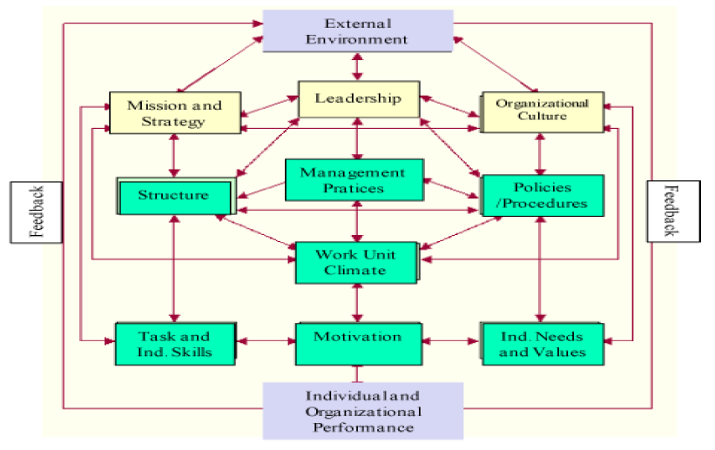
Source: Model of Organisational Performance Change (Litwin, 2002:19)

8.0 Change-Oriented Decision-Making and Problem-Solving Process
Given the imperative for change in the health facility as evident in the Burke-Litwin Change Model, it is decided that the SWOT (strengths, weaknesses, opportunities, and threats) decision-making technique is suitable for coming up with relevant data (Bateman et al, 2009),
8.1 Management solution, especially from within the confines of the health facility, that will help in coming to terms with the best solution to be adopted from a pool of alternative solutions that are to be gathered. In fact, a combination of the Burke-Litwin Change Model and the SWOT decision-making technique will go a long way in gathering relevant data and using them appropriately for sustainable positive change. So, in the first place along the line of the decision-making process, by collaborating with the team of the health facility, certain areas within each segment of the Burke-Litwin model are identified with the hope that if such areas are addressed change will be enhanced within the segment concerned. Besides, the change may establish positive links with other segments within the health facility.
8.2 Organisational, in the spirit of change, there is acute involvement of the staff in the planning and decision-making process. Indeed, everyone is involved in the examining and identifying the strengths, weaknesses, opportunities, and threats of the strategies that have been thrown up for positive communication-enhancing change within the health facility. Representatives of the various departments, especially junior officers, interns, and nurses are invited to participate in the analysis of identifying. the strengths, weaknesses, opportunities, and threats of the strategies and to have same communicated across the health facility.
Clearly, the SWOT analysis has enabled us to have a better understanding of our strategies' strengths, weaknesses, opportunities, and threats. Moreover, the workers, particularly those that were hitherto excluded from the communication links have now gotten a sense of belonging. Not only are they now aware of the internal capacity of the strategies for moving the health facility forward, but they are also elated that they are now taken into consideration by being brought into the company's communication. The new order of things has the potential of simulating their attachment to the health facility and their trust for the company's leadership. Even more, the SWOT analysis that we adopted as a decision-making technique has enabled the heads of the various departments of the facility to become better aware of the variables associated with the environment and the healthcare industry where they operate.
8.3 Motivation, by studying, analyzing, and identifying the overall opportunities and threats associated with the status of poor communication in the health facility and equally the benefits and opportunities promised by the strategies for positive change in the intra-hospital communication system that we have thrown up, the leadership are now poised for the outside-the-box communication system that has come to stay.

9.0 Choosing from a List of Alternative Solutions
Based on the careful analytical procedure through which we carried out our research on the poor communication situation at the health facility. It bears repeating as a matter of utmost importance that effective communication and teamwork amongst healthcare workers is very important particularly as far as the safety and wellbeing of the patients are concerned (Manojlovich et al, 2007). As has been stated earlier, we have found several factors to be responsible for the cold communication system at the health facility. Of these factors the most prominent are poor quality of collaboration among members of staff, poor leadership on the part of the administrators, and lack of coordination. It should be noted that there is particularly lack of teamwork and collaborative efforts between the nurses and the interns. This deficiency has serious negative impacts on the safety and health of the patients.
Besides, Spiridonov (2017) has noted that for effective healthcare delivery to be accomplished it is necessary to have in place a spirit of collaboration and mutual respect among those working at the various levels of the healthcare system especially given the fact that their individual services are interconnected with those of their colleagues. However, we have found out that in the scenarios we have examined at the health facility, the most prominent cause of communication-related failure is deficient quality of collaboration within the workforce. We have particularly noticed in this regard that patients' care are disrupted by the misunderstanding and bullying that characterise the relationship between many of the workers at various ranks particularly nurses and interns. We have also noticed that the goals of interns and nurses are disparate and sometimes competing and such goals have the tendency of compromising efforts at teamwork and team coordination (Quine, 2002). At the same time, it is noticeable that while nurses especially those belonging to the same ward often work as a collective and a team, the same cannot be said of the interns as they are mostly observed working autonomously sometimes in poorly defined roles and under little or no supervision at all. The consequence is the regular feeling on the part of the interns of being isolated and abandoned. This situation is compounded by the fact that interns, unlike their counterpart in the nursing department, are hesitant and reluctant when it comes to senor members staff in the settlement of disputes. Interestingly, this empirical fact is in tandem with the discovery by Manojlovich et al (2007) that doctors of junior ranks are reluctant to seek guidance from their professional seniors or to confess it to them when they are struggling in their job.
We have stated that such factors as deficient quality collaboration, poor leadership, deficient coordination, and lack of shared mental models are all harmful to effective healthcare delivery service. We have gone further to add contextual pieces of evidence concerning the beleaguered relationship between nurses and interns in particular, a relationship that is detrimental to the health and wellbeing of patients under their care. Also, during the study we have discovered that the sum of the failures of associated with poor teamwork among the staff in the healthcare facility result generally in patients' harm. Based on the above findings we have come up with several solutions as ways of enhancing communication among the staff providing healthcare at the facility. Of course, none of them is left behind as they are all stakeholders who should put their act together for effective results aimed at the patient's absolute satisfaction.
Using the PMI decision-making model, we examine some of the solutions below with a view to settling for the best alternative. By the way, the PMI model which was created by Edward de Bono is an acronym for Plus, Minus, and Interesting. It uses Plus (Pro), Minus (Con) and Interesting as means for scoring the values of ideas. This system or model enables us to evaluate the extent an idea is acceptable or negligible, so that the higher the idea scores in terms of Plus (+) the more acceptable it becomes. At the same time, the lower it scores in terms of Minus (-), the faster we must let go of it. To calculate the total score of a PMI operation, the scores ascribed to the Plus, Minus and Interesting should be added up. It should be noted that the interesting scores can either be positive or negative depending on circumstance (Idea Sandbox, 2021).

Plus (Pro) | Minus (Con) | Interesting (Implication)
Recruiting more interns and nurses for workload reduction (+2) | More money will be spent (-6) | Who will provide the funding? (-2)
Using legislative, collective, and regulatory agreements to stop the culture of bullying and undermining of junior officers (+5) | Requires a lot of legal expertise and may be hard to interpret and use. (-5) | We may need to hire new legal team
Strengthening support accorded junior officers by senior doctors and giving multidisciplinary training to junior staff as this will enhance capacity and boost doctor–nurse collaboration (+5)
Encouraging inter-professional shadowing between perhaps medical student and nurses to enhance junior doctor–nurse.  Relationship (+3) | The shadowed may feel perturbed or spied upon. (-5) | The mistrust may increase. (-3)
There should be a redefinition of the roles to be played by every one of the staff and there should be better use of existing PTTSs, and ISBAR. (+3) | May lead to high rate of staff turnover and the PTTSs and ISBAR may not be available. (-3) | A lot of explaining may become necessary. (+2)

The third proposed solution which has to with strengthening support accorded junior officers by senior doctors and giving multidisciplinary training to junior staff for enhancing capacity and boosting doctor–nurse collaboration scores positively without reservation. It is therefore the solution to be applied among the whole lot. This solution is at the team level of intervention to enhance communication. This is very significant as we really concerned about encouraging or supporting collaborative teamwork for better service delivery. Besides, Dutton (2003) opines that such multidisciplinary team training as crew resource management draws members of staff together thereby enabling them to interact not only while training but equally after the training and, by so doing, their professional collaborative is enhanced. In fact, during such trainings, they may be accorded knowledge that has to do with the professional importance of collaborating with one another as medical workers for the optimal satisfaction of their patients. What is more, by the doctors giving more support to junior staff, the psychological obstacle that hinders the junior staff from reaching out to the doctors will be defeated and a sense of partnership will be developed all to the benefits of the patient

10.0 Concluding Remarks.
This report has presented the causes and effects of lack or deficiency of communication in a certain healthcare facility in United Kingdom. Because of the severity of the effects which hinge largely on poor service delivery and therefore on loss of reputation and the risk of being subjected to cost-intensive litigations over breach of legislations protecting the rights of patients to utmost healthcare. The need for positive change has therefore been stressed and proffered sustainable solution to the problem.
To facilitate the satisfactory implementation and monitoring of the proposed solution, we recommend that the UK Medical Research Council Complex Intervention Framework (Craig et al, 2008) be used to as a guide in the course designing the course of putting the content of this report to effective use. It should also be noted that intervention based on this report must involve all stakeholders in the medical facility concerned especially the collaboration between medical and nursing schools, as well as hospital-based senior doctors and nurses to produce a sustained change in teamwork among the entire workforce of the hospital. It is also the responsibility of the above stakeholders to ensure full compliance by positively ensuring that every member of staff adheres strictly to the spirit and letter of change in the facility.

11.0 Reference
Bateman, T. & Snell, S. (2009). Management, 8th edition. New York: McGraw-Hill. Burke, W. W. (2002). Organization change: Theory and practice. Thousand Oaks, California: Sage Publications
Campbell, R. (2012), Managing corporate communication, chapter 15. International City/County Management Association
Coiera E. (2016), Organisation-based communication: a new informatics paradigm. Proc AMIA Annu Fall Symp. 2016:17-21.
Colvard, J. (2003). Managers vs. Leaders, taken from Govexec.com (www.govexec.com/dailyfed/htm) on 6/04/2012.
Craig P, Dieppe P, Macintyre S. (2008) Developing and evaluating complex interventions: the new Medical Research Council guidance BMJ 2008; 337: a1655.
Deakin, S. & Morris, G. (2012) Labour Law (Hart 2012) Ch 6
Doyle, A. (2021), Communication Skills for Workplace Success, https://www.thebalancecareers.com/communication-skills-list-2063779
Dutton R.P. (2003), Daily multidisciplinary rounds shorten length of stay for trauma patients. J Trauma Acute Care Surg 2003; 55:913–9.
Gardiner, P., (1999). Soaring to new heights with learning-oriented companies. Journal of Workplace Learning, 11(7) 255. Jackson DJ, Alston GL. Interprofessional communication. Drug Topics. 2011 Aug;155(8):42-51.
Harris, MF (2002) Communication across the divide. A trial of structured communication between general practice and emergency departments. Aust Fam Physician 2002; 31:197-200
High Speed Training (2021), Principles of the Care Act 2014, www.highspeedtraining.co.uk/hub/principles-of-the-care-act-2014/#
Idea Sandbox (2021), Three Simple Decision-Making Tools, https://idea-sandbox.com/blog/three-simple-decision-making-tools/
Kotter, J. P. (1990). What leaders really do? Harvard Business Review, 68, 103-111. Portes, J (2020): “Immigration between the referendum and Brexit”, UK in a Changing Europe, 20 June 2020, available at https://ukandeu.ac.uk/long-read/immigration-between-the-referendum-and-brexit/#
Kouzes, J. & Pozner, B. (2007). The leadership challenges. San Francisco: Jossey-Bass. Rowland, E. (2020) Covid-19: A Business Impact Series Economic Impact & Pandemic Planning, KPMG, Issue 1, 30 March 2020
Litwin, G. H. & Stringer, R. A. (1968). Motivation and organizational climate, Boston: Harvard Business School Press
McGaughey, E. (2019) A Casebook on Labour Law (Hart 2019) chs 12–14.
Manojlovich M & DeCicco B. (2007), Healthy work environments, nurse-physician communication, and patients’ outcomes Am J Crit Care 2007;16:536–43.
SkillsYouNeed (2021), What is Communication? https://www.skillsyouneed.com/ips/what-is-communication.html
Spiridonov, I. (2017) Causes of Ineffective Communication between Medical Specialist Journal of IMAB - Annual Proceeding (Scientific Papers) 2017 Jul-Sep;23(3):
Thomas, A. & MacDiarmid, A. (2004). Encouraging employee engagement, CMA Management, 78, 14-16, Weller, JM, Barrow M, Gasquoine S. (2011), Inter-professional collaboration among junior doctors and nurses in the hospital settin. Med Educ 2011;45: 478–87.
Tombs V. (2018) Communication behaviours in workplace: an observational study. Bmj. 2018 Feb 28;316(7132):673-6.
Quine, L (2002). Workplace bullying in junior doctors: questionnaire survey. Br Med J 2002; 324:878–9.

Warren, J. (2007). Service user and carer participation in social work, Exeter: Learning Matters.

Iriss. (2021)Community care & older people. http://content.iriss.org.uk/keycapabili

St Peter’s Hospice (2021). care teams. http//stpetershospice.org.uk/our.ca

http://hypatia.lb.teiath.gr/bitstream/11

