LEVEL 6 ASSESSMENT SPECIFICATION

Student name: | Jessica Ainsworth | Student ID number: | P148445
Programme: | Primary
Module: | Principles of Pedagogy
Module code: | M6X01438/C | Contribution to Overall Module Assessment (%): | 100%
Lecturer: | Siân Brooks | Internal Verifier: | Siân Brooks
Assignment Title: | ‘Describe a learning event which has happened during your recent school experience. Reflect upon what took place, connecting events to theories of learning and teaching. Make recommendations about how you could improve your own practice in the light of this. Produce a poster to illustrate how you would develop the elements of an effective learning environment.’ | Word count (or equivalent): | 5,000 or equivalent.
Submission deadline: | 17/10/18 (23.59) | Return date of provisional marks & written feedback: | 14/11/18
Submission method: | All written assessments, where practical and possible, must be submitted via Turnitin unless otherwise instructed by the Lecturer. (Please DO NOT put this assessment specification into Turnitin or it will match many similarities with other students’ submissions.)  Alternative submission method (if applicable):  Late submission of the assessment will result in a late penalty mark. Penalties for late submission: Up to one week late, maximum mark of 40%. Over one week late, 0%. Only the Extenuating Circumstances Panel may approve a change to submission dates.
Academic honesty / referencing: | Academic honesty is required. In the main body of your submission you must give credit to authors on whose research and ideas your work is based. Append to your submission a reference list that indicates the books, articles, etc. that you have used, cited or quoted in order to complete this assessment.

Module Learning Outcomes
(from module syllabus)
1. understand, synthesise and evaluate the main theories that underpinning learning, behaviour and assessment in the primary school
2. reflect critically on how learning theories inform the planning and provision of high quality learning environments, demonstrating a clear understanding of how theory and practice are interrelated
3. organise knowledge and learning through the use of a range of information sources, and present work appropriately.



Describe a learning event which has happened during your recent school experience. Reflect upon what took place, connecting events to theories or learning and teaching. Make recommendations about how you could improve your own practice in the light of this. Produce a poster to illustrate how you would develop the elements of an effective learning environment.

Principles of Pedagogy: Effective learning and teaching in the Primary Context (M6X01438-C)

Word count: 4555

Introduction
Many philosophers, such as Lev Vygotsky, Maria Montessori Jean Piaget and Jerome Bruner have a unique input into children’s learning today. However, whether their theories vary or whether they are in agreement, the main purpose amongst them all was to ensure they were ‘educating the young child’ (Gray, Mcblain, 2012). Learning is a vigorous process that continues throughout a persons’ life and more often than not, it is believed that the acquisition of knowledge is from the help of teachers. Locke (1632 – 1704), was one of the earliest philosophers to identify this stating knowledge is attained through ‘experience, repetition, training and virtue’ (Gray & Mcblain, 2012), making it vitally important that teachers recognise good practice and they observe and reflect on the strategies implemented. As a result, they are able to link their practices in with the relevant theories to improve the learning that takes place in their classrooms. This research includes specific factors such as; outdoor learning, questioning and exploratory talk. An immense influence in the education of wales is the work of a man named Graham Donaldson. After he released his Successful Futures Report (2015) many pioneer schools have taken the opportunity to implement his theory and ideas into their schools. However, in order to do that successfully, the teaching profession need to ensure they are fully equipped in the knowledge of how children learn best. The aim of this essay will be to assess skilfully a learning event I had the chance to observe in a mainstream school. I will be sure to link this in with relevant theory and literature and explain how I would hope to make this practice better or equally good in the future.
The learning event observed took place in an urban area and used English medium. It was a large primary school in South Wales currently holding 750 students on register. The English as a foreign language (EFL) percentage was 31% and they had one ward that was classed as one of the most deprived children in Wales. Free school meals (FSM) averaged at 31% and they are currently recognised as a Green support category school. The learning event occurred in a Year 2 class of 28 pupils, 5 of whom were identified as having additional learning needs (ALN). Before any research was conducted, ethical issues were respected and BERA (2018) principles were adhered to. Anonymity was important to consider with all children referred to as numbers, for example ‘child 1’. I also ensured I never used the teachers name or school name as it is important to keep their identity hidden and confidential. I obtained permission in the form of a letter by the school to confirm that I was authorised to take pictures. All participants were also made aware of the studies taking place and gave their consent. This all complies with the BERA (2018, p4) legislation and highlights one of the main ethical principles ‘all social science should respect privacy, autonomy, diversity, values and dignity of individuals, groups and communities’.

Observation
The subject of the learning event I observed was mathematics and numeracy. It included both the indoor and outdoor learning environment, was based around ‘more than and less than’ and involved the introduction of ‘time’. To kick start their learning in the morning the teacher began with a ‘1K run’ to ensure that all children were awake, motivated and ready to learn. This is a new whole school initiative with the hope of promoting children’s Health and Wellbeing, a matter that is highlighted throughout the Successful Futures report by Graham Donaldson (2015). The school also follows its own Food and Fitness Policy 2015 to ensure that the initiative takes place and works accordingly. The children completed four laps around the tennis courts, lined up and then made their way back to class. When entering the classroom, the teacher vocally informed them it was time for maths by asserting “mae’n amser mathemateg”. Some children went to get a drink of water and others sat ready in rows on the carpet. This maths session was split into 3 parts, it started with a small introduction to kick start their thinking, followed by reviewing their learning from the previous week, then finished with a main activity in which they participated in groups of mixed ability levels. The introduction included reciting the 3x tables in which the entire class participated. The teacher used a metre ruler stick as a visual aid, and stuck post-it notes along the stick of the chosen times table (3). This helped to encourage all the children to join in and say the 3x tables all together. After repeating multiple times, the teacher then went on to ask questions such as “What is 3x3?” varying the order and the children put their hand up ready to answer. The aim of this recital is to check if the children have successfully learnt the 3x table and test whether it is retained in their long-term memory, effectively storing and processing the information and not forgetting.
In the next part of the lesson the teacher moved on to ‘what is 10 more than….’. The activity took place on the classroom carpet and the whole class was included. The teacher used the interactive whiteboard to engage the children and structure the activity through posing questions. All children had access to mathematic resources this being; whiteboards, pens and a whiteboard rubber. First, the teacher put forward a sum of ‘what is 10 more than 13’ then allocated time for the children to work out the sum independently. Whilst the children were working out the sum, the teacher would go around each of the children, checking their understanding and crouching down to their level. If support was needed, the teacher would help the children using previously taught methods for the type of sum given. After 2/3 minutes of allowing the children to think, process and work out their calculations the teacher stood back up and prepared the children to finish with the signal of “Barod?... un, dau, tri”. This part of the session was a recap from the previous weeks topic of ‘number vale and place’. As the children had learnt many strategies, this allowed the teacher to see if the children had retained any of the methods, understood them and were able to use their core structure of the numbers 1 – 10. I found this part of the activity interesting as the teacher engaged with the children using a checking-strategy method rather than a straightforward one-way method which was known as right or wrong (see appendices A for conversation dialogue & B for picture of methods modelled by teacher).
The most effective way of recording this kind of talk was through note-taking (transcribed). The talk and engagement happened naturally, and it was important not to interrupt the social interaction that occurred, as it may have led to the children’s attention being diverted or even being put off contributing ideas when trying to capture the moment by tape recording. It was important not to hinder the pupils thinking or participation. This method also allowed me to script exactly what was said, making the notes reliable and easy to refer to in the future. However, if I had a video recording device to hand it would have been a more effective method for observation and would have allowed me to capture the interaction in more detail, observing a tangible connection through direct engagement. If my observation was solely based on behaviour and social engagement it would have been the key method used, but as this was not the case an observation was made through transcript (note taking) as I was able to dialogue a true detailed version.
The teacher moved onto the next part of the maths session and introduced the new sub-topic of ‘time’. This session followed on from a teaching strategy known as ‘flipped learning’ and a newly recognised teaching style called ‘the Singapore approach’. The teacher was able to link both methods together and promote the learning for all children. The teacher started the session by reading a poem called ‘the analogue clock’ on the interactive whiteboard (see appendix C for poem). This poem was sent home as part of their flipped learning task to ensure they had some recollection of how the clock worked beforehand. However, the teacher made sure it was read aloud with the children and repeated one instructional fact before allowing them to work in smaller groups. This being; “Remember, the long hand tells the minute of the clock and the short hand tells the hours of the clock”. “That is our important rule in Maths today”.
The teacher then put up a visual reminder of where each group was working that day and sent the children off to get started. The groups were planned to include mixed abilities and in accordance with the skills needed to learn in the literacy and numeracy framework (2015). There were three groups; 1 gold, 1 silver and 1 bronze. This is where the Singapore approach was put into practice and made the observation more interesting for me as it is a new teaching method I had not heard of. Therefore, it was interesting to hear and see how it worked. The approach worked by introducing a new topic weekly and followed the concrete, pictorial and abstract theory (CPA) by Jerome Bruner. Jean Piaget’s stages of development theory works alongside it which I will continue to discuss in the next section of this essay. The next group activity I observed involved outdoor learning and was a Learning Support Assistant (LSA) led task. I watched the children pair up in 2 or 3s and become human clocks. They used the appropriate resources which included a hoop (face of clock), long and short stick (hands) and chalk to draw the numbers outside (see appendix D for human clock).
Once the children had made their clocks the LSA briefly practised, o’clock, quarter past, half past and quarter to reminding them where the hands would sit on each. I also noticed that the LSA would place emphasis on tone and pitch when stating ‘past’ or ‘to’ when stating a time. The children then had an opportunity to question and test each other with several cards. Each card had a time written on it and a clock to symbolise the correct time. The children took it in turns to test each other; one child would say a time and the other would place the correct hands on the correct time (see appendix E for paired dialogue on time).
After 5 minutes of the children testing each other the LSA prepared the children to stop the activity by saying “Un, dau, tri… Barod?”. She paused for a second and then engaged by lifting her hand and pointing to her ear saying “Gwrandewch” to ensure all children were ready to listen to her next command. The LSAs explained that she would now be questioning the pairs on time and that they were to collaborate to attempt to get the right time on their clock the fastest. At the end of this quick test, the LSA would be awarding the team with points. The LSA stood in front of the groups and allowed them 30 seconds after each question was fired. She repeated the time again if the children had the time incorrect whilst also reminding them again of the big hand and small hand rule. Once the children were happy, she would turn around her big clock and show the correct time. The children would then check whether they had it right or wrong and would self-correct themselves.
I chose to follow this activity as it was based on active learning outdoors. This type of learning effectively fits in with Lev Vygotsky’s ideas on social constructivism and the zone proximal development (ZPD). The learning adheres to the gap between a child’s aptitude of being able to complete a task under the supervision and guidance of an adult alongside peer collaboration. Richardson (2018) set out many case studies in this area of learning and stated the importance of teachers supporting children in a range of contexts. She identified in the past, mathematics lessons would usually be associated with indoor paper-based activities to develop children’s mathematical skills. However, she evidenced that it helped to develop their understanding of problem solving, numeracy and their reasoning. The outdoors is an environment that enhances the engagement of exploring, practising, talk and enjoyment. Revitalising that engagement equals success. Another positive factor was the use of exploratory talk the children were able to connect with and relate to real-life context during this activity. With the example shown above it shows the interaction of problem solving through language. Mercer (1997) identified a taxonomy of talk; disputational talk where this one person doing the decision making, cumulative talk interacts by positivity and doesn’t acquire criticism and lastly exploratory talk is where partakers challenge, engage and help others to understand by justifying your reasons.
Link with theory
There are many views and innovators that have taken charge in the field of learning theories. However, the theory that links best to the learning event observed is known as constructivism. Constructivism is about learning and knowledge and is described as identifying “what ‘knowing’ is and how one “comes to know” (Fosnot, 2005). One key theorist was Jean Piaget whose ideas were based on cognitive development and thinking. His belief was that people learn and develop through exploration and interaction within their environment. He stated that ‘cognitive conflict’ occurred when present knowledge is contested by innovative experiences (Pritchard, 2015). Piaget expressed the view that from this; children needed to rearrange and build their mental schema. However, to do this effectively and in the best interest of the child it is essential children are left to self-regulate the process without any assistance or guidance from a practitioner. As this process takes place it allows a child to develop a better understanding, form ideas and build upon existing knowledge. He believed that a child was a ‘lone scientist’ and they did not acquire the attention of a teacher (Wadsworth, 2004). Piaget viewed teaching as unrelative and favoured the thought of ‘discovery learning’ to determine new information. His belief formed the idea that cognitive development was programmed as a process and that learning involved modification in that process. According to Pritchard (2015) Piaget’s theory protested three stages; assimilation where fresh knowledge is placed into existing schemas, accommodation which is the altering process and equilibrium is the stage of no conflict between old and knowledge that has been acquired.
In reflection to the learning event observed, the learning that took place linked to Piaget’s ideas in the sense that the children already had existing knowledge on the sub-topic of time. Throughout school and life in general people have routines which run by time and the children understood that day/night worked by the hours in a clock. Through ‘discovery learning’ the teacher planned activities to aid the children to learn and explore the clock by playing ‘human clock’. The resources used provided a stimulus for engagement and allowed the children to get an active representation of the hands working clockwise and how the small and big hands worked. Once that knowledge was practised and reconfigured into existing knowledge, the accommodation helped build the knowledge and recollection to ensure that when the child was asked a time, they were able to place the hands on the correct time. This consequently certifying that something new had been embedded into their cognitive development.
Though, in order to further cognitive development, language is thought to be key in this process. This is an area that Piaget did not consider throughout his theories. In contrast, Lev Vygotsky was a philosopher to identify this role which therefore led to social constructivism being developed. His view was that social interaction and learning precedes development. He stated ‘every function in the child’s development appears twice’ indicating that the social level came first, and the individual level came after (Vygotsky). For example; the development of learning happens from people interacting and socialising first and then inside the child later. His concept identified language as the leading tool in acquiring knowledge and through social ability and talk the existing and new knowledge were able to construct. From Vygotsky’s interest in cognitive development he was able to observe and establish the ZPD theory (see appendix F). This diagram symbolised how Vygotsky viewed the occurrence of cognitive development. He believed ZPD was the distance between the autonomous problem-solving level of development and the potential level guided by an adult or from collaboration with peers in problem solving (Vygotsky, 1978). Vygotsky identified the middle zone as to where the cognitive development occurs within a child.
In accordance to the learning event I observed a social setting was applied in the group activity. A learning aim and objective was set for the children. This was to be able to recognise how a clock works, what the hands represent and identify; o’clock, half past, quarter past and quarter to. However, for this learning to occur the social interaction between the LSA and children needed to happen as well as peer dialogue. As seen in appendix E, the children interacted by building upon each other’s knowledge. It was done by explaining and showing each other the correct way of completing the answer or task. If the children were not to interact, a different type of learning would have taken place and possibly left the children disengaged if they did not understand. Although this theory is credited, there is also some criticism held that the vision is unclear on the needs of a child. This includes a child’s ability level and what motivates the child to learn (Chaiklin, 2003). People have also questioned the process of development and how the development actually occurs within a child. Another key theory that linked in to this learning event was scaffolding developed by Jerome Bruner. The notion is comparable to the concept of the ZPD and follows on from Vygotsky’s social constructivism idea. This is through the scaffolding notion that an adult was valuable in guiding and supporting a child’s learning through dialogue. Bruner identified that a structured interaction amid adult and child will help the child to reach a target set (Bruner, 1966). Similarly, Bruner regards a child from birth as an intellectual and active problem solver with aptitudes alike an adult. His vision was that language was a driven programme for freeing any person from limitation which enhanced a flexible cognition (Mcloed, 2008). Constructive teaching practice was demonstrated through the learning event in each activity when the teacher applied effective questioning. The teacher would pose a question and allowed the children time to answer and engaged their thought processes through discussion and example. When the child gave reasoning for their methods or answer the teacher praised them on their efforts.
In future practice, these are all concepts I will apply to co-ordinate and enhance the learning taken place. I will use a scaffolding approach in the sense of questioning and challenging the children to build the language use. This will also be in hope of engaging the children and developing their higher order thinking skills to ensure a deeper understanding has occurred. I will also improve on the scaffolding created by providing feedback to all my students. I would use feedback; to provide the children with information on what they achieved successfully and feedforward; to guide them on what could be improved next time or in a future learning experience. This strategy also allows the children to take control of their learning and earn ownership (Gray and Ferrell, 2013).
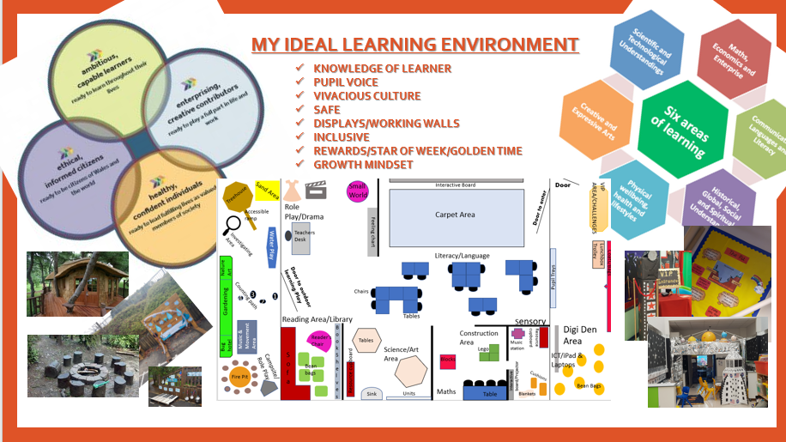
My learning Environment
A classroom environment is one of the main factors that influences children’s learning. It should be a safe place that heartens communication, exploration and develops many relationships at different levels (Montessori St Nicholas, 2018). Therefore, enthusing the correct layout by providing the children with a positive and supportive environment should allow them to learn and engage better. (Dorman, Aldridge, & Fraser, 2006). This includes making a child feel like they belong, certifying their trust and providing them with encouragement. You should also urge them to take risks, believe and challenge themselves to push further (Bucholz & Sheffler, 2009). It’s about encouraging that growth mindset. Therefore, I will consider the aspects of my ideal learning environment and state how it will create the constructive learning experiences mentioned above.
I have based my learning environment in a foundation phase classroom and within this environment, I would create themes termly, weekly or monthly to suit the needs of the children. These themes would be chosen and decided upon by pupil voice as it is important to teach and engage them through their own interests rather than structured learning. I would then work and co-ordinate my planning around this. I feel this strategy is important as it has been identified children can absorb information better when they are more familiar with their surroundings (Bransford, Brown and Cocking, 2000). Using a theme-based curriculum is a way of applying knowledge through cross-curricular activities whilst also engrossing the children through an interest. Donaldson (2015) highlights six areas of learning and four vital purposes in the successful futures report which can be covered in activities based on one theme. This is an opportunity for imagination and creativity to thrive in the environment for not only the teachers but the children too (Bransford, Brown and Cocking, 2000). Not only does implementing themes help cross curricular activity, outdoor learning plays a significant role too. According to Learning (IOL) (2009) outdoor learning is an extensive expression that incorporates education, skills, play and the natural environment. Creating forest schools in the outdoor learning is also important as it allows the children to grow and experience the importance of the natural environment and hold sustainability. Rousseau (1762) believed that children growing up outside in nature allows them to create an understanding and care for a healthy environment and nature itself. By providing the children with areas such as the gardening patch and bug hotel it enhances the caring and real-life provision set out in that area. The outdoor environment allows for space and free movement which providentially, the Foundation Phase (learning.gov.wales, 2015) has recognised. The environment is dynamic and helps children to develop cognitively as well as physically in fine and gross motor skills. It is an area of learning that reinforces children to find their role and most importantly find their voice, making it a vital tool in the learning process (Waite, 2017).
Digital competence is another tool in which I would reinforce throughout my learning environment. Outside my classroom I have created a ‘Digi den’ area which allows the children to independently go off and engage with an activity. I made the area comfy with cushions and safe to enable them to fully relax and engross themselves in their learning environment. Permitting the children time away from the classroom will also allow me as a teacher and them as my students to build up trust for one another and allocate them to take some control of their learning. I also feel that by implementing digital competence into the learners it ties together real life with schooling. By applying it to real-life context, Donaldson (2015) supports digital competence and proposed it’s importance in one of his four purposes “develop enterprising, creative contributors, ready to play a full part in life and work”. Technology has advanced tremendously over the recent years making it essential for all children and young adults to equip and prepare themselves for the present need. Therefore, in my learning environment, I would prioritise the learning opportunity throughout all curricular areas and ensure the children are interacting with technology in different situations daily. However, in stating that, I would not plan for the use of technology if it was not relevant to a child’s learning and the set of skills targeted at that time.
My classroom proposes space, its attractive and appealing and has many zones to explore. My aim is to incorporate these areas and ideal resources to ensure that children can reach their state of flow in any learning activity. This incorporates Csikszentmihalyi’s theory of positive psychology. Through thorough examination Mihaly Csikszentmihalyi found that people acquire contentment during a state of consciousness called flow (Mutucumarana. 2012). Whilst in this state, they become engrossed in an activity. This engrossment is also known to strengthen if it involves an activity that entails their creative ability. Once a person hits this optimal stage, they become more alert, feel strong and have effortless control allowing them to reach their peak ability. To ensure this is cultivated for each person, it is important to prepare an environment and inclusive strategies that will challenge a person. Though, the challenge set will not be too difficult or simple. All six areas of learning have been built into my classroom to ensure that the children can be challenged at all times and hopefully reach the peak flow multiple times in the class year. It is also essential to ensure every child feels they have a sense of belonging and feels comfortable and safe within this environment, I would include many key approaches to ensure well-being was promoted. This would include; a physical initiative similar to the learning event of a run daily and also praising children’s work, behaviour and efforts by rewarding them success awards.

Conclusion
In conclusion, it is evident to see that the importance of studying a critical incident is to ensure a teacher can reflect on their own teaching practice, link it with relevant theory and improve your style and teaching strategies. It’s not to focus on the things that didn’t go right or according to plan (Mcgrane & Lofthouse, 2010). In this learning event, I saw that the learning synchronised the social constructivist theory by Lev Vygotsky. A central belief was that language and social contact was effectively a key role in enhancing development. By engaging in social interaction, it allowed the children to learn from one another, strategise and develop a deeper understanding of the sub-topic being taught. Therefore, when analysing their learning objectives, it was aiding them to reach the goals set. It is clear to see that that constructivist view is an approach well attained in the classroom and I will be sure to use it in future practice. It is also evident to see that by providing the children with a vibrant and appealing learning environment the children will naturally want to explore and discover new things. The outdoor learning environment includes many aspects which will have a positive influence on a child’s learning development. These being; water play, sand play, investigate area, music sera, gardening, nature and bug hotel, campsite and a treehouse to hold learning time. The learning event I observed has allowed me gain further and deeper knowledge on the theories that enlighten teaching practice today. After reflecting on this and designing my own ideal learning environment it has enabled me to form my own ideas on what effective teaching practice is. As a result, I have been able to recommend improvements and suggest what I would see as good teaching practice to use in the near future.
APPENDIX
Appendix A: A conversation dialogue to show the talk used during observation between teacher and class
Teacher: What strategy did you use child 1?
Child 1: I counted on in 1s
Teacher: Can you show me how you done it on your whiteboard?
Child 1: Yes (holds up whiteboard)
Teacher: What did you use to help you count 10 ones?
Child 1: I used a number line Teacher: Well done. That is method 1.
Teacher: Right, so who can tell me a second method?
Teacher: Child 2, what method did you use?
Child 2: I used the tens and units method
Teacher: What did you change?
Child 2: I crossed out 1 and put a 2. I added one more 10 the one.
Teacher: Yes, that’s right. We add 1 to make 2 and the units stay the same.
Teacher: We have one more method. What did you use, child 3?
Child 3: I done a 100 square and jumped down 1 space.
Teacher: Fantastic. That’s our 3rd and final strategy.

Teacher: Well done. That is method 1.

Appendix B: A visual representation to show the methods the children drew up on their whitebeards and discussed with class teacher. ’10 more than…’

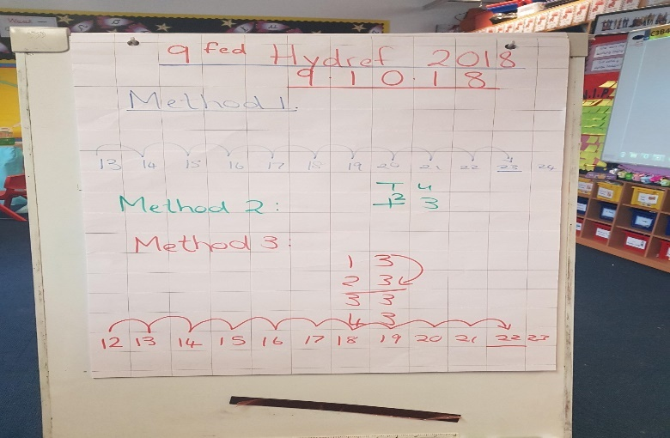

Appendix C: The Analog Clock poem to introduce time. Poem had been sent home to support the children’s ‘Flipped Learning’.

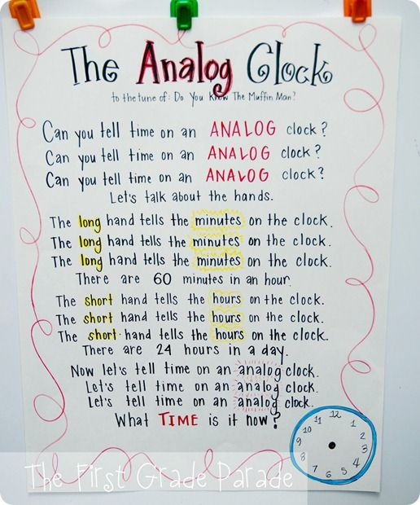

Appendix D: A visual representation of the human clock in group work

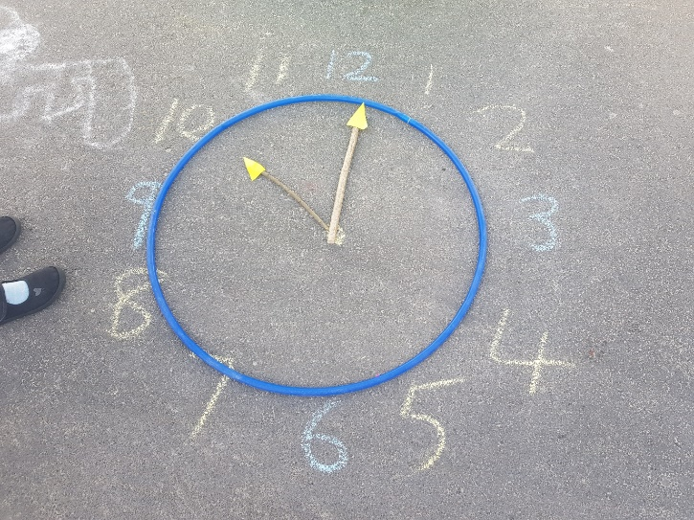

Appendix E: A conversation dialogued between two children on time

Child 1: “show me quarter to 10”
Child 2: “I put this hand here”
Child 2: “Did you say quarter past or to”
Child 1: “Quarter to!”
Child 1: “That’s the longest hand”
Child 1: “Quarter TO 10”
Child 1: “The big hands on the wrong one”
Child 2: “Am I right?”

Appendix F: Diagram to show the ZPD theory by Lev Vygotsky

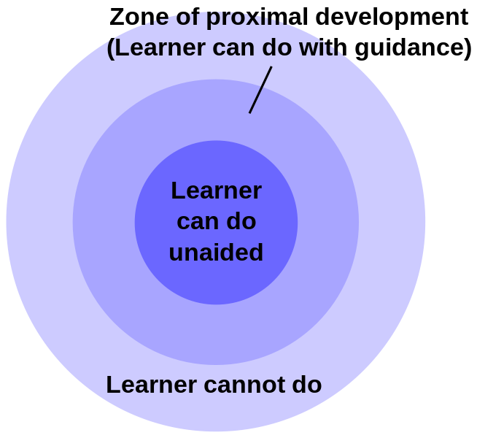

REFERENCES
Bransford, J., Brown, A. and Cocking, R. (2000). How people learn. 2nd ed
BERA. (2011). Revised Ethical Guidelines for Educational Research. Available at: www.bera.ac.uk/wp-content/uploads/2014/02/BERA-Ethical-Guidelines-2011.pdf?noredirect=1
Bucholz, J. L., & Sheffler, J. L. (2009). Creating a warm and inclusive classroom environment: Planning for all children to feel welcome. Electronic Journal for Inclusive Education, 2(4). Available at: http://corescholar.libraries.wright.edu/cgi/viewcontent.cgi?article=1102&context=ejie
Bruner, J. S. (1966). Toward a theory of instruction, Cambridge, Mass.: Belkapp Press.
Chaiklin, S. (2003). The zone of proximal development in Vygotsky’s theory of learning and school instruction. 39-64. Available at: http://www.cles.mlc.edu.tw/~cerntcu/099-curriculum/Edu_Psy/Chaiklin_2003.pdf
Donaldson, G. (2015). Successful futures. Independent Review of Curriculum and Assessment Arrangements in Wales.
Dorman, J. P., Aldridge, J. M., & Fraser, B. J. (2006). Using students' assessment of classroom environment to develop a typology of secondary school classrooms. International Education Journal, 7(7), 906–915
Fosnot, C. (2005). Constructivism. New York: Teachers College Press.
Gray, L. and Ferrell, G. (2013). Feedback and feed forward. [online] Jisc. Available at: https://www.jisc.ac.uk/guides/feedback-and-feed-forward.
Learning.gov.wales. (2015). curriculum for wales. [online] Available at: http://learning.gov.wales/docs/learningwales/publications/150803-fp-framework-en.pdf
McLeod, S. A. (2008). Bruner. Available at: https://www.simplypsychology.org/bruner.htm
Montessori St Nicholas. (2018). The Montessori Learning Environment - Montessori St Nicholas. [online] Available at: https://www.montessori.org.uk/about-us/what-is-montessori/the-montessori-learning-environment.
Mutucumarana, H. (2012). Csikszentmihalyi and Happiness. [online] Pursuit-of-happiness.org. Available at: https://www.pursuit-of-happiness.org/history-of-happiness/mihaly-csikszentmihalyi/
Pritchard, A. (2015) Ways of learning: Learning theories and learning styles in the classroom. London: Routledge.
Richardson, G. (2018). Open up to outdoor mathematics. [online] Ltl.org.uk. Available at: https://www.ltl.org.uk/nsgw/documents/LTL-Maths-Early-Years-Booklet-final1432742138.pdf
Rousseau, J-J. (1762). The social Contract. London: Penguin.
Wadsworth, B. J. (2004). Piaget's theory of cognitive and affective development: Foundations of constructivism. Longman Publishing.
Waite. S. (2017) 2nd edition. Children learning outside the classroom. From birth to eleven. London: Sage.

