

Module name: Protecting and Supporting families in Health and Care
Module number: BMHP5021
Student name: Melania Ciornei
Student number: 2329516
Lecturer name: Robert Nartowski

Table of contents
Introduction and Early Help System……………...........................................................3
Explanation of the Multi-Agency working……………………………………………………..........4
Evaluation of Local Authority Websites…………………………………………………................5
Leicestershire County Council……………………………………………………………………6
Norfolk County Council……………………………………………………………………...7
Leeds County Council……………………………………………………………………….9
Comparative Analysis……………………………………………………………………………….11
Conclusion with recommendations for improvement…………………………………………….12
References list……………………………………………………………………………………....13

- Introduction
Early Help is a central component of safeguarding policy in England, designed to identify emerging needs before they escalate into statutory intervention (DfE, 2023). Positioned within the preventative duties of Section 17 of the Children Act 1989 and national guidance in Working Together to Safeguard Children (DfE, 2023), Early Help reflects an expectation that professionals collaborate to support families at the earliest point of concern. The Early Help System Guide (DLUHC & DfE, 2022) further stresses that families must be able to access support quickly, including through clear digital signposting.
In the digital era, online information has become a critical aspect of safeguarding (Munro, 2011). Research shows that many families first seek help online, meaning accessibility, clarity and navigation strongly influence engagement with support services (SCIE, 2024; NSPCC, 2023). However, digital exclusion linked to poverty, language barriers and limited digital literacy can delay help-seeking and heighten safeguarding risks (Gov.uk, 2023; NHS Digital, 2023). Recent initiatives, such as the Supporting Families Programme 2022–2025, reinforce the need for accessible digital guidance and early intervention.
This report examines how Leicestershire, Norfolk and Leeds local authorities communicate and signpost Early Help online by analysing their website accessibility, clarity, and safeguarding alignment, followed by a comparative evaluation and recommendations for improvement.

- Early Help System
The Early Help System Guide defines Early Help as “a coordinated network of services, processes and interventions designed to support children and families at the earliest indication of need” (DLUHC & DfE, 2022). It does not function as a single service but operates as a whole-system approach spanning universal, targeted and specialist provision. This reflects the reality that challenges faced by families rarely exist in isolation and require support that is flexible, locally responsive and collaborative.
The core purpose of Early Help is prevention, aiming to improve outcomes before difficulties escalate into statutory intervention. Rather than intervening only when risks become acute, Early Help encourages voluntary, family-led engagement at the earliest opportunity (EIF, 2022). Brown and Green (2019) argue that intervention is most effective before thresholds are met, reinforcing its preventative focus. Research also shows that families are more likely to seek support when information is clearly signposted, particularly during high-stress periods (Research in Practice, 2022; NSPCC, 2023). This indicates that accessibility is not simply a communication preference but a safeguarding priority.
Early Help aligns with wider legislation, particularly Section 17 of the Children Act 1989, which places a statutory duty on local authorities to safeguard and promote the welfare of children in need (DfE, 2023). Both the Early Help System Guide (DLUHC & DfE, 2022) and Working Together to Safeguard Children (DfE, 2023) emphasise that effective Early Help relies on multi-agency coordination, informed consent and clear referral pathways. The Early Help System Guide also outlines five maturity descriptors — family voice, workforce development, community partnerships, leadership and accountability, and use of evidence — to support strategic improvement at local level. However, researchers argue that Early Help can be undermined by inconsistent funding and postcode lottery variations, meaning access to support can depend heavily on where families live (LGA, 2023).
These principles underpin the analysis within this report, which evaluates how Leicestershire, Norfolk and Leeds local authorities communicate and signpost Early Help through their online platforms.

c) Multi-Agency Working
Multi-agency working is a fundamental component of the Early Help system and is embedded within statutory safeguarding frameworks. It refers to professionals from different agencies, such as social workers, schools, health practitioners, housing services and police working together to support families in a coordinated way. Working Together to Safeguard Children (DfE, 2023) states that local safeguarding partnerships must include three statutory partners: the local authority, the police and the Integrated Care Board (ICB). These organisations share responsibility for identifying needs early and ensuring that families receive support at the earliest point of concern.
Effective multi-agency collaboration enables professionals to respond to complex and interconnected issues such as domestic abuse, mental health difficulties, school absence, parental conflict and financial instability, issues which rarely occur in isolation (NSPCC, 2023; Atkinson and Stanley, 2020). Approaches such as Team Around the Family (TAF) and Family Hubs bring professionals together through joint assessments and shared action plans. This supports a holistic view of the family rather than focusing on individual concerns. In my analysis of the three local authorities’ websites, I have assessed whether their digital signposting reflects this coordinated approach.
This collaborative model aligns with the principle of a “no wrong door” system, where families do not need to understand complex service structures themselves. Instead, any professional they approach should be able to help them access the right service. Comparable approaches across the UK reflect similar principles: Scotland’s GIRFEC framework promotes “one child, one plan”, while Wales and Northern Ireland use tools such as JAFF and UNOCINI to coordinate support across agencies (Scottish Government, 2022; Welsh Government, 2017).
Working Together to Safeguard Children (DfE, 2023) also emphasises the importance of informed consent, information sharing and clear referral pathways. Therefore, local authority websites must present multi-agency processes clearly, using plain language, visual tools and accessible guidance. Without this clarity, families may struggle to understand how services connect, leading to delays in intervention, particularly for those experiencing digital exclusion or stress. This shows that digital accessibility is not optional, but essential to safeguarding practice.
d) Evaluation of Local Authority Websites
The quality of digital signposting is not merely informational, SCIE (2024) argues that poor web design can delay safeguarding responses by preventing timely referrals during periods of family stress. Tables 1–3 have been included to clearly present the strengths and weaknesses identified in each local authority website.
Leicestershire County Council
The Leicestershire County Council website presents Early Help information across multiple webpages, including the Safeguarding Partnership site, which makes navigation challenging during periods of stress (Leicestershire County Council, 2025). As shown in Figure 1, the homepage displays a wide range of topics, but Early Help is not visibly signposted. Instead, users must rely on dropdown menus and the search function to locate relevant support, which may disadvantage families with limited digital literacy or language barriers (SCIE, 2024).
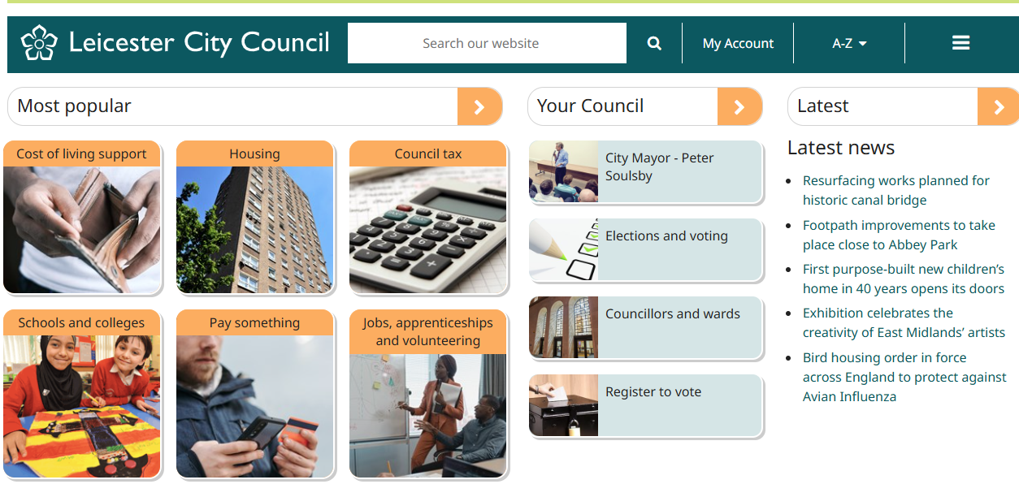
Figure 1. Homepage of Leicestershire County Council (Leicestershire County Council, 2025).
In addition, Early Help cannot be accessed directly and must be manually searched, as shown in Figure 2, where suggested results appear only after typing into the search bar. This approach may create delays in help-seeking and increase anxiety during times of family stress, particularly when a clear landing page is absent (Research in Practice, 2022). The use of professional terminology such as “thresholds” and “levels of need” may further discourage voluntary engagement among families with lower literacy levels (Frost, Abbott and Race, 2015), contradicting inclusive safeguarding principles.
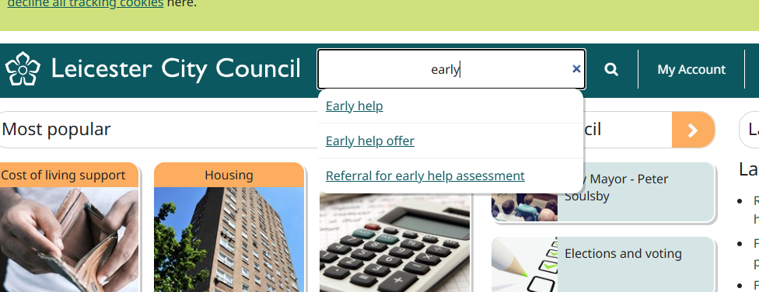
Figure 2 . Search results for ‘Early Help’ on Leicestershire website (Leicestershire County Council, 2025).
As shown below in Table 1, while Leicestershire offers a wide range of services and references multi-agency working, the lack of clear signposting and referral pathways limits accessibility. This falls short of the “no wrong door” model outlined in Working Together to Safeguard Children (DfE, 2023), which requires clear and timely access to Early Help support.

Table 1. Evaluation of Leicestershire County Council
Strengths | Weaknesses
Wide range of services | Information spread across multiple sites
Multi-agency references | Use of professional language
Local service directory | No clear online referral form

Norfolk County Council
Early Help is clearly integrated with Family Hubs on the Norfolk County Council website, demonstrating strong multi-agency coordination and alignment with the “no wrong door” principle (DLUHC & DfE, 2022). As shown in Figure 3, the website provides a dedicated ‘Children and Families’ section, which makes navigation easier compared to Leicestershire
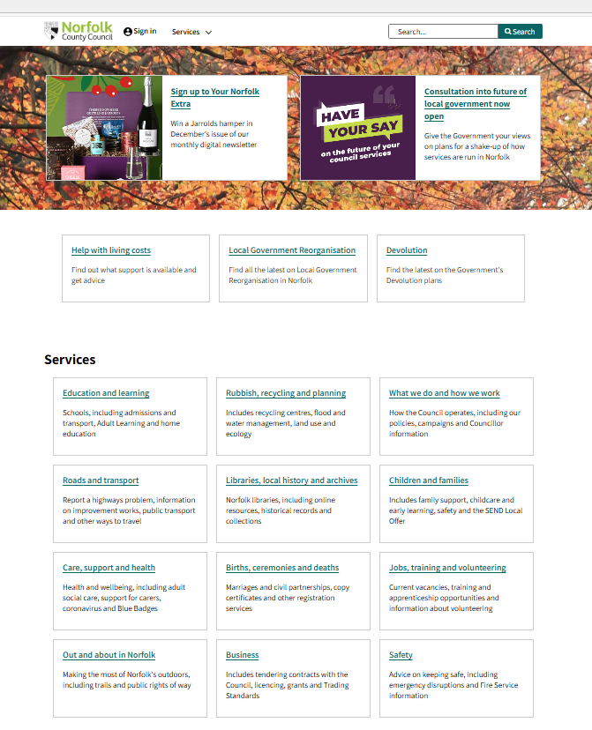Figure 3. Homepage of Norfolk County Council (Norfolk County Council, 2025).
Within this section, Early Help is signposted clearly, with a link titled Early help for children and families, as shown in Figure 4, allowing users to access support quickly. This reflects a preventative and user-friendly approach, consistent with expectations in Working Together to Safeguard Children (DfE, 2023).
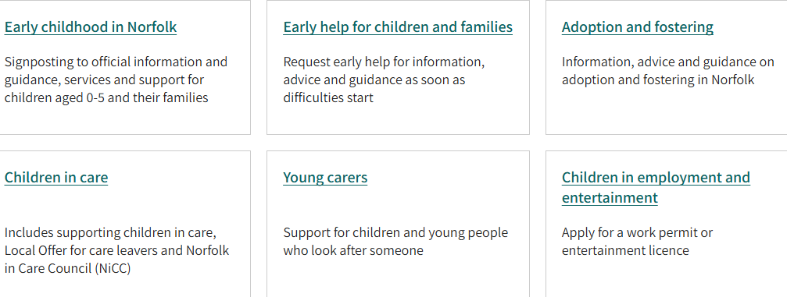
Figure 4. Children and families section of Norfolk County Council (Norfolk County Council, 2025).
However, despite clear navigation and inclusive language, the website lacks visual tools such as flowcharts or step-by-step referral guidance, which may support accessibility for neurodivergent users and those with lower literacy levels (SCIE, 2024; NICE, 2023). Some guidance documents also open externally as PDFs, which may reduce usability on mobile devices and contribute to digital exclusion.
As shown in Table 2, Norfolk provides the strongest family-facing Early Help model of the three local authorities, although improvements such as mobile-friendly design, translation tools and visual referral pathways would further enhance accessibility (Norfolk County Council, 2025).
Table 2. Evaluation of Norfolk County Council
Strengths | Weaknesses
Easy to navigate | Few visual tools
Inclusive language | Some guidance hosted externally
Online referral form
Emphasis on early support

Leeds County Council
Leeds presents Early Help using distinctive tools such as One Minute Guides, which summarise complex information into short, accessible formats. This approach reflects an understanding that lengthy policy documents can be overwhelming during periods of family stress and supports non-specialist accessibility (SCIE, 2024). Importantly, Leeds defines Early Help as “an approach, not a service” (Leeds City Council, 2025), showing strong alignment with the preventative safeguarding principles outlined in Working Together to Safeguard Children (DfE, 2023). The inclusion of Family Hubs and an Early Help Front Door indicates an awareness of multi-agency collaboration and the “no wrong door” model promoted in national guidance (DLUHC & DfE, 2022).
However, as shown in Figure 5, Early Help is not directly visible on the homepage. Navigation requires users to select multiple options before reaching relevant support, which may disadvantage families experiencing stress, lower digital literacy, or limited knowledge of service structures. Early Help pathways are spread across three separate platforms, the main council website, the Family Hubs page and the Safeguarding Partnership site, which places responsibility on families to determine where to begin.
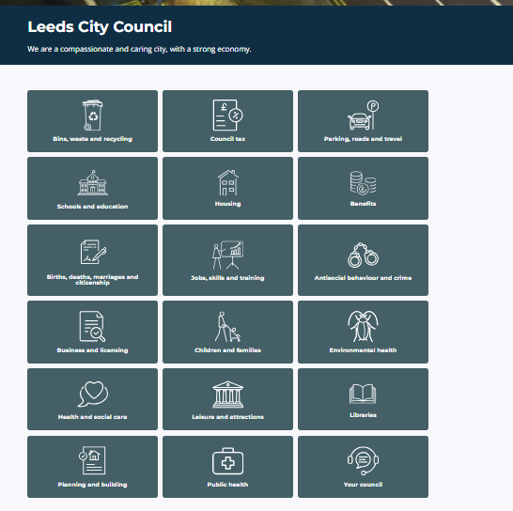
Figure 5. Homepage of Leeds City Council (Leeds City Council, 2025).
As shown in Figure 6, families must enter the ‘Children and families’ section before seeing any reference to Family Hubs or Early Help. While this illustrates structured service categorisation, it may also create unnecessary delays during urgent help-seeking, particularly for individuals facing language barriers, anxiety or digital exclusion (SCIE, 2024).
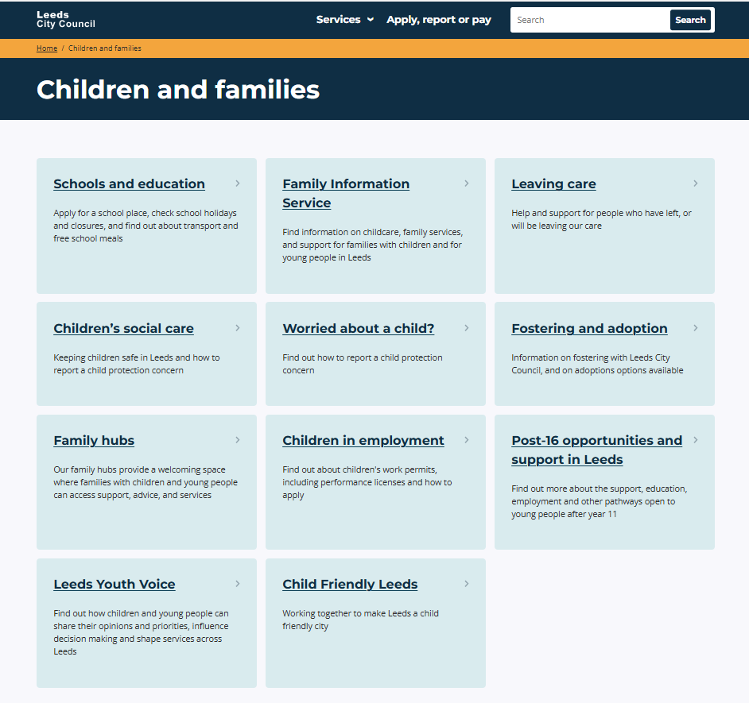
Figure 6. Children and families section of Leeds website (Leeds City Council, 2025).
Although Leeds demonstrates strong conceptual understanding and strategic policy alignment, usability could be significantly improved by consolidating information into a single landing page, offering multiple referral options and incorporating visual signposting to reduce navigation stress during times of need (Leeds City Council, 2025).
Table 3. Evaluation of Leeds City Council – Strengths and Weaknesses
Strengths | Weaknesses
Innovative use of One Minute Guides | Information scattered across sites
Strong multi-agency information | Some professional tone
Clear understanding of policy | No visible online referral form

e) Comparative Analysis
The three local authority websites present Early Help information in different ways, each demonstrating strengths but also displaying shared challenges. Norfolk provides the most family-facing model, using accessible language and offering a visible online self-referral form, which supports early voluntary engagement. Its information is easy to locate through clear menu navigation, making it the most suitable website for families seeking help independently. However, the site would benefit from visual tools and translation options to enhance accessibility for neurodivergent users and those with lower literacy levels.
Leeds demonstrates the strongest policy alignment, describing Early Help as “an approach, not a service” and using One Minute Guides to simplify complex concepts. However, information is spread across multiple websites, which may increase stress for families who need a single-entry point. Although multi-agency working is clearly explained, navigation is inconsistent and referrals are phone-based, creating barriers for users with anxiety or language difficulties. A central landing page with multiple referral options would significantly improve accessibility.
Leicestershire provides a wide range of services and a local directory, demonstrating an understanding of community needs. However, Early Help information is scattered across different webpages and uses professional terminology such as “thresholds” and “levels of need.” This may discourage voluntary engagement and delay support, particularly for digitally excluded families. The absence of a visible self-referral form further reduces accessibility.
Across all three websites, two consistent weaknesses were identified: the absence of visual signposting (e.g., “Start Here” buttons or flowcharts) and a lack of inclusive design features such as translation tools or easy-read formats. This is further evidenced by the fact that none of the websites fully reflect SCIE’s (2024) four accessibility domains - clarity, usability, inclusivity and navigation - suggesting that safeguarding expectations are not yet fully embedded into digital practice. According to Working Together to Safeguard Children (DfE, 2023), local authorities must ensure that families can understand and access support quickly. Therefore, to meet safeguarding expectations, digital platforms must function as active gateways to help, rather than simply information repositories (Ofsted, 2024).

Table 4. Comparison of Website Effectiveness
Area of Comparison | Most Effective | Least Effective
Family-friendly language | Norfolk | Leicestershire
Referral accessibility | Norfolk | Leeds
Ease of navigation | Norfolk | Leicestershire
Policy alignment | Leeds & Norfolk | Leicestershire
Clarity of service model | Leeds | Leicestershire

f) Conclusion and Recommendations
This report concludes that Norfolk County Council provides the most family-focused and accessible approach to Early Help. Its clear language, visible referral route and integration with Family Hubs align strongly with preventative safeguarding principles outlined in Working Together to Safeguard Children (DfE, 2023). Leeds demonstrates strong policy alignment and innovative tools such as One Minute Guides; however, the separation of information across multiple webpages may delay help-seeking. Leicestershire presents a wide range of services but relies on professional terminology and fragmented webpages, potentially discouraging voluntary engagement and delaying access to support.
To strengthen accessibility and digital signposting across all authorities, the following evidence-based recommendations are proposed: clear “Get Help Now” landing pages (Research in Practice, 2022); use of non-stigmatising language (Frost, Abbott and Race, 2015); visual referral tools for neurodivergent and lower-literacy users (SCIE, 2024; UNICEF, 2022); postcode-based Family Hub locators (LGA, 2023); translated, mobile-friendly versions to reduce digital exclusion (Gov.uk, 2023); separation of professional and family-facing content (DfE, 2023); and visible self-referral forms to encourage early engagement (EIF, 2022).
However, digital accessibility alone is insufficient without consistent funding, workforce training and multi-agency collaboration. Ultimately, Early Help is only effective if families can access support quickly, before challenges escalate into crisis.

References
Atkinson, M. and Stanley, J. (2020) Multi-agency working in children’s services: Challenges and best practice. London: Policy Press.
Brown, T. and Green, L. (2019) ‘Multi-agency approaches to child safeguarding’, British Journal of Social Work, 49(3), pp. 456–472.
Department for Education (DfE) (2023) Working Together to Safeguard Children. London: HM Government.
Department for Levelling Up, Housing and Communities & Department for Education (DLUHC & DfE) (2022) Early Help System Guide. London: HM Government.
Early Intervention Foundation (EIF) (2022) Evaluating the impact of family hubs. Available at: https://www.eif.org.uk (Accessed: 21 November 2025).
Frost, N., Abbott, S. and Race, T. (2015) Family Support and Early Intervention: Creating Effective Services. London: Sage.
Gov.uk (2023) Digital inclusion and access report. Available at: https://www.gov.uk/government/publications/digital-inclusion (Accessed: 17 November 2025).
Leeds City Council (2025) Early Help Strategy and One Minute Guides. Available at: https://www.leeds.gov.uk (Accessed: 20 November 2025).
Leicestershire County Council (2025) Help for Children and Families. Available at: https://www.leicestershire.gov.uk (Accessed: 21 November 2025).
Local Government Association (LGA) (2023) Improving access to Early Help services. Available at: https://www.local.gov.uk (Accessed: 18 November 2025).
Munro, E. (2011) The Munro Review of Child Protection: Final Report. London: Department for Education.
NHS Digital (2023) Digital wellbeing and family stress report. Available at: https://digital.nhs.uk (Accessed: 22 November 2025).
NICE (2023) Digital service design guidelines for health and care. Available at: https://www.nice.org.uk (Accessed: 15 November 2025).
Norfolk County Council (2025) Early Help and Family Hubs Information. Available at: https://www.norfolk.gov.uk (Accessed: 17 November 2025).
NSPCC (2023) Early intervention in safeguarding. Available at: https://www.nspcc.org.uk/early-help (Accessed: 20 November 2025).
Ofsted (2024) Local authority support services: Inspection findings. London: Ofsted.
Research in Practice (2022) Family support and Early Help: Evidence review. Available at: https://www.researchinpractice.org.uk (Accessed: 20 November 2025).
Scottish Government (2022) GIRFEC Framework: Getting It Right for Every Child. Available at: https://www.gov.scot (Accessed: 20 November 2025).
Social Care Institute for Excellence (SCIE) (2024) Digital safeguarding and accessibility standards. Available at: https://www.scie.org.uk (Accessed: 20 November 2025).
UNICEF (2022) Guidelines for child-friendly digital services. Available at: https://www.unicef.org (Accessed: 24 November 2025).
Welsh Government (2017) JAFF and multi-agency frameworks in Wales. Cardiff: Welsh Government.

