

Sustainable Business – The role of sustainability in business and organisations within the area of Llandeilo, Carmarthenshire.

BA Business and Management – BMSP6018

Sarah Carr – 2107448



Declaration

- This work has not been previously accepted in substance for any degree and is not being concurrently submitted in candidature for any degree.

- This dissertation is being submitted in partial fulfilment of the requirements for the degree Business and Management.

- This dissertation is the result of my own independent work and investigation, except where otherwise stated.

- Other sources are acknowledged by footnotes giving explicit references. A bibliography is appended.

- I hereby give consent for my dissertation, if accepted, to be available for photocopying and for interlibrary loan, and for the title and summary to be made available to outside organisations.

Name: ……………………Sarah Carr ………………………..
Date of Submission: …………………………30th April 2024…………………..
Signature: ………………………S Carr……………………..

Acknowledgements

I wish to thank everyone who took the time to help me with any part of this dissertation especially the 104 participants in the survey.

I would like to thank all the lectures at UWTSD Business School for all their help, encouragement and understanding over the last three years.

I owe a big thank you to my husband and two teenage boys, who continually reassured me that I could complete this course and who sacrificed many days out and time together so I could study.

I would finally like to thank the class of 2024. The first day on campus was terrifying, but over the last three years we have all grown together and have gained so many new friends. There is one person in particular, who kept me sane, smiling, laughing and full of snacks during every class without her the last three years wouldn’t have been the same.

Figures and Tables
Figures
Figures | Name and Reference | Page Number
Figure 1 | Sustainable Development Goals  (United Nations,2022) | Page 10
Figure 2 | The Circular Economy  (WDO,2020) | Page 11
Figure 3 | Three P’s of the Triple Bottom Line (Miller,2020) | Page 12
Figure 4 | Carroll’s CSR Pyramid (Carroll,2016) | Page 13
Figure 5 | The Research Onion Model (Saunders, Lewis, Thornhill,2019) | Page 16
Figure 6 | Location of Business or Organisation | Page 22
Figure 7 | Age of Participants | Page 23
Figure 8 | Trading length of business or organisation | Page 24
Figure 9 | List of industries surveyed. | Page 25
Figure 10 | How important sustainability is to participants | Page 27
Figure 11 | Participants effort to reduce environmental impact. | Page 28
Figure 12 | Current sustainable practices. | Page 29
Figure 13 | ‘Other’ sustainable practices | Page 30
Figure 14 | How do you package your final product? | Page 31
Figure 15 | Reducing Carbon Footprint statement response. | Page 32
Figure 16 | Reasons for no sustainable practices | Page 33
Figure 17 | Other’ reasons for no sustainable practices | Page 34
Figure 18 | Importance of suppliers ‘green’ credentials | Page 35
Figure 19 | Rating of support from local council and Government | Page 36
Figure 20 | What services would you like to see implemented? | Page 37

Figure 21 | Do you have an environmental management system in place? | Page 38
Figure 22 | Would you participate in an award scheme? | Page 39

Tables

Table 10 | Participating Industries | Page 26

Table of Contents
Chapter 1 – Introduction. 7
1.1Purpose of Research 7
1.2 Research Question 7
1.3 Overview of the Study 8
Chapter Two – Literature Review. 9
2.1 Introduction 9
2.2 Sustainable Development Goals 9
2.3 Circular Economy 11
Ellen MacArthur Foundation 11
2.4 Three P’s of Sustainability 12
2.5 Corporate Social Responsibility 13
Carroll’s Corporate Social Responsibility Pyramid 13
2.6 Legislation 14
Post Brexit Legislation 14
2.7 Why aren’t businesses becoming sustainable? 14
Chapter Three – Methodology. 16
3.1 Introduction 16
3.2 Research Design 16
Approaches 17
Strategies 17
Choices 18
Time Horizon 18
Techniques and Procedures 18
3.3 Limitations 20
Sample Size 20
Online Survey 20
3.4 Ethical Considerations 20
3.6 Summary 21
Chapter Four – Findings and Analysis. 22
4.1 Introduction 22
Question 1 22
Question 2 23
Question 3 24
Question 4 25
Question 5 27
Question 6 28
Question 7 29
Question 8 31
Question 9 32
Question 10 33
Question 11 35
Question 12 36
Question 13 37
Question 14 38
Question 15 39
4.2 Findings Overview 39
Chapter Five – Discussion. 41
5.1 Introduction. 41
5.2 Research Questions 41
Question 1 41
Question 2 41
Question 3 41
Question 4 42
Question 5 42
Chapter Six – Conclusion. 43
6.1 Introduction 43
6.2 Recommendations 43
Recommendation 1 43
Recommendation 2 44
Recommendation 3 44
6.3 Further Studies 44
Chapter Seven – Bibliography. 46
Chapter Eight – Appendices 50
9.2 Questionnaire 50

Chapter 1 – Introduction.

1.1Purpose of Research
The purpose of this research is to investigate the role of sustainability in businesses and organisations in a rural community in West Wales. There is a continued debate on the effects of climate change due to large corporations, and what they need to do to improve those issues. However, this study will look at small, independent businesses. Small and medium businesses are crucial to the overall stability of the global economy, they account for over 95% of all businesses (Thompson, 2014).

1.2 Research Question
This research project will look at the role of sustainability in the business and organisations withing the market town of Llandeilo, Carmarthenshire.

The motivation for this study comes from our ever changing world. Since the beginning of the Industrial Revolution human activities have rapidly increased the volume of emissions into the Earth’s atmosphere. In 2021, the Intergovernmental Panel on Climate Change’s (IPCC) report, Climate Change 2021: The Physical Science Basis stated that the “average atmospheric carbon dioxide levels have increased from 280 parts per million to 410 parts per million in the last 150 years” (IPCC, 2021).

To make any change to the world we live in everyone must do their part. The aim of this project is to investigate how businesses and organisations are changing the standard model of business to incorporate more sustainable practises. The study will be focused on businesses and organisation within a five mile radius of Llandeilo in Carmarthenshire, Wales.

The research project will look at,
- Do businesses and organisations have a sustainable approach in place,
- Is sustainability an important factor within their business or organisation,
- What are the reasons against sustainability?
- How can the local council or Welsh government help businesses reduce their environmental impact?
- Are suppliers or contractors ‘green’ credentials important factors.

These questions will be answered by conducting research to gather evidence and a short survey distributed to local businesses within the five miles of the town centre.

1.3 Overview of the Study
The introduction to the research study will present background information on the chosen topic, sustainable business as well as introduce the research question, aims and objectives of the project. Chapter two will highlight relevant literature, theory and research conducted with regards to sustainability within small businesses and that in rural communities where applicable. Following the literature review, the methodology of the study will be explained and will give justification for the methods used for data collection including any limitations, ethical considerations, and analysis methods.

Chapter four will contain the results from the data collection which will be converted into graph form using Microsoft Excel to create a visual representation of the results, followed by an analysis of the findings. In chapter five I will discuss the findings, and finally chapter six concluding with my list of recommendations for the future of this issue and possible avenues for further research.

The following are the research objectives for this study,
- To investigate the need for sustainable business, by researching the social, financial, and environmental impacts.
- To analyse the current situation with business
- To identify the common barriers and strategies facing businesses and organisations by collecting data.
- To evaluate and compare the data to achieve the behaviours of small businesses compared to that of secondary research findings.

Chapter Two – Literature Review.

2.1 Introduction
It can be suggested that business historians have documented how businesses have made the world unsustainable. The twentieth century is unique in its history for all its technological and industrial advancements. Those global developments also drastically increased the rate of climate change and scientists began to inform people of the dangers. Since the end of the First World War, emissions into the atmosphere have skyrocketed. Statistics from the U.S. National Oceanic and Atmospheric Administration shows that the levels of Carbon Dioxide in the atmosphere are fifty percent higher in 2022 than before the industrial period (Little, 2023).

Many argue that the effect of Industrial capitalism and globalisation are the main culprits to the environmental crisis the world is currently facing. It can be suggested that business historians have been documenting for many years, how businesses have made the world unsustainable (Bergquist, 2017).

Sustainability is often thought of as being a new phenomenon. However, environmental historians have shown that concerns with regards to the environment and conservation go back as far as the late nineteenth century. A group of entrepreneurs began to suggest that preventing pollution recycling, access to healthy food and renewable energy was their responsibility (Rosen, 1995).

2.2 Sustainable Development Goals
Sustainability is now becoming a critical part of many businesses across the world. The release of the Brundtland Report by the World Commission on Environment and Development (WCED) in 1987, brought the concept of sustainability to the forefront. The report also known as ‘Our common future’ defined sustainable development as ‘development that meets the needs of the present without compromising the ability of future generations to meet their own needs’ (Brundtland, 2021).

The sustainable development goals were created in 2012 at the United Nationals Conference on Sustainable Development in Rio de Janeiro.

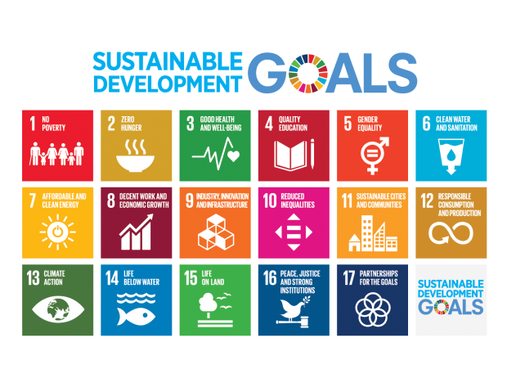
Figure 1 - The Sustainable Development Goals - (United Nations, 2022)

The sustainable development goals were created to transform the world. They are a ‘call to action’ to end poverty, inequality, to protect the planet and to make sure that all people enjoy health, justice, and prosperity. In 2015, all the countries within the United Nations, at the time one hundred and ninety three members, agreed and adopted the agenda for sustainable development as part of a 15 year plan. The agenda sets out seventeen goals, which includes 169 targets (World Health Organisation, 2023). As shown in figure 1, the goals range from zero hunger, climate action, industry, innovation and infrastructure to responsible consumption and production. Creating these goals is giving businesses and organisations all over the world the opportunity to adopt and implement them into their day to day tasks and help combat the effects of climate change.

2.3 Circular Economy
The circular economy is a closed loop system. Its objective is to reduce waste and use the resources available to create new life cycles of products. In a circular economy ‘today’s products are tomorrow’s raw materials’ (PWC, 2018). It is designed to use the resources to their maximum potential unlike linear models where a product is produced, used and disposed. The main aim of a circular economy is to ‘keep products, components and materials at their highest utility and value at all times’ (Deutz, 2020),
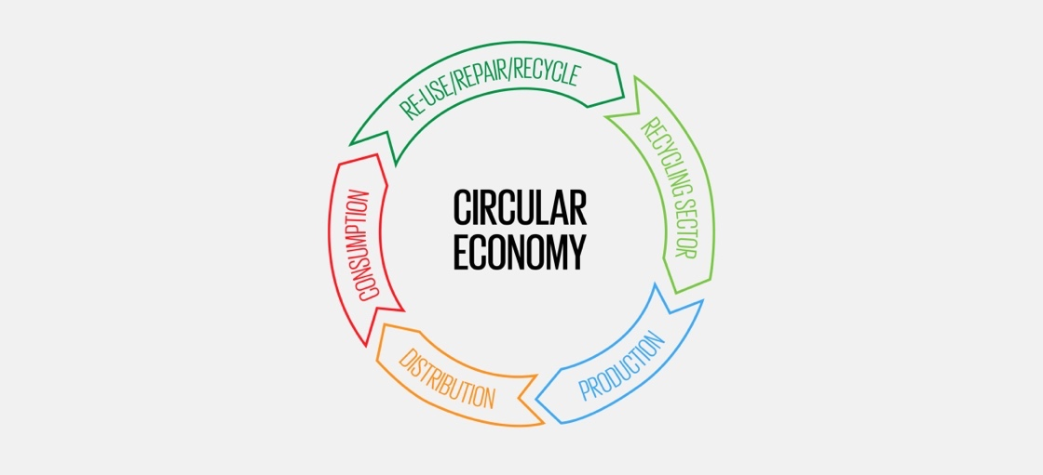
Figure 2 - The Circular Economy Model - (WDO, 2020)

Ellen MacArthur Foundation
The Ellen MacArthur Foundation was launched in 2010. It is an international charity that aims to accelerate the transition to the circular economy worldwide. The foundation develops and promotes the circular economy to combat some of the biggest issues facing people worldwide including climate change, pollution, waste, and biodiversity loss (Ellen MacArthur Foundation, 2023).
The circular economy is based on three principles.
- Eliminate waste and pollution.
- Circulate products and materials.
- Regenerate nature.
At the centre of the circular economy is the idea that all businesses need to adopt the system in order to eliminate waste and pollution of a products lifecycle. In order to do this companies may consider eliminating single use products, and producing items that can do on to be reused or redesigned to create a longer lifecycle (Foti, 2023).

2.4 Three P’s of Sustainability
Sustainability has become a word large corporate business use. The goal of any sustainable business strategy is to positively impact the environment, society, and their shareholders. It’s becoming a well-known fact that implementing these types of sustainable strategies are not only impacting the environmental issues but also increasing a company’s success (Miller, 2020).

The three P’s are also a well-known concept accepted and used by corporations. The three P’s refer to People, Planet and Profit and is often referred to as the triple bottom line.
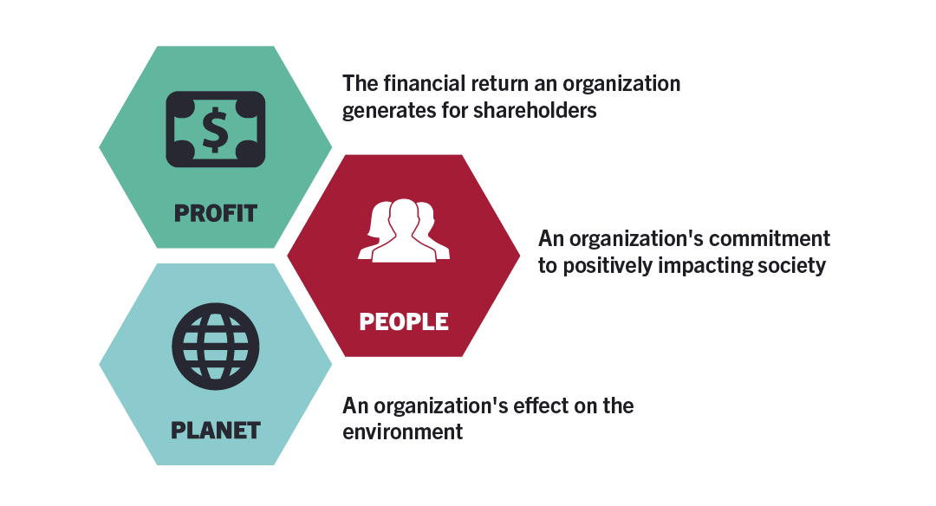
Figure 3 - The 3P’s of the triple bottom line - (Miller, 2020)

Unlike the standard ‘bottom line’ that focuses entirely on profit and loss, the triple bottom like measures the social and environmental impact a business has. There are many benefits to businesses adopting this new concept these include;
- Created value for shareholders.
- Improves brand reputation.
- Attracts new employees.
- Minimises compliances risks.
- Improved investment opportunities.
(MindTools, 2022)

2.5 Corporate Social Responsibility
Howard Bowen defined corporate social responsibility as ‘the obligations to pursue policies, make decisions, or follow lines of action that align with the objectives and values of our society’ (Bowen, 2013).

Carroll’s Corporate Social Responsibility Pyramid
Carroll’s CSR pyramid is a framework that explains how and why CSR principles should be at the centre of every business. The framework (seen in figure 4) was developed by Archie Carroll in 1991, it gives business leaders the information so they can assess their level of social responsibility by meeting the economic, legal, ethical, and philanthropic responsibilities at that present time (Anderson, 2023).
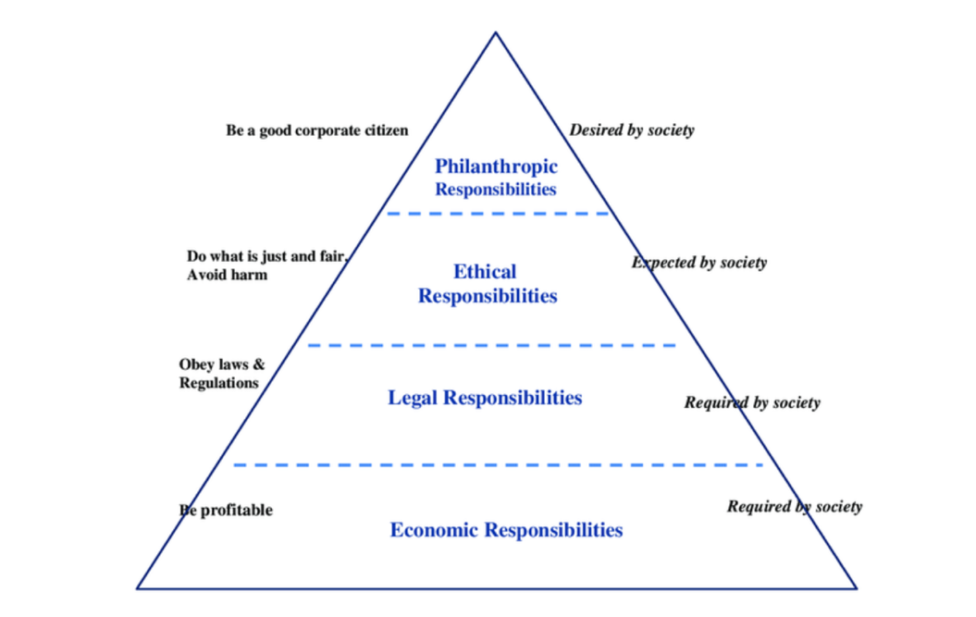
Figure 4 – Carroll’s CSR Pyramid - (Carroll, 2016)

Small business may not have a large budget to designate to CSR. However, CSR doesn’t necessary mean donating money to environmental charities, or planting hundreds of trees. It can be simple and relatively low cost alternatives such as changing to recyclable packaging on products, minimizing the amount of waste produced and lowering energy usage.

2.6 Legislation

Post Brexit Legislation
Before the United Kingdom left the European Union, they followed the legislation and regulations set out by the European environment policy. Once the United Kingdom left rules regarding water quality, clean air, the protection of nature among others were at risk. The Environment Act which became a law in 2021, is the UK’s new framework for environmental protection. The act sets out plans to make provisions for targets, plans and policies to improve the environment. The main aims include to improve air and water quality, protect wildlife, and increase the ability to recycle and reduce plastic waste.

2.7 Why aren’t businesses becoming sustainable?

Sustainability is becoming more and more prominent in our everyday lives. However, there are still some people who argue the topic of sustainability. There are many reasons as to why business are not becoming sustainable.
The cost of living in the United Kingdom has risen dramatically. In the five years costs have increased dramatically due to inflation, shocks to global supply chains and markets due to events such as the Russia, Ukraine War, Brexit, and the Coronavirus pandemic (Kings College London, 2023). Due to these events many businesses are struggling.

With UK government committing that the UK will be net zero by 2050, many businesses could fail to meet that commitment. Research conducted by Simply Business found that out of the one thousand small businesses in the UK surveyed, 57% said that the financial cost effects their sustainability efforts’ (Parrish, 2023). Sustainable goals of small businesses are being forgotten to keep their products at an affordable cost for their customers.

No clear Government guidelines is another difficulty for businesses to become sustainable. Many online forums have discussed the difficultly in understanding the guidelines set out for by the government to be applicable for smaller businesses. Similarly, some businesses believe that sustainability does not fit neatly into their business plan (Laughland & Bansai, 2011).

The argument between the bottom line over the triple bottom line. The lack of guidelines with the triple bottom line concepts leads the doubters to claim that the model is vague, and any business can claim to follow it when in reality they are not. There is no monitoring, therefore business owners can claim to be using it when in reality they are not (Kamando, 2019).

Chapter Three – Methodology.

3.1 Introduction
The focus of this study will be the sustainability approaches within businesses and organisations within Llandeilo, Carmarthenshire. In order to answer the question ‘the role of sustainability in businesses and organisation within the chosen area, this study will take a quantitative approach. This chapter will explain the research design, the data method and collection including any limitations and ethical considerations.

3.2 Research Design
The design of this study will follow the model created by Saunders, the research onion.

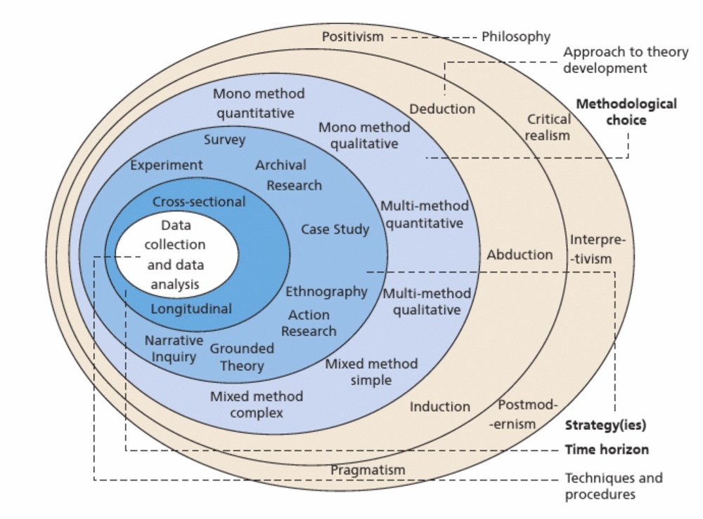
Figure 5 - The Research Onion Model (Saunders, Lewis, & Thornhill, 2019)

This model was primarily designed to be used for research in business studies as it provides a structured framework for designing research studies and selecting the correct techniques (Melinkovas, 2018). The research onion model consist of six layers that ‘symbolically illustrates the way in which different elements involved in the research could be examined to develop the final research design’ (Saunders, Lewis, & Thornhill, 2019).
The six layers as shown in figure 5 consist of philosophy, approaches, strategies, choices, time horizon and techniques and procedures, including survey design, data collection and analysis. There will also be evidence of the sampling, ethical considerations, and limitations of this research study.

Approaches
Theory is critical to any research project. Inductive and deductive research approaches are two forms used by researchers. A deductive research approach is ‘a scientific approach that is used to test a theory or hypothesis through observations and empirical evidence’ (Aransiola, 2023). While an inductive approach ‘begins with a set of empirical observations, seeking patterns in those observations, and then theorizing about those patterns (DeCarlo, 2018).

A deductive research approach will be used in this research project due to the existing related theories related to sustainability business practices and will discuss against the findings of this study.

Strategies
For this research project a quantitative method will be used. A quantitative research method ‘collects statistically significant information from existing and potential customers using sampling methods and sending out online surveys, online polls, and questionnaires’ (Fleetwood D. , 2018). The main characteristics of this type of method is the results can be converted into numerical form, enabling researchers to analyse the data and uses those statistics to derive conclusions.

This research project will use online surveys to gather the data needed. In line with the chosen approach, a semi structured survey will be used, due to its speed, efficiency, and cost effectiveness (Gurbuz, 2017).

The survey will be created using Microsoft forms, and a link to the form will be given to the participants. Before completing the survey, the participants will be asked to read a brief statement outlining the reason for the research study, explaining that all information is anonymous and contact information for the researcher if they require any further information.

Choices
A Mono method is used when research is focused on either a quantitative or qualitative data gathering. A qualitative method is ‘used to understand people’s beliefs, experiences, attitudes, behaviour, and interactions, it generates non-numerical data (Pathak, Jena, & Kalra, 2013).

For this research project a quantitative method will be used. A quantitative research method ‘collects statistically significant information from existing and potential customers using sampling methods and sending out online surveys, online polls, and questionnaires’ (Fleetwood D. , 2018). The main characteristics of this type of method is the results can be converted into numerical form, enabling researchers to analyse the data and uses those statistics to derive conclusions.

Time Horizon
The time horizon is an important part to any research project. It is necessary to specify a timeline for the study. Longitudinal research studies are ‘surveys conducted over time to measure change (Kuhn, 2023). A cross sectional study ‘is a type of research that analyses data of variables collected at one given point in time across a sample population or pre-defined subset’ (Fleetwood D. , 2024).

Techniques and Procedures

Survey design
A questionnaire will be created using Microsoft Forms. It will be a semi structured survey providing both open ended and closed ended questions. The majority will be closed ended questions as they allow for easy and quick answers, simple to analyse and can streamline data collection. However, where more information is needed, open ended questions will be given where the participants can give their answer in as much detail as the feel appropriate. The questionnaire will have fifteen questions and they are listed below;
- Is your business/ organisation located within 5 miles of the market town of Llandeilo, Carmarthenshire?
- What is your age group?
- How long have you been trading as a business or organisation within the area of Llandeilo, Carmarthenshire?
- What sector does your business or organisation belong to?
- Sustainability is an important part of my business or organisation.
- How will you rate your business or organisations effort to reduce its environmental impact?
- What current sustainable practises do you use in your business or organisation?
- How do you package you final product? Do you use any recycled or recyclable materials?
- Reducing your Carbon Footprint/ level of waste is something your business or organisation aims to do in the next 12 months.
- If you do not have any sustainable practises within your business or organisation what is the main reason for this?
- A suppliers ‘green’ credentials impact your decision to purchase from them?
- How would you rate the support from local council/ government in helping businesses and organisations to reduce their carbon footprint?
- What services would you like the local council to implement within the local area to help you become more sustainable?
- Does your business or organisations have an environmental management system in place?
- If there was an award scheme similar to the food hygiene rating, showing how sustainable your business or organisation is, would you participate?

Data Collection
In order to create a list of participants, research will be carried out to identify business within the local area, including visiting the area, online research of social media platforms and previous known history of the area. Once a list has been generated of suitable participants the survey will be distributed via online platforms such as Facebook and Instagram. There will also be emails set out to the participants where available to invite them to take part in the study, as not every business utilises social media.

Analysis
The information gathered for them the questionnaire will be analysed using Microsoft Excel. Excel is a software programme that functions by processing numbers, it can also preform arithmetic and statistical calculations to create reports in the form of tables, graphs, and diagrams (Bao, 2024).

3.3 Limitations

Sample Size
Being able to collect an appropriate sample size could be a limitation. Participation in this study is voluntary and would be against the ethics code of the university to force them.

Online Survey
The questionnaire being available on online platforms could make it difficult for some participants to complete. Many of the business owners in the area of research are part of the older community and many might not want, or do not have access to equipment to participate.

3.4 Ethical Considerations
The research study will be completed following the University of Wales Trinity St David’s ethical standards. Before any participants were contacted with regards to their participation an in-depth ethics form has been completed and received permission from the research supervisor to continue. The confidentiality and anonymity of the participants will be considered. Each participant will be informed that their participation will be voluntary, and they have the right to have their data withdrawn for the study at any time, also none of their personal information will be collected via the questionnaire enabling their answers to remain anonymous. All data collected will be sorted on the university one drive platform with a two authenticator password protection.

3.6 Summary
Saunders’ model, the research onion, has outlined the methodology of this study. A questionnaire following the quantitative method will allow for a larger sample size and more data to be analysed.

Chapter Four – Findings and Analysis.

4.1 Introduction
This chapter will present the findings from the primary research. A total of 106 responses were obtained. These results were obtained by email, face to face interaction, use of social media, local business groups and telephone call requests to businesses asking for their participation in this research study. 4.2 Findings from questionnaire

Question 1
Is your business/ organisation located within 5 miles of the market town of Llandeilo, Carmarthenshire?

Figure 6- Location of Business or Organisation

Figure 6 relates to the first question in the survey, is your business located within five miles of the town centre of Llandeilo? To be a part of this research project the introduction specifically stated that each participant needed to be within the area. 96% of participants answered yes, however 4% checked no. The data collected from the 4% will be removed from the study in order to consistent with the research specifics set out by myself.

Question 2
What is your age group?

Figure 7 - Age of participants

Figure 7 shows us the age groups of the participants in the study. From the graph it can be seen that the largest group that precipitated is between the ages of 35 – 44 at 39% of those surveyed. The second largest groups are 45 – 54 years at 27%, followed by 55 -64 year group at 21% and 25 – 34 years at 8%. The smallest groups are those in the oldest year group 65+ at 2% and youngest 18 – 24 at 3%.

Question 3
How long have you been trading as a business or organisation within the area of Llandeilo, Carmarthenshire?

Figure 8 - Trading length of business or organisation

Figure 8 shows us the trading lengths of the participants surveyed. The largest groups 10 years plus at 30% and 2 – 5 years at 29%.

Question 4
Which sector does your business or organisation belong to?

Figure 9 - Lists of industries surveyed.

Figure 9 identifies the different industries that each participant works within. The table below also shows the number of participants in each industry.

Industry | Participants | Industry | Participants
Accommodation | 2 | Hospitality | 20
Accountancy | 1 | Hotel | 1
Administration | 1 | Information Technology | 2
Agriculture | 11 | Legal | 3
Appliance Testing and Repair | 1 | Manufacturing | 5
Architecture | 2 | PR & Marketing | 1
Art Industry | 2 | Property | 2
Beauty | 2 | Renewable Energy | 2
Care | 2 | Retail | 15
Cleaning | 1 | Third Sector | 1
Construction | 3 | Tourism | 7
Education | 3 | Transportation | 1
Hair and Beauty | 4 | Travel | 1
Health | 3 | Veterinary | 1
Horticulture | 1 | Waste Management | 1

Table 1- Participating Industries

Question 5
Sustainability is an important part of my business or organisation.

Figure 10- How important sustainability is to participants.

The participants surveyed where asked to give their response to the statement, ‘Sustainability is an important part of my business or organisation’. Figure 10 gives us the information from the 102 responses 69 participants strongly agreed or agreed with the statement, 24 gave a neutral response, while 9 either disagreed or strongly disagreed with the statement.

Question 6
How would you rate your business or organisations effort to reduce its environmental impact?

Figure11 - Participants effort to reduce environmental impact.

In question six each participant was asked to rate their current effort to reduce their environmental impact. Figure 11 shows us that none of the participants rated themselves as poor, 28% rated as fair, 41% as good and 24% as very good. The smallest group, 7% rated their current effort to reduce their environmental impact as excellent.

Question 7
What current sustainable practises do you use in your business or organisation? (choose all that apply)

Figure 12- Current sustainable practices
Figure 12 shows us the list of sustainable practices and asked the participants to select all that they currently use.
- 90 of the participants stated they recycle paper, plastic and or glass.
- 54 are reducing their food waste and or composting the food waste.
- 28 currently using renewable energy or trying to lower their energy usage.
- 34 of participants use sustainable packaging for their products.
- 49 currently use local suppliers for their products.
- 48 of those surveyed are currently going paperless within their business where possible.
- 12 of the respondents gave another option to sustainable practices currently used.

Responses to ‘Other’ option

Figure 13- ‘Other’ sustainable practices
The participants were given the option to describe their other sustainable practices in the survey. Figure 13 shows us their responses.
- Working from home.
- Installation of solar panels.
- Recycling products and waste from manufacturing.
- Use of hybrid or low emission vehicles.
- Only offering a delivery service to the immediate local area.
- Using Eco friendly cleaning products.

Question 8
How do you package your final product? Do you use any recycled or recyclable materials?

Figure 14- How do you package your final product?

Figure 14 shows if the participants use recycled or recyclable materials in your final product. The data shows that 57 of the participants declared that this question was not applicable to them. From the remaining participants we can see that 35 said yes, and 4 said no, they do not use recyclable or recycled materials to package their final product. However, 6 of those surveyed said that changing their packaging to recyclable materials is something they would consider.

Question 9
Reducing your Carbon Footprint/ level of waste is something your business or organisation aims to do in the next 12 months.

Figure 15- Reducing Carbon Footprint statement response.

Figure 15 identifies the response to the statement giving to the participants, reducing your Carbon Footprint/ level of waste is something your business or organisation aims to do in the next 12 months’. Almost half 48%, agree with the statement and 19% strongly agree. The smallest group at 2% where the participants that strongly disagreed with the statement.

Question 10
If you do not have many sustainable practises within your business or organisation what is the main reason for this?

Figure 16 - Reasons for no sustainable practices.

Figure 16 shows the options given to the participants in order to determine if they do not have many or any sustainable practices in place, why.
- 39 of the participants stated that cost was the reason.
- 6 stated having no single definition of sustainability.
- 19 believe lack of informative government guidelines.
- Consumers not factoring sustainability into their purchase decisions was the answer for 14 participants.
- 16 participants believe that sustainability doesn’t fit neatly into their business.
- 12 stated ‘other’ reasons.

Results from ‘other’ option

Figure 17- ‘Other’ reasons for no sustainable practices

Question 10 had the option for participants to give further or other reasons as to why they do not have many sustainable practices in place. Figure 17 shows us their responses. They are;
- Impractical alternatives.
- Disagreeing with the climate change argument.
- Planning constraints and or building regulations.
- Single use plastics are unavoidable in medical settings.

Question 11
A suppliers ‘green’ credentials impact your decision to purchase from them?

Figure 18 - Importance of suppliers ‘green’ credentials

Figure 18 gives the responses to the question, does a suppliers ‘green’ credentials impact your decision to purchase from them. 29 participants agreed and 7 strongly agreed with the statement. 44 of those surveyed had a neutral response while 19 disagreed and 3 strongly disagreed.

Question 12
How would you rate the support from your local council/ government in helping businesses and organisations to reduce their carbon footprint?

Figure 19 - Rating of support from local council and Government.
Question 12 asks the participants how the rate the support from local council and government to reduce their carbon footprint. Figure 19 shows the results.
More of the responders claimed the support was poor or fair.
- 27% rated poor and 40% rated fair.
- 26% rated as good.
While 7% rated the support as very good. Not one participant rated the support from local council or government as excellent.

Question 13
What services would you like the local council to implement within the local area to help you become more sustainable?

Figure 20- What services would you like to see implemented?

The respondents were asked to choose from a list of suggested services that the council could implement to help them become more sustainable. Each participant was asked to select as many that would apply to them. Figure 20 shows the results.
- 33 would like to see more recycling centres or drop off points.
- 57 would like a reduction in business rates for sustainable business or organisations.
- 34 selected free advertising or promotional opportunities.
- 67 of those surveyed would appreciate more information on access to sustainable business funding, grants, or loans.
- 58 agreed with more advice and support from local council on sustainable business practices.

Question 14
Does your business or organisation have an environmental management system in place?

Figure 21- Do you have an environmental management system in place.
Figure 21 shows the response to question 14, Does your business or organisation have an environmental management system in place? 72 participants of this survey stated they do not have a system in place within their business. 17 do currently have, and 13 are considering implementing an environmental management system in the future.

Question 15
If there was an award scheme similar to the food hygiene rating, showing how sustainable your business or organisation is, would you participate?

Figure 22 - Would you participate in an award scheme.
The final question asked if they would participate in an award scheme similar to the food hygiene rating, showing customers how sustainable the business or organisation is, would they participate? 68% of those asked agreed to taking part in a similar system while 32% said they would not.

4.2 Findings Overview
Below is a bullet point summary of the main findings received from the research survey:
- 69 participants strongly agreed or agree with the statement that ‘Sustainability is an important part of my business or organisation’.
- 69% of the participants rated their effort to reduce their environmental impact of fair or good.
- Over half of the respondents to the survey currently recycle paper, plastic and glass and also reduce their food waste or composting as part of their sustainable practices.
- Some participants implement other practices such as installation of solar panels, working from home and the use of hybrid or low emission vehicles.
- Out of the 102 participants, 45 of them require packaging their final product. 35 of them currently use recycled or recyclable materials in their packaging, 4 do not and 6 are currently considering the change.
- 67% of participants agree or strongly agree that reducing their waste/ carbon footprint in the next twelve months is something they aim to do.
- Cost was the highest reason given as to why business and organisation do not have many sustainable practices.
- 12 participants gave ‘other’ reasons as to why they do not or have limited sustainable practices, such as impractical alternatives, building regulations, single use plastics being unavoidable in their field and also disagreeing with the climate change argument.
- 36 people agreed or strongly agreed that a suppliers ‘green’ credentials are impacting their decision to purchase for them, 22 disagreed or strongly disagreed with the statement. 44 of participants gave a neutral response.
- 67% of those questioned believed that the support from local council and or government was below average (27% poor, 40% fair).
- Not one rated the support as excellent.
- 67% of people would appreciate more information regarding sustainable funding, grants or loans from the local council or government.
- 57% would appreciate a reduction in business rates for sustainable businesses.
- 72 participants do not have an environmental management system in place.
- 68% of those surveyed would take part in an award scheme similar to the food hygiene system where they would be rated for their sustainable practices within their business.

Chapter Five – Discussion.

5.1 Introduction.

The results from the survey show us that businesses within the local community are using some form of sustainable practises. This chapter will now look at the research questions stated in Chapter one and apply them to the data collected during the study.

5.2 Research Questions

Question 1
Do businesses and organisations have a sustainable approach in place?
The results indicate that over half the business that took part in the study do already have sustainable practices in place. Some are taking their commitment to becoming a sustainable business further by installing solar panels and using hybrid or low emission vehicles.

Question 2
Is sustainability and important factor within their business or organisation?
‘Sustainability is an important part of my organisation’, is a statement made to the participants in question five of the survey. They were asked whether they agreed or not on a scale of strongly agree to strongly disagree. Sixty nine of those one hundred and two asked agreed or strongly agreed with the statement. This far exceeded my expectations, as I believed that that number would be much lower. Having completed research into the area, businesses didn’t give the impression that they were operating with any sustainable practices, other than using recyclable packaging and recycling paper and plastic. 24 of the participants gave a neutral response to the statement. It shows that people are noticing and trying to do something to combat the environmental effects of the last century.

Question 3
What are the reasons against sustainability?
The cost related to sustainable practises is the cost. Thirty nine participants in the research study stated this was the reason they have limited or no sustainable practices in place. As stated in the literature review, the cost of living crisis is also having an effect. The research conducted by Simply Business is somewhat echoed in this study, while over half of their participants stated cost is delaying implementing their goals, while this study it was just under half.
Despite all the research, articles, and news stories regarding the effects of climate change there are some people who disagree with the facts. In the survey, 2 people did state that they do not have any practices in place due to the reason they disagree with the climate change argument.

Question 4
How can local council or Welsh Government help businesses reduce their environmental impact?
The support given to small business by local council and the Welsh Government in Carmarthenshire has been rated by forty percent in this study as fair. Considering the UK governments plan to become net zero by 2050 (UK Government, 2023), I would believe they would be doing all they can to help all types of businesses and not only large corporations.
The survey gave the participants an opportunity to choose from five services that the local council or Welsh government could implement to help them with their sustainable goals. Those choices, advice on sustainable business practices, information on access to sustainable business funding/ grants/ loans, free advertising or promotional opportunities, more recycling centres/ drop off points and a reduction in business rates for sustainable businesses or organisations. The top three choices in response to this question was information on funding, grants or loans, more advice on sustainable practices and a reduction in business rates.
This shows that businesses want to be more sustainable but are either in the dark about how best to implement the changes or simply cannot afford it.

Question 5
Are suppliers or contractors ‘green’ credentials important factors?
Currently within the area surveyed the result show that the ‘green’ credentials of suppliers or contractors are not important factors for business owners. Twenty two participants disagreed with the statement while forty four gave a neutral response. Business owners don’t see their suppliers sustainability credentials as important; therefore, do they think their customers consider these issues? The literature review conducted for this study states that being a sustainable business can increase your profile and in turn customer base.

Chapter Six – Conclusion.

6.1 Introduction

This research study was conducted to investigate the role of sustainability within businesses and organisations in a rural community in West Wales. The reason for this topic was to investigate whether the current environmental issues facing the world are being considered by small independent businesses or is the cost of implementing sustainability practises making sales and profit a more pressing issue.

The research aimed to investigate the role of sustainability in businesses and organisations within 5 miles of Llandeilo, Carmarthenshire. Based on the quantitative analysis of the businesses I can concluded that sustainability does have a role within the businesses and organisations in Llandeilo.

This research study started with the intension of investigating why businesses aren’t using sustainable practises, as previous visual investigations completed by the researcher showed that the level of sustainable practices was low. However, since conducting this study the more in depth research has showed that Llandeilo businesses do have sustainable practices and they are also keen to implement more with help and support from local council, government, and possibly charitable organisation.

6.2 Recommendations

After analysing and discussing the research findings below are my recommendations to help the small businesses in Llandeilo and beyond to become more sustainable.

Recommendation 1
Increase awareness of sustainable practises.
Many businesses are aware of the basic sustainable practices such as recycling, reducing food waste and renewable energy. However, many find it difficult to implement new practices due to the cost attributed to them and have little to no knowledge of the options available. Its recommended that local council or even sustainable businesses could inform the businesses in the area of the practices they could implement. This could be done via a online forum or an event within the county to inform and raise awareness to sustainable business and the benefits in the long term not only to the business but also the environment.

Recommendation 2
Reduction in business rates for sustainable business.
The option of reducing business rates or offering some sort of relief scheme to businesses trying to become or are already sustainable could be an appealing offer for many. Businesses are currently finding it difficult to set aside cash flow to introduce new sustainable initiatives. The scheme could offer the reduction as long as companies can show that a certain amount of the reduction they receive will go towards implementing sustainable business practices.

Recommendation 3
Sustainable Business Rating Scheme
The introduction of a scheme similar to the food hygiene rating. Currently every business that serves food or drink is rating by their local environmental health department, assessing each business on how the handle food, how it is prepared, cooked, and stored, the condition of the premisses along with cleanliness, ventilation, equipment and others. Many people use these rating as a guide as to wear to eat. If a similar scheme was in place that assessed how sustainable business where, looking at their practices but also their suppliers, contractors and possibly ‘triple bottom line’, once they have a rating it could in the same way entice people to their business. Participants in this study where asked if they would take part in a scheme like this and sixty eight percent said that they would. Not only would it be beneficial to the business but in turn business owners could learn more about sustainability and implement more sustainable practices to increase their score and eventually help the environment.

6.3 Further Studies

To better understand the implications of the results future studies could look at this topic again, but possibly take a different approach to this study. A qualitative approach would allow the researcher to gain more understanding of the issues facing small business owners in the quest to become more sustainable. The possibility of a longitudinal research study could also be beneficial as the business owners could be interviewed multiple times over a longer period of time. Researchers will be able to access whether the actions or practices that are put into place during this time have an effect on their triple bottom line.

Chapter Seven – Bibliography.

Anderson, K. (2023, January 13). Carroll's CSR Pyramid: principles and examples. Retrieved March 2024, from Greenly: https://greenly.earth/en-gb/blog/company-guide/carolls-csr-pyramid-principles-and-examples
Aransiola, O. J. (2023, August 21). What is deductive research? Meaning, stages and examples. Retrieved January 15, 2024, from Formpl: https://www.formpl.us/blog/what-is-deductive-research-meanng-stages-examples
Aspers, P., & Corte, U. (2019). What is qualitative research.
Bao, J. (2024, January 23). Introducing forms data sync to excel. Retrieved February 2024, from Microsoft: https://techcommunity.microsoft.com/t5/microsoft-forms-blog/introducing-forms-data-sync-to-excel/ba-p/4036051
Barbosa, M. (2020). Sustainable Strategic Management (GES): Sustainability in small business. Journal of CLeaner Production, 258.
Bergquist, A.-K. (2017). Business and sustainability: new business history perspectives. Harvard business school.
Bhandari, P. (2022, May 7). Ethical considerations in research - Types and examples. Retrieved January 14, 2024, from Scribbr: https://www.scribbr.co.uk/research-methods/ethical-considerations/
Bowen, H. R. (2013). Social Responsibilities of the businessman. University of Iowa Press .
Brundtland. (2021). Our Common Future. Retrieved December 2023, from United Nations: http://www.un-documents.net/our-common-future.pdf
Carroll, A. B. (2016). Carroll's pyramid of CSR : taking another look. International journal of Corporate Social Responsibility .
Chang , R.-D., & Zuo , J. (2017). Evolving theories of sustainability and firms: history, future directions and implications for renewable energy research . Renewable and sustainable energy reviews, 48-56.
Comin, L., Aguiar, C. C., Sehnem, S., & Yusliza, M. Y. (2019). Sustainable business models : a literature review. Benchmarking : An International journal.
Consulation, S. (2016). Evaluating efficacy of survey research as quantitative research methods. Retrieved January 2024, from Statistics Consulation: https://www.statisticsconsultation.com/evaluating-efficacy-of-survey-research-as-a-quantitative-research-method/#:~:text=The%20Survey%20Method%20has%20several,measure%20multiple%20variables%20at%20once.
DeCarlo, M. (2018). Inductive and deductive reasoning . In Scientific inquiry in social work . Pressbooks.
Deutz, P. (2020). Circular Economy. Retrieved January 2024, from Science direct: https://www.sciencedirect.com/topics/social-sciences/circular-economy
Dudovskiy, J. (n.d.). Purposive Sampling. Retrieved January 14, 2024, from BRM - Business Research Methodology: https://research-methodology.net/sampling-in-primary-data-collection/purposive-sampling/#google_vignette
Elizabeth , S. L., Martens , M. L., & Cho, C. H. (2010). Engaging small and medium sized business in sustainability q. Sustainability Accounting, Managment and Policy Journal , 178-200.
Ellen MacArthur Foundation. (2023). An intro to the Ellen MacArthur Foundation. Retrieved December 2023 , from Ellen MacArthur Foundation: https://www.ellenmacarthurfoundation.org/media-centre/overview#:~:text=The%20Ellen%20MacArthur%20Foundation%2C%20an,transition%20to%20the%20circular%20economy
Ellen MacArthur Foundation. (2024). What is a circular economy? Retrieved April 15, 2024, from Ellen MacArthur Foundation: https://www.ellenmacarthurfoundation.org/topics/circular-economy-introduction/overview
Fernando, J. (2024, March 6). What is CSR? Corporate Social Responsibilty Explained. Retrieved April 10, 2024, from Investopedia: https://www.investopedia.com/terms/c/corp-social-responsibility.asp
Fleetwood, D. (2018). Quantitative research: what it is, practices and methods. Retrieved January 2024, from Question Pro: https://www.questionpro.com/blog/quantitative-research/
Fleetwood, D. (2024). Cross-sectional study. Retrieved January 2024, from Question Pro: https://www.questionpro.com/blog/cross-sectional-study/#:~:text=A%20cross%2Dsectional%20study%20is%20a%20type%20of%20observational%20research,transverse%20study%2C%20or%20prevalence%20study.
Foti, L. (2023, April 23). Everything you need to know about the Ellen MacArthur Foundation. Retrieved January 2024, from SpecSights: https://specright.com/blog/everything-you-need-to-know-about-the-ellen-macarthur-foundation
Gurbuz, S. (2017). Survey as a quantitative research method.
Information Resources Managment Association . (2020). Sustainable Business: Concepts, Methodologies, Tools and Applications . USA: IGI Global .
IPCC. (2021). Climate Change 2021: The Physical Science Basis. Cambridge: Cambridge University Press. Retrieved from Intergovernmental Panel on Climate Change : https://www.ipcc.ch/report/sixth-assessment-report-working-group-i/
Kamando, J. (2019, October 23). Pros and Cons of the triple bottom line. Retrieved April 2024, from Sustained Kitchen: https://www.sustained.kitchen/latest/2019/10/23/pros-and-cons-of-the-triple-bottom-line
Kings College London. (2023, October). Breaking Point - The cost of living crisis in London and what can be done about it. Retrieved April 2024, from Kings College London: https://www.kcl.ac.uk/policy-institute/assets/breaking-point-cost-of-living-crisis-in-london-report.pdf
Kuhn, G. (2023, June 1). Longitudinal research : definition, process, and benefits. Retrieved January 2024, from Drive research: https://www.driveresearch.com/market-research-company-blog/longitudinal-research-definition-process-and-benefits/
Lakshmi, V., & Kennedy, H. (2018). Sustainable business model : a theoretical frameowek for manufacturing firms. International Journal of Business and Managment Invention , 1-4.
Laughland, P., & Bansai, T. (2011, January). The top ten reasons why businesses arent more sustainable. Retrieved April 2024, from Ivey Business Journal: https://iveybusinessjournal.com/publication/the-top-ten-reasons-why-businesses-arent-more-sustainable/#:~:text=Sustainability%20still%20does%20not%20fit,avoid%20being%20perceived%20as%20greenwashing.
Le Roux, S., Tuckerman, L., & Vorley, T. (2022). Small Business Sustainability: Insights and Implications . Small Business Britiain .
Little, B. (2023, April 18). How early signs of climate change date back to the industrial revolution. Retrieved December 2023, from History: https://www.history.com/news/industrial-revolution-climate-change#
Lohrey, J. (2019, March 4). Cross section design of business research method. Retrieved January 2024, from Small business chron: https://smallbusiness.chron.com/crosssection-design-business-research-method-81863.html
Melinkovas, A. (2018). Towards an explicit research methodology: adapting research onion model for future studies . Journal of future studies , 29-44.
Miller, K. (2020, December 8). Retrieved March 2024, from The triple bottom line: What it is and why its important: https://online.hbs.edu/blog/post/what-is-the-triple-bottom-line
MindTools. (2022). The Triple Bottom Line. Retrieved March 2024, from Mind Tools: https://www.mindtools.com/awbh8iv/the-triple-bottom-line
NSW Government. (2024). Causes of Climate Change. Retrieved January 06, 2024, from NSW Government: https://www.climatechange.environment.nsw.gov.au/why-adapt/causes-climate-change#:~:text=The%20enhanced%20greenhouse%20effect,-Human%20activity%20has&text=Since%20the%20start%20of%20the,gas%20concentrations%20in%20our%20atmosphere.
Parrish, R. (2023, August 31). Sustainability in business - goals affected by rising costs. Retrieved April 2024, from Simply Business: https://www.simplybusiness.co.uk/knowledge/articles/sustainability-in-business-goals-affected-by-rising-costs/#:~:text=Our%20SME%20Insights%20Report%2C%20where,keeping%20costs%20affordable%20for%20customers.
Pathak, V., Jena, B., & Kalra, S. (2013, September). Qualitative research. Retrieved January 2024, from National libary of medicine: https://www.ncbi.nlm.nih.gov/pmc/articles/PMC3757586/#:~:text=Qualitative%20method%20is%20used%20to,gaining%20increased%20attention%20across%20disciplines.
Pestana, Z. (2020, July 14). Samll business /Social responsibility : benefits, ideas and examples. Retrieved March 2024, from Aspire: https://aspireapp.com/blog/small-business-social-responsibility
Phair , D., & Warren , K. (2021, January). Saunders' research onion: explained simply. Retrieved January 14, 2024, from GradCoach: https://gradcoach.com/saunders-research-onion/
PWC. (2018). Closing the loop - the circular economy, what it means and what it can do for you. Retrieved December 2023, from PWC: https://www.pwc.com/hu/en/kiadvanyok/assets/pdf/Closing-the-loop-the-circular-economy.pdf
Rosen, C. M. (1995). Businessmen against pollution in late nineteenth century Chicago. The business history review, 351-397.
Saunders, M., Lewis, P., & Thornhill, A. (2019). Research methods for business students. Pearson Education .
Seuring , S., Stella , T., & Stella, M. (2021). Developing and publishing strong empirical research in sustainability management - addressing the intersection of theory, method and empirical field. Frontiers in sustainability.
Streefkerk, R. (2022, May 4). Scribbr. Retrieved January 23, 2024, from Inductive vs deductive reasoning - difference and examples: https://www.scribbr.co.uk/research-methods/inductive-vs-deductive-reasoning/
Thompson, P. (2014, August 2014). The sustainability imperative for small business. Retrieved January 2024, from IFAC: https://www.ifac.org/knowledge-gateway/preparing-future-ready-professionals/discussion/sustainability-imperative-small-business
Townley, G. (2021, June 4). The role of businesses in a more sustainable future. Retrieved March 1, 2024, from GOV>UK: https://companieshouse.blog.gov.uk/2021/06/04/how-businesses-can-work-towards-a-more-sustainable-future/
UK Government. (2021). Environment Act 2021. Retrieved March 2024, from Legislation.GOV: https://www.legislation.gov.uk/ukpga/2021/30/contents/enacted
UK Government. (2023, December). Net Zero Government Initiative. Retrieved April 2024, from GOV.UK: https://assets.publishing.service.gov.uk/media/6569cb331104cf000dfa7352/net-zero-government-emissions-roadmap.pdf
United Nations. (2022). Sustainable development goals. Retrieved December 2024, from United Nations: https://www.un.org/sustainabledevelopment/sustainable-development-goals/
United Nations. (2023). The 17 Goals. Retrieved December 2023, from United Nations: https://sdgs.un.org/goals
United Nations Commission on Sustainable Development. (2007, April). Framing sustainable development - the Brundtland report - 20 years on. Retrieved December 2023, from United Nations: https://www.un.org/esa/sustdev/csd/csd15/media/backgrounder_brundtland.pdf
WDO. (2020, September 25). Designing towards a circular economy. Retrieved April 2024, from World Design Organisation : https://wdo.org/designing-towards-circular-economy/
Williams, A. (2023, April 5). Guide to sustainable business practices in 2023. Retrieved October 25, 2023, from Shorts: https://blog.shorts.uk.com/sustainable-business-practices
World Health Organisation. (2023). Sustainable development goals. Retrieved December 2023, from World health organisation: https://www.who.int/europe/about-us/our-work/sustainable-development-goals#:~:text=Section%20navigation&text=The%20Sustainable%20Development%20Goals%20(SDGs,enjoy%20health%2C%20justice%20and%20prosperity.

Chapter Eight – Appendices

9.2 Questionnaire
The role of sustainability in businesses and organisations within the area of Llandeilo.

Thank you for taking time out of your day to complete this survey. Before continuing, I want you to be aware of what my research is about and how you will be contributing.
I am a level 6 student at the University of Wales Trinity St David studying for a BA Business Management. As part of my studies, I am completing a Sustainable Business Dissertation, the topic I have chosen is ‘The role of sustainability in businesses and organisations within the area of Llandeilo, Carmarthenshire.
By taking part in this survey, you consent to the following,
- to take part in a research study consisting of 15 questions.
- that your identity cannot be connected to my data and all data you provide will be kept confidential.
- your participation in this survey is voluntary and you can withdraw from this survey at any time without reason.
Thank you once again for your time.

- Is your business/ organisation located within 5 miles of the market town of Llandeilo, Carmarthenshire?
- Yes
- No

- What is your age group?
- 18-24
- 25-34
- 35-44
- 45-54
- 55-64
- 65+

- How long have you been trading as a business or organisation within the area of Llandeilo, Carmarthenshire?
- 1 year or less
- 2-5 years
- 6-10 years
- 10 years +
- Which sector does your business or organisation belong to?
………………………………………………

- Sustainability is an important part of my business or organisation.
- Strongly agree
- Agree
- Neutral
- Disagree
- Strongly disagree

- How would you rate your business or organisations effort to reduce its environmental impact?
- Poor
- Fair
- Good
- Very good
- Excellent

- What current sustainable practises do you use in your business or organisation? (choose all that apply)
- Paper/ plastic/ glass recycling
- Reducing food waste/ composting
- Using renewable energy/ lower energy usage
- Sustainable packaging
- Using local suppliers
- Going paperless (where possible)
- Other ……………………………………….

- How do you package your final product? Do you use any recycled or recyclable materials?
- Yes
- No
- Something I would consider
- N/A

- Reducing your Carbon Footprint/ level of waste is something your business or organisation aims to do in the next 12 months.
- Strongly agree
- Agree
- Neutral
- Disagree
- Strongly disagree

- If you do not have many sustainable practises within your business or organisation what is the main reason for this?
- Cost
- No single definition of sustainability
- Lack of informative government guidelines
- Consumers do not factor sustainability into their purchase decisions.
- Sustainability doesn’t fit neatly into the business.

- A suppliers ‘green’ credentials impact your decision to purchase from them?
- Strongly agree
- Agree
- Neutral
- Disagree
- Strongly disagree

- How would you rate the support from your local council/ government in helping businesses and organisations to reduce their carbon footprint?
- Poor
- Fair
- Good
- Very good
- Excellent

- What services would you like the local council to implement within the local area to help you become more sustainable?
- More recycling centres/ drop off points.
- Reduction in business rates for sustainable business or organisations
- Free advertising/ Promotional opportunities
- Information on access to sustainable business funding/ grants/ loans
- Advice and support on sustainable business practices

- Does your business or organisations have an environmental management system in place?
- Yes
- No
- Something I am considering.

- If there was an award scheme similar to the food hygiene rating, showing how sustainable your business or organisation is, would you participate?
- Yes
- No

