Appendix i
Lesson study 1 interview
Interviewer: So boys how do you feel about the lesson we did this morning went? Where we did our work and I asked the other student to tell us a good and a bad thing about the work…
Student 1: Excellent.
Interviewer: Did it help you do better work next time?
Student 1: Yes. because I did the ears and I did the drippys.
Interviewer: So how did Student 2 help you do that?
Student 2: I did them on my picture.
Student 1: And then I did them on mine.
Interviewer: Ok so when they looked at your work do you think you did better or worse when they gave you advice?
Student 2: Better.
Interviewer: Why do you think your work before we showed you the first picture of the butterfly and you drew your last picture got better?
Student 1: Because in the last one we had the picture to use, and in the first one we didn’t have the picture.
Interviewer: Did you just use the picture?
Student 1: Because they told me about the other things that I didn’t see.
Interviewer: Which bits did you miss out then?
Student 1: I missed the ears and I missed the drips.
Interviewer: Perfect.
Interviewer: You know what we did today guys? When I was asking what could make this one better what other lessons could I do that in?
Student 1: A painting lesson.
Student 2: A pen lesson.
Interviewer: How would it help?
Student 2: Because it would be better.
Interviewer: Who could help you if you were doing a writing lesson, to write the words better?
Student 2: ####, she’s the best writer.
Interviewer: So one of the other children?
Student 1: You friend.
Interviewer: Perfect, your friend, how would they know what to do?
Student 2: They probably practice at home, they can do letters some people cant do.
Lesson study 1 Interview 2
Interviewer: When we finished our first picture, how do you think, or do you think when the other children told you what was good or bad about yours, did it make your next picture better? And if it was, why was it better?
Student 3: Because (Long pause)
Interviewer: Why do you think it would make yours better when they said what was good or bad about it?
Student 3: Because they told me what was right so I could do it next time
Interviewer: Student 4 what about you? Do you think when the other children said what was good or bad about your picture did it make it better or worse?
Student 4: Worse because I didn’t do it right, umm it made it worse for me, it made me a bit upset.
Interviewer: So, what did you do better Student 3 when I showed everyone your work, what did you do differently?
Student 3: I did the drips on the wings because they said the picture we copied had drips on the bottom of the wings and I didn’t have them.
Student 4: Nothing.
Interviewer: What do you think was different from your first picture to your last picture?
Student 3: I had the drips after and I didn’t have them before and I had the antenna pointing outward but they were in on the photo.
Interviewer: Was there anything else? Did we see the picture before we drew our first picture?
Both: YES
Interviewer: No I don’t think we did, we got it out after the first picture we drew of our butterflies.
Interviewer: What colours did you draw your butterflies?
Student 3: Pink and orange and green
Student 4: I drew mine rainbow style
Interviewer: What about your last picture?
Student 4: We drew it the proper colours.
Student 3: Yes I drew mine black and blue.
Interviewer: Brilliant girls, what we just did in that lesson was something called peer assessment where the other children in the class help improve your work. We just did it in an art lesson where we drew, could you think of any other lessons you could do it in?
Student 3: Dance lessons!
Student 4: Yeah that would work really well
Student 3: I can teach the dance lessons because I’m a really good dancer. And tell people how to get better.
Interviewer: Any other lessons?
Both: Nope

Appendix ii
Lesson study Interview 2
Interviewer: How do you feel the help of the other pupils made your picture better?
Student 1: My friend told me what I needed to do, he told me to put some blue on my picture so I did that. I added more grey on to my work as well so it looked more like a butterfly. On my last picture I made sure there were not too many lines filling the body, making less stripes.
*Prompt for next student to answer*
Student 2: On my first picture everyone told me I did the wrong colours and other stuff. The second time I drew the butterfly with the right colours. The third time I changed the wings and I also changed the lines on the body for a little bit less. My friends told me.
Student 3: I thought it was very helpful because they could tell me how to improve my work. Like, they told me what I can change to make it very good. My friend told me to change the shape of the wings.
Interviewer: What did you do better after other pupils looked at your work?
Student 1: Yes it was way better
Student 2: yes
Student 3: It got a lot closer to the last butterfly, they told me what I needed to change, like the wings.
Interviewer: What other types lessons could we peer assess in? How?
Student 1: Writing, when I was on blue group my friend asked me how to spell something and I told him how to spell it.
Student 2: Maths, sometimes I cant do an answer and I keep trying and getting it wrong, if I ask a friend she can give me clues to get the right answer.
Student 3: I can’t think of any
Interviewer: Why do you think your first and last picture was different?
Student 1: On my first one I didn’t do any blue then on the second one there was more blue
Interviewer: why do you think this?
Student 1: my friend said to change it.
Student 2: On the last picture I forgot what to change, my friends told me and reminded me what I had to do.
Student 3: The first picture was drawn really bad and the last was drawn really good. The first time we drew anything and the last time we knew what we had to draw because someone told me what to draw and I seen the picture
Interviewer: Why do you think we helped you with questions?
Student 1: to make sure we were talking about the right stuff
Student 2: same
Student 3: You helped us say what parts of the butterfly we could change
Appendix iii
Black writing: observation from Lesson study 1
Red writing: observation from Lesson study 2
Awareness – (Of discomfort, or action/experience)
Beginning of the experience
Students are extremely relaxed and enjoying their drawing. Students have a number of colours to choose from, students have used their imagination throughout the first drawing as there is no expectations.
Students excited to be brought out of class to do a different task. After settling enjoy drawing and colouring in a butterfly when there’s no expectation on them. Asked questions about the task just to clarify.
Describe the situation (Include salient feelings, thoughts, events or features)
Four students. Classroom is empty and students are given free reign in where they sit and what they use. Positive environment as all of the students are engaged and enjoying the lesson. Students were enthusiastic to give feedback on their partners work the first time. Two of the students had a positive reaction when they were told what they need to improve on. One student struggled to stay engaged and it seemed they had no intentions of listening to their peers.
Eight students (more than in previous school, and in a much smaller room) Children choosing a variety of colours. Children silent through the first phase of the task, making the odd remark. But not having conversations. Second drawing, pupils more chatty, appear to be happy to be taking part in task. They are looking at their work compared to the others, as they should all have the same picture at the end of it.
Third drawing,

Analyse feeling and knowledge (Identify and challenge assumptions – imagine and explore alternatives)
Clear representation of what the students need to do. This is shown within the lesson as they have all engaged in answering questions and talking about the different requirements within the butterfly. This is evident that peer assessment has been implemented and used effectively. Students have been open minded when receiving their feedback. Students have accepted the challenge and taken the task seriously. The more the lesson went on the less the children spoke, as their concentration levels increased throughout.
All children understood the initial task, with few questions “how big?” “how much time?” First drawings all resembled butterflies. During first assessment, pupils didn’t mind saying what they thought. Children more chatty, less imagination used to found the task easier. Second assessment pupils needed more probing as it was finer details that were being looked at. Third drawing were more chatty again.
Relevance of knowledge (Does it help to explain /resolve the problem? How was your use of knowledge)
Peer assessment has been implemented and students can see the expectations in contrast to their live drawing. Both students have given pro’s and cons within the lesson, this is clear throughout the reflection times as all of the students have reflected on each others work, promoting peer assessment. Their knowledge and expectations increased throughout the lesson. One student struggled but managed to gain knowledge and it was shown in her drawings that she did take the feedback on board.
After the initial drawing pupils with the help of the teacher were able to give feedback to each other. All children involved with the feedback. After trying to copy the picture, the pupils need to be given more probing questions to look into more detail what is in the picture. The peer assessment helped the children who claimed not to be good at drawing, as the other children helped them identify what was needed.
Identify learning (Which has occurred?)
Through the drawings it is clear that students have identified what they have done well and what they need to change to make the drawing better. Learning and understanding is shown which has allowed them to draw the butterfly clearer. The students have clearly taken on board what they need to add to their drawing and have then delivered this in the next drawing. Images clearly show learning and the positive result of peer assessment.
Children were able to set out a success criteria based on the peer assessment without much probing from teacher. Through the peer assessment they were able to identify what their individual work needed to have added or taken away. When assessing the other pupils work they are re-enforcing what a good one looks like.

Appendix iv
Lesson study 1
Participant 1
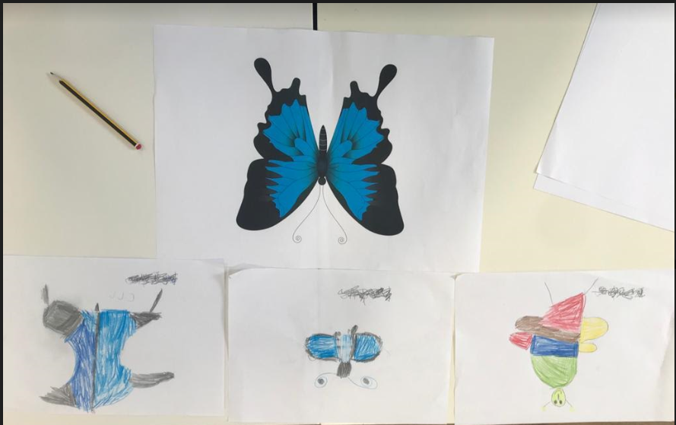

Participant 2
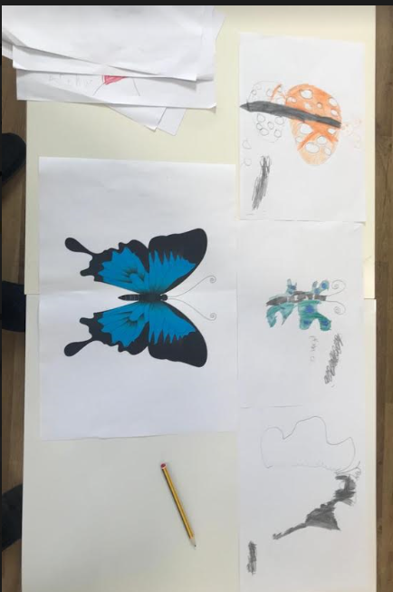
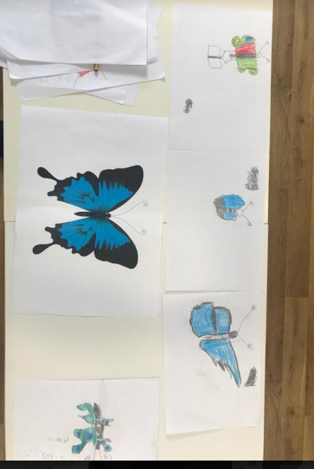
Participant 3

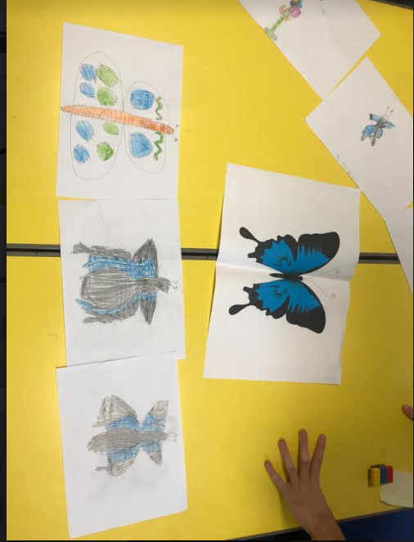
Appendix v
Participant 1

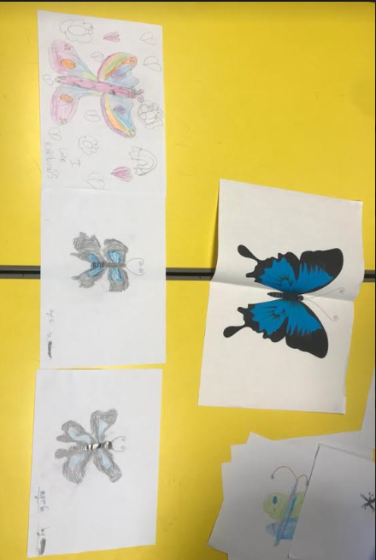
Participant 2

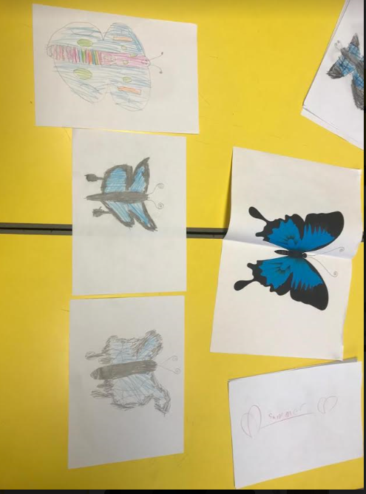
Participant 3

Appendix vi
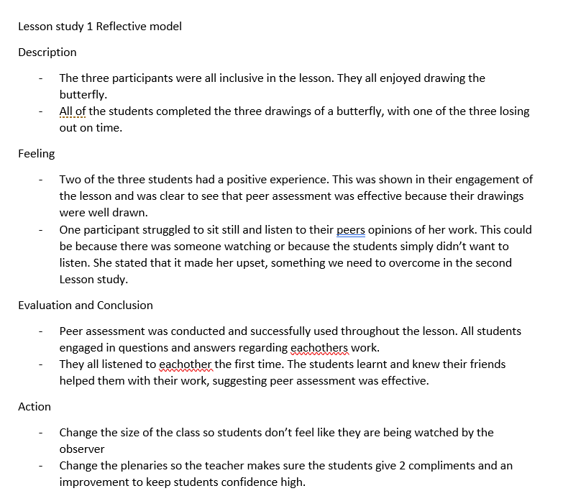
Reflective model notes Lesson Study 1

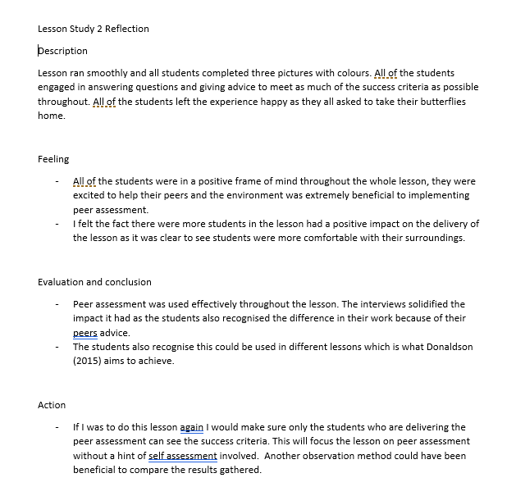
Reflective model notes Lesson Study 2

Appendix vii
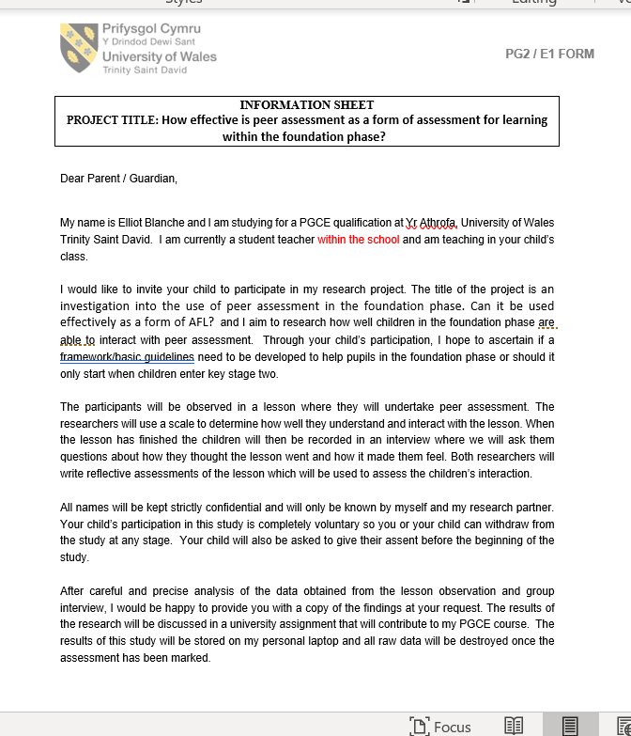
Information sheet

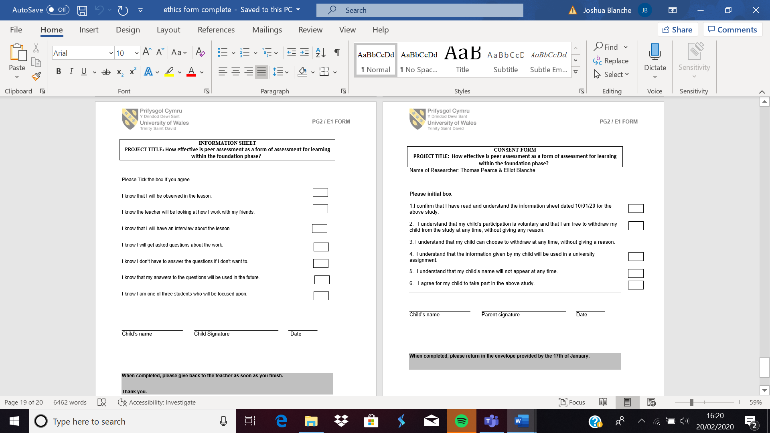
Consent forms

