Anna Harries, Student Number: 0151943

Title: Functionality Report for “Tendable” Application.
Abstract
Background - Nursing staff have an obligation to develop means to measure quality of care and to enhance patient safety and efficiency of the nursing process (Welsh Government, 2015). There are a number of applications available for off the shelf procurement to aid this and one of these have been implemented within two clinical areas. There was a clear overall aim at procurement to monitor and improve quality and clinical governance as part of the quality framework and Nursing strategy and this sets out the business aim. However operationally the objective was to implement a digital system to host a suite of audits across all areas of the Trust.
Objectives – The purpose of this paper is to analyse the challenges, benefits and limitations of the newly implemented product “Tendable” by exploring the applicability of the implemented solution to the underlying task. Essentially by asking the question, does the product fit the purpose?
Methods – Usability surveys were carried out on the first 3 clinical area users, this unfortunately only covered 7 members of staff due to the scale of the rollout. Each of the 7 staff members have used the application for a month and have previously been responsible for producing paper audits. With this small sample size it was necessary to add observation in practice, monitoring of compliance and accuracy to aid the data collection. The results were analysed using a suitably score for the questionnaires and the fit between individuals, task and technology (FITT) framework was used to interpret the findings (Ammenworth et al, 2006)
Results – At an early stage of implementation and rollout the results were very positive and the use of the FITT framework aided identification of intervention required and the fit between each factor. All of the results were based on qualitative data with a recommendation that further review is to be repeated as departments join the rollout.
Discussions – The discussions are structured around the FITT framework, which was slightly extended to consider context as a wider circle around the original framework. This was necessary with the external factors identified through the process.

Introduction
Clinical audit has taken an evolutionary path over many years and Crabtree et al (2020) captures this neatly in a recent publication taking the journey from 1989 to the time of writing. However, The World Health Organisation (1983) detail Quality assurance in a much earlier publication and it is certain that the concept can be traced much earlier again. Crabtree et al (2020) not only covers the changing process but also the professions involved, this then highlights the importance of team effort in successful audit and summarising that a

“robust, well executed Clinical Audit can identify healthcare deficits and (when supported by managers) can effect changes to improve quality and patient care.
Clinical Audit is a robust, easily applicable, cost-effective tool to review quality of care.” (Crabtree et al, 2020, pp. 214-215).

Department of Health (2020) also describe clinical audit can be used to support quality improvement in clinical settings within their guidance on evaluating digital health products and that
“Audit involves systematically assessing everyday performance against criteria” (Department of Health, 2020. pp. 1).
Through this process it makes sure the organisation is doing what it should be doing and asks if anything can be done better.
Clinical audit in practice is used to monitor the day to day performance of a service or product against a national or known standard. Regular clinical audit is required by bodies like the Nursing & Midwifery Council and produced nationally, for example, The Health and care standards (Welsh Government, 2015).
An audit may be led by clinical staff but non-clinical staff can lead the evaluation or certainly be involved. Audit should be teamed with good change management principles to make sure that recommendations from the audit lead to improved practice (Patel, 2010).
Within the National Health Service (NHS) Trust board of executives identified that little or no assurance was provided by the clinical teams and there was a lack of structured reporting against national standards. In response to this situation and lack of success in implementing paper audits a digital product was identified as a solution.

There are many products available for purchase (MEG is one of these), most of which are mobile applications. The Trust was tunnelled towards one product which shared services are considering as an All Wales contract that will allow accessibility for all Health boards and Trusts in Wales at a negotiated combined cost. Whilst this “All Wales” contract has not been secured it is likely that this will be next steps as two differing Health boards already use the application.

Tendable is a smart digital inspection application that intends to produce quality audits more efficiently and more effectively. There were many benefits reported by the company to implementing the application:

- Empowering teams to drive quality and safety improvements
- User friendly
- Best Practice sharing
- Ensures consistency of questions and guidance across all sites
- Paperless audits
- Saves time and money
- Clear evidence at all levels
- Real time dashboards and alerts
- Organisational memory of feedback and outcomes. (reported at set up meeting with Tendable)

A similar product was also in use within the Infection, prevention and control team within the Trust. However, this was desk top based and not a mobile application so the team often completed on paper and then inputted data into the electronic system.
A potential other consideration would be an in-house development but this was time critical for the assurance required to executive board.

Therefore due to the urgency Tenable was procured and implemented as soon as possible. There were obvious concerns regarding engagement from the clinical team with the speed required for implementation. This raised the need to investigate suitability and the fit between individuals, task and technology at an early stage.

Methods
Many models for implementation can be used to analyse the suitability or fit of a product or service (Kooij, 2018). However, the method applied for this digital product is the Fit between individuals, Task and Technology (FITT) framework (Figure 1) which was developed by Ammenworth et al (2006). This decision was clear as the need to understand the interaction between user and task which the FITT frame was specifically adapted to consider as previous framework lacked this interaction. (Ammenworth et al 2006, PP.4).

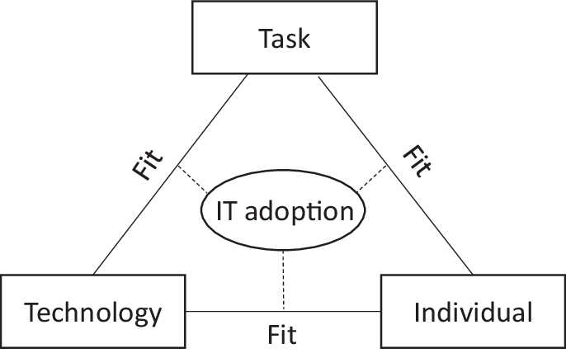
(Figure 1)

An individual can represent individual users or a user group, this can be patients or staff in the clinical setting but in this paper the user represents a small number of individual nurses who have been provided access to the application.

Technology is the tool that is required to accomplish the task. This can be many products in differing forms (hardware, software, applications). For this paper the Technology is the audit application tool called Tendable. Technology is not restricted to computer based and includes all tools used by the individuals to complete the tasks. In the implementation of Tendable, this technology will include the training resources used to aid staff use of the product.

The task is described as the wholeness of the tasks and the working processes, as part of achieving the aim or completing the task by the user who is supported by the technology.

The framework will aid the assessment of the quality of the fit between each of these three parts. Through this assessment the optimal fit can be achieved by identification of attributes requiring management direct influence, an example of this would be training sessions for users to improve the fit between technology and individuals.

In order to apply the FITT framework data is required from the project and this was collated in a number of ways.

Before procurement a workshop or table top exercise was held with representatives from most areas, this was an assessment of who completed which audits and their opportunity to state their opinions and ideas towards how to present assurance on nursing standards in each of the departments. The project lead documented themes and statements made pre introduction of any intervention.

After one month use of the application, each user was sent a suitability questionnaire in publisher so that they could directly input the answer and return via email. Nine questionnaires were sent out with seven returned within 5 days, A 78% response rate was not expected as the clinical pressures were extremely high at the time with COVID-19 implications.
A standardise well used questionnaire (Figure 2) was used to produce a system usability scare score as Laubheimer (2018) recommends using a standard over a home grown. This is on the basis that the standard are support by research to demonstrate their validity, reliability and sensibility.

The System Usability Scale (SUS) has been in use since the 1980s and individuals are familiar with the format.

In addition to the completed questionnaire, each participant also explained their answers in email text. This proved an additional data resource and will be used as a recommendation to include in future use of the suitability questionnaire. The additional information proved very informative to the use of the FITT framework.

Through individual interviews with staff, detailed data was gained with regards to the fit. There were no structured questions within these and viewed more as supportive meeting with questions and answered delivered in both directions.

Observation was also documented by the project lead as use of the application was visible remotely with regards to compliance and audits submitted. As the Trust is a very small organisation the line of communication was always easily accessible and responsive. The initial decision to start with outpatients department and the inpatient ward was based on the outpatient’s manager enthusiasm to commence audits as recognition that there was no structure in place. The inpatient ward did currently complete audits but found the administration of in putting data to excel after initially completing on paper very time consuming, so there was recognition of how this could reduce the time spent on audits.

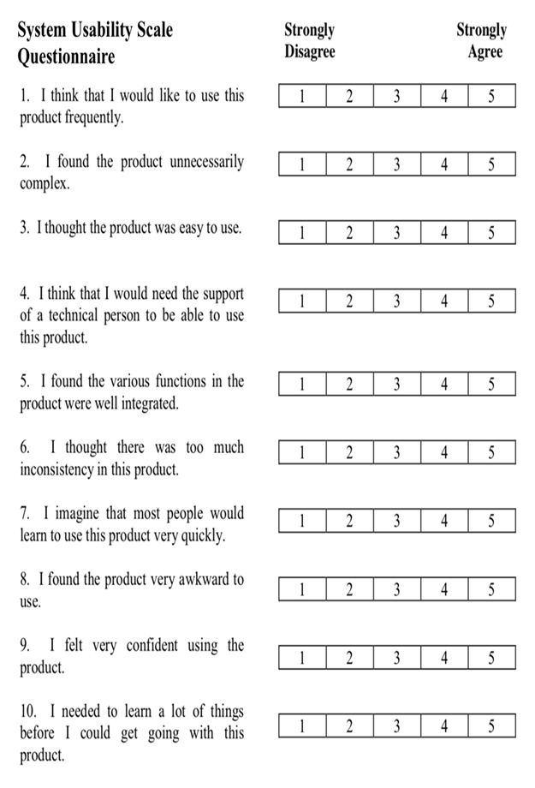
(Figure 2)

The project leads experience/ journey log is also considered and often featured within the highlight reports produced from implementation meetings to board. This covers the relationship fit between the company and individuals or organisation. While Ammenwerth et al (2006) recommends that the organisation slots in the either individual or task. However, a later publication by Kujala et al (2020) where Ammenworth is second author slightly adapts the FITT framework as seen in Figure 3.

This seems to fit appropriately for this paper and allows the complete picture to be presented of the challenges and strengths.

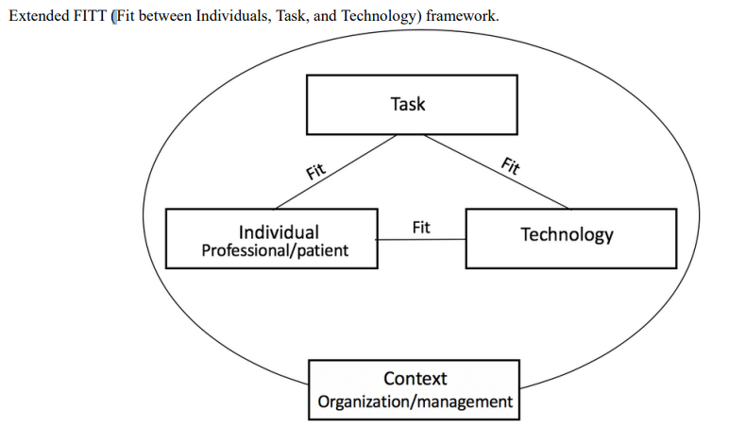
Figure 3 (Kujala et al (2020 pp. 14)

Limitations and Strengths Identified

The number of individuals and areas to gain data from are limited due to the size of the application rollout. There is just one ward and one outpatient area using the application in live stetting. An additional mobile blood donation area were piloting alongside the 2 live areas. More staff have been trained to use the observation and questionnaires were limited to those staff that had used for a month.

Product implementation was also during the COVID-19 pandemic and at certain points staffing levels were critical, implementation was via teams training and observations and discussions were often over teams. This was not the optimal team interaction but necessary to maintain social distancing and reducing footfall in clinical areas.

During the early stages of rollout the project lead did at times become the user (individual). As the Trust is a small organisation and it is often the case that individuals can take on many roles with a title. This is beneficial in part with staff engagement as they can be viewed as a closer member of the team, often seen as rolling up the sleeves and not just sitting in a director’s chair. However within system suitability a fit assessment it can be seen as influencing the results. This cannot be avoided at this stage, however moving forward into hopefully business as usual position that need will lessen.

There has been an attempt to not vary from the FITT framework as this is the projects leads first use of the framework and the product itself seems to not require any variation.

The project rolled out to the areas that were enthusiastic first and it is certain that if the review were to be repeated after rollout to a department resisting change the results would differ. This would suggest the need and recommendation for regular assessment of fit throughout all stages of rollout.

Results
- Pre- implementation Results – Qualitative data
From the initial work shop it was evident that there was no structure and little consistency to audit. The only standard audit across the site was infection control hand hygiene but all others differed in format and questions that did not seem to be standard based. The inpatient ward did produce a number of these audits which very often remain on paper due to the administration aspect of uploading. Therefore the inpatient ward staff were enthused with the idea of digital as a time saver. The ward manager wanted to be first in line to use any digital product procured.
Outpatient’s manager was new in post and had asked what audits are completed to the previous manger to be told none other than hand hygiene which surprised her at the time. Therefore this outpatient’s manger was keen to be first inline too for any system as this was identified as lacking.
Chemotherapy department were also keen to be involved as very little audits completed and they were surprised at the number the inpatient ward completed. Again the manager was new in post and the audits that were presented from this area were more checklist than true audit. This manager was shocked at the initial ask to produce a suite of audits on a monthly basis and feared the time it would take. However, with the need presented they were very much on board but not first inline.
Pharmacy were asked to the workshop as a show case as this department held accurate and standard based audits but all on paper. The Pharmacy lead was very keen to be in rollout for medicines audits to be digital and this really assisted and strengthened the project leads case for working with all to find a resolution to the concern of lack of quality assurance.
The initial aim was to get all staff together to share audits and start working on standards yet so little was produced from the existing departments that it was logical to start from point zero and suggest a product that is standard based. Welsh Blood Service (WBS) were not involved at this workshop stage but did show interest at a later stage of the discussions.
- Observation – Qualitative data
The project lead is very familiar with all staff as they are also the digital nursing lead and previous digital implementations have been before this auditing system. There were no concerns regarding digital skills in any area and the users of the audit system in the first stages will be senior staff. Staff did not report any concern with ability or fear of technology. However, there is a culture within the Trust of resistance to change. It is a small organisation and often describe themselves as a family and “things” have remained the same for many years.
Thankfully trusting relationship is being developed between project lead and staff with the added benefit of new staff being employed allowing this part of change easier but there are areas that remain a challenge. Through this observation it was important to start implementation in those areas that welcomed intervention and had enthusiasm for the project.
There were some technical problems initially after go live with the application, the Wi-Fi connection proved difficult but were solved quickly. However this was not the ideal start and there was a fear it would reduce enthusiasm. Thankfully this was not the case and the first audits were completed easily so there was a recognition that the system did work. It is also a known problem on site for the Wi-Fi to cause problems so it always has to be a consideration. The building is lead lined in parts because of the treatments performed on site.
All staff used the application after just one short training session and the project lead being on site. By this stage an additional part time digital clinical nurse specialist had joined the team and allowed one to support outpatients department and the other to support the inpatient ward. This in person support was highlighted as a positive from all staff.
During the first month all staff were supported and prompted to complete audits, however the second month has started and they have already completed half of the audits required without prompting.
There are two parts to the digital solution, audit data input which staff have taken to with very little training. The second part is managing a dashboard of the results/actions and producing reports. This was not separated in the system usability scale questionnaire but was evident through observation and discussions that it is this production of reports that will require further training and this is planned once data is submitted to the system for staff to then work with. It is this part that concerns staff slightly as seems more complex before they receive any training.
Observation of the data input into the application are visible on a dashboard to the project lead and the quality of data is extremely high as the system does not allow gaps in data entry. For the first month all 7 audits were completed for the 2 live departments and the pilot data in the test environment was also complete. It is also possible to review this dashboard from a standard compliance lens and target intervention where required.

- System Usability Scare Questionnaire – Qualitative data
This type of data would generally be quantitative but in this case it will be qualitative as the number involved is just seven, this is not as a result of poor response rate or engagement it is simply that the users are limited at this stage of rollout. The response rate is 78% and far exceeds on expectation as the clinical pressures were tremendous at the time of issuing. The quality of the responses also far exceeded expectation as they all provided a narrative as to why they responded as they did. With the number of questionnaires being just 7 it allows full reporting of these rather than producing an overall SUS score. This is highlighted in Table 1 below.

SUS Score Recorded | Comment in Brief
100 | Impressed with the whole package and received all training
95 | Identified that training would be required for all for reporting
90 | Only thing found difficult is finding the reports
87.5 | Found very useful in practice
80 | Easy to use
70 | Using as pilot, awaiting report training
52.5 | Using as pilot, awaiting report training
Table 1
This creates an average SUS score of 82 which is Grade A and excellent based on the scale proved in Table 2 below from Laubheimer (2018). This is significant that 5 out of the 7 are in excellent rating and the two that sit lower are awaiting further training on the reporting aspect of the system and using in pilot/ test environment.

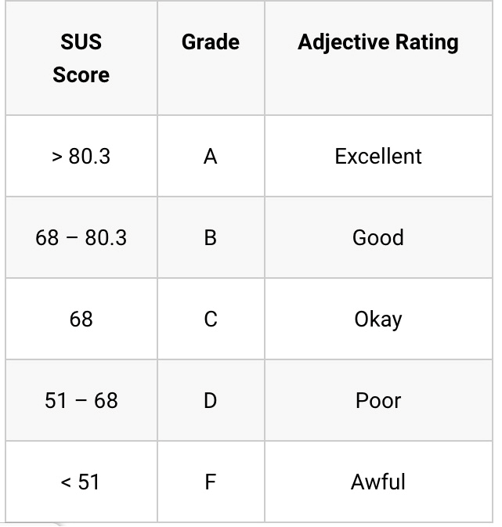
Table 2 (Laubheimer, 2018. pp. 7)
- Project Lead experience/log – Qualitative data
From first discussions with Tendable (when they were called Perfect Ward) they completely understood the aim of Trust. While this can often be the case with companies and then the barriers emerge, there have been no barriers. The company even extended the number of departments included with no additional cost. Over the month preparing for implementation and during the first month of implementation the company have understood the small nature of the Trust and the difficulties it can have with relaying on the same people within practice. Much of the standards tagging work was completed by the company team for user approval, this took the time pressure off the individuals and organisation.
The company representatives have been extremely reactive to all communication and were on hand during go live. The company were prepared to be on site but the organisation had to decline as the site is not allowing any visitors due to COVID-19 precautions.

Discussion
When considering the results and applying the FITT framework, this allows a nicely structured discussion section as all aspects slot into the 3 sections.
- Fit between the individual and the technology.
The system usability scale score averaged as an excellent rating within this first stage rollout to 3 clinical areas. However it is recognised that these first areas are those that pushed themselves to the front of the line proving their enthusiasm. This may well differ when conducted at further rollout and may require differing intervention to aid implementation. However, basic change management techniques cover the concept the rest will hopefully follow (Cameron, & Green, M, 2020). This is expected to happen as this has been the case in other digital projects and a pattern of rollout is emerging for all projects.
From the easy input of raw data into the system, the quality of data collected, reduction of time spent on audits and the usability score of the system this certainly demonstrates a fit.
However it was identified for further intervention that extended training is required for reporting function within the application. This will allow full use of all parts of the system.
It is also recommended that this review is completed in cycles after each rollout and at full implementation in all areas. As it is possible that some departments and a change of individual will alter the usability scoring and require differing intervention my management teams.
- Fit between technology and task
The product is specifically designed to aid healthcare organisations with assurance audit compliance and reporting. The concern for the project lead was around the difference in standards between England and Wales. This did not prove an issue as the standards can be set to the Trust preference and standards. However as a starting point standards were set from a neighbouring Health board and then tweaked for the needs of the Trust.
The system itself will not accept incomplete audits and therefore can only improve the fit, the deciding factor on this point could be connected to does this rigidity effect the fit between individual and technology. As this did not feature as a concern between individual and technology suggests that users are familiar with this function within other systems.
The company providing the product has been and is continuing to be very engaged and supportive. As a result the fit between the technology and the task improves as attention to detail is continually monitored and requests for change are completed in real time.
There is one outstanding consideration which was mentioned briefly in one discussion by a user and also discussed with the company. Interoperability is a very important digital feature and is considered in depth with the Topol Review (Topol (2019). The review advised further development of the health information technology infrastructure is needed and specifically with regards to interoperability across all services. From a clinical perspective, systems talking to each other is vital or there is the risk that the usability is equal to paper as they sit in isolation. Clinical teams will frequently comment on repetition of data input and the more systems available the more problematic this will become.
The value that this product can bring to an organisation that does not have any assurance in place is tremendous and can instantly improve practice. Visibility of the audits and standards is the key to identifying areas for improvement or indeed celebration. However that is an easy assumption to be made and there are tools to formally test the value of the data submitted and of the system to the organisation. Coiera (2019) in the chapter of Scott et al (2019) covers in how assessing technology success and failure through using information chain theory. This could be a recommendation at a later stage of implementation.
- Fit between the individual and task
Real time entry was achieved which reduced the administration time that the inpatient ward identified.
The visibility of data/reports are now accessible by many hierarchies within the Trust and reduce the frequent ask for the detail as reports are generated automatically.
Improving quality and compliance of audit data was not going to be difficult with such a low compliance starting position however the quality and compliance has dramatically improved as the user is forced to complete questions in the audit (as no answer is not accepted). The challenge was to attain all 7 audits for each area each month and this has been achieved.
Nilssonon et al (2020) used the FITT framework to explain the patient experiences of using an e-health tool and through this a diagram was produced to illustrate and summarise the framework for a self-management tool. This has been applied to the use of Tendable in this Trust below in Figure 4 and aided the written discussion.
The outer context circle has not been added to the diagram but is discussed. While no adaptation to the FITT framework was viewed as necessary at the start of this process, through progression it seems vital to add this context. As the FITT framework was initially developed and published in 2006 (Ammenwerth et al, 2006), this addition of context may be now required to update and keep the framework in use some 15 years later.

Completion of a suite of assurance audits for each clinical area based on national standards

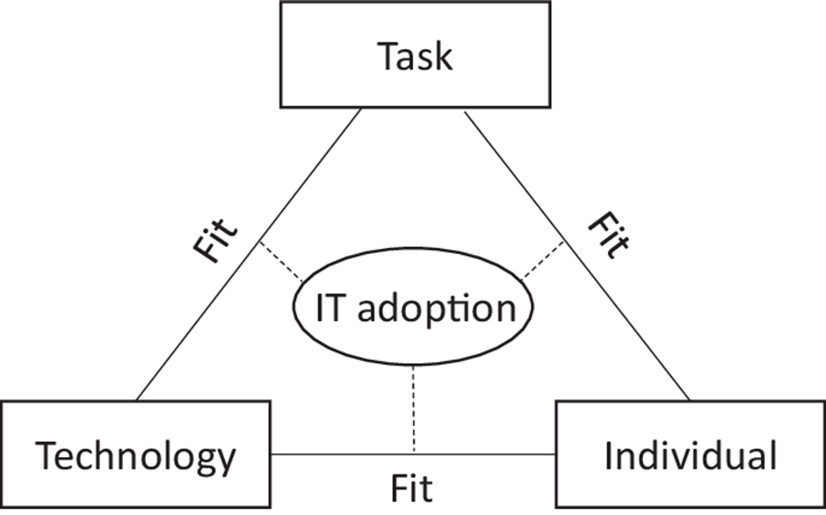
Pre-set standards
Engaged company
System won’t accept
Incomplete audits
Real time entry
Visibility of data/reports
Improving quality
and compliance of audit data

Future requirement -
work on interoperability
Tendable
Further training will allow full use of system capabilities

Individual—user of the application at clinical management level. Department managers
Tendable procured mobile application. With pre-set assurance based on national standards

Reducing time
Easy data entry and usability

Extend training for reporting function

Figure 4
- Fit between Context and the original FITT framework
In adding the Context outer circle as highlighted in figure 3, really encapsulates the environmental factors around the process. Implementation commenced in the centre of the Omicron restrictions in practice which hit staffing significantly within the small NHS Trust. As a result further rollout is paused currently, training has been on teams and the company could not support in person.
There is a culture of not embracing change within the family like organisation which is improving the more positive changes that are implemented. However there is still a slight air of resistance at first and then acceptance.
The organisation itself is very engaged by providing the funding for procuring such a product and at speed. This has added pressure as the speed is also expected at implementation, however this has been managed and absorbed by the project lead and the pause has aided managing this expectation.

Recommendations
Through this review many recommendations and interventions have been identified, some of these are short term and some are longer term with wider programme impact or even recommendation for the FITT framework.
- Short term
It was identified that further training with regards to the reporting function in the system was required, this is planned within the implementation but recognised by the staff within the system usability scale questionnaire. Based on this, a repeat of the questionnaire to staff would identify if this intervention of training improved the score provided or created more uncertainty.
It has been identified as a limitation that the project lead was heavily involved and when the system moves into to business as usual this should be short term. This will have the potential to allow staff to strengthen implementation or the project could lose momentum. However, the monitoring of compliance can be remote so momentum can be maintained remotely.
Repeating this review with more live departments and increased users will allow a quantitative review of the system usability scale, this was not achieved with 7 responses but will be possible with all 16 areas live and an aim of 5-6 users per department especially if the 78% response rate is maintained. This could be six to eight months but still considered as short term as planned rollout dictates this.
- Long term
There has been a national recommendation to improve interoperability within systems, currently this product does not connect to any other system. It has been identified through discussion with staff that interoperability between Tendable and the incident reporting system (Datix) and the feedback system (CIVICA) would be extremely beneficial as they all produce action plans and these can often interlink as the same “issue” or as a result of evidence of improvements in place. This is currently seen as a limitation within the system and requires further attention but important to keep on the agenda.
There is recognition that the system has to be correctly implemented before linking into other systems, therefore longer term consideration.
The use of other system evaluation approaches can be applied and if value is to be considered then Information value Chain Theory (Coiera, 2019) can be applied.
- Use of FITT Framework
It is also recommended to continue using the FITT framework with the addition of the wider context circle as this is an opportunity to include the externally influential factors. At this stage no other framework is considered.

References
Ammenwerth, E., Iller, C., & Mahler, C. (2006) IT-adoption and the interaction of task, technology and individuals: a fit framework and a case study. BMC Medical Informatics and Decision Making, 6(1), pp. 3–3. Available at: https://doi.org/10.1186/1472-6947-6-3 [Accessed; 9 March 2022]

Cameron, E & Green, M. (2020) Making sense of change management : a complete guide to the models, tools and techniques of organizational change (Fifth edition.) Kogan Page, London.
Coiera, E. (2019) Assessing Technology Success and failure Using Information Value Chain Theory. In: Scott, P., de Keizer, N & Georgiou, A. (2019) Applied Interdisciplinary Theory in Health Informatics A Knowledge Base for Practitioners. Available at: https://ebooks.iospress.nl/ISBN/978-1-61499-990-4 [Accessed; 7 March 2022]
Crabtree, A., Sundararaj, J. J., & Pease, N. (2020) Clinical audit?—invaluable. BMJ Supportive & Palliative Care, 10(2), pp. 213–215. Available at: https://doi.org/10.1136/bmjspcare-2019-001981 [Accessed; 9 March 2022]

Department of Health (2020) How to use a clinical audit to evaluate your digital health product. Online Guidance. Available at: https://www.gov.uk/guidance/clinical-audit-descriptive-studies [Accessed; 9 March 2022]
Kooij, L., Groen, W. G., & van Harten, W. H. (2018) Barriers and facilitators affecting patient portal implementation from an organizational perspective: Qualitative study. Journal of Medical Internet Research, 20(5), e183–e183. Available at; https://doi.org/10.2196/jmir.8989 [Accessed; 9 March 2022]
Kujala, S., Ammenwerth, E., Kolanen, H., & Ervast, M. (2020) Applying and Extending the FITT Framework to Identify the Challenges and Opportunities of Successful eHealth Services for Patient Self-Management: Qualitative Interview Study. Journal of Medical Internet Research, 22(8), e17696–e17696. Available at; https://doi.org/10.2196/17696 [Accessed; 8 March 2022]
Laubheimer, P (2018) Beyond the NPS: Measuring Perceived Usability with the SUS, NASA-TLX, and the Single Ease Question After Tasks and Usability Tests. Available at; https://www.nngroup.com/articles/measuring-perceived-usability/ [Accessed 08/03/2022]
Nilsson, L., Hellström, A., Wennerberg, C., Ekstedt, M., & Schildmeijer, K. (2020). Patients’ experiences of using an e-Health tool for self-management support after prostate cancer surgery: a deductive interview study explained through the FITT framework. BMJ Open, 10(6), e035024–e035024. Available at; https://doi.org/10.1136/bmjopen-2019-035024 [Accessed; 7 March 2022]

Patel, S. (2010) ‘Achieving quality assurance through clinical audit’, Nursing Management, 17(3), pp. 28-34.

Scott, P., de Keizer, N & Georgiou, A. (2019) Applied Interdisciplinary Theory in Health Informatics A Knowledge Base for Practitioners. Available at: https://ebooks.iospress.nl/ISBN/978-1-61499-990-4 [Accessed;7 March 2022]
Topol, E., (2019) The Topol Review. Preparing the Healthcare Workforce to Deliver the Digital Future, pp.1-48. Available at; https://topol.hee.nhs.uk/ [Accessed; 8 March 2022]
Welsh Government, (2015), Heath and Care standards, Department of Health. Available at: https://gov.wales/sites/default/files/publications/2019-05/health-and-care-standards-april-2015.pdf [Accessed; 15 January 2022]

World Health Organisation (1983) ‘The principles of quality assurance’, International Journal for Quality in Health Care, 1(2-3), pp. 79-95.

