BA: Business and Management

Module: Project Management and sustainability BMSP5008

Lecture: Glenn Behenna

Student: George Parker

Student number: 1704367

Submission deadline 22nd March 2019

Table of condense

1.0-Introduction

2.0-What is project management

3.0-project management principles

4.0-Project life cycle

5.0-Project manager

6.0-Project management tools and techniques

6.1-Prince2

6.2-Critical path analysis

6.3-Product based panning

7.0-Stakeholders

8.0-Conclusion

9.0-Bibliography

1.0-Introduction
Within this assignment there will be the provision of a critical assessment of the tools of the usefulness in project management and sustainability. The usefulness of tools and various techniques in the use of manging a project will by analysed to a high level for each of the chosen tools and techniques. These will be used demonstrate the ability to plan they implementation of a project and consider through doing this will consider who are the appropriate stakeholders within a project and what is the level of risk that they are exposed to resulting from the planned project.

2.0-What is project management
To understand what project management, you must first understand what is meant by a project, a project is temporary or short term with a predetermined time defined from beginning to end as well as having defined levels of resources available and scope for the project’s direction. A project must also be unique by not being a usual operation without any usual routine with it, although it will have a designated set of operations designed to accomplish the singular goal of the project ("What is Project Management?", 2019), (Lientz & Rea, 2002).
Project management is the application of knowledge, skills, tools and techniques to a project through various activities and techniques so that the projects requirement can be met. This can be done through the leading of others within a singular or multiple task for a shared goal which is usually expected to be the well execution of the project in question (A guide to the project management body of knowledge, 2004), (Lock, 2013).
Classically project management is made up of the trifecta of time, cost and quality working through a team to achieve a set sheared goal that conforms the desired set costed decided that also is up to a high quality as well as being done within an appropriate window of time so that the project in question can be efficient. However, with time and analyses the trifecta of aspects of project management has changed to become people, processes, and technology. The new trifecta of project management principles shows that the people who are involved in the project are one of if not the most important parts of the project as the entirety of the project focuses around them. Following this is processes which indicate that the action taken towards the completion of the project are all integral to the outcome of the project making each process carried out an important part of how the end of the project will be in either a positive or a negative sense (Chin, 2004), (Mishra & Soota, 2006).

3.0-project management principles
There are principles to project management that must be followed for the success of the project to be high, and for the duration of the project to flow well with all members and those involved in the project working well together, (Williams, 2008), (Pennypacker, 1997), (Salama, n.d.), (Principle, 2019) these are-
- The first principle of project management is the clear definition of the objective and its perimeters, this is done sot that those who are working on the project know what they are working towards and are able to do so well and to also allow those who set the project are able to know what to expect from the project so there is no disappointment at the end of the project’s life cycle.

- The next principle of project management is good planning and control method, this is done so that all participants on the project team are able to understand what each other are thinking and discuss their views on how the project should be tackled and designed a method with the impute of all of the project team so that there is a clear understanding of what is required.
- The next principle is to have a good quality of project manager, this must be someone that the rest of the team respect and can work with so that there are little to no social issues with the project between different individuals working on the project as well as to allow those who set the project to be informed to the direction that the project is taken and the distance that the project is from completion. The next principle of project management is to have good management support, this allows for the managers to understand what is needed for the team to complete their project and to do so also goon management support allows for the changing of section conditions such as time scale if there unforeseen restrains that cause a delay to the project and for the management to be understanding of what is required for the risks completion.
- The next principle of project management is enough time and resources provided to the team, this is an incredibly important principle as without enough time for the project’s completion the project will be forcibly rushed to meet time constraints that will cause a compromise in the end products quality in some way and without enough resources given to the project there will also be compromises made in terms of production and or materials to keep in line with restrictions that the team is working with.

- The next principle of project management is the commitment by all, this means that all involved in the completion of the project must be solely committed the its completion without being involved in side projects and having other priorities that can cause the project to suffer and potentially result in the projects failure.

- The next principle of project management is high user involvement, this is the desired end user of the conceived product must be involved in its development and testing so that it can be seen if the product is able to meet its needs well or if not it can be realised early so that changes can be made in the process to fix the issues in question.

- The next principle in project management is good communications, these can be as simple as verbal communications that accurately state what is being done or is requires to be done in the next stage of the project or through e-mail to inform others involved in the project what is being done without any misunderstandings being made.

- The next principle of project management is good project organisation and structure, the is a key principle as it sets the grounds for a successful project as by having high levels or organisation within a project it is understood what each member of the team is doing and how they are doing their task and a high level of project structure means that each member to the project team knows who to go to regarding any issues that may come up and how to solve them.

- The final principle of project management is being able to stop a project, this can be done if it is recognized that there has been a pre-emptive failure in an area of the project of the project in question has taken too long to complete so it has become inefficient to continue with the project. For this to be done the project manager and team members must recognize the failure of their project and also formally discuss what were the factors that lead to the project’s failure.

4.0-Project life cycle

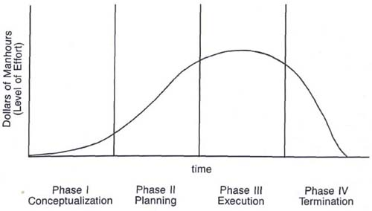
(Project life cycle, 2019)

For every project there is a life cycle that goes along with it, there are four stages that a project typically goes through during its life cycle the first stage is during the project start up. Here is where the goals of the project are set out to the team and they are told what they will be required to do and within what time as well as what reassures they will have available to carry out their agreed upon task. The second stage is the planning and organisational stage of the task, here is where the project is planned out and organised into specific tasks to be carried out along the different phases of the project life cycle, this is all then co-ordinated by the project manager so that everything can be done efficiently and done well. The third stage of the project life cycle is implementation and monitoring this is usually the most time consuming stage as well as the more costly stage in both financial terms as well as in staffing levels, this is the result of observational viewing of if the product fits its desired purpose or if it does not and if not how can it be altered to do so. Finally, there is completion and evaluation, in this finally stage the product is presented to those who set the project and then upon its completion the project is analysed and discussed amongst the team to find what they felt went well and what did not so that they can improve themselves in further projects within the future ("The 4 Phases of the Project Management Life Cycle |Lucidchart", 2019), (Westland, 2010), (Means & Adams, n.d.).

5.0-Project manager
It is extremely important to consider the role of the project manger in detail as the entire project revolves around the project manager and it is managers responsibility for the success or failure of the project in question (Newton, n.d.). The project manager is the driving force that is behind a project who is constantly pushing for it to succeed this is only amplified if the project manger has the knowledge and experience to co-ordinate multiple entities and different elements that are involved in the project’s life cycle towards the ultimate goal of success in the set task. Project mangers are responsible for multiple roles including leading their team through various stages by planning and co-ordinating team members roles ensuring they are best suited to their task to optimizes the chance of success. The project managers role also includes monitoring and controlling their teams’ actions through communication with them what is required of them in a positive way to get the most out of their project team (Davidson, 2001).

6.0-Project management tools and techniques

6.1-Prince2
Prince to is a project management methodology which theoretically allows the user to overcome all challenges that are set in there place whilst allowing the user to maintain a positive relationship with their clients, however prince2’s main benefit is that it can be used for any project no matter of the projects size or the projects variety and or the organisation that wishes to use it no matter where in the world it is needed to be used. Prince2 is so flexible that is can be used in physical projects such as designing toys and cars to undergoing a digital transformation project as well as creating a marketing campaign, this is done by prince2 being made up of seven themes, seven principles and six processes. The process act as the “how?” The project in question can be done and the themes act as the “what?” and the principles act as the “why?”. The seven principles of prince2 include a business justification for the project that incorporate different learning lessons across the project via various roles and responsibilities that work through different stages whilst simultaneously manage the expectations of all parties involved in the project so that all members involved can stay focused on the project and tailor it the desired audience. The seven themes include what will be done over the projects management which includes a business case for the project where its requirements are formally set out by the overarching organisation. The quality of the projects purpose will also be viewed and plans will be made around the products development various risk factors will also be looked at to see if there are any potential dangers the project which can be avoided and if so what changes will need to be made to the project and how will all of this have an impact of the progression of the project moving forward. Finally, the six principles of prince2 are made up of the starting up of a project then the decision of which direction the project should take then over this is decided the project will initiate then the stages of progressing will be controlled through different stage boundaries and once all stages are complete the project will be closed. When these three areas are used together, they create an easily repeatable guide that can be incredibly flexible in its use to create successful projects. Prince2 allows for a structured approach to project management that when it is applied well will avoided dealing with most of not all problems that commonly occur during a project’s life cycle (Hinde, 2012), (Managing successful projects with PRINCE2, 2017).
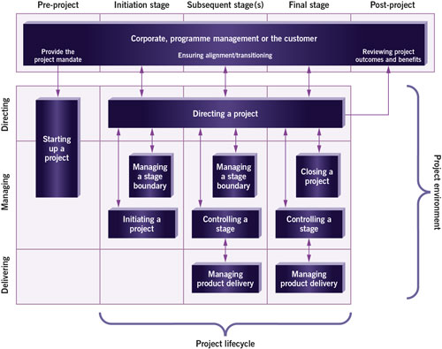
(PRINCE2, 2019)
From looking at prince2 it is clear to see that there are infinitely more positives with this project management tools that there are negatives such as that prince2 in universally inclusive allowing for anyone no matter of language or verity of business to use the tool to complete their chosen task with a high level of success. Another positive of using prince2 is that there is no project too big or too small for the tool to be useful on this means that it is able to aid in any task that it is required to be used in. there is not so much as a negative with prince2 but such a formality, because the tool uses so many aspects in planning it requires large amounts of time and planning be done before any aspect of a project can be initiated meaning that there may be more favourable alternatives to prince2 with projects that need to be done in a very short time scale.

6.2-Critical path analysis
Critical path analysis is a planning tool that helps a project or critical path by seeking to understand what the critical activities within the sequence of event are from the very beginning of the project through until the end of the project which cannot be delayed without the consequential effect of delaying the rest of the project. Critical path analysis is a representation of the project in its entirety from start to end with all activities on the path being critically analysed whilst the path having a float value of zero. Even the critical path is the longest path it makes up the shortest time possible to complete the project critical path analysis shows different ways in which a finished goal can be reached by assigning set times to specific tasks then calculating which path will take the shortest time to complete and following this method (Thornley, 2001), (Harrison, 1997).
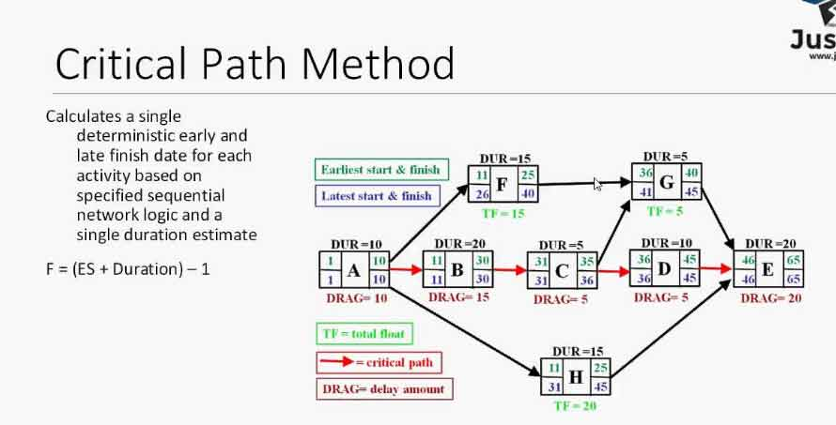
(Critical path analysis, 2019)

Critical path analysis is a beneficial tool, it allows the team using it to work float of each activity allowing an accurate prediction of how long a project will take for it to be completed, as well as pushing managers to compress tasks to increase efficiency as well as properly plan what will be needed for the task in advance which can reduce the consequences that could come from improper planning of a project. There are negatives that come from critical path analysis such as with large and complex projects there will be far too many dependency’s and activities that will overcomplicate and be time consuming for a project, as well as this critical path analysis does not consider the amount of resources available for a project which can lead to resource allocation issues if not adequately panned for.

6.3-Product based panning
Product based panning is a tool that is almost self-explanatory, this tool focuses around three steps the first being the identification of the specialist management products what will be produced through a breakdown of the product structure. The next step is to describe the final product of the project and also any simple integrational products as they may be required. Finally, there should be a clear sequence of events in logical order done through a product flow diagram which can be clearly understood (Dickersbach, 2005).

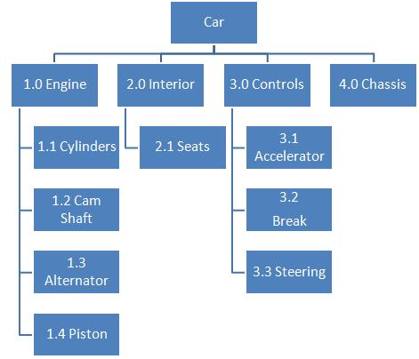
(Product based planning, 2019)
Product based panning is a good tool to utilise as it allows it is able to work for physical products as well as digital and social products such as marketing strategies and event panning, this means that product based panning can be used for almost anything and allows the project manager and team to consider numerous outcomes and clearly define the purpose of the project for stakeholders to see what is being done and finally it allows for a simple sequential structure that shows how the project will flow. Product based panning can have some negative associated with it such as causing some members within a team to move onto tasks to soon as they see the simplistic of the stages move too quickly through them without informing other members of the teams on occasion. Also product based panning dose not incorporate creative thinking within the project so that any ingenious ideas that could reduce time or increase the usability of the project may be ignored and or forgotten by the project team.

7.0-Stakeholders
Within any project there are many stakeholders, a stakeholder is anyone who has an interest in the outcome of the project in question for any matter of reason. Stakeholders can be split into two categories there are internal and external stakeholders for internal stakeholders there are project sponsors who the financial benefactors to the project are as well as the project team whose soul task is to complete the project in question. Trade unions are another internal stakeholder as well as agents of change that can rely on the project to invite change, a final internal stakeholder is other members of staff that will be affected by the outcome of the project. Externally the stakeholders include the suppliers of reassures as well as the general public which will consume the product created during the project also there are shareholders and trustees who depend on the succeed of the project for financial reasons finally there are end users of the created product or service who will rely on the product or service in everyday life (Gunsteren, Binnekamp & Graal, 2011), (Eskerod & Jepsen, 2013).

8.0-Conclusion
In conclusion there are many good tools and techniques that are available for a project management team to use that can streamline and shorten the duration of projects on a constant basis. There are many aspects of project management that constantly need to be considered within the panning of a project and no matter of the tool and or techniques used to help the project process the most useful tools is reparative practice and experience as without this it is not possible to learn form mistakes and make changes to avoid issues in the future.

9.0-Bibliography

(Critical path analysis, 2019). Retrieved from http://www.businessstudynotes.com/wp-content/uploads/2017/09/Critical-Path-Method.jpg
(PRINCE2, 2019). Retrieved from https://www.projectsmart.co.uk/10-principles-of-good-project-management.php
(Principles, 2019). Retrieved from https://www.projectsmart.co.uk/10-principles-of-good-project-management.php
(Product based panning, 2019). Retrieved from https://expertprogrammanagement.com/wp-content/uploads/2011/10/product-breakdown-structure-example1.jpg
(Project life cycle, 2019). Retrieved from https://lh6.googleusercontent.com/r-FMlIvA3_U20689oA9B23-TtpNV5YxEXDWjMUYdGoeLMGJmlTgrJKHFxD-v99qX93q8RasCUisN6_u57yNpcaHh0P2K987o08_RJWxrZJHttowAvZLopUW5nbE5DZJVIyUOjQlx
Chin, G. (2004). Agile project management. New York: AMACOM.
Davidson, J. (2001). 10 minute guide project management. Indianapolis, Ind: Alpha Books.
Dickersbach, J. (2005). Characteristic Based Planning with mySAP SCM. Berlin, Heidelberg: 9201.
Eskerod, P., & Jepsen, A. (2013). Project stakeholder management. Farnham, Surrey, England: Gower.
Gunsteren, L., Binnekamp, R., & Graal, R. (2011). Stakeholder-oriented project management. Amsterdam: IOS Press.
Harrison, A. (1997). A survival guide to critical path analysis and the activity on node method. Oxford [England]: Butterworth Heinemann.
Hinde, D. (2012). Prince2 study guide. Chichester: Wiley.
Lientz, B., & Rea, K. (2002). Project management for the 21. century. San Diego: Academic Press.
Lock, D. (2013). Project management, 10th edition. Farnham, Surrey, England: Gower Pub.
Means, J., & Adams, T. Facilitating the Project Lifecycle.
Mishra, R., & Soota, T. (2006). Modern project managment. New Delhi [u.a.]: New age international Publ.
Newton, R. The project manager.
Pennypacker, J. (1997). The principles of project management. Sylva, North Carolina: Project Management Institute.
Project Management Institute. (2004). A guide to the project management body of knowledge. Newtown Square, Pa.
Salama, M. Principles of sustainable project management.
The 4 Phases of the Project Management Life Cycle |Lucidchart. (2019). Retrieved from https://www.lucidchart.com/blog/the-4-phases-of-the-project-management-life-cycle
Thornley, G. (2001). Critical path analysis in practice. Oxon [England]: Routledge.
TSO. (2017). Managing successful projects with PRINCE2. London (London).
Westland, J. (2010). The Project management life cycle. London and Philadelphia: Kogan Page.
What is Project Management?. (2019). Retrieved from https://www.pmi.org/about/learn-about-pmi/what-is-project-management
Williams, M. (2008). The principles of project management. Collingwood, Vic.: Sitepoint.

