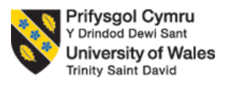
PROGRAMME: MASTER OF BUSINESS ADMINISTRATION
MODULE: MARKETING MANAGEMENT
MODULE CODE: LCMB7024
ASSIGNMENT TITLE: MARKETING ENVIRONMENT ANALYSIS
CHOSEN BUSINESS- CODELCO (CHILE)
STUDENT NAME: YASH THAKOR
ID: 2436840
LECTURER: LAILA MAAZOUZ

Executive summary
The report has evaluated the two external marketing environment actors that had impacted Codelco’s adoption and transition towards lower-carbon products and cleaner products on technology. It has been identified that water shortage and ethical ESG reporting are the key external environmental factors that increase the risks of sustainability and ethical business accountability.

Table of Contents
Task 1: Marketing Environment Analysis 4
Critical evaluation of Chile’s external environment using PESTLE analysis 4
External marketing environmental factors 5
Task 2: Strategic Growth and Competitive Positioning 7
The Ansoff Matrix 7
Strategic Positioning 10
Strategic Market Development Pathways 11
Task 3: Critical Reflection on AI Usage 13
a. Tool Disclosure 13
b. Critical Evaluation of AI Output 13
c. Contribution Analysis 13
d. Ethical & Professional Reflection 14
References 15
Appendix 1: AI out put 20

Task 1: Marketing Environment Analysis
The marketing environmental analysis is defined as the strategic processes of evaluating both external and internal factors, inducing a company's performance. The present assessment focuses on assessing the external marketing environment actors that are directly inducing the transition of Codelco (Chile) towards lower-carbon products. The natural environment actor and one external environment actor are discussed that have a direct impact on the overall transition of the business towards more carbon neutral products.

Critical evaluation of Chile’s external environment using PESTLE analysis
Factors | Impact | Attributes
Political | Positive | Political stability  - The political landscape is stable at 0.12 point in the stability index (The Global Economy, 2025).
Economic | Positive | GDP rates  - The GDP rate in Chile has risen moderately to 2.4% as compared to 2.8% in 2024 (World Bank, 2026).
Social | Negative | Consumer price inflation  - The consumer price inflation in Chile rose to 4.2% in 2025, causing high prices of goods and services (World Bank, 2025).
Technological | Negative | Technological advancement with AI and automation  - The mining sector is using Advancing Mining Technology and autonomous ground robots for line mapping and safety inspection (Trade, 2026).
Legal | Positive | Compliance with Mining Royalty Law (No. 21,591)  - Mining Royalty Law establishes hybrid tax systems for large scale producers by implementing 1% ad valorem tax on annual sales for generating public revenue (IEA, 2023).
Environmental | Negative | Natural resource constraints  - Technological advancement for companies such as Google and Microsoft are impacted by water scarcity in Chile (Heikkinen and Bustamante, 2026).
Table 1: PESTLE Analysis of Chile
(Source: Influenced by World Bank, 2025)
The analysis of Chile's external environment has outlined that the country has moderate political stability that is crucial for expanding business expansion and improving cross border relations. The findings of the analysis have outlined that the GDP rate in Chile has experienced a slight increase to 2.4% as compared to 2.8% in 2024 (World Bank, 2026). However, the inflation rates in Chile have increased by 4.2% in 2025 that directly influences consumer purchasing intentions and behaviour (World Bank, 2025). However, the consumer price inflation and changing demands does not directly impact Codelco, however, it dictates the dedicated revenue, national funding contribution and shift towards sustainable mining practices.
The technology advancement in the finding sector is also enhancing and changing with the adoption of Advancing Mining Technology and autonomous ground robots (Trade, 2026). The technology advancement in the mining sector provides an opportunity for Codelco to improve its operational efficiency through autonomous technology for minimising environmental footprint and improving production efficiency. However, environmental factors are a major concern for businesses due to natural resource (water) scarcity as Chile experienced water levels reduction by 10%-37% over the past years (Earth, 2022). The lowering level of water is a major concern for Codelco as it restricts the business to transition to more carbon neutral products due to use of water for extracting and processing critical minerals such as lithium.

External marketing environmental factors
Natural Environment factor- Water Shortage
One Natural Environment factor that may impact the low carbon product adoption of Codelco in Chile is the shortage of natural resources such as water shortage. Mining processes heavily rely on water usage including mineral extraction, dust suppression, and material transport that may be impacted by water shortage (Sankaran, 2025). As per the PESTLE analysis of Chile, water shortage and scarcity are major concerns that are also impacting the expansion of businesses such as Google and Microsoft in Chile with their AI data centre. Moreover, Barrick Gold mining company is also focused on addressing the water scarcity concerns for 140 energy-efficient projects and source 19% of electrical energy from renewable sources (Onifade et al. 2024). Moreover, Codelco has achieved a reduction of around 310 litres per second in water consumption in high water stress regions in Chile, equivalent to 12% (Codelco, 2025). Thus, Codelco is also working towards enhancing its accountability towards reducing its reliance on groundwater as its key resource for mineral extraction and processing.
Adoption of low carbon products are significant for Codelco in enabling the business to achieve sustainability, accountability and improve marketing performance through building brand reputation. For example, Codelco has adopted a new low carbon explosive for its copper mining that assists in reducing 40% of the business’ explosive consumption and reducing scope 3 emission (Reuters, 2024). The adoption of the low carbon products such as copper mining the explosive are significant for the environment marketing of Codelco and improve its business accountability. Thus, addressing its reliance on ground water is being addressed through implementing desalination centres and plants in the Northern District to make use of salient water.
External Environmental Factor - Ethical compliance with sustainability reporting and maintaining competitiveness
Codelco is facing concerns with ethically reporting its mining processes and environmental impact that has raised questions of investors on the brand's trust and reputation. Codelco fired an executive and held accountable multiple employees after internal audits, outlining that 20,000 tonnes and 6,875 tonnes of copper mining estimates were overstated (Jamasmie, 2026). The two overestimations of around 27,000 for copper outline the ethical and poor sustainability reporting and business accountability of the business, limiting its approach and transition towards more carbon neutral products and approaches. Codelco has also identified issues with its governance due to unethical governance and reporting of its annual copper product along with environmental impact (Cambero, 2026). Moreover, the net debt of Codelco to Ebitda has increased by 3.8x as compared to 0.7x for global mining companies in Chile. Thus, Codelco is also facing issues with maintaining its financial performance and stability due to rising debts, requiring the company to improve its competitive advantages.
Codelco is working towards enhancing its sustainability, accountability and competitiveness through implementing a circular economy strategy. As part of its circular economic strategy, Codelco is managing waste by recovering 49.4% of non-hazardous waste and leading the International Council on Mining and Metals (ICMM) group (Codelco, 2025). The business is also planning to recycle 65% of its industrial waste as part of its circular economy strategy and boost competitiveness (Codelco, 2025). Thus, improving business accountability required Codelco to integrate a comprehensive governance and reporting structure for outlining its ESG reporting and market competitiveness.

Task 2: Strategic Growth and Competitive Positioning

The Ansoff Matrix
Market penetration: Focuses on increasing market share in the existing market with existing products (Kotler et al., 2024). Codelco does this by improving long-term supply chain contracts with major customers in China. This segment of the market accounted for 71% of copper sales in 2023, followed by 11% in Japan and 7% in Europe (Codelco, 2024). In 2023, the company produced 1324 kt of refined copper, which was a 7% increase from 2022 and sold 1317 kt (Codelco, 2024). It maintained 88% of the market share in Chile and solidified its position as the largest copper producer in the world. The diversified market penetration ensures a high-quality and reliable supply of copper.
Market development: This element focuses on entering new markets with existing products (Ferreira and de Sá, 2024). Codelco is expanding in emerging economies like Southeast Asia and the Middle East, where the demand for copper is growing due to renewable energy, infrastructure and electrification. Copper demand in Asia is projected to grow 3.1% annually through 2030 (IEA, 2024). The increasing demand is primarily driven by EV adoption and clean energy. Codelco is also increasing participation in the green copper market of Europe, where the demand for low-carbon copper is rising under the EU Green Deal.
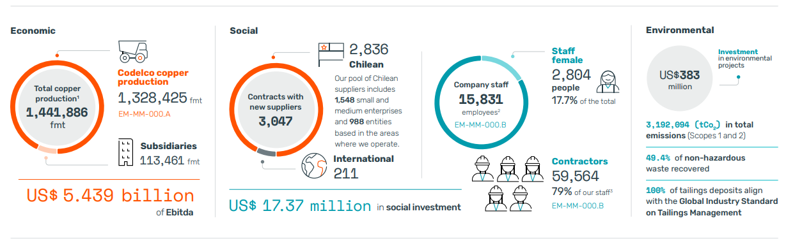
Figure 1: ESG 2024 achievements of Codelco
(Source: Codelco, 2024)
Product development: This element focuses on developing new products from existing markets (Ferreira and de Sá, 2024). Codelco is advancing value-added copper products like copper cathode with a low carbon footprint and oxygen-free copper for higher efficiency of application. In 2023, the company launched the “responsible copper” brand, which guarantees a carbon footprint 16% lower than the average industry and also traceability (Codelco, 2024). Additionally, it is also focusing on copper solutions for EVs, renewable energy and energy storage.
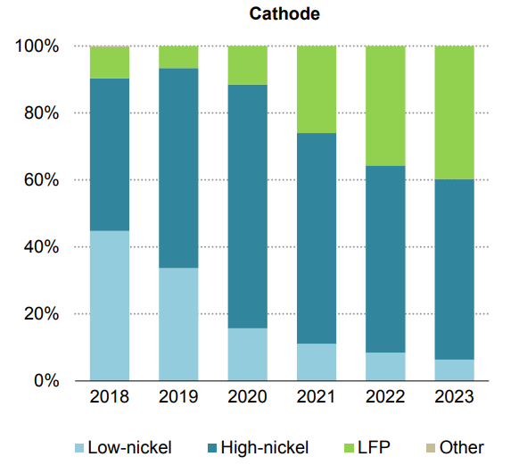
Figure 2: Electric car battery cathode and anode chemistries sales share, 2018-2023
(Source: IEA, 2024)
Diversification: Focuses on developing new products for new markets (Qomaroet al., 2024). Codelco is diversifying in adjacent areas like lithium exploration in Salar de Maricunga, exploring partnerships in renewable and hydrogen energy and also investing in water desalination projects. The Maricunga lithium project has a resource potential of 1.8 million tonnes of lithium carbonate equivalent (Codelco, 2024). It positions Codelco in the critical mineral market essential for the global energy transition.
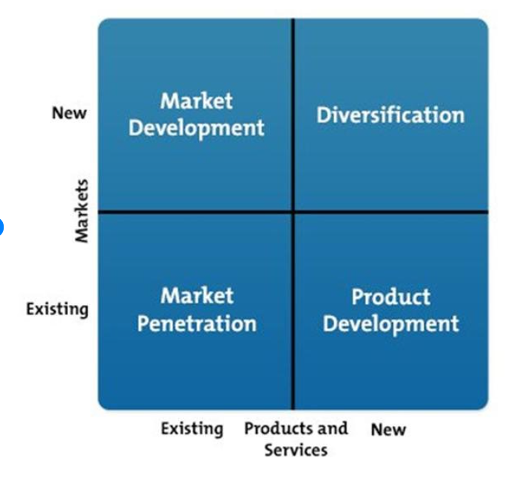
Figure 3: Ansoff Matrix
(Source: Jhunjhunwala and Chaudhuri, 2021)

Strategic Positioning
The global copper industry is experiencing sustained demand growth that is driven by renewable energy, electrification, grid expansion and EVs The total demand for copper can increase to 31.1 million tonnes by 2030 from 25.9 million tonnes in 2023 (IEA, 2024). The clean energy-related copper demand is also expected to grow to 12 million tonnes from 6.3 million tonnes during the same period (ICA, 2024). The emerging economies, particularly the Southeast Asian nations, are expected to significantly contribute to the growth as clean energy investment and infrastructure accelerate.
The company has the priority to supply copper, particularly for electrification, renewable energy and advanced manufacturing, while improving the relationship with customers all across Asia and other emerging markets (Codelco, 2025). The strategy enables it to capture new demand without fundamentally changing the core product portfolio and hence reduce strategic risk while supporting long-term revenue generation.
Justification
The market development is in alignment with competitor strategy and industry trends. The global copper demand will approximately grow by one million tonnes annually until 2035, and it will be supported by renewable power systems, EVs, and AI-related data centres (Reuters, 2024). Leading miners, similarly, are expanding their exposure to the high-growth copper market rather than diversifying away from copper (Reuters, 2024). Being the largest copper producer in the world, Codelco is well positioned to leverage the structural demand by increasing exports to developing economies where energy transition projects and infrastructure continue to expand.

Strategic Market Development Pathways
Expand into high-growth emerging markets
Codelco should prioritise expansion of commercial presence in the rapidly growing copper-consuming market, particularly Vietnam, Indonesia and India, where the investment in EVs, renewable energy, urban infrastructure and power transmission is rapidly accelerating. The electricity network worldwide requires 80 million kilometres of refurbished and new grid by 2040, significantly increasing the demand for copper (IEA, 2024). India alone aims to achieve 500 GW of non-fossil electricity capacity by 2030, which creates substantial demand for refined copper in renewable energy technology and transmission equipment (IEA, 2024). A comparable strategy has been adopted by Rio Tinto, which has expanded the customer partnership across Asia for securing long-term sales for critical minerals supporting the energy transition (Rio Tinto, 2024). Codelco can improve long-term supply agreements with manufacturers in the market while leveraging the reputation of Chile as a reliable copper supplier.
Develop value-added sustainable copper solution
Sustainability has already become a significant purchase criterion, particularly among renewable energy and automotive manufacturers. Aurubis AG, for example, has expanded the portfolio for low-carbon and recycled copper products to meet the growing demand from European industries pursuing carbon neutrality (Aurubis AG, 2024). Similarly, the company can improve its market position by integrating environmental product declarations, digital traceability and verified emission reporting into its product offerings. The initiative will enable the company to differentiate itself while achieving increasingly stringent environmental procurement standards across international markets.
Achieving competitive advantage
The market development initiative can improve the competitive position of Codelco by differentiating the company on both sustainability performance and market reach. The strategic position can be illustrated in the perceptual map where competitors are analysed on environmental sustainability and market coverage (IEA, 2024). While producers like Freeport McMoran and BHP maintain extensive global operations, the combination of investment in decarbonization, government backing and certified responsible production of Codelco provides an opportunity to occupy the high market coverage and high sustainability quadrant. The positioning creates a competitive advantage which is difficult for rivals to replicate (Codelco, 2024). It also enhances customer trust, long-term contracts, and premium commercial partnerships with multinational manufacturers.
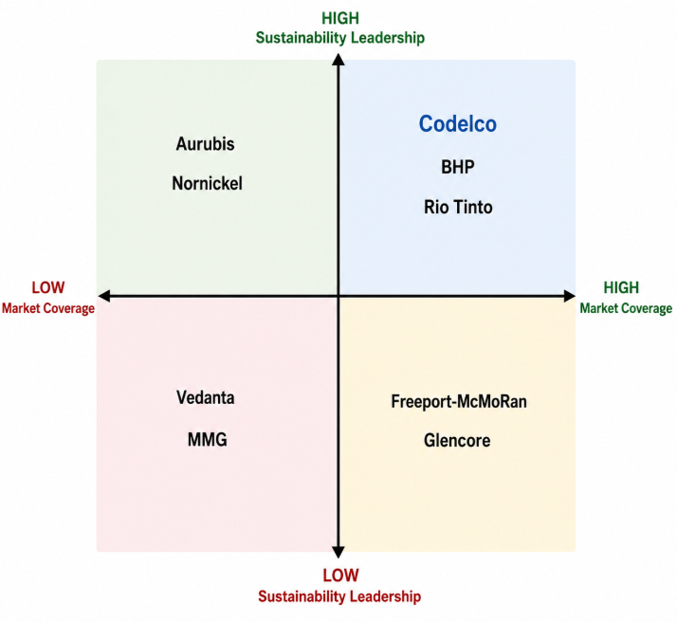
Figure 4: Perceptual map
(Source: self-created)

Task 3: Critical Reflection on AI Usage

a. Tool Disclosure
The tool used for the development of the report consists of ChatGPT that assists in idea generation, assisting in identifying the issues in concerns such as the natural resources that are impacting Codelco. Girotra et al. (2023) have defined that ChatGPT are efficient in developing reports and research through focusing on idea generation surrounding the research and improving critical thinking. Moreover, the structure of the study has also been supported by the output of the ChatGPT, reducing the time on structure of the study and improving critical analysis of the external environmental factors. Thus, the study on External environment analysis of Codelco has been conducted by using ChatGPT for generating ideas regarding two natural and se external factors impacting lower-carbon products for Codelco.

b. Critical Evaluation of AI Output
The output of the study has been clearly and systematically evaluated by comparing the information obtained from the AI output with company records of Codelco, its sustainability reporting. Giray (2024) has defined that using peer-reviewed articles and its implications in the study are efficient for supporting the factors and improving quality of the contextual information. The AI outputs generated by ChatGPT have been compared with the industry reports, company records along with peer -reviewed articles that have assisted in creating credible and reliable data-based reports on Codelco. The use of peer-reviewed articles has been effective for ensuring the credibility of the sources and supporting and rejecting the findings from the AI output generated by ChatGPT.

c. Contribution Analysis
The AI-generated output focused on outlining diverse natural and external factors that are impacting Codelco and its overall transition towards more carbon neutral products in the Chile mining sector. On the other hand, the study has been structured by analysing the external environment through conducting PESTLE analysis for outlining two external marketing factors. It has been down-identified that the 2 key external marketing factors are water scarcity and ethical ESG reporting by the management teams of Codelco. It has been identified that mining companies such as Codelco's Andina and El Teniente are facing fresh water shortage due to a 45% decline in freshwater (Cambero, 2022). Thus, the report has been structured and conducted using self-knowledge and conducted research for gathering existing resources to improve authenticity of the findings.

d. Ethical & Professional Reflection
The use of AI in the study is associated with increasing the risks of biases along with providing inaccurate information based on limited data used for training algorithms. Klimova et al. (2023) have outlined that one of the major concerns with AI is its ethical issues such as inaccurate data usage, misuse of data and inaccurate findings. Thus ensuring the credibility of the finding can be enhanced and improved through comparing the findings of the AI with credible sources.

References
Aurubis AG (2024) Annual Report 2023/24. Available at:https://www.aurubis.com/en/dam/jcr:85390d77-75bf-404b-9d84-1cbbac0bc867/Aurubis_Annual%20Report_FY%202023_24-2.pdf (Accessed: 04 July 2026).
Cambero, F. (2022) Focus: Chile's parched mines race for an increasingly scarce commodity: water. Available at: https://www.reuters.com/world/americas/chiles-parched-mines-race-an-increasingly-scarce-commodity-water-2022-05-06/ (Accessed: 4 July 2026).
Cambero, F. (2026) Copper miner Codelco sacks executives after El Teniente audit. Available at: https://www.reuters.com/business/chiles-codelco-replaces-top-executives-el-teniente-mine-after-investigation-2026-02-13/ (Accessed: 4 July 2026).
Codelco (2024) Annual Report 2023. Available at:https://www.codelco.com/en/memoria2024/informesfinancieros (Accessed: 04 July 2026).
Codelco (2024) Sustainability Report 2023. Available at:https://www.codelco.com/prontus_codelco/site/docs/20250610/20250610162815/250717_codelco_alta.pdf (Accessed: 04 July 2026).
Codelco (2025) Advancing our 2030 targets in Sustainable Development Commitments. Available at: https://www.codelco.com/english/sustainability/2030 (Accessed: 4 July 2026).
Codelco (2025) Annual Report 2024. Available at:https://www.codelco.com/sites/site/docs/20250428/20250428185356/operational_and_financial_report_december_31_2025.pdf (Accessed: 04 July 2026).
Codelco (2025) Codelco launches its 2024 Sustainability Report and reinforces its commitment to transparency and sustainable development. Available at: https://www.codelco.com/en/codelco-lanza-su-reporte-de-sustentabilidad-2024-y-refuerza-su (Accessed: 4 July 2026).
Earth (2022) Chile Water Crisis: 13 Years and Counting. Available at: https://earth.org/chile-water-crisis/ (Accessed: 4 July 2026).
Ferreira, A.P.P.F.S. and de Sá, M.M.B.P., (2024) ‘The importance of the Ansoff matrix for the study of the information services market ‘, The Canadian Journal of Information and Library Science, 47(2), pp.78-84. Available at:https://ojs.lib.uwo.ca/index.php/cjils/article/view/17432
Giray, L., (2024). ‘Benefits and challenges of using AI for peer review: A study on researchers’ perceptions.’ The Serials Librarian, 85(5-6), pp.144-154. Available at: https://www.researchgate.net/profile/Louie-Giray/publication/385845873_Benefits_and_Challenges_of_Using_AI_for_Peer_Review_A_Study_on_Researchers%27_Perceptions/links/675ffbc0af28fb680fb918ab/Benefits-and-Challenges-of-Using-AI-for-Peer-Review-A-Study-on-Researchers-Perceptions.pdf?__cf_chl_f_tk=VZuR_.EYCeNBcsyNTT5V2jgFX_OO7xAw2FXpwmFzjl0-1783151225-1.0.1.1-VpFQP1N_6yyUxxE5FRUyOPF0z83rcpB54f5LZ96xdBo
Girotra, K., Meincke, L., Terwiesch, C. and Ulrich, K.T., (2023). Ideas are dimes a dozen: Large language models for idea generation in innovation. Available at SSRN, 4526071. Available at: https://mackinstitute.wharton.upenn.edu/wp-content/uploads/2023/08/LLM-Ideas-Working-Paper.pdf
Heikkinen, A. and Bustamante, L. (2026) ‘What you see here is a wetland without water’: how the datacentre boom is exacerbating Chile’s mega-drought. Available at: https://www.theguardian.com/global-development/2026/may/26/chile-datacentres-water-tech-companies-mega-drought (Accessed: 4 July 2026).
ICA (2024) Industry reports on sustainable copper production. Available at:https://internationalcopper.org/2024-annual-report/ (Accessed: 04 July 2026).
IEA (2023) Mining Royalty Bill. Available at: https://www.iea.org/policies/17058-mining-royalty-bill (Accessed: 4 July 2026).
IEA (2024) Copper. Paris: IEA. Available at: https://www.iea.org/reports/copper (Accessed: 04 July 2026).
IEA (2024) Global Critical Minerals Outlook 2024. Available at:https://iea.blob.core.windows.net/assets/ee01701d-1d5c-4ba8-9df6-abeeac9de99a/GlobalCriticalMineralsOutlook2024.pdf(Accessed: 04 July 2026).
IEA (2024) Global Critical Minerals Outlook 2024. Available at:https://www.iea.org/reports/global-critical-minerals-outlook-2024 (Accessed: 04 July 2026).
International Energy Agency. (2024). Electricity 2024. Available at:https://www.iea.org/reports/electricity-2024 (Accessed: 04 July 2026).
Jamasmie, C. (2026) Codelco fires executive after audit points to 27-year output low. Available at: https://www.mining.com/codelco-fires-executive-after-audit-points-to-27-year-output-low/ (Accessed: 4 July 2026).
Jhunjhunwala, A. and Chaudhuri, T.D, (2021), ‘Innovation, growth and value creation: a study of Indian companies’, International Journal of Business Innovation and Research, 25(3), pp.328-352.Available at:https://www.researchgate.net/figure/The-Ansoff-matrix-Source-Image-from-the-web_fig2_343157949
Johnson, G., Scholes, K., and Whittington, R. (2020) Exploring Strategy (12th ed.). Pearson. Available at:https://www.researchgate.net/figure/The-Ansoff-matrix-Source-Image-from-the-web_fig2_343157949https://books.google.com/books?hl=en&lr=&id=ieksEAAAQBAJ&oi=fnd&pg=PT26&dq=Johnson,+G.,+Scholes,+K.,+and+Whittington,+R.+(2020)+Exploring+Strategy+(12th+ed.).+Pearson.&ots=XEI6WiN984&sig=QmLQ_a_d9Am22yNT72uiIl8reNM
Klimova, B., Pikhart, M. and Kacetl, J., (2023). ‘Ethical issues of the use of AI-driven mobile apps for education.’ Frontiers in public health, 10, p.1118116. Available at: https://www.frontiersin.org/journals/publichealth/articles/10.3389/fpubh.2022.1118116/pdf
Kotler, P., Keller, K. L., Chernev, A., (2024) Marketing Management (16th Global ed.). Pearson. Available at: https://cir.nii.ac.jp/crid/1370025429414517777
Onifade, M., Zvarivadza, T., Adebisi, J.A., Said, K.O., Dayo-Olupona, O., Lawal, A.I. and Khandelwal, M., (2024). ‘Advancing toward sustainability: The emergence of green mining technologies and practices.’ Green and Smart Mining Engineering, 1(2), pp.157-174. Available at: https://doi.org/10.1016/j.gsme.2024.05.005
Qomaro, G.W., Nasrulloh, N. and Salleh, A.Z., (2024) ‘Leveraging The Ansoff Matrix for Strategic Growth in Packaged Food Micro-Enterprises’, Dinar: Jurnal Ekonomi dan Keuangan Islam, 11(1), pp.51-66. Available at:https://journal.trunojoyo.ac.id/dinar/article/view/27163
Reuters (2024) BHP expects copper demand to grow by 1 million metric tons a year until 2035. Available at:https://www.reuters.com/markets/commodities/bhp-expects-copper-demand-grow-by-1-mln-metric-tons-year-until-2035-2024-09-30/ (Accessed: 04 July 2026).
Reuters (2024) Chile's Codelco to deploy lower carbon explosives in copper mine. Available at: https://www.reuters.com/markets/commodities/chiles-codelco-deploy-lower-carbon-explosives-in-copper-mine-2024-12-19/ (Accessed: 4 July 2026).
Reuters (2024) Codelco eyeing more output, not competition with BHP, Chile's mining minister says. Available at:https://www.reuters.com/markets/commodities/codelco-eyeing-more-output-not-competition-with-bhp-chiles-mining-minister-says-2024-04-22/ (Accessed: 04 July 2026).
Rio Tinto (2024) Annual Report 2024. Available at:https://www.riotinto.com/en/invest/reports/annual-report (Accessed: 04 July 2026).
Sankaran, M. (2025) Smart Strategies for Optimizing Water Use in Mining. Available at: https://ketos.co/smart-strategies-for-optimizing-water-use-in-mining (Accessed: 4 July 2026).
The Global Economy (2025) Chile: Political stability. Available at: https://www.theglobaleconomy.com/Chile/wb_political_stability/ (Accessed: 4 July 2026).
Trade (2026) Chile Country Commercial Guide. Available at: https://www.trade.gov/country-commercial-guides/chile-strategic-technologies (Accessed: 4 July 2026).
World Bank (2025) Inflation, consumer prices (annual %) - Chile. Available at: https://data.worldbank.org/indicator/FP.CPI.TOTL.ZG?locations=CL (Accessed: 4 July 2026).
World Bank (2026) GDP growth (annual %) - Chile. Available at: https://data.worldbank.org/indicator/NY.GDP.MKTP.KD.ZG?locations=CL (Accessed: 4 July 2026).

Appendix 1: AI out put


