Data Analysis and Visualisation
Assessment 2 t-Test June 2021 Term 1 and Term 2

Student: Gabor Gulyas (20299954)
Class: BSc Cloud Computing June 2020/2021
Lecture: Koushik Modak
Date 02/09/2021

Table of Contents

Introduction 2
Description of the dataset 3
Visualisation of the dataset: 6
Analysis and results: 7
Outliers in the dataset: 10
Factors affecting Hypotheses testing 11
Conclusion 12
References 12
Appendix 13

Introduction

A t-test is a measurable test that is utilized to analyse the method for two gatherings. It is normally utilized in theory testing to decide if an interaction or treatment affects the number of inhabitants in interest, or regardless of whether two gatherings are not quite the same as each other. We have a paper that shows some statistic details about how many white and how many BAME patients with Covid-19 infection in the UK in the objected time. We have a probability table as well that we can use when we test t values. We are on this casework to try to demonstrate an ability to present nominal and ordinal network data that informs an easy understanding of the data and the appropriate statistical methods for the analysis of well-defined problems.

Description of the dataset

A Data set is a set or assortment of information. This set is typically introduced in a plain example. Each section depicts a specific variable. What's more, each column compares to a given individual from the informational collection, according to the given inquiry. This is a piece of information for the executives.
Informational indexes depict values for every factor for obscure amounts like tallness, weight, temperature, volume, and so forth of an item or upsides of irregular numbers. The qualities in this set are known as a datum. The informational index comprises information of at least one individual relating to each line.
Dataset Meaning
An informational index is an arranged assortment of information. While dealing with the information, the informational index can be a lot of tables, blueprints and different articles. The information is coordinated to a specific model that assists with preparing the required data. The arrangement of information is any for all time saved assortment of data that normally contains either case-level, accumulated information, or factual direction level information.
Types of Data Sets
In Statistics, we have various sorts of informational collections accessible for various kinds of data:
- Numerical data sets
The mathematical informational collection is an informational collection, where the information is communicated in numbers instead of regular language. The mathematical information is in some cases called quantitative information. The arrangement of the multitude of quantitative information/mathematical information is known as the mathematical informational index. The mathematical information is consistently in the structure of the number, with the end goal that we can perform a number-crunching procedure on it.
- Bivariate data sets
An informational index that has two factors is known as a Bivariate informational index. It manages the connection between the two factors. Bivariate dataset typically contains two sorts of related information.
- Multivariate data sets
The dataset with various factors. When the dataset contains at least three than three information types (factors), then, at that point the informational index is known as a multivariate dataset. As such, the multivariate dataset comprises individual estimations that are gained as a component of at least three than three factors.
- Categorical data sets
Absolute informational collections address elements or attributes of an individual or an article. The all-out dataset comprises of an all-out factor likewise called the subjective variable, that can take precisely two qualities. Subsequently, it is named as a dichotomous variable. Unmitigated
information/factors with multiple potential qualities are called polytomous factors. The subjective/unmitigated factors are regularly thought to be polytomous variables except if in any case indicated.
- Correlation data sets
The arrangement of qualities that exhibit some relationship with one another demonstrates correlation informational collections. Here the qualities are observed to be subject to one another. For the most part, a connection is characterized as a factual connection between two substances/factors. In certain situations, you may need to anticipate the relationship between things. It is fundamental to see how connection functions. The correlation is grouped into three sorts. They are:
- Positive correlation – Two factors move a similar way (Either both are up or both or down)
- Negative correlation – Two factors move in inverse ways. (One variable is up and another variable is down as well as the other way around)
- No or zero correlation – No connection between two factors.

Mean, Median, Mode and Range of Data-Sets
The mean, median and mode alongside range are the significant themes in Statistics. Allow us to get past informational collections here.
Mean of a data set collection is the normal of the multitude of perceptions present in the table. It is the proportion of the number of perceptions to the all-out number of components present in the informational index. The equation of mean is given by;

Mean = Sum of Observations/Total Number of Elements in Data Set

The Median of an informational index is the centre worth of the assortment of information when organized in climbing requests and dropping requests.
Mode of a data-set is the variable or number or worth that is rehashed the greatest number of times in the set.
Range of a data set is the distinction between the greatest worth and least worth.

Range = Maximum Value – Minimum Value
- Median of a data-set: 43,5
- Mode of a data-set: 50
- Range of a data-set: 87
.

Visualisation of the dataset:

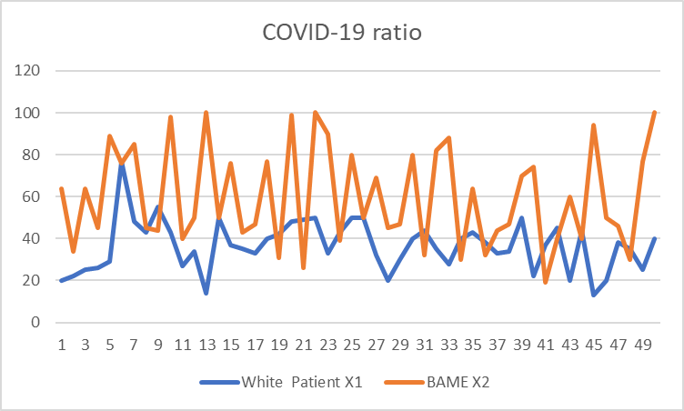

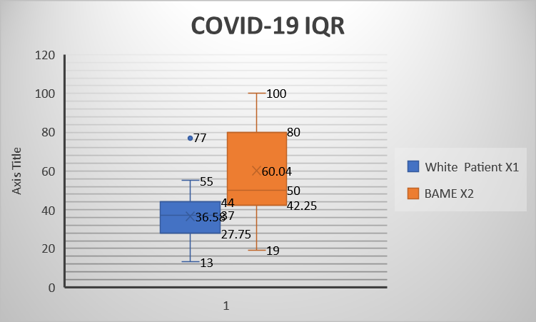

In these two graphics is easy to show you, how much difference between the two types of patient. BAME people are got infected normally age between 40 and 80, the white patient is been infected mostly between 30 and 50 and is got some young patient value what you can see in the second diagram line a patient there under 20 what makes confuse because the task description writes: „All the patient age is between 20 and 100 years.

Analysis and results:

- Identify Independent sample/paired sample
Sample 1 white people, sample 2 BAME. No relationship between, different values, randomly we can select values and, in this case, we need to use an independent (two)sample.
- Write your Null and Alternative Hypotheses. The concept of the hypothesis, developing null and alternative hypothesis:

Null Hypothesis: BBC news, it has been identified that the infection rate of Covid-19 is the same ratio between white and BAME in the UK
Alternative Hypothesis: BBC news, it has been identified that the infection rate of Covid-19 is varied between white and BAME in the UK

- Calculate the degree of freedom Df=(N-2=n1+n2-2=50+50-2=98) Df=98
- Calculate t-obt value and find t-crit value for significance level of p=0.10, p=0.01, and p=0.02. The images below illustrate the t-Test computation in Excel at these levels of significance.

First Fig T test in Excel for a significance level of p=0.10.:

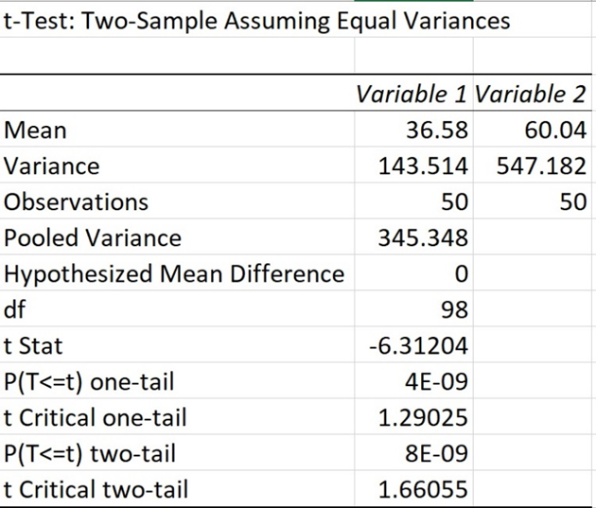

Second Fig T test in Excel for a significance level of p=0.01.:

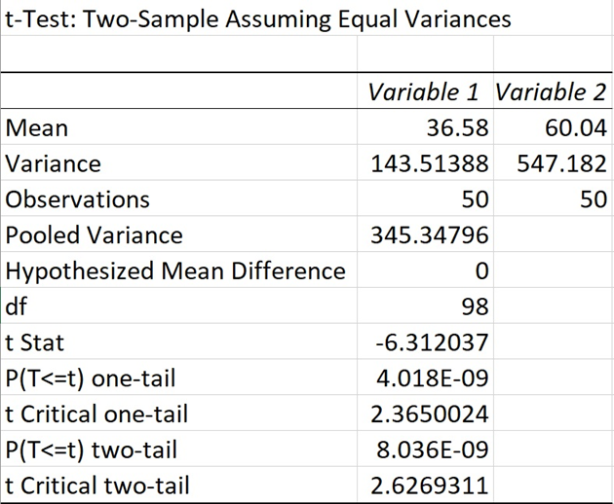

Third Fig T test in Excel for a significance level of p=0.02.:

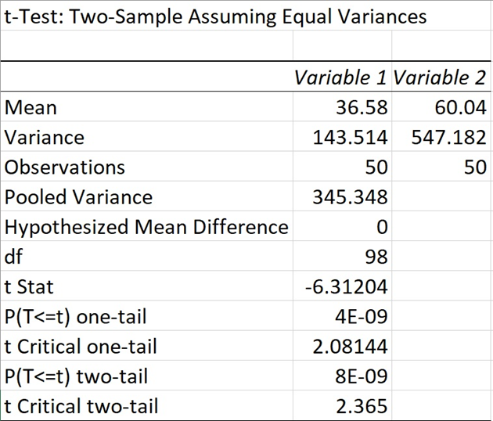

Decide whether or not to reject the null hypothesis.
Using either the one-tailed test or two-tailed test, it compared the t value obtained (the absolute value, regardless of the sign) to the tabulated values. T value is -6.31 in the given dataset (df = 50+50 - 2 = 98), at 98 degrees of freedom. With a value of t of -6.31 and 98 degrees of freedom, what is the probability that you will commit a type I error? It is necessary to consult the probability table of t values (Table 2) to answer this question. For an undirected hypothesis, significance level p will be less than 0.05 and for a directed hypothesis will be less than 0.025, so the null hypothesis will be rejected if the t value exceeds the critical value (corresponding to 98 degrees of freedom).

It can be seen that the t value is statistically significant, irrespective of whether we conduct the test with a two-tailed hypothesis or a one-tailed hypothesis since t obt = 6.31 is greater than t crit = 1.66/2.62/2.36. As a result, we can rule out the null hypothesis since t obt > t crit, and we can conclude that white and BAME people in the United Kingdom have significantly different infection rates of Covid-19.
There is statistical significance at a level of .01, .02 and .10 at a 99%, 98%, 90% level. Both t and obt are significant, as well as the mean values. We found that BAME people in the UK were more likely than white people to be infected with Covid-19. BAME and white patients' infection rates differ substantially, indicating that the magnitude of the difference is substantial.

Outliers in the dataset:

As a result, our dataset has upper and lower bounds of 20 and 100. Patients between the ages of 20 and 100 who are white and BAME are considered to be outliers. Later, I'll consider how T-obt and T-crit might vary if these outliers are included, and what happens if the outliers are removed. Using Excel, Table 1 shows the t-Test calculations with and without outliers.
Table 1:

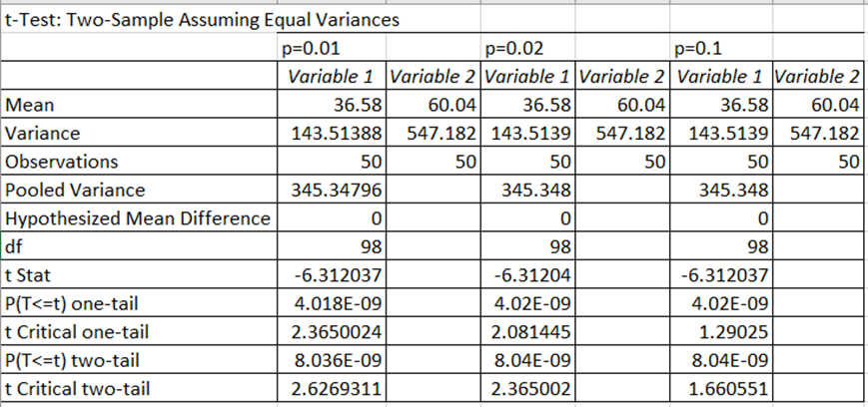

Table 2:

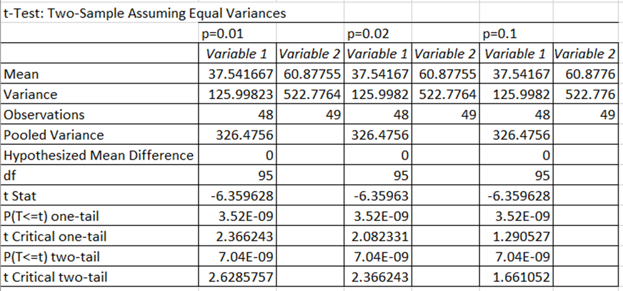

The differences in sample size between BAME and white people are apparent from tables 1 and 2. The mean and variance of each p value are different. Regardless of whether it is one tail or two tails, the t obt value is close and the t crit value is the same. Outliers should therefore always be kept in mind. Outliers are also caused by errors. Occasionally, abnormal values reveal previously unnoticed phenomena. Additionally, descriptive statistics are often sensitive to outliers, so we should be cautious about confirming them. A mean and standard deviation are calculated based on the associated data.

Factors affecting Hypotheses testing
There is a high rate of Coronavirus contamination among White and BAME. There are a similar number of examples in the dataset, which makes the analysis more robust. Based on directed theory testing, we can say that the spread of contamination is not dependent on the

number of inhabitants of a specific race. The skewness of information among BAME is larger because of the thought of exceptions. However, the difference in change between the two sets is extremely large, further discrediting the invalid theory. This demonstrates that every race has its own distinct disease pace of Coronavirus, which is confined to inner elements and has no outer components. Interior components may include their lifestyle, their cleanliness, or their lack of precautions.

Conclusion

The given task depended on utilizing one such device of information examination for the Coronavirus related information that is speculations trying. The given dataset has been investigated utilizing enlightening measurements, speculation testing, and anomalies. The task gives the point-by-point part of speculations examination of the dataset in a most extreme exploratory way. The thought of Coronavirus contaminations steers clears the race of individuals, except for the way that shows their cleanliness and way of life.

References

- Mezei Istvan, Farago Istvan, Simon Peter- Bevezetes az analizisbe
- Dr. Gaspar Csaba – Analízis (2004)
- Gonda Istvan, Dr. Nemeth Jozsef – Bevezetes az Analizisbe (2011)

Appendix

Table with the white and BAME patients with Covid-19 infection in the UK.

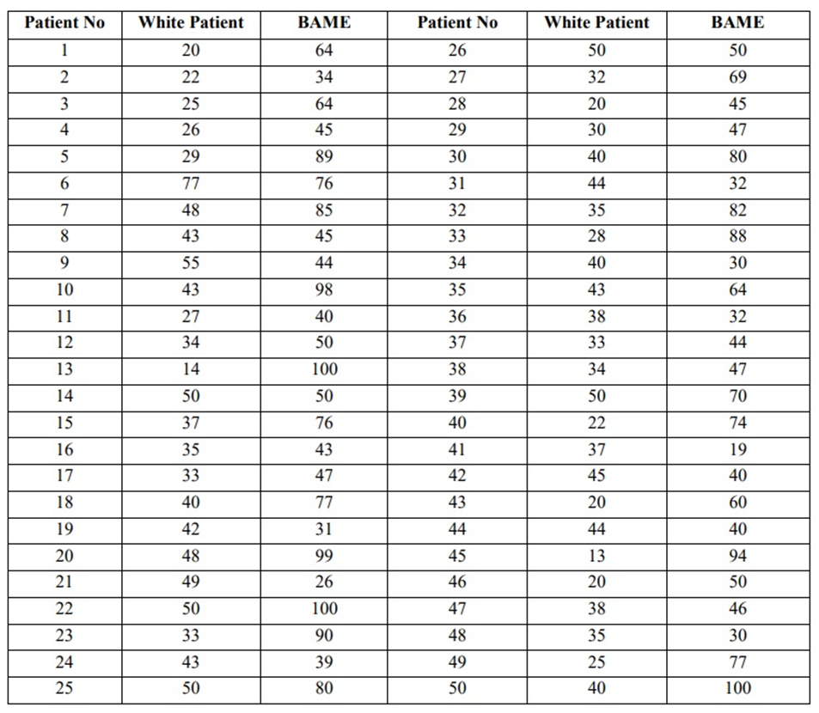

Probability table of t values.


