  Component One: Student Journal (learning log) 750 words +/- 10%  Contribution to Overall Module Assessment: 25% | Student No: | 2245306
 | Module Title: | Hotel Placement – Operating Hotel Facilities
 | Module Code: | BMIH4006
 | Lecturer:
By using Gibbs's reflection model, I will describe my learning experiences from my placement as a housekeeper in the housekeeping department of The Savoy in this learning log. I will provide a detailed reflection on my placement reflection and the key developmental areas.
Reflection
My placement was in the housekeeping department of The Savoy which is one of the most famous hotels in the UK. This placement was six weeks and I maintained a lot of work and responsibilities at the placement organization. The main responsibility was to maintain orderliness and cleanliness in the hotel context. In terms of tasks, this includes issues like restocking amenities, changing linens, room cleaning, as well as emasculating the guests. All of these duties work as a part of my experience in my professional career and I understood that my main aim as a housekeeping should engage in guest satisfaction (Akgündüz, 2015).
During the placement period at The Savoy, I have experienced a lot of new things that are impactful to my emotions and feelings. Firstly, the fast-paced nature is an overwhelming issue that was a new thing to me and I engage myself in this sector at the workplace. Maintaining the high standard of the workplace was a challenging fact for me because this was hard for me to manage all these issues efficiently and effectively. However, I appreciated this issue by managing the tasks properly under the supervision of my seniors at the workplace. I also got a collaborative workforce that manages effective team skills that helped me to increase my enlightening and rewarding facilities at the workplace (Zabidi et al., 2014). However, I gained a good overview of the crucial management of work dynamics for managing deadlines. So, this helped me to arrange good command over my job experiences.
My experience in this placement includes both good and bad issues which are impactful for my future career. At the placement, I understood that I have good command over problem-solving, higher thinking, time management and communication which are influential in every aspect. I could manage difficult tasks by discussing them with my senior teammates and supervisors. I was also effective in managing deadlines of the task that is considered to be a core issue in developing guest service at the workplace. At the same time, I have good command over my problem-solving skills which helped me to manage unexpected problems at the workplace. However, I have lacking in my technical skills which caused me a lot of pain during the whole placement period at this hotel (Quaglietta et al., 2016). I also face troubles regarding the future development of my employability skills which is a core thing in this regard at the workplace.
In terms of guest satisfaction, the role of housekeeping is significant because of its extensive management in all sectors. From my placement, I have understood that his job role includes the most influential tasks in the hotel industry that should be managed properly. A well-structured and managed hotel emphasizes the housekeeping department for being successful in the business industry of hospitality. These are also influential for getting positive reviews from the guests.
The experiences and knowledge I have gathered from this placement are valuable because these are effective for providing effective insights and lessons on housekeeping facilities. I have also understood that teamwork, effective communication and proper attention are pivotal issues for managing guest satisfaction at the placement organization. I have developed my knowledge in tourism management in a higher context in this current period by encompassing good command over different key skills (Lee et al., 2015). At the same time, I have also acquired a major understanding of the issues of transformative functions that are effective for acquiring effective success in the tourism and hospitality sector.
From this reflection on my placement at The Savoy, I have found some places that should be developed with effective strategies. Firstly, I need to work on my cleaning techniques because different types of latest products and materials are impactful for cleaning. So, I need to work on my continuous learning process that can be taken from different online and offline courses (Kandampully et al., 2015). After that, I need to work on the development of my non-verbal cues like gestures, postures and facial expressions which are key elements in the hospitality industry. Apart from these, I need to work on my technical skills because these are effective in providing digital facilities for guests from different places in the world.
Development is a key function in human life and placement can help a person to develop skills and attributes in human life from different perspectives.

Component Two: Health and Safety Guide
Contribution to Overall Module Assessment: 25%
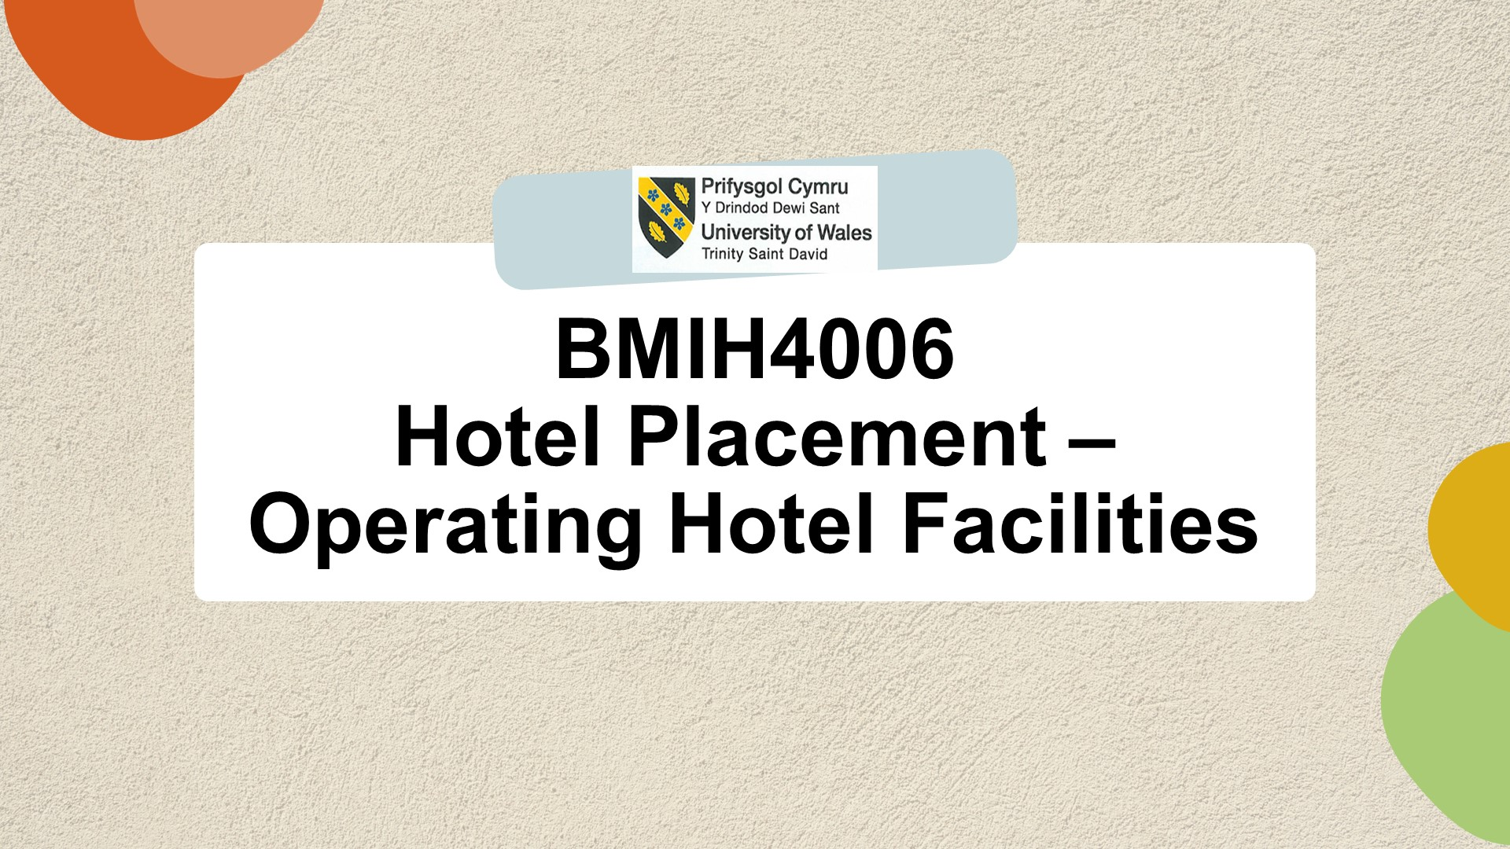

Introduction
This presentation will talk about the issues of the potential risks of industry best practices and regulations related to housekeeping safety (Bridger, 2018). At the same time, this will also provide information regarding precautions, procedures and equipment for implementing proper safety in room cleaning. Lastly, this will provide insights into the major hazards and their solutions to house cleaning.
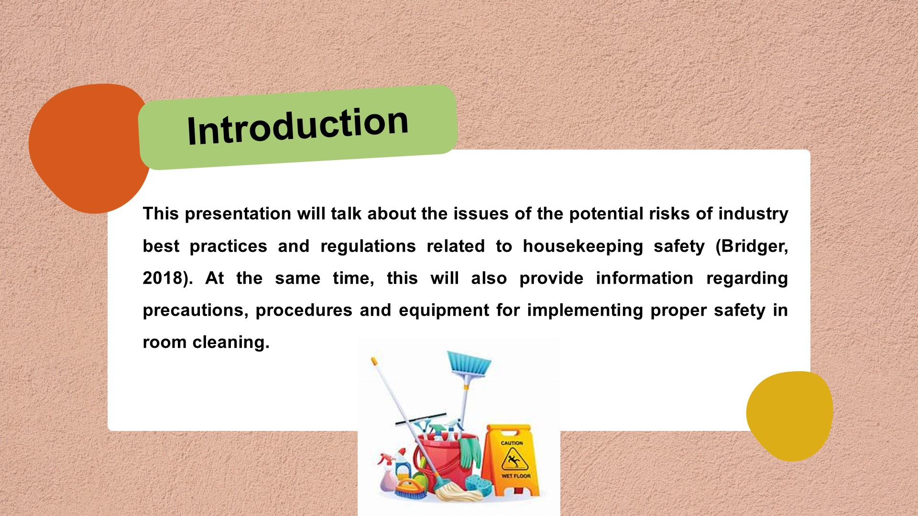

Identification of the potential risks, gathering information on industry best practices and regulations related to housekeeping safety
Housekeeping safety is a key concept in the hospitality industry and this includes diverse risks that are effective for housekeepers. Some of the most common risks are wet floor slips, hazardous chemicals, musculoskeletal injuries and biological hazards during cleaning procedures. All these risks are highly impactful for marinating the safety of housekeepers at the workplace (Cottrell, 2019).
The hospitality industry has developed some major regulations and practices for mitigating this kind of risk in the housekeeping department. Continuous training opportunities are the most important way to mitigate those risks at the workplace. In times of cleaning with dangerous chemicals, housekeepers can wear PPEs, face masks and gloves which will save them from different negative chemicals for heath safety. Apart from these, they can also enhance their cleaning by using modern technologies for cleaning purposes at the workplace (Raghubalan and Raghubalan, 2016).
The Health and Safety Executive is considered to be the most influential regulation for housekeepers in the UK. The main aim of this regulation is to provide proper ventilation and a chemical-free environment for the cleaners. The main aim of the British Institute of Cleaning Science is to provide safety procedures to the cleaners by encompassing quality in work.
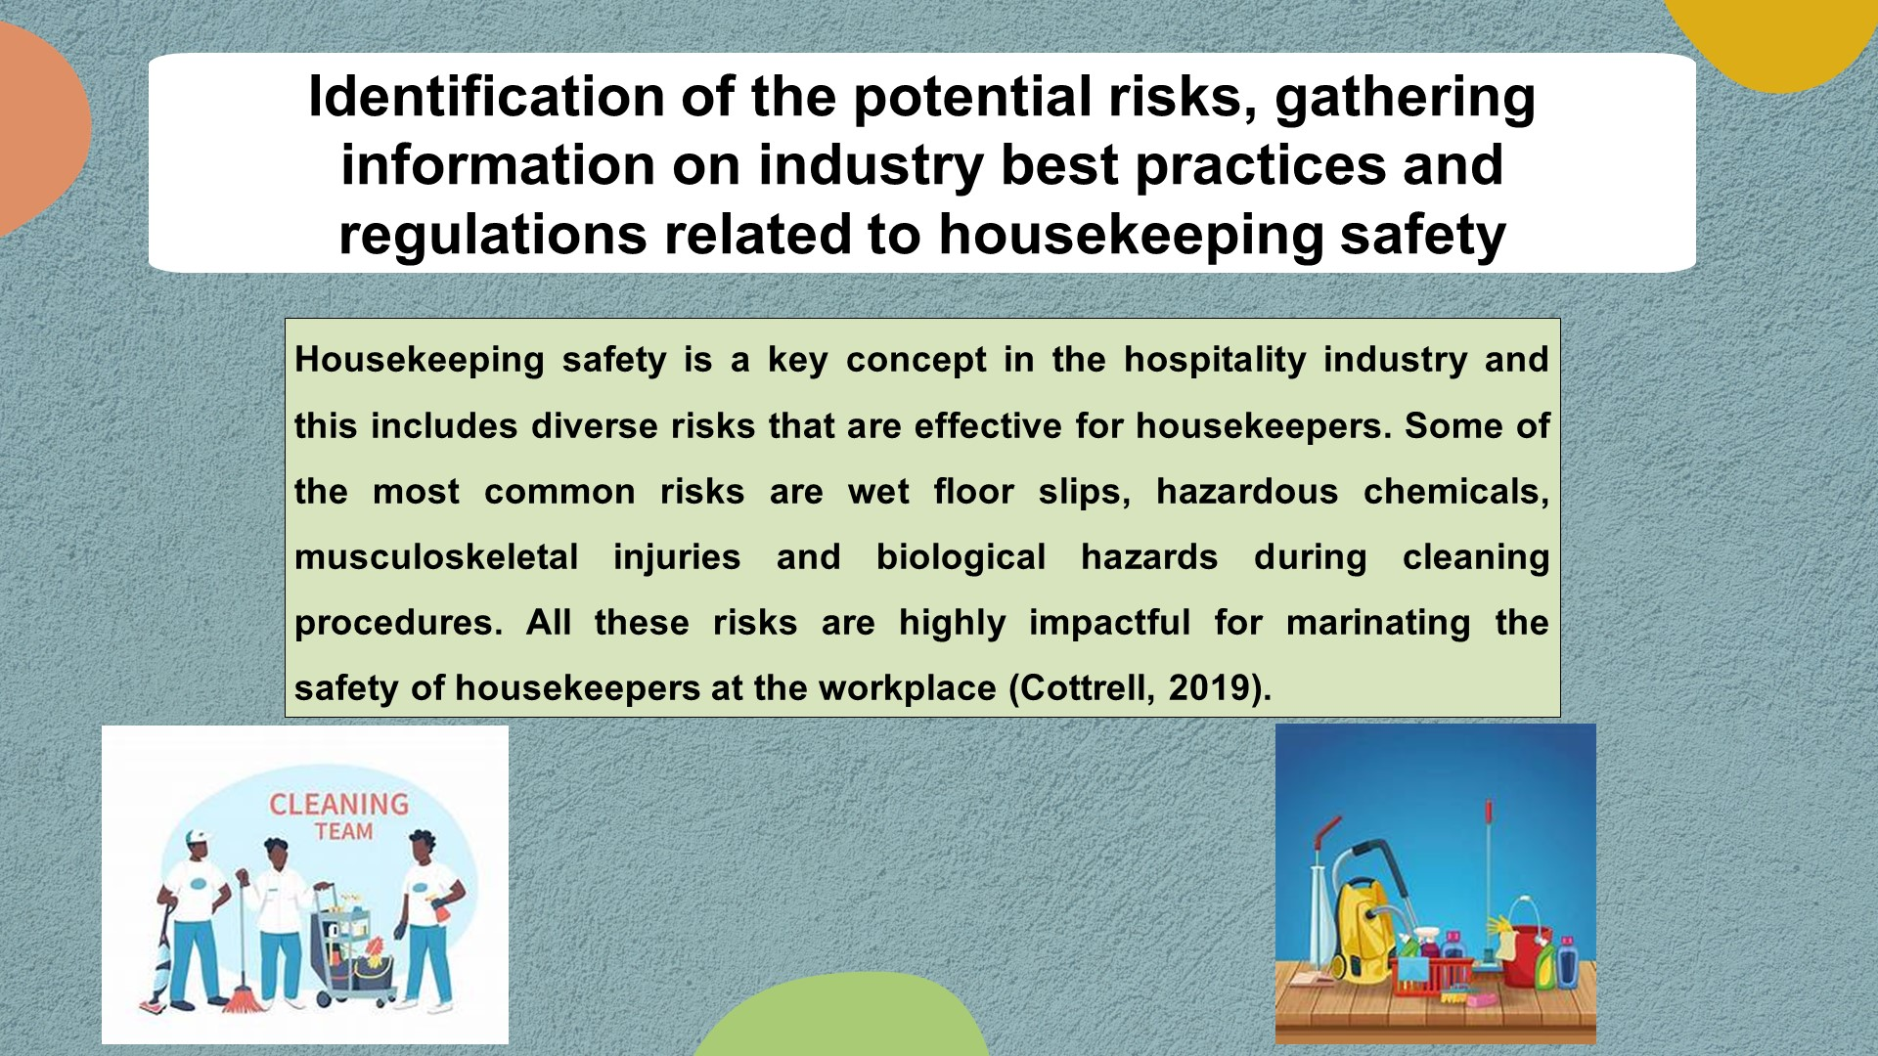

Precautions
Injuries and accidents are common in the hospitality industry regarding the housekeeping department. To save the employees who are engaged in the housekeeping department should follow some precautions and they are here.
- The housekeepers should wear PPE along with proper face masks and hand gloves. The quality of these elements should be emerging and effective because these are connected to the management of proper safety for the housekeepers (Quick, 2020).
- Then the used chemicals in the cleaning procedure should be authentic and preserved in a reliable place.
- The housekeepers should wear reliable shoes to avoid slips on the wet floors.
- Proper lifting techniques should be provided during the training sessions that will help to promote safety protocols.
- The hotels should provide a clutter-free environment for work that can include proper equipment and cords for preventing different types of accidents.
- At the same time, the housekeepers need to engage in safety contents of any kind of chemicals and materials that are effective for managing business development features (Touitou et al., 2017).
- Lastly, regular feedback and monitoring are essential to measure the effectiveness of taken initiatives.
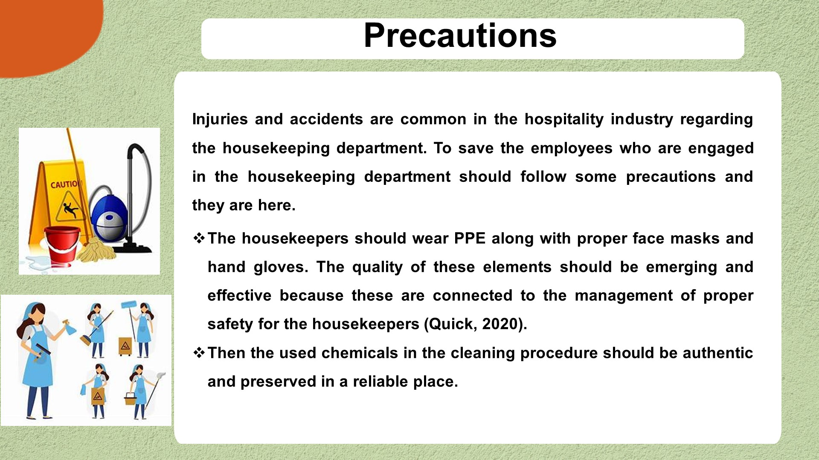

Procedures
For cleaning a room, a step-by-step procedure should be followed because this emphasizes the issues of safety protocols. Those step-by-step procedures are here.
Inspection and Preparation: At first, housekeepers need to gather PPE and cleaning supplies. Then, they need to inspect the major dangers that are evident in the cleaning spot (Ferdinand and Kitchin, 2017).
Ventilation: They need to use proper ventilation facilities for circulating the toxic air that is effective for managing cleaning.
Safety Measures: They need to manage proper masks, non-slip shoes, and gloves for handling different types of chemicals. They also need to look after the electrical appliances.
Wiping and Dusting: For wiping, housekeepers need to start from the highest part and end at the lowest part of the room. They also need to wear damp clothes to manage the airborne dust.
Surface Disinfection: To make the surface more effective, housekeepers need to use disinfection materials like Dettol, Savlon etc. that are effective in managing heath conduct (Cowie et al., 2015).
Floor Cleaning: For cleaning the floors, the housekeepers can use vacuum cleaners that are effective in managing edges and corners.
Final Inspection: lastly, the cleaners need to do a final inspection of the overall cleaning procedures.

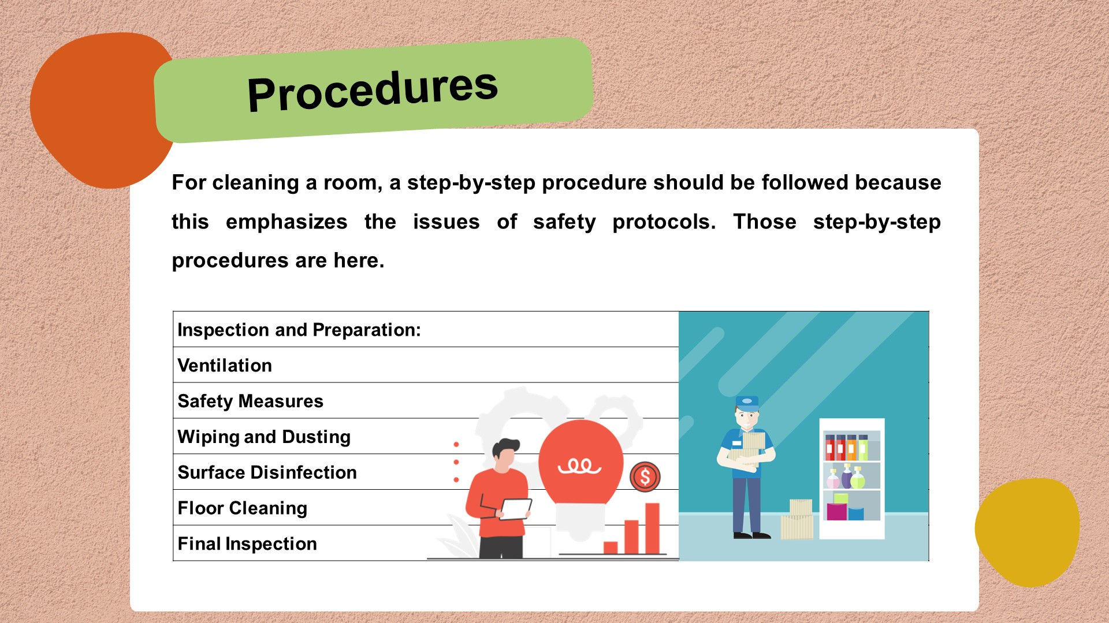

Equipment
The term, "Safe Room Cleaning" is an emerging concept in today's tourism and hospitality industry that includes diverse functions which are effective for managing the proper safety of the housekeepers (Sharma et al., 2019). For the overall management of safe cleaning procedures, some essential tools are required that are portrayed here.
- A cleaning Caddy is a key piece of equipment that helps the cleaners to manage the cleaning procedures effectively.
- Nitrile or latex gloves are essential for ensuring safety from germs and chemicals.
- Scrubbing Brushes are used to clean bathrooms, basins and bathtubs.
- Disposable masks should be provided to inhale the chemical and allergens fumes.
- Non-slip shoes are essential to resist slips on the floors.
- Vacuum Cleaner is a powerful machine for cleaning the upholstery and carpets in the rooms.
- Microfiber Clothes are highly important for cleaning the furniture and surfaces.
- Trash Bags are used for disposing and collecting wastes from the rooms.
- Lastly, housekeepers should use proper safety signs for managing different types of hazards in the room context.
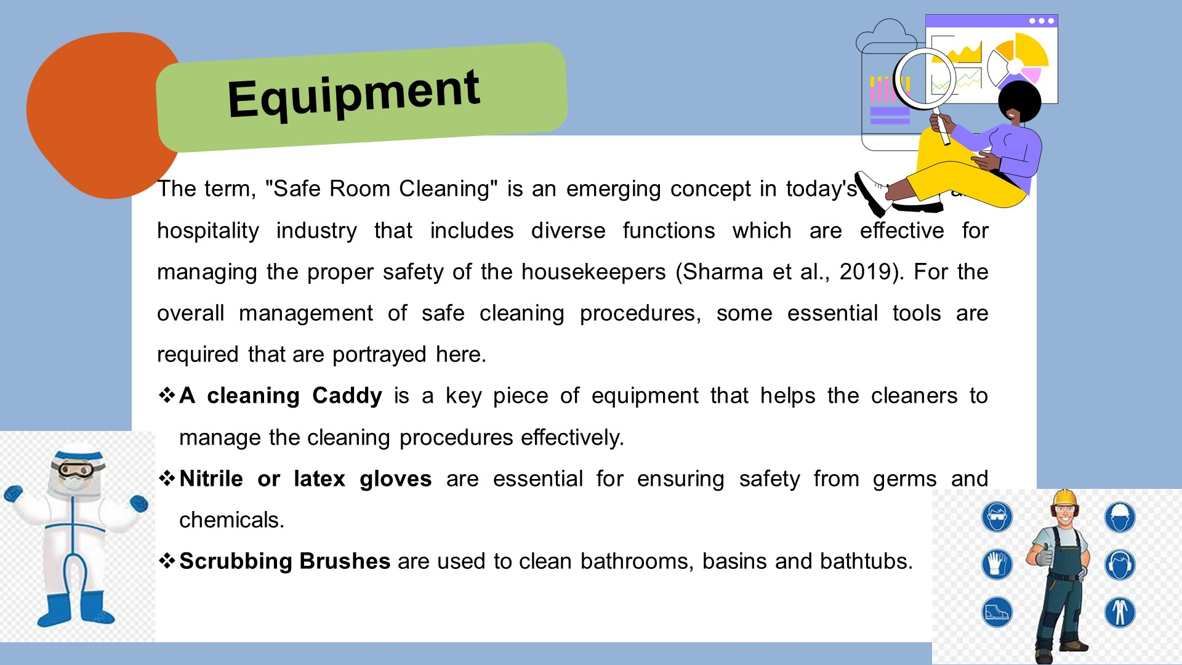

Hazard Mitigation
For managing proper safety at the tourism spots, hazard mitigation facilities are highly impactful because these can save the lives of the guests and the housekeepers. Some of the potential risks and their mitigation are discussed here.
Hazards | Mitigation
Wet floors can cause spills and mopping that are dangerous for cleaning safety. | Using signs like "Wet Floor" will help the cleaners to be aware of the issues. At the same time, they also need to wear slip-resistant shoes that are effective for managing their safety (Williams et al., 2020).
Lifting Injuries may be caused by lifting different types of heavy materials like mattresses and furniture. | In this regard, housekeepers must have to use effective techniques for weight lifting and provide possible assistance to each other in time of lifting.
Skin contact and inhalation of different cleaning chemicals may cause a lot of diseases in human beings. | To keep oneself safe from the exposure of chemicals, housekeepers need to use proper face masks and gloves. At the same time, they also need to read out the manufacturer's instructions which are important before using chemicals.
Fire and electrical hazards are like taking risks. | In this regard, housekeepers need to be more concerned.

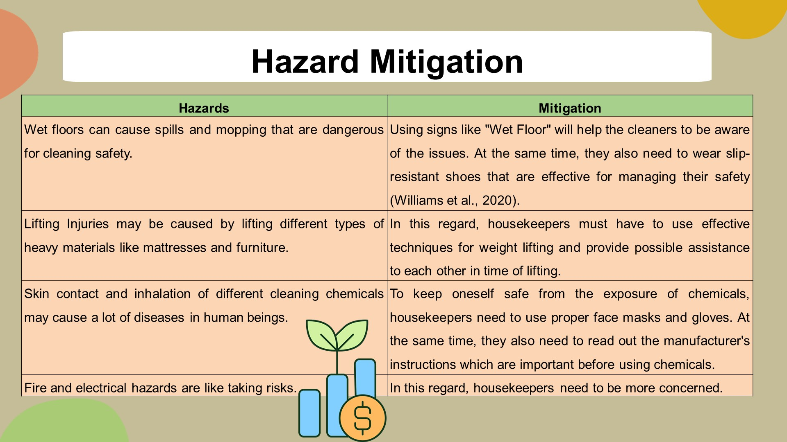

Conclusion
In terms of the tourism and hospitality industry, housekeeping is an important department that focuses on diverse issues regarding the overall development in this current period (Mejia et al., 2021). Despite having a lot of risks in this profession, a vast number of people work as housekeepers in different places all over the world. So, this is important to manage proper safety for the housekeepers.
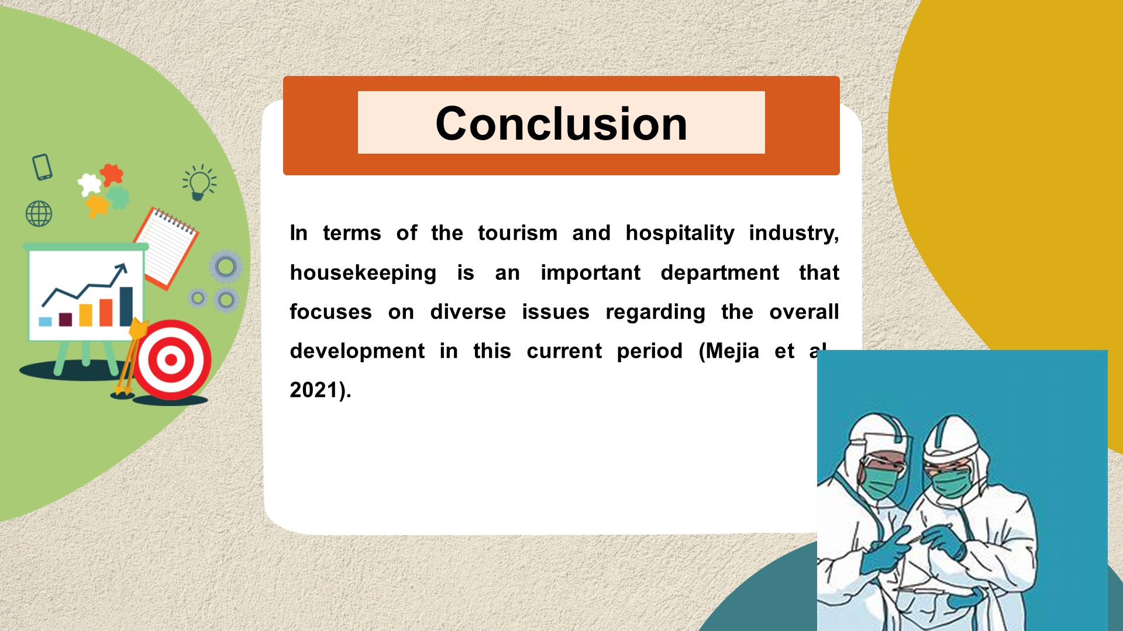

Reference List

Adeani, I.S., Febriani, R.B. and Syafryadin, S. (2020) 'USING GIBBS REFLECTIVE CYCLE IN MAKING REFLECTIONS OF LITERARY ANALYSIS,' Indonesian EFL Journal, 6(2), p. 139. https://doi.org/10.25134/ieflj.v6i2.3382.
Akgündüz, Y. (2015) 'The influence of self-esteem and role stress on job performance in hotel businesses,' International Journal of Contemporary Hospitality Management, 27(6), pp. 1082–1099. https://doi.org/10.1108/ijchm-09-2013-0421.
Bridger, E. (2018) Employee engagement: a practical introduction. 2nd ed. HR Fundamentals. London: CIPD and Kogan Page.
Cottrell, S. (2019) The Study Skills Handbook. 5th ed. London: Red Globe Press.
Cowie, M.R. et al. (2015) 'Adaptive Servo-Ventilation for central sleep apnea in systolic heart failure,' The New England Journal of Medicine, 373(12), pp. 1095–1105. https://doi.org/10.1056/nejmoa1506459.
Ferdinand, N. and Kitchin, P. (2017) Events Management - An International Approach. 2nd ed. London: SAGE Publications Ltd.
Kandampully, J., Zhang, T. and Bilgihan, A. (2015) 'Customer loyalty: a review and future directions with a special focus on the hospitality industry,' International Journal of Contemporary Hospitality Management, 27(3), pp. 379–414. https://doi.org/10.1108/ijchm-03-2014-0151.
Lee, J.H. et al. (2015) 'Fluorescent in situ sequencing (FISSEQ) of RNA for gene expression profiling in intact cells and tissues,' Nature Protocols, 10(3), pp. 442–458. https://doi.org/10.1038/nprot.2014.191.
Mejia, C., Ciarlante, K. and Chheda, K. (2021) 'A wearable technology solution and research agenda for housekeeper safety and health,' International Journal of Contemporary Hospitality Management, 33(10), pp. 3223–3255. https://doi.org/10.1108/ijchm-01-2021-0102.
Quaglietta, E. et al. (2016) 'The ON-TIME real-time railway traffic management framework: A proof-of-concept using a scalable standardised data communication architecture,' Transportation Research Part C: Emerging Technologies, 63, pp. 23–50. https://doi.org/10.1016/j.trc.2015.11.014.
Quick, L. (2020) Managing Events. Real Challenges, Real Outcomes. London: SAGE Publications Ltd.
Touitou, Y., Reinberg, A. and Touitou, D. (2017) 'Association between light at night, melatonin secretion, sleep deprivation, and the internal clock: Health impacts and mechanisms of circadian disruption,' Life Sciences, 173, pp. 94–106. https://doi.org/10.1016/j.lfs.2017.02.008.
Raghubalan, G. and Raghubalan, S. (2016) Hotel Housekeeping - Operations And Management. 3rd ed. India: Oxford University Press.
Sharma, N., Chaudhary, N. and Singh, V. (2019) Management Techniques For Employee Engagement In Contemporary Organizations. Hershey, Pennsylvania: IGI Global
Zabidi, M.A. et al. (2014) 'Enhancer–core-promoter specificity separates developmental and housekeeping gene regulation,' Nature, 518(7540), pp. 556–559. https://doi.org/10.1038/nature13994.
Williams, K, Woolliams, M & Spiro, J. (2020) Reflective writing, Macmillan International, Oxford.


