
Electical Machines
M6X00373Steve Mosey UWTSD
Adrian Thomas 1708738

Contents
1 Abstract 3
2 Introduction 4
2.1 DC motors: - 4
2.2 Magnetism 6
2.3 Magnetism & Motor’s 8
2.4 Specific problem 9
2.5 FEM 10
3 Method 10
4 Results 12
4.1 Total flux 12
4.2 Flux leakage 13
4.3 Flux cutting rotor coil vs angle 14
The values can then be put into a graph to provide estimates of the flux 15
5 Discussion 16
6 Conclusion 17

1 Abstract
The following report is designed too look at magnetic flux being used, created and leaked in a DC motor circuit using FMEE 4.2 simulation software. The aim is to establish flux leakage, an estimate of the total flux being created in the stator circuit & an estimate of the flux cutting the rotor coil as a function of coil angle. In order to complete this a given design is created in the software which then shows the lines of magnetic flux being generated in the circuit, from this measurement can be taken at given points to establish values for the above areas in question.

2 Introduction

2.1 DC motors: -
In the basic sense a motor is a machine that takes electrical energy and converts this into mechanical energy. The direction of force is given by Flemings Left hand rule To achieve this the motor uses the basic principle of magnetism, by placing a current carrying conductor within a magnetic field it experiences a mechanical force.
The construction of a DC motor can be seen below
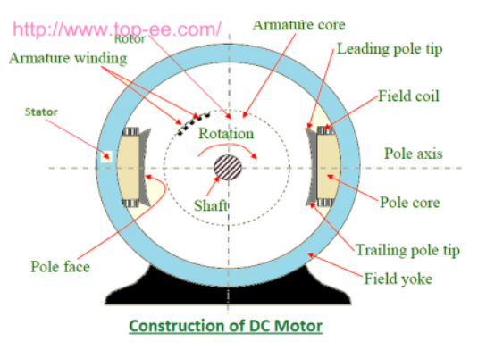
https://www.top-ee.com/construction-of-d 1
Within the make up of the motor we have the stationary part “Stator” and rotational part “Rotor”
The stator houses the field windings and also the supply, the job of the field windings is to become electro magnetics and provide the flux required for the machine to operate. The field windings are made up of copper coils which are wound over slots in the pole shoes, when current is applied the adjacent poles have the opposite polarity. However in very small motor a permeant magnetic may be used.
Attached to the stator within the yoke are the poles, these comprise of the pole core and pole shoe. The pole core is made up of thin lamination of steel or iron, it is constructed this way to reduce power losses from Eddy currents. The pole shoe is designed to spread flux that is produced over the air gap between the stator and rotor to reduce reluctance losses.
(https://www.top-ee.com/, 2019)
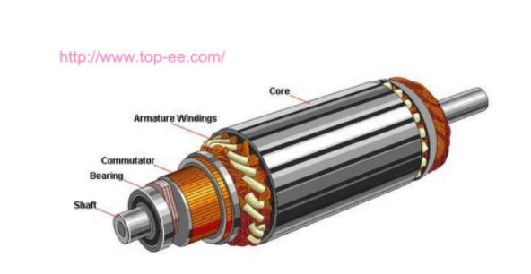
https://www.top-ee.com/construction-of-d 2
The rotor consists of a laminated low-hysteresis silicon steel core with slots in which house the copper coils of the armature windings . There are two main ways of constructing these windings
- LAP winding – in this case the number of parallel paths between conductors and poles in equal
- Wave winding – in this case the number of parallel paths is always equal to 2 irrespective of the number of poles
The rotor assembly also housing the commutator which, this is made up of thin segment of copper insulated from each other by a mica, the role of the commutator is to transmit the supply to the armature windings. This transfer is done via carbon brushes
(ttps://www.electrical4u.com/construction-of-dc-motor-yoke-poles-armature-field-winding-commutator-brushes-of-dc-motor/, 2019)
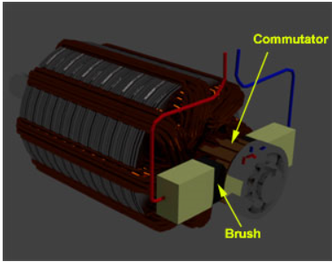
https://www.electrical4u.com/constructio 1

2.2 Magnetism
A magnet is simply an object or material that produces a magnetic field, these can be both permanent or electromagnets. Magnets have the following properties
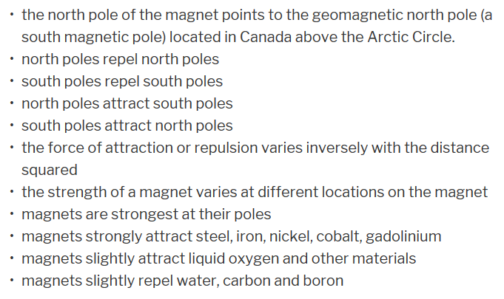
https://www.universetoday.com/82049/how- 1
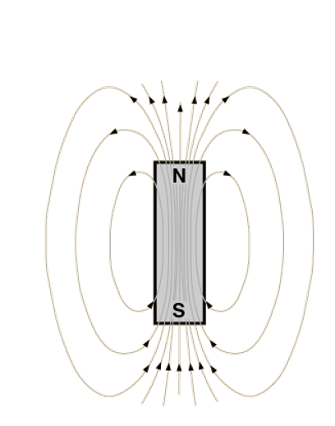
https://moodle.uwtsd.ac.uk/pluginfile.ph 1
A magnet works by electron flow, when current is passed through a wire a magnetic field is created around it therefore when electrons flow a magnetic field is created. While lots of materials produce a magnetic field ferromagnetic materials are the only ones considered truly magnetic as these are the only ones attracted to a magnetic strongly, all other substances respond weekly to a magnetic field. Ferromagnets tend to have electrons orbiting them and thus create their own magnetic field.
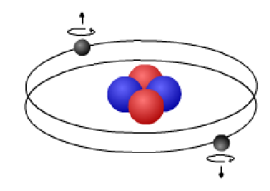
https://moodle.uwtsd.ac.uk/pluginfile.ph 2
Groups of these atoms tend to orientate themselves in a common direction this is known as a magnetic domain, with each domain having its on north and south poles. When a iron has a domains which are pointing in random direction the magnetic fields of the domain cancel out and thus the material is not magnetic.
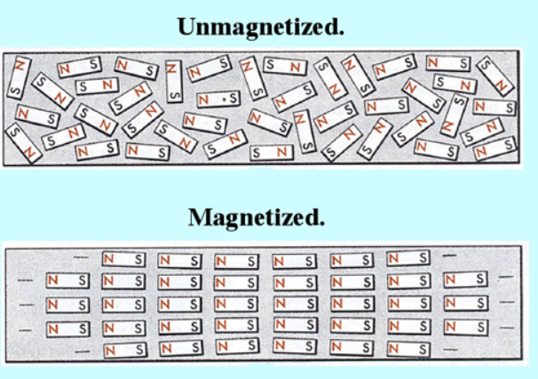
http://boomeria.org/physicslectures/seco 1
When a current is passed through this same material the domain begin to align and create a magnetic field, the higher the current the more domains align until saturation point is reached.
(Coffey, 2019)

2.3 Magnetism & Motor’s

The stator is a magnet all be it permanent or electro, the armature is in simple terms a coil of which when current flow via the commutator creates its own magnetic field, the commutator is split into sections so when power is applied there will be opposite polarity, this ensures that electricity will always flow away on the left side and flow towards on the right side and hence the coil will keep rotating. The more sections or loops in the commutator the smoother the rotational motion
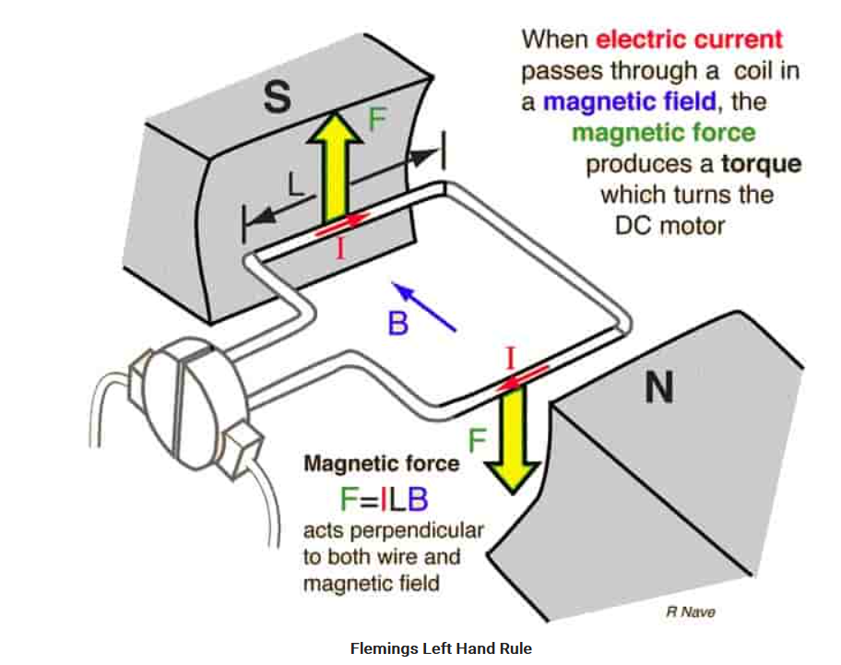
https://studyelectrical.com/2014/12/work 1
As can be seen in the depiction above when a current is applied to the armature is generates a magnetic field, this field interacts with the field generated by the stator and hence gives rotation and torque. When the armature is rotating it cuts through the magnetic flux lines, according to Faraday’s law of electromagnetic induction and EMF is induced in the armature windings, the direction of this is such that is opposes the armature current, the magnitude of this is directly proportional to the motor speed. When load is low speed will increase and hence back emf will also increase, due to the increased emf armature current will reduce, as torque is proportional to armature current this will also decrease until it become stable for the load
(Daware, 2019)

2.4 Specific problem

The specific problem is to analyse a dc motor stator circuit more specifically how much total magnetic flux is being created in the stator, how much flux is being leaked and finally an estimate of how much flux is cutting the rotor coil as a function of the coil angle. These point can then be used to help understand how the magnetic circuit and the flux interact
To complete this task FEM software will be used specifically FEMM (Finite Element Method Magnetics) 4.2 software

2.5 FEM

This is a numerical method used for solving problems of engineering & maths physics, these problems require the solution to boundary value problems for partial differential equations. The finite element of the problem then results in a system of algebraic equations. It then subdivides a large system into a smaller system with the smaller parts being the finite elements. The simple equations that model these finite elements are then assembled into a larger system of equations that models the entire problem.
(Unknown, 2019)

3 Method

Using the FEMM 4.2 software a model was created with the following dimensions
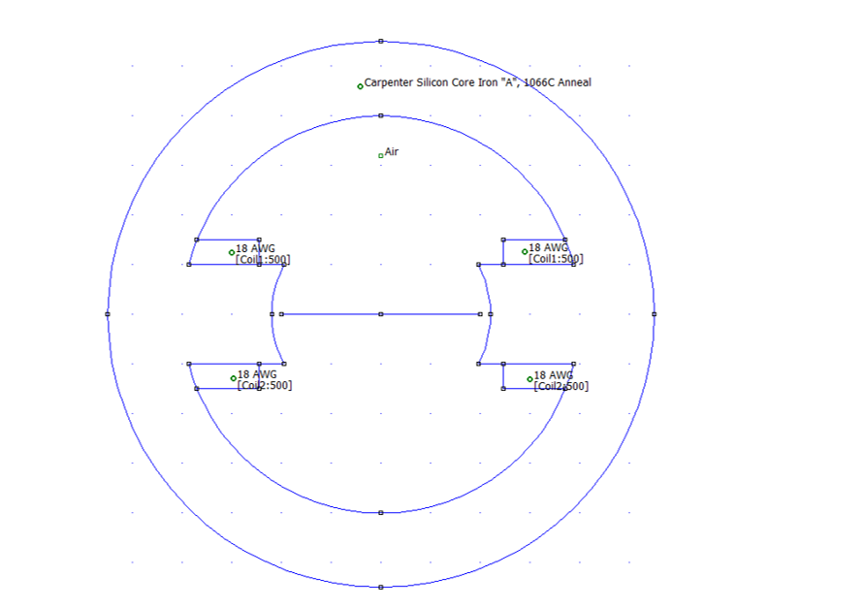
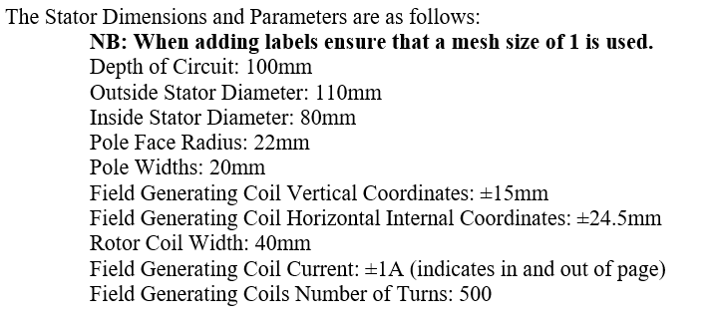

Once the model was complete a mesh was then drawn which draws a triangular mesh of the problem, the mesh spacing can be altered to suit the problem however a small number of nodes generated will result in an inaccurate model with too many nodes resulting in a excessive simulation time. Next the model was analysed by “turning the Crank” in the software and viewing results with Glasses symbol
(Meeker, 2019)

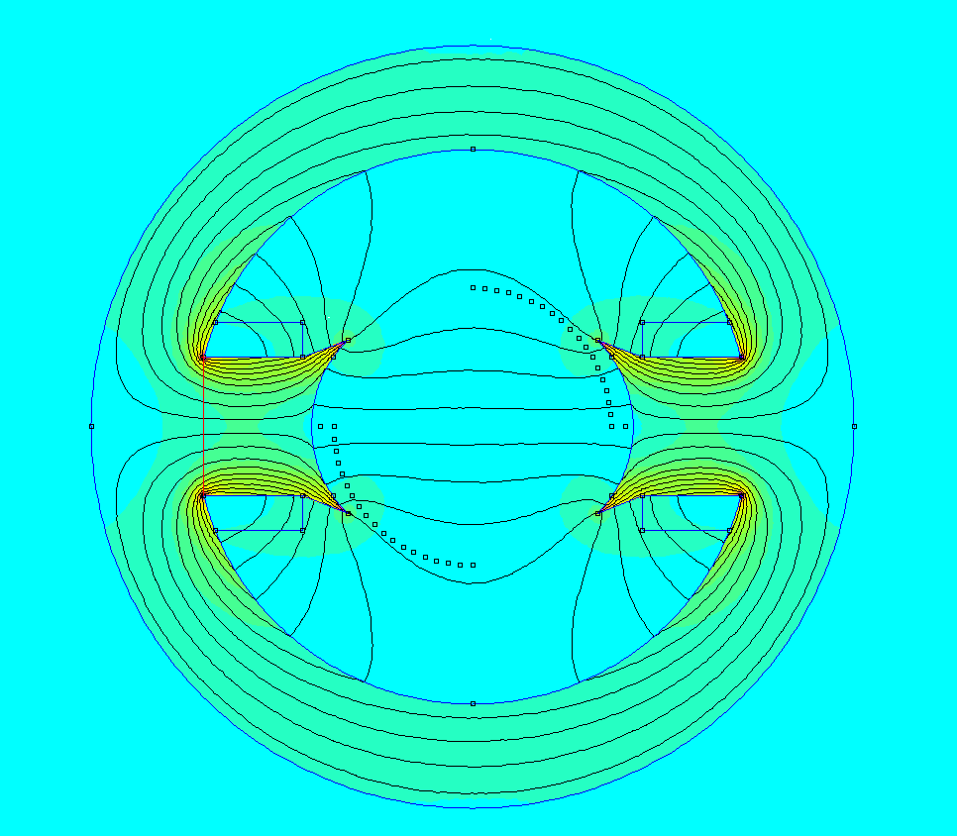
This allows the lines of magnetic flux generated by the circuit to be viewed, points are then placed around the rotor diameter to allow points to measure values from, the following can be calculated
- Total magnetic flux in the stator
- Flux leakage
- Flux cutting the rotor as a function of angle

4 Results

4.1 Total flux

By inserting a line across the pole body the total flux can be calculated via the software, in the case of the this problem the total flux produced was
6.48E-05 | Weber’s

4.2 Flux leakage

The flux leakage is calculated by $\frac{Total flux-Useful flux}{Total Fux}$

Flux leakage is defined as the flux that does not follow the intended path of the magnetic circuit

Useful flux is defined as flux which passes through the air gap and is utilised in the magnetic circuit

Fringing can be seen on the above simulation model this is where the flux lines bulge out around the rotor, because of this air gap the effective air gap area increases and the flux density of the air gap decreases

(Unknown, https://circuitglobe.com/what-is-leakage-flux-and-fringing.html, 2019)

Useful Flux | 2.28E-05 | Webers
Total Flux | 6.48E-05 | Webers
Flux Used | 3.52E-01 | or | 35.20%
Flux leakage | 64.80%

4.3 Flux cutting rotor coil vs angle

In order to calculate the above measurement, points where put around the rotor diameter top form 90 degree, a line was then inserted between two points i.e. from 10˚ + to 10 ˚-. These values can then be made replicated to form the other half of the waveform and give 180˚ sample and finally make the values opposite polarity to give the further 180˚.

The values can then be put into a graph to provide estimates of the flux

Angle | X | Y |  | Phi (Wb)
0 | 20.00 | 0.00 |  | 3.16E-09
5 | 19.92 | 1.74 |  | -2.56E-06
10 | 19.70 | 3.47 |  | -5.19E-06
15 | 19.32 | 5.18 |  | -8.00E-06
20 | 18.79 | 6.84 |  | -1.11E-05
25 | 18.13 | 8.45 |  | -1.45E-05
30 | 17.32 | 10.00 |  | -1.82E-05
35 | 16.38 | 11.47 |  | -2.08E-05
40 | 15.32 | 12.86 |  | -2.21E-05
45 | 14.14 | 14.14 |  | -2.26E-05
50 | 12.86 | 15.32 |  | -2.28E-05
55 | 11.47 | 16.38 |  | -2.28E-05
60 | 10.00 | 17.32 |  | -2.26E-05
65 | 8.45 | 18.13 |  | -2.25E-05
70 | 6.84 | 18.79 |  | -2.25E-05
75 | 5.18 | 19.32 |  | -2.23E-05
80 | 3.47 | 19.70 |  | -2.21E-05
85 | 1.74 | 19.92 |  | -2.20E-05
90 | 0.00 | 20.00 |  | -2.20E-05

5 Discussion
From the results seen above it can be seen that maximum flux levels are achieved around 54˚
The maximum level is achieved here since
this is where the rotor is most effected by the lines of flux
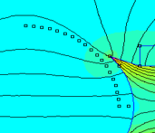It can be seen on this segment of the simulation, 54 ˚is where our points are closest to the lines of flux. This is also supported by our table above where max flux occurs approx. 50 & 55˚ sample points.
It can also be noted how much flux is leaked, in this case 64.80%

6 Conclusion

From this assignment and simulation, a greater understanding of how the armature and field winding magnetic fields interact was achieved. It was also seen how much flux is useful and therefore how much was actually leaked and not used as intended.
Greater appreciations of how a DC motor is constructed and how the various components interact within it to create mechanical force.
The author has also got a much clearer grasp on how magnets are created, their different types and how they are used in interactions.

References
Coffey, J. (2019, 03 09). Retrieved from https://www.universetoday.com: https://www.universetoday.com/82049/how-do-magnets-work/
Daware, K. (2019, 03 09). Retrieved from https://www.electricaleasy.com: https://www.electricaleasy.com/2014/01/basic-working-of-dc-motor.html
https://www.top-ee.com/. (2019, 03). Retrieved from https://www.top-ee.com: https://www.top-ee.com/construction-of-dc-motor/
Meeker, D. (2019, 03). Retrieved from https://edoc.site/: https://edoc.site/femm-42-magnetostatic-tutorial-pdf-free.html
ttps://www.electrical4u.com/construction-of-dc-motor-yoke-poles-armature-field-winding-commutator-brushes-of-dc-motor/. (2019, 03 08). Retrieved from https://www.electrical4u.com/construction-of-dc-motor-yoke-poles-armature-field-winding-commutator-brushes-of-dc-motor/: https://www.electrical4u.com/construction-of-dc-motor-yoke-poles-armature-field-winding-commutator-brushes-of-dc-motor/
Unknown. (2019, 03). Retrieved from https://en.wikipedia.org: https://en.wikipedia.org/wiki/Finite_element_method
Unknown. (2019, 03). Retrieved from https://circuitglobe.com/what-is-leakage-flux-and-fringing.html: https://circuitglobe.com/what-is-leakage-flux-and-fringing.html

