Team Information
Name of the Team: DCBR
Team Members
Student Name | Student ID
Benjamin | 2003557
Charlie Wilkins | 2104032
Rhys Davies | 2104756
Dylan Jones | 2106499

Team Evaluation (Self-Evaluate your Team)
 | 1 | 2 |  | 3 |  | 4 |  | 5
Benjamin |  |  |  |  |  |  | X
Charlie |  |  |  |  | X
Rhys |  |  |  |  |  |  | X
Dylan |  |  |  |  | X
Rate your Team's Contribution with a scale of 1 to 5 (1 No Contribution and 5 Excellent Contribution)
Add your comments on Team Evaluation: (Justify your evaluation)
Benjamin: Highly motivated and will get work done
Charlie: Will get work done but could possibly be late
Rhys: Will get work done
Dylan: Might get work done but not certain
Student 5: N/A

Table Of Contents
Team Information 1
Abstract 5
Introduction 5
Part 1 | Practical Work 5
Setting up a Virtual Machine 5
Setting up Server 1 7
Configuring Network Settings for the Virtual Machine 11
Configuring Server1 and PC1 14
Setting up an Active Directory 15
Part 2 | Observational 19
Introduction 19
Why a Type 2 hypervisor is suitable 19
The Benefits of a Type 1 hypervisor include: 19
Drawbacks of Type 1 hypervisors include: 19
Benefits of Type 2 hypervisors include: 19
Drawbacks of Type 2 hypervisors include: 20
What is DHCP? 20
AD’s technology 21
different terminologies used 22
Virtual Machine 22
Windows Server 22
ISO File 22
Active Directory 22
Domain & Domain Users 22
Windows Server Manager 22
Issues and how they were resolved. 22
Conclusion 23
Reflection on collaborative work 23
Reflection 23
References 24

Figure 1 In this screenshot you can see that the application virtual box is opened and the virtual machine file has been imported into the application, a virtual machine can be set up manually by using an ISO but in this case, it's a pre-configured VM 5
Figure 2 In this screenshot, it shows the menu in which a user would use to import the virtual machine into the virtual box itself 6
Figure 3 In this screenshot, the menu displays different settings that have been changed by someone else and it's asking the user if they would like to make any changes 6
Figure 4 In this screenshot, a user has visited the university Microsoft Azure page which contains all different kinds of software that is accessible to students but in this case, the user is searching for a Windows Server ISO 7
Figure 5 In this screenshot, the user has started creating the Server 1 virtual machine which also requires the user to import the Windows Server ISO to be able to correctly configure the virtual machine. 8
Figure 6 In this screenshot the user is now allocating computer resources to the virtual machine, it’s important to allocate the correct amount of computer resources otherwise the virtual machine may not start or may run poorly. 9
Figure 7 In this screenshot, the user has successfully imported the Windows Server ISO into VirtualBox and now it has booted and started setting up the operating system for use. 10
Figure 8 In this screenshot, the user has configured the network services in the virtual machine settings on VirtualBox which allows them to configure which network adapter can access the internet and which adapters can’t access the internet. 11
Figure 9 The same steps were repeated for Server2, as two servers and two clients needed to be created. The user then proceeded to ping the private net from the server to the client by creating network adapters. 12
Figure 10 To achieve this, the user turned on the firewall for all the virtual PCs by accessing the control panel, selecting settings and navigating to the firewall option. The virtual PCs were then restarted to save the changes made. 12
Figure 11 After completing the installation process and configuring the networking settings of the server, the user accessed the control panel and right-clicked on the Windows icon to navigate to the Network Connections tab. The two local networks were renamed. 13
Figure 12 The same steps were repeated for Server2, as two servers and two clients needed to be created. The user then proceeded to ping the private net from the server to the client by creating network adapters. 13
Figure 13 This screenshot demonstrates that server 1 and PC are connected because a ping between both PC’s have been successful. After starting the server and client, the user used the ping command to test the connection. In the command prompt. 14
Figure 14 This screenshot shows the user changing the name of the computer to make it easier to recognise which PC is which. 15
Figure 15 This screenshot shows the user that has completed the installation of adding the roles and features, the user added the Active Domain feature which allows the installation to be completed properly. 15
Figure 16 After installing the roles and configuration then this screen will pop up which demonstrates that the rules and features have been set up correctly. 16
Figure 17 In this screenshot, it shows the admin adding a user to the local domain in which they can control certain aspects of the computer. 16
Figure 18 This screenshot shows all the users that are connected to the local domain including the admins and the guest who is called “John Doe” with his initials JD which is easily identifiable 17
Figure 19 This screenshot shows the admin configuring a user's timetable in which they can log in at certain times of the day or limit their access at certain times of the day because it can be a security risk if a user had access 24/7. 17
Figure 20 This screenshot is related to the last screenshot which shows the admin configuring the security features for an account in which the admin has turned on the feature “password never expires” and “user cannot change password” which is great for security. 18
Figure 21 The final screenshot shows that all the features have been configured and the guest has now been added to the domain in which the admin has control over the user's computer settings. 18
Figure 22 An Image displaying how DHCP works [4] 20
Figure 23 Image of hierarchy for an active directory [7] 21

Abstract
This document includes a detailed amount of information about configuring and building different virtual machines, configuring the network settings on the virtual machines, and also setting up an Active Directory. To complete the task this document will be accompanied with multiple different screenshots to show evidence of the tasks being completed.

Introduction
This documentation will cover any possible issues that will occur when completing the project, the purpose of this report is to document the actions taken when undertaking different tasks so it can then be looked back upon by another team when possible. There will also be screenshots of the virtual machines to display the time and the evidence of completion.

Part 1 | Practical Work

Setting up a Virtual Machine
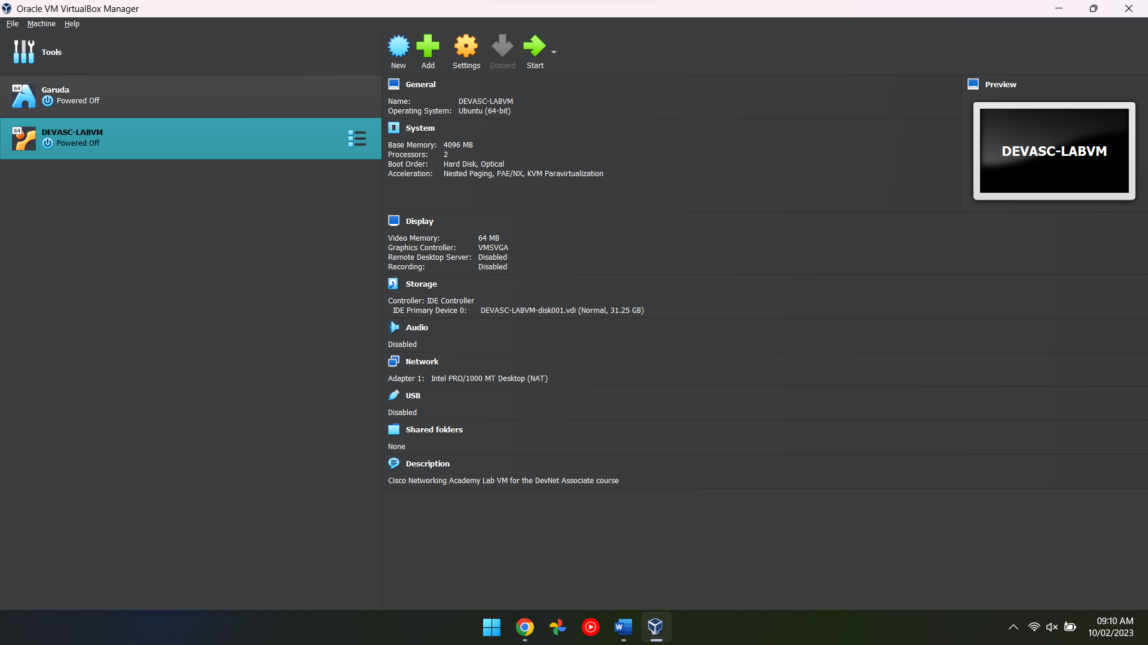
Figure 1 In this screenshot you can see that the application virtual box is opened and the virtual machine file has been imported into the application, a virtual machine can be set up manually by using an ISO but in this case, it's a pre-configured VM

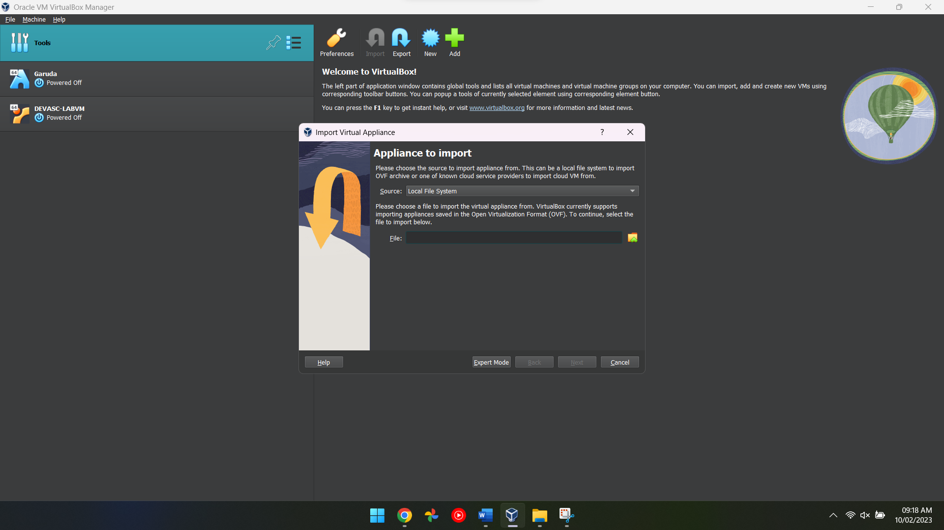
Figure 2 In this screenshot, it shows the menu in which a user would use to import the virtual machine into the virtual box itself

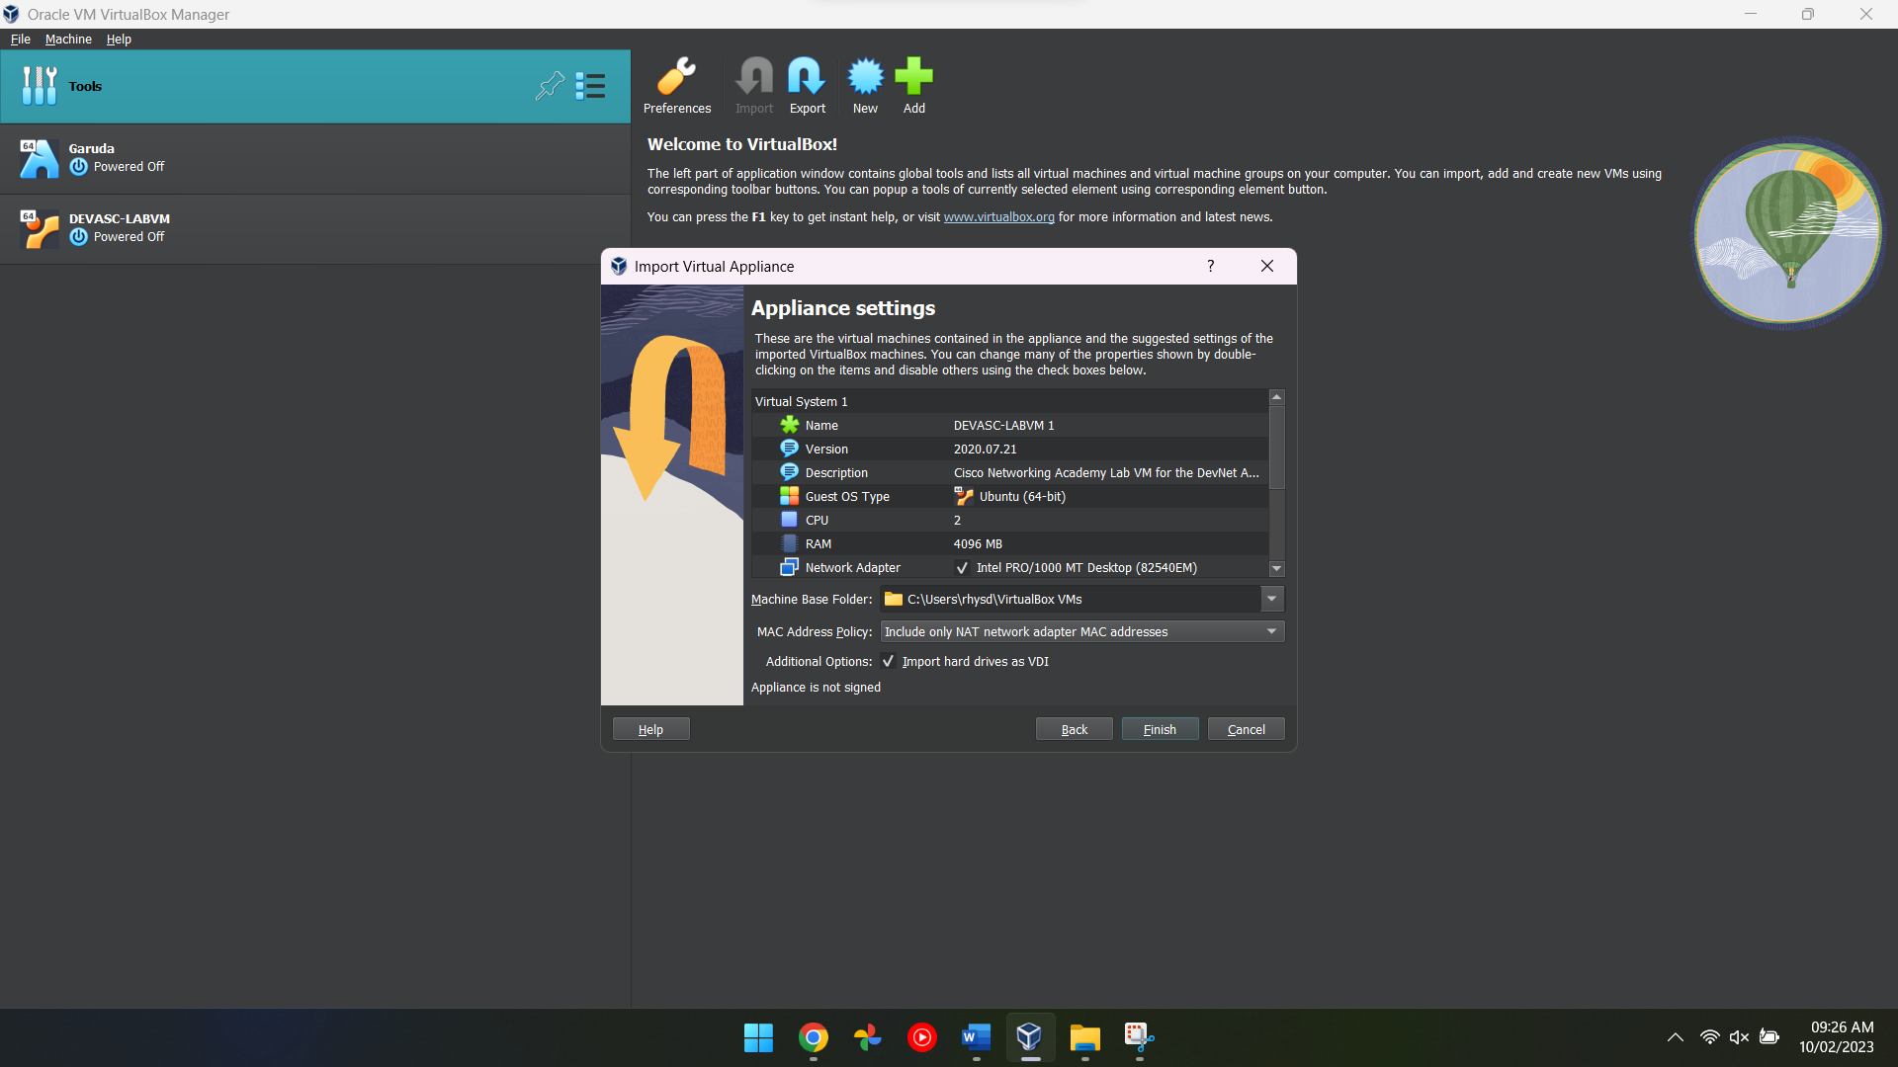
Figure 3 In this screenshot, the menu displays different settings that have been changed by someone else and it's asking the user if they would like to make any changes

Setting up Server 1
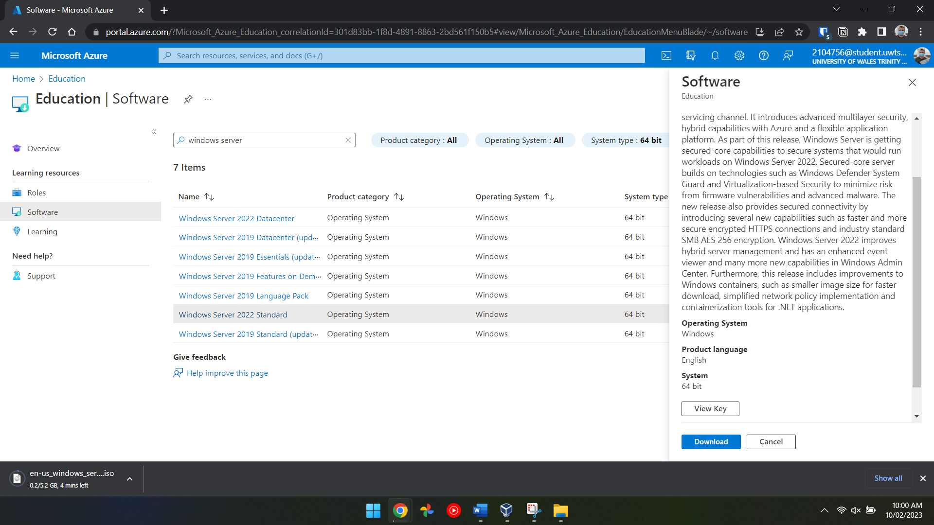
Figure 4 In this screenshot, a user has visited the university Microsoft Azure page which contains all different kinds of software that is accessible to students but in this case, the user is searching for a Windows Server ISO
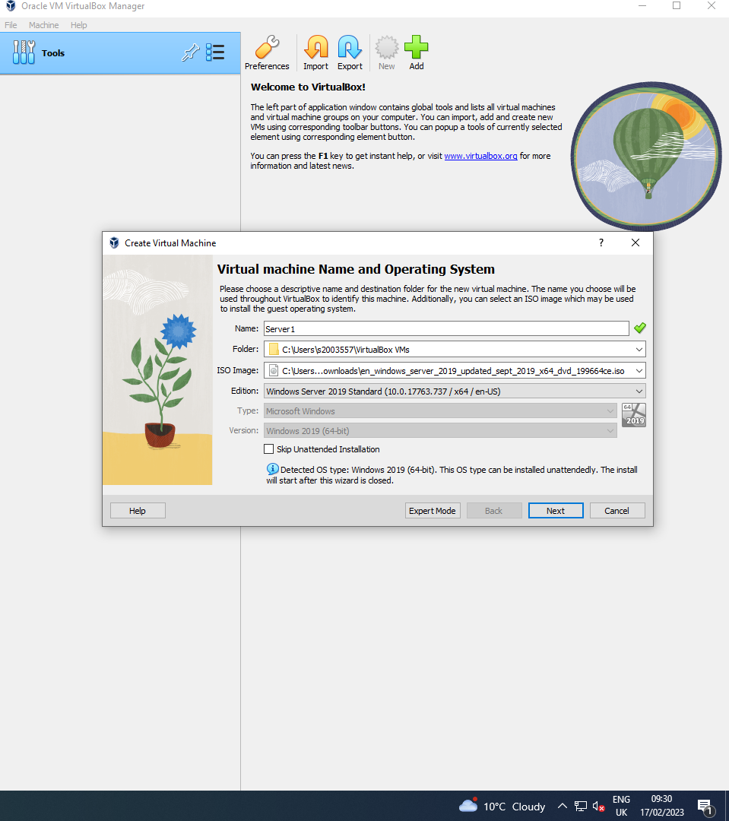
Figure 5 In this screenshot, the user has started creating the Server 1 virtual machine which also requires the user to import the Windows Server ISO to be able to correctly configure the virtual machine.
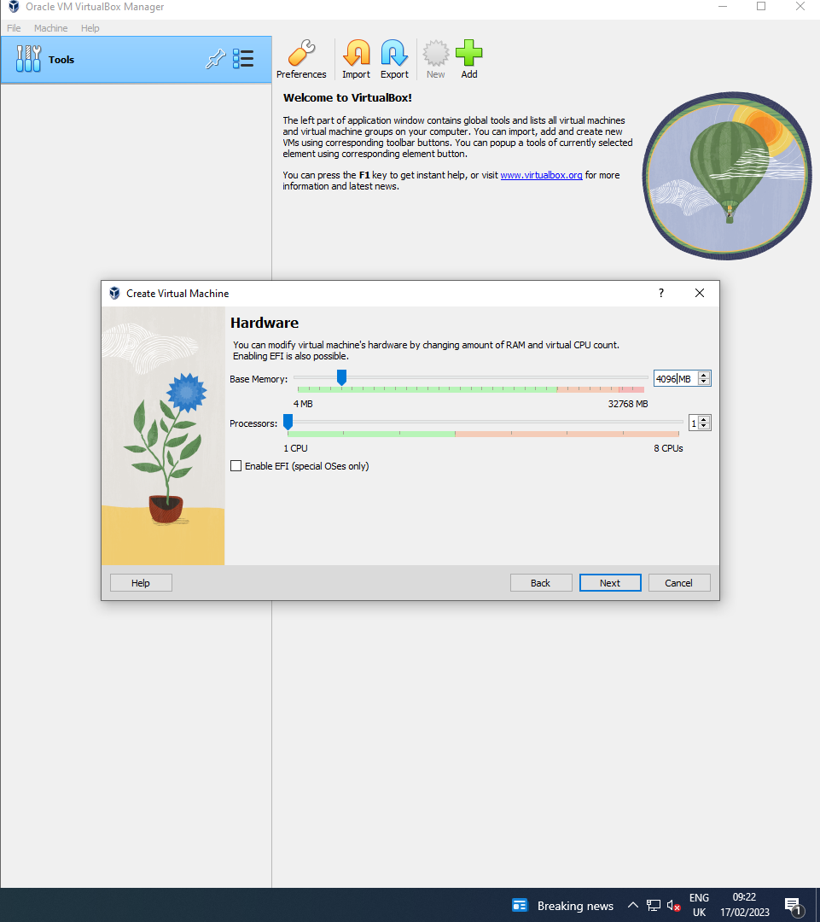
Figure 6 In this screenshot the user is now allocating computer resources to the virtual machine, it’s important to allocate the correct amount of computer resources otherwise the virtual machine may not start or may run poorly.

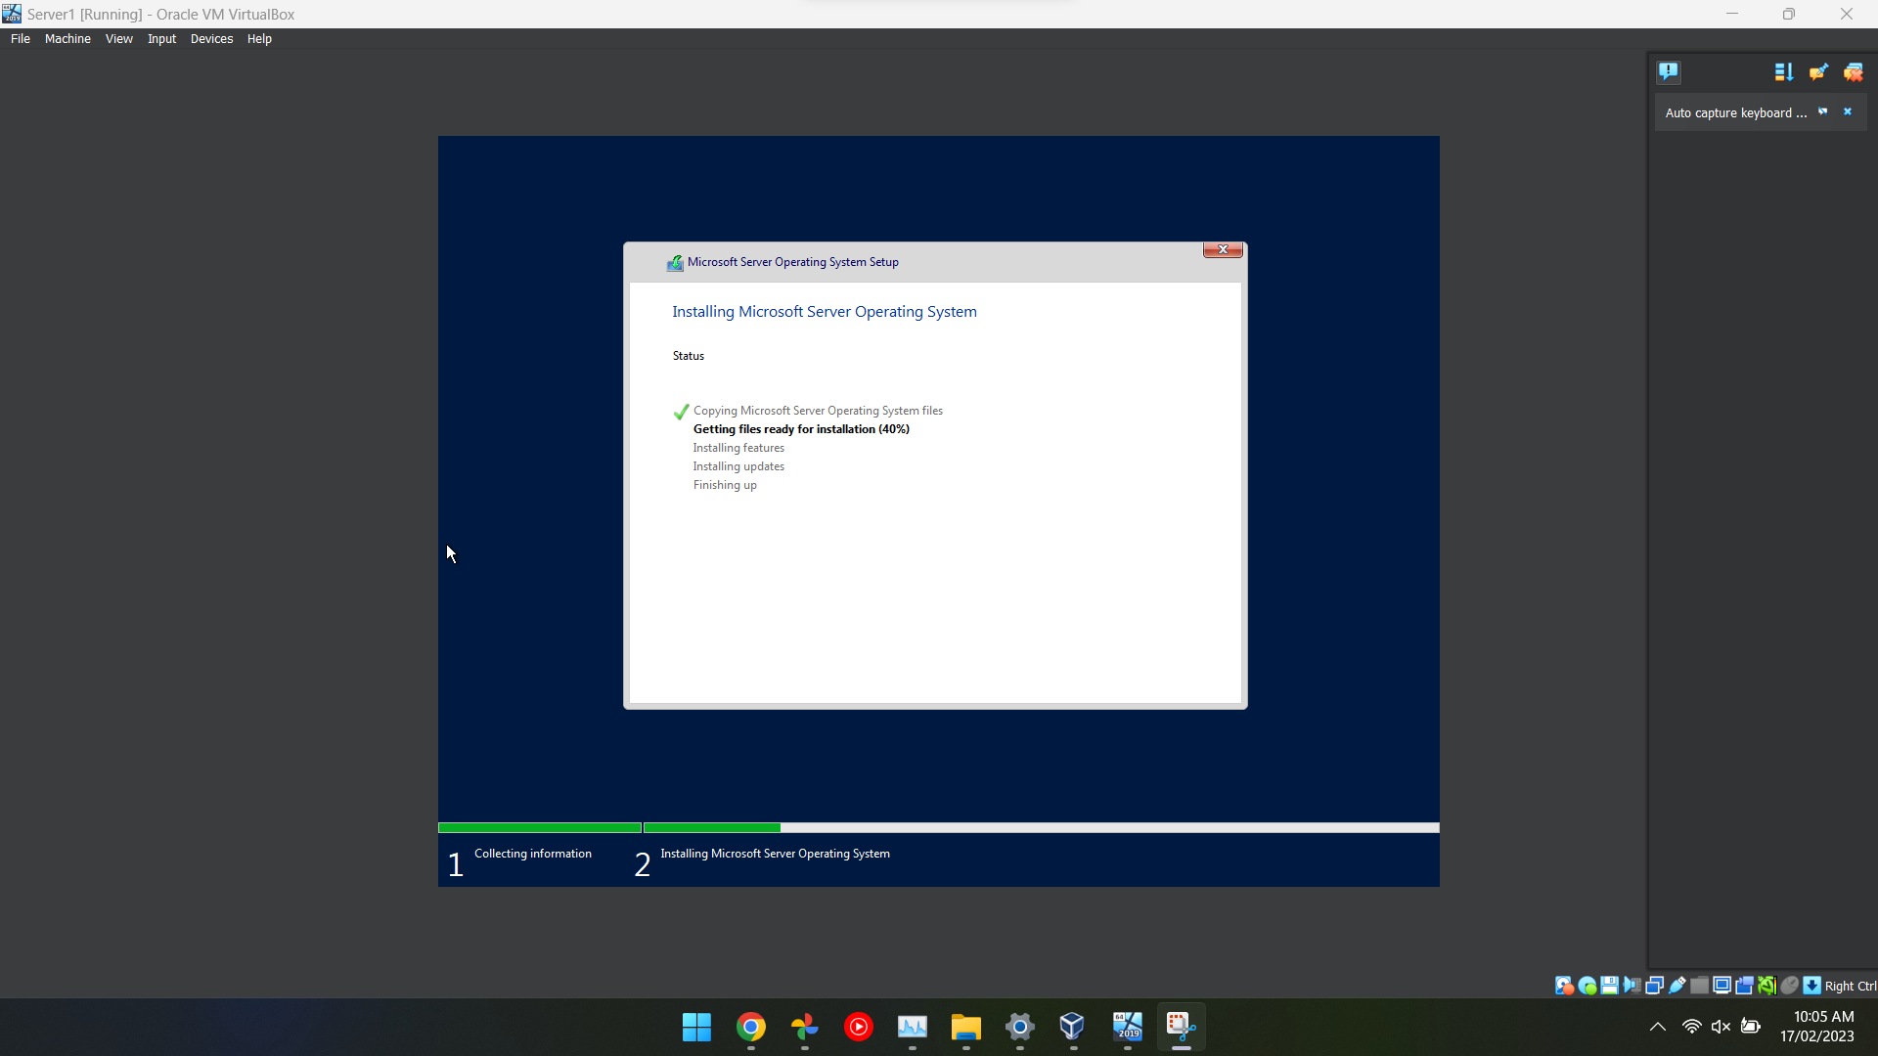
Figure 7 In this screenshot, the user has successfully imported the Windows Server ISO into VirtualBox and now it has booted and started setting up the operating system for use.

Configuring Network Settings for the Virtual Machine
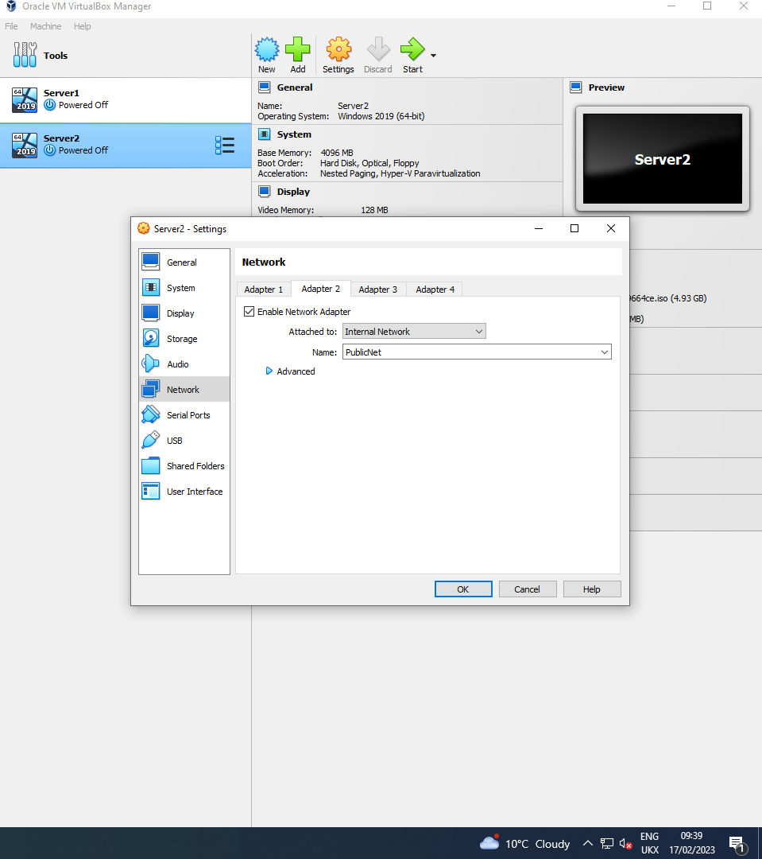
Figure 8 In this screenshot, the user has configured the network services in the virtual machine settings on VirtualBox which allows them to configure which network adapter can access the internet and which adapters can’t access the internet.

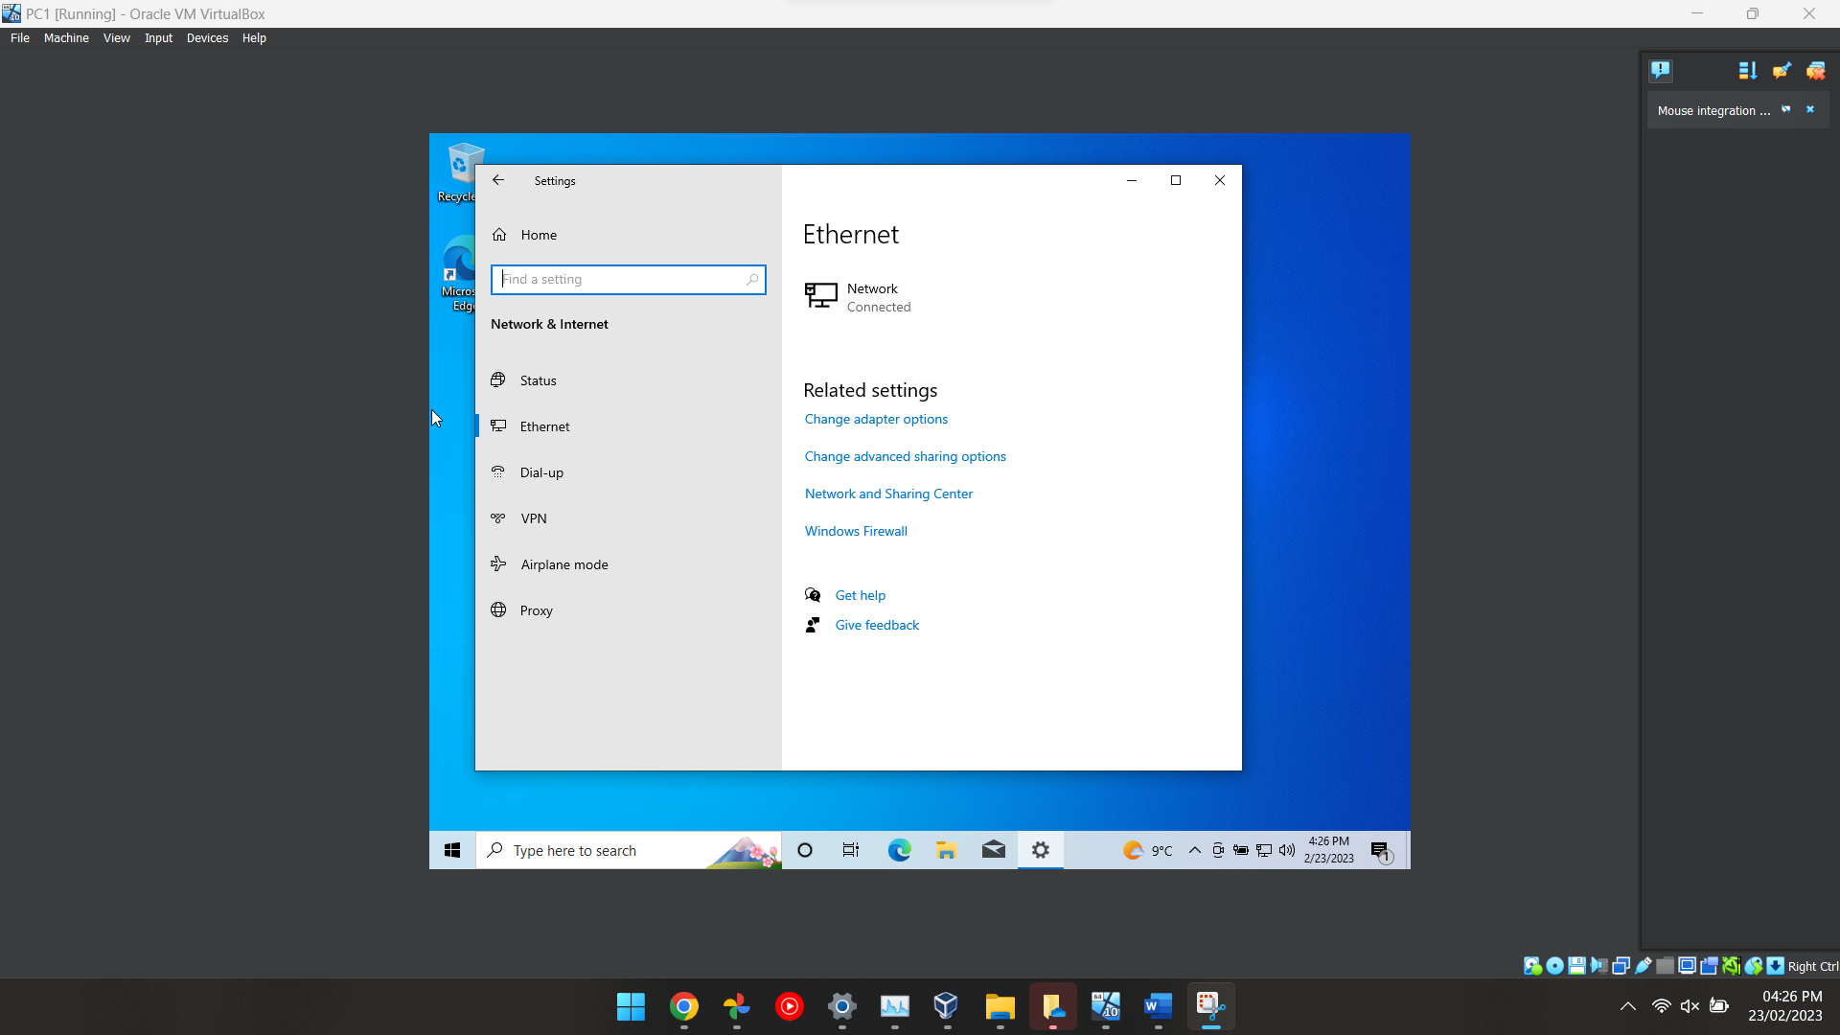
Figure 9 The same steps were repeated for Server2, as two servers and two clients needed to be created. The user then proceeded to ping the private net from the server to the client by creating network adapters.
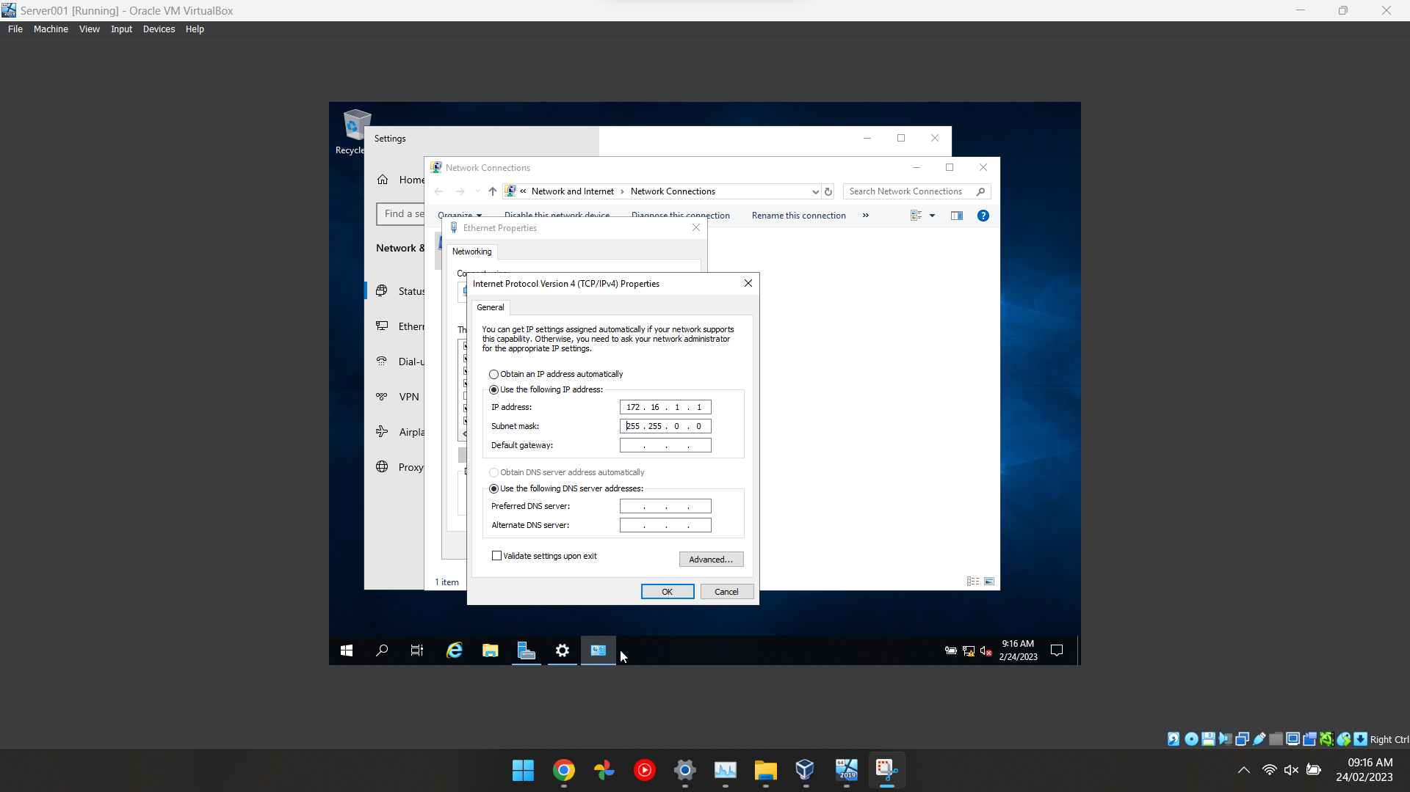
Figure 10 To achieve this, the user turned on the firewall for all the virtual PCs by accessing the control panel, selecting settings and navigating to the firewall option. The virtual PCs were then restarted to save the changes made.

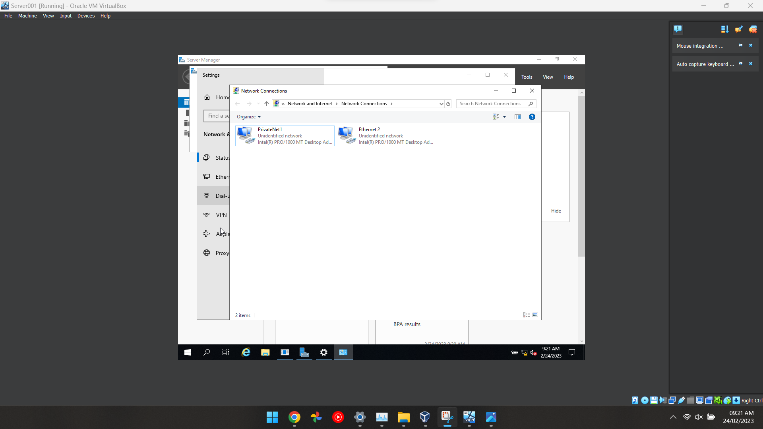
Figure 11 After completing the installation process and configuring the networking settings of the server, the user accessed the control panel and right-clicked on the Windows icon to navigate to the Network Connections tab. The two local networks were renamed.
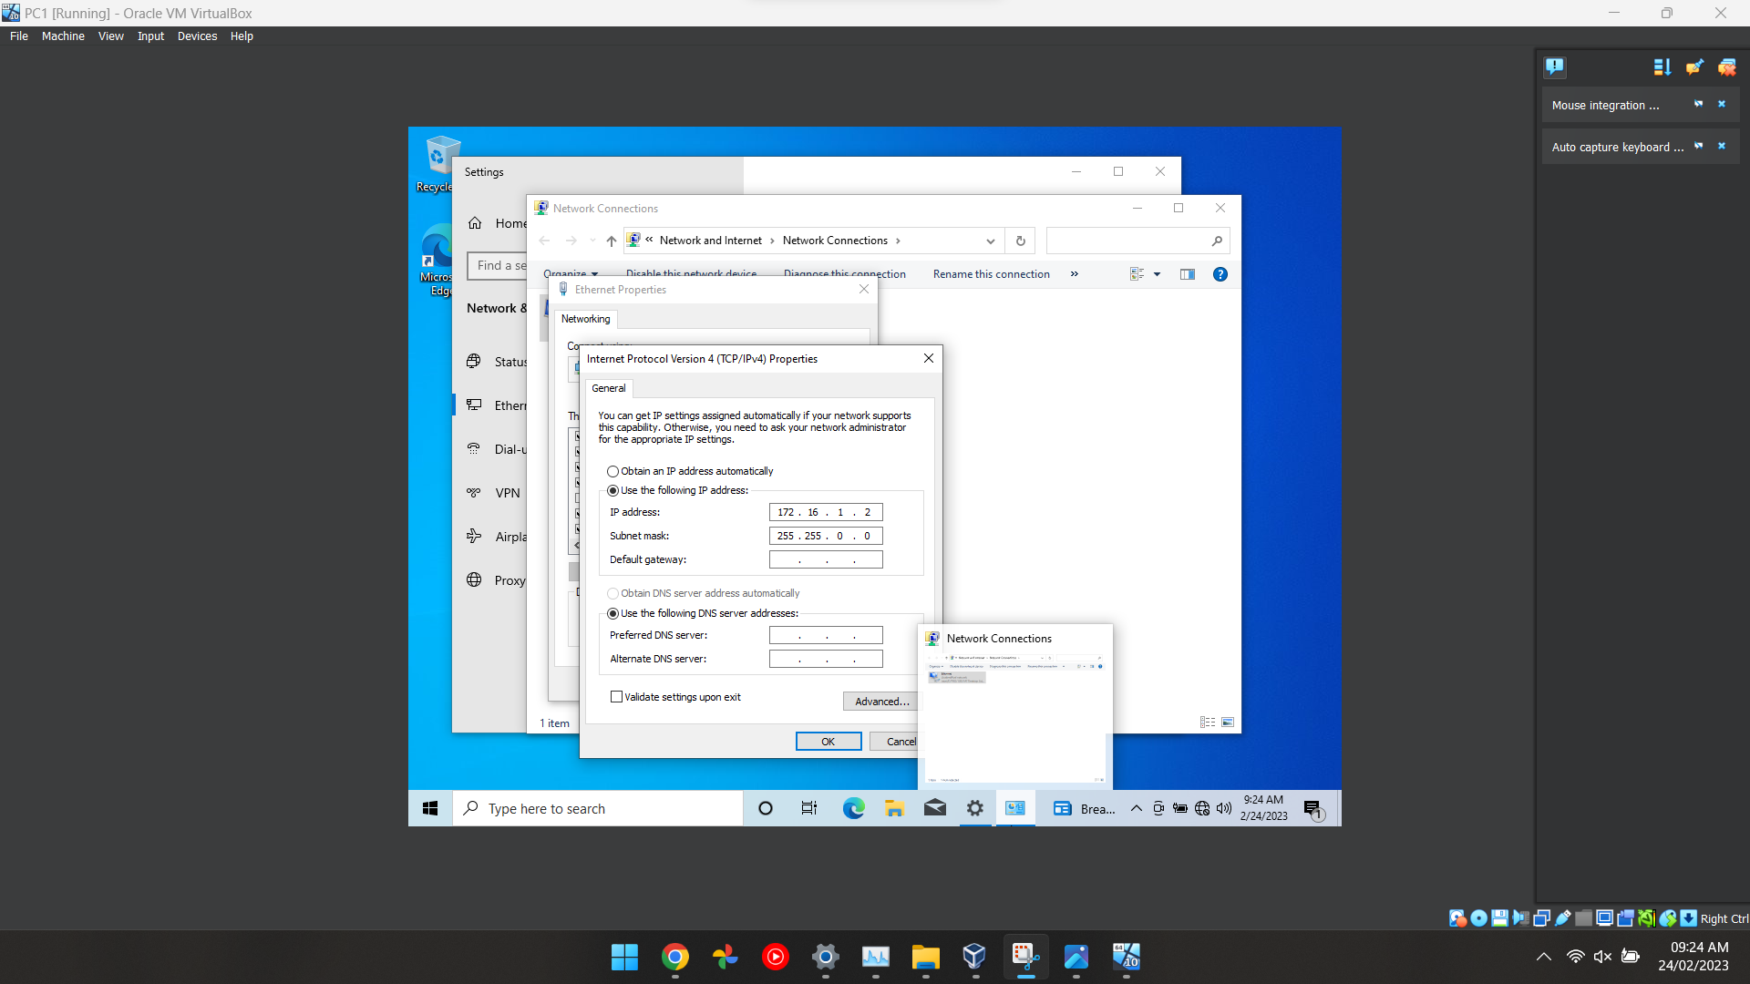
Figure 12 The same steps were repeated for Server2, as two servers and two clients needed to be created. The user then proceeded to ping the private net from the server to the client by creating network adapters.

Configuring Server1 and PC1
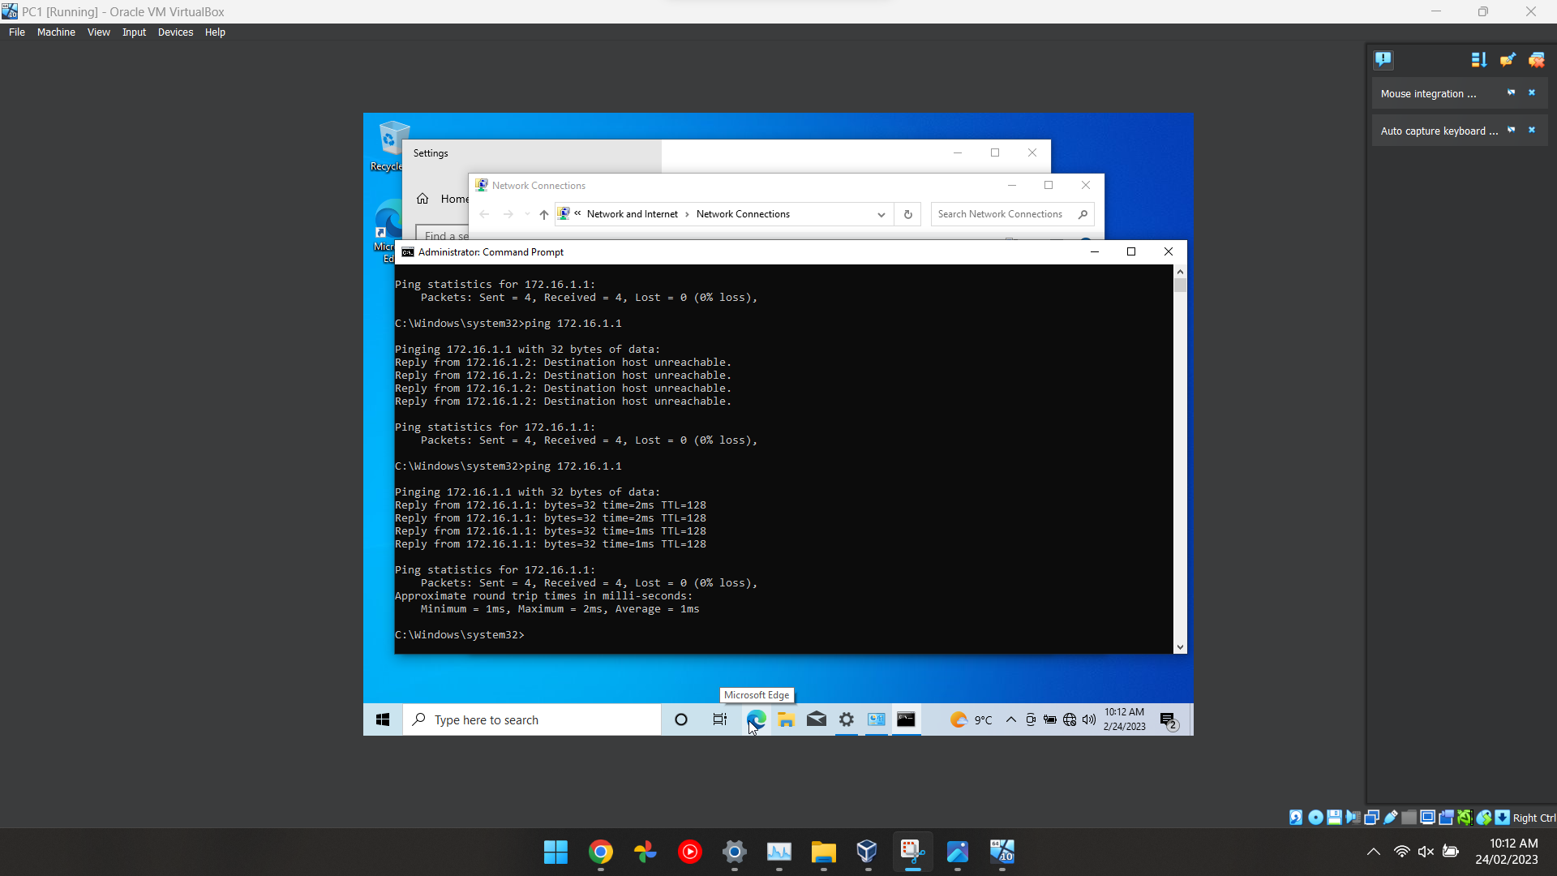
Figure 13 This screenshot demonstrates that server 1 and PC are connected because a ping between both PC’s have been successful. After starting the server and client, the user used the ping command to test the connection. In the command prompt.

Setting up an Active Directory
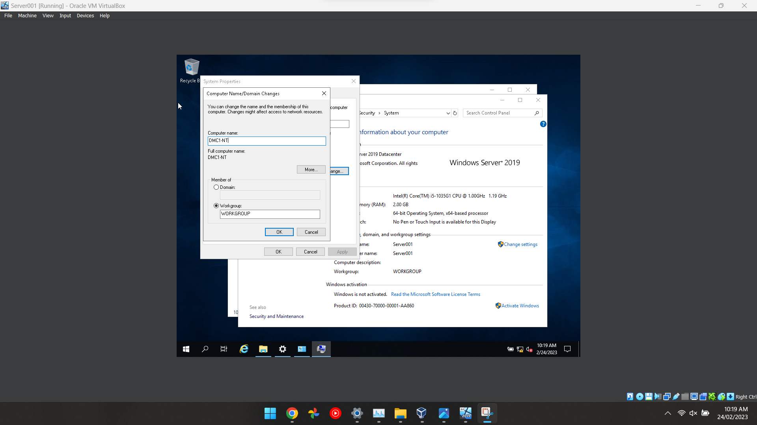
Figure 14 This screenshot shows the user changing the name of the computer to make it easier to recognise which PC is which.

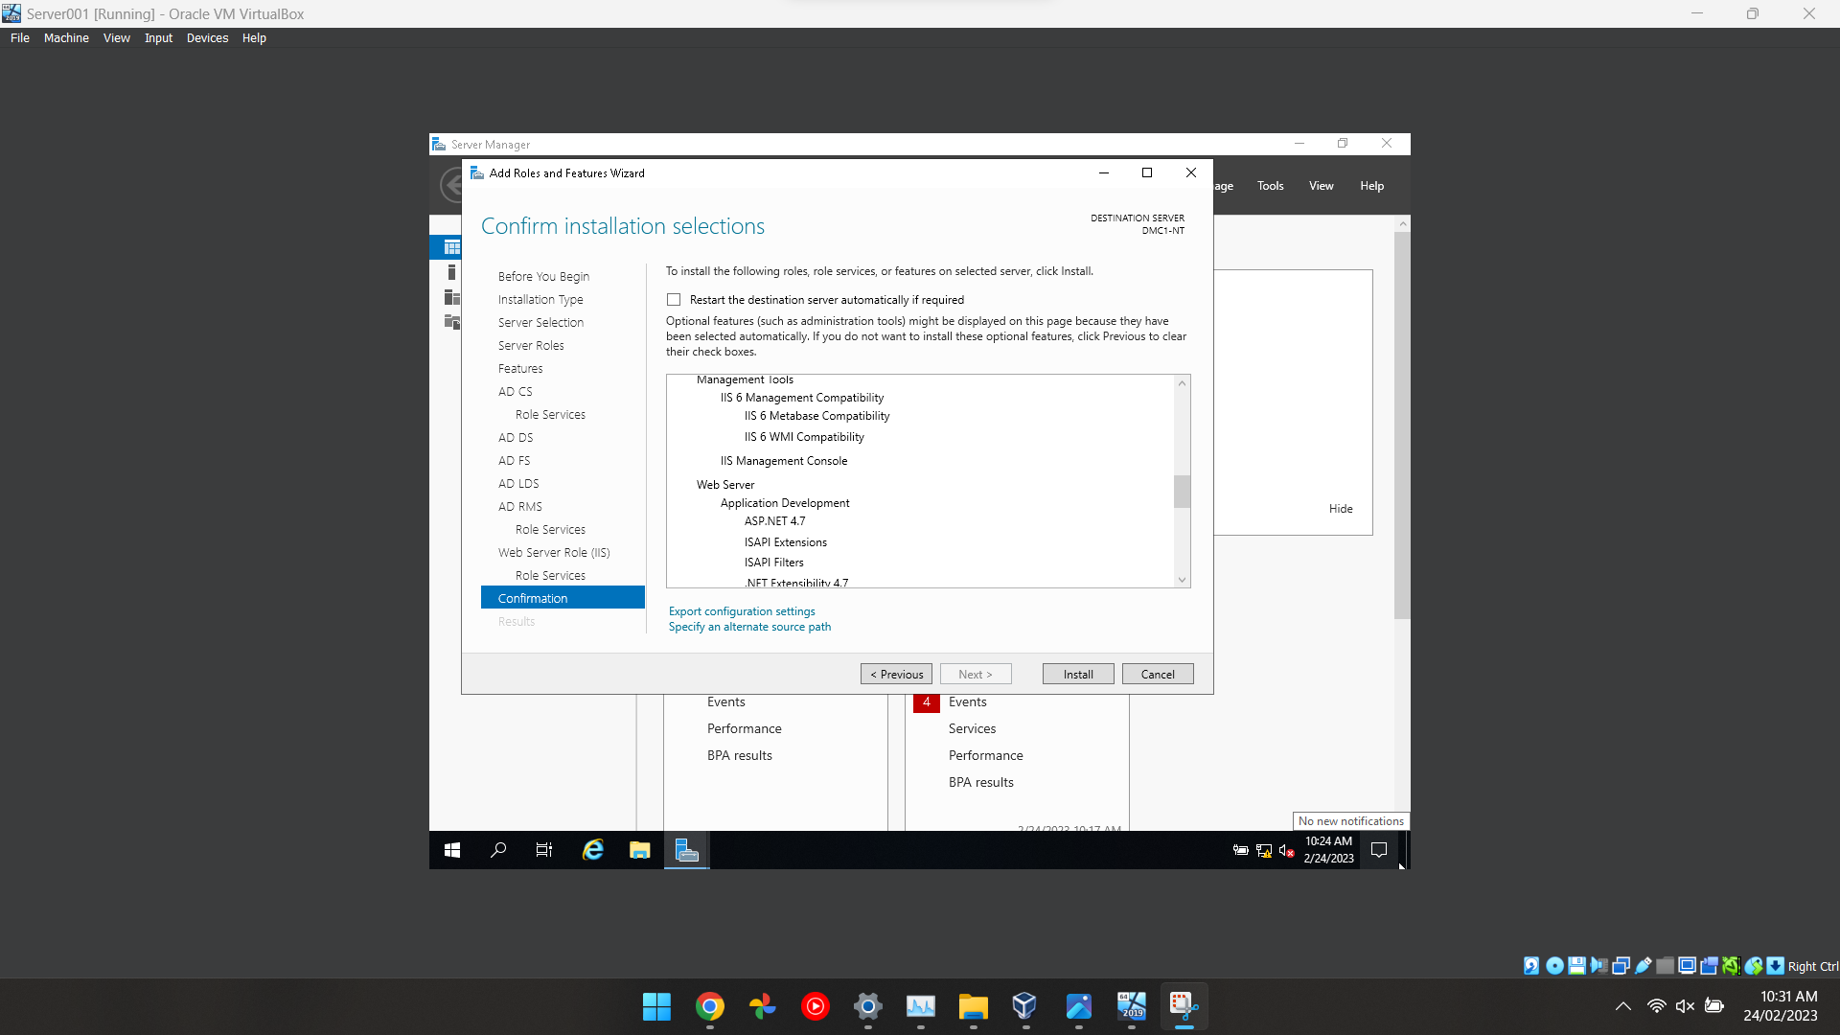
Figure 15 This screenshot shows the user that has completed the installation of adding the roles and features, the user added the Active Domain feature which allows the installation to be completed properly.

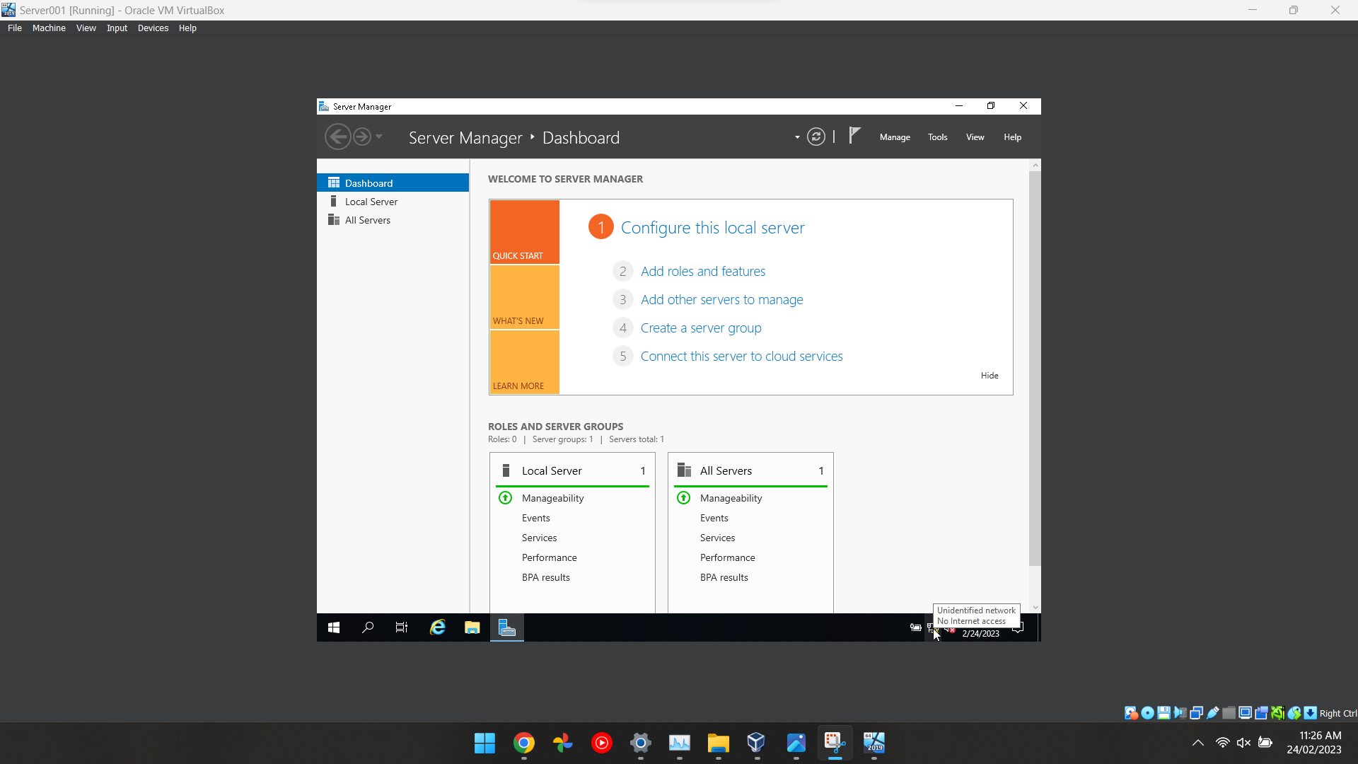
Figure 16 After installing the roles and configuration then this screen will pop up which demonstrates that the rules and features have been set up correctly.

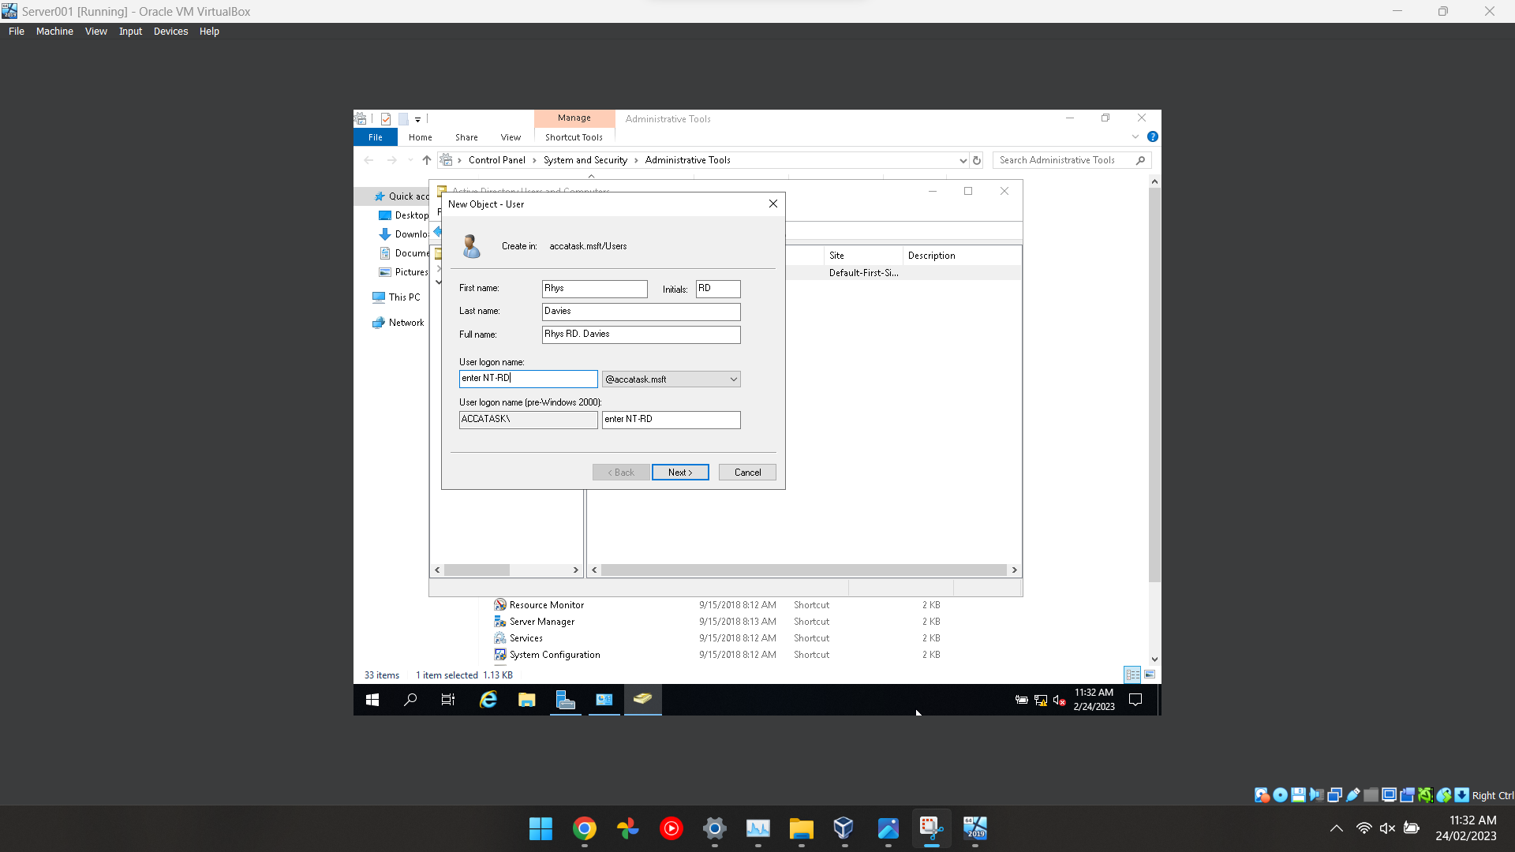
Figure 17 In this screenshot, it shows the admin adding a user to the local domain in which they can control certain aspects of the computer.

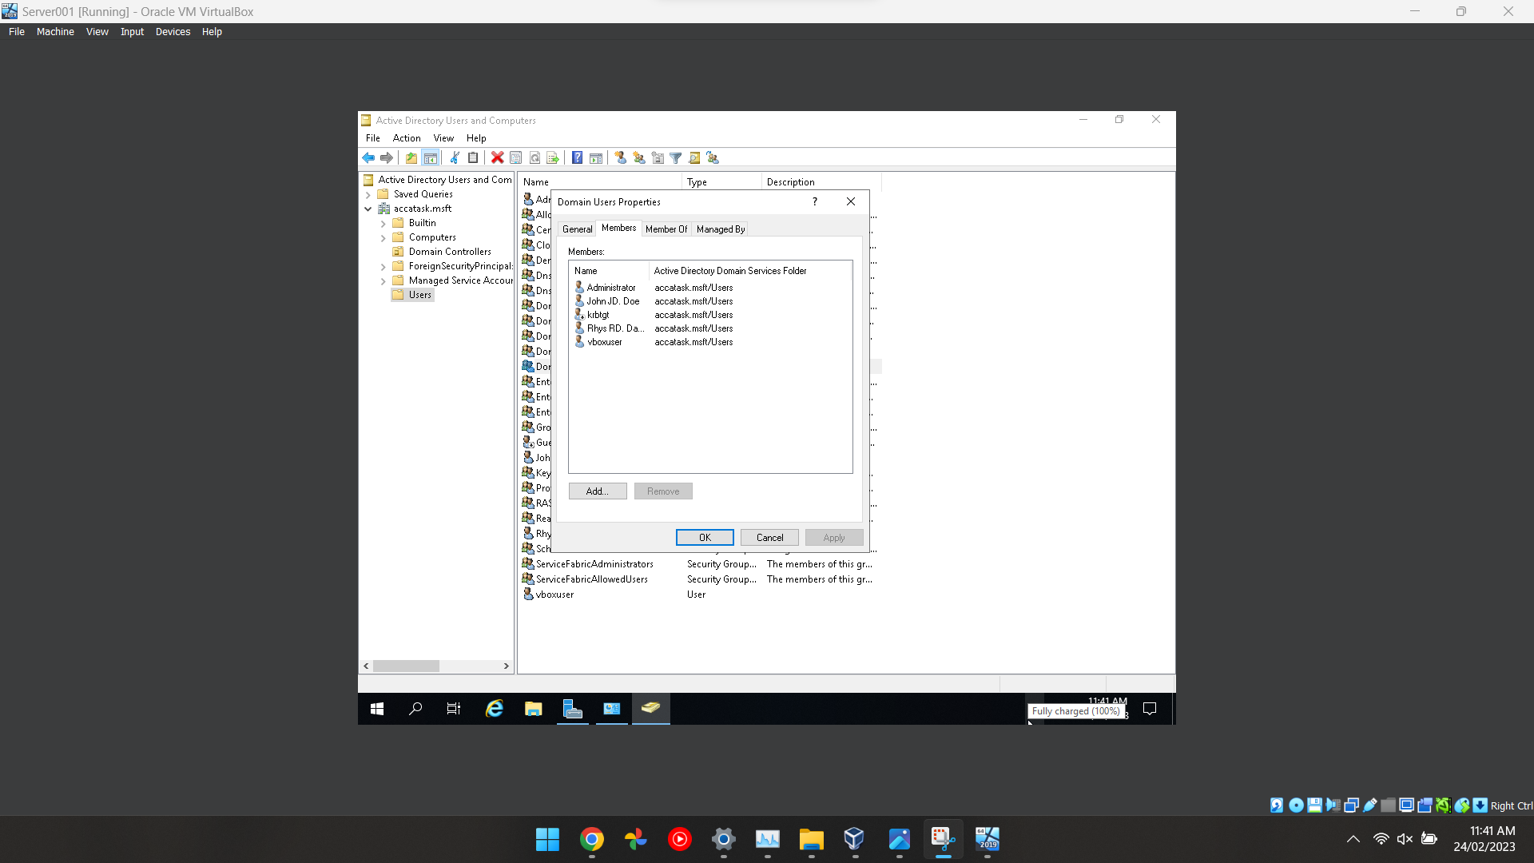
Figure 18 This screenshot shows all the users that are connected to the local domain including the admins and the guest who is called “John Doe” with his initials JD which is easily identifiable

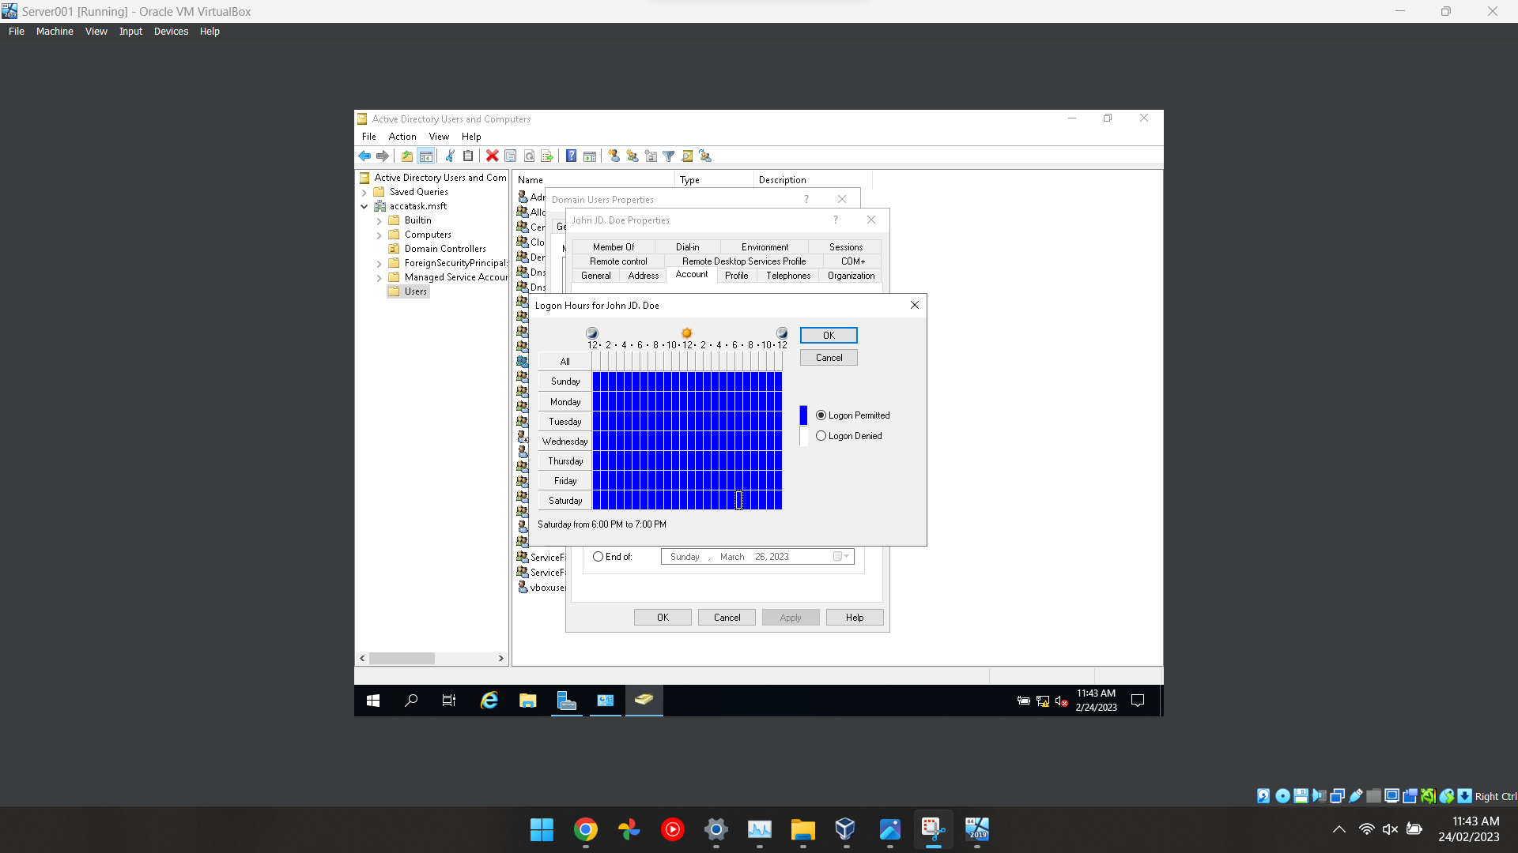
Figure 19 This screenshot shows the admin configuring a user's timetable in which they can log in at certain times of the day or limit their access at certain times of the day because it can be a security risk if a user had access 24/7.

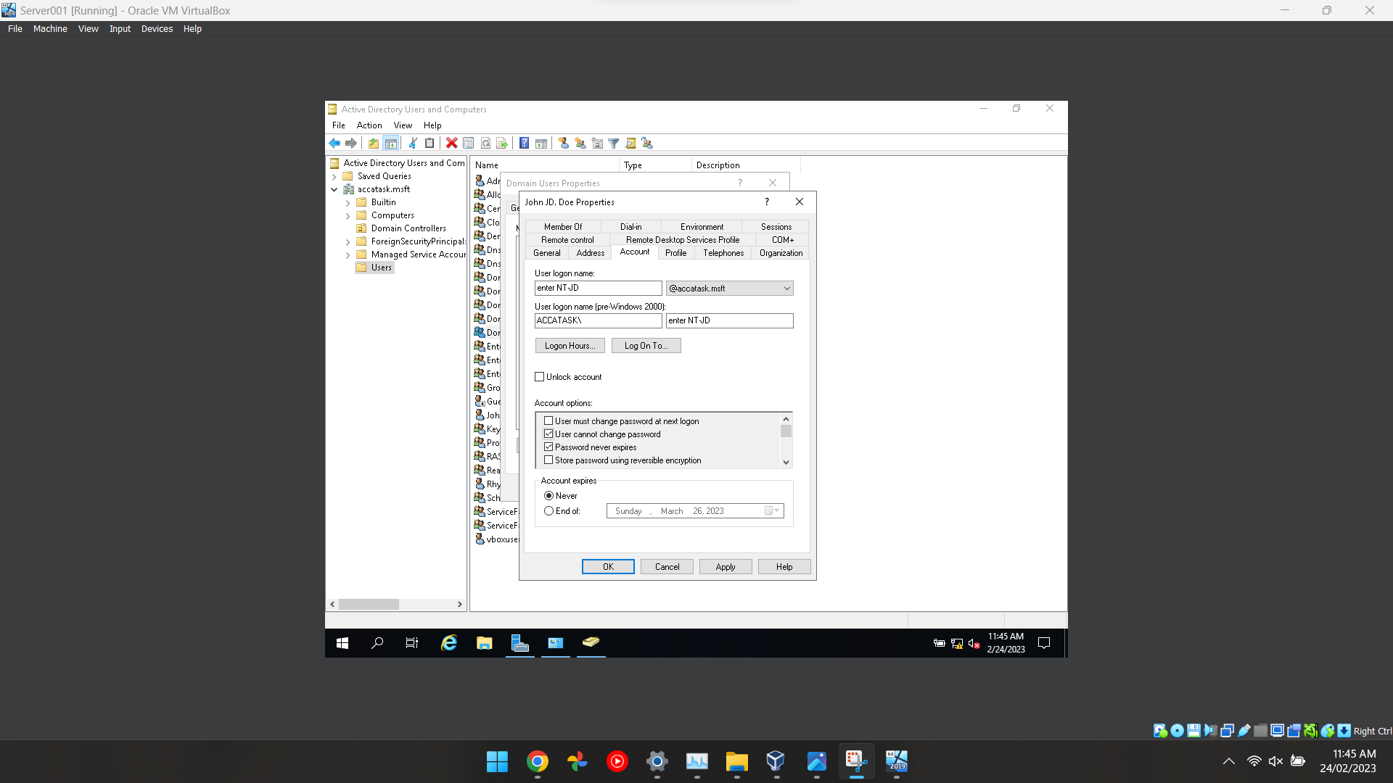
Figure 20 This screenshot is related to the last screenshot which shows the admin configuring the security features for an account in which the admin has turned on the feature “password never expires” and “user cannot change password” which is great for security.

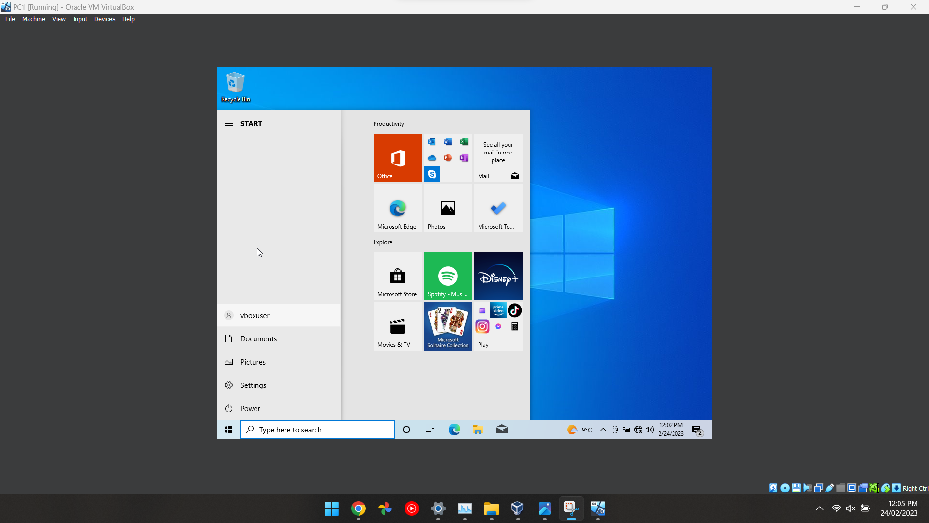
Figure 21 The final screenshot shows that all the features have been configured and the guest has now been added to the domain in which the admin has control over the user's computer settings.

Part 2 | Observational

Introduction
During the configuration of the virtual machines, several different issues appeared and there were several things that I picked up and found useful if I want to set up a virtual machine for myself. This document will discuss the differences between type 1 and type 2 hypervisors, what DHCP is and how it works, justify an active directories technology, and show different technologies that were used.

Why a Type 2 hypervisor is suitable
A type 2 hypervisor is a virtual machine that is ran on a host users operating system, [1] this type of hypervisor allows anyone to run multiple operating systems at the same time without interfering with the original operating system or the other separate virtual machines. [1]
A type 1 hypervisor is similar to a type 1 hypervisor, but the difference is that they are installed onto a computers main drive instead of an isolated environment, this is preferred in specific scenarios when a user may need to utilise the computers hardware resources to carry out a task which a normal type 1 hypervisor cannot do. [1]
Type 1 hypervisors are different compared to Type 2 because its hardware-based and is installed directly on the host machine. They are typically used in scenarios where maximum performance and security are required, such as in data centres, cloud computing environments, and high-performance computing. [1]

The Benefits of a Type 1 hypervisor include:
- High performance: A Type 1 hypervisors is allowed to use a computers resources efficiently due to having less restrictions on hardware resources which are put in place with a type 2 hypervisor. [2]
- Increased security: The reason why a Type 1 hypervisor is more secure is because there is nothing could be compromised by an attacker between them and the CPU. [2]

Drawbacks of Type 1 hypervisors include:
- Complexity: A Type 1 hypervisor may require some specialised hardware that will be more difficult to set up compared to a Type 2 hypervisor. [2]
- Cost: Depending on what a user may use a virtual machine for but if a user is looking for a more efficient workspace (multiple operating systems) then a type 1 isn’t suitable. [2]

Benefits of Type 2 hypervisors include:
- Ease of use: Type 2 hypervisors are installed through a program called VirtualBox or anything equivalent which gives a step-by-step process to install the virtual machine meanwhile a type 1 hypervisor requires a lot more tweaking. [2]
- Cost-effective: Type 2 hypervisors do not require great hardware because they are able to be run on any machine after having the correct settings applied on the settings page in VirtualBox. [2]

Drawbacks of Type 2 hypervisors include:
- Reduced performance: Because a Type 2 hypervisor is contained in an isolated environment it doesn’t have access to all of the computer resources due to restrictions placed in windows and the program that hosts virtual machines. [2]
- Compatibility issues: There is a possibility that a type 2 hypervisor may not work with all hardware and may need to be configured to work correctly and depending on the hardware it may be impossible. [2]

What is DHCP?
DHCP or Dynamic Host Configuration Protocol is a network protocol that is used to automatically assign IP addresses to other devices on a network that allows them to connect to each other and the internet. [3]
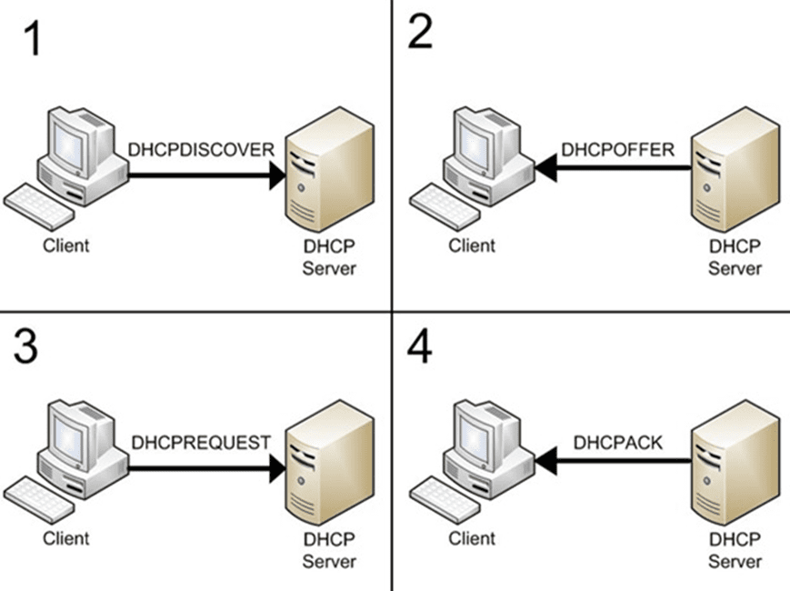
Figure 22 An Image displaying how DHCP works [4]
- A device requests an IP address by broadcasting a DHCP Discover message.
- A DHCP server on the network receives the broadcast and responds with a DHCP Offer message.
- The device accepts the offer by sending a DHCP Request message to the server.
- The server sends a DHCP Ack message to confirm that the IP address has been assigned to the device.

AD’s technology
A centralised database called Active Directory stores data on network resources like users, computers, printers, and other IOT devices, it manages these things in a hierarchical, organised, and safe manner. [5]
Active Directory has an organisational structure which is called the hierarchical. [5] Network resource management and organisation are made simple because of this, the organisational units (OUs), child domains, and objects like users and machines are placed in a hierarchical fashion in the active directory. [6]
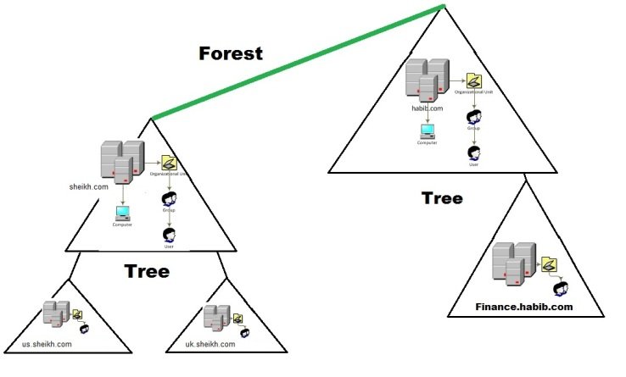
Figure 23 Image of hierarchy for an active directory [7]
An Active Directory saves an objects information in a well-organized format that makes it simple to search for and to receive for different purposes later on. A collection of characteristics, such as name, password, and group membership, are used to define objects. Administrators may easily manage different network resources by using these given features to search for and get data about different objects. [6]
Security is a top priority for the architecture of an Active Directory. The secure database offered by the active directory can be used for storing private data about users and network resources. Access control lists, permissions, and encryption are a few of the techniques that can be used to encrypt and protect this information. [6]

different terminologies used

Virtual Machine
A virtual machine is a piece of software that allows the emulation of another operating system within an operating system for testing software or safely executing malicious software to test its effects. [8] A user can use multiple virtual machines at once which can be used as an internal network and can be great to perform a real-world networking example. [9]

Windows Server
Windows server is very similar to the normal installation of Windows but the biggest difference between the two is that the Windows Server is considered “Enterprise” and has exclusive features such as Windows Sandbox and a server manager [10] allowing an administrator to have full access to a connected computer to comply with companies’ policies. [11]

ISO File
An ISO file is a standard file which contains the information and data for a given operating system, it is an image that can be used within a virtual machine or can be burned onto a CD, DVD or USB stick [12] which can then be used to install a copy of Windows onto a given computer allowing for easy installation.

Active Directory
An Active Directory is a set of networking tools that allows an administrator to control and access a connected computer effectively allowing the admin to configure them to the company's policy or adjust them to fit basic security needs. [13] An Active Directory is also a service that is found in the Windows Server operating system which allows for a centralized management system of network resources like computers, printers, and phones. [14]

Domain & Domain Users
Inside the Active Directory, Windows Server allows an admin to create and add Domain & Domain Users to the group, Domain users can then be controlled and managed by a domain controller which can then be used to acquire resources on a given network. [15]

Windows Server Manager
The Windows Server manager is the software that allows an administrator to configure rules and roles for each user depending on their requirements, it also allows them to manage multiple different servers just from a single console which is very beneficial for organisation and simplicity. To make the UI simple it provides a greater view of each server and the server roles and features to allow them to easily install, configure and manage different server components. [5]

Issues and how they were resolved.
At the very start of the tasks the team and I had several issues installing the Windows server ISO into VirtualBox, at the start we were getting error messages saying that the operating system was corrupted or sometimes it wouldn’t load at all. After some configuration we discovered that we were using the wrong version of the Windows Server ISO, so we then swapped them out for the correct version and the virtual machines booted up correctly.

Conclusion
The end of this document covers the setup of virtual machines and an active directory using Windows Server. Also, it looks at DHCP, Active Directory, and the differences between type 1 and type 2 hypervisors. The article also provides a helpful glossary of the terminology as well as an overview of the benefits and drawbacks of implementing these technologies.

Reflection on collaborative work
Throughout the group work we experienced and solved different issues that caused us to pause and go back to fix the issues, each team member contributed to the document and we were able to complete the tasks given fairly quickly due to our collaboration and team work.

Reflection
This worksheet covered a number of subjects including virtual machines, network configuration, and server management. To better comprehend the process of setting up a virtual machine using a Type 2 hypervisor, establishing network settings, and setting up an Active Directory, the document included comprehensive steps and screenshots. Also, the advantages and disadvantages of Type 1 and Type 2 hypervisors were explored.
When completing this worksheet, I learned more about virtual machines and their applications as a result of doing these activities. I learnt the value of network configuration and the advantages of using Active Directory for network configuring and for admin purposes.

References

[1] | G. A. a. Z. L. E. Bauman, “A Survey on Hypervisor-Based Monitoring: Approaches, Applications, and Evolutions,” ACM computing surveys, vol. 48, p. 1, 2016.
[2] | J. Brodkin, “A look at bare-metal hypervisor basics,” Network World, vol. 27, p. 1, 2010.
[3] | L. H. T. Co, “DHCP,” in Data Communications and Network Technologies, Singapore: Springer, 2022.
[4] | D. Petri, “Almost Everything You Need to Know About DHCP as a Systems Administrator,” PETRI, 5 May 2010. [Online]. Available: https://petri.com/almost-everything-you-need-to-know-about-dhcp-as-a-systems-administrator/. [Accessed 9 3 2023].
[5] | D. Elfassy, “Microsoft Azure: Active Directory,” 2019. [Online].
[6] | J. Fontana, “Active Directory support systems come to the fore,” Network world, vol. 16, pp. 42-42, 1999.
[7] | H. R. Sheikh, “Active Directory Hierarchical Framework,” Server Geeks, 24 10 2012. [Online]. Available: https://servergeeks.wordpress.com/2012/10/24/active-directory-hierarchical-framework/. [Accessed 9 3 2023].
[8] | B. Posey, “CA. Hosting Virtual Machines in a Multicloud Environment,” 2018. [Online].
[9] | B. Posey, “AWS Administration: Migrating Virtual Machines,” 2020. [Online].
[10] | M. Minasi, “Mastering Windows Server 2012 R2. Indianapolis,” Sybex, 2014. [Online].
[11] | J. Savill, “Mastering windows server hyper v, First edition,” Indianapolis, NY, 2017. [Online].
[12] | R. Long, “CA. VMware vSphere: Administer and Manage Virtual Machines,” 2017. [Online].
[13] | K. D. Mehta, “ Planning for Azure Active Directory,” 2020. [Online].
[14] | B. Honan, ISO27001 in a Windows environment : the best practice handbook for a Microsoft Windows environment, Cambridgeshire: IT Governance Publishing, 2009.
[15] | J. Krause, Mastering Windows Server 2019 : the complete guide for IT professionals to install and manage Windows Server 2019 and deploy new capabilities, Birmingham: Packt, 2019.

