ACADEMIC AND EMPLOYABILITY SKILLS

Table of Contents

Introduction-------------------------------------------------- 2
Skills I have now--------------------------------------------- 2
Skills I have improved-------------------------------------- 5
Skills I need to improve------------------------------------ 6
Skill Gaps------------------------------------------------------ 6
Conclusion---------------------------------------------------- 7
References---------------------------------------------------- 8

Introduction

The aim of this reflective report is to analyse the academic and employability skills gained in this module.

Academic and employability skills I have now

Time management-I learned about time management. Which is the allocation of time for different aspects of life as per their priority and using that time effectively. I learned that there should be a set time for studies, family, recreation, travel, sleep, etc. Wastage of time should be reduced. I learned that time can be managed by keeping diaries, lists and tidy workplace. I also learned how to manage time using Eisenhower method and Pareto 80-20 rule.

I think this is an incredibly important skill to have, as this will help me not only in my day-to-day life but, my study life as well, also my work. As time management is one of the biggest keys to success and peace. It can help to reduce workload, give more satisfaction in work and studies (Macan, Therese H et al, 1990) This skill has helped me to manage my time better, and lowering stress. While also having a better control of my life.
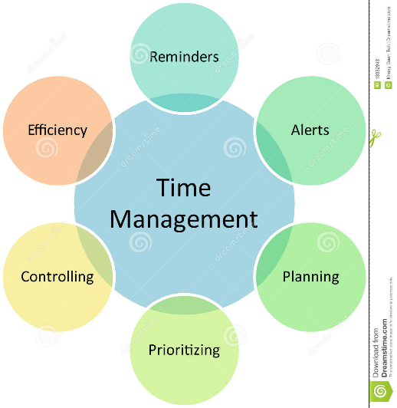

PowerPoint presentation: In this, I learned how to make PowerPoint slides. I learned some of the basic and important things to make a good slide. Some of the things that I learned were- to have bullet points which are short and to the point. I also learned about the fonts, namely, the type, the size and the colour of them. I also learned that there should be a colour contrast between the text(dark) and the background(light).

This will help me in both my education and work, as PowerPoint is an important part of communication. It is helpful because it is more interesting and eye-catching than the traditional way. It is a requirement in presenting work in all walks of academic and work life.

Paraphrasing: I have learned how to paraphrase in three different ways. Which are: using synonyms to change vocabulary, changing word class and changing the word order.
This will help me in my future assignments by helping me avoid plagiarism. And help me in producing better quality work without worrying about

Leadership skills: I learned what skills make a good leader. For example: being a good role model, can bring people together, being a good problem solver, etc.
This will help me in becoming a good leader. Being a leader is an important thing in work and education. As leaders affect the emotions, performance and efficiency of their team.

Listening skills: This module has taught me how to be a better listener. And how important it is to be a good listener. As listening skills are an important communication skill.

This will help me tremendously in my future jobs and education. As I would always have to listen to other people. People will perceive me as more professional and thing that I am interested in what they are saying. This help to make a better impression in work place.

Gibb’s reflective cycle: In this, I have learned how to author a reflective report, and the format of it. A reflective report has eight parts. And each of them will help me to write a reflective writing.
The reflective report helps us to record what happened in the past, while also preserving these records for the future (Francis M. Quinn,1998)
It is a very important skill for me. As it will help me in future studies when I am doing assignments. As a lot of assignments require writing a reflective report.
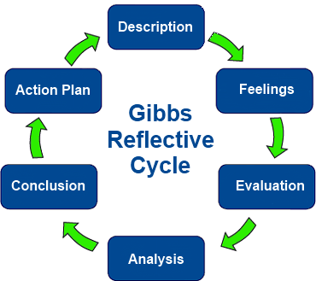
Skills I have improved

CV writing skills: I already had a basic idea of how to write a CV. But this module helped me improve it. In this module, I learned what things to include, and what not to include in a CV. I learned that the structure of a good CV.
It will help me in my future jobs. As CV is the first impression people hiring you to get of you. So it is important that it is impeccable.

Referencing: I previously had some idea about referencing. But after doing this module, my knowledge of referencing has improved quite a bit. This module has made the concept of referencing much clearer to me and has helped me overcome the fear that I had with referencing. It has now given me the confidence to do references. I have learned how to do Harvard-style referencing. Referencing is crediting the sources I have quoted, paraphrased, summarized or copied images/diagrams from.
This will help me immensely in my future assignments. As referencing is a must for all assignments. So, being able to do it well is going to be of a great help to my academic future.

Doing an interview: It is a topic, of which, I had a very limited understanding of. But this module helped me learn a great deal about it. I learned that I should be spontaneous, and not too contrived in an interview. I learned how I should do some prior research about the position I am applying for; so as to not make a fool of myself. I also learned that I should not be too nervous.

This skill will help me out immensely in my future when I am applying for jobs. As a lot of jobs require face-to-face interviews. And being equipped with these skills will help me hold my own in front of the interviewers. This helped me build confidence and reduced some of the fears.

Ability to work alone: I have always preferred to work alone. And in this module, I really got the chance to work on my own and do work at my own accord. This helped me to challenge myself intellectually, and to find solutions to things in a creative way. This has helped me to be self-motivated and confident in my own abilities.

This will help me immensely in the future as it is important to be able to get things done on my own, and not depend on others. This skill will prove to be invaluable in both my future education and jobs.

Skills I need to improve

Research skills: Though I have some grasp on this topic, I must improve it. My understanding of this topic is quite limited. Improving it would be helpful as research is imperative to produce good assignments.
Improving my research skills would greatly improve the quality of my work and help me achieve better grades. As I would be able to prepare better-informed papers, by including correct facts.

Dealing with criticism: While I am not the most thin-skinned person, I cannot deal with criticism well. Criticism always gets me really worked up. It makes me self-conscious and nervous. Dealing with destructive criticism can be more resilient and more compromising. (Baron, R. A. 1988)
I would really love to improve this skill. As it would help me to be more confident. And receiving constructive criticism gracefully will only help me improve my mistakes.

Managing stress levels: I tend to get stressed quite easily. I am not very good at Stress management is very important because stress can be detrimental to one's health. And cause a lot of unrest in myself and the team members; if working in a team.

Confidence: I get quite nervous easily. I must work on building my confidence. I must believe in myself, and my abilities more. Believing in yourself is confidence. I can build my confidence by putting myself out there more, by taking more risks and having more support and motivation from experienced individuals. (LEVIN, R.P., 2006)

Skills Gaps

Oral presentation: Being a shy, introverted person, I am very inept at giving an oral presentation. It is a difficulty I must overcome. Because it is a great skill to have in both work and education. As my education often requires me to give an oral presentation.

Teamwork: I find it very difficult to work in a team. As I do not have a very strong personality. And I dot have a strong enough voice. I am always second-guessing myself, and am reluctant to share my ideas with others, even when others prompted to do so.
I want to improve upon this skill gap of mine. As tram work is a very important skill to have in both work and studies.

Doing research: I find it quite difficult to do research for preparing my work. I struggle to find relevant and credible sources that would elevate my work and help to legitimize it. I would like to do better in this field in the future, as research is a great tool to gain more knowledge about a subject, have more understanding. And when writing, extensive research must be done, to make the work more professional and factually accurate. It is very important for a student to do research and come up with a well-informed piece of work.

Body language: Although the teacher taught about body language, it is a very difficult thing for me to grasp. I have always been very shy and reclusive. While to have a good body language, I need to be confident, have a good posture and make direct eye-contact. All these things seem very difficult for me, as I am always very nervous being in front of other people and start to fumble bad.
I would like to cover up my bases when it comes to body language, at it a big part of non-verbal communication. As being a student and an employee, I need to have positive and smart body language.

Conclusion

So, I have learned how to author a reflective report.
I could have done better if I had read more, attended more classes, been more attentive in the classes that I did attend, and asked questions about the things I was unsure of, was more interactive with my classmates, did more research, had a more organized study plan and taken more time out for studies.

References:

Macan, Therese H. et al, 1990, Journal of education psychology

Collins,J. 2004. Education techniques for lifelong learning

giving a powerpoint presentation: The art of communicating effectively1 24(4)

Business Executive. 2004. Stress management in the workplace. [ONLINE] Available at: http://www.carolespiersgroup.co.uk/pdfs/BE%20Spring%202004.pdf. [Accessed 30 April 2018].
LEVIN, R.P., 2006. The importance of confidence. Dental Economics, 96(7), pp. 86.

M., F., 1998. Continuing professional development in nursing. Cheltenham: Stanley Thornes

Numbers–This, M.N.O.P. and Easier, M.L., What is referencing? Change, 21(1), pp.143-153.

Baron, R.A., 1988. Negative effects of destructive criticism: Impact on conflict, self-efficacy, and task performance. Journal of applied psychology, 73(2), p.199.

