University of Wales Trinity Saint David
Kinetic Energy Recovery
ACHA5010
Ragulan Pulanthitan
(2200662)

Contents
Contents Page……………………………………………………………………………………………………………………...1
Introduction………………………………………………………………………………………………………………………….2
1. Selected Vehicle……………..…………………………………………………………………………………………………3
1.2 Resistive Forces……………………………………………………………………………………………………………….3
1.3 Tractive & Braking Power………………………………………………………………………………………………..4
1.4 Cumulative Energy………………………………………………………………………………………………………….5
2. KERS Design…………………………………………………………………………………………………………………......6
2.1 Efficiency…………………………………………………………………………………………………………………………7
3. Explanation……………………………………………………………………………………………………………………….8
4. Reference List……………………………………………………………………………………………………………………9

Introduction
For this piece of coursework I will be selecting a vehicle of my choice and researching specifications of it such as its test mass, frontal area, coefficients of rolling resistance and aerodynamic drag. I will then select an appropriate Worldwide harmonised Light vehicle Test Procedure (WLTP) for my vehicle, produce a spreadsheet to graphically display the cumulative tractive energy and braking energy required at the wheel over the WLTP cycle. I will then have to identify the instances of greatest possible KERS power input and energy storage requirements. With this information, I can then research and select a suitable kinetic energy recovery system for my vehicle and define the size of components needed along with their efficiency values. I’ll then be able to plot the kinetic energy recovered that is returned to the wheel road contact. With all of this, I will be able to explain how the overall system works and any variations that the driver may feel when driving a conventional internal combustion engine with friction brakes.

- Selected Vehicle
For my assignment, I have chosen a 2016 Ford Focus 1.0L EcoBoost as it is a common hatchback seen across the UK. After conducting some background research I was able to find the test mass of the vehicle to be 1900kg (www.automobile-catalog.com, 2016) and a frontal area of 2.25m² with a coefficient of aerodynamic drag being 0.31. ^{[1]} To find the rolling resistance coefficient, I used a rolling resistance calculator ^{[2]} (www.omnicalculator.com, 2024) to get the force value based on the test mass load on car tyres rolling on asphalt. With the result being 372.8 N and the load on the wheel being 18632.635 N I used the equation: $Fr=Crr ∙N$ and rearranged to calculate the coefficient of rolling resistance (Crr). I found this to be 0.02.
The 1 litre Focus outputs a power of 74 kW ^{[3]} (Car.info, 2024.) which divided over its curb mass gives a power to weight ratio of 58 W/kg. This is well over the threshold of 34 W/kg which qualifies it into the Class 3 of the World harmonized Light vehicles Test Procedure (WLTP.) Specifically, due to its top speed of 185km/h being well above 120km/h, it is a class 3b vehicle.
Figure 1: WLTP Cycle for a Class 3b vehicle ^{[4]} (www.transportpolicy.net, 2024)
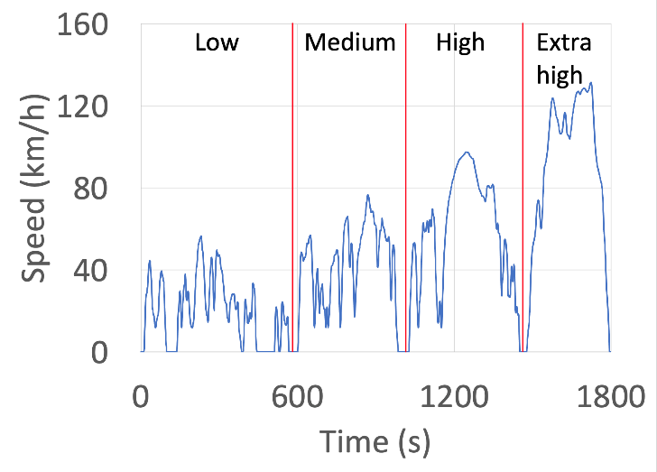
1.2 Resistive Forces
Using the data already provided to me about the WLTP Class 3 cycle, I was able to calculate the resistive forces of my vehicle, or the forces that oppose motion. The acceleration force was calculated using Newton’s second law of motion $F=m∙a$ whereby the acceleration of the vehicle in every point within the cycle was multiplied by its mass: 1900kg. The rolling resistance remains a constant 372.80N across the entire cycle. The aerodynamic drag is dependent on the vehicle’s speed and its frontal area (A) with coefficient of drag (Cd) which is used in the equation: $\frac{1}{2}Cd∙ρ∙A∙v^{2}$ where rho (ρ) is the density of air. All three of these forces added create the total resistive forces that oppose the motion of the vehicle and I can graphically display their effect over the timescale of the WLTP Class 3 cycle.

Figure 2.1: Graph of Resistive Forces across the WLTP Class 3 cycle

1.3 Tractive & Braking Power
Because power is equal to force times speed $P=F∙v$ I am able to easily calculate and display the tractive and braking power of the vehicle at every second throughout the course of the duty cycle. Displayed on figure 3, you can view the areas of acceleration and deceleration of the vehicle and begin to see where energy can be recovered and deployed across the timescale.
Figure 2.2: Graph of Power across the WLTP Class 3 cycle

  - Cumulative Energy
After separating the power from the vehicle into tractive and braking we’re able to add these values together to gather information on the total cumulative power for each purpose. After multiplying each instance of power by (1/3600) of an hour (1 second), we have a value of energy at each second in the WLTP cycle. We can plot these datasets for cumulative energy and compare how much energy is lost due to friction. As seen in figure 2.3 below, 4.78kWh of energy is used to overcome the tractive forces and accelerate the vehicle. Conversely, only 0.877kWh of energy is used under braking for deceleration purposes. 3.903kWh of energy is lost between them (81%). Most of this loss can be attributed to the frictional forces in the braking system giving off heat energy which is waste. During the regenerative cycle of the flywheel kinetic energy recovery system, 30% of the accumulated energy is still lost due to friction in the bearing and windage effects. This leaves us with 614Wh of cumulative energy usable by the wheels for acceleration, compared to the 877Wh recovered whilst the vehicle was undergoing deceleration by braking.
Figure 2.3: Graph of Cumulative Energy across the WLTP Class 3 cycle

- KERS Design
After calculating the resistive forces and using them to find the tractive and braking power and energy throughout the WLTP cycle, I am able to start identifying components for a suitable kinetic energy recovery system (KERS) that could be used in my selected vehicle. The energy used under braking will have to go through the transmission which is our five speed manual gearbox, before going into a CFT gearbox for a flywheel and being passed through a controller before being stored as rotational kinetic energy in a flywheel. The flywheel would be made up of carbon filament wrapped round a steel hub weighing 5kg as seen below. ^{[5]} This gives it good tensile strength. The flywheel can store up to 60kW of power (Sam, 2011) but the high speed means that the shaft torque is low. This is a good storage capacity as the highest power regenerated in an instance throughout the WLTP Class 3b cycle is 34kW.
Figure 3: CAD model of Flywheel for KERS ^{[5]}
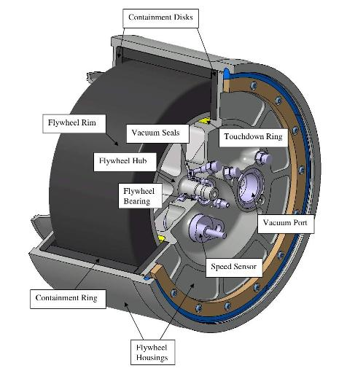

2.1 Efficiency
After doing some background research into mechanical kinetic energy recovery systems, I found that flywheel based energy recovery systems have an efficiency of 70% ^{[6]} over the full regenerative cycle. This level of efficiency throughout the whole cycle is better than systems which use batteries since the energy isn’t transformed into different types. In an electric system, kinetic energy is initially turned into electrical energy in the motor/generator. It is then stored as chemical energy in the battery. When deployed, it is converted back to electrical energy in the motor before being used as kinetic energy to power the wheels. This four stage process of energy transformations reduces the overall efficiency. With that being said, a mechanically driven flywheel still has losses due to friction in the bearings and windage effects, which come from the geared system that’s preferred over having a motor and generator in a battery based system. Electrical kinetic energy recovery systems do obtain the benefit of being able to store the energy for a longer period of time but the efficiency values aren’t as good as flywheels. Batteries also cannot be fully discharged constantly and we should assume that all of the stored energy from a braking period is used in the next tractive zone of the WLTP cycle. The limitation of the flywheel being its inability to store energy for a long period of time can be overlooked when used across shorter periods in “cut and thrust traffic,” (Boretti, 2011.) If we take the efficiency of the flywheel energy recovery system and apply it to the maximum possible power harnessed from deceleration (34.397kW), we find that 24.078kW is what gets returned to the wheels when deployed. The cumulative energy recovered is plotted on the same graph as braking energy in figure 2.3 to highlight the losses caused by the flywheel energy recovery system.

- Explanation
I have chosen to use a flywheel for my kinetic energy recovery system as it has good values of efficiency as previously mentioned. The lack of energy transfers compared to those seen in electrical systems, aid the efficiency of the flywheel and maximizes the energy retained from braking. The clutched flywheel transmission is what’s used to transmit the drive between the flywheel and the main gearbox using a series of small clutches. Separate gears and high speed clutches are used to perform a controlled slip in order to transmit the drive. When connected to the engine speed shaft within the vehicle’s transmission, the three gears in the CFT KERS are multiplied by the number of gears in the main vehicle’s gearbox to provide a variety of overall ratios between the flywheel and wheels. The efficiency of a slipping clutch depends upon the speed across it and with various gears to choose from, a high efficiency option is always available. A computer controller picks the most suitable gear by partially engaging the high speed clutch designated to that gear. This control system would use hydraulic pressure to close the clutches and transmit the drive, effectively changing gears without any torque disruption as the speed across the engaged clutch tends to zero. Due to the high energy absorption rate of the flywheel, my kinetic energy recovery system will be designed to do most of the deceleration of the vehicle when the drive force request pedal is initially released. With the clutched flywheel transmission taking most of the energy from the wheels to the flywheel, the vehicle would’ve already lost considerable speed before friction brakes would be required. This should make the driving experience easier with the assisted deceleration and acceleration using the energy harvested under braking and deployed on throttle. As mentioned earlier in section 2.1, the system can be used most effectively in “cut and thrust traffic” where the regenerative cycle is being repeated often, such as in a busy metropolitan area.

- Reference List

[1] www.automobile-catalog.com. (2016). Detailed specs review of 2016 Ford Focus 1.0 EcoBoost (100) model for Europe. [online] Available at: https://www.automobile-catalog.com/car/2016/2082410/ford_focus_1_0_ecoboost_100.html#gsc.tab=0 [Accessed 9 Jan. 2024].

‌[2] www.omnicalculator.com. (2024). Rolling Resistance Calculator | Cars, Bicycles, Tires. [online] Available at: https://www.omnicalculator.com/physics/rolling-resistance.

‌[3] Car.info. (2024). Specifications for Ford Focus 1.0 EcoBoost Manual, 5-speed. [online] Available at: https://www.car.info/en-se/ford/focus/focus-5-door-hatchback-10-ecoboost-17124981/specs#:~:text=Engine%20%26%20Performance [Accessed 9 Jan. 2024].

‌[4] www.transportpolicy.net. (2024). International: Light-duty: Worldwide Harmonized Light Vehicles Test Procedure (WLTP) | Transport Policy. [online] Available at: https://www.transportpolicy.net/standard/international-light-duty-worldwide-harmonized-light-vehicles-test-procedure-wltp/#:~:text=The%20Worldwide%20Harmonized%20Light%20Vehicles.

‌[5] Sam (2011). Flywheel hybrid systems (KERS). [online] Racecar Engineering. Available at: https://www.racecar-engineering.com/articles/f1/flywheel-hybrid-systems-kers/#:~:text=Solution%201%20%E2%80%93%20the%20flywheel&text=Further%20work%20has%20optimised%20the [Accessed 12 Jan. 2024].

‌[6] Boretti, A.A. (2011). Improvements of vehicle fuel economy using mechanical regenerative braking. International Journal of Vehicle Design, 55(1), p.35. doi:https://doi.org/10.1504/ijvd.2011.038046.

