Module Code: BMSW4001
Academic and Employability Skills
Assessment 1: ACE Practical Portfolio
(Task 2: Report)

Student Name: Yeliz Koncak
Student ID: 2028995

Table of Contents
Introduction 1
Gibbs Reflective Cycle 2
Selected Topics 3
Time management 3
Reflection 4
Academic Writing 5
Conclusion 7
Reference 8

Introduction
Through reflection, a learner can step back from his learning experience, develop his critical thinking ability, improve his future probable performance by reflecting and assessing what he has learned and what is his achievement from the learning. Developing the competencies and professional skill is crucial in the highly competitive world of work; hence, this reflective assessment on my Academic and Employability skill will upgrade my knowledge after completing the assignment. Here, I will use the Reflective Cycle by Gibbs to cast light on some of the topics I have accomplished and to assess the effectiveness and implementation of these learning in my academic and professional environment.

Gibbs Reflective Cycle
Graham Gibbs is the introducer of a reflective cycle that offers a structure to boost learning from the learners’ experience. The cycle comprises six stages which are Description, Feelings, Evaluation, Analysis, Conclusion, and Action plan (Adeani, Febriani and Syafryadin, 2020).

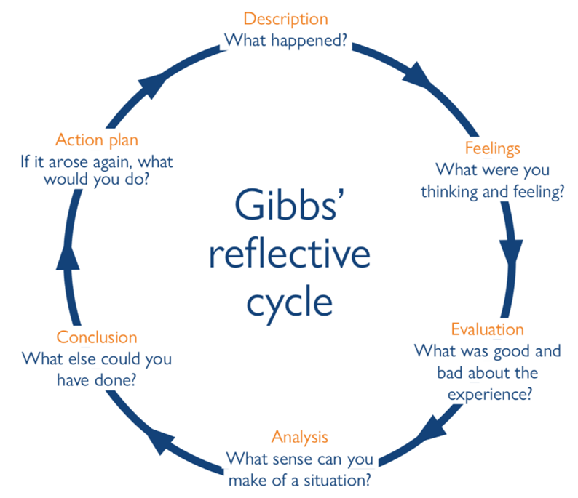
Figure 1: Gibbs Reflective Cycle (Adeani, Febriani and Syafryadin, 2020)

To demonstrate my reflection on this very module, I will use this learning cycle since it is very clear, apprehensible, and precise for analysis, elaboration and of the experience to apprehend its results.
The main objective of this activity is analysing my learning progress in some particular topics and measuring the efficacy of my learning. Three topics that I will cover here are Academic Writing, Time management, and reflection. My learning on these three topics will be demonstrated intricately incorporating Gibbs Learning Cycle.

Selected Topics

Time management
Time management is the procedure to plan and organise tasks to share one’s time to accomplish his activities. Before attending the course, my idea on time management was like this. However, after finishing the course, I have gathered in-depth knowledge on time management and the most important of them is, time management is not only dividing the time among tasks rather a lot of factors should be considered while making sound time management. In this course, from my course teachers and class discussions, I have learned what factors needs to be considered and what needs to be ignored to effectively manage my time. For example, I have learned that effective time management requires effective task delegation, prioritising the essential tasks, decision-making efficacy, scheduling of the tasks, and goal setting (Griffin and Annulis, 2016).
As Peter Drucker said, ‘Time is the scarcest resource and unless it is managed nothing else can be managed’ (Griffin and Annulis, 2016). I have learned that time management requires prior tasks such as deadlines and goal setting, effective planning, delegating the tasks, and prioritising them as per their importance. After accomplishment, each activity should be reviewed on whether the deadlines have been met. Time management, in short, is a process of planning and prioritising the effective control of the spent time on each activity to facilitate smart work instead of hard work. Thus, improved time management has aided me in boosting my performance and improving my academic results.
The following tactics I have apprehended from my class lectures regarding time management:
- I have apprehended to plan and organise my daily actions and maintain a “To-Do List” and “Task Plan’. To effectively setting my goals and targets, I have learned the importance of “SMART” goal-setting. Since sticking to a stringent routine does not work sometimes, rather a person has to make smart decisions by knowing the proper time to accomplish a task.
- To manage time properly, priority setting is a crucial task that I have recognised lately. Hence, I can now sort out my most important responsibilities first to perform that on an urgent basis; thus, I can give proper effort and full attention to perform them efficiently. This classification aids me in sorting out my priority tasks.
- Another important aspect of time management is removing or lessening distractions which I have ignored before the module. Distractions are the activities that hamper accomplishing our essential activities such as television, social media, mobile and computer games, garrulous co-workers that cost our crucial hours. When I have learned about the distraction, I have been capable of cutting them off from my schedule and can be able to perform my tasks efficiently and improved.
- Previously I used to ignore the significance of setting a deadline for my important tasks that needed to be covered within a certain time that made me rushing to finish my tasks at the eleventh hour. Now I have learned the importance of setting deadlines and taking responsibility for my work.
- Last but not the least, I have learned that reviewing the time spent on a particular project and evaluating it against the standard schedule is another significant aspect of better time management (Subedi, 2018). Hence, I have started keeping a record of my everyday tasks and auditing my activities after a certain interval, usually after 10 days. This action helps me to improve my task performance and efficiency to a great extent.
Thus, accomplishing this assignment module has aided me with improved time management.

Reflection
Reflection is an activity that helps us to identify and process the gist of work and learning experience. After undertaking this assignment, what I have understood is that reflection inspires one to grow to be the best version of himself. Reflection is an ongoing and dynamic process of deep, honest, and intricate thinking on the overall learning and experiment. Reflection is a generic term for those intellectual and affective activities in which individuals engage to explore their experiences, to lead to a new understanding and appreciation (Andrews and Russell, 2019)
A reflection is a significant tool that aids in processing the professional and personal information and experience meaningfully by enhancing the knowledge of a setting and deepening the understanding (Miller, Biggart and Newton, 2018). I have learned how to utilise ‘Gibbs Reflective Learning Cycle’ to reflect on an experience and how to measure the outcome of the learning. Now I can assess what experience I have gathered, what I am feeling about the experience, the bad and good things about the experience, the alternatives I can go with, and developing my action plan that illustrates if I have to deal with a similar situation in future, then what actions I will take. Moreover, reflection on my task has helped me in encouraging motivation, self-facilitated learning, and assuring the quality of learning (Subedi, 2018). These altogether safeguard the effective learning of a learner. The following tactics I have apprehended from my class lectures regarding reflection:
- While I have initiated reflective assessment on my various experience, learning, and works, I have used reflection’ strategy such as having a reflective journal, using a notice board, having a friendly mentor who can guide me and assess my shortcomings as well as achievements, performing action research, and practising professional learning (Miller, Biggart and Newton, 2018).
- While conducting a reflection, I have started to assess my improvement and knowledge enrichment from varied experiences, evaluate my learning process, connect concepts to practice, consider opportunities and alternatives, question my ideas and thoughts, examine new strategies, enhance my potentials while enhancing my learning.
- I have been acquainted with varied reflective methods such as Gibbs’ Reflective Cycle, Kolb’s Reflective Cycle, Honey and Mumford cycle etc. (Subedi, 2018). All the tools are effective in assessing one’s experience and enhancing it in future. What Gibbs said about reflection is, reflection on the learning and experience help the learner to enhance his performance while the incident is taking place as well as in future.
This module has aided me in enriching my learning on reflective practice that will assist me in reflecting on future experiences meaningfully. After completing this module, I have understood the significance of reflection for my personal development.

Academic Writing
Before undertaking this course, what I have known about academic writing is, it is formal writing with compound sentences and intricate vocabulary on a particular topic. But after accomplishing this task, my idea on academic writing has been altered and I have gained in-depth knowledge on academic writing. Academic writing is a precise, clear, structured, and focused report based on evidence to make the readers understand the topic. Academic reports and writing do not necessarily require a complex structure, vocabulary, and sentences; however, they ensure a formal style and tone (Hendrawan and Daryanto, 2019).
I have learned that the purpose of academic writing is explaining the findings of the research to convince its readers about the accuracy and implementation of the theory and explanation of the findings. Thus, academic writing necessitates an elaboration of activity while the description needs identifying, reporting, defining, paraphrasing, summarising, and recording. The following tactics I have apprehended from my class lectures regarding academic writing:
- After completing the module, I have learned that academic writing should be impartial and unbiased in conveying knowledge only by constructing arguments on evidence, not by the authors’ assumptions. The claim in the research findings should be backed up by proper evidence, not by meagre assertations (French, 2018). To avoid bias, the original works of the varied authors should be referenced fairly and accurately. The research methodology needs to be clearly outlined and the limitations should be honestly represented.
- The language used in academic writing requires enough attention since a clear and precise language ensures the appropriate understanding of its users. Vague knowledge should be avoided in academic writing. I have learnt that usage of clear and simple language helps the readers grab the perceived meaning that the writers want to convey.
- I have now learnt the way to circumvent confusing words and hence, I will avoid confusing words such as ‘Perhaps’, ‘Probably’ etc. since this translates into a lack of confidence about a claim (Hendrawan and Daryanto, 2019). Furthermore, I have learnt to avoid jargon generally; jargon can be used only when it makes the write-up more precise and accurate instead of making it complicated.
- Academic writings are meant to be backed up by sources such as the findings of other researchers and academicians to support the newfound results and claims. Thus, I have learnt to use well-sourced references published in recognised journals. Since academic writings should be based on prior research and collaboration, finding out credible and proper sources is vital (HEALEY, 2021). Hence, now I use academic databases, and university libraries to back up my writings with credible sources. Furthermore, I have learnt to cite my work using varied styles such as Harvard, APA, and Chicago styles of referencing.
I have learned the correct and consistent rules of academic writing by ensuring accurate grammar, punctuation, and citation. Since academic writing differs from literary, marketing, and journalistic text, it does not instigate emotional response, instead, it communicates ideas, information, findings, and arguments (HEALEY, 2021). Thus, avoiding emotive text is essential.

Conclusion
Reflective practice enhances self-awareness and facilitates analysis and review of what one has learnt and the competencies one has developed by assuring a sound appreciation of his capabilities (Adeani, Febriani and Syafryadin, 2020). This module has given me a chance to practice reflective writing on the development of my Time Management skills, Academic Writing, and reflection skill. By incorporating reflective learning practice in my future learning assessment, I can fasten my skill improvement and reinforce my constructive outlook. This reflection has aided me in finding significance and meaning in the class lectures and given assignments that outline instructions for facing the intricate incidents successfully. This module has improved my understanding and with its capacity development and knowledge that will aid me in my future academic and professional work and learning. Furthermore, it will facilitate my creative thinking capabilities and active engagement in my priority tasks.

Reference
Adeani, I., Febriani, R. and Syafryadin, S., 2020. USING GIBBS' REFLECTIVE CYCLE IN MAKING REFLECTIONS OF LITERARY ANALYSIS. Indonesian EFL Journal, 6(2), p.139.
Andrews, G. and Russell, M., 2019. Employability skills development: strategy, evaluation and impact. Higher Education, Skills and Work-Based Learning, 2(1), pp.33-44.
French, A., 2018. Academic writing: anxiety, confusion and the affective domain. Journal of Academic Writing, 8(2), pp.202-211.
Griffin, M. and Annulis, H., 2016. Employability skills in practice: the case of manufacturing education in Mississippi. International Journal of Training and Development, 17(3), pp.221-232.
HEALEY, C., 2021. ACADEMIC WRITING and DYSLEXIA A Visual Guide to Writing at University, London, Routledge. Journal of Academic Writing, 4(3), pp.128-132.
Hendrawan, R. and Daryanto, D., 2019. Employability skills: Industry perspective and achievement of student of employability skills. Journal of Physics: Conference Series, 1402, p.022049.
Miller, L., Biggart, A. and Newton, B., 2018. Basic and employability skills. International Journal of Training and Development, 17(3), pp.173-175.
Subedi, N., 2018. Soft Skills as Employability Skills: Fundamental Requirement for Entry-level Jobs. KMC Research Journal, 2(2), pp.133-142.

