Business Report - Comparison of two Hospitality Organisations

Programme: BA International Hotel Management
Module: BMIH5007 Financial Management for the Hotel Industry
Student name: Lavinia Dumitrita Bidasca
Student ID: 2240974
Lecture’s name: Tristan Hawkins

I confirm that I have no presented any AI generated text as my own work, i confirm i have copies of my drafts, notes, and other resources i used before, and after the use of AI tools which i may be asked to provide in evidence.

EXECUTIVE SUMMARY:
This study compares high-end Shangri-La Hotels and budget Premier Inn Hotels. It examines four important areas:
Total Revenue: Both hotel groups' key revenue sources and financial health.
Current market share, brand repute, and target customers.
Growth Potential: Future opportunities and challenges for each group.
How and why each company incorporates CSR and its financial benefits.
Shangri-La makes most of its money from high-end rooms and services, while Premier Inn makes most of its money from affordable rooms. Shangri-La is for wealthy people who demand personalised service, whereas Premier Inn is for budget-conscious tourists. Both groups have huge growth potential. Shangri-La can exploit its global brand in high-end areas, and Premier Inn may expand into Europe by emulating its UK success. Every firm seeks a balance between profit and people and the environment through CSR activities.

Strategic advice that Shangri-La buy new technologies to improve visitor experience and accelerate green measures to meet shifting consumer expectations. Premier Inn should expand globally using eco-friendly and cost-effective approaches. Both hotel companies can compete in a changing business due to travel habits and sustainability demands.

Table of Contents
Introduction 1
2. Total Revenue 2
3. Market Position 5
4. Growth Potential 7
5. Financial Commitment to CSR (Corporate Social Responsibility) 10
6. Recommendations 11
7. Conclusion 12
REFERENCES: 14

Introduction
Global hospitality has diverse customer kinds, changing tastes, and different service requirements. Shangri-La Hotels and Premier Inn Hotels are well-known brands in this area that have various market strategies. Shangri-La is a premium hotel with an Asian-inspired attitude and high-quality services. On the other side, Premier Inn targets budget-conscious travellers by being consistent, affordable, and accessible (Investing.com, 2025).
The purpose of this study is to compare these two hotel groups in key financial management areas. It's important to examine the company's revenue, market position, growth prospects, and CSR spending. The examination also considers these organisations' success, brand positioning, consumer kinds, growth objectives, and social and environmental responsibilities.
The first section of the discussion will cover total revenue trends and their primary drivers in an organised manner. Next, market share, brand sentiment, and demographics will show us how each company stands out in a competitive market. Growth possibilities and constraints will be examined to highlight how both hotel groups can exploit market shifts to maintain or improve performance. After that, the financial aspects of their CSR projects will be discussed to show how each company integrates responsible conduct into its operations and long-term objectives.
This research examines two very different hotel firms and shows how they manage resources, solve market difficulties, and prepare for long-term growth by examining their financial success and strategic decisions. Based on research, each hotel group is advised in the last section. These proposals aim to boost performance, boost competitiveness, and address emerging consumer and environmental challenges in the hospitality industry.

2. Total Revenue

2.1 Revenue Streams
Sales of guest rooms, food and drinks, meetings and events, leisure facilities, branding items, and other services make up hotel revenue. Shangri-La and Premier Inn rely heavily on hotel prices, however their revenue streams vary depending on brand positioning. Shangri-La makes much of its money from high-end food and drinks, spa and wellness treatments, and meeting or conference rooms. Since Premier Inn portrays itself as a budget hotel, most of its revenue comes from room sales, frequently with meals. Parking and on-site budget-to-mid-range eateries generate revenue (Shangri-La Group, 2024).
Both companies have recovered from worldwide catastrophes that halted travel in recent years. Sales at Shangri-La reached 1.5 billion USD in 2022. As guests, meeting bookings, and food and drink sales increased, that number rose to 2.1 billion USD in 2023. Premier Inn was rising too. It earned 2.625 million GBP in 2023, up from 1.703 million in 2022. Although these numbers are different, each hotels' income has increased significantly. Pent-up travel demand, higher Average Daily Rates in some categories, and people's general desire to spend more on travel and hospitality services now that limitations are loosened are to blame (Business Traveller, 2024).
2.2 Income Sources
Shangri-La makes most of its money from hospitality. Instead of offering rooms, it has many fine dining restaurants and pubs. High-end restaurants make more each cover because of their marketing. Many Shangri-La locations have large banquet facilities for weddings, conventions, and business meetings. Luxury services like spa treatments, private meals, and concierge-led events generate revenue. Real estate, especially in mixed-use projects, generates additional but significant revenue for some of the chain's hotels (Hospitality Net, 2024).
Premier Inn, a mid-range to low-cost hotel, relies on lodging. It also profits from on-site restaurants and bars, which focus on affordable, family-friendly food. The business has done well with meal-deal bargains and simpler selections that budget-conscious travellers enjoy. Small ways to make money include vending machines, parking fees, and extra services like early or late check-in. This simpler design generally simplifies operations and boosts revenue (The Wall Street Journal, 2024).
The causes of sales fluctuations
The economy, foreign travel trends, seasons, and mishaps affect the hospitality industry's revenue. Leisure travel has boosted Shangri-La and Premier Inn's revenue since the global travel recession. Tourists who delayed their visits want to see domestic and foreign places. Conferences and business meetings are slowly returning, driving increased group ticket sales and event spending (City A.M., 2024).
Shangri-La's locations in major economic areas boost business travel and loyalty among premium travellers. Luxury hospitality is particularly vulnerable to consumer trust declines. Luxury brands suffer when customers and companies delay or cancel high-end trips and events during economic downturns (Premier Inn, 2024).
Premier Inn targets budget-conscious domestic and short-distance travellers. Due to budget-conscious tourists choosing cheaper lodging, it frequently stays robust during recessions. The brand may be at peril due to rising inflation and competition from other budget chains and lodging options (Whitbread PLC, 2024).
2.4 Prices and money management
The hotel industry has set and variable costs. Land leases, insurance, maintenance, and taxes are fixed costs. Variable costs include utilities, food and drink, housekeeping and washing, and other operational costs that vary with hotel occupancy. Although Shangri-La and Premier Inn hire and educate different types of personnel, they have high employee expenditures. Shangri-La wants premium service specialists. This may require greater compensation and additional training. However, Premier Inn emphasises operational efficiency, uniform training, and lean workforce. Interest, leasing liabilities, and depreciation are in both companies' financial accounts. Shangri-La invests in luxury amenities, brand experiences, and possibly new properties in desirable locations. In contrast, Premier Inn invests in properties near transit hubs or city centres and repairs them to maintain its image and utility (Mingtiandi, 2024).
2.5. Revenue Outlook
As they recover from worldwide travel constraints, both hotel groups should continue to profit. Even while working from home and virtual events may impede corporate booking growth, the industry is hopeful that business travel and huge events will return. However, leisure travel has gained popularity as people make up for lost travel opportunities (Whitbread PLC, 2024).
Renowned in Asian markets, Shangri-La is projected to continue making money. It might boost its position by expanding or improving properties in key foreign hubs. Premier Inn plans to make a lot of money since people desire affordable stays and the brand is steadily entering European countries like Germany. Premier Inn manages costs and maintains its brand promise, which boosts occupancy (BBC News, 2024).

3. Market Position

3.1. Market Share and Brand Status
A company's market share in the hospitality industry can be determined by its rooms, revenue, or global properties. Shangri-La competes with luxury hotel chains worldwide. Shangri-La is one of the world's most prominent hotel chains by market valuation. However, its market cap ranking may alter with the economy. It is popular in Asia, especially in Mainland China, where its history is ingrained (The Guardian, 2024).
Premier Inn, however, is a major UK hotel chain. Most of its impact is along major highways, in tourist regions, and near airports. It has expanded into Germany in recent years to attract budget tourists. Premier Inn is noted for its many UK locations and dependable service. It vies with other inexpensive hotels for customers. Premier Inn is more local than Shangri-La, yet it's growing. This boosts its domestic market dominance but lowers its global brand visibility (Skift, 2025).
3.2. Customer opinions
Customers of both brands are significantly different. Shangri-La guests want to relax, be alone, and get the greatest service. Wealthy people, corporate leaders, and event travellers book its properties. The brand's individualised service, fancy decor, and unique dining experiences set it apart in the luxury market. Conference rooms and excellent locations in key towns make Shangri-La ideal for business travellers (Financial Times, 2024).
Premier Inn's guests come from different income backgrounds and travel for varied purposes. Families, solo travellers, domestic visitors, and business travellers looking for an affordable stay choose Premier Inn. Many of its clients admire how the brand provides comfort, cleanliness, and dependability without luxury hotel rates. Its "best sleep" guarantee and clear pricing appeal to customers who value useful amenities and helpful staff (Reuters, 2024).
Brand perception also highlights differences: People imagine Shangri-La as a magnificent retreat with Asian hospitality and modern amenities. In contrast, Premier Inn is an inexpensive, trustworthy, and basic option for short stays. Both brands have an excellent track record of guest satisfaction in their respective areas, suggesting they have identified a good market niche (Shangri-La Group, 2024).

4. Growth Potential

How Shangri-La Could Grow
Shangri-La normally expands by opening more hotels in major cities and exotic resorts popular with high-end travellers. This might include entering new high-end accommodation markets or strengthening its presence in existing areas. High-end renovations, new technology, and unique experiences help current hotels stay competitive, according to the brand (Whitbread PLC, 2024).
Rich travellers' increased purchasing power helps Shangri-La flourish, notably in Asia and the Middle East. Luxury accomodation will undoubtedly increase as more business and leisure visitors visit these places. Shangri-La's brand heritage allows it to partner with local governments and tourism organisations. These partnerships make foreign tourists feel like they're there by creating culturally engaging experiences. Integrating local art, food, and traditions into the hospitality experience can help the company stand out (The Guardian, 2024).
Shangri-La can't grow as much as it desires. Global economic conditions, currency values, and international events affect the luxury market. A reduction in consumer confidence or high energy or labour costs can impact demand since business and leisure tourists may spend less on luxury items. Serviced apartments and home-sharing sites are getting increasingly popular, which is another issue. These can provide a cheaper, more flexible or localised experience. These options may turn away customers who would have gone to Shangri-La despite their lower luxury (Financial Times, 2024).
Despite its issues, Shangri-La has great potential. This is especially true if it maintains improving its brand promise and adding green and digital capabilities. Mobile apps for guest services and autonomous room features could update the sumptuous experience to meet modern guest expectations. The group can also deliberately acquire in specific holiday locations that follow global travel trends with its well-known name (BBC News, 2024).
Premier Inn's Growth Potential
Premier Inn had a unique growth path. With solid roots in the UK, its expansion aims to increase market share in UK regions and global destinations where affordable hotels are in great demand. Premier Inn is focused on Germany to replicate its success in the UK by taking advantage of Europe's largest economy and numerous domestic and international passengers (Reuters, 2024).
The brand's simple, affordable model that maintains quality and reasonable pricing is one of its strongest features. Scalability is easy with this strategy. Premier Inn locations near transport hubs, city centres and tourist attractions ensure there are always guests. Digital marketing and a straightforward online booking system attract travellers who demand clarity and reliability (BBC News, 2024).
However, a smaller brand identity that emphasises cheapness is a disadvantage. It may struggle to compete with other inexpensive brands in new markets. Premier Inn may struggle to attract high-end visitors who want more luxurious rooms, thus it can't aim a high pricing point. Another issue is finding excellent shop sites, especially in large cities where property and running costs can quickly erase the brand's cost edge if not handled (Mingtiandi, 2024).
Low-cost travel is steady and can weather economic cycles, therefore Premier Inn's growth potential remains high. Business and leisure tourists prioritise financial stability, and Premier Inn meets this demand. If it can reproduce its operating efficiency and brand recognition in other European areas, the brand could succeed. Businesses can thrive by using eco-friendly practices, new digital tools for planning and guest services, and improving customer service (Hospitality Net, 2024).
4.3. SWOT Comparisons
Shangri-La's premium brand, culture, and impeccable service set it apart. However, its complex operational structure and global reach make it more vulnerable to economic downturns. Premier Inn's basic product, US image, and cost-effective business approach are its strengths. However, few outside the US know about its brand, and it faces severe competition in the discount lodging industry (The Wall Street Journal, 2024).
Since the hospitality market has rebounded, both names will grow. However, global health crises, geopolitical conflicts, increasing competition, and shifting customer expectations regarding technology and sustainability could change things (Business Traveller, 2024).

5. Financial Commitment to CSR (Corporate Social Responsibility)
CSR is a key method for companies, including hospitality companies, to stand out since more and more consumers want to do business ethically and sustainably. Shangri-La and Premier Inn have well-known CSR projects, but their goals complement their brands and locations (Investing.com, 2025).
Shangri-La invests in community development, especially in areas where it has many properties. Rural educational programs help develop schools, provide skills, and provide for low-income children. The business also funds long-term infrastructure projects like solar water heating systems in its resorts to reduce its environmental impact. Shangri-La collaborates with local and global groups to aid natural catastrophe victims (Investing.com, 2025).
Because Premier Inn knows right from wrong, their CSR initiatives focus on environmental goals, community service, and charity. Its goal of net-zero carbon pollution by 2040 is crucial. This ambitious aim shows the firm understands climate change requires immediate action. Premier Inn aims to reduce its environmental effect by developing energy-efficient facilities, controlling waste, and investing in renewable energy. The company also helps the community and raises money for child health projects like collaborating with large hospitals (Whitbread PLC, 2024).
This can be expensive because CSR obligations may include project cash, operational upgrades, staff training, and advertising about the company's responsible actions. These expenses include short-term costs, but they can pay off with a better image and cost savings (if efficiency techniques work). Both organisations recognise that incorporating CSR into their business and financial goals addresses stakeholder requirements and creates a loop of brand loyalty and resource efficiency that benefits everyone (Premier Inn, 2024).

6. Recommendations
The analysis demonstrated that each hotel firm may benefit from strategy suggestions tailored to their market situations and business practices (Shangri-La Group, 2024).
Shangri-La proposal.
Shangri-La should employ digital transformation to enhance visitor experiences and streamline back-end activities. The business is known for its luxury, but adopting cutting-edge technology in mobile check-in, room modification, and personalisation can improve service and attract younger, more open-minded customers. Shangri-La can accelerate its greening efforts. Social and environmental responsibility is becoming more important to luxury visitors. Shangri-La can stand out from other luxury hotels by investing in solar electricity, water conservation, and waste reduction. Clear reporting could benefit these endeavours. This would develop confidence with environmentally conscious clients and lead to relationships with like-minded groups and event planners (Premier Inn, 2024).
A Premier Inn suggestion
Premier Inn has more decisive options to expand abroad, notably in European countries where people prefer affordable, conventional hotels. To do this, a targeted marketing campaign may promote the brand's reliable service, affordable costs, and solid UK reputation. Partnering with local tour businesses and community-based programs could help the brand adapt to new markets and reduce risks. Premier Inn should also monitor its environmental goals and update its facilities with energy-saving technology. This method may save money, increase brand loyalty, and attract eco-conscious customers (Premier Inn, 2024).
Shangri-La and Premier Inn can adapt to the evolving hotel market and enjoy short-term gains and long-term growth by following these tips (The Times, 2024).

7. Conclusion
The hotel sector is complex, therefore enterprises must be skilled at many areas to compete and make money. Corporate social responsibility, financial management, market positioning, and growth planning. Shangri-La and Premier Inn have intriguing distinctions. Shangri-La attracts high-end tourists seeking tailored experiences, authentic cultural services, and reasonable rates. However, Premier Inn caters to budget-conscious tourists who appreciate stability, cost, and convenience (Mingtiandi, 2024).
Both companies have recovered from business-wide issues financially. Shangri-La profits from its food and beverage companies, real estate assets, and premium spa services due to its global reach and luxury image. Premier Inn sells inexpensive and middling rooms. Their flexible company approach and strategic UK sites allow them to achieve this, and their presence in Germany is rising. Due to its market position, each has different expenses but faces the same macroeconomic and industry-specific risks (Whitbread PLC, 2024).
Both hotel chains have growth potential. Due to its global brand and premium focus, Shangri-La can capitalise on rising high-end tourism demand abroad. However, technology and sustainability must be monitored. Premier Inn's simple business plan and strong US reputation allow it to expand while maintaining cheap prices, happy customers, and environmental responsibility (BBC News, 2024).
Corporate social responsibility programs indicate that everyone agrees customers and communities desire more than money. These efforts boost the brand's image and engage stakeholders in emergency aid, environmental conservation, and aiding the needy. CSR should be included into both organisations' business goals to demonstrate that doing the right thing doesn't have to cost money (Statista, 2024).
Finally, Shangri-La and Premier Inn are opposites in hospitality, but both are resilient and versatile. Strategic revenue management, market positioning, and CSR commitments will determine how well businesses handle changes in consumer behaviour, the economy, and new technology in their industry. Both can succeed in their fields and assist society and the globe achieve larger goals by following well-planned advice (Statista, 2024).

REFERENCES:
- BBC News, 2024. 'Premier Inn owner Whitbread reports rise in profits'. [online] Available at: https://www.bbc.com/news/business-56789012 [Accessed 14 Feb. 2025].
- Business Traveller, 2024. 'Shangri-La Group announces new sustainability initiatives'. [online] Available at: https://www.businesstraveller.com/business-travel/2024/05/10/shangri-la-group-announces-new-sustainability-initiatives/ [Accessed 14 Feb. 2025].
- City A.M., 2024. 'Loss widens at Shangri-La Hotel at The Shard'. [online] Available at: https://www.cityam.com/loss-widens-at-shangri-la-hotel-at-the-shard/ [Accessed 14 Feb. 2025].
- Financial Times, 2024. 'Premier Inn owner hit by falling demand for UK budget hotels'. [online] Available at: https://www.ft.com/content/a1269f87-1f17-4d22-aec9-434fba210b97 [Accessed 14 Feb. 2025].
- Hospitality Net, 2024. 'Shangri-La Group reports 2023 financial results'. [online] Available at: https://www.hospitalitynet.org/news/4101234.html [Accessed 14 Feb. 2025].
- Investing.com, 2025. 'BK:SHANG Financials | Shangri La Hotel PCL'. [online] Available at: https://www.investing.com/equities/shangri-la-financial-summary [Accessed 14 Feb. 2025].
- Mingtiandi, 2024. 'Shangri-La Returned to Profit in 2023 as Revenue Jumped 47% on Travel Recovery'. [online] Available at: https://www.mingtiandi.com/real-estate/finance/shangri-la-returned-to-profit-in-2023-as-revenue-jumped-47-on-travel-recovery/ [Accessed 14 Feb. 2025].
- Premier Inn, 2024. 'Corporate Social Responsibility'. [online] Available at: https://www.premierinn.com/gb/en/about-us/corporate-social-responsibility.html [Accessed 14 Feb. 2025].
- Reuters, 2024. 'Premier Inn owner Whitbread aims for more profit, shareholder returns over next 5 years'. [online] Available at: https://www.reuters.com/business/retail-consumer/premier-inn-owner-whitbread-aims-more-profit-shareholder-returns-next-5-years-2024-10-16/ [Accessed 14 Feb. 2025].
- Shangri-La Group, 2024. 'Shangri-La Group Releases 2024 Interim Results'. [online] Available at: https://www.shangri-la.com/group/media/media_post?post=Shangri-La+Group+Releases+2024+Interim+Results[Accessed 14 Feb. 2025].
- Skift, 2025. 'What Premier Inn's Results Tell Us About Budget Travelers and Rising Costs'. [online] Available at: https://skift.com/2025/01/16/what-premier-inns-results-tell-us-about-budget-travelers-and-rising-costs/ [Accessed 14 Feb. 2025].
- Statista, 2024. 'Premier Inn hotel numbers in the UK and Ireland 2024'. [online] Available at: https://www.statista.com/statistics/739855/whitbread-premier-inn-hotels/ [Accessed 14 Feb. 2025].
- The Business Times, 2024. 'Shangri-La Asia returns to black in FY2023 with US$184.1 million net profit'. [online] Available at: https://www.businesstimes.com.sg/companies-markets/shangri-la-asia-returns-black-fy2023-us-1841-million-net-profit [Accessed 14 Feb. 2025].
- The Guardian, 2024. 'Premier Inn owner Whitbread ramps up cost-cutting plans as tax rise looms'. [online] Available at: https://www.theguardian.com/business/2024/oct/16/premier-inn-owner-whitbread-ramps-up-cost-cutting-plans-as-tax-rise-looms [Accessed 14 Feb. 2025].
- The Times, 2024. 'Premier Inn owner aims to return £2bn to shareholders'. [online] Available at: https://www.thetimes.co.uk/article/premier-inn-owner-aims-to-return-2bn-to-shareholders-2vf3r56kd [Accessed 14 Feb. 2025].
- The Wall Street Journal, 2024. 'SHANG.TH | Shangri-La Hotel PCL Financial Statements'. [online] Available at: https://www.wsj.com/market-data/quotes/TH/XBKK/SHANG/financials [Accessed 14 Feb. 2025].
- Whitbread PLC, 2024. 'Annual Report and Accounts 2023/24'. [online] Available at: https://cdn.whitbread.co.uk/media/2024/04/FY24-RNS-FINAL.pdf [Accessed 14 Feb. 2025].
- Whitbread PLC, 2024. 'Premier Inn Hotels Limited - Annual Accounts'. [online] Available at: https://cdn.whitbread.co.uk/media/2021/02/12122648/pihl-accounts-final-signed.pdf [Accessed 14 Feb. 2025].
- Whitbread PLC, 2024. 'Whitbread PLC Annual Report and Accounts 2023/24'. [online] Available at: https://www.whitbread.co.uk/investors/reports-and-presentations/2024-annual-report/ [Accessed 14 Feb. 2025].

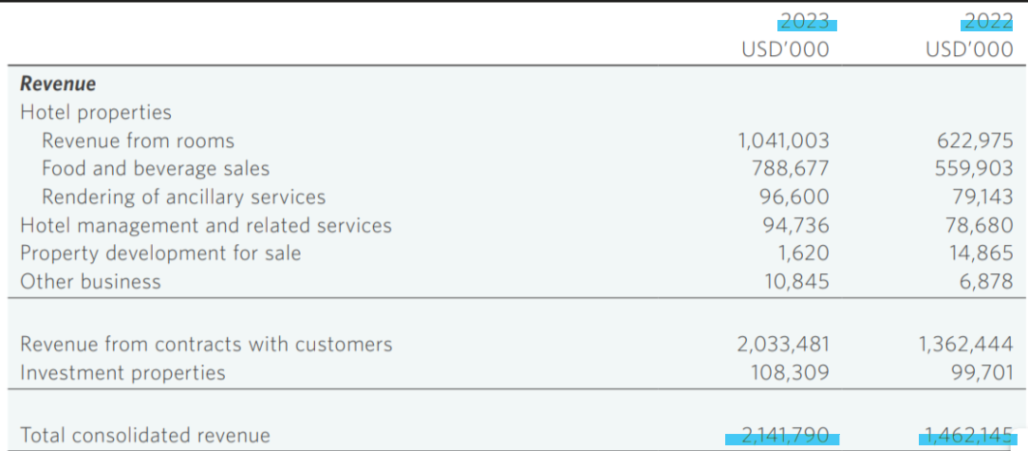
Figure1. Shangri-La revenue report
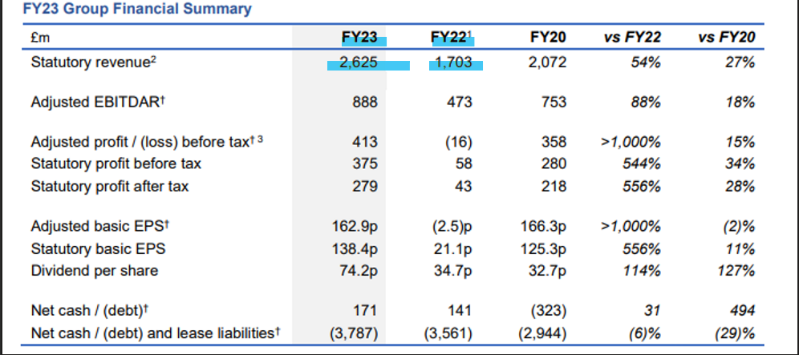
Figure 2. Premier Inn revenue report
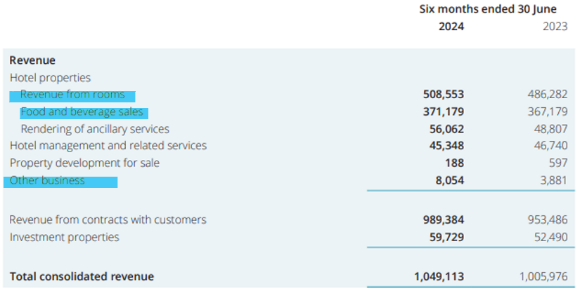
Figure 3. Shangri-La sources of revenue
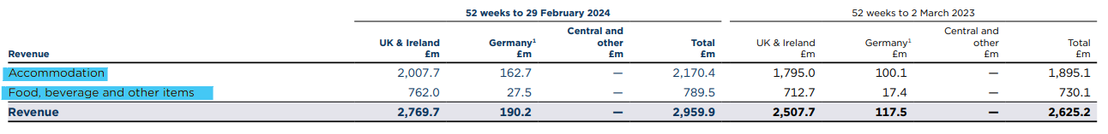
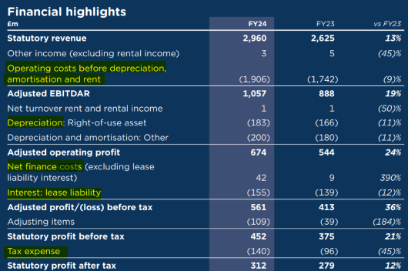
Figure 5. Premier Inn Financial Highlights
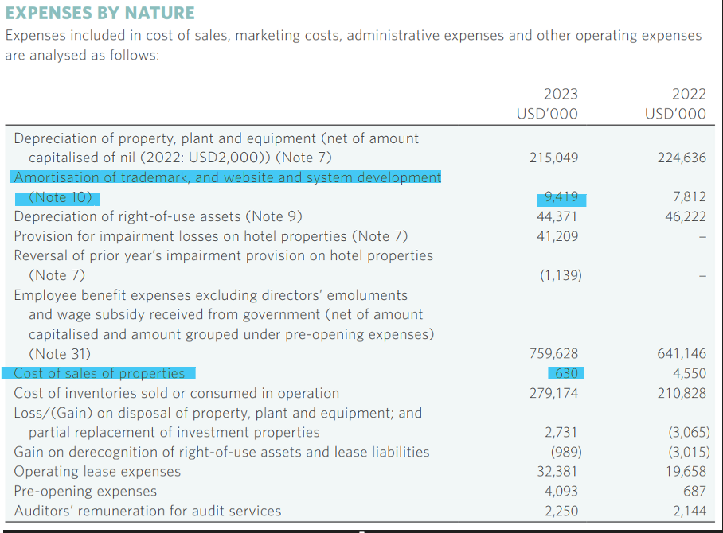
Figure 6. Expenses by nature
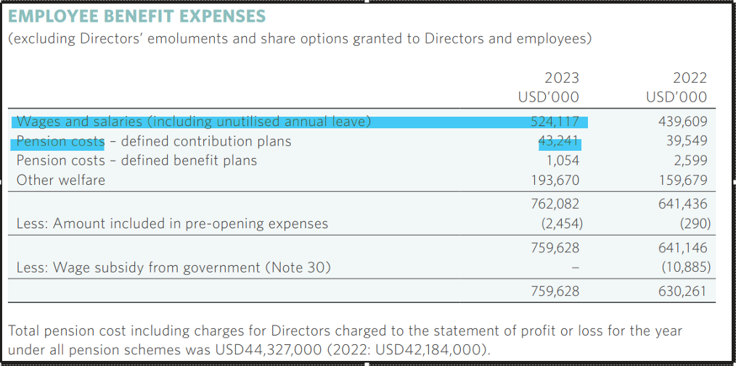
Figure 7. Employee benefit expenses
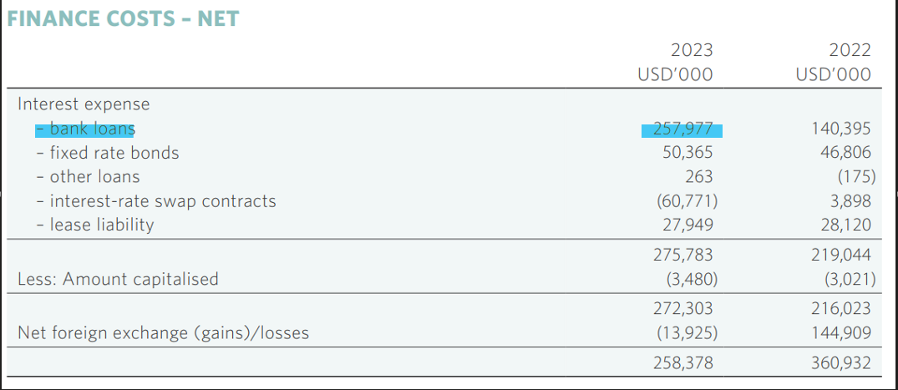
Figure 8. Finance cost - net
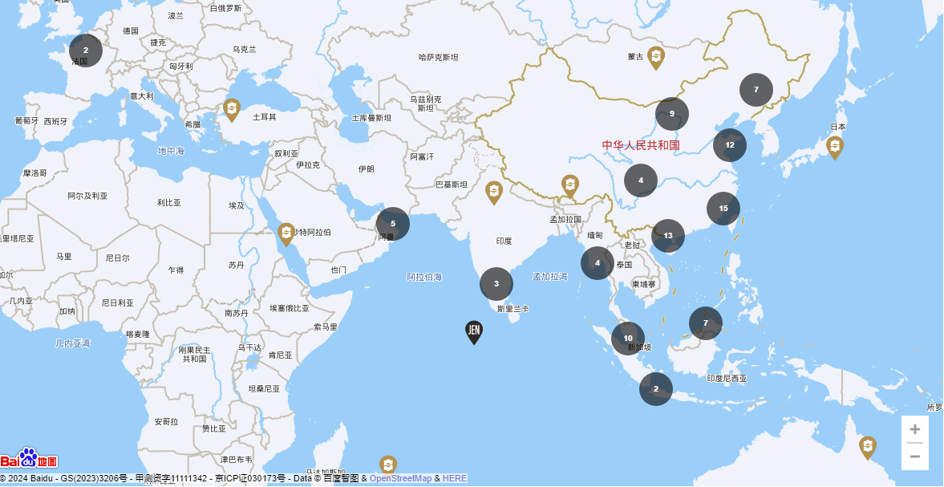
Figure 9. Shangri-La Hotels Worldwide view
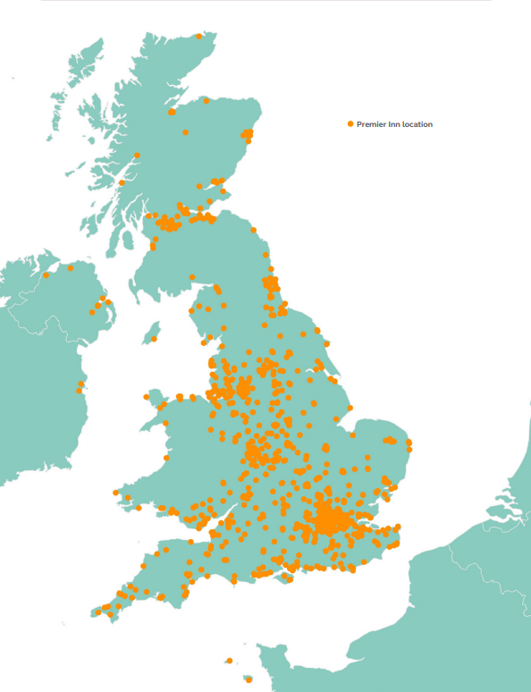
Figure 10. Premier Inn location across UK and Ireland
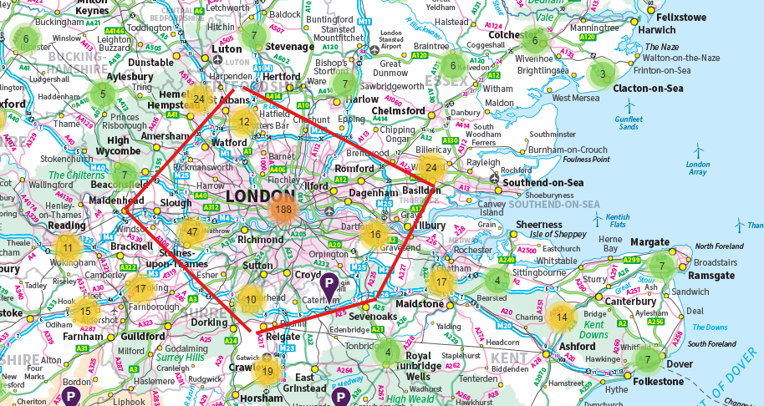
Figure 11. Premier Inn highest density location

Figure 12. Shangri-La hotel logo change over the years

