
University of Wales Trinity Saint David, London Campus
MSc Cyber Security
Module: Digital Forensics Analysis
Assignment Title: Research, Analysis and Investigate Cybersecurity incidents and perform digital forensic assessment
Student Name: Aviral Tyagi
Student ID: 2530743
TASK 1
Digital Forensics: Current State, Convergence with Cybersecurity, and Future Direction

Introduction
Digital forensics involves the identification, preservation and analysis of digital evidence for use in an investigation or as evidence in court. The field has come a long way in disk imaging. Mobile devices, cloud accounts, and evidence produced by AI will be frequent challenges for investigators in 2026 [1]. The current toolset, forensics in relation to cybersecurity, emerging trends, key challenges for investigators and the job market in the UK and internationally are analyzed in this report. It's intended to provide a realistic, hands-on view; a textbook-level description would be outdated in just a couple years due to the rapid evolution of the industry.

Current State of the Field: Tools, Features and Capabilities
Most laboratories are not dependent on just one product. They use a limited amount of commercial platforms, similar to standard forensic practice [2]. With its proprietary hardware-level exploits [3] Cellebrite remains a top choice for mobile extraction, particularly on locked Android and iOS devices. Magnet AXIOM is different: it collects disk, memory, mobile and cloud artefacts in one case timeline, that is appropriate for investigations across multiple device types [4]. In 2025-26 both vendors introduced their support for AI assisted triage, which includes the flagging of AI manipulated images in Cellebrite [5] [6]. What that means is that the tools aren't redundant; it's a way of cross-checking the artefact recovery because no single platform can reliably parse every app or file format.
Free and open-source tools such as Autopsy, Volatility and The Sleuth Kit should not be dismissed as lesser options simply because they cost nothing. Courts care about documented methodology and examiner competence under the Daubert standard, not the price of the tool, a point already established in foundational forensic scholarship [7], [8].
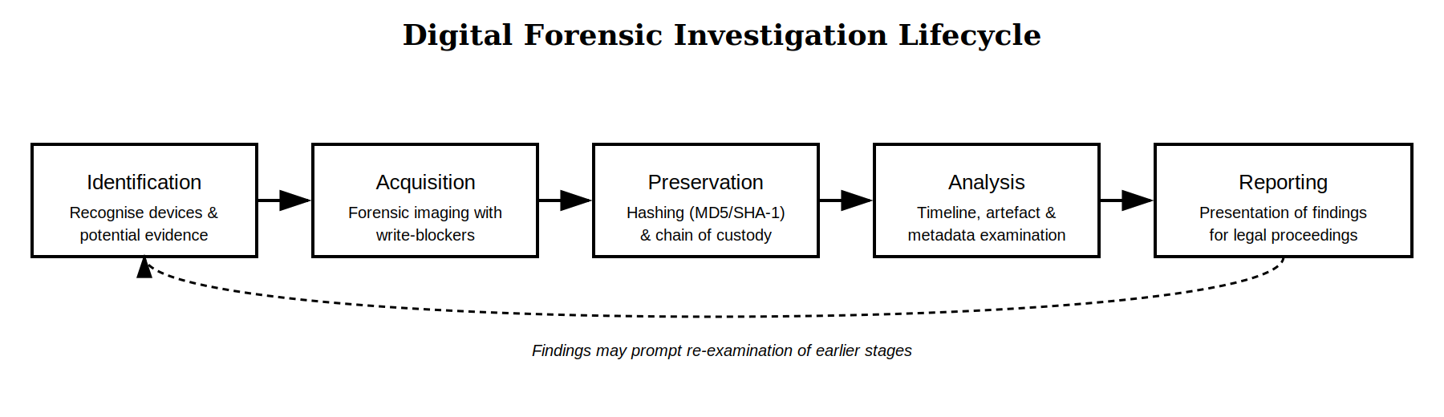
Figure 1: A generalised digital forensic investigation lifecycle, adapted from acquisition and chain-of-custody practice described across current industry guidance [5], [3].

The Intersection of Digital Forensics and Cybersecurity
Forensics and cybersecurity are not mutually exclusive, one following the other; one is not a follow-on to the other. The two fields do have a great intersection of incident response: Forensic timeline reconstruction and log and malware analysis are often the same activity, done by similar teams [9]. It's not what it's about, it's about how. Prevention is a key aspect of Cybersecurity and Forensics is understanding what has actually happened, but both are utilizing the same data, such as endpoint logs, network captures and cloud audit trails [10]. The overlap is the reason workforce research studies now combine the terms "digital forensics" and "incident response" together to form a single skills gap [11]. In real life, when a forensic examiner has joined an incident response case in the middle of it, the distinction between the two roles might be lost.
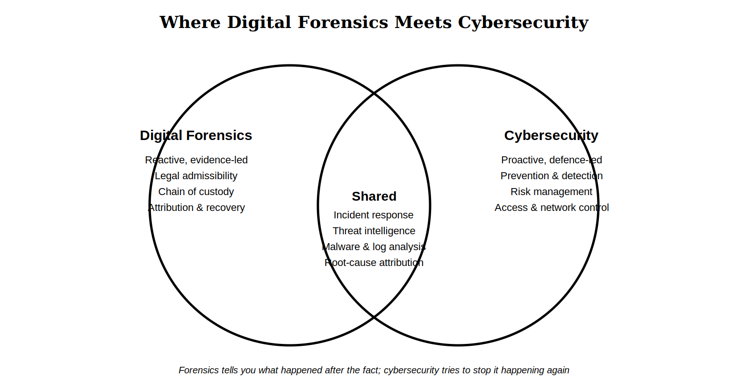
Figure 2: Digital forensics and cybersecurity share methods and data sources at the incident-response layer, while differing in orientation (reactive vs. proactive).

Emerging Trends in Digital Forensics
There are three obvious trends in use at the present time. For one, investigators are increasingly relying on cloud and remote acquisition, not seizing devices wholesale, instead pulling out specific app information [1]. Second, there is an increasing trend towards embedding AI directly into forensic platforms for artefact summarisation and anomaly detection, which although early rather than mature, are described by vendors as such. Third, the market is growing rapidly, at approximately USD 14.85 billion in 2025, and a projected USD 31.74 billion by 2030 [12], with the market for cloud forensics jumping around 16.5% a year until 2031 [13]. Europol's latest threat assessment confirms this – it names encryption, proxy infrastructure, and AI as the growing areas that are transforming cybercrime, and therefore investigations into it [14]. The range of evidence sources is also expanding beyond phones and laptops: artefacts on wearables, in smart home devices and connected vehicles are becoming more and more relevant to cases.

Key Challenges Facing the Discipline
The same issues arise again: encryption, volume of data, anti-forensic and jurisdiction. According to one of the more recent reports in 2024, 68% of the cybercriminals seek to conceal evidence using encryption, making it impossible to decrypt in a realistic investigation time frame [15]. Cloud evidence is another challenge as there is an even lower level of direct access for investigators to the infrastructure and reliance is placed on third parties to be outside of the relevant jurisdiction [9]. A recent case in the UK illustrates the scope of the issue: for nearly two years a water company had no awareness of intruders, and only discovered the delay because of long retention logs and endpoint baselines [16]. This isn't even the end of it: Anti-forensic techniques are commonplace as well, file wiping, manipulation of the date of the files, encrypted messaging apps, etc. are not uncommon, and investigators must now assume that evidence has been deliberately obscured, and not just lost. None of these issues are novel in nature, but their scope is new, and that is causing investigators to increasingly turn to automation that is still defensible in court.

National and International Job Market
It's a good job market both ways. In the UK the NCAP is actively seeking, as are Police Regions and private DFIR consultancies, from laboratory based investigator to expert-witness positions [17], [18]. According to careers guidance, there has been a more than doubling of national significant cyberattacks from 2024 to 2025 and bodies like BCS and CIISec serve as indicators of career progression [19]. It's not just the UK where there's a demand. According to the US BLS, the number of forensic science technicians is expected to grow 13% until 2034, while the number of other cyber security-related positions is predicted to grow by about 3.4 to 3.8 million through 2026-27 [20]. Forensics is a positive indicator for anyone entering the field now, given that it is at a time when the skills gap is well documented and where it is a cross skill set that is challenging to train on mass [11]. Technical competency with tools, report writing skills and confidence in explaining findings under cross-examination is sought at all times by employers and striving to advance with bodies such as BCS and CIISec is evidence of it.

Conclusion
All five of these areas suggest a maturing field that is developing rapidly and unevenly. The technological developments of tools and the use of AI are progressing at a faster rate than the laws and jurisdictions in place to regulate them. For an apprentice investigator, it is important to understand any particular tool, but not as important as to know how and when to use a defensible methodology and to be able to document it, and this was repeated in the sources used for this report.

References
[1] Oxygen Forensics, "CEO Lee Reiber: Digital Forensics 2026 and Beyond," Oxygen Forensics, 2026. [Online]. Available: https://www.oxygenforensics.com/news/digital-forensics-2026-and-beyond/. [Accessed: Jul. 22, 2026].
[2] B. Nelson, A. Phillips, and C. Steuart, Guide to Computer Forensics and Investigations, 7th ed. Boston, MA, USA: Cengage Learning, 2025.
[3] Sherlock Forensics, "Cellebrite vs Magnet AXIOM 2026: Forensic Tool Showdown," Sherlock Forensics Blog, 2026. [Online]. Available: https://www.sherlockforensics.com/blog/cellebrite-vs-magnet-axiom-2026.html. [Accessed: Jul. 22, 2026].
[4] D. Gupta, "Top 5 DFIR Tools for 2026: Magnet Axiom vs Cellebrite vs Volexity Surge vs Velociraptor vs Mandiant," guptadeepak.com, 2026. [Online]. Available: https://guptadeepak.com/tools/top-5-dfir-tools-2026/. [Accessed: Jul. 22, 2026].
[5] Cotocus, "Top 10 Digital Forensics Tools in 2026: Features, Pros, Cons & Comparison," Cotocus Blog, 2026. [Online]. Available: https://www.cotocus.com/blog/top-10-digital-forensics-tools-in-2025-features-pros-cons-comparison/. [Accessed: Jul. 22, 2026].
[6] TechTarget, "2026 Guide to Digital Forensics Tools for Enterprise Execs," TechTarget, 2026. [Online]. Available: https://www.techtarget.com/searchsecurity/tip/Digital-forensics-tools-experts-use. [Accessed: Jul. 22, 2026].
[7] Sherlock Forensics, "Android Forensics Tools Compared 2026," Sherlock Forensics Blog, 2026. [Online]. Available: https://www.sherlockforensics.com/blog/android-forensics-tool-comparison-2026.html. [Accessed: Jul. 22, 2026].
[8] E. Casey, Digital Evidence and Computer Crime: Forensic Science, Computers, and the Internet, 3rd ed. Waltham, MA, USA: Academic Press, 2011.
[9] Digitpol, "Computer Forensics in 2026: Evolving Techniques in a Complex Digital Landscape," Digitpol, 2026. [Online]. Available: https://digitpol.com/computer-forensics-in-2026-evolving-techniques-in-a-complex-digital-landscape/. [Accessed: Jul. 22, 2026].
[10] International Journal for Research in Applied Science & Engineering Technology (IJRASET), "Digital Forensic: Techniques, Challenges, and Future Direction," IJRASET, 2025. [Online]. Available: https://www.ijraset.com/best-journal/digital-forensic-techniques-challenges-and-future-direction. [Accessed: Jul. 22, 2026].
[11] DestCert, "Cybersecurity Job Demand in 2026: Trends, Growth, and Outlook," DestCert, 2026. [Online]. Available: https://destcert.com/resources/cybersecurity-job-demand/. [Accessed: Jul. 22, 2026].
[12] ECCU, "Why Digital Forensics Is One of the Fastest-Growing Careers in Cybersecurity," EC-Council University Blog, 2026. [Online]. Available: https://www.eccu.edu/blog/digital-forensics-career-guide/. [Accessed: Jul. 22, 2026].
[13] R. Sharma et al., "Cloud Digital Forensics: Beyond Tools, Techniques, and Challenges," National Center for Biotechnology Information, 2024. [Online]. Available: https://www.ncbi.nlm.nih.gov/pmc/articles/PMC10819343/. [Accessed: Jul. 22, 2026].
[14] Europol, Internet Organised Crime Threat Assessment (IOCTA) 2026: How Encryption, Proxies and AI Are Expanding Cybercrime. The Hague, Netherlands: Europol, 2026. [Online]. Available: https://www.europol.europa.eu/publications-events/main-reports/iocta-report. [Accessed: Jul. 22, 2026].
[15] Mailxaminer, "Top Digital Forensics Challenges in 2026 (Solved for Investigators)," Mailxaminer Blog, 2026. [Online]. Available: https://www.mailxaminer.com/blog/current-challenges-in-digital-forensics-investigations/. [Accessed: Jul. 22, 2026].
[16] Digital Forensics Magazine, "News Roundup — 13th May 2026," Digital Forensics Magazine, 2026. [Online]. Available: https://digitalforensicsmagazine.com/news-roundup-13th-may-2026/. [Accessed: Jul. 22, 2026].
[17] Forensic Focus, "Digital Forensics Jobs Round-Up, July 13 2026," Forensic Focus, 2026. [Online]. Available: https://www.forensicfocus.com/jobs/digital-forensics-jobs-round-up-july-13-2026/. [Accessed: Jul. 22, 2026].
[18] Glassdoor, "Digital forensics jobs in the United Kingdom," Glassdoor, 2026. [Online]. Available: https://www.glassdoor.co.uk/Job/united-kingdom-digital-forensics-jobs-SRCH_IL.0,14_IN2_KO15,32.htm. [Accessed: Jul. 22, 2026].
[19] Prospects.ac.uk, "Becoming a Forensic Computer Analyst," Prospects.ac.uk, 2026. [Online]. Available: https://www.prospects.ac.uk/job-profiles/forensic-computer-analyst/. [Accessed: Jul. 22, 2026].
[20] CompareCheapSSL, "Cybersecurity Job & Salary Statistics in 2026," CompareCheapSSL, 2026. [Online]. Available: https://comparecheapssl.com/cybersecurity-job-salary-statistics-global-insights/. [Accessed: Jul. 22, 2026].
TASK 2
DIGITAL FORENSIC INVESTIGATION REPORT
Case Reference: QT-IP-2025-014
Subject Matter: AI Chip Design Patent (ID: QT-AI-2025)
Investigator: Aviral Tyagi, Digital Forensic Examiner
Client / Instructing Party: Quantum Tech — Corporate Security & Legal Department
Forensic Tool Used: Cellebrite Physical Analyzer v7.73.0.11
Report Classification: Confidential — Legal Privilege / Law Enforcement Use
Prepared in line with ACPO digital evidence principles.
PART A — DIGITAL FORENSIC REPORT

1. Executive Summary
This investigation covers three people — Emma, Joe and Norman — and how the digital evidence recovered from their phones ties them to a plan to steal and sell confidential Quantum Tech research data. Emma had legitimate access to this data through her role at the company. Chat evidence recovered from her Huawei phone shows her asking Joe to find a buyer, and Joe later brought in Norman, who negotiated a price and an offshore payment arrangement.
Three phones were seized and examined using Cellebrite Physical Analyzer: a Huawei phone belonging to Emma, a Samsung phone belonging to Joe, and a Nokia phone belonging to Norman. WhatsApp chats, a Facebook chat, geotagged photographs and a travel ticket recovered from these three devices independently support one another. This report sets out that evidence exhibit by exhibit.

2. Case Background
Quantum Tech identified unusual activity connected to Emma's access to confidential material relating to its AI-based Neuro product, and suspected she was preparing to pass this data to a competitor for payment. Three phones were seized for forensic analysis: Emma's Huawei phone, a Samsung phone believed to belong to Joe, and a Nokia phone believed to belong to Norman.
In her WhatsApp messages, Emma refers to the target company as "ABC Technologies." This report treats that as an informal reference to Quantum Tech, consistent with the case briefing and the QT-AI-2025 patent at the centre of the investigation.

3. Evidence Inventory and Chain of Custody
The table below lists the three phones examined, with the device identifiers recovered during extraction. Ownership was not confirmed until the correlation work set out in Section 5.
Exhibit | Device | Owner | Key Identifiers | OS / Status
EX-01 | Huawei POT-LX1 P Smart | Emma | IMEI1: 860962043462662 IMEI2: 860962043422658 | Android 10
EX-02 | Samsung SM-A137F Galaxy A13 | Joe | IMEI1: 357898921470825 IMEI2: 357712351470827 | Android 14
EX-03 | Nokia C2 2nd Edition | Norman | IMEI1: 353766763818217 IMEI2: 353766763818209 | Android 11
All three devices were extracted with Cellebrite Physical Analyzer, with automatic hash verification performed at the point of acquisition. Extraction summaries are provided in Section 5.7 and Appendix B.

4. Methodology
- All three phones were extracted using Cellebrite Physical Analyzer (version 7.73.0.11). Each extraction was hash-verified by the tool itself at the point of acquisition.
- WhatsApp and Facebook chats were reviewed message by message, in full conversation view, with original timestamps preserved.
- Photos and their embedded EXIF metadata (GPS position, capture time, modified time) were checked against dates and locations referenced in the chats.
- Device identifiers (IMEI numbers, model, OS version) were recorded from each extraction to support the ownership analysis in Section 5.
- Every screenshot used as evidence is reproduced directly from the Cellebrite Physical Analyzer interface, so the source tool, device and timestamp are visible on the exhibit itself.
This investigation is based on the three mobile phone extractions listed in Section 3.

4.1 Acquisition Workflow (Cellebrite UFED)
Acquisition of each phone was carried out in Cellebrite UFED (version 7.76.0.24), a separate acquisition tool from the Cellebrite suite used for image capture only. The resulting image was then analysed in Cellebrite Physical Analyzer, as shown throughout Section 5. The screenshots below document the acquisition workflow step by step and directly support the chain-of-custody details in Section 3.
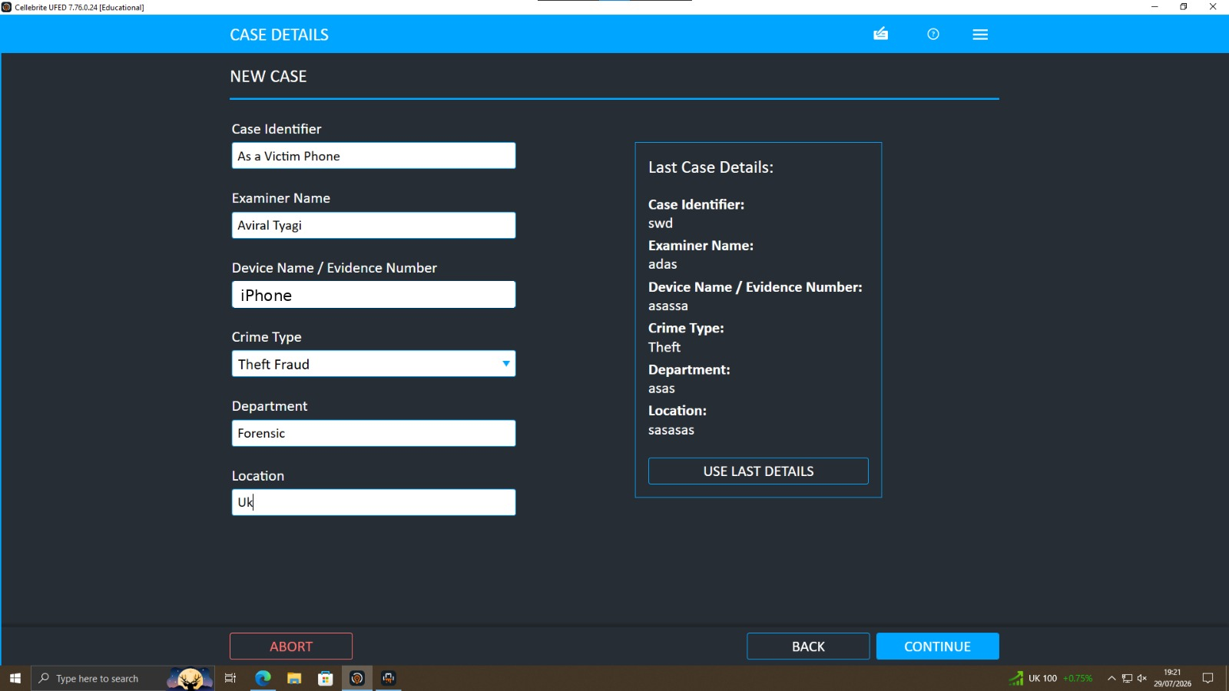
Step 1 — A new case is opened in UFED with examiner name, device reference, crime type, department and location recorded before any extraction begins.
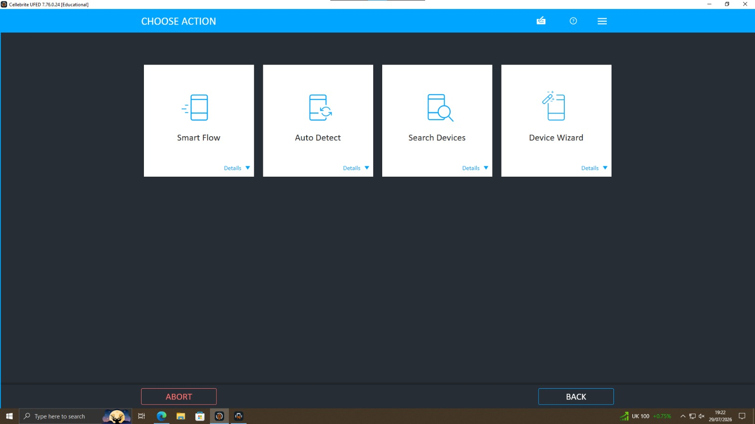
Step 2 — The examiner chooses an acquisition method; Auto Detect was used to identify the connected device automatically.
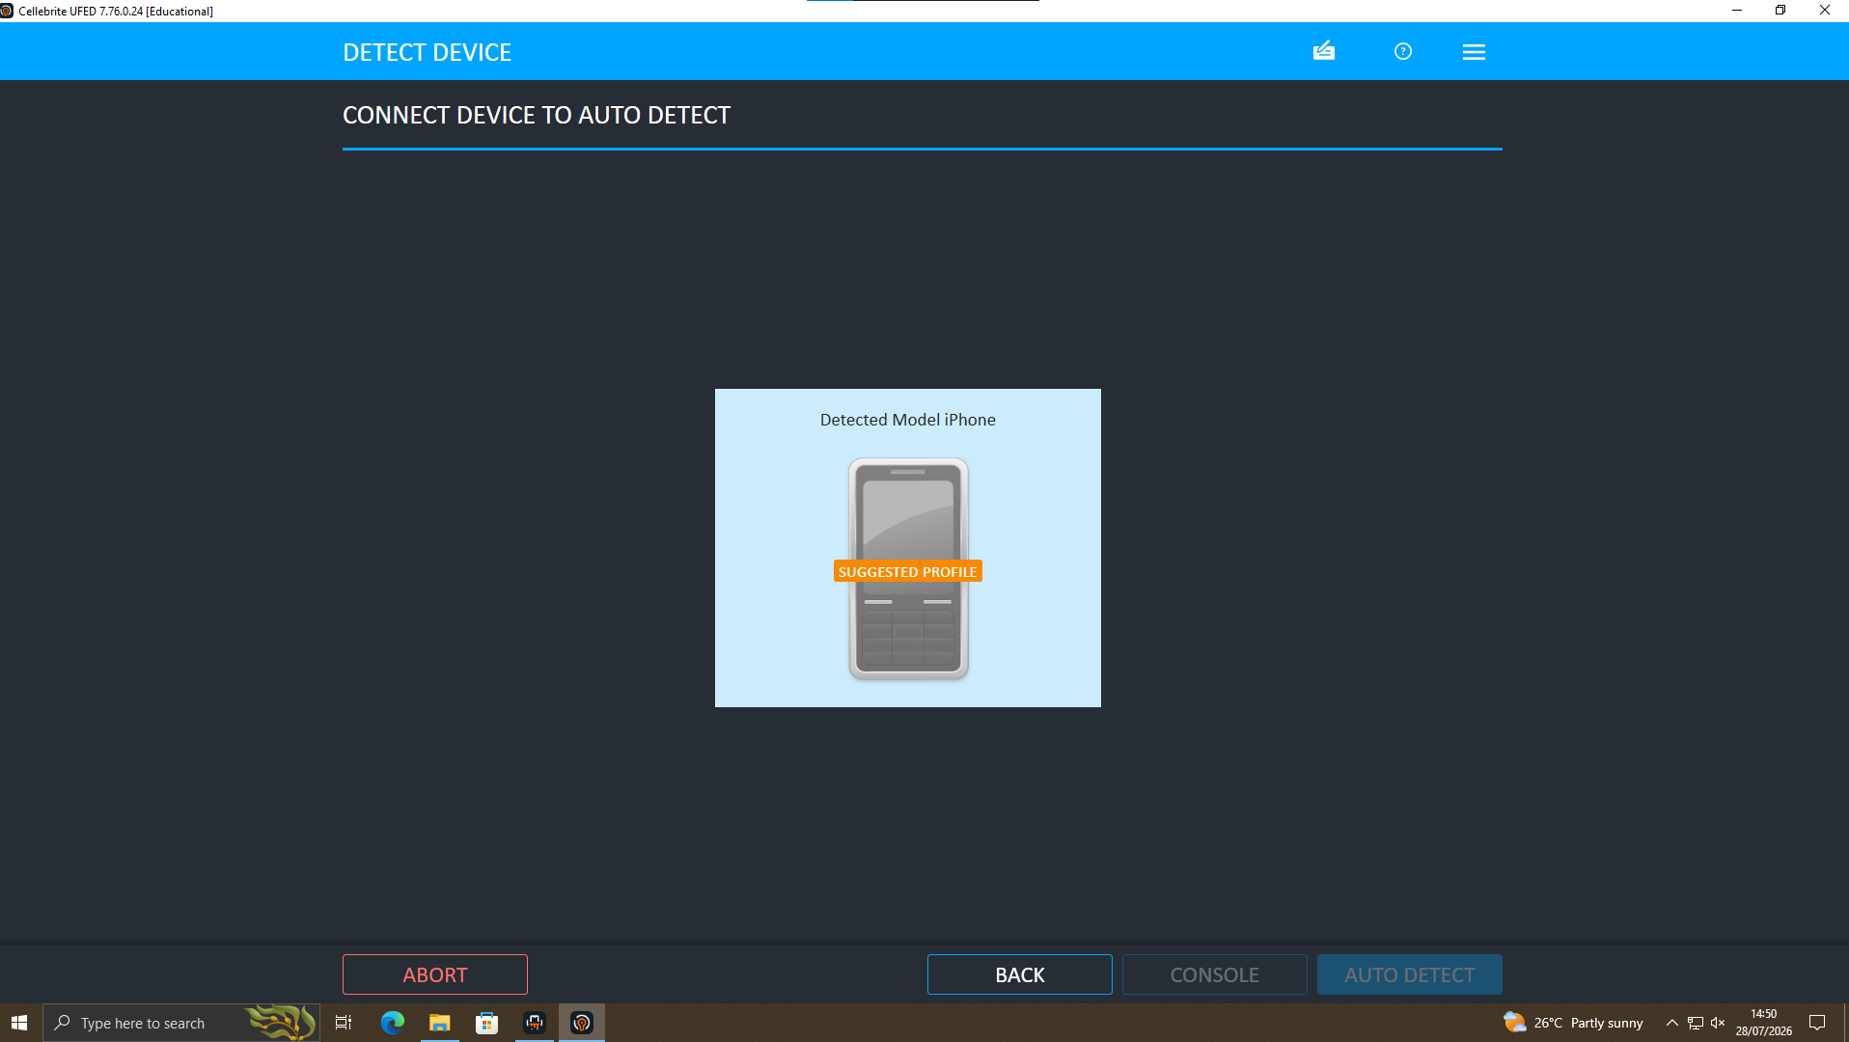
Step 3 — UFED auto-detects the connected handset and suggests the matching device profile before extraction starts.
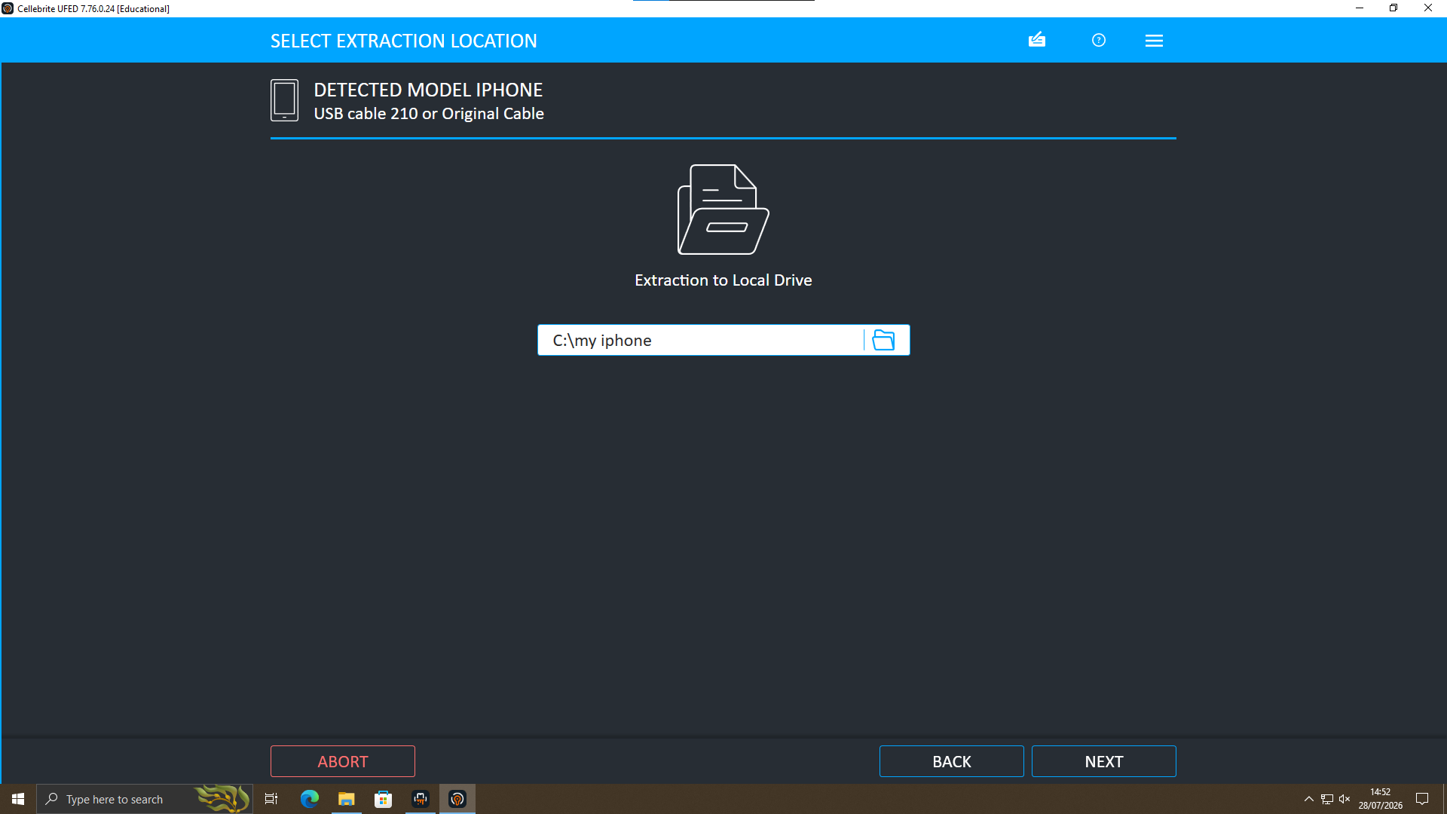
Step 4 — A local drive destination is chosen for the extracted image, keeping the acquisition self-contained and traceable.
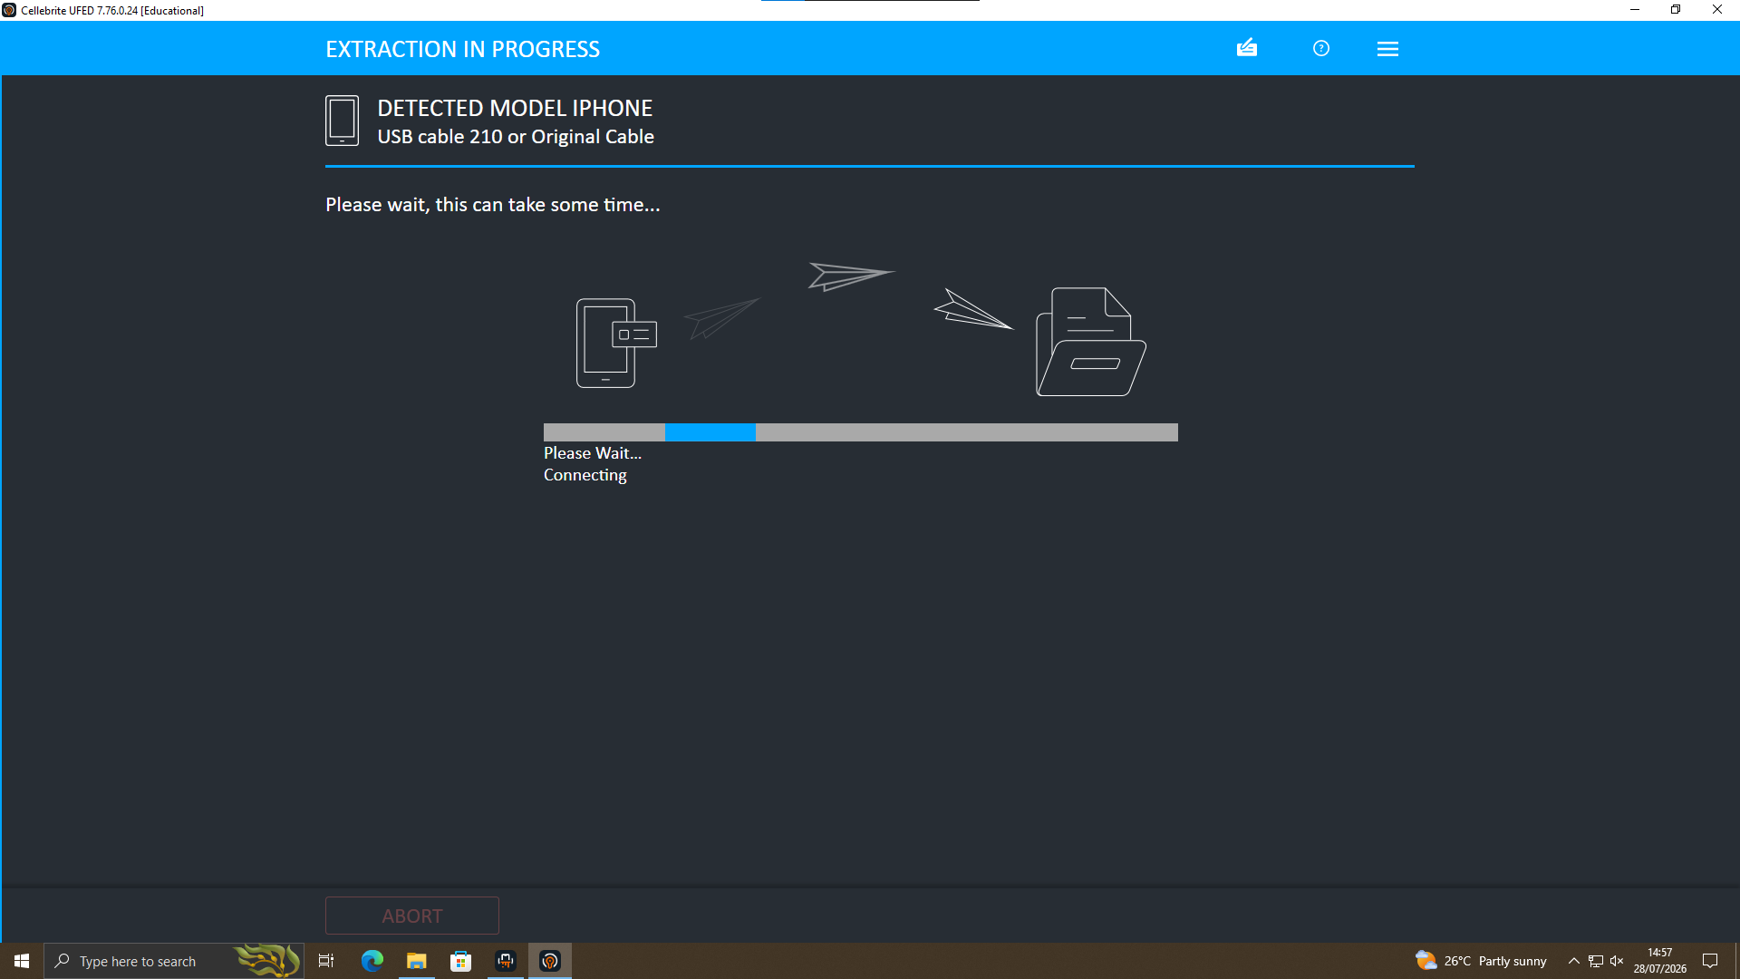
Step 5 — The extraction runs while the tool copies data from the handset to the target location; this stage is not interrupted.
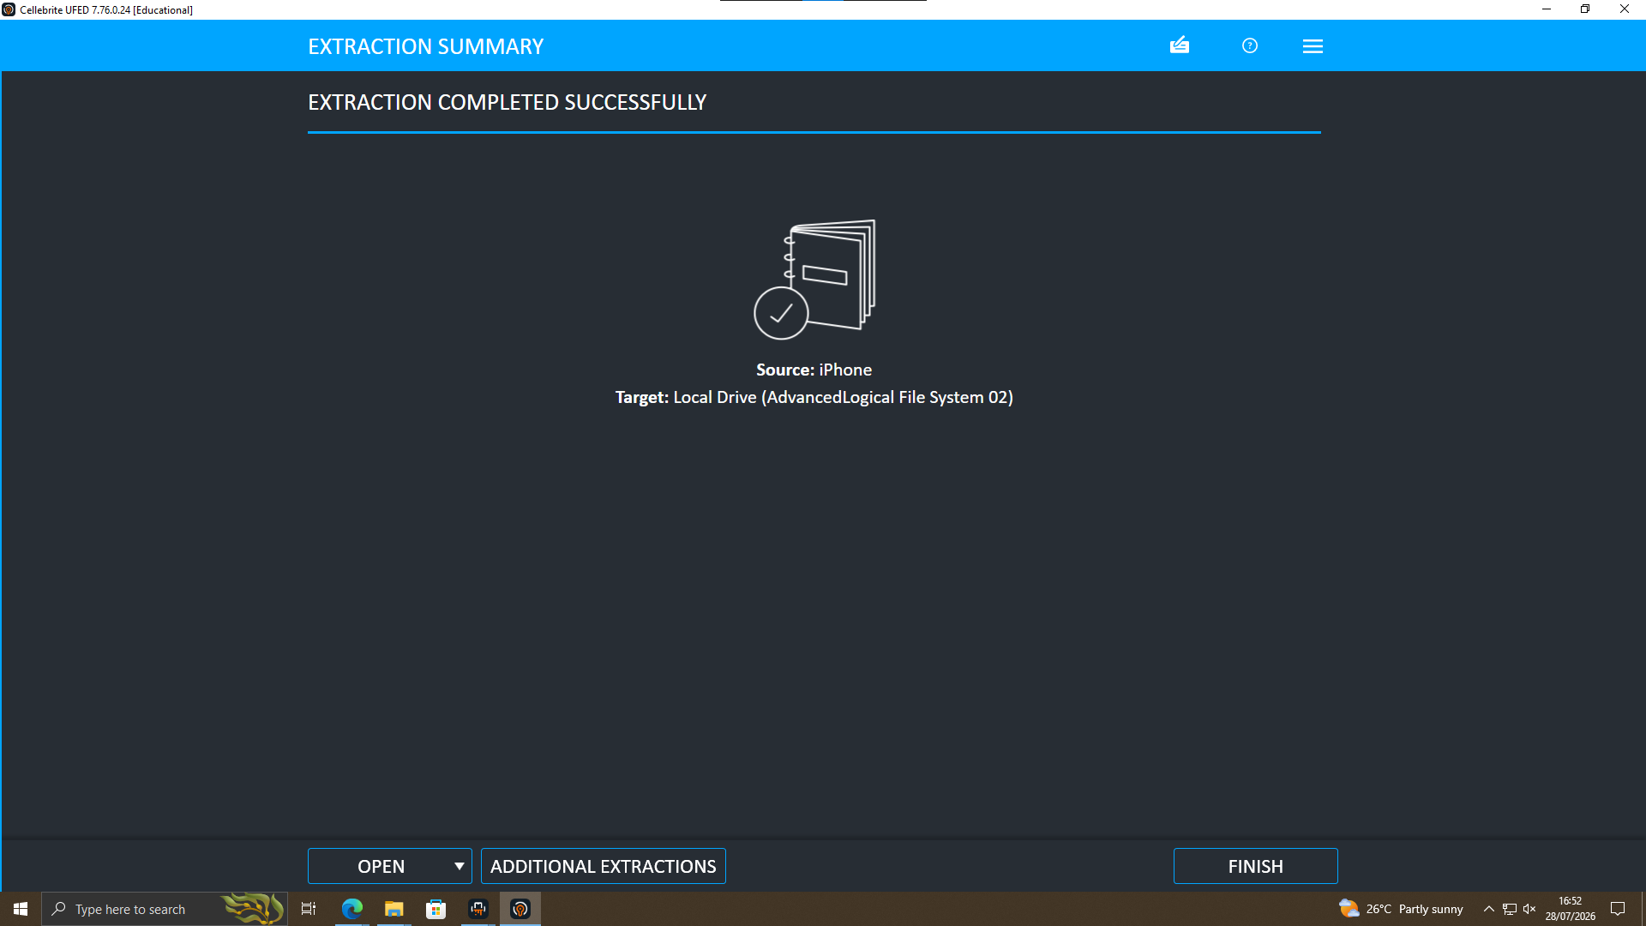
Step 6 — UFED confirms the extraction completed successfully, showing the source device and target location for the record.
This workflow was repeated for each exhibit in Section 3, with the case details (examiner, device reference, crime type, department and location) entered fresh for every device, to keep a separate, auditable acquisition record per phone.

5. Findings
Each finding below follows the same structure: the evidence itself, the analysis linking it to other exhibits, and the finding that follows. Full exhibit images are reproduced in Part B.

5.1 Emma reaches out to Joe — 21 August 2024
Evidence: WhatsApp chat recovered from Emma's Huawei phone, dated 21/08/2024 (Exhibits A1–A3). Emma opens contact, names the Neuro product data, and Joe agrees to raise the offer with a contact at a hotel.
Analysis: This is the first point at which a plan to sell company data is put in writing, by the person with legitimate access to it.
Finding: The evidence supports Emma as the originator of the plan and Joe as the person she recruited to find a buyer.

5.2 Confirming the Samsung phone belongs to Joe
Evidence: Joe told Emma he was meeting clients at a hotel on 21/08/2024. A geotagged photo recovered from the Samsung phone (Exhibit B1) was captured the same day, 08:38 UTC.
Analysis: The photo timestamp lines up with the account Joe gave Emma on the same day, on the phone the chat was read from.
Finding: This is the first evidence tying the Samsung phone to Joe. It is corroborated further in Section 5.3.

5.3 The Manchester meeting — 20 November 2024
Evidence: On 20/11/2024, Emma chases Joe on WhatsApp; Joe says he is meeting the client in Manchester (Exhibits A4–A5). A National Rail ticket photo recovered from the Samsung phone (Exhibit B2) shows a journey from Wigan to Manchester booked for 22/11/2024.
Analysis: The travel evidence is independent of the chat content, and the booked date falls within the week Joe described.
Finding: The correlation between the chat and the travel ticket further supports the Samsung phone belonging to Joe, and confirms the meeting took place broadly as described.

5.4 Commercial negotiation — 31 January 2025
Evidence: WhatsApp messages dated 31/01/2025 (Exhibits A6–A8) discuss a price of 5 million, an offshore payment structure, and a request for a "demo sample" of the material.
Analysis: This is the clearest evidence of a live commercial negotiation, rather than a general or exploratory discussion.
Finding: The evidence supports an active, specific deal being arranged for the sale of the data.

5.5 Emma and Norman, using a false name
Evidence: A Facebook conversation recovered from Emma's Huawei phone, also dated 31/01/2025 (Exhibits A9–A10), shows an account registered as "Peter Dover" — logged in and used on Emma's own phone — agreeing a staged "Blueprint" release with a contact saved as "Norman Smith," for the same 5 million offshore figure.
Analysis: The same figure appears on the same day, in two separate conversations, on two different platforms — one of which uses a false identity.
Finding: This supports Emma dealing with Norman directly, in parallel with Joe, and indicates a deliberate attempt to conceal her identity in that specific conversation.

5.6 Confirming the Nokia phone belongs to Norman
Evidence: A hotel key-card photo on the Samsung phone, dated 04/09/2024 (Exhibit B3), and a personal photo on the Nokia phone geolocated near Swansea, also dated 04/09/2024 (Exhibit C1).
Analysis: Both devices show activity in the same date window, and the Facebook exchange in Section 5.5 shows Norman is already aware of the details of Joe's arrangement with Emma.
Finding: The evidence supports the Nokia phone belonging to Norman and places him and Joe as active in the deal around the same period. This is an attribution supported by correlation, not an independently verified identity check.

5.7 Device Extraction and Hash Verification
Evidence: Cellebrite Physical Analyzer extraction summaries for all three phones (Exhibits D1–D3), each showing hash verification status recorded at the point of acquisition.
Analysis: Hash verification confirms the forensic image matches the data on the original device, with no alteration during extraction.
Finding: All three extractions are verified. This supports the integrity of the evidence used throughout this report.

6. Communication Analysis
The table below summarises the communications recovered across the three devices. No call-log evidence of substance was recoverable; this is recorded as a limitation in Section 11 rather than assumed.
Date | Platform | People | Key Evidence | Significance
21/08/2024 | WhatsApp | Emma, Joe | Data named; Joe agrees to find buyer (A1–A3) | Origin of the plan
20/11/2024 | WhatsApp | Emma, Joe | Manchester meeting referenced (A4–A5) | Confirms ongoing negotiation
31/01/2025 | WhatsApp | Emma, Joe | Price and offshore terms discussed (A6–A8) | Establishes commercial terms
31/01/2025 | Facebook | Emma ("Peter Dover"), Norman | Same terms confirmed directly (A9–A10) | Links Norman to the same deal

7. Timeline of Events
Date | Event | Evidence | Source
21/08/2024 | Emma first raises selling company data with Joe | WhatsApp chat (A1–A3) | Huawei (Emma)
21/08/2024 | Joe is out meeting clients as claimed in chat | Geotagged photo (B1) | Samsung (Joe)
04/09/2024 | Joe and Norman both show activity in the same window | Hotel key photo (B3) / personal photo (C1) | Samsung & Nokia
20/11/2024 | Emma chases Joe; Joe says he's meeting the client in Manchester | WhatsApp chat (A4–A5) | Huawei (Emma)
22/11/2024 | Travel ticket confirms the Manchester trip | Rail ticket photo (B2) | Samsung (Joe)
31/01/2025 | Joe tells Emma a price of 5M and an offshore deal is agreed | WhatsApp chat (A6–A8) | Huawei (Emma)
31/01/2025 | Emma, as "Peter Dover," agrees the same 5M offshore deal directly with Norman | Facebook chat (A9–A10) | Huawei (Emma)

8. Suspect Assessment

Emma — Suspected Initiator
Emma had legitimate access to the confidential Neuro product data through her role at Quantum Tech. The evidence supports her as the person who started the plan, pushed Joe for progress, and later negotiated directly with Norman under a false Facebook identity.

Joe — Suspected Intermediary
The evidence is consistent with Joe acting as the intermediary: he met contacts in person, travelled to Manchester, and reported figures and progress back to Emma. This supports his role as the person running the sale process on Emma's behalf, rather than the originator of it.

Norman — Suspected Buyer / Buyer's Representative
Norman negotiated the practical terms of the handover, including a staged release and the 5 million offshore figure. The evidence supports him as the buyer, or the buyer's representative, closing the deal directly with Emma. Per the original case briefing, the competitor Quantum Tech suspected throughout — NexGen Circuits — is the most likely party on the other end of this arrangement, potentially via its R&D Director, Vanessa. No direct message to or from Vanessa was recovered from the three phones examined; this connection is inferred from the case briefing and is not independently evidenced here.

9. Conclusion
The chats, photographs and location evidence recovered from all three phones support one connected account. Emma raised the idea, Joe found a route to a buyer, and Norman handled the terms of the deal. The same figures, the same dates, and the same arrangement appear across separate conversations on separate devices, which is evidence of coordination rather than coincidence.
Device ownership is supported in the same way: photo timestamps and locations line up with what each person said in their own chats, which is how the Samsung phone was tied to Joe and the Nokia phone to Norman. All three extractions were hash-verified, which supports the integrity of this evidence.
This assessment is based on correlation across independent sources rather than a single piece of conclusive proof, and the limitations in Section 11 should be read alongside it.

10. Recommendations
- The evidence should be referred to the relevant investigative/legal authorities for further assessment, in relation to the unauthorised use and attempted sale of confidential company data.
- Law enforcement should attempt to identify the real individual behind the "Norman Smith" account and the party on the other end of the offshore payment arrangement.
- The Facebook account operating as "Peter Dover" should be preserved and investigated further, as it shows Emma actively concealing her identity during negotiation.
- Quantum Tech should review access controls around Neuro product data and improve monitoring for unusual account activity.
- All three phone images and their hash verification records should be retained securely for any future legal proceedings.

11. Limitations
- Call log detail was limited in the extraction; findings in this report rely primarily on chat, photo and location evidence, which independently corroborate one another.
- Norman's real identity was not confirmed beyond the device evidence available. The Facebook name "Norman Smith" and the phone linked to it are treated as the same person based on the correlation in Section 5.6.
- Vanessa's direct involvement, referenced in the original case briefing, is not evidenced in the three phone extractions reviewed. It remains an assumption pending further evidence from NexGen Circuits.
- A separate password-protected archive (.7z) containing a single Word document was also received. This is not a phone and has not been logged as a device exhibit — it is treated as a possible document-based finding, potentially related to the QT-AI-2025 patent, and could not be opened or analysed as the password is not known. It is not included in the Evidence Inventory in Section 3 and is flagged here as an open item for follow-up.

PART B — FORENSIC EVIDENCE / PRACTICAL DOCUMENTATION
The exhibits below are reproduced directly from Cellebrite Physical Analyzer, uncropped, for verification. Each exhibit is cross-referenced against the finding it supports in Part A. No screenshot is included here unless it supports a specific finding above.

Appendix B — Acquisition / Extraction Evidence and Hash Verification
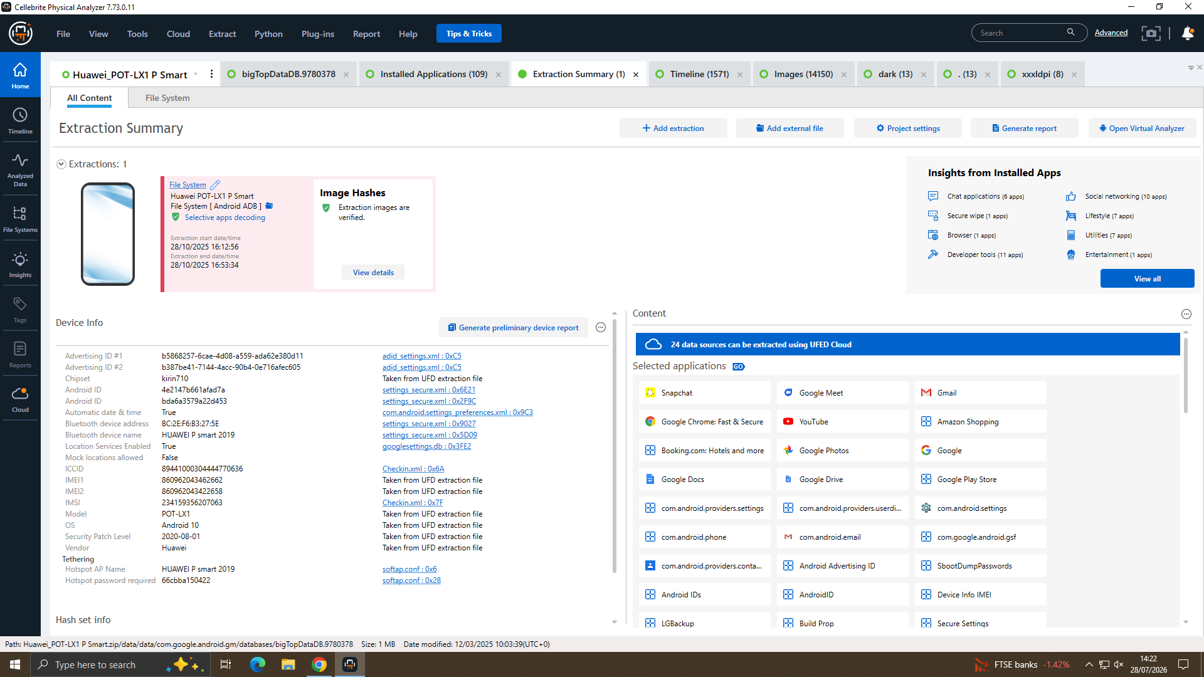
Exhibit D1 — Huawei POT-LX1 P Smart, full extraction summary, hashes verified.
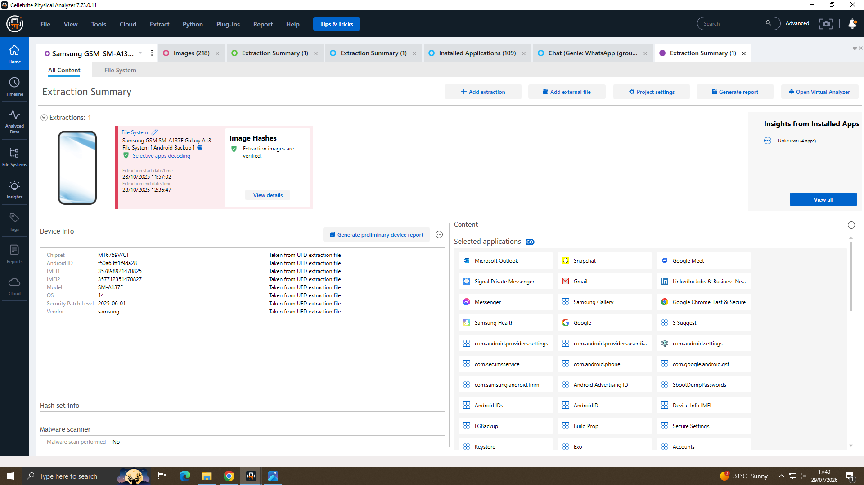
Exhibit D2 — Samsung SM-A137F Galaxy A13, full extraction summary, hashes verified.
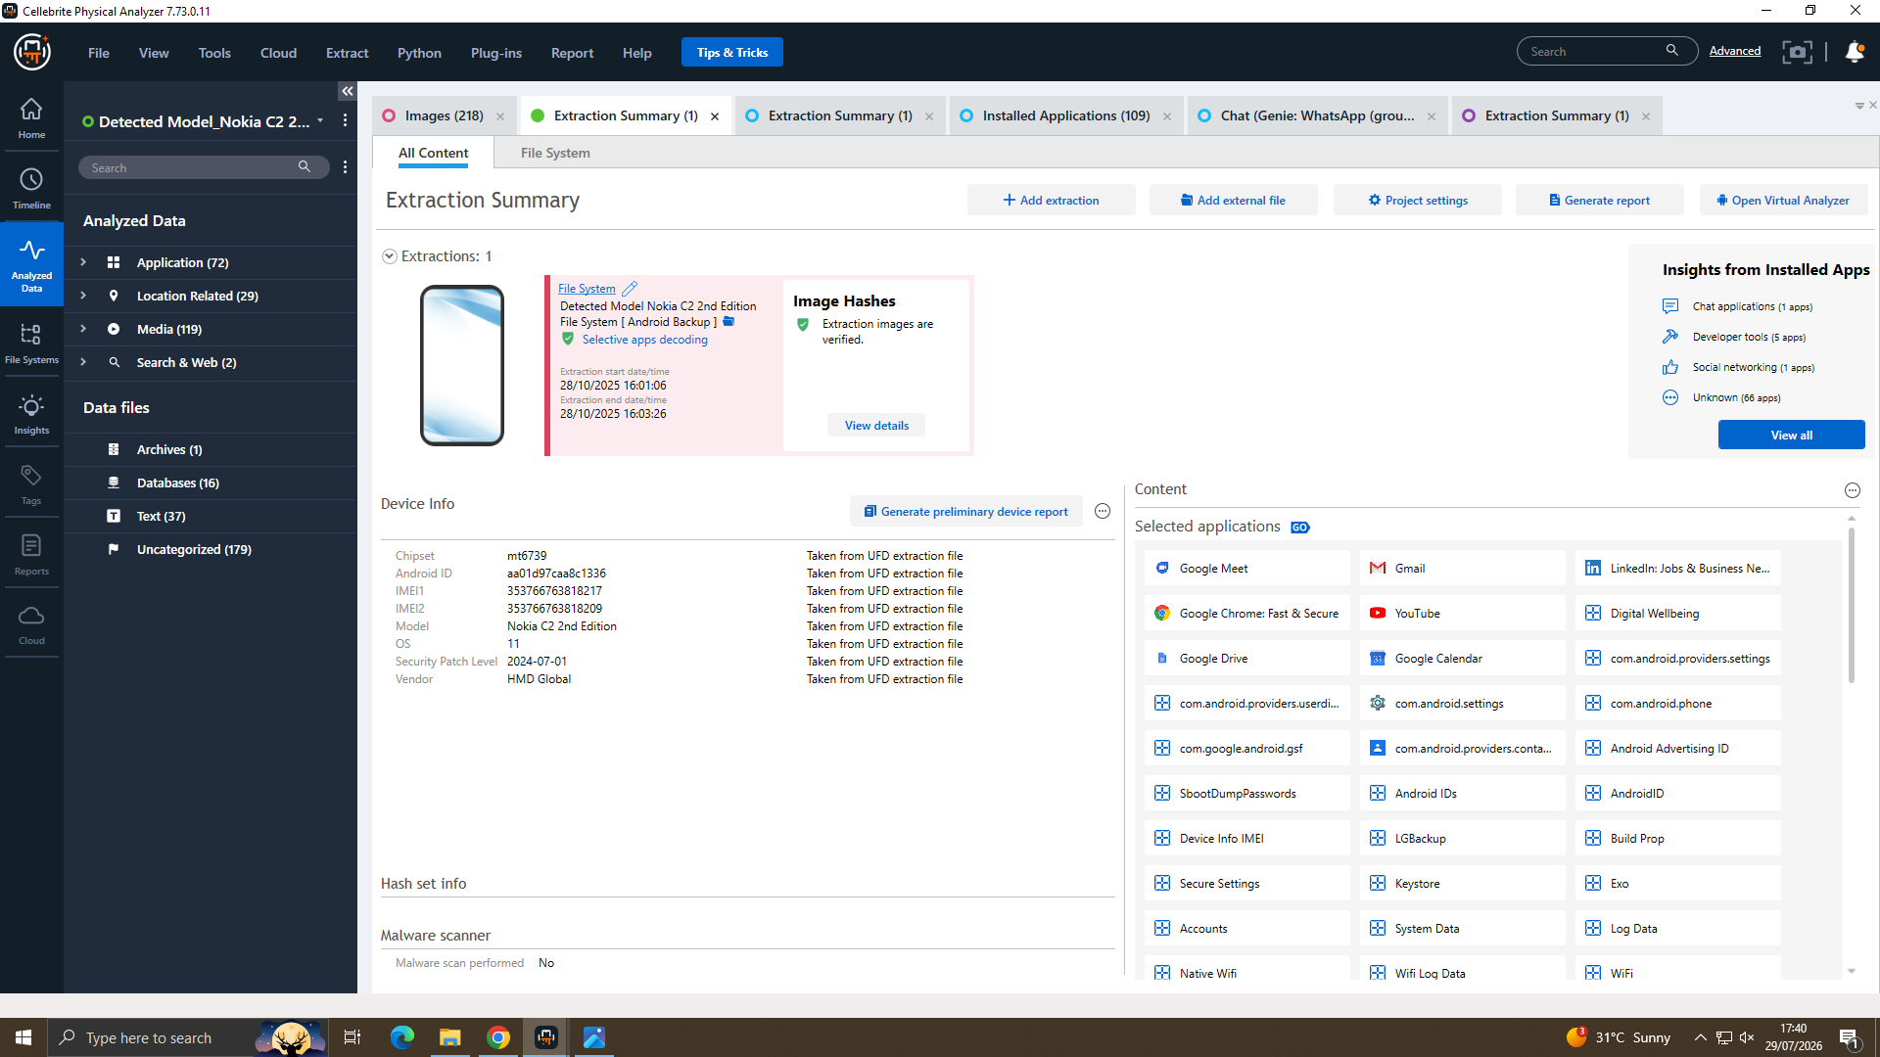
Exhibit D3 — Nokia C2 2nd Edition, full extraction summary, hashes verified.

Appendix C — WhatsApp Evidence, Huawei (Emma and Joe)
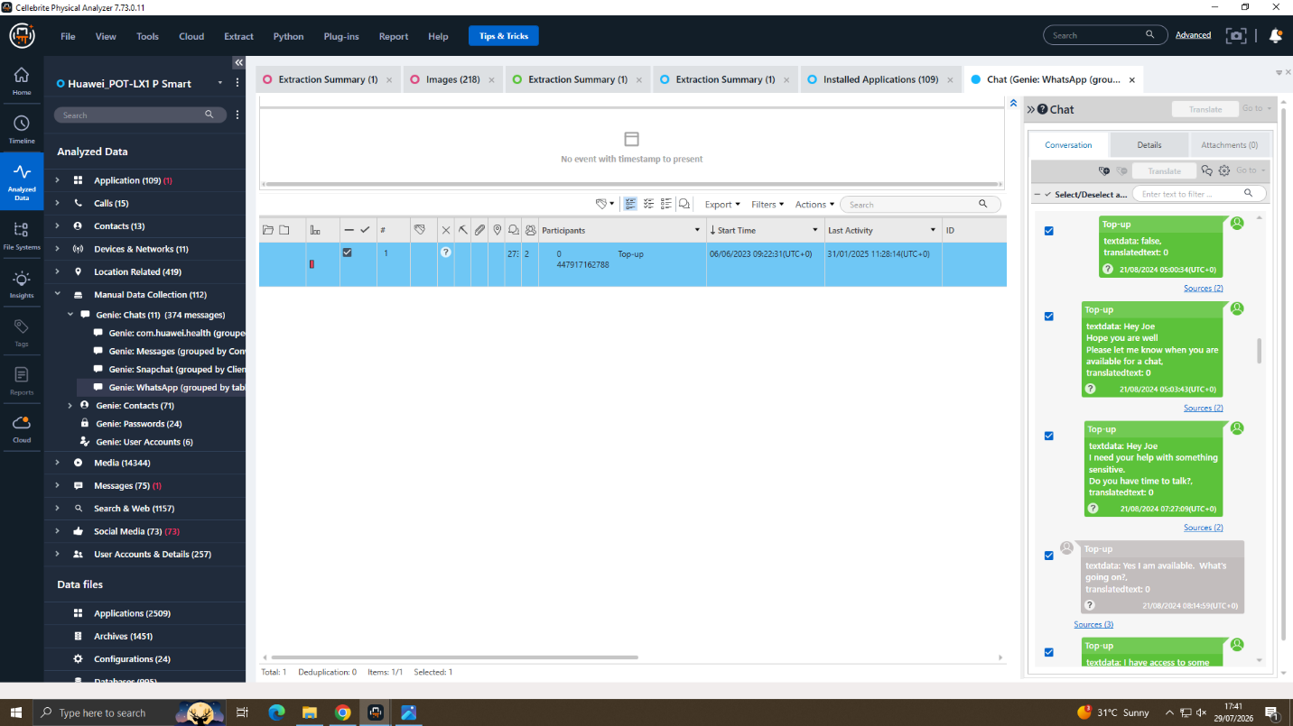
Exhibit A1 — 21/08/2024 — Emma opens contact with Joe.
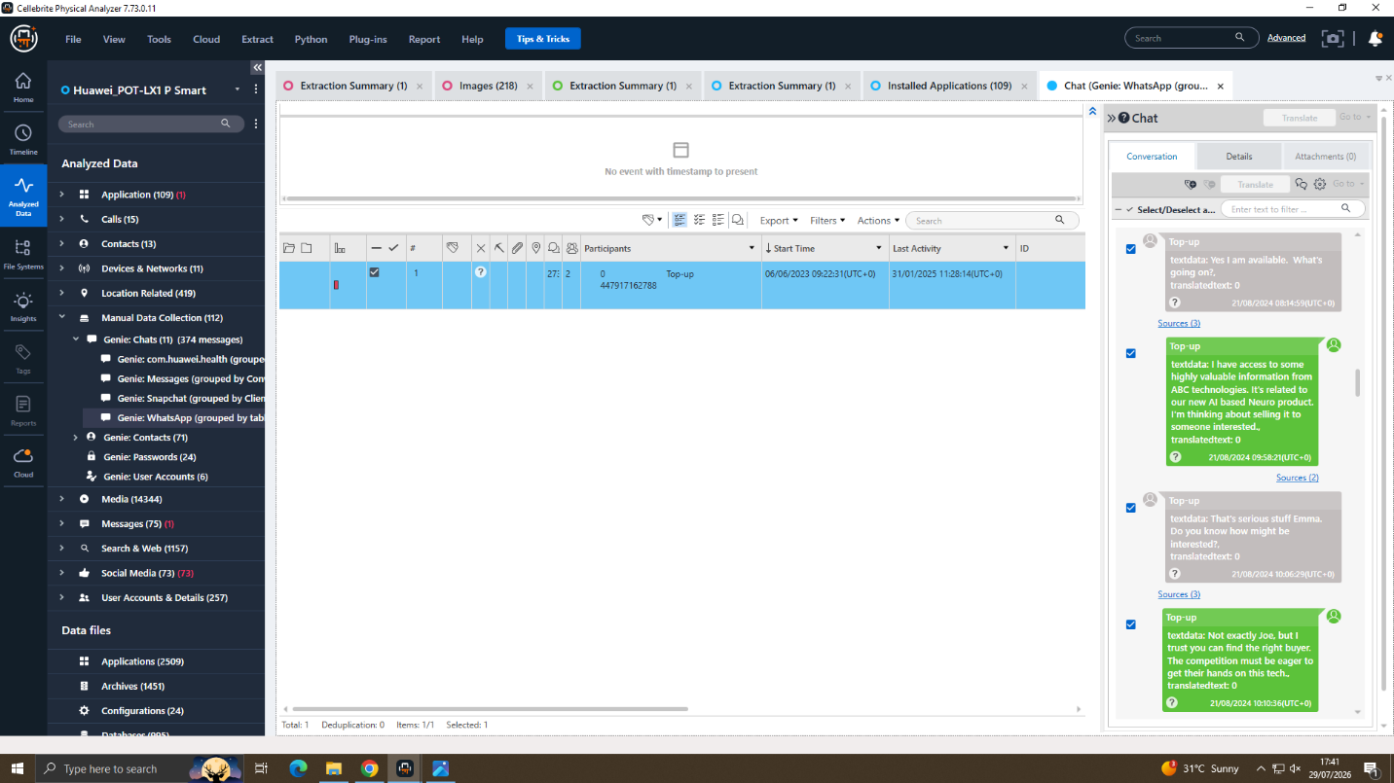
Exhibit A2 — 21/08/2024 — Emma names the Neuro product data.
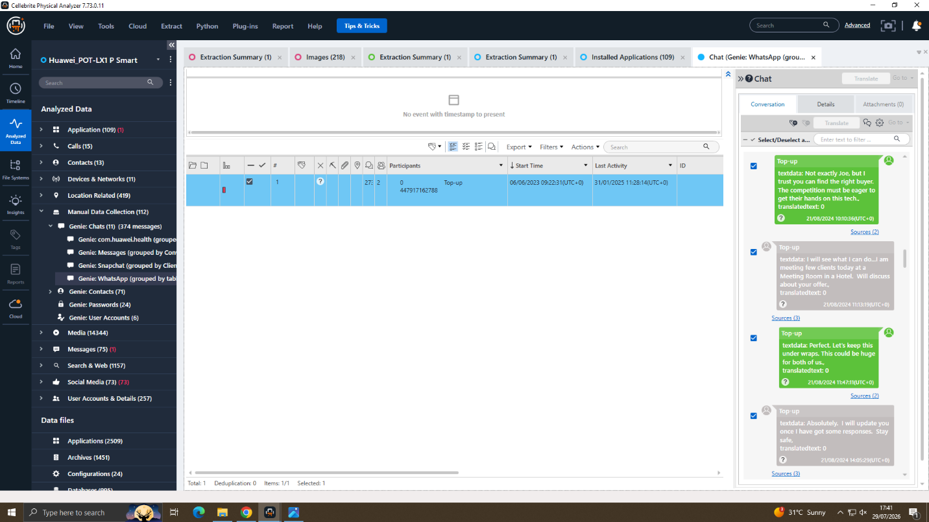
Exhibit A3 — 21/08/2024 — Joe agrees to raise the offer at a hotel.
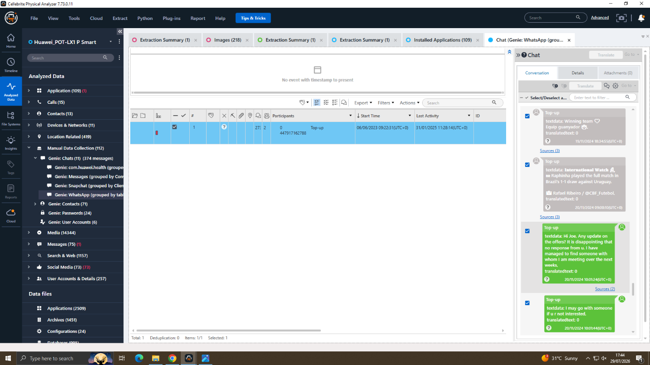
Exhibit A4 — 20/11/2024 — Emma chases Joe for an update.
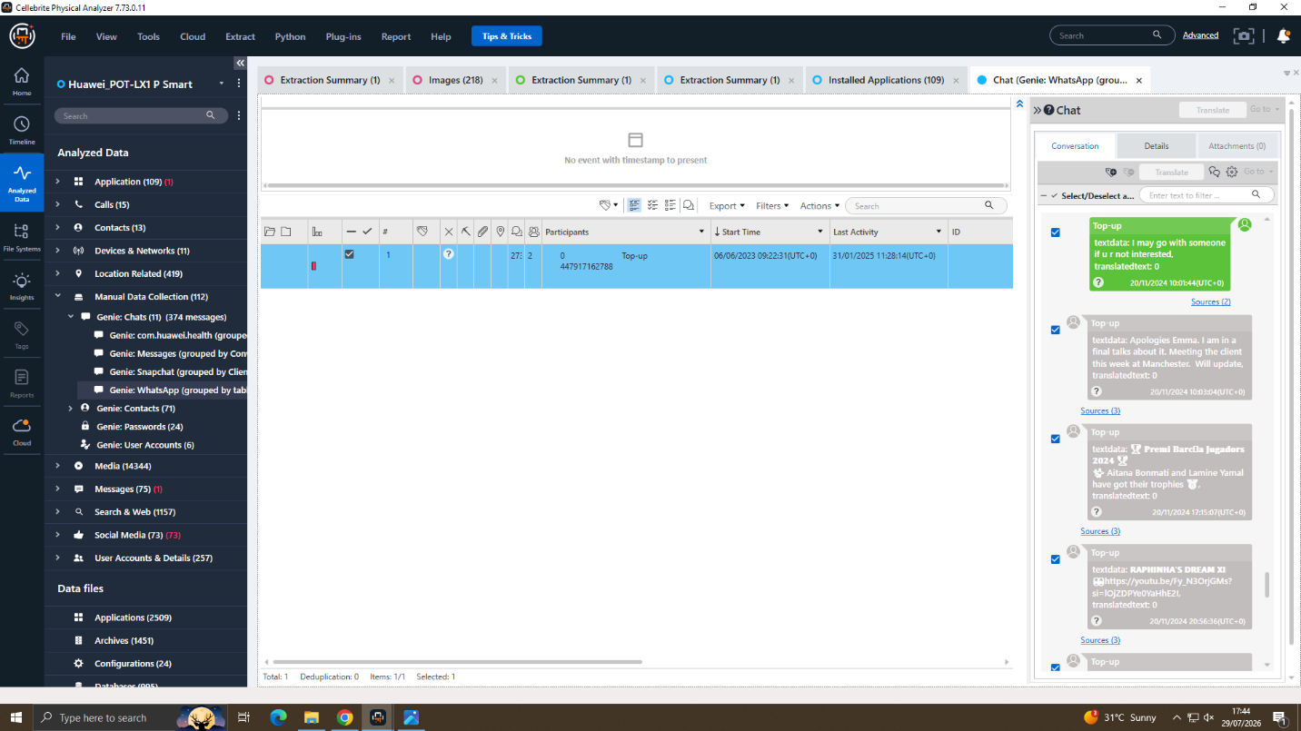
Exhibit A5 — 20/11/2024 — Joe says he is meeting the client in Manchester.
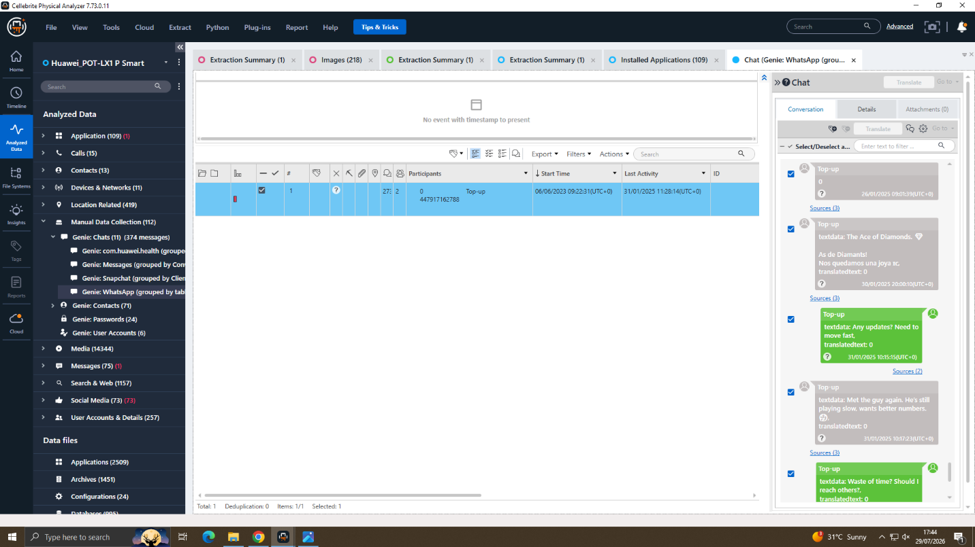
Exhibit A6 — 31/01/2025 — Emma pushes for an update; buyer is slow but serious.
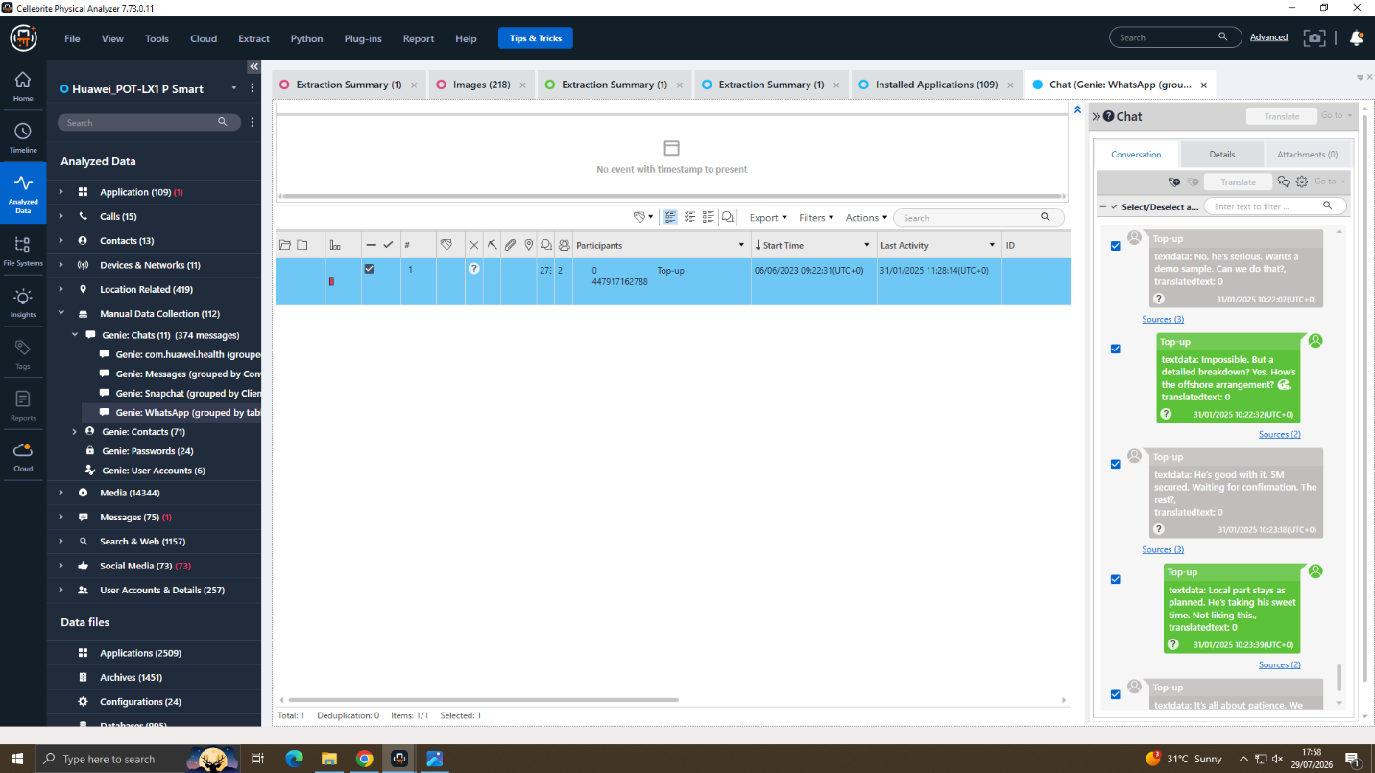
Exhibit A7 — 31/01/2025 — Demo sample request; offshore arrangement discussed.
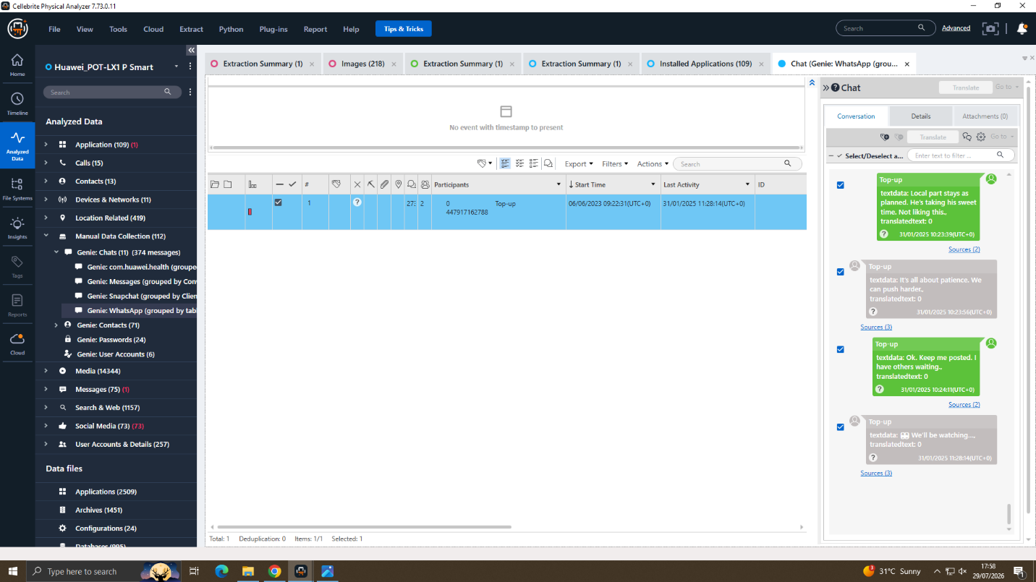
Exhibit A8 — 31/01/2025 — 5M secured; both agree to keep pushing.

Appendix D — Facebook Evidence, Huawei ("Peter Dover" and Norman Smith)
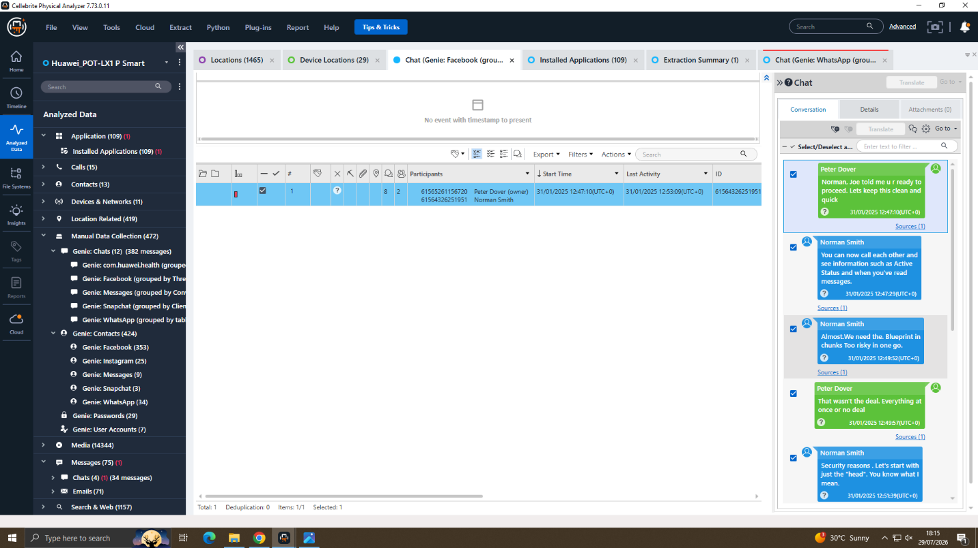
Exhibit A9 — 31/01/2025 — "Peter Dover" opens contact with Norman Smith.
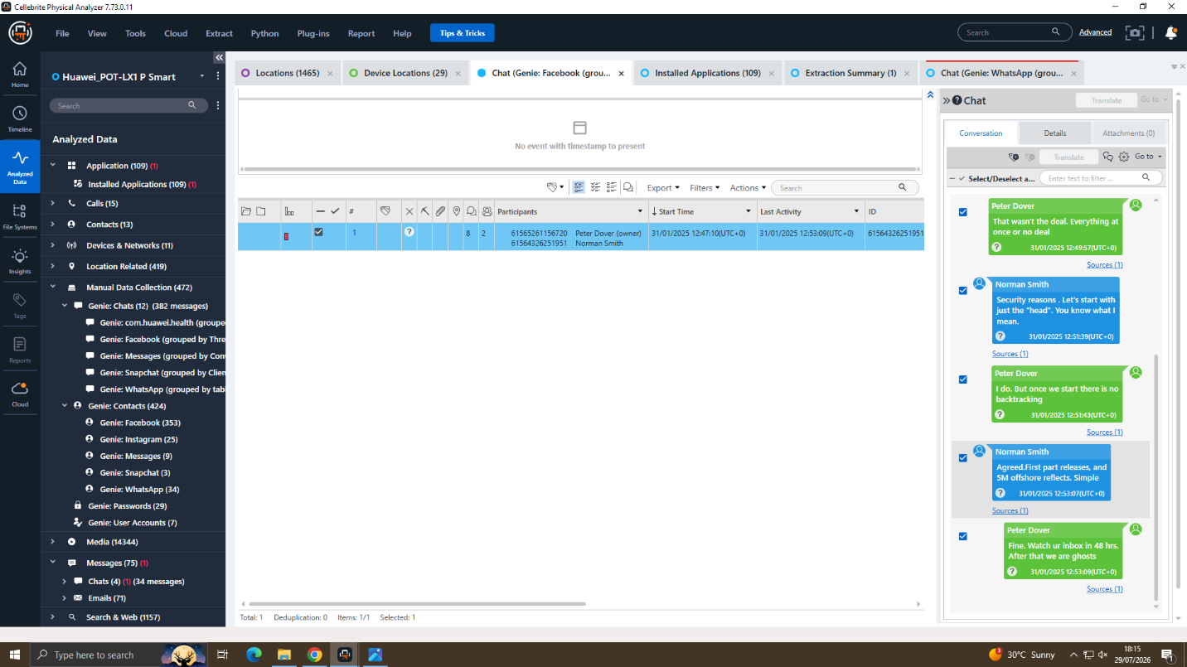
Exhibit A10 — 31/01/2025 — Staged "Blueprint" release agreed for 5M offshore.

Appendix E — Photographs, EXIF and Location Evidence
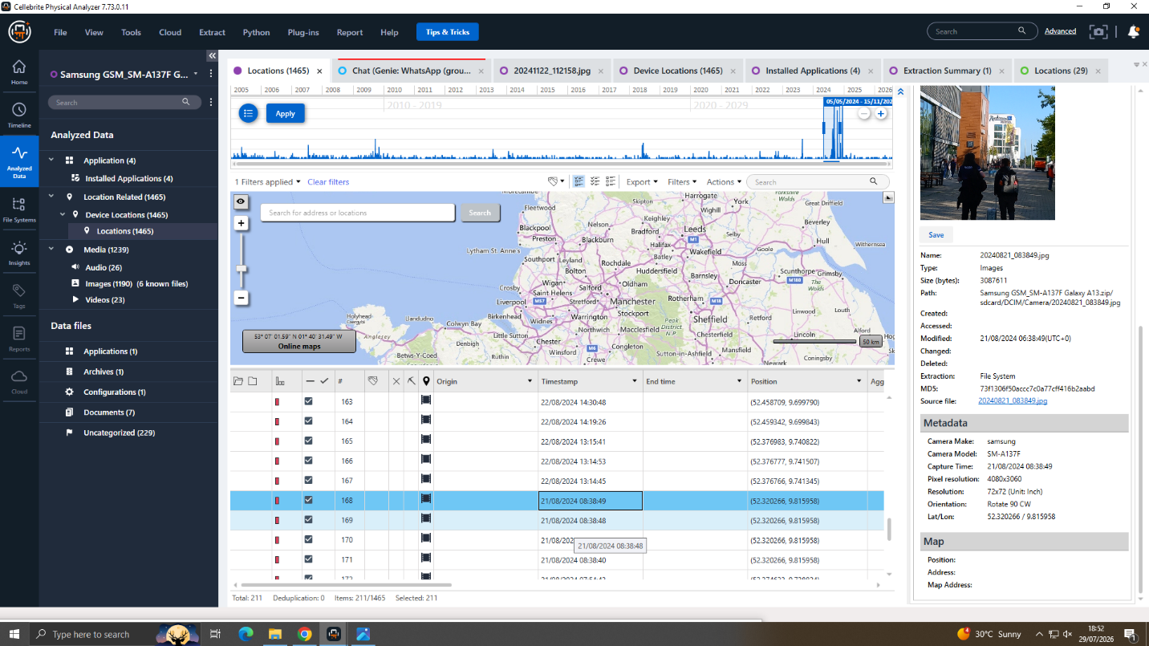
Exhibit B1 — 21/08/2024 — Geotagged photo matching Joe's hotel meeting claim (Samsung).
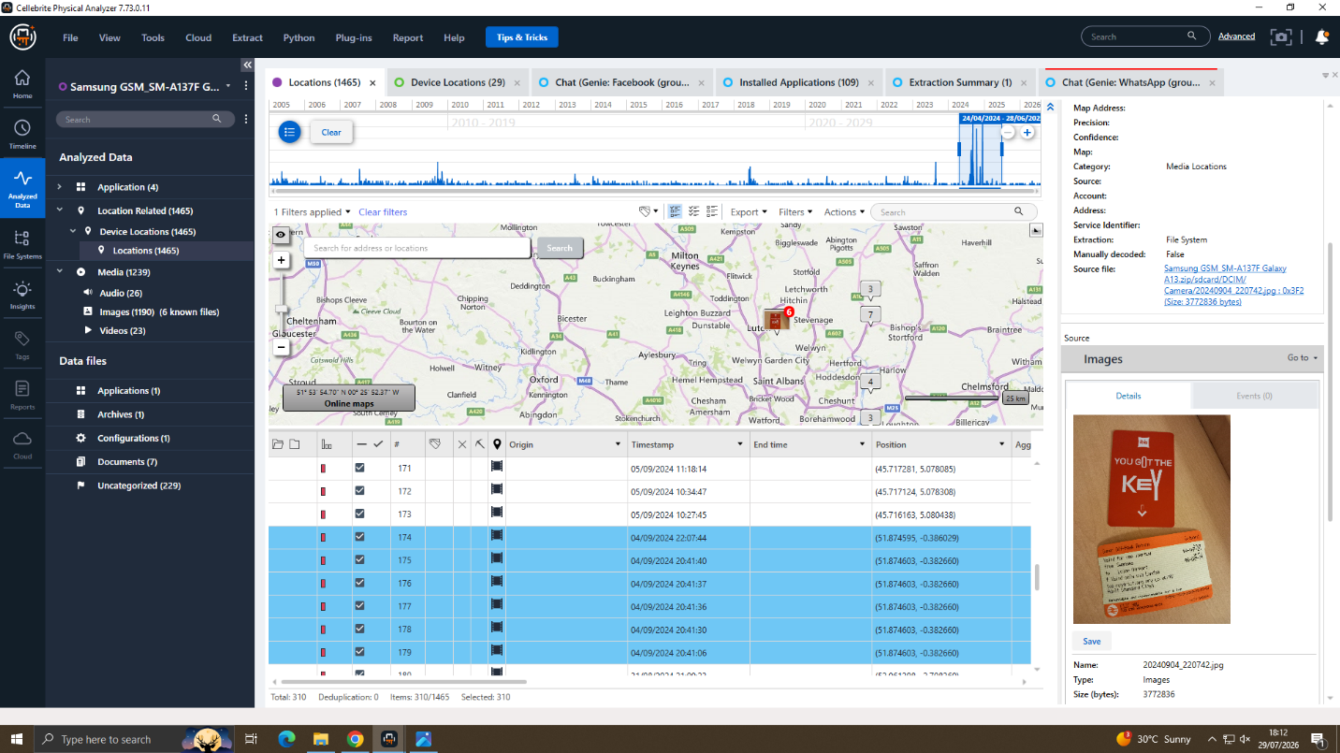
Exhibit B3 — 04/09/2024 — Hotel key-card photo (Samsung).
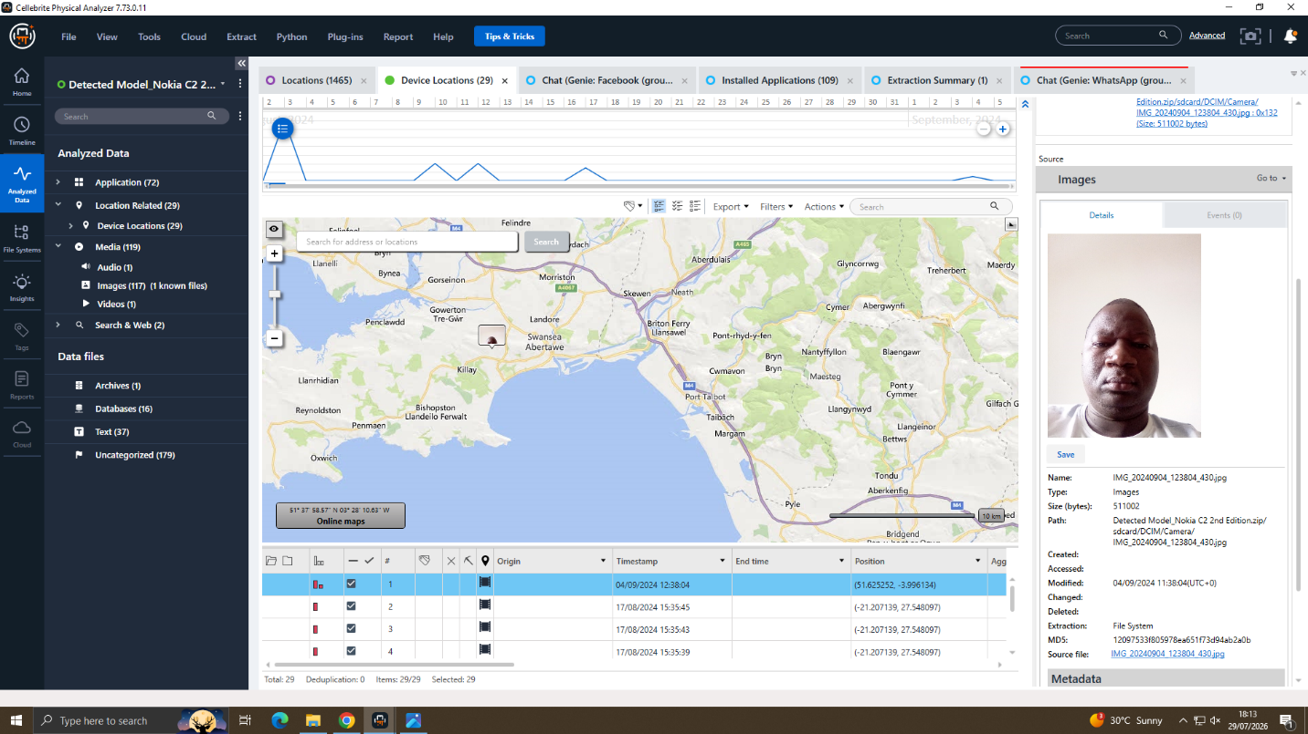
Exhibit C1 — 04/09/2024 — Personal photo geolocated near Swansea (Nokia).

Appendix F — Travel Evidence
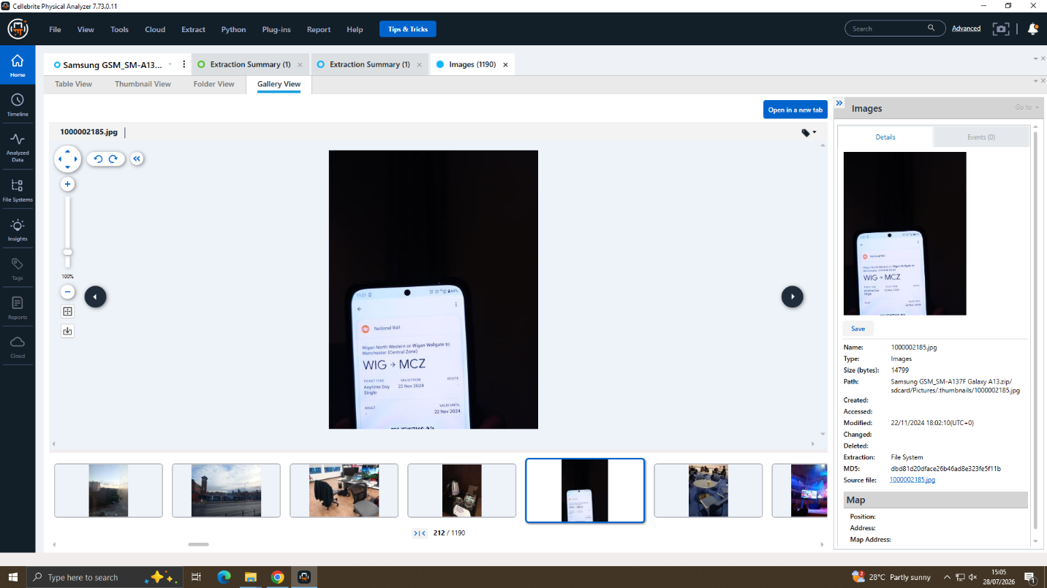
Exhibit B2 — 22/11/2024 — National Rail ticket, Wigan to Manchester (Samsung).
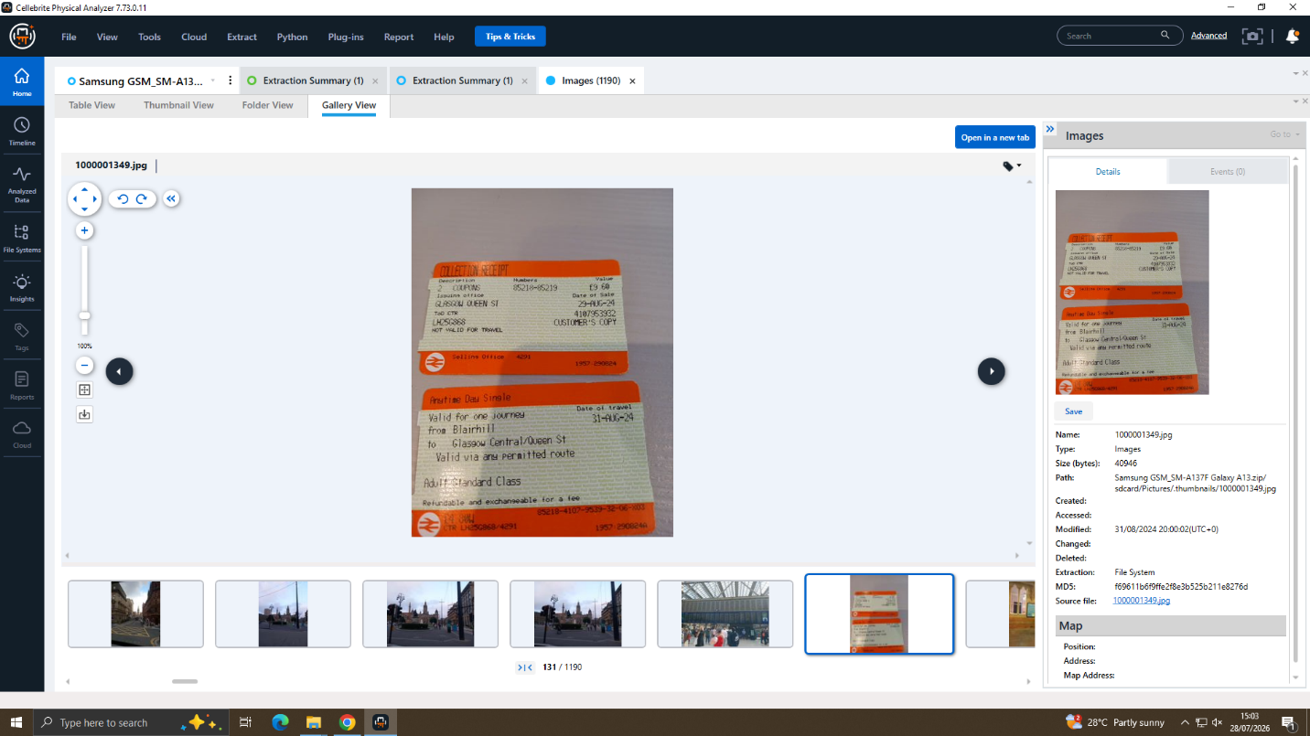
Exhibit B4 — Additional travel ticket recovered from the same device (Samsung).

Appendix G — Timeline / Correlation Evidence
Correlation is demonstrated through the timeline and cross-referenced exhibits in Sections 5–7.

Appendix H — Evidence Acquisition Workflow (Cellebrite UFED)
Full, uncropped screenshots of the acquisition workflow referenced in Section 4.1, showing the case-creation, device-detection and extraction steps performed in Cellebrite UFED.
Exhibit E1 — New case creation: examiner, device reference, crime type, department and location.
Exhibit E2 — Choose Action: Auto Detect selected.
Exhibit E3 — Detect Device: handset identified and profile suggested.
Exhibit E4 — Select Extraction Location: local drive destination chosen.
Exhibit E5 — Extraction in progress.
Exhibit E6 — Extraction completed successfully; source and target confirmed.
PART C — PRACTICAL DEMONSTRATION
This section sets out what can be demonstrated practically from the evidence and documentation already produced in Parts A and B.
- Acquisition/extraction: each phone was extracted with Cellebrite Physical Analyzer; the extraction summaries in Appendix B show the process and the hash verification result for each device.
- Tool use: Cellebrite Physical Analyzer (v7.73.0.11) was used to browse WhatsApp and Facebook conversations in full-conversation view, and to review the photo library with embedded metadata.
- Locating artefacts: relevant messages and photos were located by searching each device's chat and media sections directly within the tool, filtering by date where the case briefing indicated a relevant period.
- Timestamp and metadata examination: photo capture and modified times, and GPS coordinates, were read from EXIF data displayed by Cellebrite and cross-checked against dates mentioned in chat messages.
- Hash verification: verified automatically by Cellebrite at acquisition; results are shown in the extraction summaries in Appendix B.
- Cross-device correlation: dates, figures and locations from the Huawei, Samsung and Nokia extractions were compared directly against one another, as set out in Sections 5 and 6.
- Reaching the findings: each finding in Section 5 follows the evidence-analysis-finding structure, so the reasoning from exhibit to conclusion is traceable.
- Limitations: limited call-log data and the unconfirmed real-world identity of "Norman Smith" are set out in Section 11 and were not worked around or assumed away.
Prepared by: Aviral Tyagi, Digital Forensic Examiner

