Che-Si’s Report
Thomas Morris
Abstract
Focus on flaws in existing infrastructure, notably around unsecured wireless access points, recommendations for how to mitigate and general techniques to improve cyber security. Review of common threats currently in use. Recommendations for the future based on current best practices.
Introduction
Over the last 6 years we have seen the volume of internet traffic conducted on mobile devices nearly double, with 51.5% of all worldwide traffic being done on this medium in 2019. Looking back even further in 2009 this figure was a mere 0.7%, which illustrates the popularity and convenience mobile devices have become [1].
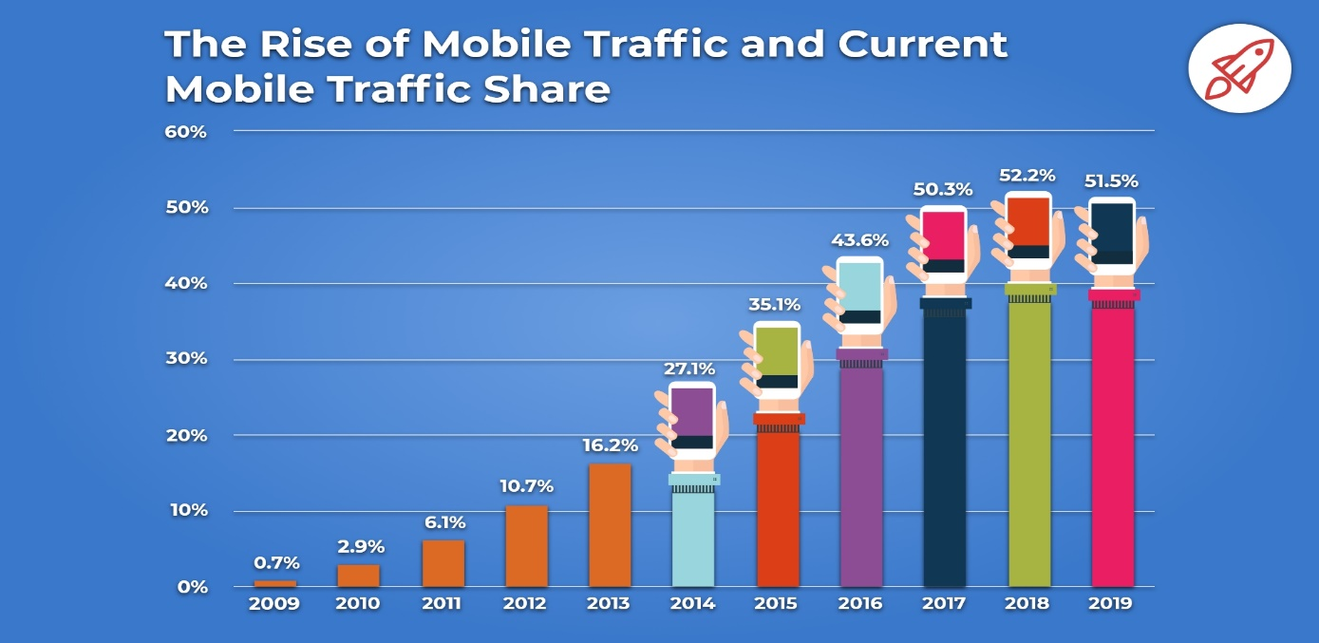
So, with this shift in how customers and staff engage with systems we must consider how network security could be at risk, and what can be done to protect against it.
As a business, network security should be a priority and something everyone is aware of as the impact of breaches and attacks could be damaging for multiple reasons. It could lead to business operations being interrupted, which may lead to a loss of business in the short and long term, which leads to financial loss. Data loss is another risk which can impact the company’s abilities to function and fines and legal issues are another strong possibility.
The modern world is becoming more digital with every passing day and companies need to react to ensure their technology is at the core of their services and not just an extension as it commonly has been in the past [2].
This report will focus on a current weakness in the company’s infrastructure, and lead to recommendations to how to mitigate it. Other possible flaws and weaknesses will also be considered, as-well as an overview of the types of networks and devices being used, and common attacks which could be faced.
We will also review the importance of policies, training, and strategies in tackling cybercrime, focusing on being proactive as much as possible.
Related Work / Review of Literature
Networks come in different shapes and sizes and depending on the combination of size and shape fall into different categories. The smallest being a Personal Area Network (PAN) which is commonly found in homes as it connects the homes personal devices through both wired and wireless method, allowing sharing of information and accessing of internet. Typically, these networks will use routers and personal devices such as phones, tablets, and computers.
A Local Area Network (LAN) extends on the PAN by incorporating more devices by the integrations of hubs and switches to create a larger connected network. The high speed and availability of connections allow staff to work from anywhere within the buildings. A LAN can be broken down into smaller sections called Virtual Local Area Networks (VLANs) which can provide added security by having unique restrictions and policies within them.
Your company is currently utilising a Wide Area Network (WAN) which is the integration of multiple LANs and MANs (Metropolitan Area Network). MANs are multiple LAN environments connected via fibre optic cables [3].
Personal mobile devices can connect easily into these networks directly via wireless connections or via approved connection methods such as a company website/customer portal.
With so many devices and locations, the ability to enter the network is increased and security needs to look at stopping unauthorised entry at any of these points or detect that entry if it is successful.
A common threat which your network could be susceptible to is piggybacking. We will explore this further throughout the report. Piggybacking is where attackers will join a wireless network without permission. One way is by making use of an unsecured wireless network.
This threat can easily be mitigated by securing the network, changing the SSID from the default setting and enabling authentication to join the network. The SSID can also be hidden meaning only those informed of its details will be able to find and access it. [4]
Even after the network is secured it can still be vulnerable if users are not protecting their own accounts. Passwords should not be repeated and should be complex, made up of numbers, letters, and characters, avoiding the use of dictionary words. Passwords can be cracked using methods such as brute force attacks where software is used trying every combination of characters so the more complex the password the harder it is to crack [5]. This principle applies also to the network passwords on wireless routers. A clear password policy should be in place and enforced for users to follow.
An extra layer to mitigate this threat is for users on personal device to use multi-factor authentication (MFA). This requires users to provide at least one other means of authentication on top of the username and password such as a pin number, a biometric scan (e.g., fingerprint or face), or an authenticator app on the user’s mobile phone [6].
It is still possible for these methods to be bypassed by use of phishing/vishing techniques to obtain personal information or loss of a mobile device that is not secured, so users need to make effort to ensure they are protecting their personal devices, and cautious of the personal information they disclose to others.
The FBI reported in 2017, as cited in the work of Carlton/Levy [7] that the compromise of business e-mail accounts and social engineering were two penetration vectors growing fast than any others.
Some of the common methods currently being used by hackers to crack passwords include dictionary attacks, where sophisticated software will attempt to crack using dictionary words before trying a brute force attack which uses more complex phrases.
Also common is the cracking of security questions, this is easier done by someone who knows you and the answers to your security questions, but this information is also shared by people via Social Media and hackers can identify the answers this way [8].
Design and Implementation
The current Che-Si infrastructure has unsecured wireless routers within the offices which provides a risk of unauthorised access from within the wireless routers range.
Staff, customers, and vendors all access the company’s infrastructure using user credentials but there is no multi factor authentication and no password policy enforced.
The following demonstration will focus on how an unauthorised device could access the infrastructure and data within it.
The below is a representation of the current office setup where staff are connecting to the servers via switches and a router. This router is wireless enabled so staff with remote devices like laptops can connect when onsite. The danger is though that users outside the office can also find the Wireless Router and connect to it.
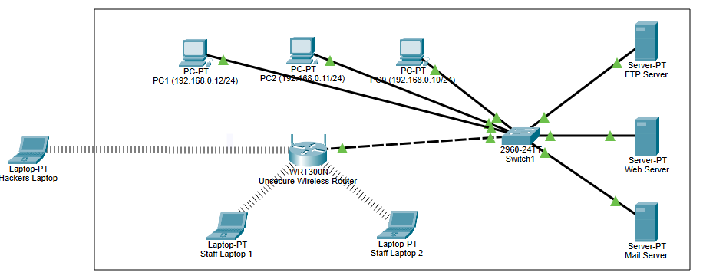
From here the hacker now has direct access to the network and can plan/perform attacks easily.
First thing we will do now is secure the wireless router.
- Change the SSID from the default name and disable the broadcast.
- Enable WPA2 Personal and assign a secure, complex passphrase.
This disconnects all the associated wireless devices.
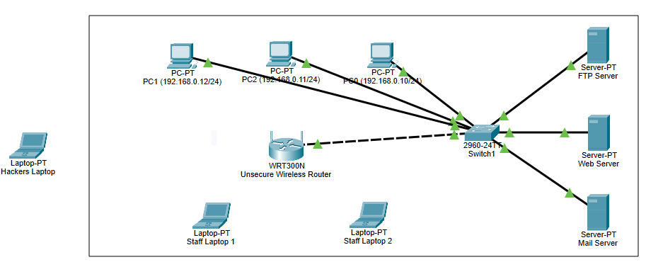
User will request/receive the connection details now.
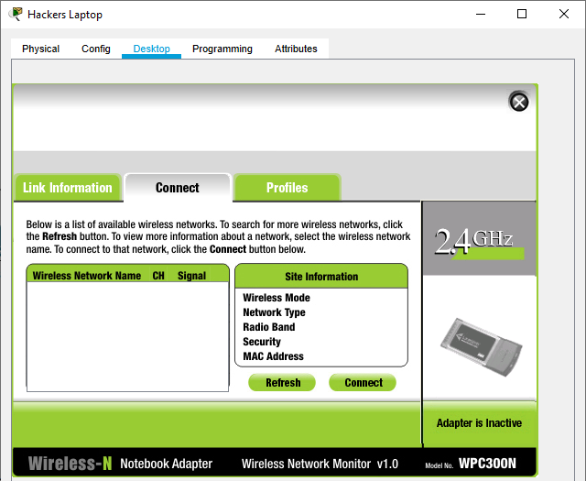
When the hacker now tried to connect to wireless networks there are no visible networks to choose from. Even if they know the SSID, without the passphrase they cannot get in.
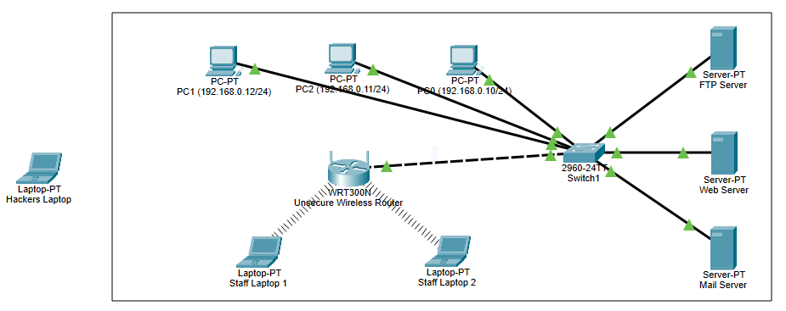
Mitigation Strategies and Recommendations
Policies allow an organisation of any size to work in a common and consistent way, they should be created and approved by the subject experts in the fields, so they reflect best practice [9].
To ensure policies are understood and utilised correctly it is important that staff are trained and/or tested on them, and for IT policies where the world is constantly developing this training should also evolve and be repeated on a regular basis to keep people aware of the latest threats and best practices. Page [10] says “your security policies are useless if your employees aren’t aware of them” which backs up that the training of these policies is as important as the creation of them.
The enforcement of policies is key too, for example ensuring a complexity requirement is defined and enforced when users set or change their passwords. The policy should set out exactly what is expected to make a valid password and will not allow users to set passwords which do not meet the complexity requirements.
Digital signatures can be thought of as an electronic version of our signatures. First though of by Whitfield Diffie and Martin Hellman, and established using RSA algorithms by Ronald Rivest, Adi Shamir, and Len Adleman. It gives the recipient a means of authenticating the data they are receiving, ensuring it is from who it says its from. Digital signatures are commonly found in secure e-mails and security protocols.
They provide us authentication, integrity, and non-repudiation. This means we can have assurance we know who has sent us data or a message, the information received is what was sent, and the sender cannot argue they did not send the information either [11].
They are necessary to ensure we have a secure means of transferring sensitive information across the internet, presuming the private keys remain secure.
Kaspersky [12] describe encryption as “conversion of data from a readable format into an encoded format that can only read after it’s been decrypted”. The three methods of data encryption are symmetric, which relies purely on a private key shared between recipient and host. Asymmetric which is what our digital signatures were using with two keys, a private and a public where the public is shared. The third is hashing which is a method of verifying data to ensure what is received is the same as what is sent, it confirms no tampering has occurred [13].
The following recommendations are proposed for implementation into the IT policies and working practices of Che Si.
- To address the issue of unauthorised access to wireless routers, the SSID should be changed from the default and made private, and a complex, secure key added using WPA2 protocol. This secure key should be changed on a regular basis as it will need to be distributed to personnel who require access to the wireless network.
- To address the issue of weak passwords on user accounts, a complexity requirement should be enforced when passwords are created or changed to ensure they are complex. Consider the passwords need to be a minimum of 8 characters in length, contain at least one uppercase letter, one lowercase letter, one numeric character and one special character. The password should not use dictionary words, contain any personal details or commonly known information about the user.
An expiration policy should be enforced, so the password must be changed every 60 days and a previous password cannot be re-used, and at least 4 characters need to differ from the previous password.
- Asymmetric digital signatures should be utilised when sending sensitive data across the networks to ensure the data is encrypted, and the recipient has assurance what is being received is safe, secure, and intended.
- All external access from staff, vendors and customers utilising personal devices must include multi factor authentication for additional authentication before access to the network is given.

Conclusion
The risk of having a global company means the threats are everywhere and can hit at any time, from anywhere. They cannot always be stopped but every effort should be made to make it as difficult for the attacker to gain access as possible. This can be done by both ensuring best practices are followed as-well as ensuring staff are vigilant, and aware of their actions all the time.
The company should ensure a dedicated cyber security team is implemented to monitor the network/infrastructure and identify suspicious activity as it occurs, this can be done with the aide of tools for network monitoring, web monitoring and packet sniffing.
The addition of ethical hackers to the organisation to do penetrative testing is beneficial to detect weak points and ensure they are addressed.
References
[1] Broadband Search, “Key Internet Statistics to Know in 2020 (Including Mobile),” 2020. [Online]. Available: https://www.broadbandsearch.net/blog/internet-statistics. [Accessed: Dec. 13, 2020]
[2] ConsolTech, “Network Security: What it is and Why it’s More important Than Ever,” consoltech.com, Aug. 23, 2018. [Online]. Available: https://consoltech.com/blog/why-network-security-is-more-important-than-ever. [Accessed: Dec. 13, 2020]
[3] Educba, “Types of Network | Introduction and Different Types of Network,” educba.com, 2019. [Online]. Available: https://www.educba.com/types-of-network. [Accessed: Dec. 13, 2020]
[4] EM360 Tech, “How can enterprises mitigate the threat of piggybacking?,” em360tech.com, Oct. 14, 2019. [Online]. Available: https://em360tech.com/continuity/tech-news/opinion-piece/piggybacking-enterprise/#:~:text=Piggybacking%20is%20quite%20a%20misleadingly%20pleasant%20word%20for,first.%20Imagine%20a%20corporate%20building%20with%20coded%20doors. [Accessed: Dec. 4, 2020].
[5] K. Martinelli, “Password Security Guidance,” highspeedtraining.co.uk, Apr.6, 2018. [Online]. Available: https://www.highspeedtraining.co.uk/hub/password-security-guidance. [Accessed: Dec. 15, 2020]
[6] onelogin, “What is Multi-Factor Authentication (MFA), and how does it work?”, onelogin.com [Online]. Available: https://www.onelogin.com/learn/what-is-mfa. [Accessed: Dec. 15, 2020]
[7] M. Carlton, Y.Levy, “Cybersecurity skills: Foundational theory and the cornerstone of advanced persistent threats (APTs) mitigation,” vol.5, no.2, pp.16–29, 2017, [Online]. Available: http://www.iiakm.org/ojakm/articles/2017/volume5_2/OJAKM_Volume5_2pp16-28.pdf. [Accessed Jan. 1, 2021].
[8] M. Singh, “15 Password Cracking Techniques Used By Hackers in 2020,” techviral.net, Dec. 20, 2020. [Online]. Available: https://techviral.net/top-password-cracking-techniques-used-by-hackers. [Accessed: 19-Dec-2020]
[9] T. Mochal, “Why does your IT organization need formal policies”, techrepublic.com, Feb. 2, 2006. [Online]. Available: https://www.techrepublic.com/article/why-does-your-it-organization-need-formal-policies. [Accessed Dec. 15, 2020]
[10] D. Page, “Employee Cyber Security Training: What You Should Do.” Securitymetrics, Aug. 30, 2016. [Online]. Available: https://www.securitymetrics.com/blog/employee-data-security-training-what-you-should-do. [Accessed: Dec. 15, 2020]
[11] J. Lake, “What are digital signatures and how do they work?,” comparitech.com, Mar. 28, 2019. [Online]. Available: https://www.comparitech.com/blog/information-security/digital-signatures. [Accessed: Dec. 15, 2020]
[12] Kapersky, “What is Data Encryption?,” usa.kapersky.com, 2018. [Online]. Available: https://usa.kaspersky.com/resource-center/definitions/encryption. [Accessed: Dec. 15, 2020]
[13] Simplelearn, “The Most Effective Data Encryption Techniques,” simplelearn.com, Dec. 21, 2020. [Online]. Available: https://www.simplilearn.com/data-encryption-methods-article. [Accessed: Dec. 15, 2020]

