

Programme Name: Master of Business Administration
Name and Code of the Module: LCMB7035 Dissertation
Title: The Role of Mobile App Usability in Shaping Customer Loyalty in Fashion E-Commerce Platforms in India
Supervisor’s Name: Jean Wang
Name and ID of the Student - Naitik Kantibhai Sheladiya 2430954
Word Count: 14989
Submission Date: 08/06/2026



Master’s Degrees by Examination and Dissertation
Declaration Form.

I, Naitik Kantibhai Sheladiya, declare that this dissertation has been composed by myself, that the work contained herein is entirely my own except where explicitly stated otherwise in the text, and that this work has not been submitted for any other degree or qualification, in whole or in part, except as specified.

Signature: ………………… Naitik Kantibhai Sheladiya.........................

Date: …………………08/06/2026……………............................

AI Use Acknowledgement
I hereby confirm that the research, drafting, writing, analysis, interpretation, and preparation of this dissertation have not been undertaken with the assistance of any Generative Artificial Intelligence (AI) tools. All literature searches, data analysis, academic writing, editing, and referencing activities were completed independently by me. As such, no AI-generated text, images, data analysis, or other outputs supported in any part of this submission.

Acknowledgements
I would like to thank my supervisor for guidance, feedback and support during this research. I also wish to express my gratitude to everyone who had answered the survey and for valuable contribution. Finally, I would like to thank my friends for their encouragement, patience and motivation for me to finish this research.

Abstract
The purpose of the research was to influence the usability of mobile app on customer loyalty in Indian fashion e-commerce industry. The research was influenced by the increasing trend of mobile commerce in India, while the need for fashion retailers to develop customer retention in a highly competitive digital environment. Further, the usability elements like interface design, navigation, personalisation and payment convenience are associated to customer behaviour, while usability issues can negatively affect customer engagement and loyalty. The research was based on Technology Acceptance Model (TAM) and Stimulus Organism Response (SOR) Model, which account for how perceptions of usability affect the behavioural outcomes. The methodology used was quantitative research, positivist philosophy and deductive approach. A questionnaire was developed while primary data was collected from 108 respondents who have experience of using Flipkart mobile app for buying fashion items. The data obtained were analysed with descriptive statistics, correlation analysis and regression analysis using SPSS. The Cronbach's Alpha value of the questionnaire was 0.921, which is excellent reliability. The findings showed that mobile app usability was positively correlated with the customer loyalty (r = 0.569, p = 0.000), while problems with usability negatively affected customer loyalty. Thus, the findings recommended that customer loyalty is a significant mediator to link usability with long-term retention and repeat purchase intention. From the research, it is recommended that fashion e-commerce firms need to optimise their navigation structure, develop personalised navigation features, make customer support more accessible, and constantly check usability performance by forming customer feedback systems. It is concluded that usability of mobile application is considered as a strategic one that affects customer loyalty and retention.

Abbreviations
AI: Artificial Intelligence
TAM: Technology Acceptance Model
SOR: Stimulus Organism Response
SPSS: Statistical Package for the Social Sciences
UI: User Interface
UX: User Experience

Glossary
Mobile App Usability: Extent to which users can effectively use a mobile application to achieve specific tasks
Customer Loyalty: A customer's promise to keep using, buying and promoting a specific platform or brand
Customer Retention: A measure of a company's capacity to retain its customers
Personalisation: Act of adapting the content, recommendations or services based on the user preferences and behaviour
Customer Experience: Overall impression and feeling that customers have from their experience with a platform or service

Table of Contents
Chapter 1: Introduction 13
1.1. Research Background 13
1.2. Research Rationale 15
1.2.1. Theoretical Justification 15
1.2.2. Practical Justification 17
1.3. Research Contribution and Motivation 18
1.4. Research Aim, Objectives, and Questions 19
1.6. Dissertation Structure 20
Chapter 2: Literature Review 21
2.1. Introduction 21
2.2. Thematic overview of Literature 21
2.2.1. Mobile app usability and customer loyalty 21
2.2.2 Different Mobile App Usability Features Affecting Loyalty 23
2.2.3. Challenges in Mobile App Usability 25
2.2.4. Mediating role of Customer experience and loyalty 26
2.3. Theoretical foundation and Contribution 28
2.4. Conceptual Framework 30
2.5 Research Hypothesis 32
2.6. Conclusion 33
Chapter 3: Methodology 34
3.1. Introduction 34
3.2. Research Philosophy, Approach, and Design 34
3.2.1. Research Philosophy 34
3.2.2. Research Approach 35
3.2.3. Research Strategy 36
3.3. Justification for Research Methodology 36
3.4. Sampling Strategy and Respondent Selection 37
3.4.1. Sampling Technique 37
3.4.2. Sample Size and Respondent Profile 37
3.4.3. Justification of Sampling 37
3.5 Data Collection Methods 38
3.5.1. Data Type 38
3.5.2. Questionnaire Design 38
3.5.3. Data Collection Process 39
3.6. Data Analysis Approach 39
3.6.1. Analytical Method 39
3.6.2. Interpretation 40
3.6.3. Reliability 40
3.7. Research Quality and Rigour 40
3.8. Ethical Considerations 40
3.9. Chapter Summary 41
Chapter 4: Results and Data Analysis 42
4.1 Introduction 42
4.2 Demographic analysis 42
4.3 Analysis 43
4.3.1 Mobile App Usability and Customer Loyalty 43
4.3.2 Customer Challenges in App Usability 48
4.3.3 Mediating Role of Customer Loyalty 52
4.3.4 App Design and Customer Retention Strategies 55
4.4 Statistical analysis 57
4.3.1 Correlation analysis 57
4.3.2 Hypothesis testing (using Regression Analysis) 58
4.5 Summary 59
Chapter 5: Discussion and Analysis 60
5.1. Purpose 60
5.2. Discussion with literature 60
5.2.1. Mobile App Usability and Customer Loyalty 60
5.2.2. Customer Challenges in App Usability 61
5.2.3. Mediating Role of Customer Loyalty 62
5.2.4. App Design and Customer Retention Strategies 63
5.3. Integration with theoretical framework 64
5.4. Robustness Considerations 65
5.5. Practical Synthesis 66
5.4. Summary 66
Chapter 6: Conclusions 67
6.1. Summary of key findings 67
6.2. Linking with Objectives 68
6.3. Recommendations 69
6.4. Theoretical and Managerial Implications 70
6.5. Limitations 71
6.6. Directions for Future research 71
Reference List 72
Appendices 84
Appendix 1 Survey Results 84
Appendix 2 Statistical results of all data 89
Appendix 3 Correlation Analysis 102
Appendix 4 Hypothesis Testing (using Regression Analysis) 103
Appendix 5: Survey Questionnaire 104

List of Figures
Figure 1: Indian fashion e-commerce market 12
Figure 2: Mobile has been the default for global commerce 24
Figure 3: Technology Acceptance Model 25
Figure 4: Stimulus Organism Response (SOR) Model 26
Figure 5: Conceptual Framework 28
Figure 6: Research Onion 30
Figure 7: Visually appealing interface 38
Figure 8: App loads and delay 39
Figure 9: Product search 40
Figure 10: Checkout and payment process 41
Figure 11: Personalised recommendations 41
Figure 12: Navigation issues 42
Figure 13: Technical glitches 43
Figure 14: Issues in product information 44
Figure 15: Tracking order issues 45
Figure 16: Preference of Mobile App 46
Figure 17: Preference of Flipkart App 47
Figure 18: Promotion of New discounts and recommendations 48
Figure 19: Flipkart’s customer support is easy to access 49
Figure 20: Customers recommend Flipkart to use 50
Figure 21: Customer’s interest to purchase products again from Flipkart 50
Figure 22: Customers spend time on Flipkart to explore products 51

Chapter 1: Introduction

1.1. Research Background
The Indian retail market has also experienced a significant change due to the rapid development of digital commerce and mobile technologies. According to IBEF, the Indian e-commerce market is valued at $125 billion in 2024, and it is predicted to exceed $145 billion in 2025, with projections reaching to $345 billion by 2030 (IBEF, 2025b). This expansion is largely enabled by rising internet penetration, a growing number of smartphone users, and the growth of digital payment systems. Further, India has emerged as one of the largest digital consumer markets, with over 270 million online shoppers, which underlines the scale and significance of the sector (IBEF, 2025b).
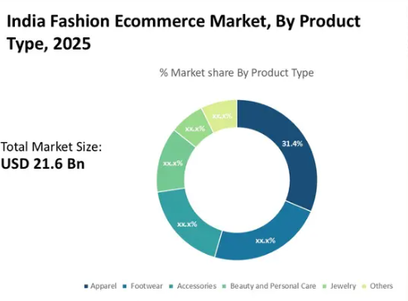

Figure 1: Indian fashion e-commerce market
(Source: Shevgan, 2025)
The fashion e-commerce segment is among the fastest-growing industries within this broader industry. The Indian fashion e-commerce market is estimated at around $21.6 billion and it is projected to increase at an average annual rate of 24.2% annual rate to reach $98 billion by 2032 (Shevgan, 2025). Besides, the apparel industry is estimated to reach around $120 billion by 2025 due to changing customer preferences and the rising popularity of branded products (Unicommerce, 2025). Thus, fashion e-commerce shows a competitive and dynamic industry, where digital platforms play a key role.
Mobile commerce has gained a leading platform for online shopping. Mobile applications offer higher conversion and engagement rates in contrast to traditional web platforms, as they offer a convenient and personalised shopping experience (Srivastva, 2024). This trend is pronounced in India, where the ‘digital economy is mobile first’. It is reported that there are approximately 800 million smartphone users in the country, where mobile-led digital activity is one of the driving economic agents (Times of India, 2025). Further, mobile commerce pays a major share of e-commerce transactions and technologies like the UPI, which has enabled 20 billion transactions in 2025 (IBEF, 2025a). Thus, mobile applications have been the main point of interaction between consumers and fashion brands.
Despite this rapid growth, the industry faces a major challenge in customer retention and engagement. E-commerce platforms exist in a competitive market where players like Myntra, Flipkart and Amazon always compete for market share (Wadhwa, 2024). Although these platforms are attractive to many users, it is hard to retain them. This is primarily due to the presence of substitutes and low switching costs for consumers. Thus, even minor usability issues may lead to customer dissatisfaction and switching platforms. Further, the mobile app usability has become a key determinant of customer behaviour. Usability can be defined as the ease of navigation, search and completion of transactions by the users within an application (Hamid et al. 2022). In fashion e-commerce, it becomes imperative, as purchasing decisions include product comparison, personalised references and visual exploration (Marwan, Harkim and Sugiharto, 2024). Moreover, many applications continue to be challenged by problems like low loading speed, complex navigation, and unstable operation across devices.
Moreover, the significance of the problem is rising due to the evolving consumer demands. The number of e-commerce users is likely to be around 400-450 million in India by 2027, which means that the future market will be highly competitive (Sheth et al. 2022). In case, younger consumers who constitute a significant segment of the population relish smooth and customised digital experiences. Thus, it is important that companies should not just aim to acquire users but also retain them by improving their usability. Despite the significance of usability, there is still no such clarity in the direct and indirect influence of usability on customer loyalty, mainly in the Indian fashion e-commerce scenario. The majority of existing research is on general e-commerce platforms or other industries, but limited research examines fashion applications where interaction among users is complex and visually driven. Thus, the research analyses the impact of mobile app usability on determining customer loyalty in Indian fashion e-commerce platforms. It addresses a critical gap by linking usability, customer experience and loyalty within a developing market context.

1.2. Research Rationale

1.2.1. Theoretical Justification
The existing literature offers a strong theoretical framework for understanding the relationship between mobile application usability and customer loyalty. One of the widely applied frameworks is the Technology Acceptance Model (TAM), which explains user behaviour in terms of perceived usefulness and ease of use (Musa et al. 2024). These constructs make a huge difference in user engagement and continued usage behaviour, which forms the foundation of customer loyalty in mobile environments (Malik, Abdullah and Fakhrorazi, 2025). The research findings validated that the perceived usefulness and ease of use have a major effect on behavioural intention and loyalty outcomes, which shows that usability is a key factor of customer retention. Further, the research on mobile applications revealed that usability is not just a matter of technical efficiency, but also of psychological and experience aspects like user satisfaction and interaction quality (Lu, Qu and Chen, 2025). Besides, the Stimulus Organism Response (SOR) model offers a balancing view that interprets how external stimuli like app design, navigation and system performance affect internal states like satisfaction and emotions, which in turn lead to behavioural responses like loyalty. Apart from that, customer loyalty is closely linked with loyalty outcomes in digital service environments (Ho et al. 2025). Moreover, usability is a key factor in customer experience and purchase intention, while there is a high correlation between usability and behavioural results (r = 0.68 experience, and r = 0.62 purchase intention) in retail and mobile commerce settings (Swati and Tiwari, 2025). Thus, it is clearly defined that customer loyalty is formed by usability, satisfaction, and perceived value and it is well supported by theoretical models, such as TAM and SOR.
Despite these theoretical developments, certain aspects remain unclear that need to be explored further. At first, most of the literature focuses primarily on technology adoption, instead of long-term loyalty. Although TAM analyses initial acceptance, it does not address sustained engagement and repeat behaviour. Previous studies on mobile services have focused on adoption behaviour, with limited emphasis on post-adoption behaviour like loyalty and retention (Ho et al. 2025). Besides, the conceptualisation and measurement of usability of mobile apps are inconsistent. Usability is a multi-dimensional concept, which includes interface design, efficiency, cognitive load, and system performance, but these dimensions are usually researched instead of an integrated framework (Weichbroth, 2025a). Besides, the empirical findings across certain contexts are not always reliable. In particular, it is evidenced that usability is directly related to loyalty, whereas others believe that this is mediated by satisfaction, trust, and engagement. Factors like trust and perceived security are important in the relationship between loyalty and usability, which implies that the usability factor may not explain the customer behaviour (Bajwa et al. 2025). In addition, the majority of studies have been done in areas like mobile banking, fintech, and payment systems, which are not similar to fashion e-commerce. Fashion websites include visual exploration, hedonic shopping, and customised browsing that need an alternative theoretical approach (Boardman and McCormick, 2021). Unlike geographic limitations, there are also limitations in that most studies are related to a single country context or developed markets, which limits the applicability to emerging economies, such as India.
From the discussion, a clear research gap can be identified. Although prior studies have validated that usability, satisfaction and trust affect customer loyalty, there is limited understanding of how variables interact with the particular context of Indian fashion e-commerce mobile apps. The existing models, such as TAM and SOR models, explain the adoption and behavioural responses, but do not capture the complexity of multi-dimensional usability features and their combined effect on long-term loyalty. Further, the lack of integrated frameworks that link usability, customer experience, and contextual factors limits theoretical development. The existing usability studies are still fragmented and need additional empirical validation to develop logical models (Weichbroth, 2025b). Besides, it can be underlined that the need to shift from initial usage to retention and long-term involvement, especially in highly competitive digital markets where switching behaviour is high (Malik, Abdullah and Fakhrorazi, 2025). Further, there is limited research in the Indian context, despite rapid digital growth and unique consumer behaviour patterns. This lack of contextual evidence limits the generalisation of existing theories and limits their applicability. Thus, the gap identified lies in the combination of the usability factors, mediating aspects of customer experience, and contextual factors in a single framework, i.e., Indian fashion e-commerce platforms.

1.2.2. Practical Justification
This research is significant in terms of practical and managerial aspects, particularly in the fast-changing Indian digital commerce environment. The current market is highly competitive and technology-driven, where customer experience is a major source of competitive advantage to organisations. From a McKinsey report, India’s e-commerce share in total retail is projected to increase from 6-11% by 2030, which shows a shift towards digital channels (McKinsey, 2026). This growth creates intense competition between platforms, as companies should distinguish themselves not just using pricing and products but through digital experience and usability. Further, mobile applications have become key to business strategy. It is further identified that mobile applications are currently determining the customer interaction and operational efficiencies and companies can no longer afford to view creation of apps solely as a technical process (Dhruv and Pawar, 2026). Rather, usability has to be correlated with business objectives, customer expectations, and long-term retention strategies. This highlights a key managerial challenge, as firms invest a lot of money in acquiring users on board but fail to retain them due to poor app experience.
However, the scale of mobile usage exacerbates this issue. The global mobile app downloads will exceed 300 billion in 2025, with rising markets like India offering a significant portion of this growth (Singh, 2025). Further, increased downloads do not ensure customer loyalty. Most users abandon apps soon after installing, which creates a major gap between acquisition and retention. Thus, companies face a critical issue of high customer churn and low lifetime value. Even shifting consumer expectations adds extra pressure to managers. It states that organisations should remove friction in the customer journey and offer seamless digital experiences to influence the purchase decisions (Schweide et al. 2022). This shows that even with insignificant usability issues, like slow loading or complex navigation, it can negatively affect customer loyalty and result in switching behaviour.
However, the cost of poor usability is high. Companies that do not maximise user experience can lose market share, lose customer interaction and miss long-term revenue growth. Meanwhile, firms that have invested in personalisation and usability-driven approaches have a higher chance of increasing retention and sustainable growth. Hence, the research offers practical relevance, as it addresses managerial issues that lack understanding of how the usability of mobile apps affects customer loyalty.

1.3. Research Contribution and Motivation
The rationale behind this research is the need to develop a holistic and contextual understanding of customer loyalty in mobile commerce, mainly in the Indian fashion e-commerce industry. From a theoretical aspect, this research refines the application of existing frameworks by linking experiential and behavioural aspects clearly. Although theories such as TAM explain user acceptance and SOR explain behavioural responses, they tend to be used independently. Mobile environments are complex, where the usability features interact with psychological and contextual factors simultaneously. Mobile apps require integrated usability and customised experience design to influence the loyalty outcomes (Lu, Quand Chen, 2025). Thus, the research contributes by linking the usability dimensions with behavioural outcomes using a structured framework and developing the explanatory power of existing theories without replicating conceptual discussions.
Further, the research offers an empirical contribution by focusing on actual user behaviour and measurable outcomes, instead of theoretical assumptions. The existing literature analyses that customer loyalty in mobile commerce is dependent on several interacting variables that include satisfaction, perceptions of risk, and perceived usefulness (Saibaba, 2025). However, most research examines these factors individually or within limited contexts. Consequently, the research examines combined effects within a specific setting, which can help to understand the user response to the mobile app environment effectively. Further, around 80% of users drop apps in 90 days after installation, which underlines the need to examine real behavioural results, rather than relying on intentions (Londoño-Giraldo, López-Ramírez and Vargas-Piedrahita, 2024). Hence, the research contributes to retention behaviour and user continuity that remains underexplored.
From a practical contribution, this research offers clear recommendations on improving the performance and retention strategies of mobile apps. Managers often face uncertainty in identifying usability factors that influence loyalty. Although the influence of convenience, security, and trust on user behaviour is not a new concept, it is not always apparent how they affect each other (Bajwa et al. 2025). Thus, the research offers insights that can support decision-making in areas like interface design, navigation efficiency, and personalised engagement strategies. This is critical in competitive markets where small usability developments can affect customer retention.
Moreover, the research offers originality, as it integrates mobile app usability, customer experience, and loyalty in an industry-specific and geographically focused study. Although prior studies have addressed these constructs individually, there is limited integration in the Indian fashion e-commerce environment. Thus, this research contributes by addressing a major gap, and offers a structured analysis that links theory with practical application.

1.4. Research Aim, Objectives, and Questions
Aim:
The research aim is to analyse the role of mobile app usability in shaping customer loyalty in fashion e-Commerce platforms in India.
Objectives:
- To investigate effects the mobile app usability that affects customer loyalty in fashion E-commerce platforms in India
- To identify the challenges faced by customers towards mobile app usability in shaping customer loyalty in fashion e-commerce platforms
- To establish whether customer loyalty will mediate the relation between app usability and the customer loyalty
- To provide evidence-based recommendations for app design and engagement tactics to boost retention and loyalty for Indian fashion apps
Research Questions:
- What is the relationship between mobile app usability and customer loyalty with fashion e-commerce sites in India?
- How do mobile app features such as interface design, notifications, personalised recommendations, and payment convenience drives customer loyalty on fashion e‑commerce apps in India?
- What usability challenges are faced by customers while using fashion e-commerce mobile apps in India that impact their loyalty?

1.6. Dissertation Structure
Chapter 1 includes the introduction part of the research, which includes the research background, motivation, aims, and objectives of the research. This is followed by chapter 2, which includes a literature review, where concepts such as mobile app usability, customer experience, and customer loyalty and theoretical frameworks are defined. Besides, chapter 3 describes research methodology, i.e., research design, data collection and methods of analysis, while chapter 4 provides results and the data analysis, and chapter 5 provides a discussion of the findings, which are organised based on the research objectives and conceptual framework. The conclusion and recommendations are offered in chapter 6, where major findings are summarised, and implications are discussed.

Chapter 2: Literature Review

2.1. Introduction
This literature discusses the major concepts around the issue of mobile app usability and customer loyalty in fashion e-commerce sites. The key purpose of this section is to review existing literature and identify how usability drives customer behaviour. It is found that usability, customer loyalty, and perceived usefulness have a close relationship with loyalty results (Saibaba, 2025). Hence, the review is focused on significant relations. At first, the concept of mobile app usability through interface design, navigation, speed, and personalisation has been reviewed. These factors matter, as they influence how effectively users interact with applications. Further, the review will examine how these usability features affect customer loyalty, such as repeat purchase behaviour and long-term engagement. However, the literature will examine the challenges faced by users, including technical and data security risks, and a lack of user experience, which may reduce the level of retention (Kumari and Das, 2025). Moreover, the role of customer experience between usability and loyalty will be studied. However, the literature will include theoretical frameworks, like TAM and SOR, to explain user behaviour. Thus, the section offers an organised insight into existing research, and identifies certain areas for further investigation.

2.2. Thematic overview of Literature

2.2.1. Mobile app usability and customer loyalty
Mobile app usability is the ease with which users can interact with an application to achieve tasks like browsing products, item selection, and making a payment. Usability includes the ease of navigation, interface clarity, responsiveness, and efficiency (Alzahrani and Alzahrani, 2025). These elements are effective, as they have a direct impact on user experience. In addition, usability is not just a technical attribute but also a key factor of customer behaviour in a digital context (Abbas et al., 2024). This is because usability directly shapes how easily users interact with a system, which influences their experience, satisfaction, and decision-making behaviour in digital environments.
However, certain studies confirm that usability has a positive relation with customer loyalty. For instance, user experience (UX) and user interface (UI) elements have a positive impact on user loyalty (Talmera, Wardhana and Ratnasari, 2025). Likewise, customised suggestions and user-friendly navigation would develop user engagement towards subsequent purchases (Cen and Zhao, 2024). Furthermore, Indian fashion e-commerce sites have better usability features that may retain customers for a longer time (Murthy et al., 2025). This is because better usability features like intuitive navigation, faster performance, and personalised recommendations improve user experience, which makes shopping easier and engaging, which encourages repeat usage and long-term retention. On the other hand, mobile shopping applications have experienced significant growth and it is found that customer loyalty in the fashion e-commerce market is considerably shaped by perceived usefulness, trust and attitude (Saibaba, 2026). It is also examined that repeat purchase behaviour, customer retention, engagement frequency and advocacy are considered key indicators of loyalty. It is further studied that Indian customers in e-commerce fashion consider easy navigation, visual appeal, user-friendly functionalities and clear layout while making online purchases (Murthy et al. 2025). This allows them to easily make decisions, which enhances their online shopping experience, enabling them to become loyal to the brand. Brands must understand the needs of customers to stimulate them to use mobile shopping applications. However, it is understood that behaviour loyalty of customers can be measured through repeat purchase intention and actual buying frequency. In addition, attitudinal loyalty, comprising resistance to switching alternatives and preferences, can measure behavioural loyalty of customers.
Further, usability also affects trust and perceived value, which are key drivers of loyalty. In a recent e-commerce study, trust and loyalty are found to be key factors that play a significant role in purchase behaviour and repeat behaviour (Anora, Muchayatin and Ginting, 2025). This implies that a user will be willing to trust the platform when they find an app reliable. Besides, mobile services found that perceived ease of use and usefulness are important factors in customer loyalty (Malik, Abdullah and Fakhrorazi, 2025). Thus, usability helps in building an emotional and functional link with users, which can help in retaining customers. It is also studied that customer retention, reflected in the intention for continuing to utilise the same app, is an essential dimension of loyalty in competitive e-commerce markets. However, usability also reduces user effort and develops efficiency. Higher usability reduces errors and search time, which allows users to find products and complete the transactions (Guo, Zhang and Xia, 2023). This efficiency develops loyalty and facilitates users to revisit the platform.
Besides, usability is essential in the fashion e-commerce sector because it includes interactive and visual decision-making. In addition, user engagement in mobile commerce settings, like time spent exploring products and frequency of app visits, can be considered as a strong predictor of loyalty. Before purchasing products, users need to navigate several choices, compare styles, and view images. Thus, the presence of Zoom, filter options, and personalised recommendations contributes to the shopping experience. Interactive and visualised interfaces also help to facilitate user engagement and decision-making (Alrefaei et al., 2023). This is because usability improves ease of interaction, but customer loyalty depends on multiple additional factors like trust, emotional link, perceived value, and competitive alternatives, which show that usability alone cannot fully ensure repeat behaviour. In contrast, it is found that usability could have a direct impact, such as mobile app usability and customer loyalty and an indirect impact on loyalty, which can be shown in terms of trust and data privacy (Bahar et al. 2024). This is because mobile app usability improves ease of use while data privacy builds trust. They directly influence loyalty by strengthening it indirectly through user confidence and commitment to the brand. Thus, usability should be considered with other variables to analyse the customer behaviour.

2.2.2 Different Mobile App Usability Features Affecting Loyalty
Usability defines how users interact with applications and determines if they can continue using the platform over time. At first, the interface design plays a key role in usability. The interface is clearly displayed and easy to understand for the user on how the app is structured. User experience design is a key factor in mobile applications, which increases loyalty and user engagement (Lu, Qu and Chen, 2025). The interface design is even more important in fashion e-commerce, where visual appeal holds importance. Further, the usability features include navigation and search functionality. The users expect to find the products without any kind of confusion. The research on mobile applications has revealed that ease of navigation is a strong predictor of customer retention, as it reduces customer effort and increases efficiency (Winata and Arma, 2025). Further, the products can be navigated with ease via powerful filters, categories, and search bars.
Further, there should be performance speed and responsiveness. Users may be irritated with sluggish loading applications that lead to abandonment. The mobile commerce research pointed out that the performance of apps has a major influence on users and spending behaviour (Al-Shamaileh and Sutcliffe, 2023). Hence, quick loading speed and fast transition increase customer loyalty and promote repeat usage. Even personalisation has been a key feature in modern e-commerce applications. The engagement and relevance are developed by offering personalised recommendations based on user behaviour. Personalised services could be used in creating closer relationships with customers, which increases loyalty (Ramesh and Padmaja, 2025). In fashion apps, personalised suggestions in terms of preferences and past searches make shopping enjoyable and convenient. However, the ease of navigation and the speed of performance are key predictors of customer retention (Huma et al., 2024). It analysed that easy navigation reduces search time and user effort, whereas fast performance ensures uninterrupted transactions that develop user loyalty and facilitate continued app usage.
However, usability and loyalty are also affected by security and privacy capabilities. It is found that the users are likely to trust apps that protect financial and personal data. Usability and data privacy are key factors that influence brand loyalty and customer retention when combined with one another (Bahar et al. 2024). Hence, it could be said that secure payment systems and data protection policies develop customer trust. Other than this, updates and feature improvements are imperative in developing usability. Applications that continuously update their operations align with user feedback and are likely to help in retaining customers. Sustained usability improvements would underline the level of user engagement and long-term loyalty (Ramesh and Padmaja, 2025). Customer loyalty in digital platforms is based on a set of usability, engagement approaches, and technological innovation (Pereira et al., 2025). Customer loyalty develops from continuous interaction and value creation, where usability ensures ease of use, while engagement builds emotional and behavioural connection. Besides, technological innovation improves personalisation and experience, which develops long-term relationships with users. Thus, usability features should be integrated to develop a smooth user experience. The authors also revealed that interface design, navigation, speed, personalisation, and security are the key features of usability that determine customer loyalty. These characteristics increase user experience, reduce effort and develop loyalty. It is considered crucial for business organisations to ensure that usability features are well integrated in order to engage customers with the brand, thereby gaining a loyal customer base.

2.2.3. Challenges in Mobile App Usability
As mobile app usability has been rated as a major consideration that contributes to customer loyalty, the concept of usability remains highly volatile and context-dependent in emerging markets like India. This is especially applicable to the Indian situation since the usability of mobile apps depends on the presence of varied user factors like varying levels of digital literacy, quality of devices and network infrastructure (Agrawal, Kumar and Singh, 2021). The Indian market also has a large number of users who do not have a history of using desktop systems and directly embrace smartphones, which makes the usability of a simple app design important. Further, the large difference in the devices and online connectivity offers a divergent user experience in different regions. However, usability issues appear at several levels, like design, system performance, and user cognition. Besides, interface design and information architecture have been the critical usability challenges. Poor content structuring and ineffective interface design can significantly reduce the usability rate because users cannot understand the flow of applications and their navigation (Weichbroth, 2025b). Further, it is relevant in fashion e-Commerce, where users interact with large product collections. For instance, when categories, filters, and layouts are not logically arranged, it leads to confusion for users, which increases the drop-off rates. Thus, the usability issues are not merely practical but cognitive because they raise mental efforts.
Further, the performance-related issues have been a key barrier to effective usability. Efficiency and system responsiveness are among the key usability factors that determine user perception (Li et al. 2022). Besides, most applications do not perform steadily because of excessive functionality, such as high-resolution pictures and recommendations. Based on mobile usability models’ performance, delays have a direct impact on perceived ease of use and efficiency of tasks (Wu, Xu and Abdinnour, 2021). As the small delays disrupt user experience during the checkout process, it negatively affects loyalty and conversion. Further, infrastructure and device-related challenges are significant in the Indian context. The differences in device quality, network conditions, and operating systems influence the process of mobile usability. It has been found that usability problems may be caused by hardware constraints like screen size, processing speed and memory capacity (Weichbroth, 2025b). Moreover, mobile spaces have smaller screens and interaction spaces that limit usability and information display. Thus, an app that performs well on high-end devices may not offer the same experience on low-cost smartphones, which leads to unequal usability experiences.
The other critical issue is the lack of continuous usability testing and adaptation. Despite the existence of usability testing frameworks, not all firms update their applications on a regular basis, depending on the feedback provided by the user. The existing research on usability is fragmented, and practice is frequently limited (Weichbroth, 2025b). This brings a divergence between theoretical usability principles and real-world application performance. However, it should be mentioned that these issues are unified, instead of being secluded. For instance, poor interface design leads to a higher cognitive load, while performance problems lead to user frustration (Faudzi et al. 2024). Thus, usability should be viewed as a system-level construct, instead of individual features. Thus, the literature points out that mobile apps' usability issues are multi-dimensional and include design complexity, performance limitations, device heterogeneity, and cognitive overload.

2.2.4. Mediating role of Customer experience and loyalty
Mobile app usability and customer loyalty do not have a direct relationship. Rather, the existing literature reveals the fact that customer experience and customer loyalty act as mediating variables. This shows that usability affects customer perceptions and emotion, which defines loyalty. Certain studies affirm that perceived ease of use and usefulness have a significant effect on customer loyalty. Mobile commerce research showed that the usability aspects of the system, efficiency and ease of navigation are statistically associated with user loyalty levels (Mangune, 2024). This confirms the fact that when a user finds an app simple and effective, they get to build positive experiences.
Moreover, there is a significant correlation between the usage of mobile apps and customer loyalty, which in turn affects repeat usage behaviour (Kamalia and Gomathi, 2025). It means that a user who likes the experience of using the app will use the platform more to make purchases. Hence, usability creates a foundation for loyalty. Further, this relationship is improved by the aspect of personalisation and engagement. The research by Siyal et al. (2024) indicated that customised features such as personalised recommendations are important in increasing behavioural intention and continued use of apps. Moreover, the loyalty program revealed that users who interact with personalised rewards and app features achieve higher retention and long-term loyalty (GSPANN, 2025). Thus, the improved user experience with personalisation leads to increased loyalty.
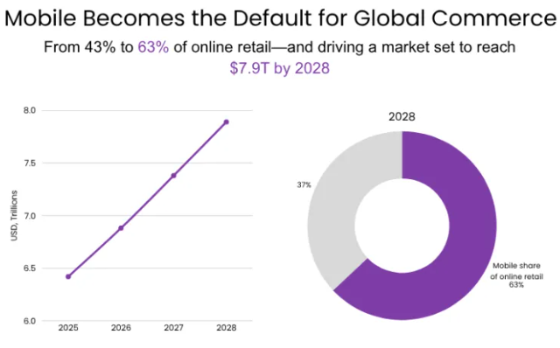

Figure 2: Mobile has been the default for global commerce
(Source: Puczyk, 2026)
It is found that mobile commerce is growing very fast, which supports the relevance of experience as a mediating variable. Mobile devices are the source of almost 80% of retail site visits and 66% of global orders (Puczyk, 2026). For instance, the mobile becomes the default for global commerce, from 43% to 63% of the online retail, which drives the market to reach $7.9 trillion by 2028. It shows that most users interact with brands through mobile apps. Thus, their experience in interactions becomes an important determinant of loyalty. When the experience is interesting, the users will be more likely to return. However, poor experiences may result in switching behaviour very easily. Other studies also believe that customer experience may not be enough to assure long-term loyalty. Determinants of mobile commerce loyalty, several factors including trust, engagement and perceived value play a role in determining loyalty (Saibaba, 2025). This shows that loyalty is not only important but it also interacts with other psychological factors in influencing the behaviour.
From the theoretical perspective, this mediating relationship could be described in terms of the Stimulus Organism Response (SOR) model (Hanafiah, Aminuddin and Mahdzar, 2023). Here, mobile app usability features serve as stimuli, customer experience and satisfaction as the organism and loyalty behaviour as the response. Thus, usability influences the perception of internal users, which leads to behavioural consequences. Overall, it is evident that customer experience and customer loyalty play a mediating role in the usability of mobile apps. Moreover, usability develops user perceptions, which leads to loyalty, while it ultimately drives repeat purchase and long-term involvement.

2.3. Theoretical foundation and Contribution
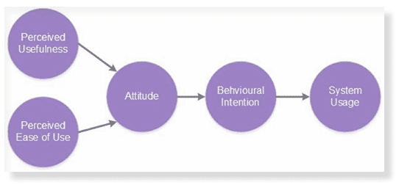

Figure 3: Technology Acceptance Model
(Source: Allen, 2020)
The literature has been based on two significant theoretical models, i.e., the Technology Acceptance Model (TAM) and the Stimulus Organism Response (SOR) Model. The theories are useful in explaining the impact of mobile app usability on customer loyalty in e-commerce platforms operating in the fashion industry. At first, the Technology Acceptance Model (TAM) is a popular model that can be developed to understand how users adopt and use digital technologies. TAM is one of the proven models that have been developed in technology studies, which has two central constructs, that is perceived usefulness and perceived ease of use (Musa et al., 2024). Besides, perceived usefulness is the degree to which a user feels that the application increases their performance, whereas perceived ease of use is the extent to which the system is easy and simple to operate (Anaam et al.2023).
Moreover, there is empirical evidence in favour of TAM in mobile settings. Perceived usefulness and ease of use had a significant impact on user intention and engagement with a p-value of 0.001 to 0.049, which is significant (Bahaj, 2025). Furthermore, mobile applications indicated that convenience and usability attributes have a direct effect on trust and loyalty, which highlights that user-friendly design is vital (Bajwa et al., 2025). Thus, TAM identifies the impact of usability characteristics, including navigation, interface design, and payment convenience, on user acceptance and continued usage (Musa et al., 2024). However, TAM primarily deals with initial adoption and offers no inclusive data regarding emotional or behavioural responses, including loyalty. Thus, there is a need to have a theoretical underpinning to understand the long-term customer behaviour.
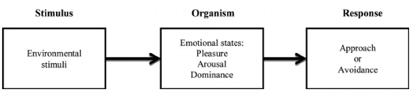

Figure 4: Stimulus Organism Response (SOR) Model
(Source: De Villiers, 2018)
Secondly, the Stimulus Organism Response (SOR) Model is a more detailed account of user behaviour. The external environmental stimuli (stimuli) affect internal psychological conditions (organism), which in turn result in behavioural outcomes (response) (Hanafiah, Aminuddin and Mahdzar, 2023). The interface design, loading speed, and personalisation are certain usability features that serve as stimuli in case of mobile application. These characteristics affect user perceptions, emotions, and loyalty, which act as organism. Finally, the repeat purchase and continued use of the apps are behavioural patterns that reflect the response. Further, the most recent research supports mediating nature of internal factors in this context. On mobile services indicates that customer loyalty has a positive relation with loyalty outcomes, while the relationship is influenced by the individual user characteristics (Ho et al., 2025). It means that usability is not enough and it works via psychological variables like loyalty and trust.
Moreover, certain studies also indicated that TAM might be expanded by integrating other factors, such as trust, perceived quality, and user experience. TAM models integrate such aspects like self-efficacy and trust, which improve user behaviour prediction in digital environments (Tian and Chan, 2024). Thus, the integration of TAM and SOR offers an inclusive insight into functional and emotional levels of user behaviour. However, it is mentioned that the two theories have certain limitations. TAM fails to capture contextual factors including cultural differences, whereas SOR tends to simplify complex decision-making process (Yaqub et al., 2024). Thus, TAM describes the role of usability in user adoption and perceived value, whereas SOR describes conversion of these perceptions into customer loyalty.

2.4. Conceptual Framework
The conceptual framework integrates key concepts that were identified in the literature, which includes mobile app usability, customer experience, and customer loyalty. This framework explains how usability devises loyalty through mediated factors. Usability is not a direct cause of loyalty, but it operates via loyalty and trust processes (Mofokeng, 2025). Thus, this framework offers a systematic model on which the research is guided by linking the variables and explaining their relations.
Considering the components of the conceptual framework, the first element is mobile app usability that is independent variable. It includes factors such as navigation, interface design, performance, and personalisation. Features decide how easily users interact with the mobile apps (Alzahrani and Alzahrani, 2025). Further, it also indicates how usability increases efficiency and user effort that directly affects user perceptions. The second element is the customer experience and loyalty that is regarded as a mediating variable. Customer experience is the perception that is created upon interaction with the app, whereas loyalty reflects level of fulfilment (Guntur and Martini, 2025). Customer loyalty has a positive relation with the loyalty outcomes in mobile services (Ho et al. 2025). Thus, this aspect describes psychological process that takes place internally.
However, trust and perceived value are mentioned as supporting factors. These factors reinforce the link between loyalty and usability. It is found that security, privacy, and perceived usefulness have a direct and indirect effect on loyalty due to satisfaction (Mofokeng, 2025). Thus, they facilitate the effectiveness of usability features. The final element is the customer loyalty, which is the dependent variable. It has measures like repeat purchases, retention and continued use of apps. Hence, this represents the final behavioural outcome. Further, the Indian fashion e-commerce environment is taken as the contextual factor. It matters since the behaviour of users change depending on market conditions, digital adoption, and cultural conditions.
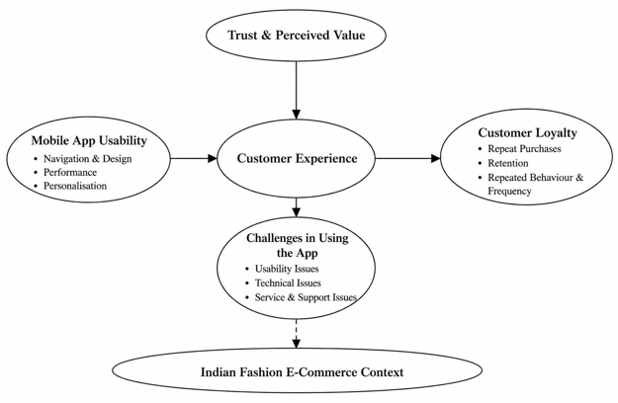

Figure 5: Conceptual Framework
(Source: Self-created)
The conceptual framework offers a clear outline of the research analysis. It helps in investigating the impact of usability of mobile apps on customer experience and loyalty. Besides, it enables the research to examine the effect of these factors on customer loyalty results, such as retention and repeat purchases. Besides, the framework will facilitate the data analysis in the findings section by categorising variables into independent, mediating and dependent categories. Further, it will also facilitate cross-case comparison in the conclusions section by identifying the key relationships and patterns. Moreover, it should be noted that the framework is not rigid. It can be refined using empirical findings during the research process. Hence, the framework also serves as a guiding model, which bridges the gap between theory and practical analysis.

2.5 Research Hypothesis
H1: Mobile app usability has a positive effect on customer loyalty in fashion e-commerce platforms in India.
H2: The challenges faced by customers while using Fashion E-Commerce mobile apps have a negative impact on the customer loyalty in India.

2.6. Conclusion
Although the research on mobile commerce has been researched extensively, there are still significant gaps in literature. At first, the majority of the literature is dedicated to general mobile apps or industries, including Fintech and banking, while only a small number of studies specifically characterise fashion e-commerce platforms, which imply visual and interactive decision-making. In case, the existing research examines direct relationships between usability and customer loyalty, whereas few researches inspect the mediating processes between usability, experience, and loyalty. For instance, customer loyalty is a mediator between service quality and customer loyalty, while it remains underdeveloped in mobile commerce settings (Zariman, Humaidi and Abd Rashid, 2022). Thus, this study fills the gaps by focusing on Indian fashion e-commerce applications.
It could be summarised from the literature that usability of mobile applications plays an important role on customer loyalty, which is attributed towards customer experience and customers’ buying behaviour. However, there are gaps in terms of specific fashion studies, Indian context and integrated framework. Thus, the research contributes to the fact that it helps to fill these gaps and offer a detailed relationship between usability and loyalty in e-commerce fashion platforms.

Chapter 3: Methodology

3.1. Introduction
This chapter tends to outline and justify the methodological aspects, which are adopted for addressing the research aim and questions from initial chapter. The research focuses in analysing the role of mobile app usability in shaping customer loyalty in fashion e-commerce platforms in India using an online survey design. Research methodology initiates a coherent plan, which aligns with philosophical assumptions, data collection methods, and the research approaches for ensuring consistency in addressing the research problems (Dissanayake, 2023). However, this chapter discusses the research strategy, philosophy, data collection, approach, and key analysis techniques. Further, it also offers a clear justification of the selection of methodological choice for ensuring academic credibility, rigour and transparency.

3.2. Research Philosophy, Approach, and Design

3.2.1. Research Philosophy
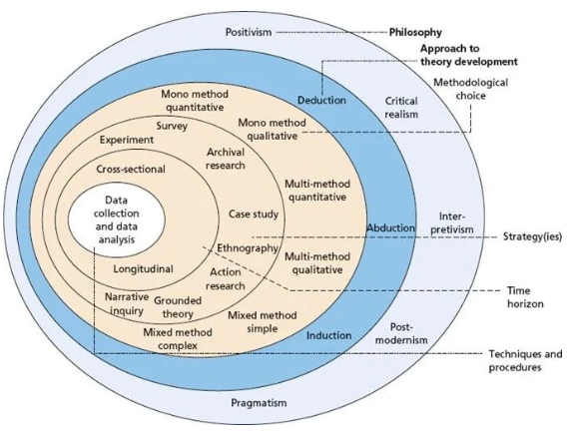

Figure 6: Research Onion
(Source: Saunders, Lewis and Thornhill, 2019)
From an ontological perspective, the research analysed that customer decisions are influenced by identifiable and real factors such as trust, environmental awareness and price that exist independently of the individual clarification. In terms of epistemological aspect, knowledge is created using statistical analysis and empirical observation that ensures objectivity and reduces researcher bias (Sol and Heng, 2022). Besides, the research has adopted a positivist philosophy, which aimed to identify the relation between mobile app usability and customer loyalty. Positivism is based on the assumption, where it is said that reality is observable, independent, and objective, which could be analysed using scientific methods (Ali, 2024). However, this aligned with the present research, where customer loyalty is defined as a phenomenon, which could be quantified using structured survey data. Hence, positivism is effectively related with the hypothesis testing and quantitative research, where the variables are well defined and relationships are maintained systematically (Gamage, 2025). Moreover, the philosophy proves to be effective in analysing the cause-effect relations in customer loyalty through a structured research design.

3.2.2. Research Approach
This research adopted a deductive approach, which aligned with positivist philosophy. The deductive approach begins with an existing theory and develops the specific relations or expectations, which are being tested using the empirical data (Hall, Hall and Shaw, 2022). However, the conceptual framework that is initiated in literature, based on the Technology Acceptance Model and Stimulus Organism Response (SOR) Model, along with the conceptual framework that has been developed in literature. However, the research has tested these relationships by collecting quantitative data on key variables, such as trust, loyalty, perceived value, mobile app usability, and repeat purchases. This helps to examine, if mobile app usability can influence customer loyalty in Indian context across the fashion e-commerce sites. Eventually, the deductive approach also helps in statistical testing and structured analysis, which tend to increase replicability and objectivity (Fife and Gossner, 2024). Moreover, the approach also intends that findings have been logically derived from the theory, which is supported by empirical data.

3.2.3. Research Strategy
In this research, the use of a quantitative strategy has been applied that is effective in examining customer loyalty for a defined sample. It is evident that a survey strategy enables in effective collection of standardised data, which allows in comparison of the responses and identification of clear patterns. Based on the positivist philosophy, the quantitative surveys are effective, as they generate statistical and measurable data to support the objective conclusions (Park, Konge and Artino, 2020). In case, the structured questionnaires with the help of Likert scale responses are being used in measuring the key constructs of mobile app usability, like performance, personalisation, navigation and design, while customer loyalty aspects like retention and repeat purchases. Thus, the survey strategy also allows in effective data collection from a considerably large pool of respondents to develop reliability of key findings. Eventually, the strategy proves effective with the research objectives in testing the ideal relations between variables in a data-driven manner.

3.3. Justification for Research Methodology
The selection of survey-based methodology aligns with the research aim, which focuses in investigating the impact of usability of mobile apps on customer experience and loyalty. As the research investigates on perception-based variables like awareness, personalisation, and repeat purchases, it needs direct input from customers, which cannot be appropriately fulfilled by secondary data. The primary data collection allows the researcher to collect the contextual and current data that directly captures current consumer loyalty and experience (Ganesha and Aithal, 2022). However, it is analysed that the survey technique is suitable, which enables in acquisition of the standardised and measurable data from a defined sample. Further, the use of structured questionnaires with Likert scale responses allows in a comparative and statistical analysis, which supports positivist and deductive nature of the research. Besides, there are some limitations including bias in responses and possibility that stated customer loyalty might differ from actual experience. For addressing this, the questionnaire is formatted using neutral and objective questions, which assures reliability and reduces the measurement error.

3.4. Sampling Strategy and Respondent Selection

3.4.1. Sampling Technique
In this research, the use of a convenience sampling technique has been utilised, which aligned with the data collection approach. The convenience sampling is a strategy that helps in selecting respondents, in terms of ease of access and willingness for participation, instead of just random selection (Golzar, Noor and Tajik, 2022). For this research, the respondents are recruited through online platforms, i.e. using email or whatsapp that proves effective in finding higher response rate from the social media communities, as fashion e-commerce customers from India are available readily. It is evident that the approach is suitable, since the research focuses on actual individuals that are aware of the mobile app usability features such as navigation, browsing, user design, high performance and accessibility. The convenience sampling facilitates in effective data collection within limited time and resource limitations that is essential for the survey design (Ahmed, 2024). In case, the method could set up the selection bias, as the sample might not fully represent the broader population. Hence, the findings have been interpreted within the chosen participants by acknowledging limitations in generalisability.

3.4.2. Sample Size and Respondent Profile
The research has collected responses from 108 respondents, which is sufficient in determining the significant behavioural trends of Indian fashion e-commerce platforms. The sample size is suitable to offer statistics analysis, while remaining is manageable within resource and time limitations. However, the respondents are the customers who are aware and have experiences of Flipkart mobile app usability and are familiar with fashion e-commerce sites in India. Thus, the participants have been recruited via online platforms such as social media networks and referrals. This assures that the respondents are not just available, but also relevant to research topic on mobile app features to drive customer loyalty.

3.4.3. Justification of Sampling
The sampling procedure is selected based on the practical feasibility and relevance of the research context within a limited timeframe (Cash et al., 2022). It allowed the researcher to access respondents who are active participants of using mobile apps for varied purposes. Besides, this method is consistent with the nature of research to investigate behavioural tendencies in a specific group of consumers, instead of generalising entire population. Thus, it ensures that information collected is relevant, focused, and aligned with the research scope.

3.5 Data Collection Methods

3.5.1. Data Type
The study uses primary data, which has been collected with the help of an online questionnaire that helps in measuring the consumer loyalty and experience. The data is especially crucial in consumer behaviour research, where their personal attitudes and decision-making patterns should be captured in a systematic manner. The primary data collected via surveys enables researchers to analyse consumer loyalty and behavioural patterns of using mobile apps with quantifiable indicators (Mishra et al. 2023). Thus, the findings have been based on up-to-date and respondent-driven insights, instead of secondary interpretations. On the other hand, Flipkart app has been taken into consideration based on which participants will be asked close-ended questions. This app has been selected because it is one of the largest e-commerce platforms in India and it provides rich consumer interaction with fashion products. Moreover, the app includes features like personalised recommendations, customer reviews and ratings, easy navigation and search filters and secure checkout and payment integration.

3.5.2. Questionnaire Design
The questionnaire is created using Google Forms, which ensures effective distribution and systematic data recording. It is comprised of 21close-ended questions that are backed by a 5-point Likert scale with strongly disagree to strongly agree. The Likert scale is popular in consumer research, as it enables measurement of attitudes, perceptions and behaviour in a measurable format (South et al. 2022). The research questions are well formulated as per the research objectives. However, Google Forms were used to design the questionnaire, which will have 20 close-ended questions that were based on a 5-point Likert scale, which includes options between strongly disagree and strongly agree. Q1-Q5 gathered demographic and frequency of shopping information of respondents. Besides, the mobile app usability included navigation, performance, convenience of payment, personalisation and customer support from Q6 to Q11. The Questions 12-15 explored customer difficulties during their mobile app usage at Flipkart, such as navigation problems, technical troubles, ineffective product information, and issues with order tracking. Moreover, Q16-Q21 was used to measure customer loyalty variables: retention intention, repeated behaviour, recommendation intention, repeat purchases, and frequency of use. Moreover, pilot test was carried out with 15-20 respondents to clarify the questions, remove ambiguity and develop reliability. The pilot participants were selected from target population of mobile app users in fashion e-commerce. Moreover, the feedback was gathered regarding clarity of question to analyse ease of understanding and clarity.

3.5.3. Data Collection Process
The data collection procedure follows a fully online distribution procedure, which aligned with the ethics form. The questionnaire is distributed via email mainly, which allowed in targeting the respondents that are active in e-commerce environment. Besides, the research has been well informed by providing the participants with a brief introduction of what is going to take place. The survey has been done for 2 weeks, which is effective to receive responses. Besides, all the responses were automatically saved in the platform and stored safely. This developed in efficiency, reduced manual errors, and maintained accuracy in handling data.

3.6. Data Analysis Approach

3.6.1. Analytical Method
The research used descriptive and inferential statistical analysis to test the relationships between mobile app usability and customer loyalty with the help of SPSS software. Besides, the structured methods, such as frequency distribution and percentage analysis were used in organising and analysing survey responses (Arundel, 2023). Further, this allows in identification of trends in trust, loyalty, and usability. However, Likert scale data has been used to quantitatively assess responsiveness and performance, which can be compared with other respondents in a systematised manner.

3.6.2. Interpretation
The conceptual framework created in literature helps to interpret findings. The findings are compared to test the research objectives, whether Mobile app usability has a significant effect on customer loyalty in fashion e-commerce platforms in India, as from hypothesis. Moreover, the focus is laid on determining the customer loyalty and service gap, which was highlighted in the literature. Hence, the interpretation offers link with empirical findings with theoretical constructs to ensure that conclusions are data-driven and conceptually grounded.

3.6.3. Reliability
A standardised questionnaire is used and data analysis procedures are consistent to achieve reliability. All the respondents were asked the same questions, which reduced variation in data collection. Thus, careful data coding and checking were applied to reduce errors and improve consistency in results.

3.7. Research Quality and Rigour
The research achieves rigour based on maintaining criteria of validity and reliability. Construct validity is ensured by aligning the survey questions on research objectives and conceptual variables. Besides, the internal validity is sustained by systematic analysis, which links the data with conclusions. Research validity is improved by devising clear analytical procedures and reasoning (Yazan and Vasconcelos, 2016). Further, the external validity is addressed by selecting a relative sample of customers from India, which allows in limited generalisation within similar research context. This can be developed by clear recording of the procedures so that the research could be replicated.

3.8. Ethical Considerations
The research follows ethical standards as per approved ethics form. The respondents have been informed regarding the purpose of research, while the participation has been voluntary. However, no identifiable or personal information is collected and thus anonymity and confidentiality is ensured. They also offer their participants the right to withdraw at any point before submission. Further, any data obtained is stored in a secure manner with password-protected systems. The research also provides proper representation of the responses and does not involve any data manipulation. Hence, the ethical integrity is ensured during the research process.

3.9. Chapter Summary
This chapter has described the research methodology, such as data collection, data analysis and ethical considerations. There has been a systematic and organised method to develop reliability and validity. The research objectives align with the methodology, which helps to conduct an empirical investigation. The next chapter will introduce and discuss the results based on the data collected.

Chapter 4: Results and Data Analysis

4.1 Introduction
This chapter evaluates the survey responses and analyses customers’ responses regarding the usability aspects of Flipkart and how much they can rely on this app to explore products. Moreover, here, through questions, customer loyalty needs to be analysed and examined how customers’ loyalty plays a role in enhancing their shopping experience.

4.2 Demographic analysis
The qualitative aspect of demographic segment analysis carried out in this research indicates that the major respondents were young adults who are active online shoppers. In the age category, the largest number of persons (around 41%) belonged to the category of 31-40 years, while around 28% belonged to the age group 21-30. This suggests that respondents aged 31–40 years were more represented in the sample. The largest proportion of females in the study was around 61%, and the males were around 31%. This means that female respondents constituted the majority of the sample and may provide valuable insights into fashion shopping app usage patterns. As far as educational background is concerned, the majority were postgraduates (57%), and the second was undergraduates (24%). This indicates that a substantial proportion of respondents possessed higher educational qualifications, which may influence their familiarity with mobile shopping applications and usability aspects. In regard to monthly income, the group with INR income between 40,001 and 60,000 is the majority (37%) and that with monthly income less than INR 20,000 is the second largest group (27%). Based on the frequency of Internet fashion purchases, a total of 35% purchased fashion products 2-3 times over a 6-month period, and around 31% purchased fashion products on a monthly basis. This indicates that the respondents had prior experience with fashion e-commerce platforms, making them suitable for providing perceptions regarding customer loyalty and mobile app usability.

4.3 Analysis

4.3.1 Mobile App Usability and Customer Loyalty
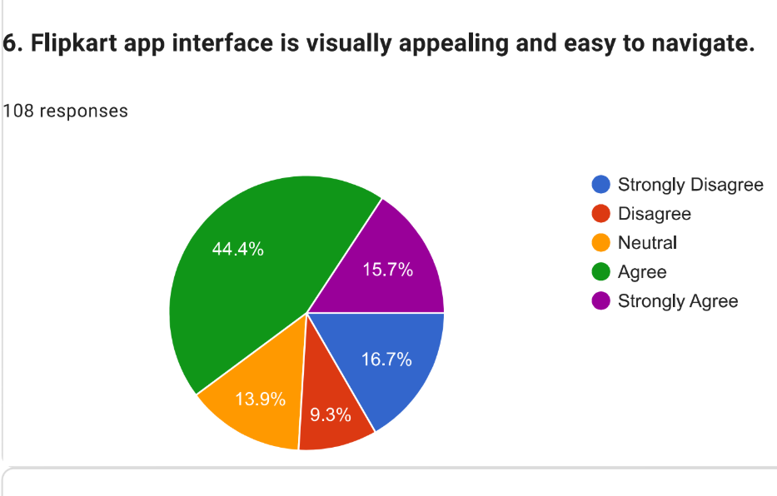

Figure 7: Visually appealing interface
(Source: Self-created)
According to the results of Question 6, the majority of the users generally had a positive perception of the usability of the Flipkart app. 44% agreed that the interface of the app is attractive and easy to navigate and 16% strongly agreed. This is further supported by SPSS analysis data, which reveals a mean score of 3.33, a mode score of 4 and a standard deviation of 1.318, suggests that respondents generally viewed the app interface favourably, although opinions varied among participants. The results are broadly consistent with the research of Talmera, Wardhana and Ratnasari (2025), who found that UI and UX elements have a positive influence on users' loyalty when accessing mobile commerce applications.

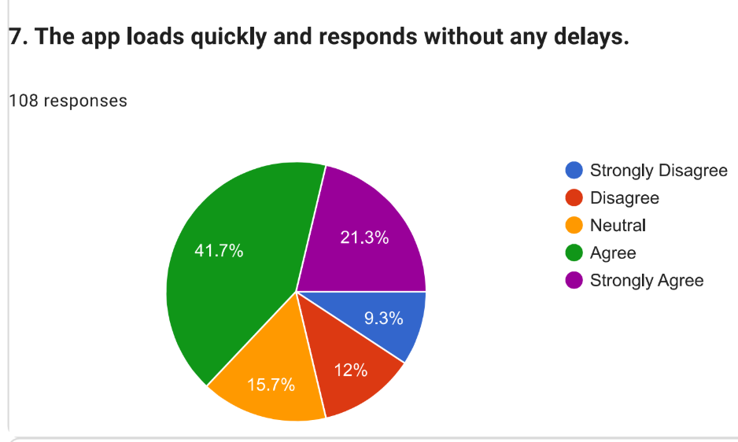

Figure 8: App loads and delay
(Source: Self-created)
For Question 7, the results show that the importance of speed of app performance results in customer loyalty. The participants felt that the app loaded efficiently without significant lag or delays, with approximately 42% agreeing with the statement. The proportion of people who strongly disagreed with the statement was just 9%. The same result is seen with the SPSS analysis, which returned a mean value of 3.53, a mode of 4 and an SD of 1.218, suggesting that respondents generally held favourable views regarding the speed and responsiveness of the app, although some variation in opinions existed. The results support the findings of Felix and Rembulan (2023), who found that responsiveness and performance of a mobile commerce platform highly affect the engagement and loyalty of customers.

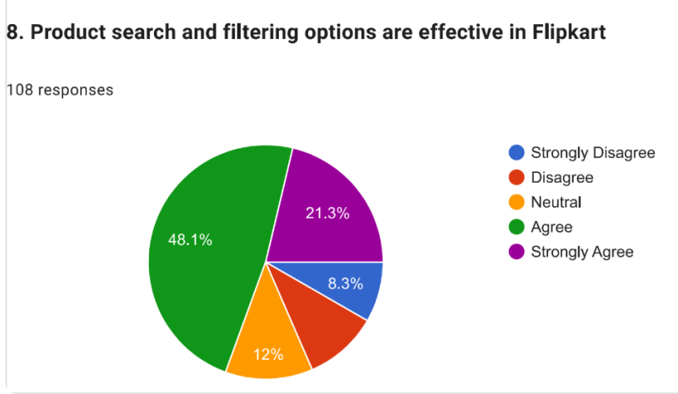

Figure 9: Product search
(Source: Self-created)
The result of the question is that on their website, Flipkart users feel that product search and filter are positively affecting their loyalty. About 48% respondents agreed search and filtering options are effective and 21% strongly agreed. This is backed up by the SPSS results, which agree, with a mean score of 3.63, a mode at 4 and a standard deviation of 1.171 suggesting that respondents generally held positive views regarding the app's ability to help them locate products efficiently. This suggests that effective search and filtering functionality may reduce customer effort and contribute to a more convenient shopping experience. The results are similar to findings of Isen et al. (2026), that easy navigation and efficient search function are good predictors of customer retention and repeat usage in mobile commerce platforms.
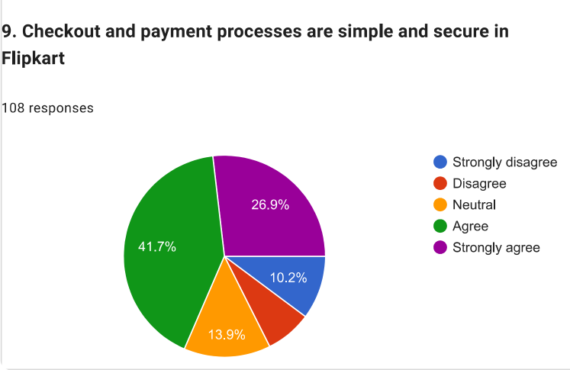

Figure 10: Checkout and payment process
(Source: Self-created)
The results obtained for Question 9 suggest a positive effect on customer loyalty due to its focus on checkout ease and payment convenience in Flipkart. It has been seen that, around 42% of respondents who agreed, 27% are strongly agreed, said the checkout/payment process was simple and secure. This is further corroborated by the SPSS analysis, which shows a mean of 3.67, a mode of 4 and a standard deviation of 1.236, suggesting that respondents generally held positive opinions regarding payment usability, although some variation in responses existed. The findings align with the statement of Ting and Ahn (2023), which showed that customer convenience in payment, coupled with trust levels have a positive impact on customer loyalty in e-commerce platforms.
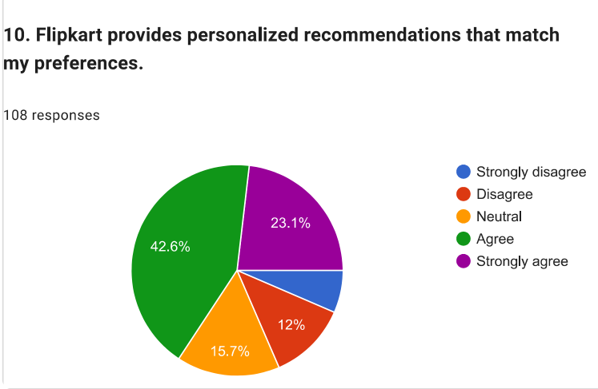

Figure 11: Personalised recommendations
(Source: Self-created)
In terms of the results of the question 10, around 43% of the respondents confirmed Flipkart makes personalised recommendations as per their preferences, and 23% strongly agreed. This is also backed up by the mean score being 3.63, mode scoring 4, and the large volume of standard deviation being 1.155, which suggests that respondents generally viewed the personalisation features of the app favourably. This means customised suggestions results in better customer engagement, better shopping convenience, and increased intention to repurchase, leading to increased customer loyalty. The same findings were reported by Oualid, Selma and Soufyane (2024), who discovered that personalised services may enhance customer engagement and contribute to customer retention in mobile commerce.

4.3.2 Customer Challenges in App Usability
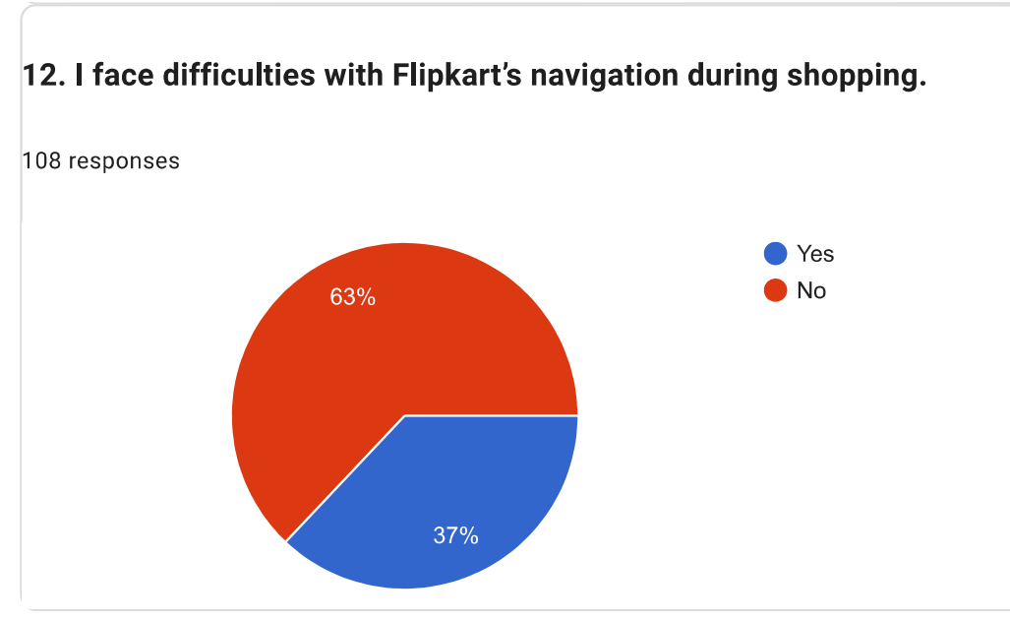

Figure 12: Navigation issues
(Source: Self-created)
As per the graph, 37% stated that they face clear navigation difficulties while shopping on Flipkart, whereas a 63% majority did not encounter these roadblocks. The statistical analysis yields a mean score of 1.6296, a dominant mode of 2.00, and a standard deviation of 0.48516. The high modal concentration at 2.00 indicates that the user pathways remain generally functional for the baseline tier of customers. This internal tension reflects macro e-commerce challenges. In support of this, Acosta-Vargas et al. (2022) noted that 54.4% of the analysed ecommerce websites have problems that detract from the usability of the websites, namely the contrast problems related to the layout of the perceptual and visual aspect of the navigation in the websites.
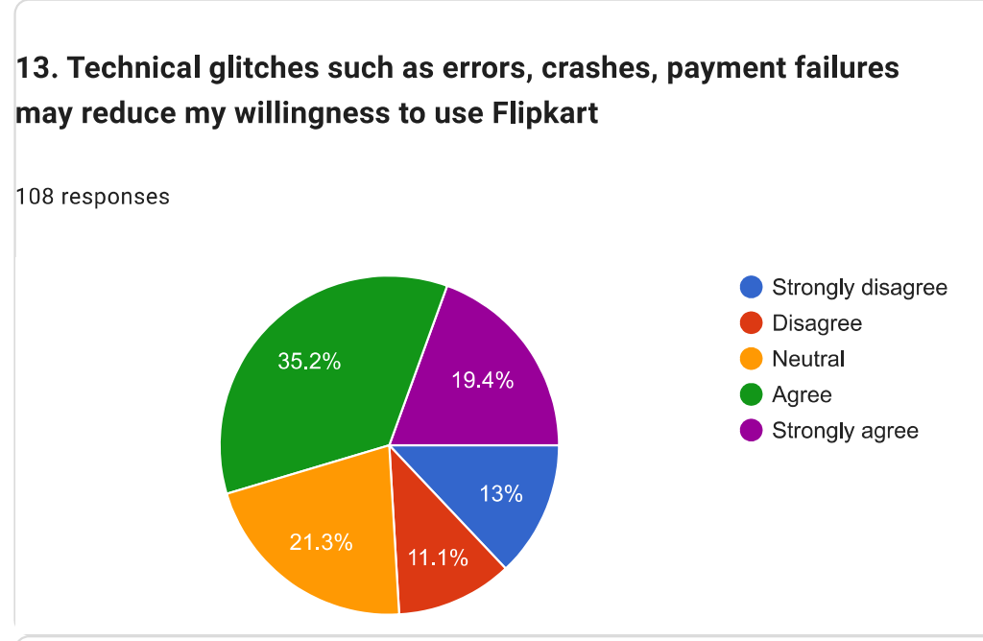

Figure 13: Technical glitches
(Source: Self-created)
As per the graph, a moderate percentage of 54.6% agreed that technical glitches such as errors, application crashes, or payment failures actively reduce their willingness to use Flipkart (35.2% agree, 19.4% strongly agree). Meanwhile, a minor 24.1% expressed open disagreement. However, the mode of 4.00 highlights that software instability is a primary driver of customer churn. This localised behaviour is like a global checkout trend that shows sudden application performance issues and runtime bugs make up to 17% of shopping cart abandonment on digital platforms (Domadenik, Koman and Redek, 2018).
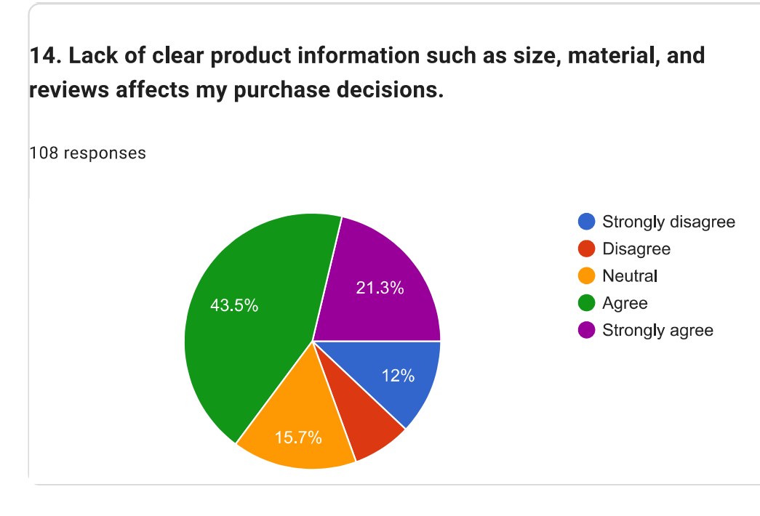

Figure 14: Issues in product information
(Source: Self-created)
It has been found that 65% (44% agree, 21% strongly agree) of buyers responded that the lack of comprehensive product details (such as sizing charts, material definitions, and authentic user reviews) directly alters their final purchasing choice. Conversely, 19% disagreed. However, the solid mode of 4.00 highlights that information completeness dictates checkout conversion. This dependency is supported by the study by Kaur Chatrath, Batra and Chaba (2022), who found that external consumer insights confirm that 47% of today's online shoppers feel it is essential to have comprehensive and high-quality product information if they want to finalise their brand selections.

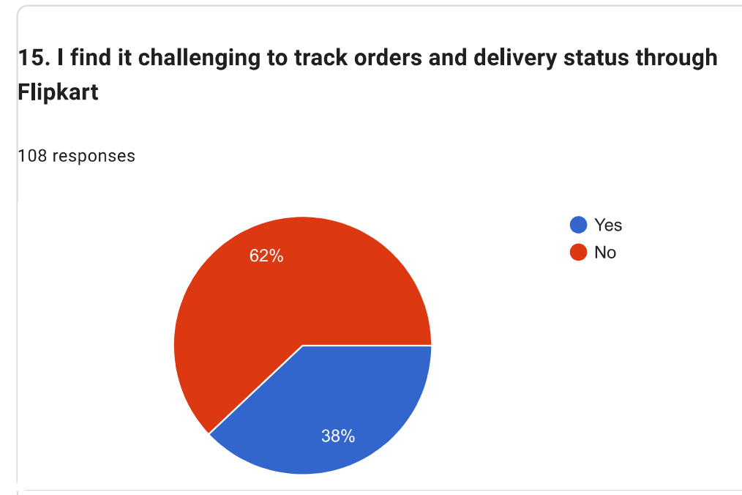

Figure 15: Tracking order issues
(Source: Self-created)
According to the graph, 38% of the respondents verified that monitoring their active order status and delivery checkpoints through Flipkart is challenging, while 62% completed their transactions without visibility struggles. The statistical framework shows a mean of 1.6204, a mode of 2.00, and a standard deviation of 0.48756. Though the mode confirms a baseline functional tracking layer for the majority, the 38% customer friction cluster exposes delivery updates' opacity. According to GlobeNewswire (2024), 67% of online shoppers faced delivery issues like delayed deliveries, lack of delivery updates, or delivery failure.

4.3.3 Mediating Role of Customer Loyalty
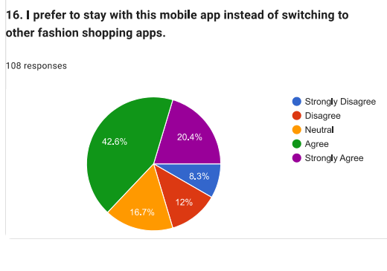

Figure 16: Preference of Mobile App
(Source: Self-created)
Most respondents, with 43% agreed and 20 strongly agreed, give an indication of high customer satisfaction and loyalty towards the Flipkart app. While it is not a comprehensive review, the respondents seem happy about the platform's UI, pricing, ease of use, and shopping experience, which further diminishes the chances of exiting to other applications. The SPSS analysis for the particular point highlights a mean score of 3.5463 and a mode of 4.00. The key takeaway from this finding is that Flipkart has been able to maintain customer satisfaction by building a sense of trust and convenience in their shopping experience and continuing to deliver a high level of service (Rather, Hollebeek and Rasoolimanesh, 2021). A high level of loyalty is able to give the business a big edge over the competition when it comes to online fashion retailing.

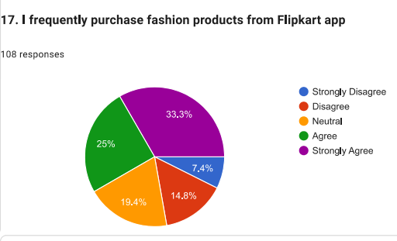

Figure 17: Preference of Flipkart App
(Source: Self-created)
The statements were generally positive in terms of purchasing behaviour with 25 respondents agreeing with the statement 25% and 33% strongly agreeing. This indicates that the people are indeed utilising the application for fashion-related buys. The SPSS analysis for the particular point highlights a mean score of 3.6204 and a mode of 5.00. The most important implication is that Flipkart's fashion product can successfully drive purchase decisions for consumers via the product variety, promotions available, price competitiveness, and ease of use (Dhiman, Chand and Gupta, 2018). The high frequency of buying also suggests that they feel that the platform is dependable and effective in satisfying their fashion requirements. This regular buying behaviour can lead to better revenue for the business and improved market standing for the organisation.

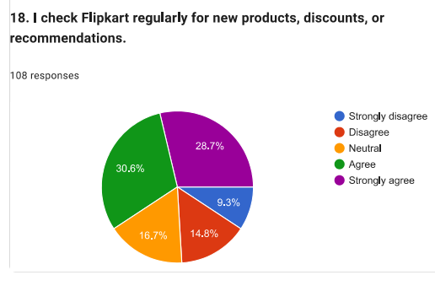

Figure 18: Promotion of New discounts and recommendations
(Source: Self-created)
A high proportion of respondents gave "agree" 30% and "strongly agree" 28% in favour of 18 indicates that the customers are very active in the application. The SPSS analysis for the particular point highlights a mean score of 3.5463 and a mode of 4.00. Flipkart's marketing efforts, such as personalised recommendations, notifications, and discount campaigns, seem to be working well in keeping customers engaged and active on the platform (Singh and Srivastava, 2018). The conclusion of this finding is that ongoing customer interaction will boost the chance of impulse buying and long-term customer retention. It also can help build customer relationships and brand awareness in a saturated e-commerce space.

4.3.4 App Design and Customer Retention Strategies
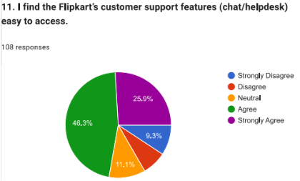

Figure 19: Flipkart’s customer support is easy to access
(Source: Self-created)
From question 11, it has been evaluated from the above graph that customers are happy to easily access Flipkart’s customer support features. Moreover, around 46% customers agreed with this fact that they found Flipkart’s customer service app, which is easily accessible. Additionally, the same result reflects on SPSS analysis, here ‘mode’, which is 4.00, appropriate for descriptive reporting and analyse customer’s opinion to the specific context. Customers raised complaints on ‘Flipkart help centre page’ and the executives resolved the issue to get better customer service experience (Flipkart-Customer Service, 2023).
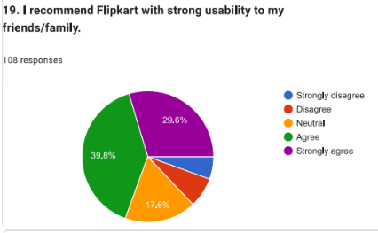

Figure 20: Customers recommend Flipkart to use
(Source: Self-created)
It has been evaluated from question 19 that customers are recommending the app Flipkart to their friends, colleagues, and relatives for getting shopping experience. In relevance, based on the usability, customers are suggested to use Flipkart to have hassle-free experience. Around 40% agreed and 30% a moderate percentage agreed with this fact. Flipkart offers 75-80% discounts on products to increase their sales in summer (Flipkart-Summer sale, 2026). SPSS analysis highlights that mean value is 3.8056 of this particular question and this value is appropriate for the analysis.
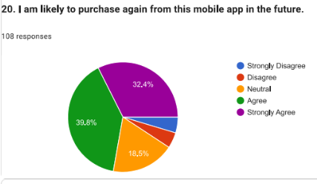

Figure 21: Customer’s interest to purchase products again from Flipkart
(Source: Self-created)
Survey question no.20 evaluates customer’s interest and likeliness to purchase products from this app again in the future. Hence, it has been obtained that around 40% customers are agreed and 32% of customers agreed to the responses for this question. Kannan (2026) stated that this is reflected that Flipkart’s sales reached to 83,000 crore in 2026 after March. It is relevant because SPSS analysis reflects that the mean value is 3.90, supports the fact that there is a positive relation where customers suggest the brand to others.
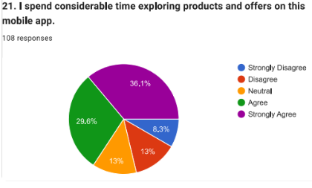

Figure 22: Customers spend time on Flipkart to explore products
(Source: Self-created)
For question no. 21, it can be stated that around 36% customers gave a moderate agreement to this question. Kannan (2026) suggested that this states that customers are considered Flipkart is a useful app where they spend time to explore their new arrivals and get the offers available on the wide range of products. The mean value is 3.72 suggests that there is a synchronisation between the data and the survey question. This reflects that data justifies the context of this question.

4.4 Statistical analysis

4.3.1 Correlation analysis
The correlation analysis establishes that the mobile app usability, usability challenges, and customer loyalty are moderately correlated among Flipkart users.
Mobile App Usability and Customer Loyalty
For the first analysis, the Pearson correlation coefficient is 0.569, suggesting that there is a moderate positive correlation between mobile app usability and customer loyalty. According to LinkedIn (2023), Google found that for every 1-second delay in mobile page load time, the likelihood of bounce rises by 32%, and having a faster and smoother mobile experience greatly enhances repeat customer engagement. This is in line with the correlation results that find r = 0.569, indicating that the usability of the web service is likely to show positive correlation with the level of customer loyalty. The significance value is 0.000, which further indicates that the results are reliable and the relationship between the variables is statistically associated at the 0.01 level. (Shown in Appendix 3)
Challenges in Mobile App Usability and Customer Loyalty
Likewise, the second analysis shows that challenges in usability and customer loyalty are correlated at 0.408. This means that there is a moderate correlation between usability problems and customer loyalty, meaning that usability issues like navigation problems, app crashes, and confusion about information will result in lower customer loyalty. (Shown in Appendix 3)

4.3.2 Hypothesis testing (using Regression Analysis)
H1: Mobile app usability has a positive effect on customer loyalty in fashion e-commerce platforms in India.
The hypothesis testing using regression analysis suggests that mobile app usability has a moderate influence on customer loyalty of fashion e-commerce sites in India. The R-value of the regression model obtained is 0.569, and the R² is 0.324, which indicates that 32.4% of the variation in customer loyalty is explained. The value of the ANOVA (0.000) suggesting that it is an important factor but not the sole determinant of loyalty. Thus, H1 is accepted. (Shown in Appendix 4)
H2: The challenges faced by customers while using Fashion E-Commerce mobile apps have a negative impact on the customer loyalty in India.
The regression analysis for H2 has an R-value of 0.408 and an R² value of 0.166, which means that usability problems account for 16.6% of the variance in customer loyalty. The 0.000 significance indicates that the relationship is statistically significant. The beta score is 0.408, indicating that there are usability issues, which have a negative impact on customer loyalty. Therefore, H2 is also supported, as usability problems have a negative effect on customer satisfaction and repeat purchase intention. (Shown in Appendix 4)
According to the Baymard Institute (2025), the average shopping cart abandonment rate is 70.22%, and one of the most common causes of this is that the checkout usability is complicated. Besides, 18% of users turn away from purchases if checkout is too cumbersome or lengthy. This is in line with H2 results that indicated that usability problems have adverse effects on loyalty and purchase intention.

4.5 Summary
Customer engagement and loyalty are significantly impacted by a mobile commerce platform's responsiveness and performance. The majority of users had faith in the app's capacity to locate what they were looking for. This implies that customers may buy more easily and with less effort thanks to search and filtering features.

Chapter 5: Discussion and Analysis

5.1. Purpose
This chapter critically discusses and interprets the findings from the previous chapter in relation to the research aim, objectives, and questions. The chapter does not restate statistical results, but explains them in the context of Indian fashion e-commerce applications. However, the research assesses the impact of mobile app usability on customer loyalty and explores the significance of usability elements such as navigation, interface design, personalisation, and convenient payment methods. Further, it investigates the challenges faced by users and explores the mediating role of customer experience in strengthening the loyalty outcomes. The findings are analysed through theoretical frameworks, i.e., the Technology Acceptance Model (TAM) and the Stimulus Organism Response (SOR) Model. Hence, this chapter links empirical evidence with the theory and contributes to understanding customer behaviour in the mobile commerce environment.

5.2. Discussion with literature

5.2.1. Mobile App Usability and Customer Loyalty
Mobile shopping applications have seen tremendous growth, especially in the fashion e-commerce industry. Studies have shown that factors such as perceived usefulness, trust, and user attitudes towards the application are key drivers of customer retention in this area. In this context, Hanafiah, Aminuddin and Mahdzar (2023) stated that the Stimulus Organism Response (SOR) model evaluates the behavioural outcomes that come from environmental stimuli and their response. Hence, customers’ loyalty is seen not just in the length of usage, but also in repeat buying, customer retention, frequent engagement, and brand evangelism. For brands, understanding the needs of their customers is crucial to ensure that mobile shopping platforms are used for a longer period. It is considering the usability of mobile apps, their role in improving ease of use and user experience is paramount, and robust data privacy protection fosters consumer trust. These factors help foster customer loyalty, instilling trust and reinforcing their loyalty to the brand, which can have a positive indirect effect on their long-term loyalty (Ho et al., 2025). In terms of analysing consumer behaviour in mobile commerce, therefore, usability is not considered on its own, but together with other influencing variables.
Further, customer loyalty may be measured by observing customer behaviour, including the intention to buy products again and the frequency of purchases. Furthermore, Anaam et al. (2023) suggested that customer loyalty in the mobile shopping context could be measured by attitudinal loyalty, based on resisting the temptation to switch to alternative platforms, and by brand loyalty, manifested in the consistent choice of a particular brand. According to the results of Question 6, the majority of the users generally had a positive perception of the usability of the Flipkart app. For question 7, suggest that respondents generally viewed the app's speed and responsiveness favourably, which may be associated with customer loyalty. Findings revealed that personalised services enhance customer engagement and retention in mobile commerce (Bahaj, 2025). Based on the results from Question 9, respondents generally viewed the checkout process and payment options favourably, suggesting that these features may contribute to customer loyalty by providing greater convenience and ease of use.

5.2.2. Customer Challenges in App Usability
Based on the survey results, usability issues are still a concern when it comes to customer perception and loyalty in fashion eCommerce applications. While the majority of respondents offered positive feedback, there were some issues in terms of usability. For example, 37% responded that they were having trouble in navigating during a shopping experience with the mobile app, while statistical analysis showed a mean score of 1.63 and a SD of 0.49. The findings indicated that the relationship between usability issues and customer loyalty is weak, but exists. The correlation, r = 0.408, suggested that navigation difficulties, technical glitches, and information-related problems can explain the reduction in customer loyalty, but not all. This partially links with the literature of Weichbroth (2025b) and Li et al. (2022), which indicated that other variables like trust, perceived value, and product quality might affect customers' loyalty choices. Further, the findings analysed that product categories, filters, or search functions that are not instinctive lead to less satisfaction. The survey results are supported by Acosta Vargas et al. (2022), who found that 54.4% of websites analysed in e-commerce had usability problems that negatively affected the quality of navigation.
Further, the statistical results confirm the adverse effects of usability problems on customer loyalty. The correlation analysis showed a moderate relationship, with an R-value of 0.408, between problems with the usability and loyalty outcomes. Moreover, the R-value of the regression analysis is 0.408, while the R² value is 0.166, which indicates that the usability problems account for 16.6% of the variance in customer loyalty. Thus, when customers face issues with the app, they are unlikely to maintain loyalty or make purchases via the app. Moreover, these results align with prior research, which shows that performance limitations, device variations, and cognitive overload have a detrimental impact on mobile usability and engagement. This is because delays, technical disruptions, and lack of responsiveness in the system reduce the perceived ease of use and diminish customer commitment (Li et al. 2022). Hence, the findings validate Hypothesis 2, which states that customer challenges in app usability have a significant negative effect on customer loyalty and long-term retention of Indian fashion e-commerce platforms.

5.2.3. Mediating Role of Customer Loyalty
The findings analysed that customer loyalty is a significant mechanism through which mobile app usability influences long-term customer retention. The survey results revealed that overall responses to variables related to loyalty intention were positive for the fashion e-commerce applications. Besides, most respondents said that they would rather stick with the same app than move to other competing platforms. Further, the correlation analysis showed that there was a moderately positive correlation between mobile app usability and customer loyalty (r = 0.569). The regression analysis showed an R² value of 0.324, where usability explains 32.4% of the variation in customer loyalty. Thus, improving usability is expected to increase the customers' intention to repurchase and continued app usage. Although descriptive results revealed that respondents reported positive usability experiences with favourable loyalty intentions, the research did not conduct a formal mediation analysis. Thus, the findings offered direct support to the effects of the mediators as previously reported in the literature. The findings are similar to the literature of Mangune (2024) and Kamalia and Gomathi (2025), but the evidence needs to be analysed with caution, as the relationship was merely inferred from respondents' perceptions instead of being directly tested using mediation modelling.
Moreover, the findings also align with the SOR Model. According to Hanafiah, Aminuddin, and Mahdzar (2023), the usability features serve as stimuli, whereas loyalty and customer perceptions are internal responses that affect customers' future behaviour. Likewise, TAM proposed that perceived usefulness and perceived ease of use have a positive impact on intention for continued use (Musa et al., 2024). Hence, the present results have validated that usability does not have a direct influence on customer behaviour but also increases loyalty through positive customer experiences and perceptions.

5.2.4. App Design and Customer Retention Strategies
The findings analysed that app design is a significant factor in retaining customers in Indian fashion e-commerce. While the previous discussion is on usability and loyalty, this section focuses on how certain design elements encourage customers to use the application over time. A positive response was obtained from the survey results in terms of the design of the apps. For instance, Flipkart's customer care features, such as chat and helpdesk, received a mean score of 1.39, while 67% of the respondents agreed that these were easily accessible. Further, the SD of 0.49 is relatively low, which indicates that customer opinions were similar. These results aligned with the idea that improving support functions can build customer trust and reduce shopping friction. From the literature, Qu and Chen (2025) stated that UX design is crucial for increasing customer engagement, as it allows users to interact with applications efficiently. Likewise, Winata and Arma (2025) stated that well-structured navigation systems contribute to retention by supporting users to complete tasks easily. The positive responses revealed that customers value applications that offer a fast response time and easy interaction.
Further, the statistical data also indicated the strategic nature of app design. The correlation coefficient, r = 0.56, is positive, which indicates that higher usability and design performance are linked with higher levels of retention and repeat engagement. However, the results align with the literature, which emphasised the importance of ongoing improvement as a retention method. Ramesh and Padmaja (2025) argued that companies that continuously update their apps and remain responsive to users' expectations are likely to be successfully engaged in the long term. Similarly, literature by Pereira et al. (2025) highlighted the importance of combining usability, technological innovation and engagement strategies for customer retention. Thus, the findings identified that fashion e-commerce companies should focus on developing responsive support systems, intuitive design structures, and steady improvements in usability to improve customer retention and reduce switching behaviour in a highly competitive digital market.

5.3. Integration with theoretical framework
The findings offer significant support to the theory from the literature in Chapter 2 and confirm expected relationships within the conceptual model. The research revealed that Mobile app usability is a key driver of customer loyalty, while customer experience and loyalty perceptions act as intervening mechanisms influencing long-term customer retention. These empirical results support this proposition, as the correlation showed that there is a positive relationship between mobile app usability and customer loyalty (r = 0.569), while the regression model produced R² = 0.324 and p = 0.000. The results revealed that usability is a significant predictor of loyalty behaviour in Indian fashion e-commerce apps.
The findings also align with the Technology Acceptance Model (TAM), where Musa et al. (2024) stated that perceived usefulness and perceived ease of use drive behavioural intentions and continued use of the system. Likewise, Anaam et al. (2023) argued that users are likely to engage with technologies that are easy to operate and develop task performance. However, the positive relationship found in this study analysed that if customers perceive the fashion shopping applications as easy to navigate and efficient, they are likely to develop a favourable attitude towards using these applications, which supports theoretical assumptions of the TAM. Further, the findings support the Stimulus Organism Response (SOR) Model. Hanafiah, Aminuddin and Mahdzar (2023) stated that usability factors like interface design, navigation, and performance are external stimuli that trigger internal psychological responses before behavioural responses are produced. The survey results revealed that 63% agreed that they would prefer to stay with the same application, as opposed to switching to other apps. This reflects that positive app experiences lead to loyalty intentions. This aligns with the literature by Ho et al. (2025), who argued that loyalty outcomes emerge from internal evaluations, rather than direct technical interactions.
However, the findings also showed a slight refinement of the original framework. The conceptual model showed that customer experience is the focal point between usability and loyalty. As the results support the pathway, it was found that customer loyalty itself operates as a bridging mechanism between usability and retention outcomes. This finding aligns with Kamalia and Gomathi (2025), who reasoned that positive user experiences developed loyalty, which drives the repeat usage behaviour. Thus, the revised conceptual pathway has been Mobile App Usability → Customer Experience → Customer Loyalty → Customer Retention.

5.4. Robustness Considerations
The findings are reasonably strong, as primary relationships were statistically strong across the analysis. The regression model for usability and loyalty was significant (R2 = 0.324 and p = 0.000), while the regression model for challenge was significant (R2 = 0.166). Besides, the internal consistency of the questionnaire was also excellent with a Cronbach's Alpha of 0.921. However, these findings identified that the responses were consistent with the overall conclusion. It is asserted that retention is not only determined by usability, because trust, perceived value, and satisfaction will influence the retention. Saibaba (2025) and Bajwa et al. (2025) found that customers are willing to continue using an app if they trust the brand or perceive low risk, when usability is not perfect. This means that loyalty in the survey reflects brand strength, rather than design quality.
Further, the responses from self-reported survey data are from one fashion app context, which may reflect the platform experience of the Flipkart users rather than the wider Indian fashion e-commerce market. As argued by Weichbroth (2025b), usability perceptions are dependent on the context and can change depending on device quality, the user's ability, and familiarity with the interface. Thus, the research is credible, but the findings are treated as evidence, rather than a universal rule.

5.5. Practical Synthesis
The discussion stated 3 practical lessons, which are useful for managers. First, when it comes to retention, effort is removed with app design. The literature revealed that ease of navigation, performance speed, and clear layout influenced customer behaviour, while Winata and Arma (2025) argued that reduced search effort and smoother transactions contribute towards retention. This is supported by the survey because the core usability model was significant, which means that design changes can influence loyalty in measurable terms.
However, the support access should be integrated into the retention strategy. The literature correlated customer loyalty with perceived usefulness, trust, and service quality. Hence, chat, helpdesk, and order support should not be considered as secondary responsibilities. They should be accessible quickly at checkout or after delivery. This aligns with the findings of Lu, Qu and Chen (2025), who argued that engagement and innovation work to maintain customer loyalty. Moreover, personalisation should be used carefully and consistently. From the literature, personalisation and trust are effective for continued use, while they feel relevant rather than intrusive. Thus, strong loyalty responses indicated that customers are receptive to an app that is relevant and convenient.

5.4. Summary
The responsiveness and performance of a mobile commerce platform have a big impact on customer engagement and loyalty. The majority of respondents had positive judgments on the usability of payments, and customer loyalty in e-commerce platforms was positively impacted by both customer convenience and trust levels. This suggests that search and filtering capabilities may make purchases easier and less labour-intensive for consumers.

Chapter 6: Conclusions

6.1. Summary of key findings
The research focused on the role of mobile app usability on customer loyalty in the Indian fashion e-commerce sites in India. The findings have shown that usability has remained a major factor in customer behaviour and loyalty. Besides, the statistical analysis indicated a correlation between mobile app usability and customer loyalty (r = 0.569), while the regression model was able to explain 32.4% of the variance in customer loyalty. These findings mean that customers will be loyal when applications are efficient, convenient, and user-friendly. The findings align with the literature of Talmera, Wardhana and Ratnasari (2025), and Malik, Abdullah and Fakhrorazi (2025), which indicated that the usability dimensions positively affect customer engagement, continued use, and loyalty behaviour. The research revealed that the usability issues remain a problem in customer perception and retention. The survey results identified that 37% of respondents faced difficulties in the navigation process, while the regression results indicated that usability problems had a significant impact on the results of loyalty, with R² = 0.166. The findings align with the literature of Weichbroth (2025b), who recommended that a lack of information architecture and complexity of interfaces contribute to higher cognitive effort and lower usability. Li et al. (2022) stated that responsiveness of the system and its efficiency are vital factors in positive user experiences.
Further, the results showed that customer loyalty is an important mechanism between usability and long-term retention. The survey revealed that 43% agreed and 20% strongly agreed that they would stick with the current application, rather than change to others. Similarly, 70% agreed that they would recommend the application to others, showing strong loyalty intentions. This links with the literature by Mangune (2024), and Kamalia and Gomathi (2025), who stated that positive experiences with a mobile app strengthen repeat usage behaviour and long-term loyalty. Moreover, the results support the theoretical assumptions of TAM and the SOR Model. It is analysed by Musa et al. (2024) and Hanafiah, Aminuddin and Mahdzar (2023) that usability affects behavioural outcomes by perceived usefulness, ease of use, and internal customer evaluations. Hence, the research concluded that the factors of mobile app usability, customer experience, and customer loyalty exert an impact on customer retention in the Indian fashion e-commerce platforms.

6.2. Linking with Objectives
The first objective was to explore the impact of Mobile App Usability on Customer Loyalty in Indian Fashion e-Commerce. The results indicate that this objective has been met. The results obtained in findings indicated that Mobile Apps' perceptions of usability were generally positive, particularly regarding navigability, personalisation, and payment. Further, a moderate positive correlation between mobile app usability and customer loyalty was found in the statistical analysis, with r = 0.569. The regression analysis also showed that the proportion of variance in customer loyalty was explained by the usability, with R² = 0.324, which indicated that there was a significant relationship between them.
The second objective was to recognise the challenges that customers are facing with mobile app usability to influence customer loyalty. This objective was met through survey findings. From chapter 4, 37% of respondents agreed that they had problems finding their way through the application, while a few respondents offered occasional issues relating to usability. The regression results showed that factor usability challenges significantly had an impact on customer loyalty, with an R² of 0.166 and a p-value of 0.000. This shows that there are still barriers to usability that impact customer experiences and the formation of customer loyalty.
The third objective was to determine if customer loyalty is a mediating factor between app usability and retention-related outcomes. The survey findings supported this objective. It is found that 63% agreed that they preferred to stay with the same app in contrast to switching to competitors. Moreover, 70% agreed that they would recommend the application to others. These are behavioural indicators that positive usability experiences are transformed into intentions for loyalty, which lead to continued engagement and retention.
The fourth objective was to offer evidence-based recommendations for app design and engagement strategies to increase retention and loyalty. The findings offered a strong foundation for the objective. For instance, 67% agreed that it was easy to access customer support features, and favourable responses were seen on measures related to app design. These results recommend that improvements in usability, support accessibility, and customer engagement can support retention results. Thus, all the objectives were accomplished while insights were gained through evidence derived from the research to develop customer loyalty in Indian fashion e-commerce applications.

6.3. Recommendations
The findings revealed certain gaps in areas of usability that can reduce customer retention. Thus, the recommendations are directly linked to the survey results and are based on the survey results.
Recommendation 1: Develop Navigation Simplicity and Product Discovery
A major gap identified was that a significant number of respondents who were having problems while navigating the application showed that some users faced challenges regarding search and browse problems. Hence, fashion e-Commerce stores have to have simple menu structures, better search filters, and develop category organisation. Lu et al. (2025) argued that intuitive navigation and user interaction are critical aspects of the user experience in mobile apps. It is also found that intuitive navigation develops engagement and facilitates continued app usage. Thus, reducing the customer effort during browsing can build long-term loyalty.
Recommendation 2: Expand Personalisation Capabilities
The survey outcomes indicated that although people mostly liked the recommendation feature, there is scope for improving personalised shopping experiences. Thus, companies should utilise browsing history, buying behaviour, and preference information to offer relevant product recommendations. Moreover, there is growing consumer demand for personalised experiences and rewards across mobile platforms, while personalisation improves engagement and loyalty.
Recommendation 3: Improve security and privacy measures to build trust.
Another gap is the need to develop customer confidence, as loyalty develops through trust and perceived value. The respondents showed positive loyalty intentions, while sustained data protection and transaction security should be continually repeated. Mofokeng (2025) stated that perceived ease of use, privacy, and security have a direct and indirect effect on e-loyalty. Hence, the fashion retailers should develop transparency about data usage, develop a payment protection mechanism, and communicate about security updates.

6.4. Theoretical and Managerial Implications
This research offered notable theoretical implications for the literature on mobile commerce, usability, and customer loyalty. First, the results extended existing knowledge by analysing that mobile app usability is not just an adoption factor, but also a post-adoption behavioural factor. The current research showed that the relevance of usability in influencing the long-term customer outcomes, like loyalty and retention, is significant. However, this contributes to the ongoing shift from technology adoption to sustained engagement and loyalty building. For instance, in the mobile context, customer loyalty is no longer just a function of initial acceptance of the service, but an ongoing experience and satisfaction. Further, the research validated the Technology Acceptance Model and Stimulus Organism Response Model. These results recommend that usability-related factors affect customers' behaviour by means of internal evaluations and loyalty creation, rather than direct technological interaction. Hence, the research validates a holistic view of digital consumer behaviour, in which functional and psychological aspects act together.
From a managerial perspective, the findings revealed that organisations should view usability as a strategic business resource, instead of a technical design problem. The statistical results showed that relations between variables of usability and loyalty were significant, which means that it is likely to invest in user experience quality to increase customer loyalty. For managers, performance should not be measured in terms of downloads or user acquisition, but through repeat visits, recommendation behaviour, and retention. Moreover, the study emphasised the need to adopt a customer-centred design approach. Hence, it is important for Indian fashion e-Commerce companies to keep a regular check on usability performance, customer feedback, and behavioural analytics. Further, the mechanisms of customer care, customisation, and trust creation should be included in the overall retention strategy.

6.5. Limitations
While the research fulfilled its objectives, some practical limitations were noted. The analysis was performed with data collected from users of a single fashion e-commerce platform. Thus, the findings might not capture usability experience on other platforms like Myntra, Ajio, or new fashion apps that have different interface layouts and engagement approaches. Further, the research assessed customer perception at a single time and was not able to explore variations in customer loyalty, considering updates to the app, promotions, or technology developments. Moreover, there was no behavioural data available on metrics like actual purchase frequency, session duration, and retention. Thus, the conclusions are based primarily on perceived rather than observed customer behaviour.

6.6. Directions for Future research
Future research should stop relying on perception-focused surveys and integrate the results with real-life indicators of behaviour, including repeat purchases, shopping cart abandonment rates, browsing habits, and customer lifetime value. Further, a comparison between several fashion e-commerce platforms would offer insight into platform-specific characteristics that can affect loyalty. The research can explore the impact of AI-driven recommendation systems, virtual try-on features, live commerce capabilities, and social shopping on customer retention within the Indian market. Thus, future research could investigate variations among diverse age groups, income levels, and digital literacy to create specific strategies for increasing customer loyalty and engagement.

Reference List
Abbas, H., Munir, S., Tahir, M., Noor, M., Honey, Q., Hamza, M.A. and Iqbal, M.W. (2024) “Enhancing User Experience: Cross-Platform Usability in Digital Banking Apps,” Journal of Computing & Biomedical Informatics, 7(02). Available at: https://doi.org/https://jcbi.org/index.php/Main/article/download/543/451.
Acosta-Vargas, P., Salvador-Acosta, B., Salvador-Ullauri, L. and Jadán-Guerrero, J. (2022) ‘Accessibility challenges of e-commerce websites’, PeerJ Computer Science, 8, p. e891. Available at: https://doi.org/10.7717/peerj-cs.891.
Agrawal, G., Kumar, D. and Singh, M. (2021) ‘Assessing the usability, accessibility, and mobile readiness of e-government websites: a case study in india’, Universal Access in the Information Society [Preprint]. Available at: https://doi.org/10.1007/s10209-021-00800-8.
Ahmed, S.K. (2024) “How to choose a sampling technique and determine sample size for research: A simplified guide for researchers,” Oral Oncology Reports, 12, p. 100662. Available at: https://doi.org/10.1016/j.oor.2024.100662.
Ali, I.M. (2024) ‘A Guide for Positivist Research Paradigm: from Philosophy to Methodology’, Idealogy Journal, 9(2), pp. 187–196. Available at: https://doi.org/10.24191/idealogy.v9i2.596.
Allen, R. (2020) Digital Marketing Models: The Technology Acceptance Model, Smart Insights. Available at: https://www.smartinsights.com/manage-digital-transformation/digital-transformation-strategy/digital-marketing-models-technology-acceptance-model/ (Accessed: 1 April 2026).
Alrefaei, D., Zhang, L., Sankar, G., Djamasbi, S., Tulu, B., Flanagan, C., Kalayjian, A., Ge, C., Franco, C., Meraj, S. and Muehlschlegel, S. (2023) Using Eye Tracking to Measure User Engagement with a Decision Aid, Springer Nature Switzerland. Available at: https://link.springer.com/chapter/10.1007/978-3-031-35017-7_5 (Accessed: March 7, 2026).
Al-Shamaileh, O. and Sutcliffe, A. (2023) “Why people choose Apps: An evaluation of the ecology and user experience of mobile applications,” International Journal of Human-Computer Studies, 170, p. 102965. Available at: https://doi.org/10.1016/j.ijhcs.2022.102965.
Alzahrani, Amal and Alzahrani, Abdulaziz (2025) “Examining factors affecting students’ intention of using collaborative platform (Metaverse) with an extended acceptance technology model (TAM),” Distance Education, 47(1), pp. 136–156.Available at: https://doi.org/10.1080/01587919.2025.2578734.
Anaam, E.A., Haw, S.C., Palanichamy, N., Ali, A. and Azni, S. (2023) “Analysis of Perceived Usefulness and Perceived Ease of Use in Relation to Employee Performance,” International Journal of Membrane Science and Technology, 10(2), pp. 1607–1616. Available at: https://doi.org/10.15379/ijmst.v10i2.1836.
Anora, A., Muchayatin and Ginting, Y.M. (2025) “The Influence of E-Commerce Trust, Site Loyalty, and Satisfaction on Digital Consumer Purchase Behavior,” Indonesian Journal Economic Review (IJER), 5(1), pp. 43–54. Available at: https://doi.org/10.59431/ijer.v5i1.512.
Arundel, A. (2023) ‘How to Design, Implement, and Analyse a Survey’, How to Design, Implement, and Analyse a Survey. Available at: https://doi.org/10.4337/9781800376175.
Bahaj, S.A. (2025) “Student’s perception of mobile payment application using TAM model: An empirical study in Saudi Arabia,” International Journal of Data and Network Science, 9(1), pp. 87–96. Available at: https://doi.org/10.5267/j.ijdns.2024.9.020.
Bahar, A., Prananta, A.W., Afifudin, M. and Taufikur Rahman, R. (2024) “Mobile App Usability, Data Privacy, Brand Loyalty, and Customer Retention in Indonesia’s Online Transportation Services Industry,” International Journal of Business, Law, and Education, 5(2), pp. 2562–2572.Available at: https://doi.org/10.56442/ijble.v5i2.902.
Bajwa, F.A., Fu, J., Bajwa, I.A., Ahmad, S. and Mahmood, F. (2025) ‘Factors influencing usage and loyalty for payment app customers in Saudi Arabia’, ActaPsychologica, 255, p. 104961.Available at: https://doi.org/10.1016/j.actpsy.2025.104961.
Baymard Institute (2025) 49 Cart Abandonment Rate Statistics 2025, Baymard.com. Available at: https://baymard.com/lists/cart-abandonment-rate (Accessed: 26 May 2026).
Boardman, R. and Mccormick, H. (2021) ‘Attention and behaviour on fashion retail websites: an eye-tracking study’, Information Technology & People, 35(7), pp. 2219–2240. Available at: https://doi.org/10.1108/itp-08-2020-0580.
Cash, P., Isaksson, O., Maier, A. and Summers, J. (2022) ‘Sampling in design research: Eight key considerations’, Design Studies, 78(1), p. 101077. Available at: https://doi.org/10.1016/j.destud.2021.101077.
Cen, Z. and Zhao, Y. (2024) “Enhancing User Engagement through Adaptive Interfaces: A Study on Real-time Personalization in Web Applications,” Journal of Economic Theory and Business Management, 1(6), pp. 1–7. Available at: https://doi.org/10.70393/6a6574626d.323332.
De Villiers, M.V. (2018) ‘Importance of location and product assortment on flea market loyalty Importance of location and product assortment on flea market loyalty’, The Service Industries Journal [Preprint]. Available at: https://www.researchgate.net/publication/321073510_Importance_of_location_and_product_assortment_on_flea_market_loyalty_Importance_of_location_and_product_assortment_on_flea_market_loyalty (Accessed: 1 April 2026).
Dhiman, R., Chand, P.K. and Gupta, S. (2018) ‘Behavioural Aspects Influencing Decision to Purchase Apparels amongst Young Indian Consumers’, FIIB Business Review, 7(3), pp. 188–200. Available at: https://doi.org/10.1177/2319714518790308.
Dhruv, S. and Pawar, P. (2026) Mobile App Consulting: A Complete Guide for Businesses in 2025, Aalpha.Available at: https://www.aalpha.net/blog/mobile-app-consulting-for-businesses/?(Accessed: April 3, 2026).
Dissanayake, E. (2023) Research Onion: a Systematic Approach for Designing Research Methodology. Part One, ResearchGate. ResearchGate. Available at: https://www.researchgate.net/publication/368874144_Research_Onion_A_Systematic_Approach_for_Designing_Research_Methodology_Part_One (Accessed: 27 April 2026).
Domadenik, P., Koman, M. and Redek, T. (2018) SHAPING THE FUTURE: OPPORTUNITIES AND CHALLENGES OF E-COMMERCE. Available at: https://www.ef.uni-lj.si/assets/Studij/IMB/PKP-knjiga/PKP_18_Shaping-the-Future_Opportunities-and-Challenges-of-E-Commerce.pdf.
Faudzi, M.A., Cob, Z.C., Ghazali, M., Omar, R. and Sharudin, S.A. (2024) ‘User Interface Design in Mobile Learning Applications: Developing and Evaluating a Questionnaire for Measuring Learners’ Extraneous Cognitive Load’, Heliyon, 10(18), pp. e37494–e37494. Available at: https://doi.org/10.1016/j.heliyon.2024.e37494.
Felix, A. and Rembulan, G.D. (2023) ‘Analysis of Key Factors for Improved Customer Experience, Engagement, and Loyalty in the E-Commerce Industry in Indonesia’, AptisiTransactions on Technopreneurship (ATT), 5(2sp), pp. 196–208. Available at: https://att.aptisi.or.id/index.php/att/article/view/350.
Fife, S.T. and Gossner, J.D. (2024) ‘Deductive Qualitative Analysis: Evaluating, Expanding, and Refining Theory’, International Journal of Qualitative Methods, 23(1), pp. 1–12. Available at: https://doi.org/10.1177/16094069241244856.
Flipkart-Customer Service (2023) Flipkart Customer Care & Help Center, Flipkart.com. Available at: https://www.flipkart.com/helpcentre (Accessed: 26 May 2026).
Flipkart-Summer sale (2026) Flipkart Summer Sale 2026 with Exclusive Offers, Flipkart.com. Available at: https://www.flipkart.com/summer-sale-store (Accessed: 26 May 2026).
Gamage, A.N.K.K. (2025) ‘Research design, philosophy, and quantitative approaches in scientific research methodology’, Scholars Journal of Engineering and Technology, 13(02), pp. 91–103. Available at: https://doi.org/10.36347/sjet.2025.v13i02.004.
Ganesha, H.R. and Aithal, P.S. (2022) ‘How to Choose an Appropriate Research Data Collection Method and Method Choice Among Various Research Data Collection Methods and Method Choices During Ph.D. Program in India?’, Zenodo (CERN European Organization for Nuclear Research), 7(2). Available at: https://doi.org/10.5281/zenodo.7277944.
GlobeNewswire (2024) Descartes’ Annual Ecommerce Study Shows Online Buying Grows but 67% of Consumers Face Delivery Problems, GlobeNewswire News Room. GlobeNewswire. Available at: https://www.globenewswire.com/news-release/2024/05/07/2876492/9197/en/descartes-annual-ecommerce-study-shows-online-buying-grows-but-67-of-consumers-face-delivery-problems.html (Accessed: 26 May 2026).
GSPANN (2025) Best Loyalty Programs for Mobile App Engagement | GSPANN, GSPANN. Available at: https://www.gspann.com/resources/white-papers/boost-e-commerce-success-developing-top-notch-loyalty-programs-for-mobile-app-engagement/ (Accessed: 1 April 2026).
Guntur, M.F.S.P. and Martini, E. (2025) “The influence of mobile service quality on customer loyalty of Gojek with customer satisfaction as a mediated variable,” Edelweiss Applied Science and Technology, 9(7), pp. 2340–2349.Available at: https://doi.org/10.55214/2576-8484.v9i7.9180.
Guo, J., Zhang, W. and Xia, T. (2023) “Impact of Shopping Website Design on Customer Satisfaction and Loyalty: The Mediating Role of Usability and the Moderating Role of Trust,” Sustainability, 15(8). Available at: https://doi.org/10.3390/su15086347.
Hall, J.R., Hall, S.S. and Shaw, E.H. (2022) ‘A Deductive Approach to a Systematic Review of Entrepreneurship Literature’, Management Review Quarterly, 73(1), pp. 1–30. Available at: https://doi.org/10.1007/s11301-022-00266-9.
Hamid, K., Iqbal, M.W., Abdul, H., Muhammad, B., Fuzail, Z., Ghafoor, Z.T. and Ahmad, S. (2022) ‘Usability Evaluation of Mobile Banking Applications in Digital Business as Emerging Economy’, IJCSNS International Journal of Computer Science and Network Security, 22(2), p. 250. Available at: https://doi.org/10.22937/IJCSNS.2022.22.2.32.
Hanafiah, M., Aminuddin, M. and Mahdzar, N. (2023) ‘Adoption of the Stimulus-Organism-Response (S-O-R) Model in Hospitality and Tourism Research: Systematic Literature Review and Future Research Directions Adoption of the Stimulus-Organism-Response (S-O-R) model in hospitality and tourism research: Systematic literature review and future research directions’, Asia-Pacific Journal of Innovation in Hospitality and Tourism, 12(1), pp. 19–48. Available at: https://fslmjournals.taylors.edu.my/wp-content/uploads/APJIHT/APJIHT-2023-12-1/APJIHT-121_P2.pdf (Accessed: 1 April 2026).
Ho, H., Han, S.-M., Cha, J. and Pham, L. (2025) ‘Mobile Banking Customer Satisfaction and Loyalty: The Roles of Technology Readiness’, Journal of risk and financial management, 18(7), pp. 403–403. Available at: https://doi.org/10.3390/jrfm18070403.
Huma, S., Ahmed, W., Ikram, M. and Najmi, A. (2024) “Influence of mobile application service quality and convenience on young customer retention,” Spanish Journal of Marketing - ESIC, 29(4), pp. 402–424.Available at: https://doi.org/10.1108/SJME-11-2023-0310.
IBEF (2025a) Indian E-commerce Industry Analysis, India Brand Equity Foundation. Available at: https://www.ibef.org/industry/ecommerce-presentation (Accessed: April 3, 2026).
IBEF (2025b) India’s E-commerce Boom: Growth, Trends & Future Prospects, India Brand Equity Foundation. Available at: https://www.ibef.org/industry/ecommerce (Accessed: April 3, 2026).
Isen, B., Moyosore, F.O., Adetola, T.P., Lawal, A.K., Amuna, M., Ntim, P.Y. and Kwarteng, R.A. (2026) ‘The Impact of Customer Analytics on Sales Funnel Conversion and Customer Retention in the E-Commerce Industry’, Asian Journal of Economics, Business and Accounting, 26(1), pp. 207–224. Available at: https://doi.org/10.9734/ajeba/2026/v26i12136.
Kamalia, W.M. and Gomathi, Dr.P. (2025) ‘View of The Impact Of Mobile Apps On Shopping Experience In Coimbatore Supermarkets’, International Journal of Environmental Sciences, 11(17), pp. 900–907.Available at: https://theaspd.com/index.php/ijes/article/view/4389/3205?(Accessed: 1 April 2026).
Kannan, U. (2026) With Rs 83,000 crore revenue, Flipkart secures second spot in Hurun India Unlisted Gems 2026 list, Deccan Herald. Available at: https://www.deccanherald.com/business/companies/with-rs-83000-crore-revenue-flipkart-secures-second-spot-in-hurun-india-unlisted-gems-2026-list-3910345 (Accessed: 26 May 2026).
Kaur Chatrath, S., Batra, G.S. and Chaba, Y. (2022) ‘Handling consumer vulnerability in e-commerce product images using machine learning’, Heliyon, 8(9), p. e10743. Available at: https://doi.org/10.1016/j.heliyon.2022.e10743.
Kumari, P. and Das, Dr.A. (2025) The Impact of Mobile and Smartphone Usage on E-Commerce in India: An Empirical Investigation, International Journal of Contemporary Research In Multidisciplinary. Available at: https://doi.org/10.5281/zenodo.14990059 (Accessed: March 7, 2026).
Li, W., Zhou, Y., Luo, S. and Dong, Y. (2022) “Design Factors to Improve the Consistency and Sustainable User Experience of Responsive Interface Design,” Sustainability, 14(15). Available at: https://doi.org/10.3390/su14159131.
LInkedIn (2023) The Impact of Page Load Speed on User Experience, www.linkedin.com. Available at: https://www.linkedin.com/pulse/impact-page-load-speed-user-experience-apostolos-grigoropoulos-zespc (Accessed: 26 May 2026).
Londoño-Giraldo, B., López-Ramírez, Y.M. and Vargas-Piedrahita, J. (2024) ‘Engagement and loyalty in mobile applications for restaurant home deliveries’, Heliyon, 10(7), pp. e28289–e28289.Available at: https://doi.org/10.1016/j.heliyon.2024.e28289.
Lu, G., Qu, S. and Chen, Y. (2025) “Understanding user experience for mobile applications: a systematic literature review,” Discover Applied Sciences, 7(6), pp. 587-. Available at: https://doi.org/10.1007/s42452-025-07170-3.
Malik, H.A.S., Abdullah, N.A.H.N. and Fakhrorazi, A. (2025) “Understanding customer loyalty in mobile wallet apps: A post-pandemic analysis with customer involvement as moderator,” Innovative Marketing, 21(1), pp. 338–349. Available at: https://doi.org/10.21511/im.21(1).2025.27.
Mangune, R. (2024) ‘Mobile Commerce Users’ Satisfaction: Its Implications To Accountancy, Business And Management (ABM) Students’, International Journal Of Advanced Multidisciplinary Studies, IV(11), pp. 2799-0664. Available at: https://doi.org/28-37.
Marwan, A., Harkim, H. and Sugiharto, B. (2024) ‘The Impact of Visual Marketing on Purchasing Behavior in E-Commerce: a Case Study in the Fashion Industry’, Golden Ratio of Data in Summary, 4(2), pp. 1022–1031. Available at: https://doi.org/10.52970/grdis.v4i2.769.
McKinsey (2026) The great unbundling of Indian e-commerce: MSMEs and the direct-to-consumer revolution, McKinsey. Available at: https://www.mckinsey.com/industries/logistics/our-insights/the-great-unbundling-of-indian-e-commerce-msmes-and-the-direct-to-consumer-revolution?(Accessed: 3 April 2026).
Mishra, M., Kushwaha, R., Gupta, N., Sinha, A. and Dwivedi, H. (2023) ‘Survey data to evaluate consumer behaviour and consumption pattern of sustainable apparel: A study on consumer awareness level’, Data in Brief, 49, p. 109350. Available at: https://doi.org/10.1016/j.dib.2023.109350.
Mofokeng, T.E. (2025) “Mechanisms of building customer loyalty: Mediation of customer satisfaction with online retailing in South Africa,” Telematics and Informatics Reports, 20, p. 100262. Available at: https://doi.org/10.1016/j.teler.2025.100262.
Murthy, M., Sridhar, T.S., Ram Rohit, V. and Kulkarni, V.Q. (2025). Deciphering the customer satisfaction of Indian online clothing stores. Journal of Marketing & Social Research, 2, pp.351-363. https://www.jmsr-online.com/article/deciphering-the-customer-satisfaction-of-indian-online-clothing-stores-86/
Musa, H.G., Fatmawati, I., Nuryakin, N. and Suyanto, M. (2024) ‘Marketing research trends using technology acceptance model (TAM): a comprehensive review of researches (2002–2022)’, Cogent Business & Management, 11(1). Available at: https://www.tandfonline.com/doi/pdf/10.1080/23311975.2024.2329375 (Accessed: 1 April 2026).
Oualid, C., Selma, D. and Soufyane, B. (2024) ‘The Impact of Content Personalization on Customer Engagement and Market Risks of E-Stores’, Financial Markets Institutions and Risks, 8(3), pp. 37–56. Available at: https://doi.org/10.61093/fmir.8(3).37-56.2024.
Park, Y.S., Konge, L. and Artino, A.R. (2020) “The Positivism Paradigm of Research,” Academic Medicine, 95(5), pp. 690–694. Available at: https://doi.org/10.1097/acm.0000000000003093.
Pereira, M. de S., de Castro, Beatriz Schmitt, Cordeiro, B.A., de Castro, Bruno Schmitt, Peixoto, M.G.M., Silva, E.C.M. da and Gonçalves, M.C. (2025) “Factors of Customer Loyalty and Retention in the Digital Environment,” Journal of Theoretical and Applied Electronic Commerce Research, 20(2), p. 1. Available at: https://doi.org/10.3390/jtaer20020071.
Puczyk, A. (2026) Mobile Commerce Stats: TikTok, AI & Online Shopping Future, Neontri. Available at: https://neontri.com/blog/mobile-commerce-statistics/ (Accessed: 1 April 2026).
Ramesh, Mr.V. and Padmaja, Dr.B. (2025) “Impact Of Mobile Banking Apps On Customer Engagement And Loyalty-A Study,” EPRA International Journal of Research &amp; Development (IJRD), 10(4), pp. 203–212.Available at: https://doi.org/10.36713/epra21150.
Rather, R.A., Hollebeek, L.D. and Rasoolimanesh, S.M. (2021) ‘First-Time versus Repeat Tourism Customer Engagement, Experience, and Value Cocreation: An Empirical Investigation’, Journal of Travel Research, 61(3), p. 004728752199757. Available at: https://doi.org/10.1177/0047287521997572.
Saibaba, S. (2025) “Determinants of Customer Loyalty in Mobile Commerce: An Artificial Neural Network Analysis,” SSRN Electronic Journal, pp. 51–74. Available at: https://doi.org/10.2139/ssrn.5591970.
Saibaba, S. (2025) “Determinants of customer loyalty in mobile shopping apps: Extending expectation-confirmation theory in the Indian context,” Innovative Marketing, 21(4), pp. 318–336. Available at: https://doi.org/10.21511/im.21(4).2025.23.
Saibaba, S. (2026) “Decoding Customer Satisfaction and Loyalty in the Era of Smartphone Shopping Applications in India–Moderating Effect of Experience”, Journal of Business and Management Studies, 8(4), pp.01-32. https://al-kindipublishers.org/index.php/jbms/article/download/12050/10834
Saunders, M.N.K., Lewis, P. and Thornhill, A. (2019) Research Methods for Business Students. 8th Edition, Pearson, New York.
Schweidel, D.A., Bart, Y., Inman, J.J., Stephen, A.T., Libai, B., Andrews, M., Rosario, A.B., Chae, I., Chen, Z., Kupor, D., Longoni, C. and Thomaz, F. (2022) ‘How consumer digital signals are reshaping the customer journey’, Journal of the Academy of Marketing Science, 50(50), pp. 1257–1276.Available at: https://doi.org/10.1007/s11747-022-00839-w.
Sheth, A., Unnikrishnan, S., Bhasin, M. and Raj, A. (2022) “How India Shops Online 2022,” Bain & Company, 11 October. Available at: https://www.bain.com/insights/how-india-shops-online-2022-report/ (Accessed: April 2, 2026).
Shevgan, M. (2025) “India Fashion Ecommerce Market Size and Share, 2025-2032,” CoherentMI, 10 April. Available at: https://www.coherentmi.com/industry-reports/india-fashion-ecommerce-market?(Accessed: April 3, 2026).
Singh, S. (2025) 30 Mobile App Download and Usage Statistics for Businesses to Optimize Their Digital Strategy, Appinventiv.Available at: https://appinventiv.com/blog/mobile-app-download-and-usage-statistics/?(Accessed: 3 April 2026).
Singh, S. and Srivastava, S. (2018) ‘Moderating effect of product type on online shopping behaviour and purchase intention: An Indian perspective’, Cogent Arts & Humanities. Edited by A. Wade, 5(1). Available at: https://doi.org/10.1080/23311983.2018.1495043.
Siyal, A.W., Chen, H., Jamal Shah, S., Shahzad, F. and Bano, S. (2024) “Customization at a glance: Investigating consumer experiences in mobile commerce applications,” Journal of Retailing and Consumer Services, 76, p. 103602. Available at: https://doi.org/10.1016/j.jretconser.2023.103602.
Sol, K. and Heng, K. (2022) ‘Understanding epistemology and its key approaches in research’, Cambodian Journal of Educational Research, 2(2), pp. 80–99. Available at: https://doi.org/10.62037/cjer.2022.02.02.05.
South, L., Saffo, D., Vitek, O., Dunne, C. and Borkin, M.A. (2022) ‘Effective Use of Likert Scales in Visualization Evaluations: A Systematic Review’, Computer Graphics Forum, 41(3), pp. 43–55. Available at: https://doi.org/10.1111/cgf.14521.
Srivastva, R.K. (2024) “The Rise of Mobile Commerce: Trends, Strategies, and Implications for Retailers,” ShodhSagar Journal of Commerce and Economics, 1(1), pp. 40–45. Available at: https://doi.org/10.36676/ssjce.v1.i1.08.
Swati and Tiwari, P. (2025) ‘Impact of mobile app usability on retail customer experience and purchase intention in Delhi’, International Journal of Research in Marketing Management and Sales, 7(2), pp. 355–360.Available at: https://doi.org/10.33545/26633329.2025.v7.i2d.307.
Talmera, A.T., Wardhana, M. and Ratnasari, V. (2025) ‘Analysis of the Influence of UI/UX Elements on User Satisfaction and Loyalty: An Empirical Study on the Tokopedia Platform’, Journal of Social Research, 4(7), pp. 1756–1766. Available at: https://doi.org/10.55324/josr.v4i7.2613.
Tian, Y. and Chan, T.J. (2024) ‘Predictors of Mobile Payment Use Applications from the Extended Technology Acceptance Model: Does Self-Efficacy and Trust Matter?’,SAGE Open, 14(4). Available at: https://doi.org/10.1177/21582440241292525.
Times Of India (2025) “India’s digital economy to cross $1tn by 2030: Report,” Times of India, 26 June. Available at: https://timesofindia.indiatimes.com/city/bengaluru/indias-digital-economy-to-cross-1tn-by-2030-report/articleshow/122076652.cms?(Accessed: April 3, 2026).
Ting, L. and Ahn, J. (2023) ‘Understanding the roles of interaction and trust in formation of loyalty toward customer-to-customer (C2C) platforms’, Asia Pacific Journal of Marketing and Logistics [Preprint]. Available at: https://doi.org/10.1108/apjml-12-2022-1072.
Unicommerce (2025) “Apparel Industry in India 2026: Trends, Challenges, Growth Opportunities & Solutions,” Unicommerce, 30 December. Available at: https://unicommerce.com/blog/apparel-industry-challenges-solutions/?(Accessed: April 3, 2026).
Wadhwa, N. (2024) E-Commerce in India 2025: Key Stats & Top Players, bloomagency.Available at: https://bloomagency.in/e-commerce-in-india-2025-key-stats-top-players/?(Accessed: April 3, 2026).
Weichbroth, P. (2025a) Classification and taxonomy of mobile application usability issues, arXiv.org. Available at: https://arxiv.org/abs/2512.05450.
Weichbroth, P. (2025b) Usability Issues With Mobile Applications: Insights From Practitioners and Future Research Directions, arXiv.org. Available at: https://arxiv.org/abs/2502.05120 (Accessed: March 27, 2026).
Winata, V. and Arma, O. (2025) “AnalyzingThe Effect Of E-Wallet Usability On Customer Retention In Mobile Payment Apps,” JUMDER: JurnalBisnis Digital danEkonomiKreatif, 1(2), pp. 38–57. Available at: https://doi.org/10.1234/jumder.v1i2.23.
Wu, D., Xu, J. (David) and Abdinnour, S. (2021) “Tablets for problem-solving through a flow theory: the impact of navigation and visual appearance on perceived performance and efficiency,” Information Technology & People, 35(1), pp. 142–164. Available at: https://doi.org/10.1108/ITP-07-2019-0323.
Yaqub, M.Z., Badghish, S., Yaqub, R.M.S., Ali, I. and Ali, N.S. (2024) “Integrating and extending the SOR model, TAM and the UTAUT to assess M-commerce adoption during COVID times,” Journal of Economic and Administrative Sciences [Preprint].Available at: https://doi.org/10.1108/jeas-09-2023-0259.
Yazan, B. and Vasconcelos, I.C.O.D. (2016) ‘Three approaches to case study methods in education: Yin, Merriam, and Stake’, Revista Meta Avaliação, 8(22), pp. 149–182. Available at: https://www.researchgate.net/publication/306178561_Three_approaches_to_case_study_methods_in_education_Yin_Merriam_and_Stake (Accessed: 28 April 2026).
Zariman, N.F.M., Humaidi, N. and Abd Rashid, M.H. (2022) “Mobile commerce applications service quality in enhancing customer loyalty intention: mediating role of customer satisfaction,” Journal of Financial Services Marketing, 28(4), pp. 649–663. Available at: https://doi.org/10.1057/s41264-022-00190-9.

Appendices

Appendix 1 Survey Results
Demographic analysis
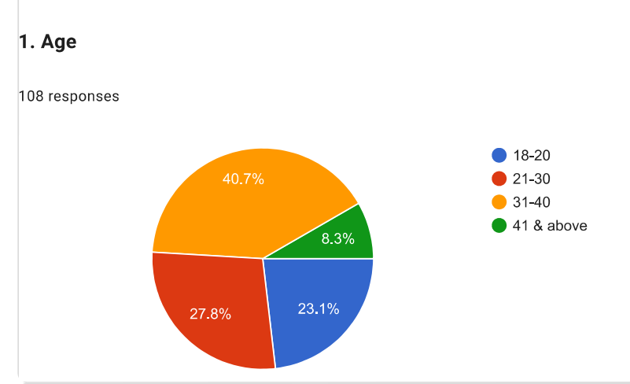
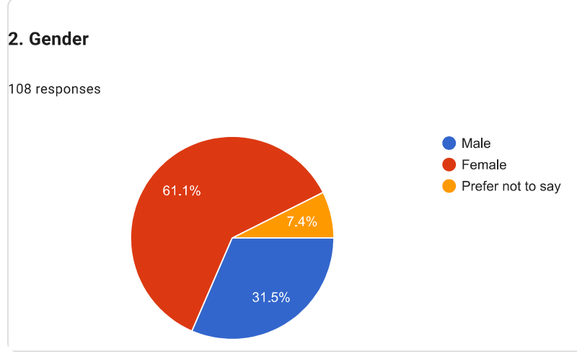
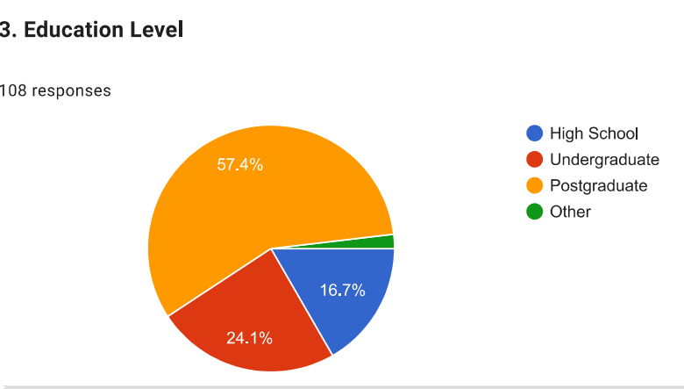
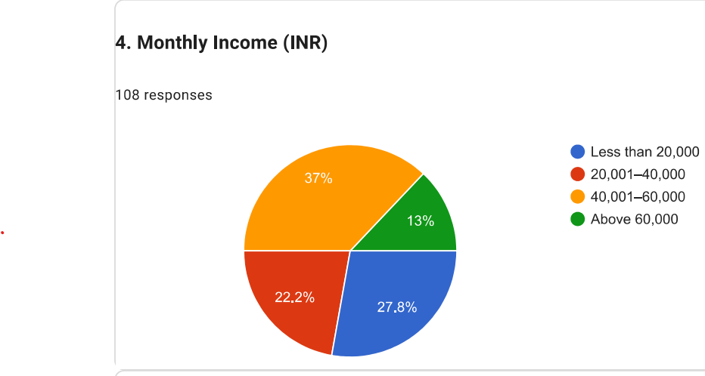
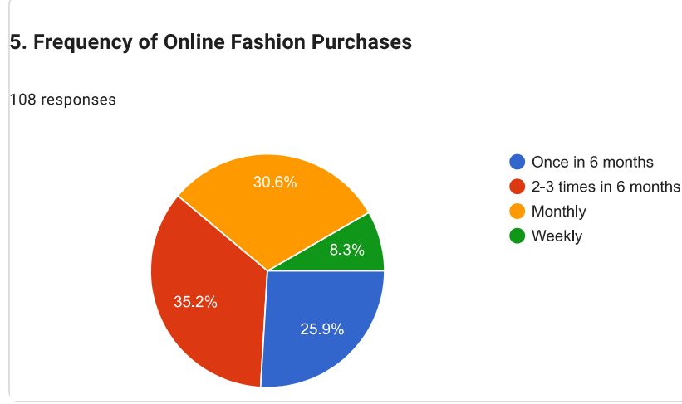
Figure 17: Demographic analysis results
(Source: Self-created)
1. Age
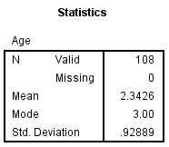

2. Gender
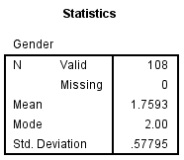

3. Education Level
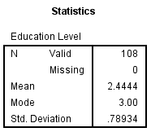

4. Monthly Income (INR)
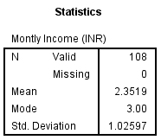

5. Frequency of Online Fashion Purchases
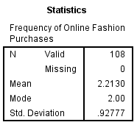

Figure 18: All demographic data statistical SPSS analysis results
(Source: Self-created)

Appendix 2 Statistical results of all data
Mobile App Usability and Customer Loyalty
6. Flipkart app interface is visually appealing and easy to navigate.
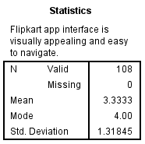

7. The app loads quickly and responds without any delays.
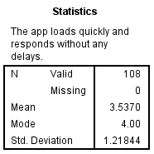

8. Product search and filtering options are effective in Flipkart
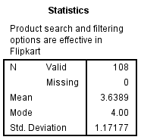

9. Checkout and payment processes are simple and secure in Flipkart
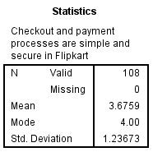

10. Flipkart provides personalized recommendations that match my preferences.
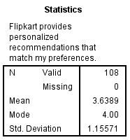

Figure 19: Mobile App Usability and Customer Loyalty
(Source: Self-created)

Customer Challenges in App Usability
12. Difficulties with Flipkart’s navigation during shopping.
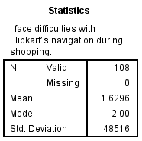

13. Technical glitches such as errors, crashes, payment failures may reduce my willingness to use Flipkart
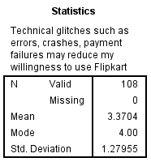

14. Lack of clear product information such as size, material, and reviews affects my purchase decisions.
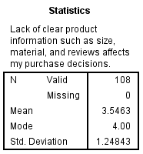

15. Challenging to track orders and delivery status through Flipkart
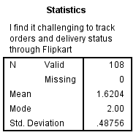

Figure 20: Customer Challenges in App Usability
(Source: Self-Created)

Mediating Role of Customer Loyalty
16. I prefer to stay with this mobile app instead of switching to other fashion shopping apps.
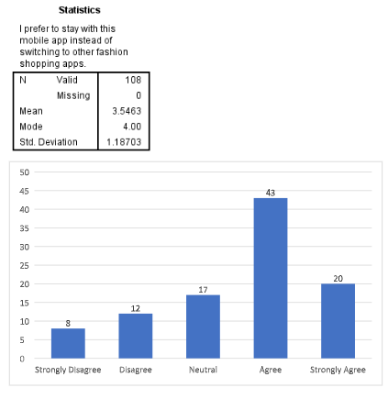
17. I frequently purchase fashion products from Flipkart app.
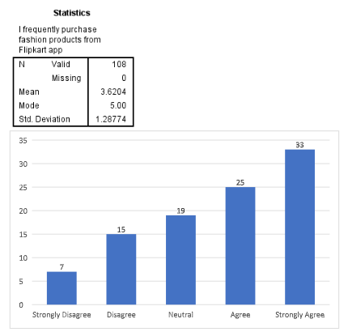
18. I check Flipkart regularly for new products, discounts, or recommendations.
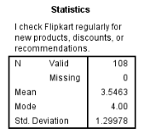
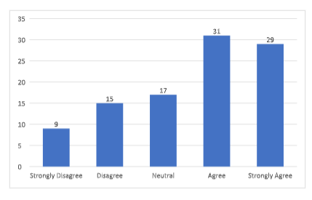
Figure 21: Mediating Role of Customer Loyalty
(Source: Self-Created)
App Design and Customer Retention Strategies
11. I find the Flipkart’s customer support features (chat/helpdesk) easy to access.
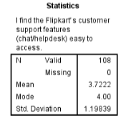
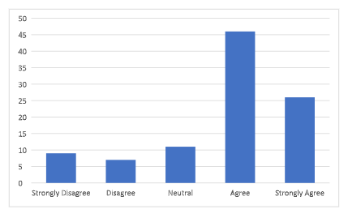
19. I recommend Flipkart with strong usability to my friends/family.
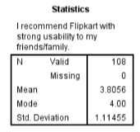
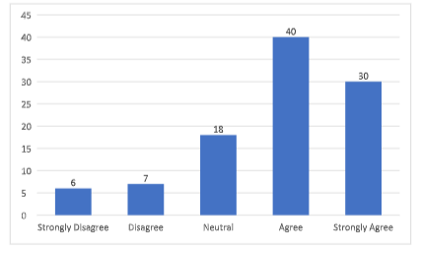
20. I am likely to purchase again from this mobile app in the future.
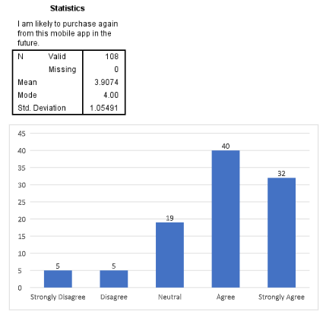
21. I spend considerable time exploring products and offers on this mobile app.
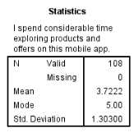
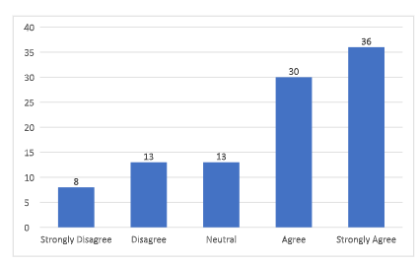
Figure 22: App Design and Customer Retention Strategies
(Source: Self-Created)

Appendix 3 Correlation Analysis
Mobile App Usability and Customer Loyalty
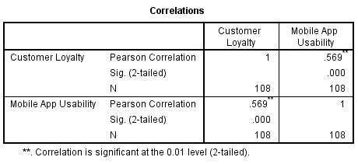
Challenges in Mobile App Usability and Customer Loyalty
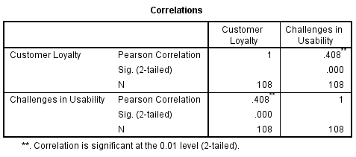

Appendix 4 Hypothesis Testing (using Regression Analysis)
H1: Mobile app usability has a positive effect on customer loyalty in fashion e-commerce platforms in India.
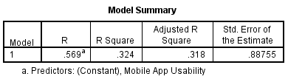
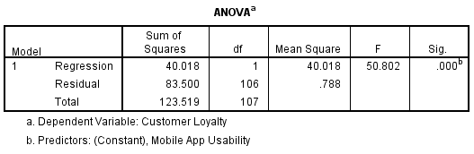
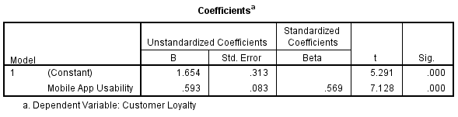
H2: The challenges faced by customers while using Fashion E-Commerce mobile apps have a
negative impact on the customer loyalty in India.
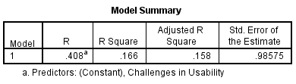
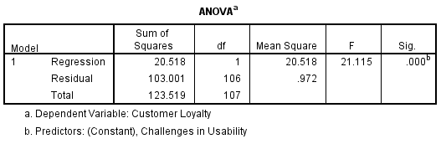
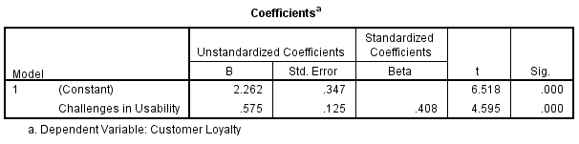

Appendix 5: Survey Questionnaire
1. Age
☐ 18-20
☐ 21–30
☐ 31–40
☐ 41 and above
2. Gender
☐ Male
☐ Female
☐ Prefer not to say
3. Education Level
☐ High School
☐ Undergraduate
☐ Postgraduate
☐ Other
4. Monthly Income (INR)
☐ Less than 20,000
☐ 20,001–40,000
☐ 40,001–60,000
☐ Above 60,000
5. Frequency of Online Fashion Purchases
☐Once in 6 months
☐ 2-3 times in 6 months
☐Monthly
☐Weekly
This questionnaire is to understand your experience on mobile app usability with Flipkart app.
6. Flipkart app interface is visually appealing and easy to navigate.
☐ Strongly Disagree
☐ Disagree
☐ Neutral
☐ Agree
☐ Strongly Agree
7. The app loads quickly and responds without any delays.
☐ Strongly Disagree
☐ Disagree
☐ Neutral
☐ Agree
☐ Strongly Agree
8. Product search and filtering options are effective in Flipkart
☐ Strongly Disagree
☐ Disagree
☐ Neutral
☐ Agree
☐ Strongly Agree
9. Checkout and payment processes are simple and secure in Flipkart
☐ Strongly Disagree
☐ Disagree
☐ Neutral
☐ Agree
☐ Strongly Agree
10. Flipkartprovides personalized recommendations that match my preferences.
☐ Strongly Disagree
☐ Disagree
☐ Neutral
☐ Agree
☐ Strongly Agree
11. I find the Flipkart’s customer support features (chat/helpdesk) easy to access.
☐ Strongly Disagree
☐ Disagree
☐ Neutral
☐ Agree
☐ Strongly Agree
12. I face difficulties with Flipkart’s navigation during shopping.
☐ Yes
☐ No
13. Technical glitches such as errors, crashes, payment failures may reduce my willingness to use Flipkart
☐ Strongly Disagree
☐ Disagree
☐ Neutral
☐ Agree
☐ Strongly Agree
14. Lack of clear product information such as size, material, and reviews affects my purchase decisions.
☐ Strongly Disagree
☐ Disagree
☐ Neutral
☐ Agree
☐ Strongly Agree
15. I find it challenging to track orders and delivery status through Flipkart
☐ Yes
☐ No
Section D
16. I prefer to stay with this mobile app instead of switching to other fashion shopping apps.
☐ Strongly Disagree
☐ Disagree
☐ Neutral
☐ Agree
☐ Strongly Agree
17. I frequently purchase fashion products from Flipkart app
☐ Strongly Disagree
☐ Disagree
☐ Neutral
☐ Agree
☐ Strongly Agree
18. I check Flipkart regularly for new products, discounts, or recommendations.
☐ Strongly Disagree
☐ Disagree
☐ Neutral
☐ Agree
☐ Strongly Agree
19. I recommend Flipkart with strong usability to my friends/family.
☐ Strongly Disagree
☐ Disagree
☐ Neutral
☐ Agree
☐ Strongly Agree
20. I am likely to purchase again from this mobile app in the future.
☐ Strongly Disagree
☐ Disagree
☐ Neutral
☐ Agree
☐ Strongly Agree
21. I spend considerable time exploring products and offers on this mobile app.
☐ Strongly Disagree
☐ Disagree
☐ Neutral
☐ Agree
☐ Strongly Agree

